Better Control of Health Care Costs and Reduction of Medical Errors by Using Heath Information Technology

Dimitrios Tsoromokos, Zaharias Dermatis, Nikolaos Tsaloukidis, Filippos Gozadinos,

Athina Lazakidou

University of Peloponnese, School of Economy, Management and Informatics, Department of Economics, Digital Health Applications and Health Economics Analytics Laboratory, Tripoli, Greece

Corresponding Author:
D. Tsoromokos
University of Peloponnese
School of Economy, Management and Informatics
Department of Economics
Digital Health Applications and Health Economics Analytics Laboratory
GR-22100, Tripoli, Greece
E-mail: dtsoromok@uop.gr

Abstract
Better use of data and technology has the power to improve health, transforming the quality and reducing the cost of health and care services. Adoption of electronic medical records systems and valid comparative performance reporting would enable the development of value-based competition and quality improvement to drive transformation. Health Information Technology should facilitate system integration for broader optimization, and comparative benchmarking should encourage development of market-leading examples of ways to better organize, pay for, and deliver care. Patient safety can be improved through e-prescribing by increasing prescription legibility, decreasing the time required to prescribe medications and dispense them to patients, and decreasing medication errors and Adverse Drug Events. Besides helping adverse drug interactions and allergic reactions to medications, e-prescribing helps reduce medical errors caused by poor handwriting. E-prescribing can also produce significant cost savings by informing doctors of effective generic alternatives to brand-name drugs.
Keywords: Medical Errors, Health Information Technology, Control, Ε-prescribing, Healthcare Costs

1. INTRODUCTION
Although errors in medication, surgery, and diagnosis are the easiest to detect, medical errors may result more frequently from the organization of health care delivery and the way that resources are provided to the delivery system. Incorrect diagnoses may lead to incorrect and ineffective treatment or unnecessary testing, which is costly and sometimes invasive. Also, inexperience with a technically difficult diagnostic procedure can affect the accuracy of the results.

Medical errors may result in:
- A patient inadvertently given the wrong medicine.
- A clinician misreading the results of a test.
- An elderly woman with ambiguous symptoms (shortness of breath, abdominal pain, and dizziness) whose heart attack is not diagnosed by emergency room staff.

Adverse drug events (ADEs) are a serious public health problem. The numbers of adverse drug events will likely grow due to:
- Development of new medications
- Discovery of new uses for older medications
- Population aging
- Increase in the use of medications for disease prevention
- Increased coverage for prescription medications.

A therapeutic consultation program, including drug utilization reviews and disease management programs, reduces costs by improving outcomes for patients with chronic conditions. It ensures those patients take their prescribed medication correctly and makes sure unnecessary medications are not being prescribed. Ultimately, this oversight works to reduce doctor and hospital visits caused by adverse drug interactions, skipped doses or ineffective prescriptions.

Regular auditing of pharmacy claims has identified hundreds of millions of dollars in noncompliance, error and fraud already, and can be completed in a matter of months. That is why combining auditing efforts with PDL, Drug Rebate and Population Health can act as a deterrent and generate future savings. This creates a “sentinel effect” in the medical community, actively discouraging fraud, waste and abuse within your pharmacy network while encouraging the development of a healthy, cost-effective program.

Acquiring and implementing secure and effective information technology that spans the patient home, ambulatory care clinic inpatient facility, diagnostic lab, provider practice, policymaker, and payer communities should lead to improved quality of care through a more comprehensive decision-making process and better-informed decision making at all stakeholder levels. Physicians can perform diagnoses based on more current and comprehensive background healthcare data through comparative analysis with other practitioners, and their patients can benefit from improved quality of care through this information exchange. One of the tremendous patient benefits stems from the fact that the information data-sets will include both provider and payer information from both public and private sources, including care maps or prescribed care pathways for relevancy. Patients can also begin to build their own ancillary records: logs of their adherence to medication schedules, exercise routines and dietary plans. They can even begin to form social networking based collaborations around their efforts with like-minded or afflicted individuals.

Healthcare public policymakers can rely on this data to develop and implement more effective healthcare delivery and payment policies, and report patient care outcomes based on statistically accurate clinical practice and demographic information. With the adoption of privacy and security enabled technologies, patients will have greater access to their personal health records, and can confidently help to maintain and update their personal information.

2. Theoretical approaches
Electronic Health Records (EHRs) and Health Information Exchanges (HIEs) with e-Prescribing reduce costs while adding an additional layer of patient safety monitoring and improving the quality of patient care overall. EHRs are comprehensive health records that include data on medical procedures, diagnoses, lab results and vaccinations – providing a total electronic view of a patient’s medical life. The HIE is the framework that enables the exchange of EHRs between all healthcare stakeholders to provide information that can be used at the point of care. EHR and HIE systems not only improve data accessibility and reduce medical errors; they facilitate lower cost, higher quality patient-centered care. The Health Information Exchange can also support population health programs, medical homes and care management by providing physicians with a longitudinal view of a patient’s record at the point of care. Adding clinical decision support or care alerts further insures that the patient is being managed within evidence-based or program guidelines.

E-prescribing has the potential to increase patient safety and patient medication adherence; create cost savings for medical clinics, hospitals, and patients; and improve efficiency in the ambulatory care setting. Patient safety can be improved through e-prescribing by increasing prescription legibility, decreasing the time required to prescribe medications and dispense them to patients, and decreasing medication errors and Adverse Drug Events.

Electronic prescribing (e-prescribing) is an important part of the nation’s push to enhance the safety and quality of the prescribing process. E-prescribing allows providers in the ambulatory care setting to send prescriptions electronically to the pharmacy and can be a stand-alone system or part of an integrated electronic health record system.

A therapeutic consultation program, including drug utilization reviews and disease management programs, reduces costs by improving outcomes for patients with chronic conditions. It ensures those patients take their prescribed medication correctly and makes sure unnecessary medications are not being prescribed. Ultimately, this oversight works to reduce doctor and hospital visits caused by adverse drug interactions, skipped doses or ineffective prescriptions.

Regular auditing of pharmacy claims has identified hundreds of millions of dollars in noncompliance, error and fraud already, and can be completed in a matter of months. That is why combining auditing efforts with Drug Rebate and Population Health can act as a deterrent and generate future savings. This creates a “sentinel effect” in the medical community, actively discouraging fraud, waste and abuse within your pharmacy network while encouraging the development of a healthy, cost-effective program.

Evidence-based guidelines, predictive modeling, patient/provider profiling, reporting, risk stratification, and data-driven management solutions can improve healthcare delivery and quality, while promoting medical best practices and reducing costs.

3. LITERATURE REVIEW
Elizabeth A. Flynn et al. in an article published in the American Journal of Health-System Pharmacy (AJHP), present the best twelve methods for detecting medication administration errors in U.S. hospitals and skilled-nursing facilities, comparing the methods’ validity and cost-efficiency. These were:
1. Directly observing medication administration
2. Reviewing patients’ charts
3. Reviewing incident reports involving medication errors
4. Attending medical rounds to listen for clues that an error has occurred
5. Interviewing health care personnel to stimulate self-report
6. Analyzing doses returned to the pharmacy
7. Testing urine for evidence of omitted drugs and unauthorized drug administration
8. Examining death certificates
9. Attending nursing change-of-shift report
10. Comparing medication administration record (MAR) with physicians’ orders
11. Performing computerized analysis to identify patients receiving target drugs that may be used to treat a medication error or to search for serum drug concentration orders that may indicate an overdose and
12. Comparing drugs removed from an automated drug-dispensing device for patients with physicians’ orders.

A panel of six experts on medication errors considered these methods and recommended that incident report review, chart review, and direct observation be compared for their ability to detect medication administration errors. Closing the article, the authors conclude that direct observation was more efficient and accurate than reviewing charts and incident reports in detecting medication errors [1].

In another article, Radley et al. conducted a systematic literature review to derive a summary estimate of the effect of computerized provider order entry (CPOE) on medication errors. Only for the 2008, the processing prescription drug order through a CPOE system decreases the likelihood of error on that order by 48% (95% CI 41% to 55%). Given this effect size, and the degree of CPOE adoption the authors appreciate a 12.5% reduction in medication errors, or ∼17.4 million medication errors averted in the USA in 1 year. The method and the tools analyzed in the article entitled "Reduction in medication errors in hospitals due to adoption of computerized provider order entry systems", published in 2013 in the Journal of the American Medical Informatics (JAMIA) [2].

Five years before, in the same journal, Ammnwerth et al. published an article entitled "The Effect of Electronic Prescribing on Medication Errors and Adverse Drug Events: A Systematic Review". In this paper present a systematic review which analyses the relative risk reduction on medication error and adverse drug events (ADE) by computerized physician order entry systems (CPOE). Of the 25 studies that analysed the effects on the medication error rate, 23 showed a significant relative risk reduction of 13% to 99%. Six of the nine studies that analyzed the effects on potential ADEs showed a significant relative risk reduction of 35% to 98%. Four of the seven studies that analyzed the effect on ADEs showed a significant relative risk reduction of 30% to 84%. In the end conclude that electronic prescribing seems to be a useful intervention for reducing the risk of medication errors and ADEs [3].

In the next paragraph present by Detsky the three obvious ways to control healthcare costs. The first would be to curb consumption by “outlawing” health insurance (or at least not encourage its purchase via the use of tax subsidies) so individuals face the full costs at the point of healthcare delivery. The second approach is to simulate market forces that induce consumer discipline with substitute incentives or friction. Managed care uses third party decision makers for approval prior to utilization. And the third approach is global budgets with top-down overall constraints on healthcare expenditures. This requires a system of government that identifies who is responsible for healthcare and enables that entity to execute this strategy. Global budgets are often coupled with bilateral monopolies whereby a single purchaser (e.g. government) negotiates prices with single organizational structures like physicians’ associations or hospitals. Most of the developed world uses some variation of this strategy while perhaps allowing a secondary private market to flourish for those who choose to pay for “extra” care. In the end, the author applauds the people who developed the concept of accountable care organizations (ACOs), and do so even louder for those who are attempting the daunting task of implementation. ACOs will lengthen the time horizon for healthcare organizations, especially when combined with the provision of the Affordable Care Act that forbids de-insuring people. ACOs will also broaden the work force used to provide care thus inducing different behaviors aimed at achieving long-term health gains [4].

M. Garrouste-Orgeas et al. published in the Intensive Care Medicine, an article which entitled "Understanding medical errors and adverse events in ICU patients". The work organization has an impact on medical errors. For example, in England, reducing work shift was associated with lower rates of adverse events. Additional, the authors mentioned that the prevention is better than cure, and particularly so with regards to medical errors. They propose several important areas for consider. First, an internal reporting system of all adverse events. A reporting system is there only to learn from the mistakes and errors made and hence prevent their recurrence. Then, there must be and openness and transparency regarding medical errors, both between staff and leaders, but also towards patients and family. The culture should change from a punishment-oriented culture and focus on systems and not individuals. It is nonsensical that in 2015 barcode scanners are used almost universally in all supermarkets in Europe but just in a minority of medication dispensers. In the end, the staff needs safe care and a safe environment. This mean that time must be given to caregivers to be aware of their errors so as to learn from them [5].

4. USE OF MEDICAL APPLICATIONS FOR MEDICAL ERRORS REDUCTION
D. Lee et al. in an article published in the Springer in 2014, present their proposed model for medical error reduction (figure 1).
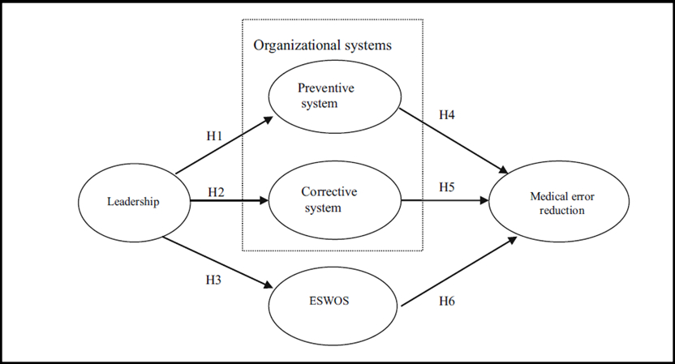
Figure 1. The Research Model for Medical Error Reduction

The Figure 1 shows the research model describing how organizational systems and ESWOS affect medical error reduction through the hospital leadership. The strong support from the leader is essential to successfully creating a culture of quality and safety for patients in the hospital. As the leadership has strong influence on the working environment, employees would receive sufficient organizational support for improving their work through the efficient leadership. The organizational system is implemented to prevent and correct errors that might occur in diagnosis and treatment, the organizational system can reduce medical errors. According to Woolf et al.’s (2004) study, 83 % of medical errors are due to mistakes in treatment or diagnosis, and two out of three medical errors were set in motion by communication errors. The Employee satisfaction with organizational support (ESWOS) will positively affect medical error reduction.

The results of the study shed new insights about how hospitals can improve their operations through medical error reduction. One of the findings of our study is that medical error reduction is associated with effective organizational systems and ESWOS by hospital leadership to improve quality of care. Second, the results show that the preventive systems are more important than the corrective systems for reducing medical errors. Third, ESWOS is important in that all of the efforts to reduce medical errors are related to medical manpower. And fourth, there is a significant difference between the large- and small-sized quality assurance (QA) team’s roles for medical error reduction in only reduced frequency of errors (RFEs). Thus, organizations can use a variety of ways to provide quality of care, such as reward systems to prevent medical errors and open discussion about medical error related issues [6].

In the next article present a system for the reduction of medical errors which called "bar-code eMAR". The authors observed 14,041 medication administrations and reviewed 3082 order transcriptions. Noted 776 errors in medication administration on units that did not use the bar-code eMAR (an 11.5% error rate) versus 495 such errors on units that did use it (a 6.8% error rate) — a 41.4% relative reduction in errors. The rate of potential adverse drug events fell from 3.1% without the use of the bar-code eMAR to 1.6% with its use, representing a 50.8% relative reduction. The transcription errors occurred at a rate of 6.1% on units that did not use the barcode eMAR but were completely eliminated on units that did use it. The authors present the four stages of the inpatient medication process with data from their analysis and from other studies (figure 2).
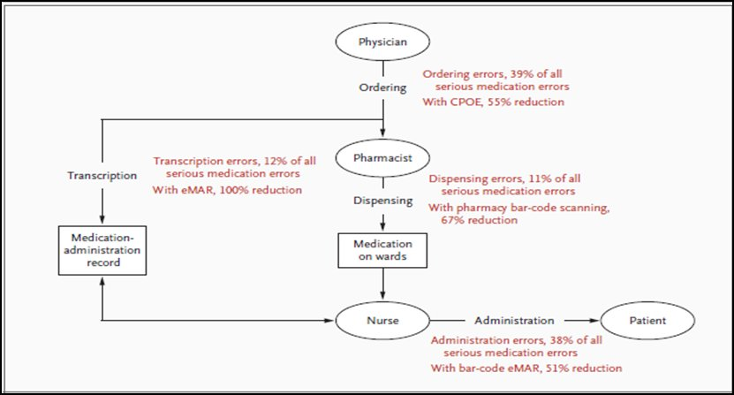
Figure 2. Four Stages of the Inpatient Medication Process

The paper entitled "Effect of Bar-Code Technology on the Safety of Medication Administration" and published in The New England Journal of Medicine in 2010 [7].

An innovative software system has been introduced through which healthcare professionals can be informed about a patient's deteriorating condition. This system transmits real-time messages through pagers and cellular phones to clinicians. Making it possible to integrate laboratory, medication and physiologic data alerts into a comprehensive real-time wireless alerting system.

It should be noted that clinical decision making is a complex process that depends on human ability to provide undivided attention and to memorize, recall, and synthesize huge amounts of data – all vulnerable areas. IT systems can improve access to pieces of information, organize them, and identify links between them. Clinicians are aware of the information (such as a patient's allergies, a drug recall warning, or a drug–drug interaction) but forget to consider it at the time of prescribing. IT systems are effective in bridging this gap by presenting the relevant information to the clinician at the time of decision making.
This software system detects alerts and then sends them to caregivers. The alert detection system monitors data flowing into a clinical information system. The detector contains a rules engine to determine when alerts have occurred. When all the necessary data has been collected, a series of alerting algorithms are executed and a decision is made as to whether or not an alert has occurred. If an alert condition is detected an application formats a message and transmits it to the alphanumeric pagers of various recipients. The message is sent as an e-mail to the coded PIN of individual caregivers' pagers or cell phones. The message then appears on the device's screen and includes appropriate patient identification information (figure 3 & 4).

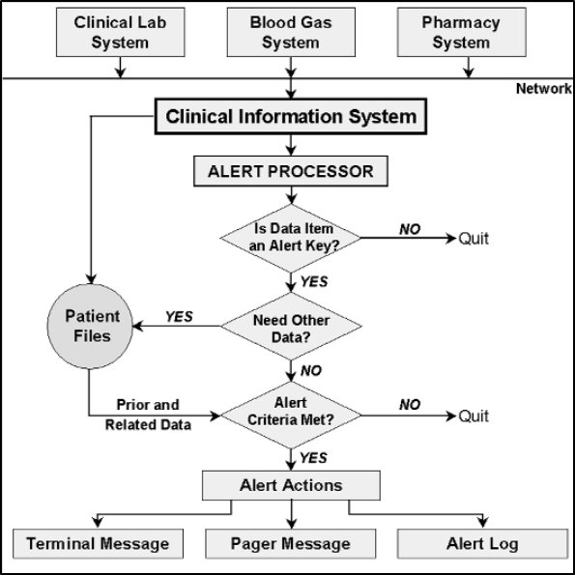
Figure 3. Alert Detection System
It has been demonstrated in numerous controlled trials that alerts are an integral part of a clinical decision support system. For example, in studies that were conducted, physicians who were sent e-mails notifying them of an increase in serum creatinine in patients who were receiving nephrotoxic were able to adjust or discontinue medication 21.6 hours earlier than physicians who were not delivered an e-mail. What is more, clinicians who were paged about 'panic' laboratory values, time to therapy decreased 11 percent, and mean time to resolution was 29 percent shorter [8].

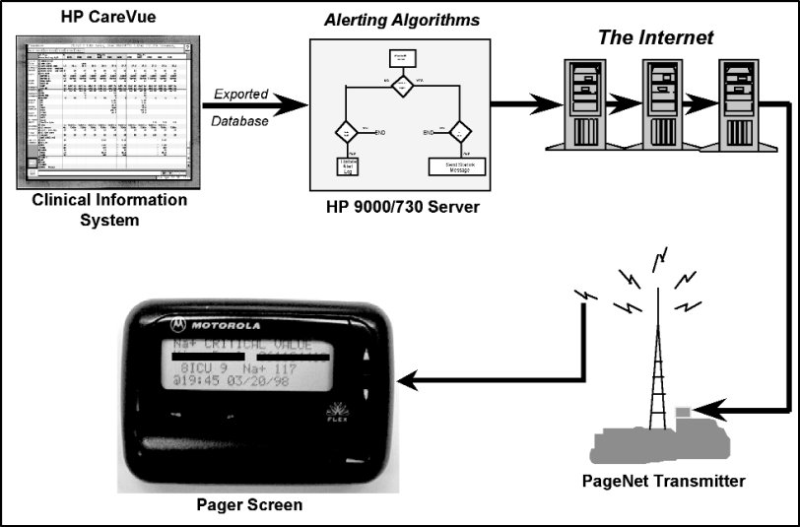
Figure 4. The Cedar-Sinai Wireless Alerting System

Table 1. Medical devices for elderly.
Source: http://medical-alert-systems-review.toptenreviews.com/
Fall Detection | This pendant comprises the necessary technology to detect that the individual wearing the pendant has fallen down. Should an individual experience a serious fall resulting from a heart attack, stroke or other serious medical event and not be able to press the pendant, the system within the pendant will detect the fall and notify the base station.
Mobile GPS System | Cellular and GPS technology have been combined to aid active senior citizens or disabled individuals who do not want to be restricted to their homes. These systems can determine location and send emergency services should the individual need urgent assistance. Thus, you are assured that the people you care about will get the necessary help that they may need.
CO Monitoring | Each year, more than 400 deaths in America are linked to carbon monoxide poisoning and 20,000 individuals will be hospitalised suffering from symptoms. It is no wonder that this odorless gas is also known as the Silent Killer. Mortality due to monoxide poisoning is more common among the elderly and individuals with weaker immune systems.  Detectors can identify dangerous levels of this gas and alert both the individual and the medical alert system provider of its presence. Should an individual not be able to fend for himself in such a situation, his medical alert provider will notify emergency services.
Fire and Smoke Monitoring | Smoke detectors can now do more than make loud noises when they detect smoke in a home. They not only alert you of a potential fire but they also send a signal to your medical alarm provider.  These alarms are sensitive to smoke, fire and heat and they will emit an alert and send a message to the call center should they detect any of the above in a home.

Another way for better control of Health Care Costs was presented by Tsoromokos et al. using Geographical Information Systems (GIS) to provide better financial management of biomedical equipment. An online platform has been designed as a cadastre and price observatory for better financial management of the biomedical equipment to the Public Hospitals of the Greek National Health System. It used the platform of ArcGIS - Esri. In a database will be the classification of machines per Hospital, category, model, manufacturer and GMDN code. Data will be entered to the system by authorized clinical engineers from the Department of Biomedical Engineering of the Hospital. It will compare the maintenance contracts, procurement costs of new equipment, fault repair costs, the spare parts and will calculate indices like index age of equipment, index costs equipment renewal, index maintenance costs, etc).

Financial management for a maintenance program focuses primarily on two tasks: monitoring costs and managing the budget. Managing the maintenance budget is not unlike managing any other organizational budget. The established budget represents the target or benchmark for the program. Actual costs are compared to the budget. Any difference between actual and budget data triggers a review of the reasons for the variance. Budgeting can be problematic with regard to Corrective Maintenance (CM) costs because such costs are unpredictable. An unexpected and expensive repair required for a critical medical device can cause a substantial budget variance. However, expenses of this type must be anticipated as much as possible so that, over time, the average level of CM expenses remains within the target budget. It is a good idea to allocate the cost of repair to a separate account from the Inspection and Preventive Maintenance (IPM) work. This will allow for accurate cost accounting and future budgeting for IPM and more accurate repair accounting. Additionally, it is important to consider adjusting the maintenance budget after acquisition of new equipment or removal of existing equipment as this affects costs associated with both IPM and CM.

Timely and economical maintenance activities maximize the value of health technology resources, which is especially important when resources are limited. When the various financial, physical and human resource aspects are carefully examined, a successful program that suits the needs can be designed and executed. However, the program must be considered an integral part of health-care delivery with a minimum set of resources designated to fulfill the tasks outlined by the program. Only in this way patients will have access to the biomedical equipment that can provide them with an accurate diagnosis, effective treatment or appropriate rehabilitation [9].

According to the ECDC (European Disease Prevention and Control Center), 4.1 million patients are affected each year from hospital infections and 37,000 deaths as a result thereof. Approximately 20-30% of hospital infections are considered preventable with prevention and control measures.

Hospital infection impose direct costs such as medicines, materials and equipment as well as indirect costs such as the fall of the patient quality level, discomfort and anxiety.
In addition, nosocomial infections impose costs to health services as more working hours in medical and nursing staff, as well as living expenses for relatives of patients and environmental costs reimbursed.

The LIMOXIS (figure 5) is an information system created in order to control, record and financial manage the nosocomial infections for optimal hospital management aiming to reduce the incidence and cost.

Figure 5. Screenshot of the LIMOXIS System

The cost of hospital infection depends on the days of stay, materials and medications used. THE LIMOXIS addition to the above features and key data elements such kind of infection, clinical, age, gender, dates of entry and exit of the patient. To have a reliable cost effect is the use of Closed Consolidated hospital fees (DRGS) which determine the cost of the initial diagnosis. Also, the selection of statistical data, a complete statistical analysis for each incident is displayed with data such as duration and cost of stay, materials, drugs, incidence of specific nosocomial infections, providing important information to take decisions and to design policies in order to reduce hospital infection outbreaks. The LIMOXIS is easy to use and is applied to tablet, mobile and desktop enabling the data update from users at any time [10].

Closing the section with all applications that can lead to a reduction of medical errors with the use of Health IT, application of digital pen and paper (DPP) is presented. The digital pen resembles a common pen. However, it contains an integrated digital camera, an advanced image microprocessor, a rechargeable battery and a portable communication device for a wireless connection (Bluetooth). It is low cost compared with other solutions, simple to use, reliable, and if used in conjunction with a mobile phone can send data to your office from anywhere you are. Additionally, there is the possibility of receiving a reply to the mobile phone used for sending data of a manuscript form, so as to correct any errors or omissions made in the supplement. This ensures high quality and speed in sending data. If mobile phone use, together with the information retrieved from the digital pen can still send information such as digital images or GPS coordinates.
Before final storage and verification / validation of data, accuracy of information achieved through (Optical Mark Recognition) OMR and (Optical Character Recognition) OCR software. The above process is described in figure 6 and figure 7.

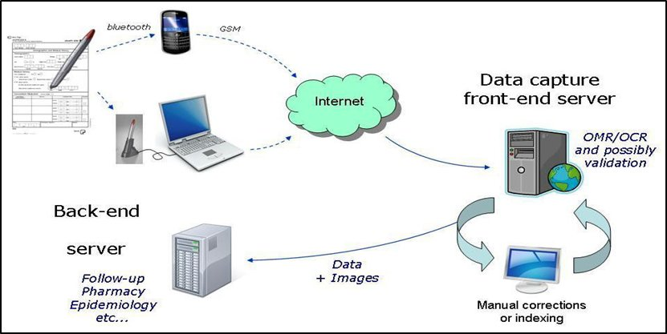
Figure 6. The Digital Pen and Paper Technology (DPP)
Source: http://www.coresit.com/EN/sensaas_digitalpen.html

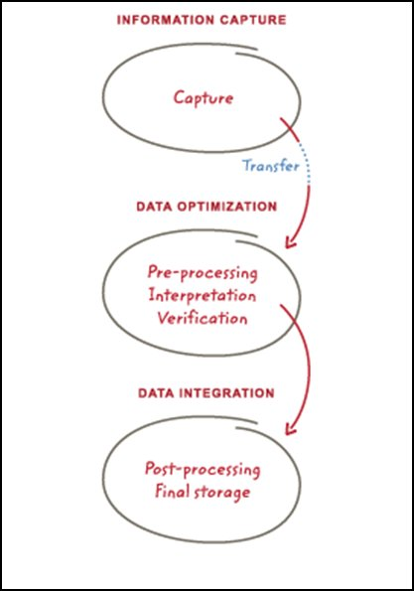
Figure 7. Information Capture, Data Optimization and Data Integration
Source: http://old.qnr.com.gr/site/categories/it_products/digital_pen_paper/form.csp

5. Conclusion
Healthcare is characterized by a reliance on human operators who work with increasingly complex technology and variable levels of uncertainty. This can lead to error and needs to be managed through a framework where organizations are available for continuously improving the quality of services and safeguarding high standards of care. The use of information technology, information accessibility, communication, patient collaboration and multi-professional team-work are the main successful strategies to reach the goal of reduced medical errors and patient safety within healthcare organizations.

REFERENCES
[1] E. A. Flynn, K. N. Barker, G. A. Pepper, D. W. Bates, and R. L. Mikeal, "Comparison of methods for detecting medication errors in 36 hospitals and skilled-nursing facilities," American Journal of Health-System Pharmacy, vol. 59, 2002, pp. 436-446.
[2] D. C. Radley, M. R. Wasserman, L. E. Olsho, S. J. Shoemaker, M. D. Spranca, and B. Bradshaw, "Reduction in medication errors in hospitals due to adoption of computerized provider order entry systems," Journal of the American Medical Informatics Association, vol. 20, 2013, pp. 470-476.
[3] E. Ammenwerth, P. Schnell-Inderst, C. Machan, and U. Siebert, "The effect of electronic prescribing on medication errors and adverse drug events: a systematic review," Journal of the American Medical Informatics Association, vol. 15, 2008, pp. 585-600.
[4] A. S. Detsky, "How to control health care costs," Journal of general internal medicine, 2012, pp. 1-2.
[5] M. Garrouste-Orgeas, H. Flaatten, and R. Moreno, "Understanding medical errors and adverse events in ICU patients," Intensive Care Medicine, vol. 42, 2016, pp. 107-109.
[6] D. Lee, K. S. Hong, and N. Y. Kim, "Effects of hospital leadership, organizational systems, and ESWOS on medical error reduction," Service Business, 2014, pp. 1-19.
[7] E. G. Poon, C. A. Keohane, C. S. Yoon, M. Ditmore, A. Bane, O. Levtzion-Korach, et al., "Effect of bar-code technology on the safety of medication administration," New England Journal of Medicine, vol. 362, 2010, pp. 1698-1707.
[8] D. W. Bates, M. Cohen, L. L. Leape, J. M. Overhage, M. M. Shabot, and T. Sheridan, "Reducing the frequency of errors in medicine using information technology," Journal of the American Medical Informatics Association, vol. 8, 2001, pp. 299-308.
[9] D. Tsoromokos, Z. Dermatis, N. Tsaloukidis, A. Lazakidou, "Using Geographical Information Systems (GIS) to Provide Better Financial Management of Biomedical Equipment," Proceedings of the 1st International Conference on Research in Health Care, Athens, Grecce, June 2015.
[10] F. Gozadinos, D. Tsoromokos, N. Tsaloukidis, A.Konstantinopoulou, Z. Dermatis, A. Lazakidou, "Design of a Useful Information System Specialized for Control, Registry and Financial Management of Nosocomial Infections for Better Work Hospital Administration: The LIMOXIS System," Proceedings of the 6th International FOHNEU Congress New Occupational Health Horizons, Rotterdam, The Netherlands, March 2016.

