The Origin and Genesis of the Dokan Conglomerate, NE Iraq
Varoujan K. Sissakian, Hala A. Al-Musawi, Nadhir Al-Ansari³and Sven Knutsson

Abstract
The "Dokan Conglomerate" is a new lithostratigraphic unit of Pleistocene age added to the Iraqi stratigraphic column within the Quaternary Period. The conglomerate is exposed northwest of Sulaimaniyah, starting from Khalikan anticline, near Kani Watman village; it extends on the top of the anticline for about 5 Km, and is exposed also along the southern and eastern banks of Dokan Lake. The Dokan Conglomerate consists of almost monotype clasts, which are derived mainly from the Qamchuqa Formation, well cemented by calcareous materials forming very hard beds; however, locally, sandstone and claystone are interbedded with the conglomerate beds. The thickness of the conglomerate reaches up to 300 m, but generally varies between (100 – 200) m. The Dokan Conglomerate is thickly well bedded to massive, either horizontally capping Tanjero, Shiranish, Kometan and Qamchuqa formations, on the top of Khalikan anticline, or overlies them along the northeastern limb of the anticline; with clear dipping beds. The origin and the mode of deposition of the Dokan Conglomerate are given, discussed and its deposition is tectonically correlated with the growth and development of Khalikan anticline, besides the effect of a large normal fault that is responsible for development of the depression, which is used as Dokan Reservoir. Geomorphological and structural evidences are given too; to confirm the mode of deposition. The estimated age of the conglomerate is Pliocene? – Pleistocene.

Keywords: Conglomerate, Dokan, Iraq

- Introduction
The Dokan Conglomerate is a new lithostratigraphic unit of Pleistocene age, which is added to the Iraqi Stratigraphic column by Karim and Taha [1] adopted by Sissakian and Fouad [2, 3, 4] and was used in the Geological Map of Iraq, at scale of 1: 1000000 and Geological Map of Erbil, Mahabad and Sulaimaniyah Quadrangles, at scale of 1: 250000, respectively. The thickness and areal distribution of the Conglomerate unit permit to consider it as a new lithostratigraphic unit, following ICS regulations.
The only carried out works concerning the Dokan Conglomerate are those mentioned hereinafter:
- Karim and Taha [1] recognized the Dokan Conglomerate for the first time and reported about its distribution, constituents, thickness, origin and age.
- Sissakian and Fouad [2,3, 4] adopted the term of the Dokan Conglomerate during the checking and updating of the Geological Map of Iraq and geological Maps of Erbil and Mahabad, and Sulaimaniyah Quadrangles, at scale of 1: 250 000. But, they did not argue the claimed origin of the conglomerate.
Apart from the aforementioned works, none mentioned the presence of the Dokan Conglomerate. Ibrahim [5] compiled a photogeological map of the northern parts of Iraq; he interpreted the whole succession as Cretaceous rocks. However, Sissakian [6,7] during the interpretation of aerial photographs for the sake of compilation of the Geological Maps of Iraq; in those areas, which are not covered by geological mapping, considered the Dokan Conglomerate as clastics of Fatha, Injana, Mukdadiya and Bai Hassan formations at the southern and eastern banks of Dokan Lake (Fig.2), due to the large similarity between them, when viewed from aerial photographs and even in the field from high elevations (Fig.3). Nevertheless, Sissakian and Fouad [2, 3, 4] checked the involved outcrops and found them not to be Fatha, Injana, Mukdadiya and Bai Hassan formations, but to be the Dokan Conglomerate.
The aim of this study is to deduce the origin of the Dokan Conglomerate and to debate the claimed origin by Karim and Taha [1], as compared with tectonic history of the involved area, using morphotectonic facts [5, 6, 7].

The location of the studied area is northwest of Sulaimaniyah city, NE of Iraq. It extends from Kani Watman village; in the extreme northwest to the eastern bank of Dokan Lake; in the extreme eastern part of the Dokan Conglomerate exposures (Fig.1). The studied area is located within the High Folded Zone of the Outer Platform, which forms the northeastern part of the Arabian Plate [8].

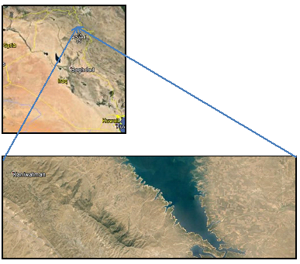
Fig.1: Google Earth image of the studied area
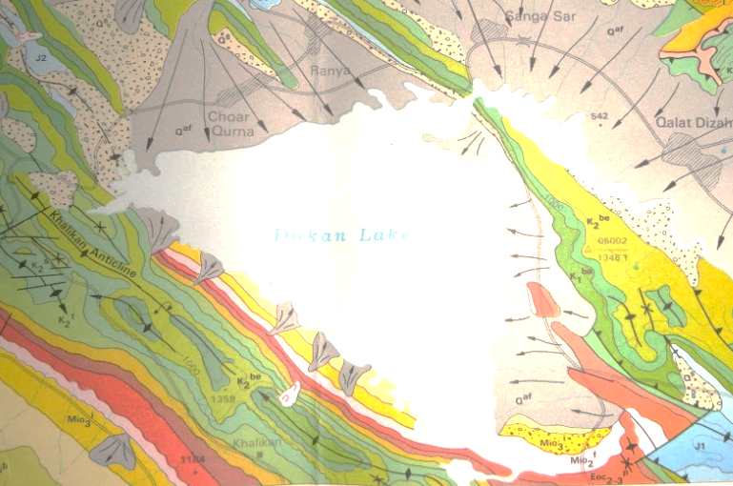
Fig.2: Geological map of the involved area (After [6])
For the legend, refer to Fig. (5)
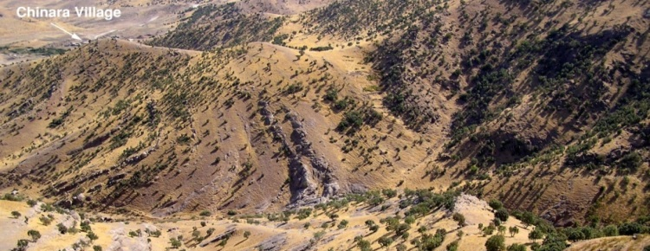
Fig.3: General view of the Dokan Conglomerate (After [1]).
Note the alternation of soft sandstone and claystone horizons alternated with the hard conglomerate beds, which give them resemblance to Fatha, Injana, Mukdadiya and Bia Hassan formations; from aerial photographs and Landsat images

- Materials and Methods
To achieve the aim of this study, the following materials were used:
- Geological maps, at scale of 1: 100 000, 1: 250 000 and 1: 1000 000
- Google Earth, DEM and Satellite images
- Relevant published articles and reports
The geological maps [2, 3, 4] with the Google Earth, DEM and Satellite images were used to recognize the areal distribution of the Dokan Conglomerate and to recognize its relation with the exposed formations in the study area.
Field work was carried out in August, 2014 to acquire interesting data, like constituents of the conglomerate; their description, thicknesses, and dip measurements; many interesting and representative exposures were photographed too. Some structural data were also reviewed to elucidate the relation between the Dokan Conglomerate and the underlying exposed geological formations
Within GIS and Digital Elevation Model (DEM) applications, spatial analysis and hydrological tools of Arc GIS were used to calculate coverage areas of some outcrops.

- The Dokan Conglomerate
The Dokan Conglomerate is a lithostratigraphic unit of Pleistocene age recognize by [1] adopted by [2, 3, 4] and used in the Geological Map of Iraq, at scale of 1: 1000000 and Geological Maps of Erbil and Mahabad, and Sulaimaniyah Quadrangles, at scale of 1: 250000. The used term "Dokan Conglomerate" by [1] fulfils the conditions stated by ICS [12] for the nomenclature of stratigraphic units.

3.1 Geographical Extent
The Dokan Conglomerate is exposed west of Sulaimaniyah city, along Khalikan and Kosrat anticlines, and along the southern and part of the eastern banks of Dokan Lake (Figs.4 and 5).
The exposures of the Dokan Conglomeate starts from Kani Watman village (Fig. 6) in the extreme northwestern part of the coverage area, as high stnding exposures above the Tanjero Formation at the northwestern plunge area of Khalikan anticline, northwest of Sulaimaniyah city. The exposures of the conglomerate extends eastwards on the top of Khalikan anticline (Fig.7) overlying different formations.

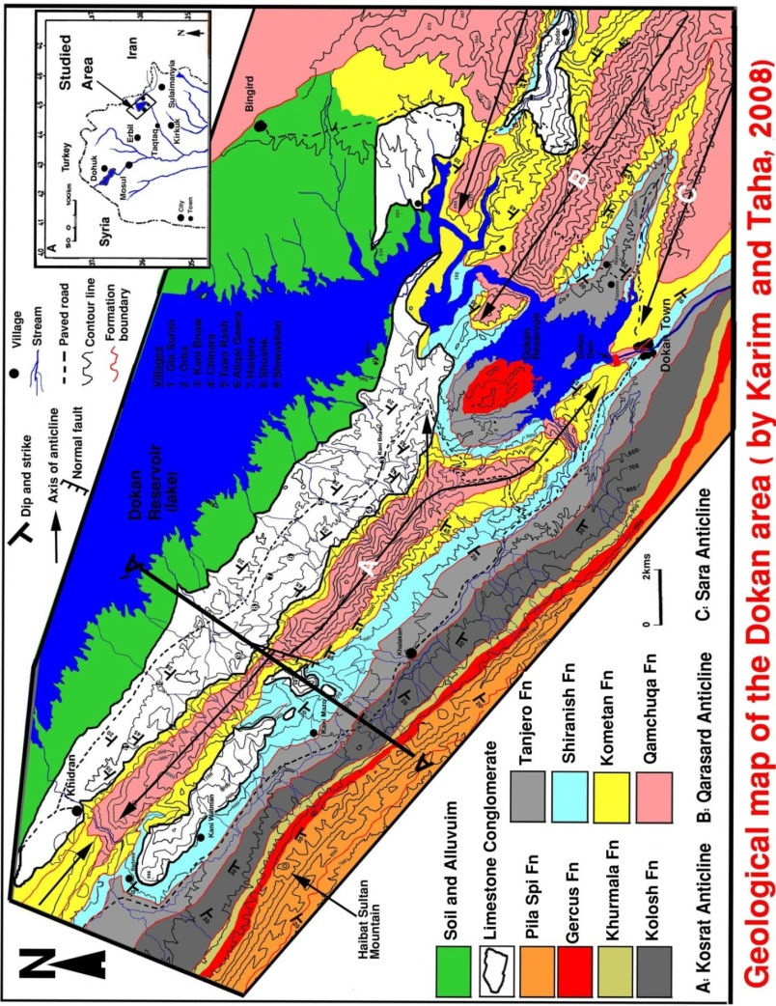

Fig.4: Geological map of the extension of Dokan Conglomerate (After [1])
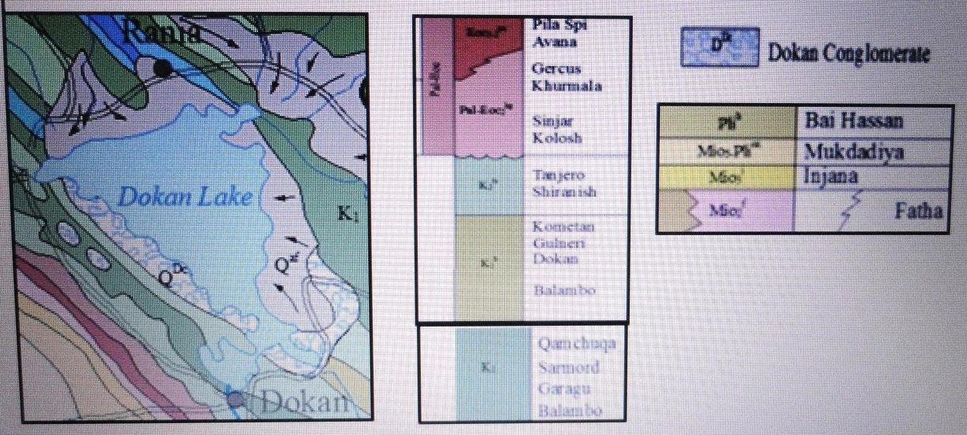

Fig. 5: Geological map showing the distribution of the Dokan Conglomerate
(After [2])

DC
TF

Fig. 6: Beginning of the exposures of the Dokan Conglomerate (DC)
near Kani Watman village, overlying the Tanjero Formation (TF).
Note the abrupt starting of the exposure pattern of the conglomerate

Characteristics of the Dokan Conglomerate
The Dokan Conglomerate consists of thick succession of tough and concrete like rocks, which form high mountains such as Buko Zawa and Kani Zard (about 1050 m high). The thickness is variable, but it reaches more than 300 m in some places [1]. The hardness, well bedding and jointing of the conglomerate give rise to high cliffs of massive masses; locally forming Hoodoos feature (Fig.6). The conglomerate consists mainly of limestone in pebble, boulder and block sizes (Fig.8, Left). The limestone is derived mainly from the Qamchuqa Formation and rarely from the Kometan Formation, very well cemented by calcareous materials; giving the beds very hard strength. The beds are thickly well bedded to massive, the thickness of the individual bed ranges from (1 – 7) m (Fig.8, Right).

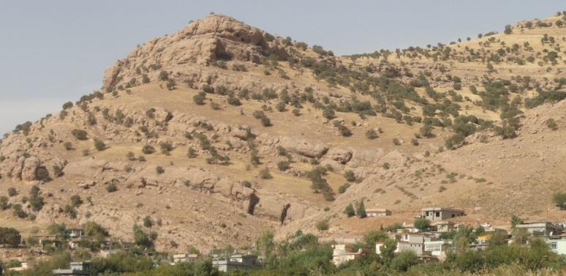

Fig.7: Exposures of the Dokan Conglomerate overlying the Shiranish Formation (Bellow the village). Note the opposite dip direction of the conglomerate.

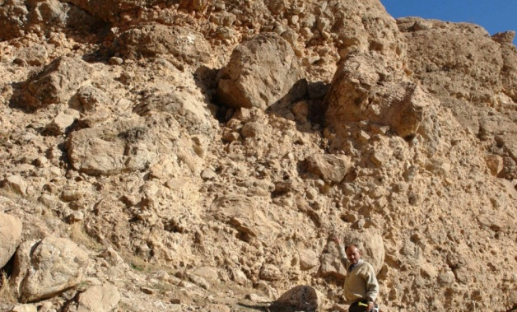

Fig.8: Left) Different sizes of limestone boulders and blocks (After [1]), Right) Thickly bedded to massive bedding and jointing nature of the conglomerate; forming Hoodoos, near Kani Watman village.

The beds of the Dokan Conglomerate are either horizontally overlying the older exposed formations, as in Kani Watman vicinity (Fig.6), or show NE dipping, coinciding with the dip of the underlying rocks of older formations (Fig.7). The dip amount ranges from (15 – 60)°, forming angular unconformity with the underlying rocks.

According to [1] locally, the conglomerate contains rare boulders of the Pila Spi Formation, and chert pebbles, especially in the upper part. The clasts are dolomitized and contain radiolitid rudist, stromatolite and orbitoids forams. The cement material consists of calcite and the clasts are sub angular to well rounded, badly sorted, which show well developed imbricated pebbles and shows different paleocurrent directions, such as south, southwest or southeast.

The exposures of the Dokan Conglomerate in the southern and southeastern banks of Dokan Lake include soft sandstone and rare claystone beds too, alternated with the hard conglomerate beds; giving them the shape of Cuestas and Hogbags (Fig.3). This nature was a main reason that led [7] to interpret them; from aerial photographs as the clastics of Fatha, Injana and Mukdadiya formations.
The reason why the clasts of the Dokan Conglomerate are mainly derived from the Qamchuqa Formation is that the Qamchuqa Formation is the only formation that includes very hard weathering resistant dolomite, dolomitic limestone and limestone beds, as compared to the soft rocks of Tanjero, Shiranish and Kometan formations, and even rocks of the Sarmord and Balambo formations, which are exposed in the surrounding areas (Figs.3 and 4). The soft rocks were weathered and eroded and formed the cementing materials of the hard clasts, which differ in size and reach to more than 1 m in size. The presence of clasts derived from the Pila Spi Formation [1] is problematic, since no outcrops of the Pila Spi Formation occur northwards from the exposures area of the Dokan Conglomerate (Figs.3 and 4).

- Origin of the Conglomerate
According to [1] the Dokan Conglomerate is located in the proximal area (more close to mountain range) therefore, it is less affected by stream confluence from different source area and the clasts are only derived from Qamchuqa, Dokan and Kometan formations. The absence of chert and and igneous and metamorphic rocks are most possibly attributed to the presence of a barrier that prevented the influx of the sediments from present Thrust Zone towards south (towards of present location of outcrops of the Dokan Conglomerate). This barrier consisted of limbs of the anticlines that composed of about 600 m of hard limestone of the Qamchuqa Formation. The evidence for this is that there are, in the source area of the Dokan conglomerate, many northwest – southeast anticlines. The crests and cores of these anticlines are removed (weathered) during Pliocene and supplied limestone clasts to the studied area forming the Dokan Conglomerate, while the limbs acted as a barrier for diverting the streams from the sources in the present source area away from the location of Dokan Conglomerate during deposition. Moreover, [1] have manifested the depositional scenario of the conglomerate in Fig.(9).
Although the authors adopted large parts of the study of [1] however, they are not in full accordance with the claimed origin and depositional scenario of the conglomerate. The details of the depositional style and origin are given in the coming paragraph of the DISCUSSION. The given depositional model and origin of the conglomerate are more related to the lateral growth concept of the anticlines given by [8,13,14]), and [10], as evidenced from morphotectonic, topographic, structural and geomorphological features in the studied area and near surroundings.

- Discussion
The Dokan Conglomerate is deposited in a shallow basin of fresh water, with continuous deposition, not interrupted during Pleistocene and even Pliocene?, as indicated from its huge thickness, which attains 300 m and the type of the sediments, such sediments are confirmed to be of shallow basinal sediments [15]. The huge thickness of the conglomerate near Kani Watman village (Fig.6), which represents the northwestern limit of the exposure areas, as abrupt starting of the conglomerate with such huge thickness (Fig.7) indicate the deposition in a shallow basin that had sharp edge during the deposition with continuous subsiding; otherwise the beginning of the outcrop wouldn't have such shape and thickness. The continuous subsiding of a basin is a common feature in intermontane basins [8, 10, 13, 14]; it is also confirmed by the existing of large topographic depression, which is utilized as the Dokan Dam reservoir.
The depression is most probably formed due to a normal fault that runs almost NE – SW, forming the western bank of Dokan lake, which was the course of the Lesser Zab River; before inundation of the depression by Dokan lake. The abrupt disappearance of the southwestern limb of Ranya anticline east of Chuwar Qurna town (Figs.10 and 11) is another indication for the presence of the fault. Moreover, the indication of sharp edged shallow depression as deduced from the outcrop pattern of the Dokan Conglomerate is another prove for the straight line caused by the fault, besides the existence of limestone outcrops along the western bank of the lake, below the top surface level (Fig.12) that indicate the downthrown block of the fault.

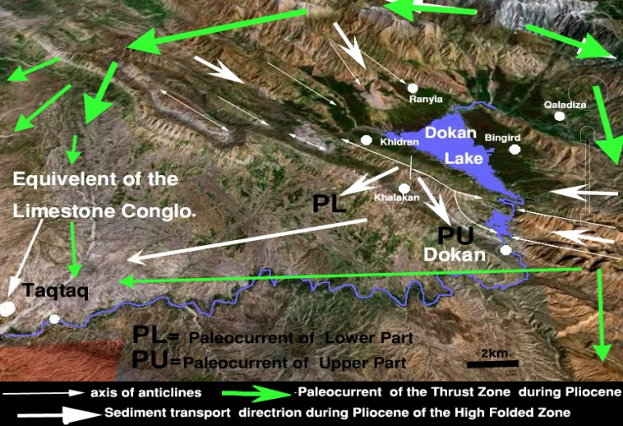

Fig.9: Depositional scheme of the Dokan Conglomerate
(After [1])

According to the authors’ opinion, the Dokan Conglomerate started depositing on the northwestern plunge area of Khalikan anticline, which was not yet completely developed and grown to its nowadays size. Originally, the plunge area of Khalikan anticline and northwards were still not raised yet and forming large depression, part of which is occupied as the reservoir of Dokan Dam. The depositional basin was covering large part of the depression, as indicated by the presence of outcrops of the Dokan Conglomerate on the southern and southeastern banks of Dokan Lake (Figs.4 and 5) and on the top of Khalikan anticline (Fig.13). The author believes that the outcrops extend more northwards and are inundated by Dokan Dam's reservoir.

The continuous deposition of the Dokan Conglomerate in the deep depositional basin was contemporaneous with the lateral and vertical growths of Khalikan anticline; therefore, the conglomerate overlies many exposed formations (Tanjero, Shiranish, Kometan and Qamchuqa) in Khalikan anticline (Fig.14). The presence of a large wind gap in the middle part of Khalikan anticline is good indication for the lateral and upwards growth of the anticline. According to [10] wind gaps are good indications for the lateral growth of anticlines. Therefore, the outcrops of the Dokan Conglomerate can be found on the plunge area and top of Khalikan anticline.
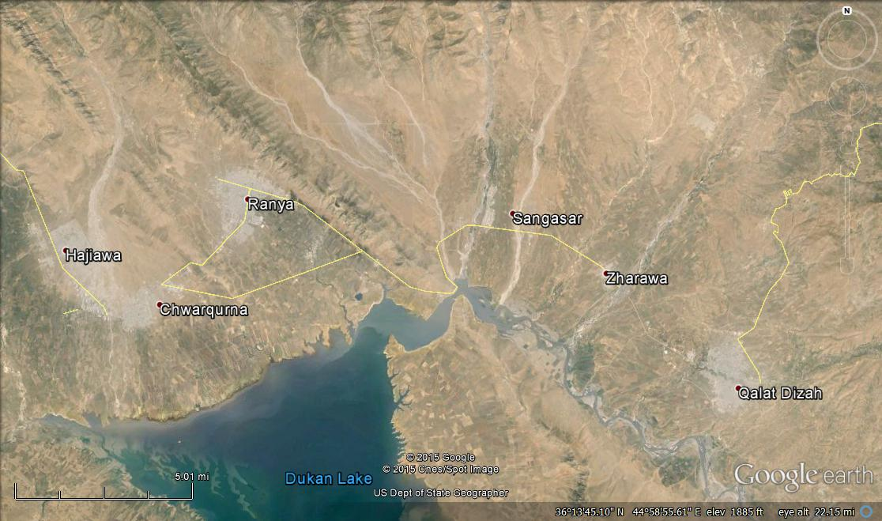
5 Km

Ranya anticline

Fig.10: Google Earth image showing the huge alluvial fans that have supplied the soft materials forming the claystone and sandstone beds within the Dokan Conglomerate. Note the absence of a large part of the southwestern limb; east of Chwar Qurna town, most probably due to normal faulting that runs parallel to the western bank of Dokan lake.

After the deposition of the Dokan Conglomerate, during Late Pleistocene and may be early Holocene and with the climatic changes towards dry phases, the conglomerate suffered, as all exposed rocks from intense erosion; consequently large parts were weathered and eroded; therefore, the exposure pattern was divided into main parts: The first part on the top of Khalikan anticline and the second part along its northeastern limb that extends below the reservoir of Dokan Lake. The author believes that those parts along the northeastern limb have suffered from tension and shear fractures more than other parts of the anticline; therefore, the outcrops on those parts were more fractured and sheared, consequently more easily eroded and washed out [7,8].

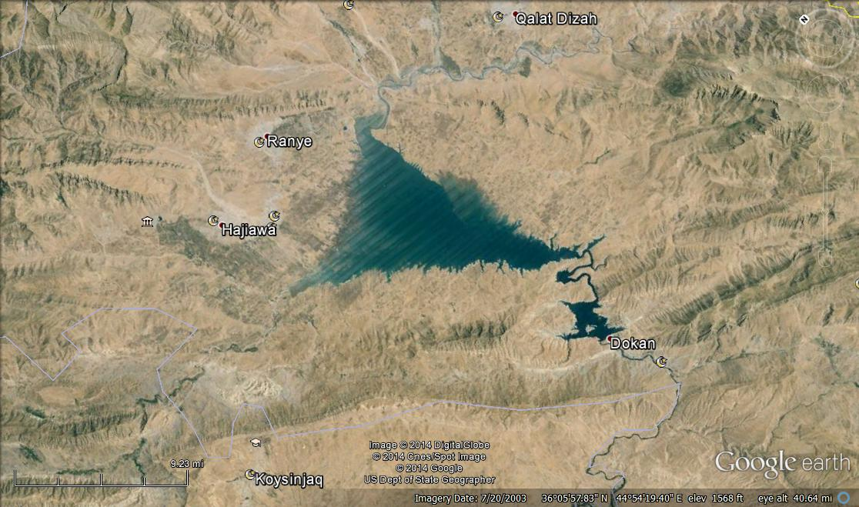
Khalikan anticline
15 Km

NEL
NEL
SWL

Fig.11: Google Earth image; facing NW.
Note the absence of large parts of the southwestern limb (SWL) of Ranya anticline in the depression, whereas the northeastern limb (NEL) is continuous north of Dokan Lake.

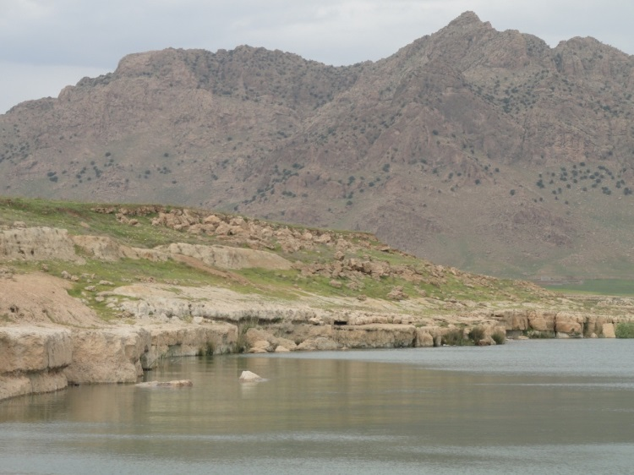

Fig.12: Limestone outcrops of the southwestern limb of Ranya anticline,
appeared due to lowering of the water level in Dokan lake (December, 2014).

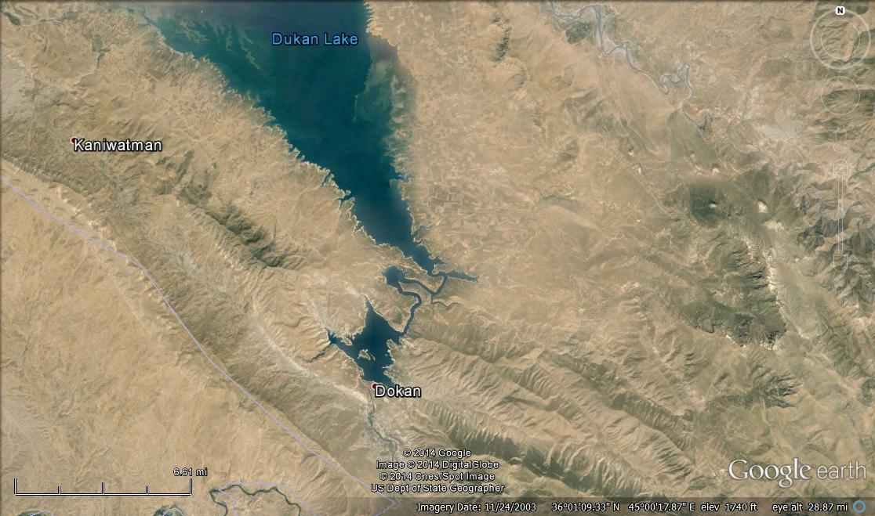
WG
T
5.5 Km

K
S
Q
DC
DC

Fig.14: Google Earth image. Note the exposure pattern of the Dokan Conglomerate (DC), dark colored. Formations: T= Tanjero, S= Shiranish, K= Kometan and Q= Qamchuqa.
WG = Wind gap

The presence of sandstones and claystones within the conglomerate beds along the exposures of the Dokan Conglomerate in the southern and southeastern banks of Dokan Lake is attributed to the huge alluvial fans, which had supplied huge quantities of fine clastics to the deepest parts of the depositional basin and still they exist in Hajiawa, Chuwar Qurna, Ranya, Sanga Sar and Qalat Diza areas (Fig.10); therefore, the other outcrops, like in Kani Watman village lack the sandstone and claystone beds.

The different dip amounts of the beds of the Dokan Conglomerate are attributed to: The beds of the conglomerate are horizontally lying in the northwestern plunge area of Khalikan anticline, at Kani Watman vicinity (Fig.6), because the conglomerate was deposited on almost horizontally lying beds; as it is at the plunge area of an anticline; therefore, the beds exhibit horizontal dip. Whereas, at areas were the conglomerate was deposited over the tilted beds of Khalikan anticline, as in the northeastern limb of Khalikan anticline (Fig.7), then the conglomerate beds exhibit dipping slightly less than the dips of the underlying rocks. It is the same case along the southern and southeastern banks of Dokan Lake (Fig.3).

Using the exposure dating concept of [10], the estimated age of the Dokan Conglomerate is Pliocene? – Pleistocene. This age is correlated with the age of the Bai Hassan Formation, because they both have the same characteristics, although the latter has very vast geographic extent and more thickness. This is also attributed to the small depositional basin for the former and the limited source area, as compared to the source area of the latter.

- Conclusions
The following are concluded from this study:
- The Dokan Conglomerate was deposited in a shallow basin of fresh water.
- The age of the Dokan Conglomerate is Pliocene? – Pleistocene, and most probably is well correlated with the Bai Hassan Formation.
- The Dokan Conglomerate consists of two parts: The first part that is developed on the top of Khalikan anticline; consists only of conglomerate, whereas the second part that is developed along the banks of Dokan Lake; consists of alternation of conglomerate, sand stone and claystone.
- The source of the sandstone and claystone beds is the large alluvial fans that are still active around Dokan Lake.
- The thick deposits of the Dokan Conglomerate are attributed to the lateral and vertical growths of Khalikan anticline.
- The clasts of the Dokan Conglomerate are mainly derived from the Qamchuqa Formation; this is attributed to the fact that the Qamchuqa Formation is the only formation, which includes very hard weathering resistant rocks.

REFERENCES
[1] Karim, K.H. and Taha, Z.A., 2012. The origin of Conglomeratic Limestone "Dokan Conglomerate" in Dokan Area, Kurdistan Region, NE Iraq. Iraqi Bulletin of Geology and Mining, Vol.8, No.3, p. 15 – 24.
[2] Sissakian, V.K. and Fouad, S.F., 2012. Geological Map of Iraq, scale 1: 1000000, 4th edit. Iraq Geological Survey Publications, Baghdad, Iraq.
[3] Sissakian, V.K. and Fouad, S.F., 2014 a. Geological Map of Erbil and Mahabad Quadrangles, scale 1: 250000, 2nd edition. Iraq Geological Survey Publications, Baghdad, Iraq.
[4] Sissakian, V.K. and Fouad, S.F., 2014b. Geological Map of Sulaimaniyah Quadrangle, scale 1: 250000, 2nd edition. Iraq Geological Survey Publications, Baghdad, Iraq.
[8] Burbank, D.W. and Anderson, R.S., 2001. Tectonic Geomorphology. Blackwell Science, Malden.
[9] Huggett, R.J., 2007. Fundamentals of Geomorphology, 2nd edition. Routlege Taylor and Francis Group, London and New York, 458pp.
[10]Keller, E.A. and Pinter, N., 2002. Active Tectonics, Earthquakes, Uplift and Landscape, 2nd edition. Prentice Hall, 362 pp.
[11] Fouad, S.F., 2012. Tectonic Map of Iraq, scale 1: 250000, 3rd edition. Iraq Geological Survey Publications, Baghdad, Iraq.
[5]Ibrahim, Sh.B., 1984. Report on photo geological mapping of a part of Folded Zone in northeast Iraq. Iraq Geological Survey Library report no. 1379.
[6]Sissakian, V.K., 1997. Geological Map of Erbil and Mahabad Quadrangles, scale 1: 250000. Iraq Geological Survey Publications, Baghdad, Iraq.
[7]Sissakian, V.K., 2000. Geological Map of Iraq, scale 1: 1000000, 3rd edition. Iraq Geological Survey Publications, Baghdad, Iraq.
[12] ICS (International Commission of Stratigraphy) 1994. Stratigraphic Guide. A Guide to Stratigraphic Classification, Terminology, and Procedure. GeoScienceWorld.
[13] Burbank, D.W. and Pinter, N., 1999. Landscape Evolution: The Interactions of Tectonics and Surface Processes. Basin Research, Vol.11, p. 1 – 6.
[14] Burbank, D.W., Mclean, J.K., Bullen, M.Y. and Miller, M.M., 1999. Partitioning of Intermontane Basins by Thrust-Related Folding. TienShan, Kyrgyzstan. Basin Research, Vol.11, p. 75 – 92.
[15]Binh, N.T.T., Tokuaga, T., Nakamura, T., Kozumi, K., Nakijima, M., Kubota, M., Kameya, H. and Taniue, M., 2009. Physical properties of the shallow sediments in late Pleistocene formations, Ursa Basin, Gulf of Mexico, and their implications for generation and preservation of shallow overpressures. ELSEVIER, Marine and Petroleum Geology, Vol. 24, Issue 4, p. 474 – 486.

Private Consultant, Erbil, Iraq. e-mail: varoujan49@yahoo.com
Iraq Geological Survey; Baghdad.
Lulea University of Technology, Lulea, Sweden. e-mail: nadhir.alansari@ltu.se, Sven.Knutsson@ltu.se Article Info: Received : January 10, 2011. Published online : July 17, 2012

