**GEOLOGICAL CHARACTERIZATION OF AZARA BARITE MINERALIZATION, MIDDLE BENUE TROUGH NIGERIA**

**A.O. Aladesanmi,1 A. K. Ogundana2  C. A. Oyelami,3 L. Jenakumo4**

1,2,4Department of Geology, Afe Babalola University, Ado Ekiti

3Department of Geological Science, Osun State University, Osogbo

Email: of Corresponding Author:jideadedipe@yahoo.com

**ABSTRACT**

The Azara Barites mineralization in the Middle Benue trough occurs as vein infilling materials associated with Lead-Zinc lodes. A fracture formed as single linear structures with thickness of generally not more than 0.5m. The Geological characterization of the Azara barite deposits which include; geotechnical, petrological and geochemistry were studied within the four (4) Selected veins samples: V1 N (08020’40.6’’) E (0090 17’21.3’’) V 12 N(08021’59.0’’) E(009021’13.6’’) V13 N(08021’44.0’’) E (009021’14.6’’) V17 N(08022’27.1’’) E(0090 17’31.7’’). Soluble alkaline earth metal test (100mg/l) indicate presence of calcium or magnesium which is good for drilling fluid, hardness capacity of the veins mineralization ranges from 3.0 to 3.5 with an average specific gravity of 4.2. This classify the veins as a high grade barite. Fluid performance was measured based on yield point and plastic viscosity which is high even at aging and at high temperature. Quantitative mineralogical analysis reveals barite as the main mineral with an average of 92 wt.% and quartz as an associated minerals with average of 8wt.%.The mineralogy revealed a mineralization with one of the purest veins and less number of impurity, the colour index criteria also classify the veins to be melanocratic (60-90).The Elemental composition of the veins show classes of major elements with average weight percentage of greater than 1% (SiO2, SO3, BaO , SrO,) also reveal that the veins are oversaturated based on the composition of SiO2 and Metaluminous group ( K2O+Na2O+Ca2>Al2O3>Na2O+K2O) with modal minerals of feldspar and normative minerals of Anorthite + Diopside. These have contributed to the grade and value of Azara barite mineralization veins and its purity and quality for exploration purposes.

Keywords: Barite, Mineralization, Quartz,Benue Trough,Petrology

**1.0 INTRODUCTION**

Barite is the natural form of the sulphate of barium (BaSO4). It is a fairly dense industrial mineral used in oil drilling operation and other industries. The importance of Barite as a major raw material in paints, paper, rubber, plastic, glass, match, leather processing, tobacco, fertilizer, radiological and pharmaceutical industries has been found on its specific gravity and the percentage of other constituents or inherent impurities. Barite may be found in conjunction with metallic and non-metallic mine, but its quality and quantity determine its economic viability in any deposit before considering for extraction. Barites veins in Benue trough seem to have their root in the basement complex beneath the cretaceous sedimentary rock cover (Oyawoye 1972). Barites mineralization in the Middle Benue Trough occurs in Aloshi, Akiri, Wuse, Azara, Faya, Gbande(Plateau State), Keana (Nasarawa State), Gboko, Guma, Gwer, Ushongo, Markudi, Konshisha (Benue State),Sardauna, Karim Lamido, Yoro, Lau, Dumgel, and Ibi areas (Taraba State). The barite resource in these areas is hosted in the igneous-metamorphic rocks of the Pre-Cambrian as well as in sandstones, shale, mudstone, siltstone and limestone of the Benue Trough sedimentary formations.

The barite deposit in Azara occurs as hydrothermal veins within the Cretaceous Keana sandstone of the Middle Benue Trough. The defunct Nigeria Mining Corporation identified eighteen hydrothermal veins (Fatoye *et al.,* 2014). The mineralized veins strike generally in the NE-SW, NW-SE and E-W directions (Chaanda *et al.,* 2010). Azara barites deposit is the best known deposit of barites in Nigeria. Government need to support more research on Barite mineralization in order to meet its utility in our industries. This paper therefore intends to look more into geological properties of Azara Barite to ascertain its qualitative and geotechnical strength necessary for industrial application.

**1.1 Location And Accessibility Of The Area Of Study**

The study area is located within Azara in North-west of Nasarawa state, Nigeria. It lies within coordinates 8022’0” N and 9015’0” E in DMS (Degrees minutes seconds) or 8.36667 and 9.25 (in decimal degrees).The whole area is reasonably accessible by roads and network of footpaths.

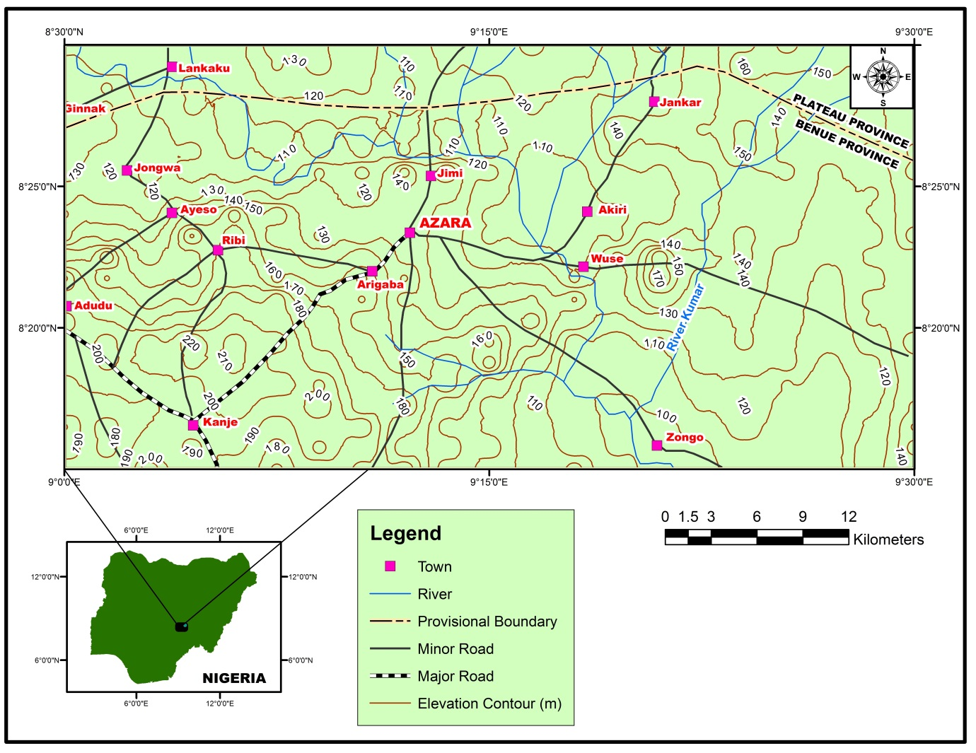

**Fig. 1. Base map showing the location of the study area**

**2.0 REGIONAL GEOLOGY**

**2.1 Geological Setting of Benue Trough**

The Benue Trough of Nigeria is a rift basin in central West Africa that extends NNE–SSW for about 800 km in length and 150 km in width. The southern limit is the northern boundary of the Niger Delta, while the northern limit is the southern boundary of the Chad Basin. The trough contains up to 6,000 m of Cretaceous – Tertiary sediments of which those predating the mid-Santonian have been compressionally folded, faulted, and uplifted in several places. Compressional folding during the mid-Santonian tectonic episode affected the whole of the Benue Trough and was quite intense, producing over 100 anticlines and synclines (Benkhelil, 1989). Following mid-Santonian tectonism and magmatism, depositional axis in the Benue Trough was displaced westward resulting in subsidence of the Anambra Basin. The Anambra Basin, therefore, is a part of the Lower Benue Trough containing post-deformational sediments of Campanian-Maastrichtian to Eocene ages. It is logical to include the Anambra Basin in the Benue Trough, being a related structure that developed after the compressional stage (Akande and Erdtmann, 1998). The Benue Trough is arbitrarily subdivided into a lower, middle and upper portion. No concrete line of subdivision can be drawn to demarcate the individual portions, but major localities (towns/settlements) that constitute the depocentres of the different portions have been well documented (Petters, 1982; Nwajide, 1990; Idowu and Ekweozor, 1993; Obaje et al., 1999).

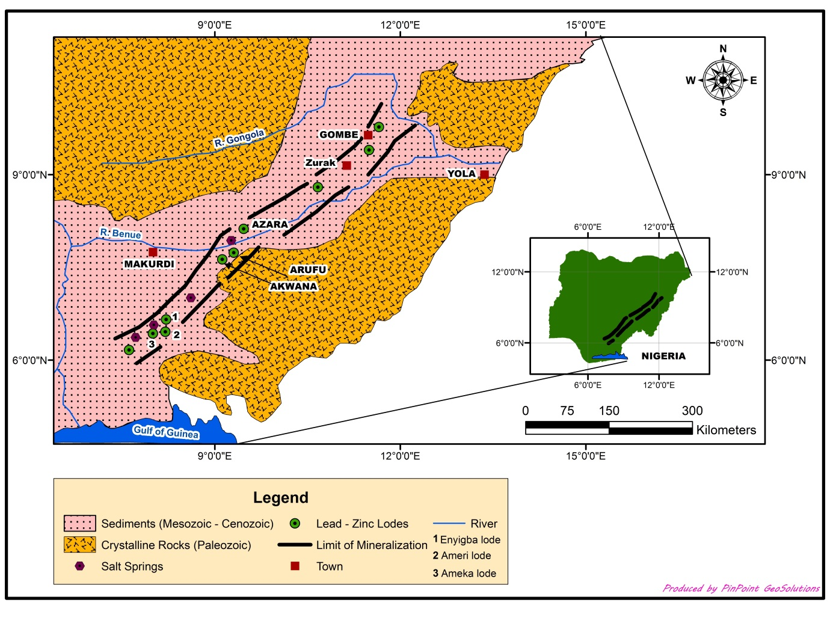

***Fig 2.***: *Geological map of Benue Trough*

**2.2 The Stratigraphy Settings of Middle Benue Trough**

In the Middle Benue Trough, around the Obi/Lafia area, six Upper Cretaceous lithogenic formations comprise the stratigraphic succession. This succession is made up of Albian Arufu, Uombaand Gboko Formations, generally referred to as the Asu River Group(Offodile, 1976; Nwajide, 1990). These are overlain by the Cenomanian – Turonian Keana and Awe Formationsand the Cenomanian – Turonian Ezeaku Formation. The Ezeaku Formation is coterminous with the Konshisha River Groupand the Wadata Limestonein Makurdi area. The Late Turonian – Early Santonian coal-bearing Awgu Formationlies conformably on the Ezeaku Formation. In the Makurdi area, the Makurdi Sandstone inter-fingers with the Awgu Formation. The mid-Santonian was a period of folding throughout the Benue Trough. The post-folding Campano-Maastrichtian Lafia Formationended the sedimentation in the Middle Benue Trough, after which widespread volcanic activities took over in the Tertiary.

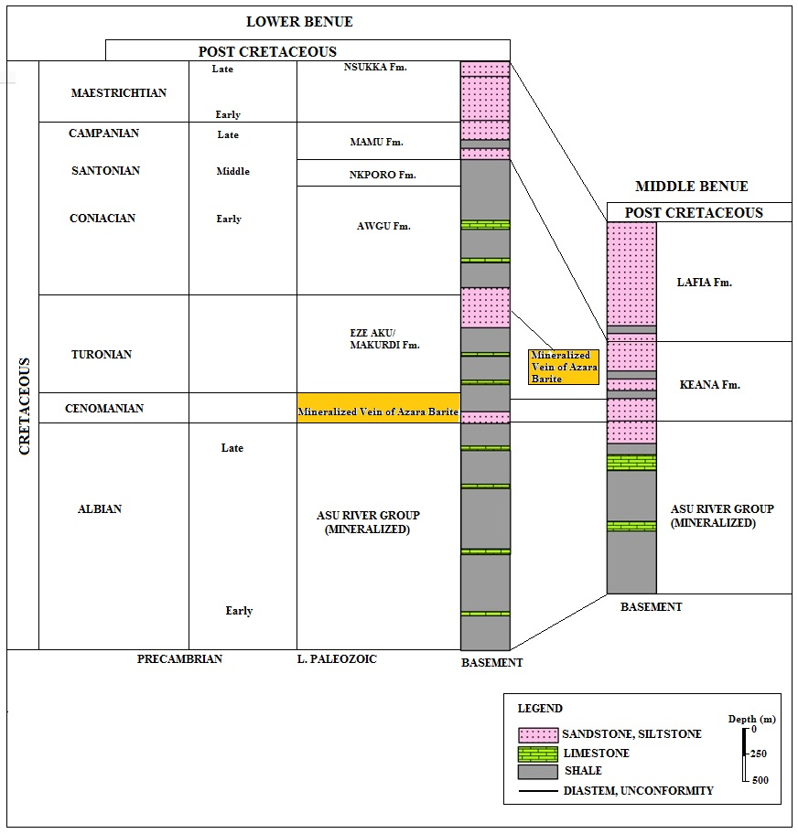

**Fig. 3. Cretaceous stratigraphy of Lower Benue trough and Middle Benue trough (modified After Akande 1989)**

**3.0 MATERIAL AND METHOD**

The method involved traversing across the mapped area, using the GPS for location and the outcrop in the study area were conspicuously exposed for Identification and description of their features. Samples were taken along the established veins. These samples were studied in the field as hand specimen and also taken to the laboratory for detail analyses. The Petrological study included colour, lithologies and structures of various sizes along the host rocks. Geochemical analysis was carried out at XRD and XRF facility of the Department of Geology, University of Pretoria, South Africa. Geotechnical tests were carried out at Petroleum Training Institute, Effurun, Nigeria. The tests include: specific gravity, hardness, soluble alkaline earth metals test and fluid performance.

**3.1. Geochemical Analysis**

**Mineral identification:** Initial investigations was done using the naked eye, the hand lens and a stereobinocular microscope to determine the ore types present and select representative specimens for thin and polished section preparation. At this stage uncommon minerals were identified in the hand specimen by using the determinative charts in mineralogical textbook.

**X-ray diffraction:** X-ray diffraction is used to identify clay mineral structure and properties, and for mineral analysis and mineral abundance measurements through spectroscopic sensing. The samples were milled to powdered form and packed into an aluminum holder. It was then placed in the diffractometer and bombarded with X-rays. The diffracted rays are collected by a detector and the information relayed to a computer where they were converted to d-values of specific intensities. These were later presented graphically in the form of ‘’diffractograms’’ Diffractograms were later identified using a database of over 70,000 recorded phases for mineral.

**4.0 RESULTS AND DISUSSIONS**

**4.1 Petrological and Geotechnical testing Results**

The geotechnical test show various results across the veins of the ore samples . The following specific gravity were recorded 4.2, 4.2, 4.1 and 3.6 (Vein 1,Vein 12,Vein 13 and Vein 17 respectively). The value presents barites of Azara mineralization as a good grade based on values higher than 4.0 with just a sample falling short of the quality in Vein 17.The weight % of the BaO in the Vein 1,Vein 12 and Vein 13 in table 1 of the Elemental composition, confirm the value of their specific gravity as a high grade ore, and also provide required weight for the drilling mud in the oil industry. The hardness observed is range between 3-3.5 on the average. Performance test show that the plastic viscosity (6.5 to 20) and yield point (4 to 6) remain high even when its contaminated under very high temperature. The test results reveal Barite as an ingredient for a good lubricant and drilling fluid, a good gel to suspend drill cuttings and source materials for paints, pharmaceutical, glass and chemical industries with little or no beneficiation when compare to ASTM standard.

**4.2 Geochemical Analysis and Results**

**Geochemical results show the intrinsic nature of the ore in the area**

The chemical composition of the Azara Barite samples show three major classes of Element in their oxides form in Table 1 below.

1. Major; **SiO2, SO3, BaO , SrO,**

2. Minor; **TiO2, Fe2O3, CaO , Na2O, CuO**

3. Trace; **Al2O3, MnO, MgO, K2O, P2O5, Co3O4, WO3, ZrO2, V2O5, Cr2O3**

Vein 1 show high content of BaO responsible for high specific gravity and Vein 17 with least BaO content has lowest specific gravity of all. Elemental composition of BaO in all the samples is 56.6% on average and this give room for less impurities in the overall value of the Ore grade. Other impurities like water soluble elements: CaO, MgO and K2O are less than 0.01 in concentration. And Al2O3 and Fe2O3 were presence in Trace and minor form and this account for absence of silicate minerals and high resistance of the ore to weathering.

**Table 1. Elemental composition of Barite Ores from Azara Barite Mineralization**

|  |  |  |  |  |  |  |  |  |  |
| --- | --- | --- | --- | --- | --- | --- | --- | --- | --- |
| Location | BARVEIN13 | BARVEIN12 | BARVEIN1 | BARVEIN17 | Location | BARVEIN13 | BARVEIN12 | BARVEIN1 | BARVEIN17 |
| Elemental composition(%) | Elemental composition(%) |
| BaO | 56.70 | 56.30 | 59.10 | 54.20 | **SiO2** | 6.20 | 8.24 | 5.49 | 8.39 |
| CuO | 0.04 | 0.02 | *<0.01* | 0.04 | **TiO2** | 0.05 | 0.07 | 0.09 | 0.04 |
| P2O5 | *<0.01* | *<0.01* | *<0.01* | *<0.01* | **Al2O3** | *<0.01* | *<0.01* | 0.70 | *<0.01* |
| Co3O4 | *<0.01* | *<0.01* | *<0.01* | *<0.01* | **Fe2O3** | 0.25 | 0.09 | 0.19 | 3.40 |
| SrO | 1.89 | 1.78 | 0.72 | 1.55 | **MnO** | *<0.01* | *<0.01* | 0.02 | 0.15 |
| WO3 | *<0.01* | *<0.01* | *<0.01* | *<0.01* | **MgO** | *<0.01* | *<0.01* | *<0.01* | 0.30 |
| ZrO2 | *<0.01* | *<0.01* | *<0.01* | *<0.01* | **CaO** | 0.05 | *<0.01* | 0.02 | 0.07 |
| V2O5 | *<0.01* | *<0.01* | *<0.01* | *<0.01* | **Na2O** | 0.60 | 0.44 | 0.71 | 0.61 |
| Cr2O3 | *<0.01* | *<0.01* | *<0.01* | *<0.01* | **K2O** | *<0.01* | *<0.01* | 0.12 | *<0.01* |
| LOI | 1.13 | 0.90 | 1.38 | 1.00 | **SO3** | 33.10 | 32.20 | 31.50 | 30.20 |

**4.3 Discussion of X-Ray Diffraction**

The quantitative and qualitative analysis of the sample show Barite and quartz as the major minerals in Table 2 below. Barite is the dominant mineral in the four samples, the weight ranges from 90.17wt% to 93.80wt%. The average mean of the barite weight % is 92.145wt% this indicate that the veins in the area is very rich in barite mineralization with less or no trace of impurity**.** This findings are in agreement with the Nigerian Geological survey Agency (NGSA) report and this is an indication that the purest and the most economically viable barites mineralization in Nigeria occur at Azara in the Middle Benue Trough with >80% BaSO4 as shown in the table 2. Quartz is the only recorded associated mineral in the sample analysed, with the weight percentage of less than 10% make it trace minerals. The weight range from 6.2wt% in vein 1 to 9.83wt% in vein 17 with average mean of 7.855wt% which indicate that none of the vein host quartz up to 10wt%. Vein 1 is the most high grade of all veins with value of 93.8wt% of Barite and 6.2wt% of quartz. From the observation of the results of all the veins sample, the minerals could be classified as melanocratic, this could be as a result of the less purity and less associated minerals.

**Table 2: Result of the XRD analysis**

|  |  |  |  |  |  |  |  |
| --- | --- | --- | --- | --- | --- | --- | --- |
| **Barite VEIN 12** |  | **Barite VEIN 13** |  | **Barite Vein 1** |  | **Barite Vein 17** |  |
|  | weight% |  | weight% |  | weight% |  | weight% |
| Barite | 91.34 | Barite | 93.27 | Barite | 93.8 | Barite | 90.17 |
| Quartz | 8.66 | Quartz | 6.73 | Quartz | 6.2 | Quartz | 9.83 |

**Table 3: Comparison of average barite composition from different localities in the middle Benue Trough, Nigeria**

|  |  |  |  |  |  |  |
| --- | --- | --- | --- | --- | --- | --- |
| Localities | Azara Deposit Present Work | Azara Deposit NMC | Chiata Deposit NMC | Gbande Deposit NMC | Keana Deposit NMC | Ibi Deposit NMC |
| Ave. BaSO4 (wt %) | **92.145** | **86.49** | **93.53** | **60.51** | **93.12** | **92.91** |

**5.0 Conclusions and Recommendations**

**5.1 Conclusions**

This research work has attempted to characterise the barite mineralization in Azara and its properties based on terms of petrological and geochemical analyses which revealed its hardness range to be 3.0-3.5, specific gravity mean of 4.2 with fluid performance that can be compared with API standard and other industrial specification by ASTM shows that the ore are of very good grade with just an exception of a single vein quality, this could be said to be controlled by the concentration Barium Oxide (BaO) and presence or absence of associated minerals.

**5.2 Recommendation**

Based on the need to have a fair playing ground for both processors and consumers of barite in Nigeria, it is important that the product is processed to the required standards. Uncontrolled importation of barite poses a serious threat to the development of the local mining industry. The very laudable efforts of the government in developing the local industry may be undermined if a favourable environment for the local production of barite is not created. Regarding production, one of the objectives of the local content policy is to promote a framework that guarantees active local participation and uphold the desire quality to compete with the foreign content without compromising standards.

**REFERENCES**

Akande SO, Ojo OJ, Erdtmann BD, Hetenyi M (1998) Paleoenvironments, source rock potential and thermal maturity of the upper Benue rift basins, Nigeria. Implications for hydrocarbon exploration. Org Geochem 29:531–542

Benkhelil J (1989) The origin and evolution of the Cretaceous Benue Trough, Nigeria. J Afr Earth Sci 8:251–282

Coope J.A. (1991) *Monitoring Laboratory Performance with Standard Reference Samples.* Abstract,15th Geochemical Exploration Symposium,Reno

Elueze AA (1982) Mineralogy and chemical nature of meta-ultramafites in Nigerian schist belts. J Mining Geol 19:21–29

Fletcher W.K. (1981) *Analytical Methods in Exploration Geochemistry. Handbook of Exploration Geochemistry*, vol. 1, Elsevier, Amsterdam.

Fletcher W.K. (1987) Analysis of soil samples. In Fletcher W.K., Hoffman S.J., Mehrtens M.B., Sinclair A.J. & Thomson I. (eds), *Exploration* *Geochemistry: design and interpretation of* *soil surveys*, 73–96. *Reviews in Economic Geology*, vol. 3. Society of Economic Geologists, El Paso

Farrington JL (1952), “A preliminary description of the Nigerian Barite Field”. Bull. Soc. Econ. Geol., 4th ed., 583-608.

Griffiths, J. “Barytes Non-drilling applications. Ind. Mimer*.”,*21th, June 1984.

Grant NK (1970) Geochronology of Precambrian basement rocks from Ibadan, South-Western Nigeria. Earth Planet Sci Lett 10:19–38

Hutchison C.S. (1974) *Laboratory Handbook of Petrographic Techniques.* Wiley, New York

Idowu JO, Ekweozor CM (1993) Petroleum potential of Cretaceous shales in the Upper Benue Trough, Nigeria. J Petrol Geol 21:105–118

Jones M.P. (1987) *Applied Mineralogy*. Graham & Trotman, London.

Larocque A.C.L. & Cabri L.J. (1998) Ion-microprobe quantification of precious metals in sulphide minerals. In McKibben M.A., Shanks W.C. & Ridley W.I. (eds), *Applications of Microanalytical Techniques* *to Understanding Mineralizing Processes*. *Reviews in Economic Geology* **7**, 155–168

Ladoo, R. B. and W. M. Myers (1951), “Barium Minerals, Non-Metallic Minerals”, McGraw-Hill Book Co. Inc., NY. 2nd. ed., 67-80,

Mottana,A. and G. Liborio,(1977) “Minerali E Rocce”, ArnoldoMondadori, Milano, 1st ed P142-148

Massonne, J.“Technology and uses of barium and strontium compounds”. Ind. Miner*.,*6th, June (1982).

Nwajide CS (1990) Sedimentation and paleogeography of the Central Benue Trough, Nigeria. In: Ofoegbu CO (ed) The Benue trough structure and evolution. Vieweg, Braunschweig, pp 19–38

Offodile M.E. (1976). “A Review of the Geology of the Cretaceous of the Benue Valley, In Geology of Nigeria” (C.A. Kogbe Ed.) Univ. Ife, pp.319-330

Offodile ME (1976) The geology of the Middle Benue, Nigeria. Palaentological Institute, University Uppsala, Special Publication 4:pp 1–166

Oyawoye MO (1972) The basement complex of Nigeria. In: Dessauvagie TFJ, Whiteman AJ (eds) African geology. Ibadan University Press, pp 66–102

Obaje NG, Ulu OK, Petters SW 1999, Biostratigraphic and geochemical controls of hydrocarbon prospects in the Benue Trough and Anambra Basin, Nigeria. NAPE Bull 14:18–54

Obaje NG (1994) Coal petrography, microfossils and paleoenvironments of Cretaceous coal measures in the Middle Benue Trough of Nigeria. Tuebinger Mikropalaeontologische Mitteilungen 11,1–165

Oyawoye M.O (1972) “The Basement Complex of Nigeria.In African Geology” (T.F. Dessauvagie and A.J. Whiteman Eds), Ibadan University Press. pp. 67-98.

Ralston R. JR., V. Camilo and H. W. Emrich, (1956), “Barite in ceramic whiteweares”. J.Am. Ceram. Soc,39, 2 73.

Reijers TJA, Nwajide CS (1998) Geology of the Southern Anambra Basin. Unpublished Report for Chevron Nigeria Limited. Field Course Note 66 pp

Rahaman MA (1976) Review of the basement geology of South-Western Nigeria. In: Kogbe CA (ed) Geology of Nigeria, 2nd edn, Elizabethan Publishers, Lagos, pp 41–58

Sprigg G. (1987) Advances in image analysers. *Microscopy and Analysis*, **Sept.**, 11–13

Tate RB (1959), “Geological Survey of Nigeria (GSN)” cape publisher Abuja 2nd ed , P69-80

Tsailas, D.P., S.D Catrakis, and A.Z Frangioskis, ( 1968). “The role and the mechanism of the action of sodium silicate in the flotation of barite”, Paper D-17, VIII International Mineral Processing Congress, Leningrad

Zussman J. (1977) *Physical Methods in Determinative Mineralogy*. Academic Press, London

**APPENDIX**

Position [°2?] (Cobalt (Co))

10

20

30

40

50

60

70

80

Counts

0

1000

2000

3000

4000

OyelamiC_Bar_VEIN12

Peak List

Quartz; O2 Si1

Barite; Ba1 O4 S1

**Fig4.1 Showing X-ray diffractogram of barite in vein 12**

Position [°2?] (Cobalt (Co))

10

20

30

40

50

60

70

80

Counts

0

1000

2000

3000

4000

OyelamiC_Bar_VEIN13

Peak List

Barite; Ba S O4

Quartz low, syn; Si O2

**Fig4.2 Showing X-ray diffractogram of barite in vein 13**



**Fig4.3 Showing X-ray diffractogram of barite in vein 1**



**Fig4.4 Showing X-ray diffractogram of barite in vein 17**