RADIOLOGY OF URINARY SCHISTOSOMIASIS: A CASE REPORT AND REVIEW OF LITERATURE
¹Aiyekomogbon Joshua Oluwafemi, ²Bioku Muftau Jimoh
¹ Departments of Radiology, University of Abuja, and Ahmadu Bello University Teaching Hospital, Zaria, Nigeria.
²Department of Surgery, Federal Medical Centre, Jabi-airport Road, Abuja Nigeria.

Aiyekomogbon, JO (MBBS, FWACS, FMCR). femimogbon2002@yahoo.com. Affiliation: Department of Radiology, Ahmadu Bello University Teaching Hospital, Zaria / Department of Radiology, University of Abuja, Abuja, Nigeria.
Bioku, MJ (MBChB, FWACS).mbioku@gmail.com. Affiliation: Department of Surgery, Federal Medical Centre, Abuja, Nigeria.
Correspondence: Dr. Aiyekomogbon, Joshua Oluwafemi. Department of Radiology, University of Abuja, Nigeria. femimogbon2002@yahoo.com
Telephone number: +2348028432907

Abstract
A 23 year old male undergraduate presented to our health facility with 10 year history of terminal haematuria, dysuria, feelings of incomplete emptying and increased urinary symptoms. His clinical examination was unremarkable.
He had a plain abdominal x-ray done, and it shows rim calcification of the urinary bladder wall. The bladder wall was also observed to be thickened on sonographic assessmen. There was also mild dilatation of the calyces bilaterally, and cow-horn appearance of the distal ureters was also demonstrated radiologicaally.
A clinical and radiological diagnosis of urinary schistosomiasis was made and he was medically treated with praziquantel. He’s currently on regular follow-up at urology clinic of the institution. terminal hematuria has stopped, but occasional feelings of incomplete emptying is still being experienced.

Keywords: Schistosomiasis, Rim calcification, cow-horn, hydronephrosis.

INTRODUCTION
Schistosomiasis is a parasitic disease caused by blood flukes (trematodes) of the genus schistosoma. After malaria and intestinal helmithiasis, schistosomiasis is the third most devastating tropical disease in the world, being a major source of morbidity and mortality for developing countries in Africa, Asia, South America, the Middle East, and the Caribean [1]. Several Parasites of the genus Schistosoma are responsible for the disease, but the commonest is Schistosoma haematobium which causes urinary schistosomiasis [1-2].
Urinary schistosomiasis is of great public health importance in developing countries. In sub-Saharan Africa alone it is estimated that 70 million individuals experience haematuria, 32 million with difficulty in urinating and 18 million with bladder wall pathology as well as 10 million with major hydronephrosis from infection caused by Schistosoma Haematobium. Mortality rate due to non-functioning kidney from schistosomiasis has been put at 150,000 per year [3].
Urinary schistosomiasis is endemic in Nigeria [4]. Past estimates have put the infection at about 25 million people being affected in Nigeria and 101 million are at risk of the infection [4].
To our knowledge, there are few reports documenting exclusively radiology of urinary schistosomiasis in our environment. Thus, we present and discuss an exemplary case of schistosomiasis with plethora of uro-radiologic features.
CASE PRESENTATION
Y S was a 23-year old male undergraduate who presented with 10-year history of terminal heamaturia, dysuria, feelings of incomplete urinary emptying and increased urinary frequency. There was no preceding history of fever, malaise, focal itching or rashes prior to the onset of the terminal haematuria. There was also no alteration in bowel habits, vomiting, abdominal swelling or haematochezia.
The index patient grew up in a locality having many ponds where he went swimming and fishing on many occasions. Some of his siblings and friends in the neighborhood had terminal haematuria which was generally accepted in his community as normal occurrence among adolescent, indicating maturity.
When examined, he was calm and not in any form of distress. The vital signs were within normal limits and the review of the systems was essentially normal. A clinical diagnosis of urinary schistosomiasis was made.
The plain abdominal X-ray (kidney, ureters and bladder – KUB), figs 1a and 1b revealed a circumferential opacity of calcific density outlining the entire wall of the urinary bladder, giving an egg shell calcification. An irregularly outlined opacity of calcific density in keeping with calculus was noted in the region of urinary bladder lumen. The renal and ureteric regions were essentially preserved. Abdomino–pelvic ultrasound scan revealed bladder wall thickening (0.54cm) which was also brightly echogenic (fig. 2). The noted calculus on plain radiograph was passed out on micturition prior to the ultrasound scan and it was therefore not visualized sonographically. Mild calyceal fullness was demonstrated bilaterally (fig. 3).
Intravenous urography (fig. 4) revealed mild dilatation of the upper moiety calyces bilaterally, and irregularity with dilatation of the distal third of the right ureter. There was also bowing of the distal ureters giving the classical cow horn appearance of schistosomiasis. There was no filling defect or area of ureteric narrowing seen. The urinary bladder showed mucosal thickening, wall calcification and significant post-voidal urine volume. Micturating cystourethrography showed normal urethra and bladder neck. There was no vesico-ureteric reflux seen. A radiological diagnosis of urinary schistosomiasis was made.

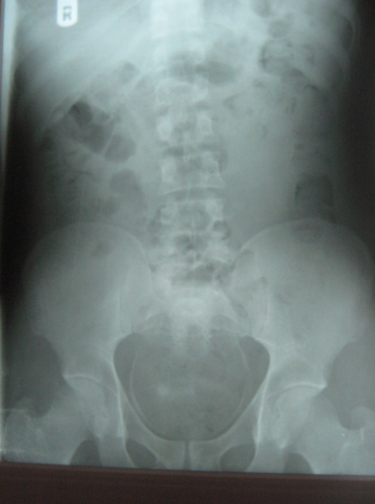
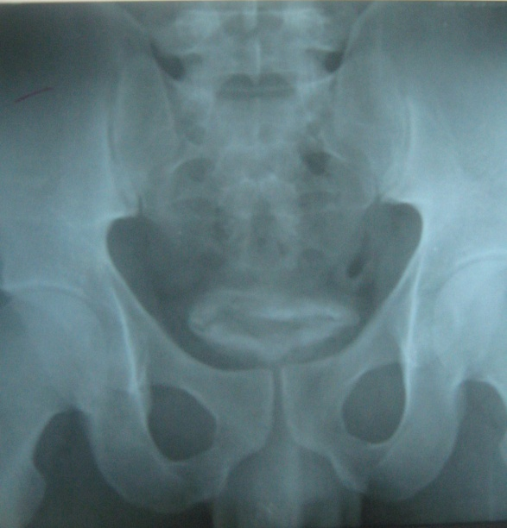
Figs. 1a and 1b are plain radiographs of the abdomen and pelvis respectively showing rim calcification (curved arrows) of the urinary bladder (1a, full bladder and 1b, post-voidal). An irregular opacity of calcific density in keeping with calculus (black arrow) is also noted in the region of the urinary bladder lumen.

Figure 2.An ultrasound image showing hyper-reflective and thickened urinary bladder (UB) wall (arrow).

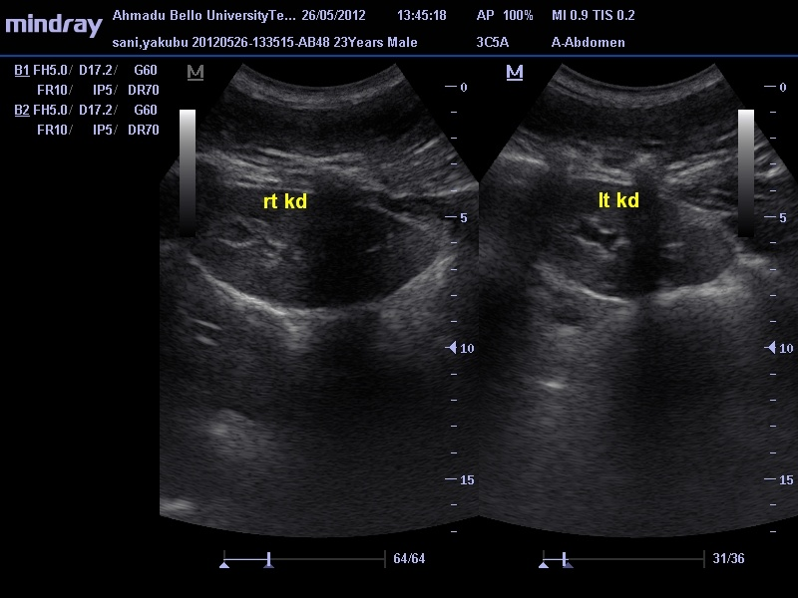

Figure 3. Ultrasound images of the kidneys showing bilateral mild calyceal fullness (white arrows).

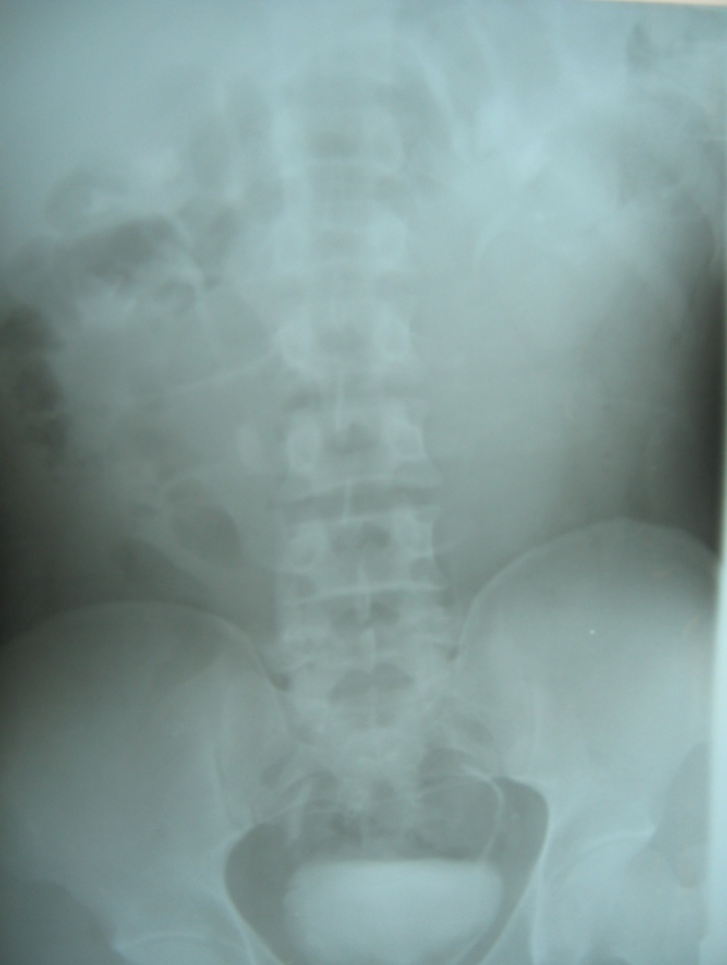
Fig. 4, intravenous urogram showing mild dilatation of the right distal ureter (straight arrow) and mild fullness of the upper moiety calyces of both kidneys (curved arrows). There is also bowing of the distal ureters giving the cow horn appearance of schistosomiasis.

The urine cytology and culture (including AFB) were negative. Schistosomal ova were not seen in the urine. The serum urea and electrolyte also showed normal findings. The red blood cell morphology was normal but toxic granulation of neutrophils was noted. There was also mild eosinophillia of 8%.
He was treated with prazyquantel orally at a standard dose of 40mg/kg body weight as single dose. Terminal haematuria has stopped and he is on regular follow-up at the surgical outpatient urologic clinic.
DISCUSSION
Urinary schistosomiasis is caused by the blood fluke, schistosoma haematobium. The disease causes chronic ill health, and it is endemic in most African and eastern Mediterranean countries [5]. The infection is acquired through contact with fresh water infested with the infective Cercariae shed from the intermediate host (Bulinus species). Once Cercariae penetrates the human skin, the parasites develop into adult worm within an average of 63 to 65 days and the worms usually migrate to the veins draining the urinary bladder where they reside and provide large numbers of eggs [4-5]. One average adult worm pairs live for three to five years, but some can live up to 30 years with the reproduction potential of one schistosome estimated to be up to 600 billion schistosomes [6]. The eggs of S. haematobium have a terminal spine and must transverse the bladder tissues towards the lumen of the bladder and urinary tract for elimination via-urine. In the process, a considerable number become trapped in the bladder walls and surrounding tissue to initiate immune–induced inflammatory reactions resulting ultimately in morbidity [5].
Schistosomiasis is more common in males, most likely because of increased exposure to infected water via bathing, swimming, and agricultural activities [1][7]. The prevalence and severity of schistosoma infections vary with age. Children and adolescents are infected most often. Infection rates and severity vary with gender specific activity at all ages [8]. This index case was a male and 23-year-old. He was infected at adolescent age of 13 and now presenting with chronic form of the disease.
Schistosomiasis generally affects over 207 million people worldwide 85% of whom live in Africa and an estimated 700 million people are at risk of infection in 76 countries where the disease is considered endemic [1]. Schistosoma haematobium infection is widely distributed in Nigeria and is hyper endemic in many states of the north and south-west with moderate to low endemicity in the south-east [9]. Our patient hails from Kano state, North-West geopolitical zone.
Clinical features depend on the chronicity of the disease. In acute phase, affected patient usually present with pruritic rash due to cercarial dermatitis (Swimmer’s Itch) and katayama fever [10]. This state is usually missed in most patients, as it was in the index case. In chronic state, possible presentation include dysuria, increased urinary frequency, terminal haematuria and haematospermia [11]. Rarely, schistosoma haematobium causes intestinal or liver disease, and cardiopulmonary affectation resulting in larval pneumonitis. There could be progressive fibrosis, obstructive uropathy, bladder wall calcification, ureteric calcification, malignant transformation of the urinary bladder pathology, portal hypertension and infertility [11]. At the time of presentation, most of the enumerated complications were not appreciated in our patient except bladder wall calcifications, terminal haematuria and mild obstructive uropathy.
Diagnosing chronic urinary schistosomiasis can be difficult with urinalysis and parasitological assessment; hence the need for imaging techniques. Abdomino-pelvic ultrasound in schistosomiasis may reveal thickened bladder wall, bladder wall calcification, bladder calculi, hydronephrosis and/or hydroureter. The abdomino-pelvic ultrasound scan done in the index case revealed most of the enumerated features. Plain abdominal radiography also demonstrated circumferential bladder wall calcification and a suggestion of an irregular opacity of calcific density in the region of the bladder lumen, connoting bladder calculus. This was however passed on voiding two days after the radiographic evaluation.
Renal effects are known to occur in schistosomiasis, either directly through glomerular immune complex deposition in schistosoma mansoni infection or indirectly following damage to the urinary tract in schistosoma haematobium infection [12]. The renal complication in this index case is indirect, evidenced by irregularity and mild dilatation of the lower third of the right ureter, with mild bilateral calyceal fullness. This is similar to the findings of Umerah [12] which revealed that sixty-five percent of ureters in patients with urinary schistosomiasis showed striking deformities, giving cow-horn appearance due to fibrosis at the bladder trigone. It was also noted by the same author that stasis and dilatation of the upper urinary tract were present in the absence of mechanical obstruction. This is in consonance with the finding in our patient where mild calyceal fullness without obvious distal mechanical obstruction was found.
Four patterns of urinary bladder calcifications are documented [12]; the linear rim calcification, an amorphous form, uniform opacity and curvilinear forms. This index case had the commonest pattern, bladder rim calcification.
Parasitological diagnosis by microscopy of urine for parasite eggs is the most practical and widely used method for identifying infected individuals [13]. Egg output in urinary schistosomiasis can be influenced by several factors such as time of collection of urine (peak egg excretion occurs around noon), day to day variations, seasonal variations, environmental conditions, and chronicity of the disease [13]. Therefore negative results following microscopic examination of single urine specimen for urinary schistosomiasis is not reliable. It was also noted by Lehmanet al[14] that increasing age of patient with schistosomiasis correlated with decreasing egg excretion. The index case was 23-year old and had single urine parasitological examination. This could explain the negative results obtained in him.
The management protocol for urinary schistosomiasis is both medical and surgical depending on the stage of the disease [15]. Currently, medical treatment options are limited to prazyquantel and metrifonate [15].Surgical management is reserved only for complicated cases of schistosomiasis. Orally administered Praziquantel at a standard dose of 40mg/kg body weight is the only drug on the WHO model list of essential medicine for treating schistosoma haematobium. Our patient was treated with prazyquantel at 40mg/kg body weight in single dose.
Several measures have been described to prevent schistosomiasis. These include health education, reduction in the frequency of water contact for most domestic activities such as fetching water for drinking, washing, or bathing in streams and ponds, and access to adequate sanitation to avoid environmental contamination with parasite eggs [15]. Other control measures include containment of the intermediate host snail (using molluscicides) and chemotherapy to the infested human population aimed at reducing disease burden and thereby transmission. These are recommended in our environment as that will go a long way to reduce the incidence of the disease.
CONCLUSION
Urinary schistosomiasis can present with plethora of radiologic signs. Some of these were demonstrated in our patients. The treatment as well as preventive measures of this pathology was re-echoed.

REFERENCE
- Schistosomiasis, fact sheet No 115 February 2012. World Health Organization Available at Http://www.who.int/mediacentre/facesheets/fs115/en.index.html accessed Oct. 5, 2010.
- Wagatsuma T, Aryeetey ME, Nkrumah FK, Sack DA, Kojima S. Highly Symptom-aware Children were Heavily Infected with Urinary Schistosomiasis in Southern Ghana. Cen Afr. J. Med. 2003. 49; (1-2): 16-19.
- Van der Werf MJ, De Vlas SJ, Brooker S, Looman CWN, Nagelkerke NJ, Habbema JD et al. Quantification of Clinical Morbidity Associated with Schistosome Infection in Sub-Saharan Africa. Acta Trop. 2003; 86(2-3): 125-139.
- Chitsulo L, Engels D, Montresor A, Savioli L. The Global Status of Schistosomiasis and its Control. Acta Trop. 2000; 77 (1): 41-51.
- Steinmann P, Keiser J, Bos R, Tanner M, Utzinger J.Shistosomiasis and Water Resources Development: Systematic Review, Meta-Analysis, and Estimates of People at Risk. Lancet Infectious Diseases 2006; 6: 411-425.
- Gryseels B, Polman K, Clerinx J, Kestens L. Human schistosomiasis. Lancet 2006; 368 (9541): 1106-1118.
- Faruk S, Azeez AO, Isa AS, Zubairu I. Urinary Schistosomiasis in the Danjarima Community in Kano, Ngeria. The Journal of Infection in Developing Countries 2011; 3(6): 452-457.
- Mwanakasale V, Siziya S, Mwansa J, Koukounari A, Fenwick A. Impact of Iron Supplementation on Schistosomiasis Control in Zambian School Children in a Highly Endemic Area. Malawi Med. J. 2009; 21 (1): 12-18.
- Ofoezie IE. Human Health and Sustainable Water Resources Development in Nigeria: Schistosomiasis in Artificial Lakes. Natural Resoucres Forum 2002; 26(2):150-60.
- Sobh MA, Moustafa FE, Sally SM, Deelder AM, Ghoneim MA. Characterization of Kidney Lesion in Early Schistosomial-Specific Nephropathy. Nephrol Dial Transplant. 1988; 3(4):392-398.
- Locsey L, Mozes P. Late Urinary Tract Complications of Schistosomiasis. OrvHetil. 1991; 132(46): 2537-40.
- Umerah BC. The Less Familiar Manifestations of Schistosomiasis of the Urinary Tract. Br J Radiol. 1977; 50(390): 105-109.
- Hassan SI, Talaat M, el Attar GM. Evaluation of Urinalysis Reagent Strips versus Microscopical Examination of Urine for SchistosomaHaematobium. Journal of the Egyptian Society of Parasitology 1994; 24 (3): 603-9.
- Lehman JS, Farid Z, Smith JH, Bassily S, EL-Masry NA. Urinary Schistosomiasis in Egypt: Clinical, Radiological, bacteriological and parasitological correlations. Transaction of the Royal Society of Tropical Medicine and Hygeine. 1973; 67 (3); 384-399.
- Savioli L, Engels D,Roungou, JB, Fenwich A, Endo H.Shistosomiasis Control. Lancet 2004; 363(9409):658.

