Designing a GIS-based Platform for Efficient Cost Control and Management of Diagnostic Imaging Examinations

Dimitrios Zarakovitis*, Nikolaos Tsaloukidis, Athina Lazakidou

University of Peloponnese, Department of Economics, Digital Health Applications and Health Economics Analytics Laboratory, Tripolis, Greece

Corresponding Author:
Dimitrios Zarakovitis
University of Peloponnese
School of Economy, Management and Informatics
Department of Economics
Digital Health Applications and Health Economics Analytics Laboratory
Tripolis, Greece
E-mail: dzarkovit@uop.gr

Abstract
Nowadays, there is a growing demand for health services of high quality and low-cost. The development of digital technology has created a large volume of information. In the health sector, the largest amount of data is transmitted by radiology laboratories because of the diagnostic imaging examination data. The aim of this project is to create an online platform for the rational management of total cost and revenues of diagnostic imaging imaginations of hospital units. Geographic Information Systems (GIS) are used for design of interactive maps that are uploaded on a central information system. GIS systems are used for the spatial analysis of quantitative and qualitative variables. The platform acts as a surveillance system that enables users to analyze financial data and share their results. The results concern 23 Hospital Units (H.Us) of the 6th Health Region in Greece in the period from 2012 to 2015. A spatial analysis was performed in correlation with the statistical analysis. There is an overtime reduction of the number of diagnostic imaging examinations. There is also a strong linear correlation between the cost, revenues of diagnostic imaging examinations and the number of hospital beds.

Keywords: Geographic Information Systems, GIS, Management, Diagnostic Imaging Examinations, Reveues, Cost.

1 Introduction
Health care quality improvement increases total expenditure and raises some serious problems which affect access to health care services and insurance patients’ cover [1]. Health care indicators are used globally for calculating measurable variables. These variables are related to the number of preventable visits in the Emergency Departments (ER), the nursing skills correlated to patients’ mortality and the cost of healthcare services [2], [3].
The cost of health care is equivalent to the total operating expenditure and includes all types of health care indicators. Quality cost describes the difference between the actual cost of health care services and the reduced cost, if patients’ needs conform to health care services [4]. The effectiveness of a hospital unit (H.U.) is mainly assessed by measuring health outcomes. The process is completed by using medical data and comparing care plan guidelines. In several cases nursing or medical staff is asked to determine patient’s status and implement electronic health records. Patients’ electronic record concerns certain demographic factors, health related evidence, cost treatment and total discharge rates [5].
OECD data reveals that in 2013 – 2016 the hospital discharge rates were estimated at almost 5.000 to 25.000 dollars yearly per 100.000 for most OECD countries. The mean discharges rate was almost 15.500 dollars. In the European Union the same rate was estimated at almost 8.000 to 25.000 dollars yearly while the mean rate was 25.000 dollars [6].
Imaging examinations performed for therapeutic and diagnosting purposes play a significant role in the estimating cost procedure. These kinds of examinations determine the diagnostic effect and can be harmful to the human body, in cases of unnecessary use of X-rays. The term ALARA (As Low As Reasonably Achievable) is used for preventing unnecessary imaging radiation exposure [7], [8], [9], [10]. Greece is among the European countries with the greatest number of CT and MRI exams. They are estimated at 150 and 64 accordingly per 1.000 inhabitants in 2013 – 2017 [11], [12]. The rise of digital technology creates new applications for cost reduction and limitation of radiation dose of diagnostic imaging examinations. Health professions students and health professionals must be prepared to address future patients’ needs [13].
Geographic Information Systems (GIS) are a useful tool for developing web-based applications which improve the efficiency of hospital units. They are increasingly recognized tools in health sector [14] and they are used for comparing relative costs, assessing health care insurance benefits and improving outcomes [15], [16]. Geographic Information Systems have emerged in the past decades as the information systems capable of assisting in effective disease control and epidemiology [17], [18].
The growing use of GIS in all fields of task has extended their capabilities. They play a strong role in health sector in order to achieve cost savings and promote efficient improvements [19], [20]. The use of GIS also becomes essential in analyzing and visualizing quantitative and qualitative data, stored in health data bases, in order to solve problems and make decisions [21], [22], [23]. These spatially orientated systems use analytic tools for enhancing functionality [24], [25], [26], [27] and grouping imaging examinations, according to the total cost and revenues of the hospital units.

2 Object
The purpose of this paper is to design an online platform for effective cost control and management of diagnostic imaging examinations. The project will provide evidence - based research to guide health management in reducing the excessive cost of diagnostic exams. The paper proposes an alternative method for the geographical recording of total expenditures and revenues of the laboratory departments of the hospital units.
Spatial analysis will also help health managers to identify the most efficient and beneficial laboratories of the hospital units. The GIS-based platform is intended to act as a cost surveillance system in the decision-making process. It will offer an innovative approach for saving funds available for investments in public health and advancing in health care practice.

3 Material and Method
ArcGIS software is used for the digital processing of the available data. Data concerns the total cost and revenues of the diagnostic imaging examinations as well as the number of diagnostic tests performed in 94 public Greek hospitals and Health Centers in the 6th Health Region. In this study, diagnostic imaging examinations concern all the exams that are performed in the radiology departments of the Hospital Units. All available data was acquired by the Department of Health Data Processing and Analysis of the Ministry of Health. Some of the data was recovered from the hospital units themselves, following the relevant authorization given by the 6th Health Region. Data concerns the period 2012-2015.
Significant difficulties occurred during data acquire, due to the transition from the old National Health Informative System (esynet) to the new Business Intelligence (BI) system. 6th Health Region is divided in the territory of:
- Peloponnese that includes all hospitals in the prefecture of Arcadia, Laconia, Sparta, Korinthos, Messinia and Argolida. The total number of the H.Us in this territory is estimated at almost 30.
- Western Greece that includes the public hospitals in the prefecture of Achaia, Ilia and Aitoloakarnania. There are almost 29 H.Us located in the territory of Western Greece.
- Epirus that includes the hospitals in the prefecture of Ioannina, Thesprotia, Arta and Preveza. The total number of the H.Us of this specific territory is estimated at 21.
- Ionian Islands that include the hospital units of Corfu, Lefkada, Kefalonia and Zakinthos. The total number of the H.Us, located in this territory, is the smallest one, compared to the rest of the territories and it is estimated at 14.
The GIS-based platform is created in 3 different steps:
- 1st Step: The ArcCatalog application is used for creating the shape files that contain all available financial data (Figure 1). Shape files consist of points, lines, and polygons and are used for the digitization of raw data. Data is grouped on attribute tables by the number of exams, total cost and revenues per year. Several tools of the ArcCatalog application unleash users’ potential and enable them to visualize their results. They are mainly used for creating buffer polygons and computing geometric intersections or units in input features as well as measuring quantitative data. By using these tools, data is summed up and sorted by year. Files can be copied and stored in a geodatabase, consisting of spatially distributed elements defined in the space as points, lines or surfaces.
- 2nd Step: The shape files are uploaded on ArcMap application and a map layer is downloaded by a variety of GIS samples authorized by ESRI. Financial data are presented on bar diagrams with different color per year for each territory and prefecture of the 6th Health Region. At this point an interactive map (‘smart map’) is created that allows users to interact with the system. By clicking on the bar diagrams, pop-up windows emerge that contain all financial data of the diagnostic exams. Users can extract big data in a very short time. A variety of statistic tools is at users’ disposal. Descriptive statistics can be calculated very easily and presented on the interactive maps (Figure 2). In this study, the standard deviation, the maximum and minimum price of total cost and revenues as well as the mean number of diagnostic imaging examinations are estimated. Statistical results are presented on bar diagrams.
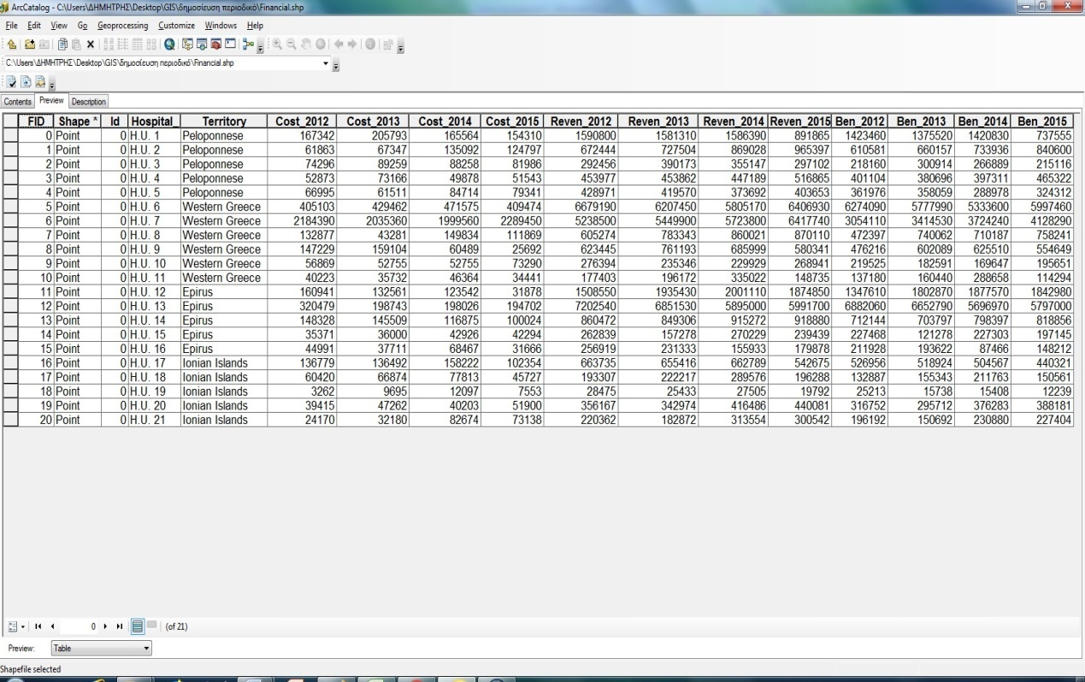
Figure 1: ArcCatalog Application of GIS
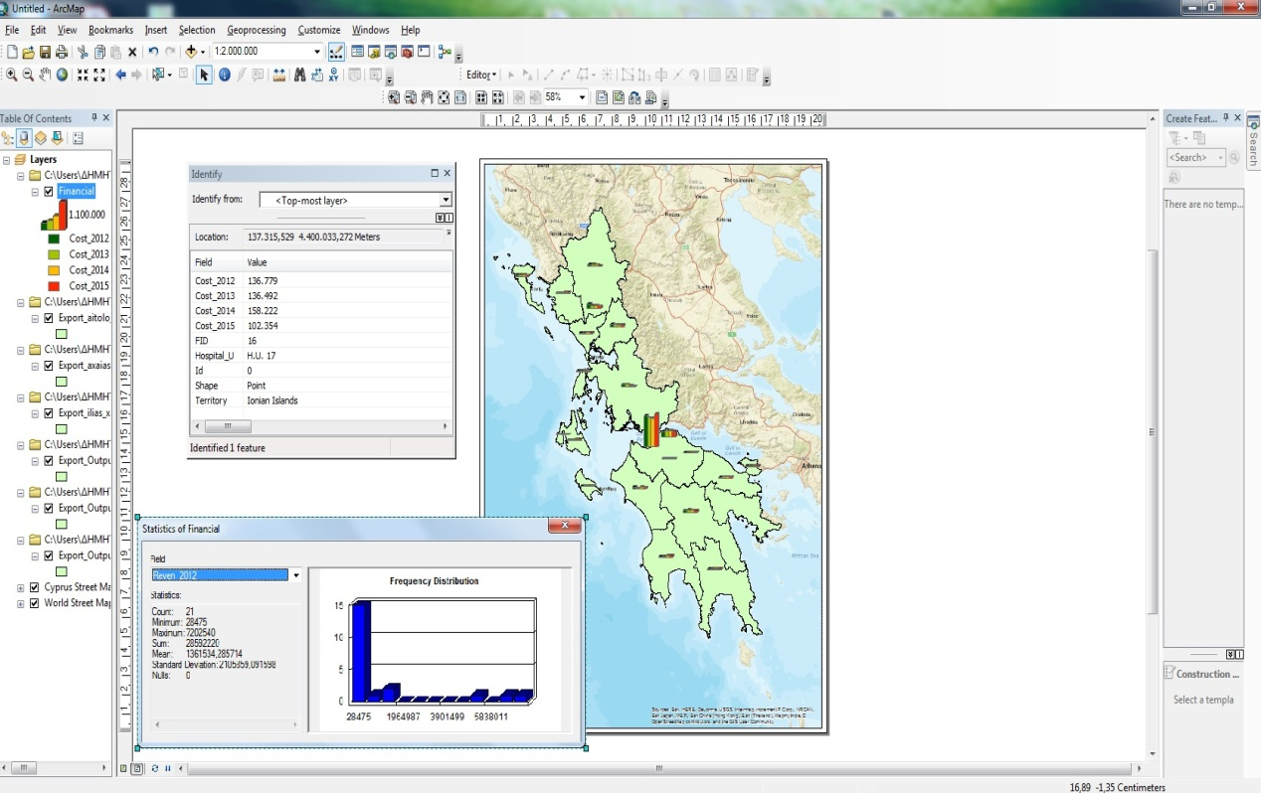
Figure 2: ArcMap Application of GIS
- 3^{d} Step: At this point, all files are uploaded on the Map Layout application and 6 ‘smart’ maps are created (Figure 3, 4, 5, 6, 7, 8). They consist of the total cost data, revenues data, number of diagnostic exams and the estimated benefit or loss of each H.U. accordingly. Users can print the maps and analyze their results on graphs and tables that are embedded on the maps. These maps form the digital platform that is uploaded on a GIS server and shared by users. GIS-web applications enable users to run the platform on a tablet or mobile phone (Figure 9).
In order to evaluate the financial results of the GIS-based platform, a statistical analysis was performed by using SPSS Statistics 23. The same sample of 94 H.U. was also used for the same period of time. The variables of total cost, revenues, number of examinations and hospital beds were statistically tested according to their level of significance by using the linear regression model and a trend analysis.
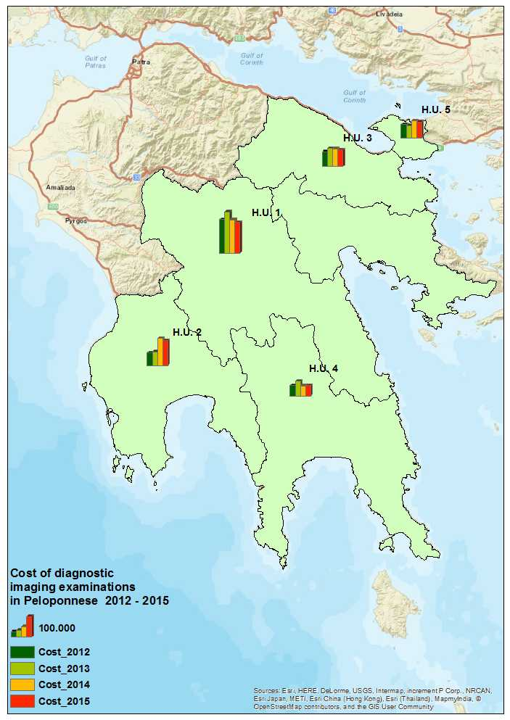
Figure 3: Cost Data in Peloponnese
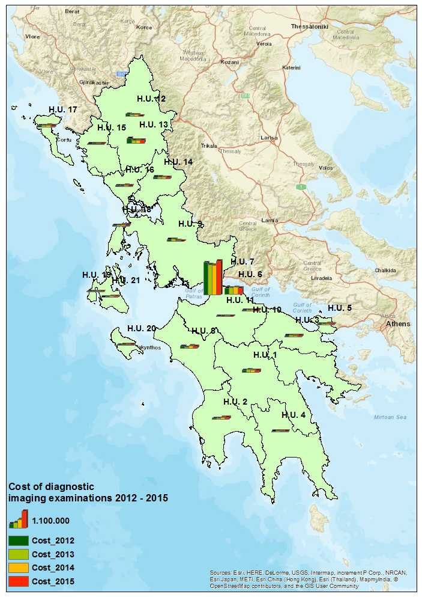
Figure 4: Cost Data in the 6th Health Region
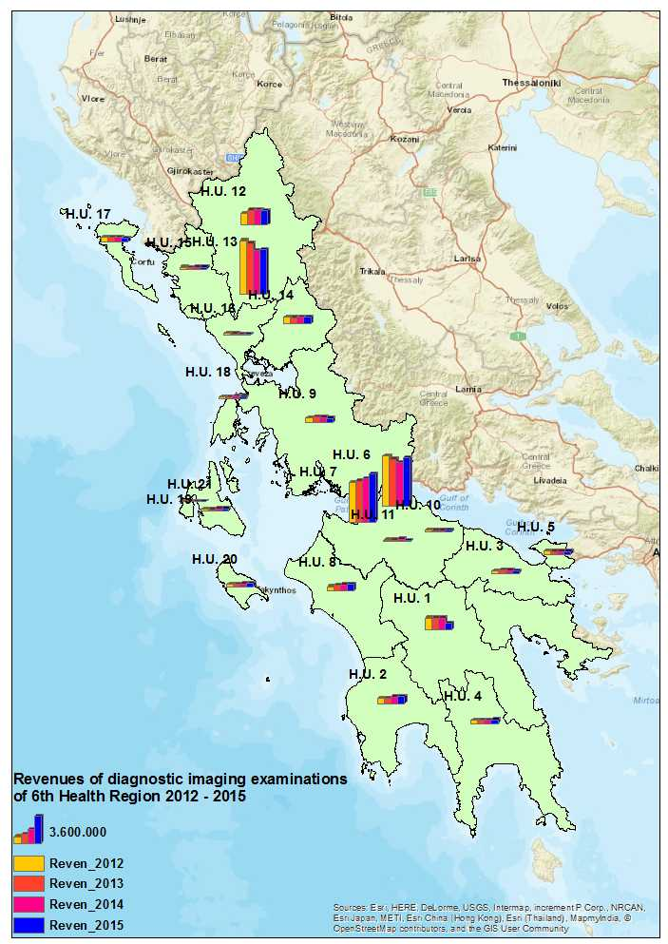
Figure 5: Revenues of Diagnostic Imaging Examinations in the 6th Health Region
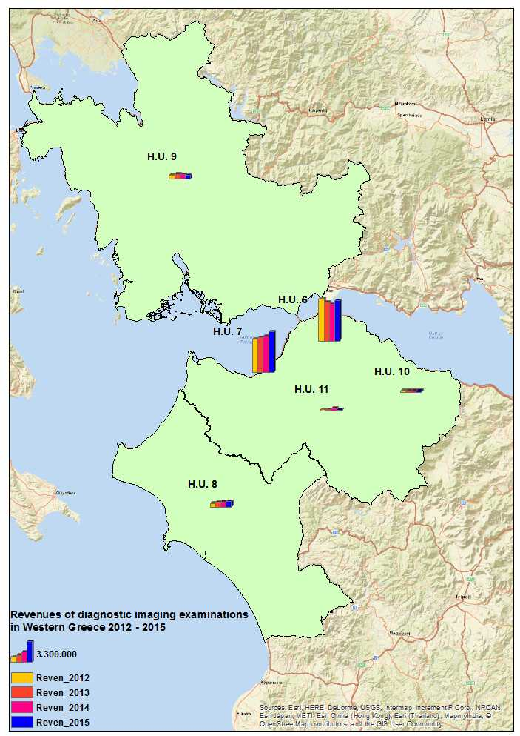
Figure 6: Revenues of Diagnostic Imaging Examinations in Western Greece

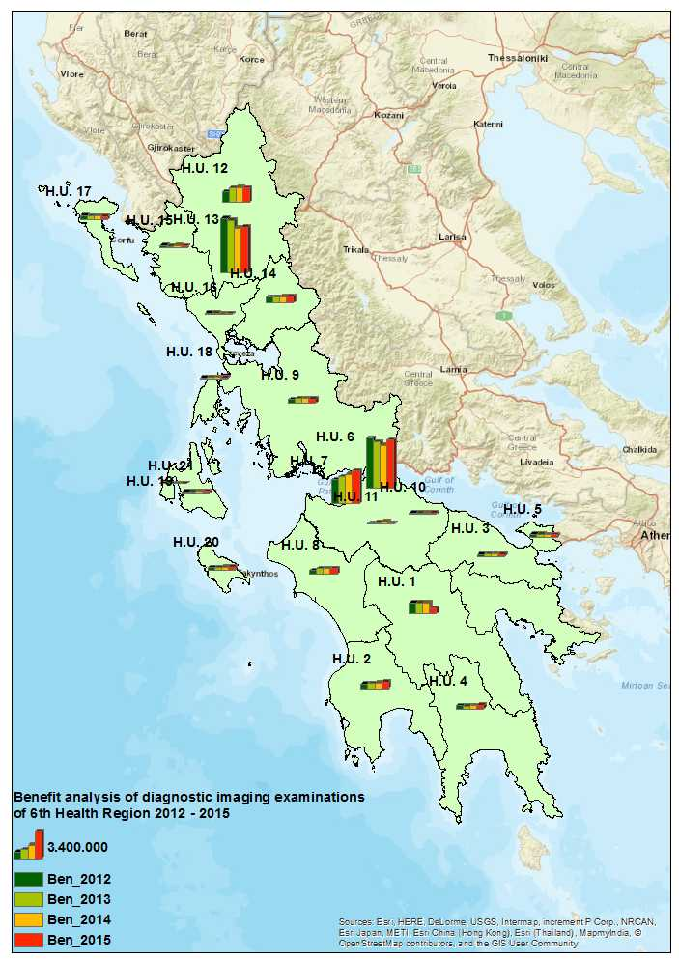
Figure 7: A GIS Benefit Analysis Map of Imaging Examinations in the 6th Health Region
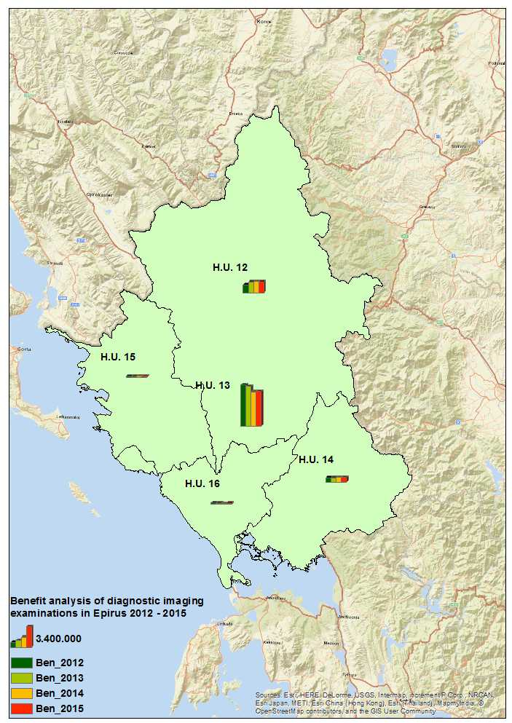
Figure 8: A GIS Benefit Analysis Map of Imaging Examinations in Epirus

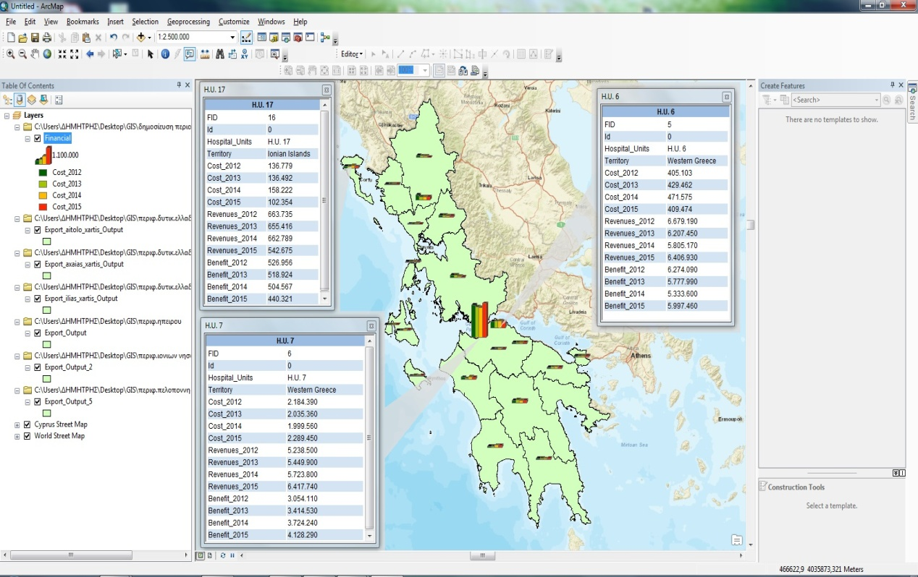
Figure 9: GIS-based Platform for Management of Imaging Examinations

3 Main Results
The cost results of GIS analysis are sorted by territory and are the following (Table 1):
- Peloponnese:
- H.U. 1 presents the greatest annual cost compared to the other H.Us in Peloponnese (Figure 3). In 2012 – 2013, there is a cost increase estimated at 23%. In 2015, the cost is reduced by approximately 25% compared to 2012. The increase in 2012-2013 is estimated at 38.451 euros. The decrease is estimated at 51.483 euros. The total cost of the four-year period for Hospital 1 is estimated at almost 693.000 euros. This number amounts to 1/4 of the total cost of all H.Us in Peloponnese. The total cost of all H.Us in Peloponnese is estimated at 22.580.978 euros.
- In 2012 – 2015, H.U. 2 presents a cost increase estimated at 118%, namely 73.220 euros. In 2014 – 2015 there is a 7,5% cost decrease estimated at almost 10.300 euros.
- The estimated cost decrease of H.U. 3 is 8% in 2012 – 2015 that amounts to 7.273 euros.
- H.U. 4 presents a cost decrease in 2015, compared to 2013 estimated at 29,5%. The decrease amounts to almost 21.600 euros. It is well mentioned that the cost in 2015 is almost equal to the cost in 2012.
- In 2012 – 2015, there is a cost increase for H.U. 5 estimated at almost 18.4% that equals to almost 12.340 euros.
- The mean cost rate in 2012 – 2014, is increased by almost 30% while it is decreased for the next period by almost 20%.
- The rest of the H.Us presents the lowest cost in Peloponnese (Figure 4).

- Western Greece:
- The cost of diagnostic imaging tests of H.U. 6 is increased by 1% in 2012 – 2015, namely 4.371 euros. The total cost of the H.U. 6 is the greatest compared to the rest of the H.Us in the 6th Health Region for the same period of time (Figure 4).
- A small cost increase is also registered in H.U. 7 in 2012 – 2015. The estimated percentage is 4,8% and amounts to almost 105.000 euros.
- In addition, the percentage of cost reduction of H.U. 8 is estimated at approximately 16% or 21.008 euros. A slight increase is also recorded in 2014, compared to 2012. This increase is estimated at around 13% and amounts to almost 17.000 euros. In 2012-2013, there is a great decrease estimated at 67,4%.
- H.U. 9 presents the greatest decrease in 2012 -2015 estimated at 82,5%, that is almost 120.000 euros.
- H.U. 10 and H.U. 11 display the lowest cost in Western Greece in 2012 – 2015 (Figure 4). The cost of H.U. 10 in 2015 is increased by almost 29% compared to 2012, namely 16.421 euros. The decrease rate of H.U. 11 is estimated at almost 14,4% in the same period.
- The mean cost rate is estimated at almost 114.000 euros and it is invariable in 2012 – 2015.
- Epirus:
- In 2012 – 2015, H.U. 12 demonstrates a significant cost reduction estimated at 80% or almost 130.000 euros.
- The corresponding reduction rate of H.U. 13 is approximately 39% that is almost 125.000 euros for the same period. Despite the greater reduction rate of H.U. 12, both hospitals approximately demonstrate the same reduction number.
- The reduction rate of H.U. 14 is estimated at 32,5% in the same period of time.
- A small cost increase is registered in H.U. 15 at approximately 19,6% or 6.923 euros in the same period of time. In 2015, the total cost of all H.Us in Epirus is significantly reduced, compared to the cost in 2012. The decrease rate is estimated at almost 41%.
- A significant cost decrease is also registered in H.U. 16 and it’s estimated at 29,6%.
- Ionian Islands:
- In 2012 – 2015, the total cost of diagnostic tests of H.U. 17 is the greatest in Ionian Islands. In 2015, the cost is reduced by 25%, compared to 2012.
- During the same period, a significant reduction was also registered in H.U. 18 and is estimated at 24% that is almost 14.700 euros.
- It is worth mentioning that the cost of H.U. 19 is increased by almost 271% in 2012 – 2014 that amounts to almost 8.800 euros.
- The increase rate of H.U. 20 is also estimated at almost 31,7% that amounts to 12.485 euros.
- There is also a significant increase rate in H.U. 21 in 2012 – 2014. It’s estimated at almost 242%, namely 58.500 euros.

Table 1: Cost of Imaging Examinations of Hospital Units of 6th Health Region
Hospitals | Total cost 2012 | Total cost 2013 | Total cost 2014 | Total cost 2015
Peloponnese
H.U. 1 | 167.342 | 205.793 | 165.564 | 154.310
H.U. 2 | 61.863 | 67.347 | 135.092 | 124.797
H.U. 3 | 74.296 | 89.259 | 88.258 | 81.986
H.U. 4 | 52.873 | 73.166 | 49.878 | 51.543
H.U. 5 | 66.995 | 61.511 | 84.714 | 79.341
Western Greece
H.U. 6 | 405.103 | 429.462 | 471.575 | 409.474
H.U. 7 | 2.184.390 | 2.035.364 | 1.999.560 | 2.289.445
H.U. 8 | 132.877 | 43.281 | 149.834 | 111.869
H.U. 9 | 147.229 | 159.104 | 60.489 | 25.692
H.U. 10 | 56.869 | 52.755 | 60.282 | 73.290
H.U. 11 | 40.223 | 35.732 | 46.364 | 34.441
Epirus
H.U. 12 | 160.941 | 132.561 | 123.542 | 31.878
H.U. 13 | 320.479 | 198.743 | 198.026 | 194.702
H.U. 14 | 148.328 | 145.509 | 116.875 | 100.024
H.U. 15 | 35.371 | 36.000 | 42.926 | 42.294
H.U. 16 | 44.991 | 37.711 | 68.467 | 31.666
Ionian Islands
H.U. 17 | 136.779 | 136.492 | 158.222 | 102.354
H.U. 18 | 60.420 | 66.874 | 77.813 | 45.727
H.U. 19 | 3.262 | 9.695 | 12.097 | 7.553
H.U. 20 | 39.415 | 47.262 | 40.203 | 51.900
H.U. 21 | 24.170 | 32.180 | 82.674 | 73.138

The total revenues of all public hospitals in the 6th Health Region concern of the following diagnostic imaging examinations:
- Magnetic Resonance Imaging scans (MRI)
- Computerized Tomography scans (CT)
- Dental Χ-rays
- DEXA scan for the diagnosis of osteoporosis
- X-rays
- Digital Subtraction Angiography scans (DSA)
- Scintigraphy scans
- Mammorays
- Radiotherapy scans
GIS analysis also revealed the following revenue results of Greek public hospitals in the 6th Health Region in 2012 – 2015 (Table 2):
- Peloponnese:
- H.U. 1 presents 41% of the total revenues in Peloponnese. This is the greatest percentage that is recorded among all public hospitals in the specific territory. It is worth mentioning that the decrease rate of H.U. 1 is estimated at almost 44%. H.U. 3 presents the lowest total revenues compared to the rest Hospital Units in Peloponnese
- Western Greece:
- The greatest revenues are registered in the public hospitals of Western Greece compared to all hospitals in the 6th Health Region. H.U. 6 presents the greatest revenues in this territory that amount to almost 45% of the total revenues in Western Greece (Figure 6). The majority of H.Us. in this territory display a revenue decrease that rates to 4% - 16%. H.U. 7 and H.U. 8. Display an increase rate that is estimated at 22,5% and 43,75% respectively.
- Epirus:
- The revenues of H.U. 12 are increased by 24% in 2015 compared to 2012. This is the greatest rate that is recorded among all hospitals of the 6th Health region.
- The decrease rate of H.U 16 is estimated at 30% that amounts to almost 77.000 euros. The lowest total revenues are registered in H.U. 15 and H.U. 16. These amount to 2,5% and 2,2% respectively of the total revenues registered in Epirus.
- Ionian Islands:
- The public hospitals in Epirus display the lowest revenues in the 6th Health Region. The relative percentage is estimated at almost 5,3% compared to the total revenues of public hospitals in the 6th Health Region. The total revenues of the majority of H.Us. are increased by almost 1,5% - 36,4% in 2015, compared to 2012. H.U. 19 displays the lowest revenues in the 6th Health Region as well as in Ionian Islands.
- H.U. 21 displays the greatest increase rate estimated at 36,4%

Table 2: Total Revenues of Imaging Examinations of Hospital Units of 6th Health Region
Hospitals | Total Revenues 2012 | Total Revenues 2013 | Total Revenues 2014 | Total Revenues  2015
Peloponnese
H.U. 1 | 1.590.801 | 1.581.311 | 1.586.389 | 891.865
H.U. 2 | 672.444 | 727.504 | 869.028 | 965.397
H.U. 3 | 292.456 | 390.173 | 355.147 | 297.102
H.U. 4 | 453.977 | 453.862 | 447.189 | 516.865
H.U. 5 | 428.971 | 419.570 | 373.692 | 403.653
Western Greece
H.U. 6 | 6.679.190 | 6.207.449 | 5.805.173 | 6.406.931
H.U. 7 | 5.238.504 | 5.449.897 | 5.723.804 | 6.417.735
H.U. 8 | 605.274 | 783.343 | 860.021 | 870.110
H.U. 9 | 623.445 | 761.193 | 685.999 | 580.341
H.U. 10 | 276.394 | 235.346 | 229.929 | 268.941
H.U. 11 | 177.403 | 196.172 | 335.022 | 148.735
Epirus
H.U. 12 | 1.508.548 | 1.935.428 | 2.001.111 | 1.874.853
H.U. 13 | 7.202.541 | 6.851.533 | 5.894.997 | 5.991.698
H.U. 14 | 860.472 | 849.306 | 915.272 | 918.880
H.U. 15 | 262.839 | 157.278 | 270.229 | 239.439
H.U. 16 | 256.919 | 231.333 | 155.933 | 179.878
Ionian Islands
H.U. 17 | 663.735 | 655.416 | 662.789 | 542.675
H.U. 18 | 193.307 | 222.217 | 289.576 | 196.288
H.U. 19 | 28.475 | 25.433 | 27.505 | 19.792
H.U. 20 | 356.167 | 342.974 | 416.486 | 440.081
H.U. 21 | 220.362 | 182.872 | 313.554 | 300.542

The cost-benefit analysis shows that the majority of hospitals in Peloponnese present a benefit reduction in 2015 compared to 2012. The estimated percentages for H.U. 1, H.U. 3 and H.U. 5 are almost 48%, 1,4% and 10,4% accordingly. The rest of the hospitals display a benefit increase that is estimated at almost 38% for H.U. 2 and 16% for H.U. 4 (Table 3).
In Western Greece, the majority of public hospitals display a benefit reduction for the same period of time. The relative percentages rate to 4,4% - 16,7% while the percentages of benefit increase rate to 16,4% - 35,1%. H.U. 11 displays the greatest decrease rate that amounts to 16,7% while the decrease rate of H.U. 6 is almost 4,4% (Table 3).
In Epirus, there is also a benefit reduction in 2015 compared to 2012 for the majority of hospitals (Table 3). The estimated percentages rate to almost 13% - 30%. H.U. 12 presents the greatest benefit increase estimated at 36,5% in the same territory. The greatest decrease rate is registered in H.U. 16, namely 30% (Figure 8).
In Ionian Islands, H.U. 19 displays the greatest benefit reduction estimated at 51,4% compared to all hospitals in the 6th Health Region for the same period of time. The estimated reduction amounts to almost13.000 euros. The same H.U. also displays the lowest benefit in the specific territory (Table 3).

Table 3: Hospital Units Benefit of Imaging Examinations of 6th Health Region
Hospitals | Benefit 2012 | Benefit 2013 | Benefit 2014 | Benefit 2015
Peloponnese
H.U. 1 | 1.423.459 | 1.375.518 | 1.420.825 | 737.555
H.U. 2 | 610.581 | 660.157 | 733.936 | 840.600
H.U. 3 | 218.160 | 300.914 | 266.889 | 215.116
H.U. 4 | 401.104 | 380.696 | 397.311 | 465.322
H.U. 5 | 361.976 | 358.059 | 288.978 | 324.312
Western Greece
H.U. 6 | 6.274.087 | 5.777.987 | 5.333.598 | 5.997.457
H.U. 7 | 3.054.114 | 3.414.533 | 3.724.244 | 4.128.290
H.U. 8 | 472.397 | 740.062 | 710.187 | 758.241
H.U. 9 | 476.216 | 602.089 | 625.510 | 554.649
H.U. 10 | 219.525 | 182.591 | 169.647 | 195.651
H.U. 11 | 137.180 | 160.440 | 288.658 | 114.294
Epirus
H.U. 12 | 1.347.607 | 1.802.867 | 1.877.569 | 1.842.975
H.U. 13 | 6.882.062 | 6.652.790 | 5.696.971 | 5.796.996
H.U. 14 | 712.144 | 703.797 | 798.397 | 818.856
H.U. 15 | 227.468 | 121.278 | 227.303 | 197.145
H.U. 16 | 211.928 | 193.622 | 87.466 | 148.212
Ionian Islands
H.U. 17 | 526.956 | 518.924 | 504.567 | 440.321
H.U. 18 | 132.887 | 155.343 | 211.763 | 150.561
H.U. 19 | 25.213 | 15.738 | 15.408 | 12.239
H.U. 20 | 316.752 | 295.712 | 376.283 | 388.181
H.U. 21 | 196.192 | 150.692 | 230.880 | 227.404

The SPSS analysis revealed that the majority of hospitals display an overtime reduction of both number of X-rays and CT scans in 2012 – 2015. There is a significant statistical difference of the number of CT scans and X-rays between H.U. 1 and the rest of the public hospitals in the 6th Health Region. The main results are the following (Table 4, Table 5):
- There is a reduction of both number of X-rays and CT scans of H.U. 3 compared to H.U. 1. These are estimated at 34,1% and 29,1% respectively (p-value < 0.001 / p-value= 0.004 < 0.05).
- H.U. 4 displays a 42% reduction rate of the number of X-rays compared to H.U. 1 (p-value < 0.001). The reduction rate of CT scans is estimated at 27,5% and it’s statistically significant (p-value < 0.001).
- There is also a statistically significant reduction rate of X-rays in H.U. 2 that is estimated at 39,7% (p-value < 0.001). The relevant rate of CT scans is 25,6% (p-value < 0.001).
- The reduction percentages for both examinations of the H.U. 5 compared to H.U. 1 are also statistically significant (p-value < 0.001, p-value = 0.005 < 0.05) and are estimated at 31,2% and 21,5% respectively.
- H.U. 18 displays an overtime reduction of both examinations compared to H.U. 1. The percentages are estimated at 28,5% and 30,3% respectively and are statistically significant (p-value < 0.001, / p-value < 0.001).
- The overtime reduction rate of both X-rays and CT exams of H.U. 19 is also statistically significant and it’s estimated at 45,4% and 29% respectively (p-value < 0.001).
- In terms of geographical spread, there is a significant difference between the number of both X-rays (p-value < 0.001) and CT scans (p-value = 0.021 < 0.05) and the Hospital Units.

Table 4: Statistical X-ray Data of the GIS-based Financial Analysis
Hospitals | B - value | p-value | 95% confidence interval
H.U. 1 | Reference variable
H.U. 2 | -39.7% | <0.001* | -48.2% | -31.1%
H.U. 3 | -34.1% | <0.001* | -42.7% | -25.6%
H.U. 4 | -42.0% | <0.001* | -50.6% | -33.5%
H.U. 5 | -31.2% | <0.001* | -39.8% | -22.7%
H.U. 18 | 28.5% | <0.001* | 19.9% | 37.0%
H.U. 19 | -45.4% | <0.001* | -53.9% | -36.8%

Table 5: Statistical CT scans Data of the GIS-based Financial Analysis
Hospitals | B - value | p-value | 95% confidence interval
H.U. 1 | Reference variable
H.U. 2 | -25.6% | <0.001* | -45.2% | -6.0%
H.U. 3 | -21.9% | 0.004* | -41.5% | -2.3%
H.U. 4 | -27.5% | <0.001* | -47.1% | -7.9%
H.U. 5 | -21.5% | 0.005* | -41.1% | -1.9%
H.U. 18 | 30.3% | <0.001* | 10.7% | 49.9%
H.U. 19 | -29.0% | <0.001* | -48.6% | -9.4%

The trend analysis also revealed the following X-ray results:
- The number of X-rays performed in the majority of public hospitals in 2013 was greater compared to 2012 by 2,3% but the result isn’t statistically significant (p-value=0.408 > 0.05).
- The number of X-rays performed in the majority of public hospitals in 2014 was greater compared to 2012 by 3,9% but the result isn’t statistically significant (p-value=0.151 > 0.05).
- On the contrary, the number of X-rays performed in the majority of public hospitals in 2015 was increased by 5,7%. This is a statistically significant result (p-value=0.037 < 0.05).

Table 6: Trend Analysis of X-ray Results
Year | B - value | p-value | 95% confidence interval
2012 | Reference year
2013 | 2.3% | 0.408 | -19.9% | 24.4%
2014 | 3.9% | 0.151 | -18.2% | 26.0%
2015 | -5.7% | 0.037* | -27.8% | 16.5%

The trend analysis of CT scans results are the following:
- There is a statistically significant reduction of CT scans in 2012 – 2013 estimated at 23,2% (p-value < 0.001).
- The number of CT scans performed in 2012 – 2014 was reduced by 21,7%. This is also a statistically significant result (p-value < 0.001).
- There is no statistical significance between CT scans in 2012 – 2015. The reduction rate is estimated at 7,5% (p-value=0.178 > 0.05).
In this study, the cost of diagnostic imaging examinations consists of:
- The cost of X-ray films
- The cost of consumables used in the radiology departments such as gauzes, syringes and medicines
- Running costs and maintenance cost of medical equipment used in the radiology departments.
SPSS analysis of the financial data of the GIS-based platform also reveals an overtime strong linear correlation between hospital beds in all territories of the 6th Health Rin 2012 – 2015 and:
- CT revenues
- X-ray revenues
- Cost

Table 7: Trend Analysis of CT Scans Results
Year | B - value | p-value | 95% confidence interval
2012 | Reference year
2013 | -23.2% | <0.001* | -42.7% | -3.8%
2014 | -21.7% | <0.001* | -41.2% | -2.3%
2015 | -7.5% | 0.178 | -27.0% | 11.9%

Furthermore, the authors agree that a linear correlation model should be used between revenues (both X-rays & CT revenues), cost and number of hospital beds for each year separately. In all territories of the 6th Health Region, there is a strong linear correlation between the cost, revenues and the number of hospital beds in 2012 – 2015 (Figure 10, Figure 11, Figure 12 & Figure 13).
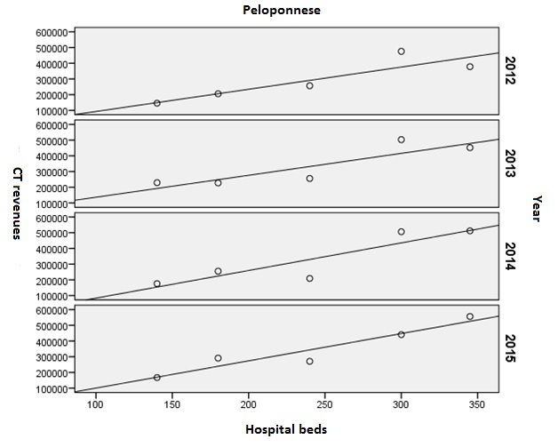
Figure 10: Linear Correlation Diagram between CT Revenues and Number of Hospital Beds in Peloponnese
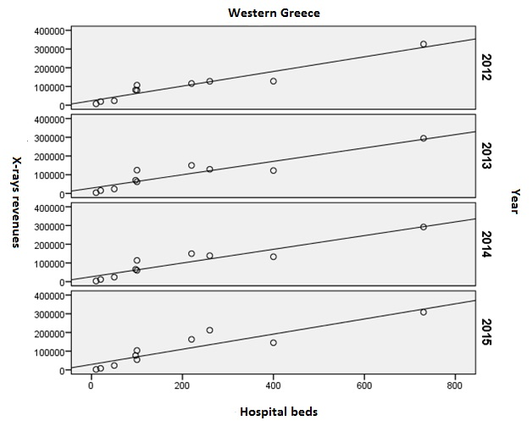
Figure 11: Linear correlation diagram between X-rays revenues and number of hospital beds in Western Greece
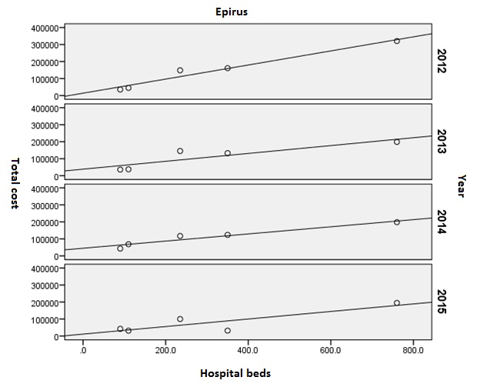
Figure 12: Linear Correlation Diagram between X-rays Revenues and Number of Hospital Beds in Epirus
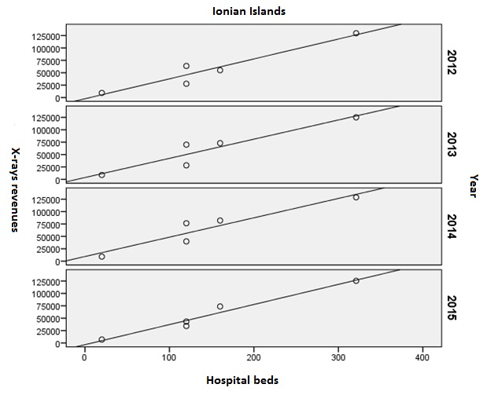
Figure 13: Linear Correlation Diagram between X-rays Revenues and Number of Hospital Beds in Ionian Islands

Discussion
Greek Healthcare System has recently adopted e-prescription services in order to limit the excessive number of medical prescriptions [28]. Although this is an encouraging health policy effort, it still lacks of a rational system of financial management of diagnostic imaging examinations. Greeks hospitals are in need of a surveillance system that will promote fast processing of financial data. This system is expected to prevent cost overestimation in medical equipments and facilitate the tracking and replacement of obsolete medical devices.
The GIS-based platform reveals that a great number of diagnostic imaging examinations were performed in the majority of public hospitals in the 6th Health Region. Although there is a high prevalence of CT and MRI scans in Greece, this study reveals that there is a significant reduction of CT scans and X-rays in 2012 – 2015. Most Greek hospitals display enough revenues in order to cover their total expenses of providing H.Us. with the necessary consumables. It is obvious from this study that the total expenditures are great enough to cover patients’ need but ineffective spending and waste in Greek healthcare system is still present [29].
The present study also reveals that there is an overtime reduction of the estimated benefit. It means that in a few years, most Greek public hospitals will face several problems of financial austerity. They will have to save funds in order to cover their needs and satisfy patients’ needs. The proposed digital platform is expected to help Hospital Units to establish a central surveillance system for the rational management of total revenues and expenditure of public hospitals.

Conclusions
The GIS-based platform enables fast data processing in real time and strengthens network connection with all users. It also enables users to exchange and interpret information data without knowledge of the data structure. The complex capabilities of the platform facilitate visual modeling of spatial data and geographic mapping from different projection systems.
Furthermore, the digital platform promotes earlier detection of emergent situations and reduces the time of decision - making. It also supports digital mapping by using open source data. The created maps are interpretable, making it easier for users to interact with the data collected. The whole process is completed by installing the GIS-based platform in a central information system. In this way, real time user’s intervention is facilitated and the process of visual modeling is completed. By successfully establishing this digital application, it is possible to draw useful conclusions about the control and management of diagnostic imaging examinations.

References
- Obama B. United States health care reform: progress to date and next steps. Jama. 2016; 316: 525-32. Available from:
http://doi.org/10.1146/annurev.publhealth.24012902.140843.
- Davies, S., Schultz, E., Raven, M., Wang, N. E., Stocks, C. L., Delgado, M. K., & McDonald, K. M. (2017). Development and validation of the agency for healthcare research and quality measures of potentially preventable emergency department (ED) visits: the ED prevention quality indicators for general health conditions. Health services research, 52(5), 1667-1684. Available at: https://onlinelibrary.wiley.com/doi/abs/10.1111/1475-6773.12687
- Aiken, L. H., Sloane, D., Griffiths, P., Rafferty, A. M., Bruyneel, L., McHugh, M., Sermeus, W. (2017). Nursing skill mix in European hospitals: cross-sectional study of the association with mortality, patient ratings, and quality of care. BMJ Qual Saf, 26(7), 559-568. Available at: http://qualitysafety.bmj.com/content/26/7/559.abstract.
- Mitra A. Fundamentals of quality control and improvement. John Wiley & Sons, 2016.
- Moorhead, S., Johnson, M., Maas, M. L., & Swanson, E. (2018). Nursing Outcomes Classification (NOC)-E-Book: Measurement of Health Outcomes. Elsevier Health Sciences
- OECD. Available from: https://data.oecd.org/healthcare/hospital-discharge-rates.htmmaging examinations
- Cohen MD. ALARA, Image Gently and CT-induced cancer. Pediatric radiology. 2015; 45: 465-70. Available from: http://link.springer.com/content/pdf/10.1007/s00247-014-3198-3.pdf.
- Ahmad, I. (2018). Occupational radiation dose limits: Towards breaking the one-size-fits-all paradigm. Physica Medica: European Journal of Medical Physics. Available from: https://www.physicamedica.com/article/S1120-1797(18)31294-8/abstract.
- Niklas, M. Ã., Hansson, S. O., Holmberg, J. E., & Rollenhagen, C. (Eds.). (2018). Handbook of Safety Principles (Vol. 9). John Wiley & Sons.
- Sherer, M. A. S., Visconti, P. J., Ritenour, E. R., & Haynes, K. (2017). Radiation Protection in Medical Radiography-E-Book. Elsevier Health Sciences.
- OECD. Available from: https://data.oecd.org/healthcare/computed-tomography-ct-exams.htm#indicator-chart.
- OECD. Available from: https://data.oecd.org/healthcare/magnetic-resonance-imaging-mri-exams.htm#indicator-chart
- Aungst TD, Lahoz MR and Evans PJ. Digital health evaluation workshop for interprofessional healthcare students. DIGITAL HEALTH. 2017; 3: 2055207617740089.
- Makanga PT, Schuurman N, von Dadelszen P and Firoz T. A scoping review of geographic information systems in maternal health. International Journal of Gynecology & Obstetrics. 2016; 134: 13-7. Available from: http://onlinelibrary.wiley.com/doi/10.1016/j.ijgo.2015.11.022/full.
- Ferguson WJ, Kemp K and Kost G. Using a geographic information system to enhance patient access to point-of-care diagnostics in a limited-resource setting. International journal of health geographics. 2016; 15: 10. Available from: https://doi.org/10.1186/s12942-016-0037-9.
- Mibindzou Mouelet, A., El Idrissi, M. D. Z. E., & Robyn, P. J. (2018). Gabon Indigents Scheme: A Social Health Insurance Program for the Poor. Available from: https://elibrary.worldbank.org/doi/abs/10.1596/29184.
- Quinn, E., Hsiao, K., Truman, G., Rose, N., & Broome, R. (2018). Lessons Learnt From Exercise Celestial Navigation: The Application of a Geographic Information System to Inform Legionnaires’ Disease Control Activity. Disaster medicine and public health preparedness, 1-3. Available from: https://doi.org/10.1017/dmp.2018.40.
- Fornace, K. M., Surendra, H., Abidin, T. R., Reyes, R., Macalinao, M. L., Stresman, G., ... & Drakeley, C. J. (2018). Use of mobile technology-based participatory mapping approaches to geolocate health facility attendees for disease surveillance in low resource settings. International journal of health geographics, 17(1), 21. Available at: https://ij-healthgeographics.biomedcentral.com/articles/10.1186/s12942-018-0141-0.
- Seidman, G., & Atun, R. (2017). Does task shifting yield cost savings and improve efficiency for health systems? A systematic review of evidence from low-income and middle-income countries. Human resources for health, 15(1), 29. Available from: https://human-resources-health.biomedcentral.com/articles/10.1186/s12960-017-0200-9.
- Pagatpatan, C. P., & Ward, P. R. (2018). Understanding the factors that make public participation effective in health policy and planning: a realist synthesis. Australian journal of primary health, 23(6), 516-530. Available at: http://www.publish.csiro.au/py/py16129.
- Ramadan, A. A. B., Jackson-Thompson, J., & Boren, S. A. (2017). Geographic information systems: Usability, perception, and preferences of public health professionals. Online journal of public health informatics, 9(2). Available from: https://www.ncbi.nlm.nih.gov/pmc/articles/PMC5630278/.
- Bloch, J. R., Cordivano, S., Gardner, M., & Barkin, J. (2018). Beyond bus fare: deconstructing prenatal care travel among low-income urban mothers through a mix methods GIS study. Contemporary nurse, 54(3), 233-245. Available from: https://www.tandfonline.com/doi/abs/10.1080/10376178.2018.1492349.
- Asante-Duah, K. (2017). Designing Public Health Risk Management Programs. In Public Health Risk Assessment for Human Exposure to Chemicals (pp. 385-407). Springer, Dordrecht. Available from: https://link.springer.com/chapter/10.1007/978-94-024-1039-6_14.
- Wang F. Quantitative methods and socio-economic applications in GIS. CRC Press, 2014.
- Mena, C., Fuentes, E., Ormazábal, Y., Triana, J., & Palomo, I. (2017). Spatial distribution and physical activity: implications for prevention of cardiovascular diseases. Sport Sciences for Health, 13(1), 9-16. Available at: https://link.springer.com/article/10.1007/s11332-017-0349-6.
- Fernandes, H., Teixeira, R., Daniel, B., Alves, C., Reis, A., Paredes, H., Barroso, J. (2017, July). Design of geographic information systems to promote accessibility and universal access. In International Conference on Universal Access in Human-Computer Interaction (pp. 291-299). Springer, Cham. Available at: https://link.springer.com/chapter/10.1007/978-3-319-58700-4_24.
- Li, Y., Vo, A., Randhawa, M., & Fick, G. (2017). Designing utilization-based spatial healthcare accessibility decision support systems: A case of a regional health plan. Decision Support Systems, 99, 51-63. Available at: https://www.sciencedirect.com/science/article/pii/S0167923617300891.
- Vassilakopoulou, P., Marmaras, N. (2017). Cultivating the Installed Base: The Introduction of e-Prescription in Greece. In Information Infrastructures within European Health Care (pp. 89-108). Springer, Cham. Available from: https://link.springer.com/chapter/10.1007/978-3-319-51020-0_7.
- Couffinhal, A., Socha-Dietrich, K. (2017). Ineffective spending and waste in health care systems: Framework and findings. Tackling Wasteful Spending on Health, 17. Available from: https://networks.sustainablehealthcare.org.uk/sites/default/files/resources/Tackling%20Wasteful%20Spending%20on%20Health.pdf#page=19.

