STRESS TESTING CREDIT RISK OF MADAGASCAR BANKING SECTOR UNDER GLOBAL MACROECONOMIC FACTORS
Abstract
This study aims to assess the vulnerability of banking sector’s credit portfolio under macroeconomic shocks. It uses Global Vector Autoregressive Model (GVAR) to investigate the transmission of global, external and domestic macroeconomic shocks on banks non-performing loans. The macroeconomic factors which influence the loan portfolio quality will be found by using general impulse response analysis. Then, the stress test analysis will be performed to assess banks vulnerability on credit risk indicator which is measured by the non-performing loan. The study contribution is double: on the one hand, compared with macro stress test literature framework, the study attempts to provide a specific GVAR model with Madagascar component and it will be used as a tool to link global economic dynamic to credit risk indicator for assessing banks vulnerabilities. On the other hand, this article attempts to fill the lacks concerning the stress testing works about Madagascar which study is a recent framework. Thus, this investigation is the first study of which treats macro stress testing credit risk in the case of Madagascar. The Results outline that the aggregate non-performing loan reacts most to domestic GDP shock, the exchange rate shock and to the global shock of oil price.
Key words: Madagascar, macroeconomic stress test, credit risk, banking sector, Madagascar
JEL classification: C33, G32, E44
- Introduction
The recent financial crisis has highlighted the importance of assessing financial stability as a whole and the implementation of macroprudential policy into the general line of political policy. This is why the Financial Stability Commission has been constituted to ensure financial stability, improve the openness and transparency of the financial sector, and apply international financial regulation. In addition, to support the macroprudential policy assessment, the International Monetary Fund (IMF) and the World Bank in the Financial Sector Assessment Program has conducted periodically a stress test and evaluation of financial sector in their country members. Since then, stress test has been developed much more by regulatory authorities and central banks as a tool of macro-prudential policy which continues to evolve so far. Foglia [1] for example provides an overview of the stress testing practice of different authorities. We outline the recent study developed by ECB (Dees et al., [2]) which provides with an analytics approach of stress testing in the Euro Zone and conducts an analysis of capital adjustment feedback effect in the macroeconomy.
At the African countries level, the consultative group for Sub-Saharan Africa is part of the regional advisory groups of the Financial Stability Commission. Subsequently, African Central Banks have given increasing importance to the assessment of financial stability and macroprudential supervision at the regional level by the end of 2011. As well, the FSAP program conducted by the IMF and the World Bank continues to cover most of African countries including Madagascar. Concerning growing stress testing literature, apart from authorities report for assessing financial stability, we identify for example the studies of H.de Wet et al. [3] and Havrylchyk [4] for South Africa, Aboagye [5] for Ghana and Farayibi [6] for Nigeria.
For Madagascar’s case, the first traces of the macro-prudential policies application lies in the establishment of the Financial Stability Unit in 2013 and the Financial Stability Committee internal to the institution in 2014 by the Madagascar Central Bank in 2013 (BCM, [7]). Thereafter, the Central Bank of Madagascar publishes annually a financial stability report. Thus, Madagascar financial sector stress testing is still a recent study. Besides, the recommendations of Bank for International Settlements [8] want those banks to regularly apply and update their stress testing environment. Also, the Basel II objective requires the banks to conduct stress tests to find out their minimum capital requirements as future potential and to consider at least the effect of mild recession scenarios.
This paper aims to carry out macro stress testing that links real macroeconomic shocks and a credit risk portfolios of the banking sector. This macro stress testing credit risk is a top-down stress testing approach and aims to support existing stress testing exercises conducted by the IMF and the Central Bank in the financial stability report in Madagascar case.
The non-performing loan (NPL) is the indicator used to capture bank credit risk. A Satellite GVAR approach will be applied as an econometric model to generate macroeconomic scenario and to assess the impact of shocks on banks portfolios. The GVAR model has been adopted in this study because it carries out the international interaction between economic variables. As a small open economy, Madagascar is supposed to be influenced by international macroeconomic evolution. Hence, the research intends to evaluate the relationship between NPL and domestic, foreign and global macroeconomic variables.
The paper contribution on the existing literature is double. Firstly compared with stress test literature in Madagascar banking system case, the practice of the stress test approach is still a recent evaluation method. Thus, this survey attempts to fill the gap and to extend the literature on financial evaluation stability already conducted. There are the IMF assessments under the Financial Sector Assessment Program (FSAP) (IMF, [9]) and those conducted by the Central Bank of Madagascar in the Financial Stability Reports (BCM, [7], [10], [11], [12]).
Secondly, compared to the macro stress testing literature, this study tries to extend a specific GVAR model as a tool for assessing credit risk management for Madagascar. For that, the survey follows Pesaran et al. [13] and Dées et al. [14] methodology to construct the country and region to form the specific GVAR model to the economic situation. The model constructed is used for generating the macroeconomic scenario. Also, a study on macroeconomic stress test using a compact econometric model for the linkages between various econometric risk factors and quality of credit portfolio has not yet been done for the case of Madagascar.
Results suggest that the evolution of the non-performing loan and the GDP follow the cyclical pattern. The banking sector capital position is also sensitive and reacts most to global shocks of oil price and to domestic GDP shock.
This paper is organized as follows. The second section reviews the related literature in macro stress testing which includes related researches as well for Madagascar’s case. The third section describes the empirical framework, the data and outlines the estimation process. Section 4 provides the estimation results from econometric models and discusses the issue of the stress testing credit risk under the scenario designed in the model. The last section concludes the whole study.
- Related literature
The literature describes several approaches for conducting stress testing in order to assess banking sector vulnerabilities to macroeconomic shocks. Several studies distinguish various modeling of credit risks with macroeconomic variables as a risk factor. Sorge [15] provides an overview of the several methodologies on stress testing in the financial system.
Most of previous studies analyzed the relation between macroeconomic factors and credit risk indicators such as Non-Performing loan ratio (NPL) and Loan Loss Provision ratio (LLP). The choice of these indicators depends on each study and particularly on the data availability. Studies using the non-performing loans are for example those performed by Kalirai and Scheicher [16] for an Australian bank, Babouček and Jančar [17] for the Tcheque Bank, Zeman and Jurca [18] for Slovak Banking sector. For those using of the LLP as credit risk indicator, we can distinguish the study of Virolainen [19] for the bank of Filand, Kosmidou and Moutsianas [20] for Greek banking sector. Likewise, some authors use both of these indicators, as an example we can cite Kattai [21] works about the Estonian Bank credit risk model.
The credit risk model based on NPL ratio gives an advantage in the sense that the model is able to run both at the aggregate, sectoral or individual levels. So, using NPL ratio as a credit risk indicator is appropriate to perform aggregate, sectoral and individual portfolios analysis. Besides, as noted by Åsberg and Shahnazarian [22], model based on individual portfolios is needed to be conducted if we want to obtain a specific result.
Drawing macroeconomic scenario constitutes the steps in scenario stress testing as performed in this study. Literature in macroeconomic scenario stress testing distinguishes econometric model to generate scenario analysis. The literature shows many kinds of econometric model but we note the predominance of vector autoregressive (VAR) approach. Anyway, either VAR or vector error correction model (VECM) is used if there is no available proper macroeconomic model to generate desired scenarios (Foglia, [1]). Among the Stress testing Studies that use either VAR or VECM model to generate macroeconomic figure the study of Blaschke et al. [23] which suggested VAR model is by to assessing the transmission of macroeconomic indicators impact on financial indicators, such as NPL ratio or banking assets; Hoggarth et al. [24] in the stress test analysis of UK banking sector tries and measures the link between economic cycle and bank fragility; and Zeman [18] in the stress test of the Slovak bank and use the VECM model to identify long-term relationships between macroeconomic variable and financial indicator.
However, the VAR model has some limitations for the generation of extreme scenarios. The studies conducted by some authors Van den End et al. [25] and Drehmann et al. [26] demonstrate the non-linear distribution of the default probability under macroeconomic shocks conditions. Authors argue that the non-linearity of the default rate distribution increases with the magnitude of the macroeconomic shock. Fong and Wong [27] note that stress tests using standard linear model underestimates the probability of conditional default under macroeconomic shock.
To deal with nonlinear relationships between corporate credit risk and macroeconomic factors, there are some studies to be highlighted. We can distinguish for example the Global VAR model introduced by Pesaran et al. [28] and MVAR model developed by Fong et al. [29]. However, following the literature overview, the most model recently used is the GVAR model. Chudik and Pesaran (2014) provide surveys of the latest developments in the GVAR modeling which outlines the theoretical foundations of the approach and its empirical applications such as financial and credit risk applications. The advantage of the GVAR model is that it takes into account the non-linear relationships between macroeconomic variables and financial variables without modifying the model structure (Castrén et al., [30]). In addition, Pesaran et al. [28] in their study about the conditional credit loss distribution based on GVAR model, found that the effects of these shocks on losses are asymmetrical and non-proportional, reflecting the highly non-linear nature of the credit risk model. Another advantage of GVAR approach is that it links the credit risk of diversified international loan portfolios in a detailed macroeconomic model that allows for country-region differences(Castrén et al., [30]). So, the GVAR approach carries out the international and global interaction of macroeconomic risk factors and not only the domestic dynamics.
The Global VAR Approach (GVAR) is originally introduced by Pesaran et al. [13], and provides a relatively simple but effective way of modeling complex, high-dimensional systems such as global economies. The model is designed initially to analyze the effects of real and financial shocks, at the national and international level, on credit or model risk. Thereafter, the GVAR model has undergone several developments according to the composition of the regions and countries composing the model.
The GVAR model by Pesaran et al. [13] is known as PSW version. The model is made of 25 countries in the world classified in 11 regions. Later, Dees et al. [14] update the countries included in the model as version. This version covers 33 countries from the different region of the world so far. Hence, the DPdS model is the best endowed to carry out an analysis that takes into account the international dynamic. Therefore, the countries selected in the model do not cover African components. So, H.de Wet et al. [3] propose to add an African component to the PSW GVAR model. The model includes main countries of South Africa trade partners and develops to be a credit risk management tool.
There are some studies which apply GVAR model as a tool for assessing the credit risk of corporate sectors. Pesaran et al. [13] conducted a study on stress testing credit risk and the business cycle. The authors use the GVAR model to generate the scenarios to assess the impact of macroeconomic variables on business default probabilities. The model includes 25 countries grouped into 11 regions for a quarterly period from 1979 to 1999. The Global VAR model is used as an input for simulations of corporate returns, which are then linked to the distribution of losses of a corporate portfolio loan. Alessandri et al. [31] developed a quantitative framework for assessing the systemic risk that explicitly characterizes bank balance sheets and allows for macro-credit risk, interest income risk, market risk, network interactions, and returns effects on the assets. The basic macroeconomic model is a GVAR version of two countries: the United Kingdom as a small open economy and the United States taken as the representative of the rest of the world. The study focuses on projections on the system-wide bank assets in the UK. The investigation shows how a combination of commercial losses and extreme business losses can precipitate widespread claims and trigger a contagious defect associated with network effects and the sale of distressed assets.
H.de Wet et al. [3] developed a South African component of the GVAR model for the purpose of credit portfolio management in South Africa. All domestic factors for South Africa taken into account are both at global and individual level. The GVAR model includes 14 countries trading partners of South Africa and South Africa itself. The global macroeconomic variables such as GDP, the general price index, the exchange rate, the interest rate and the money supply. Concerning the South African correlation VECM model, all these variables are retaken and added with housing price, household debt, and oil price. The main objective of their investigation is to provide specific elements of South Africa to the GVAR model. The results of their survey show that the correlation model could be used as a specific credit risk portfolio management tool for South Africa.
Castrén et al. [30] conducted a study about euro area case with corporate default probability under a range of domestic and global macroeconomic scenarios for the period 1992-2005. They use GVAR model in order to generate the macroeconomic scenario. In addition, they use a satellite approach to link firms default probabilities to domestic euro area macroeconomic factors. Once estimated, the satellite model is integrated into a GVAR model to form a satellite GVAR model. Expected default frequencies are used as credit risk indicator to capture the default probabilities of firms. Their study includes both aggregate and sectorial expected default frequencies. The authors indicate the usefulness of the Satellite GVAR model as a useful tool for analyzing macro-financial shock scenarios designed for stress testing exercises and to link this to a micro level of expected default information.
For stress test study that has been done in the case of Madagascar, we can distinguish IMF stress testing exercises in the FSAP program and the stress test performed by the Central bank of Madagascar in the Financial Stability Report. The methodology used by the IMF (Hardy, Daniel C. and Guerra Ivan, [32]) is the ascending stress test or bottom up approach using the financial soundness indicators. The study covers solvency, liquidity and risk stress test. The results of the study demonstrate the robustness of the banking system as a whole in the face of normal economic fluctuations, and credit risk remains predominant and other risk factors remain as important. The scenarios were based both on historical events and future forecasts, and tests focus on one-year effects.
In the Financial Stability Reports, the Madagascar Central Bank (BCM, [7], [10], [11],[12]) conducted a stress testing of the banking sector. Stress testing exercise includes solvency, liquidity and risk stress test. The methodology used focuses on the indicators of soundness and financial stability such as the adequacy of capital or solvency ratio, the quality of assets, liquidity, the coefficient of use of deposits and return on equity. The financial soundness analysis uses the Herfindahl-Hirschmann Concentration Index (HH), applied to banks' assets. The results of the analysis show the soundness and profitability of the banking sector in general, despite some signs of the small banks fragility.
- Methodology
In order to assess the impact of macroeconomic shocks on credit risk, the methodology is divided into three steps. First of all, we construct and estimate the GVAR model to capture the global and foreign chocks effect on Madagascar macroeconomic variables. Then, in the satellite model, we estimate separately the relation between domestic macroeconomic factors in the GVAR model and the credit risk indicator. Finally, the result of satellite model will be integrated into the GVAR model in order to capture the effect of global and foreign shocks on the credit risk indicator. The satellite approach combines to the GVAR model forms the Satellite GVAR model.
- The model
The construction of the GVAR model which carries out Madagascar components is based on the Pesaran et al. [13] and Dées et al [14] methodology. Countries and regions to make up the GVAR model are considered as best suited for the economic situation of Madagascar.
GVAR model is a global model that combines individual country VECMX* or VECM with exogenous variables models, in which domestic variables are related to country-specific foreign variables. The model assumes that there is an N+1 countries in the global economy, where i=0,1,2…N, where 0 is the cross-reference country. In the most case, reference country is the United States. GVAR model has the following reduced form:
$x_{it}=a_{i0}+a_{i1}{+Ѱ}_{i0}d_{t}{+Ѱ}_{i1}d_{t-1}+ф_{i1}x_{i,t-1}+ф_{i2}x_{i,t-2}+Ʌ_{i0}x_{i,t}^{*}+Ʌ_{i1}x_{i,t-1}^{*}+ε_{it}$ (1)
For $t=1,2,…,T$ et $i=0,1,2,…,N$
Where, $x_{it}$ is a $k_{i}×T$ vector of country specific variables
$a_{i1}$ is a $k_{i}×1$ vector of linear coefficient
$x_{it}^{*}$ is a $k_{i}^{*}×T$ vector of specific foreign variables of country $i$ ; with $Ʌ_{i0}$ and $Ʌ_{i1}$ matrix $k_{i}×k_{i}^{*}$ matrix of fixed coefficient
$d_{t}$ is a $s×T$ vector of global variables such as oil price, raw material price and metal price, and they are exogenous for all country ; with $Ѱ_{i0}$ and $Ѱ_{i1}$ as a ${ k}_{i}×s$ matrix of fixed coefficient
$ф_{i1}$ et $ф_{i2}$ are the lagged coefficient matrix of domestic variables
and $ε_{it}$ is a $k_{1}×1$ vector of country specific shocks
Thus, in this study, we use four countries versions Dées et al [14] GVAR model and add Madagascar as an individual country in the model. The four countries which are the main trade partners of Madagascar are countries of Euro zone, United Kingdom, Japan and the United States. In fact, Madagascar is considered in the GVAR model as a small open country whereas the foreign countries represent its four major trade partners. Therefore, specific macroeconomic foreign variables in the model (star variables) are constructed by using each associated trade weight (see table 1). Trade weight is needed to capture the impact of the global economy on domestic variables. These trading partners’ in our model are the countries used by the Central Bank of Madagascar to calculate real effective exchange rate.
Table 1 : Madagascar major trade partners and foreign weight
Country | Trade weigth
United States | 0,093
Euro zone countries | 0,760
Japan | 0,110
United Kingdom | 0,037
Total | 1
Source: Central Bank of Madagascar, 2017

- Variables in the GVAR model
Macroeconomic variables in our GVAR model follow Dées et al. [14] specification. All variables used for the model and their transformations are listed below. Sets of foreign variables are the gross domestic products (GDP), consumer price index (CPI), the exchange rate of the currency to US Dollars (E), short-term interest rate (R) and long-term interest rate (LR). Global variables include oil price (OIL), raw material price (RM) and metal price (MT). Their transformations are:
$y_{it}=ln\left(\frac{{GDP}_{it}}{{CPI}_{it}}\right)$, $q_{it}=ln\left(\frac{E_{it}}{{CPI}_{it}}\right)$, $p_{it}=ln\left({CPI}_{it}\right)$, $r_{it}=0.25 ln\left(1+\frac{R_{it}}{100}\right)$ ${lr}_{it}=0.25 ln\left(1+\frac{{LR}_{it}}{100}\right)$, ${oil}_{t}=ln\left({OIL}_{t}\right)$, ${rm}_{t}=ln\left({RM}_{t}\right)$, ${met}_{t}=ln\left({MT}_{t}\right)$
Where i stands for the index representing Madagascar trading partner
For the case of Madagascar, domestic variables include gross domestic products (GDP), consumer price index (CPI), short-term (R) and long-term (LR) interest rates. For the case of exchange rate variable, real effective exchange rate (E) is used rather than domestic currency to US dollar.
$y_{t}=ln\left(\frac{{GDP}_{t}}{{CPI}_{t}}\right)$, $p_{t}=ln\left({CPI}_{t}\right)$ , $e_{t}=ln\left(E_{t}\right)$, ${lr}_{it}=0.25 ln\left(1+\frac{{LR}_{it}}{100}\right)$, $r_{t}=0.25ln\left(1+\frac{R_{t}}{100}\right)$,
- Data sources
The survey uses a quarterly data from 2005Q1 to 2015Q4 due to the unavailability of financial data out siding this period. The serial of non-performing loan (NPL) is available only for that time period. The data source of macroeconomic global and foreign variables is the same as employed in the DPdS version and the lasted GVAR toolbox by Smith et al. [33]. However, the serial data of this package end at the 2013Q1. But, this study extends to the period 2015Q4 by using the same data source. Missing value was approximated by interpolating annual available data. Madagascar macroeconomic data comes from the national statistical office (INSTAT) and from the Central Bank of Madagascar. Descriptive statistics of data are given in appendix 1. All variables data sources are summarized in table 2.

Table 2: Series of global, foreign and domestic variables and data sources
Variables | Data source
Global and foreign variables
- Gross domestic products (GDP)  - Consumer price index (CPI)  - Exchange rate (E)  - Short term (R)  - Long term (LR) interest rate  - Oil price  - Raw material price  - Metal price | International Financial Statistics (IFS) of IMF
Domestic and exogenous variables
- Gross domestic products (GDP)  - Consumer price index (CPI)  - Exchange rate (E)  - Short term (R)  - Long term (LR) interest rate  - Non-performing loan | - National Statistic Office  - National Statistic Office  - National Statistic Office  - Statistical information bulletin of Central Bank of Madagascar  - Statistical information bulletin of Central Bank of Madagascar  - Central Bank of Madagascar
- Gross domestic products in its real term measure the wealth volume of a nation. This indicator characterizes the overall economic activities. Quarterly GDP series in the IFS was used for the four major trading partners. For Madagascar, interpolation of annual data were carried out and based by the method used in the last version of GVAR (Smith and al., [33]).
- Consumer price index measures the inflation. This indicator gives between two given periods the average variation of goods price consumed by households. It is a synthetic measure of products price evolution in constant terms. CPI foreign variables series is taken from the IFS data. For Madagascar’s case, it is taken from the national statistical office (INSTAT).
- Exchange rate measures the price of domestic currency against the price of another foreign currency. For the foreign variables, the concept of exchange rate used in this study is the foreign US currency Dollars, taken from IFS data. For Madagascar, the concept of real effective exchange rate was used as a domestic variable; data source is the Central Bank of Madagascar.
- Concerning the interest rate, foreign serial data of short term and long term interest rate are also taken from IFS data. For Madagascar, the data is from the Central Bank of Madagascar.
After estimating the GVAR model (1), the satellite approach will be performed separately to estimate relations of macroeconomic factors with the non-performing loan. Castrén et al. [30] describes the importance of the satellite approach because it isolates the credit risk indicator from the GVAR system.
- The satellite equation
The satellite approach is performed to estimate separately the domestic macroeconomic factors in the GVAR model with the non-performing loan. Domestic macroeconomic factors which are endogenous in the GVAR model become exogenous in the satellite equation. The non-performing loan is used as a credit risk indicator, endogenous variable. The satellite equation takes the form below:
$Y_{jt}=b_{j0}+b_{jt}X_{t}+ε_{t}$ (2)
for $j=1,…..k$
$j$ is the index of sectors
$X_{t}$ is a $k×T$ matrix of domestic exogenous variables, that are endogenous in the GVAR model
$b_{j0}$ is the intercept
$b_{j1}$ is a $1×k$ vector of parameters
$ε$ is a $1×T$ vector of residual
$Y_{jt}$ is a $1×T$ vector of endogenous variables for sector $j$. In our case, Y stands for aggregate non-performing loan ratio.
In the satellite model, to be able to use non-performing loan as an indicator, we use the logit transformation of the credit risk indicator (Virolainen, [19]) below:
$$Y_{jt}=\frac{1-{npl}_{t}}{{npl}_{t}}$$
- Satellite GVAR model
The satellite GVAR model is the combination of the GVAR model (1) with the satellite equation (2). For this purpose, after having estimated the satellite equation, we integrated it into the GVAR model. The GVAR model was used to generate macroeconomic scenario through the generalized impulse response function. So, in the satellite GVAR model, the non-performing loan captures the conditional change of the domestic macroeconomic factors from the scenario generated by the GVAR model and the change of the global and foreign variables.
- Results
The simulation results are as follow:
- Unit root tests
Following PSW and DdPS, we performed the unit root test macroeconomic factors. For the foreign and global factors, we follow the integration test results of PSW [13] and DdPS [14] that show that global and foreign variables are weakly integrated order one I(1).
For the credit risk indicator and macroeconomic domestic and exogenous variables cases, we used the Augmented Dickey-fuller test (ADF). The results show that all macroeconomic series in our model are integrated of order one I (1). The results from the unit root test are in line with the economic theory because macroeconomic variables are generally integrated of order one.
Table 3: Unit root test domestic variables results
Variables | Equation specification | Lag length | ADF statistics
y | C | 0 | -2.539**
p | T,C | 3 | -3.175***
e | T,C | 3 | -9.071*
r |  | 0 | -7.208*
lr |  | 0 | -6.653*
npl |  | 4 | -2.815*
Source: INSTAT, own calculations. ***, **, and * denote significance at the 1, 5, and 10% level, respectively.

- Satellite GVAR estimation results

In principle, small open economy such as Madagascar is influenced by global economic evolution. So doing the GVAR estimation, we study particularly the impact of the international economies on Madagascar economy. In our case, we focus on Madagascar VECMX* model in GVAR result, where the endogenous variables are Madagascar macroeconomic factors and exogenous variables are trading partner’s macroeconomic variables and global variables. After estimating GVAR model, the generalized impulse response function (GIRFs) is performed to generate factors shocks as scenarios in the satellite model. In other words, dynamic relation results are used to simulate the effect on the credit risk indicator in the satellite GVAR model.
For the satellite model, we estimate the non-performing loan ratio and the domestic macroeconomic factors as exogenous variables. These macroeconomic factors are endogenous in the GVAR model. Equations and results are presented below:
$$npl=α_{1}GDP+α_{2}CPI+α_{3}E+α_{4}R+α_{5}LR+β$$
Where npl the non-performing loan ratio and the right-side variables are the gross domestic products (GDP), the consumer price index (CPI), the real effective exchange rate (E), the short-term interest rate (R) and the long-term interests rate (LR) .α and β are the parameters.
In the satellite model, the unit root test of domestic factors and the non-performing loan ratio indicate that all series are integrated in order one I(1), so we can try and test the possibilities of a long-run equilibrium relation. We employ Johansen Cointegration techniques. The test shows that the NPL ratio and the factors are cointegrated. Trace and Maximum Eingen value statistics both indicate one cointegration equation (table 4).
Table 4: Johansen test of cointegration rank statistics
Unrestricted Cointegration Rank Test (Trace)
Hypothesized |  |  |  | Trace |  | 0.05
No. of CE(s) |  | Eigenvalue |  | Statistic |  | Critical Value |  | Prob.**
None * |  | 0.680234 |  | 108.0335 |  | 95.75366 |  | 0.0055
At most 1 |  | 0.483831 |  | 64.70724 |  | 69.81889 |  | 0.1195
At most 2 |  | 0.344027 |  | 39.57706 |  | 47.85613 |  | 0.2380
At most 3 |  | 0.317723 |  | 23.55492 |  | 29.79707 |  | 0.2199
At most 4 |  | 0.209772 |  | 9.026799 |  | 15.49471 |  | 0.3629
At most 5 |  | 0.002111 |  | 0.080295 |  | 3.841466 |  | 0.7769
Trace test indicates 1 cointegrating eqn(s) at the 0.05 level
* denotes rejection of the hypothesis at the 0.05 level
**MacKinnon-Haug-Michelis (1999) p-values
Unrestricted Cointegration Rank Test (Maximum Eigenvalue)
Hypothesized |  |  | Max-Eigen |  | 0.05
No. of CE(s) | Eigenvalue |  | Statistic |  | Critical Value |  | Prob.**
None * | 0.680234 |  | 43.32628 |  | 40.07757 |  | 0.0208
At most 1 | 0.483831 |  | 25.13019 |  | 33.87687 |  | 0.3763
At most 2 | 0.344027 |  | 16.02213 |  | 27.58434 |  | 0.6639
At most 3 | 0.317723 |  | 14.52812 |  | 21.13162 |  | 0.3233
At most 4 | 0.209772 |  | 8.946504 |  | 14.26460 |  | 0.2906
At most 5 | 0.002111 |  | 0.080295 |  | 3.841466 |  | 0.7769
Max-eigenvalue test indicates 1 cointegrating eqn(s) at the 0.05 level
* denotes rejection of the hypothesis at the 0.05 level
**MacKinnon-Haug-Michelis (1999) p-values
Source: Own calculations
The estimated coefficients of the long run relationship and the short-run dynamic of the satellite equation are presented below. Details are presented in appendix 2. The cointegrating equation ${ect}_{t-1}$ or the long run model result takes the following forms:
$${ect}_{t-1}=1,00 {npl}_{t-1}-3,00 {GDP}_{t-1}+0,77 {CPI}_{t-1}+1,22E_{t-1}-0,83R_{t-1}-3,95{LR}_{t-1}-7.24$$
[-11.82] [8.28] [9.71] [-0.39] [-1.73]
The endogenous variable is the aggregate non-performing loan. All variables are given in logarithms as given in the GVAR model. In the long run relation, all coefficients except short-term interest rate are significant at the 5% level.
The result of the dynamic short run is summarized in the table below:
Table 5: Short run dynamics of satellite model
 | CE | Const | $${ΔGDP}_{t_{-1}}$$ | $${ΔIPC}_{t_{-1}}$$ | $${ΔE}_{t_{-1}}$$ | $${ΔR}_{t_{-1}}$$ | $${ΔLR}_{t_{-1}}$$
Δnpl | -1.019 | 0.019 | -1.889 | -0.420 | -0.249 | -2.817 | -5.535
T statistic | [-8.1216] | [ 1.8750] | [-1.6837] | [-0.0119] | [ 0.9954] | [-2.4838] | [-0.6775]
Adjusted $R^{2}$ | 0.530408
F-statistic | 6.970246
Source: own calculations
In the short run dynamics, recall force must be strictly negative and significant to have an economic interpretation of VEC model, which is verified in our case. All coefficients are significant in the short run despite the IPC and the long-term interest rate. Coefficients in the model have also the expected sign.
The relation between GDP and NPL follow the cyclical theory. The growth of GDP decreases the share of non-performing loan ratio in short run and in the long run. The long-term interest rate growth decreases the NPL ratio in the long run and in the short run. The short-term interest rate is also correlated negatively with the NPL ratio but the coefficient is not significant in the long term. Inflation is positively correlated at a significant degree with the NPL ratio in the long run. But in the short run, the coefficient is not significant. The growth of real exchange rate decreases the NPL ratio in the short run but it increases this ratio in the long run.
Residual diagnostic tests have also been performed in order to verify the estimation result and the satellite model specification. The results of residual diagnostics are summarized in Appendix 2. First, for the normality test, Jacques Bera statistics are lower than the critical value, so the null hypothesis of the residual normality cannot be rejected. Then, the LM non-autocorrelation statistic indicates the value inferior of LM critical value, in fact, the null hypothesis of non-autocorrelation of the residual series is accepted, so the result shows the absence of serial correlated error terms. Finally, the absence of heteroscedasticity test was examined by using White statistics; the statistic value is lower than the critical value, so the residual series are homoscedastic. We can conclude that our satellite model is best specified.
- Impacts of scenario in the NPL ratio
In this paragraph, we discuss the impact of one standard error of selected domestic, foreign and global macroeconomic variables shocks on the aggregate NPL ratio over four quarters horizon. We report in this paper the main following shocks as stress scenarios which affect the most the risk indicator: negative Madagascar GDP shocks, a positive shock of euro exchange rate and positive shock of oil price. All figures give a measurement of the reactions compared with the baseline. A bootstrap experiment analysis was performed for producing the lower and upper bounds of the NPL ratio reaction to the satellite GVAR model. The bootstrap results of all conditional shocks show that the aggregate NPL reactions are inside the confidence interval between 5% and 95 %.
Results of satellite GVAR simulation reveal the importance of the impacts on aggregate non-performing loan ratio against negative GDP shock, foreign positive Euro shock, and global oil shock. By the way, signs of the impacts on aggregate NPL are expected and fit the economic business cycle theory.
A negative standard error shock of the Madagascar GDP leads to an increase of non-performing loan ratio during the forecast horizon, it means a deterioration of banks loan portfolios quality (graph 1).
Graph 1: NPL reaction to one negative standard deviation of Madagascar GDP shock
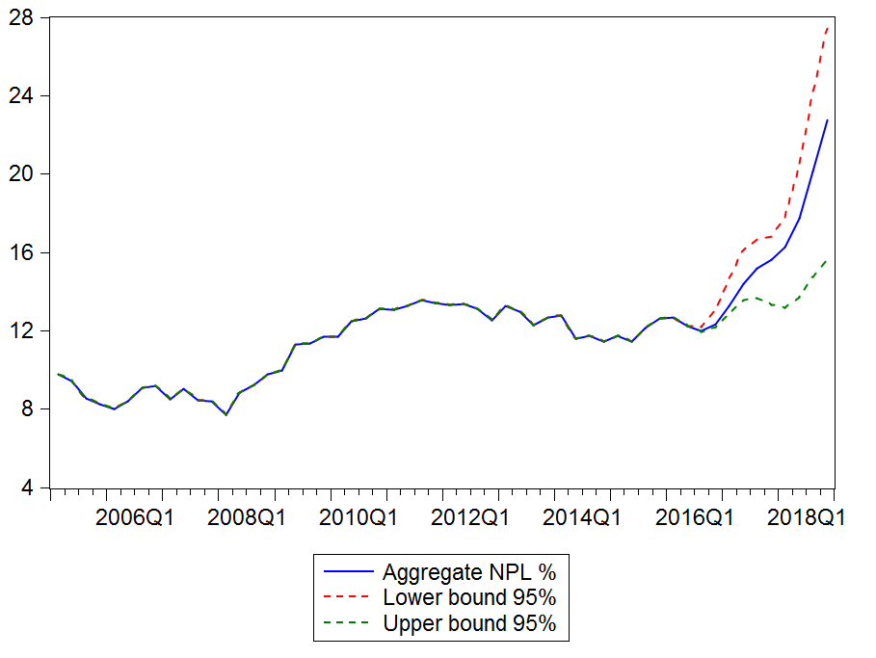
Positive one standard error shocks of the Euro real exchange rate (depreciation) which implies an increase of domestic real effective exchange rate implies an increase of NPL ratio until the value of +4.1% for the five first quarters (graph 2) and after that the NPL decreases.
Graph 2: NPL reaction to one positive standard deviation of Euro exchange rate shock
(ie depretiation)
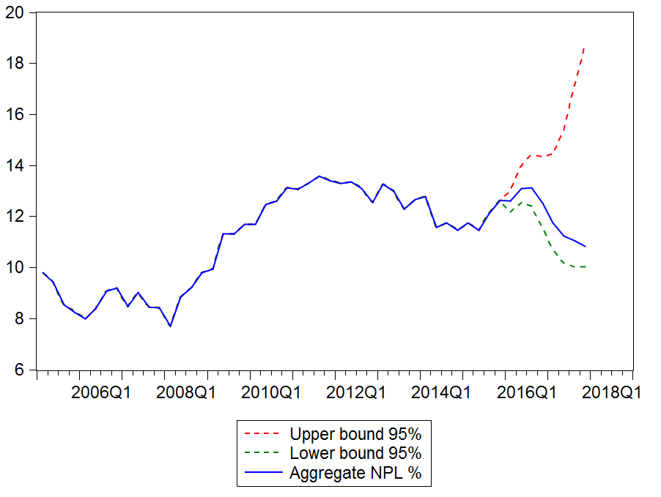
The positive one standard deviation of oil price shock increases the NPL ratio after the second quarter. Then, it decreases for a period of three quarters before finally increasing again. The growth of oil price deteriorates the economic situation and that could have a considerable consequence on the advance of credit portfolios quality.
Graph 3: NPL reaction to one positive standard deviation of global oil price shock
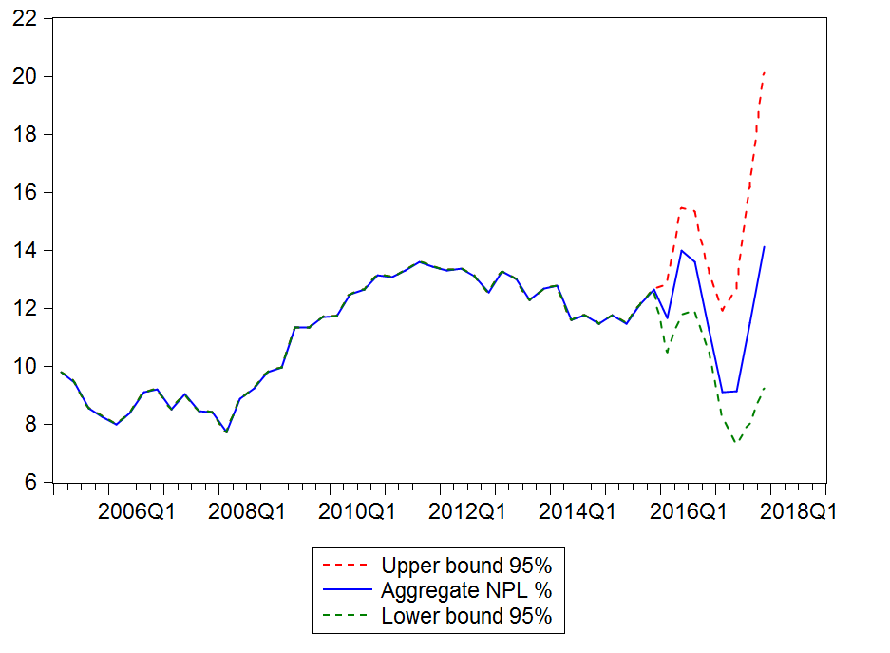
- Conclusion
This paper develops a macro stress testing in order to assess banking sector credit risk under global macroeconomic factors. A GVAR model for Madagascar has been used as a tool for generating scenario which allows international interaction between dynamic, foreign and global macroeconomic variables. To evaluate the impacts on NPL ratio to different conditional shocks we have estimated the satellite equation which assigns separately the NPL and domestic macroeconomic variables that would be afterwards combined into GVAR model.
The results show negative correlation between aggregate NPL and GDP shock which fits the cyclical pattern. The macroeconomic environment is a source of influence for banks’ activities. The NPL reacts positively to exchange rate shocks until 12 quarters and after that NPL reacts negatively. The negative reaction on NPL to the conditional positive oil price shock takes effect after the second quarter.
Therefore, this study encounters some limits. As well as this study is focused on the aggregate banking sector, a sectoral analysis is needed in order to support and refine the results. This can allow a deeper analysis of credit risk portfolio situation under stress scenario. Also, the size of our data is very limited and the precision degree of our results depends on the availability of a consistent data. However, the long serial of financial indicator data problem is met by almost all the studies in macro stress testing. For the future, the extension of the study may be the measure of the impact on default probabilities of banks for both aggregate and sectoral and the change in capital adequacy ratio against these macroeconomic stressed conditions.
References
[1] Foglia, A., (2008). "Stress testing credit risk: a survey of authorities' approaches." International Journal of Central Banking 5: 9–45.
[2] Dees, S., J. Henry and R. Martin., (2017). "STAMPE: Stress-test analytics for macroprudential purposes in the euro area." Frankfurt: European Central Bank.
[3] H. de Wet, Albertus R. Van Eyden and R. Gupta., (2009). "Linking global economic dynamics to a South African-specific credit risk correlation model." Economic Modelling 26(5): 1000-1011.
[4] Havrylchyk, O., (2010). A macroeconomic credit risk model for stress testing the South African banking sector, University Library of Munich, Germany.
[5] Aboagye, A. Q. and E. Ahenkora., (2017). "Stress Testing Exposure of Banks to Sectors of the Ghanaian Economy." Journal of African Business 19(1): 27-38.
[6] Farayibi, A., (2016). Stress Testing in the Nigerian Banking Sector, University Library of Munich, Germany.
[7] Central Bank of Madagascar. (2014a). Financial stability Report 1: 1-96.
[8] Basel committee on banking supervision., (2009). “Principles for sound stress testing practices and supervision” BIS: Bank for International Settlements.
[9] IMF., (2006). Republic of Madagascar: Financial System Stability Assessment, including Reports on the Observance of Standards and Codes on the following topics: Banking Supervision, and Anti-Money Laundering. August 15.
[10] Central Bank of Madagascar. (2014b). Financial stability Report 2: 1-64.
[11] Central Bank of Madagascar. (2015). Financial stability Report 3: 1-73.
[12] Central Bank of Madagascar. (2016). Financial stability Report 4: 1-70.
[13] Pesaran, M. H., T. Schuermann and S. M. Weiner., (2004). "Modeling regional interdependencies using a global error-correcting macroeconometric model." Journal of Business & Economic Statistics 22(2): 129-162.
[14] Dees, S., F. d. Mauro, M. H. Pesaran and L. V. Smith., (2007). "Exploring the international linkages of the euro area: a global VAR analysis." Journal of applied econometrics 22(1): 1-38.
[15] Sorge, M., (2004). "Stress-testing financial systems: an overview of current methodologies." BIS Working papers 165.
[16] Kalirai, H. and M. Scheicher., (2002). "Macroeconomic stress testing: preliminary evidence for Austria." Financial Stability Report 3: 58-74.
[17] Babouček, I. and M. Jančar., (2005). Effects of macroeconomic shocks to the quality of the aggregate loan portfolio, Czech National Bank.
[18] Zeman, J., and Pavol Jurca., (2008). "Macro stress testing of the Slovak banking sector." National bank of Slovakia working paper 1.
[19] Virolainen, K., (2004). "Macro stress testing with a macroeconomic credit risk model for Finland." BOFIT Discussion Paper, 12.
[20] Kosmidou, K. V. and K. A. Moutsianas., (2015). "Stress testing the Greek banking system." Journal of Finance and Economics 3(3): 89-102.
[21] Kattai, R., (2010). "Credit risk model for the Estonian banking sector", Working Papers of Eesti Pank of Eesti Pank.
[22] Åsberg, P. and H. Shahnazarian., (2008). Macroeconomic impact on expected default frequency, Sveriges Riksbank Working Paper Series.
[23] Blaschke, W., M. S. M. Peria, G. Majnoni and M. T. Jones., (2001). "Stress testing of financial systems: an overview of issues, methodologies, and FSAP experiences". IMF Working Paper, 88.
[24] Hoggarth, G., S. Sorensen and L. Zicchino., (2005). “Macro stress tests of UK banks”. BIS papers.22. Basle: Bank for International Settlements.
[25] Van den End, J. W., M. Hoeberichts and M. Tabbae., (2006). "Modelling scenario analysis and macro stress-testing". De Nederlandsche Bank.
[26] Drehmann, M., S. Sorensen and M. Stringa., (2006). "Integrating credit and interest rate risk: A theoretical framework and an application to banks' balance sheets". Bank for International Settlements Conference on “Risk management and regulation in banking”. Switzerland: Basel, Citeseer.
[27] Fong, T. and C. S. Wong., (2008). "Stress testing banks' credit risk using mixture vector autoregressive models."
[28] Pesaran, M. H., T. Schuermann, B.-J. Treutler and S. M. Weiner., (2006). "Macroeconomic dynamics and credit risk: a global perspective." Journal of Money, Credit, and Banking 38(5): 1211-1261.
[29] Fong, P., W. Li, C. Yau and C. Wong., (2007). "On a mixture vector autoregressive model." Canadian Journal of Statistics 35(1): 135-150.
[30] Castrén, O., S. Dées and F. Zaher., (2010). "Stress-testing euro area corporate default probabilities using a global macroeconomic model." Journal of Financial Stability 6(2): 64-78.
[31] Alessandri, P., P. Gai, S. Kapadia, N. Mora and C. Puhr., (2009). "Towards a framework for quantifying systemic stability." International Journal of Central Banking 5(3): 47-81.
[32] D. Hardy and I. Guerra., (2016). République de Madagascar, Évaluation de la stabilité du système Financier. International Monetary Fund.
[33] Smith, L. V. and A. Galesi. (2014). "GVAR Toolbox 2.0", User guide.

APPENDIX
Appendix 1: Descriptive statistics of domestic, foreign and global variables
Table 6: Descriptive Statistics of Domestic Variables
Madagascar | Mean | Median | Maximum | Minimum | Std. dev.
REAL GDP | 6,40904977 | 6,41110627 | 6,5394053 | 6,24154789 | 0,076908
INFLATION | 0,00745673 | 0,00751379 | 0,0154951 | 0,00209822 | 0,0034227
REAL EFFECTIVE EXCHANGE RATE | 4,68914997 | 4,75217801 | 4,86284643 | 4,36723311 | 0,17323668
NOMINAL SHORT TERM INTEREST RATE | 0,05598991 | 0,0569465 | 0,06559107 | 0,04010418 | 0,00793737
NOMINAL LONG TERM INTEREST RATE | 0,02829425 | 0,0287782 | 0,03386208 | 0,02159029 | 0,00402731
Source: Own construction
Table 7: Descriptive Statistics of Foreign-Specific Variables
REAL GDP | Mean | Median | Maximum | Minimum | Std. dev.
EURO | 5,86529726 | 5,86523605 | 5,97155559 | 5,73367218 | 0,06013396
JAPAN | 5,19433445 | 5,19121909 | 5,30747227 | 5,09108655 | 0,05212463
MADAGASCAR | 4,65776493 | 4,64931475 | 4,81939753 | 4,56580683 | 0,05706847
UNITED KINGDOM | 4,75487141 | 4,74610532 | 4,91564763 | 4,65625409 | 0,05836246
USA | 5,13962429 | 5,13491129 | 5,27897998 | 5,03551263 | 0,05544408
INFLATION | Mean | Median | Maximum | Minimum | Std. dev.
EURO | 0,00668867 | 0,00645063 | 0,01296664 | 0,00252321 | 0,0028193
JAPAN | 0,00590348 | 0,00554796 | 0,01203547 | -0,0079079 | 0,00348208
MADAGASCAR | 0,00399479 | 0,00368443 | 0,01154183 | -0,0059567 | 0,00288198
UNITED KINGDOM | 0,00458632 | 0,0042855 | 0,01208899 | -0,0067436 | 0,00302845
USA | 0,0043942 | 0,00412455 | 0,00959335 | -0,0014889 | 0,00222925
REAL EFFECTIVE EXCHANGE RATE | Mean | Median | Maximum | Minimum | Std. dev.
EURO | 2,67607826 | 2,73723395 | 2,82990272 | 2,40787726 | 0,14412071
JAPAN | -0,2919257 | -0,2683417 | -0,1248867 | -0,4569113 | 0,09726567
MADAGASCAR | -4,2966433 | -4,3017109 | -4,1155654 | -4,4425782 | 0,07671086
UNITED KINGDOM | -4,0511352 | -4,0489420 | -3,8689942 | -4,2077949 | 0,07446405
USA | -1,3646651 | -1,3795113 | -1,1937005 | -1,4646519 | 0,06658406
NOMINAL SHORT TERM INTEREST RATE | Mean | Median | Maximum | Minimum | Std. dev.
EURO | 0,03869879 | 0,03866368 | 0,04409585 | 0,02966437 | 0,00449791
JAPAN | 0,01801331 | 0,01838443 | 0,02390787 | 0,0147352 | 0,00224252
MADAGASCAR | 0,00302831 | 0,00111002 | 0,00908673 | 0,00013584 | 0,00334131
UNITED KINGDOM | 0,00603972 | 0,00415314 | 0,01224835 | 0,00293514 | 0,00313971
USA | 0,0170912 | 0,01706592 | 0,02126059 | 0,01416353 | 0,00204133
NOMINAL LONG TERM INTEREST RATE | Mean | Median | Maximum | Minimum | Std. dev.
EURO | 0,02142697 | 0,02197557 | 0,02605663 | 0,01614143 | 0,00338116
JAPAN | 0,01349758 | 0,01417462 | 0,01757961 | 0,00944098 | 0,00267333
MADAGASCAR | 0,00703265 | 0,00767538 | 0,0105774 | 0,00176016 | 0,00222783
UNITED KINGDOM | 0,00851689 | 0,00928233 | 0,01226491 | 0,00320214 | 0,00232677
USA | 0,01225408 | 0,01307522 | 0,01585499 | 0,0077961 | 0,00239173
Source: Own construction
Table 8: Descriptive Statistics of Global Variables
Statistics | Mean | Median | Maximum | Minimum | Std. dev.
OIL PRICE | 4,97492402 | 4,95736702 | 5,41116991 | 4,40515368 | 0,28814208
RAW MATERIAL PRICE | 4,78954034 | 4,77406613 | 5,10349775 | 4,44738363 | 0,15314772
METAL PRICE | 5,09167082 | 5,16673772 | 5,51601476 | 4,56659914 | 0,25045391
Source: Own construction
Appendix 2: Econometric results
Table 9 : Short term dynamics of the vector error correction model
Error Correction: | D(NPL) | D(GDP) | D(CPI) | D(E) | D(R) | D(LR)
CointEq1 | -1.019777 | -0.047622 | 0.056825 | 0.028112 | -0.015211 | 0.010425
 | [-5.65597] | [-1.27015] | [ 0.86559] | [ 0.46318] | [-0.88719] | [ 0.94040]
D(NPL(-1)) | -0.038833 | 0.030982 | -0.039195 | 0.008109 | -0.007108 | -0.003826
 | [-0.27144] | [ 1.04140] | [-0.75243] | [ 0.16838] | [-0.52253] | [-0.43495]
D(GDP(-1)) | -1.889059 | 0.335333 | 0.361631 | 0.283205 | 0.021840 | 0.029779
 | [-1.73690] | [ 1.48268] | [ 0.91319] | [ 0.77355] | [ 0.21118] | [ 0.44535]
D(CPI(-1)) | -0.420483 | 0.017356 | 0.038013 | 0.016546 | -0.019819 | -0.011527
 | [-0.82042] | [ 0.16285] | [ 0.20370] | [ 0.09590] | [-0.40666] | [-0.36580]
D(TCER2(-1)) | -0.249816 | 0.070330 | -0.023440 | 0.572584 | 0.034963 | -0.042582
 | [-0.50943] | [ 0.68967] | [-0.13128] | [ 3.46861] | [ 0.74979] | [-1.41234]
D(R(-1)) | -2.817865 | 0.191073 | -0.091167 | 0.231806 | -0.310624 | -0.097931
 | [-1.21300] | [ 0.39553] | [-0.10778] | [ 0.29643] | [-1.40619] | [-0.68567]
D(LR(-1)) | -5.335641 | -0.305531 | 0.024773 | -0.374262 | 0.228547 | 0.004360
 | [-1.83056] | [-0.50407] | [ 0.02334] | [-0.38144] | [ 0.82460] | [ 0.02433]
C | 0.019028 | 0.003115 | 0.016663 | 0.002721 | 0.000355 | 0.000344
 | [ 1.36988] | [ 1.07826] | [ 3.29452] | [ 0.58182] | [ 0.26876] | [ 0.40230]
R-squared | 0.619249 | 0.410696 | 0.044068 | 0.362261 | 0.154365 | 0.135886
Adj. R-squared | 0.530408 | 0.273192 | -0.178983 | 0.213455 | -0.042950 | -0.065740
F-statistic | 6.970246 | 2.986791 | 0.197570 | 2.434452 | 0.782327 | 0.673951
Akaike AIC | -3.336268 | -6.477190 | -5.356866 | -5.513848 | -8.042149 | -8.914293
Schwarz SC | -2.991514 | -6.132435 | -5.012111 | -5.169093 | -7.697394 | -8.569538
Source: Own construction
Table 10: Testing of autocorrelation in residuals for Satellite model: LM test
VEC Residual Serial Correlation LM Tests
Null Hypothesis: no serial correlation at lag order h
Sample: 2005Q1 2015Q4
Lags | LM-Stat | p-values
1 | 58.36010 | 0.0106
2 | 42.59518 | 0.2084
3 | 26.65237 | 0.8716
4 | 64.57969 | 0.0024
5 | 20.54883 | 0.9819
6 | 45.02129 | 0.1440
7 | 25.29170 | 0.9089
8 | 91.84990 | 0.0000
9 | 37.75128 | 0.3892
10 | 43.48579 | 0.1827
11 | 21.63290 | 0.9720
12 | 53.20324 | 0.0323
Source: Own construction
Table 11 : Testing of normality in residual series in the satellite model: Jacque-Bera statistics
Component | Jacque-Bera | df | Prob.
1 | 0.352888 | 2 | 0.8382
2 | 0.449234 | 2 | 0.7988
3 | 6.984914 | 2 | 0.0304
4 | 2.416022 | 2 | 0.2988
5 | 1.978960 | 2 | 0.3718
6 | 3.052641 | 2 | 0.2173
7 | 1.156589 | 2 | 0.5609
Joint | 16.39125 | 14 | 0.2901
Source: Own construction
Table 12 : Testing of heteroscedasticity: White statistics
Joint test:
Chi-sq | df | Prob.
344.0397 | 294 | 0.0236
VEC Residual Heteroskedasticity Tests: No Cross Terms (only levels and squares)

Source: Own construction

such as Rwanda (IMF, 2011), Nigeria (IMF, 2013), South Africa (IMF, 2014), Chad (IMF, 2016), CEMAC (IMF, 2016), Zambia (IMF, 2017)

