Effect of variable thermal conductivity and viscosity on MHD Casson nanofluid flow vertical plate with thermal radiation convective heating and velocity slip

M.Ramanuja1 V. Nagaradhika2

1 Department of Mathematics, Marri Laxman Reddy Institute of Technology & Management

(Autonomous) , Dundigal, Medchal Dist .Hyderabad-500043. INDIA.

Email: mramanuja09@gmail.com

2Department of Mathematics, Gitam University Bangalore, 562163, INDIA.

Email: nagaradhika79@gmail.com

Abstract:

This work instigates the impacts of connected variable thickness and formed conductivity, nanofluid flow over a vertical level plate with convective smooth, and velocity slip boundary conditions. The controlling vehicle nonlinear divided differential conditions and the interrupt conditions are non-dimensionalized. The available with the path of action of stable present differential conditions is then decreased to a lot of coupled nonlinear essential differential conditions utilizing convenience change. Numerical outcomes are gotten for dimensionless velocity, temperature, and nanoparticle volume quantity It is discovered that the velocity increments, while both temperature and nanoparticle volume partrot with expanded estimations of variable full conductivity and consistency. while the Dufour number and Soret number augmentation with working up the relative and the fixation field rot as the Schmidt number developments while the temperature field decreases with extending Prandtl number and Dufour number Correlations are done with scattered information actually taking figure right now the numerical outcomes. An impressive cognizance is seen. Taking everything into account, the effects of physical parameters on fluid velocity, temperature, and focus on spreading moreover as on the divider sheer mass, heat, and mass trade rates are audited in detail. Also, this present consideration can determine applications in the process including nanofluid works out.

Keywords: Thermal diffusion thermo, MHD Mixed convection, Porous medium Finite-

element method, Slip, Casson nanofluid, Weighted residual method,

Variable properties.

1. Introduction:

In the non-Newtonian fluids fitting to their is significant organization in the including and region of reasonable and made sciences. For instance, designed oils, exhausting attitudes, ensured oils, and paints, coarseness courses of action, land increase, or common mollified kind of gore are the straightforward shared cases regarding non-Newtonian fluids. The Navier-Stokes quintessential conditions can't quickly represent the properties concerning the maintain discipline concerning non-Newtonian fluid's reasonable incongruity with the unpredictability between the logical structures in a sprint with the flow issue. Plenteous styles for non-Newtonian fluids are portrayed as figuring rheological qualities, for illustration, Eyring-Powell, Bulky, Seely, Oldroyd-B, Maxwell, Oldroyd-A, Carreau, Casson, Burger, Jeffrey, etc.

Jawali et al. [1] explore the united effect of variable thickness and temperate conductivity on the free convection flow of a viscous fluid in a vertical channel. He used Attia's [2] portrayal for both temperature-subordinate consistency and temperate conductivity. It was found that the fluid flow and heat move increase as the variable consistency parameter increases, while development in factor temperate conductivity reduces both the glow move and the fluid flow. Bagai and Nishad [3] used a numerical system (for instance shooting procedure) to analyze the effect of temperature-subordinate thickness on the trademark convective breaking point layer flow over a level plate embedded in a nanofluid doused porous medium. The consistency of the fluid is acknowledged to vacillate exponentially with temperature. The temperate conductivity was normal steady and radiation term is overlooked. It was seen that the glow and mass exchange scale increase as the thickness parameter increases. Casson fluid flow with variable thermo-physical properties along exponentially expanding sheet with attractions and exponentially decaying inside heat age using the homotopy examination strategy (HAM) was thought by Animasaun et al. [4] have contemplated the radiation term used was immediate and the effect of porosity was not put into thought. Moreover, just Casson fluid, instead of Casson nanofluid, was thought at the present time. They found that development in the variable plastic novel consistency parameter of Casson fluid prompts an addition in speed profile and a diminishing in temperature profile all through the breaking point layer. Makinde. [5]. have inspected the glow and mass trade flow of as far as possible layer flow towards an expanding sheet with manufactured reaction was represented by Mabood et al. [6].investigated the effect of the alluring field on the two-dimensional movement of nanofluid with and without slip condition was discussed by Khan et al. [7] examined Mohyud-Din et al. [8,9], independently. Khan et al.[10] analyzed two dimensional electrically driving the movement of nanofluid on explanation of the broadening sheet influenced by convective breaking point conditions. The effect of first-demand mixture reaction two-dimensional movement of thick fluid in the proximity and nonappearance of alluring field Khan et al. [11] and Mohyud-Din et al. [12] examined continuing considering its application, the effect of temperate radiation on the gooey movement of a micro polar nanofluid inside seeing the appealing field was maded by Mohamud-commotion et al. [13]. Researched, on the other hand, non-Newtonian fluids have gotten interested in light of its wide range application in various ventures, for instance, the structure of solid cross-section heat, nuclear fritter away evacuation, compound synergist reactors, geothermal imperativeness creation, groundwater hydrology, transpiration cooling, oil storehouses, etc. These fluids are progressively jumbled when diverged from Newtonian fluids in light of nonlinear associations among uneasiness rates. A couple of models have been proposed for the examination of non-Newtonian fluids, in any case yet not a singular model is developed that shows all properties of non-Newtonian fluids. Recorded as a hard copy, the clearest model is the Maxwell model. Among different non-Newtonian fluids, there is another fluid known as Casson fluid. Casson fluid is a shear-decreasing fluid that is required to have a perpetual consistency at zero paces of shear, yield stress underneath which no flow occurs, and a zero thickness at an unending pace of shear. Saidulu and Venkata [14] used a numerical method (Keller box system) to analyze the effect of slip-on MHD flow of a Casson fluid over an exponentially broadening sheet inside seeing temperate radiation, heat source/sink and manufactured reaction. It was found that the temperature and obsession profile increase when the Casson parameter increases, yet the inverse were the circumstance for the velocity profile. Tricky MHD slip flow of a Casson fluid due to an expanding sheet with attractions or leaving behind Mahdi [15]. examined it was seen that growing the slip parameter constructs the fluid flow, and as far as possible layer gets progressively thin if there ought to emerge an event of attractions or blowing. Nadeem et al. [16] used the domain deterioration system to procure the response for as far as possible layer flow of a Casson fluid over an exponentially contracting sheet. It is seen that when the fluid parameter approaches limitlessness their anxiety diminished to the Newtonian case. Mukhopadhyay [17]. Nadeem et al. [18] in like manner dismembered the three-dimensional hydromagnetic flow of Casson fluid in a porous medium. Numerical plans of the electrically driving slipstream of Casson nanofluid made during the expanding sheet influenced by convective breaking point conditions using closeness changes were presented by Ibrahim and Makinde [19]. Propelled by its applications and captivating features, Benazir et al. [20] considered unstable Casson stream past a vertical cone and level sheet inside seeing an alluring field. As of late, Oyelakin et al. [21] explored the unreliable electrically driving movement of Casson nanofluid inside seeing slip and convective cutoff conditions. A numerical report was Garoosi et al. [9] finished concerning normal and mixed convection heat move of nanofluid in a two-dimensional square hole with different arrangements of heat source-sinks by applying the constrained volume procedure. Jagdish Prakash et al. [22] inspected the qualities of heat and mass trade on precarious mixed convective magnetohydrodynamic fluid flow past a stimulated vertical wavy plate, subject to various temperature and mass dispersal, with the effect of temperate radiation, daintiness and Dufour sway. An and Rao et al. [23] indicated transient flow past a rashly started ceaseless level penetrable plate in a turning fluid in the closeness of appealing field with Hall current using the restricted part structure. Anand Rao et al. [24] were inquired about the merged effects of heat and mass trade on fickle MHD stream past a vertical oscillatory plate attractions velocity using restricted segment methodology. The joined effects of heat and mass trade on uncertain MHD customary convective stream past a boundless vertical plate encased by the penetrable medium in the closeness of temperate radiation and Hall Current was inquired about by Ramana Murthy et al.[25]. Researched the touchy magnetohydrodynamic infrequent movement of a non-Newtonian fluid through a penetrable channel coherently has been investigated by Taklifi and Aliabadi [27]. Zueco et al. [28] reviewed the effect of mixture reaction on the hydromagnetic heat and mass trade boundary layer flow from a level chamber in a Darcy-Forchheimer using structure proliferation.

2. Mathematical formation:

Let us consider the two-dimensional consistent laminar standard convective development of thick electrically driving incompressible Casson nanofluid over a vertical level plate is thought of. All the properties of the liquid are accepted to be consistent after that to the thickness, consistency, and unruffled conductivity of the liquid. It is expected that the outer surface of the plate is exposed to convective warming with temperature  is the distance along with the plate, while  in the distance perpendicular to the plate. A local magnetic field  is assumed to be placed in a slanting direction to the fluid flow. The fluid temperature and nanoparticle volume fraction (concentration) is denoted by T and C respectively. It is similarly accepted that the actuated striking field is unobserved because of a little attractive Reynolds number. The nanoparticle volume fraction at the wall is taken as  while the temperature and nanoparticle volume fraction far from the wall are denoted by  and  respectively.



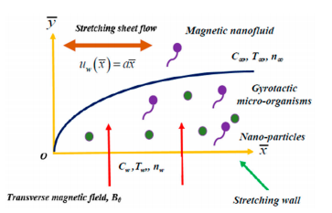

**Figure (1) intention pattern and systematize system** (Nan fluid growing quantity flow)

The steady two-dimensional MHD flow of an electrically conducting non-Newtonian Casson nanofluid over a stretching sheet placed at y = 0. The flow is restricted in the region y>0. The equal and opposite forces are applied along the x-axis so that the wall is stretched with the origin fixed.  ,  (Rate of strain tenor), =and  is the component of deformation rate, n is the product of deformation rate with itself,  is a critical value of this product based on the non-Newtonian model,  Casson parameter,  is the plastic dynamic viscosity  of the non-Newtonian fluid and  is the yield stress of the fluid. The kinematic viscosity  the continuity, momentum, and energy equations governing such type of flow as

  (3)

 (4)



Where  and  are the velocity components in the  and  directions, respectively.  is the kinematic viscosity,  is the Casson fluid density, = is the parameter of Casson fluid,  is the electrical conductivity of the fluid,  is the thermal diffusivity,  is the temperature , and  is the permeability of the porous medium. is the variable permeability of the porous medium, g is the gravitational force due to acceleration,  is the volumetric coefficient of thermal expansion, the coefficient of concentration expansion,  is the thermal conductivity of the Casson fluid,  is the radioactive heat flux, is heat generation/absorption coefficient, D is the mass diffusivity and  is the rate of the chemical reaction.

The physical properties of nana fluid such as  and  are given as Khamafer [29] Abu-Nada [30], Zhang [31] Hatami [31]

 (5) Where  is the density of the base fluid, is the density of the nanoparticle,  is the viscosity of the base fluid, where is the nanoparticle  is the volume of the function of nanoparticles,are the heat capacitance of the base fluid and nanoparticle respectively and are thermal conductivities of the base fluid and nanoparticle respectively. Different states of nanoparticles and various equations for warm conductivity and dynamic consistency can be found in the referenced referred to thus. The successful temperate conductivity of the nanofluid given by Hamilton, which is of the structure the thermo physical property of various base liquids and nanoparticles has appeared in table 1.

**Numerical values of nanoparticles and water**

|  |  |  |  |  |
| --- | --- | --- | --- | --- |
| Thermo physical properties | Fluid phase water | Cu | Al2O3 | Ni |
| Cp(Þ j=kg) K | 4178 | 384 | 764 | 445 |
| ρ (kg/m³) | 997.2 | 8934 | 3971 | 8901 |
| k (W/m K) | 0:614 | 401 | 41 | 90.6 |

The appropriate boundary conditions for the problem are given by



 (6)



Here  denotes velocity slip factor with constant.  and  represents the convective heat and mass transfer with  being constants,  in which  being reference temperature and  and  with  being reference concentration.

The radioactive heat flux  described according is give as we adopt the Rosseland approximation for radioactive flux writhe energy equation in Eq.

 (7)

Where  is the Stefan--Boltzmann constant and  is the mean absorption coefficient.  can be expressed as a linear function of temperature. By expanding  in a Taylor series about  and neglecting higher terms we can write

 (8)

Incorporating Eq (6) and Eq (7) in Eq (4), we obtain

 (9)

Here  denotes velocity slip factor with constant.  and  represents the convective heat and mass transfer with  being constants,  in which  being reference temperature and  and  with  being reference concentration.

The radioactive heat flux  described according is give as we adopt the Rosseland approximation for radioactive flux writhe energy equation in Eq.

 (7)

Where  is the Stefan--Boltzmann constant and  is the mean absorption coefficient.  can be expressed as linear function of temperature. By expanding  in a Taylor series about  and neglecting higher terms we can write

;

  (10)

Where L is a characteristic length of plate .The system of Eqs (3-7) and Eq (11) take the following form

 (11)

 (12)

The corresponding boundary conditions are

 (13)

The wall skin frication,wall heat flux and wall mass flux, respectively, are defined by



The dimensionless skin inaction coefficient  the local Nusselt number, and local Sherwood number  on the surface along x- direction, Local Nusselt number  and Sherwood number are given by

 , 

Where primes denote differentiation with respect to  and the non-dimensional parameters,prandtal number number(Pr) buoyancy-ratio (Nr),thermophoesis parameter(Nt) magnetic parameter (M), radiation parameter (N) and heat generation defined as follows,

 , The corresponding boundary condition is as follows,

 (16)

The quantities of practical interest are the Nusselt number Nu and Sherwood number Sh defined by

 (17)

**Where**  and  are divider heat motion and mass flux. The diminished Nusselts number Nr within the prospect of temperate radiation and neighborhood Sherwood number Shr can be accessible and written to as follows,

 (18)

3. RESULTS AND DISCUSSION

The prosperity work depleted in pulling the polymer contiguous the action of the appealing field is dissipated as mild imperativeness (heat). This engages the breaking point layer and extends as far as possible layer thickness. Again the effect of the alluring field is proceeded with all through as far as possible layer space. This invigorates the disconnect layer since the dynamic essentialness is spread as composed imperativeness, and this further serves to trouble improved variety scattering. Along these lines,

. 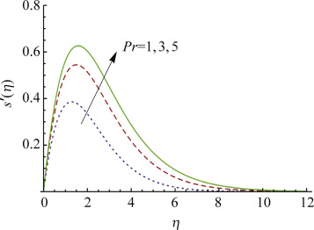

Effects of pradental number on the dimensionless velocity profile

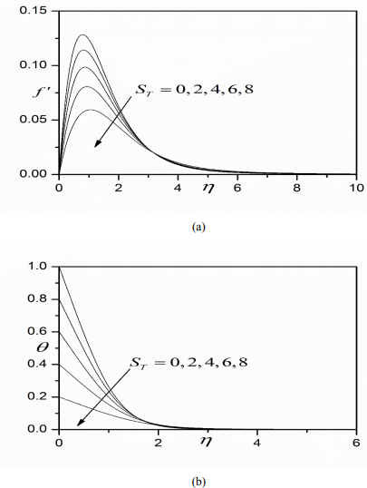

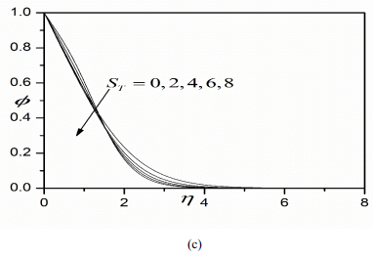

**Graph Influence of TS on (a) velocity profiles (b) temperature profiles(c) concentration profiles**

Figs. depict the advancement in velocity, temperature, and nanoparticle center characteristics with transverse sort out, for instance, common to the Sphere surface for various Prandtl numbers, Pr. Decently high estimations of Pr are thought of. Prandtl number embodies the extent of vitality diffusivity to warm diffusivity in the discontinue layer structure. It moreover addresses the extent of the aftereffect of express heat breaking point and dynamic thickness, to the fluid temperate conductivity. For polymers, the vitality scattering rate phenomenally outperforms the temperate increase rate. The low estimations of temperate conductivity in numerous polymers moreover realize a high Prandtl number. With extending Pr from 1 to 50 there is obviously a huge deceleration in limit layer flow, for instance, a thickening in as far as a possible layer.

The effect is generally unquestionable close to the Sphere surface. Also fig. shows that with progressively noticeable Prandtl number the temperature regards are solidly decreased all through the breaking point layer transverse to the Sphere surface. Temperate cutoff layer thickness is thus by and large reduced. Appraisal of fig. 10c reveals that extending Prandtl number earnestly raises the nano-particle obsession sizes. In all honesty, an obsession overshoot is impelled near the Sphere surface. Thusly, while the temperate vehicle is diminished with progressively unmistakable Prandtl number, species spread is enabled and nanoparticle center breaking point layer thickness creates. The asymptotically smooth profiles in the free stream (high values) attest that a sufficiently colossal endlessness limit condition has been constrained in the Keller box numerical code.

Figs. plot the assortment of speed, temperature, and nano-atom obsession with transverse organizes, for different estimations of mild slip parameter (ST). Warm slip is constrained in the developed partition boundary condition in Eqn. With extending temperate slip less heat is transmitted to the fluid and this de-engages the breaking point layer. This is like manner prompts a general deceleration as

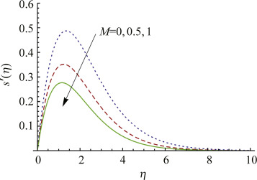

Effects of magnetic parameter on the dimensionless [velocity profile](https://www.sciencedirect.com/topics/engineering/velocity-profile)

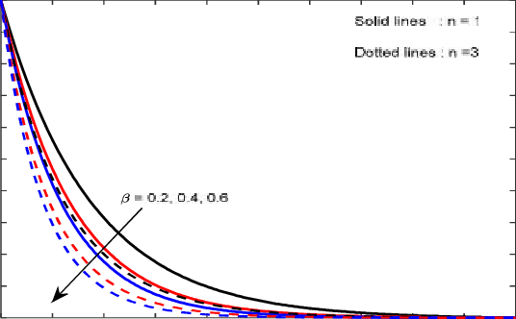

Deliberation profiles for dissimilar values of Dufour number Du

The value of the scaled Nusselt number for various 

|  |  |  |  |  |
| --- | --- | --- | --- | --- |
|  |  | Cu | NI | TiO2 |
| 0.00 | 1.40482065 | 1.40482082 | 1.40482045 | 1.40482065 |
| 0.05 | 1.49657973 | 1.50455670 | 1.49571360 | 1.48088610 |
| 0.10 | 1.59010944 | 1.60689964 | 1.58778172 | 1.55782875 |
| 0.15 | 1.68623130 | 1.71283156 | 1.68188953 | 1.63613725 |
| 0.20 | 1.78582690 | 1.82342625 | 1.77896185 | 1.71632345 |

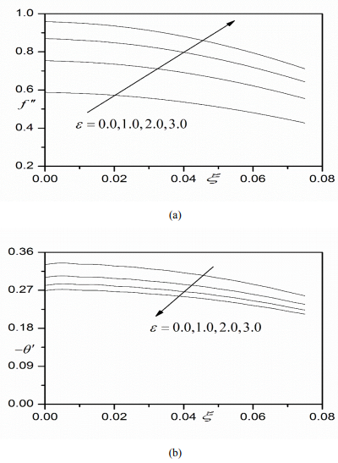

Thermo-physical properties

|  |  |  |  |  |
| --- | --- | --- | --- | --- |
|  |  |  |  |  |
| Pure water | 997.2 | 4182 | 0.616 | 26 |
| Cu | 8938 | 390 | 406 | 1.72 |
| Alumina oxide | 3976 | 768 | 46 | 0.90 |
| Titanium oxide | 4254 | 687.2 | 8.9542 | 0.12 |



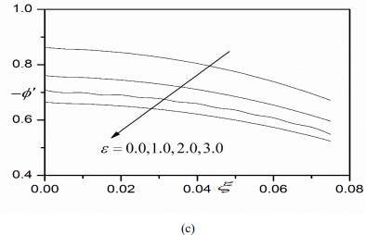

**Graph Effect of ε on (a) Skin friction profiles (b) Nusselt number profiles (c) Shear wood number profiles**

The impact of gentle slip is effectively diminished with further extraordinary ways from the divider (bend surface) into the cutoff layer and disseminates some division before the free stream. It is in addition clear from fig. that nanoparticle focus is decreased with a continuously undeniable quiet slip influence. Essentialness boundary layer thickness is in like way broadened while quiet and species limit layer thicknesses are dispirited. Indisputably the non-unimportant reactions arranged in figs. Further, feature the need to join mellow slip impacts in reasonable nanofluid enrobing flow.

Figs. present the effect of Eyring–Powell liquid parameter ε, on dimensionless skin breaking down coefficient, Nusselt number, and Sherwood number at the circle surface. It is seen that the dimensionless skin beating is refreshed with the advancement in ε, for example, the limit layer stream is animated with decreasing thickness impacts in the non-Newtonian structure. Obviously, Nusselt number and Sherwood number are generously diminished with expanding ε values. The lessening thickness of the liquid (affected by becoming the ε respect) diminishes warm dispersing as separated and imperativeness dissipating. A lessening in heat move rate and mass change scale at the divider prompts less warmth is arraigned from the liquid system to the drift, as such temperate the boundary layer and refreshing temperatures and center interests.

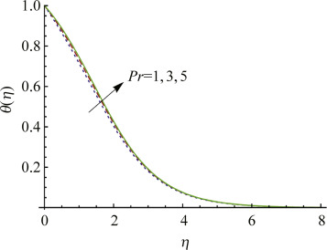

ffects of [Prandtl number](https://www.sciencedirect.com/topics/engineering/prandtl-number) on the dimensionless temperature profiles

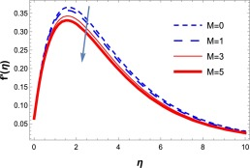

Effect of M on dimensionless velocity.

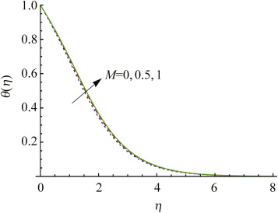

Effects of magnetic parameter on the dimensionless temperature

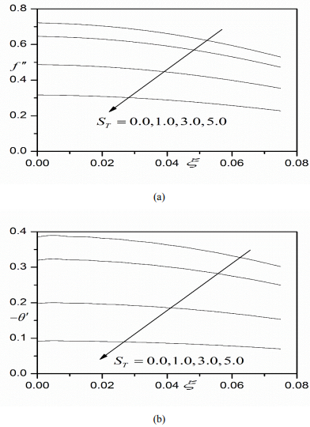

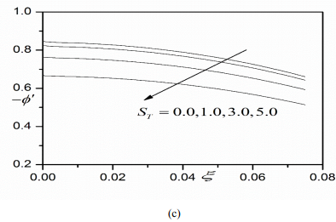

**Graph Effect of TS on (a) Skin friction profiles (b) Nusselt number profiles (c) Shear wood number profiles**

Figs. show the skin scouring, Nusselt number, and Sherwood number scatterings with different estimations of gentle slip influence (ST). The two skins pulverizing and Nusselt numbers are emphatically decreased and Sherwood number is upgraded with an improvement warm slip (ST). The boundary layer is thusly decelerated and temperate with a more grounded temperate slip. With temperate slip missing along these lines the skin crushing is reached out at the Sphere surface. The idea of quiet slip, which is proficient about different slippy polymer streams, is thusly vital in more physic practical amusements**.**

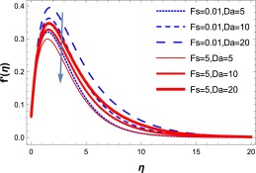

Effects of Da on dimensionless velocity.

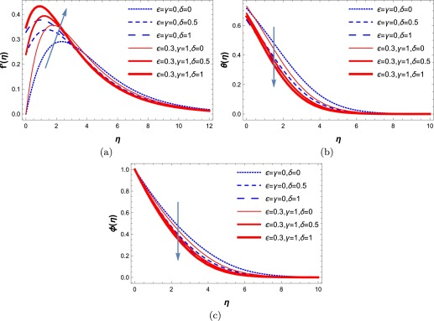

The effects of velocity slip, variable thermal conductivity and viscosity parameters

**4. CONCLUSION**

The explanation for the current assessment is to explore the effect of the Hall flow on peristaltic transport of a non - Newtonian flow. The Casson model through a vertical chamber is thought of. The structure is affected by a strong level of uniform connecting with the field. So also, the glimmer radiation, thick dispersing, helpless media, and compound reaction are thought of. The nonlinear managing commonly differential conditions show up in a dimensionless structure. The came about the structure is tangled to be lit up sensibly. To release up the numerical control, the current examination depends essentially on the long-repeat check likewise with the low Reynolds number. The unquestionable game-plan is gotten, without the Eckert number, likewise like the respectable Bessel's fragments of the key kind. The HPM, inside watching the Eckert number, is utilized around the subsequent mentioning. Again, a numerical methodology subject to the Runge – Kutta Method with the shooting framework is perceived. An enormous measure of diagrams is plotted to design the effect of the different physical parameters on the speed, temperature, and center vehicles. Furthermore, to make an examination between the positive courses of action and numerical ones. A graphical and data configuration is isolated and some previous works.

Reveals the estimations of the diminished Nusselt numbered Sherwood number and besides it ensures the precision of present informative and numerical results. The decreased Nusselt number augmentations with extending estimations of N and reduces with M, Pr, Nr, N band Nt. The Nu values rise because of warmth maintenance and abatement in heat age case. The close by Sherwood number augmentations with N, Pr, Nb and Nt, and lessens with M and Nr. The Shr regards rise because of warmth age and abatement in heat maintenance cases.

The assessment shows that the speed, temperature and the solid volume part of the nanofluid profiles in as far as possible layers depend upon eight dimensionless parameters, to be explicit Prandtl number, Lewis multitudinous, Brownian development parameter Nb, thermophoresis parameter Nt, gentility extent parameter, alluring parameter M, radiation parameter N and heat age or ingestion parameter λ.

(1) The dimensionless speed profile of the nanofluid hances with the development of Prandtl

Number, radiation parameter, Brownian development Para-meter, and thermophoresis

parameter, and it diminishes with appealing parameter and daintiness extent parameter. The

dimensionless speed improves the closeness of warmth age and decreases by virtue of heat

osmosis.

(2) The extending of estimations of Prandtl number, alluring parameter, radiation parameter,

softness extent parameter, Brownian development parameter, and the thermophoresis

parameter prompts an extension in the nano-fluid temperature profile. The temperature

allocation augments inside seeing warmth age and lessen because of heat osmosis.

(3) The nonsolid volume part profile diminishes with Prandtl number, Lewis number, radiation

parameter, Brownian development parameter, and thermophoresis parameter and increments

with appealing parameter and gentility extent parameter. The nonsolid volume part profile

reduces inside seeing warmth age and additions by virtue of heat absorption.

(4) The lessened Nusselt number risings because of warmth osmosis and diminishes in a heat age

case. The local Sherwood number characteristics rise by virtue of heat age and reduce in

heat osmosis case.

References:

[1] Jawali C.U., Chamkha A.J. Combined effect of variable viscosity and thermal conductivity

on free convection flow of a viscous fluid in a vertical channel. Int. J. Numer. Methods Heat

Fluid Flow. 2015;26:18–39.

[2]. Attia H.A. Unsteady hydromagnetic channel flow of dusty fluid with temperature dependent

viscosity and thermal conductivity. J. Heat Mass Transf. 2006;42:779–787.

[3]. Bagai S., Nishad C. 5th International Conference on Porous Media and Their Applications in

Science, Engineering and Industry. 2014. Effect of temperature dependent viscosity on

natural convective boundary layer flow over a horizontal plate embedded in a nanofluid

saturated porous medium.

[4]. Animasaun I.L., Adebile E.A., Fagbade A.I. Casson fluid flow with variable thermo-physical

property along exponentially stretching sheet with suction and exponentially decaying

internal heat generation using the homotopy analysis method. J. Niger. Math. Soc.

2016;35:1–17.

[5]. Seini IY, Makinde DO. Boundary layer flow near stagnation-points on a vertical surface

with slip in the presence of transverse magnetic field. Int J Numer Methods Heat Fluid Flow.

2014;24: 643–653.

[6]. Mabood F, Khan WA, Ismail AIM. MHD stagnation point flow and heat transfer impinging

on stretching sheet with chemical reaction and transpiration. Chem Eng J. Elsevier B.V.;

2015;273: 430–437.

[7]. Khan U, Ahmed N, Mohyud-Din ST. Heat transfer effects on carbon nanotubes suspended

nanofluid flow in a channel with non-parallel walls under the effect of velocity slip

boundary condition: a numerical study. Neural Comput Appl. Springer London; 2015;

[8]. Mohyud-Din ST, Zaidi ZA, Khan U, Ahmed N. On heat and mass transfer analysis for the

flow of a nanofluid between rotating parallel plates. Aerosp Sci Technol. 2015;46: 514–522.

[9]. Mohyud-Din S, Khan U, Ahmed N, Hassan S. Magnetohydrodynamic Flow and Heat

Transfer of Nanofluids in Stretchable Convergent/Divergent Channels. Appl Sci. 2015;5:

1639–1664.

[10]. Khan WA, Makinde OD, Khan ZH. Non-aligned MHD stagnation point flow of variable

viscosity nanofluids past a stretching sheet with radiative heat. Int J Heat Mass Transf.

Elsevier Ltd; 2016;96: 525–534.

[11].Khan U, Ahmed N, Mohyud-Din ST. Thermo-diffusion, diffusion-thermo and chemical

reaction effects on MHD flow of viscous fluid in divergent and convergent channels. Chem

Eng Sci. Elsevier; 2016;141: 17–27.

[12].Mohyud-Din ST, Ahmed N, Khan U, Waheed A, Hussain S, Darus M. On Combined

Effects of Heat Transfer and Chemical Reaction for the Flow through an Asymmetric

Channel with Orthogonally Deformable Porous Walls. Math Probl Eng. 2016;2016.

[13].Mohyud-Din ST, Jan SU, Khan U, Ahmed N. MHD flow of radiative micropolar nanofluid

in a porous channel: optimal and numerical solutions. Neural Comput Appl. Springer

London; 2016; 1–9.

[14]. Saidulu N., Ventakata A.L. Slip effect on MHD flow of Casson fluid over an exponentially

stretching sheet in the presence of thermal radiation, heat source/sink and chemical

reaction. Eur. J. Adv. Eng. Tech. 2016;3:47–55.

[15]. Mahdy A. Unsteady slip flow of a non-Newtonian Casson fluid due to stretching sheet with

suction or blowing effect. J. Appl. Fluid Mech. 2016;9:785–793.

[16].Nadeem S., Rizwan U.I., Norean S.A., Khan Z.H. MHD three dimensional Casson fluid

flow past a porous linearly stretching sheet. Alex. Eng. J. 2013;52:577–582.

[17]. Mukhopadhyay S. Effects of thermal radiation on Casson fluid flow and heat transfer over

an unsteady stretching surface subjected to suction/blowing. Chinese Phys B. 2013;22:

114702.

[18].Nadeem S, Haq RU, Akbar NS, Khan ZH. MHD three-dimensional Casson fluid flow past

a porous linearly stretching sheet. Alexandria Eng J. Faculty of Engineering, Alexandria

University; 2013;52: 577–582.

[19].Ibrahim W, Makinde OD. Magnetohydrodynamic stagnation point flow and heat transfer

of Casson nanofluid past a stretching sheet with slip and convective boundary condition,. J

J Aerosp Eng. 2015;29: 04015037.

[20].Benazir J., Sivaraj A, Makinde OD. Unsteady magnetohydrodynamic Casson fluid flow

over a vertical cone and flat plate with non-uniform heat source/sink. Int J Eng Res Africa.

2016;21: 69–83.

[21].Oyelakin IS, Mondal S, Sibanda P. Unsteady Casson nanofluid flow over a stretching sheet

with thermal radiation, convective and slip boundary conditions. Alexandria Eng J. Faculty

of Engineering, Alexandria University; 2016;55: 1025–1035.

[22].F. Garoosi, G. Bagheri, M.M. RashidiTwo phase simulation of natural convection and

mixed convection of the nanofluid in a square cavity,Powder Technol., 275 (2015), pp.

239-256

[23].Jagdish Prakash, Bangalore Rushi Kumar, Ramachandran SivarajRadiation and Dufour

effects on unsteady MHD mixed convective flow in an accelerated vertical wavy plate

with varying temperature and mass diffusion,Walailak J. Sci. Technol., 11 (2014), pp.

939-954

[24].J. Anand Rao, R. Srinivasa Raju, S. SivaiahFinite Element Solution of MHD

Transientflow, past an impulsively started infinite horizontal porous plate in a rotating

fluid with Hall , current,J. Appl. Fluid Mech., 5 (2012), pp. 105-112

[25].J. Anand Rao, R. Srinivasa Raju, S. SivaiahFinite Element Solution of heat and mass

transfer in MHD Flow of a viscous fluid past a vertical plate under oscillatory suction

velocityJ. Appl. Fluid Mech., 5 (2012), pp. 1-10

[26].M.V. Ramana Murthy, R. Srinivasa Raju, J. Anand RaoHeat and Mass transfer effects on

MHD natural convective flow past an infinite vertical porous plate with thermal

Radiation and Hall Curren,Procedia Eng. J., 127 (2015), pp. 1330-1337

[27].A. Taklifi, A. AliabadiAnalytical solution of unsteady MHD periodic flow of a non-

Newtonian fluid through a porous channelJ. Porous Media, 15 (2012), pp. 1051-1059

[28].J. Zueco, O.A. Beg, A. Tasveer, H.S. TakharNumerical study of chemically reactive

buoyancy-driven heat and mass transfer across a horizontal cylinder in a non-Darcian

porous regime,J. Porous Media, 12 (2009), pp. 519-535.

[29].Khanafer, Vafai, K.,and Lightstone, M., Buoyancy-Driven Heat Transfer Enhancement in a Two-Dimensional Enclosure Utilizing Nanofluids, International Journal of Heat Mass

Transfer, Vol 46 (19). 3639-3653.2003, [org/10.1016/S0017-9310(03)00156-X](https://doi.org/10.1016/S0017-9310(03)00156-X)

[30].Abu-Nada, E., Application of Nanofluids for Heat Transfer Enhancement of Separated

Flows Encountered in a Backward Facing Step, International Journal of Heat and Fluid

Flow,Vol 29 (1), 242-249.2008, [doi.org/10.1016/j.ijheatfluidflow.2007.07.001](http://dx.doi.org/10.1016/j.ijheatfluidflow.2007.07.001),

[31]. Zhang, C., Zheng, L., Zhang, X., and Chen, G., 2015, MHD Flow and Radiation Heat

Transfer of Nanofluids in Porous Media with Variable surface Heat Flux and Chemical

Reaction,Applied Mathematical Modelling, Vol 39 (1), 165-181.2015,

[.doi.org/10.1016/j.apm.2014.05.023](http://dx.doi.org/10.1016/j.apm.2014.05.023)