Isolation and Identification of Measles Virus from Refugees in Babylon Governorate-Iraq
Mohammad A. K. Al-Saadi¹*, Younis A.K. Al-Khafaji² , Laith A. I. K. Al-Kaif¹
1Departmennt of Microbiology / College of Medicine- Babylon University
2 Department of Microbiology / College of Dentistry Babylon University
*corresponding author : email: mbmc.kadhum70@gmail.com
Abstract:
The study included 90 vaccinated individuals (50 refugees and 40 resident) for the purpose of isolation and identification of measles virus from a suspect cases of different regions of the governorate of Babylon, that were collected during the period extent from January up to April of 2016. Where they Conducted a process of isolation on two types of cells culture included Vero cells line and chicken embryo fibroblast. The results show the success of the measles virus isolation process from three vaccinated individual refugees by cultivation of peripheral lymphocytes on both types of cells. The titer of the isolated virus on Vero cell line reach (10^{5.8} TCID₅₀ / 0.1ml),which was higher than the titer of the virus isolated on CEF which reach (10^{5.4} TCID₅₀ / 0.1ml) after the third passage of the virus. As well as isolated virus was confirmed by agar gel immune diffusion and indirect immunofluorescence technique. Conclude from the results that were obtained successful isolation process of the virus from vaccinated individual by cultivation of prefer lymphocytes.
Key words: Measles virus, Vero cells line, chicken embryo fibroblast
Introduction :
Measles is an acute very contagious viral infection affecting respiratory system, transmitted through coughing or sneezing droplets' among humans (1). Human is the natural known host of measles but not known to occur in other animals (2 , 3). Measles virus is one member of the family Paramyxoviridae which belongs to genus Morbillivirus with an envelope and has non segmented, negative-sense RNA genome composed of 15,894 nucleotides in its length (4 , 5). MeV diagnosis can be performed by several test for existed. It can be easily diagnosed by expert clinicians particularly during outbreaks. The most prominent pathognomic feature of the disease before rash appearance is Koplik's spots in oral cavity a very good indicative picture of MeV infection. A person reflected one or more of the following symptoms in addition to fever and rash, including cough, coryza, or conjunctivitis. Suspected to be a case of measles (6 , 7). MeV can be isolated from different clinical specimen, including throat wash, throat swabs, respiratory secretion, nasopharyngeal secretion, lymphocytes and urinary sedimented cells (8). Measles virus successfully isolated and adapted to a variety of cell culture and cell line, including: green monkey kidney cell (Vero cells), human ominion, human embryonic lung, and human carcinoma cells as well as chicken embryo cells (9 , 10), in addition human glioblastoma-multiform and human rhabdomyosa-rcoma cell lines (11). Whereas B95-8 (an Epstein –Barr virus- transformed marmoset B Lymphocyte line) successfully used for reproducible primary MeV isolation (12). However successful isolation of the virus from human cord blood leukocytes was performed (13). Different cell culture can successfully be use for MeV isolation, the best one is Primary human kidney, in addition to Vero cells line and Chicken embryo fibroblast with less efficient as primary cell lines. The cytopathic effect appears between 2-15 days post inoculation which are characterized by syncytium or a stellate form and visible inclusion bodies. MeV conformation can be carried by haemadsorption. However difficult isolation of MeV from acute cases with low success rate. Clinical samples taken in prodrome phase but not in the later stages of infection can be used for successful isolation of the virus. Usually attempt for isolation carried out only in complicated cases of measles such as SSPE, were virus permit in lymphocytes and in immunocompromised patient developing pneumonia(14) and by brain cells fusion with human or simian permissive cell (15 ,16 ,17). The main CPE detected in tissue culture post viral infection are vacuolization of syncytial cytoplasm, multinucleated giant cell formation and develop-ment of eosinophilic intracytoplasmic and intra-nuclear inclusion bodies (18 , 11). Some time development of spindle-shaped multinucleated cells in some clinical isolate (19). The virus antigen can be detected by immunofluorescence technique before development of infective virus or appearance of CPE (20). Detection of MeV by Indirect Immunofluoresc-ence Technique: This test used successfully for detection of MeV in positively infected sheded cell in urine of vaccinated individuals which gave positive result 4-16 days post vaccination with live attenuated vaccine, and also gave positive result 2 days before to up to 5 days post rash appearance of infected patients (21). The Study Aims of Measles Virus Isolation and identification of suspected cases from vaccinated individuals of lymphocyte cultivation.
Materials and Methods
This study was carried out in the department of microbiology in both college of medicine and dentistry college / Babylon university, during the period extended from January 2016 to May 2016. A total of 90 sera sample, fifty Refugees sera sample and forty Residents(control) sera sample were collected aseptically in sterile container, after getting all data according to information of formula that age, sex, geographical location, place displace of refugees and the vaccination date.
Table (1): The numbers and ages of blood samples collected from Refugees and Resident in Babylon governorate during Period extended from January 2016 to April 2016.
Age(year) | Total gender |  | Refugees | Resident | Total No. | %
Age(year) | M* | F*
1> | 3 | 0 | 1 | 2 | 3 | 3.3%
1-4 | 16 | 10 | 16 | 10 | 26 | 28. 9%
5-9 | 13 | 9 | 12 | 10 | 22 | 24.4%
10-14 | 5 | 5 | 6 | 4 | 10 | 11.1%
15-19 | 9 | 7 | 9 | 7 | 16 | 17. 8%
20-24 | 5 | 8 | 6 | 7 | 13 | 14. 4%
Total | 51 | 39 | 50 | 40 | 90 | 100%
*M: Male, F: Female
Production of Measles Hyper Immune Serum: Anti-MeV positive control group and Anti-MeV negative control group: Norrby (22) method was used for production of hyper immune serum in rabbits.
Peripheral Blood Lymphocytes Preparation: Heprenized 10ml sterile glass tubes were used for collected of defibrinated blood. Collected samples from viramic subjects were transferred to laboratory, then 2ml of each blood sample was gentilly applied as a cousion on the surface of 5ml sterile lymphoprep (Pharmacia- Sweden) in 10 ml capacity sterile tubes, following that tubes were centrifuged in colder centrifuge at 2000 r.p.m. for 15 minutes. Buffy coat for each sample was draw aseptically and stored in sterile container, and used for isolation of the virus at the same day of separation after freezing and thawing of cell for distribution of the lymphocytes and liberation of virus.


Blood sample

lymphoprep

Plasma
Lymphocyte
lymphoprep
Granulocytes Erythrocytes

Plasma remove
Lymphocyte
lymphoprep
Granulocytes Erythrocytes

Figure (1): illustrate Separation of Lymphocytes from Peripheral Blood.
Cell Culture: Vero (African green monkey kidney) cell line was supplied by Centre of Cancer research, Babylon medical college/ Babylon university. Vero cell was propagated in sterile RPMI- 1640 tissue culture media using 25cm² sterile disposable tissue culture flask (JET Biofil) and Chicken Embryo cell line: Primary chicken embryo fibroblast cell culture used in present study was supplied by Veterinary Center-Baghdad/ pharmaceutical and biocontrol department
Vero Cell-Line were grown in Eagle MEM enriched with L-Glutamine and containing HEPES and supplemented with Lactalbumin hydrolysate 10%, Fetal Calf Serum 10%, 100I.U. penicillin and 100ϻg/ml streptomycin for growth medium.The maintenance medium containing the same component of growth medium except fetal calf serum excluded.
MeV Isolation in Vero Cell-Line: Boold sample from 3 viremia patient was collected by vein puncture using 5ml sterile disposable syringe and saved in heprenized sterile 10ml test tube. After lymphocyte separation using lymphoprep, it was two time freezed and thawed after addition of maintenance medium, then homogenized districted cell suspension was centrifuged at 1500 r.p.m., 2ml of supernatant was used for inoculation Vero cell complete confluent monolayer after decanting the culture media and washing with sterile PBS pH 7.2, with rolling movement of the flask each 10 minutes for distribution of the virus on cell surface. Then after 2hr inoculation, 7-10 ml of maintenance (Eagles MEM) was added and incubated at 37°C and inspected daily under inverted microscope for observation of any CPE. When CPE detected in 50-75% of the infected culture, supernatant fluid was collected in sterile tubes and few ml of its leaved on remnant cell culture, and flask were frozen at -20°C for further subsequent passage.
Virus Isolation Chicken Embryo Fibroblast Cell Cultures: Chicken Embryo Fibroblast were inoculated by the same manner for Vero cells-line for isolation and augmentation of the virus.
Titer augmentation of The Measles Virus: An augmentation of The MeV was performed according to EPI (23) and Latif (17) method. Calibration of the Virus: For Calibration MeV isolated and augmen-tation in both Vero cell-line and chicken embryo fibroblast cell culture, microtitration method of Spearman-Karber method was used in flat bottom 96 wells polystyrene plate (Nunc) for calculation of TCID₅₀ by application of the following formula to calculate the proportional distance:
ID₅₀= X + 1/2d -
x= highest dilution
d= dilution factor
= total number of non-infected host
n= number of host used at each dilution (constant) (24).
Ager Gel Diffusion Precipitation Test: The test was performed according to method of Annadurai (25). Identification of Measles Virus by Indirect Fluorescent Antibody Technique(IFAT): The cell cultures were checkered for virus growth for numerous passages by IFAT with antisera to MeV. The method of Al-Kafajhi (26) were used for detection of virus.
Results and Discussion
Isolation of Measles Virus on Vero cell line After inoculation of peripheral blood lymphocytes on confluent monolayer of Vero cell line culture in 25cm² flask non cytopathic effect was detected after 24 hours, few cells shown intracytoplasmic granulation after 48-72 hours of the first passage and increasing appearance of CPE after 6 days (figure: 3) post inoculation and appearance of aggregated cells, rounding, shrinked cell, and lysis of other, these observation was compared with normal control Vero cells in another non infected flask which remain without any abnormalities. This finding consistent with (27, 28 , 11). However, these changes result from interaction of haemagglutine of MeV with surface receptor of the host cell CD46 as it is expected a vaccine strain. The MeV has good affinity for infection and augmentation in Vero cells-line which was confirmed by increase CPE in the subsequent passage of the virus and increased appearance of rounded or shrinked cell and formation of cell aggregates with empty space formation as a result of cell to cell transmission of the virus as it is an enveloped virus and morpholo-gical change appear as a result of cell to cell fusion after interaction of viral fusion protein receptor with cell membrane receptor producing conformation changes and consequently viral nucleoprotein complex penetration into infected cell.The result revealed also a clear dentritic cell formation a characteristic morphology of measles virus was noticed after 3day post inoculation in first passage of the virus. These finding increased at 5th and 6th days post inoculation figures 2 and 3.The result explain also on subsequent 2nd passage of the virus CPE appear 2nd day post inoculation and increased in number of infected cells as foci distributed throughout the culture surface as rounded cells and formation of small syncytia and increase intracyto-plasmic vacculation as a result of replication of MeV in the Vero cells. However, larger syncytia formation and Giant cells clearly demonstrated on 3rd and 4th passage of the virus. This finding gave good indication of Vero cell support for MeV replication and augmentation and can be early be used for virus isolation. These result agreement with previous study by (29, 27, 11).
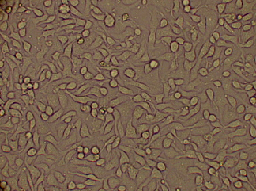
Figure (2): Control Non-infected Vero Cells Line After 3days on Eagle Minimal Essential Medium (400X) .
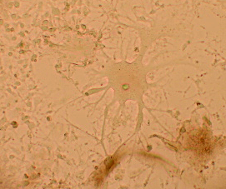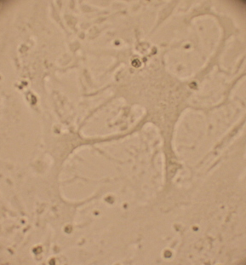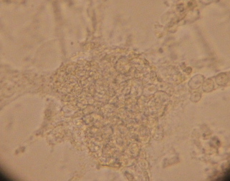
( 4 days ) ( 5 days ) ( 6 days )
Figure (3): Clear Measles Virus Cytopathic Effect Appearance on Vero Cells Line As a Dendritic Cell and Gaint Cell Formation in Eagle Minimal Essential Medium (400X).
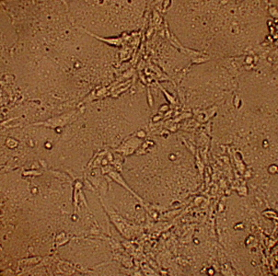
Figure (4): Third Passage Cytopathic Effect of Measles Virus on Vero Cells Line After 72 hours Post Inoculation in Eagle Minimal Essential Medium (400X).
Isolation of Measles Virus on Primary Chicken Embryo Fibroblast Cell Culture: The result showed that chicken embryo fibroblast (CEF) was able to support the isolation and augmentation of measles virus from vaccinated individual. This were confirmed through detection of CPE induced by isolated virus on tissue culture from CEF. We had been used CEF for isolation of the virus because it's easily prepared, cheep and available.The chicken embryo fibroblast was poorly permissive to an infection by the isolated virus but advance passage of virus on it, begin an adaptation process during which, the envelope glycoproteins have been selected for efficient entry of virus into CEF, as MeV entry into cells requires a precise dynamic molecular scaffold involving binding of hemagglutinine to a receptor, the suitable pairing of H and F glycoprotein and conformational change in receptor of H and / or F protein (30, 31).The capability of MeV to bind to CEF non-required CD46 receptor but lead to an endogenously synthesized protein and doesn't require N-glycosylation for its interface with MeV. This reputed MeV receptor on CEF differ from CD46 and interfaces with H protein by determinants distinct from those implicated in H interface with CD46 (Escoffier and Gerilier, 1999; Al-kaffigi, 2006). During the first passage of the virus there is no appear on CEF of the CPE after inoculation of MeV while on second passage of the virus CPE was noticed and appear after 2nd day post inoculation and increased in number of infected cells as foci distributed throughout the culture surface as rounded cells and formation of small syncytia and increase intracytoplasmic vacculation as a result of replication of MeV in the chicken embryo fibro-blast. However, larger syncytia formation and Giant cells clearly demonstrated on 2rd passage of the virus (Figure: 6). This finding gave good indication of CEF cell culture support for MeV replication and propagation and can be early be used for virus isolation. These result agreement with previous study by (32, 27). Clear dentritic cell formation a characteristic morphology of measles virus was noticed after 5days post inoculation in fourth passage of the virus in comparison with control cell culture figure 5 and figure 7.
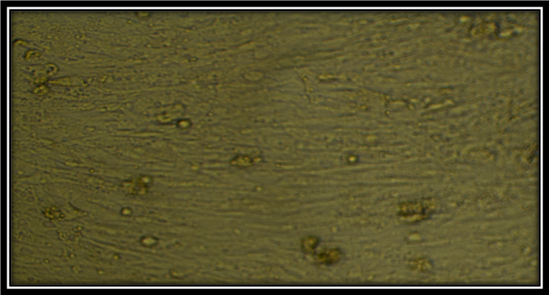
Figure(5): Primary Chinken Embryo Fibroblast Cell Culture After 3 Days Non-Infected (Control) in Eagle Minimal Essential Medium (100X).
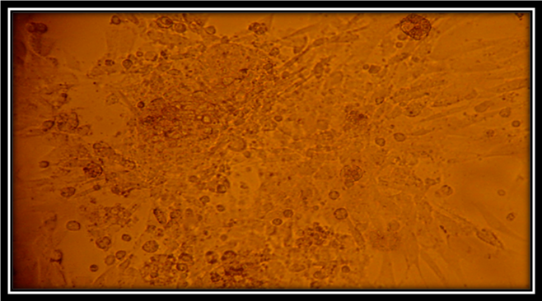
Giant cell
Figure (6): Giant Cell with Measles Virus on Primary Chicken Embryo Fibroblast Cell Culture (Cytopathic Effect) After 3 Days Post Infected of 2nd Passage in Eagle Minimal Essential Medium (100X).
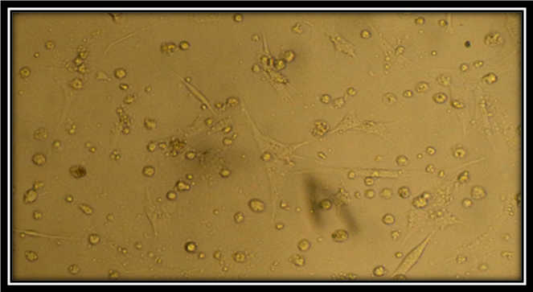
Figure (7): Fourth Passage Clear Measles Virus Cytopathic Effect appearance on Chicken Embryo Fibroblast As a Dendritic Cell After 5 Days Post Infection in Eagle Minimal Essential Medium (100X).
Titration of Viral Isolation: The titer of isolated MeV on infected Vero cell line was 10^{5.8}TCID₅₀ / 0.1ml, while the titer on infected CEF cells was 10^{5.4} TCID₅₀ / 0.1ml in 6 days of the third passage comparism control cell showing normal appearance, therefore that Vero cell was higher than CEF. This finding is agreement with (27) who stated that titration in Vero cell line higher than chicken embryo fibroblast.
Identifection of Measles Virus in Cell Culture: The isolated virus had been used detected by two method: first by using agar gel immune diffusion which is present of clear precipitin line formed between the central wells containing the antigen and the peripheral well containing the rabbits hyper immune serum figure 8.
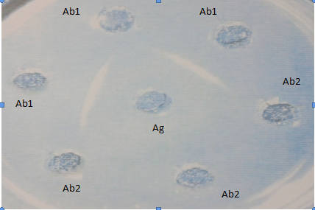
Figure (8): Precipitin Line ( ) Between Suspected Measles Virus Case (Antigen) and Hyper Immune Serum on Agarose Medium (0.8g). Ag= Suspected Case; Ab1= Rabbit Hyper Immune Serum Sample; Ab2= Normal Rabbit Serum and Non Vaccinated Children.
The second method was indirect fluorescent antibody technique (IFAT) by which the virus replication was detected by FITC conjugated anti-MeV immunoglobulin and clear appearance of bright intracytoplasmic and intranuclear fluorescen and increase in its intensity as the culture progress in time which was clearly different from control cell culture that contain no such pathognomic picture. The test was carried at different time of culture interval at 24, 48, 72 and 96 hours after 3rd and 4th passage figure 9.
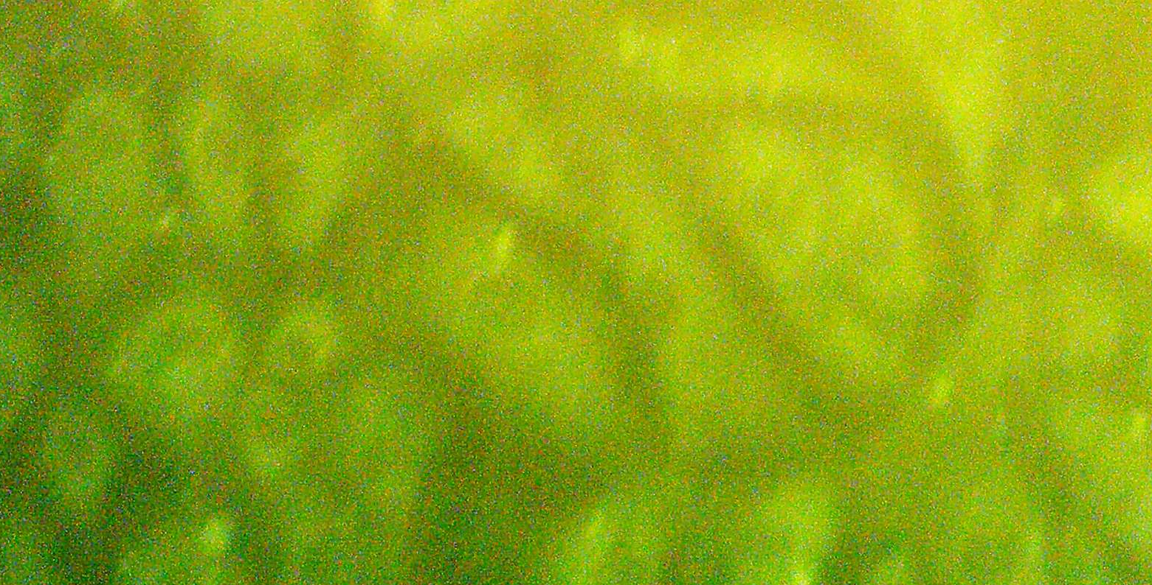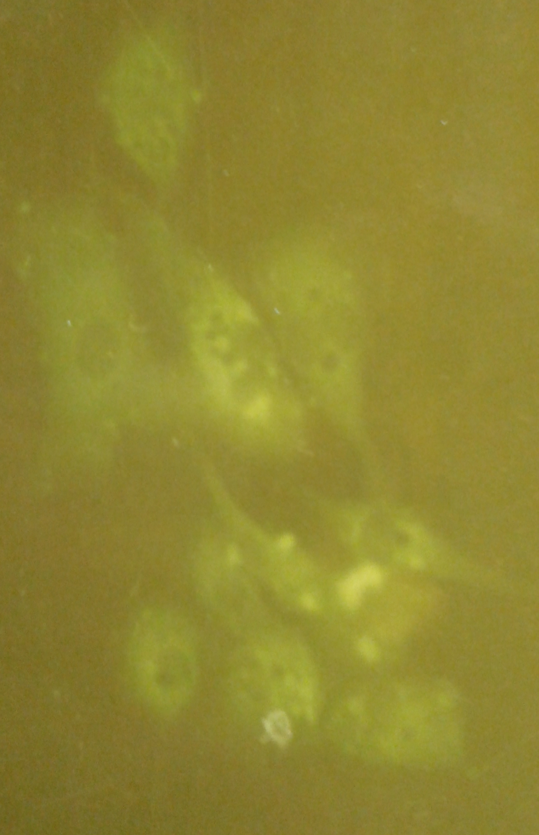
A B
Figure (9): (A) Non-infected Vero cells line control cell culture stained by Indirect Fluorescent Antibody Technique. (B) Vero cell line with Cytopathic Effect of Measles Virus stained by Indirect Fluorescent Antibody Technique after 96h post infection (1000X).
Thus from results expressed as above a Successful measles virus isolation from vaccinated individual could be done by lymphocytes cultivation.
Acknowledgements:
The thanking for volunteers (refugees and residents) who represent the samples of the present study. I would like to my special thanks for Dr. Hamed N. Al-Kelaby, supervisor of the Centre of Cancer researches / Babylon medical college and Ph.D. student Rasha F. Obid . In addition, special thanks to Dr. Mayada Al-Amery, supervisor virology laboratory in Veterinary Center-Baghdad/ pharmaceutical and biocontrol department for helping me in isolation and identification process.
Reference:-
1. Jost, M.; Luzi, D.; Metzler, S. Miran, B. and Mutsch, M. (2015). Measles associated with international travel in the region of the Americas, Australia and Europe, 2001-2013: a systematic review; Travel Med Infect Dis. ;13(1):10-8.
2. Hahm, B.; Arbour, N. and Naniche, D. (2003). Measles Virus Infects and Suppresses Proliferation of T lymphocytes From Transgenic Mice Bearing Human Signaling Lymphocytic Activation Molecule; J. Virol.;77(6):350515.
3. Lyimo, J. (2012). Uptake of Measles Vaccination Services and Associated Factors Among Under Fives in Temeke District, DAR ES Salaam Region, Tanzania. M.Sc. Thesis, Muhimbili University of Health and Allied Sciences.
4. Beaty, S.M. and Lee, B. (2016). Constraints on the Genetic and Antigenic Variability of Measles Virus. Journal / Viruses/ www. mdpi.com. 8(109); doi:10. 3390/ v8040109.
5. Plattet, P.; Alves, L.; Herren, M. and Aguilar H.C. (2016). Measles Virus Fusion Protein: Structure, Function and Inhibition. Journal / Viruses / www.mdpi.com. 8(112); doi:10.339 0/ v8040112.
6. Moss, W.J. and Griffin, D.E. (2012). Measles; Lancet. ;379 (9811):153-64.
7. Su, Q.; Zhang, Y.; Ma, Y.; et.al. (2015). Measles imported to the United States by children adopted from china; Pediatrics.;135 (4):e10327.
8. Fortuna, C.; Baggieri, M. and Marchi, A. (2014). Measles in Italy, laboratory surveillance activity during 2010; Ann Ist Super Sanita; 50(4):341-4.
9. Enders, J. F. & Peebles, T. C. (1954). Propagation in tissue cultures of cytopathogenic agents from patients with measles. Proc Soc Exp Biol Med 86, 277–286.
10. Tikhonova, N.T.; Mamaeva, T.A.; Naumova, M.A.; Leschinskaja, E,V.; volkovo, M.V. and Martynenk, I.M. (1992A). Wild measles virus strain: isolation and identification. Acta. Virol. 36(6): 557-566.
11. Al-Shammari, A.M.; Ismaeel, F.E.; Salih, S.M. and Yaseen, N.Y. (2014). Live attenuated measles virus vaccine therapy for locally established malignant glioblastoma tumor cells. Metrics, Get Permission. Vol:3 Pages 57-68. DOI http://dx.doi. org/10.2147/ OV.S59037.
12. Kobune, F.; Sakata, H. and Siugiura, A. (1990). Marmoset lymphoblastoid cells as a sensitive host for isolation of measles virus. J. Virol. 64, 700–705.
13. Forthal, D. N.; Aarnaes, S.; Blanding, J.; de la Maza, L. and Tilles, J. G. (1992). Degree and length of viremia in adults with measles. Journal of Infectious Diseases 166, 421-424.
14. Kratzsck, V.; Hall, W.W.; Magashima, K. and Ter-Meulen, V. (1977). Biological and Biochemical Characterization of latent SSPE virus infection in tissue culture. J. Med virol ; 1: 139-154.
15. Barbanti-Brodemo, G.; Oyaagi, S.; Katz, M. and Koprowski, H. (1970). Presence of two different viral agents in brain cell of patients with SSPE. Proc soc EXP Biol Med; 134: 230-236.
16. Rusutigian, R.; Winston, S.H. and Darlington, R.W. (1979). Variable infection of vero cells and homologous inter ference after cocultivation with Hela cells with persistent by Edmonston measles virus. Infect And Immun; 23(3): 775-786.
17. Latif , I. I. (2002). Measles vaccination among seropositive individuals: an in vitro and in vivo virological and Immunological study. A thesis submitted to the council of Sedum College of medicine, Saddam University.
18. Sigel C, Johnston S, and Adair S, (1990). Isolation of measles virus in primary rhesus cell from a child with acute interstitial pneumonia who cytologically had giant-cell pneumonia without a rash. Amer J clin pathol; 94(4):446-449.
19. Tikhonova, N.T.; Mamaeva, T.A.; Naumova, M.A.; Leschinskaja, E,V.; volkovo, M.V. and Martynenk, I.M. (1992B). The isolation of measles virus strain and the study of their haemagglutinating activity Vopr-virusol; 37(6): 261-264.
20. Rima, B.K.; Martin, S.J. and Gould, E.A, (1979) A comparison of polypeptides in measles and SSPE virus . J Gen Virol; 42: 603-608.
21. Sibylle, S.S. and Volkerter, M. (2000). Measles" in principles and practice of clinical virology. 4th ed: Pp:357-385.
22. Norrby, E. (1962). Haemagglutination by measles virus: A simple procedure for production of high potency antigen for haemaggl-utination inhibition (HI) test. J Infect Dis; 132: 262-269.
23. Expanded Programme on Immunization (1997). Compostion of media and other reagents in cell and virus culture in: Manual of laboratory method for testing vaccine used in the , WHO, Geneva Switzer land World Health Organization.
24. Swayne, D.E.; Glisson, J.R.; Jackwood, M.W.; Pearson, J.E. and Reed, W.M. (1998). A laboratory manual for the isolation and identification of avian pathogens. 4th edition. American Association of Avian Pathologists, University of Pennsylvania.
25. Annadurai, B. (2009). Immunology and immunotechnology. S. Chand and Company LID. New Delhi- 110055.; pP: 185-190
26. Al-Khafaji, Y. AR. , (1998). Application of locally prepared diagnostic assay for detection of human and calf Rota virus. Ph. D. thesis Baghdad University. College of Veterinary Medicine.
27. Al-Khafaji, Z.A. (2006). Isolation of measles virus and evaluation of immunological response among healthy and diabetic children. M. Sc. Thesis. College of Medicine, Al-kufa University, Iraq.
28. Yanagi, Y.; Takeda, M. and Ohno, S. (2006). Measles virus: Cellular receptor, tropism and pathogenesis. J. Gen. Virol. 87: 2767-2779.
29. Norrby, E. and Oxman, M.N. (1990) Measles virus. In: Fields BN and Knipe DM (eds) Virology, 2nd edition. New York: Raven Press Ltd, pp 1013–44.
30. Buchholz, C.J.; Schneider, U.; Devaux, P.; Gerlier, D. and Cattaneo, R. (1996). Cell entry by measles virus: long hybrid receptors un couple binding from membrane fusion. J.Virol.70:3716-3723.
31. Gerlier, D. and Devaux, P. (1997). CD46 unpremier recepteur du virus. de la rougeole.Virologie 1:321-330.
32. Escoffier, C. and Gerlier, D. (1999). Infection of Chicken Embryonic Fibroblasts by Measles Virus : Adaptation at the Virus Entry level. J. Virol.; Vol.73,No.6: P. 5220-5224.

