REAL ESTATE AND MATRICIAL ANALYSIS

Keywords: Real Estate Appraisal, Estimated Market Value (EMV), Matrix Analysis of Real Estate Values.

ABSTRACT
In this paper a new approach is presented to establish unit sale values for residential properties constituted as horizontal property units, common said freehold apartments or flats, considering a real estate investment and its Estimated Market Value (EMV).
The economic and financial parameters associated to a certain real estate investment being known, such as design and construction costs, expected sale’s values and marketing fees, an associated profitability can/may be determined.
For a presumed profitability on a given real estate investment of freehold flats, the matrix analysis allows to ascertain the overall EVM (i.e., the amount of income) according to the units typologies, constituting the whole investment, or assigning a marketing target per square meter unit value.
A study case is presented in the article considering the referred matrix approach analyzing a real estate investment consisting of different flat types (in horizontal property) to ascertain unit sale values and, at the same time, granting the overall EMV and consequently its profitability.
Considering the study case and the methodology followed by the inversion and matrix multiplication of precisely defined independent terms, one can state that the application of a matrix approach in the analysis of real estate investment is a fast and easy tool to monitor the variability of different parameters related to market investment allowing to fix unit values (per square meter) of flats based on a target profitability value for the investment.

1 - INTRODUCTION
The decision of making a real estate investment entails uncertainties and the investor's attitude towards risk taking is decisive to establish the analysis of the different factors involved, demographic, social, economic and market segmentation in which the investment takes place [1,2].
Once established the investment and defined the economic and cyclical parameters such as cost, income, and deadlines for development one or more provisional cash flows are appointed allowing an estimate of expected returns [3].
The predictable investment cashflow requires a distribution of costs and revenues over an established time frame which must be associated with the construction schedules and deadlines processes (Figure 1). Throughout all this process the investor should bear or somehow endure the costs related to the implementation of the investment.
In the case of real estate investments, revenues may often occur before they are completed. This is the case of shares or apartments of real estate investment coming into operation or which are traded during development stage covering a parcel of costs, which is denoted as "self-financing" in many occasions.
For example, the construction of a housing flats building constructible in stages, allows the proceeds from sale of shares or apartments completed and traded to cover the costs, or some parcels of it, of the remaining dwellings under construction.
In establishing and analyzing projected cash flows of any real estate investment there are two alternatives to follow to obtain the total value of revenues (total sale):
- Income can be gathered through comparative appraisals for a particular market of similar real estate units by estimating the market value (EMV) for the whole project, and thus the corresponding Internal Rate Return (IRR) can be assessed;
- Alternatively, for the same project costs, prices will depend on the required yield or (IRR) imposed by the opportunity cost on the invested capital, which reflects risk’s investors.
The first approach is most common for establishing a cash flow, and the total amount of the income is based on the EMV as the sum of the market value of each unit based on a peer to peer comparative market method.
In the second case the amount of the revenue is derived based on defining or setting a desired profitability which it’s much more effective and coherent, once sales values from different parts of investment are obtained by distributing the total revenue for each of the freehold apartments constituting the investment.
This distribution shall be carried out in accordance with the relationship between unit sales values for the different flat types or typologies depending on the specific market and/or region being assessed.
The present approach meets this demand by delivering a set of tools allowing the necessary flexibility for any investor to gather sales values for each apartment typology and investment keeping up with market trends, i.e., EMV, and controlling the expected return on the investment. Therefore, the investor has a tool to act competitively comparing and following up rivalry market values.
The solution to this problem is presented in this paper using matrix analysis to assign unit sale values, vᵤ, by type of apartment or typology granting the overall target income, and to establish meaningful minimum real estate prices
This approach can be exemplified with a study of simplified case by using the so-called pseudo-dynamic method approach to estimate the market target value EMV [4].
A real estate investment cashflow can be represented as shown in Figure 1, requiring the need to know the construction cost values, execution deadlines and marketing expected terms of sale, as well as other costs associated with the land, architectural and engineering design costs and other both direct and indirect costs.
Having fixed a return on investment and defined the value of income that meet this return, means that setting a value for the internal rate of return on the investment (IRR) results in a single unknown which is the value of the income (EMV).
It is of interest now to distribute the total amount of income, the minimum EMV, among the different apartments that make up the investment. The distribution method of this value is carried out based on unit area values, vᵤ by type of apartment.
In a simple and prompt manner, an investor may use a matrix analysis to adjust the market values, determining the unit sale values of the apartments, without compromising the expected return.
During the process of marketing and selling the investor may monitor and adjust the sales values according to the market conditions and with the competitive advantages arising therefrom.

2 - INCOME AND PROFITABILITY
In the presence of the main parameters and cashflow variables of a real estate project, it is possible to, in a simplified and low error margin way, establish an equation that evaluates the profitability according to the costs and or income associated with them [4].
Using the expression by Camposinhos [4], the internal rate of return (IRR) of a real estate investment can be obtained by Equation (1):

(1)
Where:
EMV – Estimated market value of the investment;
IRR - Internal rate of return;
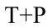 - Cost of land and projects;
- Construction cost;
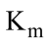- Cost associated with marketing and sales;
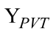- Time equivalent to the instant occurrence of income;
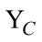 - Time equivalent to the instant occurrence of the construction;
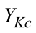- Time equivalent to the instant occurrence of indirect costs associated with construction;
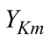- Time equivalent to the instant occurrence of costs associated with sales.

Equation 1 can be interpreted using Figure 1. The equivalent period is defined by the time elapsing between the start of a given investment component and a certain instant during its occurrence.
This period is determined to simulate the instant occurrence of a value by distributing it within its duration period so that its value, when updated at a given rate, is the same. Notwithstanding incurring into significant precision errors, the time equivalent of the current value rates at that moment is almost equal to half the term of a given activity [3].
Accordingly, the equivalent time of a component, i, investment, Yi, is the duration that elapses from the beginning of the project - generally coinciding with the acquisition of the land and project - up to half the period of development of each phase of the investment process.
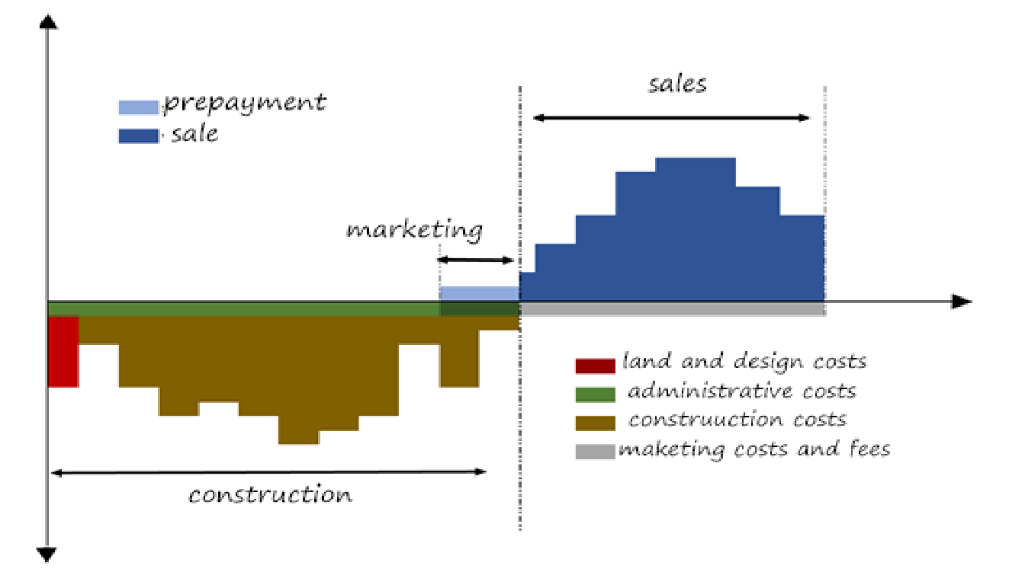
Figure 1 – Typical schedule of a real estate investment
Given the purpose of this approach, in Equation (1) we consider fixed the values of the costs, and as interdependent variables the value of income (EMV) and/or the value of the internal rate of return (IRR).
In other words, once the value of a variable is set, the value of the other is obtained explicitly, since all the remaining are considered as dependent and known.

3 - MATRIX APPROACH IN THE DETERMINATION OF SALES VALUES
Considering a given real estate investment, for example a residential housing, constituted in horizontal property (PH), composed of n apartments with differentiated typologies. The n types of apartments can be separated by their physical attributes, such as area and number of rooms, among others.
If within that real estate investment, the, n, apartments with different types are identified by their areas (A) and the corresponding unit sale values (vᵤ), then the sum of the products of their areas with their unit value of sales is equal to the total value of the income to be realized, that is the presumed transaction value (PVT) of the building.

Thus, the linear condition for determining the EMV property investment can be translated by Equation (2):
(2)

Expression (2) has an infinite number of solutions for the variable,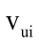, demanding (n-1) equation to eliminate the indeterminacy.
A system of linear equations must be set, thus (n-1) supplementary equation are required.
Therefore (n-1) conditions are defined based on the relation between the flats unit’s sale values,, of different, n, dwelling categories, so that a unique solution for the total revenue EMV can be calculated.
Based on data of real estate medium unitary prices ratios of the different categories depending, for example on the bedroom’s number or any other relevant attribute, a coefficient 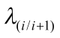 is defined representing the ration between unit sale values of the different typologies or dwelling’s categories as follows:
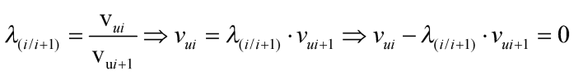 (3)
Equations (3) allows the investor to establish, n-1, relationship between the different unit sale values for the, n, different categories.
Therefore, a minimum EMV is determined by solving the system of linear equations imposing n equations for the n unknowns, according 1st Equation (2) and (n-1) equations as defined in (3).
Converting the system of linear Equations to matrix form one gets:
M .Vu = S (4)
Where,
M | The coefficient matrix with n coefficients of the unknowns with the first row; corresponding to the total construction area (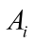) of each category, and the remaining rows with zeroed except for the positions, i and i+1, corresponding to the independent variables, and 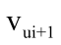 with 1 and, 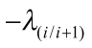, values in the respective column position (see equation 2);
Vu | The vector of unknowns, n, corresponding to the unit sale values ;
S | The call vector corresponding to the total value of the profits (EMV) in the 1st position.

3.1 – Coefficient Matrix
The coefficient matrix, (M), is defined accordingly:
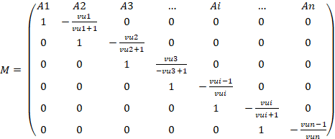 (5)

Where,
- | The areas for the sale of n flats in order i building constituents
- | The unit sale values of the n flats in order i building constituents
- | The ratio relating the sale of unit value of the flats of n-1 order and unit sales value of the flats of n order

In the residential real estate market, it is common ground that between similar or close types the unit value of sale (vᵤ i) apartments of i type increases when the area (Ai) decreases.
However, in each different apartment type specifics must be considered, since in the same order types different residential characteristics can be offered, and they should be grouped accordingly. However, case by case, it is possible to establish relation between the unit sale values of n constituent apartments of the investment.
Thus, having established the relationship between the unit sale values of n apartments of different types of orders, the ratios obtained are independent coefficients of the unknowns that make up the matrix (M) shown in (5).

3.2 – Independent vector
Equation (4) has as unknowns the values of the vector {Vu} = {vᵤ 1; vᵤ 2; Vᵤ 3; ...; Vᵤ i; ...; Vᵤ n} so in matrix notation it takes the following expanded form (6):
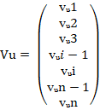 (6)
3.3 – Demand Vector
The matrix multiplication M independent coefficients with the vector elements Vu unit sale values of n different types of apartments require the result to be exactly equal to EMV.
Thus, in the matrix equation the n elements of the request vector S are defined in its expanded shape (7):

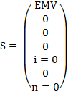 (7)
3.4 - Matrix Equation
The matrix M independent coefficients as set forth in (5) is merely indicative, but is nonetheless paradigmatic for cases in which each coefficient represents for example residential apartments of different types.
The determination of n-1 links between the n i apartment types, which are intended to determine the unit value of sale (vᵤ) can be obtained by considering the above mentioned.
Thus, the matrix notation of Equation 4 assumes the following expanded form (8):

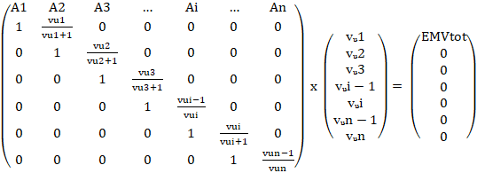 (8)

Where,
- | The areas for the sale of n flats in order, i, building constituents
- | The unit sale values of the n flats in order, i, building constituents
- | The ratio relating the sale of unit value of the flats of (n-1) order and unit sales value of the flats of order, n.
EMV - | The total amount of income to be realized (Estimated Market Value of the Investment)

The solution for the vector Vu (6) which allows the unit values of the n flats of sale i types to be found, is obtained by the resolution of the matrix equation (8) by inverting the matrix M.
Vu = M ̄ ¹. S (9)
The inverse matrix 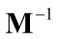 is a square matrix of the same order n, easily defined once det [M] ≠ 0. The inversion operation is available in any mathematics software as simple as "Excel".
Once defined the EMV for the real estate investment is obtained, the matrix approach allows to easily impose the unit sales price (vᵤi) for all the groups or categories and hence to determine the unit sale value of flats of different types of orders i.
Throughout this approach, it is required to replace the demand vector (S) coefficient "0" of row i by the value fixed for the apartments of order typology i, and in the matrix of independent coefficients (M) to replace the respective index λi / i +1 by 1.

4 - CASE STUDY
As example let us assume the application of a real estate investment that consists of a residential building with 42 apartments of categotiesT0, T1, T2, T3, T4 and T5, which areas and unit sale values are summarized in Table 1.
The unit sales values listed in Table 1 the comparative method of market values estimated types.

Types of Apartments | T0 | T1 | T2 | T3 | T4 | T5
Number of Apartment by Type (un) | 10 | 10 | 5 | 10 | 5 | 2
Areas by Type (m²) | 60 | 70 | 100 | 140 | 180 | 220
Unit Value (€ / m²) | 1549,30 | 1260,10 | 1136,10 | 1187,80 | 1446,00 | 1859,10
Table 1 - Areas and unit sale values by type of Apartment

In these costs and charges associated with the investment have already been established, as well as the time limits and the equivalent realization time as shown in Table 2.
Through the investment data we intend to establish the value of the income profits and profitability.
It is possible to determine the value of the total revenues to be held from the multiplication of areas of different types of apartments by the corresponding unit sales values. Using the values in Table 1 we found the value of 6 162 024 € for the EMV. With the EMV established and the remaining values in Table 2 we can use Equation (1) to find the IRR of the investment, which in this case shows a profitability of 6.28%.
Hypothetically, let us admit that rate of return, even if attractive, is considered too ambitious, so after a risk assessment investors prefer to present a more competitive marketing numbers, considering a value for the risk premium equal to 3% and one risk-free rate equal to 1.87%.

Costs and charges of the investment
Tp | 500 000€ | The cost of land and projects
C | 400 000€ | The direct cost of construction
Kc | 220 000€ | Indirect costs associated with the construction process
Km | 460 000€ | Marketing costs and others associated with the realization of income
Deadlines and equivalent time of making the investment
YEMV | 5 Years | The equivalent time for the occurrence of income, corresponding to a period of 2 years to make the sales after finishing the construction
YC | 2 Years | The equivalent time of occurrence of the construction costs, corresponding to a period of 4 years for construction completion
YKc | 2 Years | The equivalent time of the occurrence of indirect costs associated with the construction process, corresponding to the construction period
YKm | 4,75 Years | The equivalent time of occurrence of the costs associated with sales, considering that sales started ½ year before completion of the construction (3.5 + 2.5 / 2)
Table 2 - Costs, charges, terms and equivalent investment times
In this case, we must again use Equation (1), imposing the value of 4.87% for the IRR and keeping the remaining values of Table 2 corresponding to the investment and thus determining a new value for the total of the investment value. Under these conditions the new value found for the EMV is 5 966 000 €.
Let us assume that the investment in question is in some other region and investors aim to follow the trends of the real estate market in that region. For that market region, selling unit values are known for similar apartments T0 to T5, as shown below in Table 3.
North Region |  |  | New Apartments Offer
Types | Number of Apartments (un) | Areas by Type (m²) | Minimum  Unit Value (€) | Medium  Unit Value (€) | Maximum  Unit Value (€) | Unit Value  (€ / m²)
T0 | 87 | 52 | 40 000,00 € | 79 726,00 € | 475 000,00 € | 1 544,00 €
T1 | 2542 | 69 | 40 000,00 € | 84 648,00 € | 275 000,00 € | 1 220,00 €
T2 | 5521 | 102 | 41 000,00 € | 114 161,00 € | 925 000,00 € | 1 118,00 €
T3 | 4490 | 137 | 47 386,00 € | 157 685,00 € | 800 000,00 € | 1 150,00 €
T4 | 870 | 186 | 72 500,00 € | 259 464,00 € | 998 000,00 € | 1 396,00 €
T5 | 149 | 235 | 105 000,00 € | 433 181,00 € | 970 000,00 € | 1 842,00 €
Table 3 – Values of Sale - North Region
For the different typologies that the investment offers, based on the amounts stated in Table 3, one can determine the relation between the unit values of apartments for the different categories or typologies T0 to T5.
If this investment is intended to follow the new local market trend as shown in Table 3, the matrix formulation of the problem allows the definition of the coefficient matrix (M), the demand vector (S) and the unknowns vector (Vu) values are obtained according to Equation (4).
4.1 – Coefficient Matrix, Demand Vector and Solution
Being established the ratios that represent the relation between the unit values of T0 to T5 apartments of the investment, as shown in Table 4, the matrix of independent coefficients M is obtained as in expression (10).
Relation between Apartments | Ratio λi/i+1
T0/T1 | 1,266
T1/T2 | 1,091
T2/T3 | 0,972
T3/T4 | 0,824
T4/T5 | 0,758
Table 4 - Ratios of unit values of the Apartments

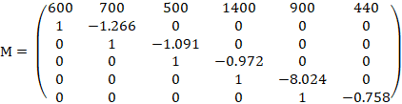 (10)

Upon this hypothesis, investors expect to realize the amount of € 5.966 million and a return of 4.87% on the investment, so that demand vector S is:

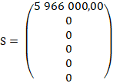 (11)

Inversing matrix, M, one obtains:

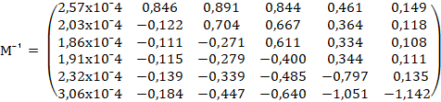 (12)

Solutioning Equation (9) leads to the following values for vector, Vu:

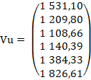 (13)

4.2 – Conditional Approach
Keeping these assumptions, let us now consider a shortage of the type T5 apartments and investors intend to set the initial price value for these two apartments (vᵤT5 = € 1,859.1 / m²).
The solution is easily found by solving equation (9), with values settled in accordance to this condition.
Once established the ratios between the unit values of the apartment’s typologies T0 to T4 as shown in Table 5, a new coefficient matrix, (Mc), will depend on the unit value for typology T5 as showed in Table 5.
Relation between Apartments | Ratio λi/i+1
T0/T1 | 1,266
T1/T2 | 1,091
T2/T3 | 0,972
T3/T4 | 0,824
VᵤT5 fixed | 1,000
Table 5 - Ratios of conditioned unit values of the Apartments

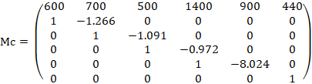 (14)

The expected gross value must be the same as the return as well, therefore the new imposed demand vector Sc is defined:
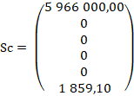 (15)

Similarly, inversion of matrix Mcˉ¹ is obtained:

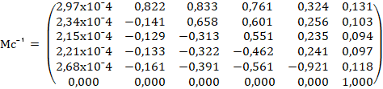 (16)
Applying Equation (9), one leads to the elementary conditioned vector values, Vuc, shown in (17), once vᵤT5 was set at 1 859.00 € / m².
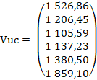 (17)
Thus, new unitary marketing values for the remaining apartments can be lessened with a more aggressive marketeering.

5 - CONCLUSION
The real estate investment analysis through the evaluation of its cashflow, determined from the costs and income to be carried out over time, requires flexible and rapid approaches to determine the unit sale values for the different types of apartments without losing control of EMV and profitability.
Following a matrix approach for market values the method shows to be a competitive tool for determining unit sale values for apartments or dwelling units of an investment after imposing a return on the investment and consequently a minimum for value for prices.
This approach enables investors to, in an efficient easy manner, determine the most competitive unit sales values on the market without putting at risk the revenues and profitability of their investments.

REFERENCES

[1] | Y. Y. Chong, Investment Risk Management, Wiley, 2003.
[2] | J. C. d. Neves, J. Montezua and A. Laia, Análise de Investimentos Imobiliários, Alfragide: Texto Editores, 2010, p. 410.
[3] | R. Pilcher, Project Cost Control in Construction, Oxford ; Boston: Blackwell Scientific Publications, 1994.
[4] | R. d. S. Camposinhos, "Método do Custo - Abordagem Pseudo-dinâmica," ISEP, Porto, 2016.

