DAPSONE INDUCED DRUG RASH EOSINOPHILIA WITH SYSTEMIC SYMPYOMS (DRESS) SYNDROME
Background:
Dapsone has been used for a variety of skin disorders like dermatitis herpetiformis, vesicobullous dermatoses, cutaneous vasculitis, polyarteritis nodosa, nodulocystic acne, cutaneous mycetoma and pustular psoriasis. Adverse effects like hmolysis (more likely to occur with deficiency of glucose 6-phosphate dehydrogenase or G6-PD), bone marrow aplasia, renal disease, peripheral neuropathy, methemoglobinemia, nausea, dizziness, and fatigue may occur singly or in combination. Dapsone hypersensitivity syndrome (DHS) is a rare complication occurring in about 0.2% to 0.5% of individuals, which if unrecognized and left untreated can lead to severe organ dysfunction and even death in about 12%-23% of cases. Here we report a case of dapsone hypersensitivity which was recognized and treated successfully.

Case report:
A 21 years old male admitted with yellowish discoloration of urine for 15 days preceded by appearance of pruritic papulovesicular erythematous rashes (Fig. 1,2) all over the body 5 days before the discoloration of urine and facial puffiness for past 3 days.
He was on Dapsone for the past 2 ½ months for psoriasiform skin lesion over limbs and trunk which was improving. On clinical examination he was febrile (Temp=101*F) with icterus and erythematous papulovesicular lesions all over the body and facial puffiness with partially healed pre-existing skin lesions (Fig. 3). Systemic examination revealed non-tender hepatomegaly. Other system examination were normal.
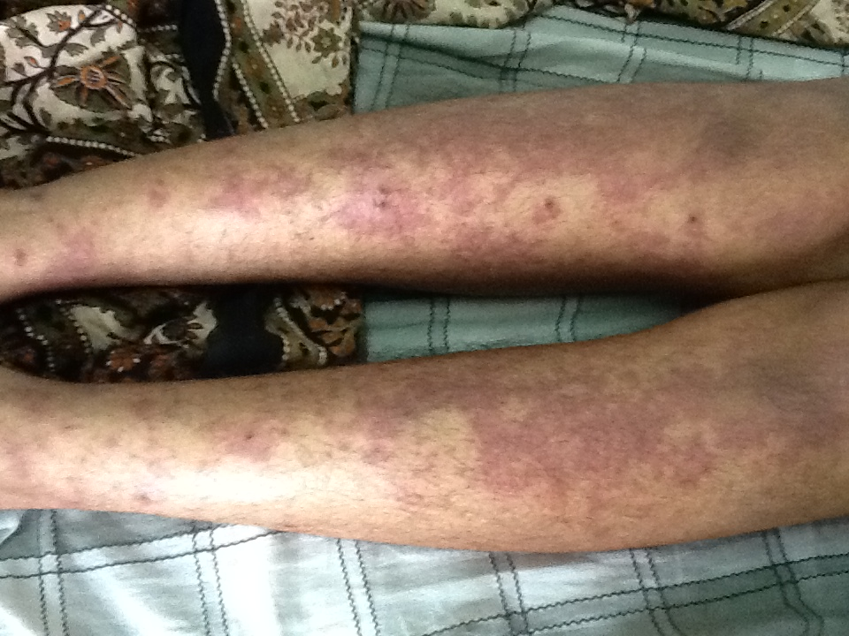
Fig. 1: pruritic papulovesicular erythematous rashes

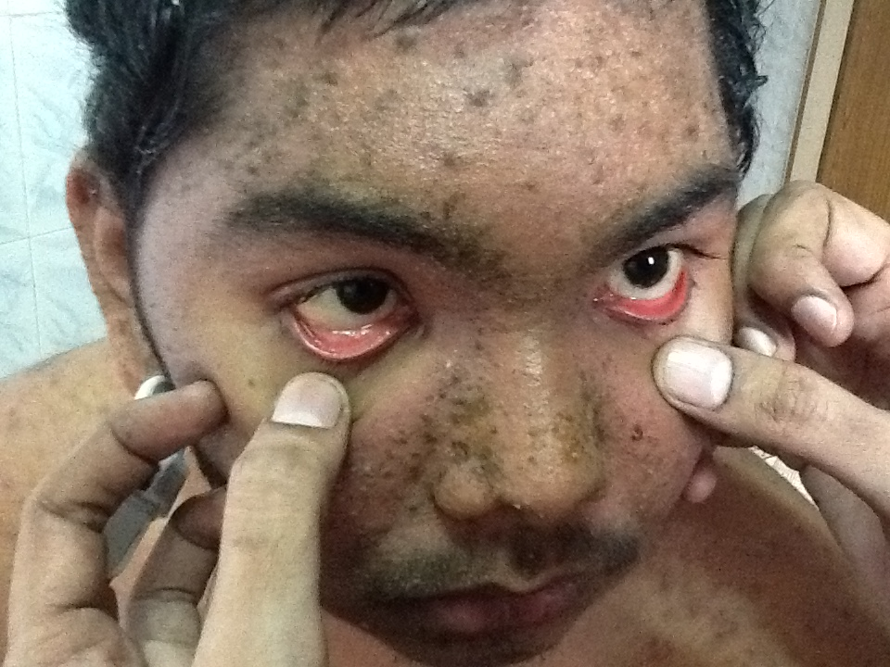
Fig. 2: pruritic papulovesicular erythematous rashes with icterus

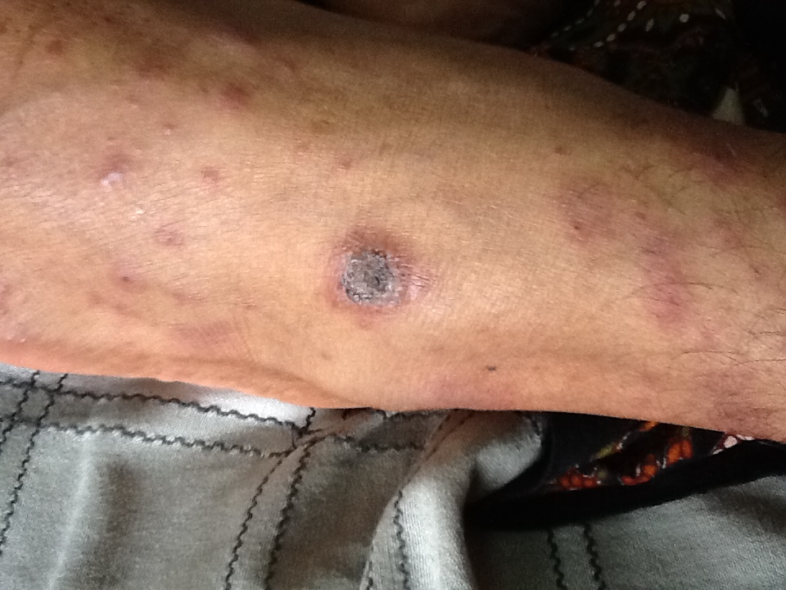
Fig. 3: partially healed pre-existing skin lesions

Full blood count showed Hb-12.3gms%, Total Count-24,700 cells/mm³(DC-P₇₀L₂₀E₁₀), Erythrocyte sedimentation rate of-20mm in the first hour, Platelets-2.59 lakhs/mm³ and smear showing peripheral eosinophilia (The absolute eosinophil count is 8320/mm³). Initial liver function test revealed rise in total bilirubin of 6.3 mg/dl [conjugated fraction of 1.6 mg/dl and unconjugated fraction of 4.7mg/dl] with rise in transaminases [Aspartate aminotransferase (AST) of 103.2 IU/L and Alanine Aminotransferase (ALT) of 218.6 IU/L] with serum Alkaline phosphatase (SAP) of 88 IU/L and Gamma Glutamyl Transferase (GGT) of 52 IU/L. The serum total protein is 6 Gms% with an Albumin of 3.1 Gms%. Serum Lactate Dehydrogenase (LDH) was 956 U/L.

Serology for viral hepatitis (HBsAg, Anti-HCV, IgM for Anti-HAV and HEV) were negative. Routine biochemical analysis showed blood sugar -106mg%, Urea-22mg% and Creatinine-0.8mg%. On Ultrasonography of abdomen, liver was normal in size and echotexture. The Direct and indirect Coomb’s test was negative. Blood for Aerobic and Anaerobic cultures were negative. Urine analysis was unremarkable. Chest radiography was normal.

Based on the patient’s medical history, clinical findings and laboratory test results a diagnosis of DHS (Dapsone hypersensitivity syndrome/drug induced rash with eosinophilia and systemic symptoms [DRESS]) was made. Dapsone was stopped. Skin biopsy was done, showed flaky hyperkeratosis, irregular acanthosis and vessel wall infiltrated with inflammatory cells predominantly eosinophils (Fig.4) suggestive of pustular psoriasis. Patient was started on Prednisolone 30mg/day along with Proton Pump Inhibitors and Acetaminophen for fever. Topical liquid paraffin for skin lesions and Cetirizine 10 mg/day was added for pruritus.

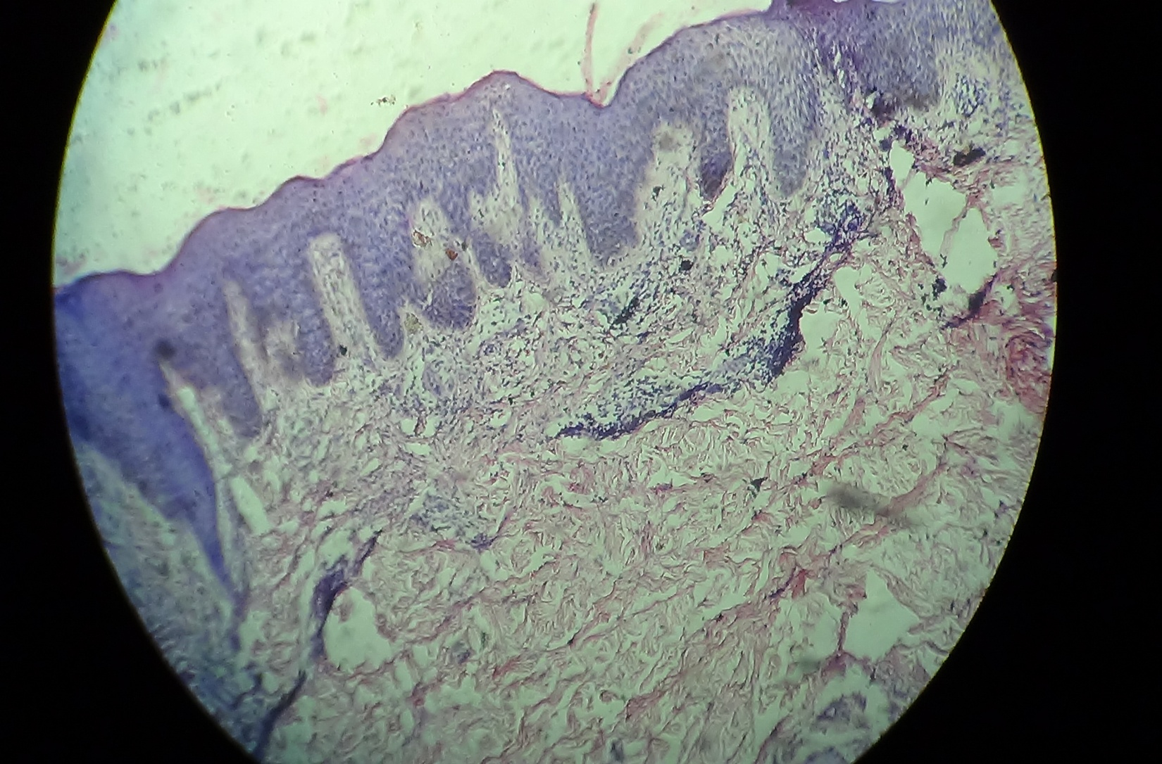
A
Fig. 4: Skin biopsy- A-hyperkeratosis and irregular acanthosis, suggestive of pustular psoriasis

Patient’s fever settled after 2 days and skin rashes were resolving (Fig.5) by 5 days after starting steroids.A repeat LFT five days later showed total Bilirubin-3.31mg%, conjugated fraction-1.42mg%, unconjugated fraction-1.89mg%, AST-54.9 IU/L, ALT-204.8 IU/L, SAP-196 IU/L, GGT-215 IU/L, Protein total=6.1Gm%, Albumin-3.8Gm%, Prothrombin Time-16.8’s,INR-1.25. Liver biopsy was done, which showed portal and peripheral areas infiltrated with eosinophils. Sinusoids show lymphocytic infiltrate. Adjoining hepatocytes showed feathery degeneration, vacuolation and regenerative changes of binucleate hepatocytes suggestive of acute hepatitis (Fig.6).
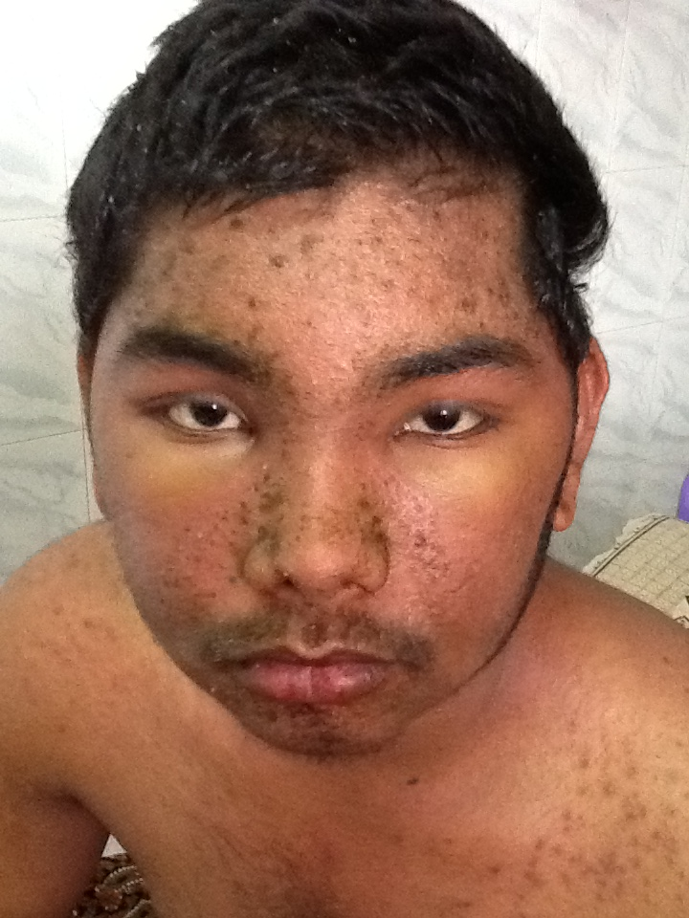
Fig. 5: Resolving skin lesions
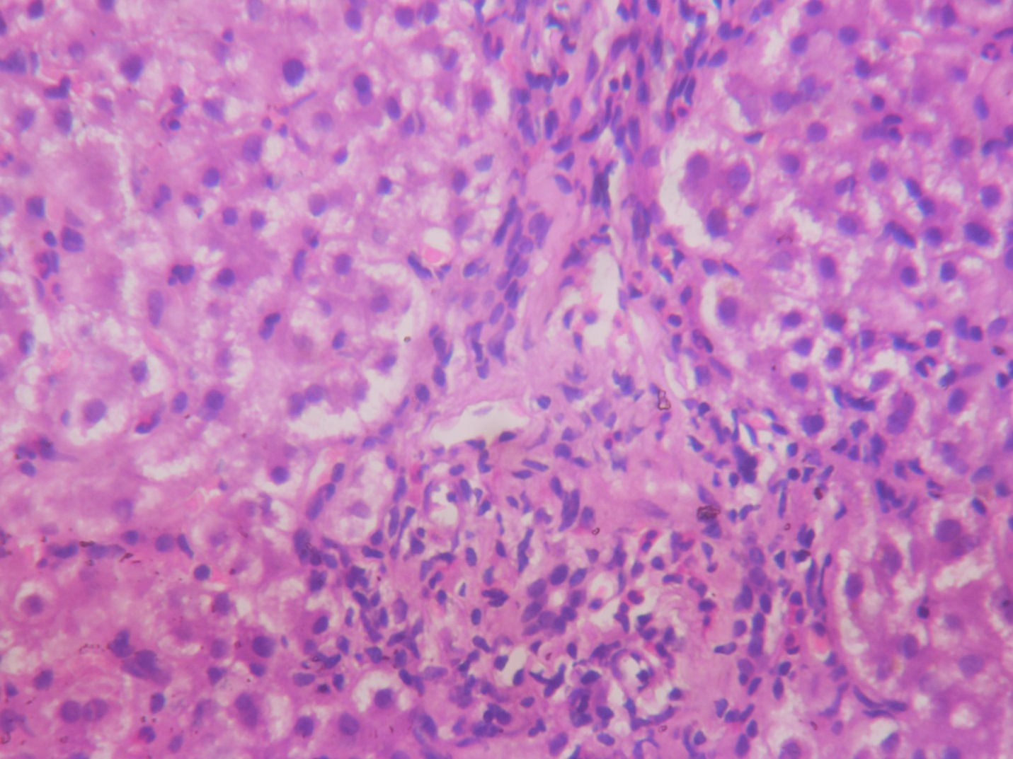
C
B
A
Fig. 6: Liver biopsy-suggestive of acute hepatitis:A-Bile duct, B-Portal Eosinophils,
C-Feathery degeneration

Discussion:
Dapsone (4, 4'-diamino-diphenyl sulfone) is the parent compound of sulfone drugs, used in the treatment of blistering skin diseases, immunological and hypersensitivity disorders.^{[1]}It is well absorbed from the gut and primarily metabolized through N-acetylation and N-hydroxylation (oxidation). The hydroxylamine and the hydroxylated metabolites are potent oxidants and cause hematologic adverse effects, predominantly hemolysis. It is excreted by the kidney, but has significant enterohepatic circulation. It has a long elimination half-life of 24 to 30 hours on the average. Strong protein binding of the drug itself (70-90%) and its major metabolite, monoacetyldapsone (99%), contribute to the long half-life.

Hypersensitivity reaction differs from other drug reactions and occurs during first 6 weeks^{[2],[3]}of initiating the treatment to as late as 6 months.^{[4]} In our patient rashes appeared by the end of 10 weeks.The side effects are very low if plasma concentration of dapsone is below 5 mg/l.^{[5],[6]}
DHS which was described first by Allday, Lowe, and Barnes^{[5],[7]} as a hypersensitivity vasculitis syndrome.^{[4],[5],[7-11]}This syndrome occurs in about 0.2% to 0.5% of patients on dapsone. DHS typically presents with a triad of fever, skin eruption, and internal organ (lung, liver, neurological and other systems) involvement as in Table.1. Our patient had the typical triad with the involvement of liver.
Table 1:
Systemic | Dermatological | Laboratory
1. Fever*  2. Pneumonitis  3. Lymphadenopathy  4. Hepatitis*  5. Hemolytic anemia*  6. Carditis  7. Encephalitis/aseptic meningitis  8. Colitis/Intestinal bleeding  9. Diabetes mellitus  10. Interstitial nephritis  11.Serositis  12.Syndrome of inappropriate secretion of antidiuretic hormone  13.Thyroiditis | 1. Exfoliative dermatitis  2.Eczematous/maculopapular eruption*  3. Oral erosions  4. Vesicles and bullae*  5. Photosensitivity | 1. Hemolysis*  2. Anemia  3. Eosinophilia*  4. Atypical lymphocytosis  5.Transaminitis/elevated bilirubin/alkaline phosphatase*  6. Hypoalbuminemia*  7.Hypogammaglobulinemia
*features present in our case

.
Richardus and Smith ^{[12]} proposed the following criteria to diagnose a case of dapsone hypersensitivity (DHS):
- The symptoms appear within 8 weeks after commencement of dapsone and disappear after the discontinuation of the drug.
- The symptoms cannot be ascribed to any other drug given simultaneously with dapsone.
- The symptoms are not attributable to lepra reaction.
- No other disease liable to cause similar symptoms is diagnosed.
The criteria for DRESS syndrome proposed by Bocquet and colleagues ^{[13]} are as follows:

(1) Cutaneous drug eruption
(2)Hematologic abnormalities, including eosinophilia greater than 1.5x10⁹eosinophils/L or the presence of atypical lymphocytes
(3) Systemic involvement, including adenopathy greater than 2 cm in diameter,
hepatitis (liver transaminases values >2 N), interstitial nephritis, interstitial pneumonia,
or carditis.

RegiSCAR(severe cutaneous adverse reactions) criteria^{[14]}: at least 3 should be present
- Acute Rash
- Fever > 38° C
- Involvement of at least one internal organ
- Lymphadenopathy in at least two site
- Blood count abnormalities - lymphopenia or lymphocytosis, eosinophilia, thrombocytopenia

These criteria emphasize two important characteristics: multiple organ involvement and eosinophilia^{.[15]}Our patient had an absolute eosinophil count of 8320/mm³ with involvement of liver.

Hyperbilirubinemia in dapsone syndrome may partly be due to hepatotoxicity in addition to hemolysis. Liver involvement displays a mixed hepatocellular and cholestatic pattern.^{[16]}ALT, AST, and total bilirubin levels are elevated. Cholestatic pattern have a less severe course characterized by high ALP and moderate transaminase levels. Hepatitis may progress to liver failure and death.Cholangitis also has been reported in a patient who had dapsone-DHS/DRESS. Our patient initially developed features of hemolytic jaundice as evidenced by unconjugated hyperbilirubinemia with hepatocellular involvement as evidenced by transaminitis progressing to cholestatic pattern as evidenced by elevated alkaline phosphatase level.

Liver biopsy usually shows predominantly eosinophilic lobular and portal infiltration, hepatitis, cholestasis, or granuloma formation.^{[17]} The mechanism of injury seems to be hypersensitivity reaction. Our patient had portal and periportal eosinophils with features of acute hepatitis (Fig.6).
Hypoalbuminemia, a feature of dapsone hypersensitivity, is due to binding of dapsone to the circulating serum albumin.^{[18]} Our patient also had initial hypoalbuminemia, which responded to steroid therapy.
Skin biopsy and immunofluorescence studies may show immunoglobulin and complement deposition, a feature of cutaneous vasculitis.^{[19]}

A variety of drugs can cause drug reactions associated with eosinophilia as in Table.2.
Table 2
Causative drugs of DIHS/DRESS
Anticonvulsant
CBZ
Phenytoin
Phenobarbital
Zonisamide
Lamotrigine
Allopurinol
Minocycline
Dapsone
Sulfasalazine
Mexiletine

Since dapsone persists up to 35 days in organs through protein binding and enterohepatic recirculation, slow tapering off of the corticosteroid therapy over at least one month with close monitoring of organ function is required. Abrupt discontinuation may cause a relapse. We tapered the dose of steroids after 4 weeks and the patient recovered completely.
Generally, DHS is a self-limiting drug reaction and most patients recover following cessation of dapsone therapy and starting treatment with oral corticosteroid. Mortality as high as 12-23% has been reported in severe DHS.^{[20]} Physicians should be aware of this infrequent but potentially fatal severe form of adverse reaction that can mimic other conditions.

Bibliography:

- Kosseifi SG, Guha B, Nassour DN, Chi DS, Krishnaswamy G. The Dapsone hypersensitivity syndrome revisited: A potentially fatal multisystem disorder with prominent hepatopulmonary manifestations. J Occup Med Toxicol 2006;1:9
- Rege VL, Shukla P, Mascarenhas MF. Dapsone syndrome in Goa. Indian J Lepr 1994;66:59-64.
- Gokhale NR, Sule RR, Gharpure MB. Dapsone syndrome. Indian J DermatolVenereolLeprol 1992;58:376-8
- Prussick R, Shear NH. Dapsone hypersensitivity syndrome. J Am AcadDermatol 1996;35:346-9
- Zhu YI, Stiller MJ. Dapsone and sulfones in dermatology: overview and update. J Am AcadDermatol. 2001;45:420–434. doi: 10.1067/mjd.2001.114733
- Pavithran K, Bindu V. Dapsone syndrome: hepatitis-B infection a risk factor for its development? Int J Lepr Other Mycobact Dis. 1999;67:171–172
- Knowles SR, Shapiro LE, Shear NH. Reactive metabolites and adverse drug reactions: clinical considerations. Clin Rev Allergy Immunol. 2003;24:229–238. doi: 10.1385/CRIAI:24:3:229.
- Leslie KS, Gaffney K, Ross CN, Ridley S, Barker TH, Garioch JJ. A near fatal case of the dapsone hypersensitivity syndrome in a patient with urticarial vasculitis. ClinExpDermatol. 2003;28:496–498. doi: 10.1046/j.1365-2230.2003.01336.x
- Rao PN, Lakshmi TS. Increase in the incidence of dapsone hypersensitivity syndrome--an appraisal. Lepr Rev. 2001;72:57–62
- Christiansen J, Tegner E, Irestedt M. Dapsone hypersensitivity syndrome in a patient with cutaneous lupus erythematosus. ActaDermVenereol. 1999;79:482. doi: 10.1080/000155599750010012
- Reeve PA, Ala J, Hall JJ. Dapsone syndrome in Vanuatu: a high incidence during multidrug treatment (MDT) of leprosy. J Trop Med Hyg. 1992;95:266–270
- Richardus JH, Smith TC. Increased incidence in leprosy of hypersensitivity reactions to dapsone after introduction of multidrug therapy. Lepr Rev 1989;60:267-73
- Bocquet H, Martine B, Roujeau JC. Drug-induced pseudolymphoma and drug
hypersensitivity syndrome (drug rash with eosinophilia and systemic symptoms:DRESS). SeminCutan Med Surg 1996;15(4):250–7
- Shiohara T, Inaoka M, Kano Y. Drug-induced hypersensitivity syndrome (DIHS): a reaction induced by a complex interplay among herpesviruses and antiviral and antidrug immune responses. AllergolInt 2006;55:1–8
- Roujeau JC. Clinical heterogeneity of drug hypersensitivity. Toxicology 2005;209(2):123–9.
- McKenna KE, Robinson J. The dapsone hypersensitivity syndrome occurring in a patient with dermatitis herpetiformis. Br J Dermatol. 1997;137:657–658. doi: 10.1111/j.1365-2133.1997.tb03814.x
- Itha S, Kumar A, Dhingra S, et al. Dapsone induced cholangitis as a part of dapsone syndrome: a case report. BMC Gastroenterol 2003;3:21.
- Karp WB, Subramanyam SB, Robertson AF. Binding of dapsone and its analogues to human serum albumin. J Pharm Sci 1985;74:690-1
- Limmerman HJ: Hepatotoxicity. 2 ^{nd} ed. Philadelphia: Lippincott Williams and Wilkins; 1999. p. 589-637
- Pandey B, Shrestha K, Lewis J, Hawksworth RA, Walker SL. Mortality due to dapsone hypersensitivity syndrome complicating multi-drug therapy for leprosy in Nepal. Trop Doct 2007;37:162-3.

