Effect Of Prolonged Fasting (More Than Eight Hours) On Fasting Plasma Glucose And Glycemic Control.

Mohamed Mashahit${}^{1}$, Hala Eltokhy${}^{2}$, Mostafa Ahmed${}^{3}$,Mohammed Ahmed${}^{4}$
Abstract

Background:Diabetes mellitus is a chronic illness that requires continuing medical care and ongoing patient self-management education and support to prevent acute complications and to reduce the risk of long-term complications. Diabetes care is complex and requires multifactorial risk reduction strategies beyond glycemic control. A large body of evidence exists that supports a range of interventions to improve diabetes outcomes and glycemic control is first target to achieve this .Aim of the work Our work aimed to study the effect of prolonged fasting more than 8 hours on plasma glucose level and glycemic control in type II diabetic patients.Subject and methods:The study included 415 diabetics (201 male & 214 female) with type II diabetes mellitus recruited from Fayoum university hospitals, and their age ranged from 35 to 65 years old. A Full medical history including the patient`s age, sex, duration of diabetes, drugs used in treatment of diabetes and history of hypoglycemia or DKA. All patients were instructed to have their usual medications and their usual dinner at the usual time ( around 7 pm ) then venous samples were obtained at 8, 10, 12 and more than 12 hours of an overnight fasting and also HbA1c was measured. Results showed that after 10 hours of fasting only 10 (2.4 % ) of the patients had FBS readings that were inconsistent with that recorded at 8 hours of fasting and could change the decision or the dose of the drug or drugs used to control the blood sugar or even the whole treatment strategy compared to the reading at 8 hours that was supposed to be the standard duration, while at 12 hours or more than 12 hours of fasting 56 (13.5 % ) and 93 (22 .4% ) of the patients respectively had FBS readings that could change the dose of the drug or drugs used to control the blood sugar compared to the reading at 8 hours of fasting and the differences were found to be statistically significant (p <0.05).It was also found that patients treated with DPP4 inhibitors plus metformin as well treated with DPP4 inhibitors plus basal insulin have more consistent FBS measurements at different fasting durations with less fluctuation. On the other hand patients treated with premixed insulin or sulfonylurea have more inconsistent FBS measurements at different fasting durations with more blood glucose fluctuation.Conclusion:This study concluded that the maximum hours of overnight fasting beyond it the readings will not be accepted or it will affect the glycemic control are 10-11 fasting hours. So, we can recommend the measurement of fasting plasma glucose after overnight fasting (8 to 11 hours) to reach the target goals for good glycemic control, and to avoid diabetic complications.
Key words: type II DM, Fasting plasma glucose, HbA1c, glycemic control.

${}^{1}$Mohamed Mashahit: Internal Medicine Department – faculty of medicine, Fayoum University. Phone: 00201227904660, 0020237831931 and 0020233357591.
${}^{2}$Hala Eltokhy: Internal Medicine Department - faculty of medicine, Fayoum University.
${}^{3}$Mostafa Ahmed: Clinical pathology Department - faculty of medicine, Fayoum University.
${}^{4}$Mohammed Ahmed: Internal Medicine Department - faculty of medicine, Fayoum University.

1 Introduction

Diabetes mellitus commonly known as diabetes or sugar for the public. Diabetes is a chronic medical condition which occurs when the human body is unable to produce or use insulin properly. This could be as a consequence of variable interaction of genetic and environmental factors. Diabetes mellitus is characterized by varying or persistent hyperglycemia accompanied by abnormal insulin secretion after a meal [1].
Diabetes mellitus affects approximately 6% of the entire population globally due to increased prevalence and propensity of diabetes to cause end-organ damage and its complications [2].
Even though it was regarded as a disease of minor consequence to world health, it now occupies one of the main causes of serious maladies in the 21st century [3].
The World Health Organization has suggested that over the next two decades, diabetes mellitus in the developing countries will be seen more in younger age group ranging from 20 to 45 years [4].
The prevalence of diabetes mellitus for all age-groups worldwide was estimated to be 2.8% in 2000 and 4.4% in 2030. The total number of people with diabetes is projected to increase from 385 million in 2014 to 555 million in 2030. The urban population in developing countries is projected to double between 2000 and 2030. The most important demographic change to diabetes prevalence across the world is increase in the proportion of people > 65 years of age[5] and [6].
Diabetes mellitus is characterized by chronic hyperglycemia, long term diabetes mellitus is associated with damage to various organs. The cornerstone of therapy revolves around disease prevention, motivation toward healthy life style choices and complication surveillance. Education of partner or caretakers is important in maintaining positive life style change in diabetic patients. Oral hypoglycemic agents are the primary treatment of type II diabetes mellitus. Intensive treatment with insulin has been shown to have significant benefits in both type 1 and type II diabetic patients [7].
Targets for diabetic control was changed recently to be 130 mg and below for the fasting and 180 mg and below for the postprandial plasma glucose and around 7% and below for the HbA1c according to the ADA and IDF guidelines [6].
The type and dose of drugs given to the patients depend upon the fasting and postprandial plasma glucose readings as well as the HbA1c level [6].
Fasting plasma glucose is responsible for 30 to 70 % of the HbA1c value and its share increases as the HbA1c increases i.e. when diabetes is not controlled [8] and [9].
Fasting plasma glucose determines the dose of basal insulin or the evening dose premixed insulin in patients treated with insulin [6].
The incidence of early morning hypoglycemia increases in intensively controlled fasting plasma glucose [10].
HbA1c level is used to monitor the status of diabetes control, but it has many limitations as in pregnancy, anemia, Hemoglobinopathies, renal failure….etc and HbA1c will not help in changing the strategy of therapy if the patients developed severe fluctuations of his plasma glucose readings [11] and [12]. Fasting plasma glucose should be measured after an overnight fasting of 8 hours for diagnosing diabetes and not less than 8 hours for monitoring of fasting plasma glucose [13]. But the guidelines did not define clearly the maximum hours of fasting beyond it the readings will not be accepted or will affect the glycemic control.
In many countries all over the world for example in Egypt, people usually have their dinner between 7 and 8 pm and laboratory units usually start to work between 9 and 10 am, so the number of fasting hours is usually more than 12 hours. The same usually happens even in hospitalized patients. So, this pattern of practice needs to be studied and evaluated.

2Aim of the Work
The aim of this work is to study the effect of prolonged fasting more than 8 hours on plasma glucose level and glycemic control in type II diabetic patients.

3 Patients and Methods

The study included 415 diabetics (201 male & 214 female) with type II diabetes mellitus recruited from Fayoum university hospitals, and their age ranged from 35 to 65 years old. A Full medical history including the patient`s age, sex, duration of diabetes, drugs used in treatment of diabetes and history of hypoglycemia or DKA. All patients were instructed to have their usual medications and their usual dinner at the usual time (around 7 pm) then venous samples were obtained at 8, 10, 12 and more than 12 hours of an overnight fasting and also HbA1c was measured.

4Statistical Analysis
Collected data were computerized and analyzed using Statistical Package for Social Science (SPSS) version 16. Descriptive statistics were used to describe variables; percentproportion for qualitative variables. Mean ± SD and range for Quantitative variables. Student’s t-test was used to compare measures of two independent groups of quantitative data.
Chi square test was used to compare two of more than two qualitative groups. P values with significance of less than 5% were considered statistically significant. For all statistical tests, a P value less than 0.05 was used to indicate significance.

5 Results
The study included 415 diabetics (201 male & 214 female) with type II diabetes mellitus recruited from Fayoum university hospitals, and their age ranged from 35 to 65 years old. A Full medical history including the patient`s age, sex, duration of diabetes, drugs used in treatment of diabetes and history of hypoglycemia or DKA. All patients were instructed to have their usual medications and their usual dinner at the usual time (around 7 pm) then venous samples were obtained at 8, 10, 12 and more than 12 hours of an overnight fasting and also HbA1c was measured. The mean age of the study population was 50.7 ± 8.6 years old and the mean duration of diabetes was 4.9 ± 4.6 years.
Table (1): Description of blood glucose level investigations among study group.
Investigations  (n=415) | Minimum | Maximum | Mean ± SD
- HbA1c level | 4.2 | 13.7 | 7.7±1.6
Fasting blood glucose level (mg/dl)
- After 8 hours | 55 | 322 | 197±77.4
- After 10 hours | 67 | 346 | 202.3±77.3
- After 12 hours | 76 | 287 | 179.6±74.9
- After >12 hours | 78 | 268 | 172.8±69.7

Table( 1): illustrates fair control of HbA1c among diabetic patients included in study, and mean fasting blood glucose level after 8 hours (197 ± 77.4) mg/dl reaching to (172.8 ± 69.7) mg/dl after more than 12 hours fasting.
Table (2): Description of different drugs used in controlling among study group.
Drug used in controlling | Number  (n=415) | %
- Sulfonylurea-metformin | 193 | 46.5%
- Mixed insulin & metformin | 134 | 32.3%
- DPP4 inhibitors- basal insulin | 29 | 7%
- Mixed insulin | 31 | 7.5%
- DPP4 inhibitors- metformin | 28 | 6.7%

Table (2): illustratesdifferent types of treatments used in controlling blood glucose level among study group with (46.5%) of them depend on sulfonylurea with metformin followed by (32.3%) mixed insulin with metformin, lowest percent of patients (6.7%) depend on DPP4 inhibitors with metformin.

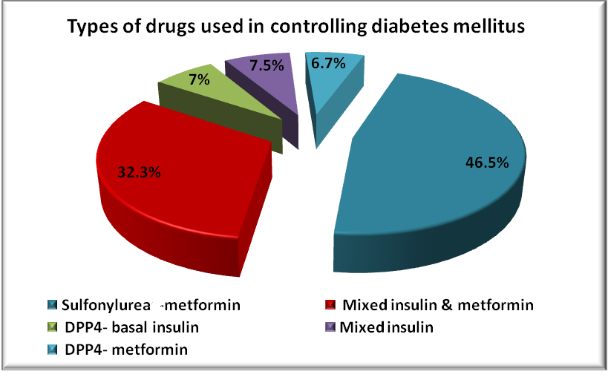
DPP4 inhibitors – basal insulin
DPP4 inhibitors – metformin

Figure (1): Types of drugs used in controlling diabetes mellitus

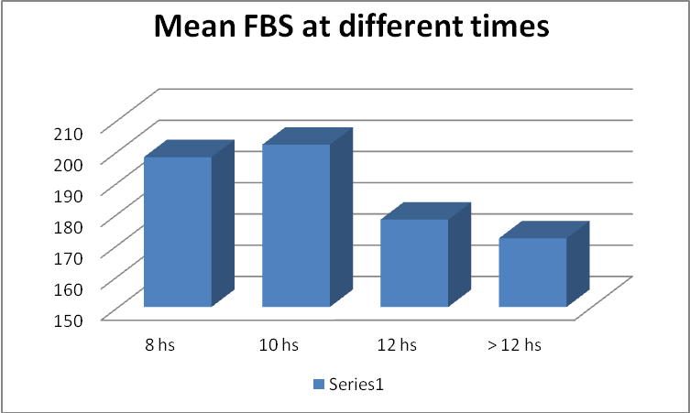

mg/dl

Figure (2): Mean FBS at different times.
Figure (2): showed that there was a statistically significant difference between the mean FBS at 12 hours (178 ± 3.5 mg) or more than 12 hours (172 ± 3.7 mg) compared to the mean FBS at 8 hours (197± 5.4 mg) (p <0.05) and there was no statistically significant difference between the mean FBS at 10 hours (202± 6.8 mg) compared to the mean FBS at 8 hours

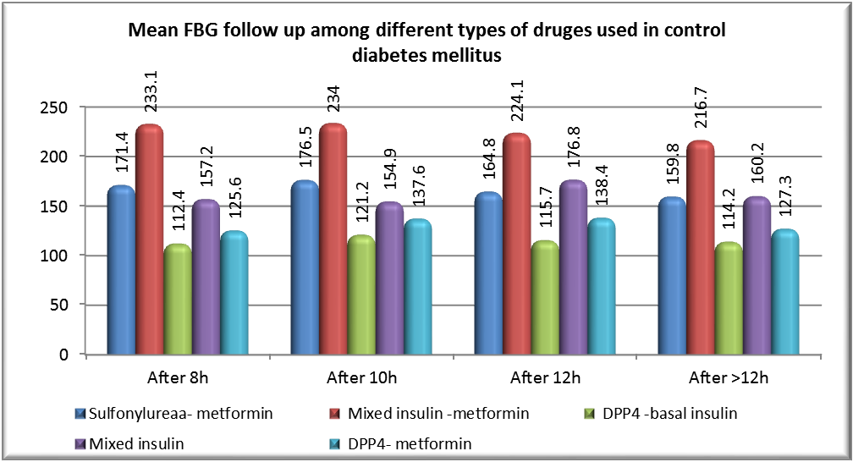
mg/dl
DPP4 inhibitors – basal insulin
DPP4 inhibitors – metformin

mg/dl
DPP4 inhibitors – basal insulin
DPP4 inhibitors – metformin
mg/dl
DPP4 inhibitors – basal insulin
DPP4 inhibitors – metformin

Figure (3): Mean FBG follow-up among different types of drugs used in controlling of diabetes mellitus.

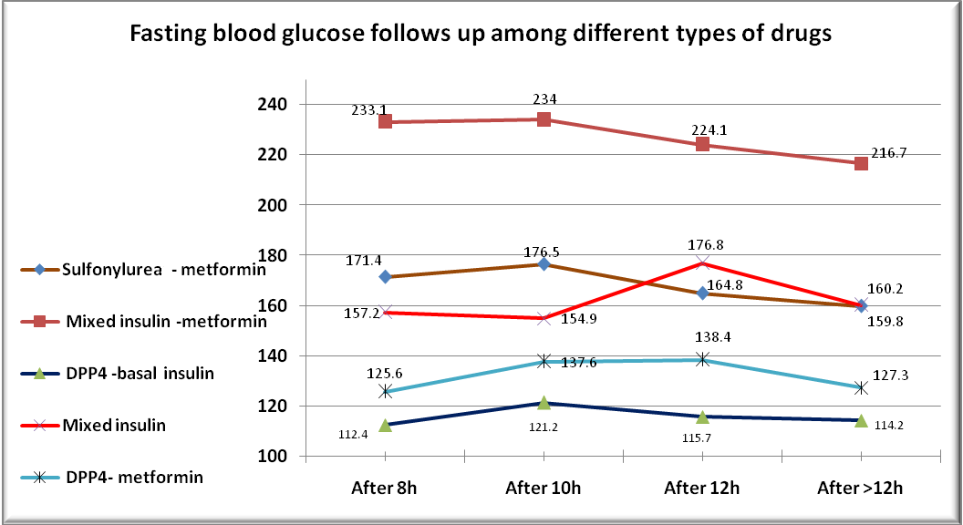
DPP4 inhibitors – basal insulin
DPP4 inhibitors – metformin
mg/dl

Figure (4): Fasting blood glucose follow- up among different types of drugs.
Figure(3)& (4): illustratedifferent fasting blood glucose levels among different drugs which clarify that patients treated with DPP4 inhibitors and metformin as well as those treated with DPP4 inhibitors and basal insulin have more consistent FBS measurements at different fasting durations with less fluctuation. On the other hand patients treated with premixed insulin or sulfonylurea have more inconsistent FBS measurements at different fasting durations with more blood glucose fluctuation.

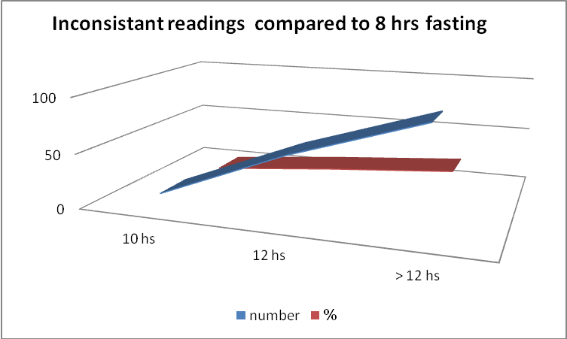
Inconsistent readings compared to 8 hours fasting

Figure (5 a): Inconsistent readings compared to 8 hours fasting.
This figure showed that at 12 hours of fasting or more, the readings were inconsistent in a significant percentage of patients.

Table (3): Number and percent of inconsistent FBS readings from the baseline (8 hours) at different fasting durations:
FBS | 8 hours | 10 hours | 12 hours | - 12 hours
Number | baseline | 10 | 57 | 93
percent | baseline | 2.4% | 13.5% | 22.4%

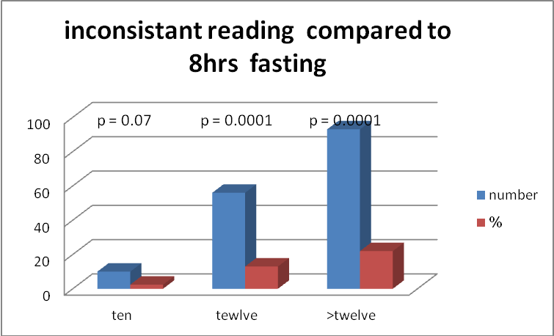
m
g/dl
Inconsistent reading compared to 8 hrs fasting
hs
Inconsistent readings compared to 8 hours fasting
hs
hs

Figure (5b): Inconsistent readings compared to 8 hours fasting.
This figure & previous table (3): showed that after 10 hours only 10 (2.4 % ) of the patients had readings that could change the decision / dose of the drug or drugs used to control the blood sugar or even the whole treatment strategy compared to the reading at 8 hours that was supposed to be the standard duration , while at 12 hours or more than 12 hours of fasting 56 (13.5 % ) and 93 (22 .4% ) of the patients respectively had blood glucose readings that could change the dose of the drug or drugs used to control the blood sugar.

6 Discussion

Diabetes mellitus is undoubtedly one of the most challenging health problems in the 21st century. The International Diabetes Federation estimates that 382 million people are living with diabetes, and of these, 185 million are undiagnosed .New cases are increasing by 8.3% worldwide, and as many as 470 million people will be at risk with pre-diabetes by 2033[14].
For decades, the diagnosis of diabetes mellitus was based primarily on plasma glucose criteria. Diagnosis of a person with diabetes was limited to the measurement of fasting plasma glucose, or an oral glucose tolerance test. The scope of diagnostic methodology was extended in 2009, when an International Expert Committee that included representatives from the American Diabetes Association (ADA), the IDF, and the European Association for the Study of Diabetes (EASD) formally recommended the use of the HbA1c test to diagnose diabetes. In 2010, the ADA officially endorsed this recommendation [11] and [13].
Previously, the measurement of HbA1c had only been permitted for the monitoring of long-term glycemic control of individuals with diabetes. In 2011, the World Health Organization (WHO) concluded that HbA1c could be used as a diagnostic test for diabetes in accordance with strict quality assurance and test standardization [15].
Accepted ADA, HbA1c test result criteria for the diagnosis of diabetes if the HbA1c level is more than 6.5 % and the potential indication of a pre-diabetic state if the HbA1c level is 5.7 to 6.4 % [6].
All forms of diabetes increase the risk of long-term complications. These typically develop after many years (10–20), but may be the first presentation in those who were not diagnosed for a long time. The major long-term complications are related to angiopathy. Diabetes doubles the risk of cardiovascular disease and about 75% of deaths in diabetics are due to coronary artery disease [16] and [17].
Targets for diabetic control were changed to be 130 mg and below for the fasting and 180 mg and below for the post -prandial plasma glucose and around 7% and below for the HbA1c according to the ADA and IDF guidelines [6].
Fasting plasma glucose is responsible for 30 to 70 % of the HbA1c value and its share increases as the HbA1c increases i.e. when diabetes is not controlled [8] and [9].
Prevention and treatment of diabetes involve a healthy diet, physical exercise, smoking cessation, and keeping normal body weight. Blood pressure control and proper foot care are also important. Type I diabetes must be managed with insulin injections. Type II diabetes may be treated with oral medications with or without insulin[8].
Insulin secretion which promotes the storage of glucose in liver and muscle as glycogen is stimulated by feeding in healthy individuals. During fasting, circulating glucose levels tend to fall, leading to decreased secretion of insulin. Concurrently, levels of glucagon and catecholamines rise, stimulating the breakdown of glycogen and at the same time gluconeogenesis is augmented .As fasting becomes protracted for more than several hours, glycogen stores become depleted, and the low levels of circulating insulin allow increased fatty acid release from adipocytes. Oxidation of fatty acids generates ketones that can be used as fuel by skeletal and cardiac muscle, liver, kidney, and adipose tissue, thus sparing glucose for continued utilization by brain and erythrocytes [10].
In individuals without diabetes, the processes described above are regulated by a delicate balance between circulating levels of insulin and counter-regulatory hormones that maintain glucose concentrations in the physiological range. In patients with diabetes, however, glucose homeostasis is perturbed by the underlying pathophysiology and often by pharmacological agents designed to enhance insulin secretion. In patients with type I diabetes, glucagon secretion may fail to increase appropriately in response to hypoglycemia. Epinephrine secretion is also defective in some patients with type I diabetes because of a combination of autonomic neuropathy and defects associated with recurrent hypoglycemia. In patients with severe insulin deficiency, a prolonged fasting in the absence of adequate insulin can lead to excessive glycogen breakdown and increased gluconeogenesis and ketogenesis, leading to hyperglycemia and ketoacidosis. Patients with type II diabetes may suffer similar perturbations in response to a prolonged fasting; however, ketoacidosis is uncommon, and the severity of hyperglycemia depends on the extent of insulin resistance and/or deficiency [10].
The liver is one of the major targets for insulin and its counter-regulatory hormones, such as glucagon. Chronic liver disease (CLD) is often associated with glucose intolerance and diabetes. The presence of CLD is associated with significant impairment in glucose homeostasis. Glucose intolerance is seen in up to 80% of patients with CLD, and frank diabetes is present in 30–60%. Depending on its etiology, CLD has a significant impact on hepatic glucose metabolism. One of the common causes of CLD is chronic hepatitis C. Chronic hepatitis C is accompanied by insulin resistance, which causes impaired glucose tolerance. Multiple mechanisms have been implicated, including fat accumulation in hepatocytes, increased insulin resistance secondary to increased tumor necrosis factor (TNF)-α, and direct or autoimmune damage to β-cells by the virus [18].
The trend for management of diabetes is to encourage diabetics for self- monitoring of blood sugar and also for self-management depending upon the blood glucose readings, fasting, 2-hours postprandial or random as well as HbA1c every three months [19] and [20].
Fasting plasma glucose should be measured after an overnight fasting of 8 hours for diagnosing diabetes and not less than 8 hours for monitoring of fasting plasma glucose, but the guidelines did not define clearly the maximum hours of fasting beyond it the readings will not be accepted or will affect the glycemic control [13].
In many countries all over the world for example in Egypt, people usually have their dinner between 7 and 8 pm and laboratory unites usually start to work between 9 and 10 am, so the number of fasting hours is usually more than 12 hours. The same usually happens even in hospitalized patients.
Our study aimed to study the effect of prolonged fasting more than 8 hours on plasma glucose level and glycemic control.
The study included 415 diabetics (201 male & 214 female) with type II diabetes mellitus recruited from Fayoum university hospitals, and their age ranged from 35 to 65 years old. A Full medical history including the patient`s age, sex, duration of diabetes, drugs used in treatment of diabetes and history of hypoglycemia or DKA. All patients were instructed to have their usual medications and their usual dinner at the usual time (around 7 pm) then venous samples were obtained at 8, 10, 12 and more than 12 hours of an overnight fasting and also HbA1c was measured.
The mean age of the study population was 50.7 ± 8.6 years old and the mean duration of diabetes was 4.9 ± 4.6 years.
Regarding different types of treatments used in controlling blood glucose level among the study group, it was found that 193 patients (46.5%) were on sulfonylurea with metformin, 134 patients (32.3%) on premixed insulin with metformin, 29 patients (7%) on DPP4 inhibitors plus basal insulin, 31 patients (7.5%) on premixed insulin& 28 patients (6.7%) depend on DPP4 inhibitors with metformin.
This study also showed that after 10 hours of fasting only 10 (2.4 % ) of the patients had FBS readings that were inconsistent with that recorded at 8 hours of fasting and could change the decision or the dose of the drug or drugs used to control the blood sugar or even the whole treatment strategy compared to the reading at 8 hours that was supposed to be the standard duration, while at 12 hours or more than 12 hours of fasting 56 (13.5 % ) and 93 (22 .4% ) of the patients respectively had FBS readings that could change the dose of the drug or drugs used to control the blood sugar compared to the reading at 8 hours of fasting and the differences were found to be statistically significant (p <0.05). We searched the internet for similar work but we found no results. It was also found that patients treated with DPP4 inhibitors and metformin as well as those treated with DPP4 inhibitors and basal insulin have more consistent FBS measurements at different fasting durations with less fluctuation. On the other hand patients treated with premixed insulin or sulfonylurea have more inconsistent FBS measurements at different fasting durations with more blood glucose fluctuation.
Regarding glucose variability and fluctuationin a meta-analysis of 18 studies found similar results and stated that DPP4 inhibitors produces less blood glucose fluctuations and reported also that glucose variability is linked to vascular complications and endothelial dysfunction[21].
Our results showed that statistically significant difference between different fasting blood glucose follow up measures with p-value < 0.05, and the best control of fasting blood glucose level occurs (after 8 -10 fastinghours) among patients depend on DPP4 inhibitors with metformin and DPP4 inhibitors with basal insulin. The best drug in controlling fasting blood glucose level was DPP4 inhibitors with basal insulin. This study concludes the best hours for overnight fasting before measurement of fasting plasma glucose is (8-11 hours) to reach the target goals for good glycemic control, and to avoid diabetic complications.

7 Conclusions
This study concludes that the maximum hours of overnight fasting beyond it the readings will not be accepted or will affect the glycemic control are 10-11 fasting hours. So, we can recommend its measurement of fasting plasma glucose after overnight fasting (8 to 11 hours) to reach the target goals for good glycemic control, and to avoid diabetic complications.

8 Limitations of the Study
No similar studies conducted before to compare the results, and to prove the maximum hours of fasting beyond it the readings will not be accepted or will affect the glycemic control. So; this pattern of practice needs to be studied and evaluated.
9 Conflict of Interest
Mohamed Mashahit, Hala Eltokhy, Mostafa Ahmed, Mohammed Ahmed declare that they have no conflict of interest.
References
[1]N Singh, V Kamath and P.S Rajini, (2005): Attenuation of hyperglycemia and associated biochemical parameters in streptozotocin-induced rats by dietary supplementation of potato peel powder.Chimica acta, 353(1-2):165-175.
[2]A.K Shetty, R Rashmi, M.G.R Rajan, et al., (2004): Antidiabetic influence of quercetin in streptozotocin-induced diabetic rats. Diabetic rats. Nutrition Research, 24(5): 373-381.
[3]H.PSang, K.K Sung and H.C Sung, (2005): Euonymus alatus prevents the hyperglycemia and hyperlipidemia induced by high-fat diet in mice. Journal of Ethnopharmacology, 102(3): 326-335.
[4]S Wild, G Roglic, A Green, et al., (2004): Global prevalence of diabetes: estimates for the year 2000 and projections for 2030.Diabetes Care; 27:1047-1053.
[5] H Stovring, M Andersen, H Beck-Nielsen, et al., (2003): Rising prevalence of diabetes: evidence from a Danish pharmaco-epidemiological database. Lancet 362:537–538.
[6]American Diabetes Mellitus, (2011):Diagnosis and classification of diabetes mellitus. Diabetes Care; 34 (Suppl.1):S62-S69.
[7]A Wright, AC Burden, RB paisey, et al., (2002):Prospective Diabetes Study Group. Sulfonylurea in adequacy: efficacy of addition of insulin 6 years in patients with type II diabetes in the UK Prespective Diabetes Study (UKPDS57). Diabetes Care; 25: 330-336.
[8]PR Kumar, A Bhansali, M Ravikiran, et al., (2010):Utility of glycated hemoglobin in diagnosing type II diabetes mellitus: a community-based study. J Clin Endoccrinol Metab; 95: 2832-2835.
[9]E Selvin, MW Steffes, CM Ballantyne, et al., (2011): Racial difference in glycemic markers: a cross-sectional analysis of community-based data. Ann Intern Med; 154: 303-309.
[10]PECryer, SN Davis and H Shamoon, (2003): Hypoglycemia in diabetes (Review). Diabetes Care; 26:1902–1912.Update 2010 by Center for Diabetes Education, McDonough, Georgia.
[11]International Expert Committee, (2009): International Expert Committee report on the role of the HbA1c assay in the diagnosis of diabetes. Diabetes Care; 32:1327-1334.
[12] XZhang, EW Gregg, DF Williamson, et al., (2010):HbA1c level and future risk of diabetes: a systematic review. Diabetes Care; 33: 1665-1673.

[13]American Diabetes Association, (2010):Diagnosis and classification of diabetes mellitus. Diabetes Care; 33 (Suppl. 1): S62- S69.
[14] D.R Guariguata, I Whiting, J Hambleton, et al., (2014):IDF Diabetes Atlas. Global estimates of diabetes prevalence for 2013 and projections for 2035. Vol. 103, Issue 2, p137–149.
[15] World Health Organization, (2011): Use of Glycated Hemoglobin (HbA1c) in the Diagnosis of Diabetes Mellitus. Abbreviated Report of a WHO Consultation. WHO/NMH/CHP/CPM/11.1. Geneva, World Health Organization.
[16] N Sarwar, P Gao, SR Seshasai, et al., (2010):"Diabetes mellitus, fasting blood glucose concentration, and risk of vascular disease: A collaborative meta-analysis of 102 prospective studies". The Lancet 375 (9733): 2215–22.
[17] PT O'Gara, FG Kushner and DD Ascheim, (2013): " ACCF/AHA guideline for the management of ST-elevation myocardial infarction: a report of the American College of Cardiology Foundation/American Heart Association Task Force on Practice Guidelines." Circulation 127 (4): 362–425.
[18] D García-Compean, JO Jaquez-Quintana and H Maldonado-Garza, (2009): Hepatogenous diabetes: current views of an ancient problem. Ann Hepatol 8:13–20, Ferri C.
[19] CG Parkin and JA Davidson, (2009): Value of self-monitoring blood glucose pattern analysis in improving diabetes outcomes. J Diabetes Sci Technol; 3:500-8.
[20] WH Polonsky, L Fisher, CH Schikman, et al., (2011): Structured self-monitoring of blood glucose significantly reduces A1C levels in poorly controlled, noninsulin-treated type II diabetes: results from the Structured Testing Program study.Postprandial hyperglycemia to HbA1c in insulin-treated Japanese diabetic patients. Endocr J; 55(4):753-756.
[21] L Nalysnyk, M Hernandez-Medina and G Krishnarajah, (2010):Glycemic variability and complications in patients with diabetes mellitus: evidence from a systematic review of the literature. Diabetes Obes Metab; 12:288–298.

