Bearing Capacity Affecting the Design of Shallow Foundation in Various Regions of Iraq Using SAP200 & SAFE softwares

Entidhar Al-Taie, Nadhir Al-Ansari, Tarek Edrees Saaed, Sven Knutsson

Abstract
Bearing pressure is the load per unit area along the foundation bottom. The value of bearing pressure can be obtained from soil exploration. In this research, three sites in Iraq were tested (Mosul at north, Baghdad at middle and Basrah at south) for the best type of foundation to be chosen. Seventy nine samples were taken from twenty three boreholes drilled to a depth ranging from 1to 24m, from various sites for the three sites. Samples were tested for their size; Atterberg limits; direct shear; unconfined compression; consolidation and SPT tests. The results showed that the nature of soil in Mosul was generally were silty clay to clay (in some areas silt or sand) with high to very high plasticity. In Baghdad, it was loam clay, silty clay, and in some areas silt. Its plasticity range was medium to high and non-plastic in few sites. For Basrah, the soil type was clay loam and in many places was sand or silt. The value of plasticity was medium. The average and the worst values of bearing capacity were: 177KN/m² and 77KN/m² for Mosul; 125 KN/m² and 68 KN/m² for Baghdad; and 84KN/m² and 24 KN/m² for Basrah. These values were used in a computer model (SAP2000 and SAFE softwares) to find the best suitable foundation in each site. The model suggests that spread or continuous and raft (if basement is used for building with many floors) are suitable for Mosul. For Baghdad, spread and raft type of foundations are suitable. While, for Basrah, raft foundation type are to be used in some areas where building should be less than three floors and for other areas, deep foundation (piles or pier) can only to be used.

Keywords: Base pressure, soil, bearing capacity, SAFE program, SPT tests.

1 Introduction
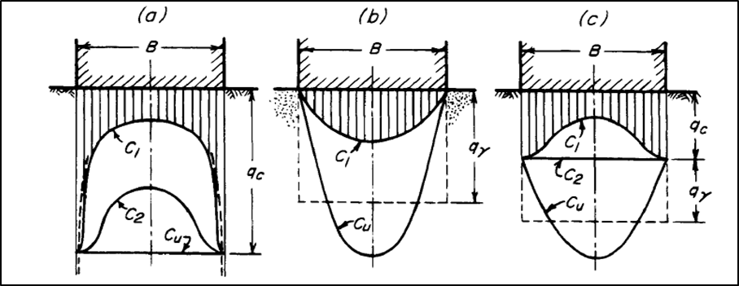
The interface between foundation and soil supports is defined by the most essential parameter which is the bearing pressure. It is the contact force per unit area along the bottom of the foundation [1]. The force acting between the foundation and the soil must be equal to the integral of the bearing pressure over the base area of shallow foundation. Bearing pressure is not necessarily distributed equally. Filed measurements and analytical studies mention that many factors define the actual distribution of the bearing pressure such as eccentricity of the added load; volume of the applied moment (if any); foundation structural rigidity; the soil stress-strain properties and bottom roughness of the foundation. Bearing pressure distribution along the shallow foundations base makes foundation exposure to concentric vertical loads [2](Figure 1).
Figure 1: Distribution of contact pressure on base of smooth rigid footing supported by (a) Real, elastic material; (b) Cohesionless soil; (c) soil having intermediate characteristics. Curve c_{u} refers to contact pressure at the loading of footing to ultimate value [2].

Generally, each structure (such as buildings, dams, bridges, towers, etc.) has two parts; the part above the ground level which is referred to as the superstructure; while, the lower part is the foundations supported by soil below. Soil is also a foundation for the structure and affords the entire load coming from above. For that, soil should be defined before any design process, starting with site investigations to define the types and properties (mechanicals and chemicals) of the soil [3 and 4]. Soil is non-homogeneous material. It does not have a unique stress-strain relationship and its behavior is affected by pressure, time, environment, and many other parameters. Soil below the ground level cannot prototype its behavior because it cannot be seen entirety and must be estimated through small samples taken from random locations [4]. Soil properties in each location are defined by various methods such as geology of the area, topography, and soil exploration (disturbed and undisturbed sampling) or the geotechnical soil properties and nature of soil layers for any project site. The aim of these tests is not only to define the soil types and properties. The aim is to define the bearing capacity parameters (angle of internal friction φ; cohesion c) that will specify the allowable stress to prevent shear failure in soil because soil is considered as heterogeneous material. Moreover, the tests of soil will define the active zone. Active zone is the soil layers which are near the ground level and its water content state in continuous change depending on evaporation and wetting [5].
Bearing capacity of soil under foundations depends on different factors such as shear strength, cohesion; unit weight of soil, etc. Foundation design must achieve two criteria. It should be safe against overall shear failure and don’t exceed the allowable settlement of the soil that supports it [6]. Figure 2, shows the relationship between the allowable bearing capacity and the width of foundation.
Earlier work done by Al-Taie et al. (2013) was included the use of a hypothetical building model designed and analyzed by STAAD Pro program for three locations (Mosul, Baghdad and Basrah) in Iraq. The work was done to find the best type of foundation to be used in each location.
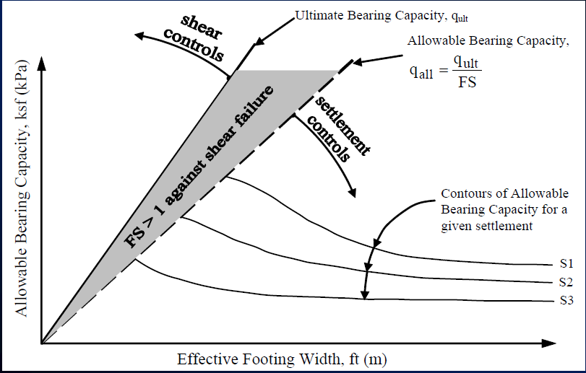

Figure 2: Relation between the allowable bearing capacity and the width of foundation [7].

In this research, a design and analysis of building model using SAP2000 and SAFE programs for three regions (Mosul in the north, Baghdad in the middle and Basrah in south of Iraq) had been undertaken. The bearing capacity used in the design will be calculated using general bearing capacity equation by Hansen [8], and the parameters used in the equation were taken from soil samples at different locations in the three regions of Iraq. Samples were tested in the field and laboratory to obtain the shear parameters. This was used to determine the best type of foundation to be chosen for the three regions.

- Methodology
  - Soil Exploration: Soil exploration was carried out through samples collected from the three different regions of Iraq. The soil nature of these locations can be summarized as follows:
    - Mosul region: Mosul soils include different types (figure 3). Some of these types can cause engineering problems (collapse, swelling, soluble in gypsum, volumetric change; etc.). Large parts of Mosul area are covered with clay of different colors (light brown, reddish brown and light green). This clay belongs to the lower Fars Formation (Middle Miocene) and has been deposited in a closed basin. Most of the clay soil of Mosul is an expansive clayey type that had affected several buildings in the center of Mosul city. The buildings in the city were normal and their foundation is within the active zone (0.5 - 7.0 m). The volumetric change into soil of the active zone is due to the change of its water content, which causes the swelling of soil [5; 9 and 10].
    - Baghdad region: This region is part of the Mesopotamia plain and characterized by great variations in the land use and high population density (figure 4). Quaternary sediments covering the Mesopotamia plain are of Pleistocene to Holocene in age. Its thickness varies from few meters up to 180m. Flood plain deposits are of fluvial nature brought by the Tigris and Euphrates Rivers. The prevalent component of soil in this region is silt and clay [11 and 12].
    - Basrah region: This region is part of the Lower Mesopotamian basin where Quaternary sediments are deposited (figure 5). Basrah region can be classified into two parts. The eastern part, constitute surficial fine-grained deposits and its thickness is 14m. While, the western part is characterized by coarse-grained sediments that are part of an alluvial fan and sandy Dibdiba Formation deposits. The sediments of Dibdiba Formation gradually changed from marine to river sediments. The upper parts are characterized by hard clay followed by very dense sandy layers having significant bearing capacity. In general, the ground surface of Basrah city is flat and its soil consist of silt and clay with little amount of sand. The sediment at depth 1-18.5 m are clayey silt, while the sediment at depth 21m are sandy silt and at 24m depth are sand [13 and 14].
    - Sampling: Disturbed and undisturbed samples were taken from nine boreholes in different locations in Mosul region northern Iraq, (figure 3).Three to four samples were taken from each borehole drilled to depth 3- 10m.
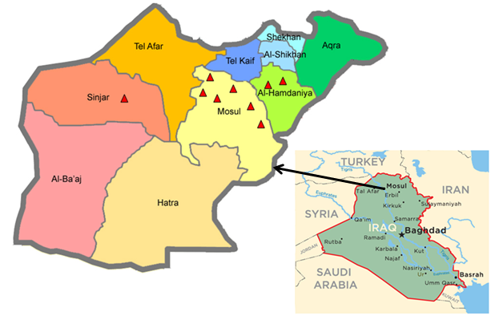

Figure 3: Mosul region northern Iraq map.
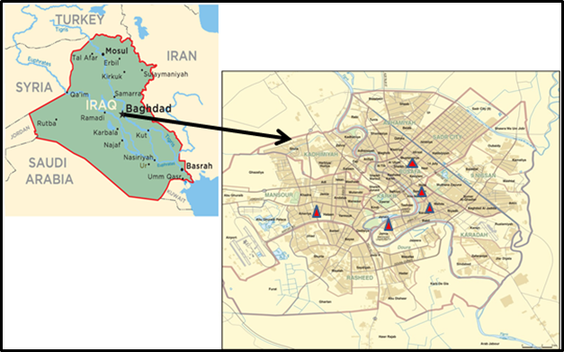
At Baghdad, samples were collected from five (figure 4). Three samples were taken from each borehole drilled to a depth of 10 - 13m.

Figure 4: Baghdad region center Iraq map.
In Basrah, samples were taken from nine boreholes in different locations (figure 5). Three to four samples were taken from each borehole drilled to a depth of 10-24 m.

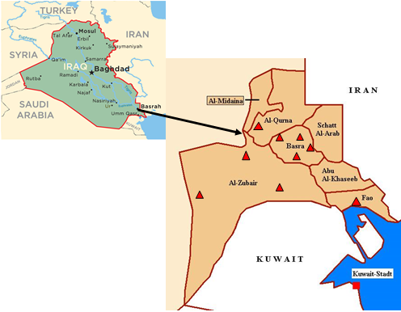

Figure 5: Basrah region in southern Iraq map.
  - Samples Tests: Field and laboratory tests were performed on the samples collected from the three Mosul, Baghdad, and Basrah. The purpose of these tests was to classify and define the mechanical properties of subsoil. All tests were done according to ASTM, AASHTO and BS standards [15 and 16] as follows :
- Sieving was performed using sieve numbers 4, 10, 20, 40, 60, 140 and 200 to classify the subsoil for each sample taken from different locations. The outcome was to find out the soil grains size distribution. Hydrometer grain size analysis was used for the part of soil particles which were finer than sieve No.200.
- Atterberg limits were used for the identification and description of subsoil conditions (ID). The test was done to obtain the liquid (LL), and plastic (LP) limits. The difference between them is the plastic index (PI).
- Strength parameters were obtained from two types of tests. The direct shear and the unconfined compression tests. The samples used for these tests should be undisturbed type. Finally, the results were cohesion (c), the angle of internal friction (ϕº) of soil and undrained compressive strength (q_{u}).
- Consolidation soil test was performed for undisturbed samples to obtain compression index (C_{c}), swelling index (C_{s}), pressure (P), and the preconsolidation pressure (P_{c}).

  - Calculations of the Bearing Capacity: The calculations of ultimate bearing capacity (q_{ult}) were performed using Hansen general equation [6] depending on the parameters obtained from the direct shear test:
$q_{ult}=cN_{c}s_{c}d_{c}i_{c}g_{c}b_{c}+qN_{q}s_{q}d_{q}i_{q}g_{q}b_{q}+0.5γBN_{γ}s_{γ}d_{γ}i_{γ}g_{γ}b_{γ}$ ..1
Where: c: cohesion of soil, kPa.
q: effective stress at the bottom level of foundation, kPa.
B: width of foundation, m.
γ: unit weight of soil, KN/m³.
N_{c}, N_{q}, N_{γ}: bearing capacity factors, (their values can take from especial tables).
S_{c}, S_{q}, S_{γ}: shape factors.
d_{c}, d_{q}, d_{γ}: depth factors.
i_{c}, i_{q}, i_{γ}: load inclination factors.
g_{c}, g_{q}, g_{γ}: ground inclination factors.
b_{c}, b_{q}, b_{γ}: base inclination factors.
The depth and shape factors values can be calculated from the following equations:
$$K=D/B…….For D/B≤1$$
Equations for calculated depth factors are:
$$d_{c}=1.0+0.4k$$
$$d_{q}=1.0+2tan∅\left(1-sin∅\right)2k$$
$$d_{γ}=1.0$$
Equations for calculated shape factors
$$S_{c}=1.0+N_{q}.B/{N_{c}}. L$$
$$S_{q}=1.0+B/Lsin∅………for all ∅$$
$$S_{γ}=1.0-0.4B/L………for B/L ≥0.6$$

In some locations in Baghdad and Basrah the calculations of ultimate bearing capacity depended on the unconfined compression strength (q_{u}) obtained from unconfined compression test and was used to calculate the undrained cohesion (C_{u}) as follow [17]:
$$c_{u}= \frac{1}{2}q_{u}…..2$$
Standard penetration test (SPT) was used in some locations in Basrah to calculate the bearing capacity value. Numbers of blows identify the compression strength (q_{u)} value depending on the correlation as shown in table 1. This correlation is quite useful when used according to the soil conditions [18].

Table 1: Relationship between N_{cor} and q_{u} [18].
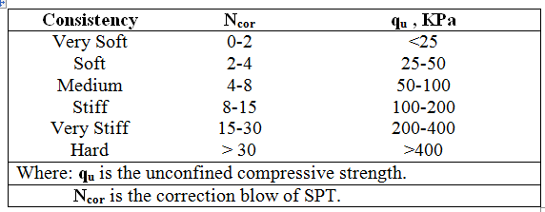

  - Results: The results of field and laboratory tests and the calculations of bearing capacity for Mosul, Baghdad, and Basrah are shown in table 2.
- Atterberg limits results included the LL, PL, and PI for different locations in the three regions. The results showed that the soil in Mosul region is between silty clay to clay with high to very high plasticity and in some areas contain sand or silt. In Baghdad region, the results showed that the soil is loam clay and silty clay, and in some areas contain silt. Range of plasticity was between medium to high and non-plastic in few sites. For Basrah region, the value of plasticity was medium and the soil type is clay loam and in many places it contains silt or sand.
- The strength parameters values for angle of internal friction ϕ, cohesion of soil c, and undrained compressive strength q_{u} were obtained from direct shear and unconfined compression tests.
- Using the consolidation test, the initial void ratio eo, compression index Cc, swelling index Cs, and preconsolidation pressure Pc were obtained. These values were used to calculate the settlement.
- In some locations in Basrah, SPT test was used to obtain the qu value.
- Bearing capacity values were obtained using the general bearing capacity equation. The results are shown in figures 6, 7 and 8 for Mosul, Baghdad, and Basrah respectively.

Table 2: Results obtained from field and laboratory tests.
Parameters obtained from field and laboratory tests | Locations
 | Mosul | Baghdad | Basrah
Atterberg Limits:  Liquid limit(L.L)  Plastic limit (P.L) %  Plastic index (P.I) % | 43-54  22-26  17-30 | 34-53  19-30  15-29 | 37-45.6  21.33-31.9  11-18
Unit weight (γ) KN/m³ | 15.7-19.7 | 14.4-20.31 | 15-20
Direct shear test:  Angle of internal friction  Cohesion (C) KPa | 15-28  0-40 | -  - | 31-33  0-4
Consolidation test:  Initial void ratio (e_{o})  Compression index  Swelling index (C_{s})  Preconsolidation pressure (P_{c}) KPa | 0.558-0.767  0.065-0.28  0.11-0.156  70-150 | 0.647-0.769  0.156-0.22  0.010-0.054  95-165 | 0.72-0.90  0.186-0.267  0.028-0.090  90-135
Unconfined test:  unconfined compression strength (q_{u}) KPa | - | 76-370.6 | 24-125
SPT test: q_{u} KPa | - | - | 24

Figure 6: Results of Bearing Capacity for Mosul.

Figure 7: Results of Bearing Capacity for Baghdad.

Figure 8: Results of Bearing Capacity for Basrah.

  - Computer modeling: The model of study was designed and analyzed using two computer programs. These programs were SAP2000 (Structural Analysis Program, version 16) and SAFE (Slab Analysis Finite Element) software for structural and foundation design and analysis. SAP2000 is a program used to design general structures such as buildings, dams, towers, stadium; etc. It has advantages such as powerful and completely integrated design program for concrete, steel, cold formed steel, and aluminum. The concrete design for frame members includes the calculation of the amount of reinforcing steel required. The program includes a wide variety of national and international design codes. Moreover, It has unlimited analysis capabilities, time-history, a complete range of finite elements analysis options and static nonlinear analysis. The program has a capability of export and import for other popular drafting and design programs as well [19 and 20]. SAFE is finite element software. It has many capabilities such as strong graphic tools for drawing various shapes and patterns, system of mesh generator, different load combinations are created, and the capability of presenting the loading states by 3D animation. The variety of outputs given by the software can be used to study the behavior of loads and deformations. SAFE is a sophisticated program for concrete slab\ beam and basement\ foundation systems. Moreover, the program has the capability to import and export models and design from other programs [21 and 22]. General steps were used in the design and analysis of any structure and foundation using SAP2000 and SAFE, are as follow [23]:
- Creating a model or modifying it, which numerically defines the geometry, loading, properties, and analysis parameters for the structure.
- Executing an analysis of the model.
- Reviewing the results of the analysis.
- Checking and optimizing the design of the model.
- Mouse over diagram shown instantaneous values.
The results to be obtained from both programs are of different types depending on the case studied or the problem to be solved.

In this study a building model was designed and the structure of the building was analyzed using SAP2000 software. The structure was of two floors of 25*60m dimensions with 3m as the height for each floor.
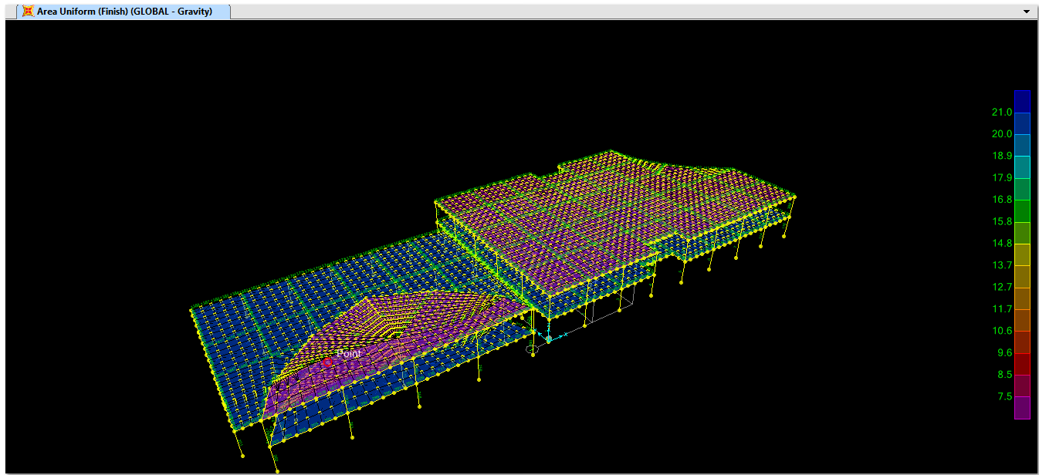
The model was loaded with dead and live loads of 29.5 KN/m² and 8 KN/m² respectively. ACI code was used in the design [24]. The model was analyzed to check the deformations for the columns and slabs (figure 9).
Figure 9: The structure of the building in SAP2000 program.

The structure model was exported to SAFE software with all loads on each column. In SAFE program, the raft foundation for the building was designed. The design parameters used were the dead load 25 KN/m², as well as the live load. The load combination was used according to ACI code [24] as follows:
1.2 DL + 1.6 LL
Where: DL is the dead load.
LL is the live load.
The building model was applied in the three regions (Mosul, Baghdad, and Basrah). The calculated bearing capacity (in section 2.3) for each location was used twice. The first using the average value and then the worst values. The results obtained from the program were illustrated in figures 10 to 15.
The results of the average bearing capacity values for Mosul are shown in figure 10. It indicates that the base pressure under the foundation ranges from 70 to110 KN/m². These values were less than the calculated value (177KN/m²).

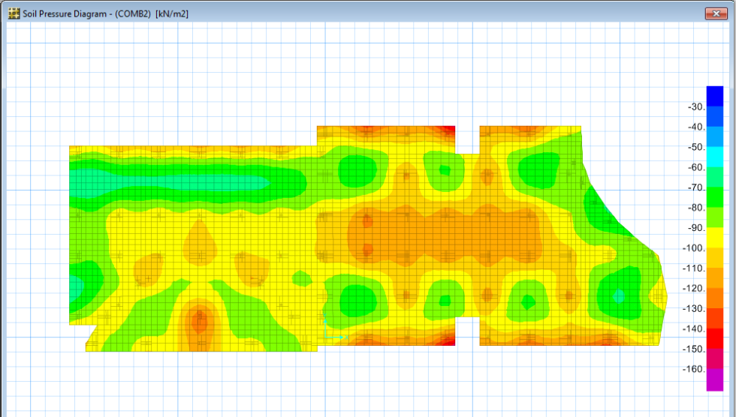

Figure 10: Average bearing capacity obtained distribution of base pressure for Mosul.

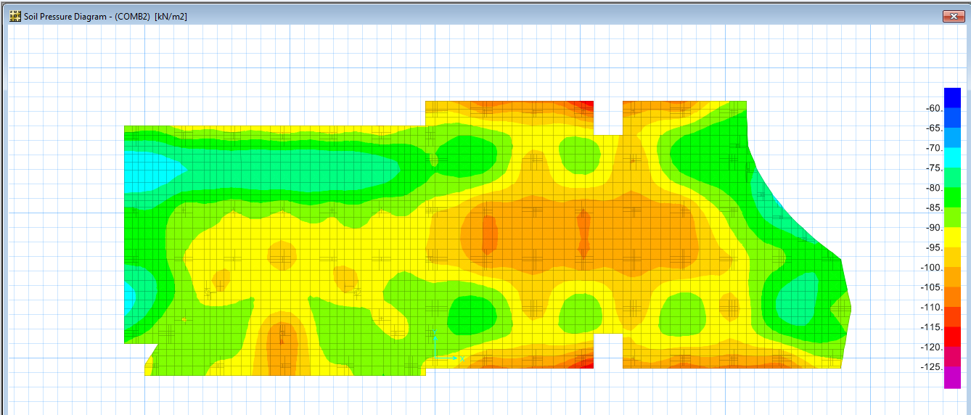
The worst value of bearing capacity used for Mosul region is shown in figure 11. The range of base pressure under the foundation was from 70 to 95KN/m². These values were close to the calculated value.

Figure 11: Worst bearing capacity obtained distribution of base pressure for Mosul.
Figures 12 and 13 show the distribution of base pressure under the foundation using the average (125KN/m²) and worst (68 KN/m²) values of calculated bearing capacity for Baghdad region. The range of base pressure under foundation was 70-100 KN/m² for average value, and between 65-96 KN/m² for worst value. In both cases, the base pressure was less than or within the calculated value of bearing capacity.
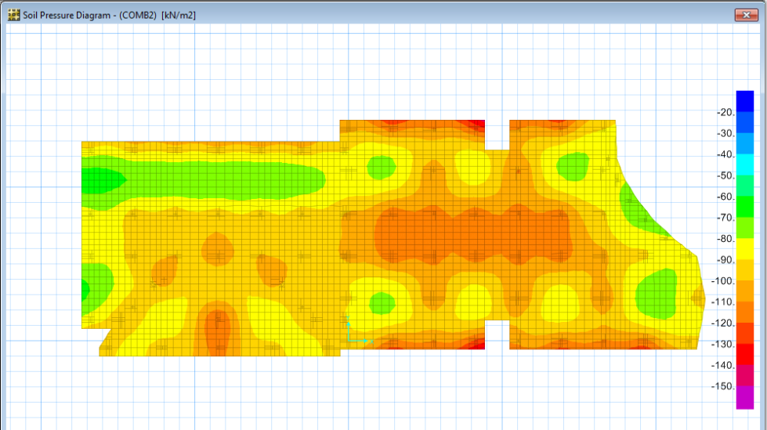

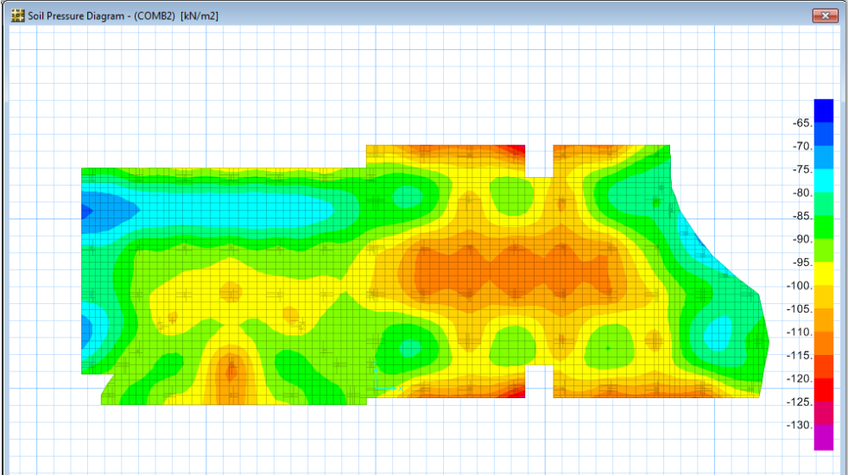
Figure 12: Average bearing capacity obtained distribution of base pressure for Baghdad.

Figure 13: Worst bearing capacity obtained distribution of base pressure for Baghdad.

For Basrah region, figure 14 shows that the base pressure distribution for average value of calculated bearing capacity was 84 KN/m². The range for the base pressure under foundation was 70-95 KN/m², which is close to the calculated value of bearing capacity.
Furthermore, figure 15 shows the distribution of base pressure for the worst calculated bearing capacity (24 KN/m²). The value of the base pressure under the foundation was between 72 -100KN/m².
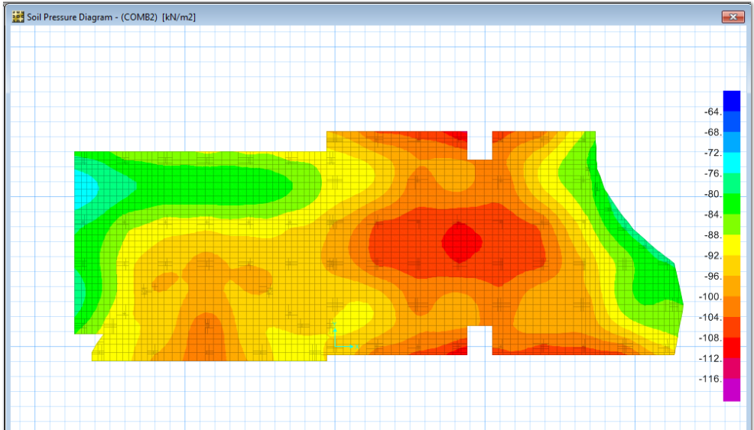

Figure 14: Average bearing capacity obtained distribution of base pressure for Basrah.
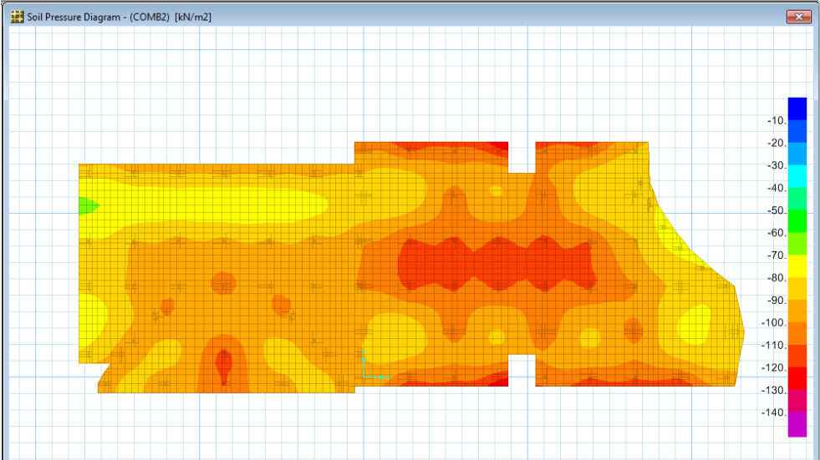

Figure 15: Worst bearing capacity obtained distribution of base pressure for Basrah.
- Discussion
In this research, the purpose of the case study was to define the soil pressure under foundation for different locations (Mosul, Baghdad, and Basrah in Iraq). Usually, SAFE program gives the results of soil pressure in two directions: tension (positive) and compression (negative). The results were only negative, which means that the effect of tension was zero (legend of the values of base pressure tabulated in the right side of figures 10-15).
The results obtained for Mosul region (figure 10), were values of the base pressure distributed under the foundation for the average value of calculated bearing capacity. The maximum value of the base pressure was 100 KN/m², which was less than the calculated bearing capacity value (177 KN/m²). It is significant that the best type of foundation should be chosen. While, the maximum value of base pressure shown in figure 11, for the worst value of calculated bearing capacity was 92 KN/m² for some areas under the foundation. These values will not affect the foundation, although it is beyond the calculated value of bearing capacity (77KN/m²). In the previous work done by Al-Taie, et al. (2014)[25] for the same building model using the same data, but the design and analysis was done using STADD Pro vi8 program for Mosul region, the results showed the maximum value of the base pressure under the foundation was 99 KN/m² for the average calculated value of the bearing capacity (177KN/m²). The result was less than the calculated value as shown in figures 16 and 17. While, the maximum value of the base pressure under the foundation was 75 KN/m² for the worst value of the calculated bearing capacity. The result value was less than the calculated (table 3). The recommendation (in the previous work) for Mosul region was to use continuous or spread type of foundation and raft type if a basement is required for buildings with many floors. While, the suggestion depended on the results obtained from SAFE program, the best type of foundation is spread or continuous for buildings with many floors, and raft type foundation if basement is to be used. Earlier work [26] for Mosul location indicated that continuous type of foundation is recommended.
The base pressure under foundation (figure 12), for Baghdad region was for the average value of calculated bearing capacity (125KN/m²). The maximum value of base pressure shown under the foundation was 95 KN/m². This value was less than the calculated value. Figure 13, shows that the base pressure under foundation for worst value of calculated bearing capacity was 68 KN/m². The result for the value of the maximum base pressure was 90KN/m². It was higher than the calculated value. While, in the previous work [25] for the same building model showed that the maximum value of base pressure under foundation was 87 KN/m², for the average of calculated bearing capacity 125 KN/m² value. The maximum value of the base pressure was 79 KN/m² for the worst value of the calculated bearing capacity. This value was higher than the calculated value (68 KN/m²), as shown in figures 16 and 17. Spread or raft foundation type for such areas are recommended using the average value of bearing capacity, and only raft foundation type is the suitable for the area with worst value of bearing capacity [25]. According to SAFE program, continuous or raft foundation type are recommended for buildings not higher than five floors. For areas with worst bearing capacity value raft or mat foundation is recommended (table 3). Previous work [26] suggested raft type of foundation for Baghdad.

Table 3: comparison of the results obtained of current and previous works.
Location | Method used | Average bearing capacity (KN/m²) | Worst  bearing capacity  (KN/m²) | Foundation to be used
Mosul | Calculated | 177 | 77 | Shallow type
 | STAAD Pro. | 99 | 75 | Continuous or spread type, & raft type for basement.
 | SAFE | 100 | 92 | Continuous or spread type, & raft type for basement.
Baghdad | Calculated | 125 | 68 | Shallow type
 | STAAD Pro | 87 | 90 | Spread or raft type.
 | SAFE | 95 | 79 | Spread or raft type.
Basrah | Calculated | 84 | 24 | Shallow and deep type
 | STAAD Pro | 81 | 77 | Raft and pile types.
 | SAFE | 81 | 96 | Raft and pile types.

Figure 14, for Basrah region shows that the maximum value of base pressure (81 KN/m²) for the average calculated bearing capacity (84 KN/m²). Figure 15 show that the value of the maximum base pressure (96 KN/m²) for the worst value of calculated bearing capacity (68 KN/m²). Previous work [25] showed that the maximum value of base pressure under foundation was 81 KN/m², for the average calculated value of bearing capacity 84 KN/ m². While, the maximum value of the base pressure obtained from STAAD Pro program was 77 KN/ m², for the worst value of the calculated bearing capacity 24 KN/m² (figures 16 and 17). The raft foundation was the type of foundation recommended for the average value of bearing capacity [25]. The piles were the best type of foundation recommended for the worst value of the bearing capacity. The suggestions according to the results obtained from the current work, is that areas with a high value of bearing capacity, raft type is recommended for building not high than three floors. The areas with low values of bearing capacity the deep foundation type is the suitable one. Al-Taie et al. [26], suggested raft foundation for Basrah.

Figure 16: The results of q average values from STAAD Pro., SAFE programs and calculations.

Figure 17: The results of q worst values from STAAD Pro., SAFE programs and calculations.

4. Conclusions
- Exploration for soil in northern (Mosul), middle (Baghdad) and southern (Basrah) parts of Iraq. Was carried out to find the best suitable foundation to be used in these areas. Field and laboratory tests were performed on seventy nine samples collected from these areas. The results indicated that the soil in Mosul had high to very high plasticity and its type was silty clay and clay, while, in some areas it was sand or silt. In Baghdad, the results showed that the soil had medium to high plasticity and non-plastic in few sites. Soil type was loam clay, silty clay and in some area silt. Plasticity of soil in Basrah region was medium and the soil type was clay loam and in many places it was silt or sand.
- Model of building was designed and analyzed using SAP2000 program specialist for structure and SAFE program specialist for foundation, depending on the calculated bearing capacities for different locations in the three regions of Iraq. The effect of loads (dead and live) on each column in the structure was transported to SAFE program. The results showed that the contours for the base pressure distribution under the foundation is more accurate and more realistic compared to results from STAAD Pro program.
- The results obtained from the programs, for Mosul region showed that the value for base pressure under foundation was lower than the average calculated bearing capacity in the whole area. The same results were obtained when using the worst value for bearing capacity as well. For that, the best type of foundation recommended for Mosul region is spread or continuous type for buildings with many floors and raft type foundation if basement is to be used.
In Baghdad region the value obtained for the base pressure under foundation did not exceed the average value of calculated bearing capacity. This makes the choice of continuous or raft foundation type is more suitable for buildings with not more than four to five floors in some locations of Baghdad. While, the results of the base pressure value were close to the worst calculated value of bearing capacity. The suitable choice for such areas is the raft or mat foundation.
Results for Basrah region showed that the suitable type of foundation for the average value of bearing capacity is the raft type for the normal building with not more than three floors. This type was chosen because the value of the base pressure was less than the calculated value. The value of the base pressure obtained using worst calculated value for bearing capacity was higher. In such a case, deep foundation (piles or drilled shafts) type is recommended.
The comparison of the results obtained from this research and the previous one (using STAAD Pro program) for the same building and areas, gave the same suggestions for the type of foundation to be used in the three regions (Mosul, Baghdad, and Basrah) due to the fact that, the values of base pressure obtained from STAAD Pro and SAP2000, SAFE programs were convergent with each other. These differences were related to the finite element technique used in each program. Moreover, the value of base pressure in any area under the foundation in SAFE program can be obtained directly from the contour.

References

[1]D. P. Coduto, Foundation Design: principles and practices, 2nd edition, printed by Prentice-Hall, Inc., New Jersey, USA, 2001.

[2] K. Terzaghi, R. B. Peck and G. Mesri, Soil Mechanics in Engineering Practice, 3rd, John Wiley & Sons, Inc., New York, USA, 1996.

[3] B. M. Das, Shallow Foundation: bearing capacity and settlement, 2nd edition, press Taylor & Francis group, New York, USA, 2009.

[4] N. S. V. Kameswara Rao, Foundation Design theory and practice, John Wiley & Sons (Asia) Pte Ltd, Singapore, 2011.

[5] B. M. A. A. Al-Imam, Primary Study to Execution and Testing Geotechnical Model Based on GIS Technique in the Left Side of Mosul City, PhD thesis, College of Engineering, University of Mosul, Iraq, 2013

[6] B. M. Das, Principles of Foundation Engineers, 7TH edition, Cengage learning, Stamford, USA, 2011.

[7] J.Riseborough and S. Tysl, LRFD implementation of shallow spread footing for bridge structures, Contech engineering solution, 2010. www.conteches.com .

[8] J. B. Hansen and S. Inan, Bulletin No. 28, geoteknisk institut, Copenhagen, 1970.

[9] M. O. Al-Ashou, Expansive properties of the clay in Mosul area, M.Sc. thesis, College of Engineering, University of Mosul, Iraq, 1977.

[10]A. H. T. Al-Zubaydi, Effect of Wetting and Drying Cycles on Swell/Collapse Behaviour and Cracks of Fine – Grained Soils, Tikrit Journal of Engineering. Sciences, Vol.18, No.4, (2011), 71-79.
[11] S. M. Ali, Hydrogeological Environmental Assessment of Baghdad Area, PhD thesis, University of Baghdad, College of Science, Iraq, 2012.

[12] S. F. A. Fouad and V. K. Sissakian, Tectonic and Structural Evolution of the Mesopotamia Plain, Journal of Iraqi Bill. Geological and Mining, Special Issue (Geology of the Mesopotamia Plain), No.4, (2011), 33-46.

[13] W. R. Muttashar, F. K. Al-Amari and M. A. A. Al-Hussein, Geotechnical analysis for types of surficial fine-grained Soils at eastern side of Basra region, Southern Iraq, Journal of University of Thi-Qar, Vol. 7, Issue 2, (2012), 1-11.

[14] M. H. A. Al-Jabberi, Sedimentological and environmental aspects of subsurface Basrah sediments-south Iraq, Mesopotamian Journal of Marine Science, vol. 25, No. 2, (2010),176-187. www.iasj.net .

[15] T. W. Lambe, Soil Testing for engineers, John Wiley & sons Inc., USA, 1951.

[16] B. M. Das, Soil Mechanics Laboratory Manual, 7th edition, OXFORD University press, New York. USA, 2009.
[17] M. B. Das, Principle of Geotechnical Engineering, 7th edition, Cengage learning, Stamford, USA, 2010.

[18] V. N. S. Murthy, Geotechnical Engineering: Principles and practices of soil mechanics and foundation engineering, Marcel Dekker Inc., New York, USA, 2002.

[19] K. Soni Priya, T. Durgabhavani, K. Mounika, M. Nageswari and P. Poluraju, Non-Linear Pushover Analysis of Flat slab Building by using SAP2000, International Journal of Recent Technology and Engineering (IJRTE), Vol.1, Issue1, (2012), 29-33.

[20] M. Y. Abdulwahid, I. A. Al-Qasem and I. Arman, Determination of load transfer in reinforced concrete solid slabs by finite element computer analysis, IOSR Journal of Mechanical and Civil Engineering (IOSR-JMCE), Vol. 8, Issue 3, (2013), 01-07. www.iosrjournals.org

[21] A. Hassani and A. Jamshidi, Modelling and structural design of a concrete block pavement system, 8th International Conference on Concrete Block Paving, San Francisco, California, USA, (2006), 389-398.
[22] M. A. Alashorafa, Modifications of Conventional Rigid and Flexible Methods for Mat Foundation Design, M.Sc. thesis, Islamic University of Gaza, Faculty of Engineering , Palestine, 2008.

[23] Computers and Structures, Inc., CSI Analysis Reference Manual, Berkley, California, USA, 2013. https://docs.csiamerica.com.

[24] ACI committee 318-08, Building Code Requirements for Structural Concrete (ACI 318-08) and Commentary, American Concrete Institute, Farmington Hills, 2008.

[25] E. Al-Taie, N. Al-Ansari and S. Knutsson, (2014), Effect of bearing capacity on designing foundations in Iraq using STAAD Pro-v8i, Engineering, 6,(2014) 292-303; http://dx.doi.org/10.4236/eng.2014.66033.

[26] E. Al-Taie, N. Al-Ansari, S. Knutsson and T. E. Saad, Foundation Assessment in different parts of Iraq using STDDA Prov8i, journal of civil Engineering and Architecture, vol. 7, No. 3, (2013), 273-281.

Lulea University of Technology, 97187 Lulea, Sweden. Email: entidhar.altaie@ltu.se
Lulea University of Technology, 97187 Lulea, Sweden. Email: nadhir.alansari@ltu.se
Lulea University of Technology, 97187 Lulea, Sweden. Email: tarek.edrees@ltu.se
Lulea University of Technology, 97187 Lulea, Sweden. Email: sven.knutsson@ltu.se

