- The effect of convertible bonds on bond portfolio optimization

Diao Shengji

Abstract

The convertible bond has become an important tool in financial market and enjoyed significant growth in China's capital markets since the Chinese government decided to select conditional companies for the pilot of convertible bonds in 1996. The convertible bond itself is attractive to both issuers and investors because of its unique dual properties of bonds and stocks. Firstly, I analysis the dataset I downloaded from WIND system, and then take the correlation relationship as my target to test the data is meaningful or not, finally, set up some porfolios and then compare the results of them. Sine the existence of the convertible bond could limit the risk and return to a certain range, I cannot help wording whether convertible bond could do a favor to the return of a portfolio consisting of other securities on the financial market. In other words, if it is positive to the efficient frontier of a portfolio.

Keywords: convertible bond, Chinese financial market, portfolio choice, mean-variance efficient frontier

- Introduction
Convertible bonds are corporate bonds issued by the issuer in accordance with legal procedures and which can be converted into stocks within a certain period of time in accordance with the agreed terms. Basically, it is a combination of a straight bond and a call option on the issuer’s equity. The United States issued the world's first convertible corporate bond in 1843. After that, convertible bond was quickly widely accepted by investors and became a major financing tool in financial market because of its unique advantages. Meanwhile, convertible bond has become an important investment and financing tool in the global refinancing channels because of its multiple characteristics, such as equity, creditor's rights and options.

The convertible bond has also enjoyed a repaid development in China. It was limited by immature capital markets and did not receive widespread attention, while it was introduced into Chinese securities market at the end of 1996. However, it has grown rapidly since 2006, ushering in the first small peak. Over the past 24 years, economic development of China has switched from high-speed growth to the new normal medium- and low-speed growth. The domestic financial market is becoming more and more mature with more standardized legal documents to support. In this situation, equity financing, bond financing and a variety of derivatives have entered the investor's view. The amount of convertible bonds issued in 2017 increased more than threefold over the previous year. As of September 18, 2019, convertible bonds were issued at $160.51 billion, twice the size of the whole volume of last year and well ahead of all other years. According to the data of Wind, Shanghai and Shenzhen combined to deal with convertible bonds of 6.29 trillion yuan in the first three quarters of 2020, an increase of 451.75 percent over the same period last year. Especially in late October, convertible bond market is the beginning of a new round of speculation with the consecutive days turnover exceeded 100 billion yuan. As a result, a large number of convertible bonds in the market have to temporarily suspend trading.

For investors, bonds provide a stable return on investment, stocks could better enjoy the benefits of corporate growth, and convertible bonds offer both possibilities. Since convertible bond can be increased in value through their equity components, while at the same time risk assurance can be obtained from the bond segment, it provides a very good portfolio of returns and risks. It is this unique yield and risk position that makes the convertible bond market perform well. For issuers, convertible bond has the characteristics of low financing cost and flexible operation. The Numerous elements and terms contained in convertible bond give it its unique advantages and influence its value. Multiple choice and its staggered relationship of rights and obligations are the financial characteristics of convertible bond, which increase its charm in actual financing investment as well as the difficulty of the study of its pricing theory. Therefore, the analysis of investment behavior in convertible bond is of great practical significance to improve the financial market.

The convertible bond could effectively improve portfolio returns while reducing portfolio risk, according to the past market experience. Here is a brief introduction to the study of investment income in the convertible bond market in the United States. Statistics from the Yamalichi Institute show that in the 36 years from 1957 to 1992, the annual compound interest rate on investment in U.S. convertible bonds reached 8. 3%, with annual returns of 6.8%, 7.3% and 10.5%, respectively, for long-term corporate bonds, medium-term corporate bonds and equities during the same period. In a complete stock market cycle (1975-1995), convertible bonds as an alternative financial product to general bonds, their stable interest income and the characteristics of bull market transit options, making it at investment risk (12.47 ) is about the same as long-term corporate debt risk (12.44%) and much lower than stock index risk (17.27%), providing investors with a return on investment that is higher than ordinary corporate debt and basically comparable to the Standard and Poor's index throughout the stock market cycle. At the same time, the 1973-1995 convertible bond market trend and the Standard and Poor's index market trend ratio chart also shows that in the risk of convertible bonds is basically only two-thirds of the risk of the stock index, convertible bonds rise space basically reached 99% of the stock index. Additionally, the data show that in 1976-2000, the return on investment of convertible bonds was generally higher than that of other bond investments. And the value of convertible bonds increased to some extent in the case of the depreciation of other bonds, even during the period of high inflation and weak bond market in the United States from 1976 to 1981.

This paper will try to analyze the role of the convertible bonds in portfolio and its influence on the effective boundaries, in order to further study whether the role of convertible bonds in the portfolio is universal. The analysis will use Harry Markowitz’s portfolio based on the Chinese market. Firstly, I will use the date to calculate seven parameter index of Convertible bond to get the relationship between the convertible bond and Chinese A stock market. In this way, I could get the conclusion weather the economy behavior could be figured out by the change of the convertible bond. Secondly, two different portfolios would be built to see the convertible bond’s influence on the return of portfolio.

- Data and methodology
  - Data source
I collect Chinese bond market data from WIND, the leading financial data provider in China. WIND financial terminal is one kind of financial data application, just like bloomberg which include bond, stock, macroeconomic and fund index. With the help of WIND financial terminal, I can gather data and information much clearly.

  - Analysis process
I will use the data collected in part 2.1 to analyze the role of convertible bond from two perspectives. On the one hand, I would like to illustrate the impact of convertible debt on the macro economy through the analysis of several important indices. That is the price, Volume and implied volatility change of Convertible bond could be used to figure the economy behavior out. On the other hand, I will build two portfolios and calculate their expected returns to illustrate the role of convertible bonds in the portfolio, positive or negative. The experimental group consisted of a portfolio of convertible bonds, Chinese securities bonds and corporate bonds, while the control group excluded convertible bonds. Other conditions are exactly the same, including the amount of investment, investor preferences, the point in time and duration of the investment.

- Convertible bond and economy behavior
This paragraph is going to talk about the change of several parameter index of Convertible bond from 4th January 2012 to 29th August 2020. During this period, Chinese A stock market and even World economic situation suffered from highly fluctuating, and Convertible bond has inner connection with economic situation significantly. Therefore, the price, Volume and implied volatility change of Convertible bond also can be used to figure the economy behavior out.

I will show my opinion and summary the change from seven different aspects, they are Volume, Volume weighted average price (VWAP), interest effect, implied volatility, dilution, conversion value and conversion price. After summarizing, we can get one rough overview of the convertible bond situation in the past eight years.

  - Volume
Volume of convertible bond represent of the business trading amount, which can also show the investors’ attitude and the resilience of the market. For example, if the Volume or trading amount of convertible bond is significantly higher than ever before, more and more investors would like to devote themselves into this “Casino”, with the help of trading liquidity, market can have more power to rise.
(figure one)
(figure two)
(figure three)

From the graph of Volume we can see that the Volume of convertible market encountered its first peak (in January 2015), and at that time the stock market was one crazy bull market, however it decrease significantly after that peak one. After that, Volume fluctuated between 0 to10,000 until March 2020, Chinese spring festival ended with Covid-19 and Chinese economy just became the survivor of this crisis. More and more capital was injected into Stock market and Convertible market in order, after that, the increasingly severe international situation have the upper hand following and the Volume decreased till now.

  - VWAP (Volume weighted average price)
VWAP is another important index just like Volume with some tiny different. Volume weighted average price is the price according to the respective amount will be more deal weighted and calculate the average, if the calculation of a security in a session VWAP, clinch a deal will be on the same day can be divided by the total Volume of gross VWAP can be used as a method of transaction pricing, also as a measure of institutional investors or traders trading performance.

(figure four)

(figure five)

From VWAP we can get the highest VWAP value happened in 21th May 2015, however, compare with the Volume table, VWAP didn’t racket at 2020 in other words, market gave high tolerance to the convertible bond price in 2020, and this bull market have more reasons to be a little bit longer.

3.3 Conversion value and conversion price
Conversion price and value are another couple which can be understood with comparison. Conversion price refers to the price paid by a convertible company to convert its bonds into shares per share. And conversion value means one risk of forced back to sell, the higher the value of the convertible bond, the higher the risk of forced resale, and the weaker the positive correlation between the convertible bond and the underlying stock price.

(figure six)

(figure seven)

According to the figure 1.3, conversion value has the same trend with VWAP, because VWAP and conversion value all represent kinds of risk but VWAP means the price that market can tolerant and conversion value represent the risk that is forced back to sell. From this table, in 19th March 2015, there is the highest risk of back to sell in convertible bond market, it means buy one convertible bond should get more profit to cover the risk. However, the convertible price of the convertible bond market is not really optimistic. Which can also be seen in Volume table. People may face to high risk without considerable margin, so the market heated but not enough.

3.4 Interest effect and implied volatility (IV)
Interest effect and implied volatility (IV) are what I want to mention in this part. Cause as two representative indexes, they have one similarity. This similarity is that both IV and interest effect can show the relationship of stock and this bond. From my own perspective, the value of interest effect shows whether this bond is inclined to common stock or common bond. For example, if the interest of convertible bond is high, this bond may have more probability to get profit from bond characteristic, and if the interest rate is low, this bond can get profit from convert to stock and this may tend to be one stock further.

(figure eight)

(figure night)

(figure ten)

For this table, I ignore the maximum value which appeared in May 2015 (2097.998). Here we can get that typically all the interest rate of convertible bond should lower than interest rate of deposit, however when financial market failure, this principle may come to invalid. And according to this principle we can know that , when interest rate is significant lower than average level, the convertible bond is much more worth to be invested in.
(figure eleven)

(figure twelve)

(figure thirteen)

Just like the definition of implied volatility, it can shows the volatility according to the past several years. If the historical volatility of the underlying stock is high, the implied volatility of the relevant warrants is also high; If the historical volatility of the underlying stock is low, the implied volatility of the relevant warrants is relatively low, especially when issuing warrants, the issuer will take the historical volatility of the underlying stock as one of the bases to determine the implied volatility of the warrants, so as to determine the price of the warrants. So here we can see the value of implied volatility is fluctuated between 15 and 40 from 2012 to the beginning of 2015, after which, it increased significantly to 75 in May 2015,and then decreased slowly to about 28 till now.

3.5 Dilution
Beyond all the exogeneity ratios, one endogenous indicator is also important. This is the amount of newly published bonds. When bull market is coming, not only the investors are crazy, the companies are also keen to make money from the capital market. So the amount of newly published convertible bond also has reference value.

(figure fourteen)

With the help of this graph, we can have one totally different respect with the bull market. Just like shown in the last paragraph, when capital market is bull market, more and more companies are willing to issue bonds. And we can see that after the third season of 2019, the newly issued CB amount is increasing significantly. The country’s new principle is another contribution to this situation, because the cost of bond financing is lower. However, from my own perspective, this condition can not continue such a long time anymore, cause the registration-based IPO system can eliminate the cost of IPO and more and more companies will be willing to issue stock instead of bond.

- Convertible bond and portfolios
4.1 Analysis principle
It is believed that risk and reward have a positive relationship. Risk-averse investors value higher returns and lower volatility, so that venture capital must provide a higher equilibrium return. Markowitz (1952, 1959) in his pioneering work on modern portfolio theory demonstrated how investors can quantify their risk-return trade-offs by measuring the expected returns of their portfolios against the results of portfolio volatility. Since Markowitz, asset pricing theory and its experience have been largely built on measuring and testing various forms of risk-return trade-offs. According to the modern asset pricing models, investors must take on additional risk if they want higher returns in the equilibrium condition. In this way, the reason and purpose of an investor, whether risk-averse or risk-averse, is in order to achieve higher returns at less risk. Therefore, the concept of 'effective boundary' is introduced here, that is, a collection of various securities that can achieve maximum return with minimal risk under the condition of benefit-risk constraints. By comparing the effective boundaries of portfolios whether convertible bonds are included, we can illustrate the impact of convertible bonds on the portfolio.

The experimental group is consisted by convertible bonds, Chinese securities bonds and corporate bonds, while the control group excluded convertible bonds. In order to minimize the error and residuals, other conditions will be exactly the same, including the amount of investment, investor preferences, the point in time and duration of the investment. In this condition, I could get the conclusion whether convertible bonds have positive or negative effects in portfolios by comparing the yields of two sets under the same risk or the different risks under the same rate of return.

  - Analysis process
After data searching and graphing, the way that I use to determine whether convertible bond is meaningful or not is to set up two or three different portfolio and then comare the results of them. By using blind to choose the best portfolio result, the best porfolio which be chosen can show the result.

Firstly, reform dataset. Here I already have the daily close price of convertible bond market, CSI300&500, treasury bond and corporate bond market, we can use formular to calculate the daily return

Formular one : Return= (Price1-Price0) / Price0

And then calculate the monthly return with the help of daily return and formular two.

Formular two: Returnm=Π(Returni-1)+1

After that ,we construct correlation matrix for value weighted average monthly return and equal weighted average monthly return to test if the correlation efficient is larger than 80% (determine the efficiency).
The next process is to construct three portfolio, they are protfolio one of CSI300, CSI500, Treasury bond and Corporate bond, portfolio two of CSI300, CSI500, Treasury bond, Corporate bond and equal weighted average return of convertible bond. And portfolio three of CSI300, CSI500, Treasury bond, Corporate bond and value weighted average return of convertible bond.

P₁ | CSI300, CSI500, Treasury bond and Corporate bond
P₂ | portfolio two of CSI300, CSI500, Treasury bond, Corporate bond and equal weighted average return of convertible bond
P₃ | CSI300, CSI500, Treasury bond, Corporate bond and value weighted average return of convertible bond.
(Table one)
And the result of portfolio two is significant worse than the result of portfolio three, so we can remove portfolio two and finally take portfolio three and portfolio one as our target porfolio.

5.Main Results

The effective boundaries are pushed up when the convertible bond is added, which means that the portfolio can earn higher expected return at the given risk level, than the original portfolio does. On the one hand, the emergence of convertible bonds has widen the investment option for investors. On the other hand, the significant increase in the effective boundaries of the portfolio including convertible bonds suggests that convertible bonds can play a positive role in the asset allocation of the portfolio, which means greater returns at the same risk.

6. Labels of figures and tables
Figure 1: Total volume

Figure 2: Total volume（seasonal）

Figure 3: Total volume（yearly）

Figure 4: Valued average price

Figure 5: Valued average price yearly

Figure 6: Conversion price

Figure 7: Conversion value

Figure 8: Interest effect
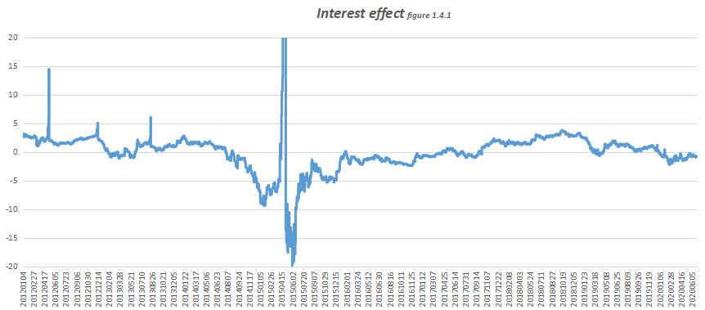
Figure 9: Interest effect(seasonal)
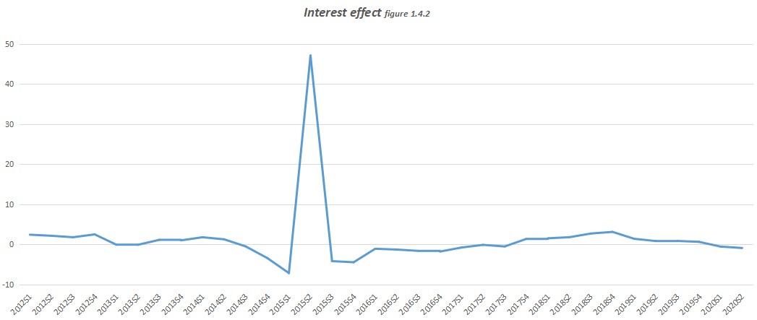
Figure 10: Interest effect(yearly) 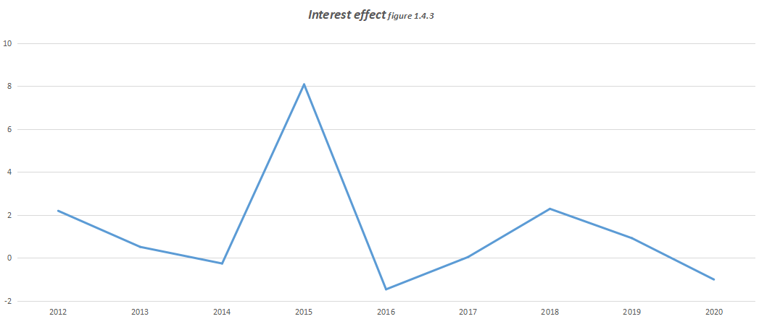
Figure 11: Implied voliatility
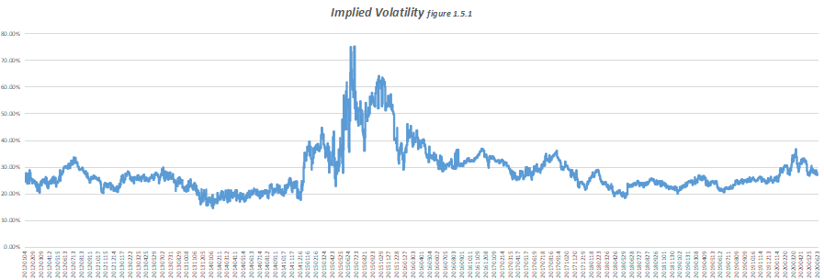
Figure 12: Implied voliatility(seasonal)
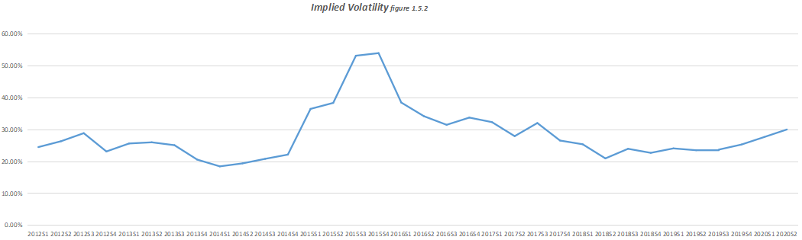

Figure 13: Implied voliatility(yearly)
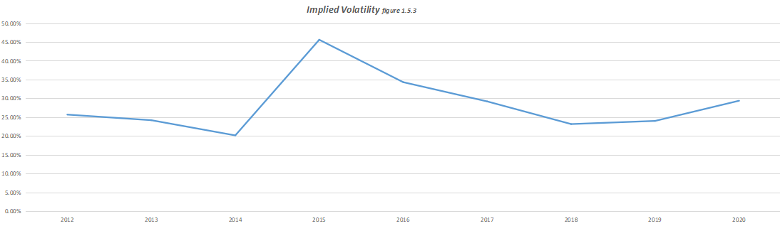

Figure 14: Newly issued CB
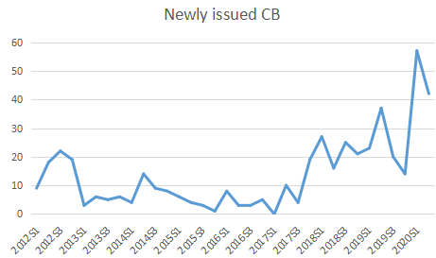

7.Reference
- Qing-fang wang,The conception of performance attribution analysis model for fixed income portfoli, Economics and Management Science
- RON cheung,VaR and its basic principles, Engineering technology Ⅱ album; Economics and Management Science
- Chen Xiaoyan, Bond Portfolio Research, Economics and Management Science
- John Hackney,Tyler R. Henry,Jennifer L. Koski, Arbitrage vs. informed short selling: Evidence from convertible bond issuers
- John Hackney,Tyler R. Henry,Jennifer L. Koski, Mathematical Model of Optimal Risk Asset Portfolio and Its Derivation
- Zhou Xiaohua Li Chunhong Huang Gang, Mathematical Model of Optimal Risk Asset Portfolio and Its Derivation, Journal of Chongqing University
- Sun Libo, An Empirical Study of Markowitz's Portfolio Theory Based on Python, The financial times
- Sun Chong, Wu Tianqing, Wang Hong, Study on portfolio selection model based on prediction theory, Journal of Yanbian University (Natural Science Edition)
- Yu-fang zhu, Research on the optimal structure of household financial investment,
Hebei enterprise
- Zhang Yuchen, Study on the Trading Strategy of Convertible Bond, Economics and Management

National University of Singapore student, email: okaydennis@hotmail.com

