Assessment of Girth and abdominal fat reduction in people using an abdominal slimming system-
Jerrold Petrofsky
Mike Laymon**
Jennifer Batt
Faris Alshammari
Jong Yim
Haneul Lee

Loma Linda University, Loma Linda California
** Touro University, Henderson NV

Dr. Jerrold Petrofsky
Professor and Director of Research
Department of Physical Therapy
Loma Linda University
Loma Linda, California, 92350
(909) 558 7274
E-mail: jpetrofsky@llu.edu

Abstract
Four groups of subjects participated in a 30 day randomized blinded study to measure the effects of an abdominal slimming system (lipolytic agent suspended in a cream, an abdominal belt and abdominal exercise) (ABSS). The subjects were divided into 4 groups. The first group was the control group, on whom only measurements were accomplished (lifestyle control group). They were instructed to not change their lifestyle. The second group (lifestyle + ABSS) used a thermal accelerator cream and abdominal belt twice a day, 7 days a week with abdominal exercise. They were not on a diet and instructed to not change their lifestyle. The third group participated in a diet and accomplished 180 minutes of mixed modality moderate intensity exercise per week (exercise control group). The exercise involved a variety of suggested exercise which kept their target heart rate at 50-85% of their maximum heart rate. The fourth group did the same program as the exercise control group and they used the ABSS system for 7 days a week (Exercise plus ABSS). Data was collected after 7 days and 30 days. The results of the experiments showed that while the lifestyle control group did not change subcutaneous fat over the one-month period, the lifestyle plus ABSS group, while not altering other body parameters i.e. thigh girth, did reduce abdominal girth and subcutaneous fat measured by Ultrasound. As expected, the exercise control group experienced reductions in weight loss, reduction in girth at the waist and abdominal fat loss. Exercise plus ABSS caused the greatest reduction in abdominal girth and subcutaneous fat and was significant compared to the exercise control group. The difference in fat loss for the exercise plus ABSS group compared to the exercise group was approximately twice the loss in fat in the abdominal area while some participants experienced as much as 4 times the fat loss due to ABSS. The study statistically demonstrated that abdominal girth and abdominal fat can be selectively targeted by the ABSS system under conditions of not changing lifestyle and when combining with diet and exercise.
Key words- exercise, weight loss, fat

Introduction

A principal problem today is obesity. Global obesity has risen significantly over the past twenty years. Over sixty million adults in the United States are obese. Of this number, thirty percent of US adults twenty years of age and older are obese [1]. The risks of increasing obesity include low grade systemic inflammation [2] hypertension, coronary heart disease, stroke, hyperlipidemia, type II diabetes, gall bladder disease, osteoarthritis, sleep apnea, and other respiratory and orthopedic conditions and some cancers [1, 3, 4].
To combat obesity, various dietary programs have been tried. These include soy based diets[5], low fat diets and low carbohydrate diets[6], high fat diets[6], a combination of surgical and diet programs [7], and high protein diets [8].
Extremes such as high fat diets or high protein diets can cause inflammation and can cause cardiovascular damage[9]. Further, rapid weight loss usually results in the weight being gained back again[6]. But programs that combine lifestyle changes and diet are much more effective, especially in terms of the fact that by doing exercise with diet, total body metabolism is increased[10]. Another advantage of regular exercise is that it increases lean body mass as well as increasing energy [11-13]. In addition to the increases in metabolism, it has been long recognized that endurance in abdominal musculature and strength of abdominal muscles is essential for health and fitness. Another aspect of a good dietary weight loss program is self-image[14]. Often, weight loss is not from the areas that people want so they are discouraged by weight loss, especially when the abdominal area still has an un-sculptured appearance [15]. Therefore, techniques such as Ultrasound, liposuction and diathermy have been used to break up fat in the abdominal area [16, 17]. These are accomplished by physicians at high cost. A simpler solution is exercise targeted to mobilize fat in the abdominal area and/or topical lipolytic creams that liberate fat.
Exercise in specific areas of the body has been, in some cases, shown to alter body composition in subcutaneous areas and remove uneven fat deposits called cellulite[18, 19]. Exercise, by increasing muscle metabolism, causes fat to be liberated throughout the body, reducing local fat deposits. This is mediated by the sympathetic nervous system. It is well known that exercise increases muscle strength as well. Topical lipolytic compounds in the form of a cream have also been used for targeting girth and fat reduction [18, 20]. One successful lipolytic compound is aminophylline [21]. It is marketed under many names and has been shown to liberate subcutaneous fat [18, 22]. Even 10 years ago, this compound was reviewed as being safe and mobilizing abdominal fat [17, 21, 23, 24] . Also, this lipolytic agent has been shown to work and not have side effects. Thus it is sold by numerous manufacturers. Caffeine has also been used as a topical agent [24, 25]. It has lipolytic properties that cause a reduction of subcutaneous fat. In addition, it increases thermogenesis in the body, also reducing body fat [25].
In the present investigation, weight loss, girth and subcutaneous fat in the abdominal area were assessed under conditions of not changing lifestyle and when combined with diet and exercise using a combination system of lipolytic cream, abdominal exercise and an elastic belt.

Subjects
The subjects in the study were 90 adults whose ages, heights and weights are listed by groups in Tables 1-4 below. Sixty-one subjects were females and 29 males. They didn’t have any cardiovascular disease or neurological injuries. The subjects were randomly divided into 4 groups. The first group was the control group, on whom only measurements were accomplished (lifestyle control group). They were instructed to not change their lifestyle. The second group (lifestyle + ABSS) used a lipolytic cream and abdominal belt twice a day, 7 days a week with abdominal exercise. They were not on a diet and instructed to not change their lifestyle. The third group participated in a diet and accomplished 180 minutes of mixed modality moderate intensity exercise per week (exercise control group). The exercise involved a variety of suggested exercise which kept their target heart rate at 50-85% of their maximum heart rate. The fourth group did the same diet and exercise program as the exercise control group and they used the ABSS system for 7 days a week (Exercise plus ABSS). All subjects signed a consent form and all procedures were approved by the Human Review Committee.

Age (years) | Height (cms) | Weight (kgs) | BMI (%) | % Body Fat
41.3 | 163.6 | 78.3 | 29.3 | 42.1
13.2 | 7.2 | 17.3 | 6.0 | 8.0

Table 1 – Lifestyle control subjects.
The top line is the mean and the second line is the standard deviation for the 30 subjects in this group

Age (years) | Height (cms) | Weight (kgs) | BMI (%) | % Body Fat
49.1 | 166.0 | 83.1 | 30.1 | 37.5
10.3 | 7.7 | 18.3 | 6.1 | 5.0

Table 2- Lifestyle plus ABSS.
The top line is the mean and the second line is the standard deviation for the 22 subjects in this group.

Age (years) | Height (cms) | Weight (kgs) | BMI (%) | % Body Fat
43.3 | 162.1 | 75.2 | 28.6 | 38.4
12.1 | 6.9 | 10.8 | 3.7 | 5.3

Table 3- Exercise control group.
The top line is the mean and the second line is the standard deviation for the 21 subjects in this group.

Age(years) | Height(cms) | Weight(kgs) | BMI(%) | % Body Fat
34.5 | 163.3 | 89.7 | 33.5 | 40.9
13.8 | 7.9 | 17.5 | 5.6 | 8.3

Table 4- Exercise plus ABSS group.
The top line is the mean and the second line is the standard deviation for the 17 subjects in this group.

Methods
Compliance-. For the 2 Lifestyle groups, they were interviewed at the end of the study to assess if they complied with the instructions to not change their lifestyle. For the exercise/diet groups, a compliance scale was used. Subjects were asked to complete log sheets on a daily basis for compliance for both the diet and exercise programs and log any foods that they ate that were not on the diet. For the 2 exercise groups a diet compliance scale was as follows each day:
----1 point each day for full compliance and then if they did not accomplish full exercise compliance, it was prorated in 1/4 increments.
---1/3 point for each of the 3 meals they complied with for a total of 1 point each day for full compliance
Diet- The diet consisted of a mixed diet with approximately the same proportions of fat, carbohydrate, and protein. The average calories were approximately 1300 calories per day for women and 1500 calories a day for men. The diet composition was approximately one third fats, one third carbohydrates and one third proteins. For the first 8 days on the 2 exercise groups, the food was provided for the diet. After that, a dietary recommendation involving a reduction in calories by following a dietary, lifestyle and behavior modification plan.
The composition of this diet (recommended foods) for the first 8 days provided the following;

WOMEN
1300 kcal
130 gm carb (40%)
98 gm protein (30%)
43 gm fat (30%)
<10 gm Sat Fat(7% total kcal)
Sodium < 2,000gm/day
Sodium Chloride < 4 gm
MEN
1,500 kcal
150 gm carb (40%)
113 gm protein (30%)
50 gm fat (30%)
<12 gm Sat Fat (7%)
Sodium < 2,000gm/day
Sodium Chloride < 4 gm
Body Fat Content- Body fat content was measured by an Impedance Plethysmograph (RJL systems, Clinton TWP, MI).
Girth Measurement- Girth measurements were made by a measuring tape with a tensionometer that applies 3 grams of force during the measurements. The same person made all measurements and was a senior student in the Physical Therapy program.

Blood Pressure- Blood pressure was measured by auscultation of the left arm. An automatic blood pressure cuff was used on the wrist (Omron Hem 621, Schaumburg, IL.).
Heart Rate- Heart rate was determined by the radial pulse by the blood pressure cuff mentioned above.
Ultrasound- Subcutaneous fat thickness was assessed with a Mindray M7 Ultrasound. The probe used was a linear probe with 512 elements in the probe which could measure the thickness of skin and subcutaneous fat to a resolution of 0.1 mm. It was used at a base frequency of 10 MHz.
Video- A video provided 2 minute abdominal isometric exercises. Subjects were instructed to put lipolytic cream on their abdominal area, place an elastic waist band on, and then follow the video with abdominal isometric exercises. They could do it either standing or sitting or they could do 2 minutes of floor crunches. The video was provided by Savvier LP.
Exercise program-
For the 2 exercise groups, the subjects were asked to perform 180 minutes of cumulated exercise per week. Each exercise session was mixed in terms of aerobic and anaerobic work and participants could select from a variety of activities such as treadmill, jogging, bicycling, stair climb, aerobic dance and similar moderate intensity exercise. The exercise could be done anytime during the day and anytime during the week.

Lipolytic thermal accelerator cream (ABSS procedure)- The lipolytic cream was a proprietary formulation that contained 2 lipolytic compounds, caffeine and aminophylline.
Subjects rubbed the thermal accelerator cream on twice daily and wore an elastic waist belt after applying it. They then accomplished a 2-minute isometric abdominal exercise either while standing or sitting. They had the option of accomplishing 2 minutes of floor crunches. The belt was worn for 8 minutes after the exercise was over (10-minute total duration). The ABSS procedure was performed twice per day and could be performed anytime during the day. The exercise plus ABSS group was instructed that they did not need to wear the belt during the exercise.
Procedures
This was a randomized blinded study so the technicians doing the measurements did not know, for each subject, which group they were in. The subjects were randomly divided into 4 groups. The first group was the lifestyle control group, on whom only measurements were done and they were instructed to not change their lifestyle (diet or exercise). Another group (lifestyle + ABSS group) used the lipolytic cream and abdominal belt twice a day 7 days a week with a video that was used after they applied the thermal accelerator cream, 2 minutes of either floor crunches or following an isometric video as described under methods. They were not on a diet and instructed not to change their lifestyle. A third group (exercise control group) stayed on the diet and accomplished 180 minutes of aerobic workout per week. The diet consisted of 8 days of planned meals after which the remaining days were a recommendation based diet. The workout was a mixed modality of moderate intensity exercise using their target heart rate and they worked at 50-85% of their target heart rate. A final group accomplished the same ABSS program as the second group, that is, they used the ABSS system twice a day for 7 days a week. However, they did 180 minutes of workouts a week of aerobic exercise and used the 8 days of planned diet for the first week and then followed recommendations for the rest of the month (exercise +ABSS group). A target heart rate between 100 and 170 beats per minute was used for the exercise sessions for both exercise groups, with heart rate being reduced by age. The exercise could include jogging, running, cycling or other aerobic activities. Data was collected after 7 days and after 30 days.

Statistical Analysis

Statistical analysis involved the calculation of means and standard deviation and related and unrelated T tests. ANOVA was used to cross compare groups. The level of significance was p<0.05.
Results
Lifestyle Control group
For the group that did not accomplish diet or exercise, the results are shown in tables 5, 6 and 7.

 | change in umbilicus girth (cm) | change in girth hips (cm) | change in weight (kg)
mean | -0.20 | -0.16 | -0.31
SD | 1.05 | 1.1 | 0.97

Table 5- Change in girth and weight in the control subjects after 7 days.
After the first 7 days (Table 5), there was no statistical difference in girth at the waist or hips (p>0.05). The subjects body weight was not statistically different (p>0.05). Similar results were seen after 1 month as shown in tables 6 and 7.

 | change in umbilicus girth (cm) | change in girth hips (cm) | change in weight (kg)
mean | 0.03 | -0.27 | 0.15
SD | 1.15 | 1.4 | 1.01

Table 6- Change in girth and weight in the control subjects after 30 days.
Here also there was also no difference in the subject’s girth at the waist or hips or in body weight as shown in Table 6. When the thickness of the subcutaneous fat layer was measured in the 3 places near the umbilicus, the average thickness of the subcutaneous fat layer was 0.21+/-0.04 cm for all of the subjects. There was no statistical difference after the month was over (p>0.05).

 | Change in BMI | Change in Body Fat
mean | 0.06 | -.27
Standard deviation | 0.35 | 1.21

Table 7- Change in BMI and body fat measured by impedance in the control subjects after 30 days.
Likewise, as shown in Table 7, BMI did not change nor did body fat comparing the initial data and the data collected after 1 month.

The resting heart rate at the beginning of the study was 75+/-7.3 beats per minute and at the end of the study was 76.1+/-8.4 beats per minute. Resting blood pressure at the start of the study was 122/83 +/- 9.2/11.3 mmHg. At the end of the study it was 121/80+/- 10.4/9.8 mmHg. There were no significant differences in blood pressure or heart rate in the control group from the beginning to the end of the study.
The post study interview with these subjects showed that they did not change their lifestyle.

Lifestyle plus ABSS group
The results of the ABSS only group are summarized in Tables 8-11.

 | change in umbilicus girth (cm) | change in girth hips (cm) | change in weight (kg)
mean | -0.92 | -0.51 | -0.46
SD | 0.89 | 1.34 | 0.54

Table 8- Change in girth and weight in the lifestyle + ABSS subjects after 7 days.

After the first 7 days, there was a significant reduction in girth at the waist (Table 8) (p<0.01) by 0.92 cm. Girth at the hips was not significantly different (p>0.05) as was the change in body weight at 7 days after the ABSS was used. After 30 days, similar results were seen as shown in Table 9.

 | change in umbilicus girth (cm) | change in girth hips (cm) | change in weight (kg)
mean | -2.45 | -.49 | -1.0
SD | 1.8 | 1.2 | 2.4

Table 9- Change in girth and weight in the lifestyle + ABSS subjects after 30 days.
Here also there was no statistical difference in the subject’s girth at the hips or in body weight (p>0.05) as shown in Table 9. The weight loss at 30 days was at 1+/-2.4 kg (p=0.06). This is not significant at the 95% level but would meet significance for 94% of the population. However, circumference at the waist was significantly lower than was seen at the start of the studies, decreasing by 2.45+/- 1.81 cm (p<0.01). The initial girth and weight data at the start of the study is listed in Table 10.

 | umbilicus girth (cm) | girth hips (cm) | Weight (kg)
mean | 100.0 | 109.8 | 83.1
SD | 12.2 | 7.5 | 18.3

Table 10- initial girth at the waist and hips and body weight at the start of the study

During the first 7 days, the top 10% of the subjects lost 3.1 cm while the top 20% lost 2.3cm. After 30 days, the top 10% and 20% of the subjects lost 5.8 cm and 5.7 cm respectively.
When the thickness of the subcutaneous fat layer was measured in the 3 places near the umbilicus, the average thickness of the subcutaneous fat layer was 0.22+/-0.04 cm for all of the subjects. After the month was over, there was a reduction of 0.04 +/-0.04 cm, a significant reduction in subcutaneous body fat (p<0.01). This amounted to a loss of 18% in subcutaneous body fat at the waist. The top 10 and 20% of the subjects at 30 days lost 0.11 and 0.09 cm respectively in subcutaneous fat.
BMI and body fat calculated by impedance measurements did not change significantly during the month as shown in Table 11.

 | Change in BMI | Change in Body Fat
mean | -0.35 | 0.64
SD | 0.86 | 2.92

Table 11- Change in BMI and body fat measured by impedance in the lifestyle + ABSS subjects after 30 days.

The compliance with the ABSS was measured for the subjects during the first 7 days and for the one month as described under methods. After 7 days the average compliance was 88.3+/- 11.6 % and at 30 days was 78.4+/-20.8%.

There was no statistical difference in the heart rate and blood pressure from the beginning to the end of the study (p>0.05).
After the test period, the post study interviews showed that they did not change their diet and exercise during the study.

Exercise control group-

The results of the exercise control group are summarized in Tables 12-15.

 | change in umbilicus girth (cm) | change in girth hips (cm) | change in weight (kg)
mean | -1.24 | -0.74 | -1.84
SD | 1.55 | 1.65 | 1.41

Table 12- Change in girth and weight in the exercise and diet only subjects after 7 days.
Tables girth hip tables 12

After the first 7 days (Table 12), there was a significant reduction in girth at the waist (p<0.01) by 1.24 cm and body weight (p<0.01). Girth at the hip was significantly different after 7 days (p<0.05). After 30 days, similar results were seen as shown in Table 13.

 | change in umbilicus girth (cm) | change in girth hips (cm) | change in weight (kg)
mean | -3.5 | -0.93 | -3.32
SD | 2.1 | 1.26 | 1.94

Table 13- Change in girth and weight in the exercise and diet only subjects after 30 days.
Here there were significant reductions in girth at the waist and body weight (p<0.01) and at the hips (p<0.01) as shown in these tables. Circumference at the waist was significantly lower than was seen at the start of the studies, decreasing by 3.5+/- 2.1 cm. The initial girth and weight data at the start of the study is listed in Table 14.

 | umbilicus girth (cm) | girth hips (cm) | Weight (kg)
mean | 98.0 | 110.4 | 75.2
SD | 20.0 | 19.6 | 10.8

Table 14- Initial girth at the waist and hips and body weight at the start of the study

When the thickness of the subcutaneous fat layer was measured at the 3 places near the umbilicus, the average thickness of the subcutaneous fat layer was 0.22+/-0.05 cm for all of the subjects. After the month was over, there was an average reduction of 0.04+/-0.03 cm, a significant reduction in subcutaneous fat (p<0.01). This amounted to a loss of 18% in subcutaneous fat at the waist.
BMI, and body fat calculated by impedance measurements, changed significantly during the month as shown in Table 15 (p<0.01). BMI was reduced by 1.3 and body fat by 2.2%.

 | Change in BMI | Change in Body Fat
mean | -1.3 | -2.2
Standard deviation | .72 | 2.5

Table 15- Change in BMI and body fat measured by impedance in the exercise and diet subjects after 30 days.

The compliance was measured for the subjects during the first 7 days and for the one month as described under methods. After 7 days the average compliance for exercise and the diet were 69.4 and 88.6% and at 30 days was 41.5% and 53.4% respectively.
The resting heart rate at the beginning of the study was 73+/-8.3 beats per minute and at the end of the study was 70.1+/-4.4 beats per minute. Resting blood pressure at the start of the study was 123/86 +/- 9.1/12.4 mmHg. At the end of the study it was 118/78+/- 11.8/8.7 mmHg. The changes in blood pressure and heart rate were significant.

Exercise plus ABSS group-

The results of this group are summarized in Tables 16-19.

 | change in umbilicus girth (cm) | change in girth hips (cm) | change in weight (kg)
mean | -1.72 | -0.93 | -2.45
SD | 1.05 | 2.12 | 1.72

Table 16- Change in girth and weight in the exercise and ABSS subjects after 7 days.

After the first 7 days (Table 16), there was a significant reduction in girth at the waist by 1.72 cm (p<0.01). Girth at the hip was also significantly less at day 7 as was the change in body weight (p<0.01). After 30 days, similar results were seen as shown in Table 17.

 | change in umbilicus girth (cm) | change in girth hips (cm) | change in weight (kg)
mean | -4.95 | -1.74 | -3.88
SD | 1.50 | 1.72 | 1.59

Table 17- Change in girth and weight in the exercise and ABSS subjects after 30 days.

There were significant reductions in girth at the waist and body weight and hips as shown in these tables (p<0.01). Circumference at the waist was significantly less than was seen at the start of the studies, decreasing by 4.95+/- 1.5 cm. The initial girth and weight data at the start of the study is listed in Table 18.
 | umbilicus girth (cm) | girth hips (cm) | Weight (kg)
mean | 105.4 | 114.5 | 89.7
SD | 14.5 | 10.4 | 17.5

Table 18- initial girth at the waist and hips and body weight at the start of the study

During the first 7 days, the top 10% of the subjects lost 3.93 cm at the waist while the top 20% lost 3.57 cm. After 30 days, the top 10% and 20% of the subjects lost 7.5 cm and 7.1cm respectively at the waist. The body weight change for the first 7 days for the top 10% and 20% of the subjects averaged respectively 5.55 and 4.83 kg and after 30 days the top 10% and 20% of the subjects lost 6.2 and 6.1 kg, respectively.
When the thickness of the subcutaneous fat layer was measured at the 3 places near the umbilicus, the average thickness of the subcutaneous fat layer was 0.21+/-0.04 cm for all of the subjects. After the month was over, there was an average reduction of 0.07+/-0.04 cm, a significant reduction in subcutaneous body fat (p<0.01). This amounted to a loss of 33% in subcutaneous body fat at the waist. For the top 10 and 20% of the subjects at 30 days, they lost 0.17 and 0.14 cm respectively in subcutaneous fat.
Data on a typical subject before (Figure 1) and after (Figure 2) the 30 day program shows the reduction in body fat below the skin.

Figure 1- subcutaneous fat before the program started
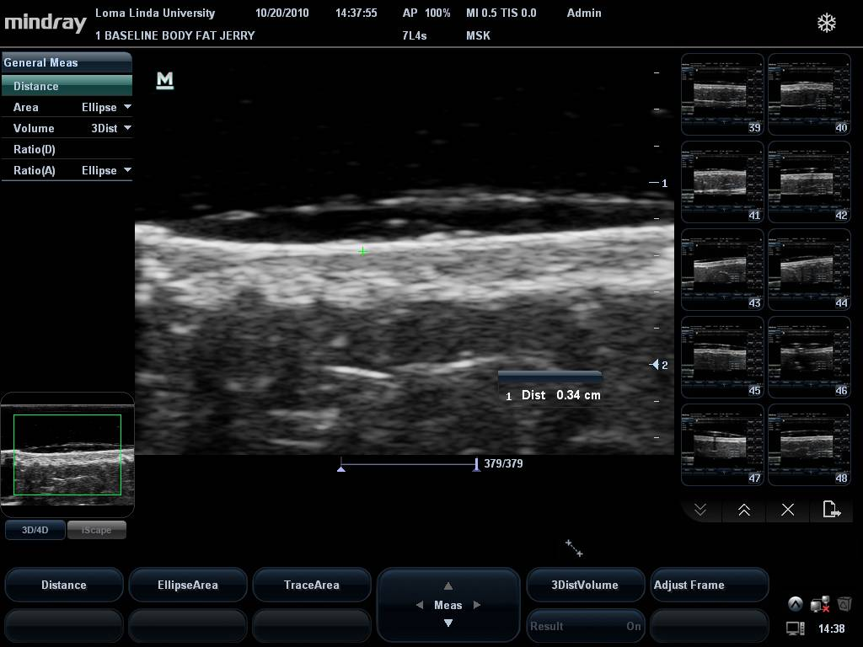

Figure 2- subcutaneous fat after the 30 day period
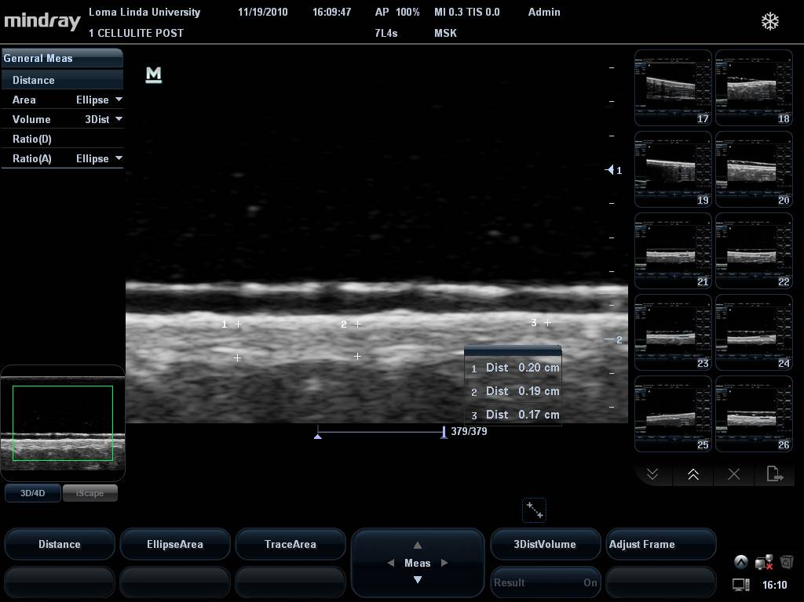
BMI and body fat calculated by impedance measurements changed significantly during the month as shown in Table 19. BMI was reduced by 1.45% and body fat by 3.1%.

 | Change in BMI | Change in Body Fat
mean | -1.45 | -3.1
SD | 0.54 | 2.52

Table 19- Change in BMI and body fat measured by impedance in the exercise plus ABSS subjects after 30 days.

The compliance was measured for the subjects during the first 7 days and for the one month as described under methods. After 7 days the average compliance for exercise and the diet were 68.8 and 91.3% and at 30 days was 42.3% and 46.8%, respectively. There was no statistical difference in compliance between the 2 exercise groups.

The resting heart rate at the beginning of the study was 77+/-11.2 beats per minute and at the end of the study was 71.1+/-5.4 beats per minute. Resting blood pressure at the start of the study was 127/87 +/- 13.1/12.1 mmHg. At the end of the study it was 117/76+/- 12.2/7.7 mmHg. The change in blood pressure and heart rate were significant.

Comparison of the experimental groups

The lifestyle plus ABSS group lost significantly greater abdominal girth, weight and subcutaneous fat compared to the lifestyle control group. The exercise plus ABSS group demonstrated a significantly greater reduction in abdominal girth and subcutaneous fat loss compared to the exercise control group (p<0.05). Weight loss and hip girth showed no statistical difference between the 2 exercise groups over the study (p>0.05). On average with exercise and ABSS, there was almost twice as much fat loss in the subcutaneous area as with the ABSS alone (p<0.05). Exercise with ABSS lost 33% vs. 18% with exercise alone, or 1.9 times the difference. The top 10 % lost 4 times as much fat with exercise and ABSS compared to exercise alone (top 10% with ABSS lost 81% vs. 18% for exercise alone or 4.5 times the loss). Lifestyle plus ABSS lost an equivalent amount of subcutaneous fat as did the exercise control group.
Discussion
The results of the experiments showed that the ABSS alone caused a significant abdominal girth and fat loss where it was applied. Even after 7 days, there was significant abdominal girth loss. At 30 days, subcutaneous fat loss was equivalent to the same fat loss as with exercise and diet alone. But the 2 together, that is diet and exercise and the ABSS system caused a very large increase in abdominal fat loss. Thus the ABSS alone was associated with, in the top 10% of the subjects, a loss of several inches off of the waist in 30 days. With diet and exercise plus the ABSS, not just the top 10% but the average subject lost about 2 inches off the waist in a 30 day diet, exercise and ABSS program. The combined subcutaneous fat loss was 33%, a major removal of fat with the ABSS, exercise and diet.
As seen in other studies and in the present investigation, fat can be targeted in specific areas of the body by using a lipolytic agent. This was not an anomaly since body fat (girth) was measured in the hips as well as the abdominal area. Since the only statistically significant change with use of the lipolytic agent was under the area where it was applied, the agent was very specific in reducing subcutaneous fat deposits as was seen in the ultrasound high resolution pictures. These results agree well with other studies where the same lipolytic agents were used, that is caffeine and aminophylline. In the Caruso study [18], for example, the subjects lost twice the girth under the area where the lipolytic agents were applied as was seen here. The elastic belt obviously provides an instant slimming effect due to its elastic nature, like other slimming garments such as girdles. What is different with the ABSS is that, in addition to the elastic belt, the system contains the lipolytic cream and abdominal exercises. As a system, this provides actual fat loss around the abdominal region. This provides an instant slimming effect of the garment while people reduce the actual girth and abdominal fat by the rest of the system.
It is noteworthy that there were no adverse events reported with the ABSS system. This is best evidenced by the fact that the heart rate and blood pressure measurements did not change for the lifestyle + ABSS group during the study.

References

1. CDC- and C.f.D.C.a. Prevention. Overweight and Obesity. 2005; Available from: http://www.cdc.gov/nccdphp.dnpa/obesity/.
2. Ramos, E.J., et al., Is obesity an inflammatory disease? Surgery, 2003. 134(2): p. 329-35.
3. Moran, R., Evaluation and treatment of childhood obesity. Am Fam Physician, 1999. 59(4): p. 861-8, 871-3.
4. Troiano, R.P. and K.M. Flegal, Overweight children and adolescents: description, epidemiology, and demographics. Pediatrics, 1998. 101(3 Pt 2): p. 497-504.
5. Razzeto, G.S., et al., Soybean flour induces a greater increase of the antioxidant defenses in rats fed with normocaloric diet compared with hypercaloric diet. J Sci Food Agric, 2014.
6. Soeliman, F.A. and L. Azadbakht, Weight loss maintenance: A review on dietary related strategies. J Res Med Sci, 2014. 19(3): p. 268-275.
7. Dixon, J.B., et al., Changes in body composition with weight loss: obese subjects randomized to surgical and medical programs. Obesity (Silver Spring, Md ), 2007. 15(5): p. 1187-98.
8. Gately, P.J., et al., Does a high-protein diet improve weight loss in overweight and obese children? Obesity (Silver Spring, Md ), 2007. 15(6): p. 1527-34.
9. Ilich, J.Z., et al., Low-grade chronic inflammation perpetuated by modern diet as a promoter of obesity and osteoporosis. Arh Hig Rada Toksikol, 2014. 65(2): p. 139-48.
10. Petrofsky, J., J. Batt, and A. Morris, Weight loss and cardiovascular fitness during a one week diet and exercise program. Journal of Applied Research, 2006. 6: p. 51-61.
11. Haskell, W.L., J.B. Wolffe Memorial Lecture. Health consequences of physical activity: understanding and challenges regarding dose-response. Med Sci Sports Exerc, 1994. 26(6): p. 649-60.
12. Boegli, Y., et al., Endurance training enhances vasodilation induced by nitric oxide in human skin. J Invest Dermatol, 2003. 121(5): p. 1197-204.
13. O'Sullivan, P.B., L. Twomey, and G.T. Allison, Altered abdominal muscle recruitment in patients with chronic back pain following a specific exercise intervention. J Orthop Sports Phys Ther, 1998. 27(2): p. 114-24.
14. Yager, Z. and J.A. O'Dea, Relationships between body image, nutritional supplement use, and attitudes towards doping in sport among adolescent boys: implications for prevention programs. J Int Soc Sports Nutr, 2014. 11(1): p. 13.
15. Olivero-Rivera, L., Mesotherapy for body sculpting. European staple of reshaping gaining ground here. Adv Nurse Pract, 2008. 16(11): p. 30.
16. Adatto, M.A., R.M. Adatto-Neilson, and G. Morren, Reduction in adipose tissue volume using a new high-power radiofrequency technology combined with infrared light and mechanical manipulation for body contouring. Lasers Med Sci, 2014.
17. Rosenbaum, M., et al., An exploratory investigation of the morphology and biochemistry of cellulite. Plast Reconstr Surg, 1998. 101(7): p. 1934-9.
18. Caruso, M.K., et al., Topical fat reduction from the waist. Diabetes, obesity & metabolism, 2007. 9(3): p. 300-3.
19. Loberbauer-Purer, E., et al., Can alternating lower body negative and positive pressure during exercise alter regional body fat distribution or skin appearance? Eur J Appl Physiol, 2012. 112(5): p. 1861-71.
20. Greenway, F.L., G.A. Bray, and D. Heber, Topical fat reduction. Obes Res, 1995. 3 Suppl 4: p. 561S-568S.
21. Lundberg, G.D., Fat reduction by topical waist applications may actually work. Medscape J Med, 2008. 10(2): p. 43.
22. Caruso, M.K., et al., An evaluation of mesotherapy solutions for inducing lipolysis and treating cellulite. J Plast Reconstr Aesthet Surg, 2008. 61(11): p. 1321-4.
23. de Godoy, J.M. and F. de Godoy Mde, Evaluation of the prevalence of concomitant idiopathic cyclic edema and cellulite. Int J Med Sci, 2011. 8(6): p. 453-5.
24. Di Salvo, R., Controlling the appearance of Celluite. Cosmetics and Toiletries, 1995. 110: p. 50-59.
25. Liu, A.G., et al., The effect of leptin, caffeine/ephedrine, and their combination upon visceral fat mass and weight loss. Obesity (Silver Spring), 2013. 21(10): p. 1991-6.

