Modeling of a New three Phase High Voltage Power Supply for Industrial Microwave Generators with magnetron

B.Bahani, M. Chraygane, R. Batit, N. El Ghazal, A. Belhaiba, H. EL Khatat

High School of Technology, MSTI Laboratory, Ibnou Zohr University

Agadir-Morocco

E-mail: b.bahani@gmail.com

M. Ferfra, M. Bassoui

Mohammadia’s School of Engineers, Research Team in Electrical Energy & Control

Mohamed V University, Rabat-Morocco

**Abstract-** The purpose of this article is to develop an improved new high voltage power supply model for magnetrons, used for the microwave generators in industrial applications. The design of this system is composed of new three-phase leakage flux transformer (a laminated magnetic closed circuit composed of five vertical columns and two yokes) supplying by phase a cell, which multiples the voltage and stabilizes the current. Each cell in turn, supplies a single magnetron. An equivalent model of this transformer is developed taking account the saturation phenomenon and the stabilization process of each magnetron.

Each inductance of the model is characterized by a non linear relation between flux and current. This model was tested by matlab-SIMULINK software near the nominal state. The results of simulation were represented a good agreement with experimental measurements. Relative to the current device, the new system provides gains of size, volume, cost of implementation and maintenance.

**Keywords:** Three-phase Transformer; Modeling; matlab-SIMULINK; Microwaves; Power supply.

1. **Introduction**

The three-phase transformer generally consists of three single-phase transformers but this solution has the disadvantage of occupying an excessive volume to be carried out in an industrial environment. The present article deals with a new approach to the study of behavior in non linear regime of a new three-phase high voltage transformer with magnetic shunt. The figure 1 shows the scheme of this new three-phase HV transformer. The new system will be used in a new power supply for a single magnetron per phase, used in microwave energy source.

A new three-phase magnetic leakage transformer, not yet so far modeled or manufactured, is the basic element of this new power supply. The new transformer supplies by phase a voltage doubler and current stabilizer cell. This special transformer with shunts ensures the anodic current stabilization in each magnetron by saturation of its magnetic circuit.

The characteristics of the magnetron [1]-[7] as well that these limit values impose a proper design of its power supply. Unlike the conventional transformer, the leakage flux in the shunt is of the same order as both the primary and secondary fluxes. Thus, the theory of classical transformers does not apply in the case of the transformer with shunts. On the other hand, the design and optimization of such devices can be facilitated using simulation tools taking into account the geometry and the non linear magnetic properties of materials. In this article, we introduce an equivalent diagram of the new transformer that meets these conditions. Integrated into an overall scheme of the new HV power supply for a single magnetron by phase, it is adapted to the modeling of the assembly by a numerical calculation of electrical circuit matlab-SIMULINK. Experimental measurements, obtained for a single-phase transformer with shunts, used to validate the simulated results of this model.

The paper is organized as follows: firstly, the mathematical equations characterizing this new special transformer was described in order to drive a new equivalent model. Secondly, an implementation of obtained model using matlab-SIMULINK software was presented. The obtained results were compared with those already found in feasibility study already done [8][9], and experimental measurements for the classical power supply for single magnetron [1][7].

1. **Improved modeling of the new three-phase transformer with magnetic shunts**

In this proposed study, the new three-phase transformer is considered without iron losses (hysteresis and Foucault currents). The leakages that exist are only channeled in the shunts. The leakage of air dispersion is negligible. Only the saturation phenomenon is taken into consideration.

A new three-phase transformer with magnetic shunt consists initially of the association of three conventional single-phase transformers with magnetic shunt which the three primary and three secondary are connected in star. The three primaries are powered by a source of three-phase balanced alternating current. Therefore, the three magnetizing currents and thus three flux in the three cores also form a balanced three-phase system. If it meets three magnetic circuits of a single-phase transformer with magnetic leakage flux, but this time the three circuits are cascaded, the common colonnes in both phase (phase 1- phase 2 ; phase 2- phase 3) is therefore travelled by a non-zero flux (Φcomp12≠ 0 and Φcomp23≠ 0) as shown in the figure 2.

**2.1 Study of the new transformer**

The purpose of this study is to determine a model that simulates as closely as possible the behavior of the new three-phase transformer with magnetic shunts.



*Fig 1. New three-phase transformer with magnetic shunts (New magnetic circuit of five colomns)*

The magnetic circuit of the new three-phase transformer is shown in Figure 1. The first and the third stage are identical, two columns, one column are wound. The second phase consists of three columns, the unit receives the windings and the other to the ends (common with the phase 1 and phase 2) are used to close the magnetic circuit.

The figure 2 shows the structure of the new three phase transformer with shunts, not yet modeled or manufactured that will be used in the HV power supplies for single magnetrons per phase. The magnetic shunts are used to deflect an important part of the flux circulating between the primary and secondary winding. Taking into account the dimensions of residual gaps and the saturation state of materials, the magnetic fluxes in the air can be considered negligible compared to the fluxes through the shunts. The three primary windings constitute a balanced three-phase load given that these three windings are the same. This means that the effective values of the three voltages are equal and the three voltages are shifted relative to it 120 degrees.

**2.2 Mathematical study of different equations**

The primary quantities are shown by r1i; n1; i1i; U1i (Phase i = 1; 2; 3) and the secondary quantities are materialized by r2i; n2; i2i; U2i (Phase i = 1; 2; 3). The fluxes Φ1i; Φ2i; Φ3i are respectively the flux passing through the primary, the secondary and the shunts of each phase as shown the figure 2:

r1i : Primary winding resistance (Phase i).

i2i : Secondary winding resistance (Phase i).



*Fig 2. Distribution of fluxes in the magnetic circuit of the new three-phase transformer*

**2.2.1 The electric equations**

The governing electrical equations of the transformer operation are obtained by the application of the generalized law Ohm in primary and secondary winding of each phase:

For the phase 1:



For the phase 2:



For the phase 3:



**2.2.2 The magnetic equations**

The similarity of the laws of electrical and magnetic circuits allows to develop fully an analogy between electrical and magnetic circuits.

The magnetomotive force is the analogue of the electromotive force, the reluctance is the analogue of resistance and flow is the analogue of the current. This analogy allows us to deduce the following figure.

*fig 3. representation of the magnetic equivalent diagram simplified of the transformer five columns*

The application of the maille law gives:

**For the phase 1:**

*For the ABCA contours:*

 (2 .7)

*For the ACDA contours :*

 (2 .8)

*For the ABCDA contours :*

 (2 .9

The equation expresses the conservation of flux in the first phase:

 2.10

**For the phase 2:**

*For the BECF contours:*





 (2 .11)

With 

*For the CFGD contours:*





 (2 .12)

With 

*For the EHFI contours:*





 (2 .13)

Avec 

*For the FIGJ contours:*





 (2 .14)

Avec 

* The subtraction equations (2 .11) with (2 .13) give :

 (2 .15)

* The subtraction equations (2 .12) with (2 .14) give :

 (2 .16)

The equation expresses the conservation of flux in the second phase:

 (2 .17)

**For the phase 3:**

*For the HKIH contours:*

 (2 .18)

*For the KIJK contours:*

 (2 .19)

*For the HKJIH contours:*

 (2 .20)

The equation expresses the conservation of flux in the third phase:

 (2 .21)

**The equation of other nodes:**

*The nodes B*

 (2 .22)

*The nodes D :*

 (2 .23)

*The nodes H :*

 (2 .24)

*The nodes J :*

 (2 .25)

1. **Modeling of the new three-phase transformer with shunts**
   1. **Equivalent electrical model of the first phase of the new transformer with shunts.**

multiplying the equation (2 .1) with the transformation ratio gives :



we put:

 ;  ; 

We can write the quantity  in the form 



On noticing that the magnitudes ,  have the dimensions of an inductor and a current.  (2 .26)

From the flux conservation equation of first phase (2.10) we have:



is therefore: 



consequently:  (2 .27)

Equation (2 .2) is worth :





 (2 .28)

We will exploit the equations (2 .7) and (2 .8) for the direction of the currents in the wiring diagram:

The equation (2 .7) give :



 (2 .29)

The equation (2 .8) give :







(2 .30)

After the equations(2 .26),(2 .27), (2 .28),(2 .29)et(2 .30), we build the electric scheme of the first phase in the transformer:



*Fig 4. Equivalent electrical model of the first phase of the new transformer with shunts.*

**3.2. Equivalent electrical model of the second phase of the new transformer with shunts.**

After the developement of the equation of second phase in accordance with the same approach of first phase we find:

 (2 .31)

 (2 .32)

 (2 .33)

 (2 .34)

 (2 .35)



*Fig 5. Equivalent electrical model of the second phase of the new transformer with shunts.*

3.3. **Equivalent electrical model of the third phase of the new transformer with shunts.**

After the developement of the equation of third phase in accordance with the same approach of first phase we find:

 (2 .36)

 (2 .37)

 (2 .38)

 (2 .39)

 (2 .40)



*Fig 6. Equivalent electrical model of the third phase of the new transformer with shunts.*

The sum of the equivalent shemas of three-phase drive us to the next global scheme



*Fig 7. Equivalent electrical model of the transformer with shunts.*

1. **Validation the new model of the new power supply**

The model of the new transformer is integrated in the new HV power supply circuit from the source to the magnetrons. Each tube microwave is represented by an equivalent diagram deduced from its electrical characteristics which is formally similar to that of a diode with dynamic resistance R=350Ω and threshold voltage E=3800V. Exploiting the matlab-SIMULINK code, the electrical behavior of the HV circuit of the new three-phase power supply with single magnetron per phase is simulated (Figure 8). The waveforms obtained from this simulation are shown in Figure 9.

The figure 9 shows that in nominal operation (U11 = U12 = U13 = 220V and f = 50Hz) the results of simulation by matlab-SIMULINK of the new device, in non linear regime, confirm the results obtained during a feasibility study already done [8-12-13]. The relative differences will never exceed 6%. These signals have the same form as those of a classical HV power supply using a transformer for a single magnetron. The phase shift of 120 degrees between them confirms the absence of interaction between magnetrons. Taking into account the accuracy of the various data and of the permissible tolerances acceptable on the operation of the magnetron, the modeling was deemed satisfactory.

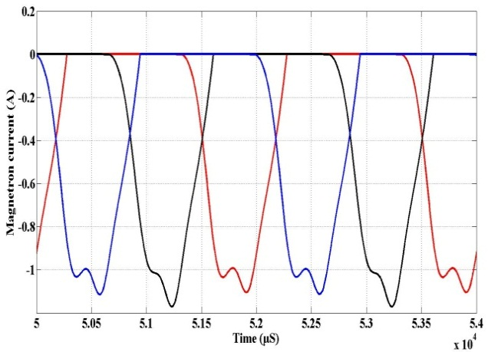

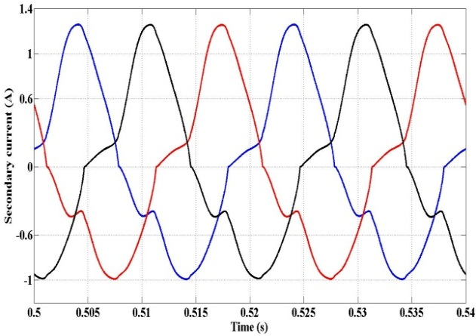

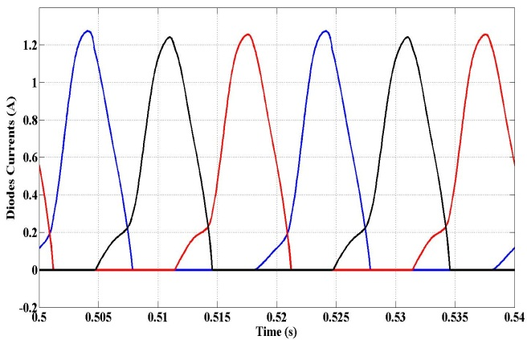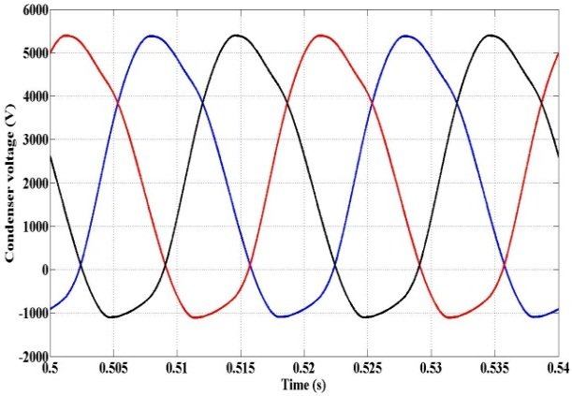

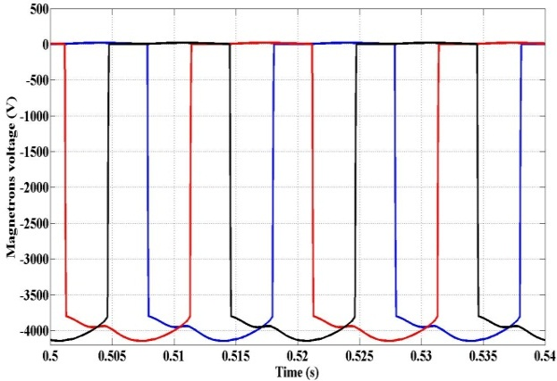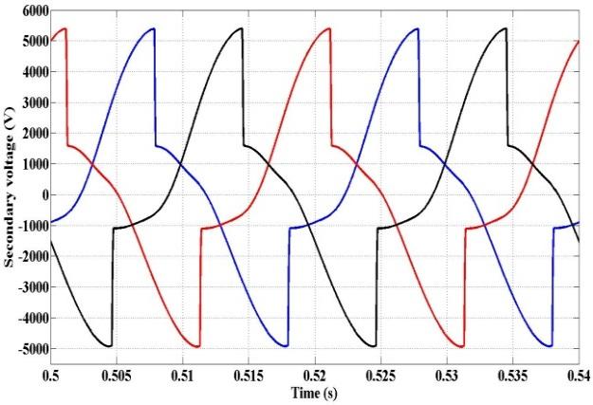

*Fig 8. Simulation with SIMULINK code: Forms of voltage and current waves (nominal operating)*













*Fig 9. Experimental waveforms of currents and voltages (nominal mode)*

Conclusion

In this article, a new original model able to represent the best possible characteristics of saturation of a new three-phase transformer with shunts, not yet so far modeled or made, was concluded. The resulting model was validated by the matlab-SIMULINK code in nonlinear regime and verifies the regulating process of the current in each magnetron. The results confirm that there are no interactions between the three magnetrons. The failure of one or more magnetrons does not affect the operation of other powered magnetrons. As perspectives, this study can be extended without any problems in case of operation of the new power supply for N = 2 magnetrons per phase in nominal scale.

**References**

[1]. B. BAHANI, M. FERFRA, M. CHRAYGANE, M.BOUSSETA, N. EL GHAZAL, A.BELHAIBA, ”**Modeling and Optimization of a New Single-Phase High Voltage Power Supply for Industrial Microwave Generators’’,** *International Review of Electrical Engineering (I.R.E.E.), Volume 9, Issue 1, 2014, Pages 136-145*

[2].M. Chraygane, M. Ferfra, M. El Khouzaï, B. Hlimi (2003),“étude de l’état magnétique interne global du transformateurs à shunts d’une alimentation pour générateurs micro-ondes à magnétron destinés aux applications industrielles”, Télécom’2003 et 3ème JFMMA– Marrakech. Communication. pp .436-439.

[3]. B. BAHANI, N. El GHAZAL, M. CHRAYGANE, A. BELHAIBA, M. BOUSSETA, M. FERFRA, ‘**’ Improved Model of New Six-Phase High Voltage Power Supply for Industrial Microwave Generators with A Single Magnetron By Phase***’’, Int. Journal of Engineering Research and Applications, Vol. 4, Issue 10( Part - 4), October 2014, pp.25-33*

[4]. Chraygane M (2007), “Modélisation avec EMTP d’une nouvelle génération d’alimentation haute tension monophasée pour générateurs microondes à magnétrons destinés aux applications industrielles”, Thèse de doctorat d’état, Université Ibn Zohr Agadir, Maroc, n° 113/07.

[5]. M. Ould Ahmedou, M. Chraygane, M. Ferfra (May-Jane 2010), “New π Model Validation Approach to the Leakage Flux Transformer of a High Voltage Power Supply Used for Magnetron for the Industrial Micro-Waves Generators 800 Watts-2450 MHz”, International Review of Electrical Engineering IREE, Vol. 5, n. 3.

[6]. M. Ould.Ahmedou, M. Ferfra, R. Nouri, M. Chraygane (From 07 to 09 April 2011), “Improved π Model of the Leakage Flux Transformer Used for Magnetrons”, International Conference on Multimedia Computing and Systems, IEEE Conference, Ouarzazat –Morocco.

[7]. M. Ould.Ahmedou, M. Ferfra, N. El Ghazal, M. Chraygane,M. Maafoufi (30 November 2011), “Implementation and Optimization Under Matlab Code of a HV Power Transformer For Micowave Generators Supplying Tow Magnetrons”, Journal of

[8]. A. Belhaiba, M. Chraygane, M. Ould Ahmedou, M. Ferfra & N. El Ghazal (27-28 Mai 2011), “Modélisation du bilan énergétique d’un générateur micro ondes industriel à un seul magnétron”, Conférence Méditerranéenne sur l’Ingénierie Sûre des Systèmes Complexes, MISC’11 Agadir-Morocco.

[9]. N. EL Ghazal, M. Chraygane, M. Ould Ahmedou, M. Ferfra & A Belhaiba (27-28 Mai 2011), “Modélisation d’une alimentation haute tension à caractère triphasé pour générateurs micro ondes industriels à un magnétron par phase”, Conférence Méditerranéenne sur l’Ingénierie Sûre des Systèmes Complexes, MISC’11 Agadir-Morocco.

[10]. N. El Ghazal, M. Ould Ahmedou, M. Chraygane, M. Ferfra, A. Belhaiba (2012), “Optimization of High Voltage Power Supply for Industrial Microwave Generators for one Magnetron”, Journal of Theoretical and Applied Information Technology, Vol. 46. No. 1, pp 001 – 010.