Impact of Financing Policies on Loan Growth
In AXIS Bank*
MAHDI QASEM SAEED SAEED  DEPARTMENT OF COMMERCE  BAMU UNIVERSITY  AND TAIZ UNIVERSITY  Email of institution :comm.mqs@bamu.ac.in  Email: wadeamahdi733408993@gmail.com | Dr. D.A.NIKAM  ASSISTANT PROFESSOR  SHRI MUKTANAND COLLEGE,GANGAPUR . BAMU UNIVERSITY  Email:drdeepak.nikam@rediffmail.com

ABSTRACT : The purpose of this paper is to measure the impact of the financing policies by deposits on loans growth in banks .This paper has been performed using applied studyon AXIS bank in India to know the impact of the financing policies by deposits on loan growth during the period (2010 - 2019). The relationship between the independent variables and dependent variable was observed using SPSS .through, a multiple regression model was applied to determine the impact between the impact of the financing policies by deposits on advances growth.The findings of the study revealed that the financing policies by deposits increases the loans growth in AXIS bank. The result of the coefficients showed that the saving deposit had a significant impact on loan growth .
KEYWORD:The financing policies by deposits , loan growth .AXIS BANK .
- INTRODUCTION
The financial system is an important tool for any country that wants to develop economically.The banks are financial institutions the main support of this system which create loans and offer related financial services for multiple financing policies , the deposits is one of the financing policies .The banks performance is based on their ability to attract a large number of customers through comparative proportion of account holders relative to other banks' amount of deposits and profit was realized. Loan officers are aware of legal restrictions and basic credit principles that would make new approaches or restraints necessary to ensure that level of return was up to their expectation.The financing policies by deposits is a one of the financing policies that banks use as a determinant of rejecting or granting loan requests. Loan growth of most commercial banks reveals that there are challenges to the developing banking sector. Banking in India has been a backbone to so many businesses in the past as well as in the present times. It started in the 18th century and is still going strong. Different types of banks in India as central banks, commercial banks, investment banks, cooperative banks, postal banks. AXIS bank is one of banks in India offer for a variety of deposit accounts such as checking, sacurrent deposits, savings, and term deposits, and it is issues different types of loans and credit cards to meet the needs of business, government and customers inside and presents advances outside India as bills purchased and discounted syndicated loans and others , and played an important role in competition in the financial industry, By attracting different deposits and expanding credit, perception of credit risk, risk aversion, availability of close substitutes for loans, etc.
1.1 Related literature:
The study of (Nguyen, T., Tripe, D., & Ngo, T. 2018 ) aimed to examine whether there is a causal relationship between bank loans and deposits in the Vietnamese banking system and the efficiency of the use of loans and deposits by the Vietnamese banks.The researcher use a pooled cross-sectional sample of financial ratios was collected from annual reports of 44 Vietnamese banks during the period from (2008 to 2015), the explanatory potential of instrumental variables in relation to the independent variables was tested , a deterministic frontier model based on corrected ordinary least squares, estimated by three-stage least squares on a simultaneous equations model, was employed to derive the frontiers for the sampled banks as well as to estimate the causality between bank loans and deposits.The findings suggest that bank deposits have a positive and significant impact on bank loans, but the reverse relationship is not significant. It is moreover suggested that in deposit-taking and loan-creating activities, Vietnamese banks performed moderately well over the period examined; however, in the near future, they should start to focus more on deposit-taking activities.
The study of ( Abugah, W. M., Nyagol, M. O., & Odoyo, F. 2017) was aimed to know the effect of lending policies on loan performance of selected commercial banks operating in Kisii County in Kenya . The research used descriptive survey approach and quantitative data was analyzed using descriptive statistics tools (SPSS). The findings of the study there were statistical significant relationships between influences of interest rate policies on loan performance ,led to improved loan performance of the commercial banks operating in Kenya.The banks are able to provide a wide range of services to their client , thus increasing the profit margin of the bank. The effect is that there is improved loan performance of the bank courtesy of the interest rates policy.
1.2 Objectives of the Study: : The objective of the study is to find out the following
1 - Measuring the impact between the financing policies by deposits on loans growth in the AXIS bank .
2 - Discovering any type of deposit that has an impact on loan growth.
1.3 Research Question : In an attempt to achieve the above objective, the study developed the following question; what is the impact of the financing policies by deposit in the AXIS bank in India during the studied period on the loan growth .
1.4 Research Hypothesis:There is not a statistically significant relationship between the financing policies by deposits on the loan growth .
- THEORETICAL FRAMEWORK
2.1 The Concept of Bank Deposits : Deposits with commercial banks are of great importance and include the largest part of the resources available to the bank in order to use it in its various activities. They are necessary for investment operations, lending, and the provision of facilities . In other words, commercial banks deal with the funds of others (citizens, companies, governmental institutions or others). (https://www.elearnmarkets.com/blog/various-types-of-bank-deposits/)
A deposit is a financial term that means money held at a bank, a deposit is a transaction involving a transfer of money to another party for safekeeping. However, a deposit can refer to a portion of money used as security or collateral for the delivery of a good. (https://www.investopedia.com/terms/d/deposit.asp).
2.2 The Deposits in AXIS Bank: Banks as financial intermediaries deal mainly in financial assets, and fact shows up well in their balance sheets. through, liabilities and assets at a point of time. A consolidated statement of the liabilities of AXIS bank for the period 2010 to 2019 is given in chart 1.1 .The liabilities of AXIS bank is represented from : capital,reserves and surplus ,minority Interest ,deposits, borrowings and other liabilities and provisions of AXIS bank.
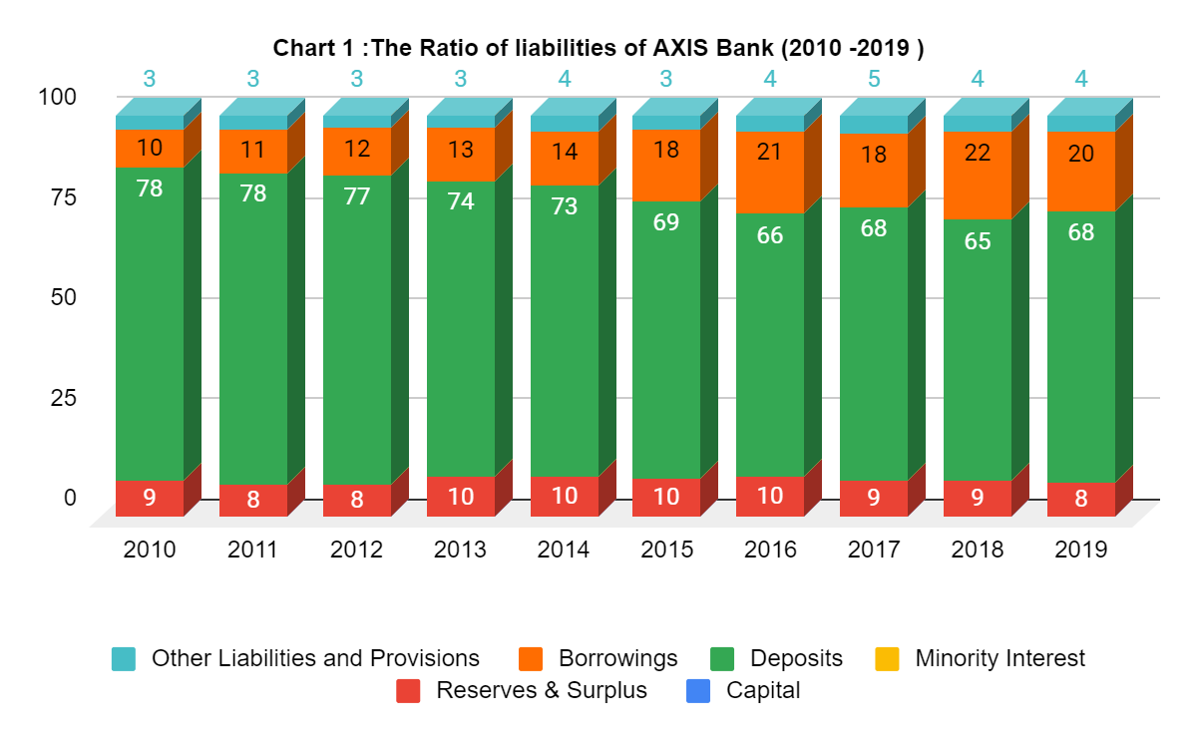
The chart above shows the ratio elements of liabilities to total liabilities during the period 2010 to 2019 . Notice the ratio of capital was between (3%to 4%) from total liabilities .While the ratio of reserves and surplus was between (8%to 10%) from total liabilities .The ratio of borrowings increases from 10 %e in 2010 to 20% in 2019 this indicates the bank follow financing policies by borrowing in the last years. While the ratio of deposits was between (65% to 78%) from total liabilities this indicates in the last years the AXIS bank follow decrease the financing policies by deposits with by 10% in 2019 from 2010, the deposits is represent the main source for financing policies, Were for almost 69 % of total liabilities for AXIS bank.
2.3 The Types of Deposits in AXIS Bank:
At the present level of financial development in India, banks are the premier financial institution. Deposit mobilisation by them remains the most important (though not the only) form of mobilisation of savings of the public. Therefore, to the extent the promotion and mobilisation of savings is a necessary prerequisite for stepping up the rate of economic growth, mobilisation by banks in real terms must be given its due weight.
(https://www.yourarticlelibrary.com/banking/liabilities-and-assets-of-scheduled-commercial-banks-main-items/40814
Table (1)Types of Deposits in AXIS Bank (2010 - 2019) (Rs. in Crore)
Year | Current Deposits (Demand ) | Savings Bank Deposits | Term Deposits | Total
2010 | 321,623,003 | 338,617,974 | 752,545,610 | 1,412,786,587
2011 | 369,075,403 | 408,503,090 | 1,114,085,821 | 1,891,664,314
2012 | 397,442,509 | 516,679,577 | 1,285,754,719 | 2,199,876,805
2013 | 482,009,212 | 637,777,349 | 1,401,704,616 | 2,521,491,177
2014 | 486,292,590 | 777,760,612 | 1,541,357,536 | 2,805,410,738
2015 | 559,370,299 | 882,921,758 | 1,780,149,643 | 3,222,441,700
2016 | 635,211,062 | 1,057,934,225 | 1,889,876,645 | 3,583,021,932
2017 | 865,240,474 | 1,260,484,706.00 | 2,024,101,572 | 4,149,826,752
2018 | 955,246,373 | 1,482,021,884 | 2,119,309,385 | 4,556,577,642
2019 | 892,138,214 | 1,541,290,515 | 3,074,030,622 | 5,507,459,351
Total | 5,963,649,139 | 8,903,991,690 | 16,982,916,169 | 31,850,556,998
Source : Prepared by the researcher from the annual reports of AXIS bank (2010 to 2019).
The table above shows the types of deposits in AXIS bank and value of deposits during the period , notice the deposits classification in AXIS bank to current (demand ), saving and term deposits . The deposits value in 2010 (1,412,786,587 Rs) increased during the period until the value amount in 2019 (5,507,459,351). The term deposits represent the high rate from other deposits.
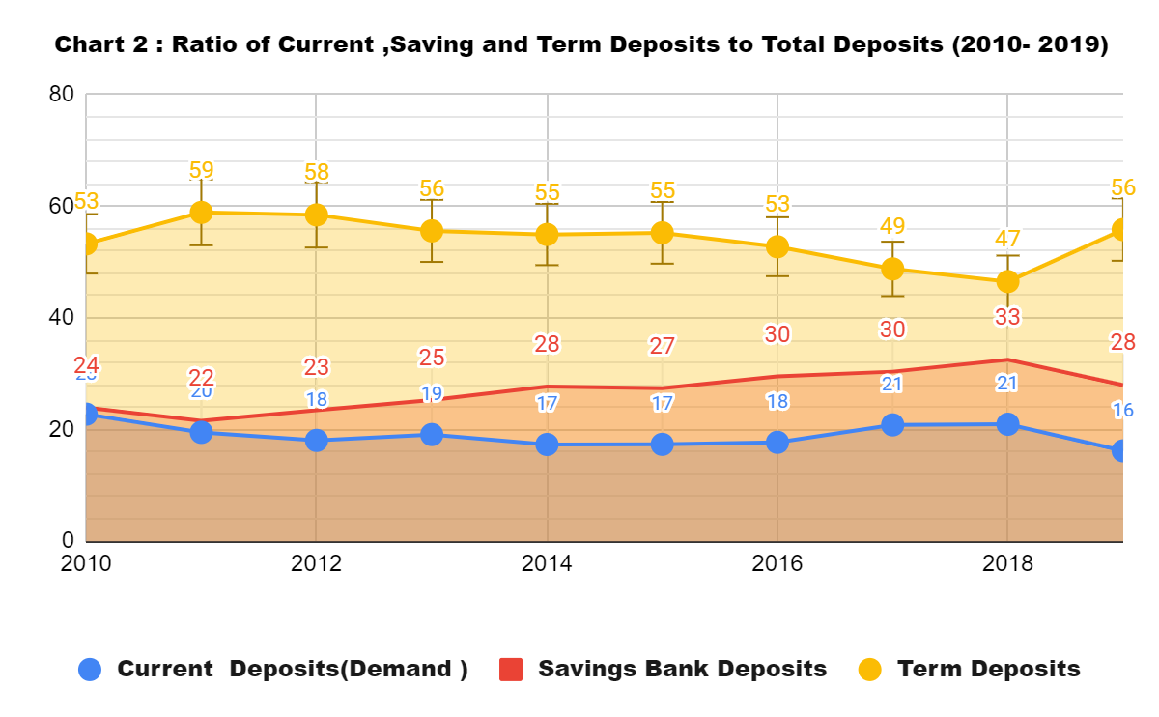
Source : Prepared by the researcher from the annual reports of AXIS bank (2010 to 2019).
Chart 2 : Indicates that term deposits account for a very high percentage of total deposits of the bank that varied between 47% to 59%from total deposits . Hence, it implies that there is a burden of high interest risk management in view of the variations in the interest rates. The AXIS bank has to ensure matching between the amount and maturity date of interest bearing liability and the amount and maturity date of interest earning assets , and have to design investment] portfolio in such a way that interest income is more than the cost of funds deployed. Otherwise financial productivity is adversely affected. Savings bank deposits clears that the ratio has increased over the period from 24.% in 2010 to to 33% in 2018. Hence, it indicates that the bank has been able to attract or mobilize more or relatively less costly deposits and therefore is not much influenced by these deposits on the financial risk . The demand deposits constitute between 16 % to 20% of the total deposits during the study period from 2010 to 2019 . Hence, it can be inferred that their impact on the loan growth is not severe. Demand deposits are to be paid by the banks on demand to the depositors without attaching or stipulating any conditions.
2.4 The advance(Loan) in AXIS bank :
The loans indicate a type of credit policies in which a sum of money is lent to another party in exchange for future repayment of the value or principal amount. In many cases, the lender also adds interest and/or finance charges to the principal value which the borrower must repay in addition to the principal balance. Loans may be for a specific, one-time amount, or they may be available as an open-ended line of credit up to a specified limit. (https://www.investopedia.com/terms/l/loan.asp)
The chart 3 below shows the ratio of assets of AXES bank during the period , notice through the chart the rate of loans was between (58 % to 64 %) that is a high ratio from all assets ,This indicates that the bank is most active and its income is from interest on loans. It must diversify the activity because of the risks of loans, as well as he has to schedule loans so that he can collect loans during repayment periods. Investments represented the second activity after deposits, which ranged between(21% to 31%) but the ratio of investment decreases were in 2010 31% of total assets while in 2019 decreased to 21% .

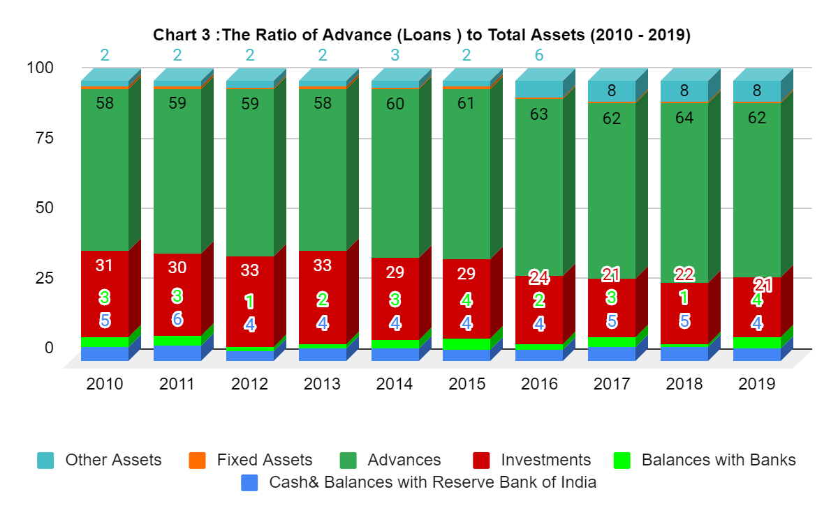 2.5 Types of Advances (Loans) in AXIS bank : Loan types according to the credit policies in banks different types of loan each loan has a specific intended use. They can vary by length of time, by how interest rates are calculated, by when payments are due and by a number of other variables. Advances are classified in AXIS bank into performing and non-performing advances (‘NPAs’) as per the RBI guidelines and are stated net of bills rediscounted, inter-bank participation certificates, specific provisions made towards NPAs, interest in suspense for NPAs, claims received from Export Credit Guarantee Corporation, provisions for funded interest on term loan classified as NPAs, provisions in lieu of diminution in the fair value of restructured assets and floating provisions.(For more details about lending policies in AXIS bank , see the bank's annual reports. (https://www.axisbank.com/shareholders-corner/shareholders-information/annual-report)
The AXIS bank presents the advances as : Bills purchased and discounted and cash credits, overdrafts and loans repayable on demand . Term loans secured by tangible assets(Includes advances against book debts ) and covered by Bank/Government Guarantees(Includes advances against L/Cs issued by banks) .Advances inside India as priority sector ,public Sector , banks and others . Advances outside India as bills purchased and discounted syndicated loans and others .
Table 2 :The Advances (2010-2019) |  | 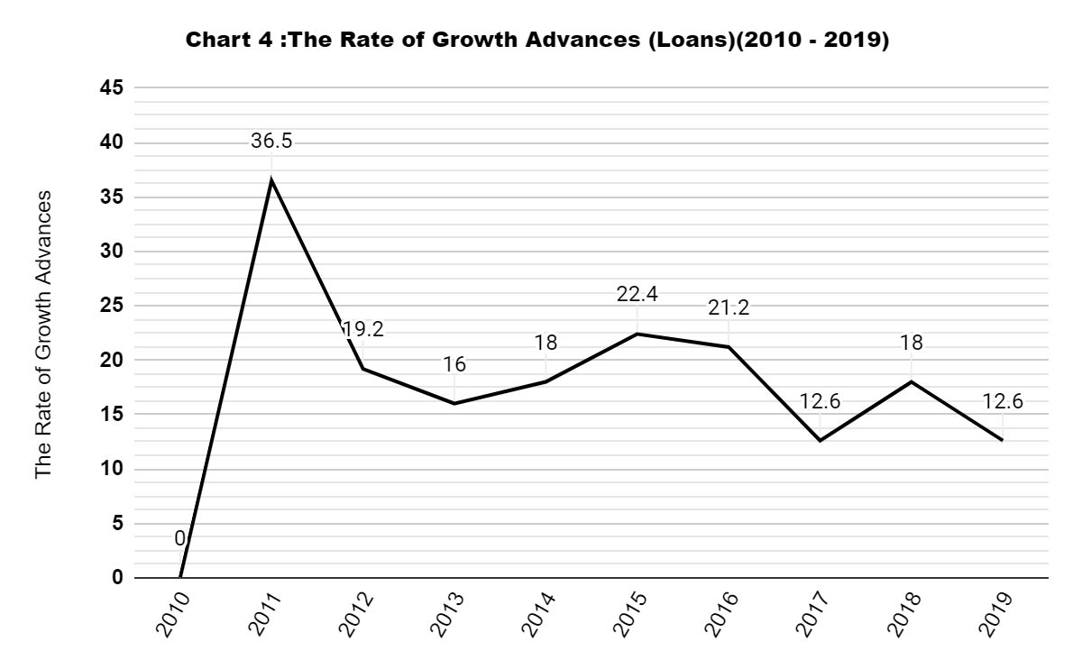
Year | Advances
2010 | 1,043,409,464
2011 | 1,424,078,286
2012 | 1,697,595,386
2013 | 1,969,901,405
2014 | 2,323,817,273
2015 | 2,844,486,456
2016 | 3,446,633,156
2017 | 3,810,802,630
2018 | 4,498,436,451
2019 | 5,066,561,244
2010 | 1,043,409,464
Source : Prepared by the researcher from the annual reports of AXIS bank (2010 to 2019).
The table and the chart above shows the rate of growth advance during the period 2010 to 2019 , the ratio of loans in AXIS bank was increase where the value of advances in 2010 amount (1,043,409,464 Rs) and in 2019 became the value of advances (5,066,561,244Rs) by increase rate 486 % on 2010 , Indicates that theAXIS bank used an expansionary method of loan growth during the period .The rate of loans in AXIS bank in 2011 was increased by 36.5 % on 2010 , and continued between increase and decrease as shown in the chart above .
- RESEARCH METHODOLOGY:
Data was collected on secondary data sources, and these sources are mainly in the annual reports of the AXIS bank on the website of the bank from 2010 to 2019 , in addition to making use of books, research and previous studies that dealt with the subject of study, directly or indirectly. The analysis used SPSS , and a multiple regression model was applied to determine the impact between the impact of the financing policies by current deposits, savings, fixed and the term deposits on advances growth in AXIS bank.

- HYPOTHESIS TEST AND FINDINGS
Table (3) Correlations
 |  | Advances | Current Deposits  (Demand ) | Savings Bank Deposits | Term deposits
Pearson  Correlation | Advances | 1.000 | .967 | .995 | .957
 | Current Deposits(Demand ) | .967 | 1.000 | .982 | .875
 | Savings Bank Deposits | .995 | .982 | 1.000 | .933
 | Term deposits | .957 | .875 | .933 | 1.000
Sig.  (1-tailed) | Advances | . | .000 | .000 | .000
 | Current Deposits(Demand ) | .000 | . | .000 | .000
 | Savings Bank Deposits | .000 | .000 | . | .000
 | Term deposits | .000 | .000 | .000 | .
N | Advances | 10 | 10 | 10 | 10
 | Current Deposits(Demand ) | 10 | 10 | 10 | 10
 | Savings Bank Deposits | 10 | 10 | 10 | 10
 | Term deposits | 10 | 10 | 10 | 10
The table above shows the correlation matrix of the three independent variables together with the dependent variable the loans. Notice the pearson correlation between the dependent variable loans and the independent variable current deposits 97% while the Sig. is (.000 )this indicates that the correlation is strong and statistically significant .Pearson correlation between the loans and the saving deposits is 99.5 % , while the Sig. is (.000 ) this indicates that the correlation is strong and statistically significant . Pearson correlation between the loans and the term deposits is 96 % , while the Sig. is (.000 ) this indicates that the correlation is strong and statistically significant .
Table (4)Model Summary
Model | R | R Square | Adjusted R Square | Std. Error of the Estimate
1 | .998ª | .997 | .995 | 94501553.942
a. Predictors: (Constant), Term deposits, Current Account Deposits(Demand ), Savings Bank Deposits
b. Dependent Variable: Advances
The model summary shows an adjusted R square value of 0.997. This reveals that about 99.7% of total loans in AXIS bank is funded by the financing policies by deposits. Only about 0.03 % are funded by other factors. With an Adjusted R square value of 0.995> 0.60, the model is said to be satisfactory in regressing the independent variables with the dependent variable.
Table (5) ANOVA
Model |  | Sum of Squares | df | Mean Square | F | Sig.
1 | Regression | 16520224046984290000.000 | 3 | 5506741348994763800.000 | 616.619 | .000^{b}
 | Residual | 53583262184938584.000 | 6 | 8930543697489764.000
 | Total | 16573807309169230000.000 | 9
a. Dependent Variable: Advances
b. Predictors: (Constant), Term deposits, Current Account Deposits(Demand ), Savings Bank Deposits
The table above represents the analysis of variance, shows an F-ratio of 616.619 with a significant p-value of 0.000 ˂ 0.05 alpha level. This result provides enough evidence to reject the null hypothesis and claim that the financing policies by deposits significantly impacts the loans growth in AXIS bank .
Table (6) Coefficients
Model |  | Unstandardized Coefficients |  | Standardized  Coefficients | t | Sig. | Correlations
 |  | B | Std. Error | Beta |  |  | Zero-  order | Partial | Part
1 | (Constant) | -117168054.713- | 190971718.825 |  | -.614- | .562
 | Current  Deposits | -.303- | .907 | -.052- | -.335- | .749 | .967 | -.135- | -.008-
 | Savings Bank  Deposits | 2.691 | .654 | .860 | 4.116 | .006 | .995 | .859 | .096
 | Term deposits | .421 | .172 | .200 | 2.450 | .050 | .957 | .707 | .057
a. Dependent Variable: Advances
The above table shows which of the independent variables has more impact on the dependent variable: The results of coefficients showed between independent variables that the saving deposit had a significant impact on loan growth as it has high value of B (2.691) and T -test (4.116) and Sig.(.006).
- CONCLUSION AND RECOMMENDATION
The results of correlation and regression coefficients have appeared like : The results of Pearson Correlation showed between the dependent variable and independent variables the correlation is strong and statistically significant between the loans and deposits, also indicates that the correlation is strong and statistically significant between types of deposits. About 99.7% of total loan in AXIS bank is funded by the financing policies by deposits, while 0.03 % are funded by other factors ,this result is satisfactory in regressing the independent variables with the dependent variable. Through the analysis of variance, the result was enough evidence to reject the null hypothesis and accept the alternative hypothesis that said the financing policies by deposits significantly impacts the loans growth in AXIS bank.The results of coefficients showed between independent variables that the saving deposit had a significant impact on loan growth as it has high value.We recommend a bank to diversify loan financing from other, safer sources, and to increase expansion financing policies in attracting savings deposits.
REFERENCES
- Nguyen, T., Tripe, D., & Ngo, T. (2018). Operational efficiency of bank loans and deposits: A case study of Vietnamese banking system. International Journal of Financial Studies, 6(1), 14.
- Abugah, W. M., Nyagol, M. O., & Odoyo, F. (2017). Effects of lending policies on loan performance of selected commercial banks in Kisii County, Kenya.
- https://www.investopedia.com/terms/d/deposit.asp
- https://www.elearnmarkets.com/blog/various-types-of-bank-deposits/
- https://en.wikipedia.org/wiki/Axis_Bank
- https://www.yourarticlelibrary.com/banking/liabilities-and-assets-of-scheduled-commercial-banks-main-items/40814
- https://www.investopedia.com/terms/l/loan.asp
- https://www.axisbank.com/shareholders-corner/shareholders-information/annual-reports
- https://www.embibe.com/exams/top-10-largest-banks-in-india/

*AXIS bank is India’s third largest private sector bank present industry banking and financial Sector .Founded in 3 december 1993 .Headquarters in Mumbai – India .It has area served in worldwide .Products :Credit cards, consumer banking, corporate banking, finance and insurance, investment banking, mortgage loans, private banking, private equity, wealth management .Asset : ₹8.00997 trillion (US$110 billion) (2019). Number of Branches: 4,050 .Number of ATMs:11,801.The Bank has a strong team of over 72,000 (2019).Official Website:axisbank.com (https://www.embibe.com/exams/top-10-largest-banks-in-india/)

