The evaluation of energy efficiency and its decoupling from economic growth under the carbon peak target
Yongke Yuan1, Yuanying Chi1*, Yun Guo1, Qian Xiao1
School of Economics and Management, Beijing University of Technology, China
Corresponding Author: Yuanying Chi
Email: goodcyy@bjut.edu.cn
Abstract: The Global Malmquist-Luenberger index was used to measure the energy efficiency of 11 provinces and regions in eastern China from 2010 to 2019, the Tapio decoupling model was constructed to analyze the decoupling relationship between economic growth and energy consumption and energy use efficiency, and the prediction results of the carbon peak time of each province in the existing literature were combined to put forward suggestions for the provinces that were not ideal for the decoupling. The results show that: (1) The total average energy efficiency of the 11 eastern regions of China during the period from 2010 to 2019 was 0.911, showing an overall upward trend, while the energy efficiency changes in each region were different; (2) The decoupling of economic growth, energy consumption and energy efficiency in Hebei and Hainan provinces was not ideal, and the decoupling in other regions was getting better; (3) There will be a large gap in the time of carbon peak in 11 regions in eastern China. Beijing, Tianjin, Shanghai, Jiangsu, Zhejiang, Guangdong and Liaoning will achieve carbon peak in 2030 and before; There will be no peaks in Hebei and Hainan regions, while the peaks in Shandong and Fujian appear after 2030.
Key words: Carbon peak; Eastern region; Energy efficiency; Tapio decoupling model; Directional distance function; Global Malmquist-Luenberger index (GML).

1.Introduction
The energy issue is one of the important issues in the economic and social development of the world. It is not only related to the quality of people's lives and the quality of ecological environment development, but also related to national economic security and strategic security. China is currently the world's largest energy consumer^{[1]}. According to the BP World Statistical Yearbook, China's energy consumption accounted for 23% of the global energy consumption in 2016^{[2]}. In recent years, although the proportion of renewable energy is increasing, coal consumption still occupies a dominant position. Coal consumption accounts for more than 50% of the total coal in the world^{[3]}, and carbon emission is the first in the world, and environmental problems are prominent^{[4]}, which has aroused the great attention of the Chinese government. He mentioned in his important speech delivered at the General Debate of the 75th session of the United Nations General Assembly that China's carbon dioxide emissions strive to peak before 2030 and achieve carbon neutrality before 2060. To achieve this double carbon goal, various provinces and autonomous regions in China are developing various emission reduction measures^{[5]}, and to achieve the emission reduction effect, Improving energy efficiency is an essential tool.
Given the important position and role of energy efficiency, many scholars at home and abroad have conducted research on it, mainly including the measurement of energy efficiency, the influencing factors of energy efficiency, and the relationship between energy efficiency and economic growth. The measurement of energy efficiency mostly uses the DEA (data envelopment analysis) method. In early research, when establishing measurement indicators, only expected output was considered, and unexpected output was not^{[6]}. However, production processes are generally accompanied by unexpected production such as carbon dioxide and sulfur dioxide, so considering unexpected output is more consistent with actual production conditions^{[7-10]}. Research on the impact of energy efficiency mainly focuses on industrial structure^{[11-16]}, industrial agglomeration^{[17]},technological progress^{[18-19]}, factor market distortions^{[20-21]}, market segmentation^{[22]}, and the degree of openness to the outside world^{[23]}.Some scholars have also studied the impact of formal environmental regulations (regulations formulated by the government to improve environmental quality) and informal environmental regulations (social groups monitor corporate behavior through consultation and advice to reduce pollution emissions) on energy efficiency^{[24]}. There are many studies on economic growth and energy efficiency, most of which consider multiple sources of energy^{[25-27]}. However, there are also studies on the relationship between single energy efficiency and economic growth, such as Che Liangliang, Han Xue, Zhao Liangshi, and others who have studied the decoupling relationship between coal utilization efficiency and economic growth in China. The study found that China's coal efficiency is low and there is large room for improvement, and the average value of coal utilization efficiency from high to low is in the eastern region, northeast region Central and Western Regions^{[28]}; Lin Boqiang studied the relationship between electricity consumption and China's economy and found that state-owned property rights reform can improve energy efficiency to a certain extent^{[29]}. From the research scale, we have studied the relationship between economic growth and energy efficiency in countries along the Belt and Road^{[30]}, the Pearl River Delta^{[31]}, Shanxi Province^{[32]}, European Union countries^{[33]} and other regions. The eastern region is the pioneer of China's urbanization and economic development. In 2012, the GDP of the eastern region accounted for 57.02% of the domestic GDP, and energy consumption accounted for 50.87% of the national total^{[33]}, Studying the relationship between economic growth and energy efficiency can provide a reference for the development of other regions. Liu Huimin^{[34]} studied the decoupling relationship between economic growth and energy consumption in eastern China, and the results showed that absolute and stable decoupling does not exist. Although China is in a weak decoupling state in most years, on a long-term scale, There is a dynamic and iterative process of "connecting-decoupling-recoupling-decoupling"between economic growth and energy consumption; Zhou Xing, Zhou Meihua, and Zhang Ming analyzed the decoupling relationship between economic growth and energy carbon emissions in the eastern region of China, and found that most provinces in the eastern region of China exhibit a weak decoupling state between economic growth and carbon emissions, while only four provinces, Beijing, Shanghai, Tianjin, and Fujian, exhibit a strong decoupling state^{[35]}, However, there are few literatures that combine the decoupling relationship between energy consumption and economic growth and the decoupling relationship between energy efficiency and economic growth. Therefore, this article will study the decoupling relationship between economic growth, energy consumption, and energy efficiency in the context of carbon peaking, providing a reference for China to achieve carbon peaking and carbon neutral goals.

2. Economic growth and energy intensity in Eastern China

2.1 Economic growth
This article uses GDP per capita to represent the level of economic development and draws the economic growth trend chart of eleven provinces in Eastern China from 2010 to 2019, as shown in Figure 1. It can be seen that Beijing's economic development is the best and its growth rate is also the fastest. Although the economy of Hainan is growing every year, the growth rate is not significant and the level of economic development is the lowest. Liaoning's GDP per capita decreased in 2016 and then slowly increased. Overall, the economic growth of the eleven regions shows an upward trend.
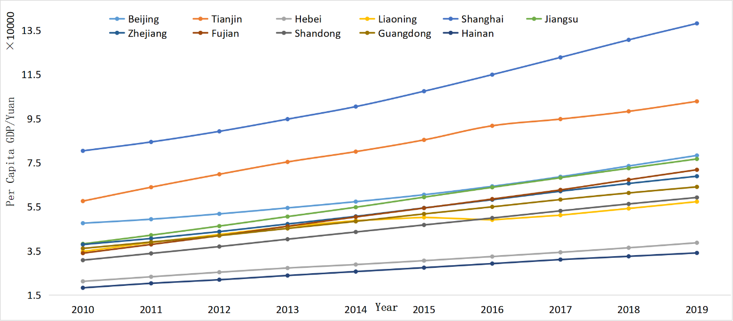
Figure 1 Economic growth trend of eastern China from 2010 to 2019

2.2 Energy intensity
This paper uses energy intensity to preliminarily estimate the energy utilization efficiency of various regions in Eastern China. The energy intensity is expressed in terms of the total energy consumption per year per actual GDP of each province and region, and a time series diagram of the energy intensity of each region is plotted, as shown in Figure 2. It can be seen that energy intensity in Hainan Province increased significantly from 2010 to 2011, and then began to decline slowly, with a downward trend in other regions. Hebei's energy intensity is the highest, and it is also declining rapidly. Beijing's energy intensity is the highest overall. Overall, energy intensity in various regions declined relatively quickly from 2010 to 2013, and declined slowly after 2013.

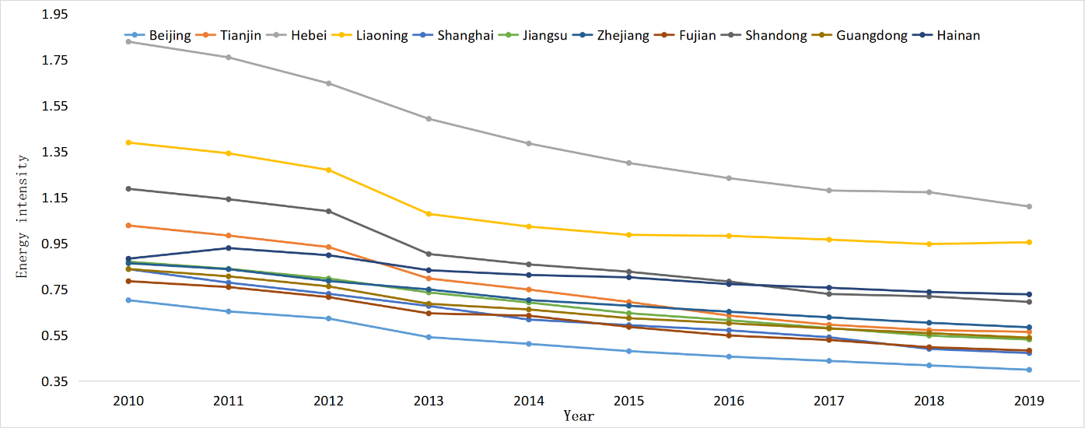
Figure 2 Energy intensity trend chart of eastern regions from 2010 to 2019

2.3 Economic growth and energy intensity
Combining Figures 1 and 2, it can be seen that economic growth and energy intensity in most regions change in opposite directions, leading to economic growth and reduced energy intensity. Beijing has the highest per capita GDP and the lowest energy intensity; Hebei has the highest energy intensity, with a per capita GDP only higher than Hainan; The overall economy of Liaoning is increasing, but its energy intensity has an upward trend, indicating an increasing trend in energy consumption per unit of GDP. Energy intensity simply examines energy efficiency from the perspective of energy consumption per unit of GDP, without considering other aspects, which is too one-sided. In order to further study energy utilization efficiency, this article uses the DDF model and GML index in DEA to calculate total factor energy efficiency and its influencing factors. Finally, it uses the Tapio decoupling model to study the decoupling relationship between economic growth, energy consumption, and energy efficiency.

3. Research methods and data sources

3.1 Measurement of energy efficiency
The directional distance function (DDF) can distinguish between good and bad outputs in the model, which is one of the reasons why it can be widely used. In actual production, the generation of expected output is often accompanied by the generation of undesired outputs, such as carbon dioxide emissions, so incorporating non-expected outputs into the input-output efficiency evaluation system will not only improve the accuracy of energy efficiency measurement, but also be close to the reality. Assuming that X represents input, Y represents good output, and B represents bad output, then the output vector is divided into good output vector $g_{y}$ and bad output vector $g_{b}$, and the input vector is $x_{k}$. There are n decision units (DMUs), each decision unit has m inputs$x=(x_{1},x_{2},x_{3}∙∙∙x_{m})∈R_{m}^{+}$, yielding i expected outputs y=($y_{1},y_{2},y_{3}∙∙∙y_{i})∈R_{i}^{+}$,and z undersired outputs $b=(b_{1,}b_{2,}b_{3}⋯b_{z})∈R_{z}^{+}$; If the direction vector is $g=(g_{y},-g_{b})$and the undesired output is strongly disposable, then the directionality distance function model is:
$$Maxβ$$
$$\left\{\begin{aligned}s.t.Xλ+βg_{x}≤x_{k} \\ Yλ-βg_{y}≥y_{k} \\ Bλ-βg_{b}≤b_{k} \\ \sum{λ}=1 \\ λ≥0\end{aligned}\right.$$
In the formula, $β$is a measure of the degree of inefficiency and includes both input and output measurements. Therefore, the model belongs to a non-oriented DDF model; $\sum{λ}=1$ represents the weight coefficient vector relative to the evaluated unit in the effective decision-making unit portfolio, which is variable return to scale (VRS). it represents the input, expected output, and unexpected output of the k-th DMU, respectively.
The GML index was proposed by Oh^{[36]} in 2010 to measure changes in productivity and the rate of change of its influencing factors. This index solves the potential infeasibility of the ML index. Based on the directional distance function, the GML index of the t+1 period with the t period as the base period is as follows:
$${GML}_{t+1}^{t}\left(x^{t},y^{t},b^{t},x^{t+1},y^{t+1},b^{t+1}\right)=\frac{1+D^{G}(x^{t},y^{t},b^{t})}{1+D^{G}(x^{t+1},y^{t+1},b^{t+1})} =\frac{1+D^{t}(x^{t},y^{t},b^{t})}{1+D^{t+1}(x^{t+1},y^{t+1},b^{t+1})}×\left[\frac{1+D^{G}(x^{t},y^{t},b^{t})}{1+D^{t}(x^{t},y^{t},b^{t})}×\frac{1+D^{t+1}(x^{t+1},y^{t+1},b^{t+1})}{1+D^{G}(x^{t+1},y^{t+1},b^{t+1})}\right]={EC}_{t+1}^{t}×{TC}_{t+1}^{t}$$
Where $D^{t}(x^{t},y^{t},b^{t}$) is the directional distance function for the t period and $D^{G}(x^{t},y^{t},b^{t})$ is the global directional distance function. the GML index can be broken down into EC and TC, where EC represents a change in technical efficiency or catch-up efficiency, and TC represents a change in technology. ${GML}_{t+1}^{t}$refers to the change in total factor productivity from period t to period t+1. If the index is greater than 1, it indicates an increase in productivity, and it is less than 1.it also indicates a decrease in productivity; ${EC}_{t+1}^{t}$Indicates the degree of convergence to the production frontier from the t period to the t+1 period. This index is greater than 1, indicating that technical efficiency has improved and contributed to total factor productivity growth; ${TC}_{t+1}^{t}$represents the outward expansion of the production frontier or the change rate of technological level from the t period to the t+1 period. This index is also greater than 1, indicating technological progress and contributing to the improvement of total factor productivity.

3.2 Decoupling theory and model
Decoupling was first applied in the field of physics, meaning that the interrelationships between two or more physical variables that had a response relationship no longer existed. Later, it was widely used in other fields. For example, the Organization for Economic Cooperation and Development (OECD) applied decoupling theory to the field of agricultural policy, exploring the relationship between policy and trade and market equilibrium. Later, The World Bank then applied this theory to the field of resources and environment.using it to analyze the decoupling relationship between economic growth, resource consumption, and environmental pollution^{[38]}. Since then, the decoupling theory has been applied more and more widely. For example, Tapio has used the decoupling theory to study the decoupling relationship between GDP, traffic volume, and carbon dioxide generated during transportation^{[39]}. Song Wei and others have studied the decoupling relationship between farmland occupation and economic growth^{[40]}. Currently, there are two main types of decoupling indicators that are widely used: the decoupling factor proposed by OECD and the decoupling elasticity coefficient proposed by Tapio. Due to the high sensitivity of the decoupling factor to the selection of base period and end period, there may be some deviation in calculation. The decoupling elasticity coefficient comprehensively considers the changes in total and relative quantities, improving the accuracy of decoupling analysis results^{[41]}. Therefore, this article selects Tapio's decoupling elasticity coefficient to study the decoupling between economic growth, energy consumption, and energy efficiency, with reference to Peng Jiawen et al.^{[42]}, The decoupling model is established based on the classification criteria shown in Table 2.

Table 1 Decoupling analysis model of economic growth, energy consumption and energy efficiency
$$∆C$$
$$∆GDP>0$$
$$∆C>0$$
$$E_{c}≥1$$
Dilated negative decoupling
$$∆GDP<0$$
$$∆C≥0$$
$$E_{c}≤0$$
Strong negative decoupling

$$∆GDP>0$$
$$∆C>0$$
$${0<E}_{c}<1$$
Weak decoupling
I

VI

II
$∆GDP$
$$∆GDP<0$$
$$∆C<0$$
$${0<E}_{c}<1$$
Weak negative decoupling
V
III
$$∆GDP>0$$
$$∆C≤0$$
$$E_{c}≤0$$
Strong decoupling
IV

$$∆GDP<0$$
$$∆C<0$$
$$E_{c}≥1$$
Recessionary decoupling

Where $∆C$ represents the change in energy consumption or energy efficiency; $∆GDP$ represents the change in regional GDP.
$$GDP elasticity of energy consumption(E_{cc})=\frac{{∆ energy consumption}/{Energy consumption in the base period}}{{∆GDP}/{Base period GDP}}$$
$$GDP elasticity for energy efficiency\left(E_{ce}\right)=\frac{{∆ energy efficiency}/{Base period energy efficiency}}{{∆GDP}/{Base period GDP}}$$
Decoupling can be divided into weak decoupling, strong decoupling, recessive decoupling, weak negative decoupling, strong negative decoupling, and expansionary negative decoupling. The strong decoupling of energy consumption from economic growth and the expansionary negative decoupling of energy efficiency from economic growth are the most ideal decoupling states. Only by achieving these two types of decoupling can the quality of economic development was improved, and the carbon peak and carbon neutral goals be achieved more quickly. The specific decoupling situation of this article will be explained in the empirical results below.

3.3 Data source and indicator selection
This article takes the panel data of eastern China from 2010 to 2019 as a sample and the data mainly comes from the National Bureau of Statistics of China, China Statistical Yearbook, China Energy Statistical Yearbook, and CEADS database. The main indicators used in this article are as follows:
Total factor energy efficiency measurement indicators:
1) Input indicators
(1) Labor indicators. Expressed as the sum of the number of urban units, private enterprises, and self-employed individuals in each province (unit: 10000 people).
(2) Energy consumption. Expressed by the total annual energy consumption of each region (unit: 10000 tons of standard coal).
(3) Capital stock. This article refers to Zhang Jun's approach to capital stock and calculates it using the perpetual inventory method (unit: 100 million yuan).
$$K_{it}=K_{it-1}\left(1-δ_{it}\right)+I_{it}$$
In the formula, $K_{it}$ is the current capital stock; $δ_{it}$ is the depreciation rate; $K_{it-1}$is the capital stock of the previous period; $I_{it}$ is the actual investment amount of the current.
2) Output indicators
(1) Expected output: This article selects the actual GDP of each province, city, and autonomous region (unit: 100 million yuan) as the output indicator. to eliminate the impact of price factors, the nominal GDP of the original data is uniformly converted into actual GDP (2000=100) based on the GDP index.
(2) Unexpected output: total carbon dioxide emissions by region (unit: million tons)
Table 2 Descriptive statistical analysis of energy efficiency inputs and outputs
 | Input output indicators | Observation | average value | standard deviation | minimum | maximum
Input indicators | Capital stock | 110 | 65875.3 | 40409.26 | 3728.995 | 174406.6
 | workforce | 110 | 2099.995 | 1561.01 | 172.8 | 7115.1
Output indicators | Total energy consumption | 110 | 19097.5 | 11438.62 | 1358.507 | 41390
 | Provincial real GDP | 110 | 24875.02 | 15481.98 | 1536.949 | 63260.76
 | CO2 emissions | 110 | 407.6269 | 279.2441 | 28.92593 | 937.1169

4 Results and Analysis

4.1 Energy efficiency

4.1.1 Trends in energy efficiency
This paper uses MAXDEA software to calculate the energy efficiency of 11 provinces, cities, autonomous regions, and the whole of eastern China from 2010 to 2019 and draws their annual average trend charts using Excel. As shown in Figure 2, the overall average energy efficiency of these 11 regions during the sample period is 0.911, and its overall trend is improving. However, specifically, energy efficiency decreased during 2010-2011, and growth was very slow during 2011-2016, and the growth rate accelerated after 2016. Among these regions, the energy efficiency fluctuations in Tianjin, Fujian, and Liaoning are relatively large. Among them, the energy efficiency of Tianjin in 2010 decreased from 120 to 0.8826 in 2014 and has been increasing all the way since 2014. The energy efficiency in 2018 and 2019 is both 1; Overall, Fujian's energy efficiency declined, from 1 in 2010 to 0.858 in 2011, and then began to rise and fall. In 2019, the energy efficiency was 0.8827, with a trend of continuing to rise; In 2014, the energy efficiency of Liaoning fell to the lowest point (0.6993), which is also the lowest point of energy efficiency in these provinces and regions. After that, it began to rise, especially after 2016, the energy efficiency curve became steeper, indicating that the growth rate of energy efficiency after 2016 was becoming faster and faster. Among these provinces, Guangdong, Beijing, Shanghai, and Shandong have relatively high energy efficiency, with Guangdong having a slight decrease in energy efficiency in 2014, while the energy efficiency in other periods is 1; In 2019, energy efficiency in Shandong decreased somewhat (0.921), and there is a trend of continued decline; Although there are fluctuations in energy efficiency in Beijing and Shanghai, the range is not significant; Hebei Province's energy efficiency dropped to the lowest level in 2016, In 2019, there is a continuous downward trend, and the overall energy efficiency of the province is in the middle level; The overall energy efficiency of Hainan Province also shows a downward trend; It can be seen that energy efficiency in Jiangsu Province has been increasing in other periods except for the decrease in energy efficiency in 2013; The energy efficiency trend curve in Zhejiang is perfect, with no downward phase and rising all the way.
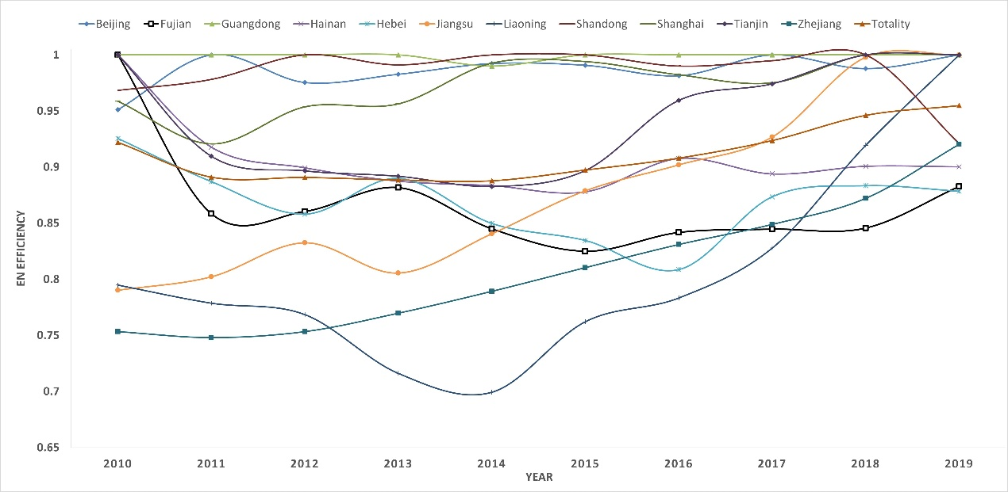
Figure 3 Energy efficiency trend chart

4.1.2 GML index and its decomposition
To specifically study the influencing factors of energy efficiency, this paper uses the GML index to calculate the total factor energy efficiency and decompose it into the technical efficiency index EC and the technical progress index TC, and GML=EC*TC. If the index is greater than 1, it indicates an improvement in energy efficiency, technological efficiency, and technological progress. Conversely, if the index is less than 1, energy efficiency decreases, technical efficiency decreases, and technology regresses. From Table 1, it can be seen that the overall energy efficiency has increased by 4.8%, which is consistent with the trend in Figure 3. However, its technical efficiency has increased by 2.1%, and its technical progress has been 2.4%, both contributing to the improvement of energy efficiency are basically the same. The increase in energy efficiency in Jiangsu, Liaoning, and Zhejiang is similar, with the increase in energy efficiency in Jiangsu and Liaoning mainly driven by the catch-up effect, while the increase in energy efficiency in Zhejiang Province is mainly due to technological progress. We can see that the GML of Fujian, Hainan, Hebei, and Shandong is less than 1, which means that their energy utilization efficiency has decreased, with the TC of Fujian being equal to 1. We can know that the decrease in energy efficiency is caused by the decrease in technical efficiency; Hainan is the opposite of Fujian, with EC equal to 1 and TC less than 1. Therefore, the decline in energy efficiency in Hainan is due to technological decline. The pulling effect of technological progress on energy efficiency in Shandong has not offset the inhibitory effect of declining technological efficiency on energy efficiency, so energy efficiency in Shandong has decreased; Similarly, the decline in energy efficiency in Hebei is both a cause of the decline in technological efficiency and a result of technological retrogression. There has been no change in energy efficiency in Guangdong and Tianjin. The improvement in energy efficiency in Beijing and Shanghai is due to technological progress.
Table 3 Cumulative change values from 2010 to 2019
 | GML | EC | TC
Beijing | 1.051 | 1.000 | 1.051
Fujian | 0.883 | 0.883 | 1.000
Guangdong | 1.000 | 1.000 | 1.000
Hainan | 0.900 | 1.000 | 0.900
Hebei | 0.949 | 0.972 | 0.977
Jiangsu | 1.266 | 1.156 | 1.095
Liaoning | 1.258 | 1.222 | 1.030
Shandong | 0.951 | 0.933 | 1.020
Shanghai | 1.043 | 1.000 | 1.043
Tianjin | 1.000 | 1.000 | 1.000
Zhejiang | 1.222 | 1.064 | 1.148
overall | 1.048 | 1.021 | 1.024

4.2 Analysis of decoupling between economic growth, energy consumption, and energy efficiency
To better explore the decoupling relationship between economic growth, energy consumption, and energy efficiency, this article analyzes the decoupling status of each province on an annual basis based on the energy efficiency trend chart in Figure 3. Based on the Tapio decoupling elasticity model, the GDP elasticity of energy consumption and the GDP elasticity of energy utilization efficiency are calculated and combined with the decoupling analysis model in Table 2, the annual decoupling status of each region can be obtained. The specific results are shown in Tables 4 and 5.
From 2010 to 2011, economic growth and energy consumption in the eastern provinces and regions were concentrated in a weak decoupling state (10/11), with 7 regions experiencing a strong decoupling state between economic growth and energy efficiency, indicatin-g that the growth rate of energy consumption in these 7 regions was slower than that of economic growth, while energy efficiency was gradually declining with economic growth; The energy efficiency of three regions is improving with economic growth, which is a good state of development. The growth rate of energy consumption in Hainan Province is faster than that of economic growth, and its energy efficiency is declining, indicating that this region is experiencing extensive economic growth.
From 2011 to 2012, energy consumption and economic growth in 11 provinces were all in a weak decoupling state, with 5 regions having a weak decoupling relationship between economic growth and energy efficiency; The strong decoupling between energy efficiency and economic growth in six regions indicates that the GDP of these six regions has increased and energy efficiency has decreased;
The decoupling of economic growth from energy consumption and energy efficiency in 2012-2015 mainly focused on weak decoupling and strong decoupling, indicating that energy consumption in the eastern region is increasing and energy efficiency is declining. In addition, during 2014-2015, the energy efficiency and economic growth of Liaoning Province were in an expansionary negative decoupling state, that is, the growth rate of energy efficiency was faster than the economic growth rate, which is an ideal decoupling.
In 2015-2016, energy consumption in 9 provinces and regions also increased with economic growth, with 4 provinces in a weak decoupling state of energy efficiency from economic growth, and 5 regions in a strong decoupling state. While energy consumption in Tianjin is decreasing with economic growth, energy efficiency is improving with economic growth. Liaoning's economic growth and energy consumption show a recessive decoupling relationship, that is, both GDP and energy consumption are declining, and the speed of energy consumption decline is greater than the speed of GDP decline. However, its economic growth and energy efficiency are in a strong negative decoupling state, that is, the economy has experienced a recession, and energy efficiency is improving, indicating that Liaoning Province is taking GDP decline as a price to achieve low-carbon development.
The distribution of 2016-2017 is similar to that of 2012-2015. The relationship between economic growth, energy consumption, and energy utilization efficiency is mainly concentrated in weak decoupling and strong decoupling relationships, respectively. Among them, nine provinces and regions have a weak decoupling relationship between economic growth and energy consumption, and five of them have a weak decoupling relationship between energy efficiency and economic growth, indicating that both energy consumption and energy efficiency increase with economic growth, There are three regions where energy efficiency decreases with economic growth, while another region (Liaoning) has an expansionary negative decoupling between energy efficiency and economic growth.
In 2017-2018, the growth rate of energy consumption in 9 provinces was slower than the economic growth rate, and the energy efficiency of 4 regions increased with the increase of GDP, while the energy efficiency of 3 regions decreased with the increase of GDP, while the energy efficiency of the remaining two regions showed an expansionary negative decoupling relationship with GDP, that is, both GDP and energy efficiency were increasing, and the energy efficiency increased faster than the growth rate of GDP. In two urban areas (Tianjin and Shanghai), energy consumption has decreased and energy efficiency is increasing.
In 2018-2019, there were 10 regions where the relationship between energy consumption and economic growth was weak decoupling, 5 of which had weak decoupling between energy efficiency and economic growth, and 5 had strong decoupling. In another region (Liaoning), both energy consumption and energy utilization efficiency have increased faster than economic growth.
To sum up, during the period 2010-2019, economic growth and energy consumption in most areas of eastern China were in a weak decoupling state, and they were in a strong decoupling and weak decoupling state from energy efficiency.
Table 4 Analysis results of decoupling economic growth and energy consumption in eastern China from 2010 to 2019
 | 2010-2011 | 2011-2012 | 2012-2013 | 2013-2014
Weak decoupling | Beijing, Hebei, Tianjin, Shanghai, Jiangsu, Zhejiang, Fujian, Shandong, Guangdong, Liaoning(10) | Hainan, Hebei, Tianjin Jiangsu, Zhejiang, Fujian，Shanghai, Jiangsu, Zhejiang Hainan, Fujian, Shandong, Guangdong，Liaoning, Beijing (11) | Beijing,Tianjin,Jiangsu,Zhejiang,Fujian,Shandong,Guangdong,Liaoning,Hainan(9)
Strong decoupling |  |  | Beijing, Hebei, Tianjin, Shanghai, Shandong, Guangdong, Liaoning(7) | Hebei, Shanghai (2)
Strong negative decoupling
Dilated negative decoupling | Hainan(1)

 | 2014-2015 | 2015-2016 | 2016-2017 | 2017-2018 | 2018-2019
Weak decoupling | Beijing,Hebei,Tianjin,Shanghai,Jiangsu,Zhejiang,Fujian,Shandong,Guangdong,Hainan(10) | Beijing,Hebei,Shanghai,Jiangsu,Zhejiang,Fujian,Shandong,Guangdong,Hainan(9) | Beijing,Hebei,Shanghai,Jiangsu,Zhejiang,Fujian,Guangdong,Hainan,Liaoning(9) | Beijing,Hebei,Jiangsu,Zhejiang,Fujian,Shandong,Guangdong,Hainan,Liaoning(9) | Beijing,Hebei,Tianjin,Shanghai,Jiangsu,Zhejiang,Fujian,Shandong,Guangdong  Hainan(10)
Strong decoupling | Liaoning(1) | Tianjin (1) | Tianjin, Shandong(2) | Tianjin, Shanghai (2)
Strong negative decoupling
Dilated negative decoupling |  |  |  |  | Liaoning(1)
Recessionary decoupling |  | Liaoning(1)

Table 5 Analysis results of decoupling annual economic growth and energy efficiency in eastern China from 2010 to 2019
 | 2010-2011 | 2011-2012 | 2012-2013 | 2013-2014
Weak decoupling | Beijing, Shandong, Jiangsu, Guangdong(4) | Jiangsu, Zhejiang, Shanghai, Fujian, Shandong, Guangdong(6) | Beijing, Shanghai, Zhejiang, Fujian, Hebei, Guangdong(6) | Jiangsu, Zhejiang, Shanghai, Shandong, Beijing (5)
Strong decoupling | Tianjin, Hebei, Liaoning, Shanghai, Fujian, Hainan, Zhejiang(7) | Hainan, Tianjin, Hebei, Liaoning, Beijing (5) | Tianjin, Liaoning, Jiangsu, Shandong, Hainan(5) | Fujian, Guangdong, Hainan, Tianjin, Hebei, Liaoning(6)
Strong negative decoupling
Dilated negative decoupling
Weak negative decoupling

 | 2014-2015 | 2015-2016 | 2016-2017 | 2017-2018 | 2018-2019
Weak decoupling | Tianjin, Shanghai, Guangdong, Jiangsu, Zhejiang, Shandong(6) | Tianjin, Fujian, Jiangsu, Zhejiang, Hainan, Guangdong(6) | Beijing,  Hebei, Tianjin, Jiangsu, Zhejiang, Fujian, Shandong, Guangdong(8) | Zhejiang, Shandong, Shanghai, Hainan, Tianjin, Fujian, Guangdong(7) | Beijing, Hebei, Fujian, Jiangsu, Zhejiang, Tianjin, Shanghai, Guangdong(8)
Strong decoupling | Hainan, Beijing, Fujian, Hebei (4) | Shanghai, Shandong, Beijing, Hebei (4) | Shanghai, Hainan(2) | Beijing, Hebei (2) | Shandong, Hainan(2)
Strong negative decoupling |  | Liaoning(1)
Dilated negative decoupling | Liaoning(1) |  | Liaoning(1) | Liaoning, Jiangsu(2) | Liaoning(1)
Weak negative decoupling

To more intuitively understand the decoupling of economic growth from energy consumption and energy efficiency in each province during the sample period, Table 4 and Table 5 are integrated, as shown in Table 6. In the table, Tcc represents the decoupling of economic growth from energy consumption, and Tce represents the decoupling of economic growth from energy efficiency. We can see that most provinces' Tcc and Tce are mainly weak decoupling and strong decoupling. For example, during the period 2010-2019 in Beijing, most years' Tcc and Tce are mainly weak decoupling, that is, economic growth, increased energy consumption, and improved energy efficiency. However, the increase in energy consumption and energy efficiency is not as significant as economic growth, such as in Tianjin, Shanghai, Zhejiang, Fujian and Jiangsu. The decoupling situation in Shandong and Guangdong is similar to that in Beijing. There are 7 years in which Tcc in Hebei is in a weak decoupling state, while 6 years in which Tce is in a strong decoupling state, indicating that energy consumption is increasing with economic growth and energy efficiency is decreasing with economic growth, which is an undesirable state. We can see that the decoupling of Liaoning Province is more diverse than that of other provinces. Its energy consumption and economic growth are mainly in a weak decoupling relationship, while energy efficiency and economic growth are mainly in a state of expansionary negative decoupling and strong decoupling. The decoupling situation in Hainan Province and Hebei Province is similar, with 8 years of weak decoupling and 7 years of strong decoupling in the sample period.
Table 6 Comprehensive results of decoupling economic growth from energy consumption and energy efficiency in eastern provinces and regions of China from 2010 to 2019
 | Beijing | Tianjin | Hebei
$$T_{cc}$$ | Weak decoupling (7)、Strong decoupling (2) | Weak decoupling (5)、Strong decoupling (4) | Weak decoupling (7)、Strong decoupling (2)
$$T_{ce}$$ | Weak decoupling (5)、Strong decoupling (4) | Weak decoupling (5)、Strong decoupling (4) | Weak decoupling (3)、Strong decoupling (6)

 | Liaoning | Shanghai | Jiangsu | Zhejiang
$$T_{cc}$$ | Weak decoupling (5)、Strong decoupling (2)、Recessionary decoupling (1)、Dilated negative decoupling (1) | Weak decoupling (6)、Strong decoupling (3) | Weak decoupling (9) | Weak decoupling (9)
$$T_{ce}$$ | Dilated negative decoupling (4)、Strong decoupling (4)、Strong negative decoupling (1) | Weak decoupling (6)、Strong decoupling (3) | Weak decoupling (7)、Strong decoupling (1)、Dilated negative decoupling (1) | Weak decoupling (8)、Strong decoupling (1)

 | Fujian | Shandong | Guangdong | Hainan
$$T_{cc}$$ | Weak decoupling (9) | Weak decoupling (7)、Strong decoupling (2) | Weak decoupling (8)、Strong decoupling (1) | Weak decoupling (8)、Dilated negative decoupling (1)
$$T_{ce}$$ | Weak decoupling (6)、Strong decoupling (3) | Weak decoupling (6)、Strong decoupling (3) | Weak decoupling (8)、Strong decoupling (1) | Weak decoupling (2)、Strong decoupling (7)
In summary, the overall decoupling situation in the eastern region has not reached a completely ideal state, and the economic growth and energy consumption in most regions are still in a weak decoupling state, without achieving a strong decoupling; Energy efficiency and economic growth are far from expansionary negative decoupling and tend to be weak and strong decoupling. It can be seen that in order to achieve the ideal decoupling of economic growth from energy consumption and energy efficiency, various regions should adopt targeted policies and measures in their subsequent development, achieve low-carbon economic development, and achieve carbon peak and carbon neutral goals as soon as possible.

4.3 Carbon emission prediction
Based on the above calculation of energy efficiency in various regions of eastern China and the decoupling study of economic growth, energy consumption, and energy efficiency, this article uses the prediction data of Pan Dong et al. ^{[43]}on the baseline scenario of carbon dioxide emissions in eastern China to understand the carbon peak time in various regions and the results are shown in Table 7.
We can see that Beijing, Tianjin, Shanghai, Jiangsu, Zhejiang, Guangdong, and Liaoning achieved carbon peaks by 2030 and before. Among them, Beijing, Tianjin, and Shanghai have relatively low cumulative carbon emissions, while Jiangsu, Liaoning, Zhejiang, and Guangdong have relatively high cumulative carbon emissions. Therefore, these four provinces should pay attention to reducing carbon dioxide emissions while achieving their carbon peak goals; There are no peaks in Hebei and Hainan regions, and carbon emissions have been increasing from 2020 to 2040 and Hebei's cumulative carbon emissions are high. In the next development, the province should focus on reducing emissions and improving energy efficiency; The peaks in Shandong and Fujian occurred after 2030.
Table 7 Carbon peak time forecast
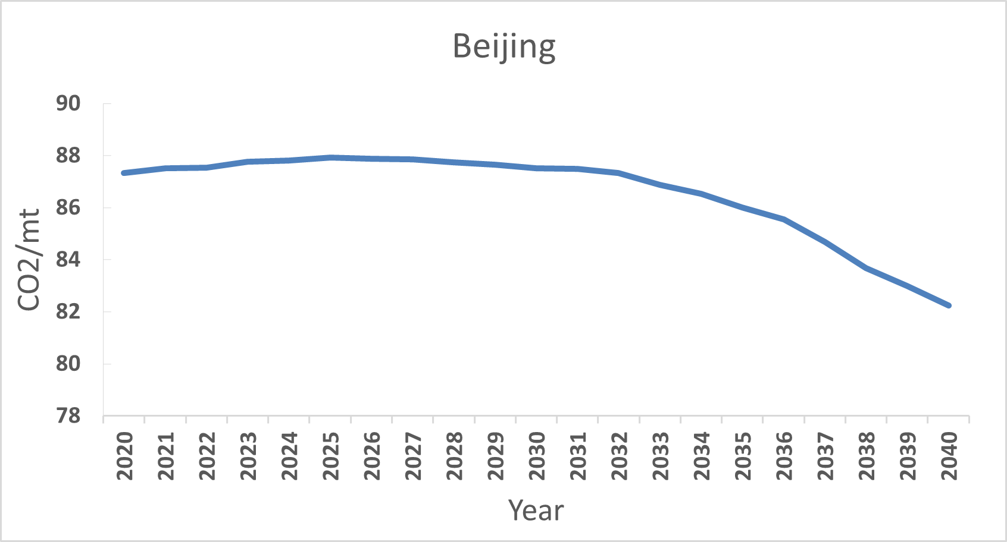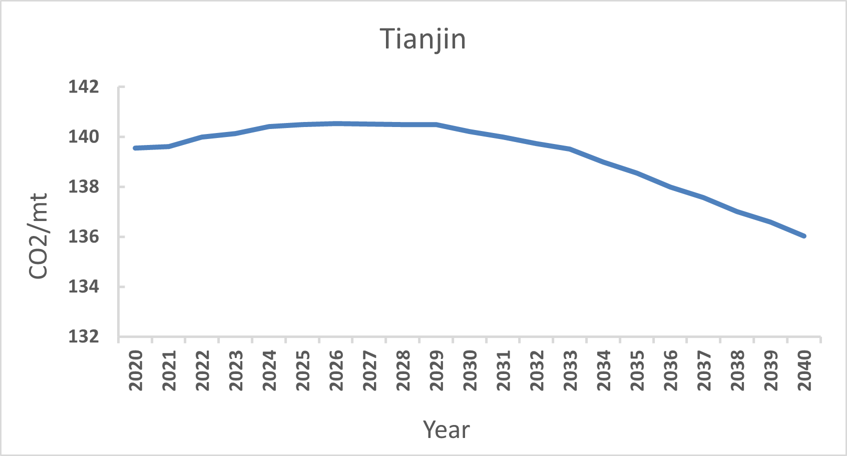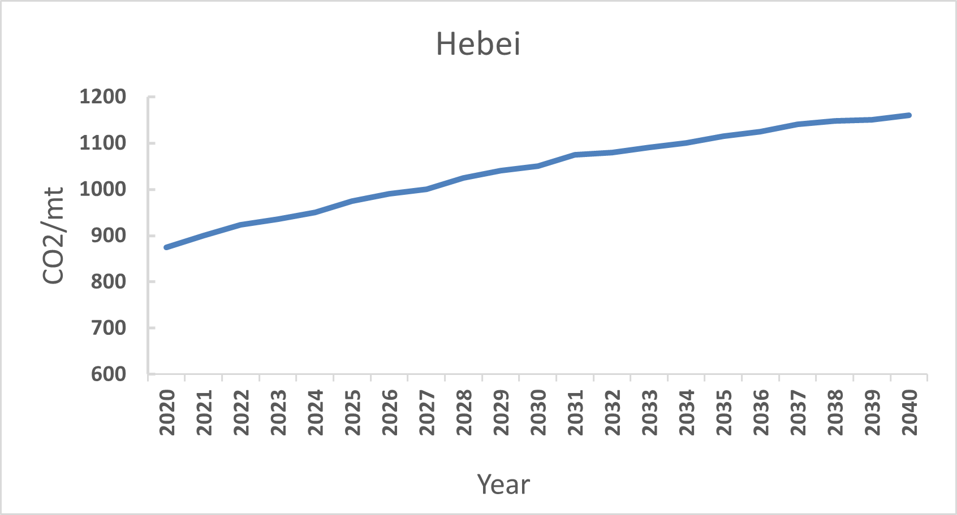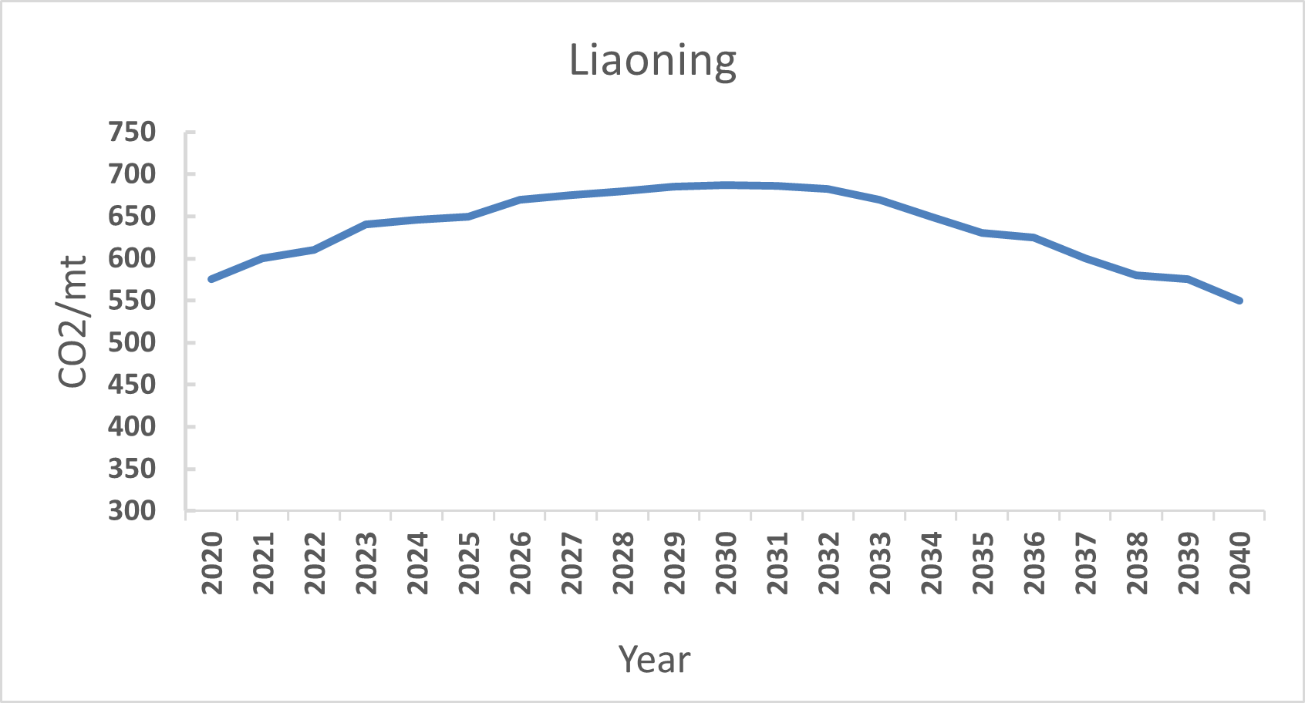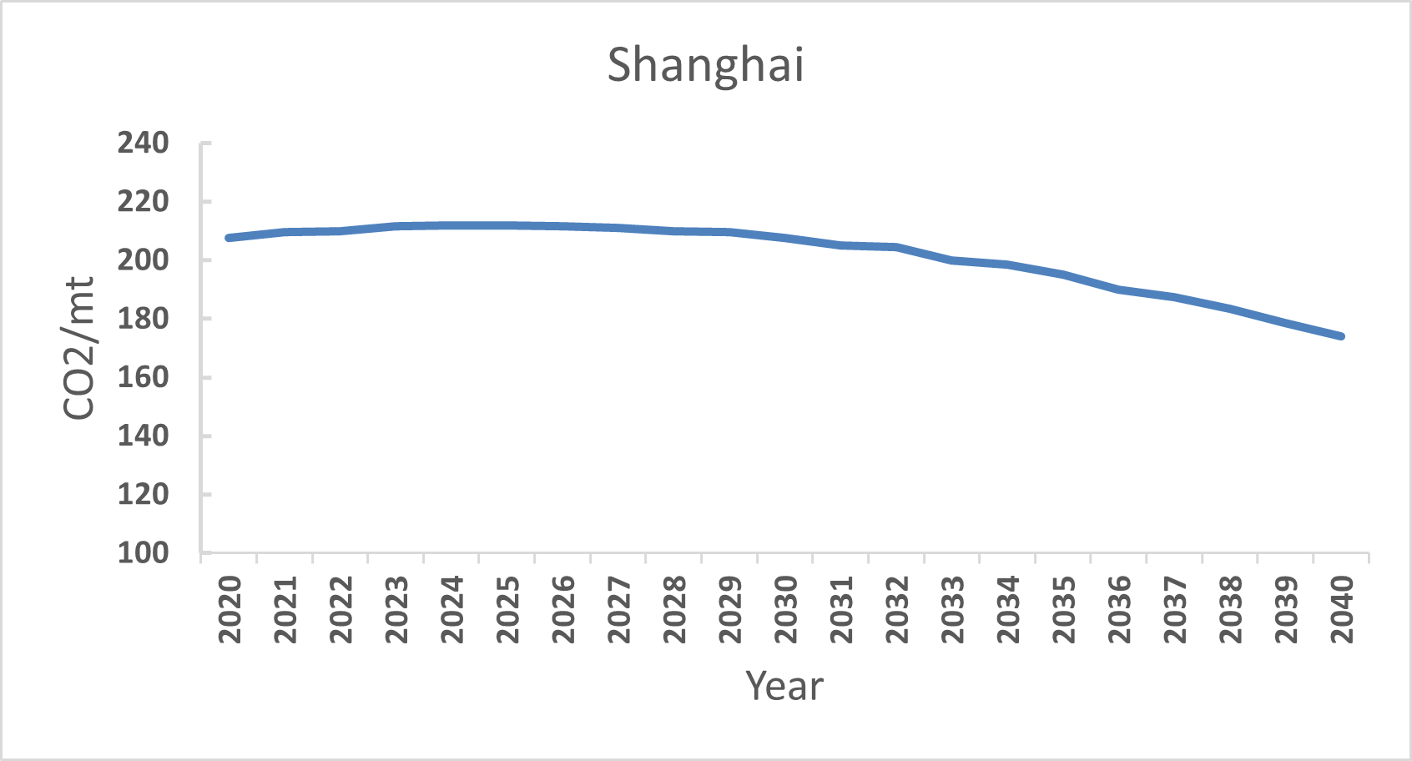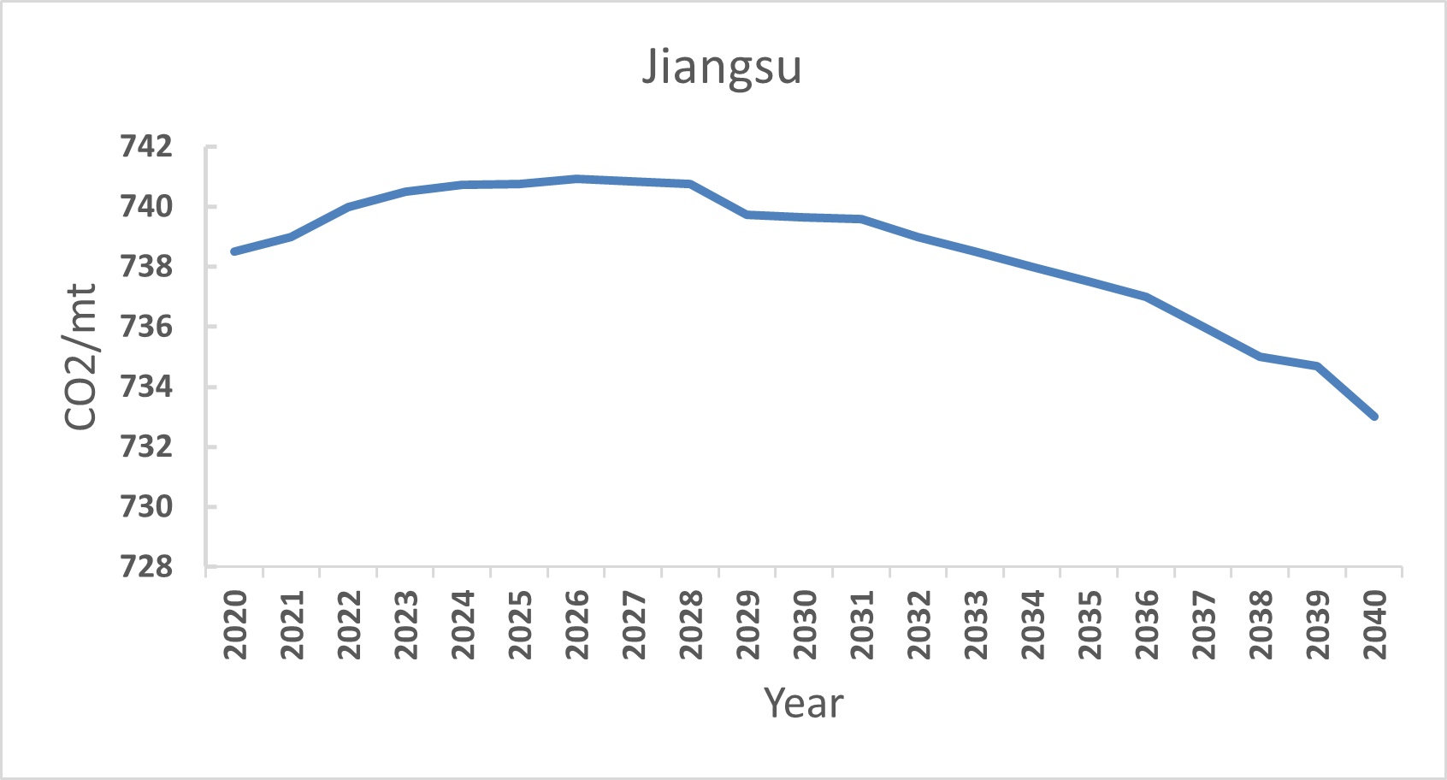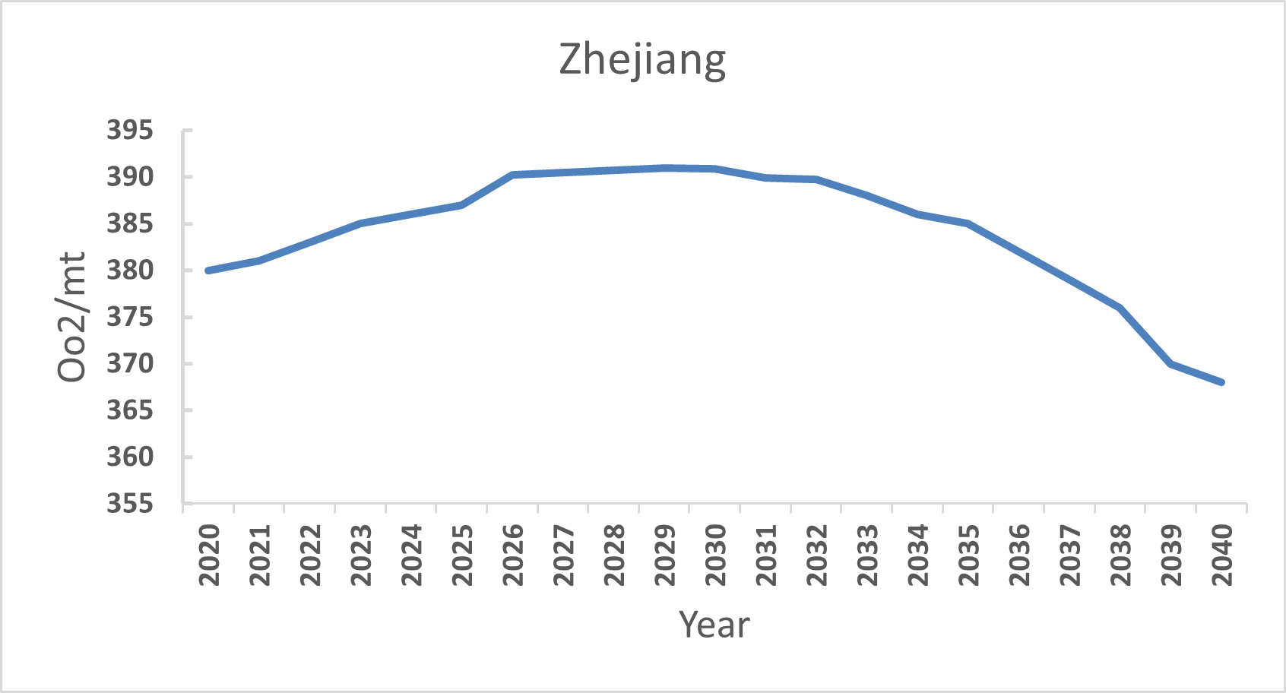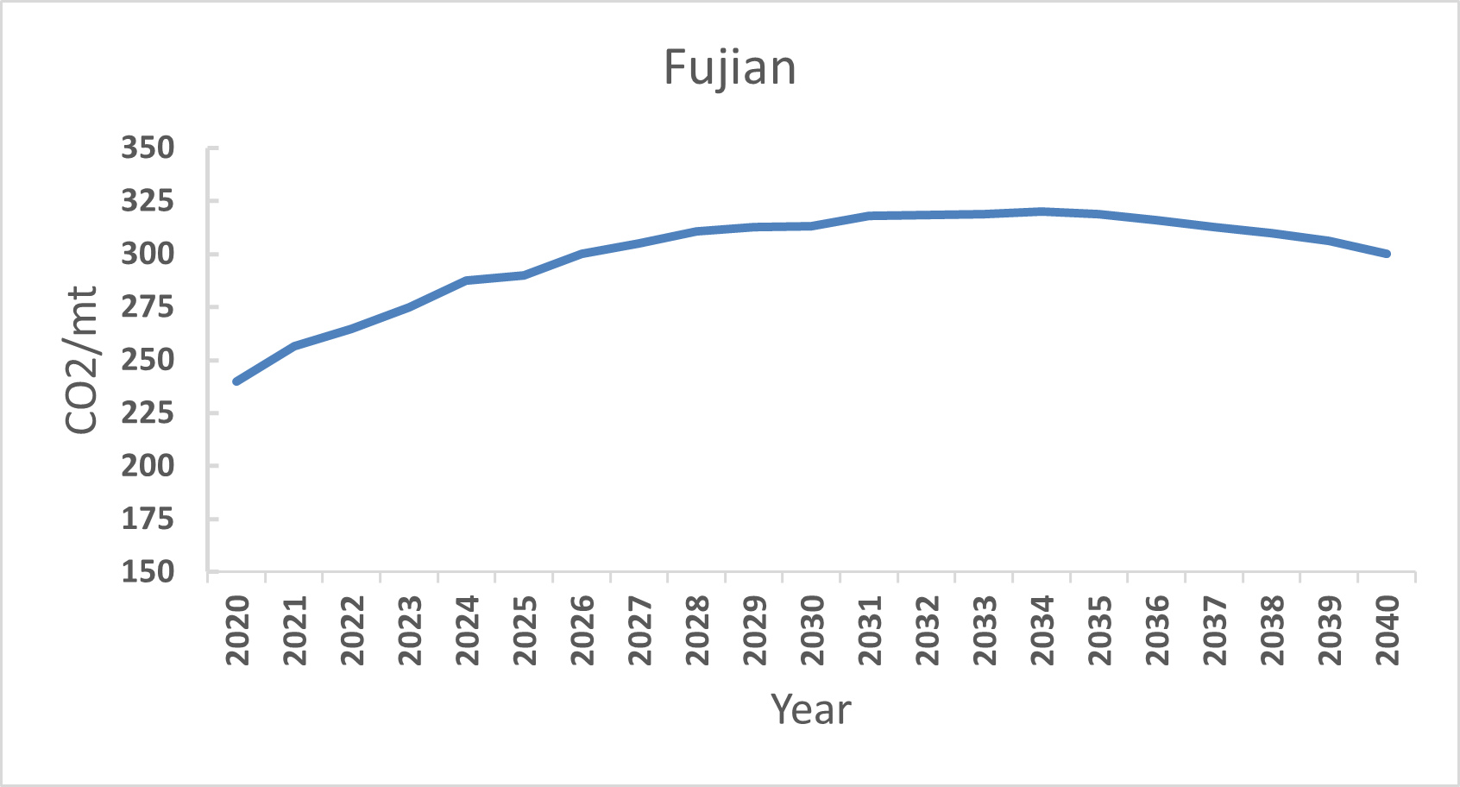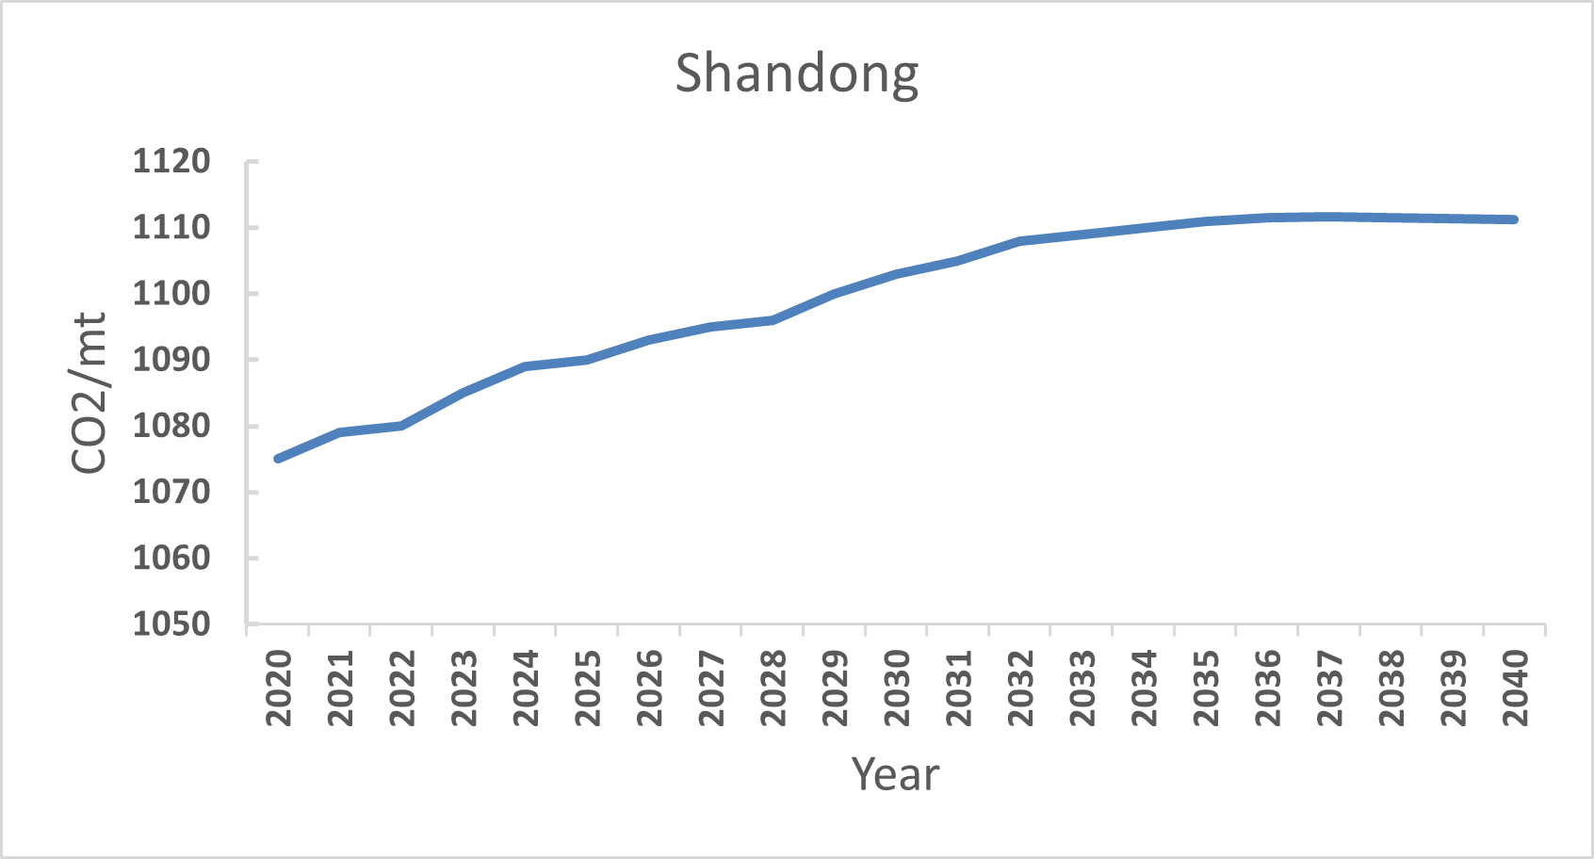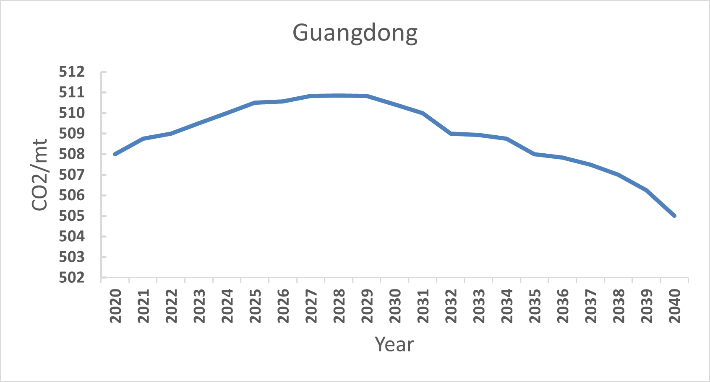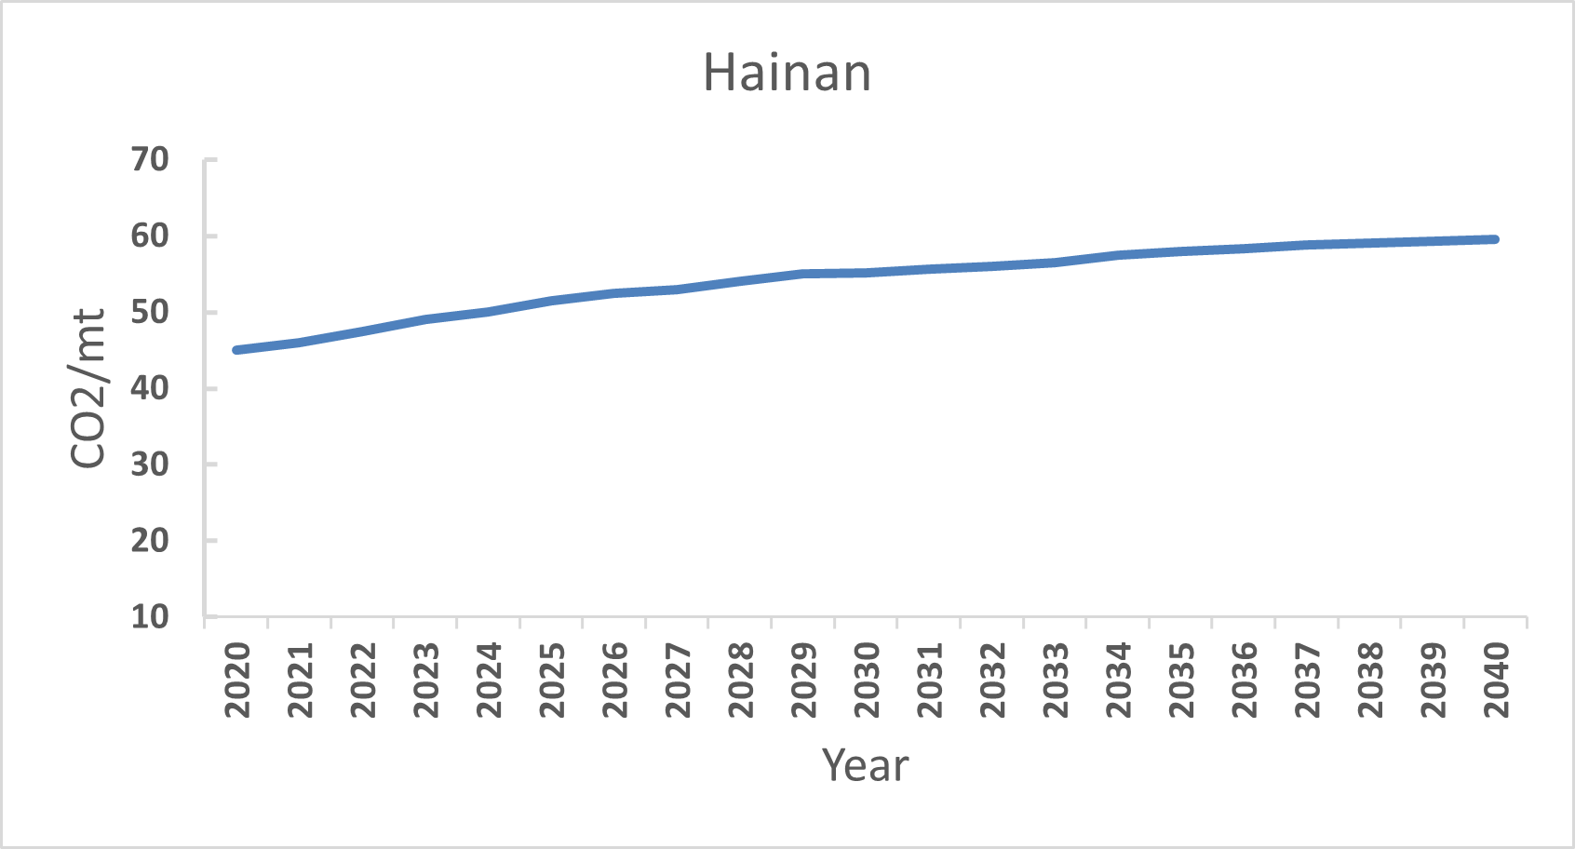
In summary, there is a significant gap in the carbon peak time in 11 regions in eastern China, and not all regions can achieve the carbon peak goal by 2030. This is mainly because each province has different energy consumption and energy efficiency. Therefore, China should fully consider the actual situation in the eastern region when formulating carbon peak strategies, and should focus on provinces with high cumulative carbon emissions and achieving the carbon peak goal after 2030.

5. Main conclusions
(1) The total average energy efficiency of 11 regions in eastern China during the period 2010-2019 was 0.911, showing an overall upward trend, while the changes in energy efficiency vary from region to region. According to the cumulative GML index and its decomposition results, we can see that the overall energy efficiency has increased by 4.8%. The energy efficiency of Beijing, Jiangsu, Liaoning, Shanghai, and Zhejiang provinces has increased, while the energy efficiency of Shandong, Hainan, Fujian, and Hebei provinces has decreased. Shandong and Fujian are caused by the decline in technological efficiency. Therefore, these two provinces should adjust and optimize the energy consumption structure and resource allocation, adjust the scale of enterprises, strengthen the training of professionals, and improve management levels, so that technological efficiency can play a positive role in improving energy efficiency. The decline in energy efficiency in Hainan Province is due to technological retrogression, so the province needs to strengthen investment in scientific research and promote scientific and technological progress. The technological retrogression and decline in technological efficiency in Hebei Province have jointly led to a decline in energy efficiency in the province. Therefore, the province needs to work together in terms of resource allocation and management level. The energy efficiency of Guangdong and Tianjin has not changed.
(2) During the period 2010-2019 in Beijing, economic growth, energy consumption, and energy efficiency were in a weak decoupling state in most years, that is, economic growth, increased energy consumption, and improved energy efficiency. However, the increase in energy consumption and energy efficiency was not as significant as economic growth. The decoupling situation in Tianjin, Shanghai, Zhejiang, Fujian, Jiangsu, Shandong, and Guangdong was similar to that in Beijing; In most years, the economic growth of Hebei and Hainan provinces has a weak decoupling relationship with energy consumption and a strong decoupling relationship with energy efficiency. That is, economic growth leads to increased energy consumption and decreased energy efficiency, which is detrimental to achieving a decoupling between economic growth and energy consumption. These two provinces should pay attention to improving their technological level and increasing investment in clean energy such as hydropower and wind power, to improve energy efficiency and reduce energy consumption, Realize weak decoupling or even expansionary negative decoupling between energy efficiency and economic growth as soon as possible, and achieve strong decoupling between energy consumption and economic growth; The energy consumption and economic growth in Liaoning Province are mainly in a weak decoupling state, with a strong decoupling relationship between energy efficiency and economic growth before 2014 and an expansionary negative decoupling relationship after 2014, which means that the development of Liaoning Province is improving.
(3) There is a large gap in the carbon peak time in 11 regions in eastern China. Beijing, Tianjin, Shanghai, Jiangsu, Zhejiang, Guangdong, and Liaoning achieved carbon peaks by 2030 and before, while Hebei and Hainan regions did not have peaks, while Shandong and Fujian peak after 2030. Therefore, provinces and regions that cannot meet the carbon peak goals on time should deeply promote the energy revolution: First, accelerate the clean and low-carbon transformation of the energy production and consumption system; Strengthen the energy security system and capacity building; Third, improve the reliability and modernization level of the energy industry chain.
(4) The three results are basically consistent: changes in energy efficiency across provinces, decoupling of economic growth from energy consumption and efficiency and prediction of carbon peak times. "Provinces with declining energy efficiency, and unsatisfactory decoupling of economic growth from energy consumption and energy efficiency all have carbon peaks after 2030 or have not yet reached peak levels. These provinces should focus on improving energy efficiency and reducing carbon in their economic development. The country should also take into account the actual situation of each province when setting peak targets for each province."

References
- Jin Yonggang. Research Review on the Connotation, Logic, and Influencing Factors of Energy Efficiency Issues [J]. Journal of Liaoning University (Philosophy and Social Sciences Edition), 2020,48 (02): 51-58.
- Wu Haitao, Li Yunwei, Hao Yu, Ren Siyu, Zhang Pengfei. Environmental decentralization, local government competition, and regional green development: Evidence from China [J] The Science of the total environment, 2019,708 (C).
- Jiang Lei, Zhou Haifeng, He Shixiong. Does energy efficiency increase at the expense of output performance: Evidence from manufacturing firms in Jiangsu province, China [J] Energy, 2021, 220 (pre publish).
- Yang Chuxiao, Hao Yu, Irfan Muhammad. Energy consumption structural adjustment and carbon neutrality in the post COVID-19 era [J] Structural Change and Economic Dynamics, 2021,59.
- Liu Xiaoxiao, Zhong Shuangying, Yang Mian. Study on the decoupling relationship of energy related CO2 emissions and economic growth in China: Using the new two dimensional decoupling model [J] Ecological Indicators, 2022,143.
- Wei Chu, Shen Manhong. Energy efficiency and its influencing factors: empirical analysis based on DEA [J]. Management World, 2007 (08): 66-76.
- Zhang Zhihui, Evolution of Regional Energy Efficiency in China and Its Influencing Factors [J]. Quantitative Economic, Technical and Economic Research, 2015,32 (08): 73-88.
- Meng Wangsheng, Shao Fangqin. Measurement of the Efficiency of Green Economic Growth in Chinese Provinces [J]. Statistics and Decision Making, 2020,36 (16): 105-109.
- Wang, R., Q.Z. Wang, and S.L. Yao. Evaluation and difference analysis of regional energy efficiency in China under the carbon neutrality targets: Insights from DEA and Theil models Journal of Environmental Management, 2021, 293.
- Faz ı L G ö kg ö z, Mustafa Taylor G ü vercin. Energy security and renewable energy efficiency in EU [J] Renewable and Sustainable Energy Reviews, 2018,96.
- Liu Yingshi, Tian Yinhua, Luo Ying. Industrial Structure Upgrading, Energy Efficiency, and Green Total Factor Productivity [J]. Financial Theory and Practice, 2018,39 (01): 118-126.
- Zhou Xing, Zhou Meihua, Zhang Ming. A Study on the Carbon Decoupling Effect in Eastern China from the Perspective of Industrial Structure [J]. Journal of China University of Mining and Technology, 2016,45 (04): 849-858.
- Wei Chu, Shen Manhong. Can Structural Adjustment Improve Energy Efficiency: A Study Based on Provincial Data in China [J]. World Economy, 2008 (11): 77-85.
- Zhang Zhihui. Evolution of Regional Energy Efficiency in China and Its Influencing Factors [J]. Quantitative Economic, Technical and Economic Research, 2015,32 (08): 73-88.
- Liu Zheng, Huang Hao, Deng Xiuyue. Population size, industrial structure, and energy efficiency: an empirical study based on spatial panel econometric models [J]. Macroeconomic Research, 2022 (08): 117-130+175.
- Shi Dan. Improvement of Energy Utilization Efficiency in China's Economic Growth Process [J]. Economic Research, 2002 (09): 49-56+94.
- Pan Yaru, Chen Zheng, Luo Liangwen. A Study on the Nonlinear Characteristics of the Impact of Industrial Agglomeration on Total Factor Energy Efficiency: An Empirical Analysis Based on China's Energy Industry Data [J]. East China Economic Management, 2017,31 (11): 121-126.
- Li Lianshui, Zhou Yong. Can technological progress improve energy efficiency—— Empirical Testing Based on China's Industrial Sector [J]. Management World, 2006 (10): 82-89.
- Yu Kang. Marketization Reform, Technological Progress, and Regional Energy Efficiency: Based on Panel Data Model Analysis of 30 Provinces in China from 1997 to 2014 [J]. Macroeconomic Research, 2017 (11): 79-93.
- Zhou Jieqi, Xia Nanxin, Liang Wenguang. Foreign energy-saving technology spillovers, factor market distortions, and energy efficiency [J]. East China Economic Management, 2018,32 (10): 34-44.
- Lin Boqiang, Du Kerui. The Impact of Factor Market Distortion on Energy Efficiency [J]. Economic Research, 2013,48 (09): 125-136.
- Wei Chu, Zheng Xinye. A New Perspective on Energy Efficiency Improvement: A Test Based on Market Segmentation [J]. Chinese Social Sciences, 2017 (10): 90-111+206.
- Li Kaifeng, Wu Weiwei. Research on Urban Total Factor Energy Efficiency in Jiangsu Province under Green Finance Regulation [J]. Ecological Economy, 2018,34 (12): 99-105.
- Mu Xianzhong, Zhou Wentao, Hu Guangwen. The impact of different types of environmental regulations on total factor energy efficiency [J]. Journal of Beijing Institute of Technology (Social Science Edition), 2022-24 (03): 56-74.
- Yilmaz Bayar, Marius Dan Gavriletea. Energy efficiency, renewable energy, economic growth: evidence from emerging market economies [J] Quality&Quantity, 2019,53 (4).
- Zakari Abdulrasheed, Khan Irfan, Tan Duojiao, Alvarado Rafael, Dagar Vishal. Energy efficiency and sustainable development goals (SDGs) [J] Energy, 2022239 (PE).
- Chen Xihong, Li Changqing, Zhang Guorong, Ji Huilin, Bai Shuangzhu. Is the quality of economic growth consistent with energy efficiency? [J] Journal of Natural Resources, 2013,28 (11): 1858-1868.
- Che Liangliang, Han Xue, Zhao Liangshi, Wu Chunyou. Evaluation of China's coal utilization efficiency and analysis of its decoupling from economic growth [J]. China Population, Resources and Environment, 2015,25 (03): 104-110.
- Lin Boqiang. Electricity Consumption and China's Economic Growth: A Study Based on Production Functions [J]. Management World, 2003 (11): 18-27.
- Yue Li, Song Yaqiong, Jiang Lingfeng. Evaluation of energy utilization efficiency of the "the Belt and Road" countries and analysis of its decoupling from economic growth [J]. Resource Science, 2019, 41 (05): 834-846.
- Ye Xiangsong, Liu Jing, Wang Jiangbo. Research on the Quality of Economic Growth and Energy Efficiency - Taking the Pearl River Delta Region as an Example [J]. Journal of Jiangxi University of Finance and Economics, 2017 (05): 3-13.
- Li Zhongmin, Qing Dongrui. Empirical Study on Economic Growth and Carbon Dioxide Decoupling: A Case Study of Shanxi Province [J]. Fujian Forum (Humanities and Social Sciences Edition), 2010 (02): 67-72.
- Ant ó nio Cardoso Marques, Jos é Alberto Fuinhas, Carla Tom á s Energy efficiency and sustainable growth in industrial sectors in European Union countries: A non-linear ARDL approach [J] Journal of Cleaner Production, 2019239 (C).
- Liu Huimin. The Decoupling of China's Economic Growth and Energy Consumption: A Study on the Spatial and Temporal Differentiation in the Eastern Region [J]. China Population, Resources and Environment, 2016,26 (12): 157-163.
- Zhou Xing, Zhou Meihua, Zhang Ming. A Study on the Carbon Decoupling Effect in Eastern China from the Perspective of Industrial Structure [J]. Journal of China University of Mining and Technology, 2016,45 (04): 849-858.
- Dong hyun Oh . A global Malmquist Leuenberger productivity index [J] Journal of Productivity Analysis, 2010,34 (3).
- Li Xiaoshun, Qu Futian, Guo Zhongxing, Jiang Dongmei, Pan Yuanqing, Chen Xinglei. Study on the decoupling of urban and rural construction land changes [J]. China Population, Resources and Environment, 2008 (05): 179-184.
- Gai Mei, Hu Hangai, Ke Lina. Analysis of the decoupling between resource environment and economic growth in the Yangtze River Delta region [J]. Journal of Natural Resources, 2013,28 (02): 185-198.
- Petri Tapio. Towards a theory of decoupling: degrees of decoupling in the EU and the case of road traffic in Finland between 1970 and 2001 [J] Transport Policy, 2005,12 (2)
- Song Wei, Chen Baiming, Chen Xiwei. Evaluation of Decoupling between Farmland Occupation and Economic Growth in Changshu City [J]. Journal of Natural Resources, 2009,24 (09): 1532-1540.
- Yasmeen, Tan, Q. Assessing Pakistan's energy use, environmental degradation, and economic progress based on Tapio decoupling model Environment Sci Pollut Res 28, 68364-68378 (2021)
- Peng Jiawen, Huang Xianjin, Zhong Taiyang, Zhao Yuntai. Research on the decoupling between China's economic growth and energy carbon emissions [J]. Resource Science, 2011,33 (04): 626-633.
- Pan Dong, Li Nan, Li Feng, Feng Kui Shuang, Peng Lulu, Wang Zhen. Development of peaking strategies for eastern China based on energy carbon emissions prediction [J]. Journal of Environmental Science, 2021, 41 (03): 1142-1152.

