COMPARISON OF CLASSIFICATION SUCCESS OF HUMAN DEVELOPMENT INDEX BY USING ORDERED LOGISTIC REGRESSION ANALYSIS AND ARTIFICIAL NEURAL NETWORK METHODS

Emre YAKUT¹ Murat GUNDUZ² Ayhan DEMİRCİ³
¹Osmaniye Korkut Ata University, Faculty of Economics and Administrative Sciences, Department of Management Information Systems, emreyakut@osmaniye.edu.tr
²UsakUniversity, Faculty of Economics and Administrative Sciences, Department of Econometrics, murat.gunduz@usak.edu.tr
³Dr. Turkish Armed Forces, kho1993@hotmail.com.tr

Economic development and growth are among the most important objectives for many countries. Not only economic development but also human development, which means enhancing and improving people’s quality of life, plays an important role for reaching this objective. In this way, it’s possible to take a more human oriented perspective by taking education, health and welfare dimensions of development into consideration by widening the perspective, which is focused narrowly on economic growth only. For this reason, human development index has become a widely preferred and recognized numerical indicator for comparison and classification of countries. Human Development Index (HDI) calculated by Human Development Report Office of United Nations Development Program (UNDP) measure people’s level of welfare every year. The purpose of this research is to compare the classification success of Human Development Index by using ordered logistic regression and artificial neural network. The data of 81 countries, which has United Nations Development Program’s Human Development Index, between the years of 2010-2012 were used in this study. Countries are classified for having very high, high and moderate levels of human development. The results of the ordered lojistic regression model indicate that determinants including infant mortality rate, health expenses, number of internet users, import and export were observed as statistically significant. As a result of the analysis, Ordered Logistic Regression Analysis proved 88% success in classification while Elman’s back propagation learning algorithm showed 92% success.
Keywords: Human Development Index, Ordered Logistic Regression, Artificial Neural Network
Gel Code: O15, C38, C45
INTRODUCTION

Human development is the process of enhancing and improving people’s life skills. This process aims to make a positive contribution to human and their living standards by equipping them with skills and capacity (UNDP 1990:1).
By its Human Development Index (HDI) developed in 1990, United Nations Development Program (UNDP) takes a more composite and human oriented perspective by taking education, health and welfare dimensions of development into consideration by widening the perspective which is focused narrowly on economic growth only (Lind, 1992:89).
Until 2010, GDP calculated per person based on purchasing power parity was taken into consideration for the economic dimension while life expectancy since birth was used for the health dimension and literacy and schooling were used for the education dimension. HDI calculates the arithmetic mean. Both economy and health dimension has one indicator while education dimension has two being literacy (2/3) and schooling (1/3) (Ivanova et al, 1999:159-160).
The human development approach comprises two central theses about people and development which are concerned with evaluating improvements in human lives as a distinctive development objective and what human beings can do to achieve such improvements particularly policy and political changes (Fukuda-Parr, 2003).
In 2010, index calculation was significantly changed. In this context, index calculation was based on arithmetic average instead of geometric average. With regards to education dimension, literacy among adults was excluded and the average of schooling rate and estimated schooling rate was considered (Morse 2014:249).
In the contemporary era, the concept of development has been in greater need of analysis and clarification and the word has come to be extraordinarily widely used in public discourse probably more so than ever before in its history (Payne & Phillips, 2010; Eren, et, al, 2014).
HDI is scored between 0 and 1. 1 shows the highest human development status. The human development report in 2014 stated 4 levels of human development as very high, high, moderate and low. Countries with HDI value lower than 0,550 was classified as low, 0,550–0,699 as moderate, 0,700–0,799 as high and higher than 0,800 as very high (UNDP 2014:156).
The purpose of this study is to compare the success of multiple classifications and to determine the effective factors by using logistic regression analysis and Elman ANN, multi-layer ANN and LVQ network. This study is comprised of 3 parts. In the first part, logistic regression analysis is introduced while the second part focuses on Elman ANN and LVQ network. In the third part, application results are compared.

- Ordered Logistic Regression Model
Logistic regression models are used for modelling the relation between dependent variables measured in different categories and independent variables of categorical or continuous measurement. Ordered logistic regression (OLOGREG) is used when dependent variables consists of at least three categories and measured by ordinal scale (Demirtas v.d.2009:869).
The main features of ordered logistic regression model are as follows (Chen and Hughes, 2004: 4):
- Outcome variable of categorical and ordinal measurement is a variable, which can be rearranged multiple times from an unobserved continuous latent variable, however it’s not clear whether the space between the categories of this ordinal outcome variable is equal.
- Ordered logistic regression analysis, uses a correlation function to explain the effects of independent variables on ordered and categorical outcome variable. This model does not require normality and constant variance assumption.
- Since regression coefficient value is not dependent on the categories of categorical output variable, ordered logistic regression model assumes that the relation between explanatory variables and ordered categorical output variable is independent from categories.

Ordered logistic regression model is actually based on the existence of an continuous and unobserved random Y* latent variable under a categorical dependent Y variable. The categories of this variable are estimated as sequential intervals on a continuous plane named as cut-off point or threshold value (McCullagh, 1980:109).
In θ_{s-1}< Y*<θ_{s} , s=1,…, j interval and in the event of θ₀=-∞ and θ_{j}=+∞ (Anderson, 1984:3), this latent Y* variable is stated as in equity (1).
$$Y^{*}=\sum_{k=1}^{K}{β_{k}x_{k}}+ε (1)$$

Here θ refers to threshold value, $x_{k}$refers to independent variables vector,$β_{k}$refers to parameter vector and $ε$ refers to error term.
The relation between observed Y variable and unobserved $Y^{*}$is shown in equity (2)(Liao, 1994:37-38):

1 if$y_{i}^{*}≤θ_{1}$
2 if$θ_{1}<y_{i}^{*}≤θ_{2}$ (3)
$y=$ 3 if $θ_{2}<y_{i}^{*}≤θ_{3}$
⁞⁞ (2)
j if$θ_{j-1}<y_{i}^{*}$
θ’s refer to threshold values that separate categories dependent variable. F being distribution function of error term, which is assumed to be distributed logistically, general probability of observed dependent variable’s falling into k. Category is shown in equity (3) for given independent variables:
$$Prob\left(y=j\backslash x\right)=F\left[θ_{j}-\sum_{k=1}^{K}{{β_{k}x}_{k}}\right]-F\left[θ_{j-1}-\sum_{k=1}^{K}{{β_{k}x}_{k}}\right] (3)$$
There are many correlation functions, which are formations of cumulative probabilities in order to estimate ordered logistic model. These functions are shown in Table 1 (Elamir and Sadeq, 2010: 652):

Table 1. Correlation Functions and Typical Application
Function | Form | Application Area
Logit | $$log⁡(\frac{x}{1-x})$$ | Categories are distributed evenly
Complementary Log-Log | $$log⁡(-\log\left(1-x\right))$$ | High categories are more likely
Negative Log-Log | $$-log⁡(-log⁡(x)$$ | Low categories are more likely
Probit | $$F^{-1}(x)$$ | Variable is distributed normally
Couchit | $$tan⁡(π\left(x-0.5\right))$$ | Variable has excessive values

L being logit distribution function in ordered logit model, the probability of observed variables’ falling into categories of dependent variable is shown in equity (4) (Akkus v.d., 2010:323):
$$Prob\left(y=1\right)=L\left(-\sum_{k=1}^{K}{x_{k}β_{k}}\right)$$
$$Prob\left(y=2\right)=L\left(θ_{2}-\sum_{k=1}^{K}{x_{k}}β_{k}\right)-L\left(-\sum_{k=1}^{K}{x_{k}β_{k}}\right)$$

$$Prob\left(y=3\right)=L\left(θ_{3}-\sum_{k=1}^{K}{x_{k}}β_{k}\right)-L\left(θ_{2}-\sum_{k=1}^{K}{x_{k}β_{k}}\right)$$
$$Prob\left(y=j\right)=1-L\left(θ_{j-1}-\sum_{k=1}^{K}{x_{k}β_{k}}\right) (4)$$
The most important assumption in ordered logistic regression model is the assumption of parallel curves. According to this assumption, regression parameters obtained in the model is the same in all categories of the dependent variable. In other words, the relation between independent variables and dependent variable does not change according to the categories of dependent variable, and parameter estimations do not change according to different threshold values. Thus, if there’s a dependent variable of J category, “$β_{k}$ ” parameter is only one. On the other hand, there is $θ_{j-1}$cut-off point (threshold value) for J-1 logit comparisons (Akin and Senturk, 2012:185).
It’s challenging to interpret parameters in ordered logistic regression. Methods of calculation of standardizes coefficients, calculation of estimated probabilities, calculation of factor change in estimated probabilities and percentage change in estimated probabilities are used for interpreting parameters. Odds ratio can also be used for interpreting parameters. In the event that all other variables are held constant, exp(β_{k}) is odd ratio for dummy variable. To standardize odds ratios, $s_{k}$: showing standard deviation, $exp(β_{k}*s_{k})$ is calculated provided that all other variables are held constant. For continuous variables; the percentage is found by $\left[\exp\left(β-1\right)*100\right]$(Ucdogruk vd., 2001).

- Artificial Neural Networks
ANNs are cellular systems that can receive, store and use information. ANNs are parallel systems, which are formed by connecting many connecting elements with links of variable weights. Multi-layer artificial neural network is the most popular one among many artificial neural networks (Lippman 1987: 15). ANN is a system based on simple neural networks, which can receive interconnected information as input, process them and submits to other units, and which can even use the outputs as inputs again (Pissarenko, 2001-2002: 35). ANN simulates the operation of a simple biological neural system. ANNs provide solutions to problems, which normally requires a person's natural ability to think and observe.

Artificial neural networks are computer systems which are developed to perform some characteristics of a human brain automatically without getting any help such as getting new information through learning, creating new information and discovering (Oztemel, 2003: 29). Artificial neural networks are used to achieve one or more processes including learning through using available data, associating, classification, generalization and optimization (Sen, 2004: 13).
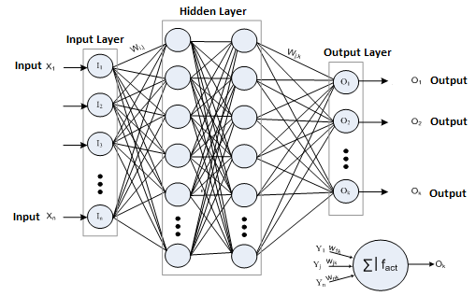
Figure 1. General Structure of an Artificial Neural Network
Use of artificial neural networks in such problems whose algorithmic solution could not be found has increased due to the fact that artificial neural networks can find solutions to new occurrences by way of examining former instances and learning the relationship between inputs and outputs of the said occurrence, regardless of whether the relationship is linear or not, from the current instances in hand. The biggest problem in artificial neural networks is that there is a need for such artificial neural networks that contain either very large neurons or multi-layered and a great amount of neurons in order to solve complicated problems (Kohonen,1987: 1-79). An artificial neural network is an intensively parallel-distributed processor which is comprised of simple processing units, has a natural tendency to collecting experiential information, and enabling them to be used (Haykin, 1999:2).
In a general artificial neural network system, neurons gather on the same direction to form layers (Yildiz, 2001: 51-67). There is parallel flow of information from the input layer to the exit in an architectural structure. Such flow is possible with parallel placed cells.

2.1. Elman Network
Elman network is an ANN type, which includes the whole multi layer ANN as well as interlayer outputs as a parallel input (Sen, 2004: 144).
Elman network delivers not only input values of a given time but also previous activity values of interlayers as an input into the network. Once the inputs are determined, the network becomes a multilayer feed-forward receptor. These inputs are used to determine network’s forward outputs (Elman, 1990: 182).
Although Elman network is quite similar to Jordan network, there are significant differences. First of all, they obtain feedback activation values from the interlayer instead of output layer. Secondly, content elements are not self-connected. This network structure is shown below (Kucukonder, 2011: 78)
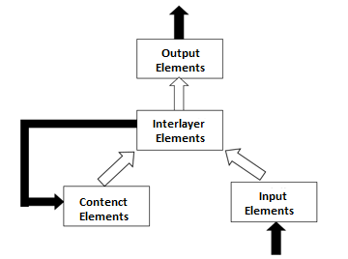
Figure2.Structure of Elman Network
In Elman network, learning is achieved in two steps according to generalized delta learning rule. Firstly, weight of net input value received by processor elements in interlayer is multiplied with and added to the weight of element values of input layer. Secondly, these connection values from content elements is multiplied with and added to previous activation values in interlayers. Elman network is shown in detail in Figure 3 below (Oztemel, 2003: 167).
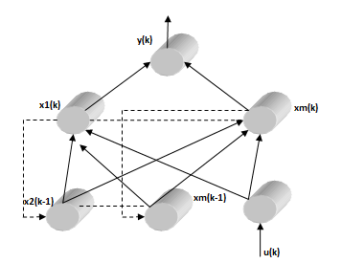

Figure3. Detailed demonstration of Elman network

2.2. LVQ Model (Learning Vector Quantization)
Developed by Kohenon (1984), LVQ Model is a network structure using reinforcement-learning model. LVQ networks are mostly used for solving classification problems.
Learning means finding which set of vectors (reference vector) should represent input vector. LVQ network’s duty is to determine the set of vectors, i.e. the ones that may be a member of input vectors, by means of learning. It learns by Kohonen’s learning principle. Only one output is valued as 1 while the others are given 0 value, and if the output is valued as 1, it means that the input belongs to the class represented by the output. Since LVQ network is used as a method of statistical classification and distinction, its purpose is classifying input data (Kohonen, 2001: 245).
LVQ network consists of entrance, exit and Kohenon levels and all neurons of the entrance layer are in connection with all neurons in interlayers. The main purpose of this network is mapping a vector of n dimension in sets of vectors (Kucukonder, 2011: 70).
During training, input vector is breakdown based on the nearest neighbour rule. The model looks for the shortest distance between the input vector and reference vectors and it’s assumed that the input vector belongs to the nearest vector group. The weights of the network are changed in order to determine reference vectors for an accurate breakdown of input vectors. For this purpose, reinforcement learning strategy is used. For determining the output value, “winner-takes-all” strategy is used. In training process, not the output value but whether it’s correct or not is stated for each iteration. Only the values of the winner vector, which is the closest to the input vector, are changed (the weights of the network for this vector). The architectural structure of LVQ network demonstrating these details is shown in Figure 4 (Oztemel, 2003: 116).

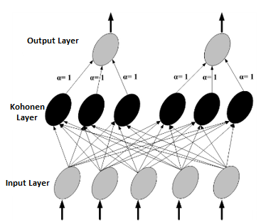
Figure 4. Structure of LVQ Network
LVQ network is composed of three layers (Adiyaman, 2007: 38):
- Input layer: There’s no data processing in this layer, and incoming information forms the vector. Each process element in this layer is connected to each process element in Kohonen layer. Learning is achieved by changing weights of input layer and Kohonen layer.
- Kohonen layer:In this layer, the weight vector, which is the closest to the input set, is determined. Each element in this layer shows a reference vector and composed of weight values of links connecting input values to process elements in Kohonen layer. The number of elements in reference vector is equal to the number of elements in input layer.
- Output layer:In this layer, the class, which the input belongs to, is determined. Process elements in Kohonen layer is linked to only one process element in output layer. The weights between Kohonen layer and output layer is (a) and equal to 1.

- Scope and Method of Study
This part gives information about the purpose, scope, limitations, universe and analysis method of the study.

  - Purpose and Significance of Study
Economic development and growth are among the most important objectives for all countries. For this reason, human development index has become a widely preferred and recognized numerical indicator for comparison and classification of countries. The purpose of this research is to compare the classification success of Human Development Index and determine the by using ordered logistic regression as well as Elman ANN, multi layer ANN and LVQ network as artificial neural networks.

3.2. Scope, Limitations and Constraints of Study
In this study, data of highly developed, developed, moderately developed and less developed countries produced by Human Development Report Office of United Nations Development Program (UNDP), which is published annually. This data covers a period of three years and is obtained from 2010-2012 Human Development Index published at United Nations Development web site.Since it was difficult to find data about less developed countries, they are excluded from the analysis. The study classifies 81 countries based on data of three years. With the addition of one more country in 2012, the universe of the study is total of 244 countries.
Income, education and life expectancy are indispensable components in calculation of human development index. Since human development level would be subject to multiple classification process, 11 independent variables were added to these three variables, thus 14 independent variables were studied in order to enable a more detailed examination of methods. The following variables were used in the analysis respectively:
X1: BÖO “infant mortality rate”,
X2: GSMH “gross national product”,
X3: LKO “high school enrolment”,
X4: BY “growth”,
X5: DYY “direct foreign investment”,
X6: ET “energy consumption”,
X7: EÜ “energy production”,
X8: E “inflation”,
X9: IH “export”,
X10: IKS “number of internet users”,
X11:ISZ “unemployment”,
X12: ITH “import”,
X13: MTAS “number of mobile phone subscribers”,
X14: SH “health expenses”
Answer variables for Human Development are coded as follows for Ordered Logistic Regression Analysis:
0: Moderately Developed,
1: Developed,
2: Highly Developed.

  - Data Analysis Method

Countries are classified for their Human Development Level by using Stata 11.2 package, Ordered Logistic Regression and Matlab 2012 software with Elman, Multi Layer Neural Networks and LVQ Network methods. In artificial neural network method, if a country is highly developed in human development, it is valued as 1 while the others’ output values are stated as 0.

  - Ordered Logistic Regression Analysis
Stata 11.2 statistical analysis program is used to classify Human Development Index of countries.
Table2: Relevance Values of the Established Model
Log-Lik Intercept Only: | -256.865 | Log-Lik Full Model: | -98.392
D(228): | 196.784 | LR(12): | 316.947
 |  | Prob>LR: | 0.000
McFadden's R2: | 0.617 | McFadden's Adj R2: | 0.555
ML (Cox-Snell) R2: | 0.727 | Cragg-Uhler(Nagelkerke) R2: | 0.828
McKelvey&Zavoina's R2: | 0.886
Variance of y*: | 28.850 | Variance of error: | 3.290
Count R2: | 0.881 | Adj Count R2: | 0.779
AIC: | 0.938 | AIC*n: | 228.784
BIC: | -1.056.570 | BIC': | -250.981
BIC used by Stata: | 273.745 | AIC used by Stata: | 224.784

In order to test relevance of the model used in study, fitstat command was run in Stata 11.2 software. Table 2 shows the conformity values of the model. Akaika information criteria (AIC) was found to be 228.784 while Bayes information criteria (BIC) was found as -250.981.Prob>LR: 0.000 model with all independent variables was found to be statistically significant. McKelvey and Zavonia’s R² value approximates to R² value, which is obtained by estimating linear regression model (Long andFreese, 2001: 148). McKelvey and Zavonia’s R² value of the model was measured as 88.6%.

Table 3: ParallelCurves Assumption Test
Variable | chi2 | p>chi2 | df
All | 14.12 | 0.118 | 14

Table 3 shows the test results of parallel curves assumption of logistic regression model. Zero hypothesis (H₀) and alternative hypothesis (H_{a}) used for testing parallel curves assumption test are as follows:
“H₀: Relevant regression coefficients are the same in all categories of dependent variable
H_{a}: Relevant regression coefficients are different at all levels of dependent variable”

Brant, detail command was run in Stata software. In the model, as P>$χ^{2}$: 0,118, H₀ hypothesis was accepted,thus it shows that estimated regression coefficients are the same in each category of the dependent variable and parallel curves assumption is realized with P>0,05.

Table 4: Established Model’s Goodness of Fit
Goodness of Fit Test of Ordered Logit Model
Pearson $χ^{2}$ test statistic | 10.24
Liberty Level | 14
P>$χ^{2}$ | 0.332

“H₀: Model-data fit is sufficient in terms of parameter’s decisiveness
H_{a}: Model-data fit is not sufficient in terms of parameter’s decisiveness”

Omodel logit command was run in Stata software. Likelihood ratio test known as $χ^{2}$goodness of fit test, evaluates ordered logistic regression model as a whole. In the model, as P>$χ^{2}$: 0,332, H₀ hypothesis was accepted, thus it was found that ordered logistic regression model is a sufficient model for classification of human development index. It can be stated that model’s goodness of fit is quite good and parameters are good at classification decisiveness.

Table 5. Results of Ordered Logistic Regression Analysis of Variables Effecting Human Development Level

 |  |  |  |  |  | Number of obs |  | 244
 |  |  |  |  |  | LRchi2(12) |  | 316,95
 |  |  |  |  |  | Prob> chi2 |  | 0.0000
Log likelihood |  | -110,706 |  |  |  | Pseudo R2 |  | 0,617
HDII | Coef. | Std. Err. | Wald | z | P>z | Odds  Ratio | [95% Conf. Interval]
BÖO | -0,132 | 0,035 | 13,985 | -3,740 | 0,000 | 0,876 | 0,817 | 0,939
GSMH | 0,000 | 0,000 | 1,840 | 1,360 | 0,174 | 1,000 | 1,000 | 1,000
LKO | 0,017 | 0,013 | 1,749 | 1,320 | 0,186 | 1,017 | 0,992 | 1,043
BY | -0,076 | 0,063 | 1,482 | -1,220 | 0,223 | 0,926 | 0,819 | 1,048
DYY | 0,000 | 0,000 | 0,175 | -0,420 | 0,674 | 1,000 | 1,000 | 1,000
ET | 0,000 | 0,000 | 0,603 | -0,780 | 0,438 | 1,000 | 1,000 | 1,000
EÜ | 0,000 | 0,000 | 0,011 | -0,110 | 0,916 | 1,000 | 1,000 | 1,000
E | 0,051 | 0,037 | 1,837 | 1,360 | 0,175 | 1,052 | 0,978 | 1,131
IH | 0,058 | 0,023 | 6,475 | 2,540 | 0,011 | 1,059 | 1,013 | 1,108
IKS | 0,104 | 0,020 | 26,893 | 5,190 | 0,000 | 1,109 | 1,067 | 1,154
ISZ | -0,005 | 0,044 | 0,012 | -0,110 | 0,914 | 0,995 | 0,914 | 1,084
ITH | -0,062 | 0,024 | 6,788 | -2,610 | 0,009 | 0,940 | 0,897 | 0,985
MTAS | -0,006 | 0,009 | 0,506 | -0,710 | 0,477 | 0,994 | 0,977 | 1,011
SH | 0,237 | 0,110 | 4,616 | 2,150 | 0,032 | 1,267 | 1,021 | 1,573
/cut1 | 1,563 | 1,539 |  |  |  |  | -1,453 | 4,580
/cut2 | 6,487 | 1,614 |  |  |  |  | 3,323 | 9,651
Results of the ordered logistic regression analysis of dependent and independent variables using mlogit command in Stata 11.2 package program are shown in Table 5. As seen in Table 5, the number of observations is 244 in the model and $χ^{2}$value is statistically significant (p <0.01). Log likelihood value of the model was found to be -110.71. The first column of Table 5 shows β coefficients of ordered logistic regression analysis. BÖO “infant mortality rate”, IKS “number of internet users” and ITH “import” with 0.01 significance level and IH “export” and SH “health expenses” with 0.05 significance level were observed as statistically significant. BÖO and ITH variables above the statistically dependent variable is marked negative while estimated value of İKS, İH and SH variables are marked positive. In addition, marginal effects will be calculated for the change in probabilities of dependent variable pursuant to change in β coefficients.

In odds ratio, one unit increase in BÖO variable decreases odds of high level human development rate by 12.4% while one unit increase in ITH variable decreases it by 6% provided that all other independent variables are held constant against moderate and low level of human development rate. One unit increase in IH variable increases odds of high level human development rate by 5.9% while one unit increase in IKS variable increases it by 10.9% and one unit increase in SH variable increases it by 26.7% against moderate and low level of human development rate. Thus, the most important variable that has a positive effect on human development level is SH “health expenses” variable, the second one is IKS “number of internet users” variable and the third one is IH “export” variable while the most important variable with negative effect is BÖO “infant mortality rate”.

For the number of categorical variables, M-1=2 cut-off value is obtained.

Ordered logistic regression model which is established for dependent variable with 3 categories used for calculation of probabilities is shown in Table 5.

Z=$\sum_{k=1}^{K}{β_{k}X_{k}=}-$0,132BÖO+1,37*10⁻¹²GSMH+0,017LKO – 0,076BY-1*10⁻¹¹DYY – 5,38*10⁻⁶ET
– 3,42*10⁻⁷EÜ+0,051E+0,058IH+0,104IKS-0,005ISZ-0,062ITH-0,006MTAS+0,237SH

Probabilities will be calculated by ordered logistic regression model.Z values obtained from the above equation will be written in the formulas below and the class the countries belong to as per their human development levels will be determined by calculating probability values of moderate, developed and highly developed index of countries.
$P\left(Y=0\right)=1-\frac{exp⁡(Z_{i}-{cut}_{1})}{1+\exp\left(Z_{i}-{cut}_{1}\right)}$ = probability values of moderate development index,
$P\left(Y=1\right)=\frac{exp⁡(Z_{i}-{cut}_{2})}{1+exp⁡(Z_{i}-{cut}_{2})}-\frac{exp{(Z}_{i}-{cut}_{1})}{1+\exp\left(Z_{i}-{cut}_{1}\right)}$ = values of development index,
$P\left(Y=2\right)=\frac{exp⁡(Z_{i}-{cut}_{2})}{1+\exp\left(Z_{i}-{cut}_{2}\right)}$ = probability values of high development index,
Probability Values of Human Development Index of Turkey in 2010:
$Z_{1}\left(x_{i}\right)=-$0,132*BÖO(16)+1,37*10⁻¹² *GSMH(7,31E+11)+0,017*LKO(56)–0,076*BY(9,29)+
-1*10¹¹ *DYY(9,04E+09)–5,38*10^{-6 *}ET(105133,1)–3,42*10^{-7 *}EÜ(32225)+0,051*E(5,7)+0,058I*H(21)+0,104I*KS(39,8)
-0,005I*SZ(11,9)-0,062*ITH(27)-0,006*MTAS(85)+0,237*SH(6,7)=3,441

$$Z_{i}-{cut}_{1}=3,441-1,563=1,878$$
$$Z_{i}-{cut}_{2}=3,441-6,487=-3,046$$
P(Y=0)= 0,133,probability of being a moderately developed country,
P(Y=1)=0,822, probability of being a developed country,
P(Y=2)=0,045, probability of being a highly developed country,
It’s determined that Turkey, which was included in the category of developed countries for human development in 2010, was classified correctly in the category of developed countries for human development with the highest probability result of 0.822 by ordered logistic regression analysis.
Probability Values of Human Development Index of Turkey in 2011:
$Z_{1}\left(x_{i}\right)=-$0,132*BÖO(15)+1,37*10⁻¹² *GSMH(7,75E+11)+0,017*LKO(61)–0,076*BY(8,8)-1*10¹¹*DYY(1,6E+10)–5,38*10⁻⁶ *ET(112458,7)–3,42*10⁻⁷ *EÜ(32064)+0,051*E(8,6)+0,058*IH(24)+0,104*IKS(43,1)-0,005*ISZ(9,8)-0,062*ITH(33)
-0,006*MTAS(89)+0,237*SH(6,7)=3,916

$$Z_{i}-{cut}_{1}=3,916-1,563=2,353$$
$$Z_{i}-{cut}_{2}=3,916-6,487=-2,571$$
P(Y=0)= 0,087, probability of being a moderately developed country,
P(Y=1)=0,842, probability of being a developed country,
P(Y=2)=0,071, probability of being a highly developed country,
It’s determined that Turkey, which was included in the category of developed countries for human development in 2011, was classified correctly in the category of developed countries for human development with the result of 0.842 by ordered logistic regression analysis.
Probability Values of Human Development Index of Turkey in 2012:
$Z_{1}\left(x_{i}\right)=-$0,132*BÖO(14)+1,37*10⁻¹² *GSMH(7,89E+11)+0,017*LKO(62)–0,076*BY(2,2)
-1*10¹¹ *DYY(1,26E+10)–5,38*10⁻⁶ *ET(115701,2)–3,42*10⁻⁷ *EÜ(31117)+0,051*E(6,8)+0,058*IH(26)+0,104*IKS(45,1)
-0,005*ISZ(9,3)-0,062*ITH(32)-0,006*MTAS(91)+0,237*SH(6,7)=4,891

$$Z_{i}-{cut}_{1}=4,891-1,563=3,328$$
$$Z_{i}-{cut}_{2}=4,891-6,487=-1,596$$
P(Y=0)= 0,035, probability of being a moderately developed country,
P(Y=1)=0,797, probability of being a developed country,
P(Y=2)=0,168, probability of being a highly developed country,
It’s determined that Turkey, which was included in the category of developed countries for human development in 2012, was classified correctly in the category of developed countries for human development with the result of 0.797 by ordered logistic regression analysis.
In this way, Turkey’s human development rate was successfully classified.

Table 6. Marginal Effects on Probability
Variable | Probability of  Moderate Development | Probability of  Development | Probability of  High Development
BÖO | 0,0017023 | 0,0285864 | -0,0302887
GSMH | -1,76E-14 | -2,96E-13 | 3,14E-13
LKO | -0,0002201 | -0,0036953 | 0,0039154
BY | 0,0009831 | 0,0165083 | -0,0174914
DYY | 1,29E-13 | 2,17E-12 | -2,30E-12
ET | 6,92E-08 | 1,16E-06 | -1,23E-06
EÜ | 4,40E-09 | 7,39E-08 | -7,83E-08
E | -0,0006499 | -0,0109138 | 0,0115637
IH | -0,0007436 | -0,0124877 | 0,0132313
IKS | -0,0013342 | -0,0224047 | 0,0237389
ISZ | 0,0000608 | 0,0010203 | -0,0010811
ITH | 0,0007969 | 0,0133821 | -0,014179
MTAS | 0,0000785 | 0,0013188 | -0,0013973
SH | -0,0030488 | -0,0511975 | 0,0542463

Marginal effects show the effect of one unit change of average on the probability of dependent variable categories. In order to calculate marginal effects, mfx command was run in Stata 11.2 software. When statistically significant variables are taken into consideration in the equation of ordered logistic regression and provided that all other variables are held constant, one unit increase in BÖO variable decreases the probability of being a highly developed country with regards to human development by 3% while it increases the probability of being a developed country with regards to human development by 2.9% and being a moderately developed country with regards to human development by 0.17%.
One unit increase in IHT variable decreases the probability of being a highly developed country with regards to human development by 1% while it increases the probability of being a developed country with regards to human development by 1% and being a moderately developed country with regards to human development by 0.08%.
One unit increase in IH variable increases the probability of being a highly developed country with regards to human development by 1% while it decreases the probability of being a developed country with regards to human development by 1% and being a moderately developed country with regards to human development by 0.07%.
One unit increase in IKS variable increases the probability of being a highly developed country with regards to human development by 2% while it decreases the probability of being a developed country with regards to human development by 2% and being a moderately developed country with regards to human development by 0.1%.
One unit increase in SH variable increases the probability of being a highly developed country with regards to human development by 5% while it decreases the probability of being a developed country with regards to human development by 5% and being a moderately developed country with regards to human development by 0.3%.

Table7: Classification Success of Ordered Logistic Regression Analysis
Ordered Logistic  Regression Analysis |  | Estimated Group |  |  |  | Accuracy  Rate
 |  | Moderate | Developed | Highly  Developed | Total
Observed  Group | Moderate | 44 | 9 | 0 | 53 | 83
 | Developed | 7 | 66 | 5 | 78 | 84,6
 | Highly  Developed | 2 | 6 | 105 | 113 | 92,9
 | Total | 53 | 81 | 110 | 244 | 88,1

Table 7 shows the results of 244 countries’ human development level classification results by using ordered logistic regression analysis. Ordered logistic regression analysis of development classification variable showed that 44 of 53 moderately developed countries, 66 of 78 developed countries and 105 of 113 highly developed countries were estimated accurately hence achieving 83% success rate for moderately developed countries, 84.6% for developed countries and 92.9% for highly developed countries. Total classification success for all countries is 88.1%.

  - Artificial Neural Networks Analysis
Matlab R2012a computer software was used to establish artificial neural network models. In order to determine the appropriate artificial neural network method, trial-and-error method is commonly used and many tests are performed. In this context, different combinations of parameters including number of hidden layers, number of nodes in hidden layers, momentum term, activation function, number of cycles were tested on both the training set and the test set to find the best performing network. Elman artificial neural network, multi layer artificial neural network and LVQ network were used as artificial neural networks in this study.
Table8: Parameters of Elman ANN, Multi Layer ANN and LVQ Network
Network type | Elman | Multi Layer | LVQ
 | ANN | ANN | ANN
Learning Algorithm | Levenberg-Marquardt  Optimization  (Supervised Learning) | Levenberg-Marquardt  Optimization  (Supervised Learning) | Learnk  (Reinforcement Learning)
Learning Rule | Gradient descent  rule | Gradient descent  rule | Kohonen rule
Number of Nodes in Entrance Layer | 14 | 14 | 14
Number of Hidden Layers | 1 | 1 | 1
Number of Nodes in Hidden Layer | 9 | 9 | 10
Number of Nodes in Exit Layer | 3 | 3 | 3
Learning Ratio | 0,01 | 0,01 | 0,01
Number of Cycles | 21 | 28 | 110
Learning Time (seconds) | 1 | 2 | 192
Transfer Function for Hidden Layers | Tansig | Tansig | Learnlv1  (LVQ1 weight  learning function)
Transfer Function for Output Layer | Purelin | Purelin | Purelin
Training Function of BackPropagation Network | Trainlm | Trainlm | No back propagation

The network structure of the models with the best number of layers and nodes for ANN used for classification estimation is given in Table 8. Elman ANN, multi-layer ANN and LVQ models were used to classify human development levels of countries. All three models had 14 nodes in the input layer and this gives the results of 14 independent variables after normalization used in classifying human development levels. Multi-layer ANN and Elman ANN had 1 hidden layer with 9 nodes in each layer while the LVQ had 10 nodes in hidden layer. In order perform three-category classification in Elman ANN,multi-layer ANN and LVQ network, there were 3 nodes in the output layer. Figure 5 shows the architectural structure of ANN Models developed by Matlab 2012 program.

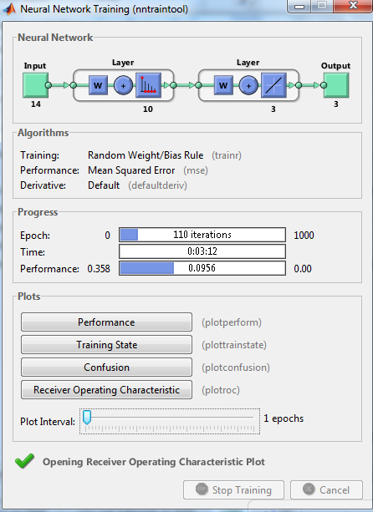
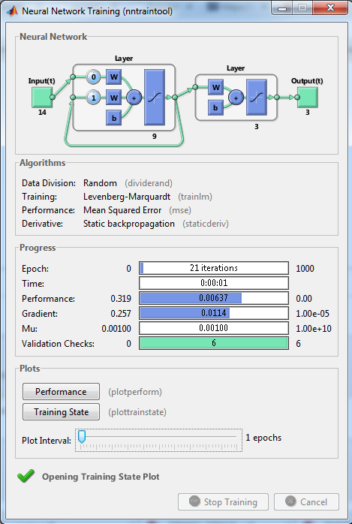
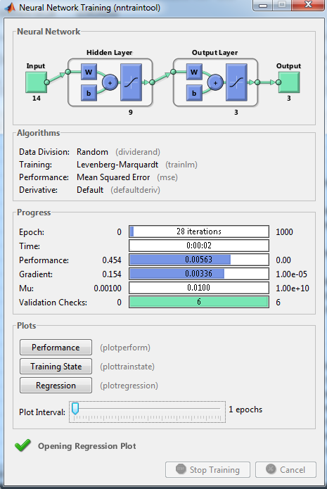

Figure 5. Models Developed by Matlab Program to Classify Human Development Level of Countries
After the training processes were completed for the established ANN models, numerous tests were performed. For Elman ANN and multi-layer ANN models, the following learning algorithm gave the best classification results for human development rate of countries: Levenberg-Marquardt Optimization learning algorithm, "tansig” as the sigmoid transfer function in hidden layers, "purelin" as the transfer function in output layer and "trainline "functions for training of back propagation network. Final ANN models, which provided the best classification results for human development levels are given in Figure 1. Reinforcement learning algorithm was used as the learning algorithm for LVQ networks, LVQ1 weight learning function was used in hidden layers and “purelin” functions were used for output layer. The most appropriate neural network models were selected as 14-1-3 for Elman neural ANN, Multi layer ANN and LVQ network.
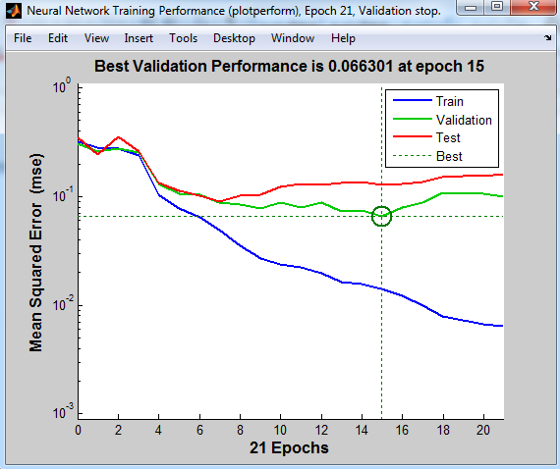
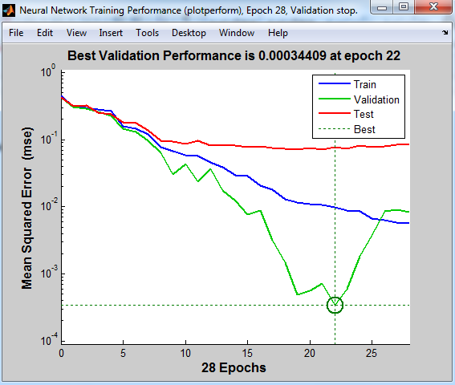
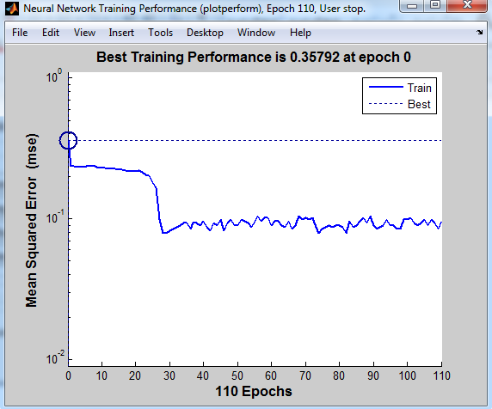

Figure 6. Cycling Performance of ANN Models

Figure 6 shows the cycling performance of ANN models. At the beginning, 1000 iterations were given for the training of the established artificial neural networks and Elman ANN spent 1 second for 21 iterations, multi layer ANN spent 2 seconds for 28 iterations and LVQ network spent 192 seconds for 110 iterations and completed the learning process.

Table 9: Classification Success of Elman ANN Analysis
Elman ANN |  | Estimated Group |  |  |  | Accuracy  Percentage
 |  | Moderate | Developed | Highly  Developed | Total
Observed Group | Moderate | 48 | 5 | 0 | 53 | 90,6
 | Developed | 0 | 74 | 4 | 78 | 94,9
 | Highly  Developed | 2 | 3 | 108 | 113 | 95,6
 | Total | 50 | 82 | 112 | 244 | 94,3

Table 9 shows the results of 244 countries’ human development level classification results by using Elman ANN. Elman ANN analysis of development classification variable showed that 48 of 53 moderately developed countries, 74 of 78 developed countries and 108 of 113 highly developed countries were estimated accurately hence achieving 90.6% success rate for moderately developed countries, 94.9% for developed countries and 95.6% for highly developed countries. Total classification success for all countries is 94.3%.

Table 10: Classification Success of Multi Layer ANN Analysis
Multi Layer ANN |  | Estimated Group |  |  |  | Accuracy  Percentage
 |  | Moderate | Developed | Highly  Developed | Total
Observed Group | Moderate | 53 | 0 | 0 | 53 | 100
 | Developed | 2 | 75 | 1 | 78 | 96,2
 | Highly  Developed | 2 | 2 | 109 | 113 | 96,5
 | Total | 57 | 77 | 110 | 244 | 97,1

Table 10 shows the results of 244 countries’ human development level classification results by using Multi Layer ANN. Multi Layer ANN analysis of development classification variable showed that 53 of 53 moderately developed countries (all of them), 75 of 78 developed countries and 109 of 113 highly developed countries were estimated accurately hence achieving 100% success rate for moderately developed countries, 96.2% for developed countries and 96.5% for highly developed countries. Total classification success for all countries is 97.1%.

Table 11: Classification Success of LVQ Network Analysis
LVQ  Network |  | Estimated Group |  |  |  | Accuracy  Percentage
 |  | Moderate | Developed | Highly  Developed | Total
Observed Group | Moderate | 46 | 7 | 0 | 53 | 86,8
 | Developed | 13 | 62 | 3 | 78 | 79,5
 | Highly  Developed | 4 | 8 | 101 | 113 | 89,4
 | Total | 63 | 77 | 104 | 244 | 85,7

Table 11 shows the results of 244 countries’ human development level classification results by using LVQ network analysis. LVQ network analysis of development classification variable showed that 46 of 53 moderately developed countries, 62 of 78 developed countries and 101 of 113 highly developed countries were estimated accurately hence achieving 86.8% success rate for moderately developed countries, 79.5% for developed countries and 89.4% for highly developed countries. Total classification success for all countries is 85.7%.

CONCLUSION
In this study, human development level of countries were classified by using ordered logistic regression, Elman ANN, multi layer ANN and LVQ network. Multiple classification methods were used to determine the relation between moderately developed, developed and highly developed countries as the dependent variable with ordered variable of 3 categories and 14 independent variables. The data of 81 countries, which has United Nations Development Program’s Human Development Index, between the years of 2010-2012 were used in this study.
In ordered logistic regression analysis among 14 independent variables, it was observed that BÖO “infant mortality rate” and ITH “import” had a statistically significant negative effect while IKS “number of internet users”, IH “export” and SH “health expenses” a statistically significant positive effect. Thus, the most important variable that has a positive effect on human development level was SH “health expenses” variable and the second one was IKS “number of internet users” varible while the most important variable with negative effect was BÖO “infant mortality rate”. Marginal effects for independent variables were calculated. It was observed that one unit increase in the most important variable SH increases the odds of being a highly developed country with regards to human development by 5% while the second most important variable IH increases this odd by 1%. The classification of Turkey, which was classified as a developed country with regards to human development in 2010, 2011 and 2012, was successfully estimated by using ordered logistic regression analysis.
For ANN, which is another classification technique for human development level; Elman ANN, multi layer ANN and LVQ network were used. For classification estimation, there was 1 hidden layer for Elman, Multi layer ANN and LVQ. For Elman ANN and Multi layer ANN, 9 nodes were used in hidden layers, and 10 nodes were used in LVQ network.

Chart 1. Performance Criterion for All Four Methods of Analysis
Chart 1 shows percentage values of all four methods of analysis for moderate, development and high development levels and the overall classification accuracy. Multi Layer ANN analysis had the best performance among all. Its classification success was 100% for moderately developed countries, 96.2% for developed countries and 96.5% for highly developed countries. As a result of comparison of analyses, it’s seen that Muli Layer ANN provides results with a higher accuracy percentage compared to Elman ANN while ordered logistic regression analysis provides results with a higher accuracy compared to LVQ network. In all four methods of analysis, it was proved that Multi Layer ANN had a better performance compared to the other three methods with regards to total classification results of moderately, developed and highly developed countries.

REFERENCES
Adıyaman, F., (2007), Talep Tahmininde Yapay Sinir Ağlarının Kullanılması, (Yayımlanmamış Yüksek Lisans Tezi), İstanbul Teknik Üniversitesi Fen Bilimler Enstitüsü, İstanbul.
Akın, H.B., ve Şentürk, E., (2012), “Bireylerin Mutluluk Düzeylerinin Ordinal Lojistik Regresyon Analizi İle İncelenmesi”, Öneri, C.10, S.37, ss.183-193.
Akkuş, Ö, Türkan, S., Tatlıdil, H., (2010), “Sıralı Bağımlı Değişken Modeli Ve Diskriminant Analizi’nin Ticari Bankaların Mali Performanslarına Göre Sınıflandırılmasında Kullanımı”, Suleyman Demirel University The Journal of Faculty of Economics and Administrative Sciences, Vol.15, No.2, pp:319-332.
Chen, C-K., and Hughes, J. Jr., (2004), “Using Ordinal Regression Model to Analyze Student Satisfaction Questionnaires”, IR Applications,Association for Institutional Research, Volume 1, pp:1-13.
Demirtas E. A., Anagun A.S., Koksal G., (2009), “Determination Of Optimal Product Styles By Ordinal Logistic Regression Versus Conjoint Analysis For Kitchen Faucets”. International Journal of Industrial Ergonomics 39: 866–875.
Elamir, E., ve Sadeq, H., (2010), “Ordınal Regression to Analyze Employees Attitudes Towards The Application of Total Quality Management”, Journal of Applied Quantitative, Vol.5, No.4, pp. 647-658
Elman, J.L., (1990), “Finding structure in time”, Cognitive Science, 14(2), 179-211.
Eren, M., Çelik, A.K., and Kubat, A., (2014), “Determinants of the Levels of Development Based on the Human Development Index: A Comparison of Regression Models for Limited Dependent Variables”, Review of European Studies, Vol. 6, No. 1, pp.10-22.
Fukuda-Parr, S. (2003). “The human development paradigm: Operationalizing Sen’s ideas on capabilities. Feminist Economics”, 9(2-3), 301-317.
Haykin, S., (1999), “Neural Networks: A Comprehensive Foundation”, Prentice Hall Inc, New Jersey.
Ivanova, I., Arcelus F.J. and Srinivasan G., (1999), “An assessment of The Measurement Properties of The Human Development Index”, Social Indicators Research 46: 157-179.
Kohonen, T. (1987), “State of the Art in Neural Computing”, “Int. Conf. on AI”, pp.1-79.
Kohonen, T., (2001), Self-Organizing Maps, Springer Series in Information Sciences, (3rd Edition), New York.
Küçükönder, H., (2011), “Yapay Sinir Ağları ve Tarımda Bir Uygulama”, (Yayımlanmamış Doktora Tezi), Kahranmanmaraş Sütçü İmam Üniversitesi Fen Bilimleri Enstitüsü, Kahramanmaraş.
Liao, T. F. (1994), Interpreting Probability Models, Logit, Probit, and Other Generalized Linear Model, Sage Publications, In Sage University Papers Series. Thousand Oaks, Calif:Sage.
Lind Niels C. (1992), “Some Thoughts on The Human Development Index”, Social Indicators Research 27: 89-101.
Lippman, R. (1987), “An introduction to computing with neural nets”, IEEE ASSP Mag., 4, 4-22.
Long, J. Scott, ve Freese, J. (2001), Regressıon Models For Categorıcal Dependent Varıables Usıng Stata, Texas, A Stata Press Publication.
McCullagh, P. (1980), “Regression Models for Ordinal Data”, Journal of the Royal Statistical Society. Series B (Methodological), Vol. 42, No. 2, pp.109-142.
Morse, S. (2014), “Stirring The Pot. Influence of Changes in Methodology of The Human Development Index on Reporting By The Pres”, Ecological Indicators 45: 245–254.
Öztemel, E., (2003), “Yapay Sinir Ağları”, Papatya Yayıncılık, İstanbul.
Payne, A., & Phillips, N. (2010). Development. Cambridge, UK: Polity Press.
Pissarenko, D., (2002), “Neural Networks For Financial Time Series Prediction: Overwiev Over Recent Research”, http://members.inode.at/d.pissarenko/fyp/Pissarenko2002.pdf
Şen, Z., (2004), Yapay Sinir Ağlarının İlkeleri, Özener Matbacılık, İstanbul.
UNDP, Human Development Report, 1990.
UNDP, Human Development Report, 2010.
UNDP, Human Development Report, 2011.
UNDP, Human Development Report, 2012.
UNDP, Human Development Report, 2014.
Üçdoğruk, Ş., Akın, F., ve Emeç, H., (2001). “Hanehalkı Harcamaların Olasılıklarını Sıralı Regresyon Modeli ile Tahmin Etme”, V. Ulusal Ekonometri ve İstatistik Sempozyumu, Adana. (http://idari.cu.edu.tr/sempozyum/bil13.htm).
Yıldız, B., (2001), “Finansal Başarısızlığın Öngörülmesinde Yapay Sinir Ağı Kullanımı ve Halka Açık Şirketlerde Ampirik Bir Uygulama”, İMKB Dergisi, Sayı:17, s.51-67.

ANNEX-1 Human Development Levels by Countries
Country | Development Level | Country | Development Level | Country | Development Level | Country | Development Level
Germany | Highly Developed | Guatemala | Moderately Developed | Latvia | Developed | Serbia | Developed
USA | Highly Developed | Georgia | Developed | Lithuania | Developed | Slovenia | Highly Developed
Australia | Highly Developed | Croatia | Developed | Luxemburg | Highly Developed | Slovakia | Highly Developed
Austria | Highly Developed | The Netherlands | Highly Developed | Hungary | Highly Developed | Sri Lanka | Moderately Developed
Azerbaijan | Developed | Honduras | Moderately Developed | Macedonia | Developed | Syria | Moderately Developed
Belgium | Highly Developed | England | Highly Developed | Malaysia | Developed | Saudi Arabia | Developed
Bolivia | Moderately Developed | Ireland | Highly Developed | Malta | Highly Developed | Chile | Developed
Bosnia and Herzegovina | Developed | Spain | Highly Developed | Mexico | Developed | Thailand | Moderately Developed
Brazil | Developed | Israel | Highly Developed | Egypt | Moderately Developed | Trinidad and Tobago | Developed
Bulgaria | Developed | Sweden | Highly Developed | Moldova | Moderately Developed | Tunisia | Developed
Algeria | Developed | Switzerland | Highly Developed | Nicaragua | Moderately Developed | Turkey | Developed
Czech Republic | Highly Developed | Italy | Highly Developed | Norway | Highly Developed | Ukraine | Developed
China | Moderately Developed | Iceland | Highly Developed | Pakistan | Moderately Developed | Uruguay | Developed
Denmark | Highly Developed | Jamaica | Developed | Panama | Developed | Jordan | Developed
Dominic Republic | Moderately Developed | Japan | Highly Developed | Paraguay | Moderately Developed | Venezuela | Developed
Ecuador | Moderately Developed | Canada | Highly Developed | Peru | Developed
El Salvador | Moderately Developed | Kazakhstan | Developed | Poland | Highly Developed
Estonia | Highly Developed | Cyprus | Highly Developed | Portugal | Highly Developed
Morocco | Moderately Developed | Kyrgyzstan | Moderately Developed | Romania | Developed
Philippines | Moderately Developed | Colombia | Developed | Russia | Developed
Finland | Highly Developed | Korea | Highly Developed | New Zealand | Highly Developed
France | Highly Developed | Costa Rica | Highly Developed | Greece | Highly Developed

