Water Quality Characterization for Drinking Purposes – A Case Study of Sorang Hydroelectric Power Project in District Kinnaur, Himachal Pradesh, India
Renu Lata¹, Madhuri S.Rishi¹, Dinesh Talwar² and Jyotsna Rikhie²
^{1&2} Department of Environment Studies,
Panjab University, Chandigarh-160014
^{3&4} Department of Chemistry,
DAV College, Sec-10, Chandigarh
Email: renu15_negi@yahoo.co.in

Abstract:
Water is a critical resource for human survival, economic development and ecological balance in nature. Himachal Pradesh is rich in natural resources which are ideally suitable for investment in three major sectors mainly tourism, industries and hydroelectric power. Hydropower inherits a number of advantages over other sources of energy. It plays an important role in enabling communities around the world to meet their power and water needs. The increase in population and the rise in the living standard of the people have put the policy makers and planners in a state where solution of power demand can be matched with the criteria of sustainable development and conservation of natural resource. The present investigation was carried out to examine the effects of the construction of Sorang hydroelectric power project, if any, on the suitability of surface water quality for drinking purpose. The physico-chemical parameters like temperature, pH, electrical conductivity, turbidity, total dissolved solids, bio-chemical oxygen demand, chemical oxygen demand, hardness, alkalinity, nitrates, fluorides, chlorides were analyzed to meet the objective of study. The results revealed that in general, the present status of water quality is suitable for drinking purposes except for a large variation in the temperature of surface water as well as groundwater samples analyzed in pre and post monsoon seasons.This factor needs to be examined seriously as it may affect the native aquatic fauna and flora. The turbidity in most of the surface water sample analyzed was near the desirable limit as prescribed by BIS [1], (i.e 5 NTU) which can also be a cause of concern for the aquatic species and hence overall aquatic ecosystem.
Key Words: Drinking water, Hydro-power project, Sustainable Development, Turbidity, Temperature, Aquatic ecosystem.

1. Introduction:

None of the earth’s resources are more versatile, vital and abundant than water. It is essential to all forms of life and makes up 50-97% of the weight of all plants and animals and about 70% of human body. It is a fundamental force in ecological life-support systems on which sustainable, social and economic development depends. The rivers and water resources have greater significance not only in the history of Indian civilization but in the civilizations of many countries of the globe since ages.
It is the most beautiful and precious gift of nature without which no life could survive on earth [2], [3]. Water takes many different shapes on earth and to study water a new science was evolved named as “Hydrology” which is the science to know the properties, distribution and behavior of water in nature [4]. Among the various needs of water, the most essential need is drinking. Surface water and ground water are two major sources for the supply of drinking water. Surface water comes from lakes, reservoirs and rivers. Groundwater comes from wells that the water supplier drills into aquifers. Maintaining the quality of water is the most important one for human being since it is directly linked with his daily life. With the passage of time, in search of better living conditions man has exploited this natural resource through electricity generation to greater extent. Particularly, in 21st century it has become the corner stone of society on which modern society stands. Thus, proper and managed study of water, especially freshwater is essential to understand the relationship and interdependence of various constituents of any habitat.

2. Description of the Study Area:
Kinnaur, located on the Indo-Tibetan border, is very scenic; and is surrounded by the Tibet on the east, Garhwal Himalaya on south, Spiti Valley on the north and Kullu on the west. It lies between North latitude 31º35’40” to 31º34’42” and East longitude 77º52’38” to 78º51’28”. Kinnaur is about 235 kilometers from Shimla.
The Sorang Hydroelectric Power Project (SHEP) is located on Sorang Khad a tributary of river Satluj near the village Nigulsari, which is about 170 kilometers from Shimla, the State Capital of Himachal Pradesh. Sorang Khad is on right bank of river Satluj, opposite village Nigulsari that falls along NH-22 and it originates at an altitude of 5625 meters in the high reaches of Kokshane Mountain in the Himalayas (Fig. 1.). The powerhouse will be fitted with a ventilation tunnel. From the powerhouse, the water will be discharged back into Satluj River, via a tail race tunnel. It will enter the Satluj River immediately downstream of the power house site. The voltage of the electricity generated at the generator terminals will be 11KW which will be stepped up to 220KW at the switchyard of the powerhouse [5]. The switchyard will be located above ground. The electricity will be exported to the grid via an 18km double circuit transmission line from SHEP to HPSEB’s Kotla Sub-station

.

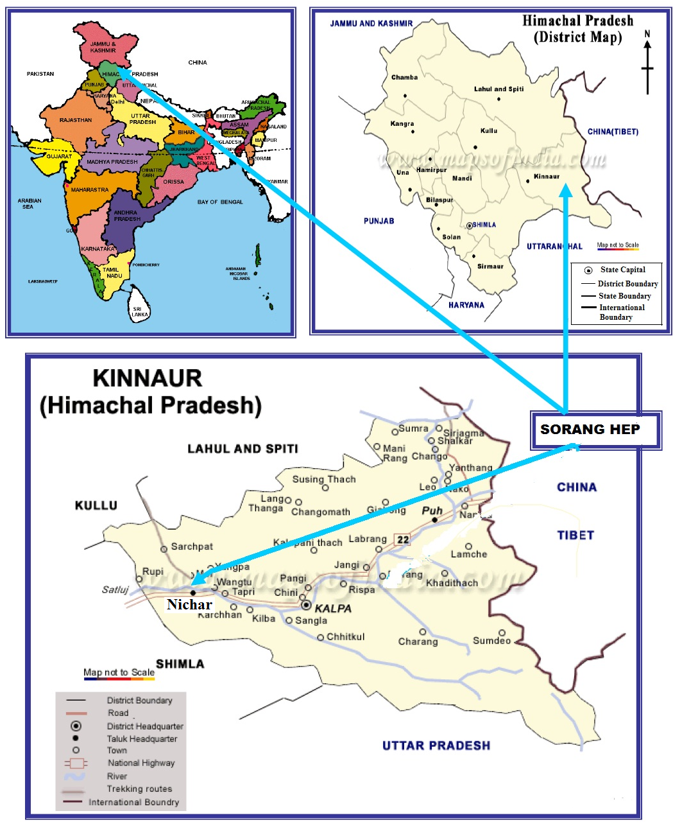
Fig.1: Map showing location of the study area, District Kinnaur

3. Geology of the Area:

In the regional overview, Kinnaur district occupies a position as harbinger between the Kumaon and Punjab Himalaya with Satluj river forming the divide [6]. Most of the area studied is composed of low and high grade metasediments presumably belonging to middle Haimanta group of rock formation and of Precambrian age and are characterized by a variety of rock type such as metapsummites, calcareous rocks and metapelites. The geological succession in the district is given in Table 1.

Table 1: Geological Succession in Kinnaur
Age / Period | Group / formation | Lithology
Quaternary | Alluvium, Terrace and Fluvial deposits | Alluvium, clay, sand, gravel, pebble, boulder and cobble.
Tertiary | Nako Granitoid | Granitoid
Mesozoic | Giumal – Chikkim Spiti formation,  Lilang Group | Shale, Sandstone, Siltstone  Carbonate rich sedimentary rocks
Palaeozoic | Kuling Group Kunzamla, Thango, Takche formation. | Sandstone, shale, conglomerate
Proterozoic | Batal formation Salkhala, Kulu, Jutogh.  Vaikrita, Rampur Group, Bandal Wangtu Gneissic Complex | Slate, phyllite, quartzite and schist, Amphibolite, Gneisses, granite, Pegmatite.
Regional stratigraphy
P | Jutogh Group | Amphibolite, Kyanite bearing feldspathic gneiss, quartzite and quartzitic gneiss
R | Jutogh Group
E | Jutogh Group
C | …………………………. Thrust…………………………..
A | Rampur Group (Manikaran  Quartzite | Massive quartzite and bedded quartzite
M | Rampur Group (Manikaran  Quartzite | Massive quartzite and bedded quartzite
B | Rampur Group (Manikaran  Quartzite | Massive quartzite and bedded quartzite
R | Jeori-Wangtu Gneissic  Complex | Amphibolite, apalite, granite, porphyritic granite and feldspathic gneiss, politic gneiss with minor quartzite and schist.
I | Jeori-Wangtu Gneissic  Complex
A | Jeori-Wangtu Gneissic  Complex
N | Jeori-Wangtu Gneissic  Complex
Source: GSI, [7)

Rocks found in the study area are mainly granite, slates, schists, gneisses, phyllite, quartzite and limestone. Study area is rich in minerals like copper, pyrite, mica and silver [8].

4. Literature Review:

- Okonkwo and Ezeonu [9] carried out the study on Design and Installation of a Mini Hydroelectric Power Plant. They stated that their work was the practical implementation of the theory of hydroelectric power generation, which considers the design and installation of mini HEP.
- A Socio-Economic Impact of a Micro-Hydroelectric Power Plant on Rural Livelihoods in Nepal was studied by Gurung, et al.[10] Their study found that a micro-hydroelectric power plant (MHP) had a significant impact on the consumption of firewood in rural households. It was revealed that children have lesser propensity to go for wood collection once their homes have been connected to the MHP. Similarly, modern electric lights in the households allow more time for students to conduct their study during night time. Thus, the MHP has positive impact on socio-economic conditions of the rural communities.
- Lata, et al. [5] studied the Socio-economic Impacts of Sorang Hydroelectric Power Project in District Kinnaur, Himachal Pradesh, India. They stated that the interests of locals must be listened to and taken care of during the planning of the projects. The policy makers must adopt a model or strategies so that the impacts and effects of such type of developmental activities on local people who are living in the vicinity as well as who have sacrificed their belongings can be minimized.
Agrawal, et al.[11] recognized that in the Himalayan region which is important from the conservation point of view, project-specific Environmental Impact Assessment studies are probably insufficient to tackle the environmental issues that are likely to result on account of the proposed HEP’s. They concluded that the Environmental Assessment at region-wise planning/policy level instead of project level approach can serve the purpose of environmental sustainability in the Indian Himalayan Region (IHR).

5. Methodology:
A total of 30 surface water samples were collected from the different locations from Sutlej, Sorang Khad and its main tributaries joining the river and from drinking water supply sources in the adjoining villages and were subjected to chemical analysis (Fig. 2.). The samples were stored in clean plastic bottles with screw caps. Prior to sample collection, all the plastic bottles were thoroughly washed and sun-dried and before sample collection the plastic bottles were rinsed twice with the same collected water samples. The bottles were then labeled and the co-ordinates of the sampling sites were duly noted. Parameters like Temperature, pH, EC and TDS were analyzed on the spot using potable water and soil analysis kit. For the analysis of other parameters, the bottles were taken to the laboratory and stored at 4ºC. For the assessment of BOD and COD samples were collected in glass bottles and taken to the laboratory within 24 hours. The water samples were analyzed in the geochemical laboratory of the Department of Geology and Water Resources Department, Chandigarh according to the standard methodology given by American Public Health Association [12], Trivedy and Goel [13] and Central Pollution Control Board, New Delhi [14].Different software like Mapinfo 6.5, Minitab 16 and Rockwares 15.0 were used to compute the data and make graphical presentations

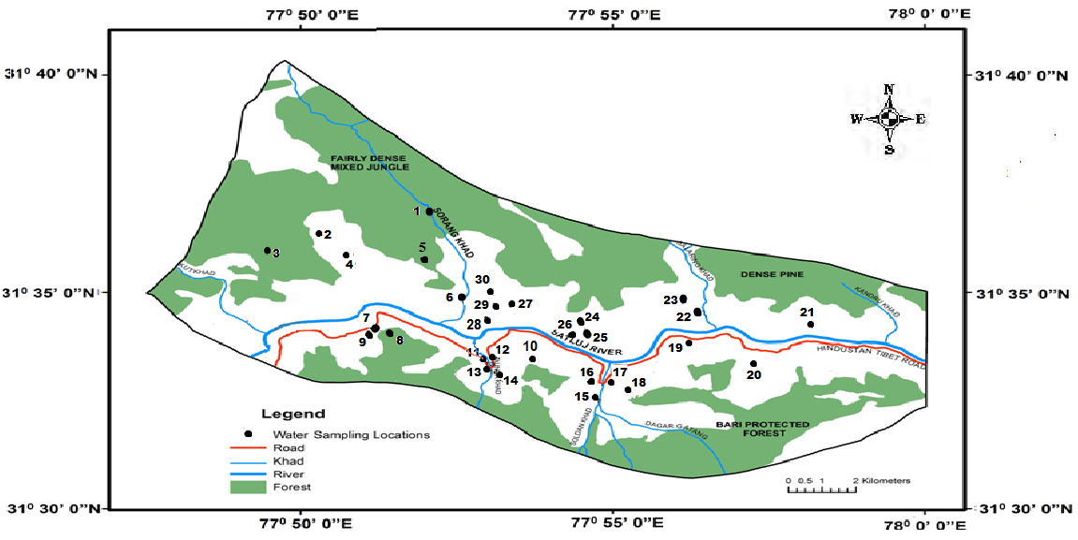 Fig. 2: Location Map of Water Sampling Stations in the Study Area

6. Results and Discussions:
Physico-chemical analysis of water samples collected from different locations around the SHEP was analyzed and the distribution of water samples showing various Parameters against maximum permissible and desirable limits are shown in Table 2 The salient features of the major ion chemistry of the area are as follows.

Table 2: Distribution of Water Samples Showing Various Parameters against Maximum Permissible and Desirable limits.

S. No. | Parameter | Max. permissible limit for drinking water | Desirable limit for drinking water | No. of water samples analyzed | No. of Samples above
 |  |  |  |  | *DL | *PL
1 | EC | 0-2000 µS/cm | 750 µS/cm | 30 | Nil | Nil
2 | TDS | 2000 mg/l | 500 mg/l | 30 | Nil | Nil
3 | Turbidity | 10 NTU | 5 NTU | 30 | Nil | Nil
4 | pH | No relaxation | 6.5-8.5 | 30 | Nil | Nil
5 | Ca²⁺ | 200 mg/l | 75 mg/l | 30 | Nil | Nil
6 | Mg²⁺ | 100 mg/l | 30 mg/l | 30 | Nil | Nil
7 | Na⁺ | No guidelines |  | 30 | - | -
8 | K⁺ | No guidelines |  | 30 | - | -
9 | Cl⁻ | 1000 mg/l | 250mg/l | 30 | Nil | Nil
10 | F⁻ | 1.5 mg/l | 1 mg/l | 30 | 3 | Nil
11 | SO₄²⁻ | 400 mg/l | 200 mg/l | 30 | Nil | Nil
12 | NO₃⁻ | No relaxation | 45mg/l | 30 | Nil | Nil
13 | DO | 6 mg/l | - | 30 | Nil | Nil
14 | COD | No guidelines | - | 30 | - | -
15 | BOD | 2 mg/l | - | 30 | Nil | Nil
*DL- Desirable Limit
*PL- Permissible Limit

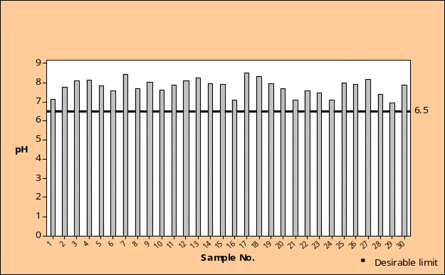  a) Distribution of pH in Water Samples | 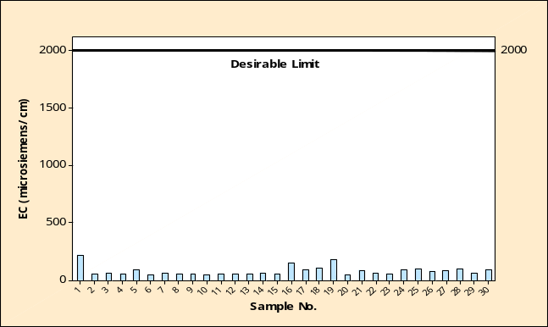  b) Distribution of EC in Water Samples
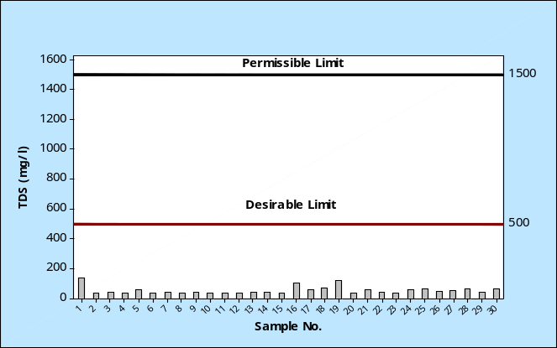  c) Distribution of TDS in Water Samples | 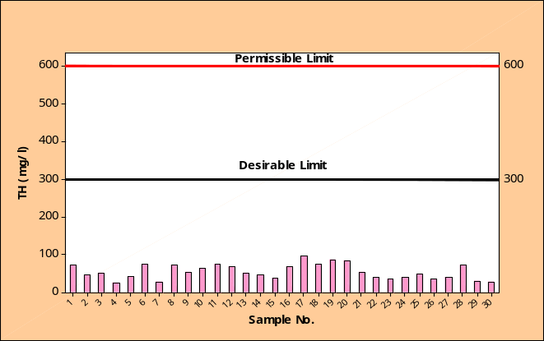  d) Distribution of TH in Water Samples
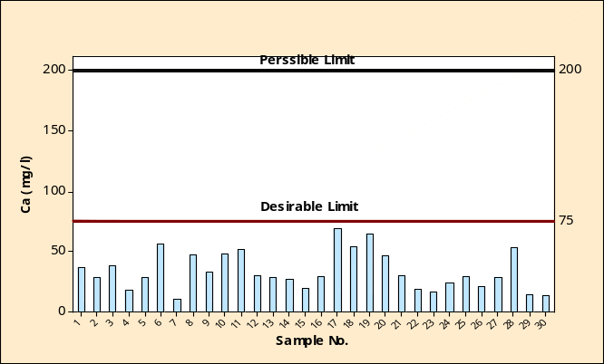  e) Distribution of Ca ²⁺ in Water Samples | 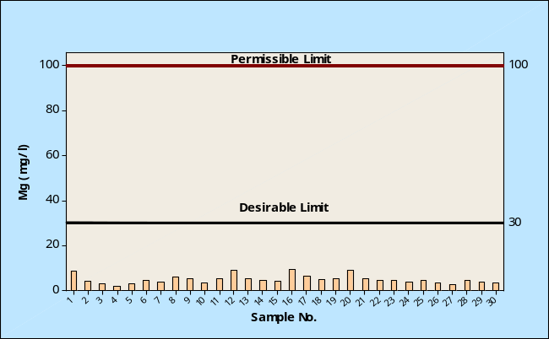  f) Distribution of Mg²⁺ in Water Samples
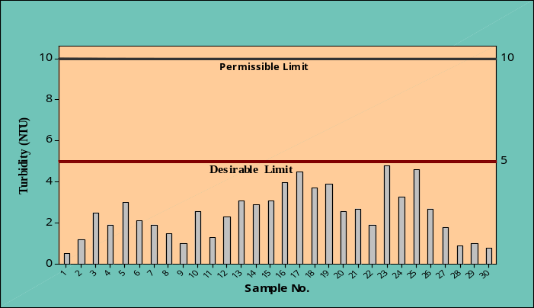  g) Distribution of Turbidity in Water Samples | 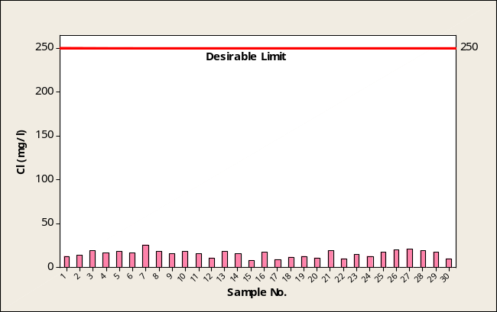  h) Distribution of Cl⁻ in Water Samples
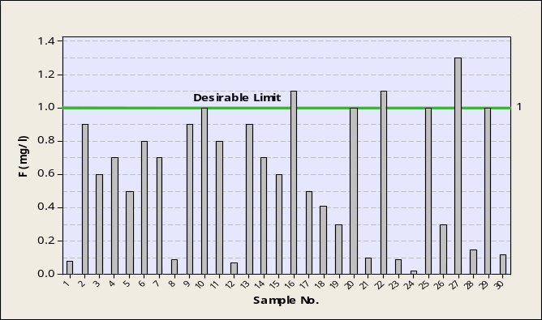  i) Distribution of F⁻ in Water Samples | 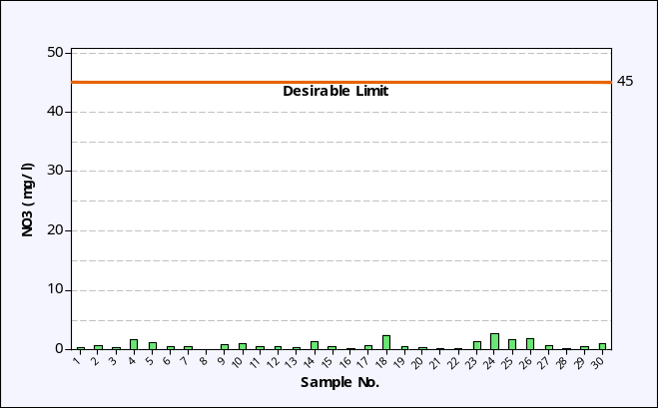  j) Distribution of NO₃ ²⁻ in Water Samples
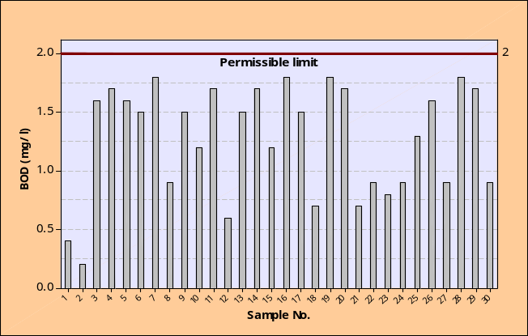  k) Distribution of BOD in Water Samples | 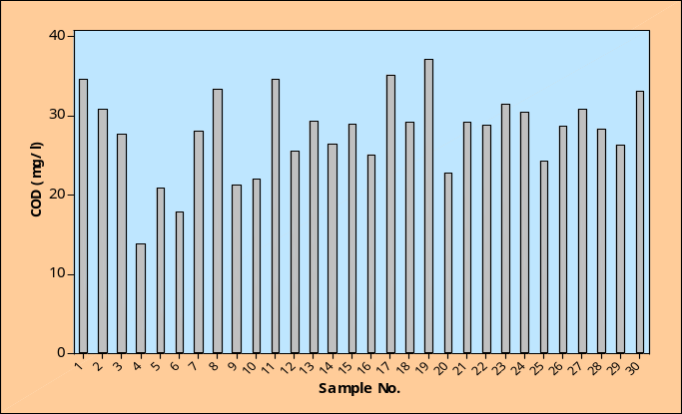  l) Distribution of COD in Water Samples
Fig. 3: Distribution of Various Parameters in the Analysed Water Samples in the Study Area

Temperature (⁰C):
Temperature is highly variable both in space and time. Temperature of the water samples was taken on the spot with the help of mercury thermometer. The temperature of water samples recorded in the field ranged between 17⁰C to 34⁰C during pre monsoon and between 10⁰C to 23⁰C during post monsoon season.

pH and Electrical Conductivity (EC):
The pH (hydrogen ion concentration) of water is very important indicator of its quality as it depends on the presence of phosphates, silicates, borates, fluorides and some other salts in dissociated form [15]. In general waters having pH between 6.5 and 8.5 are categorized as suitable, whereas waters with pH 7.0 to 8.0 are highly suitable for all purposes.
The pH value of the surface water of the study area during pre monsoon varies from 6.98 to 8.53 with mean value of 7.81 and varied from 7.00 to 8.50 with mean value of 7.76 during post monsoon which indicated that water is slightly alkaline in nature but suitable for domestic purposes [16]. Electrical conductivity of water is also an important parameter for determining the water quality. It is a measurement of water’s capacity for carrying electrical current and is directly related to the concentration of ionized substance in the water. In the present study, EC values of surface water ranged between 52.89µmhos/cm to 219µmhos/cm with mean value of 84.86µmhos/cm in pre monsoon and between 51.89µmhos/cm to 218µmhos/cm with mean value of 85.21µmhos/cm during post monsoon. Distribution of pH and EC in samples is shown in Fig. 3. (a &b).
Total Dissolved Solids (TDS):
Total dissolved salt concentrations is the primary indicator of the total mineral content in water and are related to problems such as excessive hardness. Total dissolved solids in the water samples of the study area varied from 34.37 mg/l to 142.35 mg/l with mean value of 52.25 mg/l during pre monsoon. During post monsoon, the value of TDS varied from 34.44 mg/l to 141.70 mg/l with mean value of 55.49 mg/l. The distribution of TDS in the surface water samples of the study area is depicted in Fig.1.3 (c).

Total Hardness (TH) :
It results from the presence of divalent metallic cations of which calcium and magnesium are the most abundant. The concentration of total hardness in the water of the study area varied from 26 mg/l to 96 mg/l with mean value of 55.03mg/l during pre monsoon and from 28 mg/l to 94 mg/l with mean value of 54.9mg/l during post monsoon. Fig.1.3 (d) shows the distribution of TH in the water samples of the study area.
Calcium (Ca²⁺) and Magnesium (Mg²⁺):
The amount of calcium in the surface water of the study area varied from 11.20 mg/l to 69.40 mg/l with mean value of 34.16 mg/l during pre monsoon and between 12.20 mg/l to 69.50 mg/l with mean value of 34.17 mg/l during post monsoon. Magnesium concentration in the surface water is generally less than calcium due to the slow dissolution of magnesium bearing minerals and greater abundance of calcium in earth crust. Magnesium concentration in the surface water of the study area ranged between 2.00 mg/l to 9.36 mg/l with mean value of 5.08 during pre monsoon and between 2.75mg/l to 9.19mg/l with mean value of 5.05 mg/l during post monsoon. Fig. 3. (e & f) indicates that the water of the study area were well within the permissible limits of calcium and magnesium thus, it is safe for drinking purposes.
Turbidity:
Turbidity refers to how clear the water is. It is a measure of the degree to which water loses its transparency due to the presence of suspended particulates. More the total suspended solids in the water, murkier it seems and the higher the turbidity. It is considered as a good measure of the quality of water. Turbidity in the water samples of the study area varied from 0.5 NTU to 4.8 NTU with mean value of 2.47 NTU during pre monsoon. During post monsoon, the value of turbidity varied from 0.7 NTU to 4.3 NTU with mean value of 2.22 NTU. All the samples analyzed were within desirable limit of 5 NTU (BIS, 1991) and are fit for human consumption. The distribution of turbidity at different sampling locations is shown in Figure 3. (g).

Chloride (Cl ⁻) and Fluoride (F⁻):
Chloride (Cl⁻) in drinking water is not generally harmful to human beings until high concentration is present. The chloride ion in the surface water of the study area in pre monsoon season varied between 8.40 mg/l to 25.50 mg/l with mean value of 15.71 mg/l. In post monsoon season, it varied between 8.30 mg/l to 25.30 mg/l with mean value of 15.73 mg/l. Fig. 3. (h) clearly indicates that all the water samples of the study area were within the desirable limit and hence fit for consumption. Fluoride (F⁻) is essential in trace amounts for all human beings and is one of the normal constituents of all diets. The desirable limit of fluoride in drinking water is 1 mg/l [1], Mckee and Wolf [17]. Fluoride concentrations in all the water samples were found to be within the permissible limit of 1.5 mg/l Fig. 3. (i). In pre monsoon season the fluoride concentration of surface water varied between 0.02 mg/l to 1.30 mg/l with mean value of 0.59 mg/l. In post monsoon season the concentration of fluoride varied between 0.04 mg/l to 1.30 mg/l with mean value of 0.62 mg/l. Only three samples crossed the desirable limit of 1.0 mg/l.
Nitrates (NO₃⁻ ):
Excess of nitrates consumed by humans particularly infants is likely to cause health hazards and may lead to Methaemoglobinemia (Blue baby) disease. The distribution of nitrate in water samples are shown in Fig. 3. (j). The nitrate content of water samples in the study area varied from 0.09 mg/l to 2.60 mg/l with mean value of 0.89 mg/l during pre monsoon and between 0.07 mg/l to 2.80 mg/l with mean value of 0.93 during post monsoon.

Biochemical Oxygen Demand (BOD) and Chemical Oxygen Demand (COD):
The BOD and COD for the water samples around the Sorang HEP were carried out. In pre monsoon season the BOD concentration varied between 0.2 mg/l to 1.8 mg/l with mean value of 1.27 mg/l in water samples. In post monsoon season the concentration of BOD varied between 0.4 mg/l to 1.8 mg/l with mean value of 1.24 mg/l. In pre monsoon season the COD concentration of water samples varied between 13.8 mg/l to 37.1 mg/l with mean value of 27.9 mg/l. In post monsoon season the concentration of COD varied between 13.4 mg/l to 37.3 mg/l with mean value of 27.9 mg/l. The BOD values of the study area were well within the permissible limit of 2mg/l (BIS, 1991), which indicate the absence of organic pollution loading. This is mainly due to the low population density and absence of industries in the area. As no standard have been prescribed by any agency, it is not possible to assess the suitability of water for drinking purposes with respect to COD. The distribution of BOD and COD in the study area is shown in Fig. 3 (k & l).

Table 3: Correlation matrix for the surface water samples
 | pH | EC | TDS | TH | Ca²⁺ | Mg²⁺ | Na⁺ | K⁺ | CO₃ ²⁻ | HCO3⁻ | Cl⁻ | F⁻ | NO3⁻ | SO4²⁻ | DO | COD | BOD
pH | 1
EC | -0.264 | 1
TDS | -0.258 | 1.000 | 1
TH | 0.040 | 0.325 | 0.332 | 1
Ca²⁺ | 0.150 | 0.233 | 0.240 | 0.932 | 1
Mg²⁺ | -0.207 | 0.361 | 0.364 | 0.656 | 0.337 | 1
Na⁺ | -0.110 | 0.091 | 0.095 | 0.302 | 0.346 | 0.060 | 1
K⁺ | 0.072 | 0.107 | 0.114 | 0.231 | 0.194 | 0.205 | 0.093 | 1
CO₃ ²⁻ | 0.146 | -0.039 | -0.027 | 0.146 | 0.146 | 0.077 | 0.091 | 0.267 | 1
HCO₃⁻ | 0.030 | -0.287 | -0.292 | -0.106 | -0.064 | -0.144 | 0.019 | 0.069 | -0.367 | 1
Cl⁻ | 0.006 | -0.126 | -0.131 | -0.270 | -0.174 | -0.342 | -0.016 | -0.238 | -0.396 | 0.279 | 1
F⁻ | 0.161 | -0.275 | -0.276 | -0.108 | -0.077 | -0.120 | -0.168 | -0.086 | 0.158 | 0.036 | 0.197 | 1
NO₃⁻ | 0.165 | -0.056 | -0.057 | -0.297 | -0.173 | -0.404 | 0.023 | 0.000 | -0.213 | 0.141 | -0.043 | -0.238 | 1
SO4²⁻ | 0.297 | -0.033 | -0.024 | 0.295 | 0.199 | 0.348 | -0.147 | 0.323 | 0.199 | -0.295 | -0.106 | 0.234 | -0.119 | 1
DO | 0.230 | 0.038 | 0.038 | 0.100 | 0.149 | -0.042 | 0.189 | -0.001 | 0.072 | 0.170 | 0.051 | 0.036 | 0.165 | -0.058 | 1
COD | -0.186 | 0.435 | 0.438 | 0.225 | 0.104 | 0.366 | -0.079 | 0.255 | 0.270 | -0.339 | -0.539 | -0.313 | -0.090 | 0.131 | -0.232 | 1
BOD | 0.181 | 0.126 | 0.131 | 0.274 | 0.313 | 0.058 | 0.292 | 0.470 | 0.325 | -0.194 | -0.098 | 0.111 | -0.227 | 0.340 | 0.069 | 0.177 | 1

7. Correlation Matrix (CM):
The correlation coefficient matrices defined the inter-relationships of various chemical constituents for the analyse parameters in determining the overall hydrochemistry of the water. The correlation coefficients (r) among various quality parameters were calculated and the values are presented in the table 3. During the period of investigation, the correlations of select constituents in the water samples exhibit excellent positive correlation coefficient (r > 0.9) between TDS & EC, TH , Ca²⁺& Mg²⁺, due to conductivity dependent on the total dissolved solids, the main constituent of total dissolved solids in the samples are Ca²⁺, Mg²⁺ and other ions causing hardness in the water samples. High EC in the water is due to the high solubility of calcium and magnesium and high total hardness is due to electrical conductivity which depends on total dissolved solids.

8. Hydrochemical Facies of Surface Water:
The hydrochemical facies of a particular place are influenced by geology of the area and distribution of facies by the hydro-geological controls. In the present study, the water sample of the study area has been classified as per Chadha’s diagram given by Chadha [18]. The diagram is a modified version of Piper trilinear diagram [19] and the expanded Durov diagram [20].
The chemical analyses data of all the water samples collected from the study area have been plotted on Chadha’s diagram (Fig.4.) and results have been summarized in Table 4. . It is evident from the results that the water samples collected from the study area fall in Group 1 (Ca²⁺- Mg²⁺-Na⁺- K⁺), Group 5 (Ca²⁺-Mg²⁺- HCO₃⁻) and Group 6 (Ca²⁺- Mg²⁺- Cl⁻-SO₄²⁻) type. However majority of the surface water sample fall in Group 5 (Ca²⁺-Mg²⁺- HCO₃⁻) which means alkaline earths and weak acidic anions exceed both alkali metals and strong acidic anions, respectively. Such waters have temporary hardness.

Table 4: Summarized Results of Chadha’s Classification
Classification/ Type | Surface water
Group 1 (Ca²⁺- Mg²⁺-Na⁺- K⁺) | 3
Group 2 (Na⁺- K⁺- Ca²⁺- Mg²⁺) | --------
Group 3 (HCO₃⁻- Cl⁻-SO₄²⁻) | ---------
Group 4 (SO₄²⁻⁻ - HCO₃⁻-Cl⁻) | ---------
Group 5 (Ca²⁺- Mg²⁺- HCO⁻) | 25
Group 6 (Ca²⁺- Mg²⁺- Cl⁻-SO₄²⁻) | 2
Group 7 (Na⁺- K⁺- Cl⁻-SO₄²⁻) | ----------
Group 8 (Na⁺- K⁺- HCO⁻) | ----------
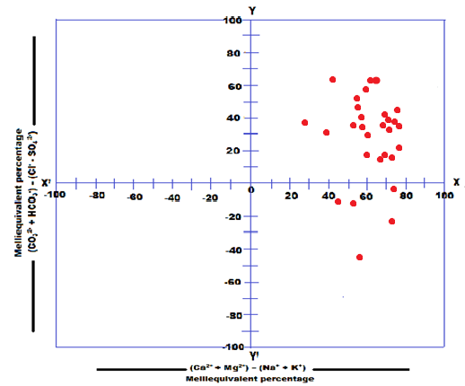
Fig. 4: Chadha’s Diagram for Analysed Water Samples in the Study Area

9. Conclusion:
A detailed study of water quality in the study area revealed that the apart from domestic sources, there were no other major sources of pollution observed in the project area. The most peculiar and noticeable factor was highly variable temperature, both in space and time. The temperature of surface water was recorded between 17⁰C to 34⁰C in pre-monsoon and 10⁰C to 29⁰C in post-monsoon seasons respectively. The substantial decrease in temperature may be attributed to the addition of snow melt in the post monsoon season. This factor should be examined seriously as it may affect the native aquatic species and hence overall surface water system. Also the turbidity of most of the surface water sample analyzed was near 5 NTU i.e. the desirable limit as prescribed by BIS [1] which can also be a cause of concern for the aquatic fauna and flora. The effect on surface water flow regime like river/ streams thereby imposes a great threat on the aquatic species in addition to affecting the vegetation and the overall lifestyles of the area which is dependent on the particular stream i.e. Sorang Khad in the present case. Therefore, it is concluded that the water quality in the study area in general, can be designated as good for domestic purposes, but enforcement of precautionary and preventive approaches instead of end in pipe solutions should be taken into consideration to avoid further contamination, degradation and overexploitation of surface water.

References:
[1] Bureau of Indian Standard “Indian Standard Specification for Drinking Water IS: 10500”, Indian Standard Institute, New Delhi, 1 – 31 (1991).

[2] S.S. Dara, In: A Textbook of Environmental Chemistry and Pollution Control, S. Chand Publication, New Delhi, 64-69, (1998).
[3] A. Kumar and G. Tripathi, In: Water Pollution Assessment and Management, Daya publication, New Delhi, 1p, (2000).
[4] G.M. Fair and J.C. Geyer, In: Elements of Water Supply and Wastewater Disposal, John Wiley Publication, USA, 1p, (1958).
[5] R. Lata, M. S. Rishi, N. Kochhar, and R. Sharma, Socio-economic impacts of Sorang hydroelectric power project in District Kinnaur, Himachal Pradesh, India. Journal of Environment and Earth Science, 3 (3): 54-61, (2013).
[6] U.K. Bassi, Final Report on the Geology of the Kinnaur District, Himachal Pradesh, Unpub. , GSI Compilation, 2-4, (1988).
[7] Geological Survey of India, Geology of Spiti-Kinnaur, Himachal Himalaya: Memoirs of the Geological Survey of India, 124: 1-210, (1998).
[8] S.V. Srikantia and O. N. Bhargava, Geology of Himachal Pradesh, Geological Society of India, Bangalore, 406 p, (1998).
[9] G.N. Okonkwo and S.O. Ezeonu, Design and Installation of a Mini Hydro Electric Power Plant, Scholarly Journal of Engineering Research, 1(1): 19-24, (2012).
[10] A. Gurung, I. Bryceson, J. H. Joo and S. E. Oh, Socio-Economic Impacts of a Micro-Hydropower Plant on Rural Livelihoods in Nepal, Scientific Research and Essays, 6(19): 3964-3972, (2011).
[11] D. K . Agrawal, M. S. Lodhi and S. Panwar, Are EIA Studies Sufficient for Projected Hydropower Development in the Indian Himalayan Region? Current Science, 98(2): 154-161, (2010).
[12] American Public Health Association, “Standard Methods for the Examination of Water and Waste Water”, American Public Health Association, 19th ed. 1015 Fifteenth Street N.W, (1998).
[13] R.A. Trivedi and P.K. Goel, “Chemical and sBiological Methods for Water Pollution Studies”, Environmental Publications, pp. 247, (1986).
[14] Central Pollution Control Board, “Pollution Control Acts, Rules, and Notifications“, 4th ed., New Delhi: Central Pollution Control Board, Ministry of Environment and Forests, Government of India, (2001).
[15] V.S. Prasad and S.K. Ayer, Drinking Water Quality Aspects in Science Reporter, March Issue, 149 p, (1983).
[16] R.K. Herojeet, M. S. Rishi and Neelam S, Hydrochemical Characterization, Classification and Evaluation of Groundwater Regime in Sirsa Watershed, Nalagarh Valley, Himachal Pradesh, India, Civil and Environmental Research, 3(7): 47-57, (2013).
[17] J.E. Mckee and H.W. Wolf, Water Quality Criteria, California State Water Quality Control Board Publication 3A, 568 p, (1963).
[18] D.K. Chadha, A Proposed new Diagram for Geochemical Classification of Natural Waters and Interpretation of Chemical Data, Hydrogeology Journal, 7(5): 431-439, (1999).
[19] A. M. Piper, A Graphical Procedure in the Geochemical Interpretation of Water Analysis, Trans. Am. Geophysical Union, 25: 914-923, (1944).
[20] S.A. Durov, Natural Waters and Graphic Representation of their Composition Dokl, Akad, Nauk SSSR, 59: 87-90, (1948).

