**FEASIBLE EXTRACTION METHOD AND NUMERICAL MODELLING OF THE UPPER OREBODY OF THE NCHANGA MINE**

Eugie Kabwe

Department of Mining Engineering, School of Mines, University of Zambia, 32379 Lusaka, Zambia

(*Corresponding author: [kabweeugie@yahoo.com](mailto:kabweeugie@yahoo.com))

**Abstract**

The Analytic Hierarchy Process used reciprocal pairwise matrix, pairwise comparison and eigenvectors, accurately defined the viable mining method. The results from the model was sublevel caving with the highest score (1.320) and max-min bellman and Zadeh optimal solution as the most preferred. Extraction process of simulation and stability analysis was done using RS3 to inspect stress redistribution and hangingwall failure mechanisms by elastic and elasto-plastic model runs, from drift excavations to initial sublevel caving. The stages and the sequence of mining done, resulted in the preliminary mine design of the orebody.

**Keywords:** AHP; Numerical simulation; RS3; Stress; Nchanga

**Background**

Nchanga mine is located in Chingola town on the Zambian Copperbelt, it’s about 30Km south of Congo DR border. The Upper orebody (UOB) is one of three superimposed stratiform orebodies at Nchanga. Others are the Lower orebody (LOB) and the Intermediate orebody (IOB) [1]. Generally, all the three orebodies have been mined from the Nchanga Open Pit, source of production from the underground mine has been the LOB for nearly 60 years. Production of the LOB is now approaching the fringe areas where both thickness and grades are reducing and the orebody will entirely be exhausted in the next few years. The UOB will thereafter become the mainstay of future mining at Nchanga underground and extend the life of the mine to about 2027. The mine currently extracts the LOB using a non-mechanized, inclined block caving system. Parts of the UOB have been mined previously, but mining ceased in 1979 and the areas previously mined have now been undercut, from the bottom of the LOB to surface, at a dip of 55°. West of the main LOB mining area, the UOB overlies a thin and weakly mineralized part of the LOB that has not been mined. This portion of the UOB lies outside the cave zone, and contains significant resources of copper and cobalt [2]. The tonnage and grade of ore produced from the LOB have steadily declined over recent years, in line with the steady depletion of the thicker, higher grade areas of the deposit. Progressively replacing production from the LOB with production from the UOB is the only option. The UOB generally overlies the LOB, and a significant part of the original UOB resource has been undercut by the block caving operation. The objectives were to;

* Determine the feasible mining method by MADM/AHP.
* Investigate stress redistribution and hangingwall failure mechanisms through an elastic and elasto-plastic model run using RS3.
* Simulate the extraction process and sequence of mining from drift excavation up to ore caving using finite element method RS3.

**Geology**

Nchanga Mine is located on the southern extremity of the Nchanga Main Syncline. The syncline is irregular, dipping to the northwest with a 20 $°$ to 30 $°$ gently plunging South Limb and a steep upturned North Limb (Figure 1). The rocks are mostly the Achean Basement Composite comprising of granites, gneisses and schists and the Late Precambrian Katanga System, this is a sedimentary series containing arenites, siltstones, dolomites, quartzites and limestones [1-6]. The main orebodies include the LOB held in argillaceous shale locally identified as the Lower Banded Shale (LBS) and the UOB lies in the feldspathic Quartzite (TFQ), the LOB is extracted from the underground mine. Towards the eastern part of the syncline the rocks are nearer to the surface and excavation is done from the Open Pit where primarily the UOB is mined [7]. Both the upper and lower orebodies at Nchanga are of the Lower Roan Group [8]. The Lower Banded Shale (LBS) hosts the LOB, which is extracted from footwall drives in the Arkose and by raises extending to the orebody contact. Haulage and access development is generally positioned in the Nchanga Red Granite (NRG), which forms the Basement of the Lower Roan Group at Nchanga. Mining excavations in both the Granite and Arkose generally require little ground support. The LBS is overlain by the very weak, semi-coherent to friable Banded Sandstones (BSS), which comprise of two banded sandstone horizons separated by a shale marker and pink quartzite [9]. The Feldspathic Quartzite (TFQ), followed by the Upper Banded Shale (UBS) and the Dolomitic Schist (Dol-Schist), overly the BSS [10]. The UOB is pre-dominantly associated with the TFQ and the lower part of the UBS formation. The TFQ, although moderately competent, has been subjected to significant folding and is heavily jointed. The UBS is considerably weaker than the TFQ, while the Dol-Schist is slightly more competent and less jointed [11].

**Thickness and Geometry**

The characteristics of the deposit in terms of its vertical height, true dip and horizontal width are summarised in (Table 1 &2). The analysis provides an indication of the proportions of the deposit that might be mined using different mining methods. Two significant folds are apparent in the UOB deposit, a northern fold affecting deeper parts of the resource, and an over thrust fold affecting the upper deposit portion. Folding present significant challenge to efficient mine design [3].

**Table 1: Width, Height and Dip of the UOB**

|  |  |  |
| --- | --- | --- |
| **Horizontal width less than** | **Vertical height less than** | **True Dip flatter than** |
| 19m | 12m | 21 $°$ |
| 23m | 13m | 24 $°$ |
| 26m | 15m | 26 $°$ |
| 30m | 16m | 30 $°$ |
| 34m | 19m | 34 $°$ |
| 38m | 21m | 39 $°$ |
| 45m | 26m | 48 $°$ |

**Table 2: Orebody characteristics**

|  |  |
| --- | --- |
| **Shape** | **Tabular** |
| Grade | Gradational |
| Thickness | 10-30 |
| Depth | Intermediate-deep |
| Dip | 20°-30° |
| Rock strength | weak host rock |
| Uniformity | Not uniform |

**Ground Conditions**

Generally, ground conditions are poor in the UOB. Tables 3, 4 & 5 below shows the geotechnical logging data of the footwall, orebody and hangingwall rock masses.

**Table 1 Hangingwall geotechnical logging results**

|  |  |  |  |  |  |  |  |  |
| --- | --- | --- | --- | --- | --- | --- | --- | --- |
| **Rock Type** | **RQD** | **RMR** | **Intact Rock Strength (MPa)** | **Joint Conditions** | | | | **Ground water** |
| Joint Separation (mm) | Joint Rough | Joint Infill | Joint Weathering |
| Dolsch | 38 | 37 | 4 | 3 | Smooth stepped | Soft Filling < 5mm | Highly Weathered | Damp |
| Dolsch | 83 | 52 | 4 | 2 | Rough Planar | None | Highly Weathered | Damp |
| Dolsch | 55 | 45 | 4 | 1 | Rough Undulating | Soft Filling < 5mm | Highly Weathered | Damp |
| Dolsch | 74 | 48 | 5 | 3 | Rough Planar | None | Highly Weathered | Damp |
| Dolsch | 59 | 44 | 5 | 2 | Slickenside Undulating | None | Highly Weathered | Damp |
| Dolsch | 60 | 46 | 5 | 2 | Rough Undulating | None | Highly Weathered | Damp |
| Dolsch | 53 | 43 | 5 | 2 | Rough Planar | None | Highly Weathered | Damp |

**Table 2 Orebody geotechnical logging results**

|  |  |  |  |  |  |  |  |  |
| --- | --- | --- | --- | --- | --- | --- | --- | --- |
| **Rock Type** | **RQD** | **RMR** | **Intact Rock Strength (MPa)** | **Joint Conditions** | | | | **Ground water** |
| Joint Separation (mm) | Joint Rough | Joint Infill | Joint Weathering |  |
| TFQ | 46 | 38 | 2 | 1 | Smooth Planar | Soft Filling < 5mm | Highly Weathered | Damp |
| TFQ | 17 | 32 | 2 | 5 | Rough Undulating | Soft Filling < 5mm | Highly Weathered | Damp |
| TFQ | 22 | 34 | 2 | 1 | Smooth stepped | Hard Filling>5mm | Highly Weathered | Damp |
| TFQ | 35 | 40 | 4 | 1 | Smooth stepped | Soft Filling < 5mm | Highly Weathered | Damp |
| TFQ | 44 | 45 | 4 | 1 | Rough Stepped/Irregular | Soft Filling < 5mm | Highly Weathered | Damp |
| TFQ | 43 | 42 | 4 | 1 | Rough Planar | Hard Filling < 5mm | Highly Weathered | Damp |
| TFQ | 46 | 37 | 2 | 5 | Smooth Undulating | Soft Filling < 5mm | Highly Weathered | Damp |
| TFQ | 48 | 54 | 7 | 1 | Rough Undulating | None | Moderately Weathered |  |

**Table 3 Footwallgeotechnical logging results**

|  |  |  |  |  |  |  |  |  |
| --- | --- | --- | --- | --- | --- | --- | --- | --- |
| **Rock Type** | **RQD** | **RMR** | **Intact**  **Rock**  **Strength**  **(MPa)** | **Joint Conditions** | | | | **Ground water** |
| Joint Separation (mm) | Joint Rough | Joint Infill | Joint Weathering |
| BSSU | 45 | 46 | 30 | 2 | Smooth Planar | None | Slightly Weathered | Damp |
| BSSU | 33 | 42 | 30 | 2 | Smooth Planar | None | Slightly Weathered | Damp |
| BSSU | 30 | 39 | 30 | 1 | Smooth Planar | None | Moderately Weathered | Damp |
| BSSU | 23 | 39 | 30 | 2 | Smooth Planar | None | Moderately Weathered | Damp |
| BSSU | 8 | 35 | 30 | 1 | Smooth Undulating | Soft Filling < 5mm | Highly Weathered | Damp |
| BSSU | 4 | 31 | 30 | 1 | Rough Undulating | Soft Filling < 5mm | Highly Weathered | Damp |
| BSSU | 0 | 38 | 25 | 1 | Rough Undulating | None | Moderately Weathered | Damp |

**Table 4 Hoek-Brown failure criterion results**

|  |  |  |  |  |  |  |
| --- | --- | --- | --- | --- | --- | --- |
|  | **Footwall** | | **Orebody** | | **Hangingwall** | |
| **Hoek-Brown Classification** |  | |  | |  | |
| Intact uniaxial compressive strength (Mpa) | 30 | | 184 | | 25 | |
| GSI | 30 | | 30 | | 35 | |
| mi | 17 | | 20 | | 12 | |
| Disturbance factor | 0 | | 0 | | 0 | |
| Intact modulus | 12000 | | 12000 | | 12000 | |
| **Hoek-Brown Criterion** |  | |  | |  | |
| mb | 1,39544 | | 1,6417 | | 1,1776 | |
| s | 0,000419 | | 0,000418942 | | 0,000730178 | |
| a | 0,522344 | | 0,522344 | | 0,51595 | |
| **Failure Envelope Range** |  | |  | |  | |
| Application (Tunnels) |  | |  | |  | |
| sig3max (Mpa) | 5,71961 | 7,84742 | 6,40948 | 8,79393 | 5,63834 | 7,73592 |
| Unit Weight (MN/m3) | 0,026 | 0,026 | 0,026 | 0,026 | 0,026 | 0,026 |
| Tunnel Depth (m) | 500 | 700 | 500 | 700 | 500 | 700 |
| **Mohr-Coulomb Fit** |  |  |  |  |  |  |
| Cohesion (c) MPa | 1,06054 | 1,31331 | 2,11289 | 2,63314 | 0,964165 | 1,18747 |
| Friction angle (phi) degrees | 31,1418 | 28,6501 | 46,3588 | 43,8419 | 28,3945 | 25,9548 |
| **Rock Mass Parameters** |  |  |  |  |  |  |
| Tensile strength (Mpa) | -0,00901 | -0,00901 | -0,0469546 | -0,0469546 | -0,0155014 | -0,0155014 |
| Uniaxial compressive strength (Mpa) | 0,516089 | 0,516089 | 3,16534 | 3,16534 | 0,602041 | 0,602041 |
| Global strength (Mpa) | 4,32549 | 4,32549 | 28,8605 | 28,8605 | 3,40761 | 3,40761 |
| Modulus of deformation (Mpa) | 976,597 | 976,597 | 976,597 | 976,597 | 1360,88 | 1360,88 |
| **Poisson ratio (*v*)** | 0.292 | | 0.292 | | 0.280 | |

**Rock mass classification**

It is recommended to use simultaneously two different methods for the geotechnical rating and classification of rock masses in order to attain accurate results [12]. The two classification methods used were the RMR and GSI (applied using RocData) (Table 4).

**Table 5 Rock Mass Rating of Host Rock (Bieniawski, 1989)**

|  |  |  |  |
| --- | --- | --- | --- |
|  | **Orebody** | **Footwall** | **Hangingwall** |
| **General Conditions** |  |  |  |
| Intact rock strength (Mpa) | 100-250 | 25-50 | 25-50 |
| RQD (%) | 50-75 | 25-50 | 25-50 |
| Discontinuity spacing (m) | 0.6-2 | 0.6-2 | 0.2-0.6 |
| Discontinuity orientation | v.favourable | favorable | fair |
| Ground water conditions | damp | damp | damp |
| **Discontinuity Conditions** |  |  |  |
| Length (m) | <1 m | 1-3 | 1-3 |
| Separation (mm) | 1-5 | 1-5 | 1-5 |
| Roughness | rough | smooth | rough |
| Infill (mm) | soft <5 | soft <5 | soft <5 |
| Weathering | high | moderate | high |
| Rock Mass Rating | 65 | 46 | 40 |
| Rock Mass Classification | Class II - good rock | Class III - fair rock | Class IV - poor rock |

Rock mass rating for the orebody and host rock was calculated using the RMR (Bieniawski, 1989) system and was found to be in the range 40–65 (Table 5). The geological strength index (GSI) results tabulated in (Table 6) were calculated from RocData and tunnel mapping data of rock masses in the orebody and host rock (Table 3, 4 & 5).

**Table 6 Rock characterization results (GSI)**

|  |  |  |  |
| --- | --- | --- | --- |
| **Rock Formation** | | **GSI Value** | **Average Condition** |
| **Footwall** | Sandstone | 30 | Poor rock mass |
| **Orebody** | Feldspathic quartzite and banded shale | 30 | Poor rock mass |
| **Hangingwall** | Dolomitic schist | 35 | Poor rock mass |

**Pilot Mining in the UOB**

Through recent studies the mine considered continuous retreat stoping (CRS) as a feasible mining method. The CRS method, which is a form of open stoping with pillars designed to fail gradually as stoping advances, may be suitable in some areas. Recently two access crosscuts were mined through the BSS, and started a trial mining operation to investigate the potential for successfully mining the UOB using modern trackless methods. The mining operation lies between 2420 and 2270 sub-haulages (Figure 1) and extends from the existing LOB cave front.

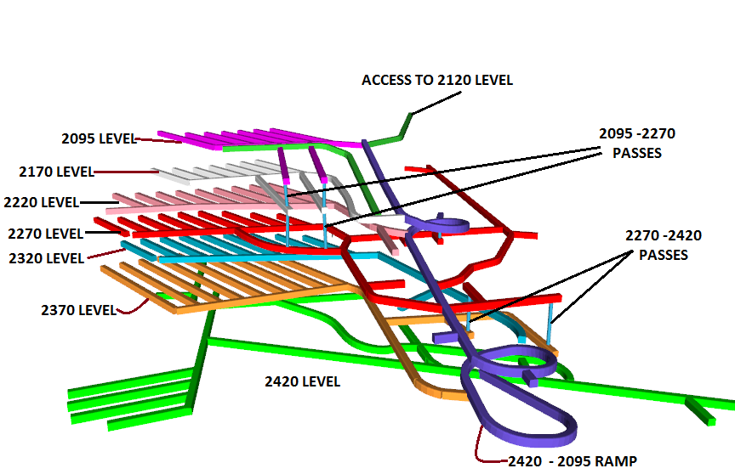

**Figure 1: Illustration of sublevels in the trial mining area**

The mining area consists of a steeply dipping area (approx. 50°) and a flatter area. CRS stoping was planned in the flatter area. The region lies at a strike length of almost 130m. It was proposed that to access ore drives in the mining area using a trackless ramp/decline mined in the hangingwall. The hangingwall excavations would intersect both the UBS and the Dol-Schist. Objectives of the operation was to develop techniques to overcome the difficulties created by the variable geometry and ground conditions in the TFQ, the UBS and the Dol-Schist.

**Continuous Retreat Stoping**

The CRS method is similar to SLC, except that the hangingwall is temporarily supported by pillars between adjacent stopes. It is intended that this pillar will fail with time, but will prevent the hangingwall from caving immediately, allowing sufficient time for the blasted ore to be recovered with minimal dilution (Figure 2). The hangingwall is expected to eventually cave some distance behind the blasted ring. As a non-entry method, it would be expected that occasional pillar failure can be tolerated, as long as this happens some distance from the draw-point, and does not adversely affect production activities. Sizing the pillars is difficult, given the lack of geotechnical data. For preliminary design purposes, it was assumed that a 3 m pillar can be formed between each panel stope.

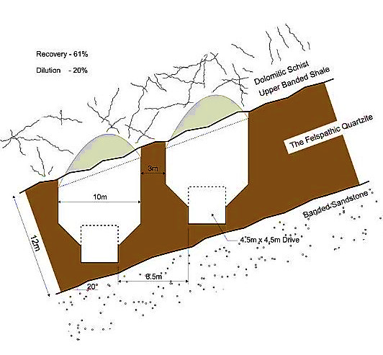

**Figure 2: Schematic Cross Section of the CRS Method**

This will require very close control on drill and blast practices, and assumes reasonably ‘massive’ quartzite. If friable zones are present, it is likely that the pillars will fail as they are being formed. It is possible that a small exposure of UBS in the stope hangingwall will remain stable long enough to allow clean recovery of the blasted ore, but it is more likely that a small skin 3m thick of TFQ will need to be left to prevent hangingwall caving [3]. The in-ore development layouts for the CRS and longitudinal SLC methods are very similar, enabling a decision to mine an area using one or the other method to be left until after the development has been completed and the detailed geology of the area is better understood (Figure 3).

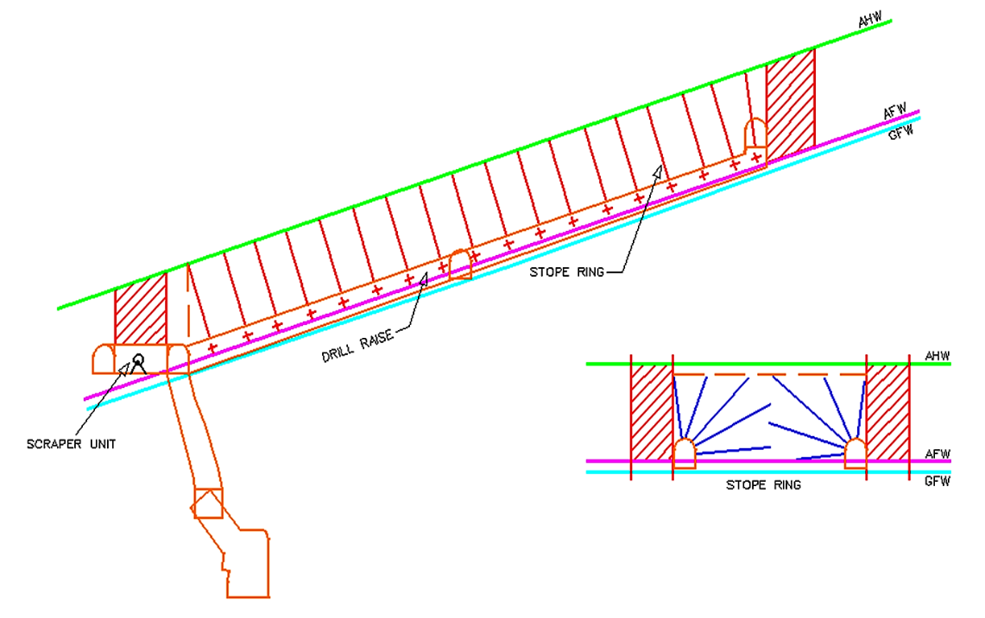

**Figure 3: Continuous Retreat Stoping**

To maximize ore recovery in the CRS, the most suitable location for the ore drives is as close to the contact between the TFQ and the weak underlying BSS as possible. As a consequence, floor heave may develop and floor conditions may be very poor for trackless vehicles. The ability to mine close to the TFQ/BSS contact, without inadvertently breaking through to the BSS, is a significant issue for the CRS methods.

**UOB mining method selection based on the traditional techniques**

Underground mining method should be primarily selected in order to utilise underground resources optimally. Besides, the ground control of excavations, driving the ventilation system, reducing the costs of excavations, driving new mining panels and preparing the underground production plans directly linked to underground mining method selection (UMMS). The UMMS process is very significant in mine designs [13]. To make the right decision on UMMS, all known criteria related to the problem should be taken into consideration. Increasing the number of criteria in decision making process makes the problem more complex, but the rightness of the decision also increases. Because of arising complexity in the decision process, many conventional methods consider only limited number of criteria. So, there is a need for alternative methods, which can consider all known criteria related to underground mining method selection in the decision making process [14]. Several methodologies were developed in the past to appraise the suitable methods of extraction for a particular ore deposit, centred on the physical and mechanical features and geotechnical properties [15].

**UMMS based on Yager’s method and the Analytical Hierarchy Process (AHP) approach**

To optimize the selection process for the UOB, two similar multiple criteria decision making (MCDM) methods, analytical hierarchy process (AHP) and fuzzy multiple attribute decision making (FMADM) can be used. Many outstanding mining method selection works have been done before based on these MCDM methods: Bitarafan applied the technique to select a mining method for an iron ore mine in Iran [15]. Karadogan applied the AHP approach of the UMMS to an underground lignite mine in Turkey [16]. Azadeh offered this method as a new approach to mining method selection and applied it to come up with the most suitable method of extraction at the Coghart iron mine in Iran. Naghadehi applied this technique on a Bauxite mine in Iran [17] and Alpay on a chromite mine in Turkey [18]. In this paper the easy applicable MCDM methods; AHP and FMADM are used to come up with a feasible underground mining method for the UOB.

**Fuzzy multiple attribute decision making (FMADM)**

The lack of precision in assessing the relative status of attributes and the performance ratings of alternatives with respect to an attribute has brought about the establishment of FMADM methods. This imprecision may arise from a variety of sources, such as immeasurable information, inadequate information and inaccessible information [19] [20].

**FMADM Approach**

The main problem of a fuzzy MADM is to select/prioritize/rank a finite number of sequences of alternatives by weighing a set of prearranged criteria. Thus, to resolve this problem, an assessment process to rate and rank, in order of predilection, the set of alternatives need to be constructed. The FMADM problem is defined below:

* A set of *m* probable alternatives, *A* = {*A1, A2… Ai…, Am*};
* A set of *n* attributes, C = {*C1, C2,…,Cj,…,Cn*} with which alternative performances are measured;
* A performance rating of alternative *Ai* with respect to attribute *Cj*, which is given by the *n* × *m* fuzzy decision matrix *Ř* = {*Řij* | i=1, 2, … *m*; j= 1, 2, …, *n*}, where *Řij* is a fuzzy set; and
* A set of *n* fuzzy weights *Ŵ*= {*Ŵj*| j=1, 2 … *n*}, where *Ŵj* is also a fuzzy set (or fuzzy number) and signifies the importance of criterion *j, Cj*, in the evaluation of the alternatives [20].

Focus in this thesis is on the Yager’s method [21]. The technique cope with both multiplex objectives and attribute situations. Yager’s technique [21] applies same principles as Bellman and Zadeh [22] max-min method, this takes into account the reciprocal matrix to mark out the limits of the pair wise comparison criteria and the resulting Eigen vector as decisive weights. Zadeh [23] proposed weighting procedure that utilizes exponentials, are applied when dealing with the problem, only one objective is taken into account when picking the ultimate alternative from a set of alternatives. When solving problems, only a single objective is considered, selection of the best alternative from a set of alternatives.

**Yager’s method**

The Yager’s method adopts the max–min principle approach. The fuzzy set decision is the intersection of all criteria: *μD* (*A*) = Min {*μC1* (*Ai*), *μC2* (*Ai*), …, *μCn* (*Ai*)}. For all (*Ai*) ∈ *A*, and the optimal decision is yielded by, *μD* (*A\**) = *Max* (*μD,* (*Ai*)), where *A*\* is the optimal decision. The major distinction in this method is that the importance of criteria is signified as exponential scalars. The foundation behind using weights as exponents is that the higher the importance of criteria, the larger the exponent, giving the minimum rule. Equally, the less important a criterion, the smaller its weight for α > 0[24]:

$μ_{D}{(A}_{i})=Min\left\{({μ_{C_{1}}{(A}_{i}))}^{α_{1}},({μ_{C_{2}}{(A}_{i}))}^{α_{2}}……….({μ_{C_{n}}{(A}_{i}))}^{α_{n}}\right\}$ (2)

**Analytical Hierarchy Process (AHP)**

Analytical Hierarchy Process combines qualitative and quantitative aspects in the selection of a process and is used for setting priorities in a multifaceted unanticipated, multi-criteria challenging situation. Delivers a flexible and easy to comprehend way of evaluating complex problems [25]. The model is used in diverse applications and practised effectively. The AHP has been useful to several decision anomalies which include software selection sourcing decisions, its main distinction is the proficiency to cope with complex and hard structured problems of which no problematic mathematical models can handle, to add on to its simplicity, flexibility and instinctive appeal, the ability to merge qualitative and quantitative measures [25].

**The AHP methodology**

The technique is built on the pairwise comparison of modules with respect to qualities and substitutes. A pair-wise comparison matrix *n×n* is created, where *n* is the number of elements to be equated. The method is applied for the hierarchy problem structuring. The problem is divided into three levels: problem statement, object identification to solve the problem and selection of evaluation criteria for each object. After the hierarchy structuring, the pair-wise comparison matrix is created for each level where a small discrete scale from 1 to 9 is used for the assessment as shown in (Table 12) [26]. The purpose of this multiple attribute decision making is to find the most appropriate mining method, the method that has the uppermost level of association with all the predefined factors. By assessing the factors to their status to the mining operation this association is measured. A higher status means a higher weight, combined with a relevance rating towards the different mining methods. The most appropriate mining method will be the one with the uppermost overall weight [13].

**Table 12: Pairwise comparison scale**

|  |  |
| --- | --- |
| **Definition** | **Relative intensity** |
| Extremely preferred | 1 |
| Very strongly preferred | 3 |
| Strongly preferred | 5 |
| Moderately preferred | 7 |
| Equal | 9 |
| Intermediate values | 2,4,6,8 |

In order to find the comparative priorities of criteria or alternatives implied by this comparison. The comparative priorities are calculated using the theory of eigenvector and eigenvalues. Given A as the pair comparison matrix then,

$\left(A-λ_{max }×I\right)×w=0$ (3)

To calculate the eigenvalue “λ max” and eigenvector w= (w1, w2..., wn), weights can be estimated as relative priorities of criteria or alternatives. The comparison is based on the biased assessment and a consistency ratio is required to ensure the selection accuracy. Consistency Ratio (CR), and normalised values for each key factor or alternative.

$λ_{max}=\frac{1}{n}\sum_{i=1}^{n}{\left\{\frac{\sum_{j=1}^{n}{a_{ij}×w_{j}}}{w_{i}}\right\}}$ (4)

Where λmax is the maximal eigenvalue, and n is the matrix size, $a_{ij}$ is an element of pairwise comparison matrix, $w_{j}$ and $w_{i}$ is the jth and ith element of Eigenvalues. The Consistency Index (CI) of the comparison matrix is calculated using Equation [5]:

$CI=\frac{λ_{max }-n}{n-1}$ (5)

The consistency Ratio (CR) is calculated as Equation [6]:

$CR=\frac{CI}{RI}$ (6)

Where “RI” Random Consistency Index. Random consistency indices are given in (Table 13).

**Table 13: Random Consistency Indices**

|  |  |
| --- | --- |
| **Matrix order** | **RI values** |
| 1,2 | 0 |
| 3 | 0.58 |
| 4 | 0.90 |
| 5 | 1.12 |
| 6 | 1.24 |
| 7 | 1.32 |
| 8 | 1.41 |

As a general rule, a consistency ratio of “0.10” or less is considered acceptable. In practice, however, consistency ratios exceeding “0.10” occur frequently.

**Eigenvector method**

This is the method used in this thesis for estimating the priority vector, the method was proposed by Saaty, priority vector should be the principle vector. Given a matrix *A* whose entries are technically obtained as ratios between weights and multiplying by *w* we get:

$$Aw=\left(\begin{aligned}\begin{aligned}{w_{1}}/{w_{1}} {w_{1}}/{w_{2}} {w_{1}}/{w_{3}}……{w_{1}}/{w_{n}} \\ {w_{2}}/{w_{1}} {w_{2}}/{w_{2}} {w_{2}}/{w_{3}}……{w_{2}}/{w_{n}}\end{aligned} \\ {w_{n}}/{w_{1}}{w_{n}}/{w_{2}}{w_{n}}/{w_{3}}……{w_{n}}/{w_{n}}\end{aligned}\right)\left(\begin{aligned}w_{1} \\ : \\ : \\ w_{n}\end{aligned}\right)=\left(\begin{aligned}{nw}_{1} \\ : \\ : \\ {nw}_{n}\end{aligned}\right)=nw$$

The formulation of the *Aw* = *nw* implies that n and w are an eigenvalue and an eigenvector of matrix A. Furthermore, by knowing that the other eigenvalue of *A* is 0, and has multiplicity (*n*−1), then its concluded that *n* is the largest eigenvalue of *A*. Henceforth, if the entries of *A* are ratios between weights, then the weight vector is the eigenvector of *A* related with the eigenvalue *n* [27]. The vector w can be obtained from any pairwise comparison matrix *A* as the solution of the following equation system,

$$\left\{\begin{aligned}Aw= λ_{max }w \\ w^{T }I=1\end{aligned}\right.$$

Where λmax is the maximum eigenvalue of *A*, and I = (1, . . . ,1) T.

**Factors for the AHP approach**

The AHP approach with 6 key factors was applied to develop an appropriate mining method, assessment matrices were created then relative weights derived for the attribute. Key factors that have a major influence in the decision making among the selected methods for the UOB are defined below. Dip is an important factor for the extraction of the UOB, reviewing the previous methods used. The UOB requires extraction methods that are aided by gravity hence the streamlined mining methods are all influenced by the dip. The cost per development of the UOB will be high, with the recent decrease in copper prices and the fact that the UOB is highly folded and very weak will incur costs in setting up supports. The orebody thickness is important due to the nature of the UOB, it is highly folded and thin in some parts. The orebody thickness will influence the needed precision and direction of drift excavations. The stress is high in the UOB due to the depth at which it lies, the mining methods should be able to deal with this high stress. The stress has influence on the rock substance strength of the orebody an important factor in extraction by caving. These key factors that are significant and that will influence the decision making are given below (Table 14), the factors encompass the components that are most important at Nchanga mine, these are Dip, costs, productivity, orebody thickness, RSS of ore zone, dilution and revenue.

**Table 14 Key factors of influence for the UOB**

|  |  |
| --- | --- |
| **Key factors** | |
| C1 | Dip |
| C2 | Costs |
| C3 | Dilution and revenue |
| C4 | Productivity |
| C5 | RSS of ore zone |
| C6 | Orebody thickness |

The 6 factors with influence and the hierarchy analysis is shown in (Figure 4), factor ranking with different mining methods for the UOB are tabulated in (Table 15) this will be used to come up with pairwise matrices. The abbreviations for the different mining methods are;

SLC: Sublevel caving.

BC: Block caving.

C&F: Cut and Fill.

SLS: Sublevel Open Stoping.



**Figure 4: Hierarchy analysis parameters applied as input for pairwise comparison matrices**

**Table 15** **Factor ranking with different mining methods for the UOB**

|  |  |  |  |  |
| --- | --- | --- | --- | --- |
| **Key factors (C1-C6)** | **SLC (A1)** | **C&F (A2)** | **SLS (A3)** | **BC (A4)** |
| Dip | 1 | 3 | 2 | 1 |
| Costs | 3 | 1 | 3 | 4 |
| Productivity | 1 | 3 | 2 | 1 |
| Orebody thickness | 1 | 3 | 2 | 2 |
| RSS of ore zone | 1 | 5 | 3 | 2 |
| Dilution and revenue | 3 | 1 | 5 | 5 |

**Pairwise comparison matrices**

Based on the AHP analysis the pairwise comparison matrices are constructed, there are six matrices constructed comparing the factors of influence on the UOB (Table 16 to 21). Another pairwise comparison matrix of the importance of the factors (**C1-C6**) is created (Table 22). Applying the Eigenvector method, pairwise comparison reciprocal matrices are constructed and computations done using Matlab (version 2014a) software, as shown below;

1. Characteristic polynomial for the matrix (Table 16) is:

x4 - 4x3 - 10.06x

Real eigenvalues: {0, 4.197}

Eigenvector of eigenvalue **λmax** = 4.197:

(0.72, 0.49, 0.37, 0.307)

**Table 16: Pairwise comparison matrix of the UOB dip**

|  |  |  |  |  |  |
| --- | --- | --- | --- | --- | --- |
|  | SLC | C&F | SLS | BC | Weight |
| SLC | 1 | 3 | 2 | 1 | 0.724 |
| C&F | 1/3 | 1 | 3/2 | 3 | 0.492 |
| SLS | 1/2 | 2/3 | 1 | 2 | 0.373 |
| BC | 1 | 1/3 | 1/2 | 1 | 0.307 |
| λ max = 4.197; CR= 0.072 ≤ 0.1 | | | | | |

1. Characteristic polynomial for the matrix (Table 17) is:

0.99x4 - 3.99x3 - 1.21e-15x2 - 0.68x - 3.03e-15

Real eigenvalues: {0, 4.04}

Eigenvector of eigenvalue **λmax** = 4.042:

(0.88, 0.25, 0.25, 0.29)

**Table 17: Pairwise comparison matrix of costs**

|  |  |  |  |  |  |
| --- | --- | --- | --- | --- | --- |
|  | C&F | SLC | SLS | BC | Weight |
| C&F | 1 | 3 | 3 | 4 | 0.886 |
| SLC | 1/3 | 1 | 1 | 3/4 | 0.253 |
| SLS | 1/3 | 1 | 1 | 3/4 | 0.253 |
| BC | 1/4 | 4/3 | 4/3 | 1 | 0.285 |
| λ max = 4.042 CR= 0.015≤ 0.1 | | | | | |

1. Characteristic polynomial for the matrix (Table 18) is:

x4 - 4x3 - 10.05x

Real eigenvalues: {0, 4.197}

Eigenvector of eigenvalue **λmax** = 4.197:

(0.72, 0.49, 0.37, 0.307)

**Table 18: Pairwise comparison matrix of productivity**

|  |  |  |  |  |  |
| --- | --- | --- | --- | --- | --- |
|  | SLC | C&F | SLS | BC | Weight |
| SLC | 1 | 3 | 2 | 1 | 0.724 |
| C&F | 1/3 | 1 | 3/2 | 3 | 0.492 |
| SLS | 1/2 | 2/3 | 1 | 2 | 0.373 |
| BC | 1 | 1/3 | 1/2 | 1 | 0.307 |
| λ max = 4.197; CR= 0.072≤ 0.1 | | | | | |

1. Characteristic polynomial for the matrix (Table 19) is:

x4 - 3.99x3 + 1.776e-15x2 - 1.39x + 3.99e-15

Real eigenvalues: {0, 4.08}

Eigenvector of eigenvalue **λmax** = 4.083:

(0.799, 0.397, 0.319, 0.319)

**Table 19: Pairwise comparison matrix of the UOB thickness**

|  |  |  |  |  |  |
| --- | --- | --- | --- | --- | --- |
|  | SLC | C&F | SLS | BC | Weight |
| SLC | 1 | 3 | 2 | 2 | 0.7996 |
| C&F | 1/3 | 1 | 3/2 | 3/2 | 0.3967 |
| SLS | 1/2 | 2/3 | 1 | 1 | 0.3188 |
| BC | 1/2 | 2/3 | 1 | 1 | 0.3188 |
| λ max = 4.083; CR = 0.03≤ 0.1 | | | | | |

1. Characteristic polynomial for the matrix (Table 20) is:

1.00x4 - 3.99x3 - 6.24x + 2.25e-15

Real eigenvalues: {0, 4.132546751566489}

Eigenvector of eigenvalue **λ**max = 4.133:

(0.877, 0.345, 0.25, 0.22)

**Table 20: Pairwise comparison matrix of the RSS of orebody**

|  |  |  |  |  |  |
| --- | --- | --- | --- | --- | --- |
|  | SLC | C&F | SLS | BC | Weight |
| SLC | 1 | 5 | 3 | 2 | 0.877 |
| C&F | 1/5 | 1 | 5/3 | 5/2 | 0.345 |
| SLS | 1/3 | 3/5 | 1 | 3/2 | 0.250 |
| BC | 1/2 | 2/5 | 2/3 | 1 | 0.223 |
| λ max = 4.133; CR = 0.04≤ 0.1 | | | | | |

1. Characteristic polynomial for the matrix (Table 21) is:

x4 - 4.00x3 - 2.27x - 1.056e-13

Real eigenvalues: {0, 4.13}

Eigenvector of eigenvalue **λmax** = 4.133:

(0.925, 0.187, 0.23, 0.23)

**Table 21: Pairwise comparison matrix of the Dilution and revenue**

|  |  |  |  |  |  |
| --- | --- | --- | --- | --- | --- |
|  | C&F | SLC | SLS | BC | Weight |
| C&F | 1 | 3 | 5 | 5 | 0.925 |
| SLC | 1/3 | 1 | 3/5 | 3/5 | 0.188 |
| SLS | 1/5 | 5/3 | 1 | 1 | 0.233 |
| BC | 1/2 | 5/3 | 1 | 1 | 0.233 |
| λ max = 4.133 CR =0.037≤ 0.1 | | | | | |

Pairwise comparison matrix for the different key factors (**C1-C2**) is shown (Table 22) the maximum eigenvalue is given as;

**λmax** = 6.28

Eigenvector of eigenvalue **λmax** = 6.281:

(0.797, 0.209, 0.323, 0.209, 0.261, 0.323)

**Table 22: Pairwise comparison matrix of the key factors**

|  |  |  |  |  |  |  |  |
| --- | --- | --- | --- | --- | --- | --- | --- |
|  | C1 | C2 | C3 | C4 | C5 | C6 | Weight |
| C1 | 1 | 2 | 4 | 1 | 3 | 4 | 0.797 |
| C2 | 1/2 | 1 | 1/2 | 1 | 2/3 | 1/2 | 0.209 |
| C3 | 1/4 | 2 | 1 | 2 | 4/3 | 1 | 0.323 |
| C4 | 1/2 | 1 | 1/2 | 1 | 2/3 | 1/2 | 0.209 |
| C5 | 1/3 | 3/2 | 3/4 | 3/2 | 1 | 3/4 | 0.261 |
| C6 | 1/4 | 2 | 1 | 2 | 4/3 | 1 | 0.323 |
| λ max = 6.281; CI = 0.05612; CR = 0.0452 ≤ 0.1 | | | | | | | |

Comparison of the key factors weighting is illustrated in (Figure 5).

**Figure 5: Comparison of key factors**

The overall rating of each alternative method of extraction is computed from the summation of the product of the relative priority of each key factor (Table 23) and the relative priority of each alternative mining method.

Overall rating of an alternative mining method Cut & Fill (C&F) is given by;

(0.797×0.492) + (0.209×0.886) + (0.323×0.492) + (0.209×0.3967) + (0.261×0.345) + (0.323×0.925) = 1.2079

**Table 23: Overall results**

|  |  |  |  |  |  |  |  |
| --- | --- | --- | --- | --- | --- | --- | --- |
|  | C1 | C2 | C3 | C4 | C5 | C6 | Overall |
| SLC | 0.724 | 0.253 | 0.724 | 0.799 | 0.877 | 0.188 | 1.320 |
| C&F | 0.492 | 0.886 | 0.492 | 0.396 | 0.345 | 0.925 | 1.208 |
| SLS | 0.373 | 0.253 | 0.373 | 0.318 | 0.250 | 0.233 | 0.678 |
| BC | 0.307 | 0.285 | 0.307 | 0.318 | 0.223 | 0.233 | 0.603 |
| Key factor weight | 0.797 | 0.209 | 0.323 | 0.209 | 0.261 | 0.323 |  |

**Results of the UMMS using the FHP approach and Yager’s method**

The final computations using AHP in Table 23 shows that the alternative mining method for the UOB is SLC, it should be selected as the optimum extraction method, it’s the most preferred to others because the priority of this alternative (1.320) is higher than all (Figure 6).

**Figure 6: AHP final rating**

The pairwise comparison matrix for the main criteria in AHP (Table 22) is also applicable in FMADM method, this is used to come up with membership levels of each criterion. The weights of the criteria are obtained from the eigenvectors = (0.797, 0.209, 0.323, 0.209, 0.261, 0.323). The exponential weights are defined from individual criterion as: α1 = 0.797, α2 = 0.209, α3 = 0.323, α4 = 0.209, α5 = 0.261, α6 = 0.323. Using the linguistic assessment, membership levels (ML) were constructed and membership decision function (MDF) with reference to Yager [21] was also determined for each alternative as shown in Table 24.

**Table 24: Membership levels and membership decision function**

|  |  |  |  |  |  |  |  |  |  |  |  |  |
| --- | --- | --- | --- | --- | --- | --- | --- | --- | --- | --- | --- | --- |
| **Cn** | **A1** | | | **A2** | | | **A3** | | | **A4** | | |
| **ML** |  | **MDF** | **ML** |  | **MDF** | **ML** |  | **MDF** | **ML** |  | **MDF** |
| C1 | H | 0.80 | 0.837 | M | 0.50 | 0.576 | MLL | 0.35 | 0.433 | MLL | 0.35 | 0.433 |
| C2 | L | 0.20 | 0.714 | VH | 0.95 | 0.989 | L | 0.20 | 0.714 | L | 0.20 | 0.714 |
| C3 | H | 0.80 | 0.930 | M | 0.50 | 0.799 | MLL | 0.35 | 0.712 | MLL | 0.35 | 0.712 |
| C4 | H | 0.80 | 0.954 | MLL | 0.35 | 0.803 | MLL | 0.35 | 0.803 | MLL | 0.35 | 0.803 |
| C5 | VH | 0.95 | 0.987 | MLL | 0.35 | 0.760 | L | 0.20 | 0.657 | L | 0.20 | 0.657 |
| C6 | L | 0.20 | 0.688 | VH | 0.95 | 0.984 | L | 0.20 | 0.595 | L | 0.20 | 0.595 |

*VH: Very High, H: High, M: Medium, MLL: More or Less Low, L: Low

Applying the membership degrees of alternatives for each criterion, results obtained for each alternative according to Equation [2] are;



$μ_{D}{(A}_{1})=min \left\{{0.80}^{0.797},{0.20}^{0.209},{0.80}^{0.323},{0.80}^{0.209},{0.95}^{0.261},{0.20}^{0.323}\right\}= 0.360$

$μ_{D}{(A}_{2})=min \left\{{0.50}^{0.797},{0.95}^{0.209},{0.50}^{0.323},{0.35}^{0.209},{0.35}^{0.261},{0.95}^{0.323}\right\}= 0.273$

$μ_{D}{(A}_{3})=min \left\{{0.35}^{0.797},{0.20}^{0.209},{0.35}^{0.323},{0.35}^{0.209},{0.20}^{0.261},{0.20}^{0.323}\right\}=$ $0.069$

$μ_{D}{(A}_{4})=min \left\{{0.35}^{0.797},{0.20}^{0.209},{0.35}^{0.323},{0.35}^{0.209},{0.20}^{0.261},{0.20}^{0.323}\right\}= 0.069$

Applying the max-min Bellman and Zadeh [22]principle, the final set is determined as shown and results obtained are;

$$μ_{D}(A)=\left\{\frac{{SLC(A}_{1})}{0.360},\frac{{C\&F(A}_{2})}{0.273},\frac{SLS(A_{3})}{0.069},\frac{BC(A_{4})}{0.069}\right\}$$

The optimal solution is;

***μ*D (A*) = max (*μ*D (A1)) = 0.360**.

Applying the max-min Bellman and Zadeh, results obtained show that Sublevel Caving method (**A1**) is the most preferred (Figure 7).

**Figure 7: Max-min Bellman and Zadeh final rating**

**Extraction Process Simulation and Stability Analysis**

This section comprise of simulation of extraction of the UOB by the proposed mining method using FEM, proceeded by the preliminary mine design.

**Process of simulation**

To understand the stress redistribution and hangingwall stability of the UOB as mining progresses to deeper levels, a numerical simulation was conducted. A three-dimensional finite element continuum conceptual model was conducted using **RS3**. The three-dimensional model was used to investigate stress redistribution and hangingwall failure mechanisms through elastic and elasto-plastic model runs. Furthermore, a parametric analysis was conducted for the estimated strength parameters for the rock mass around the UOB excavations.

**Stress**

The stress conditions within a rock mass before it is disturbed by excavations are interrelated to the load of the overlaying rock and the geological history of the rock mass. It is then inevitable that when excavations are located at greater depths they encounter high stress environments. These environments create great challenges as mining operations progress. In order to overcome these challenges, every aspect of the problem has to be considered when designing an underground mine. One of the major and most important decisions faced is how to extract the ore, which mining method and mining sequence to utilize.

**Numerical procedure**

The model setup represents the UOB at the 2420 level. The analysis model focused mainly on the drifts and caving. The first step in the creation of the model was to set the external boundaries. The boundaries where not placed far from the area to be modelled, so that they don’t affect the model in any way. The outer boundary was inserted, next step was the inclusion of the orebody and the sublevel drifts needed for the analysis. The orebody was then divided into drifts by adding material boundaries. Further step was to add the material properties to the different areas and in this model there are four different material properties; hangingwall (DolShist), footwall (BSSU), ore (TFQ) and UBS (Figure 8). When the material properties where in place, loading conditions were applied to the model and in this case gravitational force was used.

**Table 7-17: Input parameters for extraction process simulation**

|  |  |  |  |
| --- | --- | --- | --- |
| **Rock definition** | **TFQ** | **Sandstone** | **Schist** |
| Initial element loading: | field stress & body force | field stress & body force | field stress & body force |
| Unit weight (MN/m3) | 0.026 | 0.026 | 0.026 |
| Material type | Plastic | Plastic | Plastic |
| Modulus of elasticity *E* (Mpa) | 976,597 | 976,597 | 1360,88 |
| Tensile strength (Mpa) | -0,0469546 | -0,00901 | -0,0155014 |
| Failure Criterion | Hoek-Brown | Hoek-Brown | Hoek-Brown |
| Poisson’s ratio | 0.292 | 0.292 | 0.280 |
| Dilation angle | 0 | 0 | 0 |
| Uniaxial compressive (Mpa) | 3,16534 | 0,516089 | 0,602041 |
| mb Parameter (peak) | 1,6417 | 1,39544 | 0.595209 |
| S Parameter (peak) | 0,000418942 | 0,000419 | 0.00015412 |
| mb Parameter (residual) | 1,6417 | 1,39544 | 0.595209 |
| S Parameter (residual) | 0,000418942 | 0,000419 | 0.00015412 |

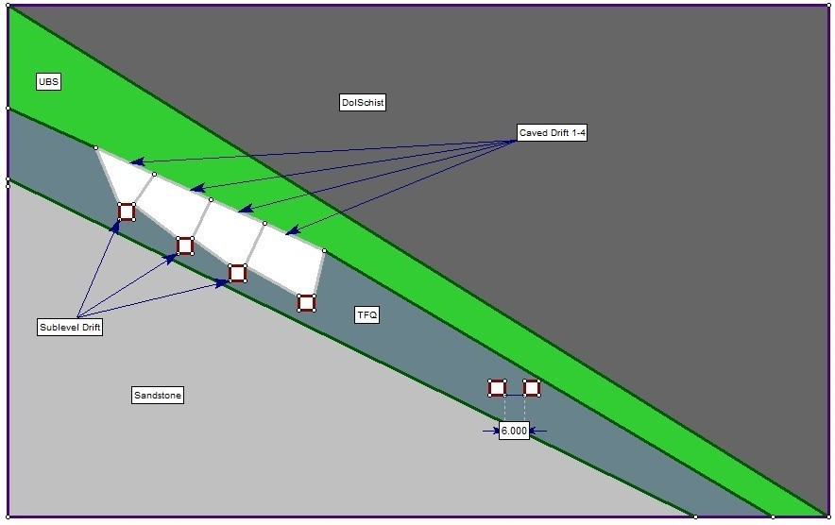

**Figure 8: Different material boundaries**

The model was discretized and meshed and the mesh density was increased around the orebody in order to get better results (Figure 9). After all the inputs where in place the mining sequence was included by excavating the drifts in stages. When the sequence was considered to be a close representation of reality the model was calculated and interpreted. Material demands where added to the top of the drifts analysed so that the stress could be monitored as mining progressed within the model.

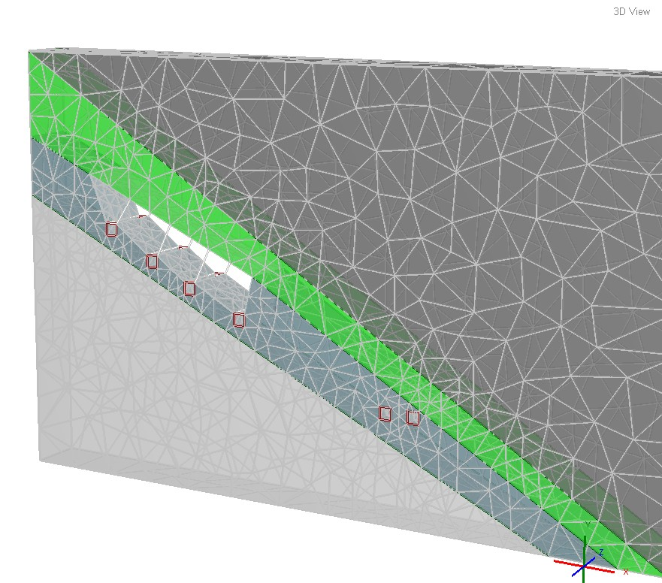

**Figure 9: Discretized and meshed stage 6 of mining sequence (Caving of 4th Drift)**

The numerical analysis performed was **RS3**. The model was based on data inputs from Nchanga mine, the first step was to verify that the inputs where correct and that the model itself was valid for the analysis. The model represents the development from driving of drifts to initial sublevel caving, the excavation stages and the sequence of mining applied in the model are illustrated in the figures below, presentations shows the 6stages of extraction sequence, shows the stress distribution, displacement distribution, strength factor and plastic zone failure (Figure 10 - 17).

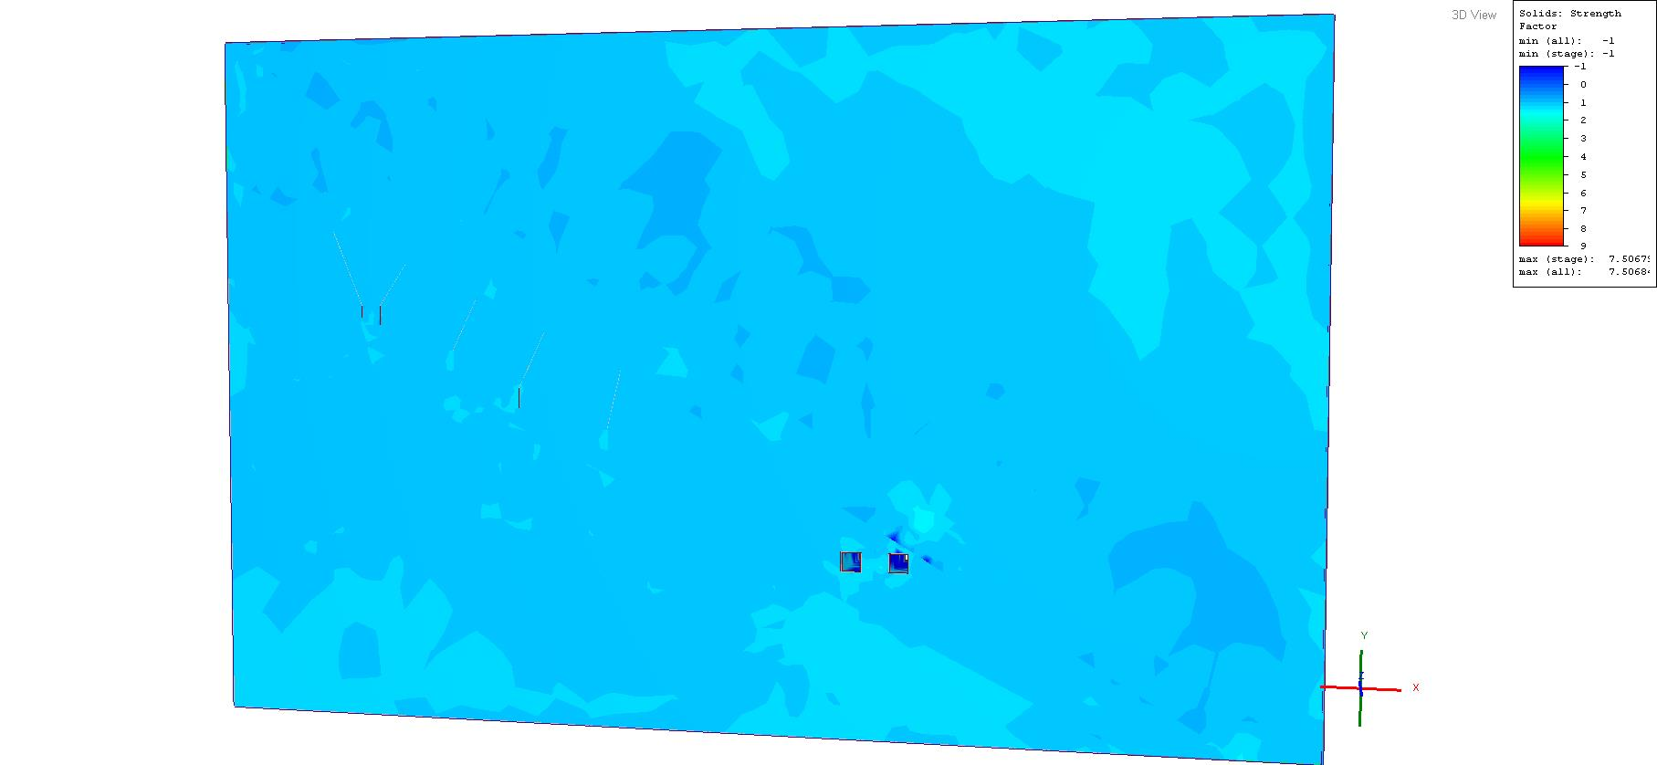

**Figure 10 Stage 1of mining sequence strength factor distribution**

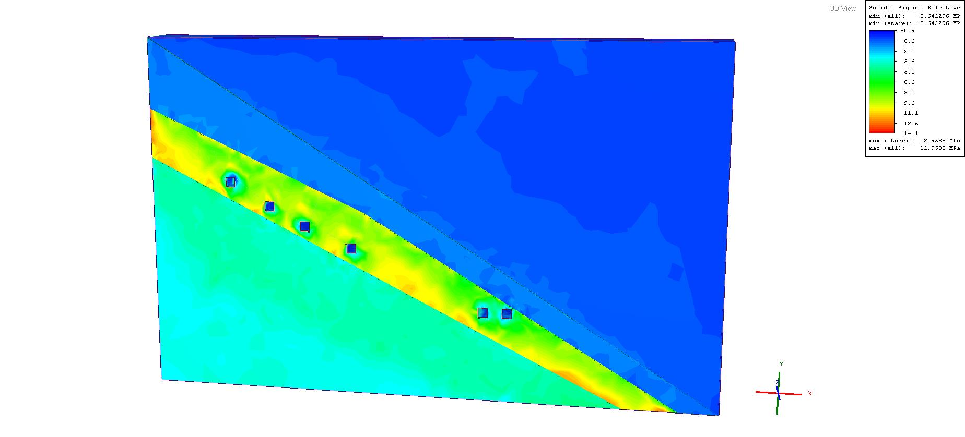

**Figure 11 Stage 2 of mining sequence stress distribution**

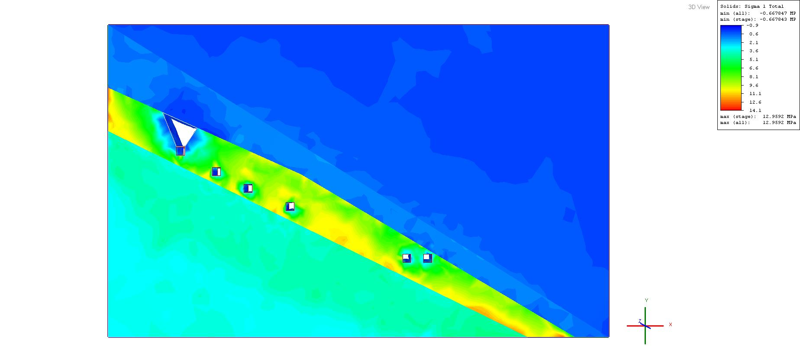

**Figure 12 Stage 3 of mining sequence stress distribution**

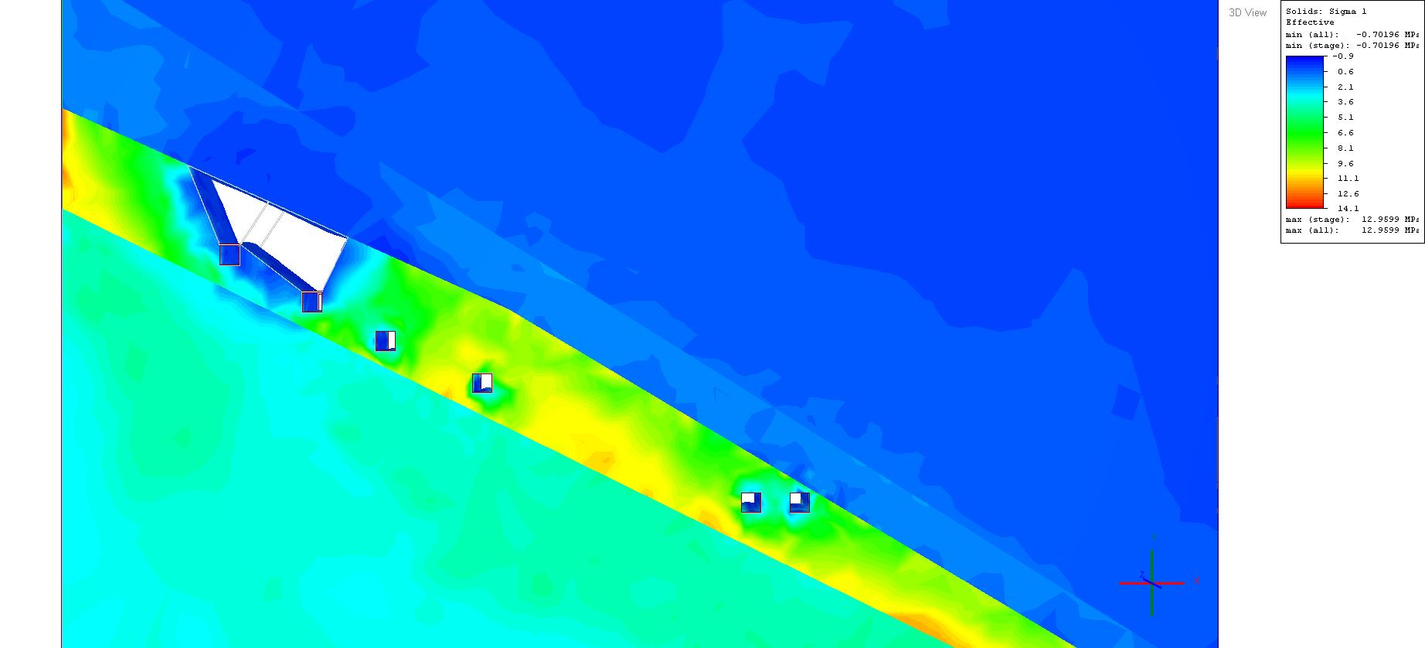

**Figure 13 Stage 4 of mining sequence stress distribution**

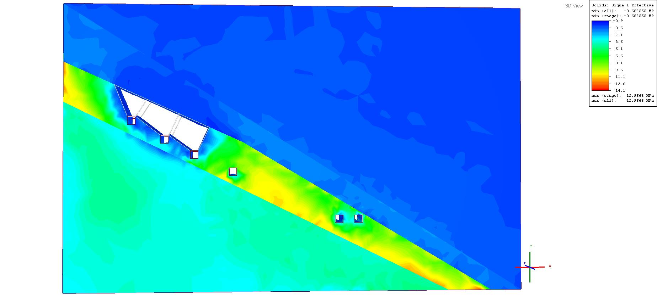

**Figure 14 Stage 5 of mining sequence stress distribution**

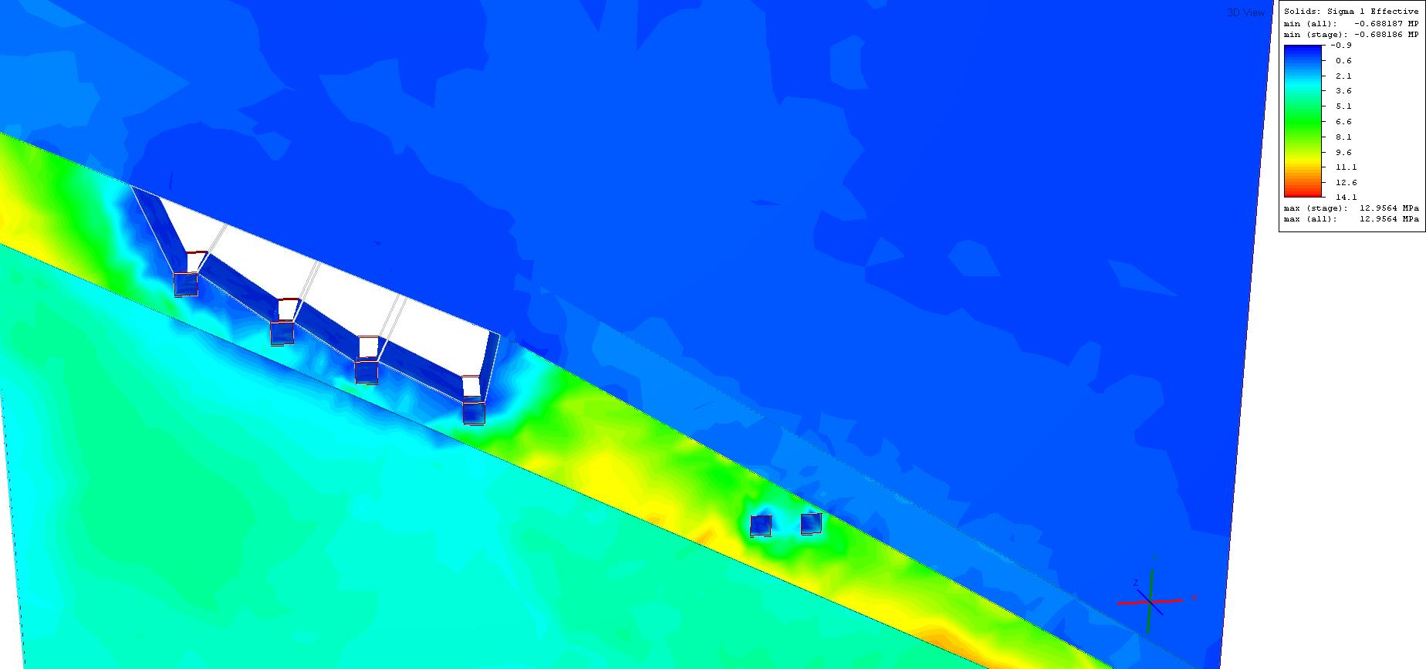

**Figure 15: Stage 6 of mining sequence stress distribution**

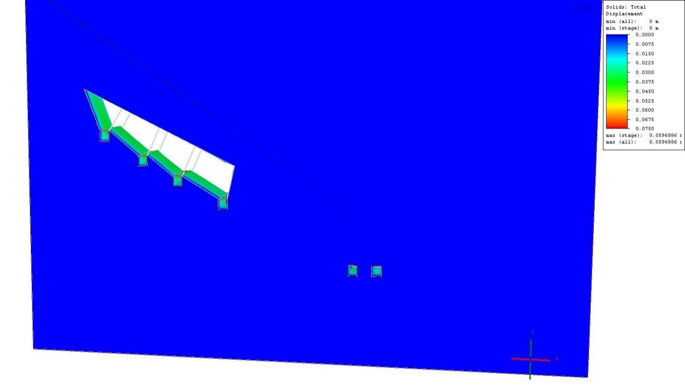

**Figure 16: Stage 6 of mining sequence displacement distribution**

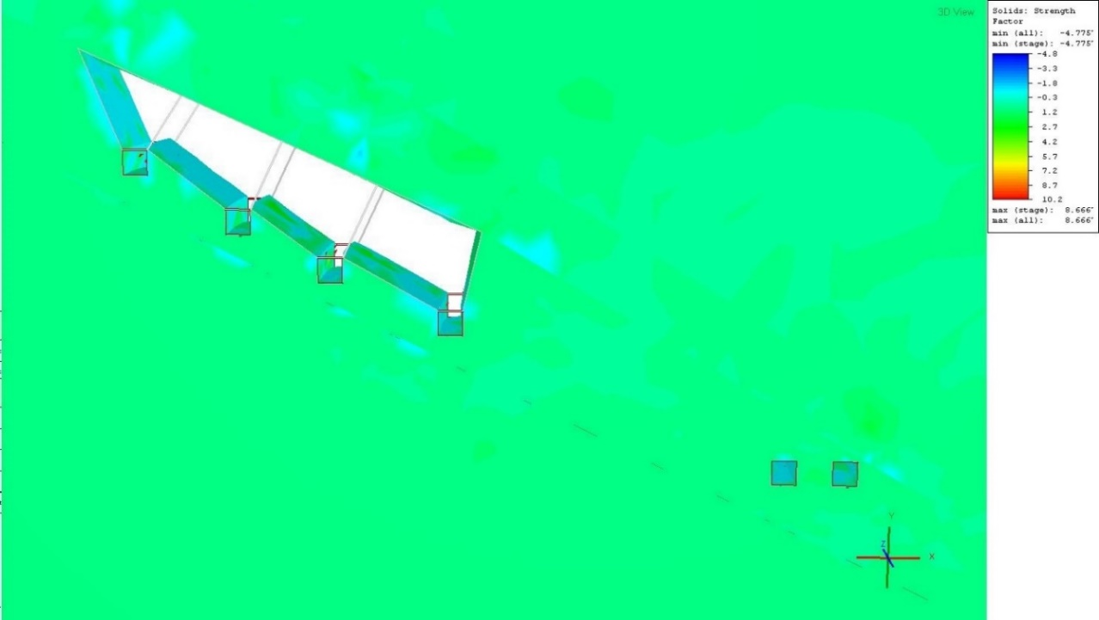

**Figure 17: Strength factor around the boundary of the excavations**

**Conclusion**

After performing a numerical analysis it was concluded that sublevel caving is an option for the UOB, provided that the drifts are fully supported with integrated support systems. Upon installing the integrated support system, overall total displacement was reduced to 0.00067m and strength factor increased to the maximum of 8.7. Major principle stress ranged from -0.69Mpa-12.96Mpa, relatively low stress.

**Sub-Level Caving**

Both transverse and longitudinal methods can be applied, depending on the dip and thickness of the orebody. SLC drives and crosscuts would be positioned in the TFQ and would be sized to accommodate the proposed drilling and loading equipment. Blast-holes would, in most cases, be fired, one ring at a time, retreating from a slot to the limits of the mining block. After blasting, the ore would be drawn until dilution becomes unacceptable. The method works from top down, and the waste rock above the orebody collapses or caves into the void as the ore is drawn.

Pillars between the SLC crosscuts or drives need to be big enough to remain stable and allow safe access to the draw-point brow for charging subsequent rings. Competing with this objective is the requirement to position the crosscuts close enough to allow good ore recovery. Sub-level interval can vary depending on the geometry of the orebody. An interval of approximately 15m would be suitable. Greater intervals, up to 25m may be possible in some thick, folded areas. Maintaining a well-formed and stable drawpoint crest to enable safe and efficient charging of blast-holes is a key requirement of the SLC method.

Ground support patterns need to be designed with this as the primary objective. Charging and blasting practices need to be designed and implemented to minimise back-break and the summit of SLC mining will result in surface subsidence. Experience in the LOB block cave suggests that a cave angle of around 55º can be projected. One of the key differences between the transverse and longitudinal methods is the different optimum position of the ore drives relative to the TFQ / BSS contact. In the transverse method, the optimum position is close to the TFQ hangingwall (Figure 18). In the longitudinal method the optimum position is close to the TFQ / BSS contact, to maximise ore recovery. Positioning the ore drives close to the hangingwall avoids the risk of inadvertently mining into the BSS and enables the actual position of the contact to be identified by either drilling or crosscut development towards the footwall.

**Primary development concept**

The design need to accommodate the use of SLC method. The design must provide for the progressive exploration of the UOB, to ensure that all mine development is appropriately positioned to enable efficient mining. The design must provide access for trackless equipment to all areas of the mine, such that vehicles can be relocated quickly between working areas. The design should aim to minimise amount of development in the BSS and in the UBS and Dol-Schist rock types, where ground support costs are expected to be high.

**Proposed design parameters**

The primary development concept for the 2420 Level is based on the following designs (Figure 8-3):

* Mining method: Sublevel caving
* Number of sublevels: 04
* Vertical interval between sublevels: 45m
* Ring burden: 2m
* Toe burden: 1.5m
* Footwall pillar: 2.5m
* Strike ore drives will be 4.5 m wide by 4.5 m high.
* SLC crosscuts will be 4.5 m wide by 4.5 m high.

Blast-holes fired, one ring at a time, retreating from a slot to the limits of the mining block after blasting.

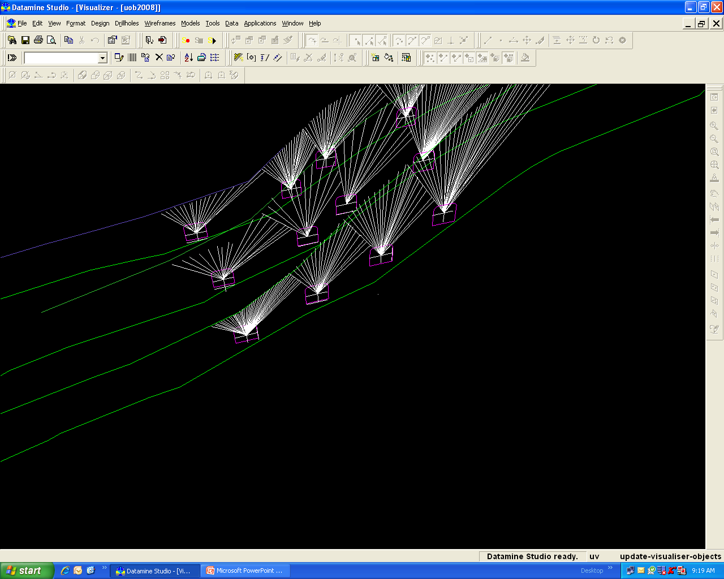

Ring

Sublevel Drift

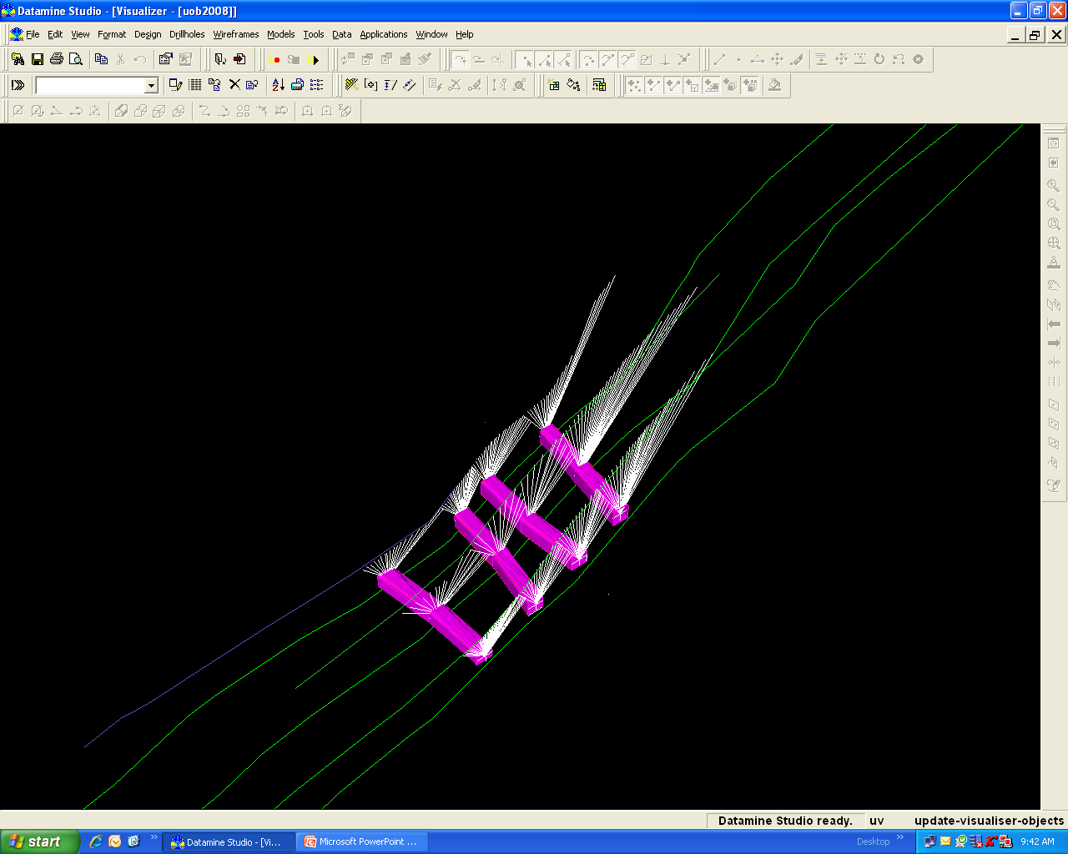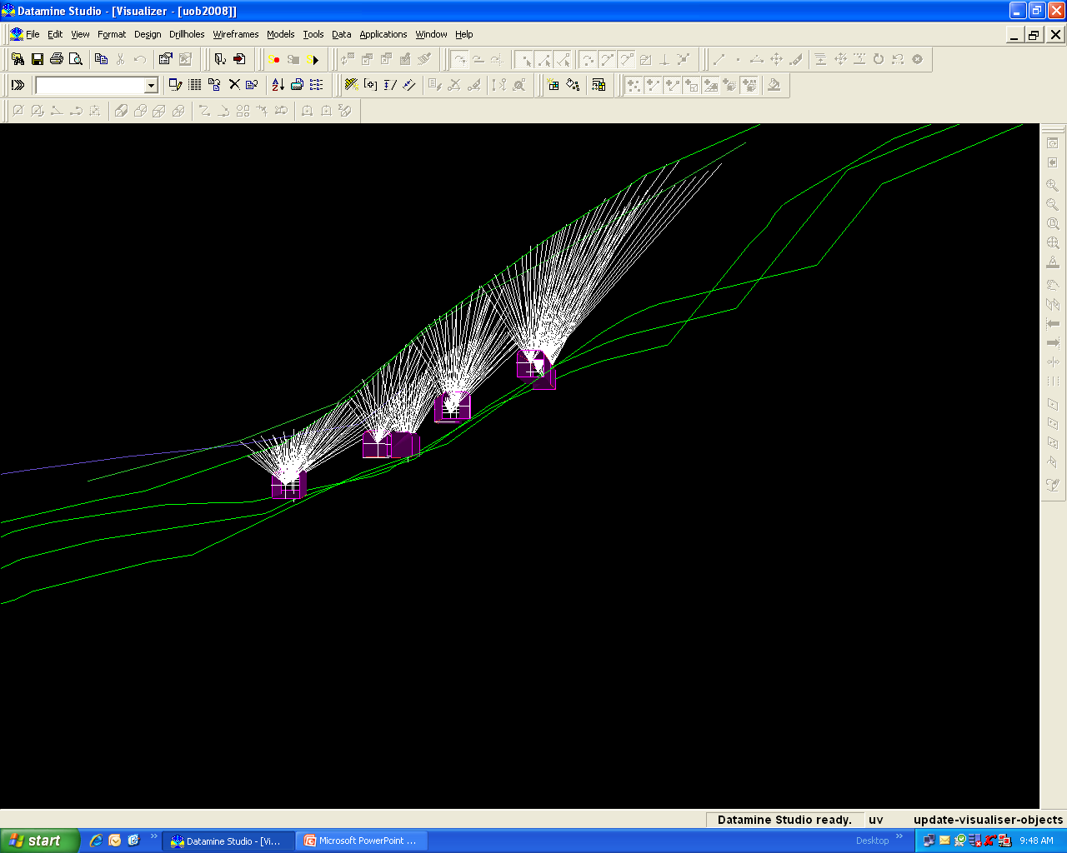

Footwall

Orebody

Hangingwall

Sublevel Drift

Ring Spacing = 2m

Ring Burden = 1.5m

**Figure 18: Proposed design parameters**

**Discussion**

The AHP used in this thesis considered the use of a reciprocal pairwise matrix, pairwise comparison and eigenvectors. Yager’s method was applied with the presentation of the max-min Bellman and Zadeh principal this accurately defined the mining method for the UOB. Alternatives in the AHP model were four mining methods selected from the UBC, the results from the 4 keyed methods in the AHP model was sublevel caving with the highest score, Yager’s method ranked sublevel caving the topmost. Since SLC is applicable, a top-down extraction sequence is required, with the cave front advancing away from the existing LOB caving area. The extraction sequence will be complicated due to the presence of an over fold in the upper part of the deposit and a steep limb of a syncline in the north-eastern area.

Stoping in the over fold area and the northern limb of the syncline will need to advance ahead of the stoping in the central section, to prevent undercutting the orebody in the over fold and northern limb. Certain parts of the UOB reserve may not be able to be economically mined, including the north-eastern extremity of the UOB reserve and parts of the over fold. In the north-eastern area, the apparent complexity of the folding and the proximity of the LOB caving area make this area difficult to access. To enable the progressive extraction of the UOB, a regular pattern of access drifts through the BSS have been designed, spaced along strike at 240m intervals

Crosscuts are positioned in the haulage, at a minimal vertical interval of 45m, haulage and crosscuts through the BSS, effectively separate the UOB into production panels 240m long by 45m vertically. Access crosscuts through the BSS are located at the extremity of each production panel, ensuring that caving always advances toward the panel access. A longitudinal SLC method would likely be the most suitable method for mining the North Limb. The limb has been divided into three panels, each with its own access ramp. Ore from the North Limb would be trucked back to the Basement through a passageway. Mining of the North Limb must conclude before access via 2420 Level is lost to caving in the main zone.

In each production panel, ore mucked from the top two strike drives will be trammed back along the drive to a short ore pass connected to the lowest strike drive in the panel. No loading chute would be required at the bottom of the ore pass, and ore from the base of the pass will be loaded to trucks by a Load-Haul-Dump (LHD) unit. Ore from the lowest strike drive will be loaded directly from the drawpoint to trucks. Loaded trucks from the production panel will haul ore through the BSS access crosscut to ore passes in the Basement. Ore pass tips would be fitted with grizzly’s, and would transfer ore to either 2120 or 2720 main haulage levels. Ore would be trammed to the hoisting shafts using the existing tracked haulage system.

**Conclusions**

Incorporating all the outcomes from both the mining method selection and geotechnical analysis a preliminary mine design was made for the UOB. The design combined sublevel drifts and developments, SLC methods used formerly were considered to be the most appropriate, although they needed modification to seize advantage of improvements in modern trackless mining equipment. The transverse SLC method is more suitable in shallower dipping areas, while the longitudinal method will have application in the steeper dipping and some heavily folded areas. Maintaining access to the SLC crests and blast-hole collars will be challenging, and blast-hole stability may be a significant issue. Maintaining well-formed and stable drawpoint crests, to enable safe and efficient charging of blast-holes, is a key requirement of the SLC method. Ground support patterns will need to be designed with this as the primary objective. Charging and blasting practices will need to be designed and implemented to minimise back-break and brow damage. SLC mining will result in surface subsidence and a cave angle of around 55° is expected.

The design will accommodate the exploitation of the longitudinal and transverse SLC methods. The design provides access for trackless equipment to all areas of the mine, such that vehicles can be relocated quickly between working areas. The design minimises the amount of development in the BSS, the UBS and Dol-Schist rock types, where ground support costs are expected to be high. The design enables production to start from the accessible part of the UOB in the smallest possible time.

The transverse SLC method is the definitive mining method recommended for the UOB. The method will maximise the economic returns. Mining of the UOB will extend the life of Nchanga underground mine for a period of 15 years, this will provide time for the mine to explore other alternative deposits.

**References**

1. Pearson, B. N. 1981. “The Development and Control of Block Caving at the Chingola Division of Nchanga Consolidated Copper Mines Limited, Zambia.” In Design and Operation of Caving and Sublevel Stoping Mines, by D R Stewart, 211-223. New York: Society of Mining Engineers, AlME.
2. Mbiri, L. 2011. “The Upper Orebody, a new dimension to Nchanga Underground Mining Operation.” The Southern African Institute of Mining and Metallurgy 6th Southern African Base Metals (Southern African Institute of Mining and Metallurgy) 187-208.
3. Mason, C. F. 1970. The Geology of Nchanga. Report, NCCM (Chingola Div). Geol Dept.
4. SRK. 2007. Geological Modelling and Mineral Resource Evaluation, Nchanga Underground Upper Orebody. Chingola: SRK Consulting.
5. Kabwe, Eugie & Wang Yiming. 2015. “Production potential of Nchanga underground mine’s collapsed blocks.” International Journal of Scientific & Technology Research 4 (10): 289-301.
6. Mundike.S and Lipalile.M. 2010. “Applications of Fibre-Reinforced Shotcrete (fibrecrete) Support in Drifts.” The South African Institute of Mining and Metallurgy The Third Southern African Conference on Base Metals 225-234.
7. Garlick, W, G and Haldane, R. 1976. “Geology of the Zambian Copperbelt.” In Handbook of Stratabound and Staratiform Ore Deposits, by K H Wolf, 256–273. Amsterdam: Elsevier.
8. Garrard, P. 1972. The Geology of the Chingola Area, Zambia. PhD Thesis, London: Fac Sci Uni – London.
9. Haldane, R. 1974–75. Biennial Geological Report for Chingola Division. NCCM (Chingola Div), Geol Dept.
10. Diedenrix. 2007. “The Geology of Nchanga Licence Area.” chingola.
11. Stonley, D C W. 1975. A Geological Manual for the Upper Orebody. Report, NCCM (Chingola Div). Geol Dept.
12. Flores, G., & Karzulovic, A. (2004). Geotechnical guidelines for a transition from open pit to underground mining. Subsidence. ICSII. Task 4, Technical Report.
13. Peskens, T.W. 2013. Underground mining method selection and preliminary techno-economic mine design for the Wombat orebody, Kylylahti deposit, Finland. PhD Thesis, Netherlands: Section for Resource Engineering, Department of Geoscience & Engineering, Delft University of Technology.
14. Yavuz, Serafettin Alpay & Mahmut. 2009. “Underground mining method selection by decision making tools.” Tunneling and Underground Space Technology 24: 173–184.
15. Bitarafan, M. R. & Atei, M. 2004. “Mining method selection by multiple criteria decision making tools.” The Journal of the South African Institute of Mining and Metallurgy 493-498.
16. Karadogan, A., Kahriman, A. & Ozer, U. 2008. “Application of fuzzy set theory in the selection of underground mining method.” The Journal of the Southern African Institute of Mining and Metallurgy 73-79.
17. Naghadehi, M. Z., Mikaeil, R. & Ataei, M. 2009. “The application of fuzzy analytic hierarchy process (FAHP) approach to selection of optimum underground mining method for Jajarm Bauxite Mine.” Expert Systems with Applications (36): 8218-8226.
18. Alpay, S. & Yavuz, M. 2009. “Underground mining method selection by decision making tools.” Tunneling and Underground Space Technology 173-184.
19. Yavuz, M. (2015). The application of the analytic hierarchy process (AHP) and Yager’s method in underground mining method selection problem. International Journal of Mining, Reclamation and Environment, 29(6), 453-475.
20. Chen, C. B., & Klein, C. M. (1997). An efficient approach to solving fuzzy MADM problems. Fuzzy Sets and Systems, 88(1), 51-67.
21. Yager, R. R. (1978). Fuzzy decision making including unequal objectives. Fuzzy sets and systems, 1(2), 87-95.
22. Bellman, R. E., & Zadeh, L. A. (1970). Decision-making in a fuzzy environment. Management science, 17(4), B-141.
23. Zadeh, L. A. (1973). Outline of a new approach to the analysis of complex systems and decision processes. Systems, Man and Cybernetics, IEEE Transactions on, (1), 28-44.
24. Bascetin, A., & Kesimal, A. (1999). The study of a fuzzy set theory for the selection of an optimum coal transportation system from pit to the power plant. International Journal of Surface Mining, Reclamation and Environment, 13(3), 97-101.
25. Ataei, M. Jamshidi, F. Sereshki, S.M.E. Jalali. 2008. “Mining method selection by AHP approach.” The Journal of the Southern African Institute of Mining and Metallurgy 741-749.
26. Zadeh, L. A. (1965). Information and control. Fuzzy sets, 8(3), 338-353.
27. Brunelli, M. (2014). Introduction to the Analytic Hierarchy Process. Springer.
28. Jamshidi Mohsen, Ataei Mohammad, Sereshki Farhang, Jalali Seyed Mohammad Esmaeil. 2009. “The application of AHP approach to selection of optimum underground mining method, Case Study: Jajarm bauxite mine (Iran).” Arch. Min. Sci 54: 103–117.