THE ORIGIN AND EVOLUTION OF WADI AL-AJEEJ,
AL-JAZIRA VICINITY, NW IRAQ

Varoujan K. Sissakian ¹ and Mawaheb F. Abdul Jab'bar²

Key words: Pleistocene, Al-Jazira, Drainage system, Jagh Jagh River, Iraq

ABSTRACT
Al-Jazira Plain is located in the northwest part of Iraq. It is a wide undulatory plain dissected by dens drainage system; covered mainly by alternation of green marl, red claystone, limestone and gypsum of the Fatha Formation (Middle Miocene), beside alternation of sandstone, claystone and siltstone all reddish brown in color of the Injana Formation (Late Miocene). Quaternary sediments; like terraces, valley fill sediments, sabkha, and gypcrete occur too. It forms the southern slopes of Sinjar Mountain, which forms an outstanding geomorphological feature in a wide plain, attaining to 1462 m above sea level.
Among the dens drainage system, Wadi Al-Ajeej is one of the main valleys; running almost in NE – SW trend, besides Wadi Al-Thar'thar, which runs in NW – SE trend. Both valleys flow from the southern flank of Sinjar Mountain. Although the main trend of Wadi Al-Ajeej is NE – SW, but west of longitude 41ᴼ 40' N, the branches have NNW – SSE trend, some of them flow inside Iraqi territory from Syria.
Historical books and geological evidences confirm that Wadi Al-Ajeej, which is the continuation of Jagh Jagh River in Syria was flowing much far from its nowadays course, starting almost from extreme northeastern parts of Syria; crossing Sinjar Mountain within the nowadays Syrian territory, and then running southeast to merge in the Euphrates River. The old crossing site (water gap) along Sinjar anticline is slightly towards west of the Iraqi – Syrian border, where the plunge within the beds of the Fatha Formation is and the presence of river terraces on the top of the Sinjar Mountain, at that locality. Even now, it forms a low land where it is occupied as unpaved truck to cross the mountain; inside Syria. The estimated age of abandoning Wadi Al-Ajeej to its original course is most probably during the Late Pleistocene.

- Introduction
Wadi Al-Ajeej is one of the main valleys in the Jazira Plain with a trend of NNE – SSW for the main valley, however, the main branches, which drain from the southern flank of the Sinjar Mountain; west of the longitude 41ᴼ 40' N have trend of NNW – SSE. This trend (NNW – SSE) was the main trend of Jagh Jagh (Jagh Jagh) River, which was initially the continuation of Wadi Al-Ajeej; before its separation from the main Jagh Jagh River. The NNW – SSE trend is the normal trend of the Tigris River and Wadi Al-Thar'ther; in near vicinities.

The studied area is located at the Jazira Plain in the northwestern part of Iraq and extends inside Syria (Fig.1). There are many previous studies concerning Al-Jazira Area, but most of them dealt with the general geology, geomorphology, tectonics, geological hazards, and few historical studies. The most important are:
- Soosa (1965)[1] reported a historical review about the ancient courses of the Tigris and Euphrates Rivers and their main tributaries, and their influences on the main flood events in Baghdad and near surroundings. Also he mentioned the old Jagh Jagh River, and Wadi Al-Ajeej which represents its old course.
- Al-Sakini (1993) reported a historical review about the ancient courses of the Tigris and Euphrates Rivers and their main tributaries, including Jagh Jagh River.
- Zuwaid (1988), Sissakian and Hafidh (1993 and 1995), and Hassan and Hassan (1994) reported about the compiled geological map of quadrangles, at scale of 1: 250 000 that represent part of the studied area, including some geomorphological data concerning Jagh Jagh River.
- Sissakian and Ibrahim (2005) compiled the Geological Hazards Map of Iraq, at scale 1: 1000 000 and demonstrated the existing geological hazards in the Jazira Plain, among them is the floods in Wadi Al-Ajeej.
- Sissakian et al. (2006 and 2007) compiled the Geological Hazards Map of Haditha and Ramadi Quadrangles, at scale of 1: 250 000, and reported about the geological hazards in the Jazira Plain, among them is the floods in Wadi Al-Ajeej.
- Sissakian and Al-Mousawi (2007) reported about the karstification and related problems in Iraq, and partly in the Jazira Plain.
- Sissakian and Abdul Jab'bar (2009) used remote sensing and GIS applications in detecting geohazards in the Jazira Area, nearby Wadi Al-Ajeej.
- Ma'ala (2009) compiled the geomorphological map of the Jazira Plain and demonstrated the geomorphological units and features.
- Ma'ala and Al-Kubaisi (2009) compiled the geological map of the Jazira Plain and reported about the exposed formations in the area, including the terrace system.
- Fouad (2009) compiled the tectonic map of the Jazira Plain and reported about the structural evolution of the plain and its subsurface structures, which have indirect role with Ajeej valley.
- Sissakian and Fouad (2012) compiled the Geological Map of Iraq, at scale of 1: 1000 000 and demonstrated the exposed geological formations, part of them are related with Wadi Al-Ajeej.

The aim of this study is to deduce the origin and evolution of Wadi Al-Ajeej, which was the continuation of Jagh Jagh River inside Syria. To discuss how the river was separated to form the nowadays Wadi Al-Ajeej, and why the main trend was shifted from NNW – SSE to NNE – SSW.
___________________________________________________
¹ Consultant Geologist, Erbil, Ainkawa
² Assistant Chief Geologists, Iraq Geological Survey, Baghdad, Iraq 17/12/14
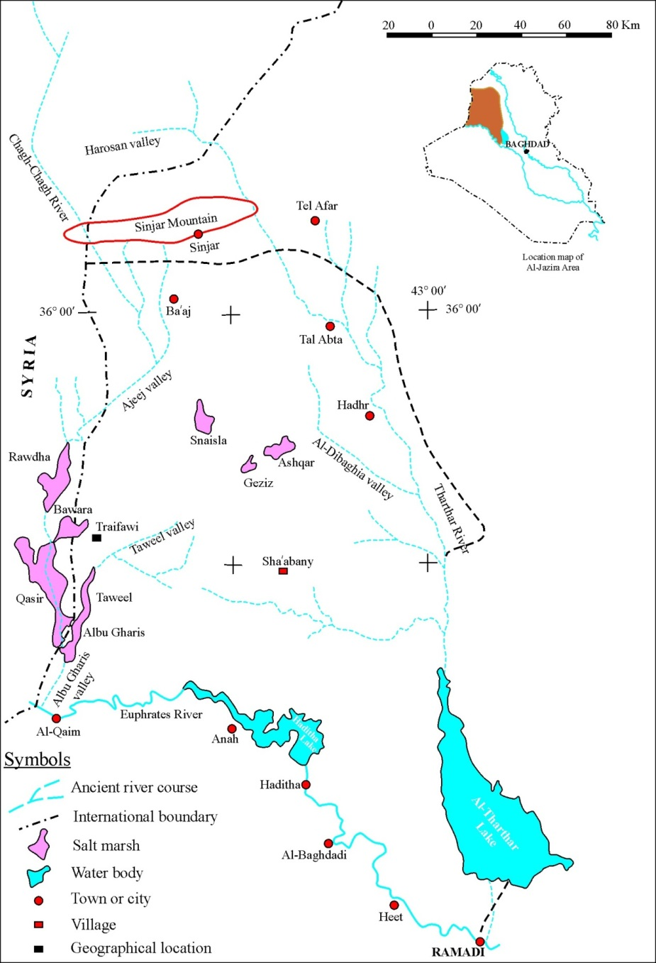

Fig.1: Location map and courses of ancient rivers in Al-Jazira Area
(Modified from Al-Sakini, 1993, in Ma'ala, 2009)

- Materials Used and Methodology
To achieve the aim of this study, the following materials were used:
- Google Earth and Satellite images of different bands.
- Topographic maps at scale of 1: 100 000 and 1: 25 000.
- Relevant geological, geophysical and structural geology reports, maps and published articles.
- Relevant historical books.

The Google Earth and Satellite images were used to follow-up the traces of the abandoned river; inside Syria, which was originally crossing Sinjar Mountain. They also were used to locate the terraces of the river on the top of Sinjar Mountain, at the crossing area. Geological maps, reports and publishes articles were used to indicate the surface and subsurface regional and local geology of the studied area. Historical books were used to know about the initial course of the abandoned Jagh Jagh River and the evolution of Wadi Al-Ajeej; wadi is a local name for a valley.

- Geological Setting
The geological setting of the studied area is briefed as:

  - Geomorphology
The developed geomorphological units and existing features in the studied area are mentioned hereinafter and represented in generalized geomorphological map (Fig.2), based mainly on Ma'ala (2009). Those which are directly involved with the aim of this study are briefly described.

- Units of Structural – Denudational Origin: Two units are developed, these are: Plateau and Dissected Slopes.

- Units of Denudational Origin: Four units are developed, they are: Pediment, Badlands, Erosional Plains, and Mesas and Buttes.

- Units of Solutional Origin: Two units are well developed, these are: Sinkholes and Salt Marshes.

- Units of Fluvial Origin: Four units are developed, these are:

River Terraces: These are well developed along Wadi Al-Ajeej, in 3 levels: (15 – 25) m, (30 – 40) m and (50 – 60) m; above the present valley floor, respectively (Ma'ala, 1976). The fourth stage might be developed in the Syrian territory, as seen in the Google Earth and Satellite images.

Infilled Valleys: Many ephemeral valleys are potential areas for flooding during heavy rain showers and form parts of Wadi Al-Ajeej.

Depressions Fill Sediments: Several closed depressions are filled by brown and black muddy sediments rich by SO₄, underlying the salt crust, such as Snaisla, Ashqar, Geziz, Umm Dhiaba, Gat'tar Salt Marshes. Some of them have direct relation with Wadi Al-Ajeej.

Alluvial Fans: Gravel accumulations were recognized at the foot of Snaisla – Tel Abta Cliff. These accumulations are most probably relict sediments of ancient alluvial fans (Ma'la, 2009). They might be originated from the old Jagh Jagh River.

- Units of Evaporation Origin: Three units are developed, these are:

Calcrete: Calcrete, covers the southwestern part of the extreme northern part of the studied area by uniform and compacted blanket of calcareous material, range in thickness between (0.25 – 0.5) m.

Gypcrete: The gypcrete covers many parts in the studied area, top of hills and mesas and partly their slopes, as well along the rims of salt marshes.

Halcrete: Halcrete is developed in salt marshes. It consists of light brown and black muddy sediments overlain by thin crust of NaCl (Halite) with crystals of gypsum (Tobbia, 1996, in Ma'la, 2009).

The first two units indicate wet climate, with presence of old streams and valleys.

20 Km

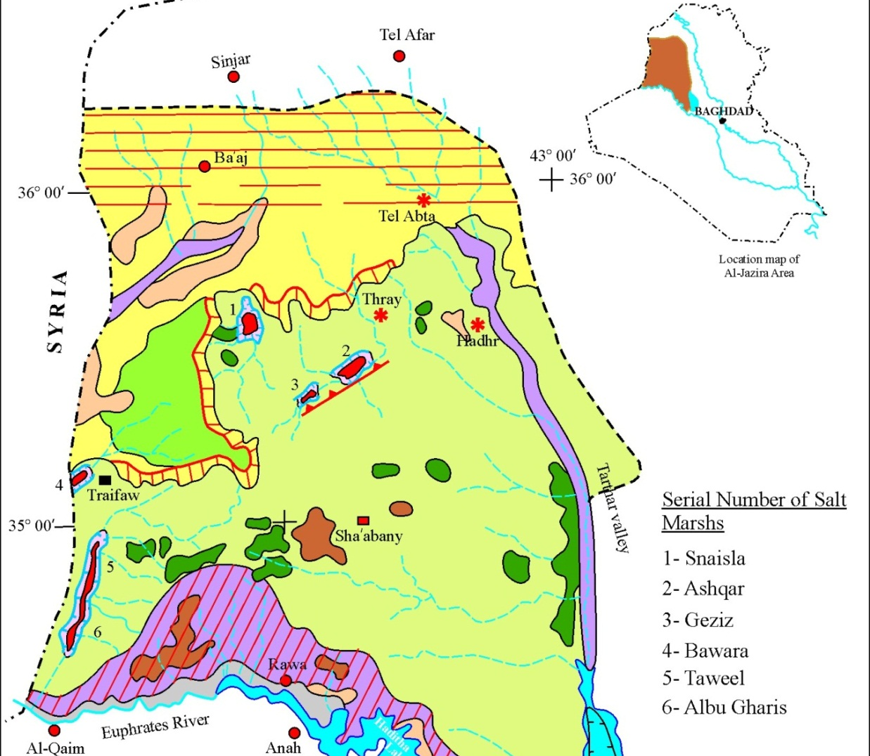
20 Km

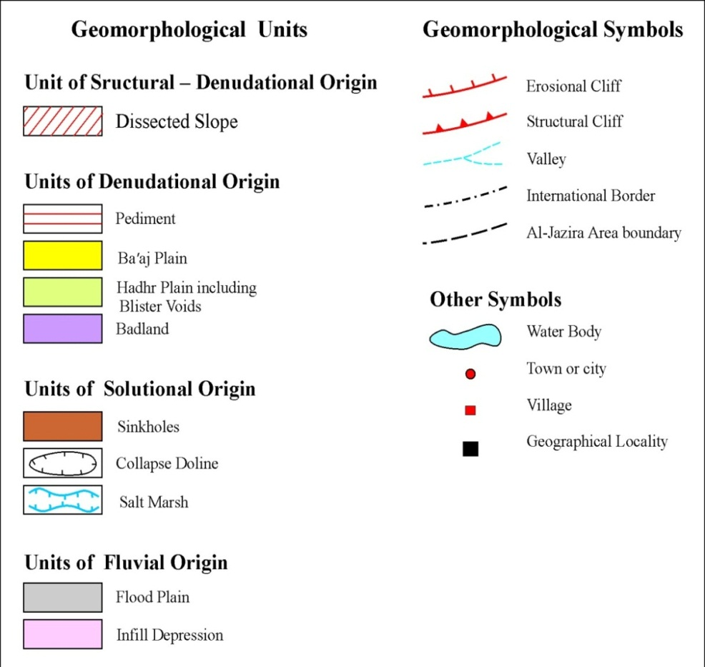

Fig.2: Geomorphological Map of Al-Jazira Area (after Ma'ala, 2009)
- Forms of Aeolian Origin: The following two forms are developed:

Sand Dunes and Nebkhas.

- Form of Anthropogenic Origin: Only some Anthropogenic Hills are present in the studied area.

  - Stratigraphy
The exposed formations in the near surroundings of Wadi Al-Ajeej are the Fatha and Injana formations, based mainly on Hassan and Hassan (1994). They are briefly described hereinafter.

- Fatha Formation (Middle Miocene): This formation is exposed widely in the southern part of the studied area. It is well developed in cyclic nature succession; each cycle consists of marl, red claystone, limestone and gypsum.

- Injana Formation (Late Miocene): This formation is exposed widely in the studied area, covering almost the course of Wadi Al-Ajeej. The Injana Formation consists of rhythmic fining upward cycles, each cycle consists of reddish brown and grey sandstone, siltstone and claystone, thin horizon of oolitic limestones occurs too in the lowermost part of the formation (Ma'ala, 1976).

- Quaternary Sediments: Terraces, depression fill and valley fill sediments; alluvial fans, gypcrete and sabkha are the main types of sediments, developed in different parts of the studied area.

  - Structure and Tectonics
The studied area is located within the Outer Platform of the Arabian Plate; Al-Jazira Zone, part of the Mesopotamia Foredeep. It is dominated by a network of subsurface extensional structures. These structures are mainly ENE – WSW and NW – SE trending grabens and normal faults (Fouad, 2012).

From neotectonic point of view, Sissakian and Deikran (1998) showed that the Jazira Area is uplifted with amount of (200 – 250) m, with estimated rate of uplift to be (0.1 – 0.2) cm/ 100 years.

- Wadi Al-Ajeej
Wadi Al-Ajeej is one of the main valleys in the Jazira Area (Plain), its length ia about 35 Km as measured from the Iraqi –Syrian border; upstream until the point where it starts gathering its main branches. It extends in ENE – WSW trend; almost in a straight line (point A in Fig.3). The main branches are of two main trends N – S and NNW – SSE, the length of these branches ranges from 30 to 55 Km. The nowadays branches are flowing from the southern flank of Sinjar Mountain, they are divided into two main trends, generally east and west of the Longitude 41ᴼ 40'. However, the old course of the ancient Jagh Jagh River can still be faintly traced where it was crossing Sinjar Mountain (left of the point B in Fig.3) before abandoning its ancient course, almost parallel to the Iraqi – Syrian international border and near the small pond, which still can be observed (Point P in Fig.3).

Three terrace levels are present along Wadi Al-Ajeej (Ma'ala, 1976), beside other two levels on the top of Sinjar Mountain, where the ancient Jagh Jagh River was crossing the mountain; as evidenced in Fig (3). However, tectonic forces and growing of Sinjar anticline and other small anticlines; inside Syria, have shifted the main course of Jagh Jagh River and separated it into two parts, the southern one is called Wadi Al-Ajeej.

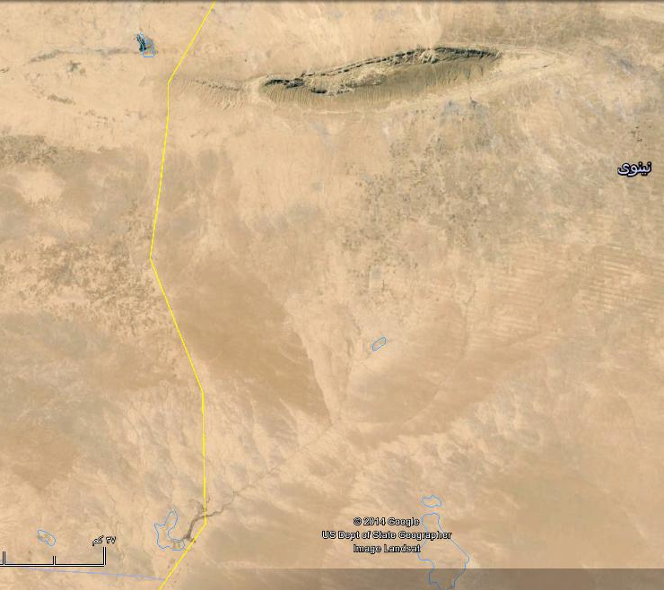
P
Syria
Iraq
B
E
A
D
C

Fig.3: Google Erth image of Wadi Al-Ajeej.
A) Represnts the gathering point of the branches,
B) Represnts the old crossing point of Jagh Jagh River to Sinjar Mountain
C – D – E) Erosional cliff, P is a small pond

The main trend of the nowadays Wadi Al-Ajeej is ENE – WSW, which is the main trend of grabens and normal Faults (Fig.4) (Fouad, 2009). Most probably it runs following the trace of a subsurface structure, which is located between Khlesia Graben and Tel Hajar subsurface anticline, although not recognized and presented in Fig.(4). Moreover, it is parallel to the well developed two lineaments that bound Ashqar Salt Marsh, which is believed to be formed due to subsidence of a graben associated with karstification (Sissakian and Abdul Jab'bar, 2009).

- Discussion
The origin and evolution of Wadi Al-Ajeej is discussed in details, based on geological and historical evidences, hereinafter.

  - Geological Evidences
The following geological evidences are used to indicate the origin and evolution of Wadi Al-Ajeej.

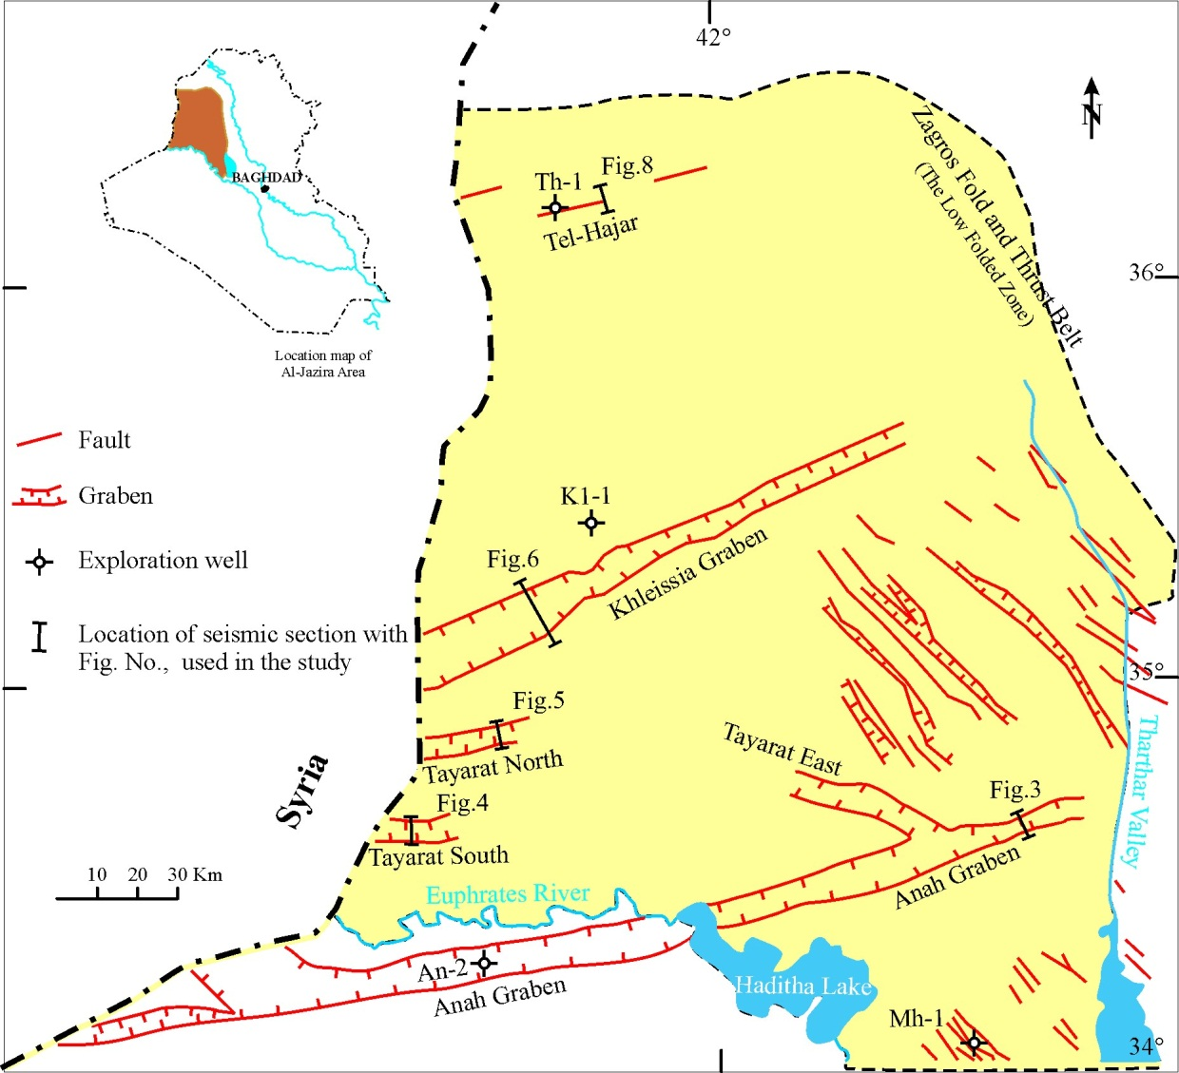

Fig.4: Structural map showing the subsurface extensional structures of Al-Jazira Area
(after Fouad and Nasir, 2009)

- River Terraces: Along the present course of Wadi Al-Ajeej, Ma'ala (1976) recognized three levels of river terraces, they are (15 – 25) m, (30 – 40) m and (50 – 60) m; above the present valley floor, respectively. They are composed mainly of limestone and chert gravels. The gravels are mainly rounded to sub-rounded. A valley with the same size and order of the present day Wadi Al-Ajeej is incapable of depositing three levels of river terraces, with the above mentioned attitudes. Moreover, Ma'ala (2009) mentioned that a fourth level may be present inside Syria.

In this research however, two higher (older) levels on the top of Sinjar Mountain, where the ancient Jagh Jagh River was crossing the mountain (Point A in Fig.5) were recognised, beside the presence of a lower level along the line B – C – D (Fig.5). If not so, then how the terraces are present at those localities; on the top of the mountain. Therefore, the only explanation for the presence of the terraces is that the presence of a river capable in incising its course and depositing terraces, continuously.

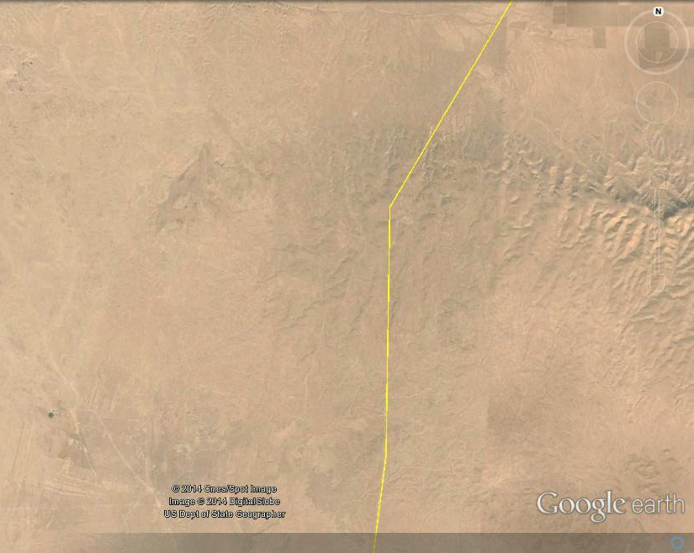
A
D
C
B

Fig. 5: Google Earth image. Two terrace levels (Dark toned patches)
at A and B. Note the scattered terraces south of the point B, along C and D

- Alluvial Fans: Alluvial fans are well developed along both northern and southern limbs of Sinjar anticline, especially the northern limb, where Sissakian (2011) had recognized four stages of alluvial fans and two stages along the southern limb. When inspecting thoroughly Google Earth and satellite images where the ancient Jagh Jagh River was crossing, no alluvial fans can be observed at both limbs of Sinjar anticline, (Fig.6), because there was a river course flowing from NNW – SSE and crossing the mountain. Therefore, the drainage system and the gradient were not favorable for development of alluvial fans on both limbs of the anticline.

A
B

Fig.6: Google Earth image of Sinjar anticline.
Note the dens net of alluvial fans inside Iraq and their absence near points A and B
- Growth of Folds: The ancient Jagh Jagh River was crossing Sinjar anticline and was flowing southeast wards relative to the course of the present day Wadi Al-Ajeej. The crossing was through a water gap developed where the closure of the Fatha Formation occurs parallel to the western plunge of Sinjar anticline (Fig.7). However, the water gap was abandoned due to the growth of Sinjar anticline and another small anticline, which is north of Sinjar abticline (point A in Fig.7), besides the climatic changes during Pleistocene. The growth of Sinjar anticline is confirmed by Ma'la (1977) and Sissakian (2011), the latter proved the growth depending on the presence of four stages of alluvial fans along the northern limb of Sinjar anticline. Moreover, Fouad and Nasir (2009) also confirmed the growth of Sinjar anticline. Abandoning of water gaps due to lateral and vertical growth of anticlines are a well know process world wide (Keller and Pinter, 2002 and Ramsey et al., 2008). It is worth to mention that the abandoned water gap should form a wind gap, in Sinjar anticline, even the wind gap is almost vanished due to continuous growth of the anticline.

The Jagh Jagh River, after abandoning its course across Sinjar anticline, changed its course towards E – W and merged in Khabour River (of Syria), which in turn merges into the Euphrates River; inside Syria. The southern part of the abandoned river; south of Sinjar anticline; called Wadi Al-Ajeej had also truncated due to the continuous growth of Khlesia High, consequently a new course was followed in ENE – WSW trend. This trend is the main trend of the subsurface structures in Al-Ajazira Area (Fouad and Nasir, 2009). The growth of of the Khlesia High is confirmed by the presence of a long crescent-shaped erosional cliff and the developed depressions, which have formed salt marshes (Figs.2, 3 and 8).

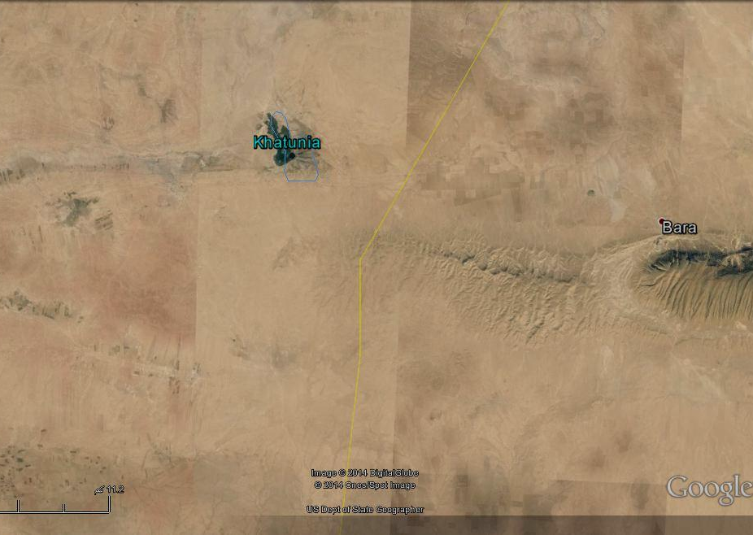
B
A

Fig.7: Google Earth image of Sinjar anticline.
A) Small growing anticline, B) Closure area of the Fatha Formation

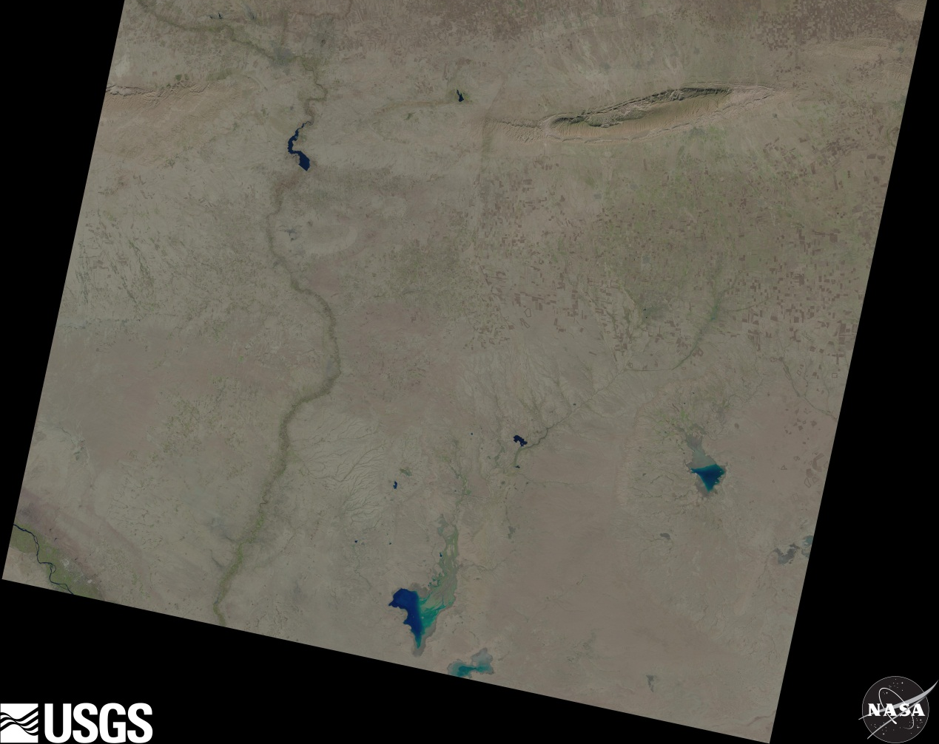
A
B
C

Fig.8: Landsat image of Wadi Al-Ajeej showing it's nowadays course.
Note the erosional cliff (A, B and C); developed due to the Khlesia High

  - Hydrogeological Evidence
Beside the present drainage system and the developed terrace system, the presence of a small and longitudinal water pond; called Kahtuniya (Figs.7 and 8) indicates the presence of old Jagh Jagh River, otherwise how the water pond was formed with extension that is parallel to the abandoned river.

  - Historical Evidences
The upper reaches of the Jagh Jagh River is in Turkey with length of 124 Km; only 100 Km is running in Syria, joining the Khabour River of Syria. It was called "Mekdonyous" by the Romans and as "Al-Harmas" by the Arabs, while the name Jagh Jagh is a Turkish term meaning a net (Internet data).

Sossa (1965) in Al-Sakini (1993) pointed out that Jagh Jagh River was well headed from south of Turkey, which was crossing through the western side of Sinjar mountain and running toward south, along the Iraqi – Syrian border, to supply many sabkhas, named: Bawara, Taweel and Albu Gharis (in Iraq) and Rawdha and Qsair (in Syria), then merging into the Euphrates River (north of Al-Qaim vicinity). The Jagh Jagh River was characterized by natural formation of elongated small swamps or lakes, which were developed along middle part and downstream (Fig.2), when the river was running southwards. Later on, the river was dried, in late Holocene, due to influence of neotectonic activity in Sinjar mountain (Mitchel, 1957), which caused the development of dry marshes or small lakes. As well, because of the high evaporation, the depressions and/ or small lakes became sabkhas or salt marshes.
- Dating
To estimate the dating of the Wadi Al-Ajeej and when it was separated from Jagh Jagh River, historical data and geological data; exposure dating method (Keller and Pinter, 2002) were used. The occurrence of three terrace levels along the course of Wadi Al-Ajeej (Ma'ala, 2009) is clear indication that Wadi Al-Ajeej was not separated from Jagh Jagh River during the whole Pleistocene, because the youngest stage is estimated to be of Late Pleistocene (Ma'ala, 2009). Therefore, the separation should be after the Late Pleistocene; consequently, we estimate that the separation was during late Holocene and younger, since some historians mentioned that Jagh Jagh River was crossing Sinjar Mountain and flowing southeastward parallel to Tharthar Valley (Soosa, 1966). The authors also estimated the change of Wadi Al-Ajeej towards ENE – WSW was almost at the same duration; when Wadi Al-Ajeej was separated from Jagh Jagh River. This assumption is based on the same continuous tectonic events in the involved vicinity; including growth of Sinjar anticline, the small domal anticline located north of Sinjar; inside Syria, the growth of Khlesia High, and the development of the depressions of the salt marshes in the vicinity.

- Conclusions
The following could be concluded from this study:
- Wadi Al-Ajeej was a part of the Jagh Jagh River, which was crossing Sinjar anticline, about 13 Km west of the Iraqi – Syrian nowadays borders, along the plunge of the Fatha Formation.
- Two terrace levels were recognized on the top of Sinjar anticline, at the crossing area, beside three levels along the present day of Wadi Al-Ajeej course.
- No alluvial fans developed on both sides of Sinjar anticline, near the old crossing area, in contrary of tens of alluvial fans east of the old crossing area and on both limbs.
- The Jagh Jagh River was crossing Sinjar anticline through a water gap, which was abandoned due to lateral and vertical growth of the anticline, beside climatic changes.
- The old course of the Jagh Jagh River; across Sinjar anticline can still be traced faintly in Google Earth and Satellite images.
- The main trend of Wadi Al-Ajeej was NW – SE, but was changed to ENE – WSW due to the Khlesia High, and following most probably a subsurface graben, which are very common in the Jazira Area.
- The separation of Wadi Al-Ajeej from Jagh Jagh River was during late Holocen and younger.

ACKNOWLEDGMENT
The authors express their thanks to Mr. Arsalan Othman for providing the Landsat image of the studied area and Mr. Hayder H.Taha (both from Iraq Geological Survey, Baghdad) for arranging the figures in the text and pointing the required marks on them.

REFERENCES
Al-Sakini, J.A., 1993. New Look on the History of the Old Tigris and Euphrates Rivers, in Light of Geological Evidences, Recent Archeological Discoveries and Historical Sources. Ministry of Oil, Iraq (in Arabic).
Fouad, S.F.A., 2012. Tectonic Map of Iraq, scale 1: 1000 000, 3rd edit. Publications of Iraq Geological Survey, Baghdad, Iraq.
Fouad, S.F.A. and Nasir, W.A., 2009. Tectonic and structural evolution of Al-Jazira Area. In: Geology of the Iraqi Jazira Area. Iraqi Bulletin of Geology and Mining (ISSN- 1811.4539), Special Issue, No. 3, p. 33 – 48.
Hassan, K.M. and Hassan, E.A., 1994. The Geology of Sur Quadrangle, sheet No. NI-38-4, scale 1: 250 000. Publications of Iraq Geological Survey, Baghdad, Iraq.
Keller, E.A. and Pinter, N., 2002. Active Tectonics, Earthquakes, Uplift and Landscape, 2nd edit. Prentice Hall, 362 pp.
Ma'ala, K.A., 1976. Report on the Regional Geological Mapping of Hadhr Area. Iraq Geological Survey Library report no. 742.
Ma'ala, K.A., 1977. Report on the Regional Geological Mapping of Sinjar Area. Iraq Geological Survey Library report no. 860.
Ma'ala, K.A., 2009. Geomorphology. In: Geology of the Iraqi Jazira Area. Iraqi Bulletin of Geology and Mining (ISSN- 1811.4539), Special Issue, No. 3, p. 5 – 31.
Ma'ala, K.A., and Al-Kubaysi, 2009. Stratigraphy, In: Geology of the Iraqi Jazira Area. Iraqi Bulletin of Geology and Mining (ISSN- 1811.4539), Special Issue, No. 3, p. 49 – 70.
Mitchell, R.C., 1957. Recent Tectonic Movements in the Mesopotamian Plain. Geographical Jour. Vol.CXXII.
Ramsey, L.A., Walker, R.T. and Jackson, J., 2008. Fold Evolution and Drainage Development in the Zagros Mountains of Fars Province, SE Iran. Basin Research, Vol. 20, p. 23 – 48.
Sissakian, V.K., 2011. Alluvial fans of Sinjar Mountain, northwest Iraq. Iraqi Bulletin of Geology and Mining (ISSN- 1811.4539), Vol. 7, No. 2, p. 9 – 26.
Sissakian, V.K. and Hafidh, Sh.Q., 1993. The Geology of Haditha Quadrangle, sheet No. NI-37-7, scale 1: 250 000. Publications of Iraq Geological Survey, Baghdad, Iraq.
Sissakian, V.K. and Hafidh, Sh.Q., 1995. The Geology of Wadi Al-Miyah and Albu Kamal Quadrangles, sheets No. NI-37-7 and NI-37-8, scale 1: 250 000. Publications of Iraq Geological Survey, Baghdad, Iraq.
Sissakian, V.K. and Deikran, D.B., 1998. Neotectonic Map of Iraq, scale 1: 1000 000. Publications of Iraq Geological Survey, Baghdad, Iraq.
Sissakian, V.K. and Ibrahim, F.A., 2005. Geological Hazards Map of Iraq, scale 1: 1000 000. Publications of Iraq Geological Survey, Baghdad, Iraq.
Sissakian, V.K. and Al-Mousawi, H.A., 2007. Karstification and Related Problems, Examples from Iraq. Iraqi Bulletin of Geology and Mining (ISSN- 1811.4539), Vol. 3, No. 2, p. 1 – 12.
Sissakian, V.K., and Abdul Jabbar, M.F., 2009. Remote Sensing and GIS Applications in Detecting Geohazards in the Jazira Area, West Iraq. Iraqi Bulletin of Geology and Mining (ISSN- 1811.4539), Vol. 5, No. 1, p. 47 – 62.
Sissakian, V.K. and Fouad, S.F., 2012. Geological Map of Iraq, scale 1: 1000 000, 4th edit. Publications of Iraq Geological Survey, Baghdad, Iraq.
Sissakian, V.K., Ibrahim, F.A. and Sa'ed, Z.B., 2006. Geological Hazards Map of Haditha Quadrangle, scale 1: 250 000, sheet No. NI-38-5. Iraq Geological Survey Library report no. 2993.
Sissakian, V.K., Abdul Ahed, I.D. and Ibrahim, F.A., 2007. Geological Hazards Map of Al-Ramdi Quadrangle, scale 1: 250 000, sheet No. NI-38-9. Iraq Geological Survey Library report no. 3031.
Soosa, A., 1965. Floods of Baghdad in History, Vol.1, 3rd edit. Al-Adeeb Press, Baghdad, Iraq (in Arabic).
Soosa, A., 1966. Floods of Baghdad in History, Vol.3. Al-Adeeb Press, Baghdad, Iraq (in Arabic).
White, W.B and White, E.L., 2006. Size scales for Closed Depression Landforms: The Place of "Tiankengs". IGU Speleogenesis and Evolution of Karst Aquifers, the Online Scientific Journal, ISSN 1814 – 294X.
Zuwaid, Q.A., 1988. The Geology of Al-Qayara Quadrangle, sheet NI-38-5, scale 1: 250 000. Publications of Iraq Geological Survey, Baghdad, Iraq.

About the authors

Mr. Varoujan K. Sissakian graduated from University of Baghdad in 1969 with B.Sc. degree in Geology, and M.Sc. in Engineering Geological Mapping from I.T.C., the Netherlands in 1982. He joined GEOSURV in 1971 as a field geologist, and was nominated as Expert in 2005; he was the Director of the Geology Department, since 2004 until October 10, 2012 when he was retired. He has 123 documented reports in Iraq Geological Survey's library and 73 published articles in different geological aspects. His major fields of interest are geological maps, the stratigraphy of Iraqi territory and geological hazards. He was the Deputy Vice President of the Middle East Sub-commission of CGMW, Paris, from February 2010 until August, 2012.
e-mail: varoujan49@yahoo.com
Mailing address: Iraq, Erbil, Ainkawa, District 108, 245/7/404

Mrs. Mawahib F. Abdul Jab'bar graduated from Baghdad University in 1994 and joined GEOSURV in 1999; she got her M.Sc. Degree in Geomorphology (Morphotectonics) in 2012, from Baghdad University. Currently, she is working as Assistant Chief Geologist in the Geology Department. She has 19 documented reports in Iraq Geological Survey's library and 14 published articles in GIS applications and remote sensing interpretations. Her main field of interest is GIS applications and using soft wares for remote sensing interpretations.
e-mail: mawaheb_geosurv@yahoo.com
Mailing address: Iraq Geological Survey, P.O. Box 986, Baghdad, Iraq

