The Measurement of The Volatility of Market Risk of Viet Nam Insurance Industry After The Low Inflation Period 2015-2017

Dinh Tran Ngoc Huy, MBA¹*²*

^{1*} Faculty of Economics, Binh Duong University, Viet Nam
^{2*} MBA, Graduate School of International Management, International University of Japan, Niigata, Japan
*Corresponding Author: e-mail: dtnhuy2010@gmail.com, Tel +84-08-39934160, SkypeID: dinhhuy121

Abstract

This paper measures the volatility of market risk in Viet Nam insurance industry after this period (2015-2017). The main reason is the necessary role of the insurance company system in Vietnam in the economic development and growth in recent years always go with risk potential and risk control policies.
This research paper aims to figure out how much increase or decrease in the market risk of Vietnam insurance firms during the post-low inflation environment 2015-2017.
First, by using quantitative combined with comparative data analysis method, we find out the risk level measured by equity beta mean in the insurance industry is acceptable, as it is little lower than (<) 1.
Then, one of its major findings is the comparison between risk level of insurance industry during the financial crisis 2007-2009 compared to those in the post-low inflation time 2015-2017. In fact, the research findings show us market risk level during the post-low inflation time has increased much.
Finally, this paper provides some ideas that could provide companies and government more evidence in establishing their policies in governance. This is the complex task but the research results shows us warning that the market risk might be higher during the post-low inflation period 2015-2017. And our conclusion part will recommends some policies and plans to deal with it.

JEL classification numbers: G010, G390
Keywords: risk management, asset beta, market risk, financial crisis, insurance industry, macro policy

1 Introduction
Throughout many recent years, Viet Nam insurance market is evaluated as one of active markets, which has certain positive effect for the economy and become one of vital players in the financial system of the nation.
Insurance companies have been affected by inflation. Generally speaking, central banks aim to maintain inflation around 2% to 3%. Increases in inflation significantly beyond this range can lead to possible hyperinflation, a devastating scenario in which inflation rises rapidly out of control, and therefore harm the insurance industry. Looking at exhibit 1, we can see the Vietnam economy has controlled inflation well.
This study will calculate and figure out whether the market risk level during the post-low inflation time (2015) has increased or decreased, compared to those statistics in the financial crisis time (2007-2009).
The paper is organized as follows: after the introduction it is the research issues, literature review, conceptual theories and methodology. Next, section 3 will cover main research findings/results. Section 4 gives us some discussion and conclusion and policy suggestion will be in the section 5.
2 Body of manuscript

2.1 Research Issues
The scope of this study are:
Issue 1: Whether the risk level of insurance firms under the different changing scenarios in post-low inflation period 2015-2017 increase or decrease so much, compared to in financial crisis 2007-2009?
Issue 2: Because Viet Nam is an emerging and immature financial market and the stock market still in the starting stage, whether the dispersed distribution of beta values become large in the different changing periods in the insurance industry.
This paper also tests three (3) below hypotheses:
Hypothesis 1: Comparing two (2) periods, during the financial crisis impact, the beta or risk level of listed companies in insurance industry will relatively higher than those in the post-low inflation environment.
Hypothesis 2: Because Viet Nam is an emerging and immature financial market and the stock market still in the recovering stage, there will be a large disperse distribution in beta values estimated in the insurance industry.
Hypothesis 3: With the above reasons, the mean of equity and asset beta values of these listed insurance companies tend to impose a high risk level, i.e., beta should higher than (>) 1. This hypothesis is based on the context of emerging markets including Viet Nam where there lacks of sufficient information and data disclosure although it might have high growth rate.
2.2 Literature review
Recently there are banking regulations such as Basel II, III which help to reduce operation risk for banks. Martin and Sweder (2012) were in favor of Basel III in the context of less leverage and higher loss absorption capacity of capital. They also pointed out that bank systemic fragility may be caused by incentives embedded in the capital structure of banks . Capital structure including debt is one of major measures to ensure bank operation smoothly. That is the reason many banks in developing countries going for listing on the stock market. Then, Najeb (2013) provided evidence on the impact of stock market development on investment and there is a positive relationship between efficient stock markets and economic growth.
Yener et all (2014) found out that increase in banks' risk might be due to unusually low interest rates through an extended period. During the financial crisis 2007-2009 in Viet Nam and global financial markets, high inflation causing high lending rates have created risks for many industries such as real estate and the whole economy. Mohamad et all (2014) showed that financial risk is vital through using both return on asset and return on equity in the performance equation. This result also implied that we cannot avoid the inverse relation of financial risk and performance; therefore, bank system would be better to make a trade-off between risk and performance.
In Viet Nam and other developing countries, banks operate based on money borrowing from financial markets and depositors or investors, also there is cross-ownership between banks. Next, Emilios (2015) mentioned that the leverage cycle might cause financial instability and also the effect of leverage restraints on good bank governance and allocative efficiency.
Atousa and Shima (2015) found out the economic growth and life insurance sector growth has positively correlated. Then, Gunarathna (2016) revealed that whereas firm size negatively impacts on the financial risk, financial leverage and financial risk has positive relationship.
Aykut (2016) suggested two major results: (i) Credit risk and Foreign exchange rate are positively correlated, while banking sector has been affected not much by interest rate, (ii) conditional bank stock return volatility has been affected positively and significantly by credit and market risk. Then, Mojtaba and Davoud (2016) generated results showing that private banks are less successful in using risk management tools in compared with public banks.
Over past years, monetary policies have certain impacts on bank system. Last but not least, Riet (2017) mentioned that after the euro area crisis, the ECB still solved a series of complex monetary policy challenges. From June 2014 its task became to design a sufficiently strong monetary stimulus that could reach market segments that were deprived of credit at reasonable costs and to counter the risk of a too prolonged period of low inflation. Hami (2017) showed that financial depth has been affected negatively by inflation in Iran during the observation period.
Finally, Chizoba et all (2018) figured out that inflation rate and insurance penetration had a positive correlation in the Nigerian insurance industry.

2.3 Conceptual theories
Positive sides of low inflation: Low (not negative) inflation reduces the potential of economic recession by enabling the labor market to adjust more quickly in a downturn, and reduces the risk that a liquidity trap prevents monetary policy from stabilizing the economy. This is explaining why many economists nowadays prefer a low and stable rate of inflation. It will help investment, encourage exports and prevent boom economy. The central bank can use monetary policies, for instance, increasing interest rates to reduce lending, control money supply or the Ministry of finance and the government can use tight fiscal policy (high tax) to achieve low inflation.
Negative side of low inflation: it leads to low aggregate demand and economic growth, recession potential and high unemployment. Production becomes less vibrant. Low inflation makes real wages higher. Workers can thus reduce the supply of labor and increase rest time. On the other hand, low product prices reduce production motivation. The central bank might consider using monetary policy to stimulate the economic growth during low-inflation environment. It means that an expansionary monetary policy can be used to increase the volume of bank loans to stimulate the economy.
Financial and credit risk in the bank system can increase when the financial market becomes more active and bigger, esp. with more international linkage influence. Hence, central banks, commercial banks, organizations and the government need to organize data to analyze and control these risks, including market risk.
For the insurance industry, high inflation may harm the insurance companies and cause higher losses and increase the operational costs. In case of low inflation, interest rates may fall and hence, it is not a benefit for insurers’ investment portfolio. Hence, risk assessment and control mechanisms are necessary for insurers to reduce these losses.
2.4 Methodology
We use the data from the stock exchange market in Viet Nam (HOSE and HNX) during the financial crisis 2007-2009 period and the post – low inflation time 2015-2017 to estimate systemic risk results. We perform both fundamental data analysis and financial techniques to calculate equity and asset beta values.
In this study, analytical research method and specially, comparative analysis method is used, combined with quantitative data analysis. Analytical data is from the situation of listed insurance firms in VN stock exchange.
Finally, we use the results to suggest policy for both these enterprises, relevant organizations and government.

3 Main Results
3.1 General Data Analysis
We get some analytical results form the research sample with 7 listed firms in the insurance market with the live date from the stock exchange.
3.2 Empirical Research Findings and Discussion
In the below section, data used are from total 7 listed insurance industry companies on VN stock exchange (HOSE and HNX mainly). Different scenarios are created by comparing the calculation risk data between 2 periods: the post – low inflation environment 2015-2017 and the financial crisis 2007-2009.
Market risk (beta) under the impact of tax rate, includes: 1) equity beta; and 2) asset beta. We model our data analysis as in the below figure:
Figure 1 – Analyzing market risk under two (2) scenarios: post – low inflation period 2015-2017 compared to the financial crisis 2007-2009
 | Risk level (equity beta) | Risk level (asset beta) | Other measures | Gap
Post – low inflation period | Scenario … | Scenario .. | Scenario .. | Analysis
Financial crisis time

Table 1 – The Volatility of Market Risk (beta) of Insurance Industry in the post- low inflation environment 2015-2017
 |  | 2015-2017 (post - low inflation)
Order No. | Company stock code | Equity beta | Asset beta (assume debt beta = 0) | Financial leverage | Note
1 | BVH | 1.588 | 0.348 | 78.1% | assume debt beta = 0; debt ratio as in F.S 2015
2 | PVI | 0.827 | 0.359 | 56.5%
3 | ABI | 0.353 | 0.161 | 54.5%
4 | BIC | 0.679 | 0.315 | 53.7%
5 | BMI | 0.924 | 0.409 | 55.8%
6 | PGI | 0.139 | 0.030 | 78.5%
7 | PTI | 0.935 | 0.402 | 57.0%

The above table shows us that with the using of leverage ranging from 53% to 78%, equity beta values vary from 0.1 to 1.5 for insurance companies.

Table 2 – The Statistics of Volatility of Market Risk (beta) of Insurance Industry in the post- low inflation environment 2015-2017
 | 2015-2017 (post - low inflation)
Statistic results | Equity beta | Asset beta (assume debt beta = 0)
MAX | 1.588 | 0.409
MIN | 0.139 | 0.030
MEAN | 0.778 | 0.289
VAR | 0.2171 | 0.0200
Note: Sample size : 7(we just take a sample of 7 insurance firms to make comparison in the below table)

Table 3 – The Comparison of Volatility of Market Risk (beta) of Insurance Industry in the post- low inflation environment 2015-2017 and the financial crisis 2007-2009
 |  | 2007-2009 (financial crisis) |  | 2015-2017 (post - low inflation)
Order No. | Company stock code | Equity beta | Asset beta (assume debt beta = 0) | Equity beta | Asset beta (assume debt beta = 0) | Note
1 | BVH | 0.966 | 0.252 | 1.588 | 0.348 | assume debt beta = 0; debt ratio as in F.S 2015 and 2008
2 | PVI | 0.937 | 0.58 | 0.827 | 0.359
3 | ABI | 0.288 | 0.104 | 0.353 | 0.161
4 | BIC | 0.114 | 0.037 | 0.679 | 0.315
5 | BMI | 1 | 0.744 | 0.924 | 0.409
6 | PGI | 0.15 | 0.067 | 0.139 | 0.030
7 | PTI | 0.145 | 0.063 | 0.935 | 0.402

Table 4 – The Difference between Volatility of Market Risk (beta) of Insurance Industry in the post- low inflation environment 2015-2017 and the financial crisis 2007-2009
 |  | GAP (+/-) 2015-17 compared to 2007-09
Order No. | Company stock code | Equity beta | Asset beta (assume debt beta = 0) | Note
1 | BVH | 0.622 | 0.096 | values (2015-17) minus (-) 2007-09
2 | PVI | -0.110 | -0.221
3 | ABI | 0.065 | 0.057
4 | BIC | 0.565 | 0.278
5 | BMI | -0.337 | -0.335
6 | PGI | -0.011 | -0.037
7 | PTI | 0.790 | 0.339

Table 5 – Statistics of Volatility of Market Risk (beta) of Insurance Industry in the post- low inflation environment 2015-2017 compared to those in the financial crisis 2007-2009
 | 2007-2009 (crisis) |  | 2015-2017 (post - low inflation) |  | GAP (+/-) 2015-17 compared to 2007-09
Statistic results | Equity beta | Asset beta (assume debt beta = 0) | Equity beta | Asset beta (assume debt beta = 0) | Equity beta | Asset beta (assume debt beta = 0)
MAX | 1.261 | 0.744 | 1.588 | 0.409 | 0.327 | -0.335
MIN | 0.114 | 0.037 | 0.139 | 0.030 | 0.025 | -0.007
MEAN | 0.552 | 0.264 | 0.778 | 0.289 | 0.226 | 0.025
VAR | 0.2352 | 0.0811 | 0.217 | 0.020 | -0.018 | -0.061
Note: Sample size : 7

Based on the above calculation result table, we analyze data as follows:
Firstly, we see in the table 1 that there is only 1 insurance firm (over 7 insurers) have equity beta values higher (>) than 1 while there are 6 insurers with beta <1, which means risk level acceptable.
And table 2 provides evidence for us to see that equity beta mean of the sample is 0.778, just little lower than (>) 1. It is acceptable.
Then, looking at the table 3, we recognize that there is only 1 insurer with equity beta values > 1 (BVH) in the post-low inflation period 2015-17, the same as only 1 insurance company (BMI) with equity beta values >= 1 in the financial crisis 2007-2009.
Next, table 4 shows that most of the equity and asset beta values in the post- low inflation period are higher (>) than those in the financial crisis 2007-2009. Esp. the figures represent the risk level of 4 insurers (BVH, ABI, BIC, PTI) higher during the post-low inflation period, whereas risk level of 3 insurers (PVI, BMI, PGI) are lower during the post-low inflation time.
Furthermore, table 5 tells us all statistics of equity beta in the post-inflation period 2015-2017 are higher (>) than those in the financial crisis 2007-2009, whereas equity beta var , asset beta max and asset beta var are slower (<) than those in the financial crisis 2007-2009.
In addition to, looking at the below chart 1- , we can find out:
Values of equity beta max and equity beta mean in the post-low inflation 2015-2017 are much higher (>) than those in the crisis 2007-2009 while asset beta mean are just little higher (>) than those in the financial crisis 2007-2009. Additionally, asset beta max, asset beta var, and equity beta var are obviously lower. It means that the level of risk in the post – low inflation period 2015-17 is higher in general and in average, although the fluctuation in risk level measured by asset beta var is lower during the post-low inflation time.
And Exhibit 5 also shows us that the insurance industry, among three (3) groups: banking, insurance and stock investment companies, has the middle values of equity, asset beta mean as well as equity and asset bet var. Insurance group is the 2nd highest and the middle group with middle risk (beta values) compared to the 2 other financial industries.

Chart 1 – Statistics of Market risk (beta) in VN insurance industry in the post – low inflation period 2015-2017 compared to the financial crisis 2007-2009

4. Discussion for further researches
We can continue to analyze risk factors behind the risk scene (risk increasing as above analysis) in order to recommend suitable policies and plans to control market risk better. Also, the role of risk management and risk managers need to be developed more.
Last but not least, we still could perform a simulation analysis for testing changing scenarios of financial leverage which has an impact on equity and asset beta values for insurance industry.
5. Conclusion and Policy suggestion
In general, insurance companies system in Vietnam has been contributing significantly to the economic development and GDP growth rate of more than 6-7% in recent years. The above analysis shows us that most of risk measures (equity beta max, mean and var) are increasing during the post-low inflation period. Insurers and insurance system in Vietnam need to continue increase their corporate governance system, structure and mechanisms, as well as their competitive advantage to control risk better. For instance, insurance system might consider proper measures and plans to manage bad contracts. Another way is increasing productivity while reducing management or operational costs.
This research paper provides evidence that the market risk potential might be higher in 2015-2017 post-low inflation period (looking again chart 1 – equity beta mean values), while the Exhibit 3 also suggests that the credit growth rate increased in 2016 and slightly decrease in later years (2017-2018). It means that the local economy is trying to control credit growth reasonably, however we need to analyze risk factors more carefully to reduce more market risk.
Looking at the above chart 1, the result also rejects the hypothesis 1 mentioning that the mean of equity and asset beta values of these listed insurance companies tend to impose a high risk level, i.e., beta should higher than (>) 1. Because the equity beta mean is lower in the financial crisis period, it also rejects the hypothesis 1 saying that comparing two (2) periods, during the financial crisis impact, the beta or risk level of listed companies in insurance industry will relatively higher than those in the post-low inflation environment. Additionally, the above result rejects the hypothesis 2 stating that because Viet Nam is an emerging and immature financial market and the stock market still in the recovering stage, there will be a large disperse distribution in beta values estimated in the insurance industry.
Last but not least, as it generates the warning that the risk level might be higher in the post-low inflation period, the government and relevant bodies such as Ministry of Finance and State Bank of Vietnam need to consider proper policies (including a combination of fiscal, monetary, exchange rate and price control policies) aiming to reduce the risk and hence, help the bank system as well as the whole economy become more stable in next development stage.
Finally, this study opens some new directions for further researches in risk control policies in bank system as well as in the whole economy. For instance, how increasing inflation and deflation affects the risk level of insurance industry.

ACKNOWLEDGEMENTS
I would like to take this opportunity to express my warm thanks to Board of Editors and Colleagues at Citibank –HCMC, SCB and BIDV-HCMC, Dr. Chen and Dr. Yu Hai-Chin at Chung Yuan Christian University for class lectures, also Dr Chet Borucki, Dr Jay and my ex-Corporate Governance sensei, Dr. Shingo Takahashi at International University of Japan. My sincere thanks are for the editorial office, for their work during my research. Also, my warm thanks are for Dr. Ngo Huong, Dr. Ho Dieu, Dr. Ly H. Anh, Dr Nguyen V. Phuc, Dr Le Si Dong, Dr Dieu Thao and my lecturers at Banking University – HCMC, Viet Nam for their help.
Lastly, thank you very much for my family, colleagues in companies and universities, and brother in assisting convenient conditions for my research paper.

References

- Atousa, G., & Shima, S., (2015), The Relationship Between Life Insurance Demand and Economic Growth in Iran, Iranian Journal of Risk and Insurance, 1(1), 111-131.
- Aykut, E., (2016), The Effect of Credit and Market Risk on Bank Performance: Evidence from Turkey, International Journal of Economics and Financial Issues, 6(2), 427-434.
- Chatterjea, Arkadev., Jerian, Joseph A., & Jarrow, Robert A., (2001), Market Manipulation and Corporate Finance: A new Perspectives, 1994 Annual Meeting Review, SouthWestern Finance Association, Texas, USA.
- Chizoba, P.E., Eze, O.R.,& Nwite, S.C., (2018), Effect of Inflation Rate on Insurance Penetration of Nigerian Insurance Industry, International Journal of Research of Finance and Economics, 170.
- DeGennaro, Ramon P., Kim, Sangphill., (2003), The CAPM and Beta in an Imperfect Market, SSRN Working paper series
- Emilios, A., (2015), Bank Leverage Ratios and Financial Stability: A Micro- and Macroprudential Perspective, Working Paper No.849, Levy Economics Institute
- Galagedera, D.U.A., (2007), An alternative perspective on the relationship between downside beta and CAPM beta, Emerging Markets Review
- Gunarathna, V., (2016), How does Financial Leverage Affect Financial Risk? An Empirical Study in Sri Lanka, Amity Journal of Finance, 1(1), 57-66.
- Martin, K., and Sweder, V.W., (2012), On Risk, leverage and banks: Do highly leveraged banks take on excessive risk?, Discussion Paper TI 12-022/2/DSF31, Tinbergen Institute
- Riet, A.V., (2017), The ECB’s Fight against Low Inflation: On the Effects of Ultra-Low Interest Rates, International Journal of Financial Studies, 5(12).
- Yener, A., Leonardo, G., & David, M.I., (2014), Does Monetary Policy Affect Bank Risk?, International Journal of Central Banking, 10(1), 95-135.

Research
- Ang, A., Chen, J., (2007), CAPM Over the Long Run: 1926-2001, Journal of Empirical Finance
- ADB and Viet Nam Fact Sheet, 2010

Other web sources
- http://www.ifc.org/ifcext/mekongpsdf.nsf/Content/PSDP22
- http://www.construction-int.com/article/vietnam-construction-market.html
- http://fia.mpi.gov.vn/Default.aspx?ctl=Article&MenuID=170&aID=185&PageSize=10&Page=0
- http://kientruc.vn/tin_trong_nuoc/nganh-bat-dong-san-rui-ro-va-co-hoi/4881.html
- http://www.bbc.co.uk/vietnamese/vietnam/story/2008/12/081226_vietnam_gdp_down.shtml
- http://www.mofa.gov.vn/vi/
- https://www.ceicdata.com/en/indicator/vietnam/real-gdp-growth
Exhibit
Exhibit 1 – Inflation, CPI over past 10 years (2007-2017) in Vietnam

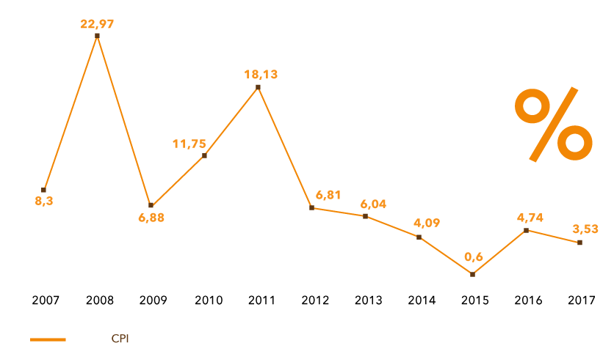

Exhibit 2 – GDP growth rate past 10 years (2007-2018) in Vietnam
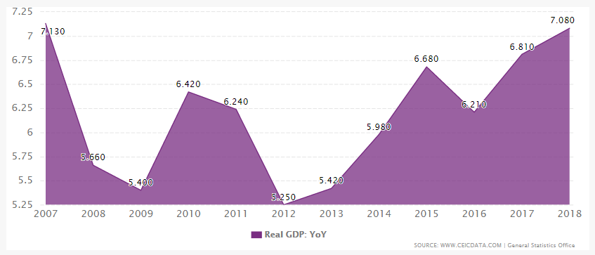

Exhibit 3 – Loan/Credit growth rate in the past years (2012-2018) in Vietnam

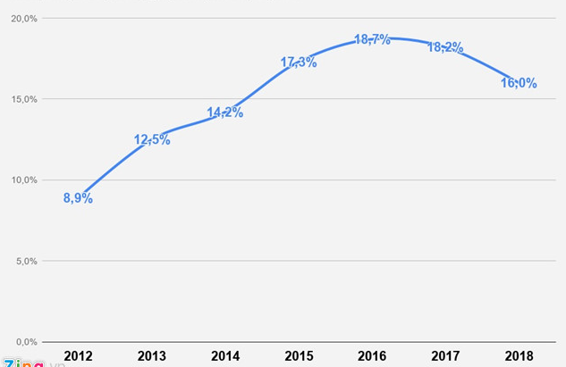

Exhibit 4 – Deposit and lending interest rates in the past 12 years (2005-2018) in Vietnam

Exhibit 5 - Statistics of Market risk (beta) in 3 industries in the post – low inflation period 2015-2017: Insurance, Stock and Banking industry group

