Measuring The Volatility of Market Risk of Viet Nam Banking Industry After The Low Inflation Period 2015-2017

Dinh Tran Ngoc Huy, MBA¹*²*
^{1*} Faculty of Economics, Binh Duong University, Viet Nam
^{2*} MBA, Graduate School of International Management, International University of Japan, Niigata, Japan
*Corresponding Author: e-mail: dtnhuy2010@gmail.com, Tel +84-08-39934160, SkypeID: dinhhuy121

Abstract

The Vietnam economy has gained lots of achievements after the financial crisis 2007-2011, until it reached a low inflation rate of 0.6% in 2015. This paper measures the volatility of market risk in Viet Nam banking industry after this period (2015-2017). The main reason is the vital role of the bank system in Vietnam in the economic development and growth in recent years always go with risk potential and risk control policies.
This research paper aims to figure out how much increase or decrease in the market risk of Vietnam banking firms during the post-low inflation period 2015-2017.
First, by using quantitative combined with comparative data analysis method, we find out the risk level measured by equity beta mean in the banking industry is acceptable, although it is little higher than (>) 1.
Then, one of its major findings is the comparison between risk level of banking industry during the financial crisis 2007-2009 compared to those in the post-low inflation time 2015-2017. In fact, the research findings show us market risk level during the post-low inflation time has increased much.
Finally, this paper provides some ideas that could provide companies and government more evidence in establishing their policies in governance. This is the complex task but the research results shows us warning that the market risk might be higher during the post-low inflation period 2015-2017. And our conclusion part will recommends some policies and plans to deal with it.

JEL classification numbers: G010, G390
Keywords: risk management, asset beta, financial crisis, banking industry, policy

1 Introduction
Throughout many recent years, Viet Nam banking market is evaluated as one of active markets, which has certain positive effect for the economy.
Generally speaking, central banks aim to maintain inflation around 2% to 3%. Increases in inflation significantly beyond this range can lead to possible hyperinflation, a devastating scenario in which inflation rises rapidly out of control. Looking at exhibit 1, we can see the Vietnam economy has controlled inflation well.
This study will calculate and figure out whether the market risk level during the post-low inflation time (2015) has increased or decreased, compared to those statistics in the financial crisis time (2007-2009).
The paper is organized as follows: after the introduction it is the research issues, literature review, conceptual theories and methodology. Next, section 3 will cover main research findings/results. Section 4 gives us some discussion and conclusion and policy suggestion will be in the section 5.
2 Body of manuscript

2.1 Research Issues
The scope of this study are:
Issue 1: Whether the risk level of banking firms under the different changing scenarios in post-low inflation period 2015-2017 increase or decrease so much, compared to in financial crisis 2007-2009 and?
Issue 2: Because Viet Nam is an emerging and immature financial market and the stock market still in the starting stage, whether the dispersed distribution of beta values become large in the different changing periods in the banking industry.
This paper also tests three (3) below hypotheses:
Hypothesis 1: Comparing two (2) periods, during the financial crisis impact, the beta or risk level of listed companies in banking industry will relatively higher than those in the post-low inflation environment.
Hypothesis 2: Because Viet Nam is an emerging and immature financial market and the stock market still in the recovering stage, there will be a large disperse distribution in beta values estimated in the banking industry.
Hypothesis 3: With the above reasons, the mean of equity and asset beta values of these listed banks tend to impose a high risk level, i.e., beta should higher than (>) 1. This hypothesis is based on the context of emerging markets including Viet Nam where there lacks of sufficient information and data disclosure although it might have high growth rate.
2.2 Literature review
Smith (2004) mentions in Chicago, properties located in a designated TIF (tax increment financing) district will exhibit higher rates of appreciation after the area is designated a qualifying TIF district when compared to those properties selling outside TIF districts, and when compared to properties that sell within TIF district boundaries prior to designation.
Yener et all (2014) found out that increase in banks' risk might be due to unusually low interest rates through an extended period. During the financial crisis 2007-2009 in Viet Nam and global financial markets, high inflation causing high lending rates have created risks for many industries such as real estate and the whole economy. Mohamad et all (2014) showed that financial risk is vital through using both return on asset and return on equity in the performance equation. This result also implied that we cannot avoid the inverse relation of financial risk and performance; therefore, bank system would be better to make a trade-off between risk and performance.
In Viet Nam and other developing countries, banks operate based on money borrowing from financial markets and depositors or investors, also there is cross-ownership between banks. Next, Emilios (2015) mentioned that the leverage cycle might cause financial instability and also the effect of leverage restraints on good bank governance and allocative efficiency.
Atousa and Shima (2015) found out the economic growth and life insurance sector growth has positively correlated. Then, Gunarathna (2016) revealed that whereas firm size negatively impacts on the financial risk, financial leverage and financial risk has positive relationship.
Aykut (2016) suggested two major results: (i) Credit risk and Foreign exchange rate are positively correlated, while banking sector has been affected not much by interest rate, (ii) conditional bank stock return volatility has been affected positively and significantly by credit and market risk. Then, Mojtaba and Davoud (2016) generated results showing that private banks are less successful in using risk management tools in compared with public banks.
Over past years, monetary policies have certain impacts on bank system. Last but not least, Riet (2017) mentioned that after the euro area crisis, the ECB still solved a series of complex monetary policy challenges. From June 2014 its task became to design a sufficiently strong monetary stimulus that could reach market segments that were deprived of credit at reasonable costs and to counter the risk of a too prolonged period of low inflation. Hami (2017) showed that financial depth has been affected negatively by inflation in Iran during the observation period.
Finally, Chizoba et all (2018) figured out that inflation rate and insurance penetration had a positive correlation in the Nigerian insurance industry.

2.3 Conceptual theories
Positive sides of low inflation: Low (not negative) inflation reduces the potential of economic recession by enabling the labor market to adjust more quickly in a downturn, and reduces the risk that a liquidity trap prevents monetary policy from stabilizing the economy. This is explaining why many economists nowadays prefer a low and stable rate of inflation. It will help investment, encourage exports and prevent boom economy.
Negative side of low inflation: it leads to low aggregate demand and economic growth, recession potential and high unemployment. Production becomes less vibrant. Low inflation makes real wages higher. Workers can thus reduce the supply of labor and increase rest time. On the other hand, low product prices reduce production motivation.
The central bank can use monetary policies, for instance, increasing interest rates to reduce lending, control money supply or the Ministry of finance and the government can use tight fiscal policy (high tax) to achieve low inflation.
Financial and credit risk in the bank system can increase when the financial market becomes more active and bigger, esp. with more international linkage influence. Hence, central banks, commercial banks, organizations and the government need to organize data to analyze and control these risks, including market risk.
2.4 Methodology
We use the data from the stock exchange market in Viet Nam (HOSE and HNX) during the financial crisis 2007-2009 period and the post – low inflation time 2015-2017 to estimate systemic risk results. We perform both fundamental data analysis and financial techniques to calculate equity and asset beta values.
In this study, analytical research method and specially, comparative analysis method is used, combined with quantitative data analysis. Analytical data is from the situation of listed real estate firms in VN stock exchange.
Finally, we use the results to suggest policy for both these enterprises, relevant organizations and government.

3 Main Results
3.1 General Data Analysis
We get some analytical results form the research sample with 9 listed firms in the banking market with the live date from the stock exchange.
3.2 Empirical Research Findings and Discussion
In the below section, data used are from total 9 listed banking industry companies on VN stock exchange (HOSE and HNX mainly). Different scenarios are a=created by comparing the calculation risk data between 2 periods: the post – low inflation period 2015-2017 and the financial crisis 2007-2009.
Market risk (beta) under the impact of tax rate, includes: 1) equity beta; and 2) asset beta. We model our data analysis as in the below figure:
Figure 1 – Analyzing market risk under two (2) scenarios: post – low inflation period 2015-2017 compared to the financial crisis 2007-2009
 | Risk level (equity beta) | Risk level (asset beta) | Other measures | Gap
Post – low inflation period | Scenario … | Scenario .. | Scenario .. | Analysis
Financial crisis time

Table 1 – The Volatility of Market Risk (beta) of Banking Industry in the post- low inflation period 2015-2017
 |  | 2015-2017 (post - low inflation)
Order No. | Company stock code | Equity beta | Asset beta (assume debt beta = 0) | Note
1 | ACB | 0.954 | 0.061 | assume debt beta = 0; debt ratio as in F.S 2015
2 | CTG | 1.676 | 0.120
3 | BID | 1.346 | 0.065
4 | MBB | 0.639 | 0.066
5 | NVB | 0.676 | 0.045
6 | SHB | 0.636 | 0.035
7 | STB | 1.165 | 0.090
8 | EIB | 0.824 | 0.087
9 | VCB | 1.393 | 0.093

Table 2 – The Statistics of Volatility of Market Risk (beta) of Banking Industry in the post- low inflation period 2015-2017
 | 2015-2017 (post - low inflation)
Statistic results | Equity beta | Asset beta (assume debt beta = 0)
MAX | 1.676 | 0.120
MIN | 0.636 | 0.035
MEAN | 1.034 | 0.073
VAR | 0.1435 | 0.0007
Note: Sample size : 9 (we just take a sample of 9 banking firms to make comparison in the below table)

Table 3 – The Comparison of Volatility of Market Risk (beta) of Banking Industry in the post- low inflation period 2015-2017 and the financial crisis 2007-2009
 |  | 2007-2009 (financial crisis) |  | 2015-2017 (post - low inflation)
Order No. | Company stock code | Equity beta | Asset beta (assume debt beta = 0) | Equity beta | Asset beta (assume debt beta = 0) | Note
1 | ACB | 0.85 | 0.083 | 0.954 | 0.061 | assume debt beta = 0; debt ratio as in F.S 2015 and 2008
2 | CTG | 0.415 | 0.024 | 1.676 | 0.120
3 | BID |  |  | 1.346 | 0.065
4 | MBB | 0.081 | 0.009 | 0.639 | 0.066
5 | NVB | 0.021 | 0.003 | 0.676 | 0.045
6 | SHB | 1.011 | 0.113 | 0.636 | 0.035
7 | STB | 0.826 | 0.089 | 1.165 | 0.090
8 | EIB | 0.629 | 0.145 | 0.824 | 0.087
9 | VCB | 0.473 | 0.03 | 1.393 | 0.093

Table 4 – The Difference between Volatility of Market Risk (beta) of Banking Industry in the post- low inflation period 2015-2017 and the financial crisis 2007-2009
 |  | GAP (+/-) 2015-17 compared to 2007-09
Order No. | Company stock code | Equity beta | Asset beta (assume debt beta = 0) | Note
1 | ACB | 0.104 | -0.022 | values (2015-17) minus (-) 2007-09
2 | CTG | 1.261 | 0.096
3 | BID | 1.346 | 0.065
4 | MBB | 0.558 | 0.057
5 | NVB | 0.655 | 0.042
6 | SHB | -0.375 | -0.078
7 | STB | 0.339 | 0.001
8 | EIB | 0.195 | -0.058
9 | VCB | 0.920 | 0.063

Table 5 – Statistics of Volatility of Market Risk (beta) of Banking Industry in the post- low inflation period 2015-2017 compared to those in the financial crisis 2007-2009
 | 2007-2009 (crisis) |  | 2015-2017 (post - low inflation) |  | GAP (+/-) 2015-17 compared to 2007-09
Statistic results | Equity beta | Asset beta (assume debt beta = 0) | Equity beta | Asset beta (assume debt beta = 0) | Equity beta | Asset beta (assume debt beta = 0)
MAX | 1.011 | 0.145 | 1.676 | 0.120 | 0.665 | -0.025
MIN | 0.021 | 0.003 | 0.636 | 0.035 | 0.615 | 0.032
MEAN | 0.538 | 0.062 | 1.034 | 0.073 | 0.496 | 0.011
VAR | 0.1297 | 0.0028 | 0.143 | 0.001 | 0.014 | -0.002
Note: Sample size : 9

Based on the above calculation result table, we analyze data as follows:
Firstly, we see in the table 1 that more banks (5 over 9 banks) have equity beta values lower (<) than 1, which means risk level acceptable.
And table 2 provides evidence for us to see that equity beta mean of the sample is 1.034, just little higher than (>) 1. It is acceptable.
Then, looking at the table 3, we recognize that there are up to 4 banks with equity beta values > 1 9CTG, STB, VCB, BIDV) in the post-low inflation period 2015-17, compared to only 1 bank (SHB) with equity beta values > 1 in the financial crisis 2007-2009.
Next, table 4 shows that most of the equity and asset beta values in the post- low inflation period are higher (>) than those in the financial crisis 2007-2009. Esp. the figures represent the risk level of all state-owned banks (now becoming JSCs: BID, VCB and CTG) higher during the post-low inflation period, whereas risk level of some commercial banks (ACB, SHB, EIB) are lower during the post-low inflation time.
Furthermore, table 5 tells us all statistics of equity beta in the post-inflation period 2015-2017 are higher (>) than those in the financial crisis 2007-2009, whereas asset beta max and asset beta var are slower (<) than those in the financial crisis 2007-2009.
In addition to, looking at the below chart 1- , we can find out:
Values of equity beta max and equity beta mean in the post-low inflation 2015-2017 are much higher (>) than those in the crisis 2007-2009 while asset beta max and asset beta mean are just little higher (>) than those in the financial crisis 2007-2009. It means that the level of risk in the post – low inflation period 2015-17 is higher in general and in average. Although the fluctuation in risk level measured by asset beta var is lower during the post-low inflation time.

Chart 1 – Statistics of Market risk (beta) in VN banking industry in the post – low inflation period 2015-2017 compared to the financial crisis 2007-2009

4. Discussion for further researches
We can continue to analyze risk factors behind the risk scene (risk increasing as above analysis) in order to recommend suitable policies and plans to control market risk better.
5. Conclusion and Policy suggestion
In general, bank system in Vietnam has been contributing significantly to the economic development and GDP growth rate of more than 6-7% in recent years. The above analysis show us that most of risk measures (equity beta max, mean and var) are increasing during the post-low inflation period. Banks and bank system in Vietnam need to continue increase their corporate governance system, structure and mechanisms, as well as their competitive advantage to control risk better.
This research paper provides evidence that the market risk potential might be higher in 2015-2017 post-low inflation period (looking again chart 1 – equity beta mean values), while the Exhibit 3 also suggests that the credit growth rate increased in 2016 and slightly decrease in later years (2017-2018). It means that the local economy is trying to control credit growth reasonably, however we need to analyze risk factors more carefully to reduce more market risk.
Looking at the above chart 1, the result supports the hypothesis 3 mentioning that the mean of equity and asset beta values of these listed banks tend to impose a little high risk level, i.e., beta should higher than (>) 1. Because the equity beta mean is lower in the financial crisis period, it also rejects the hypothesis 1 saying that comparing two (2) periods, during the financial crisis impact, the beta or risk level of listed companies in banking industry will relatively higher than those in the post-low inflation environment. Additionally, the above result rejects the hypothesis 2 stating that because Viet Nam is an emerging and immature financial market and the stock market still in the recovering stage, there will be a large disperse distribution in beta values estimated in the insurance industry.
Last but not least, as it generates the warning that the risk level might be higher in the post-low inflation period, the government and relevant bodies such as Ministry of Finance and State Bank of Vietnam need to consider proper policies (including a combination of fiscal, monetary, exchange rate and price control policies) aiming to reduce the risk and hence, help the bank system as well as the whole economy become more stable in next development stage.
Finally, this study opens some new directions for further researches in risk control policies in bank system as well as in the whole economy.

ACKNOWLEDGEMENTS
I would like to take this opportunity to express my warm thanks to Board of Editors and Colleagues at Citibank –HCMC, SCB and BIDV-HCMC, Dr. Chen and Dr. Yu Hai-Chin at Chung Yuan Christian University for class lectures, also Dr Chet Borucki, Dr Jay and my ex-Corporate Governance sensei, Dr. Shingo Takahashi at International University of Japan. My sincere thanks are for the editorial office, for their work during my research. Also, my warm thanks are for Dr. Ngo Huong, Dr. Ho Dieu, Dr. Ly H. Anh, Dr Nguyen V. Phuc, Dr Le Si Dong and my lecturers at Banking University – HCMC, Viet Nam for their help.
Lastly, thank you very much for my family, colleagues, and brother in assisting convenient conditions for my research paper.

References

- Allen, F., and Gale, D., (1992), Stock Price Manipulation, Review of Financial Studies.
- Basu, Devraj., Streme, Alexander., (2007), CAPM and Time-Varying Beta: The Cross-Section of Expected Returns, SSRN Working paper series
- Chatterjea, Arkadev., Jerian, Joseph A., and Jarrow, Robert A., (2001), Market Manipulation and Corporate Finance: A new Perspectives, 1994 Annual Meeting Review, SouthWestern Finance Association, Texas, USA.
- DeGennaro, Ramon P., Kim, Sangphill., (2003), The CAPM and Beta in an Imperfect Market, SSRN Working paper series
- Emilios, A., (2015), Bank Leverage Ratios and Financial Stability: A Micro- and Macroprudential Perspective, Working Paper No.849, Levy Economics Institute
- Galagedera, D.U.A., (2007), An alternative perspective on the relationship between downside beta and CAPM beta, Emerging Markets Review
- Gunarathna, V., (2016), How does Financial Leverage Affect Financial Risk? An Empirical Study in Sri Lanka, Amity Journal of Finance, 1(1), 57-66.
- Khwaja, Asim Ijaz., Mian, Atif., (2005), Unchecked intermediaries:Price manipulation in an emerging stock market, Journal of Financial Economics 78, 243 – 241
- Martin, K., and Sweder, V.W., (2012), On Risk, leverage and banks: Do highly leveraged banks take on excessive risk?, Discussion Paper TI 12-022/2/DSF31, Tinbergen Institute
- Rahman, Dima., (2013), Are Banking Systems Increasingly Fragile? Investigating Financial Institutions’ CDS Return Extreme Co-Movements, Quantitative Finance
- Siller, Thomas., (2013), Measuring Marginal Risk Contributions in Credit Portfolios, Quantitative Finance

Research
- Ang, A., Chen, J., (2007), CAPM Over the Long Run: 1926-2001, Journal of Empirical Finance
- ADB and Viet Nam Fact Sheet, 2010

Other web sources
- http://www.ifc.org/ifcext/mekongpsdf.nsf/Content/PSDP22
- http://www.construction-int.com/article/vietnam-construction-market.html
- http://fia.mpi.gov.vn/Default.aspx?ctl=Article&MenuID=170&aID=185&PageSize=10&Page=0
- http://kientruc.vn/tin_trong_nuoc/nganh-bat-dong-san-rui-ro-va-co-hoi/4881.html
- http://www.bbc.co.uk/vietnamese/vietnam/story/2008/12/081226_vietnam_gdp_down.shtml
- http://www.mofa.gov.vn/vi/
- https://www.ceicdata.com/en/indicator/vietnam/real-gdp-growth
Exhibit
Exhibit 1 – Inflation, CPI over past 10 years (2007-2017) in Vietnam

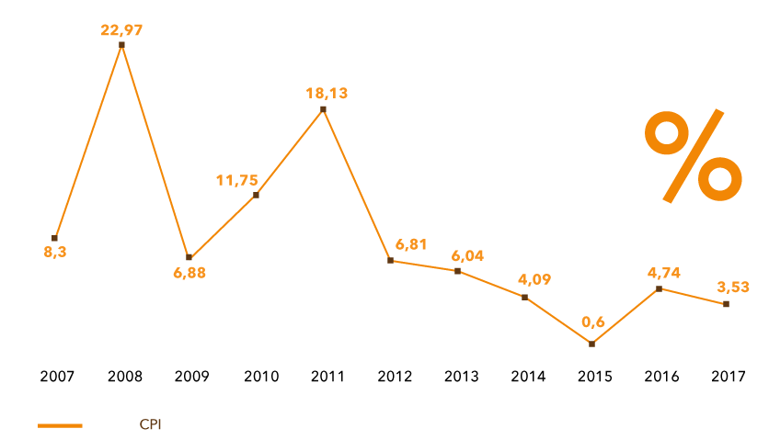

Exhibit 2 – GDP growth rate past 10 years (2007-2018) in Vietnam
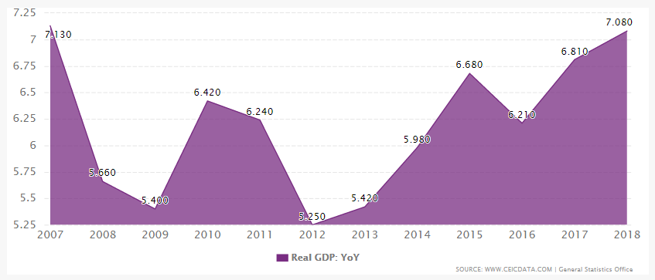

Exhibit 3 – Loan/Credit growth rate in the past years (2012-2018) in Vietnam

