Title: The Effect Of Colloidal Silver (ASAP) On The Visceral Organ Of Laboratory Model Animal.
Ajobiewe O.J. ¹ Madueke J. ¹ Umeji L. ¹ Olabode A. ¹ Odunze ¹
College of Medicine Department of Public Health Imo State University Owerri, Nigeria.
Correspondence author : josephajo2000@yahoo.com

ABSTRACT
Introduction: This study examined the toxicological effect of colloidal silver {ASAP} on the visceral organ of experimental animals used as models;
Aim: To determine the fitness of the ASAP solution for human consumption.
Study Design/Method: This study is a longitudinal observational and analytical survey. In this study, a total of 20 apparently normal rabbits were used for this study. 10 rabbits as test samples and the other 10 rabbits as control samples. Biochemical and histological analysis were carried out on the serum and tissues of organs to determine any form of abnormalities in the organ profile test. Histological demonstration of the liver glycogen using periodic acid Schiff‘s method {PAS} were also done.
Results :Statistical analysis showed insignificant liver function parameter with the SGOT and SGPT giving the lowest p value P = 0.2 at 6 months study sample {p>0.05}. Insignificant values were also observed in the renal function parameter with urea test exhibiting P = 0.05 at 3months and P =0.5 at 6months of study. The lipid profile parameters also showed insignificant p value in all test sample with the smallest p value in triglycerides at 6months p = 0.07. All histological analysis of the visceral organs showed normal histology. No pathological features seen. Although, the urea P = 0.05 at 3 months was observed, other renal function parameters were insignificant including urea P = 0.5 at 6 months. 100% glycogen constituents were also observed on all the liver tissues.
Conclusion: There was a good correlation between the biochemical parameters profiles of the liver, kidney and heart with their respective histological findings suggesting that colloidal silver does not have any toxicological effect on the visceral organ of experimental rabbits. There was a steady increase in weight among the test/control rabbits throughout the course of the experimentation.
KEY WORDS
- Colloidal Silver ASAP). Visceral organs and laboratory model animal.

INTRODUCTION:
Silver (Ag) has atomic number of 47, with an atomic weight of 108. It is one of the so-called “heavy metals” along with lead, mercury, cadmium and gold. However, Ag is said to be surprisingly non- toxic to human and Animals. Silver (Ag) has a long history of successful medical and public health use dating back 6000 years, (Thompson, 1973). Colloidal Silver otherwise referred to as ASAP is a colloid which is defined as a very small particle 0.01 to 0.001 microns in diameter (four hundred thousandths to four millionths of an inch), suspended in a different media, such as solid in a liquid. Each particle contains approximately 15 silver atoms. The particles are so small that one billion will fit into a cube four one hundredths of an inch in size.
Colloidal silver is also an electrical colloid meaning the silver particles have an electrical negative charge. Because of the small partial size and electrical charge, the particles repel each other and thus stay suspended in the water indefinitely, and do not settle out. Minerals from fruits and vegetables come in a colloidal form just like colloidal silver. Colloidal Silver has very effective antimicrobial properties killing more than 650 known pathogens including the Aids virus, Epstein Barr Virus, gonorrhea, bacteria, lyme’s Disease, Candida, fungi, warts, and parasites (Clark, 1992). Colloidal Silver taken regularly acts as a second immune system to prevent illness from pathogens. It appears to keep the liver in good shape by regenerating it when needed. In addition, it may help prevent cancer by changing cancer cells back into normal cells and by limiting fermentation in the intestines (Bjorn, 1998). By energizing the electrical system of the body, colloidal silver allows the body to function better thus resulting in better health, energy and vigor. Because it may take up four days of taking colloidal silver before it reaches maximum effectiveness, it will be more effective in both prevention and treatment if taken regularly as a supplement to the daily diet.
The use of ASAP Colloidal Silver in combating communicable and non-communicable diseases has remained an issue of public health relevance. There is paucity of its use in Nigeria and little or no toxicological effect of this drug has been evaluated. There is no doubt therefore, that evaluating the toxicological effects of this drug in view of the enormous public health problems in Nigeria is an integral part of public health promotion and risk reduction.

STUDY DESIGN/ METHOD : This study is a longitudinal observational and analytical survey.
Carried out at the laboratory service department of National Hospital Abuja located at the Central Area (Garki) of FCT Abuja. The subjects of this study comprised twenty two (22) experimental units (young albino rabbits) obtained from the small animal unit of the National Veterinary Research Institute Vom Jos, Plateau Nigeria. They were kept for a period of two weeks to observe any signs of illness. They were stabilized and checked by the Veterinary Doctor who ascertained their fitness for the study. The rabbits were fed with commercially prepared rabbits pellets containing carbohydrate, proteins and vitamins. Also green vegetables including cabbage, carrots e.t.c. and clean water were given. The rabbits were comfortably housed in a big cage within closed doors and around the National Hospital green area. The cages were washed on daily basis using diluted morigard disinfectant and water to prevent contraction of diseases. An inlet and outlet doors were created alongside with metallic nets. This created free air flow and easy manipulation of the rabbits and sanitization of the cage.
The rabbits (subjects) were categorized and grouped into three , namely;
- Group I: These were the standard and consisted of 2 rabbits.
- Group II: These consisted of 10 rabbits as the test group.
- Group III: These consisted of 10 rabbits as the control group.
The drug (colloidal silver) was purchased from a pharmaceutical retail outlet. The body weight of these rabbits ranged between 650g to 800g. 2.5mls of the drug were administered orally using sterile 2mls syringes on daily basis. Blood samples were collected from each rabbit through the jugular vein using the vacutainer set. The standard group sample were referred to as the baseline samples and provided the baseline data. The two rabbits in this group had their blood samples collected into Lithium heparin bottle soon after being satisfied fit by the veterinary doctor. They were then sacrificed and dissected. Internal visceral organs namely; Liver, Lungs and Heart were preserved in 10% formal saline for histological analysis. Blood samples were collected from the test and control rabbit and were put into lithium heparin bottle exactly 3 months after exposure of colloidal silver to the test rabbits. These samples were designated as samples 1(S1). Similar blood samples were collected after additional 3 months of exposure of the drugs to the test rabbits i.e. on the 6th month (total duration of study). These were designated as sample 2(S2). All rabbits i.e. tests and controls were weighed using a weighing balance. Measurement of the rabbit’s weight was taken only when the rabbit was in a steady state. They were sacrificed and dissected using dissecting kit. Individual rabbit, liver, kidney, lungs and heart were preserved in 10% formal solution for histological analysis. The following tests analysis were carried out in all blood samples collected namely liver function test, renal function test, lipid profile and histological /histochemical analysis. The student t-test using the Epi –info software was used for the statistical analysis.

RESULTS:

TABLE 1.

PARAMETERS | TIME | CONTROL | TEST | T-TEST | PV
SGOT | 3 MONTHS | 41.0±12.9 | 42.6±15.3 | 0.3 | 0.8
 | 6 MONTHS | 43.7±17.9 | 49.3±14.4 | 0.08 | 0.9
SGPT | 3 MONTHS | 80.5±15.9 | 76.8±16.2 | 0.5 | 0.6
 | 6 MONTHS | 85.0±16.8 | 75.8±14.2 | 1.3 | 0.20
ALK PHOS | 3 MONTHS | 142.4±32.5 | 149.0±41.5 | 0.4 | 0.7
 | 6 MONTHS | 144.7±35.4 | 145.9±36.5 | 0.07 | 0.9
TOTAL BILIRUBIN | 3 MONTHS | 3.2±2.3 | 2.4±2.2 | 0.8 | 0.4
 | 6 MONTHS | 3.3±2.2 | 2.6±1.7 | 0.8 | 0.4
TOTAL PROTEIN | 3 MONTHS | 65.9±8.8 | 68.3±7.3 | 0.7 | 0.5
 | 6 MONTHS | 63.2±9.2 | 65.2±10.2 | 0.5 | 0.7
ALBUMIN | 3 MONTHS | 49.8±7.2 | 48.9±3.6 | 0.4 | 0.7
 | 6 MONTHS | 50.0±6.5 | 51.8±6.7 | 0.6 | 0.6
The mean distribution of liver function parameters in the control and test group

TABLE 11.
.
PARAMETERS | TIME | CONTROL | TEST | T-TEST | PV
UREA | 3 MONTHS | 5.3±1.4 | 6.5±1.2 | 2.1 | 0.05
 | 6 MONTHS | 5.5±1.4 | 5.9±1.1 | 0.7 | 0.50
CREATININE | 3 MONTHS | 83.2±14.2 | 88.8±22.7 | 0.7 | 0.5
 | 6 MONTHS | 88.0±12.8 | 88.6±20.5 | 1.2 | 0.9
SODIUM (Na) | 3 MONTHS | 136.8±2.1 | 137.3±1.9 | 0.6 | 0.6
 | 6 MONTHS | 136.1±1.5 | 138.3±3.2 | 0.9 | 0.07
POTASSIUM (K) | 3 MONTHS | 4.5±0.6 | 4.5±0.4 | 0.2 | 0.9
 | 6 MONTHS | 4.3±0.3 | 4.5±0.6 | 1.0 | 0.3
BICARBONATE | 3 MONTHS | 22.0±1.6 | 21.2±1.9 | 1.0 | 0.3
 | 6 MONTHS | 21.6±1.4 | 22.0±1.3 | 0.6 | 0.5
The Mean Distribution of Renal Function Test Parameters In The Control And Test Group.

TABLE 111.

PARAMETERS | TIME | CONTROL | TEST | t-TEST | PV
TOTAL CHOLESTROL | 3 MONTHS | 69.7±21.5 | 62. ±32.0 | 0.3 | 0.8
 | 6 MONTHS | 60.9±14.3 | 74.0±34.1 | 1.1 | 0.3
HDL | 3 MONTHS | 19.0±6.5 | 23.4±10.3 | 1.1 | 0.3
 | 6 MONTHS | 20.8±6.9 | 24.1±10.2 | 0.8 | 0.4
LDL | 3 MONTHS | 18.2±12.3 | 30.0±20.2 | 0.9 | 0.4
 | 6 MONTHS | 13.0±10.3 | 29.6±19.3 | 1.3 | 0.2
TRIGLYCERIDE | 3 MONTHS | 134.5±34.9 | 178.9±104.3 | 1.3 | 0.2
 | 6 MONTHS | 114.1±28.9 | 171.4±89.7 | 1.9 | 0.07
The Mean Distribution Of Lipid Profile Parameters In The Control And Test Groups.

TABLE IV

PARAMETERS | TIME | CONTROL | TEST | t-TEST | PV
WEIGHT | START  (first weight) | 721±98.7 | 785 ±106.5 | 0.8 | 0.4
 | FINISH  (Second weight) | 1598±105.1 | 1530±180.4 | 1.0 | 0.3

The Mean Distribution Of Weight In The Controls And Test Groups.

histology of all visceral organs show no pathological features.

histochemical demonstration of liver glycogen = 100%

PLATE A
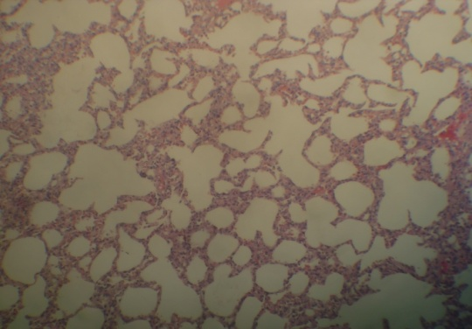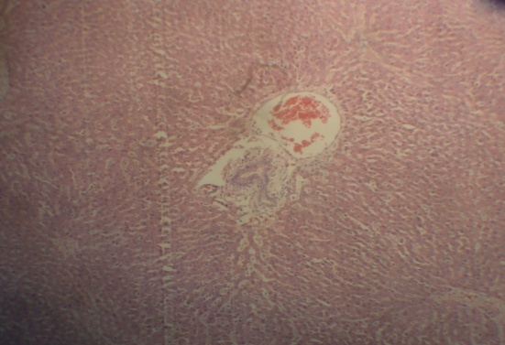

Normal rabbit lung showing Normal rabbit showing central portal tract.
Alveoli, Ducts and Dust cells.

PLATE B
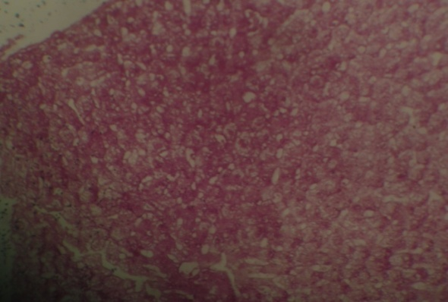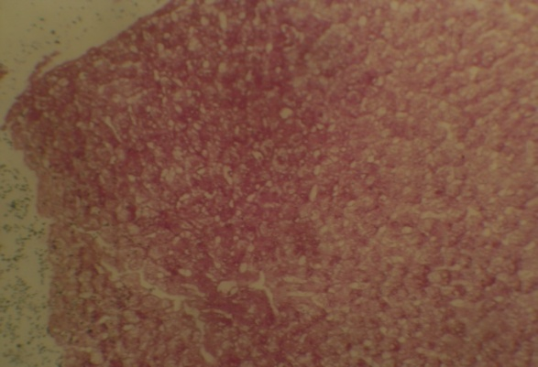

Normal rabbit liver cells showing positive Normal rabbit liver cell showing
staining by periodic acid Schiff (Glycogen negative staining by diastase periodic
deposit present in the hepatocytes). Acid shiff. (Glycogen deposit in the
hepatocytes digested by diastase).

PLATE C
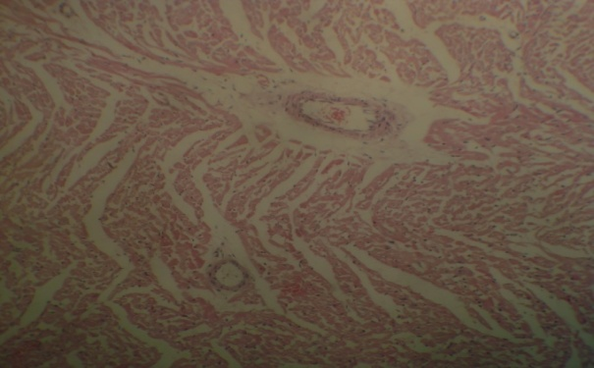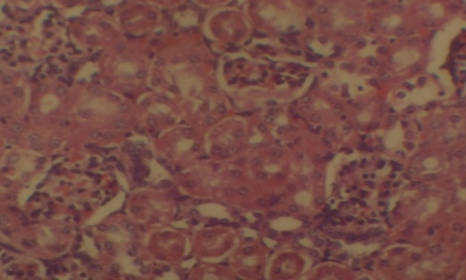

Normal rabbit heart showing cardiac Normal kidney bowman capsules, glomerulus
Muscles and coronary venules. and tubules.

DISCUSSION / CONCLUSION
The over prescription of drugs containing silver by doctors under pressure from their patients for ailments where they are useless has led to the development of resistance to antibiotic and accumulation of silver in tissues(Begley, 1994) and (Fisher et al, 1994).

This study examined the toxicological effects of colloidal silver (ASAP) on the visceral organ of experimental animal to determine fitness for man’s intake. In the toxicological study done by American biotech labs, mice were given a ten times normal dose of 10ppm silver solution. This resulted in 100% of the mice surviving and even thriving. These same groups of mice were given extremely high doses of silver solution to determine if very large doses would be toxic. 100% of these mice survived, and even gained weight, demonstrating the safety of the product.

The liver function profile tested throughout the duration of study on the test and control rabbits were very much comparable. The insignificant statistical significance at (P>0.05) indicated no abnormality on the liver tissues. The American biotech lab has established ASAP effectiveness in a number of different countries on its inhibition to hepatitis virus. This forms a good correlation with the non toxic outcome of our study. The histology of the liver showed no pathological features and the histochemical demonstration of liver glycogen was 100% established.

Table II showed a complete renal function parameter that is within normal range of a healthy rabbit during the course of the study. There was no significant value P>0.05. the histological analysis showed normal histology. There was no renal toxicity or pathological features.
Table III showed a comparable lipid profile analysis between the control and test rabbits. The lowest measure of probability of variation was detected in triglycerides at 6 months duration P=0.07.

The total cholesterol, LDL cholesterol and HDL cholesterol were insignificant. This shows that the metabolism of lipids was not affected with ASAP oral administration.

The weight ranges of rabbits recruited for study were very much comparable for the test and control cases. Though there was increase in weight in all rabbits, a comparable weight trend was also observed in them. Statistical insignificancy in the rabbit weights were noticed both at the start and at the end of the study (P>0.05) using the t- test. This indicated a uniform and steady growth and development. There was remarkable difference in weight gained both in the control and test rabbit samples when mean weight are compared 721⁺- 98.7 to 1598 ⁺- 105. 1 in control and 758⁺- 106.5 to 1530⁺- 180.4 in the test respectively. Silver is indeed surprisingly non toxic to animal unlike the other heavy metals and can be employed as a therapeutic agent for infectious diseases in medical and public health .

REFERENCES
Begley S. (1994): The End Antibiotics Newsweek, March 28, 46 – 51.
Bjorn Nordstrom, (1998): Cancer treatment method, from the colloidal silver manual, found on Astek colloidal silver.
Clark, A. (1992): The properties certain colloidal preparations of metals on pathogens, Br Med J, Feb. 17, 273-77..
Fisher J., Simon N.Y. and Schuster S. (1994): The plaque markers.

