PANEL VECTOR AUTO-REGRESSIVE MODEL FOR COVID-19 INFECTED CASES AND DEATHS
Rajarathinam, A.,¹ and Anju, J. B.²
^{1,2}Department of Statistics, Manonmaniam Sundaranar University, Tirunelveli, India
rajarathinam@msuniv.ac.in¹ and anjudwaraka71@gmail.com²
https://orcid.org/0000-0002-3245-3181¹
Abstract
This study aims to model the dynamic relationships between the number of COVID-19 infected cases and deaths in all the districts of Kerala state from January 2021 to December 2021 based on the panel auto-regressive vector model. The random effect panel vector auto-regressive model of order two was found suitable to model dynamic relationships. This model explains 62 % variations in the endogenous variable, deaths (number of deaths). The exogenous variable deaths (-1) are highly significant, whereas the exogenous variable cases(-1) are significant at a 5% level. Both of these exogenous variables positively influence the endogenous variable. The other exogenous variables, viz., deaths(-2) and cases(-2), are non-significant. The Durbin-Watson test statistic value confirms the independence of the residuals, and the Wald test confirms the validity of the significance of the estimated regression coefficients.
Kew words: Fixed and Random Effect Models, Panel VAR model, Cointegration test, Levin-Lin-Chu unit root test, Granger causality test, Hausan test, Wald test
1. Introduction
Vector autoregression (VAR) is a statistical model used to study the dynamic relationship between multiple quantities as they change over time. VAR is a stochastic process model. VAR models generalize the single-variable (univariate) autoregressive model by allowing for multivariate time series. Sims (1980) developed the VAR model with p lags, VAR(p) for expressing a set of variables as weighted linear combinations of each variable’s past values and the past values of the other variables in the set. The model does not depend on economic theory; instead, it constructs the autoregressive model regarding the lag phase as an independent variable to study the dynamic relationship between the variables. Therefore, if the intrinsic and exogenous properties do not discriminate the variables, they all are treated as endogenous variables. The panel vector autoregressive model (PVAR) is an extension of the VAR model. The VAR model can only be used to estimate the time series of variables rather than estimating the panel data variables. Later, Holtz-Eakin et al. (1988) combined the VAR model with the panel data to form the Panel VAR model. Mei.Liy and Jing (2011) constructed a multi-factor dynamic system VAR forecast model of China’s GDP, which considered six important economic indicators. Unlike to VAR model, the PVAR model introduces individual effects to reflect the individual differences in the variables. In addition, the PVAR model does not require longer spans like the VAR model and can be used to analyze comprehensive panel data with shorter pans. The PVAR model has been widely used after its improvement and perfection by Pesaran and Smith (1995), Love and Zicchino (2006), Binder and Hsiao (2010), and others.

The present chapter is aimed to estimate the causal relationships between COVID-19 infected cases and deaths in all 14 districts of Kerala state, India, from January 2021 to December 2021 are investigated based on a panel vector auto-regressive model.

2. Materials and Methods
2.1. Materials

The monthly data on COVID-19 infected cases and deaths dataset was collected from the official Kerala state government website (www.dashboard.kerala.gov.in) from January 2021 to December 2021. Various econometric tools related to panel data auto-regression modeling were employed to investigate the causal relationships between COVID-19 infected cases and the number of deaths due to COVID-19 in all 14 districts of Kerala state, India, from January 2021 to December 2021. EViews Ver. 11. was used to estimate the model and its parameters.

2.2. Methods
In analyses of time series data, the study variables must be stationary, which means that the means and variances of the variable data are the same. Accordingly, Levin-Lin-Chu unit root tests were performed to test the stationarity of the study variables, the number of COVID-19-infected cases (CASES), and deaths (DEATHS). To run the PVAR model, the study variables should not be co-integrated. The Pedroni (2004) panel cointegration test was used to assess the co-integration relationships, allowing heterogeneity in the cointegrating equation's intercepts and slopes. To estimate the cointegration relationship between the number of deaths due to COVID-19 and the number of COVID-19 cases, the Pedroni Cointegration test (with no deterministic trend, with deterministic intercept and trend; and with no deterministic intercept or trend) was performed in addition to the Kao cointegration test (Kao and Chiang, (2000)) and Johnson cointegration test (Johansen,(1988)). In the absence of Co-integration relationships between the study variables, the panel VAR model was employed to study the causal relationships between the variables.

2.3.1. Panel VAR model

The k-variate homogeneous panel VAR of order p with panel-specific fixed effects is represented by the following system of the linear equation:

i=1,2,3,…,N and t = 1,2,3,…,Ti

where Y_{it} is a vector of dependent variables; X_{it} is a vector of exogenous covariates; u_{i} and e_{it} are vectors of dependent variable-specific panel fixed-effects and idiosyncratic errors, respectively. The matrices and the matrix B are parameters to be estimated. We assume that the innovations have the following characteristics:
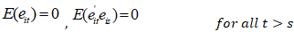
The parameters above may be estimated jointly with the fixed effects or independently of the fixed effects after some transformation, using equation-by-equation ordinary least squares (OLS). The model is "autoregressive" in the sense that it is explained (in part) by its lagged values of itself. However, it also has a "distributed lag" component in the form of successive lags of the "x" explanatory variable. Sometimes, the current value is excluded from the distributed lag part of the model's structure (Soharwardi, Khan, and Mushtaq,(2018)).
3. Results and Discussion
3.1.District-Wise Summary statistics COVID-19 infected cases
District-wise total numbers of infected cases are presented in Table – 1 and depicted in Fig.1. The result reveals that all over the Kerala state, 4479092 infected cases were registered in the year 2021. The highest and lowest number of infected cases are reported in Eranakulam (561964) and Wayanad (118592) districts. All over the state, the pattern of COVID-19 infected cases is skew-symmetric since all the skewness values are positive. The distribution in Trivandrum and Alappuzha districts is highly skewed, and the distributions in the rest are moderately skewed. All the skewness values fall between the acceptable range (− 2 and + 2). Since all the kurtosis values are more significant than one, the distribution is too peaked and leptokurtic. For the rest of the districts, the dataset has lighter tails than a normal distribution (less in the tails). Since all the p-values of the Jarque-Bera (Jarque and Bera, (1987)) test are non-significant, the infected cases are normally distributed in all the districts. Districts wise maximum number of total infected cases is reported in Fig.2.

The maximum number of total infected cases has been reported in Malappuram (123987) district, followed by Eranakulam (116878), Trivandrum (103688), and Kozhikkode (90484). In the Kerala state total number of maximum infected cases have been registered in all the districts in May. Districts wise minimum total number of infected cases is reported in Fig..3. The minimum number of COVID-19 infected cases has been registered in Kozhikkode (8871), Eranakulam (6639), Kannur (5986), etc., In Kerala state total number of maximum infected cases have been registered in all the districts in March, except Kasargod district. The minimum number of total infections in this district is 1949, recorded in December.

Table – 1: District-wise summary statistics of COVID-19 infected cases
District | Sum | Maxi. | Mini | Std.Dev. | Skew. | Kurt. | p-value
Trivandrum | 425467 | 103688 | 5385 | 26901.59 | 1.3048 | 4.4866 | 0.1049
Kollam | 347372 | 74984 | 5524 | 21120.34 | 0.8107 | 2.7369 | 0.5093
Pathanamthitta | 175817 | 28664 | 3746 | 7659.54 | 0.4203 | 2.3392 | 0.7514
Alappuzha | 268927 | 66151 | 3799 | 18547.13 | 1.0578 | 3.4795 | 0.3084
Kottayam | 293821 | 58727 | 5073 | 16144.39 | 0.8034 | 2.6360 | 0.5074
Idukki | 142083 | 27409 | 2161 | 7884.69 | 0.5965 | 2.3670 | 0.9120
Eranakulam | 561964 | 116878 | 6639 | 32400.03 | 0.7402 | 2.7654 | 0.5703
Thrissur | 475753 | 88047 | 5434 | 30455.94 | 0.4755 | 1.7677 | 0.5456
Palakkad | 336065 | 82906 | 2378 | 26444.23 | 0.7634 | 2.4507 | 0.5178
Malappuram | 487807 | 123987 | 4428 | 38455.23 | 0.9245 | 2.7984 | 0.4211
Kozhikkode | 473180 | 90484 | 8871 | 27666.71 | 0.5595 | 1.9231 | 0.5472
Wayanad | 118592 | 20372 | 1602 | 6436.95 | 0.4543 | 1.8772 | 0.5936
Kannur | 252699 | 51687 | 5986 | 15176.76 | 0.6553 | 2.2634 | 0.5683
Kasargod | 119545 | 24048 | 1949 | 8099.75 | 0.4890 | 1.7472 | 0.5318

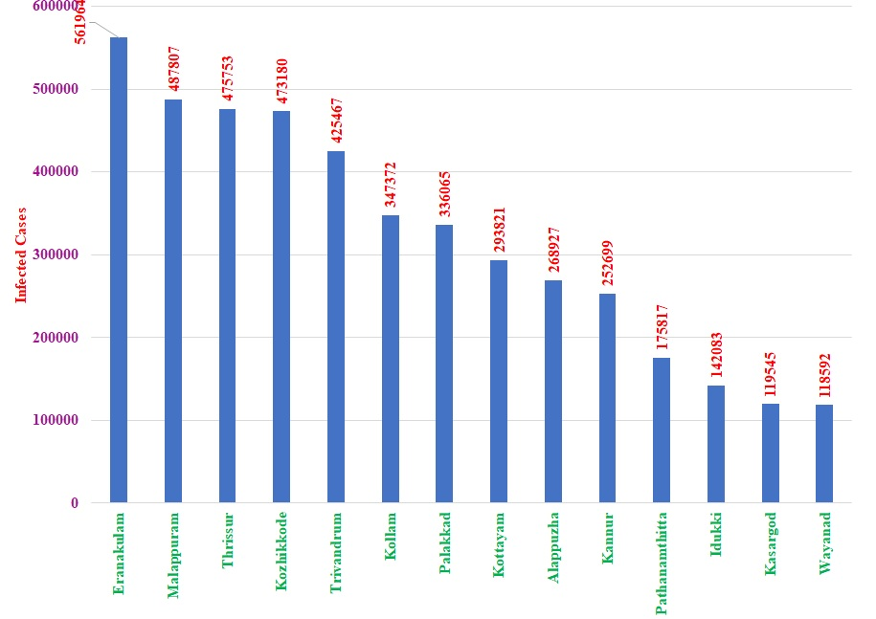
Fig.1.District-wise total number of COVID-19 infected cases
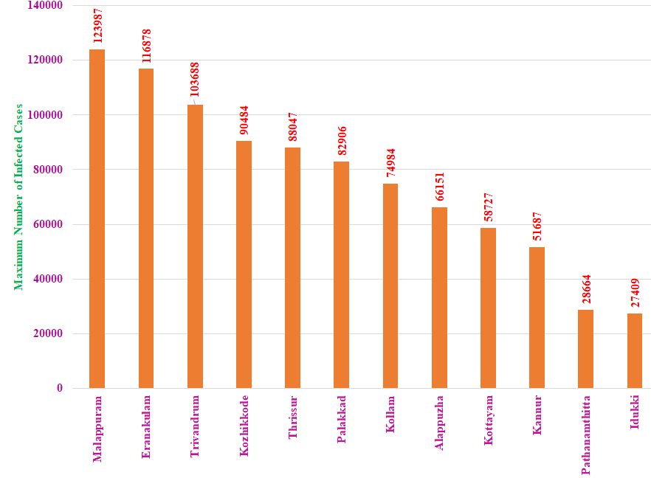
Fig.2.District-wise maximum number of COVID-19 infected Cases
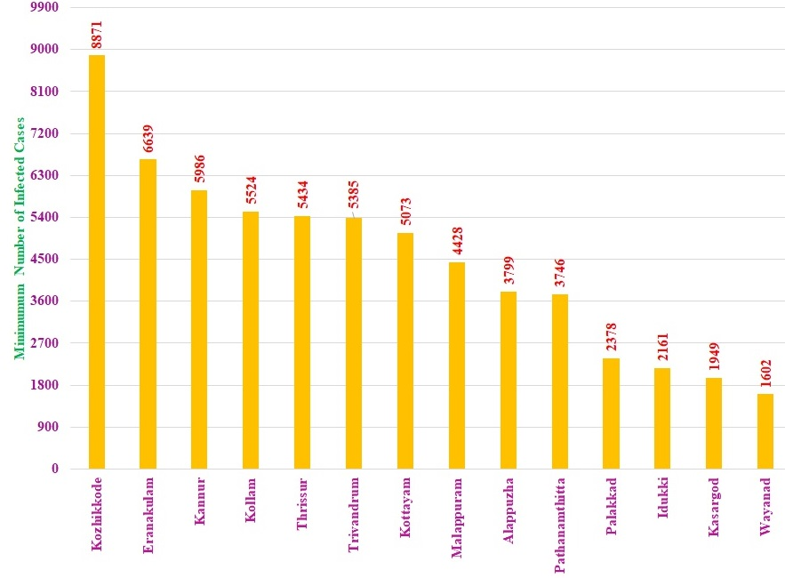
Fig.3.District-wise minimum number of COVID-19 infected cases.

District-wise total numbers of deaths due to COVID-19 infections are presented in Table –2 and depicted in Fig.4. to Fig.6. The result reveals that all over the Kerala state, 44722 deaths due to COVID-19 infections were registered in the year 2021. The highest number of deaths have been reported in Trivandrum (5631), and the lowest of 657 deaths have been recorded in Wayanad. In twelve districts, the number of deaths due to COVID-19 infections is positive, whereas, in Palakkad and Wayanad, it is negative skew-symmetric (skewed left). All the skewness values fall between the acceptable range (− 2 and + 2). Since all the kurtosis values are greater than one, the distribution is too peaked and leptokurtic. For the rest of the districts, the dataset has lighter tails than a normal distribution (less in the tails). All the p-values of the Jarque-Bera test are non-significant, indicating that the number of deaths due to COVID-19 infections is normally distributed in all the districts.

Districts wise total number of maximum deaths is depicted in fig.7.5. Total number of maximum deaths has been reported during October (Trivandrum, 1070); November (Eranakulam, 1321; Kollam, 1261; Thrissur, 981; Kozhikkode, 703; Kannur, 588, Pathanamthitta,496) and December (Alappuzha, 1032; Kottayam, 769; Palakkad,676; Malappuram, 659; Idukki, 234).

Districts wise total number of minimum deaths is depicted in fig.6. Total number of minimum deaths has been reported during February ( Kozhikkode, 57; Thrissur,46; Malappuram, 30; Kannur, 29; Kottayam, 16; Kasargod,3 In); March (Trivandrum, 50; Alappuzha,49; Kollam, 33; Pathanamthitta,15; Wayanad, 8; Palakkad,8) and in April (Idukki,4).
Table – 2: District-wise summary statistics of the number of deaths due to COVID-19 infection

District | Sum | Sum | Maxi. | Mini. | Std.Dev. | Skew. | Kurt. | p-value
Trivandrum | 5631 | 1070 | 50 | 366.80 | 366.80 | 0.39 | 1.86 | 0.9556
Kollam | 4343 | 1261 | 34 | 372.48 | 372.48 | 1.28 | 3.89 | 0.1589
Pathanamthitta | 1759 | 496 | 15 | 138.22 | 138.22 | 1.34 | 4.38 | 0.1022
Alappuzha | 3359 | 1032 | 49 | 306.11 | 306.11 | 1.48 | 4.11 | 0.0805
Kottayam | 2532 | 769 | 16 | 230.49 | 230.49 | 1.47 | 4.07 | 0.0853
Idukki | 955 | 234 | 4 | 82.23 | 82.23 | 0.85 | 2.42 | 0.4446
Eranakulam | 5267 | 1321 | 33 | 417.34 | 417.34 | 0.99 | 2.94 | 0.3732
Thrissur | 5003 | 981 | 46 | 310.33 | 310.33 | 0.20 | 1.98 | 0.7415
Palakkad | 3776 | 676 | 2 | 237.61 | 237.61 | -0.26 | 1.68 | 0.6039
Malappuram | 3319 | 659 | 30 | 209.20 | 209.20 | 0.18 | 1.95 | 0.7356
Kozhikkode | 3995 | 703 | 57 | 231.13 | 231.13 | 0.28 | 1.87 | 0.6724
Wayanad | 657 | 97 | 8 | 33.11 | 33.11 | -0.24 | 1.61 | 0.5835
Kannur | 3289 | 588 | 29 | 214.56 | 214.56 | 0.43 | 1.79 | 0.5781
Kasargod | 837 | 154 | 3 | 55.56 | 55.56 | 0.17 | 1.62 | 0.6048

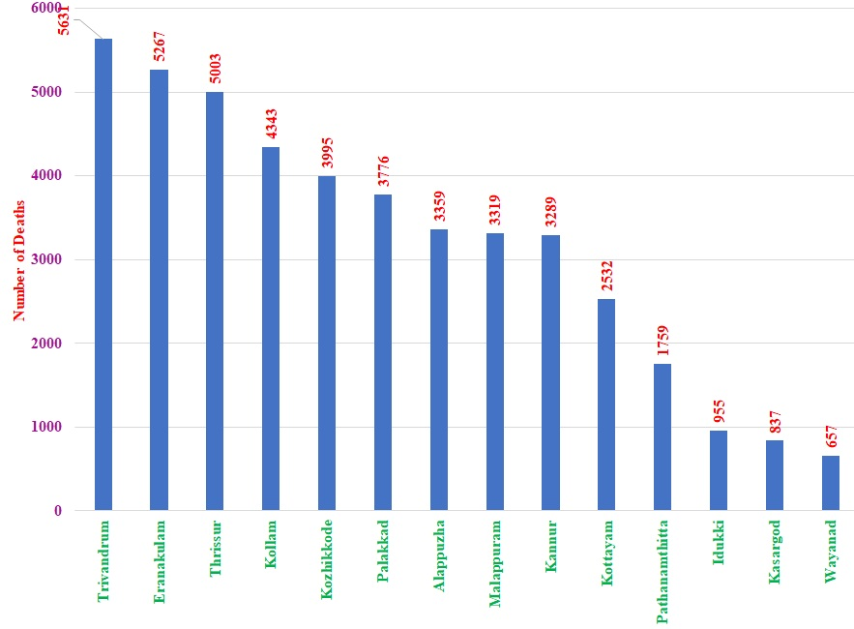Fig.4.District-wise total number of deaths due to COVID-19 infection
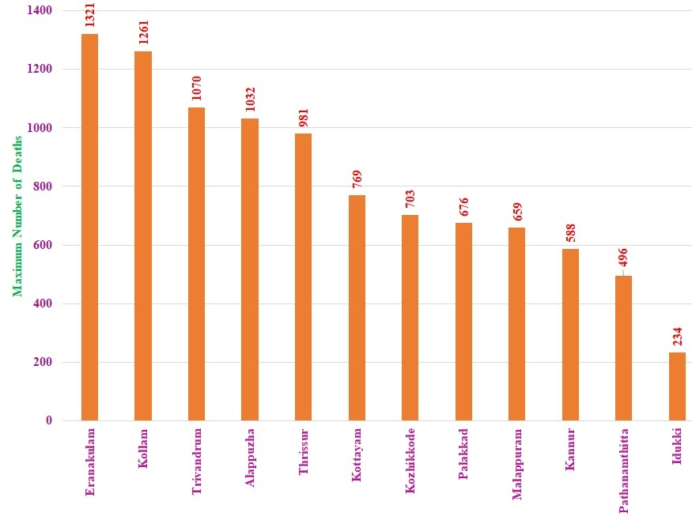
Fig.5.District-wise maximum number of deaths due to COVID-19 infection
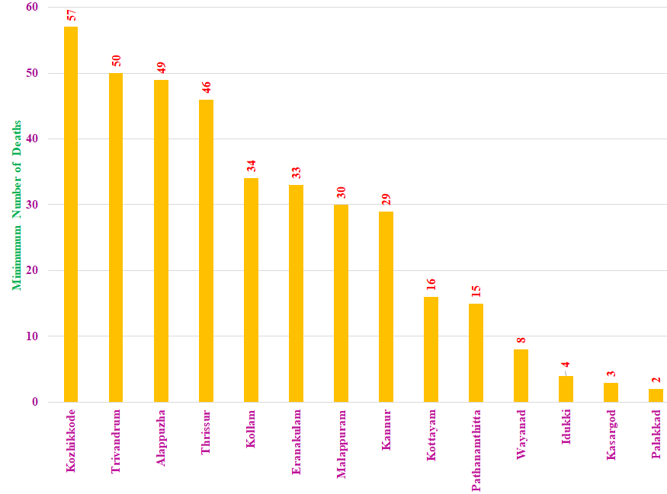
Fig.6.District-wise minimum number of deaths due to COVID-19 infection

3.2. Month-Wise Summary statistics COVID-19 infected cases
Month-wise total numbers of infected cases are presented in Table – 3 and depicted in Fig.7. The result reveals that all over the Kerala state, 4479092 COVID-19 infected cases were registered in the year 2021. The highest number of COVID-19 infected cases were reported in May (955396) and the lowest in March (64881). All over the state, the death pattern due to COVID-19 infections is skew-symmetric since all the skewness values are positive. Since all the kurtosis values are greater than one, the distribution is too peaked and leptokurtic. Although the kurtosis value in December is greater than 3, the dataset has heavier tails than a normal distribution (more in the tails). For the rest of the districts, the dataset has lighter tails than a normal distribution (less in the tails). Since all the p-values of the Jarque-Bera test are non-significant, indicating that the COVID-19 infected cases are normally distributed in all months. The maximum number of COVID-19 infected cases was reported in May (123987) (Fig.8.), and the minimum number of COVID-19 infections was reported in March (1602) (Fig.9.).

Table – 3: Month-wise summary statistics of the number of COVID-19 infection
MONTH | Sum. | Maxi. | Mini. | Std. Dev. | Skew. | Kurt. | J-Bera
January | 168245 | 24482 | 2305 | 5780.858 | 0.3683 | 2.8243 | 0.8459
February | 130225 | 15803 | 2832 | 4373.713 | 0.2050 | 1.6798 | 0.5727
March | 64881 | 8871 | 1602 | 1982.855 | 0.2887 | 2.6793 | 0.8805
April | 446601 | 64263 | 11763 | 16876.17 | 0.6176 | 2.2829 | 0.5516
May | 955396 | 123987 | 17736 | 35064.24 | 0.5081 | 1.8038 | 0.6587
June | 397586 | 50764 | 6960 | 14834.06 | 0.0286 | 1.5001 | 0.5183
July | 466626 | 68664 | 9115 | 17764.94 | 0.4109 | 2.2102 | 0.6846
August | 660472 | 91811 | 16823 | 26016.30 | 0.4446 | 1.7699 | 0.5107
September | 623625 | 80612 | 9642 | 21124.73 | 0.1040 | 2.1709 | 0.8081
October | 286915 | 41829 | 4998 | 10555.85 | 0.6430 | 2.4960 | 0.5732
November | 173157 | 25588 | 2940 | 7310.53 | 0.6667 | 2.1555 | 0.4835
December | 105363 | 19129 | 1949 | 5321.86 | 1.0841 | 3.0260 | 0.2538

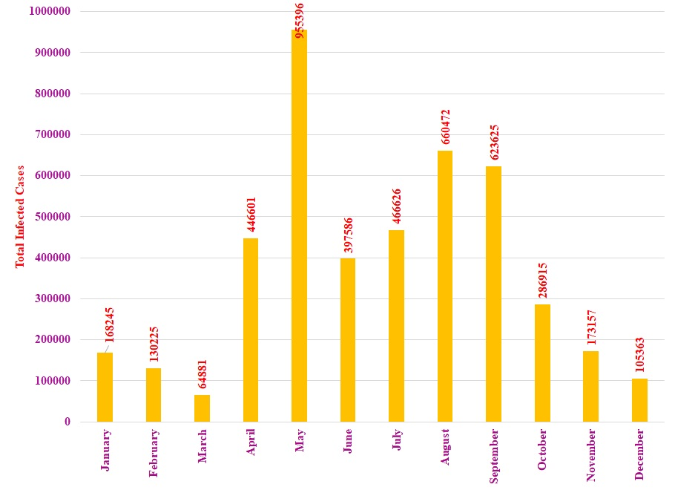
Fig.7: Month-wise total numbers of COVID-19 infected cases

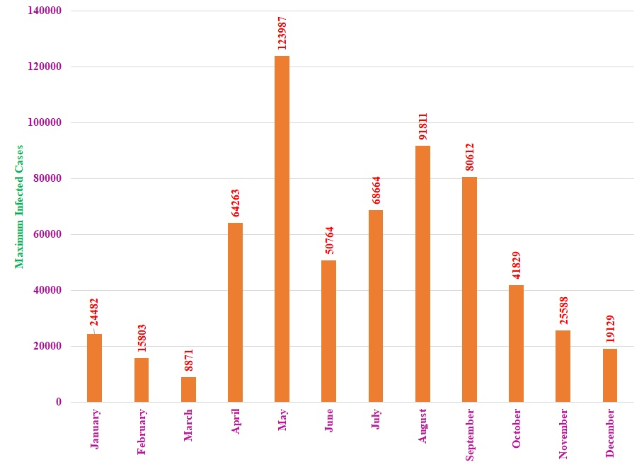
Fig.8: Month-wise maximum numbers of COVID-19 infected cases
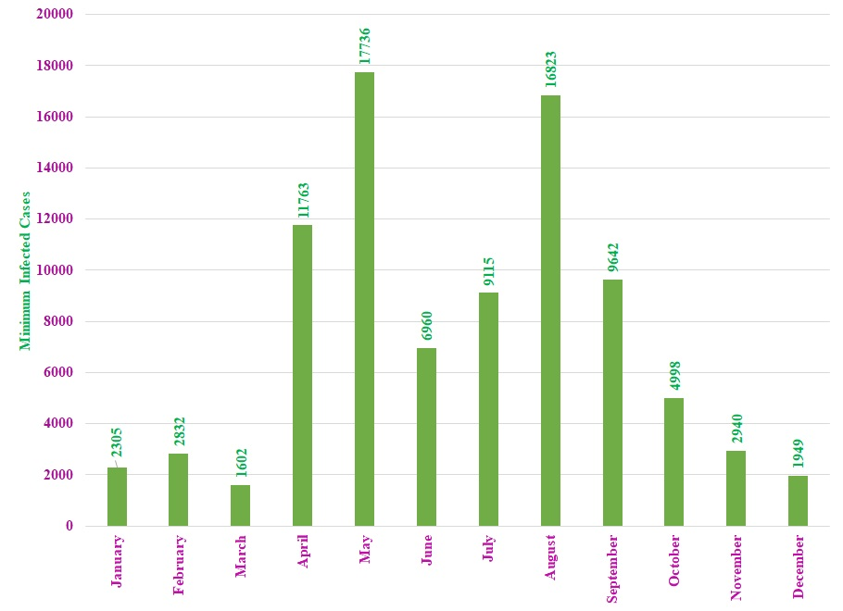
Fig.9: Month-wise minimum numbers of COVID-19 infected cases

Month-wise total deaths due to COVID-19 infections are presented in Table – 4 and depicted in Fig.10. The highest number of deaths due to COVID-19 infections was registered in November (8451) and then decreased to 7662 in December. From February onwards, the number of deaths was increasing every month. Since all the p-values of the Jarque-Bera test are non-significant, indicating that the COVID-19 infected cases are normally distributed in all months. The month-wise maximum and minimum deaths are depicted in Fig.11 and 12, respectively.

Table – 4: Month-wise summary statistics of the number of deaths due to COVID-19 infection

MONTH | Sum. | Maxi. | Mini. | Std. Dev. | Skew. | Kurt. | p-values
January | 671 | 98 | 9 | 26.79 | 0.3377 | 2.2143 | 0.7311
February | 454 | 88 | 3 | 24.10 | 0.7064 | 3.0002 | 0.5587
March | 424 | 58 | 2 | 19.12 | 0.0640 | 1.5980 | 0.5610
April | 687 | 110 | 4 | 35.36 | 0.4191 | 1.9982 | 0.6079
May | 3507 | 760 | 10 | 204.11 | 1.0407 | 3.7167 | 0.2433
June | 4420 | 1043 | 57 | 256.48 | 1.6027 | 5.6607 | 0.5063
July | 3546 | 464 | 56 | 151.79 | -0.0421 | 1.3257 | 0.4406
August | 4007 | 548 | 72 | 171.75 | 0.1481 | 1.5746 | 0.5389
September | 4299 | 596 | 70 | 169.17 | -0.0523 | 1.7992 | 0.6546
October | 6594 | 1106 | 93 | 322.99 | 0.7719 | 2.6696 | 0.4834
November | 8451 | 1321 | 97 | 374.97 | 0.6150 | 2.5433 | 0.6053
December | 7662 | 1032 | 91 | 299.84 | -0.2329 | 1.7269 | 0.5851
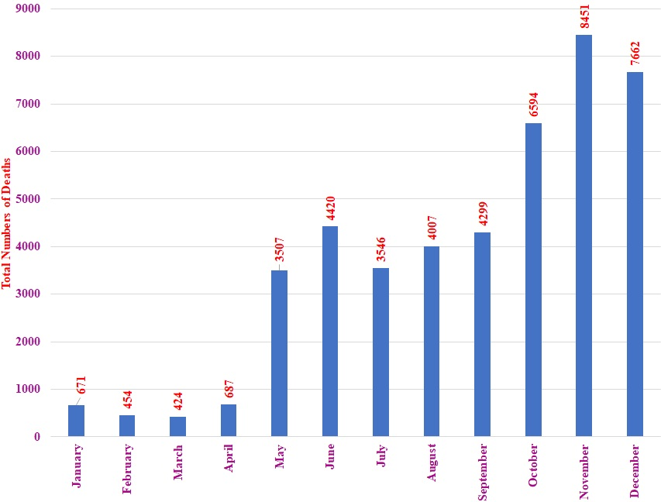
Fig.10.Month-wise total number of deaths due to COVID-19 infections
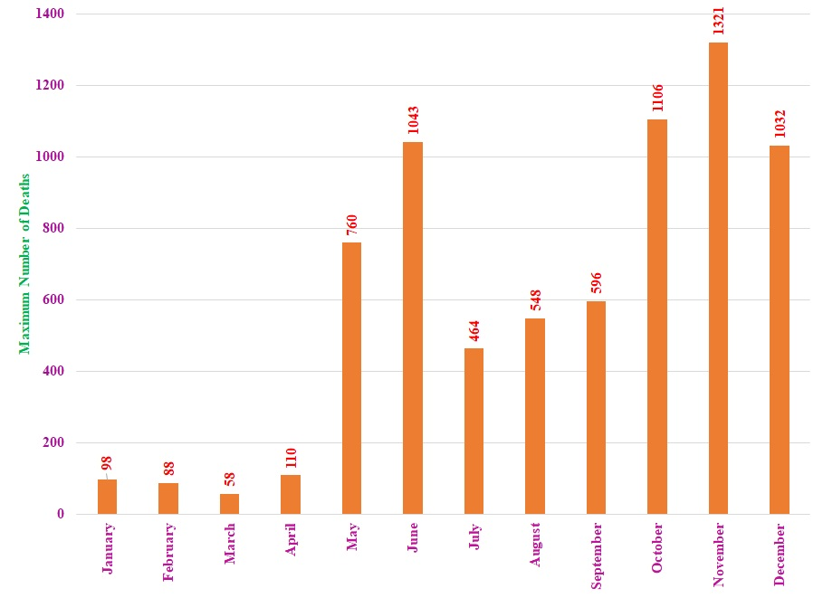
Fig.11.Month-wise maximum number of deaths due to COVID-19 infections
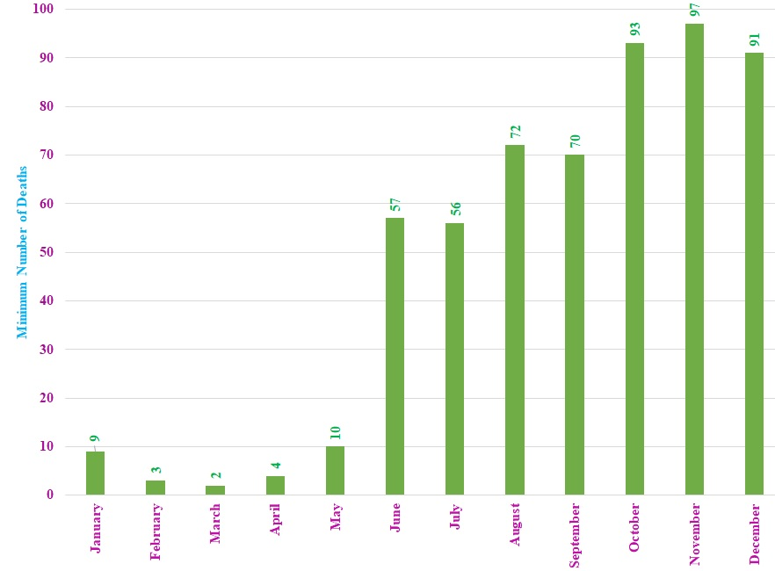
Fig.12.Month-wise minimum number of deaths due to COVID-19 infections

3.3. Unit root tests
In analyses of time series data, the study variables must be stationary, whose statistical properties, such as mean, variance, autocorrelation, etc., are all constant over time. Accordingly, Levin-Lin-Chu (2002) unit root tests were performed to test the stationarity of the study variables, viz., the number of infected cases and deaths. The results are reported in Table – 5. The test results reveal that the two variables under study are stationary since the Levin, Lin, and Chu t-statistics are highly significant (p<0.0000). Hence, the variables under study are stationary.
Table – 5: Unit root test results for the variable Cases and Deaths

Method | Cases |  | Deaths
Method | Statistic | Prob** | Statistic | Prob**
Levin, Lin & Chu t* | -4.2807 | 0.0000 | -4.9468 | 0.0000
** Probabilities are computed assuming asymptotic normality

3.4. Panel Cointegration test
To estimate the cointegration relationship between DEATH due to COVID-19 and the number of COVID-19 cases, the Pedroni Cointegration Test (with no deterministic trend, with deterministic intercept and trend; and with no deterministic intercept or trend) was performed in addition to the Kao Cointegration test ((Kao and Chiang (2000)). The results of the Pedroni and Kao Cointegration tests are presented in Tables – 6 through 9.

The test results reveal that in eleven tests, the null hypothesis of no cointegration is accepted since most of the test statistics p values are > 0.5000, indicating that no cointegration exists; i.e., there is no long-term relationship between the number of deaths due to COVID-19 and the number of COVID-19 infection cases.

Table – 6: Characteristics of Pedroni Cointegration Test (No deterministic trend)

Name of Test Statistic | Statistic | Prob. | Weighted Statistic | Prob.
Panel v-Statistic | -1.361338 | 0.9133 | -1.513637 | 0.9349
Panel rho-Statistic | 1.732908 | 0.9584 | 2.203370 | 0.9862
Panel PP-Statistic | 1.827337 | 0.9662 | 2.597631 | 0.9953
Panel ADF-Statistic | 1.574986 | 0.9424 | 2.410286 | 0.9920
Group rho-Statistic | 4.077287 | 1.0000
Group PP-Statistic | 5.098787 | 1.0000
Group ADF-Statistic | 4.799022 | 1.0000

Table – 7: Characteristics of Pedroni Cointegration Test (Deterministic Intercept and Trend).

Name of Test Statistic | Statistic | Prob. | Weighted Statistic | Prob.
Panel v-Statistic | 0.611097 | 0.2706 | 1.766901 | 0.0386
Panel rho-Statistic | 1.571157 | 0.9419 | 1.573164 | 0.9422
Panel PP-Statistic | -6.412785 | 0.0000 | -5.935624 | 0.0000
Panel ADF-Statistic | -9.289025 | 0.0000 | -8.438939 | 0.0000
Group rho-Statistic | 3.038982 | 0.9988
Group PP-Statistic | -6.250494 | 0.0000
Group ADF-Statistic | -8.045632 | 0.0000

Table – 8: Characteristics of Pedroni Cointegration Test (No Deterministic Intercept or Trend)

Name of Test Statistic | Statistic | Prob. | Weighted Statistic | Prob.
Panel v-Statistic | 0.491295 | 0.3116 | 0.321542 | 0.3739
Panel rho-Statistic | 0.148871 | 0.5592 | 0.656965 | 0.7444
Panel PP-Statistic | 0.591498 | 0.7229 | 1.233710 | 0.8913
Panel ADF-Statistic | -0.200313 | 0.4206 | 0.879375 | 0.8104
Group rho-Statistic | 3.999541 | 1.0000
Group PP-Statistic | 4.329492 | 1.0000
Group ADF-Statistic | 3.348038 | 0.9996

Table – 9. Characteristics of the Kao Cointegration Test
Test Name | t-Statistic | Prob.
ADF | 0.323838 | 0.3730

From Table – 10, the hypotheses of no cointegration were accepted for both the trace and maximum eigenvalue tests since their respective p-values are more significant than the 5% chosen significance level. Therefore, since the variables under study are stationary at the level and are not cointegrated, the PVAR(p) model is appropriate for analyzing the panel data (Rubinfeld, 1991).
Table – 10: Characteristics of Johansen Fisher Panel Cointegration test
Hypothesized | Fisher Stat.* |  |  | Prob.
No. of CE(s) | (Trace test) | Prob. | (Max-eigen test) | Prob.
None | 31.52 | 0.2944 | 26.94 | 0.5215
At most 1 | 38.56 | 0.0882 | 38.56 | 0.0882

3.5. Panel VAR model
The interpretation of the estimated coefficients of the PVAR, VAR, and VECM models are done in terms of the influence on nature (positive or negative effect) dynamic (short term and long term) between the endogenous variables taken together and especially with their own. The number of lags to be included in the VAR model using the lag selection criteria is illustrated in Table - 11. Table 11 shows that the selection criteria result reveals that the VAR of lag 2 is the appropriate model.
Table – 11: PVAR Lag Order Selection Criteria

Lag | LogL | LR | FPE | AIC | SC | HQ
0 | -483.3978 | NA | 3.91e+12 | 34.67127 | 34.76643 | 34.70036
1 | -441.7260 | 74.41386 | 2.66e+11 | 31.98043 | 32.26590 | 32.06770
2 | -434.6338 | 11.65153 | 2.14e+11 | 31.75955 | 32.23534* | 31.90501
3 | -431.8936 | 4.110180 | 2.38e+11 | 31.84955 | 32.51565 | 32.05318
4 | -428.6113 | 4.454608 | 2.57e+11 | 31.90081 | 32.75722 | 32.16262
* indicates lag order selected by the criterion
LR: sequential modified LR test statistic (each test at 5% level)
FPE: Final prediction error
AIC: Akaike information criterion
SC: Schwarz information criterion
HQ: Hannan-Quinn information criterion

The fixed and random effect (PVAR (2) models have been estimated and presented in Tables 12 and 13. To decide whether to consider the fixed effect model or random effect model, the Hasman test has been carried out, and the results are presented in Table – 14. Since the Hasman Test statistic value is non-significant, indicating that the random effect model is appropriate.

The random effect model reveals both the lag variables (exogenous variables) explain 62 % of variations in deaths. The exogenous variable DEATHS (-1) is highly significant, whereas the exogenous variable CASES(-1) is significant at a 5% level. Both of these exogenous variables positively influence the endogenous variable (DEATHS). The other independent exogenous variables, viz., DEATHS(-2) and CASES (-2) (second lag), are non-significant. Also, since the estimated Durbin-Watson stat value is 2.02, the errors due to the estimated model are uncorrelated, which is preparable.

Table 7.12. Characteristics of estimated fixed effect PVAR model

Variable | Coefficient | Std. Error | t-Statistic | Prob.
C | 88.60644 | 32.82038 | 2.699738 | 0.0079
DEATHS(-1) | 0.700019 | 0.101784 | 6.877476 | 0.0000
DEATHS(-2) | -0.014646 | 0.127208 | -0.115137 | 0.9085
CASES(-1) | 0.001857 | 0.000799 | 2.325198 | 0.0217
CASES(-2) | -0.000398 | 0.000891 | -0.446828 | 0.6558
Root MSE | 171.8097 | R-squared |  | 0.635422
Mean dependent var | 311.4071 | Adjusted R-squared |  | 0.584620
S.D. dependent var | 285.5676 | S.E. of regression |  | 184.0483
Akaike info criterion | 13.38780 | Sum squared resid |  | 4132602.
Schwarz criterion | 13.76601 | Log-likelihood |  | -919.1457
Hannan-Quinn criteria. | 13.54149 | F-statistic |  | 12.50783
Durbin-Watson stat | 2.027458 | Prob(F-statistic) |  | 0.000000

Table 7.13. Characteristics of estimated random effect PVAR model

Variable | Coefficient | Std. Error | t-Statistic | Prob.
C | 56.73332 | 26.81084 | 2.116059 | 0.0362
DEATHS(-1) | 0.728427 | 0.100089 | 7.277823 | 0.0000
DEATHS(-2) | 0.039264 | 0.120517 | 0.325794 | 0.7451
CASES(-1) | 0.002348 | 0.000734 | 3.198802 | 0.0017
CASES(-2) | -0.000440 | 0.000862 | -0.510533 | 0.6105
Effects Specification |  |  | S.D. | Rho
Cross-section random |  |  | 0.000000 | 0.0000
Idiosyncratic random |  |  | 184.0483 | 1.0000

Table 7.14. Characteristics of estimated Hausman Test

Test Summary | Chi-Sq. Statistic | Chi-Sq. d.f. | Prob.
Cross-section random | 5.014515 | 4 | 0.2858

3.6. Wald test
According to the Wald test (Wald, 1943) results presented in Table - 15, the hypothesis that all coefficients are zero is rejected at a 1% significance level; thus, the validity of the significance of coefficients is confirmed, meaning that they add explanatory power to the model.
Table 7.15: Characteristics of Wald test

Test Statistic | Value | df | Probability
F-statistic | 70.86904 | (4, 135) | 0.0000
Chi-square | 283.4761 | 4 | 0.0000

3.7. Causality test
The Granger test of causality was employed to assess whether causal relationships exist among the variables and determine the direction of the causality. The results are presented in Table - 16. The test results reveal that the null hypothesis of no causality between the independent and dependent variables running in either direction is rejected. Hence, bidirectional causality exists between the study variables.
Table – 16: Characteristics of Pairwise Granger Causality test

Null - Hypothesis: | Obs. | F- Statistic | Prob.
CASES does not Granger Cause DEATHS | 140 | 5.97657 | 0.0033
DEATHS does not Granger Cause CASES | 140 | 3.67312 | 0.0280
3.8. Impulse Response Function
Sensitivity responses of the two variables using impulse response graphs are presented in Fig.12. It can be deduced that number of COVID-19 deaths (DEATHS) is sensitive to COVID-19 infected cases (CASES), as evident from the graph labeled "Response of DEATHS to CASES" at the top right of Fig.12. Furthermore, it can be deduced that CASES is sensitive to DEATHS, as evident from the graph labeled "Response of CASES to DEATHS" at the bottom left of Fig.12. This further buttressed the findings on Granger causality earlier discussed.
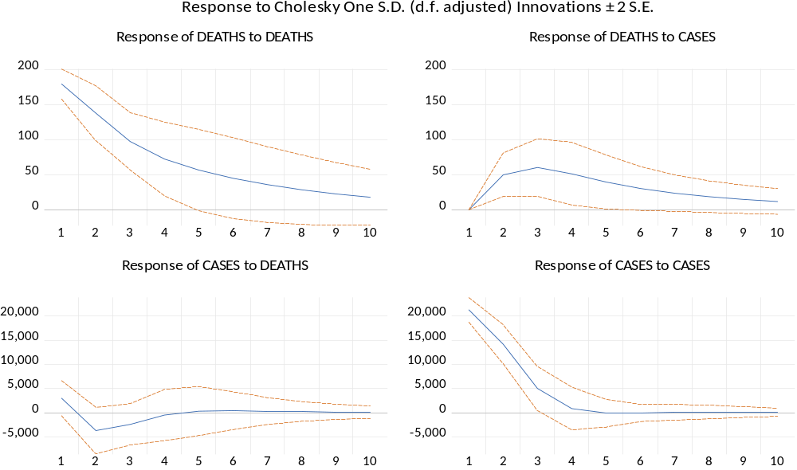
Fig.12.Impulse Response Function
4. Conclusions
The result reveals that all over the Kerala state, 4479092 infected cases were registered in 2021. The maximum number of total infected cases has been reported in Malappuram (123987) district, followed by Eranakulam (116878), Trivandrum (103688), and Kozhikkode (90484). In the Kerala state total number of maximum infected cases have been registered in all the districts in May. The minimum total number of infected cases has been reported in Kozhikkode (8871), Eranakulam (6639), Kannur (5986), etc. Total number of maximum infected cases have been registered in all the districts in March, except Kasargod district. The minimum number of total infections in this district is 1949, recorded in December. Total number of maximum deaths has been reported during October (Trivandrum, 1070); November (Eranakulam, 1321; Kollam, 1261; Thrissur, 981; Kozhikkode, 703; Kannur, 588, Pathanamthitta, 496) and December (Alappuzha, 1032; Kottayam, 769; Palakkad,676; Malappuram, 659; Idukki, 234). Total number of minimum deaths has been reported during February ( Kozhikkode, 57; Thrissur,46; Malappuram, 30; Kannur, 29; Kottayam, 16; Kasargod,3); March (Trivandrum, 50; Alappuzha,49; Kollam, 33; Pathanamthitta,15; Wayanad, 8; Palakkad,8) and in April (Idukki,4). The random effect model reveals that both the lag variables (exogenous variables) explain 62 % variations in the endogenous variable, deaths. The exogenous variable DEATHS (-1) is highly significant, whereas the exogenous variable CASES(-1) is significant at a 5% level. Both of these exogenous variables positively influence the endogenous variable (DEATH). The other independent exogenous variables, viz., DEATHS(-2) and CASES-2) (second lag), are non-significant. Also, since the estimated Durbin-Watson stat value is 2.02, the errors due to the estimated model are uncorrelated, which is preparable. Wald test confirms the validity of the significance of coefficients.
References
- Binder, B.M., C.Hsiao, and M.H.Pesaran, “Likelihood-based inference for Panel Vector Autoregressions: Testing for Unit Roots and Cointegration”, Short Panel, Mimeo, 2010.
- Granger, C.W.J.,”Investigating causal relations by econometric models and cross-spectral methods”. Econometrica, Vol.37, No.3, pp.424–438, August 1969.
- Holtz-Eakin, D., W.Newey and H.S.Rosen, “Estimating Vector Autoregressions with Panel Data”, Econometrica, Vol.56, No.6, pp.1371-1395, 1998.
- Jarque, C.M. and Bera,A.K., “A test for normality of observations and regression residuals”, International Statistical Review, Vol.55, No.2, pp.163-172, 1987.
- Johansen, S., “Statistical analysis of cointegration vectors”, Journal of Economic Dynamics and Control, Vol.12,No.2-3, pp.231-254, 1988.
- Kao, C., and M.H.Chiang, “On the estimation and inference of a cointegrated regression in panel data”, Advances in Econometrics, 15, pp.179-222, 2000 .
- Levin, A., C.F.Lin, and C.S.Chu, “Unit Root Test in Panel Data : Asymptotic and Finite-Sample properties”, Journal of Econometrics, Voll.108, No.1, pp.1-24, 2002.
- Love, I., and L.Zicchino, “Financial development and dynamic investment behavior. Evidence from panel VAR”, The Quarterly Review of Economics and Finance, Vol.46, No.2, pp.190-210, 2006.
- Mei, L.Y and X.Jing,”Forecast the GDP of Shanghai based on the multi-factors VAR model”, Journal of the Hubei University of Technology, Vol.26, No.3, 2011.
- Pedroni, P.,”Panel co-integration : asymptotic and final sample properties of pooled time series tests with an application to Ppp hypothesis: new results”, Econometric Theory, Vol.20, No.3,pp.597-625, June 2004.
- Pesaran, M.H., and R.Smith, “Estimating long-run relationships from dynamic heterogeneous panels”, Journal of Econometrics, Vol.68, No.1,pp.79-113,1995.
- Rubinfeld, R.S.,” Econometric Models and Economic Forecasts”, New York: McGraw Hill International Editions, 1991.
- Soharwardi, M.A., R.E.A.Khan, S.Mushtaq,”Long run and the short run relationship between financial development and income inequality in Pakistan”, Journal of ISOSS, Vol.4, No.2, pp.105-112, 2018.
- Sims, C.A., “Macroeconomics and Reality”, Econometrica, Vol.48, No.1, pp.1-48, 1980.
- Wald, A.,”Tests of statistical hypotheses concerning several parameters when the number of observations is large”, Transactions of the American Mathematical Society, Vol.54, pp. 426-482, 1943.

