Geotechnical Properties of Soil in Ranya and Arbat Area, Sulaimaniya, Kurdistan Region, Iraq

Galawezh Bakr Bapeer, Rozhgar Kamal Muhammad , Kazhan Akram Nadr, Loghman Khodakarami⁴and Nadhir Al-Ansari⁵

Abstract

This study deals with determine of some geotechnical properties of soil in Ranya district and Arbat sub-district area, these two areas are located in Sulaymaniya Governorate, Kurdistan region of Iraq. The soil in nature is changed from place to another. This is because of the mineral composition of rocks and climate change, so, studying the properties of soil is important for various purposes especially for engineering structures. In this paper, some geotechnical properties of soil were studied like particle size distribution, specific gravity and Atterberg limits. The study of particle size distribution indicated that the soil mostly silt and sand with few clays, this means that the soil consists of coarse and fine mixture. The Atterberg limits results are indicated that both areas with low to medium plasticity index. And the results of the specific gravity test indicated that the soil in both areas is free from iron and mica minerals. A good matching indicated between the geotechnical soil properties of Ranya and Arbat area.

Keywords: Geotechnical properties, Particle size, Atterberg limits, Specific gravity of soil, Ranya, Arbat.

1 Introduction
Soil exploration is a must in the present age for the design of foundations of any project. The extent of the exploration depends upon the magnitude and importance of the project. Projects such as buildings, power plants, fertilizer plants, bridges, etc. are localized in an area extend. The area occupied by such projects may vary from a few square meters to many square kilometers (Murthy,2007). Before a field investigation is started, available technical data including topographic maps, aerial photographs, Agricultural soil maps, ground water resources documents, geological maps, detailed information from adjacent or similar sites, local residents, and sub-surface explorations should be reviewed (Fratta et al, 2007). Soils are used as construction materials in another word the civil engineering structures are found in or on the surface of the earth. Geotechnical properties of soil influence the stability of civil engineering structures. The choice of particular methods of particle size distribution should be governed by the details required and specific characteristics of the materials to be analyzed (Olawuyi1& Asante1, 2016). Experimental characterization of the size of individual particles are achieved by a combination of two procedures: sieving and sedimentation (Jury, 1991). The sedimentation analysis is based on Stokes' law, according to which terminal velocity of sinking a spherical particle in a still liquid medium is dependent upon density and velocity of the liquid (Das, 2002). Ranya District and Arbat Sub- District area are located in Sulaimaniya Governorate, within the Kurdistan Region of Iraq. Both areas (Arbat and Ranya) are approximately 34 and 104 km far from the Sulaymaniyah city center. Ranya is located from the north west while the Arbat is from south east of the Sulaymaniyah city see Fig.1. Structurally both areas are located at the boundary between high folded zone and imbricated zone (Jassim & Golf, 2006). Alluvial sediments cover Ranya area, which consists of clay, silt, sand, and gravel (Ssisakian, 2000), see Fig.2 while Arbat area is located on Shiranish and Kometan Formations, Shiranish Formation consists of blush grey marl with marly limestone while Kometan Formation consists of well bedded white limestone.

2. Materials and Methods
Sixteen boreholes were dug from the two areas with different depth approximately ranged from 5.5m to 6.0 m. Disturbed soil samples were collected from the boreholes in order to perform classification of the soil. Classification tests were conducted on disturbed samples which the soil were separated into coarse - grain soils and fine-grained soils according to ASTM D 422. Coarse-grained soils include those particle sizes diameter larger than 0.075 mm (retained on sieve number 200) such as boulders, cobbles, gravel and sand while fine – grained soils consist of particle sizes smaller than 0.075mm (passing through sieve number 200) such as silts and clays (Allen, 1997). Sieve analysis was performed for coarse grain soil particles and sedimentation analysis (Hydrometer test) for fine grain soil particles. In the sedimentation analysis the density of the suspension is measured by taking hydrometer reading at different times (Gee & Bauder, 1986). It gives a percentage of clay and silt fractions which is used as a construction material for earth structures or as supporting strata for building structure (Roy & Bhalla, 2017). Specific gravity test was conducted to the samples according to ASTM D 854.
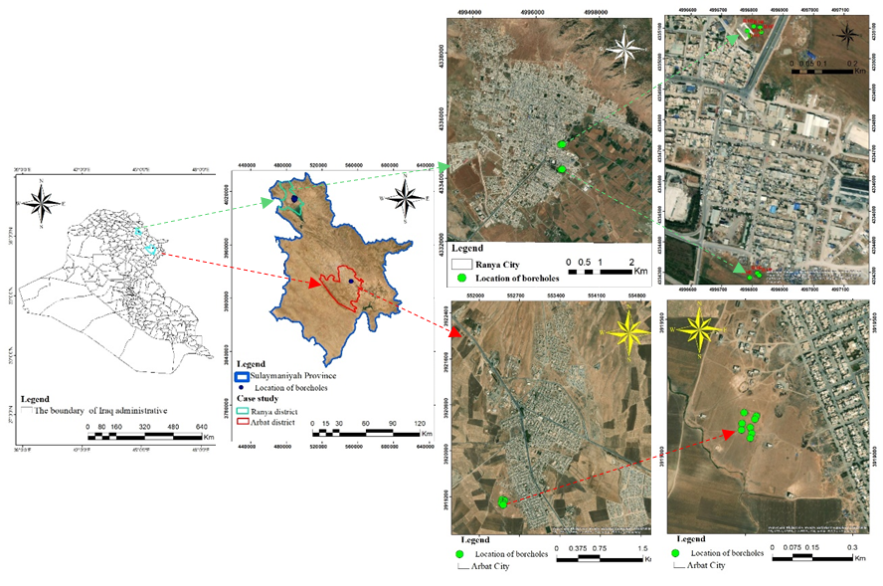

Fig.1. Location Map of Ranya and Arbat area.

Soil specific gravity refers to the mass of solid matter of a given soil sample as compared to an equal volume of water (Gofar& Kassim, 2007), the value of specific gravity obtained for at least 2 h time period by using partially vacuum and shaking method for particle size smaller than 4.75 mm was the nearest to the value of specific gravity obtained by using the pycnometer method ( Rashid et al, 2017). Atterberg limits test have been done for the same sixteen samples According to ASTM D 4318. Atterberg limits define as a water content of soil by percentage of various consistency stages for fine grained soils.
This test includes a liquid limit and plastic limit. For the liquid limit test Casagrande method was used, 250 gm of soil sample passing through sieve number 40 was taken, distilled water was added to form a soil paste then leaved to soak. A part of the soaked soil paste was placed in a Casagrande cup using groove tools to cut the soil in the cup, the cup is given blows, the number of blows required to close the groove for a distance of 13 mm is noted down, A number of trial was repeated with different percentage of water content then flow curve chart was drawn between water content percentage and number of blows, the liquid limit is obtained as a water content corresponding to 25 blows. Plastic limit can be defined as the lowest water content in which the soil can be rolled into threads 3.2 mm in diameter without breaking into pieces. Plasticity Index is the difference between liquid limit and plastic limit (Burns et al., 2005).
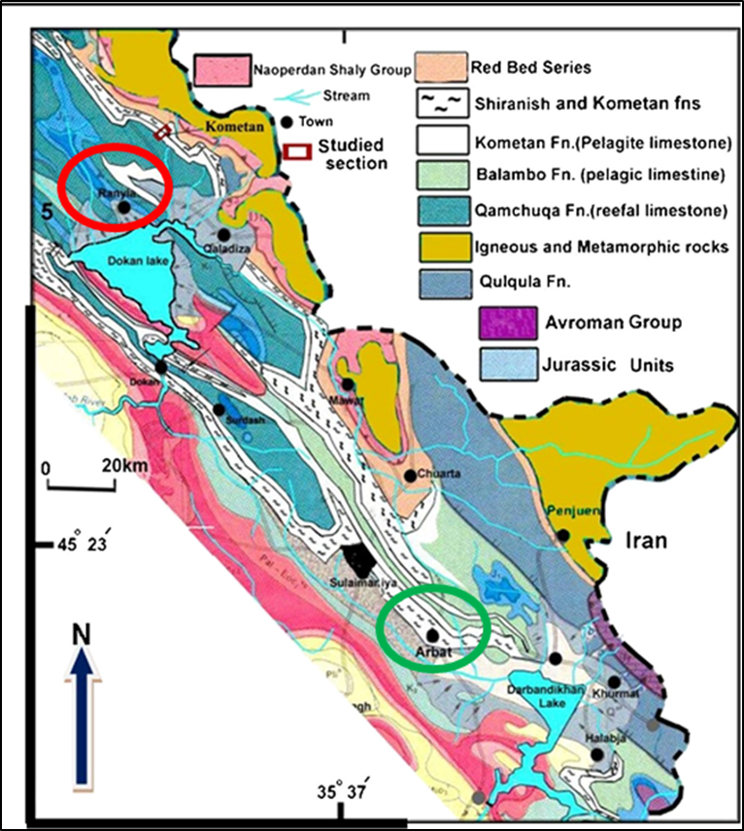

Fig.2. Geological map of the studied area (modified from Sissakian 2000)
3. Results and Discussion
The results that were obtained from the laboratory tests are as follows:
1- The particle size distribution curves suggest that the soil in Ranya Area is of sand silt mixture, with very little clay which is present in borehole No.1. While the soil in the Arbat area is of sand silt mixture without clay. This means that the soil in both areas is of mixture between coarse and fine grain texture. (Fig.3), (Tables 1,2).
2- The specific gravity classification is based on Bowles chart of specific gravity (Bowles,2012), the test results indicated that the specific gravity of soil in Ranya area ranges between (2.5 – 2.61) while in Arbat area ranges between (2.51-2.61), according to the Bowles chart, the soil in both areas is free from mica and iron. (Tables 1,2,3).
3- The liquid limit, plastic limit and plasticity index values in the studied samples according to Casagrande test method are shown in Tables (1, 2), Plasticity index classification based on plasticity index chart which was prepared by Das ( Das, 2002) (Table 4), the results indicated that the plasticity index in Ranya area ranges between (7-17) this means that the soil in this area is with a low to medium plasticity index. And the plasticity index in Arbat area is range between (6-18) this means that the soil in the Arbat area is with low to medium plasticity index also.
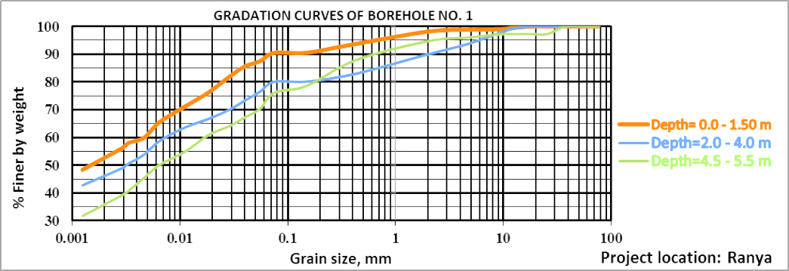

Fig. 3a: Gradation curve of borehole (No.1) Ranya area.
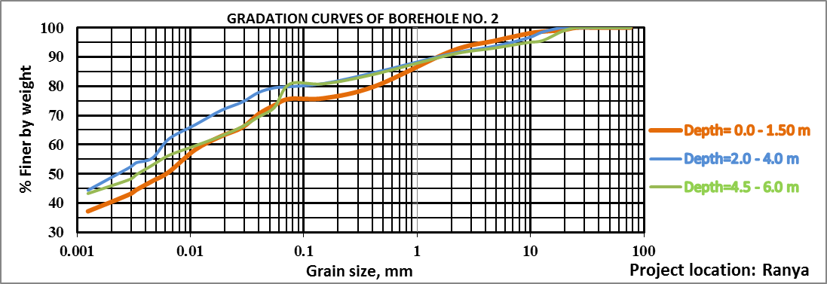

Fig. 3b: Gradation curve of borehole (No.2) Ranya area.
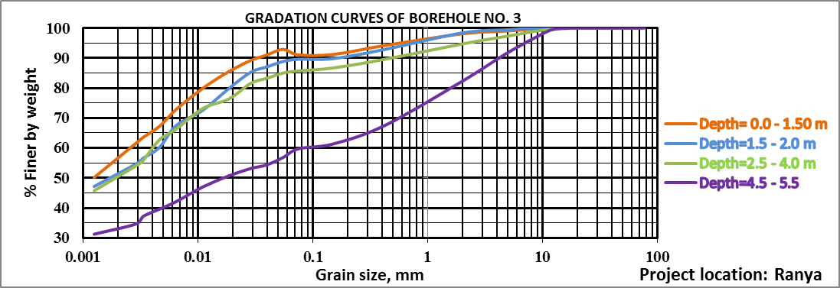

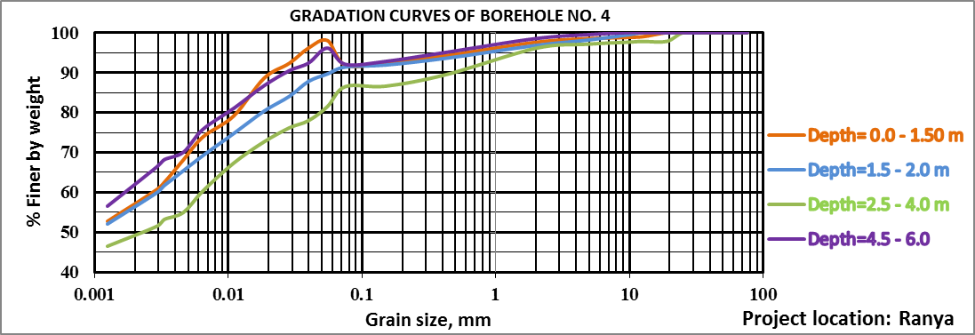
Fig. 3c: Gradation curve of borehole (No.3) Ranya area

Fig. 3d: Gradation curve of borehole (No.4) Ranya area
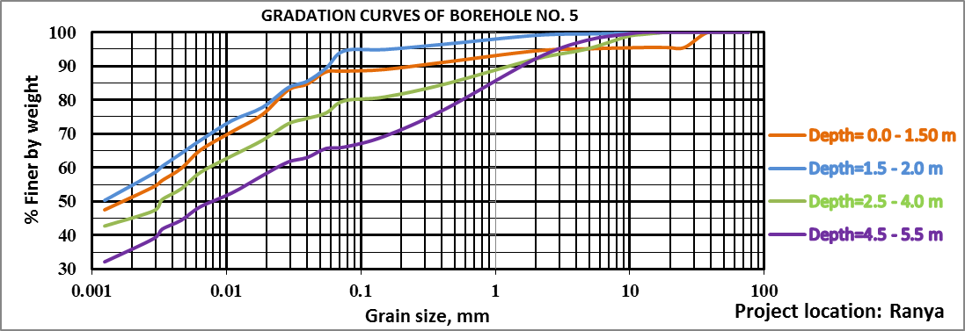

Fig. 3e: Gradation curve of borehole (No.5) Ranya area

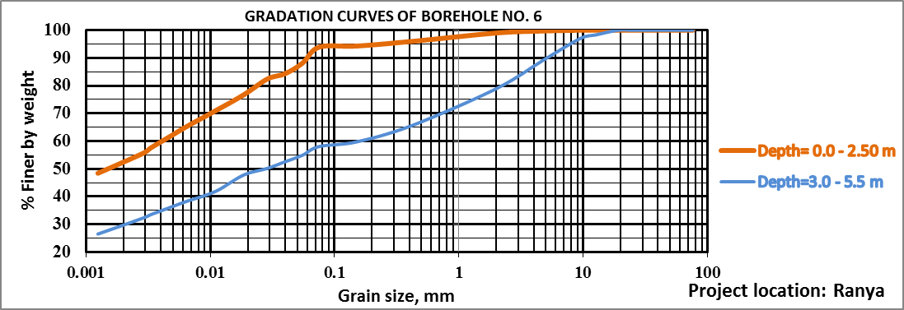

Fig. 3f: Gradation curve of borehole (No.6) Ranya area

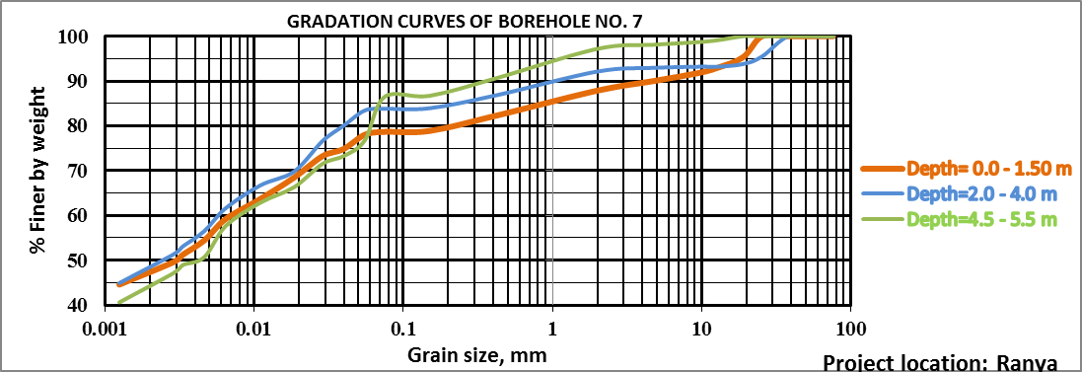

Fig. 3g: Gradation curve of borehole (No.7) Ranya area

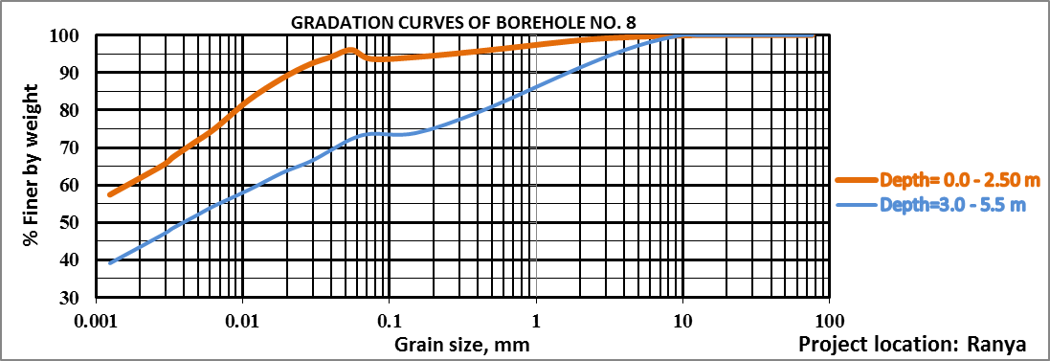

Fig. 3h: Gradation curve of borehole (No.8) Ranya area

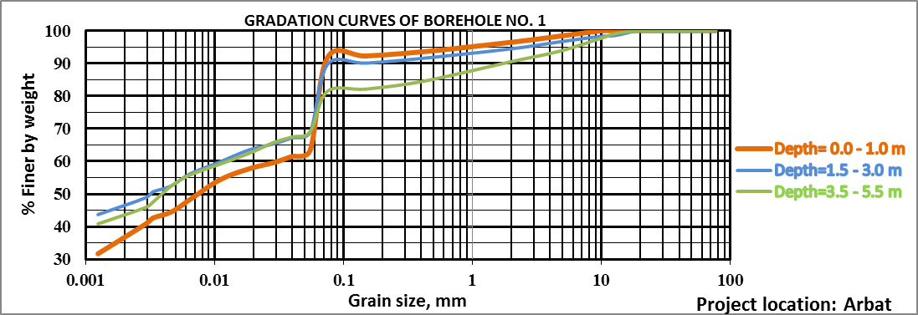
Fig. 4a: Gradation curve of borehole (No.1) Arbat area

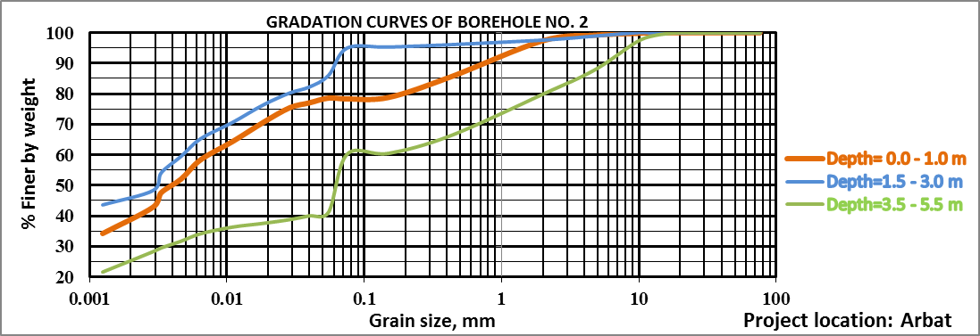

Fig. 4b: Gradation curve of borehole (No.2) Arbat area
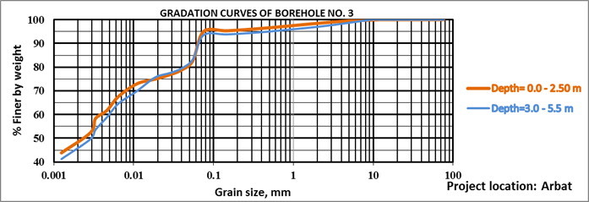

Fig. 4c: Gradation curve of borehole (No.3) Arbat area

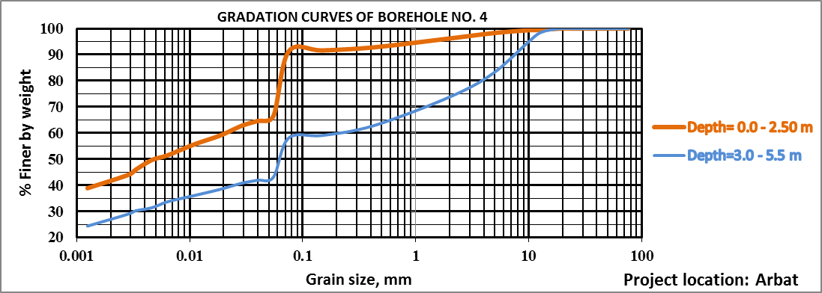
Fig. 4d: Gradation curve of borehole (No.4) Arbat area

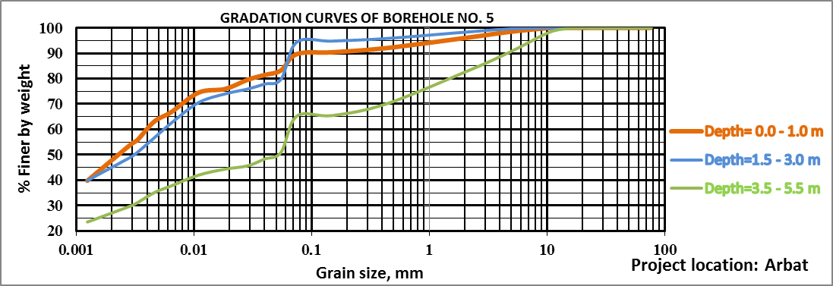
Fig. 4e: Gradation curve of borehole (No.5) Arbat area
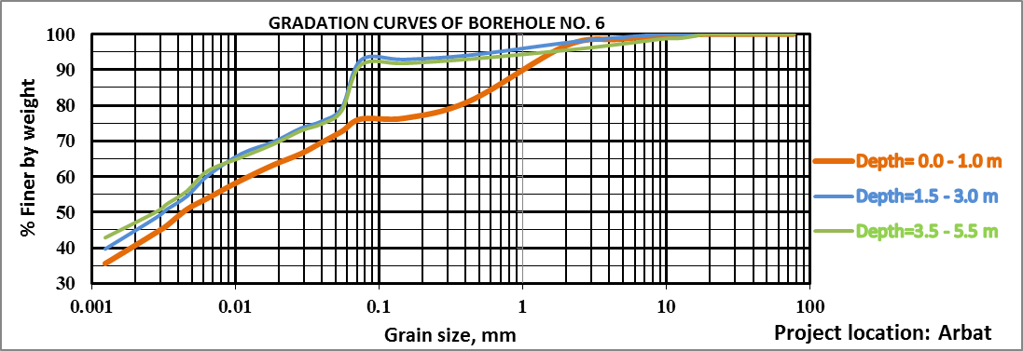
Fig. 4f: Gradation curve of borehole (No.6) Arbat area
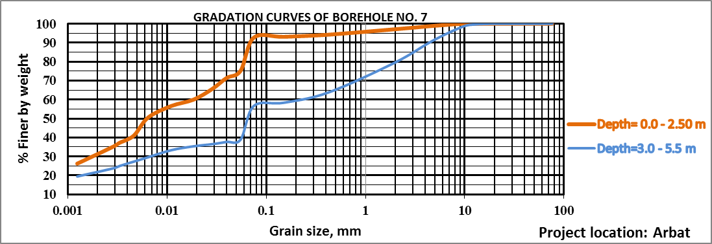
Fig. 4g: Gradation curve of borehole (No.7) Arbat area
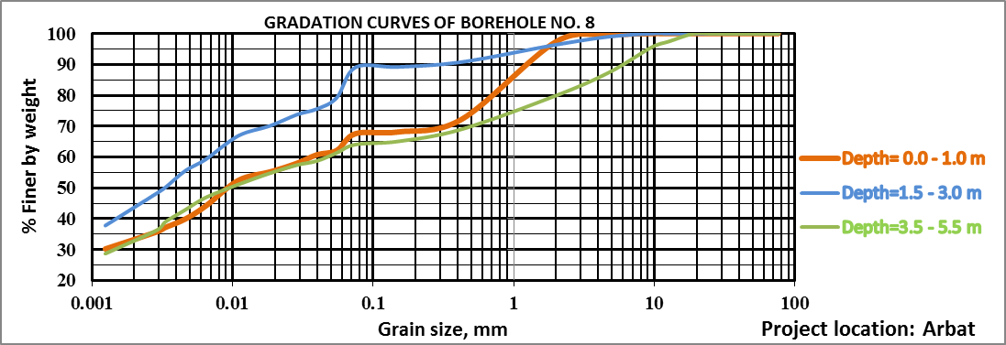
Fig. 4h: Gradation curve of borehole (No.7) Arbat area

Table 1: Some Geotechnical Properties of Ranya Area

Locat-ion | B.H no. | Boring depth (m) | Specific gravity | Atterberg limits |  |  | Classification tests of soil
 |  |  |  | Liquid limit | Plastic limit | Plasticity index | By Sieving |  | By hydrometer |  | Unified soil classification system
 |  |  |  |  |  |  | % Gravel | % Sand | % Silt | % Clay
Arbat | 1 | 0.00 - 1.0 | 2.51 | 43 | 33 | 10 | 1.67 | 6.53 | 47.29 | 44.51 | ML-Silt
 |  | 1.50 - 3.00 | 2.53 | 44 | 32 | 12 | 3.4 | 6.93 | 37.18 | 52.49 | ML-Silt
 |  | 3.50 - 5.50 | 2.55 | 52 | 35 | 17 | 6.27 | 12.27 | 28.98 | 52.49 | MH-Elastic silt with sand
 | 2 | 0.00 - 1.0 | 2.59 | 35 | 29 | 6 | 0.8 | 20.87 | 24.25 | 54.08 | ML-Silt with sand
 |  | 1.50 - 3.00 | 2.57 | 48 | 35 | 13 | 1.1 | 3.9 | 35.54 | 59.46 | ML-Silt
 |  | 3.50 - 5.50 | 2.55 | 39 | 30 | 9 | 12.2 | 27.6 | 28.52 | 31.68 | ML-Sandy silt
 | 3 | 0.00 - 2.50 | 2.54 | 37 | 31 | 6 | 0.53 | 4.47 | 33.25 | 61.75 | ML-Silt
 |  | 3.00 - 5.50 | 2.54 | 44 | 33 | 11 | 1.4 | 5.1 | 34.64 | 58.86 | ML-Silt
 | 4 | 0.00 - 2.50 | 2.53 | 45 | 32 | 13 | 1.8 | 7 | 41.55 | 49.65 | ML-Silt
 |  | 3.00 - 5.50 | 2.61 | 45 | 28 | 17 | 17.4 | 24.53 | 26.7 | 31.37 | ML-Sandy silt with gravel
 | 5 | 0.00 - 1.0 | 2.56 | 42 | 31 | 11 | 1.6 | 8.7 | 25.46 | 64.24 | ML-Silt
 |  | 1.50 - 3.00 | 2.57 | 43 | 32 | 11 | 0.4 | 5.2 | 37.65 | 56.75 | ML-Silt
 |  | 3.50 - 5.50 | 2.59 | 42 | 31 | 11 | 9.73 | 25 | 30.15 | 35.12 | ML-Sandy silt
 | 6 | 0.00 - 1.0 | 2.53 | 39 | 32 | 7 | 1.4 | 22.4 | 25.35 | 50.85 | ML-Silt with sand
 |  | 1.50 - 3.00 | 2.51 | 47 | 34 | 13 | 0.9 | 6.3 | 38.26 | 54.54 | ML-Silt
 |  | 3.50 - 5.50 | 2.51 | 46 | 32 | 14 | 2.8 | 5.8 | 35.4 | 56 | ML-Silt
 | 7 | 0.00 - 2.50 | 2.53 | 42 | 31 | 11 | 1.13 | 6.13 | 51.74 | 40.99 | ML-Silt
 |  | 3.00 - 5.50 | 2.55 | 36 | 26 | 10 | 8.93 | 34.4 | 29.41 | 27.26 | ML-Sandy silt
 | 8 | 0.00 - 1.0 | 2.52 | 34 | 27 | 7 | 0.53 | 31.87 | 27.65 | 39.95 | ML-Sandy silt
 |  | 1.50 - 3.00 | 2.55 | 44 | 33 | 11 | 1 | 9.9 | 33.51 | 55.59 | ML-Silt
 |  | 3.50 - 5.50 | 2.51 | 38 | 30 | 8 | 12.6 | 23.33 | 21.15 | 42.92 | ML-Sandy silt

Table 2: Some Geotechnical Properties of Arbat area

Locat-ion | B.H no. | Boring depth (m) | Specific gravity | Atterberg limits |  |  | Classification tests of soil
 |  |  |  | Liquid limit | Plastic limit | Plasticity index | By Sieving |  | By hydrometer |  | Unified soil classification system
 |  |  |  |  |  |  | % Gravel | % Sand | % Silt | % Clay
Arbat | 1 | 0.00 - 1.0 | 2.51 | 43 | 33 | 10 | 1.67 | 6.53 | 47.29 | 44.51 | ML-Silt
 |  | 1.50 - 3.00 | 2.53 | 44 | 32 | 12 | 3.4 | 6.93 | 37.18 | 52.49 | ML-Silt
 |  | 3.50 - 5.50 | 2.55 | 52 | 35 | 17 | 6.27 | 12.27 | 28.98 | 52.49 | MH-Elastic silt with sand
 | 2 | 0.00 - 1.0 | 2.59 | 35 | 29 | 6 | 0.8 | 20.87 | 24.25 | 54.08 | ML-Silt with sand
 |  | 1.50 - 3.00 | 2.57 | 48 | 35 | 13 | 1.1 | 3.9 | 35.54 | 59.46 | ML-Silt
 |  | 3.50 - 5.50 | 2.55 | 39 | 30 | 9 | 12.2 | 27.6 | 28.52 | 31.68 | ML-Sandy silt
 | 3 | 0.00 - 2.50 | 2.54 | 37 | 31 | 6 | 0.53 | 4.47 | 33.25 | 61.75 | ML-Silt
 |  | 3.00 - 5.50 | 2.54 | 44 | 33 | 11 | 1.4 | 5.1 | 34.64 | 58.86 | ML-Silt
 | 4 | 0.00 - 2.50 | 2.53 | 45 | 32 | 13 | 1.8 | 7 | 41.55 | 49.65 | ML-Silt
 |  | 3.00 - 5.50 | 2.61 | 45 | 28 | 17 | 17.4 | 24.53 | 26.7 | 31.37 | ML-Sandy silt with gravel
 | 5 | 0.00 - 1.0 | 2.56 | 42 | 31 | 11 | 1.6 | 8.7 | 25.46 | 64.24 | ML-Silt
 |  | 1.50 - 3.00 | 2.57 | 43 | 32 | 11 | 0.4 | 5.2 | 37.65 | 56.75 | ML-Silt
 |  | 3.50 - 5.50 | 2.59 | 42 | 31 | 11 | 9.73 | 25 | 30.15 | 35.12 | ML-Sandy silt
 | 6 | 0.00 - 1.0 | 2.53 | 39 | 32 | 7 | 1.4 | 22.4 | 25.35 | 50.85 | ML-Silt with sand
 |  | 1.50 - 3.00 | 2.51 | 47 | 34 | 13 | 0.9 | 6.3 | 38.26 | 54.54 | ML-Silt
 |  | 3.50 - 5.50 | 2.51 | 46 | 32 | 14 | 2.8 | 5.8 | 35.4 | 56 | ML-Silt
 | 7 | 0.00 - 2.50 | 2.53 | 42 | 31 | 11 | 1.13 | 6.13 | 51.74 | 40.99 | ML-Silt
 |  | 3.00 - 5.50 | 2.55 | 36 | 26 | 10 | 8.93 | 34.4 | 29.41 | 27.26 | ML-Sandy silt
 | 8 | 0.00 - 1.0 | 2.52 | 34 | 27 | 7 | 0.53 | 31.87 | 27.65 | 39.95 | ML-Sandy silt
 |  | 1.50 - 3.00 | 2.55 | 44 | 33 | 11 | 1 | 9.9 | 33.51 | 55.59 | ML-Silt
 |  | 3.50 - 5.50 | 2.51 | 38 | 30 | 8 | 12.6 | 23.33 | 21.15 | 42.92 | ML-Sandy silt

Table 3: Typical values of specific gravity (Bowles, 2012 in Roy & Bhalla,2017)
Type of soil | Specific gravity
Sand | 2.65 – 2.67
Silty sand | 2.67 – 2.70
Inorganic clay | 2.70 – 2.80
Soil with mica or iron | 2.75 – 3.00
Organic Soil | 1.00 - 2.60

Table 4: Plasticity Index Chart (Das, 2002)

Plasticity Index(PI) | Description
0 | No Plastic
1-5 | Slightly Plasticity
5-10 | Low Plasticity
10-20 | Medium Plasticity
20-40 | High Plasticity
>40 | Very High Plasticity

4. Conclusions and Recommendations
1- Ranya area is covered by alluvial sediments which consists of (clay , silt and gravel).
2- Arbat area covered by Shranish and Kometan Formations.
3- The study of particle sizes distribution indicated that the soil is mostly silt and sand with few clays.
4 The Atterberg results indicated that both areas with low plastic to medium plasticity index.
5- A good matching indicated between the geotechnical properties of Ranya and Arbat soil.

Acknowlegents
We would like to warmly thank Directorate of Slemani Construction Laboratory for their kind support during fieldwork and laboratory tests.

References

Allen, T. 1997. Particle size measurement, Powder sampling and particle size measurement, Fifth edition, Vo.1, e.i. Dupont de Nemour and Company Wilmington, Delaware, USA.
Amerial Society of Testing and Materials (2006), Annual Book of ASTM Stadards- ASTM D422.
Amerial Society of Testing and Materials (2006), Annual Book of ASTM Stadards- ASTM D854.
4- Amerial Society of Testing and Materials (2006), Annual Book of ASTM Stadards- ASTM D4318.
Burns, D. Grawford, S.F., Raquihar,G. Johnson,D. weSLEY,l. and Willians,A., 2005. Field description of soil and rock Guideline for the classification and description of soil and rock for engineering.
Das, B.M. 2002. Principles of Geotechnical Engineering. Fifth Edition. Themson Learning, Austuralia. Pp 589.
Fratta, D.Aguettant, J. Smith, L.R. 2007. Soil Mechanics, Laboratory Testing.CRC Press is an imprint of Taylor & Francis Group, an Informa business. LLC. Pp :229.
Gee, G.W. and Bauder, J.w.1986. Particle Size Analysis. Methods of Soil Analysis Part 1 .A. Klute (edi.),Soil Science Society of America. Book Series 5. Madison, Wisconisn, USA, 383-441.
Gofar, N. Kassim, . 2007. K.A. Inrtoduction to Geotechnical Engineering, Revised Edition, Prentice Hall, Copyright 2007 by Pearson Education South Asia.
Jassim, S. Z. 9and Goff, J. C. 2006. Geology of Iraq. Dolin, Prague and Moravian Museun, Berno. 341p.
Jury, W.A., W.R.Gardner, and W.H.Gardner.1991. Soil Physics. 5thed.JOHN Wiely & Sons, New Yourk.
Murthy, V.N. 2007. Advanced Foundation Engineering. Geotechnical Engineering Series. First Edition. Satish Kumar Jain for CBC Publishers and Distrbutors. India. Pp:821.
Olawuyi1,B.J. & Asante1,S . 2016. Particle Size Distribution Methods as adopted for different Materials. https://www.researchgate.net/publication/304490227.
Rashid,A.S. Roohollah,K. Nadia,A.H. Norzurairaheety, M.Y. and Norhazilan, M.N. 2017.Determination of soil specific gravity by using vacuum and shaking methods. J. Inst. Eng. India Ser. 98(1-2):25–28.
Roy, S & , Bhalla, S.K. 2017. Role of Geotechnical Properties of Soil on Civil Engineering Structures. Resources and Environment, (4): 103-109.
Sissakian, V.K., 2000. Geological Map of Iraq, 3 rd edit., scale 1: 1000 000. GEOSURV, Baghdad, Iraq.

Department of Geotechnical Engineering, Faculty of Engineering, Koya University, Koya KOY45, Kurdistan Region – .Iraq
^{, 3}, Directorate of Slemani Construction Laboratory, Sulaimaniya, Kurdistan Region, Iraq ⁴ Department of Petroleum Engineering, Faculty of Engineering, Koya University, Koya KOY45, Kurdistan Region – Iraq ⁵ Lulea University of Technology, Lulea 971 87, Sweden. nadhir.alansari@ltu.se
Article Info: Received : January 10, 2011. Published online : July 17, 2012

