Using Bull and Bear Index of Deep Learning to Improve the Indicator Model on Extremely Short-term Futures Trading

Hsien-Ming Chou

Abstract
Day traders, who trade over time horizons of one day or less, account for around 30% of the total transaction volume at present. Most day traders’ trading strategies are based on their own experiences or news headlines. They may also rely on technical indicators, such as the Relative Strength Index (RSI), to predict short-term trading opportunities and stock index turning points for making selling and buying decisions with respect to stock index futures. This study determined exact RSI indicators, which enhanced the accuracy of short-term stock index prediction. We then tested the proposed model’s performance during an unprecedented crisis such as COVID-19. We used artificial intelligence techniques, such as the SMO algorithm, to evaluate the performance of the proposed model and apply empirical methods on short-term stock index futures datasets to explore the impact of different RSI indicators on the turning points of the stock index futures. The results show that RSI 20 based on regular and COVID-19 periods can enable day traders to achieve higher profits compared to the RSI 30 index.

Keywords: day traders, relative strength index, short-term investment, artificial intelligence, COVID-19

1. Introduction

Day traders are individuals who trade full-time on short time horizons. This article focuses on day traders of stock index futures of the Taiwan Stock Exchange Capitalized Weighted Stock Index (TAIEX). Day traders tend to heavily use technical indicators for forecasting, such as Bollinger Bands (BB) or Relative Strength Index (RSI) [1-3]. RSI prediction is one of the most challenging and high-risk activities [2, 4]. It is not only impacting financial index market such as exchange rates index [5] on short-turn investment directly but also revels the importance of predicting stock index with BB or RSI. Technical indicators are important for day traders because they can capture stock index fluctuations within 95% of the normal distribution [6-8]. Transaction cycles of short-term traders usually need to account for uncertain index fluctuations and turning points, which is attempted through technical indicators for very short timeframes of 5–10 minutes [9]. Besides, day traders lack an empirical process to address a serious and sudden risk, such as COVID-19. Even if day traders may have suitable technical indicators, it is still difficult to make quick decisions or construct appropriate models for a global catastrophe. Although technical indicators such as BB and RSI are referred to by day traders, it remains unknown whether these technical indicators enable regular profits on daily transactions. In summary, day traders may be undertaking high risk in their reliance on technical indicators—not only for judging index trends or turning points but also when facing a COVID-19 kind of situation.

In this study, we address the aforementioned issues above by attempting to answer the following research questions. First, can we find a more accurate RSI indicator to determine turning points? There are many different profits for day traders if in different RSI indicators such as 20/80 or 30/70 indicator. The second question is can any empirical or predictive methods such as artificial intelligence be used for RSI prediction? An ideal method should dynamically self-learn based on new trends and sudden, dramatic developments. Accordingly, we sought to address the following related third research question: Can the trading strategy still stand on a foundation of regular models when day traders meet a COVID-19 type situation?

In this article, we attempt to build effective prediction models that can associate with technical indicators such as RSI and employ artificial intelligence to improve the accuracy of the proposed models. The main goals were to compare different index numbers for RSI to evaluate the effects of different turning points for short-term trades and to build a more stable prediction model by using machine learning to consider even high-risk unexpected events such as COVID-19.

The rest of the paper is organized as follows. The next section reviews related literature. Section 3 details RSI methods and our research model. Sections 4 and 5 describe our experiment and results. The final section summarizes our contributions and suggestions for future research.

2. Literature Review

Day traders are short-term investors who may rely on technical indicators more than fundamental macroeconomic analysis because they seek to complete their transactions within short periods for reasons such as instant gains. Artificial intelligence applications are also popular in stock index prediction. By analyzing historical data, technical indicators could be developed to predict future price movements [10]. However, many technical indicators still have room for improvement in their predictive performance and ease of use for quick decision-making by day traders. RSI is a technical indicator that may help overcome risk of loss and provide high returns within very short timeframes. RSI was developed by J. Welles Wilder. It is a momentum indicator on a scale of 0 to 100 [2].

The basic concept of RSI is that it is a type of statistical probability covering the average gain or loss used in some calculations. RSI is the average percentage gain or loss during a look-back period. The formula uses a positive value for the average loss. The RSI approach is shown mathematically in Equations (1)–(4) below.
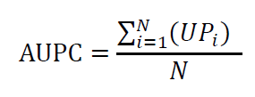
(1)

In Equation (1), AUPC means the average of upward price change moving averages in a certain period N. UP indicates the upward price change to open or close stock index in that period.
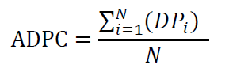
(2)

In Equation (2), ADPC means the average of downward price change moving averages in a certain period N. DP indicates the downward price change to open or close stock index in that period.
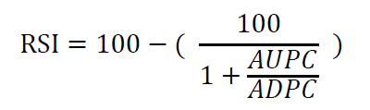
(3)

In Equation (3), RSI means the average gain or loss used in the calculation or the average percentage gain or loss during a look-back period. RSI will rise as the number and size of positive closes increase, and it will fall as the number and size of losses increase.

From the perspective of day traders, the most frequent transactions are between RSI 30 and 70 [2]. However, day traders cannot always make their judgements regarding a turning point based on the RSI 30 and 70 zone; sometimes, RSI 20 and 80 could be more accurate, and it would be profitable to wait for the stock index to move into that zone. The turning point of the upper track is in the lower or equal to RSI 30 or 20 zone, which means day traders could buy stock index in the zone because the stock is oversold in the near term. In the opposite case, if the RSI index is greater than 70 or 80, they could consider selling. Although previous research has supported the RSI approach, strategies based on different RSI indexes may lead to different prediction accuracies [2]. The choice of the machine learning algorithm too impacts predictive performance. Therefore, it could be useful to incorporate more than one machine learning algorithm [2, 4, 9, 11, 12].

With respect to the period for computation, generally, the default period suggested for investors is nine rounds. For specific terms, it could depend on short-term, medium-term, and long-term investments, and the number of periods will vary. In the cases of short term and medium term, the number of periods of RSI is very low; in the long term, the number of periods of RSI is very high. Generally, nine-day RSI and 14-day RSI are used for short- and medium-term investments, and 56-day RSI, 100-day RSI, and 200-day RSI used for long-term investments. For very short-term investments, a period of nine rounds for each five-minute period is often considered [2, 13].

Because of the COVID-19 pandemic, nearly the whole world went into lockdown, which has led to negative impacts on financial markets. Although the damage caused by COVID-19 is enormous, most studies have limited their focus to medium-term or long-term investments’ potential weak performance owing to COVID-19. There are likely to be long-term effects on the global economy [14, 15]. However, many unprecedented crises have happened in the past, and they have provided some of the best opportunities for investment. Therefore, COVID-19 may also have associated investment opportunities for profitable returns over the medium or long terms. However, the impact of COVID-19 on very short-term investment is unclear. This study is an effort to measure short-term investment performance in the RSI index range to compare the period of COVID-19 against the non–COVID-19 period.

The concept in the RSI approach used in financial prediction for very short-term investment is that a higher RSI index could signal turning points toward a downside movement. Most day traders may be able to successfully trade stock index futures within very short timeframes despite ignoring RSI because it is unclear whether only focusing on RSI 30/70 or 20/80 can help derive accurate judgements on the turning points of the stock index. Besides, even if there are effective models of RSI for decision support, COVID-19 should still be considered as an empirical test and exception for which it is worthwhile to carefully add RSI options in different scenarios for the purpose of avoiding losses in very short-term investments.

3. Research Model and Hypotheses Development

As discussed, day traders may use the five-minute moving average line of the stock index to build RSI 30 and 70 for determining turning points (Figure 1). Day traders usually use RSI indicators to make trading decisions in time units of five minutes. Usually, if the RSI is higher than 70 or 80, the stock index may be entering a high-risk zone that may produce a downward trend. On the contrary, entering the low-end zone associated with the RSI indicators 30 or 20 may be followed by an upward turning. Our research attempts to use the RSI short-term trend line to evaluate the impact of turning points in order to address our first research question.

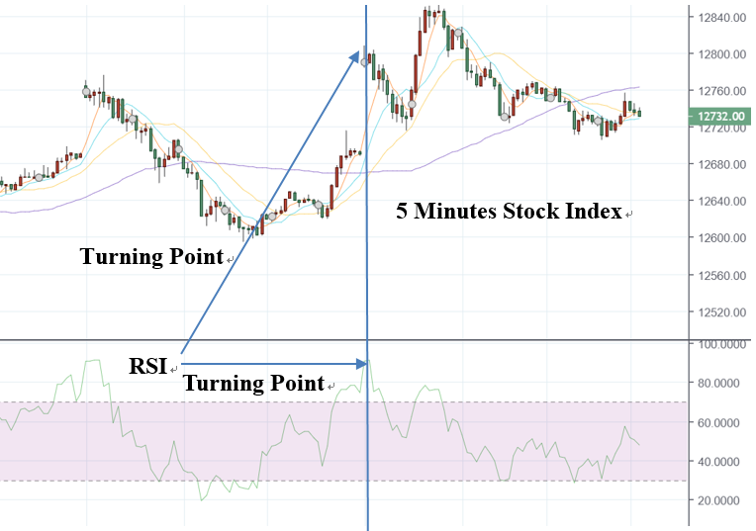

Figure 1. Short-term turning points in the RSI approach.

Turning points occur when the RSI indicator falls to 20 or relative lows within a certain five-minute moving average line of the stock index, which day traders interpret as a signal to buy stock index futures. However, RSI indicators are too wide, and reducing their transaction times could enable more accurate turning points. Even if RSI is useful for day traders, they still may not be able to determine the exact transaction points. Therefore, our first research question seeks to understand how exact RSI transaction points may be determined by distinguishing different RSI index numbers (Figure 2).

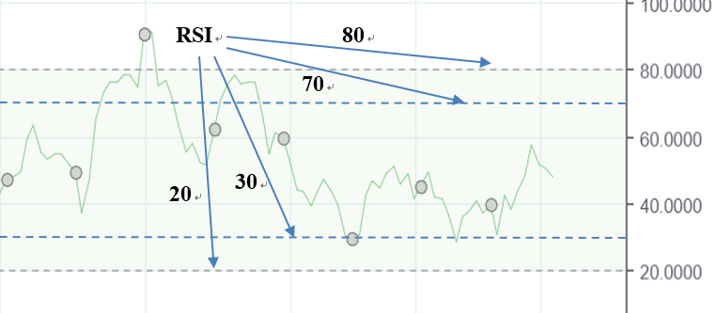
Figure 2. Multiple turning points for RSI index numbers.

An algorithm for applying our COVID-19 RSI approach is shown below. The algorithm initializes the parameters (e.g., Gain_COVID_30, Trans_COVID_30), sets up logic functions (e.g., the turning points for Trans_COVID_30), computes dynamic turning points to obtain the value of Gain_COVID_30, and enables traders to dynamically adjust their transactions based on the proposed algorithm.

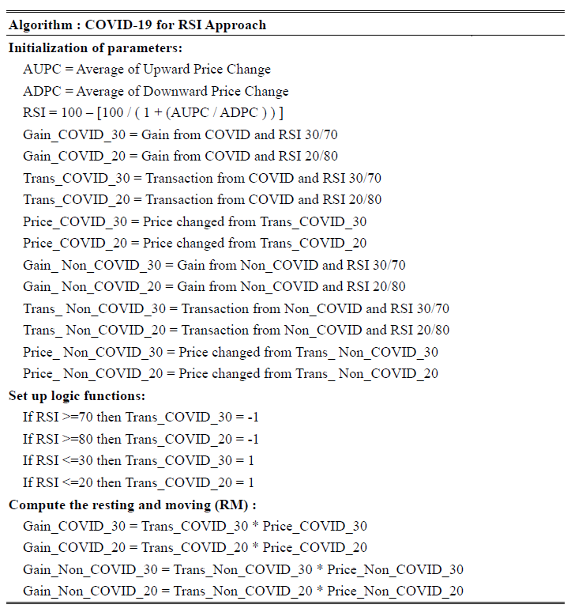

Previous research has mainly focused on a single turning point for the RSI approach. Our proposed algorithm with multiple turning points is different from previous approaches. However, despite the use of multiple RSI indicators in the proposed algorithm, we still need to obtain a solution to the second research question about the utility of artificial intelligence methods for effective prediction and dynamic self-learning. Although machine learning algorithms are useful for stock market predictions, one needs to exercise due care and caution before relying on them. The purpose of using machine learning algorithms in this study was to dynamically distinguish the best performance of different turning point predictions over the short term. This is the first empirical study to study the impact of multiple turning points on short-term stock index futures prediction and trading through machine learning algorithms. We aimed to establish a self-learning method for this purpose and address the lack of clarity regarding the predictive value of the RSI approach on turning points.

Some classification algorithms (e.g., sequential minimal optimization, also known as SMO) can handle multi-dimensional time-series data with a high level of noise and make coordinated multi-resolution predictions [16, 17]. Therefore, the SMO algorithm can be used instead of numerical quadratic programming for analytic quadratic programming to solve optimization problems, making it suitable for use in stock forecasting [1, 18-24].

If we reframe an optimization problem as a binary classification problem of a dataset in the form of ($x_{1}$, $y_{1}$), ...., ($x_{n}$,$y_{n}$), where $x_{i}$ are input vectors and $y_{i}∈\left\{-1\right.,\left. +1\right\}$ is a binary dataset ranging from minus one to one. To solve such quadratic programming problems, we can propose the formula as Equation (4):
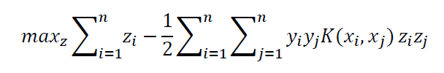
(4)

subject to:

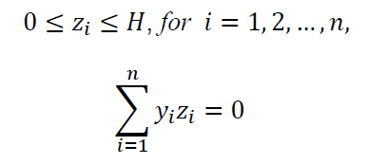

In this equation, $H$ is a hyper-parameter, $k$($x_{i}$,$x_{j}$) is the kernel function, and variables $z_{i}$ are Lagrange multipliers with the linear equality constraints ${0≤z}_{1}$, $z_{2}≤H$, and $y_{1}z_{1}+y_{2}z_{2}=k$. This enables us to investigate the impact of different turning points on short-term stock index turning points and to compare the accuracy of stock index predictions from different turning points dynamically.

To better reflect different turning points in stock index day trading, multiple turning points for short-term investment were defined: RSI 20 without COVID-19 (Treatment 1), RSI 30 without COVID-19 (Treatment 2), RSI 20 with COVID-19 (Treatment 3), and RSI 30 with COVID-19 (Treatment 4). In the research model shown in Figure 3, Treatments 1 and 2 are regular RSI turning points used by day traders, and Treatments 3 and 4 are those under unforeseen circumstances in order to avoid a huge loss or to even derive a gain. In Treatments 1 and 2, we add difference on RSI indicators with 20 and 30, Treatments 3 and 4 are the same situation. Machine learning algorithms such as SMO, deep learning, multilayer perceptron (MLP), and random forest are suitable for measuring investment performance. Machine learning techniques analyze a large amount of financial information for training, so the predictive performance will vary based on the training data and algorithm.

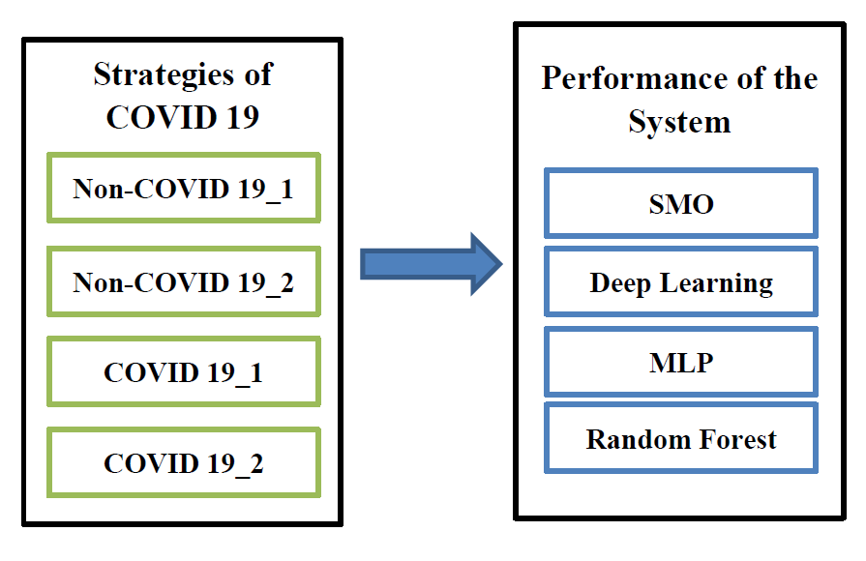
Figure 3. The research model.

To our knowledge, our work is the first to differentiate between RSI indicators for judging turning points with a machine learning system to predict stock index futures. Existing studies indicate that different turning points could have different accuracies in short-term stock index futures predictions. Accordingly, we address two hypotheses; the first is stated below.

H1. Incorporating RSI indicators 20 and 30 would generate different impacts on the turning points of short-term stock index predictions.

Day traders may have different effectiveness on different time intervals and situations of unprecedented crises. The net gain or loss during the special period of COVID-19 may influence traders’ long-term total profit. Therefore, it is important to distinguish regular and non-regular time periods for short-term investment and adjust strategies for decisions dynamically. Our second related hypothesis is as below.

H2. There is a significant difference between COVID-19 and regular non-COVID-19 periods in investment effectiveness of day traders.

4. Evaluation

We evaluated different machine learning algorithms with respect to their accuracy rates of stock index predictions. These algorithms were SMO, deep learning, MLP, and random forest. For the training dataset, we used the stock index trading data of TAIEX from 02 January 2019 to 31 May 2019 and 02 January 2020 to 31 May 2020, comprising a total of 11,490 datasets (Table 1).

Table 1. RSI indicators of COVID-19 and non-COVID-19 periods.
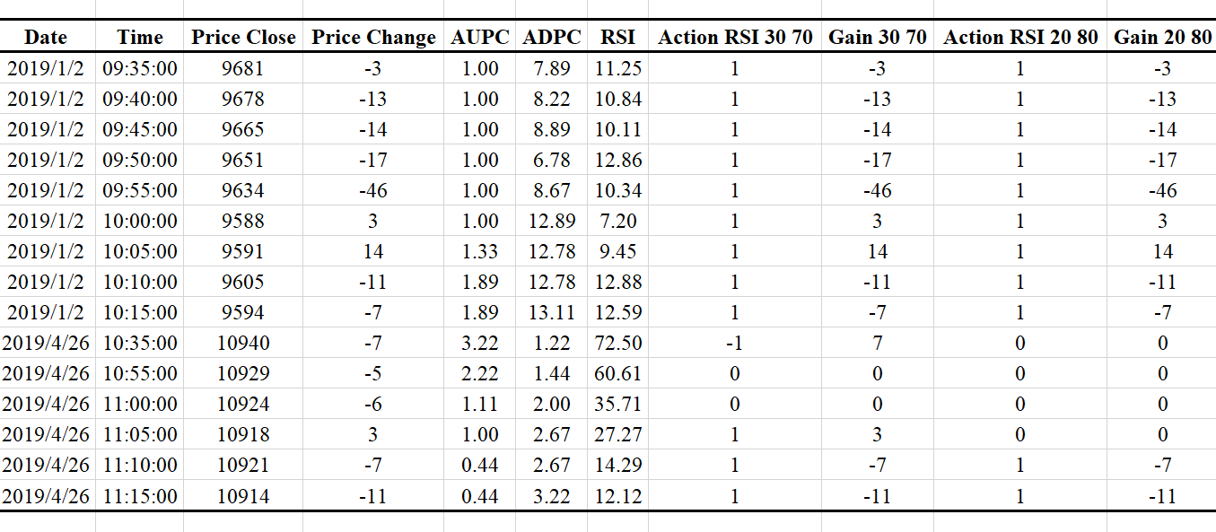

This study was divided into two parts for evaluation: the first part evaluates different RSI indicators related to different turning points of short-term stock index trading effectiveness, and the second part tests whether the better RSI indicators provide day traders higher profits compared to the COVID-19 period. The independent variables are Treatments 1, 2, and 3. The dependent variable is the accuracy of those treatments.

We tested the two hypotheses with the four machine learning algorithms using 10-fold cross validation. We set aside a subsample of the dataset for validation. These algorithms were selected because they are popular and widely used [25-27].

The performance of the models was evaluated based on their accuracy. True positive (TP), true negative (TN), false positive (FP), and false negative (FN) rates were calculated. Accuracy rate is the ratio of correct predictions divided by the total number of stock index predictions.
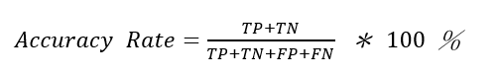
(10)

5. Results

The performance of the turning points is listed in Table 2. For Treatment 1, the average accuracy across the four algorithms was 92.77%; for Treatment 2, the average accuracy was 84.19%; for Treatment 3, the average accuracy was 91.84%; and for Treatment 4, the average accuracy was 81.52%.

Table 2. Accuracy of different turning points.
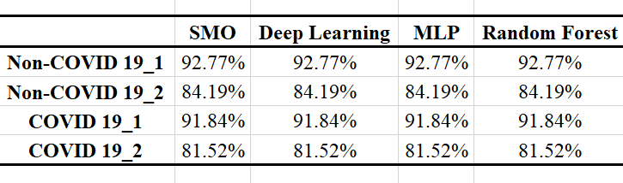

We used ANOVA to assess whether the level of treatment positively influenced the accuracy of prediction. The ANOVA results are presented in Table 3 [(F (3, 15) = 9.856E+30, p < 0.01)]. The results support our first hypothesis. We performed the LSD test for multiple comparisons. In the comparison of all levels of the treatments, Treatment 1 was significantly different from others (p < 0.05) and clearly the highest. We can conclude that the second hypothesis is also supported by our results.

Table 3. ANOVA of p values.
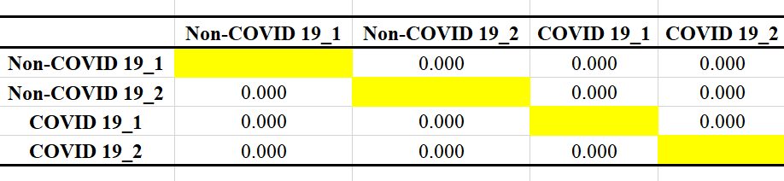
Note: p < 0.05 indicates the mean difference is significant at the 0.05 significance level.

6. Conclusion

We found that different RSI indicators have significantly different effects on the forecast of stock index futures. The accuracy of regular periods with RSI 20 is about 92.77%, which is objectively and relatively a high prediction accuracy. The results show that RSI 20 based on regular and COVID-19 periods can enable day traders to achieve higher profits. The results also show that day traders will benefit from RSI indicators even during unprecedented crises periods. The limitation of this study is that although RSI indicator 20 appears to lead to higher profits than RSI 30, it is necessary to analyze more real transaction processes to calculate actual profits and apply the proposed model to other unprecedented crises periods, such as SARS. Further research based on the results of this study will help develop more effective forecasts and trading strategies.

Acknowledgment

This work was supported by the National Science and Technology Council, Taiwan, under Grant MOST 111-2410-H-033-010.

References

1. Chou, H.-M. and T.-L. Cho, Effects of slope coefficients and bollinger bands on short-term investment. Advances in Management and Applied Economics, 2020. 10(2): p. 101-112.
2. Pedirappagari, V.R. and C.H. Babu, Validating relative strength index for developing productive trading strategies in indian stock market. International Journal of Applied Engineering Research, 2019. 14(3): p. 717-731.
3. Chen, S., et al., Bollinger bands trading strategy based on wavelet analysis. Applied Economics and Finance, 2018. 5(3): p. 49-58.
4. Dang, L.M., et al., Deep learning approach for short-term stock trends prediction based on two-stream gated recurrent unit network. IEEE Access, 2018. 6: p. 55392-55404.
5. Zhou, J., et al., A hybrid framework for short term multi‐step wind speed forecasting based on variational model decomposition and convolutional neural network. Energies, 2018. 11(9): p. 2292.
6. Leung, J. and T. Chong, An empirical comparison of moving average envelopes and Bollinger Bands. Applied Economics Letters, 2003. 10(6): p. 339-341.
7. Yan, X.X., et al., Improvement and test of stock index futures trading model based on Bollinger Bands. International Journal of Economics and Finance, 2017. 9(1): p. 78-87.
8. Lai, H.C., T.C. Tseng, and S.C. Huang, Combining value averaging and Bollinger Band for an ETF trading strategy. Applied Economics, 2016. 48(37): p. 3550-3557.
9. Cao, J.S. and J.H. Wang, Stock price forecasting model based on modified convolution neural network and financial time series analysis. International Journal of Communication Systems, 2019. 32(12).
10. Jabbarzadeh, A., et al., A multiple-criteria approach for forecasting stock price direction: Nonlinear probability models with application in S&P 500 index. International Journal of Applied Engineering Research, 2016. 11(6): p. 3870-3878.
11. Chung, H. and K. Shin, Genetic algorithm‐optimized long short‐term memory network for stock market prediction. Sustainability, 2018. 10(10): p. 3765.
12. Bai, Y., et al., A comparison of dimension reduction techniques for support vector machine modeling of multi‐parameter manufacturing quality prediction. Journal of Intelligent Manufacturing, 2019. 30: p. 2245-2256.
13. Bhargavi, R., S. Gumparthi, and R. Anith, Relative strength index for developing effective trading strategies in constructing optimal portfolio. International Journal of Applied Engineering Research, 2017. 12(19): p. 8926-8936.
14. W.Goodell, J., COVID-19 and finance: Agendas for future research. Finance Research Letters, 2020. 35: p. 1-5.
15. Ahmad, M.I., W. Zhuang, and A. Sattar, Investment behavior of orphan and nonorphan investors during COVID-19 in shanghai stock market. Psychology Research and Behavior Management, 2020. 13: p. 705-711.
16. Huang, W., Y. Nakamori, and S.Y. Wang, Forecasting stock market movement direction with support vector machine. Computers & Operations Research, 2005. 32(1): p. 2513-2522.
17. Bogle, S.A. and W.D. Potter. SentAMaL: A sentiment analysis machine learning stock predictive model. in Proceedings on the International Conference on Artificial Intelligence (ICAI). 2015. Las Vegas, USA.
18. Chou, H.-M., K.-C. Li, and S.-M. Pi, Multinational effects of foreign exchange rate in stock index with classification models for medium-term investment. Advances in Management and Applied Economics, 2019. 9(3): p. 43-53.
19. Chou, H.-M., A collaborative framework with artificial intelligence for long-term care. IEEE Access, 2020. 8: p. 43657-43664.
20. Hung, C., W.-R. Wu, and H.-M. Chou, Improvement of sentiment analysis via re-evaluation of objective words in SenticNet for hotel reviews. Language Resources and Evaluation, 2020. 55(2): p. 585-595.
21. Chou, H.-M. and C. Hung, Multiple strategies for trading short-term stock index futures based on visual trend bands. Multimedia Tools and Applications, 2021.
22. Chung, Y.-C., et al., Using textual and economic features to predict the RMB exchange rate. Advances in Management and Applied Economics, 2021. 11(6): p. 139-158.
23. Chou, H.-M., A smart-mutual decentralized system for long-term care. Applied Sciences, 2022. 12(7): p. 3664-3677.
24. Chou, H.-M., C.-W. Lee, and T.-L. Cho, The incorporation of service-learning into a management course: a case study of a charity thrift store. Sustainability, 2022. 14: p. 7132-7153.
25. Jahangiri, A. and H.A. Rakha, Applying machine learning techniques to transportation mode recognition using mobile phone sensor data. Intelligent Transportation Systems, IEEE Transactions, 2015: p. 1-12.
26. Kremic, E. and A. Subasi, Performance of random forest and SVM in face recognition. International Arab Journal of Information Technology, 2016. 13(2): p. 287-293.
27. Chou, H.M., et al. CaCM: Context-aware call management for mobile phones. in in IEEE 3rd International Conference on Collaboration and Internet Computing (CIC). 2017. San Jose, CA, US.

Department of Information Management, Chung Yuan Christian University, Taiwan; chou0109@cycu.edu.tw
https://en.wikipedia.org/wiki/COVID-19_pandemic
https://drive.google.com/file/d/1c19R_zi7EK9lsnjvLjRxH8TpmU5w75Rp/view?usp=sharing; https://drive.google.com/file/d/1EarLzSNBlta1872WzNGfkjj1LB3GlUVW/view?usp=sharing
https://en.wikipedia.org/wiki/SARS_(disambiguation)

