  - WEATHERED LAYER DELINEATION IN AN ‘X’ FIELD IN THE NIGER DELTA BASIN OF NIGERIA: The Uphole Data Acquisition Technique
ODUMODU, Chukwuemeka Frank Raluchukwu¹
and
EZEH, Martina Onyinye²
¹Department of Geology, Anambra State University, P.M.B. 02, Uli, Anambra State.
raluchukwu @ yahoo.com
²Department of Physics, Michael Okpara University of Agricultue, Umudike
tinamine8@yahoo.com

ABSTRACT

A total of sixty (60) uphole refraction surveys carried out in the “X” field in the Niger Delta Basin of Nigeria were analysed using the time-intercept technique to evaluate the weathered layer. Results from the generated isopach and isovelocity maps suggest a three layer case comprising of weathered, sub-weathered and consolidated layers. With velocities varying from 318 – 1050 m/s, the first layer was interpreted to be a weathered layer whose thickness ranges from 1.6 – 8.6 m. The thickness of the sub-weathered layer ranges from 16.3 to 28.7 m while its velocity varies from 692 to 2549 m/s. The consolidated layer velocity ranges from 1100 to 3223 m/s with an average of 2427 m/s. The average thickness of the weathered layer to the first refractor consolidated layer is 25.5 m. This is therefore the suggested depth at which shots are to be taken to obtain high quality seismic reflection data. The results will be utilized in seismic data processing for a reliable delineation of structural and stratigraphic traps in oil and gas exploration in the Southern part of the Niger Delta.

Keywords: Niger Delta Basin, Up-hole survey, Low velocity layer, Seismic refraction, Time-intercept,.

1.0 INTRODUCTION
The Niger delta is known as a prolific oil province where several oil and gas wells have been drilled. Reflection surveys are usually carried out in order to locate oil traps. In order to acquire a good quality reflection data, it is important to evaluate the unconsolidated layer which is also known as weathered layer or low velocity layer LVL. The unconsolidated layer is usually characterized by low seismic velocities. When shots are taken within the layer, the layer absorbs high frequency signals and releases low frequency signals. Consequently, the reflection signals observed in seismic sections are degraded causing an improper alignment of traces. For these reasons, it is thus necessary to take the shots below the weathered layer so as to obtain good quality seismic reflection data.
The uphole method is a seismic refraction method which is used to determine the thickness and velocity of the weathered layer and is a very important criterion used in deciding the charge depths in any seismic reflection survey. Information regarding the thickness and velocity of the weathered layer is also utilized during the processing of seismic reflection data to correct time delays (or simply static corrections). In engineering geophysical studies, the refraction survey method is also used to determine the foundation depths of major engineering structures.
Several uphole refraction studies undertaken in the Niger Delta have remained largely unpublished. Published uphole refraction studies in the Niger Delta include Ogagurue (2007), Enikansalu (2008), and Igboekwe and Ohaegbuchu (2011), Alaminiokuma and Amonieah (2012) and Selemo et al (2012). None of these published studies were undertaken in the swampy terrains of the Niger Delta. The aim of this study is to determine the variations in thickness and compressional velocity of the low velocity layer, and the consolidated layer in a swampy terrain using uphole refraction seismic survey method. The results will be useful for seismic exploration purposes as well as for construction purposes.

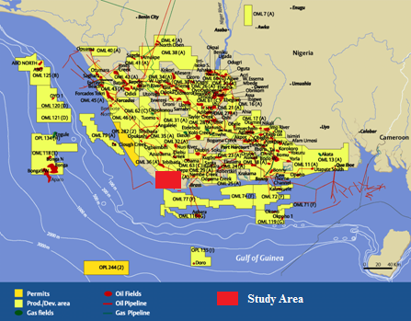
Fig. 1: Map of the Niger Delta showing the Study Area

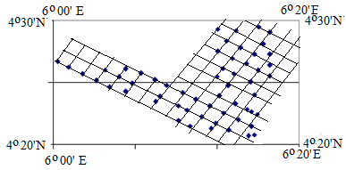
Fig. 2: Uphole layout within the Study Area

2.0 GEOLOGICAL SETTING
The study area lies within the area referred to as the Tertiary Niger Delta complex (Fig. 1). The study area is delimited by latitudes 4°20′N - 4°30′N and longitudes 6°00 - 6°20′E E (Fig. 2). According to Orife and Avbovbo (1982), the Niger Delta extends across an area of about 75,000 sq km and consists of regressive clastic sequence which attains a thickness of about 12,000m. The Anambra Basin and the Abakaliki Trough bounds the Niger Delta to the north, while it is bounded in the east by the Cameroun volcanic line, in the west by the Dahomey Embayment and in the south by the Gulf of Guinea.
Burke (1972) suggested that the siliciclastic system of the Niger Delta began to prograde across pre-existing continental slope into the deep sea during the Late Eocene and is still active today. Short and Stauble (1967) recognized three distinct lithostratigraphic units in the Niger Delta, which include the Akata, the Agbada and the Benin Formations, with depositional environments varying from marine, transitional to continental settings respectively. The age of these sediments vary from Eocene to Recent but they are time boundary transgressive.
The basal stratigraphic unit in the Niger Delta is the Akata Formation which consists of uniform dark grey over-pressured marine shales with sandy turbidites and channel fills. Its age ranges from Late Eocene to Recent. In deep water environments, these turbidites are the potential reservoirs. The thickness varies from 2000 m to 7000 m (Whiteman, 1982; Doust and Omatsola, 1990 and Corredor et al, 2005).
The major oil bearing unit in the Niger Delta is the Agbada Formation. It overlies the Akata Formation and consists of alternation of sands and shale layers. The Agbada Formation is characterized by parallic to marine-coastal and fluvial–marine deposit mainly composed of sandstone and shale organized into coarsening upward off – lap cycles (Pochal et al, 2004). It is about 3500 km thick (Corredor et al, 2005). It is the main objective for oil and gas exploration in the delta.
The Benin Formation overlies the Agbada Formation and consists of Late Eocene to Recent deposits of alluvial and upper coastal plain deposits that are up to 2000 m thick (Avbovbo, 1978). It consists mainly of coarse grained pebbly to fine grained sandstones and thin beds of shales.
3.0 THEORITICAL BACKGROUND
In seismic refraction surveys, the first wave to arrive at the geophone is called the first arrival and is used in analysis. The basic procedure starts with the generation of a seismic wave at a point source, recording the time it takes the wave energy to get to the refractor and back to a known detector following a refracted path (Nwankwo et al, 2009).
The first arrival of seismic waves is either the direct waves or the refracted wave (Fig. 3). The direct wave travels from O – R at a slower velocity V₁ while the refracted wave travels from O - R through P and Q where it is critically refracted and travels at velocity V₂ between P and Q. This implies that at short OR distances the direct wave arrives first because it has a short distance to travel but when the distance between O and R increases, the refracted wave will arrive first due to the faster travel time between P and Q which overcomes the difference in distance travelled. This therefore implies that the velocities of the layers and depth to the interface can be analyzed.
V₂ > V₁

V₁
O
R
P
Q

Fig. 3: Direct and refracted waves in a 2 layer medium (Ofomala, 2011)

The velocities are determined by plotting the travel times against the distance between the source and the receiver points (Fig. 4). The reciprocal of the gradient of the direct arrivals gives the velocity of the weathered (top) layer while the reciprocal of the gradient of the refracted arrivals is used to compute the velocity of the second layer (bedrock velocity). The intercept time of the refracted arrivals and the two calculated velocities is used to calculate the depth to the interface. The depth to the interface is calculated using the following equation.
Thus the parameters (Vw, Dw and VB) can be computed from the uphole survey data (Fig. 4b). Here also, the reciprocal of the slopes of the segment XY and YZ equals V_{W} and V_{B} respectively while XW is the thickness of the weathered layer, where W is the base of the LVL.
For a three layer case as given in Fig. 4c, the parameters can be computed using the following equation as given by Knox (1967) and Dobrin and Savit (1988)
……………………………………………………(2)
……………………………………(3)
Where t₁ and t₂ = intercept times on the distance – time graph.
V_{o} = Velociy of the first weathering layer
V₁= velocity of the second weathering layer
V₂ = velocity of the bedrock
D = Depth of shot (m)
Total thickness (m) of the weathering layer = Z_{w} = Z_{o} + Z₁
Isopachs and isovelocity maps were constructed using the geostatistical krigging technique. This was applied in the Surfer 9.0 software and used to generate the isopachs and isovelocity maps.
t₂
t₁
1/V_{o}
1/V₁
1/V₂
Z_{o}
Z₁
(c)
D_{W}
W
X
Y
Z
D_{S}
T_{UH} (S)
Fig. 4 (a) Travel time versus distance plot
(b) Uphole survey time depth relationship
(c) Typical time-depth graph for a three layer case uphole refraction profile
(b)
(a)
1/V₁
1/V₁
x

4.0 MATERIALS AND METHODS
4.1 Equipments
The equipments used in this study include
- Oyo McSeis – 160 m portable 12 or 24 channel seismograph system recorder
- Geophone arrays
- Explosives (Dynamite / Detonators) to generate energy
- A power supply system
- A starter model high voltage blaster
- A graduated carote cable

4.2 Location and Layout
The Uphole locations are shown in Fig. 2. Uphole locations are usually planned before the commencement of any seismic program. The program layout and location map was prepared and handled by the Uphole crew to enable them have access to the Uphole positions. Each uphole position was assigned a serial number, a line number and a receiver point. The drilling and uphole crew traces each uphole location using the line number and receiver point assigned to the position, which had been cut and pegged by the survey crew in advance before the commencement of the seismic operations. In some cases uphole positions can be offset as a result of poor accessibility, water logging and swampy terrain, sandiness if the formation resulting in caving in while drilling, and positions fall within or at the edge of the creeks and rivers. The uphole crew reports these problems to the Chief Seismologist who then offsets the uphole to a new position.
The layout consists of three sets of geophones planted at the intervals of 1m, 2.5 m and 5m away from the hole (Fig. 5). The geophones are then connected with the Oyo Geospace equipment as well as synchronized blaster equipment used in the detonation of caps. A power supply source of 12 – volt ordinary motor battery is used to energize the system. A graduated carote ranges from 1 cap to 6 caps depending on the resolution and the depth. A hole of 63 m was dug for each of the positions and the carote wire with the detonators attached with an anchor iron as weight was lowered into the hole and properly tapped to avoid shoot out. A reference plate with the different graduations was kept on the surface to distinguish the level of shots to be taken beginning from the deepest 60m to the first at 1m. The readings picked were then recorded by the Oyo machine in an analog form (signal) and stored in a diskette as well as printed on a hard copy and taken to the office for processing and interpretation.

OYO INSTRUMENT
Blaster
1M
2.5M
5M
Distance of the Geophone from the hole
Recording Instrument
Geophone strings
Hole with buried graduated caps
Number of caps at
each depth
Depths at which the
caps are detonated
1
2
3
4
6
8
10
12
14
16
18
20
22
24
26
28
32
36
40
44
48
52
56
60
1 Cap
1 Cap
1 Cap
1 Cap
1 Cap
1 Cap
1 Cap
2 Caps
2 Caps
2 Caps
2 Caps
2 Caps
2 Caps
2 Caps
2 Caps
2 Caps
2 Caps
2 Caps
4 Caps
4 Caps
4 Caps
6 Caps
6 Caps
6 Caps

Fig. 5: Layout for uphole acquisition

4.3 Data Processing
The recorded data was computer processed and field results of the signal display for the three (3) geophone positions were used to pick the first – time arrivals / breaks.. This was done manually by visual inspection of the plots. The heading on the plotted form is as follow;
Job: R4591 SP 7647
File: 1
Date: 06/19/12
Filter: 1536 (HZ)
Stack: 1
Sampling: 100[µSec]
Delay 00[µSec]
Time lines: 2[mSec. /Line]
Gain: 50 - 96∂β. This is adjusted in the field depending on the display.
The picked first time arrivals for any of the geophone positions is then entered into a column in the excel database (Table 1). These points are then interpolated linearly to give the lines of best fit (Fig. 6). From the interpolation, the depth and thickness of the various layers, layer velocities and statics were computed. Station elevation, datum plane and co-ordinates of position are also imputed.

TABLE 1: FIRST BREAK LISTING
Offset from Hole |  | 2.5 m
Shot | Depth in metres | Time in secs | Corrected Time in secs
1 | 1 | 9.365 | 3.5
2 | 2 | 5.0 | 3.1
3 | 3 | 5.9 | 4.5
4 | 4 | 0.0 | 0.0
5 | 6 | 6.3 | 5.8
6 | 8 | 9.1 | 8.7
7 | 10 | 8.1 | 7.8
8 | 12 | 8.7 | 8.5
9 | 14 | 10.2 | 10.1
10 | 16 | 10.9 | 10.8
11 | 18 | 12.0 | 11.9
12 | 20 | 13.5 | 13.4
13 | 22 | 14.2 | 14.1
14 | 24 | 15.7 | 15.6
15 | 26 | 17.2 | 17.1
16 | 28 | 18.5 | 18.4
17 | 32 | 19.5 | 19.4
18 | 36 | 20.8 | 20.8
19 | 40 | 22.3 | 22.3
20 | 44 | 24.2 | 24.1
21 | 48 | 25.3 | 25.2
22 | 52 | 27.4 | 27.4
23 | 56 | 29.4 | 29.4
24 | 60 | 29.7 | 29.7
Medium
coarse
sand
Clay
Coarse Sand
Depth
Thick
Z
Velocity
3.5
28.1
60.0
3.5
24.6
31.9
- 3.5
- 28.1
- 60.0
700.00
1835.82
2708.25
- 0.20

Remarks
Parameters
Lithology
Line number 4591
Station number 7647
Client
UP 057
Crew number 558 4476
0
10
20
30
40
50
60
0
10
20
30
40
Time (ms)
Depth (m)
Line number 3416

Station number 6536
Station elevation 2.44
Datum Plane 0.00
Replacement Velocity 2000.00
Maximum depth 60.0
Hole Diameter 4.5
Recorded 04-05- 12
Co-ordinates X = 398140.5
Y = 35463.8

Fig. 6: Linear interpolation of picked first arrival times to generate the line of best fit.

5.0 RESULTS AND DISCUSSION
The results of the Uphole / LVL/ refraction survey data analysis is given in Table 2 and 3, and Figs. 7 – 10. Isopachs and isovelocity maps (Fig. 7 - 10) deduced from the refraction survey data using geostatistical methods were used to illustrate the near surface characteristics weathered layer in the southern part of the Niger Delta region. The geophysical properties of the study area deduced include (i) the variations in the thickness and the seismic velocity of the weathered layer, (iii) the variations in the thickness and seismic velocity of the sub-weathered layer (iv) seismic velocity or competence of the consolidated layer.
5.1 Thickness and velocity of the weathered layer
The isopach map in Fig. 7a shows the variations in the thickness of the weathered layer. The map suggests that the thickness of the weathered or low velocity layer varies from 1.6 to 8.6 m. This map thus indicates a northerly increase in the thickness of the LVL from 2m in the southern part to about 4 m in the northwest and about 8 m in the northeast. This observation thus suggests a northerly increase in the LVL thickness in the study area.
The variation of the velocity of the weathered layer across the study area is presented by an isovelocity map as shown in Fig. 7b. It is observed from the figure that the velocity of the weathered or unconsolidated layer range from 318 m/s to 1650 m/s⁻¹. In the northern part of the area, the velocity values generally vary between 300 m/s⁻¹ to about 800 m/s⁻¹. In the southern part, or coastal region, the velocity values range between 800 m/s⁻¹ and 1650 m/s⁻¹. The anomalously high values of near surface or weathered layer velocity may be attributed to the high salinity of water in the sediments.
5.2 Velocity of the consolidated layer
An isovelocity map showing the pattern of variations of the velocity of the consolidated layer is presented in Fig. 8. Throughout the study area the consolidated layer velocity varies from 1100 to 3223 m/s, with an average value of 2427 m/s. It is observed that the seismic velocity of the consolidated layer varies from 1100 m/s in the northwestern part to 2300 m/s in the southwestern part. The consolidated layer velocity also increases from 1100 m/s in the west to about 2700 m/s in the eastern part. The velocity of the consolidated layer is thus observed to increase in a southeasterly and easterly direction from the north. It can thus be concluded that the eastern and southern parts possess the most competent bedrock because they have maximum velocities of 2700 m/s and 2500 m/s respectively. The velocity contrast of the consolidated layer which is about 2113 m/s therefore suggests that the layer is inhomogeneous. The inhomogeneity of the consolidated layer may be as a result of variations in compaction of the sediments constituting the layer.

5.4 Thickness and velocity of the subweathered layer
The variation in the thickness of the subweathered layer is given in Fig. 9a. It is observed that the thickness of the subweathered layer varies from 12 to 34 m. The variation in the velocity of the subweathered layer is also given in Fig. 9b. From the figure, the subweathered layer velocity varies from 692 to 2549 m/s with an average value of 1631 m/s.
Using a sampling density of 60 uphole / LVL points, the average thickness of the weathered layer to the first refractor consolidated layer was evaluated to be 25.5 m with an average refractor consolidated layer velocity of 2427 m/s.

6.0 CONCLUSION AND RECOMMENDATION
The average thickness of the weathered / sub-weathered layer suggests that where possible, shots should be located at depths of about 25.5 m below the top of the weathered layer where signals will travel at depths devoid of time delays during 3D/4D seismic surveys in the area. An advantage to this is that it helps to by-pass and thus minimizes the spurious effects of the low velocity weathered layer during acquisition and initial processing of the field tape in which static and dynamic corrections are applied.

Table 2. Summary on the interpretations of isopach and Isovel Models.
Geological property | Thickness (m) |  | Velocity (ms⁻¹)
 | Zone of High | Zone of Low | Zone of High | Zone of Low
Weathered Layer | northeast | Southern part | South/ Coastal region | Northern region
Sub –weathered Layer | Northwest | northeast | South | North
Consolidated Layer. |  |  | East / south | Northeastern part

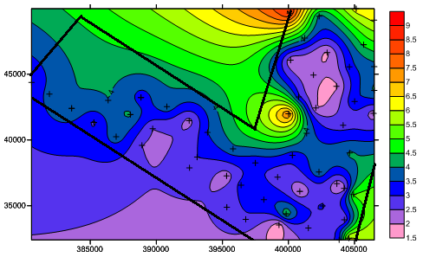
Fig. 7a: Weathered layer thickness isopach with overlay of uphole points survey grid

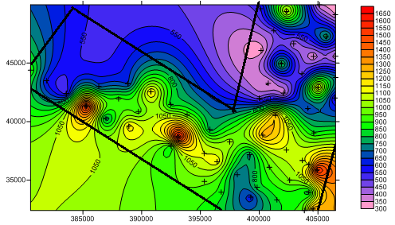
Fig. 7b: Weathered layer velocity field with overlay of uphole points survey grid

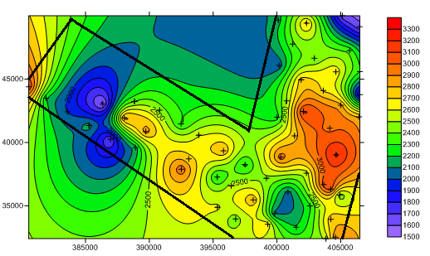
Fig. 8: Consolidated layer velocity field contour map with overlay of uphole point’s survey grid.

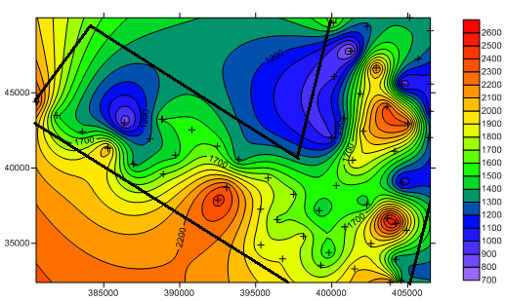
Fig. 9b: Sub weathered layer velocity field with overlay of uphole points survey grid

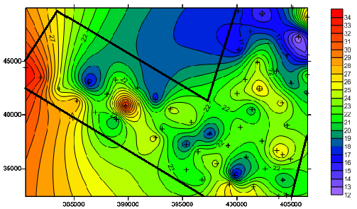
Fig. 9a: Sub-weathered Layer thickness isopach with Uphole/LVL points survey
grid overlay

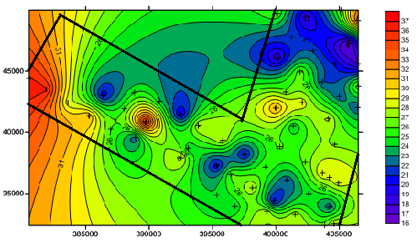

Fig. 10: Total Thickness of weathered layer thickness isopach with uphole/LVL points survey grid overlay

Table 3: Summary of Uphole (LVL) Refraction Survey Results
 | SHOT POINT | EASTINGS | NORTHINGS | Zo (m) | Z1 (m) | Vo (m/s) | V1 (m/s) | Vc (m/s)
1 | 4487 / 7255 | 380551.1 | 43241.2 | 2.4 | 33.7 | 800.0 | 2246.7 | 3194.8
2 | 4627 / 7397 | 38883.7 | 43235.2 | 2.3 | 22.7 | 638.9 | 1367.5 | 2468.5
3 | 4687 / 7287 | 381905.4 | 43490.2 | 3.7 | 32.5 | 596.8 | 1504.6 | 2201.8
4 | 4567 / 7327 | 382352.1 | 43490.1 | 2.8 | 21.2 | 1217.4 | 1876.1 | 1989.7
5 | 4587 / 7367 | 386352.4 | 43016.3 | 4.0 | 16.3 | 666.7 | 806.9 | 1556.9
6 | 4487 / 7327 | 383589.5 | 42411.2 | 4.0 | 24.3 | 519.5 | 1455.1 | 1993.7
7 | 4497 / 7367 | 385273.5 | 41332.3 | 2.9 | 28.3 | 1611.1 | 2096.3 | 2153.3
8 | 4567 / 7397 | 388036.9 | 47937.4 | 4.1 | 21.7 | 931.8 | 1299.4 | 2851.2
9 |  | 389720.5 | 40858.4 | 2.5 | 23.1 | 915 | 1458 | 2857
10 | 4487 / 7397 | 386957.5 | 40253.4 | 3.8 | 22.2 | 745.1 | 1362.0 | 1691.5
11 | 4499 / 7447 | 388911.3 | 39595.5 | 2.5 | 19.7 | 1190.5 | 1698.3 | 2141.2
12 | 4647 / 7447 | 390799.4 | 42542.5 | 3.9 | 20.3 | 1181.8 | 1561.5 | 2455.8
13 | 4647 / 7487 | 392483.4 | 41463.5 | 2.3 | 17.3 | 821.4 | 1587.2 | 2286.5
14 | 4647 / 7519 | 393872.7 | 40573.4 | 3.5 | 24.6 | 945.9 | 1344.3 | 2593.5
15 | 4567 / 7527 | 393088.5 | 38700.6 | 3.0 | 21.3 | 1666.7 | 2340.7 | 2725.2
16 | 4527/ 7527 | 392507.21 | 37885.71 | 2.9 | 25.5 | 852.9 | 2451.9 | 2981.1
17 | 4647 / 7567 | 395809.3 | 39332.6 | 3.9 | 24.1 | 764.7 | 1772.1 | 2807.0
18 | 4647/ 7597 | 397493.37 | 38253.75 | 3.1 | 17.3 | 1033.3 | 1730.0 | 2262.9
19 | 4567 / 7383 | 395319.8 | 37271 | 2.2 | 18.0 | 1100.0 | 1894.7 | 2259.9
20 | 4567 / 7597 | 396414.25 | 36569.52 | 3.2 | 23.0 | 1142.9 | 1678.8 | 2548.9
21 | 4487 7597 | 395335.78 | 34886.06 | 2.7 | 21.4 | 964.3 | 1829.0 | 2615.9
22 | 4647 / 7647 | 399176.89 | 37174 | 2.7 | 23.3 | 729.7 | 1438.3 | 2481.8
23 | 4647/ 7687 | 400861.98 | 36095.76 | 2.0 | 20.1 | 952.4 | 1689.1 | 2064.9
24 | 4527/ 7647 | 398140.5 | 35463.8 | 3.5 | 24.6 | 700.0 | 1835.8 | 2798.2
25 | 4567 / 7687 | 399824.6 | 34384.9 | 4.5 | 15.8 | 833.3 | 1519.2 | 2078.5
26 | 4487 / 7639 | 396766.9 | 33968.6 | 2.9 | 21.2 | 878.8 | 1892.9 | 2439.2
27 | 4527 / 7687 | 399285.1 | 33542.9 | 1.6 | 26.3 | 615.4 | 1675.2 | 2652.9
28 | 4647 / 7627 | 402587.9 | 34990.8 | 3.1 | 21.3 | 1000.0 | 1918.9 | 2282.1
29 | 4647/ 7667 | 404229.49 | 33937.85 | 2.5 | 19.6 | 806.5 | 1315.4 | 2766.4
30 | 4567 / 7727 | 401508.6 | 33305.9 | 2.8 | 25.0 | 848.5 | 1984.1 | 2205.5
31 | 4587 / 7777 | 403841.16 | 32405.06 | 3.2 | 23.1 | 969.7 | 2221.2 | 2514.9
32 | 4527 / 7647 | 400298.4 | 38831.8 | 3.2 | 23.0 | 1280.0 | 1575.3 | 2964.9
33 | 4727/ 7695 | 402311.7 | 37571.6 | 4.0 | 22.4 | 1081.1 | 1454.5 | 2545.5
34 | 4727 / 7741 | 404213.7 | 36323.3 | 2.2 | 26.0 | 1100.0 | 2549.0 | 3057.7
35 | 4727 / 7759 | 404929.4 | 35864.8 | 5.1 | 23.6 | 1593.8 | 1934.4 | 2428.2
36 | 4847 / 7719 | 404636.2 | 39021.7 | 4.1 | 22.7 | 854.2 | 1013.4 | 3223.3
37 | 4597 7718 | 404574.3 | 32529.59 | 6.2 | 22.1 | 1291.7 | 1372.7 | 2881.8
38 | 4797 / 7647 | 401377.4 | 40515.8 | 3.9 | 20.1 | 1258.1 | 1914.3 | 2748.1
39 | 4887 / 7688 | 404140.49 | 41121.12 | 2.8 | 25.5 | 636.4 | 1758.6 | 2962.6
40 | 4887 / 7639 | 402077.19 | 42442.17 | 2.0 | 26.7 | 363.6 | 2022.7 | 3130.0
41 | 4887 / 7597 | 400772.3 | 43278.8 | 3.1 | 23.1 | 340.7 | 1241.9 | 2503.7
42 | 4967 / 7597 | 401893.3 | 44935.8 | 2.3 | 24.4 | 851.9 | 1730.5 | 2752.1
43 | 6536 / 3864 | 403634.1 | 44087.52 | 1.9 | 20.1 | 475.0 | 2337.2 | 2676.1
44 | 4967/ 7567 | 400159.6 | 46076.3 | 2.1 | 16.1 | 318.2 | 987.7 | 2029.1
45 | 4957/ 7683 | 405008.7 | 42939.8 | 3.5 | 18.7 | 1166.7 | 2337.5 | 2842.1
46 | 3967 / 7719 | 406440.1 | 42022.7 | 2.2 | 19.7 | 523.8 | 1246.8 | 2801.5

 | SHOT POINT | EASTINGS | NORTHINGS | Zo (m) | Z1 (m) | Vo(m/s) | V1 (m/s) | Vc(m/s)
47 | 4947/ 7647 | 404614.2 | 45567.9 | 3.3 | 17.7 | 347.4 | 903.1 | 2671.2
48 | 4927/ 7699 | 406494.4 | 43769.81 | 4.1 | 22.9 | 719.3 | 1026.9 | 1755.3
49 | 4947/ 7597 | 402930.1 | 46646.8 | 1.9 | 20.0 | 404.3 | 2272.7 | 2396.2
50 | 4947 / 7567 | 401238.6 | 47760.3 | 4.1 | 17.8 | 482.4 | 692.6 | 2381.3
51 | 4727 / 7741 | 403666.4 | 36674 | 3.2 | 26.0 | 1100.0 | 2549.0 | 3057.7
52 | 5127/ 7567 | 402325.1 | 49409.8 | 3.8 | 14.6 | 1117.6 | 1269.6 | 2736.8
53 | 4987/ 7527 | 400101.6 | 49646.7 | 8.6 | 17.4 | 537.5 | 1641.5 | 2151.9
54 | 5123 / 7647 | 405693.1 | 47251.9 | 4.6 | 12.0 | 807.0 | 1304.3 | 2371.6
55 | 5998 / 8789 | 406493.8 | 45582 | 3.8 | 14.0 | 358.5 | 1068.7 | 2305.0
56 | 5197 / 7597 | 405130.1 | 49987.9 | 6.3 | 20.0 | 353.9 | 1369.7 | 1637.8
57 | 5191 / 7639 | 406477.3 | 49124.7 | 6.1 | 27.9 | 346.6 | 1379.7 | 1637.8
58 | 4827 / 7597 | 400005.2 | 41988.8 | 7.6 | 23.9 | 463.4 | 981.9 | 2342.2
59 | 4627 / 7397 | 388837.8 | 43235.2 | 3.2 | 22.9 | 640.0 | 1506.6 | 2391.6
60 | 4647 / 7356 | 387431.4 | 44700.4 | 3.0 | 24.9 | 697.7 | 1020.5 | 1773.5
61 | 4647/7367 | 400005.2 | 41988.8 | 7.6 | 16.3 | 463 | 981.9 | 2242.3

REFERENCES
Alaminiokuma, G.I. and Amonieah, J.2012, Near surface structural model for enhanced seismic data acquisition and processing in North-Central Niger Delta. American Journal of Scientific and Industrial Research.3 (6), p. 252 – 262.
Avbovbo, A.A., 1978, Geothermal gradients in the southern Nigerian basin: Bulletin Canadian Petroleum Geology., v. 26, 2, p. 268 – 274.
Burke, K.C., Dessauvagie, T.F.J. and Whiteman, A.J., 1971, the opening of the Gulf of Guinea and the geological history of the Benue depression and the Niger Delta: Nature Physical Science, v. 233, p. 51 – 55.
Corredor, F., Shaw, J.H. and Bilotti, F, 2005, Structural styles in the deep-water fold and thrust belts of the Niger Delta: American Association of Petroleum Geologists Bulletin, v. 89, p. 753 – 780.
Dobrin, M.T and Savit, S.V., 1988. Introduction to Geophysical Prospecting, (4th Edition) McGraw-Hill: New York, NY.
Doust, H., and Omatsola, E, 1990, Niger Delta, in J.D. Edwards, and P.A. Santogrossi, eds., Divergent/passive margin basins: American Association of Petroleum Geologists Memoir, v. 48, p. 201 – 238.
Enikansalu, P.A., 2008, Gephysical Seismic Refraction and Uphole Survey Analysis of Weathered Layer Characteristics in the ‘Mono Field’, South Western Niger Delta, Nigeria. Pacific Journal of Science and Technology, 9 (2), p. 537 – 546.
Igboekwe, M.U., and Ohaegbuchu, H.E., 2011. Investigation into the weathering layer using uphole method of seismic refraction. Journal of Geology and Mining Research, 3 (3), p. 73 – 86.
Knox, W.A., 1967. Multi-layer near surface reflection computation. In Musgrave, A.W., Ed; Seismic reflection prospecting, Soc. Of Expl. Geophysics, p. 197 – 216.
Nwankwo, C.N., Ekine, A.S. and Ebeniro, J.O., 2009. The use of up-hole method in the mapping of the thickness and velocity of the low velocity layer in parts of the Eastern Niger Delta, Nigeria. Nigerian Journal of Physics, 21 (1), p. 64 – 71.
Ofomala, M.O., 2011. Uphole Seismic Refraction Survey for Low Velocity layer determination over Vom field, South East Niger Delta. Journal of Engineering and Applied Sciences, 6 (4), p. 231 – 236.
Ogagarue, D.O., 2007, Comparative Study of the offset – geophone and down-dip hydrophone seismic refraction surveys with application to the Niger Delta Basin, Nigeria. Pacific Journal of Scientific Technology, 8, p. 49 – 58.
Orife, J.M. and Avbovbo, A.A. 1982, Stratigraphic and unconformity traps in the Niger Delta: American Association of Petroleum Geologists Bulletin, v. 65, p. 251-265.
Pochat, S., Castelltort, S, Vanden Driessche, J., Bernard, K., and Gumiaux, C, 2004. A simple method of determining sand / shale ratios from seismic analysis of growth faults: An example from Upper Oligocene to Lower Miocene Niger Delta deposits: American Association of Petroleum Geologists Bulletin, v. 88, 1357 – 1367.
Selemo, A.O., Nwagbara, J.O. and Nwugha, V., 2012, Determination of some physical parameters on the weathered layer around Warri, Southern Nigeria using vertical seismic profiling (VSP) Technique. International Journal of Emerging trends in Engineering and Development, 3 (2), p.257 – 280.
Short, K.C., and A.J. Stauble, 1967. Outline of geology of Niger Delta: American Association of Petroleum Geologists Bulletin, v. 51, p. 761 – 779.
Whiteman, A.J., 1982. Nigeria: Its Petroleum Geology, Resources and Potential: vols. 1 and 2: London, Graham and Trotman, Ltd., 176p. and 238p., respectively.

