The Impact of the Russo-Ukrainian War on the Risk and Return of TAIEX Options

Abstract
This study examines the impact of the Russia-Ukraine war (RUW) on the dynamic of TAIEX options' risk-return profile. Since the outbreak of the war on February 24, 2022, global economic sanctions have disrupted the world economy. Soaring energy and food prices and supply shortages have suppressed global economic growth, leading to rising inflation. Financial markets have reacted to the shocks caused by this war, thus intensifying the volatility of options markets. This study utilizes Hsu's (2013) option return models to investigate the impacts of how the war influences the TAIEX options' risk-return profile, including PDFs, profitability, and expected returns. The contributions of this paper are two-fold: It is the first paper on the (RUW) on the options markets; additionally, we demonstrate theoretically and empirically that the normality assumption of simple arithmetic returns is acceptable, making the Hsu's (2013) option return models more robust. The results indicate that the war has significantly affected and altered the PDFs of option returns, expected option returns, and volatility after the war. However, both theoretically and empirically shows that, despite the challenges posed by the war, put options trading during this period has been profitable.
Keywords: Russo-Ukrainian War, TAIEX options, Option return model, Risk/Return Profile

1. Introduction
Noting that there has been no significant warfare in the world since the Gulf War in the 90s, Russia's full-scale invasion of Ukraine by way of escalation of the Russo-Ukrainian War (RUW) on 24 February 2022 came as a surprise. The RUW is a geopolitical conflict between Russia and Ukraine (Cui, Lianbiao, et al. 2023). Several studies have highlighted the severe repercussions of geopolitical conflicts, including adverse effects on social welfare, escalating commodity prices, and inflation (Dogan, et al., 2021; Majeed, et al., 2021; Norouzi et al, 2021). Notably, Boungou, et al. (2022) employed a regional general equilibrium model to investigate the potential consequences of ongoing global geopolitical conflicts on trade, technological innovation, and economic growth, revealing significant harm to overall welfare. Meanwhile, Li, et al. (2021) delved into the effects of geopolitical risk shocks on commodity markets, concluding that these threats and geopolitical actions can yield both positive and negative impacts on commodity markets. In a separate study, Su, et al. (2020) scrutinized the link between geopolitical risks, inflation, and oil prices in Venezuela.
Boungou and Yatié (2022) conducted an analysis on the ramifications of the Russo-Ukrainian war on the stock markets of 94 countries. Their findings revealed a predominantly negative impact on stock markets, with the most significant repercussions observed in countries bordering Russia and Ukraine, as well as those that imposed severe sanctions in response to Russia's invasion. Liadze, et al. (2022) employed a global econometric model known as NiGEM to comprehensively examine the potential consequences of the Russo-Ukrainian conflict. Their research affirmed that this conflict not only induced turbulence in financial markets and sharp increases in energy and food prices but also resulted in a noteworthy one percent reduction in global GDP. Moreover, it contributed to a 1% to 2% upswing in inflation rates.
To the surprise of the world, the investors’ sentiment was adversely affected. TAIEX dropped by 2.55% to 17,595 points, while the volatility of its options soared to 20.7% (increased by 5.6%) on that day (24 Feb. 2022). Nevertheless, the shock is short-lived. TAIEX rebounded to 17,934 points with the volatility of its options reinstated to the level of 19.2% on 3 March 2022, one week after the outbreak of the military action. According to scholars (Lo, Gaye-Del, et al. 2022), the impact of the RUW on financial markets, is conditioned upon a country’s dependence on Russian commodities, employing a large panel of 73 countries. Financial markets reacted to the war-induced shock significantly, with a weaker effect on asset prices than volatility. Therefore, RUW has become a subject of aim to investigate, and we would like to examine its influence on the broader stock and options market.
Warburton and Pembertoon (2023) using S&P 500 and DJIA (2022 Jan to 2022 Apr) data to the superior performance of a moving average model (MA) and the Holt-Winters algorithm (Holt 1957 & Winters 1960), found that profitable investment prospects existed during the period of systematic risk conclude that technical analysis provided time-sensitive information for leveraged financial investments during turbulent periods of systematic risk. Therefore, we use the S&P 500 (Figure1) to draw a chart to check whether the TAIEX (Figure 2) moves with the S&P 500. We conclude that the movement is consistent on Feb 2022(RUW). Our focus is the stock market of Taiwan, which is impacted by the RUW. The primary focus of this study is to assess the Russo-Ukrainian war, in addition to its economic impact, with a particular emphasis on its effect on the Taiwan options market, especially on TAIEX options since its prices majorly reflect the movements of TAIEX. To our knowledge, this paper is the sole comprehensive exploration of the impact on options, which has not been previously addressed in the literature.

Figure 1 S&P 500
Figure 2 shows the market trend of the TAIEX (Taiwan Stock Exchange Capitalization Weighted Stock Index) during the entire research period. It is obvious that TAIEX hit the trough upon the outbreak of the RUW, but quickly got rebounded upon the digestion of the news by the market. TAIEX dropped and hit the trough again on 17 March 2022 due to the increase interest rate by 0.25% by US Federal Reserve (Fed) for the first time since 2008, the market trend of TAIEX changed from bullish to bearish. On 4 May 2022, the US Federal Reserve Open Market Committee (FOMC) announced the official commencement of the reduction of the balance sheet (QE Tampering), and TAIEX dropped to its lowest point of the year, in line with the trend of global stock markets. TAIEX stopped falling and rebounded in mid-May 2022 as the market has gradually encompassed the reality.
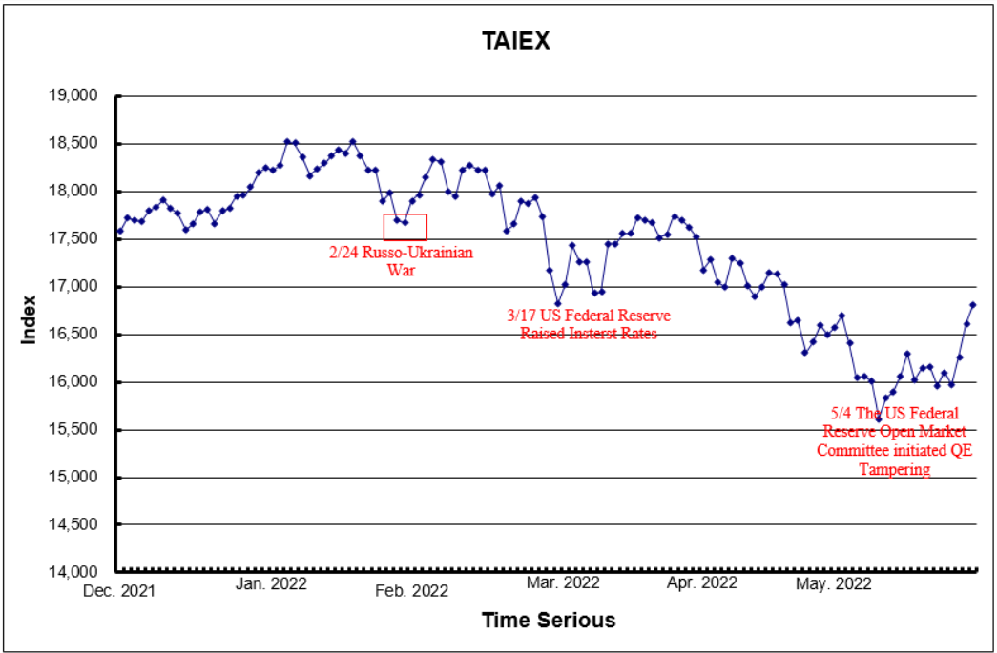
Figure 2 TAIEX

TAIEX Options (TXO) is the world’s seventh most traded equity index option ranked by the Futures Industry Association with an average daily trading volume of over 0.8 million in 2021 (according trend of the TXO Volatility index (VIX), a good indicator of market sentiment, during the entire research period. It is evident that VIX (Figure 3) reached the peak after the escalation of RUW and quickly hit the trough upon acceptance of the mishap by the market. It reached the peaks again on 17 March 2022 and 4 May 2022 due to the increase in interest rate by 0.25% by US Fed and the announcement of the official commencement of QE Tampering by FOMC. The investors gradually encompassed the reality and VIX dropped to the troughs again on both occasions.
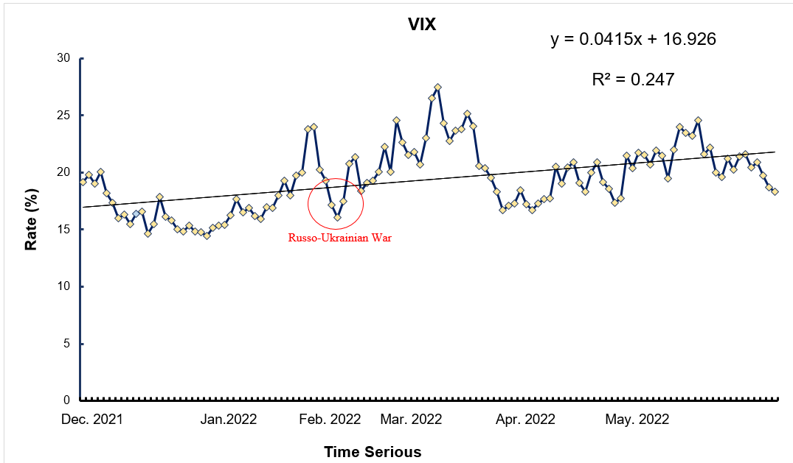
Figure 3 VIX
As options are derivatives whose value depends on the value of underlying assets and can provide leverage, investors can pay a relatively small premium for market exposure in relation to the contract value (usually 1000 shares of the underlying stock in Taiwan). They can obtain large percentage gains from comparatively small, favorable percentage moves in the underlying assets, but if the underlying asset price does not rise or fall as anticipated during the lifetime of the option, their investment’s percentage loss could be magnified. The loss can be the entire amount of the premium paid for the option or of the unlimited amount in the case of selling an uncovered option. Besides, the use of options by investors to hedge or reduce the risk exposure of their portfolios and has become increasingly popular, therefore understanding options risks and returns is of utmost essence.
An easy method to understand the risk-return characteristics of option returns is by looking into the distribution of option returns. Hsu (2013) assumes that the simple stock return is normally distributed and develops an option return model that can derive the exact PDF of a return distribution for holding the option up to expiration. This research builds upon Hsu (2013) to introduce a novel theoretical framework. The derivation process combines both theory and empirical findings to establish the notion that simple arithmetic returns may follow a normal distribution. This dispels a common misconception held by many scholars, which incorrectly associates the arithmetic return distribution with a lognormal distribution.

3. Research Design and Methodology
To achieve the research purpose, the Hsu (2013) option return model was utilized, and the validity of the normality assumption of the arithmetic stock return in the Hsu model was first verified.
Since the analysis of option return distribution is a simple and convenient way to understand the risk-return characteristic of option return, this research utilizes the Hsu (2013) option return model to investigate the impact of RUW on the risk and return of TAIEX options. The advantage of using the Hsu model is that the exact PDF of a return distribution for holding the option up to expiration can be obtained. However, the normality assumption of the arithmetic stock return in the Hsu model is easily confused by academia. Some scholars look it as log-normally distributed. Given that the return distribution is an important issue in this study, it should be basically to clarify the simple stock return distribution. We first provide proof in Section 3.1 to demonstrate the validity of the normality assumption of the arithmetic stock return and then revisit the Hsu model in Section 3.2.

3.1 Proof of stock return distribution
Academics typically express stock returns in the form of log return, which represents the continuously compound rate of return. However, in practical applications, the simple arithmetic rate for return is easier to comprehend. It should be noted that using the formula of the continuously compound rate of return (i.e., log return) for options held until expiration could pose a serious problem, as options may expire worthless. To see this, when an option is held until expiration and expires worthless, the log return is negative infinity (i.e., ln(0) → − ∞). Additionally, it is important to note that the log return of a portfolio is not equivalent to the weighted average log return of its individual securities. Therefore, it is advisable to express options return to expiration in terms of the simple arithmetic rate of return.
Given that options return to expiration had better to express as the simple arithmetic rate of return, the Hsu (2013) model assumes that the arithmetic stock return $\left({{\tilde{S}}_{T}}/{S_{0}-1}\right)$ is normally distributed, which at first glance, some scholars would think that it is log-normally distributed. To clarify this long-standing misconception in the academia, we hereby use mathematical formulation to show that the arithmetic stock return is absolutely not log-normally distributed. Therefore, the next question is what kind of distribution is the arithmetic stock return? Most of the people think that it seems to be a common belief that the arithmetic stock return is normally distributed. To be cautious, we then employ Monte Carlo simulation to demonstrate that the normality assumption of the arithmetic stock return is acceptable.

3.1.1 The Distribution of Simple Arithmetic Rate of Returns: Mathematical Formulation
According to the assumption of the Black-Scholes model (1973), ${{\tilde{S}}_{T}}/{S_{0}}$ is assumed to be log-normally distributed, or ${\ln{(}{\tilde{S}}_{T}}/{S_{0}})$ is normally distributed with mean μ and variance $σ^{2}$. ${\ln{(}{\tilde{S}}_{T}}/{S_{0}})$ represents the continuously compound rate of stock return. However, the arithmetic rate of stock return,$\tilde{R}$, is defined as
$$\frac{{\tilde{S}}_{T}-S_{0}}{S_{0}}=\frac{{\tilde{S}}_{T}}{S_{0}}-1 (1)$$
The following justifications illustrate that the arithmetic rate of return, ${{\tilde{S}}_{T}}/{S_{0}}-1,$ is absolutely not log-normally distributed:
1) A random variable which is log-normally distributed takes only a positive real value. ${{\tilde{S}}_{T}}/{S_{0}}$ will only have a positive real value; however, ${{\tilde{S}}_{T}}/{S_{0}}-1$ may take a positive, negative real value, or zero.
2) A log-normal process is the statistical realization of the multiplicative product of myriad independent random variables, each of which is positive. ${{\tilde{S}}_{T}}/{S_{0}}$ can be expressed as the following multiplicative product of myriad independent random variables (${\tilde{S}}_{i}/S_{\text{i-1}}, i=1,2,...,T$), each of which is positive.
$$\frac{{\tilde{S}}_{T}}{S_{0}}=\frac{S_{1}}{S_{0}}⋅\frac{S_{2}}{S_{1}}⋅⋅⋅⋅\frac{{\tilde{S}}_{T}}{S_{T\text{-1}}} (2)$$
However, ${{\tilde{S}}_{T}}/{S_{0}}-1$ cannot be expressed as the multiplicative product of myriad the same form of independent random variables.
3) The arithmetical stock return implies that the stock price is log-normally distributed. This argument can be obtained by following Steindl (1965) model: Denote the stock price at time t by ${\tilde{S}}_{t}$ and let the ${\tilde{R}}_{t}$ be the arithmetic stock return between period (t −1) and period t, so that
$${\tilde{R}}_{t}=\frac{{\tilde{S}}_{t}-S_{t-1}}{S_{t-1}} (3)$$
or ${\tilde{S}}_{t}=\left(1+{\tilde{R}}_{t}\right)×S_{t-1}$ (4)
Hence
$${\tilde{S}}_{t}=\left(1+{\tilde{R}}_{t}\right)⋅\left(1+R_{t-1}\right)⋅S_{t-2}$$
$$=\left(1+{\tilde{R}}_{t}\right)⋅\left(1+R_{t-1}\right)⋅\left(1+R_{t-2}\right)⋅S_{t-3}$$
$=\left(1+{\tilde{R}}_{t}\right)⋅\left(1+R_{t-1}\right)⋅\left(1+R_{t-2}\right)⋯\left(1+R_{1}\right)⋅S_{0}$ (5)
If we choose a "short" period, then we can regard ${\tilde{R}}_{t}$ as being "small", justifying the approximation log(l +${\tilde{R}}_{t}$)$≅{\tilde{R}}_{t}$. Taking the natural log on equation (5), we thus obtain
$$\ln\left(\frac{{\tilde{S}}_{t}}{S_{0}}\right)=R_{1}+R_{2}+⋯+{\tilde{R}}_{t} \left(6\right)$$
By assuming the increments ${\tilde{R}}_{t}$ with mean μ and variance $σ^{2}$, as t→∞, the distribution of $\ln\left({{\tilde{S}}_{t}}/{S_{0}}\right)$ is approximated by a normal distribution with mean μt and variance $σ^{2}t$. In other words, the limiting distribution of ${{\tilde{S}}_{t}}/{S_{0}}$ is lognormal.
Through the above mathematical arguments, we are convinced that the arithmetic rate of return is by no means the log-normal distribution but the arithmetical stock return, in the limiting case, implies that the stock price is log-normally distributed. Next, we further use Monte Carlo method to investigate whether the normal distribution for arithmetic rate of returns is acceptable.

3.1.2 The Distribution of Simple Arithmetic Rate of Returns: Monte Carlo Simulation
Suppose that the stock price (S) process follows the geometric Brownian motion,
$$dS=μSdt+σSdz (7)$$
where μ is the expected return of the stock price and σ is the volatility. Applying Ito’s lemma (Itô, 1944), the process followed by ln(S) is
$$d\ln{S}=\left(μ-\frac{σ^{2}}{2}\right)dt+σdz (8)$$
It follows that the stock price at time T is
$$S_{T}=S_{0}\exp\left[(μ-\frac{σ^{2}}{2})T+σε\sqrt{T}\right] (9)$$
where ε is a random variable from the standard normal distribution N(0, 1). We use equation (9) to construct the path for the stock price at time T in Monte Carlo simulation, and let $S_{0}$ = 1, μ = 0.25, σ = 0.2, and T = 0.25 (three month) and 0.0833 (one month).
Using Equation (9), the samples of arithmetic stock returns of size n (=100, 200, 300, 400, 500 and 1000) are tested the normality assumption in Table 1. From these results, Panel A of Table 1 presents the statistics of arithmetic stock returns for holding period of three months. It clearly shows that as the sample size increases to 1,000, the sample mean (0.0647) is very close to the that of the normal distribution (0.0574) and the sample standard deviation (0.1092) is also very close to that of the normal distribution (0.1000). The skewness is a measure of the symmetry in the distribution. Simulation results show that the sample skewness is slightly, positively skewed. Finally, excess kurtosis measures the tail heaviness of the distribution, it tells us virtually nothing about the shape of the peak (Westfall, 2014). As the sample size increases to 1,000, the excess kurtosis is only ‒ 0.0359, showing light tails or lack of outliers. In sum, the results show that for a large sample size the arithmetic stock returns, although not perfectly normal, they do not deviate from those of normal distribution too much. Similarly, Panel B of Table A1 presents the statistics for holding period of one months. As the holding period becomes shorter and the sample size increases, we find that all statistics for arithmetic returns are much closer to those for the normal distribution, showing that the shorter the distribution of arithmetic returns, the closer to the normal.
In sum, both the theoretical justification and Monte Carlo simulation results demonstrate that the normality assumption of arithmetic stock returns is fairly acceptable, enhancing the robustness of the Hsu (2013) option return models.

Table1 The Arithmetic Stock Return Using Monte Carlo Simulation
The parameters used to simulate the stock price at time T are as follows: $S_{0}$ = 1, μ = 0.2 (annual), σ = 0.1 (annual), and T = 0.0833 (Panel A) and 0.0192 (Panel B). The mean (μ) in the second column is the period mean return (= (1+ estimated annualized mean return$)^{T}$−1); the volatility (σ) in the third column is the period standard deviation of return (= $\sqrt{T}$ × estimated annualized standard deviation). The skewness in the fourth column is a measure of the symmetry in the distribution. If the skewness is between −0.5 and 0.5, the data is fairly symmetrical. The skewness of a normal distribution is 0, and a half-normal distribution has a skewness just below 1. The excess kurtosis in the fifth column measures the tail-heaviness of the distribution. The standard normal distribution has a kurtosis of zero, a positive kurtosis indicates a “heavy-tailed” distribution and a negative kurtosis indicates a “light-tailed” distribution.
Size (n) | Mean (μ) | Volatility (σ) | Skewness | Excess kurtosis
Panel A: T = 3 months
100 | 0.0510 | 0.0972 | 0.1448 | 0.3803
200 | 0.0571 | 0.1086 | 0.1927 | 0.6189
300 | 0.0659 | 0.1132 | 0.1027 | 0.0634
400 | 0.0687 | 0.1129 | 0.1311 | -0.0113
500 | 0.0659 | 0.1108 | 0.1282 | -0.0058
1000 | 0.0647 | 0.1092 | 0.1526 | -0.0359
Normal | 0.0574 | 0.1000 | -0.0000 | 0.0000
Panel B: T = 1 month
100 | 0.0219 | 0.0619 | 0.1903 | 0.1936
200 | 0.0196 | 0.0591 | 0.2438 | 0.4251
300 | 0.0151 | 0.0603 | 0.1040 | 0.3815
400 | 0.0146 | 0.0611 | 0.0700 | 0.2887
500 | 0.0158 | 0.0600 | 0.0173 | 0.2215
1000 | 0.0174 | 0.0577 | 0.0640 | 0.0987
Normal | 0.0187 | 0.0576 | 0.0000 | 0.0000

3.2.1 Model of the option return distribution holding up to expiration
Let $S_{0}$ be the stock price at time t = 0; $C_{0}$ be the call price at time t = 0; ${\tilde{S}}_{T}$ be the stock price at the expiry (T) of the option; ${\tilde{C}}_{T}$ be the call price at the expiry (T) of the option; and X be the option strike price. According to the discussion at the beginning of Sec. 3.1, the holding-to-expiration return on the call option, ${\tilde{R}}_{C}$, must be calculated in term of arithmetic return as follows:
$${\tilde{R}}_{C}=\frac{{\tilde{C}}_{T}-C_{0}}{C_{0}}=\frac{Max({\tilde{S}}_{T}-X,0)-C_{0}}{C_{0}}$$
$$=\frac{S_{0}}{C_{0}}\left[Max\left(\frac{{\tilde{S}}_{T}-S_{0}}{S_{0}}-\frac{X-S_{0}}{S_{0}},0\right)\right]-1$$
$$=\frac{S_{0}}{C_{0}}\left[Max\left({\tilde{R}}_{S}-r_{X},0\right)\right]-1 (10)$$
where ${\tilde{R}}_{S}$ is the return on the underlying stock, and $r_{X}$ is the difference (in percentage) between the strike price and the stock price. Hsu (2013) assumes that stock return is normally distributed with mean μ and standard deviation $σ$, and shows that equation (10) can be further elaborated as follows:
$${\tilde{R}}_{C}=\frac{S_{0}}{C_{0}}\left[-r_{X}+μ+σ⋅Max\left(\tilde{Z},z_{X}\right)\right]-1 (11)$$
where $\tilde{Z}$ is the standard normal distribution with mean μ = 0 and variance $σ^{2}$= 1, and $z_{X}={\left(r_{X}-μ\right)}/σ$ is the truncation point of the strike price on the standard normal distribution.
Similarly, let $P_{0}$ and ${\tilde{P}}_{T}$ be the put price at time t = 0 and T, respectively. The holding-to-expiration return on the put option, ${\tilde{R}}_{P}$, is
$${\tilde{R}}_{P}=\frac{{\tilde{P}}_{T}-P_{0}}{P_{0}}=\frac{Max\left(X-{\tilde{S}}_{T},0\right)-P_{0}}{P_{0}}$$
$=\frac{S_{0}}{P_{0}}\left[r_{X}-Min\left({\tilde{R}}_{S},r_{X}\right)\right]-1$ (12)
Equation (12) can be further manipulated as follows:
$${\tilde{R}}_{P}=\frac{S_{0}}{P_{0}}\left[r_{X}-μ-σ⋅Min\left(\tilde{Z},z_{X}\right)\right]-1 (13)$$

3.2.2 Research Data
This study uses the 24 February 2022 RUW as a watershed and divides the time horizon into two periods: pre-outbreak and post-outbreak. The study period was from December 2021 to May 2022: the first 3 months were defined as before the outbreak of the RUW, and the last 3 months were defined as after the outbreak of the war. In view of this, the index options of Taiwan Futures Exchange (TAIFEX) ranks among the top five in the world (Liao, 2020; World Federation of Exchanges, 2020), and Taiwan Index Options (TXO) ranks fourth in Asia from 2018 to 2020 Year 2 (Liu, 2018; World Federation of Exchanges, 2020), which we take as the research object. The underlying asset of TXO is TAIEX. Weekly and monthly options price data and TAIEX daily data are from TAIFEX and Taiwan Economic Journal (TEJ).

4. Results and Analysis

4.1 Change in the market trend of the TAIEX
Firstly, we look at the impacts of the RUW on the market trend of the TAIEX. Table 2 shows descriptive statistics before and after the TAIEX and Taiwan VIX in the sample period of the RUW. The lowest point of TAIEX occurred on May 04, during the outbreak of the RUW, at 15,566 points, a decrease of more than 13%. The coefficient of variation is 374.73% fluctuated more than 2.5 times after the outbreak of the RUW. The average return fell sharply from 0.05% to ‒ 0.07% , with extreme daily returns of 0.03% and ‒0.032% in the first and last three months of the RUW, respectively. As for market expectations for volatility, Taiwan's VIX index surged 27.48% in March 2022, and investors were almost twice as fearful as they were after the RUW.

Table 2 Descriptive Statistics of TAIEX and Taiwan VIX
This table reports descriptive statistics for TAIEX and Taiwan VIX. Taiwan VIX stands for the TAIEX Options Volatility Index compiled by the Taiwan Futures Exchange based on the Chicago Board Options Exchange (CBOE) methodology.
Scenarios | Before the outbreak RUW | After the outbreak RUW
Period | 2021/12/01~  2022/02/23 | 2022/02/24~  2022/5/31
Panel A: TAIEX
Mean | 18,045 | 16,926
Maximum | 18,526 | 17,934
Minimum | 17,586 | 15,617
Return | 0.05% | ‒0.07%
Std. dev. | 269 | 634
C.V | 149.60% | 374.73%
Observation | 53 | 65
Panel B: Taiwan VIX
Mean | 17.68% | 20.79%
Maximum | 24.01% | 27.48%
This table reports descriptive statistics for TAIEX and Taiwan VIX. Taiwan VIX stands for the TAIEX Options Volatility Index compiled by the Taiwan Futures Exchange based on the Chicago Board Options Exchange (CBOE) methodology.

4.2 Change in the return distribution of the TAIEX options
Secondly, we look at the impacts of the RUW on the return distribution (PDF) of the TAIEX options. Figure 4 shows the shapes of PDFs of returns on call options. Panels A and B present the shapes for weekly call options before and after the sub periods of the RUW, while Panels C and D are for monthly call options, respectively. It is obvious that the shapes of PDFs are suppressed downward for the positive returns and raised upward for the negative returns in each curve of moneyness for both weekly (Panels B) and monthly (Panels D) call options after the sub period of RUW as contrast with the corresponding before the sub period of RUW. This means that the probability density of positive call returns is significantly reduced, while those of negative returns are increased. Thus, the RUW has an adverse effect on buying call options.
In contrast, Figure 5 shows the shapes of PDFs of returns on put options. Panels A and B present the shapes for weekly put options before and after the sub periods of the RUW, while Panels C and D are for monthly put options. It is obvious that the shapes of PDFs are more clustered in negative returns for both weekly and monthly puts options before the sub-period of RUW (Panels A and C) but are more spread in positive returns for both weekly (Panel B) and monthly (Panel D) put options after the sub-period of RUW. Thus, the RUW has a favorable effect on buying put options.

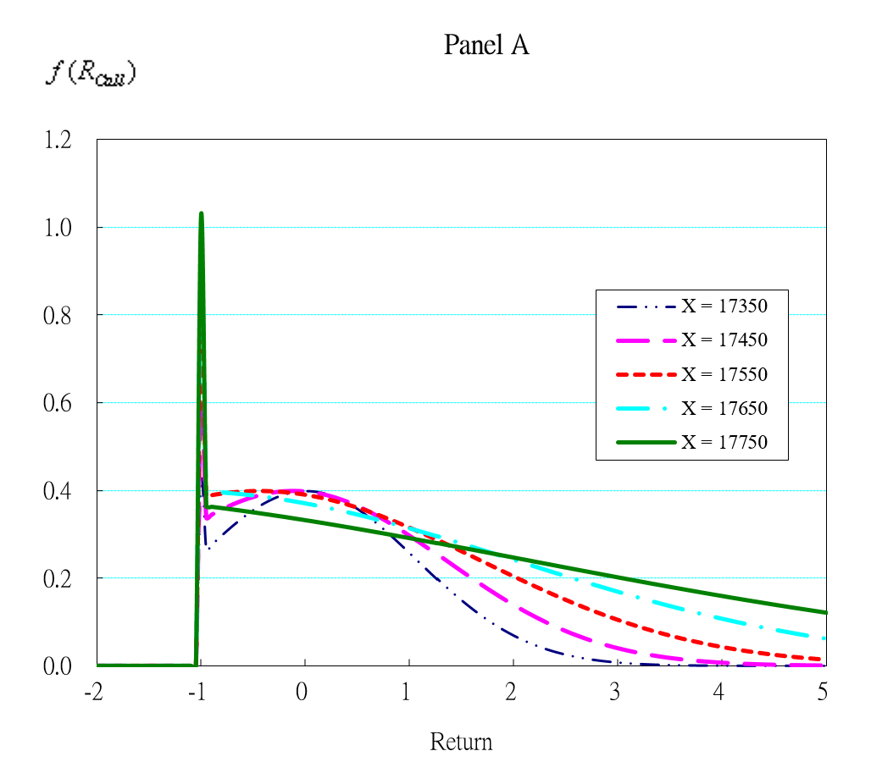Before Russo-Ukrainian War for Weekly Calls |  | 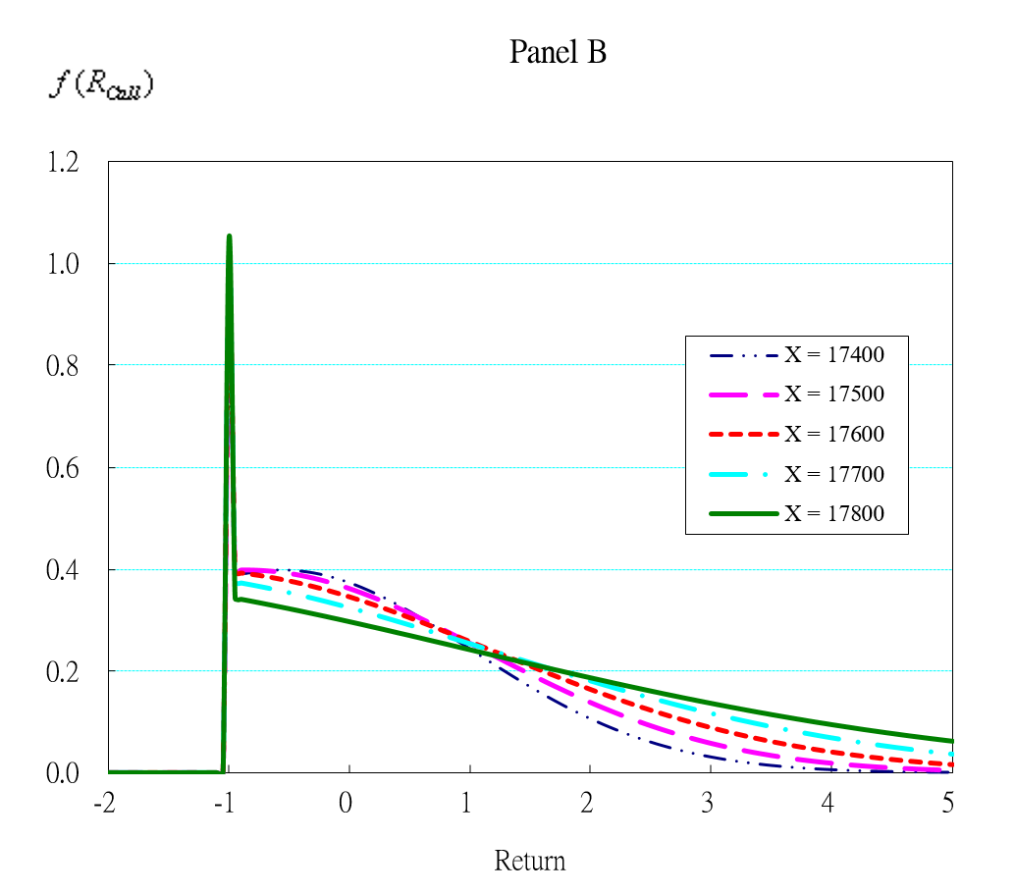  After Russo-Ukrainian War for Weekly Calls
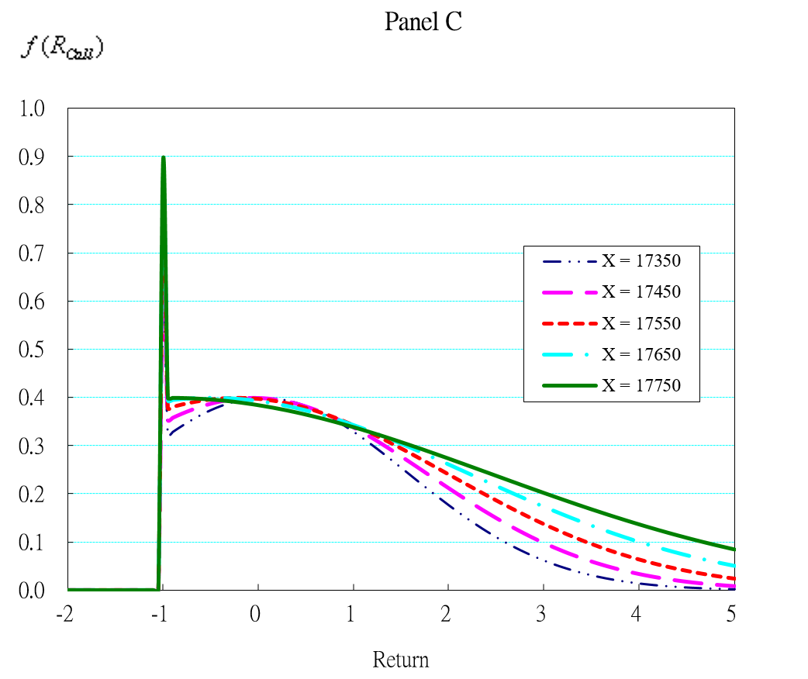  Before Russo-Ukrainian War for Monthly Calls |  |  | 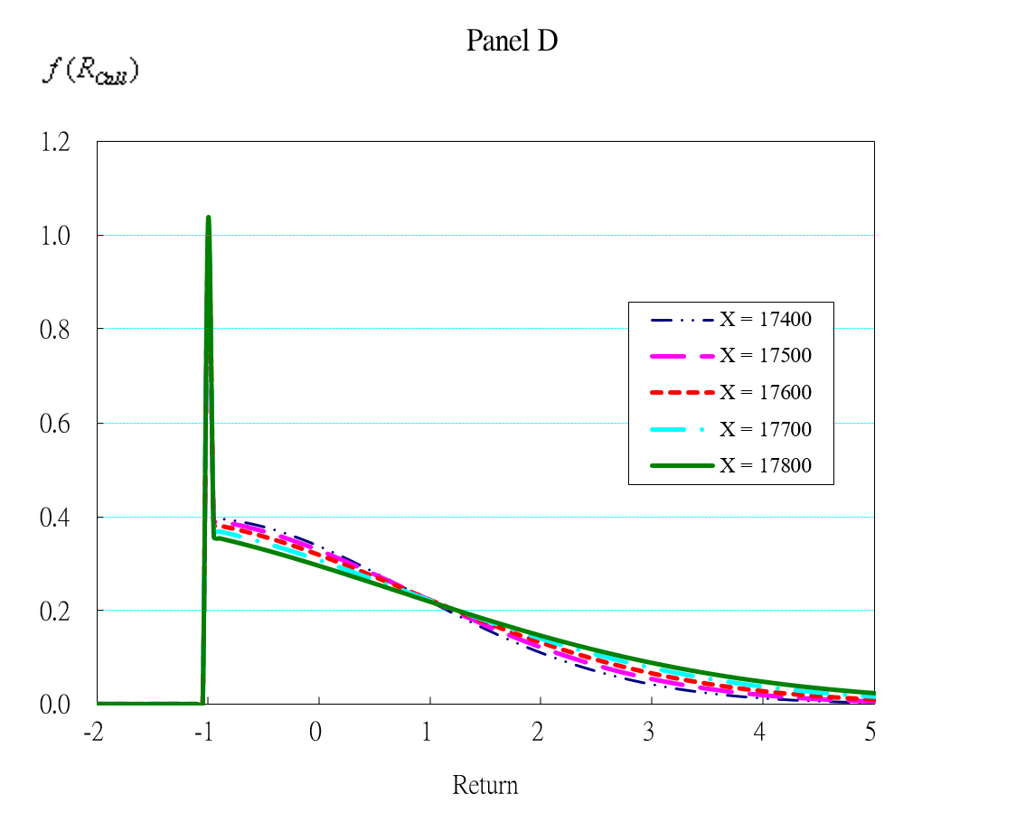  After Russo-Ukrainian War for Monthly Calls
Figure 4 PDFs of the call options for Return Distribution of Before and After War

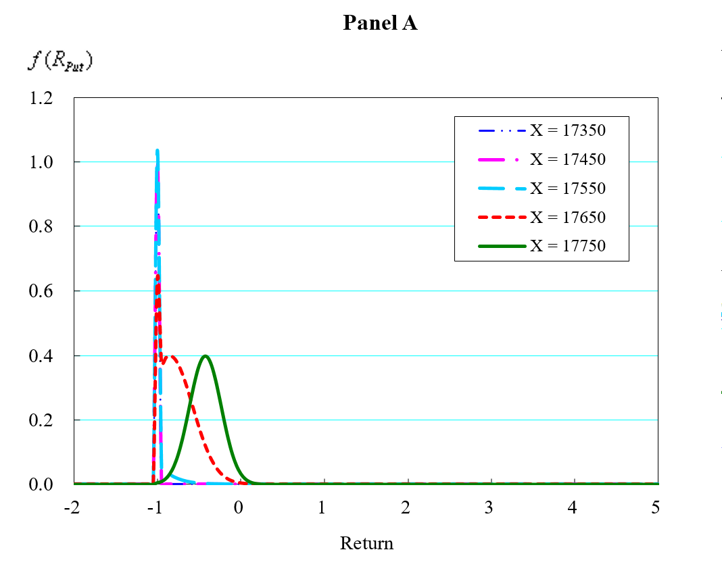  Before Russo-Ukrainian War for Weekly Put | 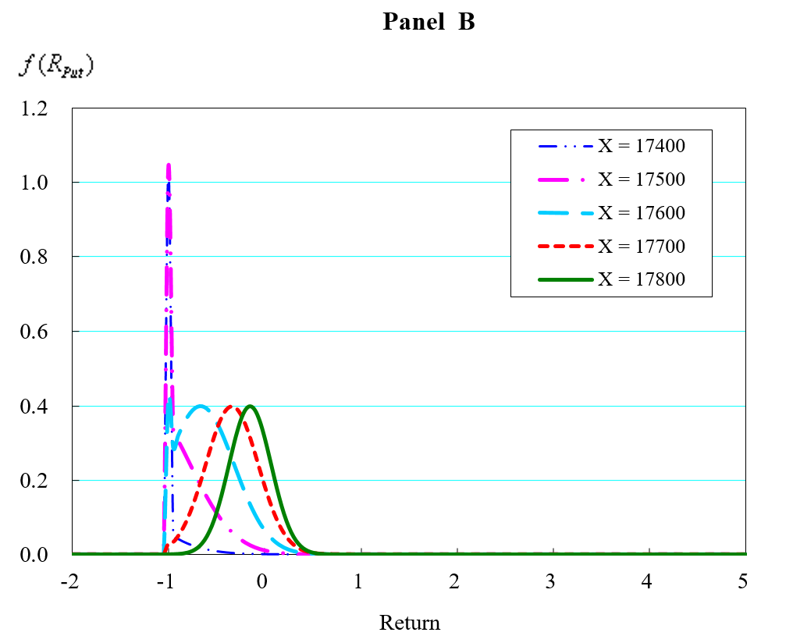  After Russo-Ukrainian War for Weekly Put
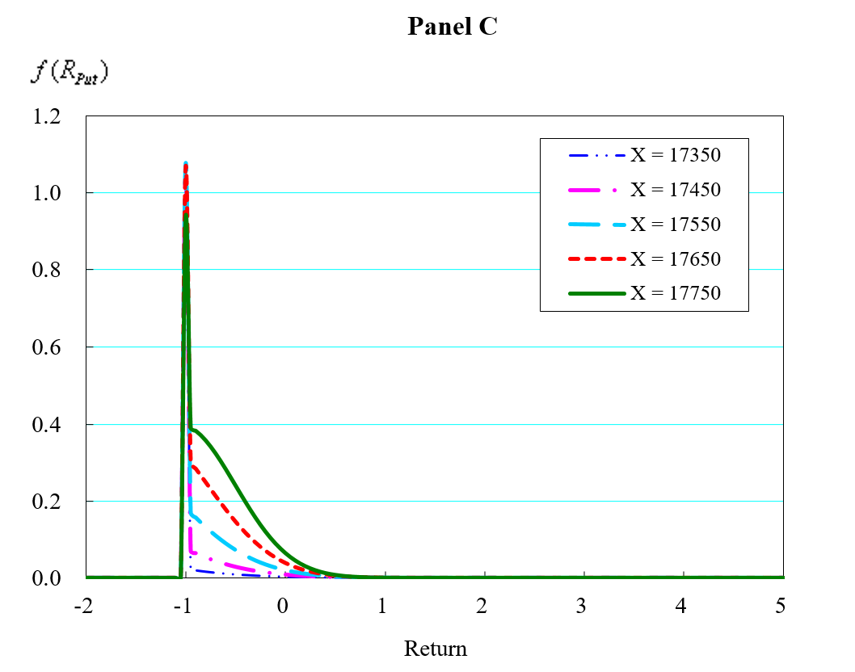  Before Russo-Ukrainian War for Monthly Put | 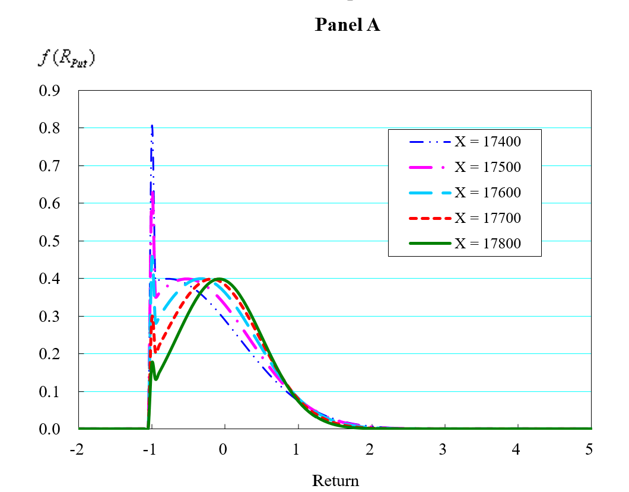  After Russo-Ukrainian War for Monthly Put
Figure 5 PDFs of the Put options for Return Distribution of Before and After War

4.3 Change in the profitability of trading the TAIEX options
Thirdly, to investigate the impacts of the RUW on the profitability of trading the TAIEX options, we can convert the PDFs of TAIEX options into the CDFs for probabilities in the entire domain, as shown in Figure 6 (call options) and Figure 7 (put options), respectively. Furthermore, for convenience of reading the win/loss probabilities in certain regions of return, we repress the corresponding figures from the Excel calculation in Table 3.

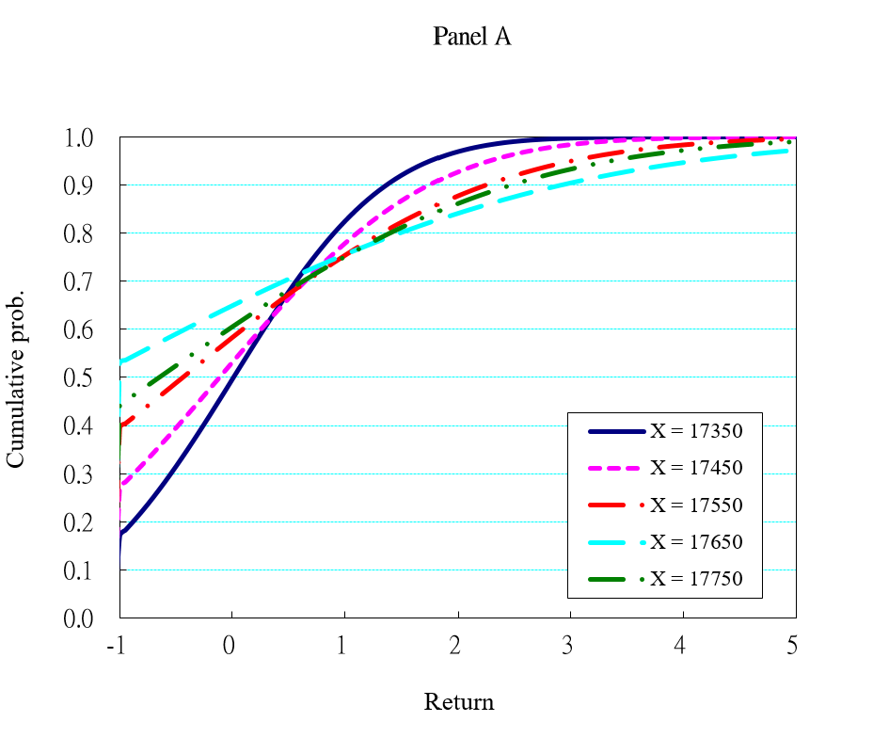 | 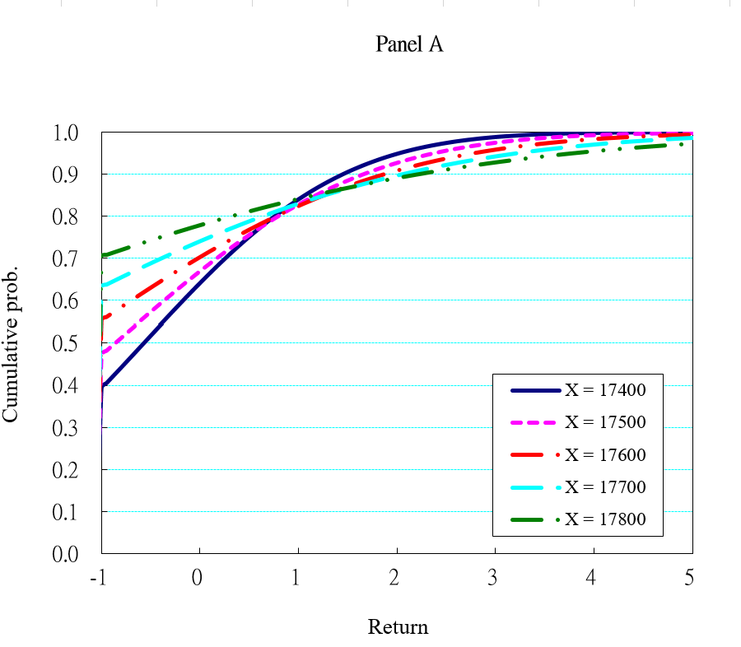
Before war (Weekly call options) | After war by (Weekly call options)
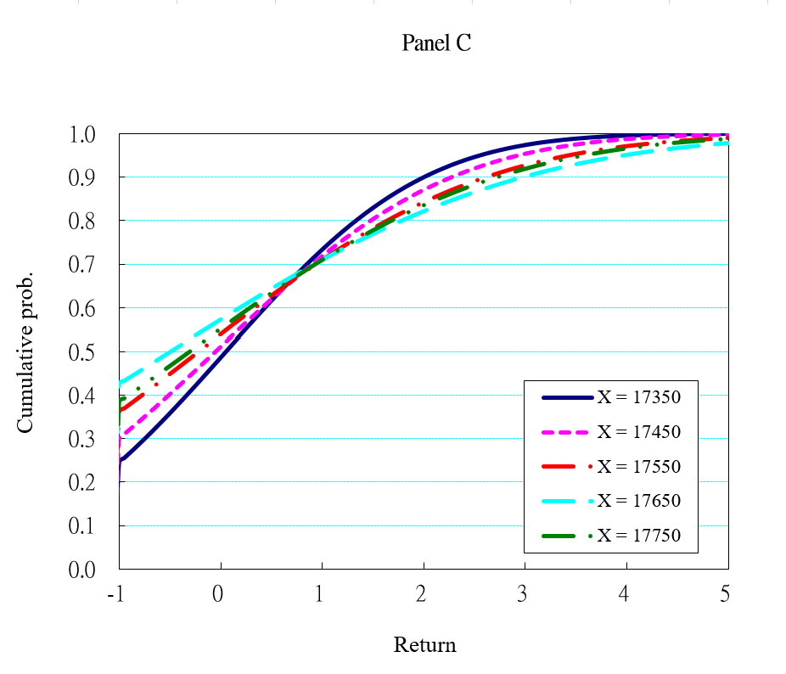 | 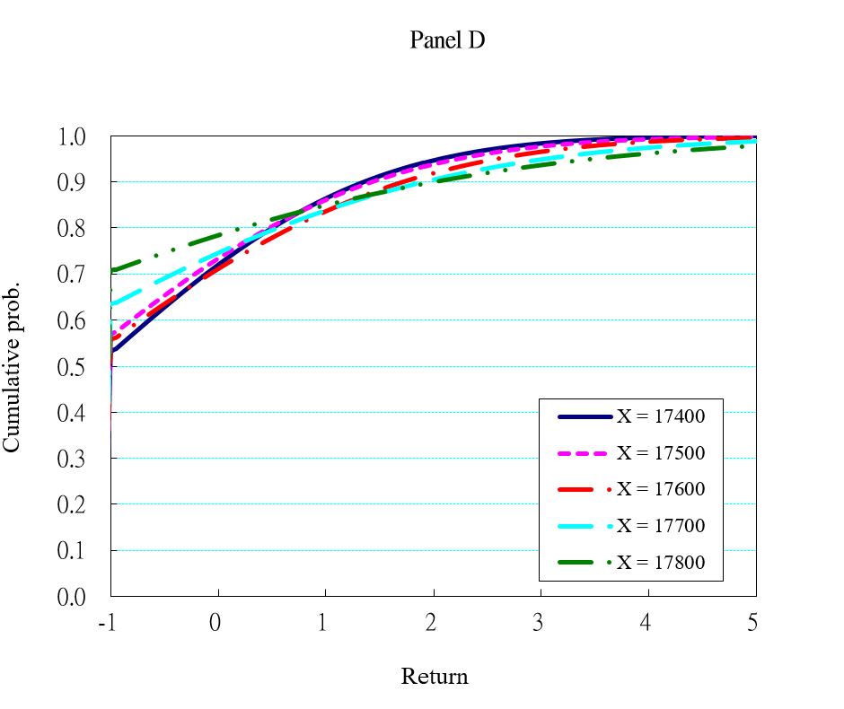
Before war (Monthly call options) | After war (Monthly call options)
Figure 6 CDFs of the call options for Return Distribution of Before and After War

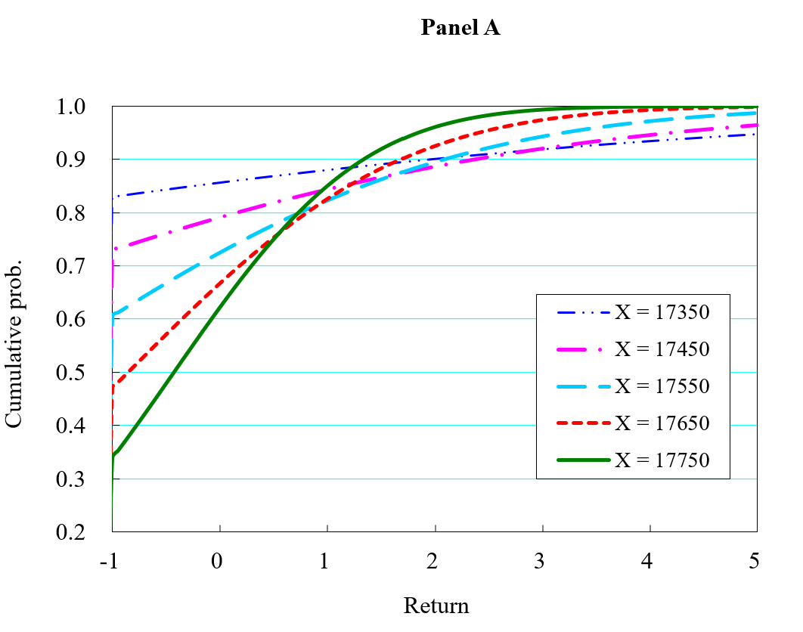 | 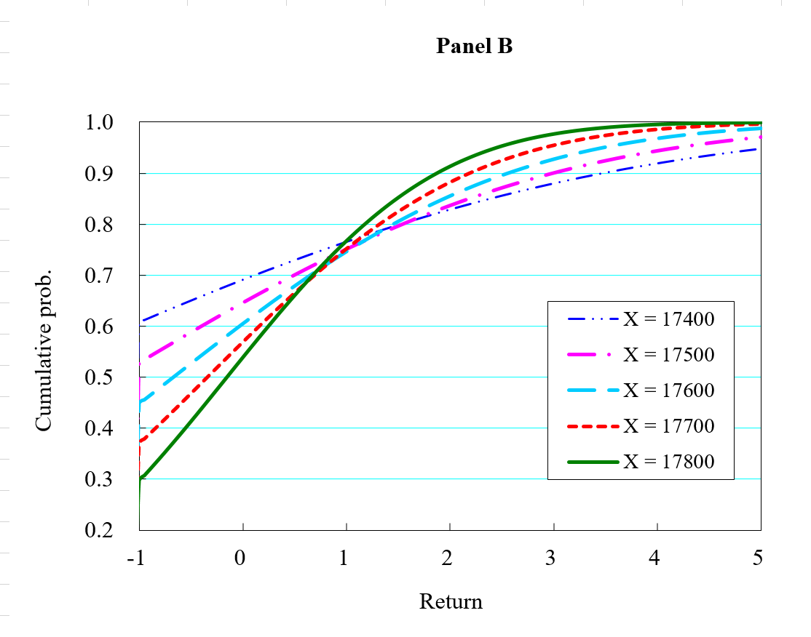
Before war (Weekly Put options) | After war (Weekly Put options)
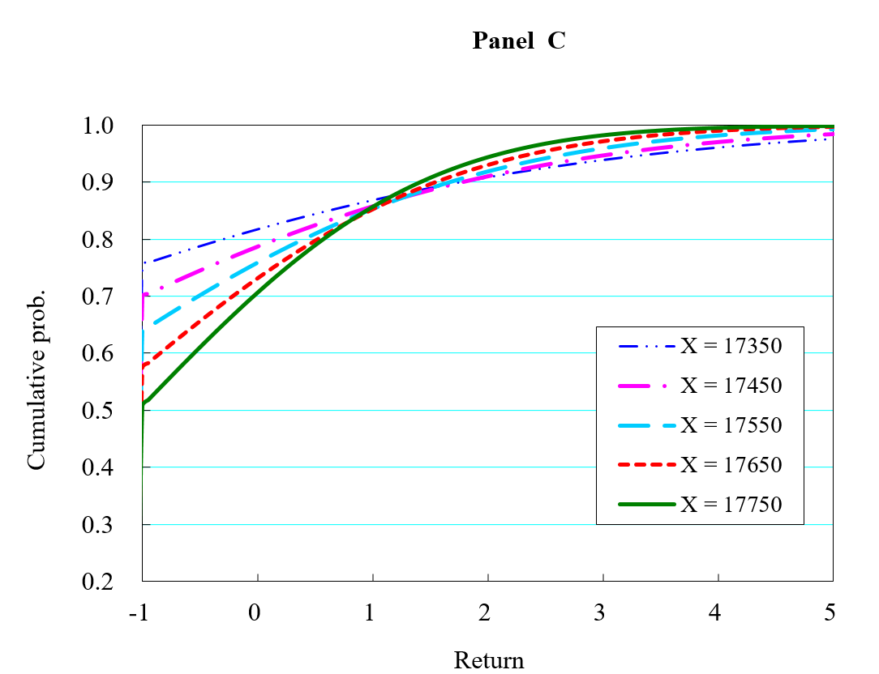 | 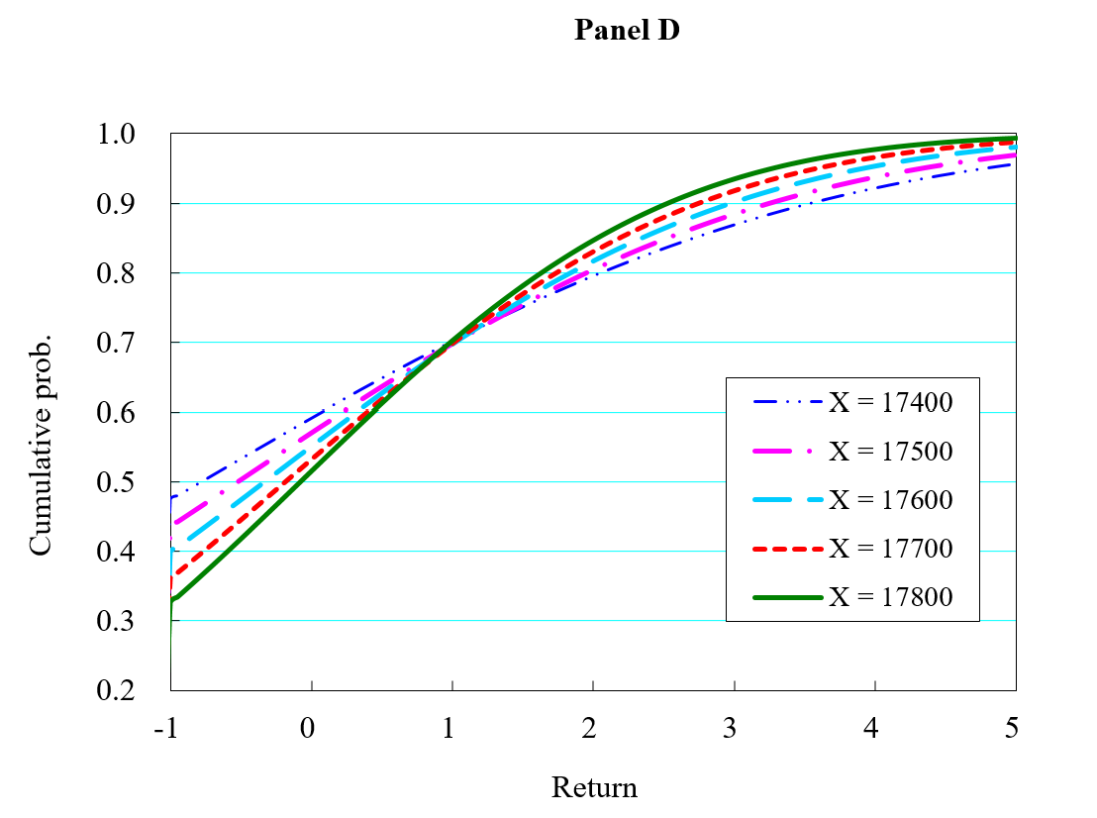
Before war (Monthly Put options) | After war (Monthly Put options)
Figure 7 CDFs of the Put options for Return Distribution of Before and After War
Table 3 (R_{call}) and Table 4 (R_{put}) reports the probabilities of some regions for weekly options, having the largest trading volumes in Taiwan, as the base case. The first column presents varying strike prices with ITM (in-the-money), ATM (at-the-money) and OTM (out-of-the-money). The range between two consecutive strike prices is 100 points. The parameters used in Panels A to D re corresponding to the diverse economic scenarios during the research period. R = ‒1 means the maximum loss (return = ‒100%); R < 0 means negative return; R > 1 means that the return is more than one (i.e., return >100%), and so on.

Table 3 Probability for trading options before and after Russo-Ukrainian ($R_{call})$

Panel A : Weekly Call Options Before Russo-Ukrainian War
Parameters:‒「$S_{0}=17,586、μ=0.1243、σ=0.1196、r=0.02、T=0.020 year$」
Strike Price | $$R_{call}$$
 | = ‒100% | ≦ 0 | ≧ 100% | ≧ 200% | ≧ 300%
X = ITM2 | 0.1702 | 0.4962 | 0.1752 | 0.0302 | 0.0024
X = ITM1 | 0.2708 | 0.5313 | 0.2214 | 0.0726 | 0.0160
X = ATM | 0.3945 | 0.5826 | 0.2468 | 0.1229 | 0.0509
X = OTM1 | 0.5300 | 0.6497 | 0.2440 | 0.1580 | 0.0948
X = OTM2 | 0.4427 | 0.6051 | 0.2492 | 0.1384 | 0.0671
Panel B： Weekly Call Options After Russo-Ukrainian War
Parameters:「$S_{0}=17,595、μ=-0.1787、σ=0.2025、r=0.02、T=0.020 year$」
Strike Price | $$R_{call}$$
 | = ‒100% | ≦ 0 | ≧ 100% | ≧ 200% | ≧ 300%
X = ITM2 | 0.3927 | 0.6411 | 0.1598 | 0.0517 | 0.0118
X = ITM1 | 0.4721 | 0.6698 | 0.1714 | 0.0725 | 0.0246
X = ATM | 0.5527 | 0.7031 | 0.1752 | 0.0910 | 0.0413
X = OTM1 | 0.6321 | 0.7400 | 0.1706 | 0.1038 | 0.0583
X = OTM2 | 0.7045 | 0.7792 | 0.1583 | 0.1087 | 0.0713
Panel C: Monthly Call Options Before Russo-Ukrainian War
Parameters:「$S_{0}=17,586、μ=0.1243、σ=0.1196、r=0.02、T=0.08year$
Strike Price | $$R_{call}$$
 | = ‒100% | ≦ 0 | ≧ 100% | ≧ 200% | ≧ 300%
X = ITM2 | 0.2449 | 0.4864 | 0.2269 | 0.1005 | 0.0265
X = ITM1 | 0.3006 | 0.5109 | 0.2819 | 0.1298 | 0.0468
X = ATM | 0.3615 | 0.5398 | 0.2897 | 0.1566 | 0.0717
X = OTM1 | 0.4261 | 0.5728 | 0.2899 | 0.1779 | 0.0919
X = OTM2 | 0.3844 | 0.5512 | 0.2907 | 0.1650 | 0.0812
Panel D: Profitability for Monthly Call Options After Russo-Ukrainian War
Parameters:「$S_{0}=17,595、μ=-0.1787、σ=0.2025、r=0.02、T=0.08year$」
Strike Price | $$R_{call}$$
 | = ‒100% | ≦ 0 | ≧ 100% | ≧ 200% | ≧ 300%
X = ITM2 | 0.5260 | 0.7190 | 0.1368 | 0.0538 | 0.0168
X = ITM1 | 0.5645 | 0.7334 | 0.1392 | 0.0662 | 0.0225
X = ATM | 0.5527 | 0.7106 | 0.1641 | 0.0807 | 0.0342
X = OTM1 | 0.6312 | 0.7460 | 0.1613 | 0.0941 | 0.0502
X = OTM2 | 0.7045 | 0.7837 | 0.1510 | 0.1004 | 0.0634

To enhance the comprehension of Cumulative Distribution Functions (CDFs) results, we use weekly options as an illustrative example and present probabilities for specific options returns across various scenarios in Table 3. We initially contrast the probabilities of different profits before and after the RUW on weekly call options (refer to Panels A and B on the left-hand side of Table 3). The probability of experiencing the maximum loss (R = −1),for trading ATM (At-The-Money)
calls is 39.45% before RUW,which subsequently increases to 55.27% after RUW.Regarding positive profits (R > 0), the probability is 41.74% (1 ‒ 0.5826) before RUW and decreases to 29.69% (1 ‒ 0.7031) after RUW. Similarly, for profits exceeding 2 (R > 2), the probability is 12.29% (1 ‒ 0.8771) before RUW and decreases to 9.10% (1 ‒ 0.9090) after RUW. In general, negative probabilities, including loss of all capital, after the RUW are much larger than those of before the RUW; while positive probabilities after the RUW are much smaller than those of before the RUW.
On monthly call options (refer to Panels C and D on the left-hand side of Table 3), the probability for ATM is 36.15% before RUW and increases to 55.27% after RUW. Regarding positive profits (R > 0), the probability is 28.97% (1 ‒ 0.7103) before RUW and decreases to 16.41% (1 ‒ 0.8359) after RUW. In general, the same trend is also true for monthly call options.
These results suggest that the RUW has triggered a bear market, making it challenging for investors to profit from long positions in call options. Specifically, for ATM options, nearly half of the chance results in the maximum loss, while only about a third of the chance leads to positive profits after the occurrence of the RUW.
In Table 4, a comprehensive analysis of put option probabilities is presented. Panels A and B are for the weekly puts. Specifically, when examining the maximum loss scenario (R = −1), before the occurrence of RUW, the probability for at-the-money (ATM) options is 60.55%, which decreases to 44.73% after RUW. On the contrarily, the probability for positive profits (R > 0) shifts from 17.71% to 25.41%, and for profits exceeding 2 (R > 2) slightly changes from 14.06% to 14.48%. These results indicate that RUW influences a negative market growth rate, amplifying the likelihood of positive profits through long puts. For example, the chance of the largest loss decreases from 60.55% to 44.73%, while the chance of positive profits (R > 1) increases from 17.71% to 25.41%.
As for monthly put options before and after RUW (Panels C and D in Table 4) reveals the same trend as weekly puts. In the before RUW period (Panel C), the probability of a complete loss for a long ATM put is 0.6385, whereas for a long ATM put after RUW is 0.3976 (Panels D). Conversely, the chance of making profits (R > 0) is only 0.2416 for a long ATM put before RUW but rises to 0.4494 for a long ATM put after RUW. Interestingly, comparing long monthly calls and monthly puts in the most severe period, the probability of earning returns for a long ATM call decreased from 28.97% (Panel C of Table 3) to 16.41% (Panel D of Table 3), while for a long ATM put, it increased from 14.47% (Panel D of Table 3) to 30.24% (Panel D of Table 4).

Table 4 Probability for trading options before and after Russo-Ukrainian ($R_{put})$

Panel A: Weekly Put Options Before Russo-Ukrainian War
Parameters:「$S_{0}=17,586、μ=0.1243、σ=0.1196、r=0.02、T=0.020 year$」
Strike Price | $$R_{Put}$$
 | = ‒100% | ≦ 0 | ≧ 100% | ≧ 200% | ≧ 300%
X = ITM2 | 0.8298 | 0.8565 | 0.1197 | 0.1989 | 0.0808
X = ITM1 | 0.7292 | 0.7910 | 0.1563 | 0.1132 | 0.0794
X = ATM | 0.6055 | 0.7247 | 0.1771 | 0.1406 | 0.0564
X = OTM1 | 0.4700 | 0.6664 | 0.1748 | 0.0749 | 0.0258
X = OTM2 | 0.3379 | 0.6211 | 0.1504 | 0.0391 | 0.0064
Panel B： Weekly Put Options After Russo-Ukrainian War
Parameters:「$S_{0}=17,595、μ=-0.1787、σ=0.2025、r=0.02、T=0.020 year$」
Strike Price | $$R_{Put}$$
 | = ‒100% | ≦ 0 | ≧ 100% | ≧ 200% | ≧ 300%
X = ITM2 | 0.6073 | 0.6907 | 0.2347 | 0.1714 | 0.1201
X = ITM1 | 0.5275 | 0.6455 | 0.2494 | 0.1636 | 0.0998
X = ATM | 0.4473 | 0.6043 | 0.2541 | 0.1448 | 0.0727
X = OTM1 | 0.3688 | 0.5684 | 0.2484 | 0.1176 | 0.0453
X = OTM2 | 0.2955 | 0.5382 | 0.2330 | 0.0865 | 0.0230
Panel C: Monthly Put Options Before Russo-Ukrainian War
Parameters:「$S_{0}=17,586、μ=0.1243、σ=0.1196、r=0.02、T=0.08year$
Strike Price | $$R_{Put}$$
 | = ‒100% | ≦ 0 | ≧ 100% | ≧ 200% | ≧ 300%
X = ITM2 | 0.7551 | 0.8169 | 0.1320 | 0.0918 | 0.1614
X = ITM1 | 0.6994 | 0.7873 | 0.1420 | 0.0892 | 0.0526
X = ATM | 0.6385 | 0.7584 | 0.1474 | 0.0816 | 0.2408
X = OTM1 | 0.5739 | 0.7312 | 0.1476 | 0.0699 | 0.0283
X = OTM2 | 0.5073 | 0.7064 | 0.1428 | 0.0556 | 0.0171
Panel D: Monthly Put Options After Russo-Ukrainian War
Parameters:「$S_{0}=17,595、μ=-0.1787、σ=0.2025、r=0.02、T=0.08year$」
Strike Price | $$R_{Put}$$
 | = ‒100% | ≦ 0 | ≧ 100% | ≧ 200% | ≧ 300%
X = ITM2 | 0.4740 | 0.5916 | 0.2985 | 0.2044 | 0.1308
X = ITM1 | 0.4355 | 0.5705 | 0.3024 | 0.1955 | 0.1155
X = ATM | 0.3976 | 0.5506 | 0.3036 | 0.1838 | 0.0989
X = OTM1 | 0.3606 | 0.5321 | 0.3022 | 0.1996 | 0.0818
X = OTM2 | 0.3249 | 0.5151 | 0.7018 | 0.1535 | 0.0651

4.4 Change in Expected Returns on the Options
Table 5 displays the expected returns associated with call and put options based on the formulas in Hsu (2013). The results in Table 5 suggest that in a bearish market scenario, where μ is less than zero (μ < 0), the expected returns for call options, weekly or monthly, are negative across all strike prices after the sub-period of RUW, in contrast to positive returns before the sub-period of RUW. Conversely, for put options, weekly or monthly, the expected returns are positive across all strike prices after the sub-period of RUW, but are negative returns before the sub-period of RUW. In summary, the more bearish the market, the more advantageous it becomes for put options, while it becomes less favorable for call options.
Table 5 Expected Returns on Options
Scenarios | E(R_{call}) for Call Options |  | E(R_{put}) for Put Options
 | Before | After | Before | After
Panel E: Weekly Options
X = ITM2 | 0.1066 | ‒0.1325 | ‒0.1847 | 0.2344
X = ITM1 | 0.1267 | ‒0.1460 | ‒0.1695 | 0.2073
X = ATM | 0.1489 | ‒0.1610 | ‒0.1520 | 0.1841
X = OTM1 | 0.1723 | ‒0.1778 | ‒0.1337 | 0.1641
X = OTM2 | 0.1953 | ‒0.1965 | ‒0.1157 | 0.1468
Panel F: Monthly Options
X = ITM2 | 0.2901 | ‒0.2866 | ‒0.3240 | 0.4562
X = ITM1 | 0.3149 | ‒0.2990 | ‒0.3094 | 0.4275
X = ATM | 0.3407 | ‒0.3119 | ‒0.2941 | 0.4012
X = OTM1 | 0.3671 | ‒0.3254 | ‒0.2784 | 0.3771
X = OTM2 | 0.3938 | ‒0.3393 | ‒0.2624 | 0.3549
Note: The first column presents varying strike prices with ITM (in-the-money), ATM (at-the-money) and OTM (out-of-the-money). The range between two consecutive strike prices is 50 (100) points for weekly (monthly) options of TXOs.

5. Conclusions and Extended Research
This study investigates the impact of the Russian-Ukrainian war on the risk-return of TAIEX options. The war was officially initiated upon the launching of a special military operation against eastern Ukraine by Russia on February 24, 2022 (Shen and Zhuocheng, 2022). This study utilizes Hsu's (2013) option return models to investigate the impacts how the war influences the TAIEX options' risk-return profile, including PDFs, profitability, and expected returns. The contributions of this paper are two-fold: It is the first paper on the Russia-Ukraine war on the options markets; additionally, we demonstrate theoretically and empirically that the normality assumption of simple arithmetic returns is acceptable, making the Hsu's (2013) option return models more robust.
Results of this study indicate that in the course of the Russian-Ukrainian war, the economic sanctions imposed by European and American countries on Russia, the return of TAIEX is unavoidably affected by inflation and rising interest rates. The war has led to a significant increase in risk premium, systematic financial stress and prices of various commodities. Thus, the Russian-Ukrainian war has indeed had a great impact on the risk and return of TAIEX options.
This study is based on a data for the period from February 24, 2022 to August 31, 2022, but later unveiled that the war would unavoidably turn into a prolonged one. While the war is still ongoing with no sign of termination, its impacts on the worldwide financial market become lessor and lessor because the major stock markets, such as in the US and Taiwan, are booming. This study uses the aforesaid research period for formulating the conclusion. In the model of Hsu (2013), it assumes that the arithmetic stock returns are normally distributed. We rigorously prove that it is absolutely not log-normally distributed and the normality assumption of arithmetic stock returns is acceptable, making the model of Hsu (2013) more robust.
We utilize the TAIEX option profile to investigate how war affects the return and risk of option characteristics. Our findings reveal that in the bearish market (after the RUW period) environment during the pandemic, the return results are consistent both theoretically and empirically. Specifically, we observe that the return on call options is negative across all strike prices, while the return on put options is positive across all strike prices.
Moreover, in a bear market, taking a long ATM put position, for example, presents an opportunity for profit, with a 50% chance of success, and as the strike price deepens, the probability of positive returns increases. Despite the unprecedented impact of the war on the stock market, it is remarkably paradoxical that it represented the optimal time for options trading profitability. Surprisingly, bear markets rewarded traders more than bull markets during this period.

References
- Black, F. & Scholes, M. (1973). The Pricing of Options and Corporate Liabilities. The Journal of Political Economy, 81(3), 637-654.
- Boungou, Whelsy and Alhonita Yatié (2022). "The impact of the Ukraine–Russia war on world stock market returns." Economics Letters 215: 110516.
- Cui, L., Yue, S., Nghiem, X. H., & Duan, M. (2023). Exploring the risk and economic vulnerability of global energy supply chain interruption in the context of Russo-Ukrainian war. Resources Policy, 81, 103373.
- Dogan, E., Majeed, M.T., Luni, T. (2021). Analyzing the impacts of geopolitical risk and economic uncertainty on natural resources rents. Resour. Pol. 72, 102056.
- Hsu, H. (2013). On the Option Expected Return and Risk Characteristics. Journal of Futures and Options, 6(1), 59-90.
- Holt, C. C. (1957). Forecasting seasonals and trends by exponentially weighted averages (O.N.R. Memorandum No. 52). Carnegie Institute of Technology, Pittsburgh USA
- Hull, J. C. (2012). Options, Futures, and Other Derivatives (8 ed.). PEARSON.
- Li, Fen, et al. (2021). "Does geopolitics have an impact on energy trade? Empirical research on emerging countries." Sustainability 13.9: 5199.
- Liu, L. Y. (2018). Special Report. SECURITIES SERVICES REVIEW, 663(2). https://www.twse.com.tw/zh/products/essay
- Liadze, I., Macchiarelli, C., Mortimer‐Lee, P., & Sanchez Juanino, P. (2023). Economic costs of the Russia‐Ukraine war. The World Economy, 46(4), 874-886.
- Lo, G. D., Marcelin, I., Bassène, T., & Sène, B. (2022). The Russo-Ukrainian war and financial markets: the role of dependence on Russian commodities. Finance Research Letters, 50, 103194.
- Majeed, A., Wang, L., Zhang, X., et al. (2021). Modeling the dynamic links among natural resources, economic globalization, disaggregated energy consumption, and environmental quality: fresh evidence from GCC economies. Resour. Pol. 73, 102204.
- Norouzi, M., Chàfer, M., Cabeza, L. F., Jiménez, L., & Boer, D. (2021). Circular economy in the building and construction sector: A scientific evolution analysis. Journal of Building Engineering, 44, 102704.
- Steindl, J. (1965). Random Processes and the Growth of Firms: A Study of the Pareto Law. Hafner Publishing Company.
- Su, C.W., Khan, K., and Umar, M. (2020). A review of resource curse burden on inflation in Venezuela. Energy 204, 117925.
- Summa, J. F. (2003). Options sellers vs. buyers who wins? Futures, 32(4), 52-52.
- Sutton, J. (1997). Gibrat's legacy. Journal of economic literature, 35(1), 40-59.
- Shen, Zhuocheng (2022). "Optimal Oil-based Exotic Options Strategies Under the Background of War: An Empirical Study in the Context of the Russia-Ukraine Conflict." 2022 2nd International Conference on Enterprise Management and Economic Development (ICEMED 2022). Atlantis Press, 2022.
- Warburton, C. E., & Pemberton, J. (2023). VOLATILE FINANCIAL CONDITIONS, ASSETS PRICES AND INVESTMENT DECISIONS: ANALYSIS OF DAILY DATA OF DJIA AND S&P500, FROM JANUARY TO APRIL OF 2022. Applied Econometrics and International Development, 23(1), 101-124.
- World Federation of Exchanges. (2020). The WFE derivatives report 2020. World Federation of Exchanges. https://www.world-exchanges.org/our-work/articles/derivatives-report-2020

Some scholars may think that no one can actually prove whether the arithmetic rate of stock return is normally distributed or not. We hereby do our best to show that the normality assumption of the arithmetic stock return is “acceptable” in doing research.
See, for example, Wikipedia, the free encyclopedia https://en.wikipedia.org/wiki/Log-normal distribution
This formulation appears in Sutton, J. (1997). Gibrat's legacy. Journal of economic literature, 35(1), 40-59.
See Hull, J. C. (2012). Options, Futures, and Other Derivatives (8 ed.). PEARSON. equation (20.17), p.448.
Hsu (2013) did not demonstrate the validity of normality assumption of the arithmetic stock return. As clarified in Section 3.1, we have proved that the arithmetic stock return is absolutely not log-normally distributed and the normality assumption is acceptable.
The formulas for the expected returns on call and put options can be found in Hsu (2013), eq. (14), p. 63 and eq. (16), p. 65, respectively.

