The effect of BMI on Oxygen saturation at rest and during mild walking

Jerrold Petrofsky**
Michael Laymon*
Iman Akef Khowailed **
Stacy Fisher*
Andrew Mills*

Loma Linda University, Loma Linda California**
Touro University, Henderson Nevada*

Send Reprint Requests to:
Dr. Jerrold Petrofsky
Professor and Director of Research
Department of Physical Therapy
Loma Linda University
Loma Linda, California 92350
(909) 558 7274
E-mail: jpetrofsky@llu.edu
Abstract
Eighty one subjects participated in experiments to examine the relationship between BMI, Body fat, arterial oxygen saturation and arterial PO2 with the subjects at rest and after 5 minutes of walking on a treadmill ergometer at 3 mph at a 3% grade. They had BMIs between 19 and 50. All subjects were free of cardiovascular disease and had normal blood pressure making it safe for them to participate in mild exercise. They were all able to walk for at least 10 minutes without cardiovascular complications and were not taking any medications that altered the autonomic nervous system. The age was between 22 and 68. The results showed that above a BMI of about 30, there was an inverse relationship between BMI and oxygen saturation in fingertip blood (correlation -0.81. p<0.001). The reduction in O2 saturation with higher BMI was made much worse when walking at 3 mph at a 3% grade on a treadmill (p<0.01). Upon walking, saturation dropped for the first 5 minutes. Oxygen saturation was reduced by almost 5% after 5 minutes of exercise. The results indicate that caution should be used in people with higher BMIs on using therapeutic exercise and a pulse oximeter should be used for safety.

Key words- BMI, oxygen saturation, obesity, exercise

Introduction

Pickwickian syndrome is a common disorder associated with obesity [1, 2]. It is characterized by low arterial PO2 and low arterial oxygen saturation [3, 4]. For example, Mr. Wardle’s servant in Charles Dickens’ posthumous papers of the Pickwick club (Pickwick Papers) [5] shows a picture of a very overweight individual called “Joe the fat boy” who is always eating and sleeping. This syndrome, because of the representation in Charles Dickens book, was originally named Pickwickian Syndrome in early case reports from over 100 years ago[3]. When President Howard Taft lost 90 lbs., he reported that he lost a tendency to be sleepy and his color was better and his ability to walk was improved[4]. In 1955, pulmonary function in overweight people was examined in more detail [6, 7]. This early name, Pickwickian Syndrome adapted by Burwell was renamed in 1969 as Obesity Hypoventilation Syndrome (OHS) [1, 2].
For someone who is grossly overweight, hypercapnia and hypoxia in arterial blood can occur if the BMI is over 30. It can get worse during sleep[2]. It is usually reserved for people who have a resting PO2 in the arterial blood of less than 70mmHg [4, 8]. Ninety percent of patients with a BMI over 30 have sleep disorders and reduced oxygen saturation at night[4].
Since, in the United states, over 1/3 of the population has a BMI >40, sleep disorders and low O2 saturation are common[4]. This is presently a global problem and not just in the United States. The incidence of OHS varies form 20-35% [9].
In the present investigation we examined 81 people with varying degrees of body fat. They were examined at rest as per the studies cited above. But in addition, they were examined during walking on a treadmill at 3 miles per hour at a 3% grade. Studies on oxygen saturation are usually related to sleep when the metabolic demands on the body are small. This study stressed the same individuals to see if oxygen saturation during walking is a better diagnostic tool to examine respiratory impairment.

Subjects
Eighty one subjects participated in these experiments. They had BMIs of between 19 and 50. All subjects were free of cardiovascular disease and had normal blood pressure making it safe for them to participate in mild exercise. They were able to walk for at least 10 minutes without cardiovascular complications and were not taking any medications that alter the autonomic nervous system. The demographics are shown in Table 1. All procedures were approved by the Solutions IRB and all subjects signed a statement of informed consent.

 | age | height | weight | BMI
mean | 48.0 | 163.3 | 87.0 | 32.6
standard deviation | 11.9 | 7.4 | 20.7 | 7.4

Table 1 – demographics of subjects

Methods

Arterial PO₂
Arterial PO₂ was calculated from the hemoglobin disassociation curve. A pulse oximeter (Santa Medical, St. Louis, MO) was used to measure fingertip oxygen saturation. Once oxygen saturation was measured, the following equations were used to calculate the arterial PO2 [10].

y = 7E-05x³ - 0.0213x² + 2.57x - 13.773
Where Y is the hemoglobin saturation and x is the partial pressure of arterial oxygen.

Exercise
Exercise was accomplished on a treadmill with variable speed and inclination. The treadmill was adjusted to 3 mph at an angle of 3 degrees for the subjects to walk.

Procedures
Subjects entered the laboratory and rested for 15 minutes prior to testing. During that time, demographics and weight and BMI were assessed. The arterial oxygen saturation was measured from the fingertip. The average reading was taken over a 1 minute period. Subjects then walked on the treadmill and saturation and heart rate were measured once per minute for 5 minutes. If saturation dropped below 60% or heart rate above 140 beats per minute, the walking was terminated.

Results

The results of the experiments are shown in Figures 1-4. As shown in Figure 1, saturation was reduced with BMI especially above a BMI of 30. The largest changes occurred for a BMI above 35.

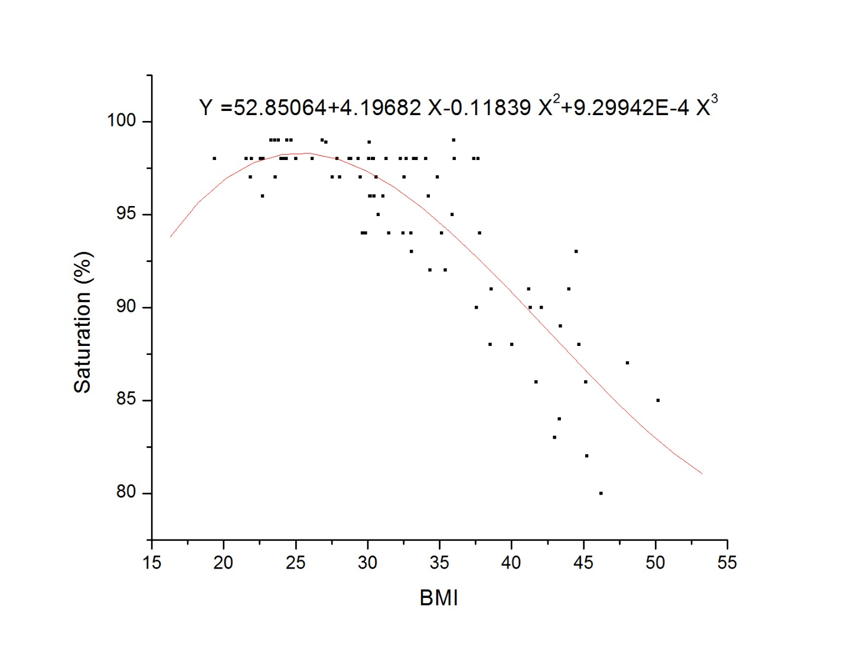

Figure 1- The relationship between oxygen saturation in the finger and BMI with the subject quietly sitting.

There was a significant correlation between hemoglobin saturation and the subjects BMI of -0.81. This was significant p=<0.001.
Figure 2 shows the relationship between calculated Vo2 and BMI. As illustrated in this figure, the calculated arterial PO2 was also reduced with BMI. The Po2 was reduced to about 89 mmHg in the heaviest subjects with the subject sitting.
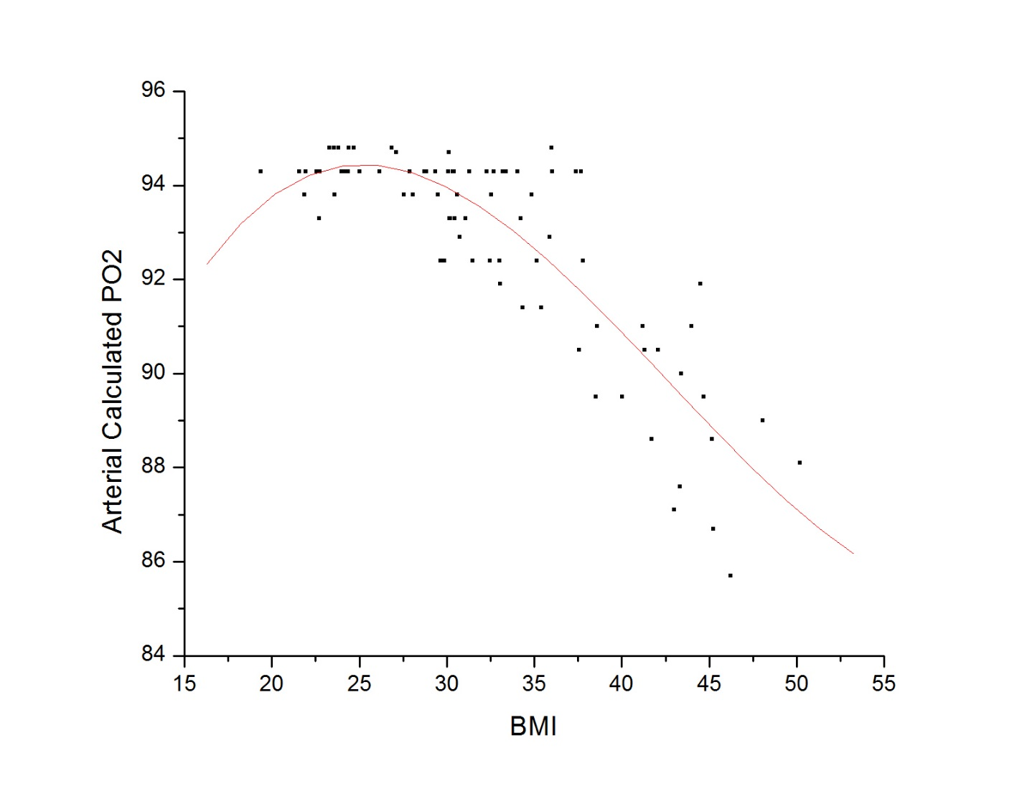
Figure 2- The relationship between calculated arterial PO2 in the finger and BMI with the subject quietly sitting in all subjects.

This was similar to the data during walking. As shown in Figure 3, PO2 dropped dramatically in the first minute of walking. After 5 minutes, the PO₂ still remained low. This reduction in PO2 was significant from rest (p<0.01).

Figure 3- The arterial PO2 in the finger with the subject walking at 3 miles per hour. Data is shown for 5 minutes.

The relationship between saturation after 5 minutes of walking and BMI are shown in Figure 4. As shown here, for BMIs over 26, there was a reduction in saturation during exercise. For the highest BMI studied here, this amounted to a 20% reduction in the hemoglobin saturation as shown in Figure 1.

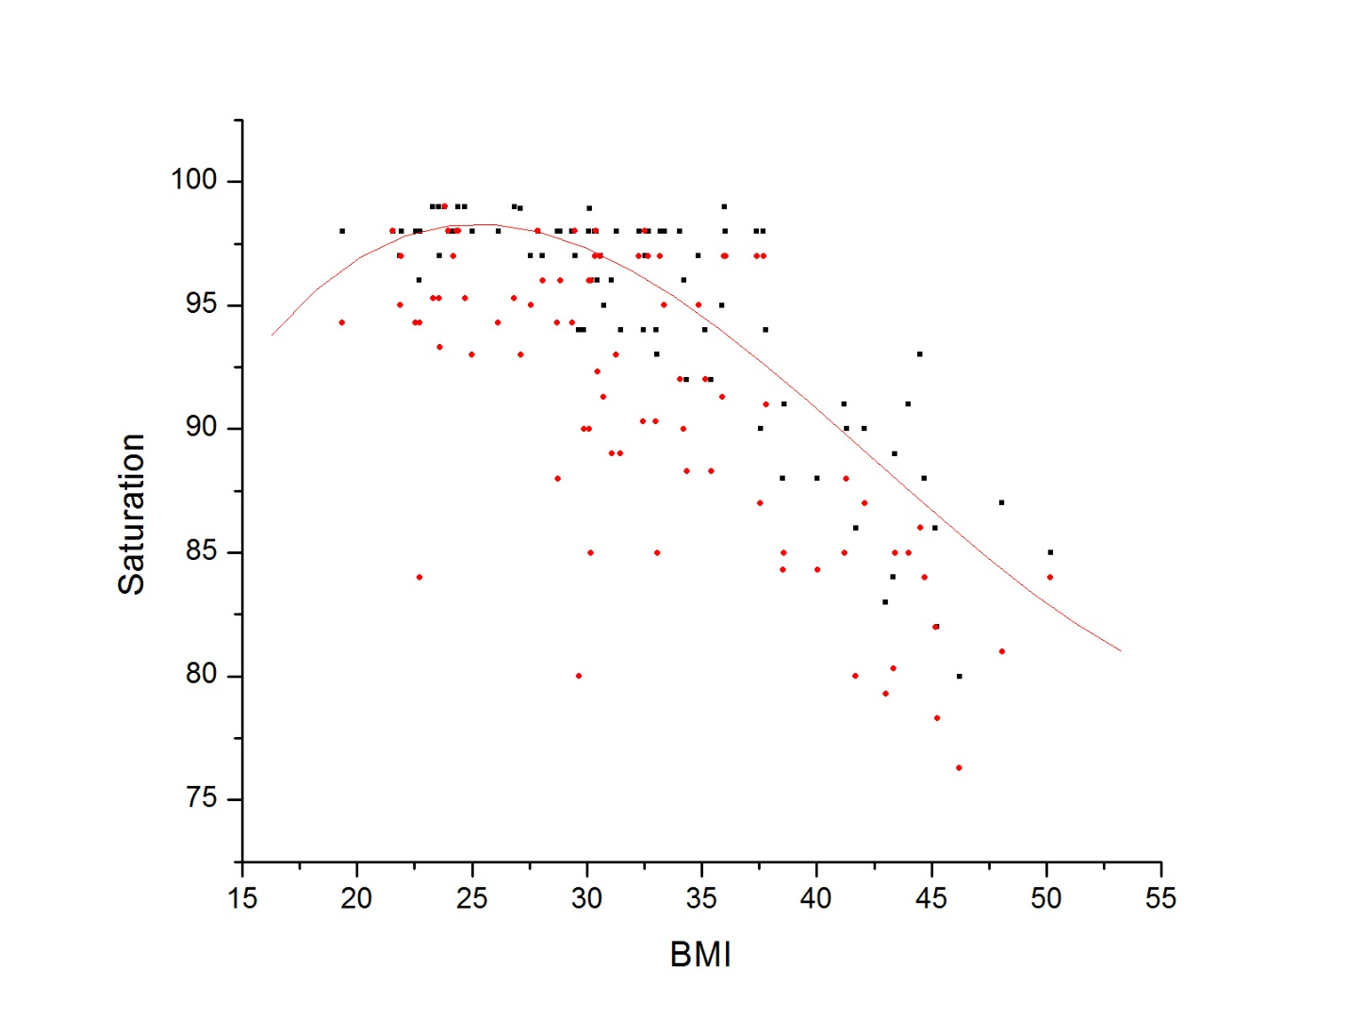
Figure 4- The Hb saturation in all subjects in relation to BMI after 5 minutes of walking on a treadmill.

The regression equation is shown for the resting measures and the black square dots representing resting data on all subjects. The red round dots are the data after 5 minutes of walking. The trend is obvious and the post walking data was significantly less than the resting data (p<0.001).
Discussion
Obesity is correlated with an increase in abdominal and visceral fat[1]. Both of these contribute to increased resistance of the chest and diaphragm [11-13]. Indirectly, obesity raises levels of inflammatory cytokines which also contributes to sleep apnea and low arterial PO2 [11-13]. Especially with chronic obesity, the normal diaphragmatic breathing gives way to intercostal breathing to reduce the effort during inspiration[14]. This causes tidal volume to fall and respiratory rate to increase[14]. The subsequent reduced lung perfusion causes venous ad mixture in the pulmonary tree[15]. This, in turn, reduces the PO2 saturation in arterial blood.
Most studies on obesity related hypoventilation, examine Po2 and hemoglobin saturation with the subject at rest. The posture is usually with the subject recumbent [4, 7]. Here subjects were sitting at rest. There was an effect of BMI on PO2 during rest but the real difference was during walking. Here the PO2 dropped within a minute of walking and averaged in subjects with a greater BMI more than triple the reduction in PO2 at rest.
This points to the need for a more dynamic test of pulmonary function in obesity related hypoventilation. With exercise more strenuous than walking, the PO2 should fall even further. This was seen in a recent study in obese adolescents[16]. Here in 92 subjects, arterial PO2 fell in relation to high BMI and pulmonary resistance was higher in more obese individuals during exercise[16]. The MVV, FVC, and FEV1 were better in obese children between 30 and 40 BMI than the control group. The test involved running on a treadmill for 6-10 minutes. But this same exercise level cannot be achieved by obese older adults and as such, in the present study, it was difficult for some people to even complete a walking test. In the children, increased BMI was associated with increased lung function whereas the opposite is true in the elderly [17]. This was attributed to the fact that young children have increased lean body mass when they are overweight since they become stronger to move their weight. In adults this is not the case.

The problem here is not in oxygen delivery but in breathing technique. If these subjects could be trained to do diaphragmatic breathing, especially with exercise, their pulmonary function should improve due to this alone and exercise performance should likewise increase. In a recent study, slow breathing with a yoga technique improved oxygen saturation in blood[18]. With reduced PO2, the fat burning ability of the body should also be reduced in favor of carbohydrate metabolism and lactic acid production. Mild hypoxia from moderate altitudes in healthy people did increase lactic acid production and lower lipid metabolism in one study [19]. This needs to be explored as well as a metabolic shift to fat with proper breathing. It is particularly noteworthy that here subjects did not have known cardiopulmonary pathologies, just high BMI.

Bibliography

1. Gastaut, H., C.A. Tassinari, and B. Duron, Polygraphic study of the episodic diurnal and nocturnal (hypnic and respiratory) manifestations of the Pickwick syndrome. Brain Res, 1966. 1(2): p. 167-86.
2. Lugaresi, E., et al., [Polygraphic data on motor phenomena in the restless legs syndrome]. Riv Neurol, 1965. 35(6): p. 550-61.
3. Lavie, P., Who was the first to use the term Pickwickian in connection with sleepy patients? History of sleep apnoea syndrome. Sleep Med Rev, 2008. 12(1): p. 5-17.
4. Mokhlesi, B., Obesity hypoventilation syndrome: a state-of-the-art review. Respir Care, 2010. 55(10): p. 1347-62; discussion 1363-5.
5. Winters, R.W., et al., A genetic study of familial hypophosphatemia and vitamin D resistant rickets with a review of the literature. 1958. Medicine (Baltimore), 1991. 70(3): p. 215-7.
6. Auchincloss, J.H., Jr., E. Cook, and A.D. Renzetti, Clinical and physiological aspects of a case of obesity, polycythemia and alveolar hypoventilation. J Clin Invest, 1955. 34(10): p. 1537-45.
7. Bickelmann, A.G., et al., Extreme obesity associated with alveolar hypoventilation; a Pickwickian syndrome. Am J Med, 1956. 21(5): p. 811-8.
8. Mokhlesi, B., M.H. Kryger, and R.R. Grunstein, Assessment and management of patients with obesity hypoventilation syndrome. Proc Am Thorac Soc, 2008. 5(2): p. 218-25.
9. Nowbar, S., et al., Obesity-associated hypoventilation in hospitalized patients: prevalence, effects, and outcome. Am J Med, 2004. 116(1): p. 1-7.
10. Leow, M.K., Configuration of the hemoglobin oxygen dissociation curve demystified: a basic mathematical proof for medical and biological sciences undergraduates. Adv Physiol Educ, 2007. 31(2): p. 198-201.
11. Vgontzas, A.N., et al., Obesity and sleep disturbances: meaningful sub-typing of obesity. Arch Physiol Biochem, 2008. 114(4): p. 224-36.
12. Vgontzas, A.N., Does obesity play a major role in the pathogenesis of sleep apnoea and its associated manifestations via inflammation, visceral adiposity, and insulin resistance? Arch Physiol Biochem, 2008. 114(4): p. 211-23.
13. Vgontzas, A.N. and E.O. Bixler, Short sleep and obesity: are poor sleep, chronic stress, and unhealthy behaviors the link? Sleep, 2008. 31(9): p. 1203.
14. Davidson, W.J., et al., Obesity negatively impacts lung function in children and adolescents. Pediatr Pulmonol, 2013.
15. Glaser, S., et al., Influence of smoking and obesity on alveolar-arterial gas pressure differences and dead space ventilation at rest and peak exercise in healthy men and women. Respir Med, 2013. 107(6): p. 919-26.
16. Faria, A.G., et al., Effect of exercise test on pulmonary function of obese adolescents. J Pediatr (Rio J), 2013.
17. Hakala, K., et al., Effect of weight loss and body position on pulmonary function and gas exchange abnormalities in morbid obesity. Int J Obes Relat Metab Disord, 1995. 19(5): p. 343-6.
18. Mason, H., et al., Cardiovascular and respiratory effect of yogic slow breathing in the yoga beginner: what is the best approach? Evid Based Complement Alternat Med, 2013. 2013: p. 743504.
19. Kelly, K.R., et al., Acute altitude-induced hypoxia suppresses plasma glucose and leptin in healthy humans. Metabolism, 2010. 59(2): p. 200-5.

