The Regional Geology of Dokan Area, NE Iraq
Varoujan K. Sissakian, Ayda D. Abdul Ahad, Nadhir Al-Ansari^{3,} Rebwar Hassan ³and Sven Knutsson

Abstract
The northern and northeastern part of Iraq, which includes the Iraqi Kurdistan Region, is characterized by mountainous area with very rugged relief. The difference in relief may reach up to 1000 m and locally more when the height reaches up to 3600 m (a.s.l.). The mountains usually represent anticlines, whereas the depressions are represented by synclines. The Lower Cretaceous rocks usually form the carapace of the mountains, whereas the soft clastics of Upper Cretaceous and Paleocene form the synclines. However, some exceptions occur when the area is affected structurally by main faults.
The main trend of the anticlines in the study area is NW – SE, which are dissected by either NE – SW normal faults or by reverse and/ or thrust faults oriented in NW – SE trend; however, some exceptions occur too.
The Dokan area is characterized by a large depression in which the Lesser Zab River was flowing; before construction of Dokan dam (1954 – 1959). The depression is a big one with surface area of about 260 Km2. The height at the surface of the reservoir when filled to normal operational level is 511 m (a.s.l.); however, the depression is surrounded; almost from all sides by high mountains that range from (800 – 1300) m (a.s.l.).
he depression is believed to be structurally controlled, a normal fault with NE – SW trend had dissected the southwestern limb of Ranya anticline, the eastern block being the down thrown one that had formed the depression, besides the exposure of soft rocks of Sarmord, Chis Gara, Barsarin and Naokelekan formations that form the core of Ranya anticline.

The regional geology of Dokan area including structure and tectonics, stratigraphy and geomorphology is discussed aiming to explain the development of the large and wide depression in a mountainous area.
Keywords: Depression, Cretaceous rocks, Tectonic geomorphology, Iraq

- Introduction
Dokan vicinity is located within mountainous area; characterized by large topographic depression that is utilized to be Dokan reservoir after construction of Dokan dam in 1959. Unfortunately, there is no geological map for the depression area that is inundated by Dokan Reservoir. However, the present geological map for the surroundings of the reservoir can give spectulation to the geology of the depression.
The study area is located in the central northern part of of Iraq, Iraqi Kurdistan Region within Sulaimaniyah Governorate (Fig.1). It comprises of mountainous area with many outstanding mountains like Khalikan, Ranya, Bana Barik, Surdash…etc, all are NW – SE trending reflecting the structural pattern of the area.

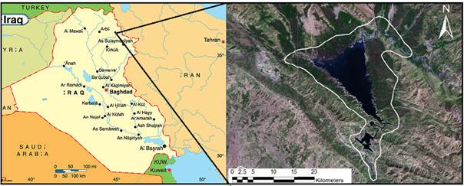

Fig.1: Location of the study area

2 Geological Setting
The study area is located within the High Folded Zone of the Outer Platform of the Arabian Plate [1]. The anticlines are long and narrow with NW – SE trend, some of them show local overturning limbs; usually, the southwestern limb is overturned.
Majority of the anticlines are faulted, some of the faults has extension of few kilometers with off set of few tens and even hundreds of meters, also with NW – SE trend; however, others are at NE – SW trend. The formers are mainly of reverse or thrust type; the northeastern block being the hanging wall, whereas the latters are of normal type; the southeastern block being the down thrown wall; however, some exceptions may occur too.
The study area suffers from the Late Alpine Orogenic; as the last forces that have developed the anticlines, with decreasing the intensity of folding southwestwards. The Neotectonic evidences indicate that the forces are still active, as seen in the tilted Dokan Conglomerates (Pleistocene age) along the southern and southeastern banks of Dokan Reservoir and top of Khalikan Mountain near Kani Otman village.

2.1 Geomorphology
The study are is a mountainous ascending in elevation north and northeast wards; forming rugged topography in some parts with deep canyon like valleys, and a wide and large depression that forms Dokan Reservoir. The most common geomorphological units and forms are: anticlinal ridges, hogbacks and questas, depositional and erosional glacis, alluvial fans, calcrete, flood plain and river terraces.
2.2 Stratigraphy

The exposed formations in the study area are described beside the main Quaternary sediments. Some photos are included too, although some of them are out of the study area, but they are representative for the given formation. The following formations are exposed in the study area; their description and the given short explanation of the basin development and tectonic affect during each period depends mainly on Sissakian and Fouad [2].

2.2.1 Jurassic

During Early Jurassic, the rate of subsidence on the northern margins of the Arabian Plate slowed and relatively uniform marginal marine clastics, evaporites and shallow water lagoonal carbonates were deposited. During Middle – Late Jurassic, the deposition occurred during isolation of the main intra-shelf basin from the Neo-Tethyan Ocean, probably due to renewed rifting along the northeastern margin of the Arabian Plate. Deposition in the basin occurred in a restricted, relatively deep water, environment during Middle Jurassic. The basin became evaporitic during Late Jurassic [Jassim and Goff, 3].
The Jurassic Period, in the study area is represented by six formations. They represent the uppermost part of the Late Permian – Liassic Megasequence (AP6) and the whole Late Toarcian – Early Tithonian (Middle – early Late Jurassic) Megasequence (AP7), and the Late Tithonian representing the lowermost part of Megasequence (AP8), established by [4]. The exposed formations are described hereinafter.

- Sarki Formation (Early Jurassic)
Near Ranya, the formation consists of thinly bedded, light grey dolomitized limestone, with splintery fractures, generally bituminous and fossiliferous [5].
The thickness near is Ranya about 250 m. The age of the Sarki Formation is Liassic, possibly including part-Rhaetic, but regarded as Liassic only, by convention [6]. However, Early Liassic age has been inferred based on the stratigraphic position of the formation between the well-defined underlying Upper Triassic Kurra China Formation and the well-defined overlying Middle Jurassic beds of the Sargelu Formation [3]. Moreover, [7] claimed that the age of the formation may start from Late Triassic?. The Sarki Formation is underlain by Baluti Formation, the contact is conformable and gradational taken at the top of interbedded green and grey shales and dolomitic limestone, and at the base of dark brown massive dolomites, which constitute the lowest feature-forming unit in Sarki [6]. Jassim et al. [8] also recorded conformable contact between the two formations. However, according to Dannington et al. [9] the contact appears to be sharp although conformable.

- Sehkaniyan Formation (Early Jurassic)
Near Ranya the formation consists of massive dark dolomite (Fig.2) with a sugary texture, generally bituminous [10]. In Surdash, it consists of three units, these are: Lower Unit (85 m) consists of brownish grey massive dolomite and dolomitic limestone. Middle Unit (44 m) consists of dark grey, thickly bedded limestone and dolomitic limestone. Upper Unit (55 m) consists of brownish and dark grey dolomitic limestone [11]. The thickness near Ranya ranges from (200 – 250) m, in Surdash 184 m. The age of the Sehkaniyan Formation is Liassic, probably Upper Liassic, by regional correlation [6] and Early Jurassic age claimed by [11]. The Sehkaniyan Formation is underlain by Sarki Formation; the contact is gradational and conformable taken at the base of dark brown massive dolomite unit, 60 m thick, and at the top of splintery, yellow-green shales with limestone [6].

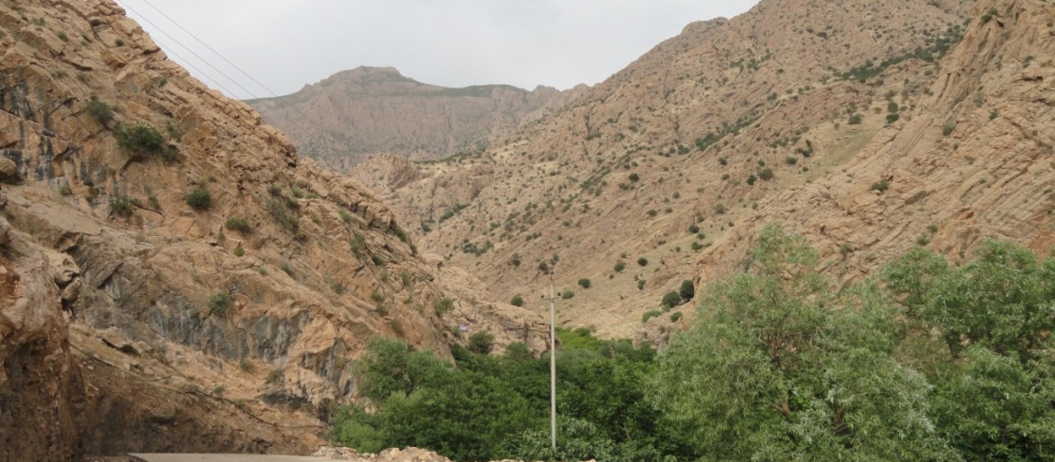

Fig.2: The Sehkaniyan Formation in Surdash anticline

- Sargelu Formation (Middle Jurassic, Bajocian – Bathonian)

Near Ranya, the formation consists of thinly bedded shaley black limestone and shale with black chert and brown dolomitic marl, highly fossiliferous [10]. The thickness near Ranya 70 m and in Surdash is 120 m. The age of the Sargelu Formation is Bathonian at the top, uppermost Liassic at the base [6]. Al-Shwaily et al. [11] claimed Middle Jurassic age (Bajocian – Bathonian) for the formation. The Sargelu Formation is underlain by Sehkaniyan Formation; the contact is gradational and conformable taken at the top of massive bedded dolomitic limestone and below thin-bedded blue cherty brittle and laminated limestone [11].

- Naokelekan Formation (Late Jurassic)
Near Ranya, the formation consists of laminated shaley limestone with mottled grey and brown limestone followed by black carbonaceous shales [10], in Surdash; it consists of black and thinly bedded shaley limestone and bituminous limestone and dolomitic limestone (Fig.3) [11]. The thickness of the Naokelekan Formation near Ranya is 14 m, in Surdash the thickness is 16 m [11]. The age of the Naokelekan Formation is Upper Oxfordian, and possibly Callovian at base [6]. Al-Shwaily et al. [11] claimed Late Jurassic age for the formation. The Naokelekan Formation is underlain by Sargelu Formation; the contact is conformable taken at the top of thinly bedded cherty limestones with Posidonia ornate Quenstedt [6]. Al-Shwaily et al. [11] recorded the same contact between the two formations in Surdash vicinity.

Fig.3: The Naokelekan Formation

- Barsarin Formation (Late Jurassic)
Near Ranya, the formation consists of black and brown bituminous dolomitic shales and thin dolomitic limestone [10]. In Surdash, it consists of dark grey thickly bedded limestone and dolomitic limestone with stromatolitic limestone [11] (Fig.4).

limestone and dolomitic limestone with stromatolitic limestone [11] (Fig.4).
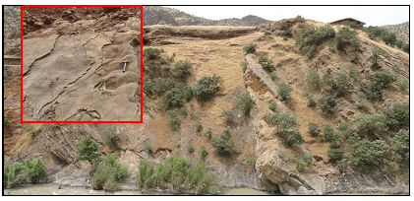
Fig. 4: Barsarin Formation capped by terrace of Rawandooz River,
in the type locality, near Barsarin village (Note the stromatolite (in the inset) as characteristic feature of the formation)

The thickness of the Barsarin Formation is 17 m, near Ranya is 10 m [6], in Surdash 17 m [11]. The age of the Barsarin Formation is not demonstrated. Upper Jurassic,? Kimeridgian, possibly Lower to Middle Kimeridgian, i.e. Lower Tithonian [6]. Al-Shwaily et al. [11] claimed Late Jurassic age for the formation. The Barsarin Formation is underlain by Naokelekan Formation. The contact is apparently gradational and conformable taken at the top of laminated dolomitized, normally bedded, slightly fragmented limestone, with thin whitish layers, and at base of an intraformational breccia, (1.3 – 1.8) m thick with angular blocks of dolomitized limestones, of different weathered appearances, but probably monogenetic [6, 11].

2.2.2 Cretaceous

During Early Cretaceous, the deposition occurred in a large intra-shelf basin contemporaneous with the new phase of ocean floor spreading in the Neo-Tethys. The opening of the Neo-Tethys led to the drifting away of a narrow micro continent; a new passive margin formed along the northeastern margin of the Arabian Plate. This margin was formed by a carbonate ridge along the north facing passive margin of the Neo-Tethys [3]. During the Late Cretaceous, a foreland basin formed around the northern margin of the Arabian Plate [12], which represents, the nowadays area of the High Folded Zone.
The climax of the obduction and closure of the Neo-Tethys occurred during the Late Campanian and Maastrichtian [3]. This contributed to a major sea transgression across whole of the Iraqi territory. The same stress regime in the northeast of the Arabian Plate led to the formation of intraplate extensional and transextensional basins of NW – SE and E – W trend, respectively [3]. These basins were in form of grabbens and were receiving synrift sediments of Late Cretaceous age [13], especially in the extreme western part of the High Folded Zone. According to [14], isolated reef buildup, which grew over a tectonic swell, was developed on the Arabian Plate's active margin during the Late Cretaceous. The unstable tectonic conditions of this period were responsible for variability and complex facies distribution of the buildup.
The Cretaceous Period, in the study area is represented by 9 formations. They represent the Late Tithonian – Early Turonian Megasequence AP8 and majority of the Late Turonian – Danian Megasequence AP9, established by [4]. The exposed formations are described hereinafter:
- Balambo Formation (Early Cretaceous, Valanganian – Turonian)
Near Ranya, the formation consists of thinly bedded, fine grained limestone with globigirinal marly shale, and hardly distinguishable from Qamchuqa and Sarmord formations [10]. In Surdash anticline, the formation consists of two units: Lower Unit consists of 140 m grey, tough, fine crystalline, thickly bedded amoniteferous limestone and dark blue papery shale. Upper Unit consists of 180 m of alternation of limestone and marl (Fig.4) [11].

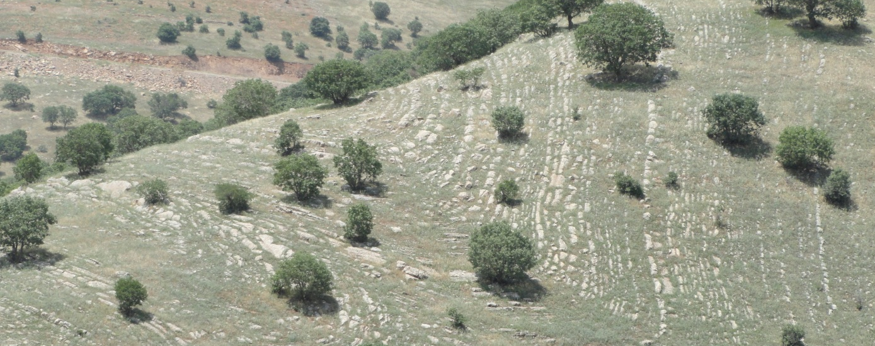

Fig.4: The Balambo Formation showing well bedded and
highly deformed nature.

The thickness of the formation near Ranya is about 500 m [10] and in Surdash anticline 320 m [11]. The age of the formation is Valanganian – Turonian [11]. The Balambo Formation is underlain by the Chia Gara Formation; the contact is based at the bottom of a thick succession of fine grained, thinly bedded limestone of dark blue colour [11].
- Sarmord Formation (Hauterivian – Barremian)
Near Ranya, the formation consists of thinly bedded marly limestone and marl with shaley partings [10] (Fig.5), in Surdash vicinity, it consists of alternation of light grey thickly bedded marly limestone and bluish grey marl [11]. The thickness of the Sarmord Formation near Ranya is about 400 m [6], in Surdash is 450 m [11]. The Sarmord Formation is underlain by the Balambo Formation; the contact is conformable and gradational based on alternation of brownish grey limestone and marl [6].
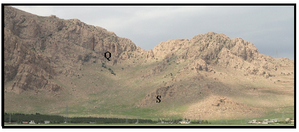

Fig. 5: The Sarmord Formation (S) overlain by the Qamchuqa Formation (Q) east of Ranya, along the eastern bank of Dokan Lake.

- Qamchuqa Formation (Early Aptian – Early Cenomanian)

The Qamchuqa Formation is one of the most wide spread formations in Iraq, it forms the carapace of the main mountains (Fig.6); in Kurdistan Region. In Surdash vicinity, the formation consists of three units. Lower Unit (162 m) consists of dark grey, massive limestone. Middle Unit (139 m) consists of alternation of grey very coarse crystalline dolomitic limestone and yellowish green marl. Upper Unit (384 m) consists of grey massive limestone and dolomitic limestone. The thickness of the formation in Surdash is 647 m. The age of the formation is Early Cretaceous age (Early Aptian – Early Cenomanian) [11]. The Qamchuqa Formation is underlain by the Sarmord Formation; the contact is conformable and gradational taken at the base of the first massive limestone [11].

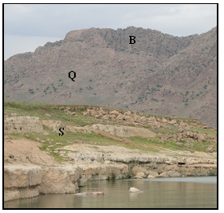

Fig.6: Along Dokan Lake near Ranya, (S) Sarmord Formation,
(Q) Qamchuqa Formation and (B) Bekhme Formation.

- Dokan Formation (Late Campanian – Late Maastrichtian)

In Dokan vicinity, the Dokan Formation consists of "light grey or white-weathering oligostiginal limestones. Locally ruby, with glauconitic coatings of constituent pebble-like masses, locally worm-riddled" [6]. The thickness of the formation is 3.65 m; however, it increases up to 120 m westwards. The age of the formation in the type locality is Cenomanian, possibly Upper, but not uppermost, or Middle [6]. The Dokan Formation is underlain by Qamchuqa Formation; the contact is an erosional unconformity [6].

- Gulneri Formation (Late Campanian – Late Maastrichtian)
In the type locality, the Gulneri Formation consists of "Black, bituminous, finely laminated calcareous shale, with some glauconite and cellophane in the lower part" [6]. According to Taha and Karim [15] the Gulneri Formation consists of marl and marly limestone, which are changed to ball and pillow-like structure by lithostatic pressure during burial, with minor shale beds, which originally were marl and are changed to shale-like rocks by pressure and solution, and impregnated by bitumen. In the type locality, the thickness of the Gulneri Formation is (1.1 – 1.2) m; however, a thickness up to 5 m is recorded eastwards. The age of the Gulneri Formation is Early Turonian [6]. The Gulneri Formation is underlain by the Dokan Formation; the contact is an erosional unconformity [6].

- Kometan Formation (Turonian – Early Campanian)
Near Ranya, the formation consists of grey; when fresh and white when weathered, thinly well bedded, chalky globigerinal limestone [10]. In Surdash anticlines, it consists of well bedded, white, hard globigerinal – oligostiginal limestone (Fig.7). The thickness of the formation near Ranya is 500 m [10], in Surdash ranges from (150 – 175) m [11]. The age of the formation, according to planktonic fauna and nano-fossils is Coniacian – Santonian. The Lower Turonian age is restricted to the High Folded Zone. Aqrawi et al. [4] claimed Upper Turonian – Lower Campanian age for the formation, whereas Karim et al. (2012) claimed Turonian to Late Campanian age. Moreover, Al-Shwaily et al. [11] claimed Late Cretaceous age. The formation is underlain by the Balambo Formation, the contact is unconformable, faunal break and intense glauconitization at the base of the formation indicate depositional hiatus, with probable erosion [6]. The Kometan Formation passes laterally into the uppermost part of Balambo Formation [10].

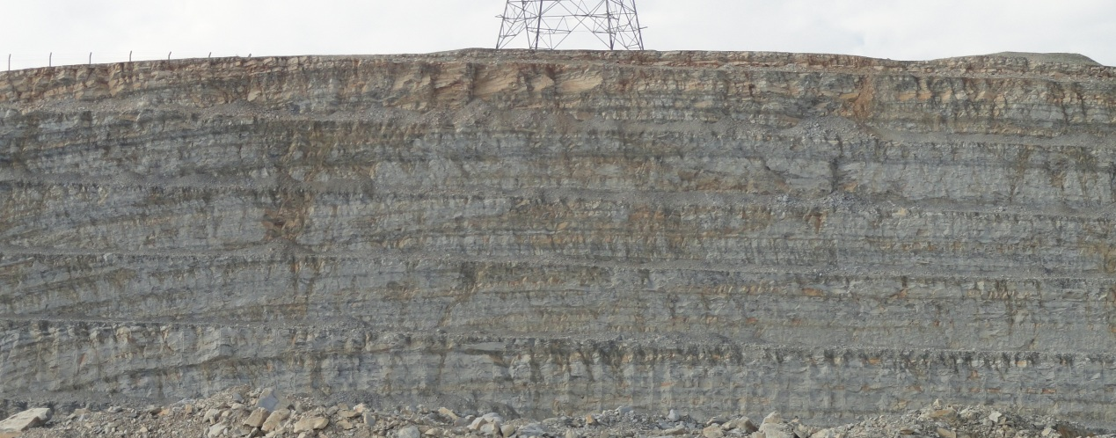

Fig.7: Thinly well bedded limestone of the Kometan Formation,
near Dokan Reservoir

- Aqra – Bekhme Formation (Late Campanian – Late Maastrichtian)
The Aqra – Bekhme Formation is one of the most wide spread formations in the Iraqi Kurdistan Region, especially in the middle and western parts of the High Folded Zone and forms the carapace of the main mountains.
In and Ranya anticline, the formation consists mainly of limestones and dolostones. The limestones are light grey, brown, hard to very hard, well bedded to massive, locally dolomitic, bituminous, fossiliferous, reefal, recrystallized, detrital, and organic [10]. Some chert and iron concretions of 5 cm in size occur too, whereas, the dolostones are brown, very fine crystalline with silty texture [16]. The thickness of the formation near Ranya is about 100 m [10]. The age of the formation is Upper Santonian [6], [17] claimed Upper Campanian – Lower Maastrichtian age. The formation in Ranya anticline is underlain by Qamchuqa Formation unconformably (Fig.6). The contact is based on the bottom of the first thick limestone or dolostone bed, which overlain a soft succession [18 Youkhanna and Sissakian, 1986]. Locally, a basal conglomerate (1.5 – 2 m) was observed between Qamchuqa and Aqra – Bekhme formations, this horizon may pass into limestones of the latter formation [16].

- Shiranish Formation (Late Campanian – Late Maastrichtian)
The Shiranish Formation is one of the most wide spread formations in Iraq, it fills the trough of the main synclines; between the anticlines in the Iraqi Kurdistan Region. Near Ranya, the formation consists of shaley marl and marl, with characteristic blue colour; it passes gradationally to Kometan Formation [10]. In Khalikan (Fig.8) and Surdash anticlines, the formation consists of two members: Lower Member (55 m) composed of alternation of marly limestone and marl. The Upper Member (150 m) composed of bluish grey, thinly to thickly bedded, fine crystalline, conchoidally fractured marl [11]. The thicknesses of the formation near Ranya is about 300 m [10], in Surdash is 250 m [11]. The age of the formation is accepted as Upper Campanian – early Upper Maastrichtian [6, 11]. The formation is underlain by the Bekhme Formation; the contact is based on the base of recrystallized thinly bedded globigerinal limestone [6]. In Surdash anticline and eastwards, Kometan Formation always underlies the Shiranish Formation; the contact is unconformable, but no any indication can be observed in the contact to prove the unconformity.

Fig.8: The Siranish Formation, at the bag ground is massive beds of the
Qamchuqa Formation (Along Sulaimaniya – Dokan road)

- Tanjero Formation (Late Campanian – Late Maastrichtian)
The Tanjero Formation is one of the wide spread formations in Iraq, it fills the trough of the main synclines between the anticlines in the Iraqi Kurdistan Region. Near Ranya, the formation consists of grey marly and silty shales, with marl and greywackes and occasional beds of conglomerate [10]. In Surdash anticline, the formation is divided into two members: Lower Member (300 m) consists of alternation of sandstone, mudstone, shale, conglomerate, claystone and sandy limestone. Upper Member (659 m) consists of alternation of sandstone, mudstone and silty claystone, dominated with mudstone and silty claystone (Fig.9) [11]. The thickness of the formation near Ranya is about 1000 m, in Surdash anticline, it is about 1000 m [11]. The age of the formation is Upper Campanian – Maastrichtian. Kassab [17] claimed Upper Campanian – Uppermost Maastrichtian age for the formation. Al-Shwaily et al. [11] claimed Late Campanian – Late Maastrichtian age for the formation. The formation is underlain by the Shiranish Formation; the contact is gradational and conformable placed at the lowest occurrence of silt grade clastics, which corresponds approximately to change of weathering colour from blue (Shiranish Formation) below to olive green (Tanjero Formation) above [6 and 11].

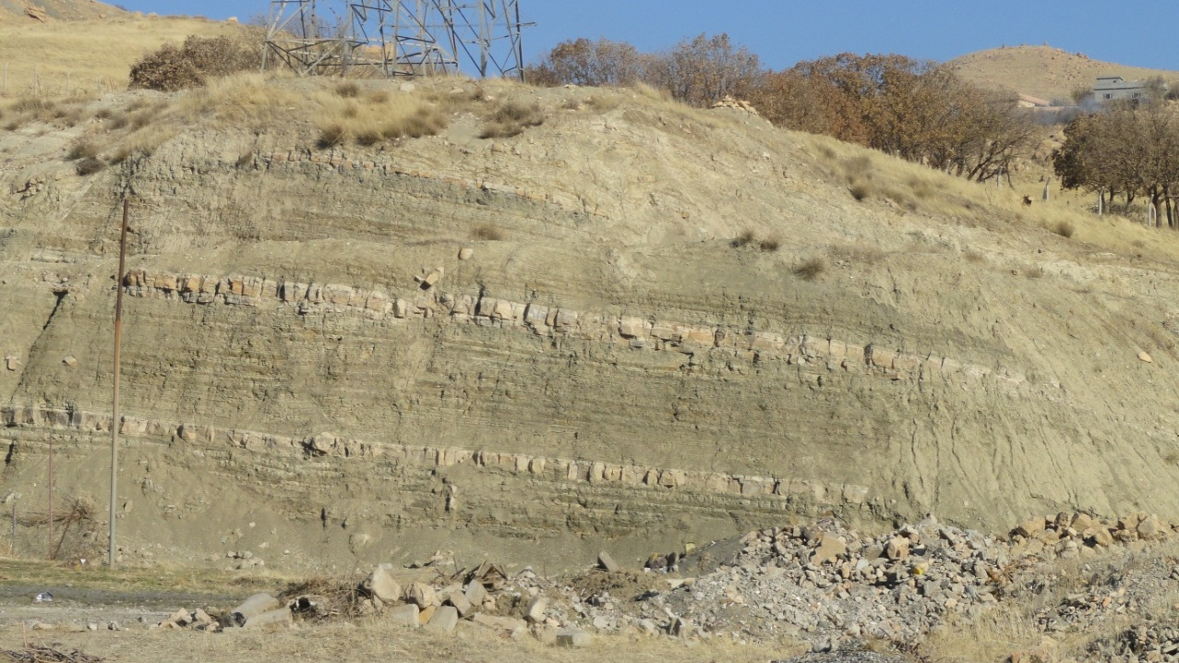

Fig.9: Thin limestone horizons within the Tanjero Formation in Surdash anticline

2.2.3 Cenozoic

The Cenozoic formations are rarely exposed in the study area. The exposed formations in the study area of Cenozoic Era belong to Paleocene – Early Eocene, only.
2.2.3.1 Paleocene – Early Eocene
During the Middle Paleocene, towards southwest of the longitudinal developed basin, a foredeep (within the foreland) was developed within the present area of the High Folded Zone, which was progressively migrating towards southwest including the area of the Low Folded Zone [3]. Mainly flysch sediments of the Kolosh Formation filled the basin, with reef bodies, which were deposited in shallow areas, representing Sinjar and Khurmala formations.

The Paleocene – Eocene Sequence, within the Cenozoic Era was deposited during a period of renewed subduction and volcanic activity associated with final closure of the Neo-Tethys. This led to uplift along the northeastern margin of the Arabian Plate with formation of ridges and basins, generally of NW – SE trend in the northern and central parts of Iraq [3]. The Paleocene – Early Eocene Sequence is represented by two formations. They represent the lower half part of the Megasequence AP10 [4], the two formations are described hereinafter.

- Kolosh Formation (Late Paleocene – Early Eocene)
The formation consists of black and very dark green shales, sandstones, claystones and very thin silicified marly limestone, with yellowish white color (Figs. 10 and 11) [11]. The thicknesses of the formation ranges from 45 to 100 m [11]. The age of the formation is Paleocene – Lower Eocene [6,17]. The formation is underlain by the Tanjero Formation; the contact is unconformable marked by a total faunal change without transitional elements [6] Al-Shaibani et al. [19] described the Cretaceous/ Tertiary contact in detail from Dokan Area. They found deeply weathered conglomerate layer with thickness of one meter (underlain by 8 m thick pebbly sandstone) indicating the contact. According to biostratigraphic study, the contact represents a gap between Middle Maastrichtian and Middle Thanetian.
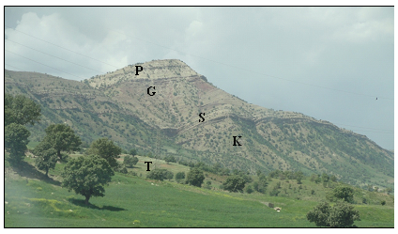

Fig. 10: Exposed sequence south of Dokan Dam.
Formations: T= Tanjero, K= Kolosh, S= Sinjar, G= Gercus and P= Pila Spi

- Sinjar Formation (Late Paleocene – Early Eocene)
The Sinjar Formation consists of of pale grey massive and fine crystalline limestone (Figs. 10 and 11). The thickness of the formation ranges from (15 – 65) m, decreasing eastwards, but increases westwards to more than 100 m, southwest of Pera Magroon. The age of the formation is Paleocene – Early Eocene [6 and 11]. The Sinjar Formation is underlain conformably by Kolosh Formation; the contact is sharp and clear, based on the bottom of the first limestone bed [11].

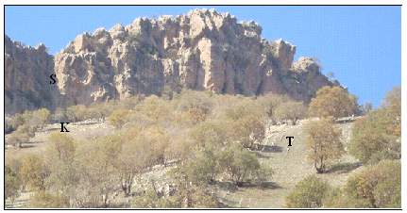

Fig.11: The Sinjar Formation (S) underlain by the Kolosh Formation (K), and
The Tanjero Formation (T).

2.2.3.2 Middle – Late Eocene

The Neo-Tethys was narrowed and closed during the final phase of subduction. A foredeep basin (within the foreland) was developed in the present area of the High Folded Zone; this foredeep was separated from the basin to the southwest by a belt of nummulitic limestone shoals of Avanah Formation, which separated between the High Folded and Low Folded Zones [3].
The Middle – Late Eocene Sequence represents the upper half part of the Middle Paleocene – Eocene Megasequence AP10, established by [4]; it includes two formations, and they are described hereinafter.

- Gercus Formation (Early – Middle Eocene)
The Gercus Formation consists of claystone, sandstone, and siltstone all red in color (Fig. 10), with very rare conglomerate lenses [6, 11 and 17]. The thickness of the formation ranges from 35 – 150) m. The age of the formation is probably Middle Lower – Middle Eocene [20].
The Gercus Formation is underlain by the Sinjar Formation or Kolosh Formation. In the first case the contact is sharp due to main difference in lithology, whereas in the latter case the color change marks the contact, which is unconformable [20].

- Pila Spi Formation (Middle – Late Eocene)
The Pila Spi Formation consists of well bedded dolomite and dolomitic limestone (Fig.10), in the lower part; some yellowish green marl may occur [20]. The thickness of the formation ranges from (35 – 110) m [20]. The age of the formation is probably Middle and/ or Upper Eocene [6]. However, the age is considered as Middle – Upper Eocene [2, 3, 16 and 20]. The formation is underlain by the Gercus Formation, the contact is sharp and unconformable marked by lithological change and presence of conglomerate; locally [2, 3 and 20].

2.2.4 Quaternary Sediments

The Quaternary sediments cover restircted parts of the study area. They include different types of Pleistocene and Holocene sediments, which are not well studied, described, mapped and dated. The presented Quaternary sediments include 10 types. They represent the uppermost part of the Late Eocene – Recent Megasequence (AP11), established by [4]. The ten types of the sediments are reviewed, hereinafter, briefly.

- Terraces (Pleistocene)
The Lesser Zab River has deposited many terrace levels, which have different extensions, thicknesses and heights from their riverbeds (Fig.12). Large streams and valleys have also developed their own terrace systems, which have almost the same characteristics of the terraces of the aforementioned rivers. Usually, (2 – 4) levels were reported from different localities. The composition of the terraces is almost uniform; the pebbles are composed of silicates and limestones with subordinate igneous and metamorphic rocks. The size of the pebbles varies between (1 – 25) cm, but exceptionally may reach 50 cm and more. The pebbles are sub rounded, rounded and well rounded, mainly of spheroidal, and disk shaped, some are rode shaped. The cementing materials are calcareous, sandy and gypsiferous. Usually, they show cross bedding, graded bedding and channeling sedimentary structures.

- Dokan Conglomerate (Pleistocene)
This is very special development of conglomerates along the southern and eastern margins of Dokan Lake and the top of Khalikan Mountain (Fig. 13). Karim and Taha [21] called it as "Dokan Conglomerate", Sissakian and Fouad [2] adopted this term. The Dokan Conglomerate is indurate and weathering resistant, mostly consists of blocks, boulders and gravels derived from Qamchuqa Formation, with some clasts from Kometan Formation. The conglomerate is folded, in some places, the dip is more than 30 degrees, and angularly overlies the Kolosh, Tanjero, Shiranish, and Kometan formations with more than 20 degrees difference in the dip. In other areas, the conglomerate shows, more or less equal dip with the aforementioned formations. In Khalikan anticline it is almost horizontally lying, with a thickness of about 300 m [21].

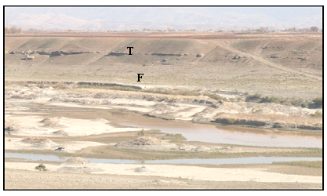
Fig.12: River terraces (T) and flood plain (F) sediments
of the Lower Zab River near Ranya

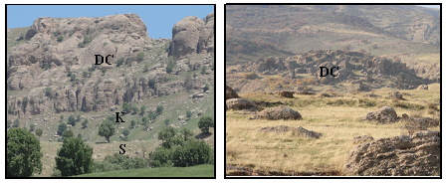
Fig. 13: Dokan Conglomerate (DC) overlying the Kometan (K) and Shiranish (S) formations. Left) along Dokan – Bustana road (Kani Otman village), Right) NE of Dokan Reservoir

- Alluvial Fan Sediments (Pleistocene – Holocene)
Alluvial fan sediments are well developed within the study area, like in Ranya and Qalat Diza, around Dokan Lake (Fig.14). They have different coverage areas, ranging from (1 – 15) Km². Those, which are surrounding Dokan Lake, consist mainly of reddish brown clayey soil, usually occupied as agricultural lands.

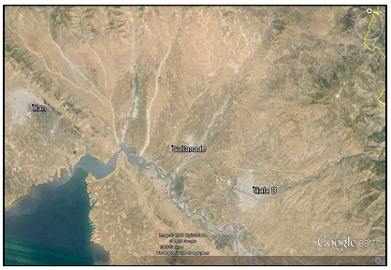

Fig. 14: Google Earth image showing alluvial fans complex; near
Qalat Diza and Ranya, beside the alluvial plain of the Lesser Zab River.

- Colluvial Sediments (Pleistocene – Holocene)
Colluvial sediments are developed in the study area, especially in areas where soft rocks are exposed. However, along the main ridges of hard rocks, continuous belt of colluvial sediments are developed too (Fig. 15). The size and constituent of the sediments depend on the source rocks, usually formed of carbonates and silicates, which are cemented by clayey and carbonate materials. The thickness of the sediments ranges from (1 – 5) m, locally they are weathered, but, the preserved parts form flat areas capping folded strata in form of plateaus.

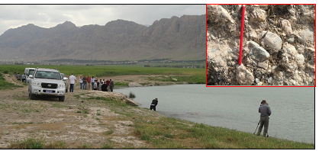

Fig. 15: Colluvial sediments along the NE limb of Ranya anticline, along Dokan Reservoir. The caption shows details of the sediments

- Flood Plain Sediments (Holocene)
Flood plain sediments are well developed alongside the Lesser River (Fig.16) and large streams and valleys. The thickness and width of the plains are highly variable, but usually the thickness ranges between (< 1 – 3) m, whereas the width ranges between (< 1 – 3) Km, exceptionally may reach more, locally, more than one level is developed. The composition of the sediments is almost similar, fine sand and clay are dominant, with subordinate clay and very fine pebbles.

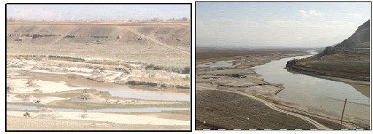

Fig. 16: Flood plain and terraces of the Lesser Zab River, NE of Ranya.

- Valley Fill Sediments (Holocene)
The valley fill sediments in main streams and valleys have thickness ranges from (< 1 – 3) m, but may exceed more than 10 m. The main composition of the pebbles is carbonates and silicates with subordinate igneous and metamorphic rocks, which increases north and northeastwards. The pebbles are rounded to subrounded, with average size of (1 – 20) cm, but may reach to more than 100 cm, spheroidal and rode shaped, with rare disk shape. The finer size clastics; sand and silt form minor constituents, especially in streams and large valleys, whereas the clay fraction is very rare, if not totally absent.

- Residual Soil (Holocene)
Residual soil covers small parts of the study area, usually in main plains. The soil is brown to reddish brown, locally black in color, calcareous and clayey, with small rock fragments of limestone, which increase in size and abundance depth wards. The thickness is highly variable it ranges between (< 0.5 – 5) m.

3 Dokan Dam and Reservoir

The Dokan Dam is a multi-purpose concrete single arch dam (Fig.17) in Sulaimaniyah Governorate, NE Iraq. It impounds the Little Zab River, thereby creating Lake Dokan. The Dokan Dam was built between 1954 and 1959, whereas its power station became fully operational in 1979. The dam is 360 m long and 116.5 m high, width at the base and crest is 34.3 m and 6.2 m, respectively with volume of 370 000 m³. The total capacity of the reservoir is 6.970 x 10 ⁶ m ³, the active capacity is 6.100 x 10 ⁶ m ³, whereas the inactive capacity is 790 x 10 ⁶ m ³, with surface area of 270 Km² at elevation of 511 m (a.s.l.). The hydroelectric power station has a maximum capacity of 400 MW.

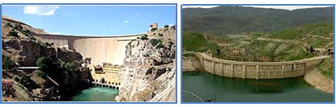

Fig.17: Dokan Dam, Left) Downstream side,
Right) Upstream side of Dukan Dam.
The reservoir behind Dokan dam represents a natural depression (Fig.18), whereas the gorge (Figs.17 and 19) within Khalikan anticline through which the Lesser Zab River crosses the anticline was selected to construct the dam.

The depression that is utilized as Dokan reservoir is one of the unique large depressions in the mountainous areas of the Kurdistan Region. Development of such a large and wide depression (Fig.18) in a mountainous area is not a normal topographic form; therefore, a reason or more should had contributed in the development of the depression in which the Lesser Zab River was running before the whole depression was engulfed and inundated by the Dokan reservoir.

3.1 Geology of the Dam Site and Reservoir
The dam is located in Khalikan anticline; its axis is almost parallel to the axis of the anticline; as it is clear from the horizontal bedding of the exposed beds (Fig.19). The foundations and the lower part of the abutments of the dam are imbedded in the massive and very hard limestone and dolomite beds of the Qamchuqa Formation, whereas the upper part is imbedded in the well thinly bedded marly limestone beds of the Kometan Formation [2, 23] (Fig.19).

Dokan reservoir is surrounded almost from all sides by alluvial fans [2, 23] (Fig.20). This is a good indication for the presence of the depression with steep banks, especially the southern side.
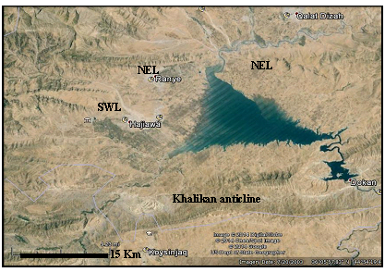

Fig.18: Google Earth image of the depression that is utilized to form Dokan reservoir; (the image is facing NW).

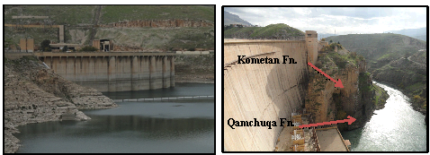

Fig.19: Dokan dam, Left) Upstream, Right) Downstream.
Note the horizontal bedding and the exposures of the Qamchuqa and Kometan formations

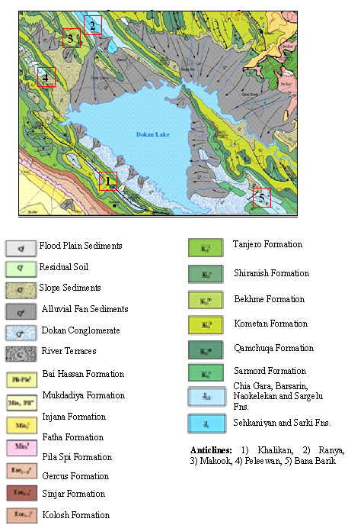

Fig.20: Geological map of the surrounding area of Dokan Reservoir [23]. Note the well-developed alluvial fans surrounding the reservoir.

The Dokan Reservoir is limited between Khalikan and Ranya anticlines; from south and north, respectively. Both have NW – SE trend [2, 23] (Fig.20). Moreover, the Makook and Peleewan anticlines plunge towards southeast along the western bank of the reservoir, and Bana Barik anticline plunges towards northwest in the eastern bank of the reservoir (Fig.20). In the cores of the mentioned anticlines, Upper Jurassic formations are exposed and locally Lower Jurassic too. The majority of the Upper Jurassic formations include soft rocks; such as shale, marl and marly limestone. These rocks are overlain by Chia Gara and Sarmord Formations, both include soft marl beds [23, 24]; usually forming slopes.

3.2 Morphology of Dokan Reservoir
Dokan Reservoir has triangle shape; the base being in the northwest, while the head is towards southeast; with almost two parallel limbs (Figs. 19 and 20); the surface area is 270 Km² at elevation of 511 m (a.s.l.). Steep ridges surround the outer limits of the reservoir; all formed by very hard carbonate rocks of Qamchuqa, Kometan and Bekhme formations (Fig.20) forming the northeastern limbs of Khalikan anticline in the south and northeastern limb of Ranya anticline in the north. However, the inner limits are covered by alluvial fan sediments that flow out of the mentioned ridges; toward the reservoir (Figs. 18 and 20).

4 Discussion

The most interesting geological aspects in Dokan vicinity are the developed depression and the Dokan Conglomerate. The former will be discussed in details, whereas the latter in brief since it is previously discussed in details [21, 22].

Dokan Conglomerate
This is a new lithostratigraphic unit of Pliocene? – Pleistocene age developed only along the southern and eastern banks of Dokan Reservoir. The conglomerate consists mainly of clasts derived from the very hard limestones and dolomites of the Qamchuqa Formation and partly of the Kometan Formation; angular in shape (Fig.13 Right); the thickness is up to 300 m [21]. The conglomerate covers Tanjero, Shiranish, Kometan and Qamchuqa formations unconformably, along the top of Khalikan anticline, the conglomerate beds overly the mentioned formations almost horizontally (Fig.13 Left). Along the the northeastern limb of Khalikan anticline, the conglomerate beds are tilted in parallel strike to Khalikan anticline but with different dip angle, overlying Shiranish Formation (Fig.20).

Dokan Reservoir
Narrow depressions representing synclines are common between two anticlines in the High Folded Zone [1, 2] in which the study area is located, whereas wide depressions are extremely rare not only in the study area; but in far surroundings too. The developed depression is tectonically controlled (Fig.21); this is attributed to the following aspects:

ـ Ranya Anticline: The northeastern limb of the anticline is truncated by a fault (Fault 1), most probably normal fault with NE – SW trend; causing steep change in the strike of the limb (Fig. 22 C). The extension of the same fault southwest wards has developed the straight western bank of the depression (Fig.21). Another fault (Ranya – Chwarqurna Fault) with the same characters of the Fault 1 has truncated the southwestern limb of Ranya anticline causing its subsidence and disappearance on surface (Fig.22 B).

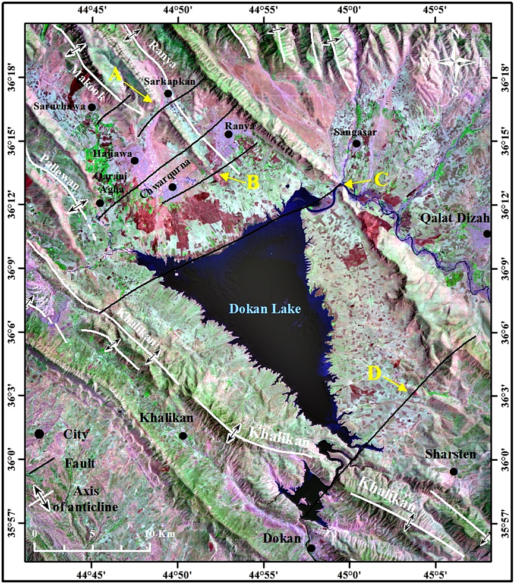
Fig.21: Landsat 5 TM image (R:G:B 742) of Dokan Reservoir showing the supposed normal faults. For the details mentioned in the text, refer to the Fig. 22.

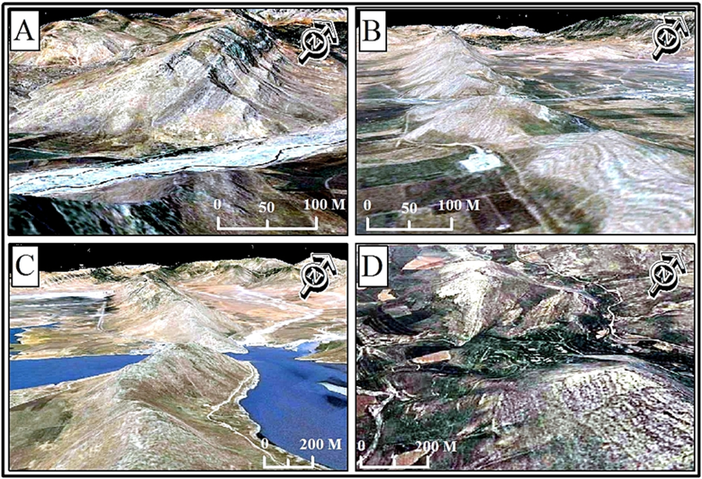

Fig. 22: Landsat 5 TM image (R:G:B 742) of Dokan Reservoir showing the details of the effects of the supposed faults.

The subsidence of the fault is also indicated by the change of the gradient that has caused the forming of another stage of the alluvial fan near Chwarqurna (Fig.21). Another fault (Ranya – Qarani Agha Fault) with the same extensions and type occurs just west of the Ranya – Chwarqurna Fault (Fig.21) it has truncated the southwestern limb of Ranya anticline forming a wide gap in the ridge (Fig.22 B). Moreover, it extension has truncated the northeastern limb of Makook anticline near Qarani Agha village (Fig.21). Another fault, called Sarkapkan Fault (Fig.21) has caused a large gap in the southwestern limb of Ranya anticline (Fig.22 A).

ـ Makook Anticline: Small part of the anticline is within the study area represented by the southeastern plunge, which exhibits a deeply incised straight valley with NE – SW trend representing another normal fault and it might had caused the disturbance of the plunge area near Saruchawa town (Fig.21).

ـ Paleewan Anticline: The southeastern plunge of the anticline is also truncated by Ranya – Hajiawa Fault (Fig.21) that has also subsided the eastern part, consequently contributed in development of the depression.

ـ Southeastern Plunge of Ranya Anticline: The southeastern plunge of Ranya anticline is truncated by a normal fault of NE – SW trend (Fig.21 and Fig.22 D), the western block being the down thrown side; thus forming a large graben that is occupied by the depression.

ـ Jurassic Soft Rocks: The exposures of soft rocks of Jurassic formations in the core of Ranya, Makook, Peleewan and Bana Barik anticlines and the overlying Chia Gara and Sarmord formations, both include soft rocks, all have contributed in development of the depression by the high grade of weathering and active erosion that had disintegrated and transported the rock fragments, consequently contributing in development of the depression.

The presence of the aforementioned five normal faults in form of step faults west of the reservoir and another fault east of the reservoir (Fig.21) that had caused subsidence (downthrown) of the western block, all those faults form a graben and is good evidence for development of the depression due to successive normal faults that have contributed in subsiding of their their downthrown blocks to form the depression, besides the presence of soft Jurassic rocks in the core of Ranya anticline that had accelerated of their weathering and erosion of large quantities of the rocks along the limbs of Ranya, Makook and Paleewan anticlines. The high rate of erosion of the soft rocks is still an active phenomenon as confirmed with the active large alluvial fans that occur in the western side of Dokan Reservoir (Fig.21).

5 Conclusions
Apart from the stratigraphic and tectonic situations of the study area, the following can be concluded from the current study:
- The Dokan Dam is planned to utilize the wide and large depression that occurs behind the dam’s location.
- The developed depression is not a normal one, since no such wide depression occurs not only in the nearby area, but the entire northern and northeastern parts of Iraq.
- The depression is developed due the a set of normal step faults with NE – SW trend; the downthrown block being the eastern blocks located west of the reservoir, whereas on the eastern part of the reservoir there is one fault with the same characters, but with the downthrown block being the western one.
- Many evidences occur for the occurrence of the mentioned faults; the most obvious indication is the truncation of many ridges, which form limbs of Ranya, Makook and Paleewan anticlines.
- Another indication for the occurrence of the mentioned faults is the development of wide gaps within the limbs of the anticlines representing weakness zones along the mentioned faults.
- Other indication for the occurrence of the mentioned faults is the change in the stages of the alluvial fans along the fault lines due to change in the gradient, others have initiated from the locations of the intersection of the faults with the streams.
- The change of the courses of some streams in a right angle direction; parallel and/ or coincide with the faults lines is another indication for the occurrences of the mentioned faults.
- The soft rocks within Jurassic formation that are exposed in the cores of Ranya, Makook and Paleewan anticlines have contributed in development of the depression, because they are easily weathered and eroded, as compared to very hard rocks of Qamchuqa and Bekhme formations.

REFERENCES
[1] Fouad, S.F., 2012. Tectonic Map of Iraq, scale 1: 1000000, 3rd edition. Iraq Geological Survey Publications (GEOSURV), Baghdad, Iraq.
[2] Sissakian, V.K. and Fouad, S.F., 2012. Geological Map of Iraq, scale 1: 1000000, 4th edition. Iraq Geological Survey Publications (GEOSURV), Baghdad, Iraq.
[3] Jassim, S.Z. and Goff, J.C., 2006. Geology of Iraq. Dolin, Prague and Moravian Museum, Brno.
[4] Sharland, P.R., Archer, R., Casey, D.M., Dvis, R.B., Hall, S., Heward, A., Horbury, A. and Simmons, M.D., 2001. Arabian Plate Sequence Stratigraphy. GeoArabia, Special Publication, No.2. Gulf Pertolink, Bahrain, 389pp.
[5] Bolton, C.M.G., 1954a. Geological Map of Kurdistan Series, scale 1:100 000, sheet K4, Ranya. Iraq Geological Survey Library report No. 276.
[6] Bellen, R.C. van, Dunnington, H.V., Wetzel, R., and Morton, D., 1959. Lexique Stratigraphic International. Asie, Fasc. 10a, Iraq, Paris.
[7] Aqrawi, A.A.M., Goff, J.C., Horbury, A.D. and Sadooni, F.N., 2010. The Petroleum Geology of Iraq. Scientific Press Ltd., 424pp.
[8] Jassim, S.Z., Karim, S.A., Basi, M.A., Al-Mubarak, M. and Munir, J., 1984. Final report on the regional geological survey of Iraq, Vol. 3, Stratigraphy. Iraq Geological Survey Library report No. 1447.
[9] Dunnington, H.V., Wetzel, R. and Morton, D.M., 1959. Mesozoic and Paleozoic: In: R.C., Bellen, van, H.V., Dunnington, R., Wetzel and D., Morton, (Eds.) 1959. Lexique Stratigraphic International. Asie, Fasc. 10a, Iraq, Paris.
[10] Bolton, C.M.G., 1954b. Geological Map of Kurdistan Series, scale 1:100 000, sheet K5, Chwarta. Iraq Geological Survey Library report No. 277.
[11] Al-Shwialy, A.Kh., Al-Mosawi, H.A., Al-Saffi, I.K., Bashir, W.Ph., Ibrahim, A.A., Al-Jubouri, B.S., Al-Kubaisi, K.N., Mahmood, A.A. and Al-Shawi, S.A., 2011. Semi detailed geological mapping of Sulaimaniyah – Surdash area. Iraq Geological Survey Library report No. 3340.
[12] Al-Qayim, B., Omer, A. and Koyi, H., 2012. Tectonostratigraphic overview of the Zagros Suture Zone, Kurdistan Region, Northeast Iraq. GeoArabia, Vol.7, No.4, p. 109 – 156.
[13] Fouad, S.F. and Nasir, W.A.A., 2009. Tectonic and structural evolution of Al-Jazira Area. Iraqi Bulletin of Geology and Mining, Special Issue No.3, p. 33 – 48.
[14] Al-Qayim, B.A. and Saadallah, A., 1994. Sedimentary facies and evolution of an active margin of building up Aqra – Bekhme Formation. Iraqi Geological Journal, Vol. 27, No.1, p. 1 – 28.
[15] Taha, Z.A. and Karim, K.H., 2009. New ideas about Gulneri Formation (Early Turonian) in Dokan area, Kurdistan Region, NE Iraq. Iraqi Bulletin of Geology and Mining, Vol.5, No.2, p. 29 – 39.
[16] Sissakian, V.K. and Youkhanna, R.Y., 1979. Report on the regional geological mapping of Erbil – Shaqlawa – Koi Sanjaq – Raidar Area. Iraq Geological Survey Library report No. 975.
[17] Kassab, I.I.M., 1972. Micropaleontology of the Upper Cretaceous – Lower Tertiary of North Iraq. Unpub. Ph.D. Thesis, University of London.
[18] Youkhanna, R.Y. and Sissakian, V.K., 1986. Anew lithological unit within Qamchuqa Formation, Shaqlawa area. Journal of Iraqi Geological Society, Vol. 19, No.1.
[19] Al-Shaibani, Sh., Al-Qayim, B.A. and Salman, L., 1986. Stratigraphic analysis of Cretaceous / Tertiary contact, Dokan Area, North Iraq. Journal of Iraqi Geol. Society, Vol.19, No.2, p. 101 – 110.
[20] Sissakian, V.K. and Al-Jiburi, B. M., 2014. Stratigraphy. In: Geology of the High Folded Zone. Iraqi Bulletin of Geology and Mining, Special Issue No.6, p. 73 – 161.
[21] Karim, K.H. and Taha, Z.A., 2012. The origin of Conglomeratic Limestone "Dokan Conglomerate" in Dokan Area, Kurdistan Region, NE Iraq. Iraqi Bulletin of Geology and Mining, Vol.8, No.3, p. 15 – 24.
[22] Sissakian, V.K., Al-Musawi, H.A, Al-Ansari, N. and Knootson, S., 2016. The origin and genesis of the Dokan Conglomerate, NW of Sulaimaniyah, NE Iraq. Earth Sciences and Geotechnical Engineering (in press).
[23] Sissakian, V.K. and Fouad, S.F., 2014. Geological Map of Erbil and Mahabad Quadrangles, scale 1: 250000, 2nd edition. Iraq Geological Survey Publications (GEOSURV), Baghdad, Iraq.
[24] Sissakian, V.K. and Saeed, Z.B., 2012. Lithological Map of Iraq, Compiled using GIS Techniques. Iraqi Bulletin of Geology and Mining, Vol. 8, No.3, p. 1 – 13.

Private Consultant, Erbil, Iraq. e-mail: varoujan49@yahoo.com
Iraq Geological Survey; Baghdad.
Lulea University of Technology, Lulea, Sweden. e-mail: nadhir.alansari@ltu.se, Sven.Knutsson@ltu.se Article Info: Received : January 10, 2011. Published online : July 17, 2012

