The Tectonic and Structural Classification of the Western Part of the Zagros Fold and Thrust Belt, North Iraq: Review and Discussion

Maher T. Zainy¹, Nadhir Al-Ansari¹, Tobias E. Bauer¹, Maria Ask¹

Abstract
The Zagros fold and thrust belt represents a tectonically significant area, and one of the richest areas in oil and gas reservoirs in the world. The Zagros fold and thrust belt is the deformational product of the Cretaceous-present day convergence of the Arabian and Iranian (Eurasian) plates (subduction and collision). The belt extends more than 2000 km from southern Turkey through the north and northeastern Iraq to the Strait of Hormuz in southwestern Iran.
The Zagros fold and thrust belt is divided into two parts which are; Western part within Iraqi region and Eastern part within Iranian region. The western part of the Zagros fold and thrust belt has been traditionally subdivided into several structural zones that are generally striking parallel to the plate boundary. This is characterized by exposure of Late Ordovician to Pliocene - Pliestocene formations with different types of Quaternary Sediments.
This research will concentrate on Western part of Zagros fold and thrust belt and the styles of structural classifications, which will aid to clarify and better understand the tectonic and structural history and evolution of the region. We have considered the last version of structural classification as the most relevant one to the reality, especially within outer platform (Unstable shelf). Where it divides the region into four structural zones, which are: Low Folded zone, High Folded Zone, Imbricate Zone, and Zagros Suture Zone and these zones were further divided to several subzones. This classification is based on the structural style and intensity of deformation, stratigraphy, mechanicalstratigraphy and tectono-stratigraphy of the deformed sequences, Age of deformation, surface physiography and morphology. The data used in the classification is more reliable, up to date and relevant.

Keywords: Tectonic, Classification, Western Zagros Belt, North Iraq

1 Introduction
During the end of the Proterozoic and beginning of the Phanerozoic (early Paleozoic), the Arabian and several other continental micro plates including Turkey, central Iran, Afghanistan, India and other smaller fragments collectively formed part of the Paleozoic northern margin of the Gondwana supercontinent which bordered the southern shore of the Paleo-Tethys Ocean[1] (Fig.1).

¹ Luleå University of Technology, Lulea, Sweden. E-mail: maher.zainy@ltu.se, nadhir.alansari@ltu.se
,tobias.bauer@ltu.se, maria.ask@ltu.se
[2, 3, and 4] considered the end of the Paleozoic (Late Permian) and the beginning of the Mesozoic (Early Triassic) to be dominated by rifting (sea - floor spreading) of the northern margin of Gondwana. The microcontinents started to separate from Gondwana drifting northeastwards and forming the Neo-Tethys Ocean, where the Neo-Tethys continued to expand on the expense of the Paleo-Tethys shrinking. [5] mentioned the final closure of the Paleo-Tethys place happened in the Jurassic, when central Iran collided with Leaurasia, at that time the Neo-Tethys reached its maximum width.
[6] considered the Mesozoic had witnessed the birth and the development of the Arabian plate which borders the western shore of the Neo-Tethys Ocean [ 6 Fig.3-14].

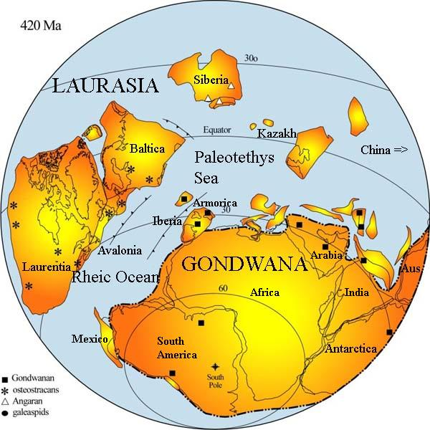

Figure 1: Supercontinent GONDWANA, early Paleozoic
(http://kingofwallpapers.com/gondwana.html).

The Arabian Plate is surrounded by several types of plate boundaries (Fig. 2). These are: The western and southern boundaries of the plate represent passive margins located at the rifting spreading ridges of the Red Sea and the Gulf of Aden. The northwestern margin is located along the Levant transform fault along the Dead Sea, and the Owen fractures at the southern margin of the Arabian Plate. The south - eastern boundary of the Arabian Plate is represented by Makran subduction zone, whereas the north and northeastern margin of the Arabian Plate is represented by the collision - subduction zones with Turkish and Iranian plates [6, 7 and 8]. The resulting late Cretaceous basin is known as the Zagros foreland basin [9, 10, 11 and 12]. The collision ultimately terminated in the formation of the Zagros fold and thrust belt.
[8] considered the Arabian plate is generally sub-divided into the Arabian shield, Arabian shelf and the Zagros fold and thrust belt.

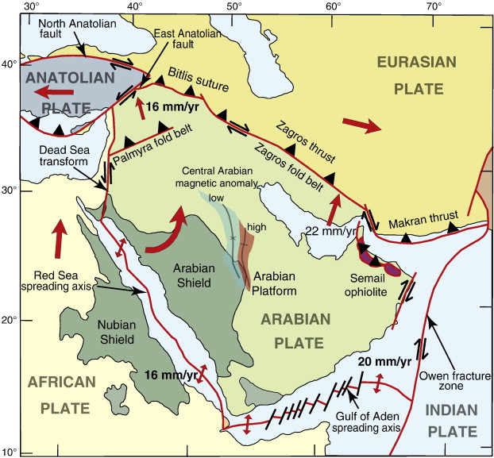

Figure 2: Main Tectonic sub-division of the Arabian plate and Location of Iraq (http://africa-arabia-plate.weebly.com/arabian-plate.html).

Zagros fold and thrust belt locate to the north and northeast of the Arabian Plate and is part of the Alpine- Himalayan belt. Zagros fold and thrust belt extends more than 2000 km from southern Turkey through northern and northeastern Iraq to the Strait of Hormuz in southwestern Iran. [10] considered this belt, as a result of structural complexity of the belt, characterizes a ∼200 to 300 km-wide zone. It includes a sequence of heterogeneous sedimentary cover strata, ∼7 to 12 km thick and composed of alternating incompetent and competent layers, overlying Precambrian crystalline basement with a complex pre-Zagros structural fabric [10].It is the deformational product of the Cretaceous to present day convergence of the Arabian and Iranian (Eurasian) plates [3, 6 and13]. [6 and 14] refers to the present morphology of the Zagros fold and thrust belt as the result of its structural evolution and depositional history. It is mountainous area, with very rugged topography due to the presence of complicated structures and main thrust sheets. The elevation ranges within study area from (500 - > 3500) m (a.s.l.), with very complicated terrain.
This study deals with the western part of the Zagros fold and thrust belt, which located within Iraqi region, along the Iraqi- Iranian and Turkish borders (Fig. 3). The study area covers approximately 82000km².

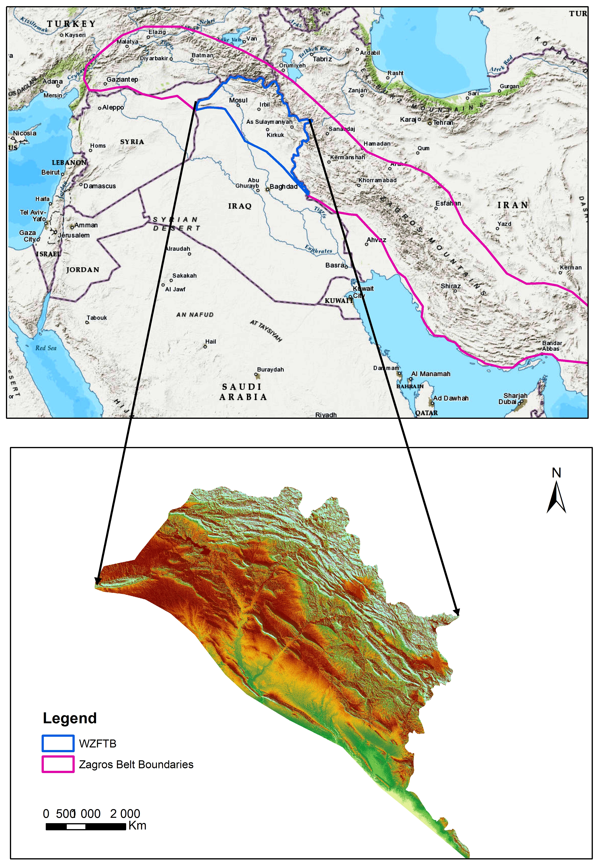

Figure 3: Location of the study area in Iraq.

The main aim of the present study is to introduce all structural classifications of the western part of the Zagros Fold and Thrust Belt and to shed light on the differences and similarities of aspects between them, and to delineate the most relevant and scientifically accepted one from the author’s opinion; based on the presented structural elements.

- Stratigraphic setting
The study area is characterized by various formations ranging from late Ordovician to Pliocene - Pliestocene in age and overlain by different types of Quaternary sediments [15]. [6] estimated the average depth of the basement to approximately (8- 14) km indicating, the basement is deeper in the study area as relative to other parts of Iraq territory.
The stratigraphic sequences are dominated by carbonates and clastics. The oldest exposed rocks are represented by the late Ordovician (460-445 m.y.) Al khabour formation mainly consists of sandstone, siltstone and shale. It is exposed in the north part of Iraq, near Iraqi-Turkish [6].The youngest rocks in the study area are represented by Pliocene - Pliestocene (3.0 m.y-10 th.y.) Bai Hassan formation mainly consists of sandy conglomerates and sandstone [6 and 15].
The Paleozoic, Mesozoic, and Cenozoic rocks comprise mainly marine carbonates with some clastic materials.

- Structural classifications of the Zagros Fold and Thrust belt
Many researchers classified Zagros belt structurally into several zones. [14 and 16] was the first who introduce a regional structural classification of the Zagros fold and thrust belt. He divided it into three parallel NW-SE trending structural belts. The belts from NE to SW are; the thrust belt, Imbricated belt and the simply folded belt. Later many other structural classifications were introduced, representing modifications of the original concept of [14 and 16], we will introduce some classifications hereinafter...
[17] considered the Zagros fold and thrust belt is bounded by two stable platforms (Fig. 4). On the southwest is the Arabian platform and on the northeast is the Precambrian metamorphic basement of central Iran. Moreover, he divided stratigraphic Zagros column from bottom to top into five structural divisions: 1.Basement Group 2.Lower Mobile Group 3.Competent Group 4.Upper Mobile Group 5. Incompetent Group.
[13] considered The Zagros orogenic belt of Iran is the result of the opening and closure of the Neo-Tethys oceanic, and He divided it, from northeast to southwest, of three parallel tectonic subdivisions: 1. The Urumieh-Dokhtar Magmatic Assemblage; 2. The Sanandaj-Sirjan Zone; and 3. The Zagros Simply Folded Belt.
[3] divided the Zagros belt into five morphotectonic units based on the topography, seismicity and exposed stratigraphy (including erosion and sedimentation), each with their own characteristics and deformation style. These five units are:1) the high Zagros thrust Belt, 2) the simple folded belt, 3) the Zagros foredeep, 4) the Zagros coastal plain and 5) the Persian Gulf-Mesopotamian lowland (Fig.5).
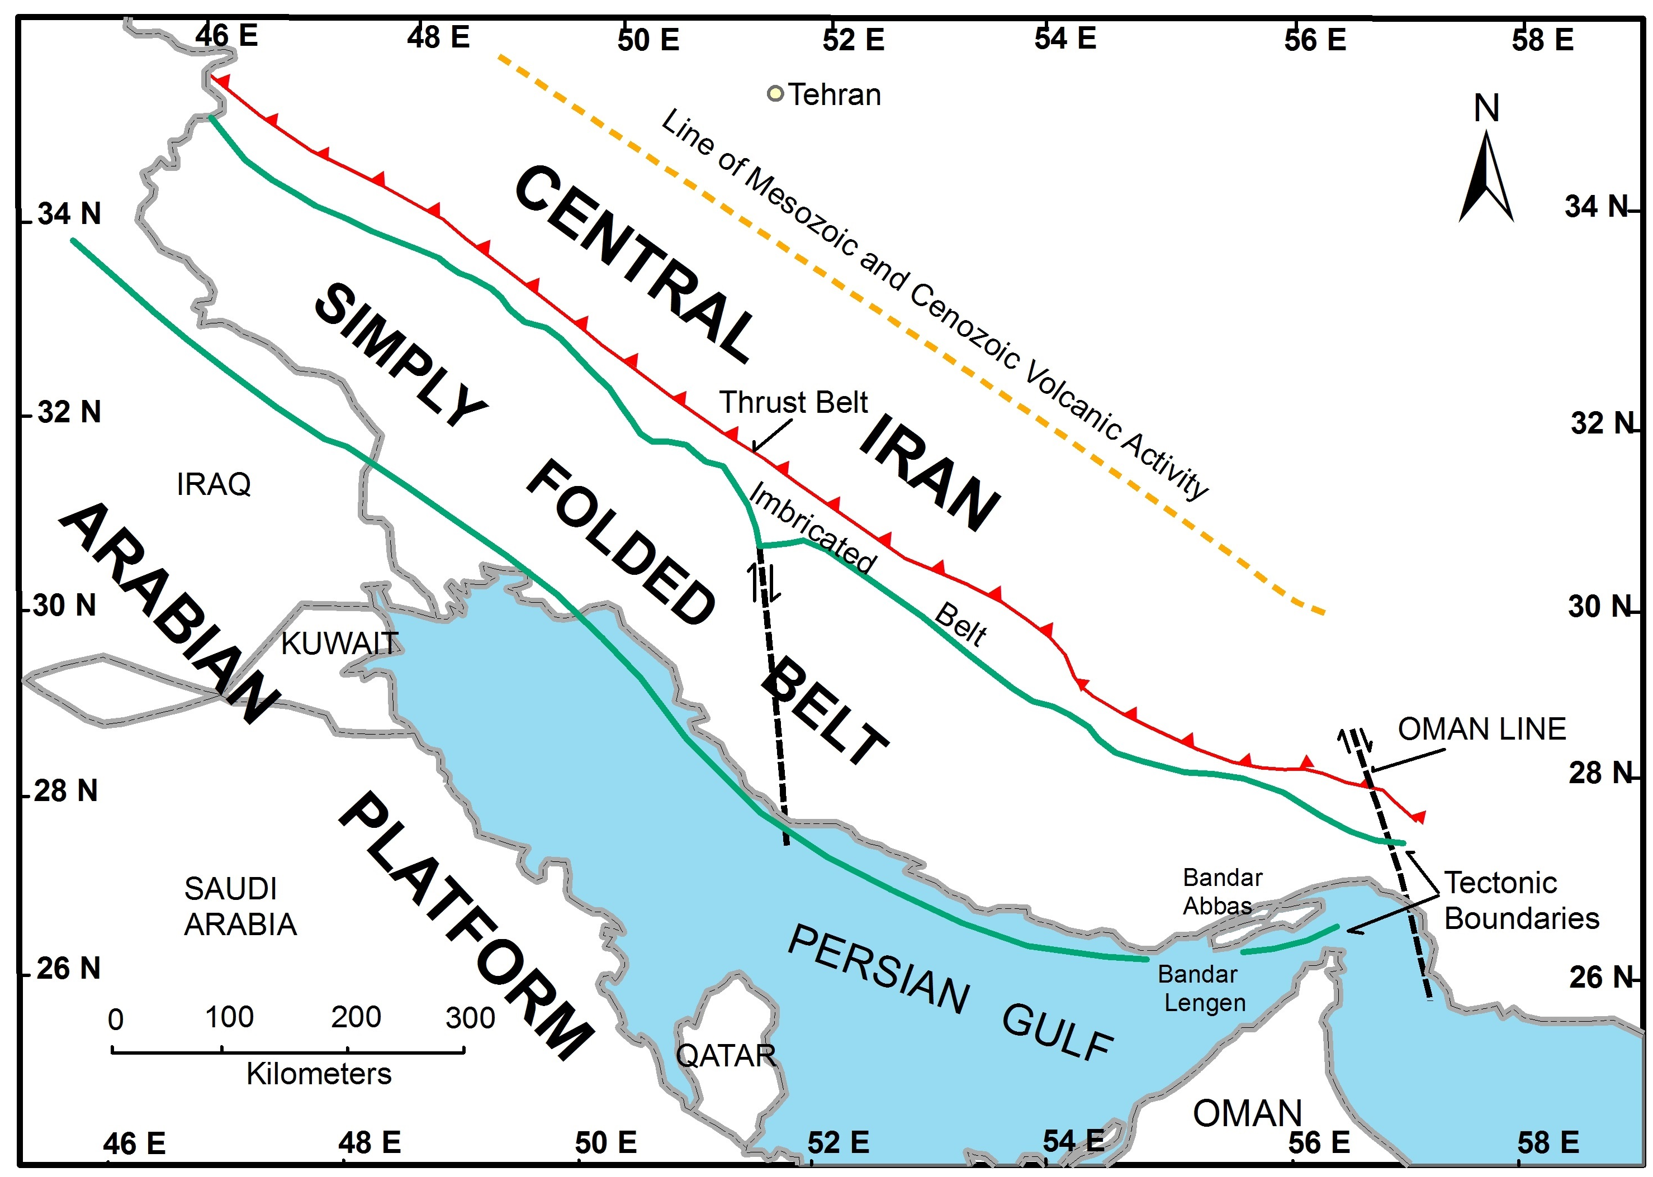

Figure 4: Tectonic settings of the Zagros fold and thrust belt showing the major tectonic belts [modified after 17]
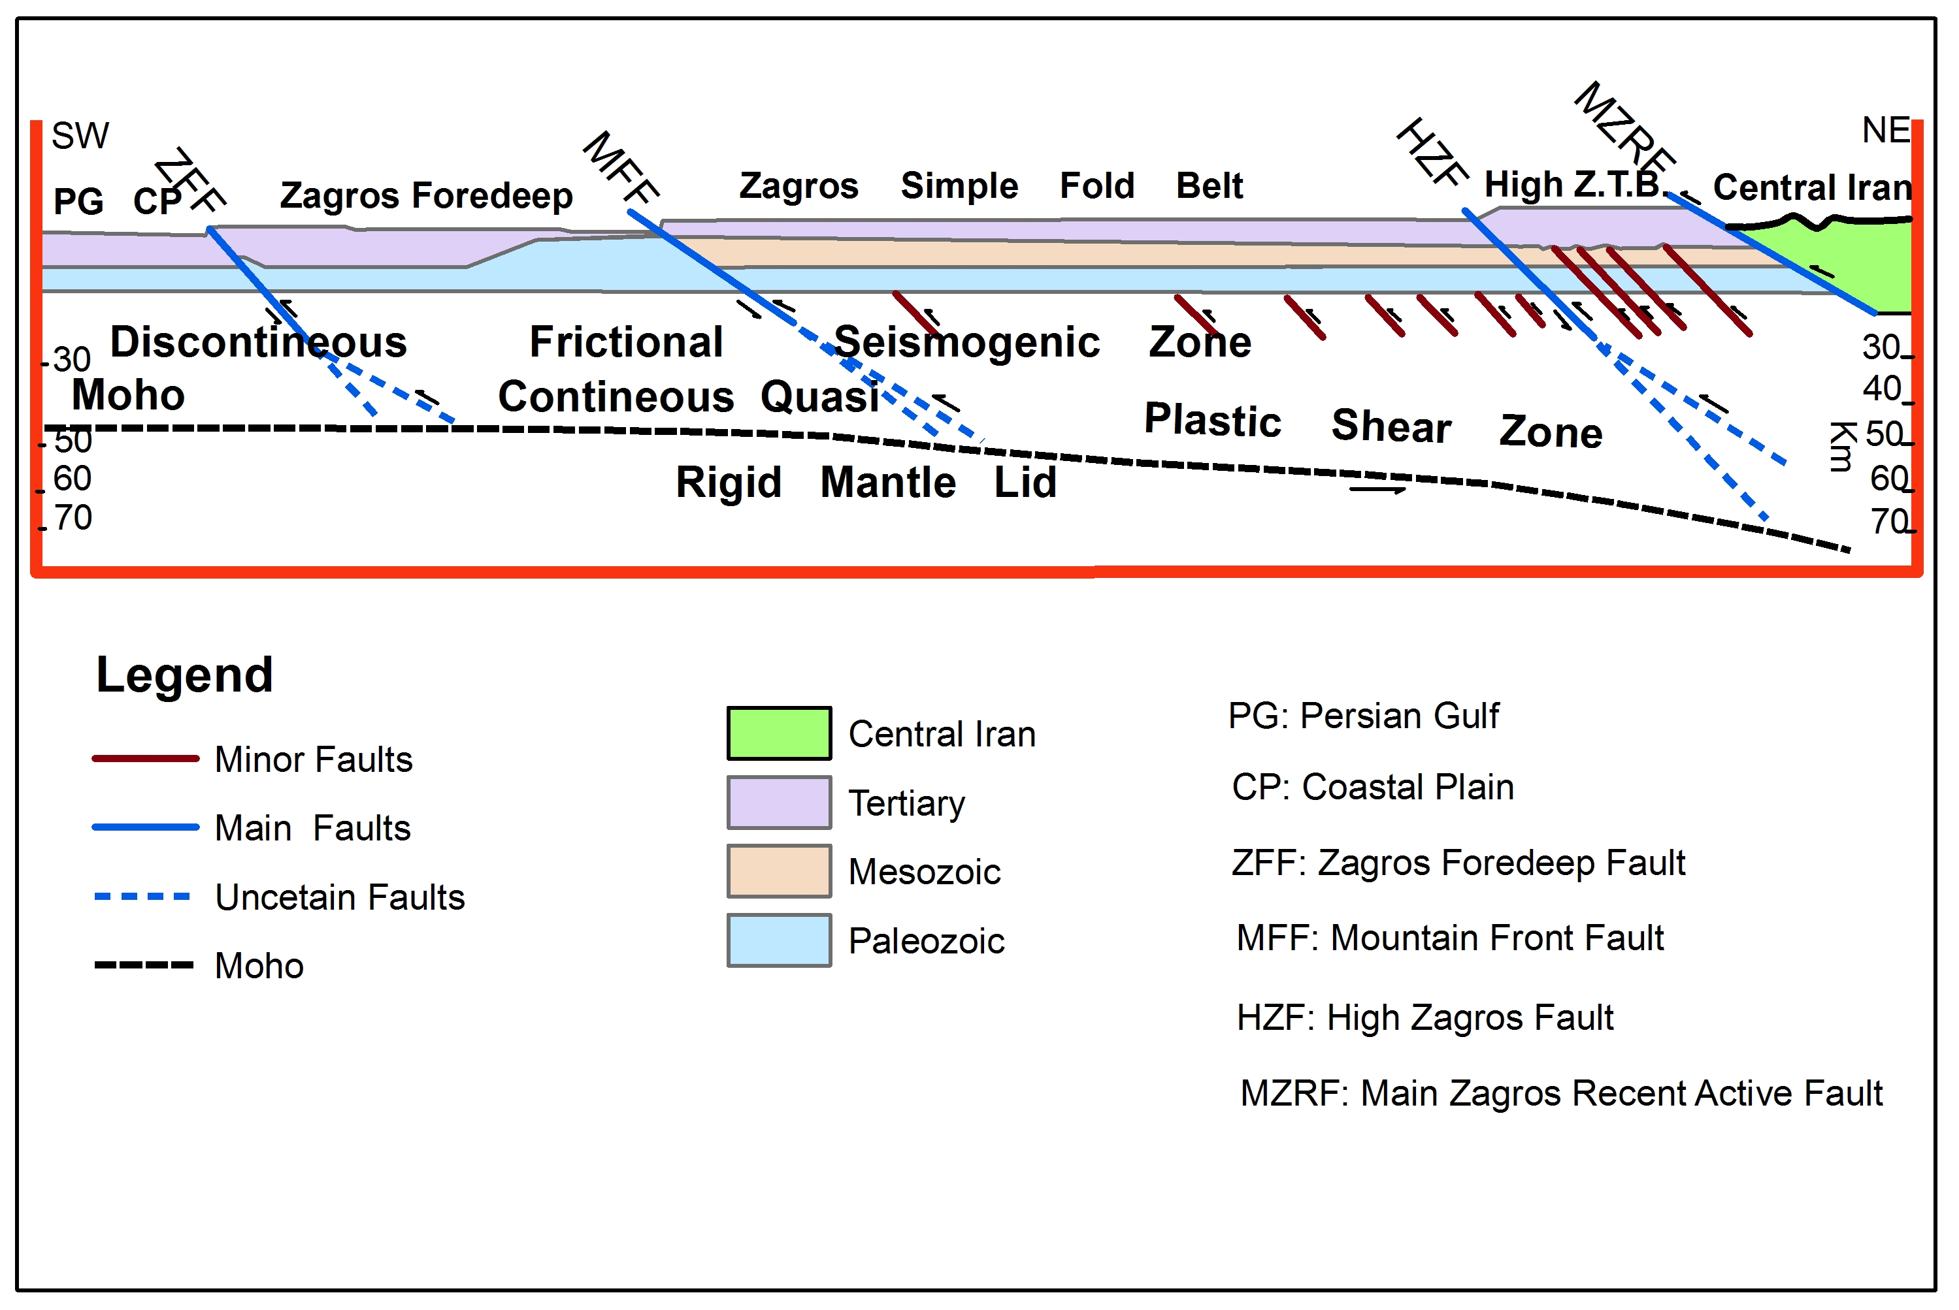
Figure 5: Simplified transverse cross section of the Zagros active fold-thrust mountain belt [modified after 3]

[18 and 19] divided the Zagros fold and thrust belt laterally into four main longitudinal segments of changing width and morphology, from SE to NW there are: Fars arc, the Dezful embayment and the Lurestan arc in Iran and the Kirkuk Embayment in Iraq (Fig.6).
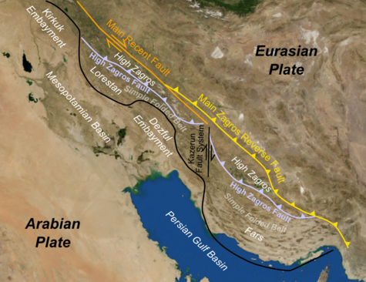

Figure 6: Tectonic Map of Zagros belt, shows the lateral divided laterally zones
Into four longitudinal segments (https://en.wikipedia.org/wiki/Zagros_fold_and_thrust_belt)

[20] divided Zagros belt into NW–SE trending structural zones (imbricated and simply folded Belt) parallel to the plate margin separated by major fault zones such as the High Zagros and Mountain Front Faults (Fig. 7). The Imbricated Belt situated between the High Zagros and Zagros Main Reverse Faults and Simply Folded Belt lies to the southwest of the High Zagros Fault.

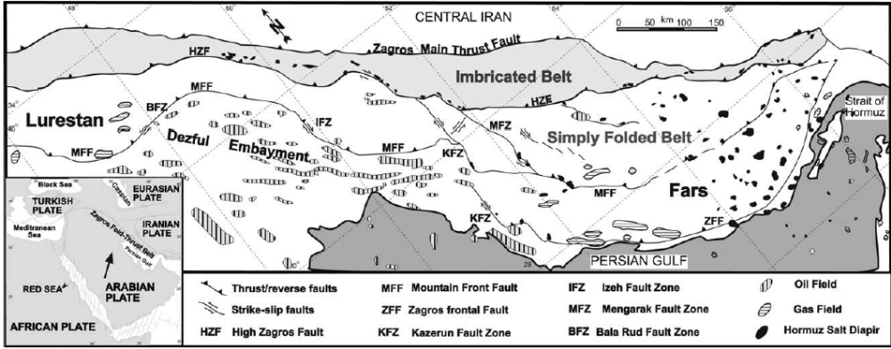
Figure 7: Structural setting of the Zagros fold-thrust belt showing the major fault zone
[from 20]
4 Structural classifications of the western part of the Zagros Fold and Thrust belt
[21] divided the Zagros fold and thrust belt into a western part within the Iraqi territory and an eastern part within the Iranian territory. It is important to mention, that almost all of the classifications have focused on the Iranian part of the Zagros, whereas the Iraqi part received only a very limited attention.
The western part of the Zagros fold and thrust belt has been traditionally subdivided into several of structural zones and subzones that are generally striking parallel to the plate boundary. Early divisions were linked more or less to oil exploration activities [22, 23, 24and 25]. More detailed classifications were introduced later by some researchers; we will introduce the structural classifications hereinafter...
[26] divided Iraq based on (the outdated geosynclines theory and terminology) into three tectonic units, whereas each of units was subdivided into tectonic subzones which are:
a- Stable platform subdivided into Rutbah-Jezirah zone and Salman zone.
b- Unstable Platform subdivided into Mesopotamian zone, Foothill folded zone and High folded zone.
c- Geosynclinal Area subdivided into external zone (Balambo-Tanjero and northern thrust zone), central zone (Qulqula-Khwakurk and Penjwin-Walash zones) and internal zone (Shalair zone) (Fig. 8). The western part of the Zagros belt is including (b-c).
[27] divided the western part of the Zagros fold and thrust belt into two main zones, which are 1- the unstable shelf 2- the geosyncline, then subdivided it into zones and subzones (Fig. 9). This classification depends on (Geophysical data, Morphological style, and the sedimentary cover).
[6] divided the Iraqi territory into a stable Shelf, an unstable Shelf and the Zagros suture zone (WZFTB including unstable shelf and Zagros suture zone) (Fig. 10), they furthermore subdivided the unstable shelf from SW-NE into the foothill zone, the high folded zone, and the imbricate zones. Additionally, they subdivided the Zagros suture zone from SW-NE into three parts, which are the Qulqula- Khwarkurk zone, Penjwin-Walash zone and Shlair zone. These classifications depend on (the rocks type, ages of rocks, thickness of the individual zones and their structural evolution).
[8] divided the Arabian plate into: a)-Arabian shield and b)-Arabian shelf. They furthermore divided the Arabian shelf into two parts. (an unfolded zone and a folded zone). Additionally, they divided the Iraqi territory from NE to SW into five parts: 1- thrust zone, 2-folded zone (high folded zone and low folded zone), 3- Mesopotamian zone (Mesopotamian Basin, Mesopotamian Basin with strike-slip faulting and Mesopotamian Basin with salt), 4- Salman zone (Salman zone and Salman zone in east of Khleisia, 5- Rutba-Jezira zone (Rutbah subzone and Jezira subzone) (Fig. 11). They furthermore considered thrust zone and folded zone within western part of Zagros belt. The western part of the Zagros fold and thrust belt including (1, 2 and 3).
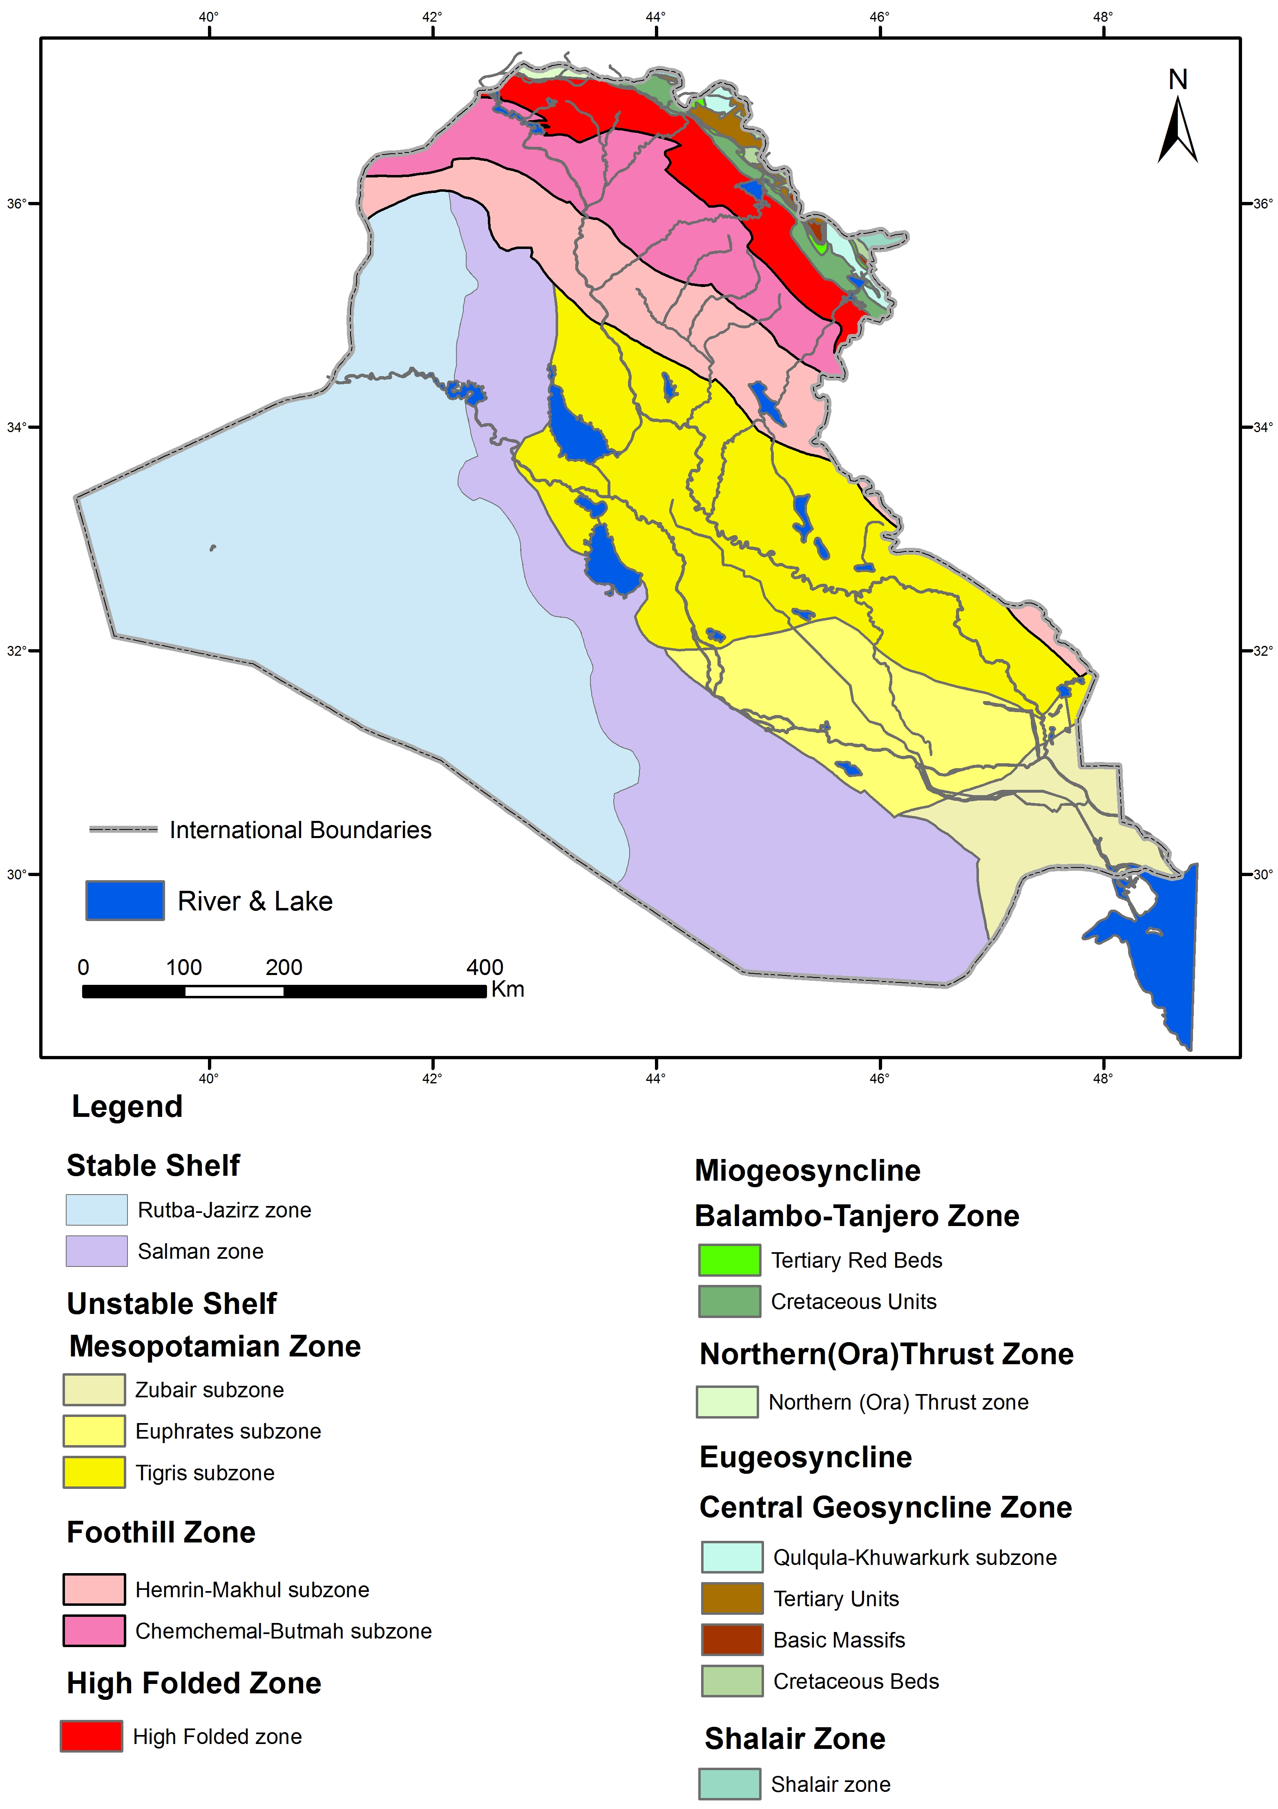

Figure 8: Tectonic Map of Iraq [modified after 26]

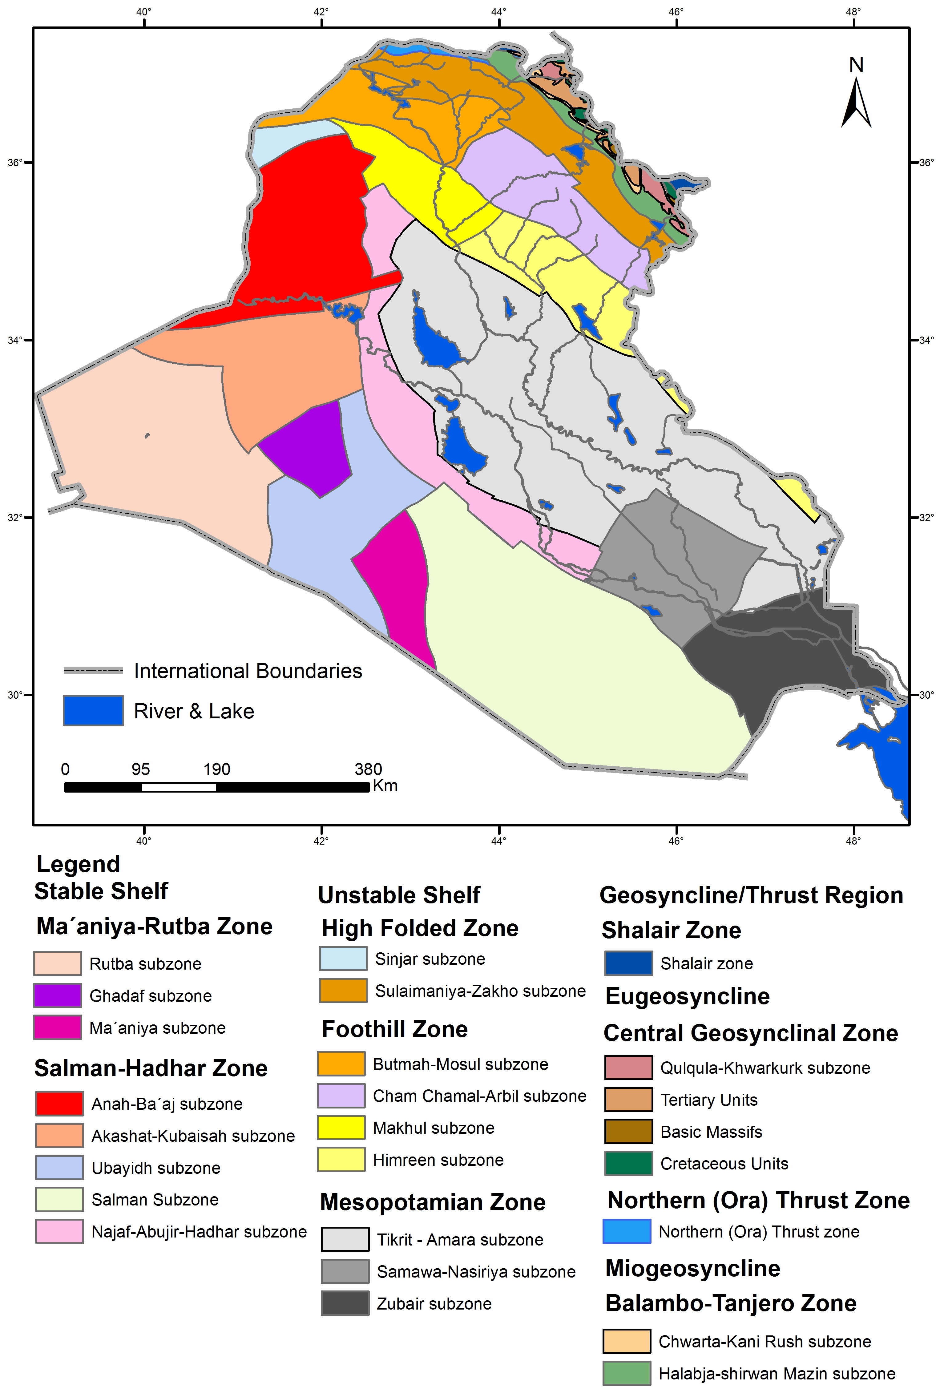

Figure 9: Tectonic Map of north part of Iraq [modified after 27]

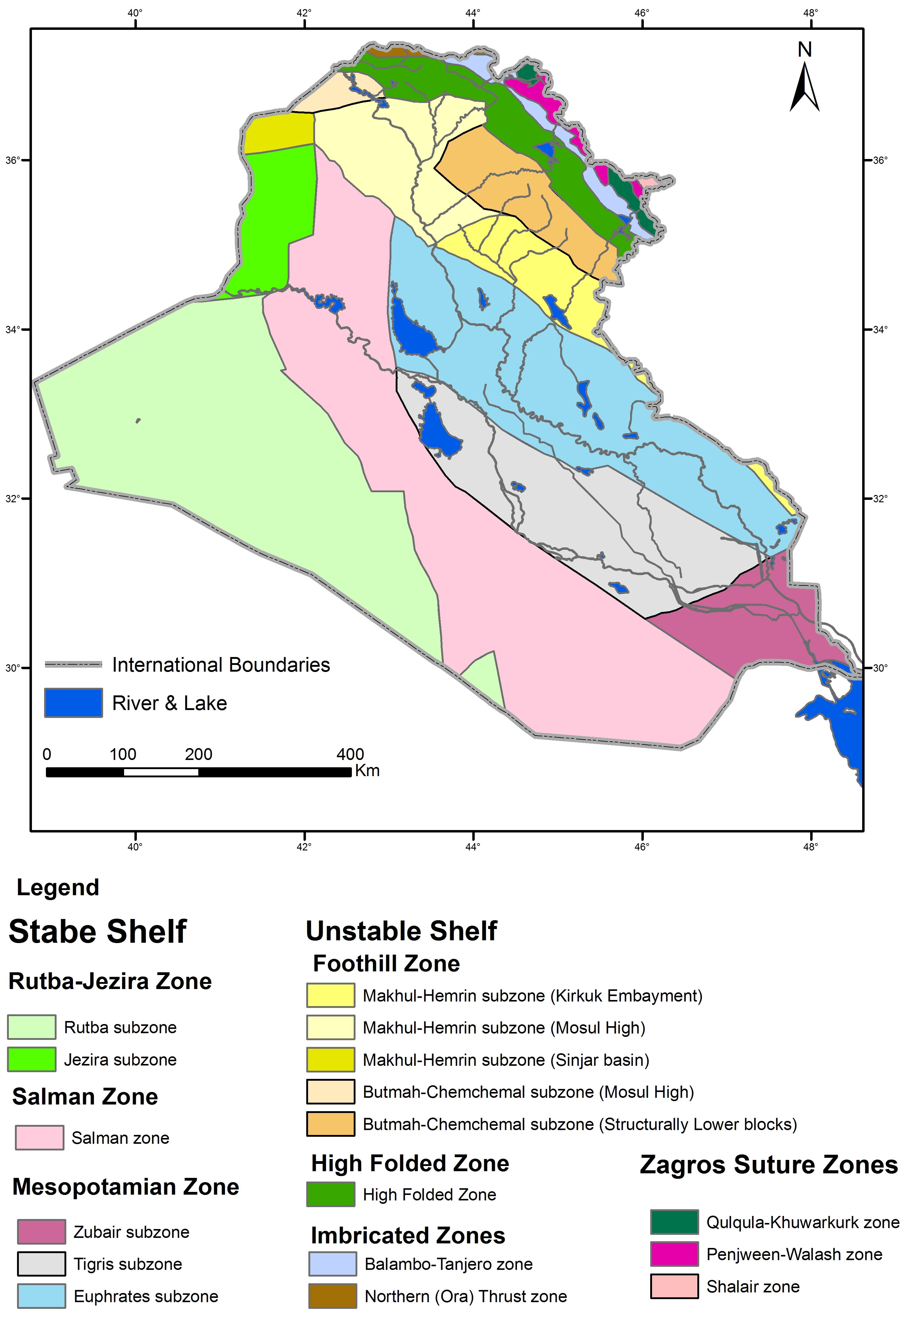

Figure 10: Tectonic Map of Iraq [modified after 6]

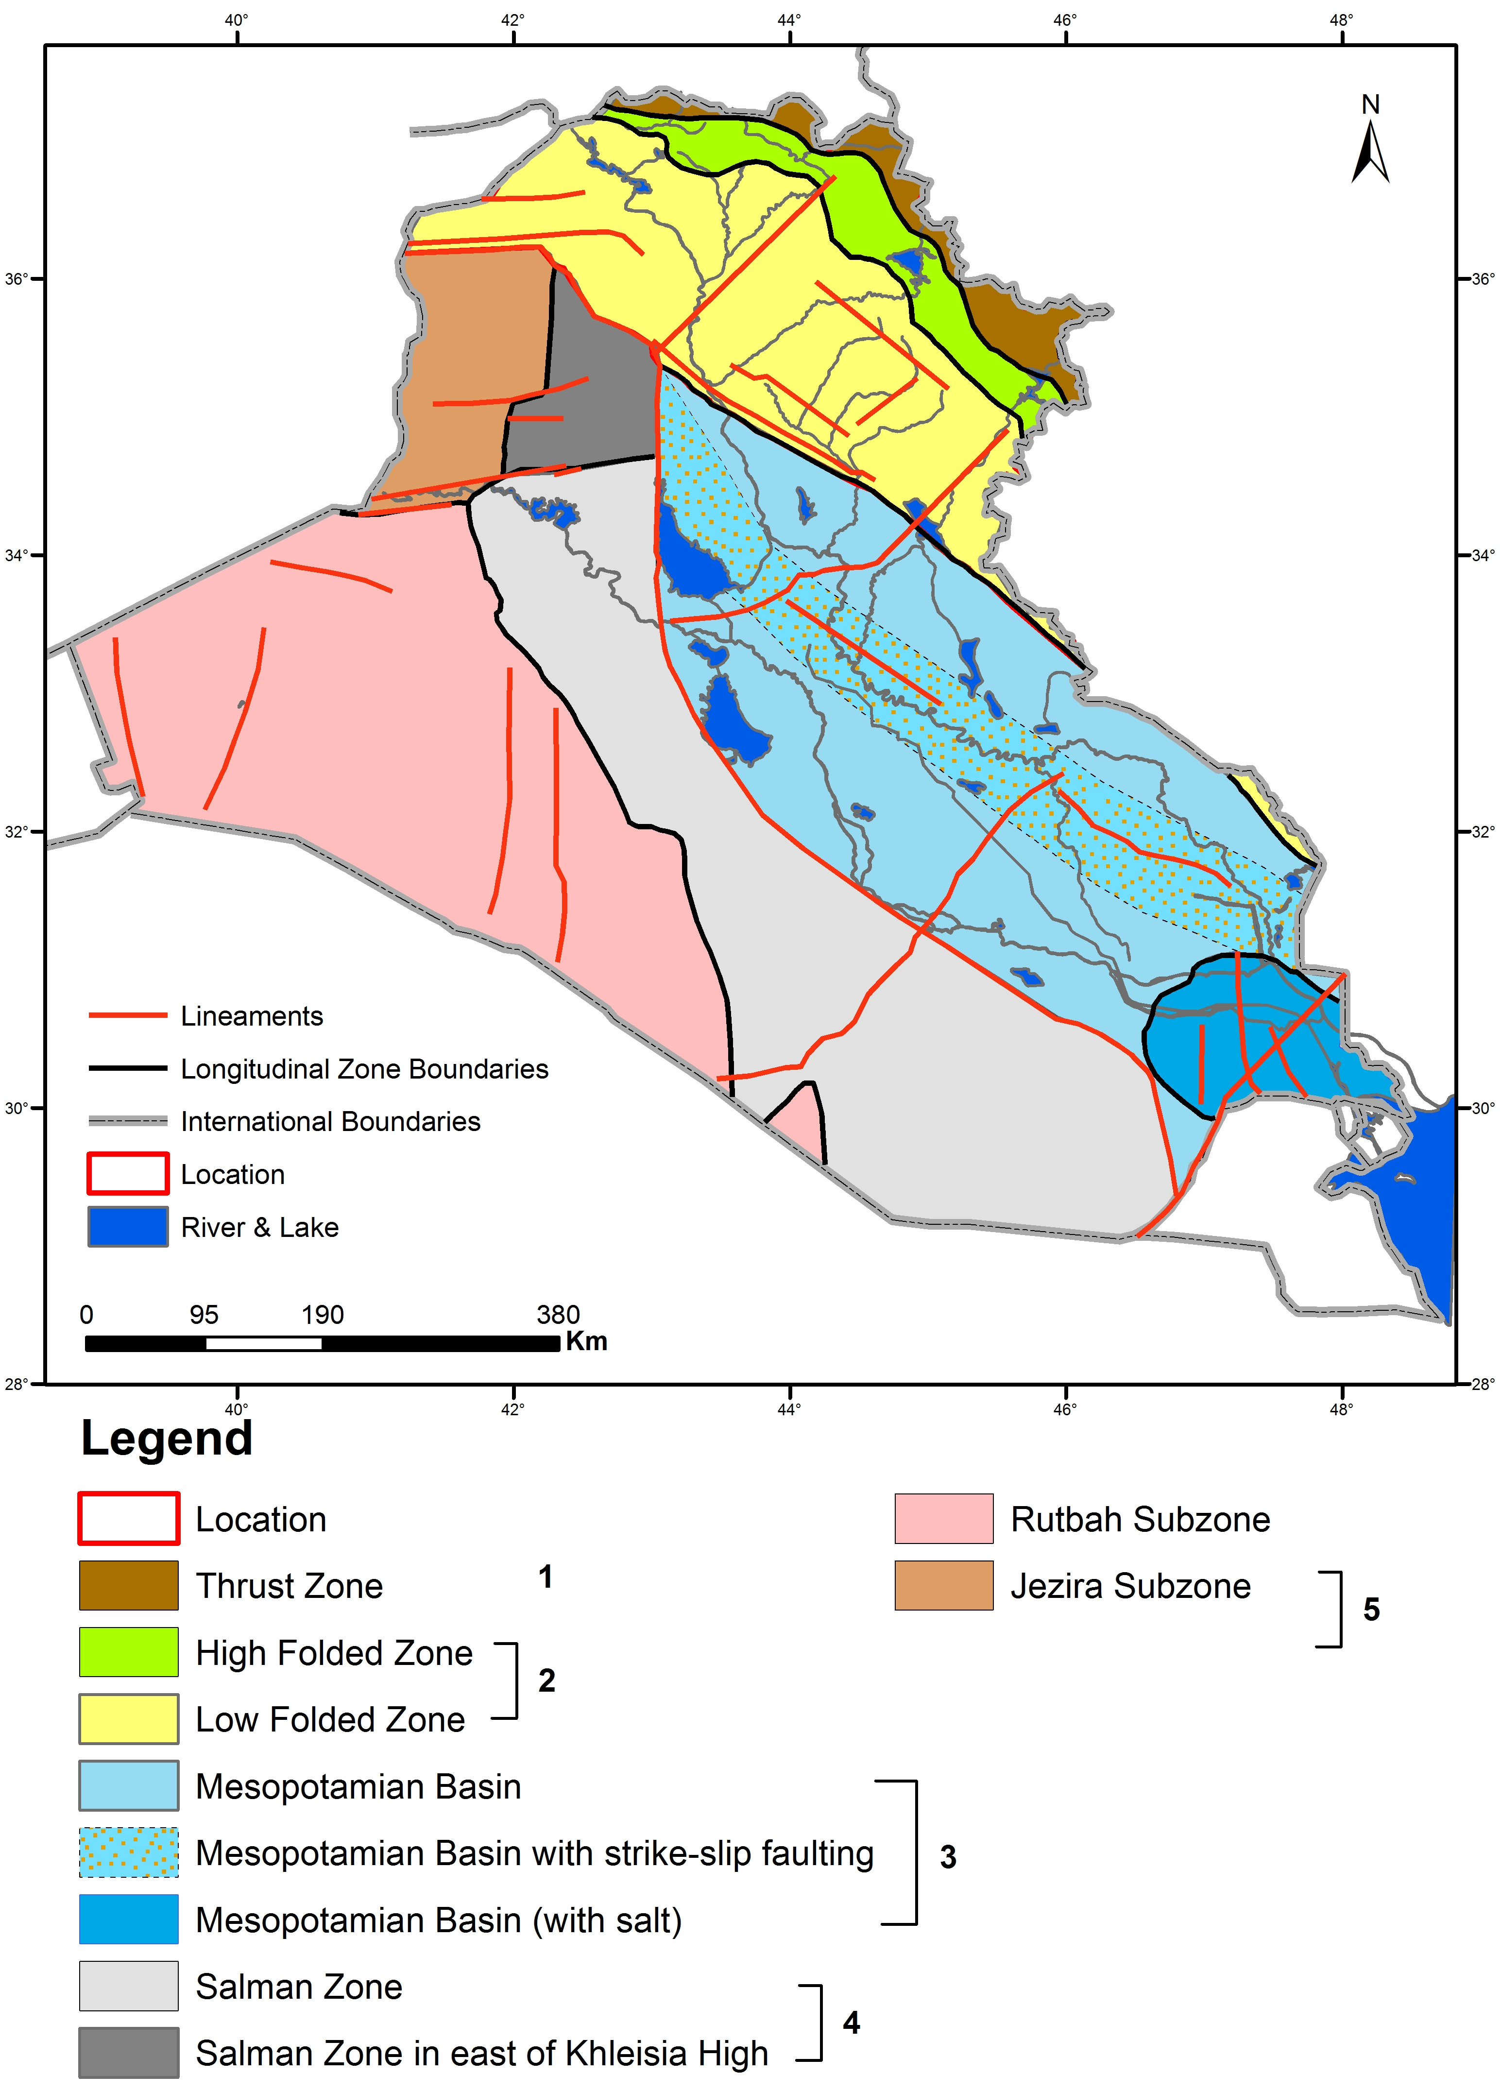

Figure 11: Structural elements map of the Iraq [modified after 8]

[12 and 28] divided the Iraqi territory into two main tectonic segments (Figs. 12 and 13). These are: 1) Arabian platform part (within WZFTB), 2) the Shalair terrane of the Sanandaj – Serjan Zone of the Eurasian plate (within the EZFTB). The former lacks any kind of metamorphism and volcanism, except within the Zagros Suture Zone. Moreover, he divided the Arabian plate form part into two main tectonic divisions, which are 1) Inner Platform (Stable Shelf) to the southwest, which is less affected by Alpine deformation and remained relatively stable, 2) Outer Platform (Unstable Shelf) to the northeast, which is involved by the deformation. Later on he divided the Outer Platform into two tectonic units, which are 1) Mesopotamia Foredeep, 2) Western Zagros Fold-Thrust Belt. Farther on then he divided WZFTB according to the modern tectonic concepts into four tectonic zones (Fig.14), which are from SW to NE 1) Low Folded Zone ; consists of series of gentle to open folds of Pliocene-Pleistocene age, 2) High Folded Zone; consists of large number of tight and overturned folds mainly with southwest vergence, 3) Imbricate Zone; consists of autochthonous Paleozoic to Mesozoic platformal and marginal sedimentary units that have been deformed more intensely with the development of series of imbricate fans and, 4) Zagros Suture Zone; consists of allochthonous Cretaceous- Eocene nappes of ophiolite, radiolarites and volcano-sedimentary rock that have been thrusted over the platformal and marginal sediments of the Arabian plate [21], and then he divided some of the zones into subzones.
This tectonic classification is based on the structural style and intensity of deformation, age of deformation, stratigraphy, mechanical-stratigraphy and tectono-stratigraphy of the deformed sequences.
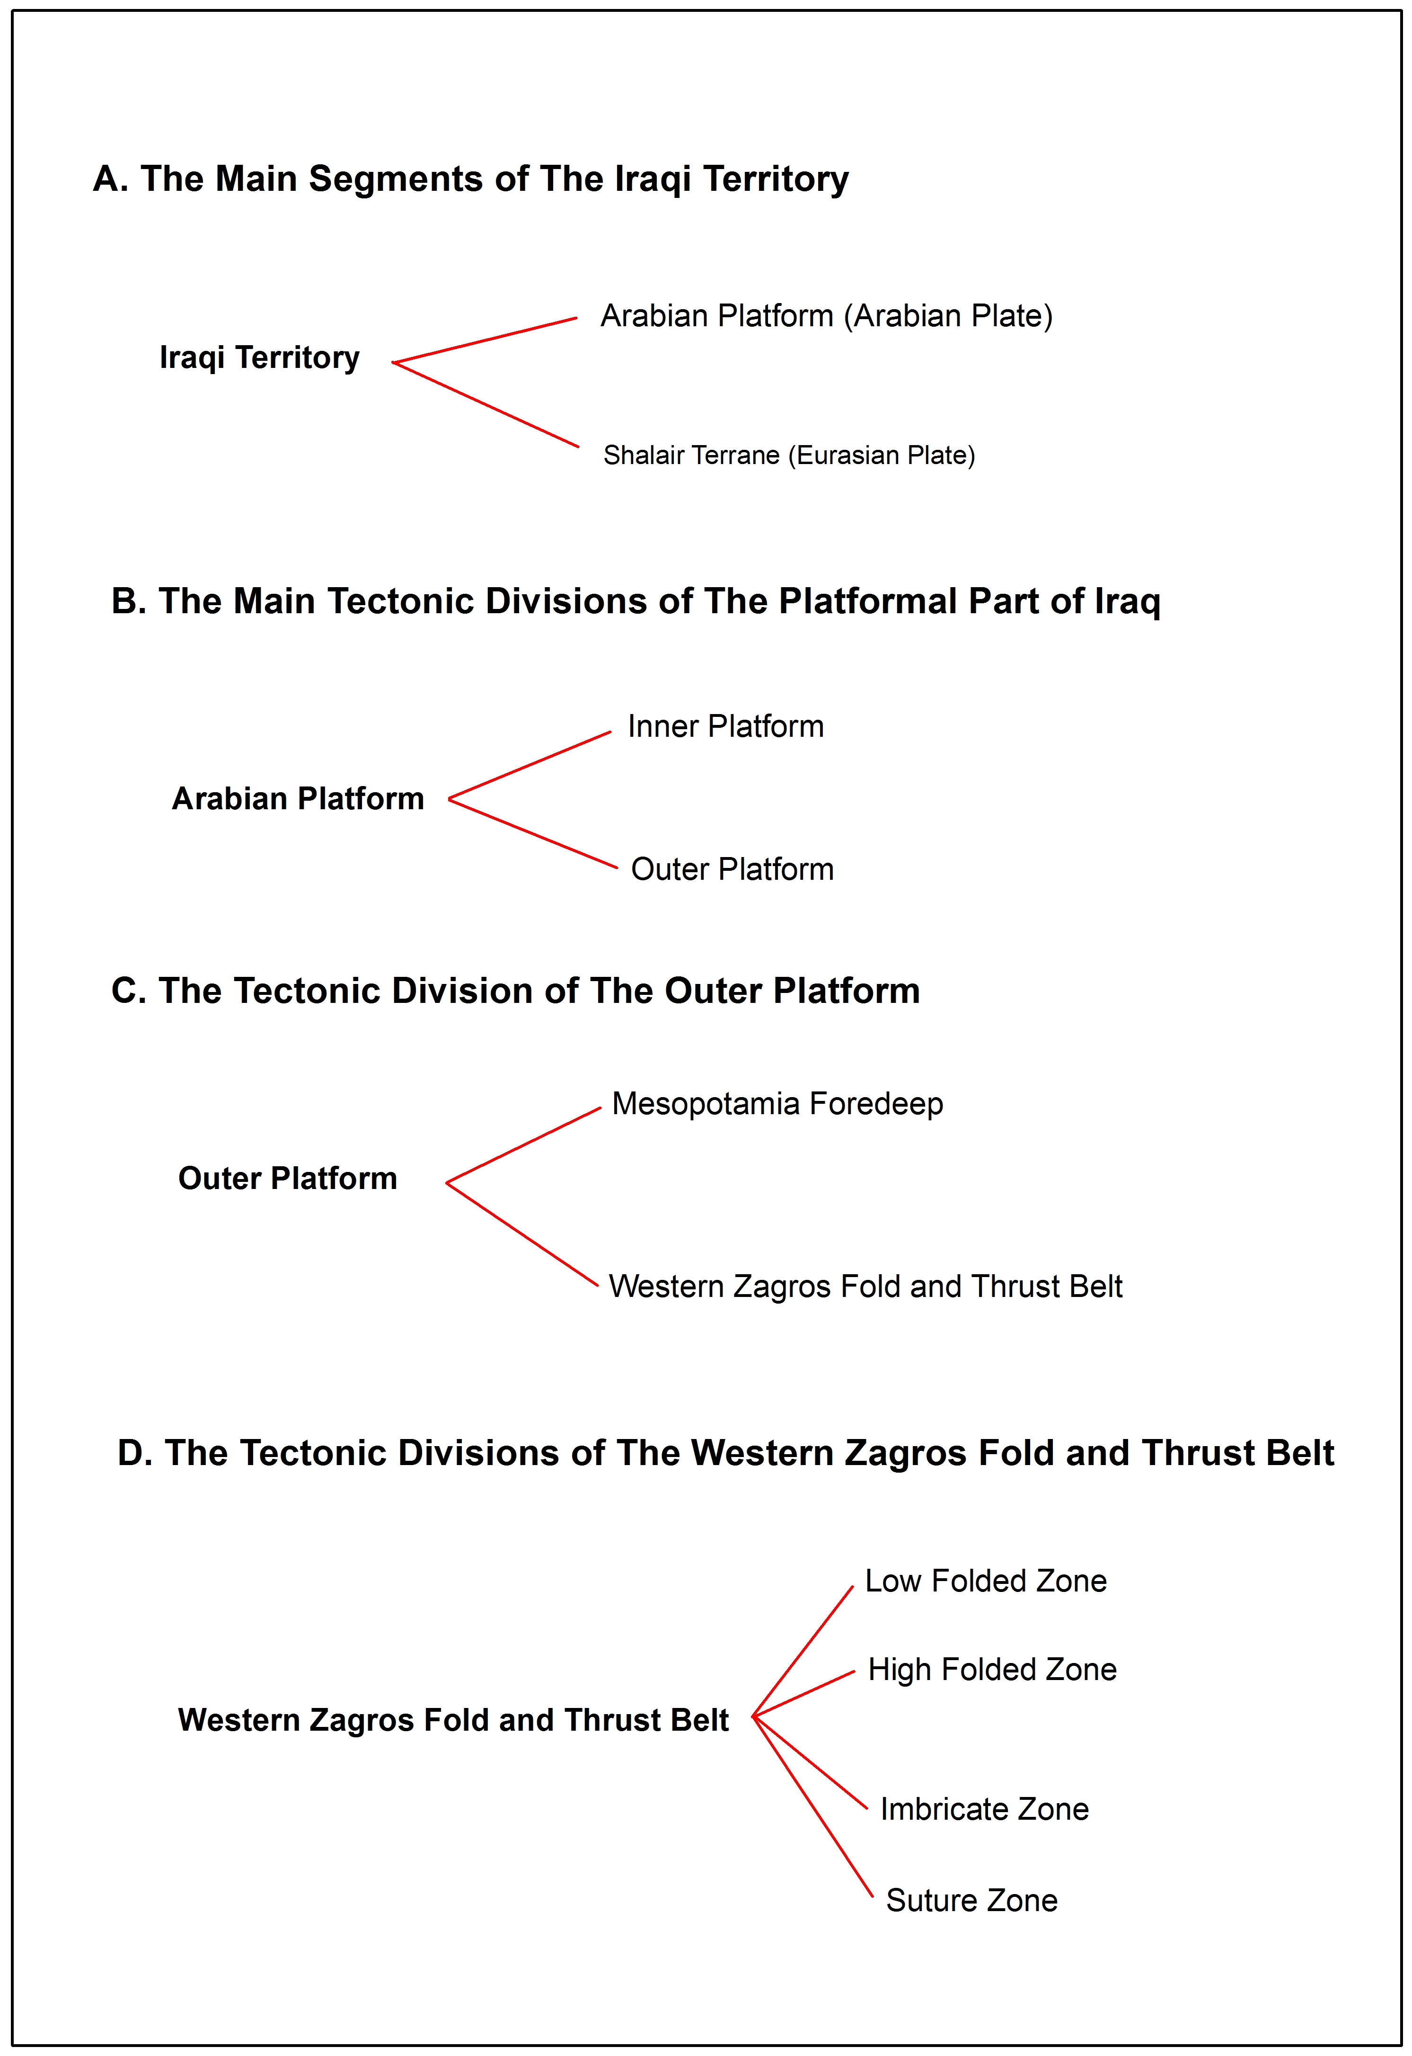

Figure 12: The Tectonic Divisions of Iraq [from 28]

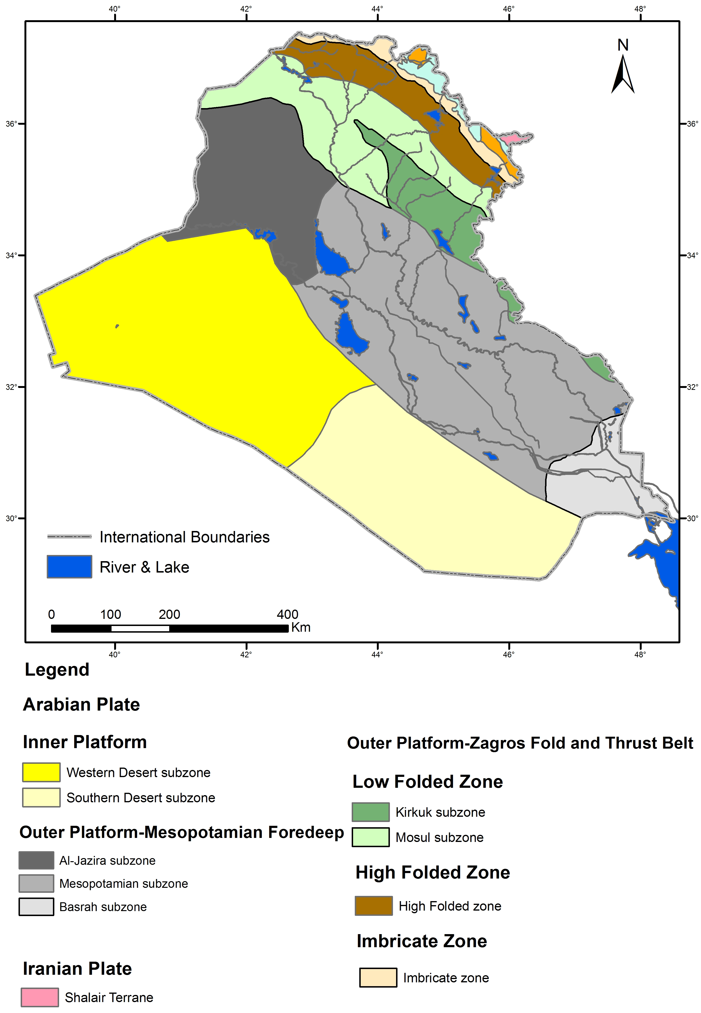
Figure 13: Tectonic classification of Iraq [modified after 29]

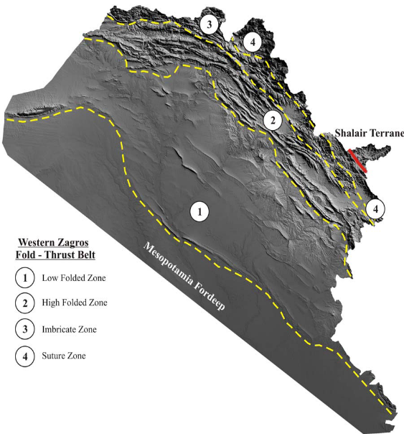


Figure 14: The tectonic subdivisions of the western Zagros fold and thrust belt
[from 4]
5 Tectonic Units
The Outer shelf (unstable shelf) has been subsiding since the opening of Neo-Tethys in the Early Cretaceous and Jassim and [⁶] considered the maximum subsidence occurred during the late Cretaceous. [30] reported that the deformation within the Zagros fold and thrust belt includes both accumulated cover and basement rocks. In general The Zagros fold and thrust belt is dominated by several lineaments trending NW-SE, NE-SW and E-W. This zone is composed of a 7 to 12km thick Neoproterozoic and Phanerozoic sedimentary sequences [13].

The western Zagros fold and thrust belt was divided by Fouad [21] to several sub tectonic units, they are, from SW to NE:-

5.1. The Low Folded Zone

The Low Folded Zone of the Western part of Zagros belt is the largest zone. It is about 700 Km long and 100 Km wide. Its coverage area is about 56930 Km². Structurally this zone contains number of folds of variable sizes and geometries. The folds extended NW – SE trend though most of the zone, but gradually changes to E – W trend northwestward towards the Turkish territory. Almost all the anticlines in the eastern part exhibit reverse faulting that has caused over-ridding on the NE limbs on the SW limbs, especially in Kirkuk Subzone [31].
The Low Folded Zone forms the first topographic and morphological front of the (WZFTB) [28]. It is located between the Mesopotamia Foredeep from the southwest and the High Folded Zone from the northeast [4, 12] (Fig.14).
The Low Folded Zone knows in Iranian Region with different names such as the Zagros deformational front [7 and 32] and the Zagros Mountain Front [3 and 33]. The exposed rock units within this zone extend from Late Cretaceous in age, which belong to the Shiranish formation to Pliocene – Pleistocene in age, which belong to the Bai Hassan formation. The exposed stratigraphical column is represented by 24 formations [34].
Based on field, seismic and well data [4 , 28] subdivided the Low Folded Zone into two subzones, which are (Kirkuk Subzone in the SE, and Mosul Subzone in the NW) (Fig.13).
[4] mentioned the folds within Kirkuk Subzone are long, narrow, asymmetrical, disharmonic structures, and the folds are NW – SE trending. They are frequently associated with thrust faults, where their back limbs have been thrusted southwestwards over their forelimbs.
Within Mosul Subzone the folds are relatively short, broad, asymmetrical to slightly, non-disharmonic structures and not associated with thrusting. The folds are NW – SE trending in the southeastern part of the region, but change to E – W direction in the northwestern part.

5.2. The High Folded Zone
The High Folded Zone is located between the Imbricate Zone to the north and northeast and to the south and southeast by the Low Folded Zone (Fig.14). Its coverage area is about 15827 Km². The zone extends from the Iraqi – Iranian borders where the folds are tending NW – SE, but gradually changes to E – W as the folds continue northwards towards the Iraqi – Turkish borders. Structurally the Zone contains a number of high amplitude, short wavelength anticlines with different dimensions, forming high rugged anticlinal mountains separated by deep and narrow synclinal valleys [28].

[6] estimated the average depth of the basement by to be (~ 8) Km. That mean the basement is shallower in the High Folded Zone as compared to its depth in the Low Folded Zone.
5.3. The Imbricated Zone
The Imbricated Zone is topographically a narrow and high zone. Structurally this zone consists of a series of southwest directed thrusts and elongated tight folds [28]. The oldest exposed rocks in Iraq located in this zone, which is Al-Khabour Quartzite formation (Late Ordovician). It is extending from the high folded zone in the SW and Zagros suture zone in the NE. It is characterized by intense folding and thrusting. [6] considered the imbricated zone can be subdivided into two sub-zones (Fig.10), which are:

5.3.1. Balambo-Tanjero Subzone
[6] reported Balambo-Tanjero subzone formed due to the opening of the Neo-Tethys during late Jurassic time. It is a narrow belt, a proximately 25 km wide trending NW-SE, and extending from the Iranian border in the SE to the Turkish border in the NW.
Balambo-Tanjero subzone is intensely folded and faulted [6]. It is characterized by lower and upper Cretaceous deposits.
[6] mentioned Balambo-Tanjero subzone is subdivided into two belts, the NE part representing a depression with Tertiary clastics sediments and the SW part where Tertiary clastic sediments are absent.
5.3.2. Northern (Ora) Thrust Sub-Zone
Northern (Ora) Thrust Subzone is an approximately 15 km wide, E-W trending belt within Iraqi territory. [35] suggested that the Triassic rocks are equivalent to the metamorphic rocks of the Shalair zone, whereas [6] considered these rocks to be part of the Northern Thrust Zone.

5.4. Zagros Suture Zone
This is the most complex and least studied tectonic zone in Iraq. The thrust zone in Iran is also known as the Crush zone. It includes the igneous and metamorphic rocks in Iraq, with other Triassic – Miocene sedimentary rocks [6]. The relationships between the established tectonostratigraphic units are poorly studied and the vague naming of rock units prevents a regional comparison [36].

The Zagros Suture Zone is divided by [6, 29] into two tectonic subzones within the Iraq territory these are:-

5.4.1. Qulqula-Khuwarkurk Subzone
Rocks in the Qulqula-Khuwarkurk Zone are formed during the Late Cretaceous [6]. They consist of radiolarian chert, mudstone and limestone, and igneous rocks towards NE. The basement is approximately-14 km deep [6]. The main structures are recumbent and isoclinal folds, thrusts and reverse faults. [6] subdivided this sub-zone into three blocks, an outer, central and inner blocks.

5.4.2. Penjween-Walsh Subzone
[6] mentioned the Penjween-Walsh Subzone represents the central, main Neo-Tethys. It formed during the Cretaceous and extends along the Iraq-Iran border, thrusted over the Qulqula-Khwarkurk subzone and the Balambo-Tanjero Subzone. The thickness of the Cretaceous and Tertiary rocks is approximately 8km and the main structures are represented by thrust sheets [6].

5.5. Shalair (Sandaj-Sirjan) Subzone (Terrane)
[2, 6 and 28] Shlair Terrane as an integral part of the Sandaj-Sirjan Zone (Eurasian (Iranian) Plate), representing the widest part of the Zagros suture zone. The zone consists of metamorphic and igneous rocks with Triassic – Miocene sedimentary rocks [15]. The thickness totals at approximately 5 km and it represented higher thrust sheets in Iraq. The W boundary of the zone is a thrust fault [6]. [28] mentioned the terrane is separated from the Arabian plate by the Zagros Main Thrust, and contains many E – W trending structures.

6 Discussion
The Zagros fold and thrust belt is divided into two parts which are a western part within the Iraqi territory and an eastern part within the Iranian territory. Almost all previous works focused on the Iranian part of the Zagros (EZFTB), whereas the Iraqi part (WZFTB) have had received only a very limited attention.
The Iraqi part of the Zagros belt has been divided into several structural zones. Early classifications were related with oil exploration activities [22, 23, 24 and 25]. After that many sub classifications were presented later by [26, 27and 37]. All of them classified based on the same principles by separating the fold belt into a major roughly NW – SE trending longitudinal zones, (assigned as Foothill Zone, High Folded Zone, and the Geosynclinal Area) [4], the regional tectonic zones were subdivided into smaller and smaller subzones that in sometimes inconsistent with each other and was a very complicated, special in tectonic classification of [27]. [6 and 8] have presented another classification, which is the same as that of [26], but with minor modification. It is noteworthy, that all these differences structural classifications are due to using differences between the used structural criteria used in the classifications. All the researchers divided Iraqi territory into Stable shelf and unstable shelf and considered Abu-Jir fault zone the limit between them.
[29 and 31 ] have introduced a new tectonic classification to the Iraqi territory, he used the first time the term Inner Platform (Stable Shelf) and Outer Platform (Unstable Shelf) (Fig.12).
[26 and 27] (Fig.8 and 9) considered the WZFTB is located within the Unstable Shelf and Geosynclinal area, then they subdivided these zones into subzones, which are considered Mesopotamian, Low Folded Zone and High Folded Zone within Unstable Shelf. Moreover, they divided the Geosynclinal Area into: Balambo Tanjero, Northern thrust, Qulqula-Khuwarkurk and Penjwin- Walash subzones within Geosynclinal area.
[6] considered WZFTB located within unstable shelf and Zagros suture zone and considered Mesopotamian within stable shelf, whereas[21 and 28] considered the Mesopotamia Zone belongs to the Outer Platform. It is worth mentioning that [6] were more detailed than [21 and 28], in Imbricate Zone, they divided it into several subzones, which are from SW to NE Balambo-Tanjero Subzone and Northern (Ora) Thrust Zone (Fig 10). Also considered Shlair Zone within WZFTB, whereas [21 and 28] considered Shlair as a Terrane and it belongs to Eurasian (Iranian) Plate (EZFTB), which is more relevant.
According to the personal opinion of the authors the tectonic classification of [29] is the most relevant one and clearer one; especially, within the Outer Platform (Unstable Shelf) which is classified it based on the structural style and intensity of deformation, stratigraphy, mechanical stratigraphy and tectono-stratigraphy of the deformed sequences. However, the western part of the Zagros fold and thrust belt of Iraq has been subdivided by [21 and 28] into four parallel structural zones trending NW – SE (Fig.14). The zones, from SW to NE are: Low Folded Zone, High Folded Zone, Imbricate Zone, and Suture Zone, with increasing deformational intensity northeastward toward the Arabian Plate margin. Also he divided the main zones into subzones, depending on field, seismic and well data. He divided the Low Folded Zone into two sub-zones, which are Kirkuk Subzone; in the SE and Mosul Subzone; in the NW. The Suture Zone is divided into two sub zones: Qulqula-Khuwarkurk Subzone; in the SE and Penjween-Walash Subzone; in the NW. Based on the difference in mobility and activity, he subdivided Mesopotamian Foredeep into three subzones: Al-Jazira Subzone; in the NW, Mesopotamia Subzone; in the middle and Basra subzone; in the SE. Moreover, he divided the Inner Platform into two subzones: Western Desert Subzone and Southern Desert Subzone; based mainly on the morphology and physiography of the area.
We can considered the classification of [29] is the most relevant one, this assumption is based on the following facts: 1) All previously existing classifications; apart from that of [6] have used the old abandoned theory of Eugeosyncline, 2) [6] considered the Mesopotamia Plain to be in the Stable Shelf (part) ignoring the presence of tens of subsurface anticlines that follow the tectonic regime of Zagros Fold. Those subsurface anticlines have N – S trend in the southern part of Iraq, then gradually change to NW – SE trend, which are the same trends of Zagros Fold style, 3) [26] have considered the Mesopotamian Plain to be part of the Unstable Shelf (part), but [6] changed their opinion in this consideration, 4) All previous Tectonic maps has considered Wadi Al-Tharthar as a contact between the Stable and Unstable Shelves (parts), attributing that to the presence of Al-Tharthar Fault. Accordingly, the Jezira area was considered within the Stable part, whereas, Fouad considered it to belong to the Unstable Shelf (Outer Platform) and to be part of the Mesopotamia Foredeep. Moreover, the Jezira area includes many subsurface anticlines that Follow Taurus Folding style, this phenomenon was considered by [29] for his assumption. It is worth mentioning that [38] confirmed the absence of Al-Tharthar Fault by means of detailed mapping, 5) [29] has used more detailed geological maps; updated maps at scale of 1:250 000 (2012 – 2014), which were not available to other authors, 6) [29] has used high quality satellite images that show more detailed data than other authors, and 7) [29] has the opportunity of field observation, checking and confirming the acquired data in 2006 – 2012.

7 CONCLUSIONS
This study has achieved the following conclusion: The tectonic maps of the Iraqi territory were reviewed and a comparison of the given classifications by different authors during many decades (1984 – 2014) are discussed and presented. The most relevant classification for the tectonic style of the Iraqi territory is considered that presented by [29]. This assumption is based on: 1) The used data is more reliable and relevant, since it presents the most updated available data, 2) The majority of the acquired data was checked in the field, 3) High quality satellite images were used to recognize and interpret the tectonic and structural forms and aspects, and 4) More well and seismic data were used in defining the contacts between the tectonic zones and subzones.

Acknowledgment
The author extends his sincere thanks to Mr. Varoujan Sissakian for reviewing of the manuscript and his critical discussion, comments and notes that have amended the manuscript, without his contribution, this manuscript wouldn’t be in its current form.

8 REFERENCES
[1] Berberian M., King G., Towards a paleogeography and tectonic evolution of Iran. Canadian journal of earth sciences. 1981; 18(2):210-265.
[2] Stocklin J., Structural history and tectonics of iran: A review. AAPG Bull. 1968;52(7):1229-1258.
[3] Berberian M., Master “blind” thrust faults hidden under the zagros folds: Active basement tectonics and surface morphotectonics. Tectonophysics. 1995;241(3):193-224.
[4] Fouad S., Western zagros thrust-fold belt: Part 1, the low folded zone. Geology of the Low Folded Zone, Iraqi Bulletin of Geology and Mining. 2012:39-62.
[5] Aubouin J., LEPICHON X, MONIN AS. Evolution of the tethys. 2. maps. Tectonophysics. 1986;123(1-4):U1-&.
[6] Jassim S., Goff J., Geology of iraq. DOLIN, sro, distributed by Geological Society of London; 2006.
[7] Emami H., Foreland Propagation of Folding and Structure of the mountain Front Flexure in the pusht-EKuhArc (Zagros, Iran). Universitat de Barcelona, Barcelona. 2008.
[8] Aqrawi A., Horbury A., Sadooni F., The petroleum geology of iraq,Scientific Press Ltd,Bucks, UK, 2010.
[9] Kazmin V., Ricou L., Sbortshikov I., Structure and evolution of the passive margin of the eastern tethys. Tectonophysics. 1986;123(1):153-179.
[10] Alavi M., Regional stratigraphy of the zagros fold-thrust belt of iran and its proforeland evolution. Am J Sci. 2004; 304(1):1-20.
[11] Bahroudi A, Koyi H., Tectono-sedimentary framework of the gachsaran formation in the zagros foreland basin. Mar Pet Geol. 2004; 21(10):1295-1310.
[12] Fouad S., Tectonic and structural evolution of the mesopotamia foredeep, iraq. Iraqi Bulletin of Geology and Mining. 2010;6(2):41-53.
[13] Alavi M., Tectonics of the zagros orogenic belt of iran: New data and interpretations. Tectonophysics. 1994;229(3-4):211-238.
[14] Falcon N., Southern iran: Zagros mountains. Geological Society, London, Special Publications. 1974;4(1):199-211.
[15] Sissakian V., Fouad S., GEOLOGICAL MAP OF IRAQ scale 1:1000000.4th edit. Iraqi Geological Survey, Baghdad, Iraq. 2012.
[16] Falcon N., Problems of the relationship between surface structure and deep displacements illustrated by the zagros range. Geological Society, London, Special Publications. 1969;3(1):9-21.
[17] Colman-Sadd S., Fold development in zagros simply folded belt, southwest iran. AAPG Bull. 1978;62(6):984-1003.
[18] Sella G., Dixon T., Mao A., A model for recent plate velocities from space geodesy. J.Geophys.Res. 2002; 107(B4).
[19 ] Molinaro M., Leturmy P., Guezou J., Frizon de Lamotte D., Eshraghi S., The structure and kinematics of the southeastern zagros fold‐thrust belt, iran: From thin‐skinned to thick‐skinned tectonics. Tectonics. 2005; 24(3).
[20] Sepehr M., Cosgrove J., Role of the kazerun fault zone in the formation and deformation of the zagros Fold‐Thrust belt, iran. Tectonics. 2005; 24(5).
[21] Fouad S., Structural zonation of western zagros fold – thrust belt of iraq, The evolution of the zagros – makran fold belt from turkey to SE iran workshop, 14-16th May, 2012 Barcelona, Spain. 2012; 25-26.
[22 ] Henson F., Oil occurrences in relation to regional geology of the Middle East, Tulsa Geological Society Digest, 1951; 19,72-81..
[23] Dunnington H., Generation, migration, accumulation, and dissipation of oil in northern iraq: Middle east. . 1958.
[24] Al Naqib K., Geology of the southern area of kirkuk liwa, iraq. General Secretariat of the League of Arab States; 1960.
[25] Ditmar V, Team I., Geological conditions and hydrocarbon prospects of the republic of iraq (northern and central parts). Manuscript report, INOC Library, Baghdad. 1971.
[26] Buday T, Jassim S., Tectonic map of iraq. DG of geological Survey and mineral investigation, Carthography Department; 1984.
[27] Al-Kadhimi J., Sissakian V., Fattah A., Deikran D., Tectonic map of iraq, scale 1: 1000 000, 2nd edit. GEOSURV, Baghdad, Iraq. 1996:1-38.
[28] Fouad S., TECTONIC MAP OF IRAQ, SCALE 1: 1000 000, 3rd Edition, Iraqi Bulletin of Geology and Mining, 2015; 11, 1, 1-8.
[29] Fouad S., Tectonic map of Iraq scale 1:1000000.Iraqi Geological Survey, National Library Legal Deposit Number 2345/2014, Baghdad, Iraq. 2014.
[30] Alavi M., Structures of the zagros fold-thrust belt in Iran. Am J Sci. 2007; 307(9):1064-1095.
[31] Fouad S., Tectonic map of Iraq, scale 1: 1000 000, GEOSURV library, Baghdad, Iraq. 2012.
[32] Leturmy P, Robin C., Tectonic and stratigraphic evolution of zagros and makran during the mesozoic-cenozoic: Introduction. Geological Society, London, Special Publications. 2010; 330(1):1-4.
[33] Burberry C., Cosgrove J., Liu J., A study of fold characteristics and deformation style using the evolution of the land surface: Zagros simply folded belt, iran. Geological Society, London, Special Publications. 2010; 330(1):139-154.
[34 ] Sissakian V. and Al-Jibuori B., Stratigraphy of the low folded zone, Iraqi Bulletin of Geology and Mining, Special Issue, 2012; 5, 63-132.
[35] Buday T. The two main structural units of the tertiary eugeosyncline of northeastern iraq. J Geol Soc Iraq Spec Issue. 1975;79-88.
[36] Sissakian V. Geological evolution of the Iraqi Mesopotamia foredeep, inner platform and near surroundings of the arabian plate. Journal of Asian Earth Sciences. 2013; 72:152-163.
[37] Buday T. The regional geology of Iraq, vol. 1: Stratigraphy and paleogeography. SOM, Baghdad. 1980.
[38] Yacoub, S., Sissakian, V., Deikran, D.,. Final geological report of NPPP. . 1991; 2022.

