**Geomorphology of Garmiyan Area Using GIS Technique, Kurdistan Region, Iraq**

**Salahalddin S. Ali [1], Foad A. Al-Umary 2, Foad A. Al-Umary [2]3 , Nadhir Al-Ansari and** **Sven Knutsson4**

**Abstract**

The goals of the present study are to investigate, explore and assess the geomorphologic characteristics of a part of Garmiyan area through highlighting the forming and controlling factors of the geomorphology, mapping the landforms and reveal the geomorphologic processes that created them in Garmiyan area. Geographic information systems (GIS) and remote sensing through satellite images and Digital Elevation Model (DEM) have facilitated the investigation in this large area with more accuracy.

The Garmiyan area is a part of Garmiyan area located about (62 Km) south of Sulaimani City and (104 km) east of Kirkuk city. It lies between longitudes (45o10- - 45o32-) E and latitude (34o40-- 35o02-) N. It is within unstable shelf where 3.9% of it lie within the High Folded Zone and 96.1 % within the Foothill Zone. The geologic formations are forming 57.93% and the Quaternary deposits are forming 42.07%. Clastic sedimentary rocks are forming nearly 99% of the total area, while non clastic sedimentary rocks are forming nearly 1%. The topography of the studied area is greatly influenced by lithologic characteristics of the geologic units. The factors, which influence the geomorphology of the studied area, are tectonics, lithology, climate, vegetation and humans. Hence the geomorphologic evolution is controlled by many geomorphologic processes. The main endogenic process is uplifting of the western and north western sides of the studied area which was the final stage of Zagros Fold Thrust Belt formation during the Arabia–Eurasia collision. The main exogenic processes include weathering, erosion, fluvial, hillslope processes, karstification and anthropogenic processes. The main geomorphologic landforms recognized in the studied area are structural, denudational, fluvial, solutional and anthropogenic landforms. Anthropogenic landforms produced by excavation by road cuttings, quarrying and farming. The geomorphic landforms indicate that deformation is propagating from northeast to southwest.

**Key words:** Garmiyan; Geomorphology, Landforms, Mapping, Iraq

**1. INTRODUCTION**

A major emphasis over the last decades has been on the development of quantitative physiographic methods to describe the evolution and behavior of surface-drainage networks [1]. Geomorphology, like the rest of the Geosciences, has developed at an enormous rate. This development was due to an interdisciplinary opening that was made towards environmental sciences, ecology, archaeology and management. In all these new disciplinary fields, the geomorphological map has become an essential tool in order to understand the environment’s dynamics but also to help in the decision making [2]. Landform classification is basically reducing terrain complexity into a limited number of easily discernible functional units that carry useful information about terrain [3].

The studied area is located about 62 km south of Sulaimani city and 104 km east of Kirkuk city. It lies between longitudes (45o10- - 45o32-) E and latitudes (34o40-- 35o02-) N with an approximate area of 1620 km2 as shown in Figure 1. The Aims (goals) of the present study are to investigate, explore and assess the geomorphologic characteristics of a part of Garmiyan area through; first by highlighting the forming and controlling factors of geomorphology like tectonic, lithology, climate characteristics; second, map the landforms to explore and interpret the types and the spatial distribution of landforms; and finally to describe and analyze the geomorphologic characteristics and processes that created them.

**2. Materials and Methods**

This work has been carried out based on the available data. The work was executed at different stages which included data collection, field work and office work with the aid of many software used for the above purposes.

The data that had been used were Digital Elevation Model (DEM) with 30m, ETM image of Landsate7 that had been taken in June (2006) QuickBird image with 0.6m resolution June (2006). All collected data during earlier stages were reorganized, processed, represented by mapping and analyzed to produce the final information presentation and mapping for different spatial interpretations like geology, lithology, topography, geomorphology and slope. Geomorphological mapping of the studied area has been based on visual interpretation of the above satellite images. The software that have been used in this study were; Adobe Illustrator 11 for drawing geological cross sections; ArcGIS 9.3 for drawing the maps.

**3. Geology**

**3.1. Tectonic situation**

The studied area is a part of Zagros Foreland Basin and Zagros Mountain in Iraqi Kurdistan Region. Zagros Mountains are the result of the collision of the Eurasian and the Arabian Plates starting in the Cenozoic up to the present day [4]. Tucker and Slingerland [5] consider Zagros Mountains as a young active fold and thrust belt. Recent GPS measurements showed that the shortening between these two plates is about 20 to 40 mm/year most of which is distributed within Zagros collision orogen [5,6]. According to [7,8] , Zagros Mountain showed shortening, folding, thrusting and thickened during (Miocene–Pliocene) and the final closure of Neo-Tethys was in Pliestocene which is represented by the deposition of the Bai Hassan Formation. Berberian & King [9] estimated that the deformation began about 5 Ma. This means that the studied area, which was a part of Zagros Foreland Basin, was covered partially with marine till the early Pleistocene. Then it began to appear on the ground surface in Pleistocene where it was formed at the final stage of Zagros Fold-Thrust belt during the Arabian–Eurasia collision. This is due to the fact that the stratigraphic and geomorphic evidences indicate that deformations increased northward.

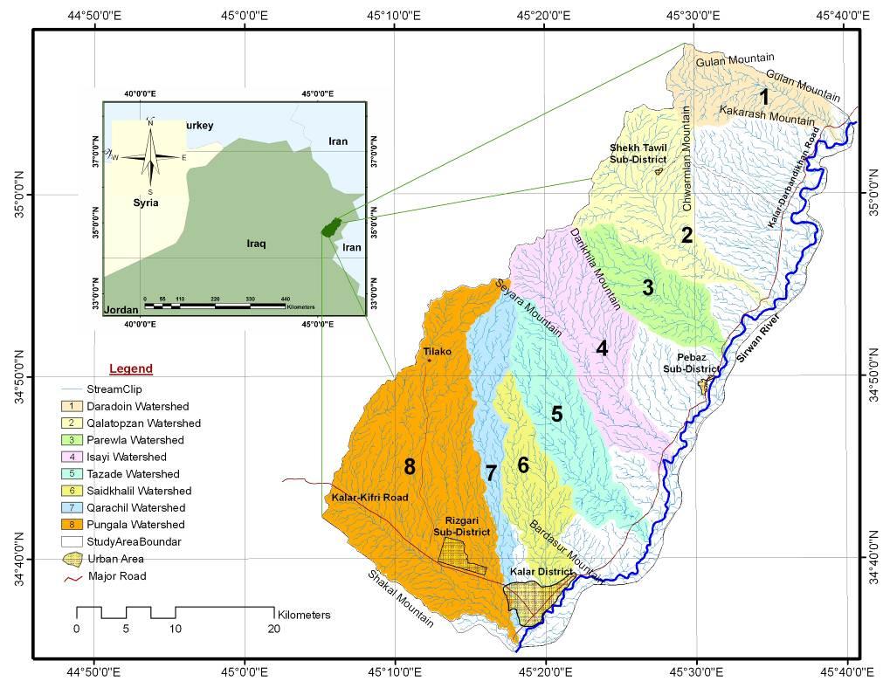

**Figure 1:** Location of the studied area.

The studied area is located within Unstable Shelf represented by Foothill and High Folded Zone which are trending NW-SE. About 3.9% of the of the studied area is located within the High Folded Zone which is characterized by Gulan anticline of high amplitude with Paleogene carbonates (Pilaspi Formation) exposed in their cores. The remainder 96.1% is located within the Foothill Zone that is characterized by long anticlines with Neogene's core and broad synclines containing thick Miocene-Quaternary molasses in which 75% comprises Chamchamal-Butmah (structurally lower blocks) sub-zone and 21.1% consists Hemrrin-Makhul (Kirkuk Embayment) the sub-zone (Figure 2).

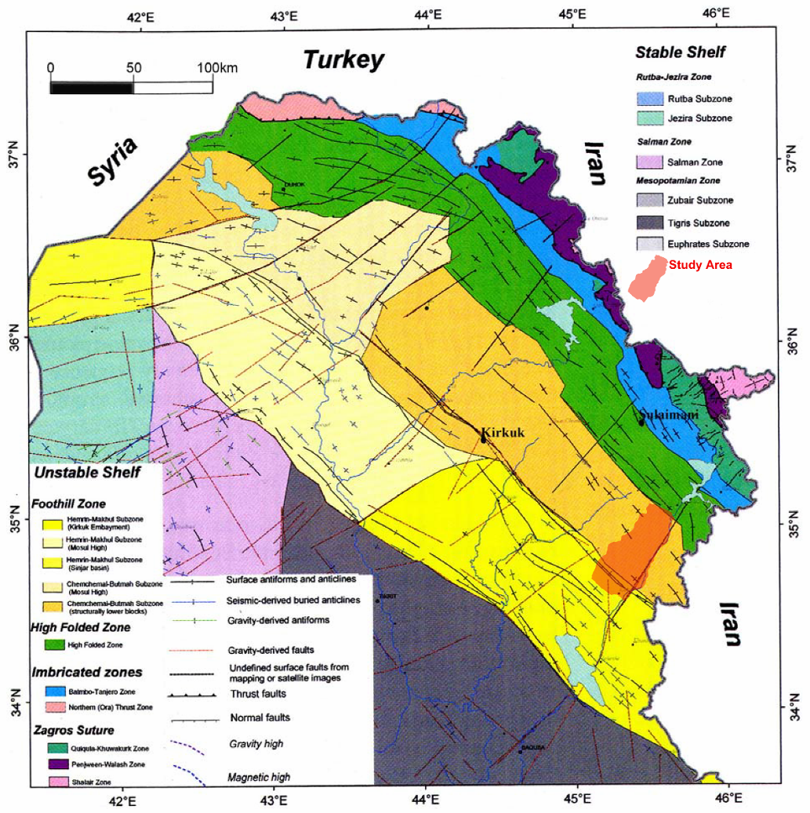

**2.**

**Figure 2:** Tectonic map of Iraq [10].

**3.2. Structure geology**

Several folds form the geological structure of the studied area as a result of the Arabian and Eurasian plate's collision. They extend northwest – southeast parallel with the main axes of the watersheds. These anticlines are separated by broad gently dipping synclines forming wide and expanded plains occupied by the sub-basin of ephemeral streams and agricultural crop lands. These anticlines, from northeast to southeast, are Gulan, Azhdagh, Chamchamal south, Bardasur and Palkhana anticlines (Figure 3).

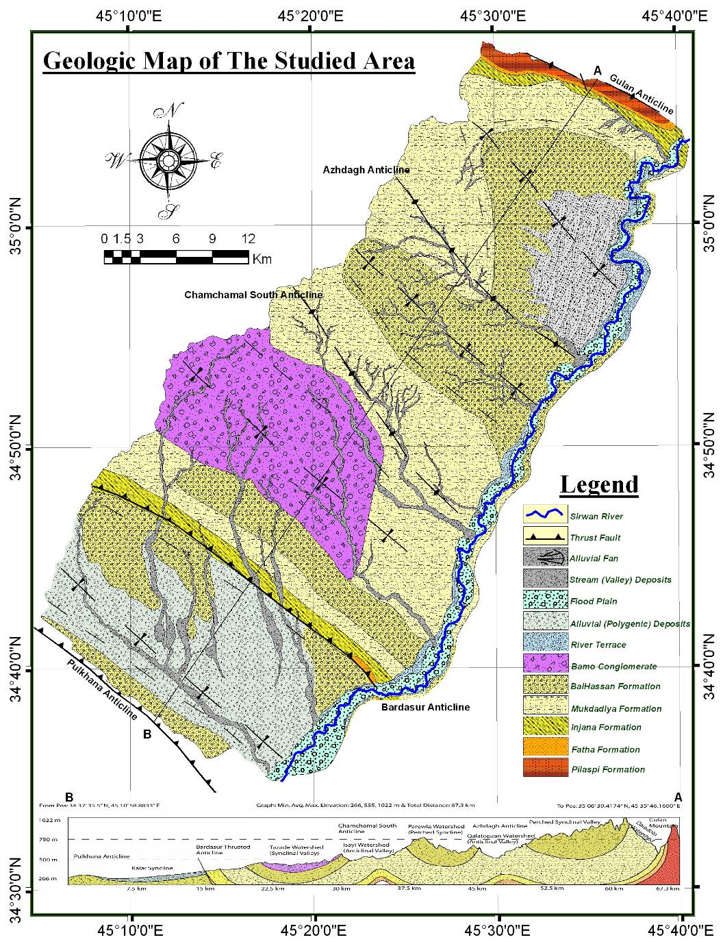

**Figure 3:** Geological map and cross section of the studied area [11,12].

**3.4. Stratigraphy**

The geological formations which crop out in the studied area from the oldest to youngest are Pilaspi, Fat'ha, Injana, Mukdadiya and Bai Hassan Formations and the Recent Deposits as shown in Table 1. They are undulating with the folds oscillation from north to south as shown in Figure 3. The area of the geologic formations that crops out in the studied area is more than the area that is covered by recent or quaternary deposits and most of the formations outcrops are located at the north and western parts of the studied area. This declares that the studied area is subjected to erosion processes more than sedimentation processes especially the mentioned parts and this will be illustrated more within the lithological controlling factor description. These formations and quaternary deposits are listed in Table 1.

**Table 1:** Spatial properties of the geologic units in the studied area.

|  |  |  |  |  |  |
| --- | --- | --- | --- | --- | --- |
| **Formations** | **Age** | **Area (km2)** | **Area %** | | **Thickness (m)** |
| **Pilaspi Fn.** | Middle – Upper Eocene | 15.514 | 0.94 | 57.93 %  Out crops of geologic formations | 265 |
| **Fat'ha Fn.** | Middle Miocene | 6.238 | 0.38 | 215 |
| **Injana Fn.** | Upper Miocene | 59.819 | 3.62 | 583 |
| **Mukdadiya Fn.** | Pliocene | 446.641 | 27.03 | 500 |
| **Bai Hassan Fn.** | Pliocene – Pleistocene | 428.950 | 25.96 | 580 |
| **Polygenetic Deposits** | Quaternary | 217.205 | 13.14 | 42.07  Quaternary deposits | 174.91 |
| **River Terraces** | Quaternary | 23.078 | 1.40 | 3 to 14 |
| **Bajada Deposits** | Quaternary | 78.064 | 4.72 |  |
| **Stream Deposits** | Quaternary | 88.198 | 5.34 | 3 to 5 |
| **Bamo Conglomerates** | Quaternary | 203.866 | 12.34 | 65.18 |
| **Sirwan River Flood Plain** | Quaternary | 85.044 | 5.15 | 3 to 5 |
| **Total** |  | 1652.6 | 100 | 100 |  |

**3.5. Lithology and Topography**

It is clear from the geological formations of the studied area; all the rocks that appear and crop out are sedimentary rocks. They are of two types; clastic and non-clastic sedimentary rocks. According to [13,14], sedimentary rocks vary greatly in their ability to resist weathering and erosion. Clastic sedimentary rocks cover more than 99% of the studied area and are represented by different types of conglomerate, sandstone, siltstone and claystone which comprise the lithology of Fat'ha, Injana, Mukdadiya and Bai Hassan Formations with Quaternary deposits (Figure 4). Non clastic sedimentary rocks are of bio-chemical origins that cover less than 1% of the studied area. They include well bedded, highly fractured lagoonal limestone of Pilaspi Formation and evaporatic bed rocks of gypsum with thickness of 5 m that belong to the lower part of Fat'ha Formation at the northern part of the studied area. The gypsum bed rocks has local effects on geomorphology of the studied area in contrast to limestone beds, due to its very small spatial representation relative to the other bed rocks that are covering the studied area. Hence its effect will be within the valley scale in contrast to limestone, which is forming a huge landscape of very high and long mountain ridge of Gulan anticline.

The clastic sedimentary rocks are responsible for the formation of most of the landforms in the studied area that are located in south of the Gulan mountain ridge. They form Pulkana, Qarachil, Saidkhalil, Tazade, Isayi, Parewla, Qalatopzan watersheds with the southern part of Daradoin watershed. They form many mountain ridges in the region like Shakal Mountain at the south and Seyara, Dari Khila and Chwarmilan mountains at the western side.

It can be noted that the unconsolidated deposits are occupying the low lands and main stream with river valleys, due to very gentle slope of these lands that cause a decrease of velocity and power function of the surface runoff to erosion. Hence the sedimentation (aggradations) processes are prevailing and predominating the erosional (degradation) processes.

This means that the topography of the studied area is greatly influenced by lithologic characteristics of the geologic units. The above lithologic variations, in addition to its influence on ground surface of the studied area geomorphologically in forming landscapes; it also has a great influence in forming the landforms, due to variation in response of rock layers to erosional processes and it causes differential erosion. In this perspective, rocks are often referred to as ‘hard’ or ‘resistant’ or ‘weak’ and ‘non-resistant’ to erosional processes. As a consequence to that the sedimentary rocks in the studied area have been classified on the basis of the description of the sedimentary rocks response to erosional processes that was made by [13] as shown in Table 2.

In addition to types of rock, particle size and rock composition, also permeability is an important property in shaping weathering because it determines the rate at which water seeps into a rock body and dictates the internal surface area exposed to weathering. According to [15,16], permeability of the bed rock is inversely proportional to the rate of erosion processes. The rock strata of the studied area have been classified depending on permeability. The rock permeability increases parallel to their resistance to erosion. In other words, the rocks response to erosion is inversely proportional to their permeability. Table 2 shows that the erosional process operate in a differentiated way where resistant rocks crop out next to no resistant rocks; as the erosional process proceeds, an uneven surface originates where more resistant rocks, slowly and hardly eroded, stand higher above less resistant rocks, which are eroded more quickly and easily. Gulan anticline consists of hard and resistant rocks forming huge mountain ridge with elevation 1110 m a.s.l extending 10 km along northern part of Daradoin watershed valley. Lithologically Daradoin watershed valley consists of rhythmic alternation of claystone (soft) and sandstone (moderate resistant) at the northern part of the watershed between Gulan Mountain and the main stream valley, whereas the southern part of Daradoin watershed comprises alternation of conglomerate, sandstone and claystone with increase of conglomerate (moderate hard) percent southward forming Chwarmilan and Kakarash Mountains. The elevation reaches 1160 m a.s.l. at Chwarmilan Mountain that consists of moderately hard standing resistant conglomerate of Mukdadiya and Bai Hassan Formations.

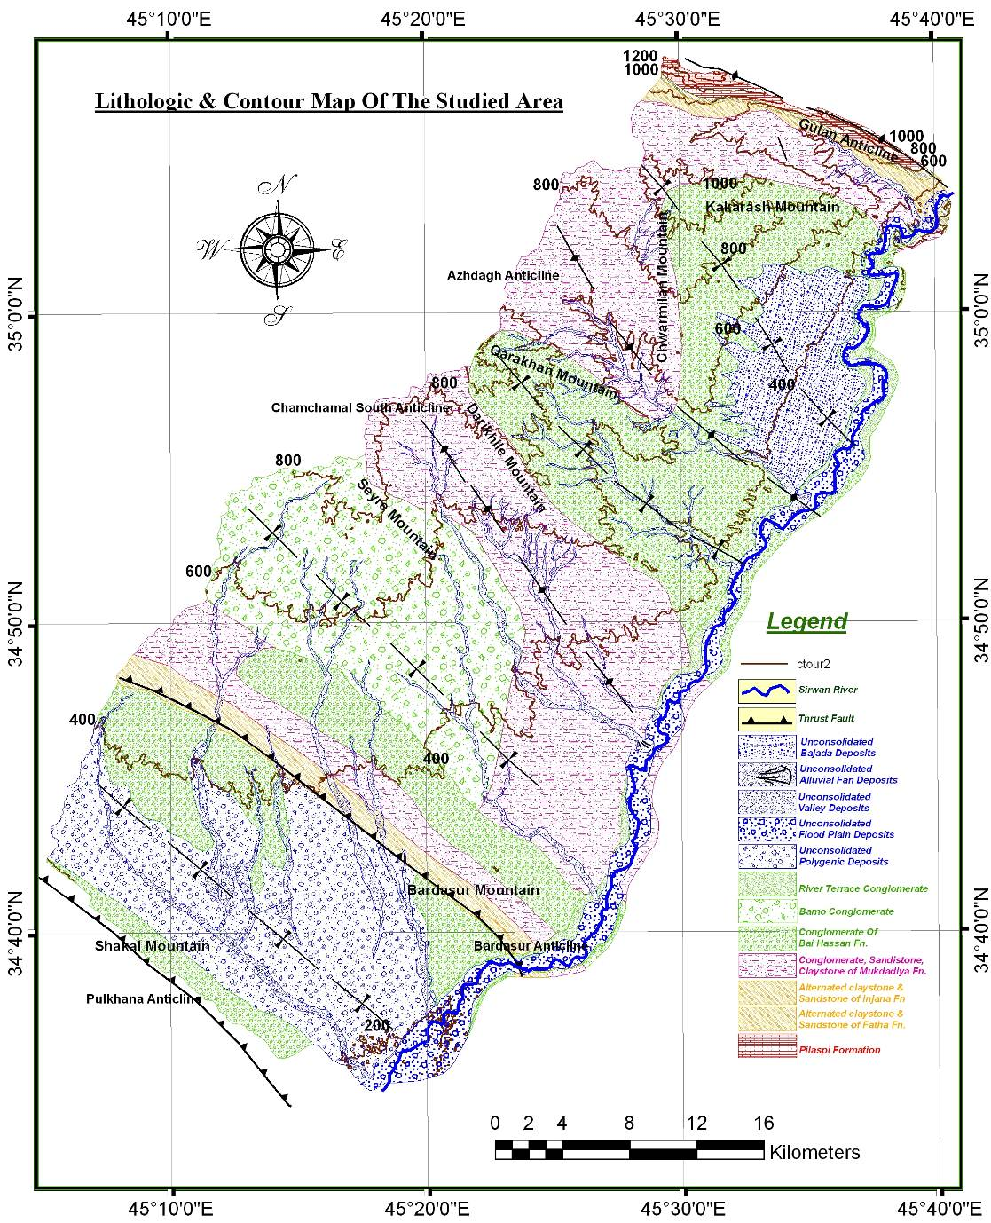

**Figure 4:** Lithologic map of the studied area.

**Table 2:** Classification of the rocks in the studied area based on [13].

|  |  |  |  |  |  |
| --- | --- | --- | --- | --- | --- |
| Types of Sedimentary Rocks | Genetic Classification of Sedimentary Rock | Geologic Units | Sedimentary Rocks Response to Erosion | Permeability range (liters / day / m2) | Sedimentary Rock % |
| Unconsolidated Deposits | Clastic | Polygenic, Bajada, Stream (Valley) and Sirwan Flood Deposits | Weakest | 400,000 – 40,000,000 | 28.35 |
| Claystone, Marlstoe Siltstone, Sandstone | Clastic | Fat'ha and Injana Formations | Weak (little resistant) to Moderate | 0.000004 – 40 | 3.99 |
| Claystone, Sandstone and Conglomerate | Clastic | Mukdadiya Formation | Weak to Moderate Hard | 0.000004 – 4,000 | 27.03 |
| Conglomerate | Clastic | Bai Hassan Formation, River Terraces and Bamo Conglomerate | Moderately hard | ≈ 4,000 | 39.69 |
| Limestone | Non-Clastic (Biochemical) | Pilaspi Formation | Hard | 0.004 – 400 | 0.94 |
| Total |  |  |  |  | 100 |

At Qalatopzan watershed, the southeastern plunge of Azhdagh anticline consists of the alternation of conglomerate, sandstone and claystone of Mukdadiya Formation with increase of course grain conglomerate upward to the flank of the plunge and upper part of the formation that forms Darikhila and Qarakhan mountains. Whereas, Isayi anticlinal watershed consists of alternation of claystone, sandstone and conglomerate with increase of fine grain rock strata toward the core of the anticline that mainly consists of alternation of sandstone and claystone with elevation 350 m.a.s.l while at the flank of the anticline it reaches more than 1100 m a.s.l. at Darikhila mountain, which consists of Bai Hassan conglomerate. The same is true for other part of the studied area at which the conglomerate bed rocks form higher elevated area, whereas claystone and siltstone with clay rich sandstone forming lower elevated area.

As a consequence, the effects of differential erosion are particularly evident on stratified and differently erodible rocks. In this case the result of erosion is the formation of steep, abrupt faces of rock that mark the outcrop of the more resistant layers; the steep faces of a cuesta, the rock terraces of a step like slope or the scarp of a mesa are typical products of differential erosion in the studied area. According to [13,17], the lithologic variation causes differential erosion and produces inverse relief where structural lows occupy high areas (perched syncline) and structural highs occupy low areas (breached anticline). Bardasure, Chamchamal south and southeastern plunges of Azhdagh anticlines are best examples of breached anticline, whereas Lalikhan-Darka area and Parewla watershed are good examples of perched synclines.

**4. Climate**

According to [18], the evolution of any landscape is the result of interactions between the flow of matter and energy entering and moving within its limits and the resistance of the topographical surface. The interrelationships between these factors and their distributions in time and space govern to a great extent the evolution and the present state of drainage-basin topography. Climate controls erosional processes both directly and indirectly. The direct control is exerted by the climate elements; temperature, rainfall and wind that show a wide variability not only from one part to another of our planet, but also within very restricted areas, as for example from one slope to another on the same mountain [17].

The studied area represents the eastern part of Garmiyan area in Kurdistan region between Kalar and Darbandikhan districts. The term (Garmiyan) is a Kurdish word used to denote the hot and dry area in Kurdistan, which describes, indicates and gives information about location and climate:

**4.1. Temperature (T)**

The spatial pattern of annual, winter, and summer temperatures over the studied area mainly depends on latitude and elevation. The distribution of mean annual temperature indicates different thermal conditions due to latitude and altitude. Temperatures are normally pleasantly cool at night in the studied area. The mean annual temperature in Kalar approaches 23 °C, while in Darbandikhan it reaches 21.4 °C (Table 3). There are notable seasonal temperature variations in the studied area at the same station and between them also. These variations are greatest between summer and winter temperatures at the same station and between both of them. These variations are less in spring and autumn at both stations. The range of temperature at Kalar station is greater than Darbandikhan station, because the humidity at Kalar station is less than that of Darbandikhan station, which is due to the presence of Darbandikhan Lake. There are spatial difference of means winter and summer temperatures and it generally declines northwards and increases southwards. The highest month temperature for both meteorological stations is July, while the coldest one is January.

**4.2. Precipitation (P)**

Rainfall is the main feature of precipitation in the studied area, but snow fall also exist along the northern part of the studied area and more exactly at the top of Gulan mountain and the upper part of Daradoin drainage basin (e.g. in Feb. 2012, a layer with few centimeters of snow persisted for two days at Gulan mountain and the upper part of Daradoin stream watershed). It can also be observed that mean annual precipitation increases gradually northwards (Table 4). Heaviest precipitation takes place at Darbandikhan station. Sometime precipitation is erratic, and a pronounced drought may even extend over two years like that of Kalar in 2006 and 2007.

The general trend lines for both stations shows decline in rainfall. These declines lead to predict future environmental geomorphic change toward more severe aridity especially at southern part of the studied area. The alternation and oscillation between the arid and humid year affect the earth surface [19]. The arid years cause soil dryness that makes it friable, cracking and ready for different types of erosion by precipitation and water flow in the region during the humid years.

**Table 3:** Latitude and elevations of stations under study in studied area and their annual, winter and summer temperatures.

|  |  |  |
| --- | --- | --- |
| **Parameters** | **Meteorological Stations** | |
| **Kalar** | **Darbandikhan** |
| **Latitude** | 34º 37¯ 30═ | 35º 06¯ 38═ |
| **Elevation (m) a.s.l.** | 220 | 560 |
| **Mean Annual Temperature (oC)** | 22.98 | 21.4 |
| **Mean Winter Temperature (oC) (Dec.-Feb.)** | 10.18 | 10.14 |
| **Mean Summer Temperature (Jun.-Aug.)** | 35.297 | 33.167 |
| **Mean Annual Range Temperature (oC)** | 13.418 | 10.977 |

**Table 4:** Mean monthly rainfall at the studied area

|  |  |  |  |  |
| --- | --- | --- | --- | --- |
| **Mean Monthly Rainfall (mm)** | | | | |
| **Month** | **Darbandikhan Station**  **(1957-2009)** | **%** | **Kalar Station**  **(1995-2009)** | **%** |
| September | 0.39 | 0.06 | 0.09 | 0.03 |
| October | 21.79 | 3.27 | 8.97 | 3.11 |
| November | 79.50 | 11.92 | 26.69 | 9.25 |
| December | 109.35 | 16.40 | 52.06 | 18.05 |
| January | 124.35 | 18.65 | 77.97 | 27.03 |
| February | 123.14 | 18.47 | 50.72 | 17.58 |
| March | 106.54 | 15.98 | 39.41 | 13.66 |
| April | 71.44 | 10.71 | 27.31 | 9.47 |
| May | 29.73 | 4.46 | 5.23 | 1.81 |
| June | 0.60 | 0.09 | 0.00 | 0.00 |
| July | 0.00 | 0.00 | 0.00 | 0.00 |
| August | 0.00 | 0.00 | 0.00 | 0.00 |
| **Mean Annual** | **666.82** |  | **288.45** |  |

In general, the studied area is characterized by absence of rainfall in summer (June, July and August) except few rainy years. Total precipitation decrease toward the south. More than half percent of the annual precipitation falls during winter at both stations which is followed by spring and autumn respectively. Summer is considered as the driest season in the year in both stations (Figure 5). Therefore, it can be concluded that there are great spatial and temporal variations of climatic characteristics. These variations affect the land surface specially in preparing soil to weathering and erosion by the alternation of the seasons with variable climatic characteristics. In summer, the dry and hot climate make the land surface specially soil friable, highly porous and ready for erosion. While during the autumn and beginning of winter the soil become saturated with water and ready to be eroded at the end of winter and during spring because during this period precipitation shows irregular manner where it oscillate between intense and slight precipitation. The behavior of annual, seasonal and monthly precipitation gives an idea and indications to variations between northern and southern parts of the studied area and reoccurrence of rain storms and it reflected on the behavior flow of streams. Most of the floods occur at northern part due to climate controlling factors. Therefore, it can be concluded that the northern part is subjected to intense erosion more relative to the southern part.



**Figure 5**: Mean seasonal percent of rainfall at the studied area

**5. Geomorphology**

**5.1. Main Geomorphologic Processes**

Landforms act as witnesses for telling the past and present geomorphological processes that are governing their creation and development now and in past geological time. In 2009, [20] stated that throughout the youngest geological history the geomorphological processes were mutually interchanging, prevailing in relief modification. Nowadays, almost all of them are still active with different intensities creating recent relief. According to [21], the northern part of Iraq, geomorphologically, is characterized by three major types of terrain: mountainous ranges, foothill pediments and alluvial plains. The most important geomorphological processes that create the landscapes and landforms in the studied area include:

**A. Uplifting**

The studied area, which was a part of Zagros Foreland Basin, uplifted to ground surface due to continuous collision of Arabian and Eurasian plates. According to [4] Mukdadiya Formation is a growth strata unit that records uplift and denudation of the fold and thrust belt in the Plio-Pleistocene. Therefore, all parts of the studied area appeared on the ground surface at the beginning of Pleistocene.

**B. Folding, Faulting and Jointing**

Many landscapes and geologic structures have been formed, in the studied area, due to uplifting and shortening of Zagros mountain that caused by the Arabian and Eurasian collision. As a result several anticlines have been raised in the area, which are oscillating with rhythmic alternation from northeast to southwest and they are Gulan, Azhdagh southeastern plunge, Chamchamal south, Bardasur and Pulkhanah anticlines. These geologic structures and landscapes reflect the continuity of Alpine orogeny. Average fold wavelengths are on the order of 13 km with amplitudes ranging from 400–1100 m. As the folds are eroded, their physiography is controlled by variations in the resistance of different sedimentary strata.

There are many types of folds in the studied area. Gulan, Azhdagh southeastern plunge and Chamchamal south anticlines are asymmetrical anticlines separated by broad asymmetrical synclines. Whereas Bardasur and Pulkhanah anticlines are thrusted, breached and asymmetrical anticlines, separated by Kalar broad syncline and their southwestern limbs are steeper than the northeastern limb because the northeastern limb is thrusted over the southwestern limb, which associated with less distinctive scarp and marked by spring along thrusted fault. In addition to thrust faults, which show structural deformation of the studied area, joints and fractures of the bed rocks also show that deformations. These joints are restricted to limestone and sandstone bed rocks of Pilaspi, Fat'ha, Injana and Mukdadiya Formations. The intersection of joint sets, nonsystematic fractures and bedding planes causes rock fall, toppling and sliding at northern and southern parts of the studied area (Figure 6).

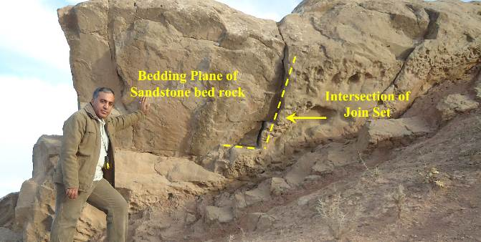

**Figure 6:** Intersection of joint sets and bedding planes of sandstone bed.

A dense pattern of closely spaced joints within well bedded limestone, of Pilaspi Formation at northern part, hastens chemical weathering, leaving upstanding areas where joints are more widely spaced. Also it aids frost wedging and causes creation of talus and debris cones along Gulan mountain slopes. While joint sets within sandstone beds are widely spaced relative to that of limestone beds; therefore, they have less effect on chemical and physical weathering within sandstone bed rocks.

**C. Fluvial Geomorphological Processes**

The fluvial geomorphological processes of the studied area include erosional and depositional processes. According to [22], stream and river flow represent the powerful agent of erosion, transportation and deposition of the ground surface materials. Stream channel within the watersheds usually grow in size and complexity in a downstream direction. This reflects the spatial variation of fluvial erosional processes within the studied area. Fluvial geomorphic processes affect the ground surface during the wet seasons, winter and spring, and fluvial degradation process reaches its maximum power in the studied area. Fluvial erosional power of the streams vary spatially in three directions; vertically, longitudinally and laterally within the watersheds in the studied area. The upper reaches of the stream are steep-sided, valleys narrowly V-shaped because stream water erodes the channels vertically and longitudinally, whereas at the middle reaches of the watersheds valleys are U-shaped due to dominance of lateral and vertical stream erosional processes, whereas the lower reaches of the watersheds valleys are broadly U-shaped because stream water erodes the channels laterally especially during wet seasons. The lateral stream erosion increases with deceasing of slope. Slope decreases toward east and southeastern parts of the studied area. This variation in slope causes transition from erosional landforms to depositional landforms like deposition of stream deposits or valley fills, alluvial fans at the watersheds outlets and bajada landforms. Along Sirwan river course other types of fluvial landforms appear, such as stream meandering, deposition of river terraces and flood plains.

**D. Karstification Processes**

Karstifcation is one of the common geomorphological processes that occupying the northern part of the studied area. According to [20], Alpine folding and uplifting of mountains built of carbonate rocks in Kurdistan region caused stronger penetration of surface water to underground. The reason belongs to many factors that collectively caused existence of this process at this part of the studied area; first the presence of soluble carbonate rock strata represented by the thick, well bedded, highly fractured and jointed Eocene limestone of Pilaspi Formation; second is having a good climatic condition at this part of the studied area which is characterized by high annual rate of precipitation and causes dissolution of the Pilaspi limestone; and third is the high percent of joints and fractures within Pilaspi limestone act as pathway for water percolation and movement within it to form a kastic feature. Karstification of Pilaspi limestone leaves distinctive karstic features like caves, lapis and small pits (Figure 7).

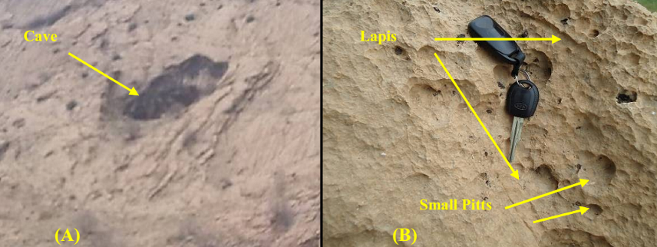

**Figure 7:** Karstification in Gulan Anticline by dissolution forming; (A) Cave (B) Lapis and small pits by rain drops.

**E. Weathering**

According to Allen and [13,22,23,24,25] the driving forces of weathering are solar energy and earth internal energy. There are many factors affecting the rate of weathering such as surface area, climate, parent material, presence of plants and animals and topography.

All types of weathering are playing important role in shaping and evolutions of earth surface at the studied area ; first **mechanical weathering** that includes pressure release fracturing, frost wedging and thermal expansion and contraction which are causes debris cones and talus accumulation along at Gulan anticline where well bedded and highly jointed and fractured limestone crops out. The rocks along the streams are rounded and smooth with removing angularity and roughness by abrasion process. Second is **organic weathering**, which includes plant (tree roots) weathering and human activity which include landforms produced by excavation, road cutting and quarrying along Sirwan River in the studied area (Figure 8). Third is **chemical weathering**, which comprises dissolution, hydrolysis, and oxidation.

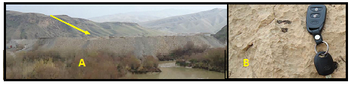

**Figure 8:** (A) Quarry excavation and (B) Chemical weathering formed by dissolution.

Also the results show the spatial variation of the weathering processes from northern to southern part of the studied area depending on the spatial variation of temperature and rainfall. Hence the northern part is subjected to chemical weathering more than the southern part which is subjected to more mechanical weathering relative to chemical weathering (Figure 9).

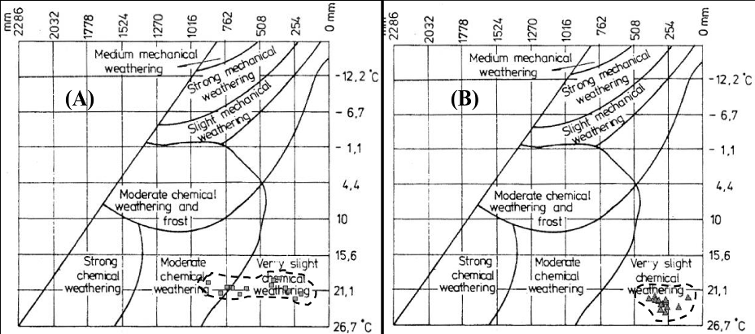

**Figure 9:** Morphogenic classification for both meteorological Stations depending on [26].(A) Darbandikhan and (B) Kalar.

All the rock types, which are forming the lithology of the studied area, are sedimentary rocks and include limestone, gypsum, marlstone, claystone, siltstone, sandstone and conglomerate. They had been folded into anticlines and synclines. They have uniformly gentle to steep dips. This variation in the lithologic properties represented by alternation of weak and resistant bed rocks, with continuous climate action over time, causing topographic variation in the studied area. The relative resistance of a rock to weathering is a function of lithology and its nature along with the climatic conditions over time that it is exposed to [22]. The well bedded and thick limestone bed rocks of Pilaspi Formation and conglomerate bed rocks of Mukdadiya and Bai Hassan Formations that are resistant to weathering and erosion tend to stand above their surroundings and form Gulan, Chwarmilan, Kakarash, Darikhila, Bardasur and Shakal Mountains in the studied area from northern part to southern part. Therefore, nearly, the rocks characteristics which form high relief and steep slopes landform are resistant to weathering and erosion in the studied area as shown in Figure 10. The differential weathering and erosion of moderate resistant sandstone bed rocks, alternating with weak siltstone and claystone, stand out and produce cliffs, cuesta and hogback landforms. The weak claystone and siltstone bed rocks undergo greater weathering and erosion to form gentler slopes, valleys, and subdued hills (Figure 11). As a whole differential weathering and erosion processes is responsible for the formation of anticlinal hills, cuestas, and hogbacks landforms in association with folded beds. It also has a strong influence on the courses of stream and patterns of drainage system.

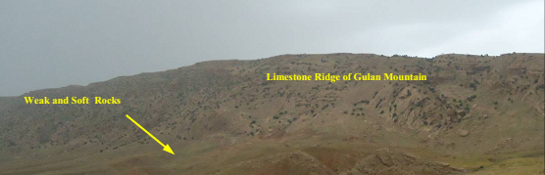

**Figure (10):** Limestone ridge of Gulan mountain.

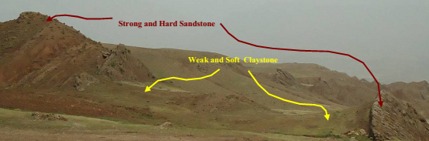

**Figure 11:** Formation of hogback and cuesta by differential weathering.

**F. Mass Wasting**

The most common types of mass wasting in the studied area are; rock falls, toppling, sliding, wedge sliding, slumping and mud flow:

**Rock Fall:** Rock fall is a very common type of mass wasting in the studied area. Movements are very rapid and may not be preceded by minor movements. The rocks or rock fragments involved in rock falls vary in sizes from tiny granular particles skittering down slope to huge boulder bounding downhill and accumulate as scree. Cone of debris and talus slope like that occur down slope of Gulan Mountain at northern part of the studied area. The crest of cuesta, hogback, and ridges landforms within out crops of Fat'ha, Injana and Mukdadiya Formations with river terrace deposits along Sirwan River, subject to breakdown away, under the influence of gravitational force when the sizes and weight of the towering ridges increase. This type of process also exists along Gulan Mountain. The highly intersected fissures, fractures, joints and bedding planes of Pilaspi limestone form rock fragments of varies sizes that they fall if they are triggered by a change in climatic elements (temperature and precipitation) and human activities.

**Toppling:** The spatial distribution of toppled rock masses is related to spatial distribution of Pilaspi, Fat'ha, Injana and Fat'ha Formations with River Terraces deposits outcrops, as in rock fall, because most of the toppled rock masses consist of sandstone and conglomerate rock fragments toppling on anti-dip slope surfaces of weak resistance claystone and siltstone strata.

**Sliding:** It occurs within the well stratified bed rocks of Fat'ha, Injana and Mukdadiya Formations in the studied area. Well bedded limestone of Pilaspi Formation intersection with joint sets and fractures, lead to detachment and sliding of rock blocks over the stable bed rocks at southwestern limb of Gulan anticline. Majority of the landslide triggering mechanisms is related to hydrological triggering, induced by precipitation and human activities. Rock slides also take places over the dip slopes surfaces of rock strata within Fat'ha, Injana and Mukdadiya Formations. The undercutting weak and soft erodable claystone and siltstone bed rocks by streams erosion cause detachments of rock blocks and sliding downward.

**Slumping:** This type of mass wasting occurs within Bai Hassan Formation and soil layers in the studied area. The slopes, along Kalar – Darbandikhan high way, had been graduated and stepped artificially to increase its stability. The stepped slopes had been slumped down slopes forming irregular fracture surface along the slope’s trend.

**5.2. Main Geomorphological Units**

The main geomorphological Units which have been recognized in the studied area are units of structural origin, units of denudational, fluvial, solution and anthropogenic origins as shown in Figure 12.

**A. Units of Structural Origin**

The tectonic and structural setting affected the spatial distribution of the landform associated with them in the studied area. Most of the landforms which are associated with the flat bed appear at the southern part, while the landforms which are associated folded and faulted structures appear at the northern part due to decrease of structural deformation southward. Folding, faulting, and jointing of rocks creates many large and small landforms:

* **Breached Anticlines**

Breached anticline is formed when the crest of an anticline is subject to erosion. This landform appears at the core of the Bardasur anticline represented by clastic sedimentary beds (alternation of sandstone, red siltstone and claystone) of Fat'ha Formation. Topographically, it has low elevation relative to the surrounding beds due to occurrence of extensive deformation at the crest of the fold. The older rocks that forms the core are of lower resistance to erosion relative to the surrounding bed rocks.

* **Homoclinal Ridge or Strike Ridge**

It is formed due to folding of the geological structures and down cutting of less resistant rocks which are represented by siltstone and claystone of Fat'ha, Injana and Mukdadiya Formations with a dip between 5º to more than 35º. It exists at the southern flank of Gulan anticline, upper part of Qalatopza watershed and core of Chamchamal south anticline. It includes:

* **Cuesta:** It occurs nearly at all the parts of the studied area formed within the bed rocks of Injana and Mukdadiya Formations at northeastern limb of Bardasur anticline and trough of Isayi syncline. The steep front slope is opposite to the dip, whereas the gently sloping is more or less parallel to the dip. The cap rock of the cuesta and the dip slope are built of more resistant strata of sandstone and conglomerate which are forming the ridges, while less resistant ones are exposed in the anti-dip slope represented by calystone. Because of contrasting slope and lithology, each side of a cuesta is shaped by different sets of processes. Rapid mass movement and gully erosion predominate on the steeper slope. Fluvial incision and slow mass movement operate on the dip slope. In the long term, a cuesta retreats and is worn down.
* **Hogback:** They are formed as a result of differential weathering and erosion over time of alternating hard and soft sedimentary rocks. They mainly occupy the northern and middle parts due to severe folding and erosion processes relative to the other parts. At the northern part, they run along the dip of the strata within the southwestern limbs of Gulan Anticline where the strata of Fat'ha, Injana and Mukdadiya Formations crops out. While at the middle part, where Azhdagh Anticline plunge, they developed within the alternating strata of Mukdadiya Formation.
* **Flatirons:** They produced by differential weathering of clastic sedimentary rocks and regularly spaced streams cutting into a dip slope or ridge (especially a cuesta or hogback), where strata of differing resistance alternating (claystone, siltstone and sandstneare). They occur along Gulan anticline at the northern part and Bardasur anticline at the southern part of the studied area where weak and resistance rock strata are alternating and causing differential weathering and the joints accelerate the process.
* **Strike Valleys**

In the studied area most of the main streams commonly develop along the strike, where a sequence of tilted strata of different resistance represented by claystone, siltstone, gypsum, sandstone, conglomerate, marlstone and limestone crop out. These strike streams are separated by strike ridges. Therefore, all of the watersheds in the studied area are extended along strike valleys and ridges with elongate shape due the above reason.

* **Landforms Associated With Fault**

In the studied area fault scarps are of two types which are thrust fault scarps and transverse fault scarp, because they are associated with two present types of fault; Bardasur and Palkhana or Shakal thrust faults and Sirwan Transverse Fault. Thrust fault scarp formed along of the face of the up thrown block and overlooking the downthrown block or southward. Erosion may remove all trace of a fault scarp but, providing that the rocks on either side of the fault line differ in hardness, the position of the fault is likely to be preserved by differential erosion. The erosion may produce a new scarp. Rather than being a fault scarp, this new landform is more correctly called a fault line scarp, while the strike slip fault is extending from northeast to southeast along Sirwan river course.

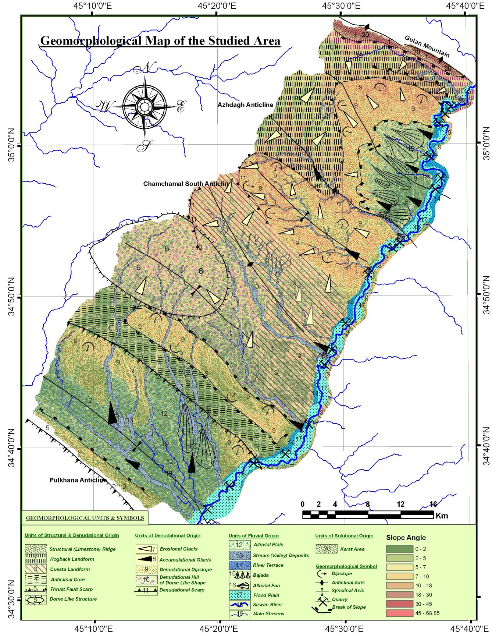

**Figure 12:** Geomorphological map of the studied area.

**B. Units of Denudational Origin**

This process is playing an important role in creation of two specific types of landforms which are:

**Erosional Glacis**

These landforms truncate weak materials such as poorly indurated Tertiary sediments in the studied area, and tend to be veneered by alluvial gravels, indicating the importance of fluvial processes in their creation. This land form is extending along the ridges and hills, forming the out crops of the formations at anti-dip slopes, front slopes, scarps and cliffs. It also represents the creep slope, fall face and trasportational mid-slope units of hillslope. This landform is distinctive at the northern part more than southern part of the studied area, due to more climatic effect and tectonic deformation northward. The tectonic deformations caused uplifting, folding, increasing of slope steepness and leading to increase the velocity of flowing water produced by intense and heavily rainfall in this part of the studied area and finally when uplift prevails relief increases, and as a consequence erosion rate is faster.

**Depositional Glacis**

Gravitational and fluid forces play important roles in moving eroded material down slope. They are well developed on the foot slope and toe slope units of hillslopes and flanks of ridges all over the studied area by accumulation and deposition of eroded glacis. They are wide spread landforms mantling lower slope, which consist of truncated weak materials derived from tertiary formations in the studied area such as talus slope (scree), talus cone, mass wasting materials in the northern part and alluvium deposits at the southern part. The glacis long profiles range from nearly rectilinear to concave; the latter form having a slope of about 10 degrees at the top, dropping to about 3 degrees or less at the base. The lithology of this landform characterized by bad sorting angular sediment consists of a wide range of grain sizes ranging from clay size to boulder size. The widespread distribution of glacis across areas of different structural setting also rules out neotectonic as a major factor in their formation.

**C. Units of Fluvial Origin**

There are two types of fluvial landforms in the studied area that are shaped by water and including fluvial erosional and fluvial depositional landforms:

**Fluvial Erosional Landforms**

The action of flowing water cuts rills, gullies, and river channels into the land surface. These landforms spread out all over the studied area with variable morphologic characteristic due to spatial variation of geologic, topographic, climatic and vegetation characteristics. They occupy the upper parts of the watersheds which developed by head cutting and deepening fluvial processes in the studied area. The bedrock channels are eroded into the limestone, gypsum, marlstone claystone, sandstone and conglomerate beds of rocks at the upper course of the streams and Sirwan river, forming V-shape valleys in the rocks especially in claystone and siltstone. This is so, because they are less resistant rocks to erosion. Hence the bedrock channels cut into bedrock in their upper reaches, where gradients are steep and their loads coarser. Tuni Bawa Umra valleys are erosional landform that formed within the inclined conglomerate bed rocks of Bai Hassan Formation in the studied area.

The alluvial channels, in all of the streams of the studied area, form sediments that have been transported by flowing water in the streams during the wet periods. They are very diverse owing to the variability in the predominant grain size of the alluvium, which ranges from clay to boulders. In plain view, alluvial channels display many forms representing graded straight, meandering and braided. All of the main streams in the studied area consist of straight channels. Their sinuosity are ranging from 1 – 1.15. Whereas meandering channels landforms are distinctive along Sirwan River channel as appears in satellite image and its sinuosity is 1.41. The flow pattern encourages erosion and undercutting of banks on the outside of bends and deposition, and the formation of point bars on the inside of bends. Point bars, riffles, cut banks and pools are characteristic features of both sinuous and meandering channels. The degree of meandering or sinuosity of Sirwan River is greater than that of other streams because rivers of very old geologic age have exhausted much of their erosive power. Sirwan river within the middle and lower reaches of the main streams are braided which characterized by numerous bars scattered throughout the channel and forming islands. The islands support vegetation like shrub and grass.

**Fluvial Deposional Landforms**

The capacity and competence of a stream to carry material depend primarily on flow velocity. This means that a decrease in velocity will cause a stream to reduce its load through deposition creating fluvial deposional landforms and include:

* **River Terraces:** According to [10], these river terraces belong to Pleistocene age and they are often restricted to narrow valleys. More than one level of river terraces can be found along Sirwan river valley at eastern part of the studied area that indicating different erosion stages. The highest river terrace extends for a considerable distance from the present day river course. They are forming nearly 23.078km2.
* **Floodplains:** They appear distinctively along Sirwan River and some location along the other streams at lower reach of the watersheds. This type of landform is forming 85.044 km2 of the studied area.
* **Alluvial Fans:** These landforms appear at the mouths of the main stream channels in the studied area, like alluvial fans which are created at the outlets of Daradoin, Qalatobzan, and Qarachil streams, where the steep slopes change to gentle slope. The alluvial deposits radiate from the fan apex and cut into the fan. They range greatly in size. They can be seen on satellite images which have been mapped. The coalition of alluvial fans at northern and southern parts of the studied area caused creation of another landform called bajada. Bajada landforms can be seen easily at both northern and southern parts. The recent and Pleistocene alluvial fans are the main indications that prove the finger print of climate change in the studied area
* **Valley Fill (Stream Deposits):** This type of landform is forming the lower reach of the watershed filling the main stream and Sirwan River channels. The forms are riffle, pool and bars. These landforms are distinctive along Sirwan River. They developed from the erosional deposits, mainly gravels which are derived from the rock strata of Mukdadiya, and Bai Hassan Formations that covering most of the watersheds. Their thickness varies in the study region. It is forming more than 5% of the studied area.

**D. Units of Solutional Origin**

This type of landform includes small cave, pits and lapis which are formed by karstification of Pilaspi limestone along Gulan anticline at the northern part.

**E. Units of Anthropogenic Origin**

They include landforms produced by excavation (e.g. road cuttings, and quarries) and farming. There has been a significant and visible anthropogenic increase in the excavation, quarrying and mobilization of sediments through fluvial processes along Sirwan river. Anthropogenic activities along the river cause creation of erosional and depositional landforms by quarrying and stream deposits extraction. Erosional landforms include excavated quarries and pools, while depositional landforms include huge gravel sediments accumulation around the quarries and creating rounded hills.

**5.3. Slope**

Watershed morphology and drainage density are strongly influenced by hillslope processes. The structure of catchment topography depends, to a large extent, on the interaction between hillslope and channel processes [27]. Normally, the higher the slope, the greater will be the run off speed with least percolation [28] and it causes more powerful geomorphic processes and increases the rate of bed rock channel incision. Slope angle, in the studied area (Figure 12), has been classified into seven classes on the bases of slope classification proposed by [29] which are illustrated in Table 5:

* The first class, level to very gentle slope, is forming 27.74 % of the studied area which occupies the lower and middle reaches of Pungala, Qarachil, Saidkhalil, Tazade and Isayi watersheds at southern part and forms low land at northern part. It also forms the lower parts of main stream valleys of Parewla, Qalatopzan and Daradoin watersheds at northern part.
* The second class is gentle slope forming the highest percentage of 36.33 % of the studied area that occupies the middle and upper reaches of Pungala, Qarachil, Saidkhalil, Tazade and Isayi watersheds at southern part and forms middle reach of Darka-lalikhan area at north.
* The third class, moderate slope, comprises 23.25% of the studied area which makes the upper reaches of Pungala, Qarachil, Saidkhalil, Tazade and Isayi watersheds at southern part and Darka-lalikhan area at northen part of the studied area. Also it comprises most of the area of Parewla, Qalatopza and Daradoin watersheds.
* The fourth class, moderately steep slope, makes 10.12 % of the studied area. It forms the slope of upper reaches of Parewla, Qalatopzan and Daradoin watersheds, whereas it comprises the upper reach valleys at southern part.
* The fifth, sixth and seventh classes, steep, very steep and vertical slopes, are forming 2.14 %, 0.38 % and 0.04 % of the studied area respectively. These three classes make the slopes of upper reach valleys of Parewla, Qalatopzan and Daradoin watersheds with few valleys at the top of doming area at southwestern part.
* The calculated slopes reveal that very gentle to gentle slopes cover 64.07% of the studied area and moderate to moderate steep slopes cover 33.37%, whereas steep to vertical slopes cover 2.56% of the studied area. The average slope of the studied area is 5.04º.
* The spatial distribution of slope classes reveals that the northern and western parts have been affected by structural geology, which in turn reflect the tectonic situation of the region, because the slope inclination angles increase with increase of relief and structural deformation area north and westward of the studied area and later the differential erosion and weathering act on the surface and rock strata to cause slope development.

**Table 5:** Slope description in studied area depending on [29].

|  |  |  |
| --- | --- | --- |
| Slope Description | Slope Class (Degree) | Area of Each Class (%) |
| Level to Very Gentle | 0 to 2 | 27.742 |
| Gentle | 2 to 5 | 36.330 |
| Moderate | 5 to 10 | 23.252 |
| Moderately Steep | 10 to 18 | 10.121 |
| Steep | 18 to 30 | 2.138 |
| Very Steep | 30 to 45 | 0.376 |
| Precipitous to Vertical | > 45 | 0.042 |

**6. Conclusions**

The present study and analysis leads to the following conclusions:

* The most important factors influencing the geomorphology of the studied area are tectonics, lithology, climate, vegetation and humans.
* The studied area is located within unstable shelf and the High Folded Zone (3.9%) and (96.1 %) located within the Foothill Zone.
* Several folds are forming the geological structure of the studied area as a result of the Arabian and Eurasian plate's collision. These anticlines, from northeast to southeast are Gulan, Azhdagh, Chamchamal south, Bardasur and Palkhana anticlines.
* The geologic formations are forming 57.93% and the Quaternary deposits are forming 42.07%. Clastic and non clastic sedimentary rocks are forming about 99% and 1%. of the total studied area respectively. As a consequence it influences the speed of erosional processes and topography. The northern part is characterizes by high intense folding and high relief, whereas the southern part of the studied area is characterized by broad crest folding and low relief relative to northern part. Therefore, the maximum elevation was observed within Daradoin watershed at crest of Gulan anticline 1806 m a.s.l. and the lowest or minimum elevation observed at the outlet of Pungala watershed.
* The main endogenic process is uplifting of western and northwestern sides due to continuous collision of Arabian and Eurasian plates. Whereas the main exogenic processes include weathering, erosion, fluvial, hillslope processes karstification and anthropogenic processes which are responsible for final stage of painting and shaping the ground surface.
* The results of morphogenic classification show that the northern part subjects to chemical weathering relatively more than southern part and vice versa.
* As a whole differential weathering and erosion processes is responsible for the formation of anticlinal hills, cuestas, and hogbacks landforms in association with folded beds.
* The intensity of hillslope processes increases with high relief characteristics.
* Karstifcation is occupying the northern part of the studied area. Due existence of soluble carbonate rock strata, high annual rate of precipitation and high percent of joints and fractures within Pilaspi limestone.
* The main geomorphologic landforms, which have been recognized, are structural, denudational, fluvial and solutional geomorphologic landforms.
* The structural landforms are breached anticline, scarp, dip slope, back slope, homoclinal ridge, strike valley, cuesta, hogback, flat iron, fold and valleys with fault scarp.
* Denudational landforms are erosional and depositional glacis.
* Fluvial landforms include erosional and depositional landforms. Erosional landforms are rills, gullies, bed rock channels and valleys. Whereas depositional landforms are river terraces, flood plains, alluvial fans and stream deposits.
* Anthropogenic landforms produced by excavation by road cuttings, quarrying and farming.
* The geomorphic landforms indicate propagation of deformation from northeast to southwest.

|  |
| --- |
| **References** |

[1] Horton, R. E., 1945, Erosional Development of Streams and Their Drainage Basins Hydrophysical Approach to Quantitative Morphology, Geological Society of America Bulletin, No. 56: 275–370.

[2] Pavlopoulos K., Evelpidou N. and Vassilopoulos A., 2009, Mapping Geomorphological Environments, Springer, London, 236.

[3] Burrough P.A., van Gaans P. F. M., MacMillan R.A., 2000, High Resolution Landform Classification Using Fuzzy-k Means, Fuzzy Sets and Systems Vol.113, p37-52.

[4] DeVera J., Gines J., Oehlers M., McClay K. and Doski J., 2009, Structure of the Zagros fold and thrust belt in the Kurdistan Region-northern Iraq, jour. of Trabajos de Geología, Universidad de Oviedo, Vol. 29, P 213-217.

[5]Tucker G. E. and Bras R. L., 1998, Hillslope processes, drainage density, and landscape morphology, Water Resource Research, Vol. 34, No. 10, p 2751–2764.

[6] Bartl N., Grasemann B., Faber R. and D. Lockhart, 2009, Tectonic geomorphology of the Safeen Anticline (Northern Iraq), Geophysical Research Abstracts, Vol. 11, EGU2009-7626, EGU General Assembly.

[7] Ziegler M. A., 2001, Late Permian to Holocene Paleofacies Evolution of the Arabian Plate and its Hydrocarbon Occurrences, Gulf PetroLink Bahrain, GeoArabia, Vol. 6, No. 3, 60p.

[8] Fakhari M. D., Axen G. J., Horton B. K., Hassanzadeh J., Amini A., 2008, Revised age of proximal deposits in the Zagros foreland basin and implications for Cenozoic evolution of the High Zagros, Elsevier B.V., Tectonophysics, Tectonophysics, doi:10.1016/j.tecto.2007.11.064

[9] Berberian M. and King G. C. P., 1981, Towards a paleogeography and tectonic evolution of Iran, Can Jour. Earth Sci., No. 18, P210–265.

[10] Jassim, S. Z, and Goff, J. C., 2006, Geology of Iraq, First edition, Dolin, Prague and Moravian Museum, Brno, Czech Republic, 341p.

[11] Sissakian, V. K., 1993, Geological Map of Iraq, Sheets No.i-38-7, Scale 1:250000, 1st edt. GEOSURV, Baghdad, Iraq.

[12] Sissakian, V. K., 2000, Geological Map of Iraq, Sheets No.1, Scale 1:1000000, 3rd edt. GEOSURV, Baghdad, Iraq.

[13] Huggett R., 2007, Fundamentals of Geomorphology, 2nd edn, Routledge, London, 483p

[14] Howard A. D, 1997, Badland Morphology and Evolution: Interpretation Using a Simulation Model, John Wiley & Sons, Ltd, Earth Surface Processes and Landforms and , Vol. 22, 211–227 (1997)

[15] Bell F. G., 2007, Engineering Geology, 2nd Edition, Elsevier Ltd., AMSTERDAM, BOSTON, 593 p.

[16] Mengler F.C., 2008, Gully Erosion on Rehabilitated Bauxite Mine, Unpublished M.Sc. Thesis, University of Western Australia.

[17] Goudie A.S.(editor), 2004, Encyclopedia of Geomorphology, Routledge Ltd, Vol. 2.

[18] Zavoianu I., 1985, Morphometry of Drainage Basin, Elsevier, Amsterdam - Oxford - New York, 251pp

[19] Anab R., 2006, Evaluation the risk of erosion in Timgad basin and its impact on Koudiet M'douar Dam – Multi-criterion approaches, unpublished M.Sc. thesis, Department of Geology – College of Science, University of Aqeed Alhaj Lkhdhir – Algeria Republic.

[20] Stevanovic Z., Iurkiewicz A. and Maran A., 2009, New Insights Into Karst and Caves of Northwestern Zagros (Northern Iraq), Acta Carsologica, Postojna, Vol. 38 No.1, P83-96.

[21] Numan, N.M.S., 2002, Tectonic investigations in northern Iraq (Report), FAO North Documentation Fund. Erbil (unpublished).

[22] Gabler R. E., Petersen J. F., Trapasso L. M., 2007, Essentials of Physical Geography, Eighth Edition, Thomson Brooks, UK, 685p

[23] Allen P. A. and Allen J. R., 2005, Basin Analysis (Principles and Applications), 2nd Ed., Blackwell, Oxford, 562p

[24] Bridge J. and Demicco R., 2008, Earth Surface Processes, Landforms and Sediment Deposits, CAMBRIDGE UNIVERSITY PRESS Cambridge, New York, Melbourne, Madrid, Cape Town, Singapore, São Paulo, 835p.

[25] Huggett R., 2010, Physical Geography, First publication, Routledge, London and New York, 225p

[26] Peltier L. C., 1950, The Geographical Cycle in Periglacial Regions, A.A.A.G., Vol. 40 , p214-236.

[27] Tucker G. E. and Slingerland R., 1996, Predicting sediment flux from fold and thrust belts, Jour. of Basin Research, Blackwell Science Ltd (1996) 8, 329–349.

[28] Panda S. K., Sukumar B., 2010, Delineation of Areas for Water Conservation in Peruvamba River basin, Kannur district, Kerala, Using Remote Sensing and GIS, international Journal of Geomatics and Geosciences Vol. 1, No. 1, 8p

[29]Young A., 1972, Slopes, London, Longman.

1. Dep. Geology, School of Science, Faculty of Science and Science Education, University of Sulaimaniyah, Iraqi Kurdistan Region, Iraq. e-mail: salahalddin.ali@univsul.edu.iq

   2 Department of Geography, College of Education, University of Tikrit, Iraq. e-mail: abidnaif@yahoo.com
2. 3Department of Geography, Faculty of Education/ Kalar, University of Garmian, Iraqi Kurdistan Region, Iraq. e-mail: sarkawtgeo@gmail.com

   4 Lulea University of Technology, Sweden. e-mail: nadhir.alansari@ltu.se, Sven.Knutsson@ltu.se

   Article Info: *Received* :