Tactic Asset Allocation and Conditional Return Expectations
Marcus Davidsson, Independent researcher, davidsson_marcus@hotmail.com

Abstract:
We will in this paper investigate if a Tactic Asset Allocation (TAA) decision tool such as the slope of a moving average on the asset return will result in a statistical higher profit for an investor compared to a simple random investment strategy. The result indicates that a moving average significantly increases our returns when it comes to index investments but it also helps us to avoid large drawdowns.
JEL classification numbers: G00, G1,
Keywords: tactic asset allocation, serial correlation, expected return

1. Introduction and Literature Review
If you believe markets are efficient (Fama, 1970) then there is no benefit in active portfolio management. If you don’t believe in market efficiency there exist two different flavors of asset allocation; Strategic Asset Allocation (SAA) and Tactic Asset Allocation (TAA). SAA is related to the traditional portfolio optimization model (Markowitz, 1959) and TAA is related to momentum investing i.e. investing in markets where the expected conditional return is positive (Jegadeesh & Titman,1993). The two approached can be differentiated further as stock picking vs. market timing. Other authors such as Sharpe (1964), Ross (1976), Black and Litterman (1992), Fama & French (1993) and Carhart (1997) have also made significant contributions to SAA. See also Davidsson (2013) for a further discussion about optimization algorithms when it comes to portfolio investments. The main tool for TAA is a moving average. A moving average is simply the average stock price over the last n periods. When a new observations is included the last observations is dropped and hence the name moving average. The moving average can both be used on price itself or on the return observations. The drawdown with using a moving average as a decision tool is that we do not discriminate between stocks in a sense that we do not filter out stocks that have non favorable reward-to-risk-ratios. SAA is much more powerful in this regard since such an asset allocation decision also takes into consideration the volatility of returns and not only expected return. We cannot have a trend if the expected return is low and the standard deviation of returns is high. Finding price trends is a very important objective for investors hence SAA is important. On the other hand very few markets have linear price trends. In such a dynamic world a moving average might be a better indicator to find investment opportunity. The intuition behind using a moving average is to try to catch expected return i.e. return momentum or at least try to time the market to make sure that our conditional expected return is positive. Conrad & Kaul (1988) have found that conditional expected return in financial markets is positive serial correlated hence there exist a scientific basis for the use of TAA. There have been many studies that investigate the effectiveness of TAA such as for example Blitz & van Vliet (2008) and James (1968). Blitz & van Vliet (2008) explain that the investigation of TAA for a broad range of asset classes has received little attention in the existing literature. The author’s further point out that TAA, applied to a twelve different asset classes, delivers significant abnormal returns. Chiarellaa, Hea and Hommesb (2006) use a stochastic dynamic financial model where demand for traded assets has both a fundamentalist and a chartist component. They found that investors that use a moving average investment tool contribute to market instability where market price differs greatly from the fundamental price. The authors also found that financial markets have long memory and skewness and kurtosis of returns.
Ahmed, Beck & Goldreyer (2005) investigates the effectiveness of using a moving average technical trading rule in the FX markets. The authors use a Variable Length Moving Average (VMA) trading models and compare the return to a buy and hold strategy. The result shows that a moving average significantly improves returns. Faber (2007) looks at equity market data from 1990 to 2000. The author finds that a simple moving average improves the investment return significantly. The return is equity like but with bond like volatility. This is also supported by Fung & Hsieh (2001) who found that hedge fund strategies usually have option like returns. Brock, Lakonishok, & LeBaron (1992) also investigate the moving average rule. They found by looking at data for the Dow Jones Index from 1897 to 1986 that a moving average trading model did outperform compared to an GARCH(m) models. They also found that buy signals generate higher returns than sell signals. George and Hwang (2004) found that the 52-week high price explains a large portion of the profits from momentum investing and that the future return forecast based upon the 52-week high does not reverse in the long run. Other authors such as Jegadeesh & Titman (1993) have investigated momentum investing. The authors explored a dataset from 1965 to 1989 where the investor ranked stocks according to their return during the last six months. The investor then takes a long position in the stocks that have outperformed and hold such positions for the next six months. They found that such an investor would on average have made a twelve percentage annual return.

Grinblatt, Titman, and Wermers (1995) used a quarterly dataset for mutual funds for the period 1974 to 1984 to investigate how popular the momentum investment strategy was. The authors found that 77 percent of the mutual funds under investigation used a momentum investment strategy i.e. buying past winners. Jensen, Johnson and Mercer (2002) investigate the benefits of adding managed (TAA) commodity futures to the traditional investment portfolio. They find that commodity futures substantially enhance portfolio performance for investors and reduce portfolio risk though added diversification. Fuertes, Miffre and Rallis (2010) look at the combination between momentum and term structure trading signals in the commodity futures markets. They found that such diversified strategy resulted in an abnormal return of 21%. Such combination outperformed any single-sort strategies and it superior return cannot be explained by the lack of liquidity, data mining or transaction costs. Weigel (1991) looks at the data from 17 US asset managers who use TAA to rebalance their portfolio (large-cap stocks, long-term bonds and cash) and found that the majority provided statistically significant market timing ability. However, the market timing ability varied considerably over time. The author also noticed that the manager’s market timing ability was inevitably related to other investment skills.
Risk management is also highly important. Risk management by using a moving average, a trailing stop loss or rebalancing of a portfolio is highly important even though it might not be so easy in practice due to many behavioral biases Kahneman (2011) and Weber & Camerer (1998). Elvin (2004) explains that there exist a behavioural bias called that the sunk cost error which is the notion that people tend to be unwilling to abandon a trade where money has been invested. Keynes said “market can stay irrational longer than you can stay solvent” (Keynes, 1936).

An interesting fact is that all financial markets have asymmetric payoffs – that is, stop loss payoffs (Fung and Hsieh, 2001). A stock cannot decrease more than one hundred percent but can easily double or triple in value. Kelly (1956), Covel (2004), Karoglou (2010) point out that change in expected return as a source of portfolio risk should not be overlooked. The importance of a Bayesian non-buy-and-hold perspective is also supported by Powers (2010). The importance of managing changes in expected return in order to minimize risk has led to that the financial community has started to think about diversifying trends instead of returns (Fabozzi & Focardi, 2010). A trailing stop loss (risk management) can be used to make sure that the expected value remains positive over time. Most professional portfolio managers tend to argue that the same effect can be achieved by monitoring changes in the Sharpe or Treynor ratio (Eakins et al, 2007). The benefit with such an approach is that the portfolio investor can further reduce return volatility around the trend (i.e. noise) by diversification (Markowitz, 1959).

2. Empirical Data
In this paper we take the naive assumption that no risk management (no stop on the equity curve) is used however we do trade both long and short positions. The investment strategy is as follows: When the slope of 150 day moving average turns positive our returns become +1*returns and when the slope of the moving average turns negative our returns becomes -1*returns. Our tactical investment strategy is tested on daily data from 1993 to 2013 for 10 global stock indexes as seen in exhibit 1. In the below exhibit we can also see the expected return and standard deviation of return for the raw dataset. The results from our moving average (MA) trading strategy can be seen in exhibit 2 and exhibit 3. In the majority of cases the equity curve is upward sloping even though the volatility can be quite significant.
In exhibit 4, 5 and 6 we do some further statistical analysis in the form of a one sample standard T-test, a one sample standard Z-test and a ChiSquare Suitable Model Test. For the T-test we can conclude that for the majority of cases the hypothesis that the data was drawn from a distribution with a mean of zero is rejected. The same goes for the Z-test and the ChiSquareSuitableModelTest.
This means that we have significant statistical evidence that tactical asset allocation in the form of a moving average is an important investment tool. The tests are done with an 80% and 95% confidence interval. In appendix 1 the expected return and standard deviation of returns is further illustrated and in appendix 2 the moving average of the trading strategy is visually presented.

Exhibit 1: Overview Data

Name | Country | Expected Return | St.Dev Return
S&P 500 | USA | 0.033 | 1.209
Nasdaq | USA | 0.045 | 1.607
FTSE 100 | UK | 0.023 | 1.173
DAX | Germany | 0.043 | 1.498
CAC 40 | France | 0.024 | 1.456
ATHEN INDEX COMPOS | Greece | 0.018 | 1.771
SMI | Switzerland | 0.032 | 1.200
EURONEXT BEL-20 | Belgium | 0.022 | 1.214
ATX | Austria | 0.032 | 1.380
HANG SENG INDEX | Hong Kong | 0.042 | 1.712

Exhibit 2: % Cumulative Return Index
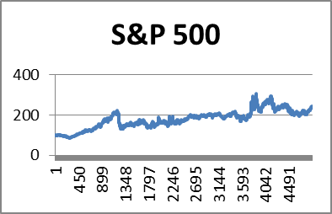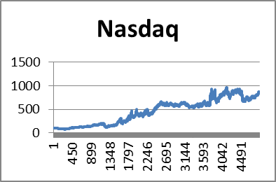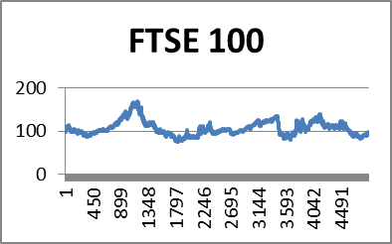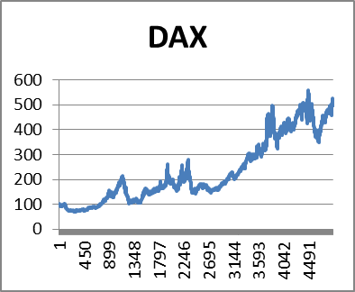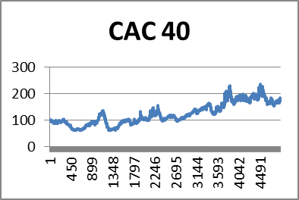
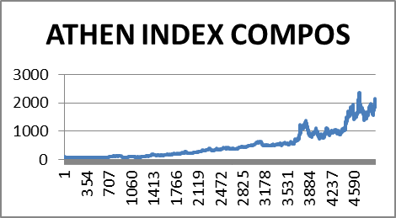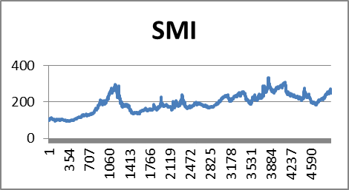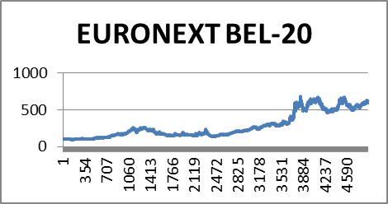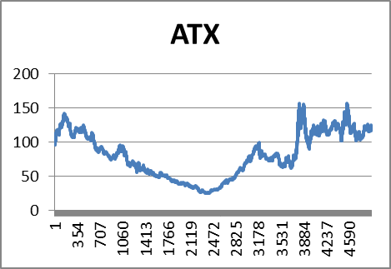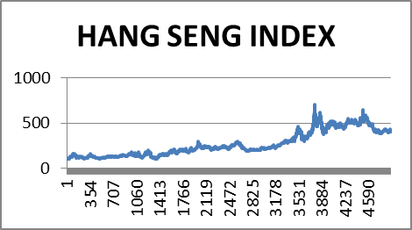

Exhibit 3: Return Histogram Trading Strategy
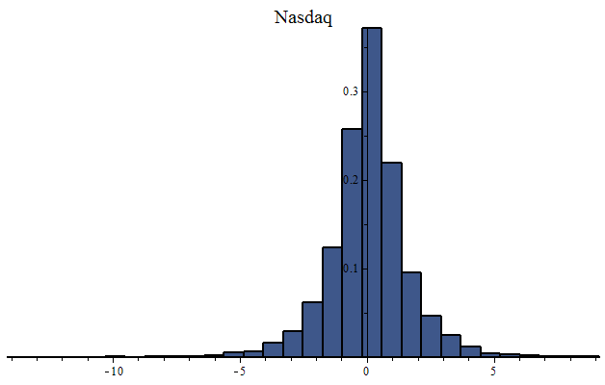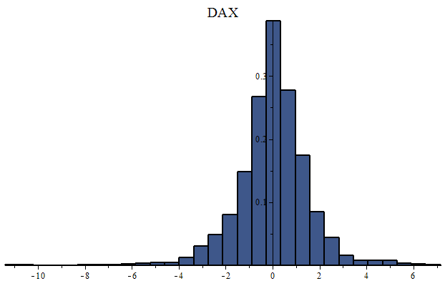
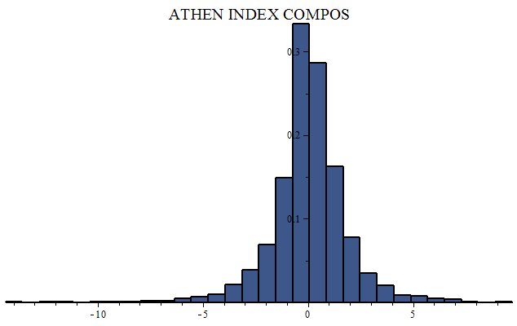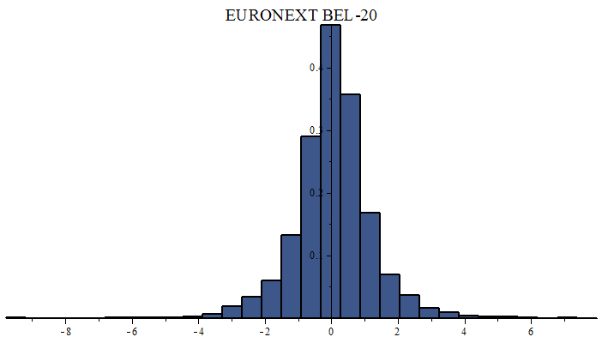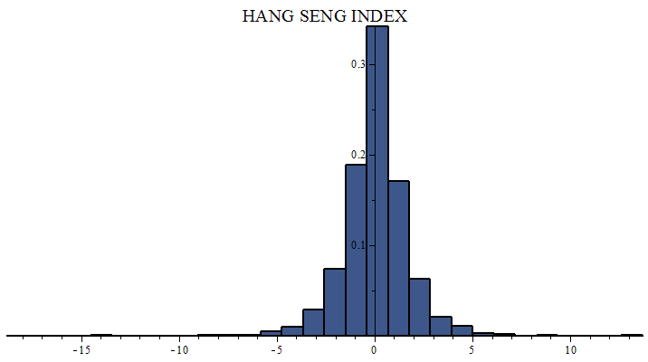
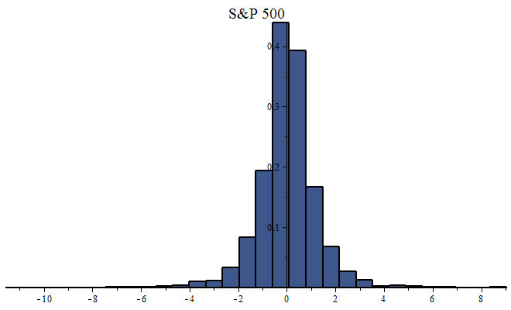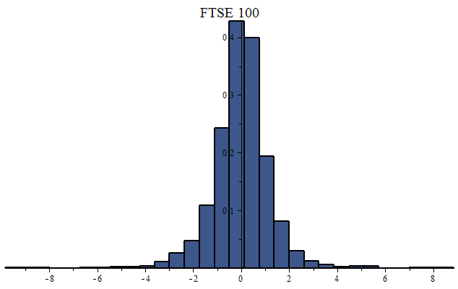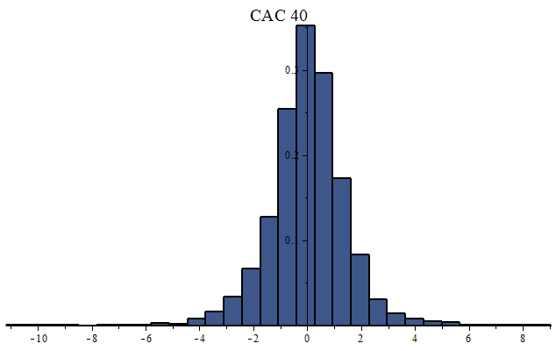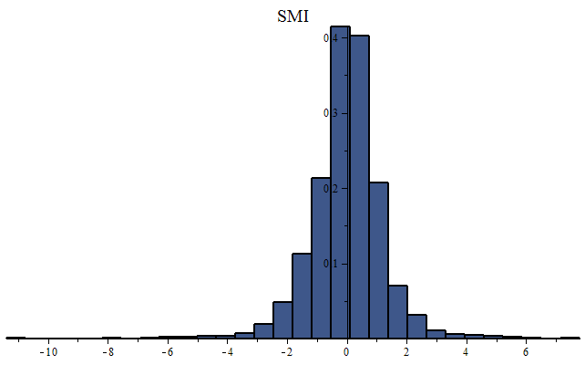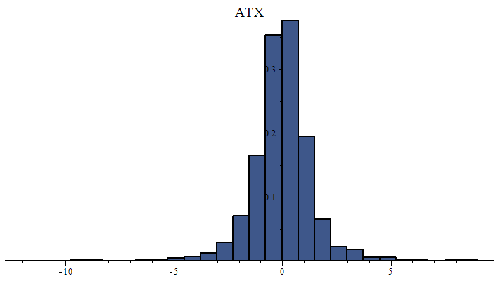

Exhibit 4: Significant Testing 1

Standard T-Test on One Sample
Null Hypothesis: Sample drawn from population with mean 0
Alt. Hypothesis: Sample drawn from population with mean not equal to 0
 | S&P 500 | Nasdaq
Sample Mean | 0.02 | 0.05
Sample StDev | 1.22 | 1.62
Computed Statistic | 1.42 | 2.45
Computed Pvalue | 0.15 | 0.01
Confi Interval 80% | 0.00 \ 0.04 | 0.02 \ 0.08
Outcome | Rejected | Rejected
 | FTSE 100 | DAX
Sample Mean | 0.00 | 0.04
Sample StDev | 1.18 | 1.51
Computed Statistic | 0.30 | 2.04
Computed Pvalue | 0.75 | 0.04
Confi Interval 80% | -0.01 \ 0.02 | 0.01 \ 0.07
Outcome | Accepted | Rejected
 | CAC 40 | ATHEN INDEX COMPOS
Sample Mean | 0.02 | 0.07
Sample StDev | 1.46 | 1.77
Computed Statistic | 1.05 | 2.96
Computed Pvalue | 0.29 | 0.00
Confi Interval 80% | -0.00 \ 0.04 | 0.04 \ 0.10
Outcome | Accepted | Rejected
 | SMI | EURONEXT BEL-20
Sample Mean | 0.02 | 0.04
Sample StDev | 1.21 | 1.22
Computed Statistic | 1.49 | 2.50
Computed Pvalue | 0.13 | 0.01
Confi Interval 80% | 0.00 \ 0.04 | 0.02 \ 0.06
Outcome | Rejected | Rejected
 | ATX | HANG SENG INDEX
Sample Mean | 0.01 | 0.04
Sample StDev | 1.39 | 1.72
Computed Statistic | 0.65 | 1.77
Computed Pvalue | 0.51 | 0.07
Confi Interval 80% | -0.01 \ 0.038 | 0.01 \ 0.07
Outcome | Accepted | Rejected

Exhibit 5: Significant Testing 2

Standard Z-Test on One Sample
Null Hypothesis: Sample drawn from population with mean 0 and known standard
deviation.
Alt. Hypothesis: Sample drawn from population with mean not equal to 0 and known
standard deviation.
 | S&P 500 | Nasdaq
Sample Mean | 0.02 | 0.05
Sample StDev | 1.22 | 1.62
Computed Statistic | 1.42 | 2.45
Computed Pvalue | 0.15 | 0.01
Confi Interval 80% | 0.00 \ 0.47 | 0.02 \ 0.08
Outcome | Rejected | Rejected
 | FTSE 100 | DAX
Sample Mean | 0.00 | 0.04
Sample StDev | 1.18 | 1.51
Computed Statistic | 0.30 | 2.04
Computed Pvalue | 0.75 | 0.04
Confi Interval 80% | -0.01 \ 0.02 | 0.01 \ 0.07
Outcome | Accepted | Rejected
 | CAC 40 | ATHEN INDEX COMPOS
Sample Mean | 0.02 | 0.07
Sample StDev | 1.46 | 1.77
Computed Statistic | 1.05 | 2.96
Computed Pvalue | 0.29 | 0.00
Confi Interval 80% | -0.00 \ 0.04 | 0.04 \ 0.10
Outcome | Accepted | Rejected
 | SMI | EURONEXT BEL-20
Sample Mean | 0.02 | 0.04
Sample StDev | 1.21 | 1.22
Computed Statistic | 1.49 | 2.50
Computed Pvalue | 0.13 | 0.01
Confi Interval 80% | 0.00 \ 0.04 | 0.02 \ 0.06
Outcome | Rejected | Rejected
 | ATX | HANG SENG INDEX
Sample Mean | 0.01 | 0.04
Sample StDev | 1.39 | 1.72
Computed Statistic | 0.65 | 1.77
Computed Pvalue | 0.51 | 0.07
Confi Interval 80% | -0.01 \ 0.038 | 0.01 \ 0.07
Outcome | Accepted | Rejected
Exhibit 6: Significant Testing 3

ChiSquareSuitableModelTest
Null Hypothesis: Sample drawn from a normal distribution with mean 0 and known
standard deviation.
Alt. Hypothesis: Sample was not drawn from a normal distribution with mean 0 and
known standard deviation.

 | S&P 500 | Nasdaq
Sample Mean | 0 | 0
Sample StDev | 1.22 | 1.62
Computed Statistic | 1050.99 | 1041.27
Computed Pvalue | 0 | 0
Critical Value 95% | 90.53 | 90.53
Outcome | Rejected | Rejected
 | FTSE 100 | DAX
Sample Mean | 0 | 0
Sample StDev | 1.18 | 1.51
Computed Statistic | 880.75 | 1045.79
Computed Pvalue | 0 | 0
Critical Value 95% | 90.53 | 90.53
Outcome | Rejected | Rejected
 | CAC 40 | ATHEN INDEX COMPOS
Sample Mean | 0 | 0
Sample StDev | 1.46 | 1.77
Computed Statistic | 823.88 | 1529.09
Computed Pvalue | 0 | 0
Critical Value 95% | 90.53 | 90.53
Outcome | Rejected | Rejected
 | SMI | EURONEXT BEL-20
Sample Mean | 0 | 0
Sample StDev | 1.21 | 1.22
Computed Statistic | 799.41 | 829.53
Computed Pvalue | 0 | 0
Critical Value 95% | 90.53 | 90.53
Outcome | Rejected | Rejected
 | ATX | HANG SENG INDEX
Sample Mean | 0 | 0
Sample StDev | 1.39 | 1.72
Computed Statistic | 1041.88 | 859.45
Computed Pvalue | 0 | 0
Critical Value 95% | 90.53 | 90.53
Outcome | Rejected | Rejected

3. Conclusion

We have in this paper shown that a simple moving average can add value when it comes to stock market investments. The reason why is because it has been shown that expected return has a significant amount of serial correlation which means that paste expected return can be used to forecast future expected return. However, financial markets also have a lot of noise hence it is not a magic bullet but it allows the investor to identify periods where the expected return is positive which allows the investor to gain an edge in the market.

Such a trading strategy is very different from a buy-and-hold also known as buy-and-hope investment strategy. Another reason why a moving average is useful has to do with structural breaks, also known as trend breaks, which can be found in financial market data. A moving average can therefore help us to avoid large drawdowns.

References
Ahmed, P, Beck, K & Goldreyer, E (2005) Moving average technical trading strategies for currencies of emerging economies, Managerial Finance, Vol. 31 Iss: 5, pp.14 - 27

Black, F and Litterman, R (1992), Global Portfolio Optimization,
Financial Analysts Journal, vol 48, issue 5, pp. 28–43

Blitz, David & van Vliet, Pim (2008) Global Tactical Cross-Asset Allocation,
Journal of Portfolio Management, vol 35, No.1, pp. 23-38

Brock, W, Lakonishok, J & LeBaron, B (1992) Simple Technical Trading Rules and the Stochastic Properties of Stock Returns, Journal of Finance, Vol. 47, No. 5, pp 1731-1764

Carhart, M (1997) On Persistence in Mutual Fund Performance.
Journal of Finance, vol 52, issue 1, pp 57-82.

Chiarellaa, C, Hea, X and Hommesb, C (2006) Moving average rules as a source of market instability, Physica A: Statistical Mechanics and its Applications, vol 370, Issue 1, pp 12–17

Conrad, J & Kaul, G (1988) Time-Variation in Expected Returns,
Journal of Business, Vol. 61, No. 4, pp. 409-425.

Covel, M (2004) Trend Following: How Great Traders Make Millions in Up or Down Markets, Pearson Education Inc
Davidsson, M (2013) The Use of Least Squares in the Optimization of Investment Portfolios, International Journal of Management , Vol 30, No 10, pp 310 – 321
Eakins, S and Stansell, S (2007) An examination of alternative portfolio rebalancing strategies applied to sector funds, Journal of Asset Management, vol 8, issue 1, pp 1-8
Elvin, M (2004) Financial Risk Taking; An Introduction to the Psychology of Trading
and Behavioural Finance, John Wiley & Sons Ltd
Faber, M (2007) A Quantitative Approach to Tactical Asset Allocation,
Journal of Wealth Management, vol 9, issue 4, pp 69-79
Fabozzi, F & Focardi, M (2010) Diversification: Should We Be Diversifying Trends?,
The Journal of Portfolio Management, Vol. 36, No. 4: pp. 1-4
Fama, E & French, K (1993) Common Risk Factors in the Returns on Stocks and Bonds, Journal of Financial Economics
vol 33 issue 1, pp 3–56
Fama, E (1970) Efficient Capital Markets: A Review of Theory and Empirical Work,
Journal of Finance, vol 25, issue 2, pp 383–417.

Fuertes, A, Miffre, J and Rallis, G (2010) Tactical allocation in commodity futures markets: Combining momentum and term structure signals, Journal of Banking & Finance, Volume 34, Issue 10, pp 2530–2548

Fung, W & Hsieh, D (2001) The Risk in Hedge Fund Strategies: Theory and Evidence from Trend Followers, Review of Financial Studies, vol. 14, no. 2
George, T and Hwang, C (2004) The 52-Week High and Momentum Investing,
Journal of Finance, vol. 59, No. 5, pp. 2145-2176
Grinblatt, M, Titman, S, and Wermers, R (1995) Momentum Investment Strategies, Portfolio Performance, and Herding: A Study of Mutual Fund Behavior, American Economic Review, vol 85, issue 5, pp 1088-1105
Kahneman, D (2011) Thinking Fast and Slow, Ferrar, Straus and Giroux

Karoglou, M (2010) Breaking down the non-normality of stock returns,
The European journal of finance, vol 16, issue 1, pp 79-95

Keynes, J (1936) The General Theory of Employment, Interest and Money

James, F (1968) Monthly Moving Averages—An Effective Investment Tool?
Journal of Financial and Quantitative Analysis, vol 3, issue 03, pp 315-326

Kelly, J (1956) A New Interpretation of Information Rate, Bell System Technical Journal, vol 35, pp 917-926

Jegadeesh, N & Titman, S (1993) Returns to buying winners and selling losers,
Journal of Finance, vol 48, issue 1, 65–91

Jensen, G, Johnson, R and Mercer, J (2002) Tactical Asset Allocation and Commodity Futures, Journal of Portfolio Management, Vol. 28, No. 4: pp. 100-111

Markowitz, H (1959) Portfolio Selection: Efficient Diversification of Investment,
New York: John Wiley & Sons

Powers, M (2010) Presbyter Takes Knight,
Journal of Risk Finance, vol. 11, issue 1
Ross, S (1976) The arbitrage theory of capital asset pricing,
Journal of Economic Theory vol 13, issue 3, pp 341–360.

Sharpe, W (1964) Capital Asset Prices - A Theory of Market Equilibrium under Conditions of Risk, Journal of Finance, vol 19, issue 3, pp 425-442

Weber, M & Camerer, C (1998) The disposition effect in securities trading: an experimental analysis, Journal of Economic Behavior & Organization, vol 33, no 2, pp 167-184

Weigel, E (1991) The Performance of Tactical Asset Allocation, Financial Analysts Journal, Vol 47, No 5, pp. 63-70

Appendix 1 Expected and Standard Deviation of Return Trading Strategy

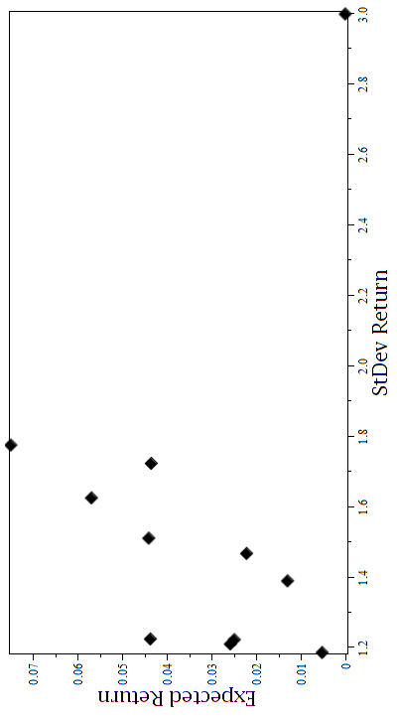

Appendix 2 Asset Return and Moving Average



