TREATMENT FOR SKIN WOUNDS BY CURCUMIN GEL

Deepan B, Dhanush R, Madeshwar A, Arun N, Murugappan M *

Department of Pharmaceutics, JSS College of Pharmacy, JSS Academy of Higher Education and Research, Ooty, Nilgiris, Tamil Nadu, India

*Corresponding author: Murugappan M
Lecturer, Department of Pharmaceutics
JSS College of Pharmacy, Ooty, Rocklands, Nilgiris, Tamil Nadu, India
Phone no: +919790030215
Email: murugappan92@jssuni.edu.in
ABSTRACT:

The main objective of this study is to treat skin wounds with curcumin gel through topical application. Additionally, this review has displayed that curcumin has strong wound-healing properties. It impacts many phases of the body's normal wound-healing cycle to hasten to heal. It is now obvious that in order to get curcumin's best therapeutic benefits on skin wounds, the giving emphasis of the drug must be modified by modifying its formulation. The composition and capabilities of gel for wound healing on the skin are thus covered in this review.
KEYWORDS (Curcumin, Topical Gel, Skin wound, Wound healing, Carbopol)

1. INTRODUCTION:

Skin is the body’s huge organ, consisting of fats, minerals, proteins and water. It is used to safeguard the inner body tissues from different environmental conditions, also it act as a protective barrier. In clinical practice, it is common to witness skin damage brought on by, tumors, Acne, Eczema, metabolic illnesses and hair loss. Several medications and treatments are used to cure skin diseases.

  - CURCUMIN
Turmeric plant, a flowering member of the Zingiberaceae family best known as a curry spice, contains curcumin, a yellow pigment that has anti-inflammatory qualities and the capacity to boost the body's production of antioxidants.

1.2. REASONS FOR USING CURCUMIN IN TOPICAL ROUTE:
The topical route of curcumin promotes re-epithelialization, reduces reactive oxygen species and inflammation, and modifies collagen, all of which promote skin wound healing. In a mouse model, curcumin has been demonstrated to guard against radiation-induced skin dermatitis. (8) (Panchatcharam M, Miriyala S, Gayathri VS, Suguna L.2008)

1.3 SUBTLE MEDICATION:
A topical drug is one that is applied directly to the skin or to an area of the body. Topical administration, which includes a wide range of classes such as creams, foams, gels, lotions, and ointments, most frequently refers to application to bodily surfaces like the skin or mucous membranes to treat illnesses. Numerous topical drugs are epicutaneous, putting them on the skin. In addition to being applied to the surface of the skin, topical drugs can also be inhaled, like asthma treatments, or administered to tissues other than the skin, such as the conjunctiva of the eye, the ear, or the surface of a tooth.

- PATHOPHYSIOLOGY OF SKIN WOUND:
Wounds are injuries that cause the skin or other body tissues to rip. They consist of skin punctures, scrapes, scratches, and cuts. Wounds can also be brought on by surgery, sutures, and stitches in addition to accidents. Cleaning minor wounds are crucial because they typically don't require medical attention.

2.1 Types of Injuries

Depending on the severity of a particular wound and the amount of time it will take for it to heal, wounds can be categorized in a variety of ways. A wound can range in severity from mild to severe depending on the source, location, and depth. We have described the many forms of wounds here.
Open or shut:

Open wounds are those where the body's natural barrier has been breached, allowing foreign objects to enter the tissues.
Contrarily, with closed wounds, the damaged tissues are not exposed to the outside, allowing the healing process to proceed without being hindered in any way by pollution. (Mafumi Shinohara Takashi Muguruma,2008)

- DIFFERENT LAYERS OF SKIN:

3.1 EPIDERMIS: The outermost skin layer on your body is called the epidermis. It defends your body from damage, keeps you hydrated, regenerates skin cells, and contains melanin, which gives your skin its color.

3.2 DERMIS: The innermost of the skin's two outer layers. Connective tissue, blood arteries, sweat and oil glands, nerves, follicles, as well as other structures, can all be found in the dermis. It is composed of a thicker bottom layer known as the reticular dermis and a thin top layer known as the dermis layer.

3.3 Hypodermis:
The layer of skin at the base of your body. It serves a variety of crucial roles, such as preserving energy, bridging the gap between your skin's dermis layer and your bones and muscles insulating your body, and safeguarding it against harm. Your hypodermis keeps getting smaller as you get older, and your skin begins to sag.

- TOPICAL DRUG ADMINISTRATION PROCEDURE:

Because topical medications are designed for local pain relief with negligible systemic side effects, they have a far better face for adverse effects. This specifically refers to medication categories with minimal systemic absorption.

4.1 ADVANTAGES

1. The first-pass metabolism is bypassed.
2. Simple to apply and convenient to use.
3. There will be no gastrointestinal incompatibility.
4. Simple medication discontinuation as necessary.
5. Drug gave precisely to a chosen location
6. Improved patient adherence.
7. Adequate for self-treatment. (6) (Biswas, M, Raj, G. and Raveendran, R. (2020)

4.2 DISADVANTAGES:
1 Patients experience discomfort since the use of ointments, lotions, pastes, and gels frequently result in stains or other messes on clothing.
2. The topical method also has no dosage accuracy as a drawback.
3. It is challenging to formulate various medications, components, or excipients.
4. Not all patients should use it; some people may experience minor skin irritability or hypersensitivity reactions. (6)(Biswas, M, Raj, G. and Raveendran, R. (2020)

5.CONSISTENCE OF CURCUMIN:

1. More than 90% of curcumin degrades quickly in buffer systems at basic ph, and this degradation is caused by an oxidative process. Curcumin is particularly unstable in phosphorus buffer at pH 7.4, where degrades to ferulic acid and feruloyl methane.

2. Since the pH in the stomach and alimentary canal is between 1 and 6, and the degradation there is extremely slow, curcumin is anticipated to just be stable in these environments. • Curcumin occurs as an isomeric form in semi-solvents as well as a keto-enol tautomer in polar solvents.

Application of curcumin wound healing:
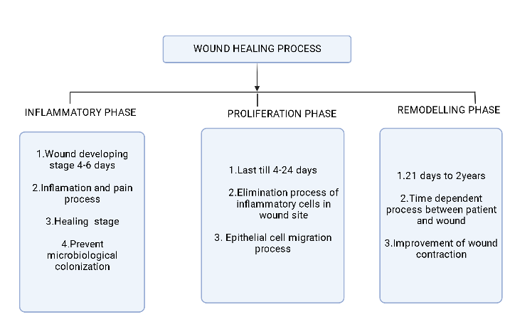
FIGURE 1: WOUUND HEALING PROCESS

CLASSIFICATION OF GELS:
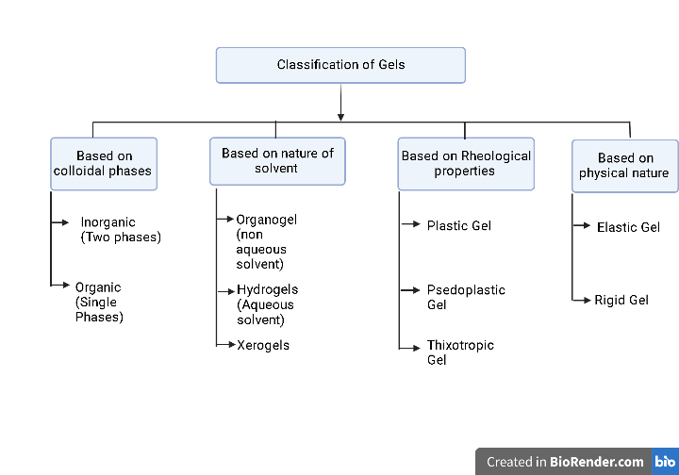
FIGURE 2: CLASSIFICATION OF GELS

6.VARIOUS STUDIES FOR CURCUMIN GEL:

6.1 Drug Content Research:

Weighed quantity of gel(100mg) is dissolved in 50ml of phosphate buffer of acidity 7.2. Then the buffer solution was transferred to volumetric flasks and required dilution made. The final solution was filtered in a 0.45m membrane filter. By using a spectrophotometer, curcumin drug content was measured at a maximum of 425nm, and the equation for linear regression derived from the calibration data was used to compute the drug content. .(5)(Nikunjana A. Patel, Natvar J. Patel, and Rakesh P. Patel,2008)

6.2 Viscosity measurements:

The viscosity is measured by using Brookfield rotational digital viscometer. It is allowed to rotate at 10pm.Before the measurement taken, the gel allowed to settle 30mins at a temperature 25⁰c (5)(Nikunjana A. Patel, Natvar J. Patel, and Rakesh P. Patel,2008)

6.3 Studies on in vitro skin permeation

By using the Franz diffusion cell, in-vitro permeation tests were studied. Rat abdomen skin was removed then diffusion cells were installed at donor and receptor compartments. The skin was treated with one gram formulation, then wrapped in paraffin film. The receptor compartment is placed in a phosphate buffer. The liquid was stirred continuously by using a magnetic stirrer. The environment was kept at 37 0.5 °C. .(5)(Nikunjana A. Patel, Natvar J. Patel, and Rakesh P. Patel,2008)

7. Preparation of curcumin Gel:

Carbopol was taken and mixed with distilled water after already being weighed. A suitable amount of ethanol was used to break the curcumin, & ethanol immersion curcumin was then shifted to an aqueous dispersion of curcumin. Carbopol gave two hours to soak while the mixture was whisked continuously with a stirrer. To form the gel and to negate the carbapol solution, triethanolamine was added. PH was maintained at 6.8.(5) (Nikunjana A. Patel, Natvar J. Patel, and Rakesh P. Patel,2008)

8. CONCLUSION:

Curcumin may be administered by the topical administration of application in an efficient and secure manner to produce local anti-inflammatory effects. It has been noted that curcumin may be used as a new therapeutic agent, particularly when applied topically
The study's topical gel compositions of curcumin are very useful and a good choice for the efficient and controlled treatment of inflammation. According to studies, curcumin accomplished this by influencing the inflammation, proliferation, and remodeling stages of the healing process. To create effective dietary approaches for wound treatment, however, more study is advised.

CONFLICTS OF INTEREST:
The authors confirm that this article has no conflict of interest
CREDIT AUTHOR STATEMENT:
Deepan B- conceptualization, validation, writing the original draft. Dhanush R- Review and editing, formal analysis. Madeshwar A- drafting and editing. Murugappan M - supervision, draft review, analysis, and editing. Arun N-Draft writing and conceptual analysis
ACKNOWLEDGEMENT
The author extends their indebtedness to the Department of science and technology – Fund for the improvement of science and technology infrastructure in universities and Higher Educational Institutions (DST-FIST), New Delhi for their infrastructure support to our department.

REFERENCE:

1.Aimee E. Krausz, BAa,1, Brandon L. Adler, BAa,1, Vitor Cabral, PhDb , 4 Mahantesh Navati, PhDc , Jessica Doerner, MSb , Rabab Charafeddine, MScc , 5 Dinesh Chandra, PhDb , Hongying Liangc Q2 , Leslie Gunther, MSc d , 6 Alicea Clendaniel, BSe , Stacey Harper, PhDe,f, Joel M. Friedman, PhDc , 7 Joshua D. Nosanchuk, MDb , Adam J. Friedman, MDa,c,;2014, Curcumin-encapsulated nanoparticles as innovative antimicrobial 2 and wound healing agent, ELSEVIER.
https://www.sciencedirect.com/science/article/abs/pii/S1549963414005279?via%3Dihub

2. Martina Barchitta 1 , Andrea Maugeri 1 , Giuliana Favara 1 , Roberta Magnano San Lio 1 , Giuseppe Evola 2 , Antonella Agodi 1,* and Guido Basile 3;2019,2019,Review Nutrition and Wound Healing: An Overview Focusing on the Beneficial Effects of Curcumin, Review Nutrition and Wound Healing: An Overview Focusing on the Beneficial Effects of Curcumin,Internatinal journal of molecular sciences.
https://www.mdpi.com/1422-0067/20/5/1119

3. 3Q1 Dania Akbik a , Maliheh Ghadiri a , Wojciech Chrzanowski a,b , Ramin Rohanizadeh a, 2014,Curcumin as a wound healing agent, ELSEVIER.
https://www.sciencedirect.com/science/article/abs/pii/S0024320514007036

4.D. Gopinatha , M. Rafiuddin Ahmeda , K. Gomathia , K. Chitraa , P.K. Sehgalb , R. Jayakumara,*;2003, Dermal wound healing processes with curcumin incorporated collagen films, ELSEVIER.
https://pubmed.ncbi.nlm.nih.gov/14738855/

5. Nikunjana A. Patel, Natvar J. Patel, and Rakesh P. Patel,2008, Formulation and Evaluation of Curcumin Gel for Topical Application, Pharmaceutical Development and Technology.
https://pubmed.ncbi.nlm.nih.gov/18821270/

6. Biswas, M, Raj, G. and Raveendran, R. (2020). Topical Route of Drug Administration and Dosage Forms. Retrieved November 21, 2020, from https://www.slideshare.net/doctormansij/topical-route-mansij

https://www.pharmapproach.com/topical-route-of-drug-administration-advantages-and-disadvantages/#:~:text=Topical%20route%20of%20administration%20provides,of%2C%20for%20its%20therapeutic%20value.

7. Hemendrasinh J Rathod1* and Dhruti P Mehta2,2015, A Review on Pharmaceutical gel, Acta Scientifica International Journal of Pharmaceutical Science

https://www.researchgate.net/publication/286451492_A_Review_on_Pharmaceutical_Gel

8. Panchatcharam M, Miriyala S, Gayathri VS, Suguna L.,2006 Curcumin improves wound healing by modulating collagen and decreasing reactive oxygen species. Mol Cell Biochem. [PubMed] [Google Scholar]

