TOURISM GEOLOGY IN NORTH AND NORTHEASTERN PARTS OF IRAQ
Varoujan K. Sissakian¹, Ayda D. Abdul Ahad², Nadhir Al-Ansari ³
and Sven Knutsson³

1 Private Consultant Geologist, Iraq, Erbil (varoujan49@yahoo.com)
2 Senior Chief Geologist, Iraq Geological Survey
3 Department of Civil Environmental and Natural Resources Engineering, Lulea University of Technology, Lulea 97187, Sweden

Abstract
Tourism Geology in Iraq is not common yet, although many sites do exist in the northern and northeastern parts of Iraq, which are mountainous areas attaining 3600 m (a.s.l.) providing spectacular scenes. Majority of those sites are used by the local people and those coming from other parts of Iraq, all of them are linked by paved roads with a lot of facilities of relevant accommodation. However, all of those sites are abandoned in winter season due to very cold and rainy season; occasionally are covered by snow.
Majority of those sites include fresh drinkable water; usually supplied from springs that yield enormous amount of water; some of them are controlled by structural elements and karst morphology.
The exposed rocks in those sites are mainly of sedimentary dominated by carbonate rocks and very rarely some igneous and metamorphic rocks occur too.

Keywords: Karst spring, Karst form, Folded rocks, Shanidar cave,

Introduction
The northern and northeastern parts of Iraq are mountainous areas with very rugged topography, which give the area spectacular scenes that are used as touristic sites. However, people enjoying those sites have no any idea about the geology of the site, since tourism geology is not known in Iraq yet. The involved offices such as Iraq Geological Survey and many universities that have Geology Departments in their structures are not contributed in this vital new branch of geology.

No brochures concerning the geology of the touristic sites are available for public. Tourism Geology is not included in the syllabuses of Geology Departments in universities. Therefore, this article can be considered as the first attempt to establish the principles of the “Tourism Geology” or Geotourism in Iraq.

Methodology
This article is conducted mainly based on the observations during field visits of the author in different parts of the involved area that were executed for checking of the geological maps at different scales, among them are the Geological Map of Sulaimaniyah and Erbil – Mahabad Quadrangles at scale of 1: 250 000 [1 and 2] and Geological Map of Iraq at scale of 1: 1000 000 [3]. Colored photographs of the touristic sites and others with geological interest from the archive of the author are used for presentation of the beauty of the sites.

Internet data and other published articles [4, 5 and 6] are used to amend the article. Moreover, the listed 13 principles by National Geographic Society - Geotourism Charter [7] for Geotourism Charter are used, whenever were found to be applicable.

Presented Touristic Sites
1- Galley Ali Beg Waterfall: This is one of the largest waterfall within the touristic sites (Fig.1). Its height is about 11 m, developed within the massive limestone rocks [8] of the Qamchuqa Formation of Lower Cretaceous age [3]. The valley (Khliafan Stream) has canyon shape with height difference between the lowest and highest elevations being about 1000 m (Fig.2). The galley itself has very unique geological interest, since the water flows in the gorge from two opposite directions; from the north and south, the two streams merge together somewhere in the middle of the gorge, then they leave the gorge by another one which has almost perpendicular direction to the main gorge (Fig.3) [9]. It can be reached through a paved road.

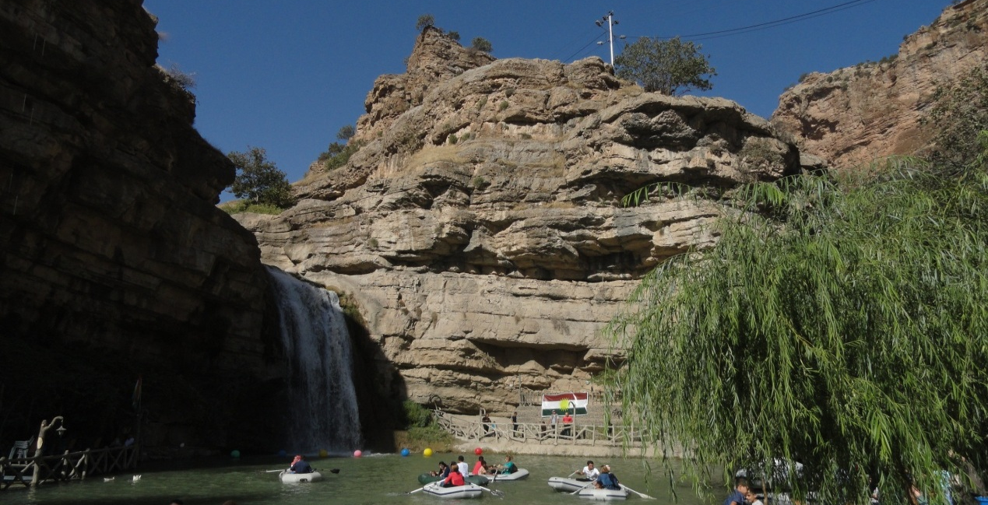Fig.1: Galley Ali Beg Waterfall
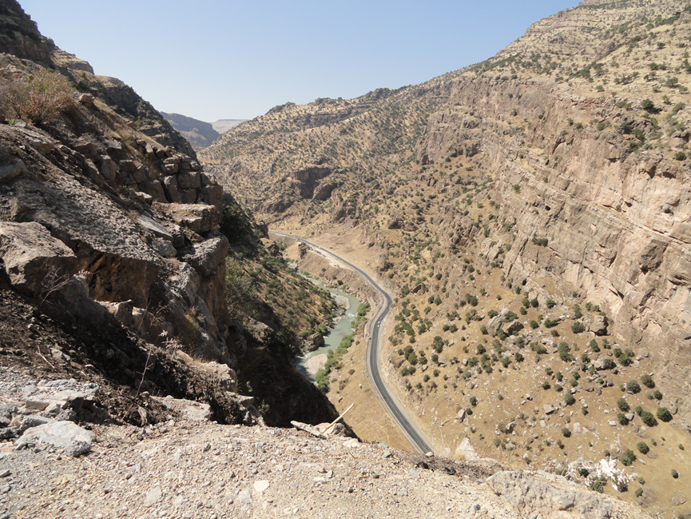
Fig.2: Galley Ali Beg gorge. Compare the width of the road and the encircled cars
(by red color) with the height of the gorge
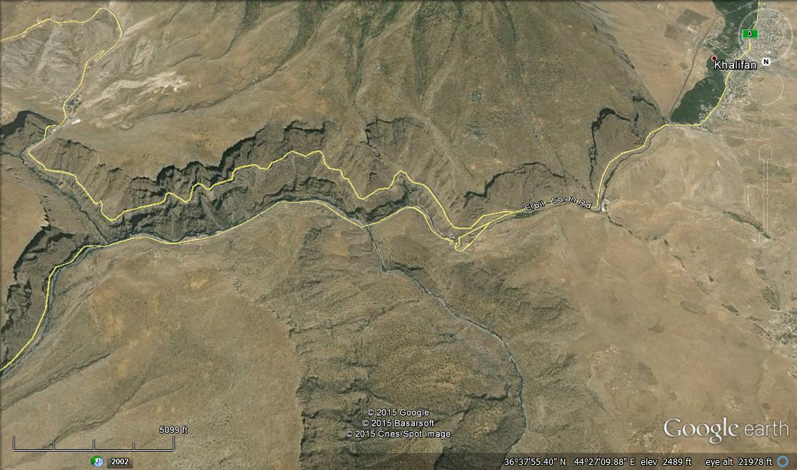
KhS
RR
A
Bekhal Springs
Gulley Ali Beg Waterfall

Fig.3: Google Earth image (facing south). Note the merging of the Khlaifan stream (KhS) into the Rawandooz River (RR), before leaving the gorge at point (A)

2- Bekhal Springs
A group of springs within well bedded carbonates (Fig.4) of the Bekhme Formation (Upper Cretaceous). The water flows out of faulted and karstified carbonate beds (Fig.5) within a distance of about 45 m. The flowing water lead to a stream that merges to Rawandouz River (Fig.3) .

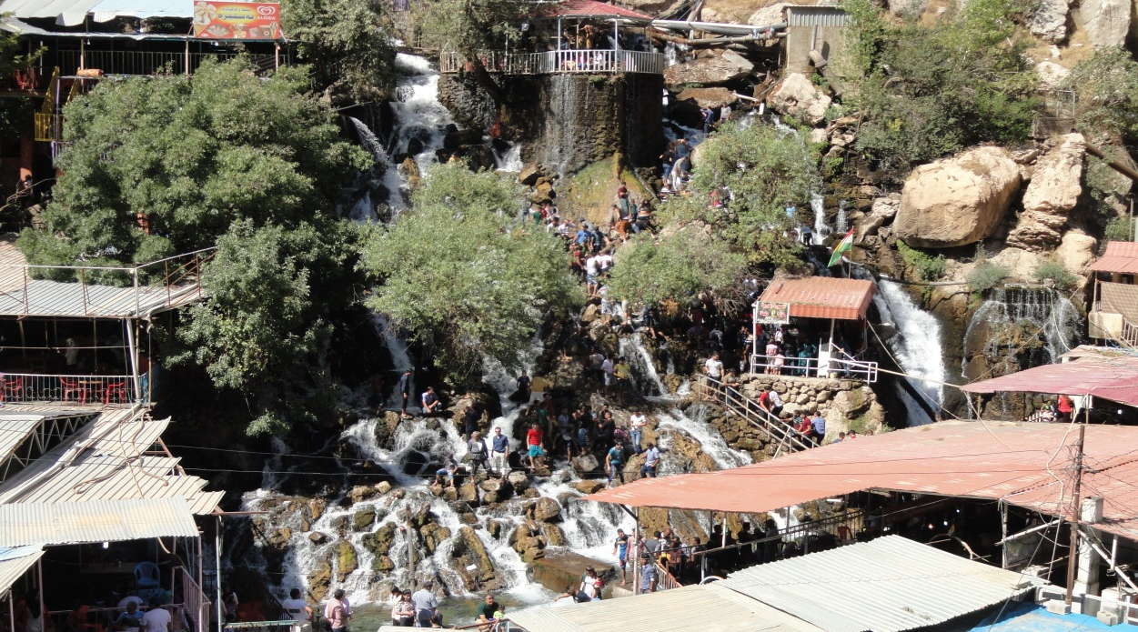

Fig.4: Bekhal springs
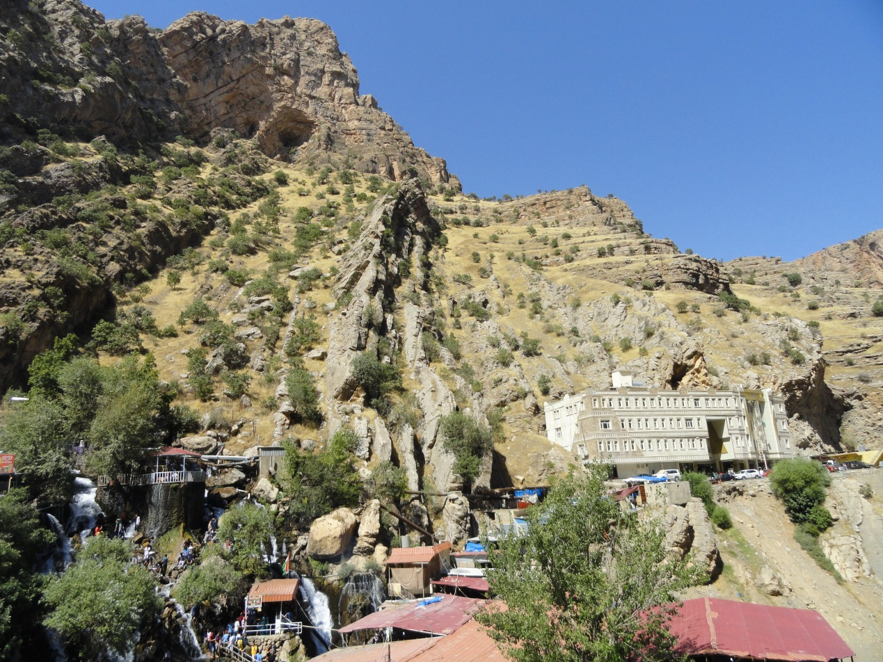
Fig.5: Bekhal springs. Note the well bedded, faulted and karstified carbonate beds, also the recently built hotel with other bungalows

Many touristic commodities are built in the site (Fig.5) beside small bungalows, which are used as either as small shops that sell domestic requirements beside food or as small hotels for the tourists. It can be reached through a paved road.

3- Jundiyan Spring: A spring that flows out of a deep karst cave. The depth is unknown. The spring has a very special and unique case, since the water flows out of the cave (Fig.6) for few hours or days; then stop flowing for few hours or days and flows back again, and so on. When the water starts flowing out of the cave, roaring sound can be heard accompanied with the flow of the water indicating that the water will be out of the cave. According to the local people, when the cave is dry, down to about 50 m can be reached; below that the cave is filled by water.

The spring is within the well thickly bedded or massive beds of carbonates of the Qamchuqa Formation (Lower Cretaceous) [3 and 2]. The flowing and terminating of the flowing water in the spring through the cave is attributed; most probably to the karst aquifer below the cave, which acts as a balance for flowing and terminating of the water.

Only small bungalows are available to the tourists as a rest sites, others sell daily requirements and food to the tourists. It can be reached through a paved road.
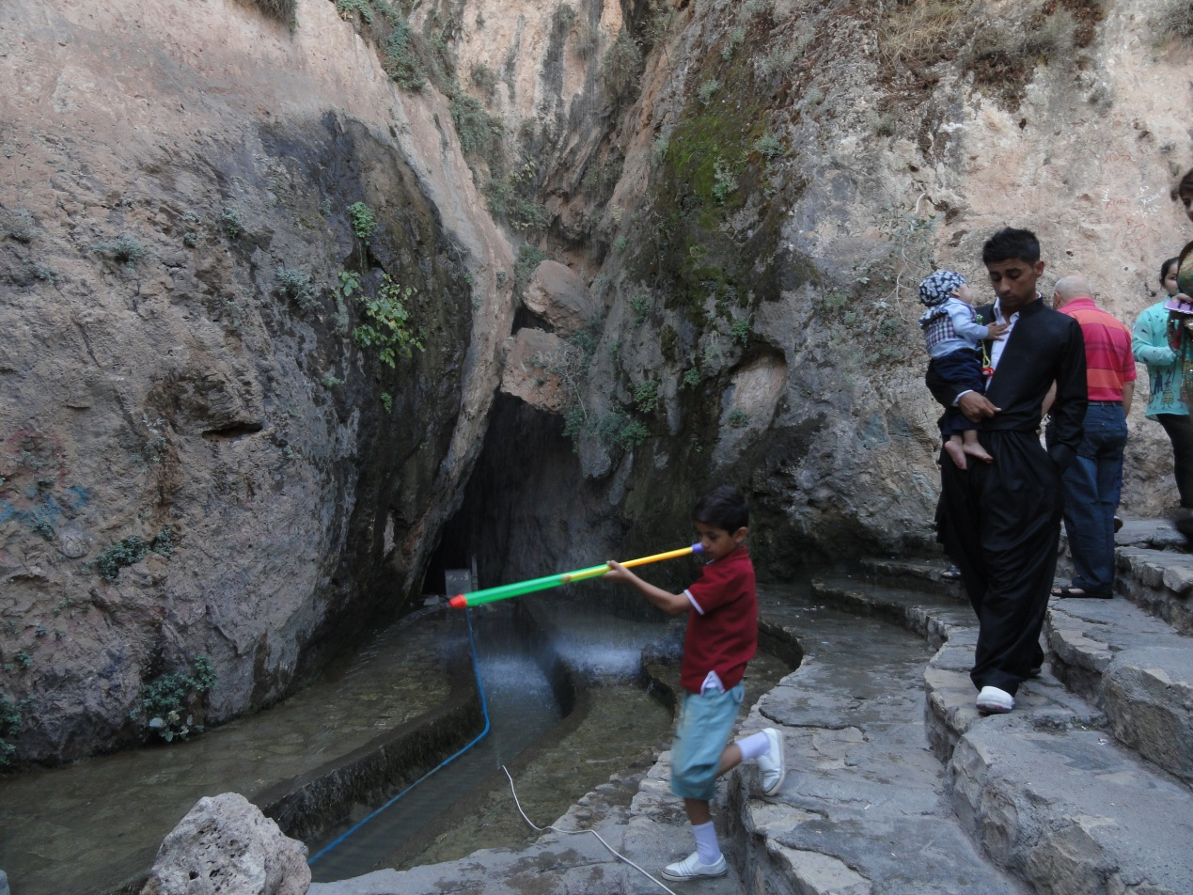

Fig.6: Jundiyan spring. Note the outlet of the cave through which the water flows out of the karst cave within the constructed concrete ditch

4- Ahmed Awa Spring: Group of springs that yield fresh water from Avroman Limestone [1] of Triassic age along the Iraqi Iranian borders (Fig.7).

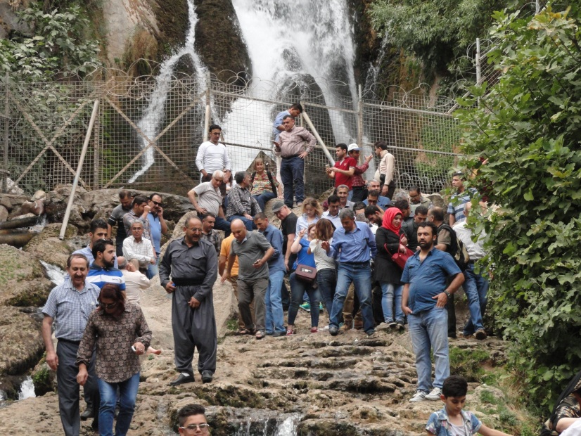

Fig.7: Ahmaed Awa Spring

The water flows from a fracture zone within the massive limestone (Fig.8). Only small bungalows are available for tourists rest and providing daily requirements for the tourists. It can be reached through a paved road.

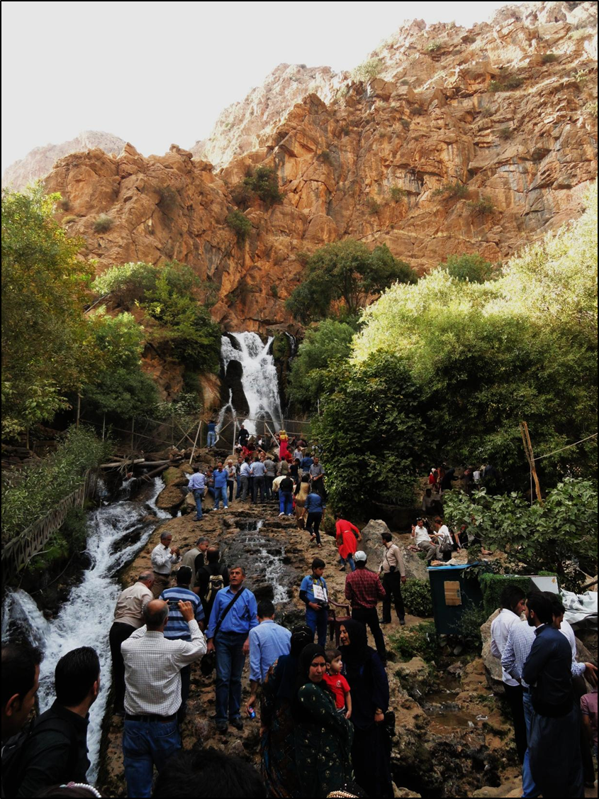

Fig.8: Ahmed Awa spring flowing enormous amount of fresh water through massive beds of Avroman Limestone (Triassic), most probably due to fractures after faulting

5- Sartaq Bammu Site: A site located behind a spectacular passage of karst origin [10] (Fig.9) developed within well bedded hard carbonates of the Pila Spi Formation of Eocene age [3 and 2].

The Sartaq Bammu site is very poor as the domestic services are needed, since apart from simple rest sites no any touristic requirements are available (Fig.10); however, it is one of the most crowded sites especially during spring season due to its spectacular scenes and pleasant weather. It can be reached through a paved road.

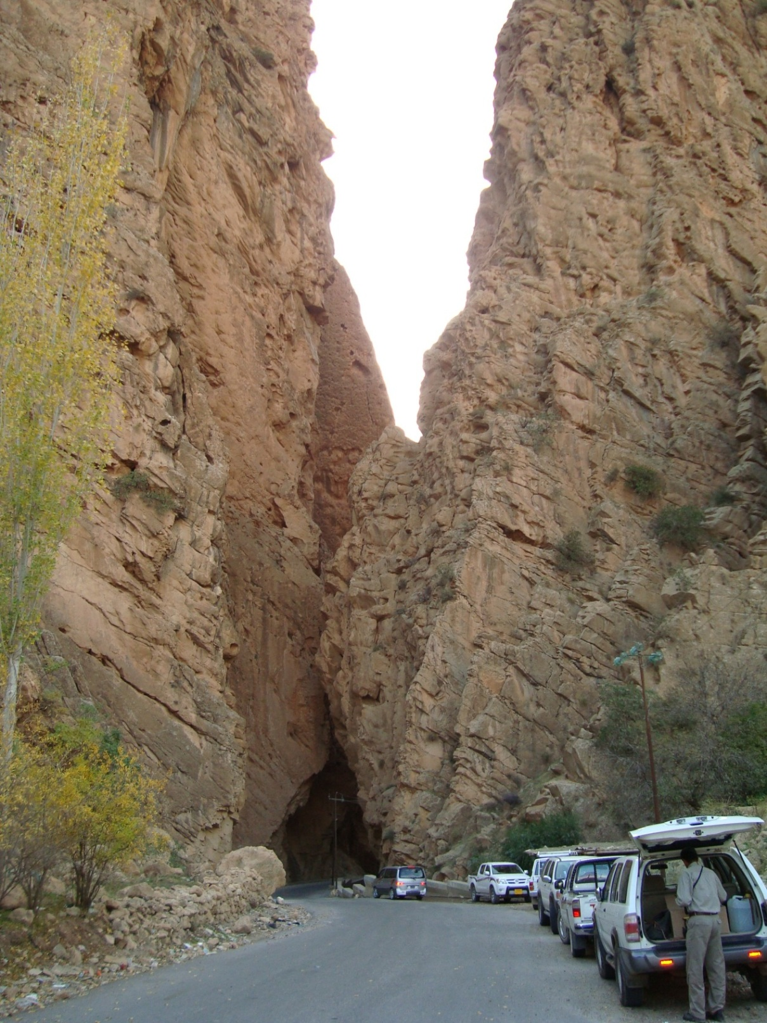

Fig.9: A narrow passage due to karst form within the Pila Spi Formation, behind the passage the Sartaq Bammu touristic site is located

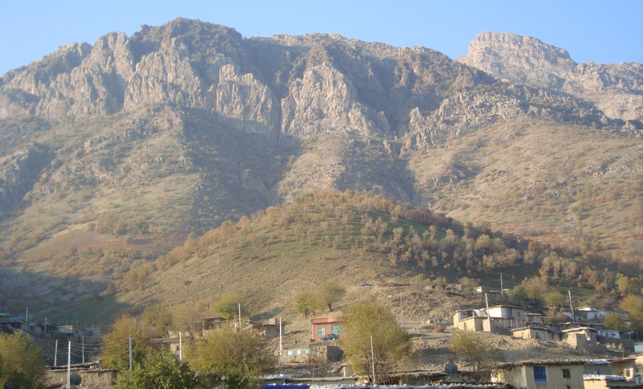

Fig.10: Sartaq Bammu site nearby to Iraqi – Iranian borders

6- Shanidar Cave: Shanidar Cave is an archaeological site located within Bradost Mountain in Iraqi Kurdistan [11]. The remains of ten Neanderthals, dating from 35,000 to 65,000 years ago, have been found within the cave. The cave also contains two later "proto-Neolithic" cemeteries, one of which dates back about 10,600 years and contains 35 individuals [5].

The best known of the Neanderthals are Shanidar 1, who survived several injuries during his life, possibly due to care from other members of his band, and Shanidar 4, whose body lay beside a flower that can either be explained as evidence of burial rituals or animal contamination.

The cave is developed within massive carbonate rocks of the Qamchuqa Formation (Lower Cretaceous). The maximum height of the entrance is about 12 m (Fig.10), with one large chamber almost of domal shape (Fig.11). In the floor of the cave, that is about 1070 m² the excavation debris of archeological studies can be seen. The cave can be reached via artificial ladder constructed from carbonate blocks of the Qamchuqa Formation with many rest stations constructed from woods of local trees (Fig.12). Two holes can be seen in the ceiling of the cave (Fig.13). Deep solution hole exist in the floor with many teps (Fig.14) that was used during the archeological excavation of the cave.

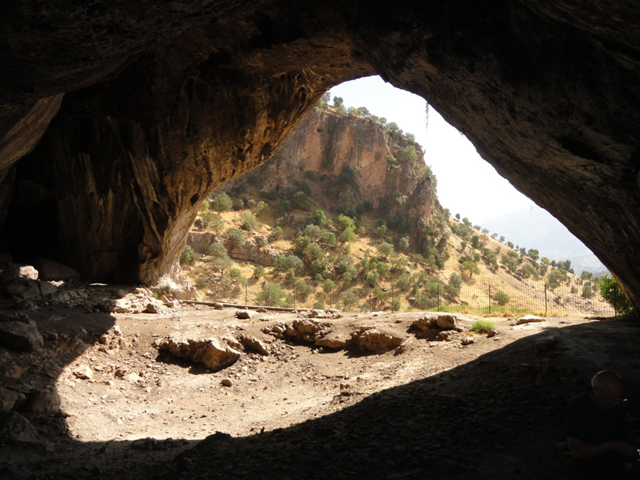
Fig.10: The entrance of Shanidar cave (view from inside)

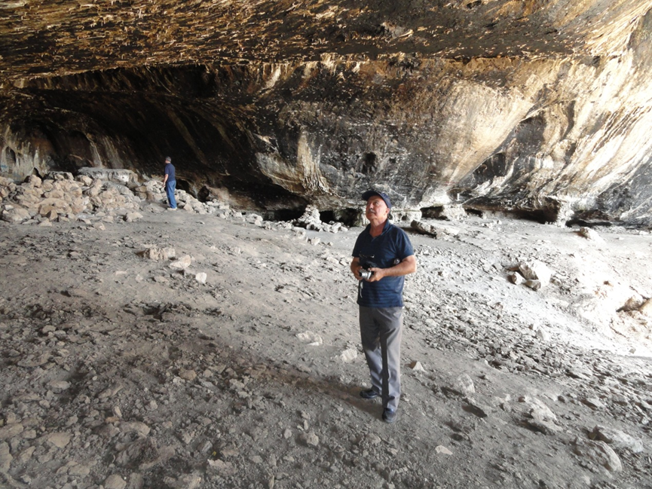

Fig.11: Inside of Shanidar cave. Note the excavation debris on the floor.
The black color is due to burning of wood during winter by local shepherds
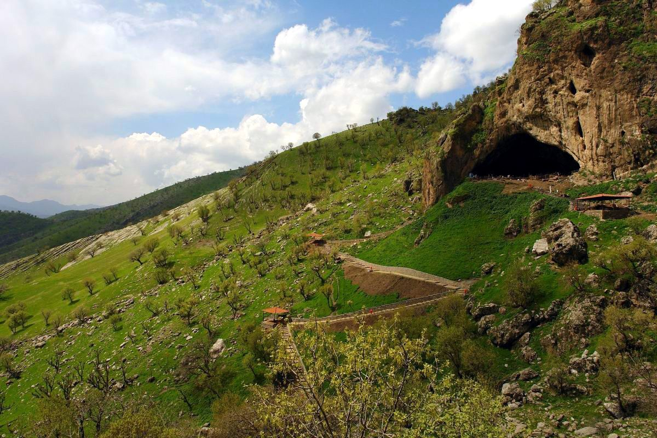

Fig.12: Outside view of Shanidar cave. Note the artificial ladder and the wooden rest stations along the way to the cave

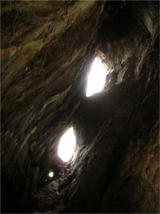

Fig.13: Two holes in the ceiling of Shanidar cave
(may be artificially opened by living Neanderthal)
A lot of archeological excavations were carried out in Shanidar cave from 1956 to 1961 by Solicki [12] (Fig.14). The first nine (Shanidar 1 – 9) were unearthed between 1957 and 1961 by Ralph Solecki and a team from Columbia University [13]. The skeleton of Shanidar 3 is held at the Smithsonian Institution. The others (Shanidar 1, 2, and 4 – 8) were kept in Iraq and may have been lost during the 2003 invasion, although casts remain at the Smithsonian [4]. In 2006, while sorting a collection of faunal bones from the site at the Smithsonian, Melinda Zeder discovered leg and foot bones from a tenth Neanderthal, now known as Shanidar 10 [6]. The ten Neanderthals at the site were found within a Mousterian layer which also contained hundreds of stone tools including points, side-scrapers, and flakes and bones from animals including wild goats and spur-thighed tortoises [13].

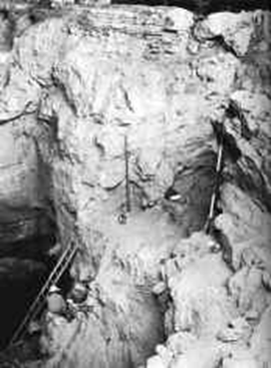

Fig.14: Archeological excavations carried out in Shanidar cave. Note the solution traces in the walls of the hole

For many years, Shanidar 4 was thought to provide strong evidence for a Neanderthal burial ritual. Routine soil samples from around the body, gathered for pollen analysis in an attempt to reconstruct the palaeoclimate and vegetational history of the site, were analysed eight years after its discovery. In two of the soil samples in particular, whole clumps of pollen were discovered in addition to the usual pollen found throughout the site, suggesting that entire flowering plants (or at least heads of plants) had entered the grave deposit [14] (Fig.15). This led to the idea that the man could possibly have had shamanic powers, perhaps acting as medicine man to the Shanidar Neanderthals [15 and 12].
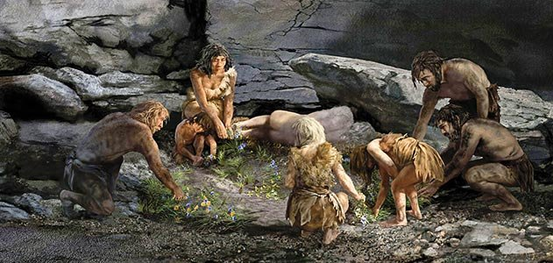

Fig.15: Spectacular drawing for burial ceremony in Shanidar cave.
Note the flowers and other plants around the grave

Solecki [12] described Shanidar cave as “Shanidar Cave is in a mountain called Baradost, overlooking Shanidar Valley. From the cave mouth one can see the Greater Zab River, a tributary of the Tigris. The cave, now some 2,500 feet (about 760 m) above sea level, was dissolved out of the mountain's limestone rock, originally laid down by an ancient sea. It has a flat earthen floor, about 11,700 square feet (about 1070 m²) in area, and a high ceiling (45 feet at the highest point, about 13.5 m) blackened with a centuries-old deposit of soot”.

Many attempts are carried on to construct a Geo-park in site of Shanidar cave and near surroundings. Among them is the ‘Kurdistan Institution for Strategic Studies and Scientific Researches” located in Sulaimaniyah city (Personal communication with Prof. Dr. Polla A. Khanqa, president of the institution, 2013) and the Natural Historic Museum; located in Baghdad (Personal Communication with Dr. Aqeel Al-Zubaidi, Geologist, National Historic Museum, Baghdad, 2015).

7- Other Suggested Sites
Hundreds of outcrops exist in different parts of the involved are with spectacular scenes that can be used as sources for tourism geology. The variation in rock type, their colour, bedding nature, structural deformation; all these factors have formed naturally beautiful scenes (Fig.16). These mentioned sites and other hundreds can be reached by paved roads, consequently can be used as good sources that attract tourists, especially in spring, summer and autumn seasons. However, in the extreme northern and northeastern parts; where the mountains are covered by snow during winter, tens of such scenes occur and can be used also as sources for tourism geology. But, they need a lot of infrastructure before being in use.

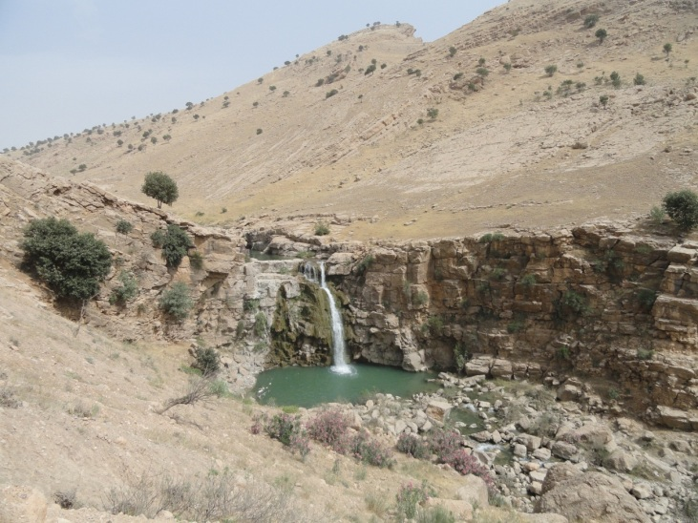
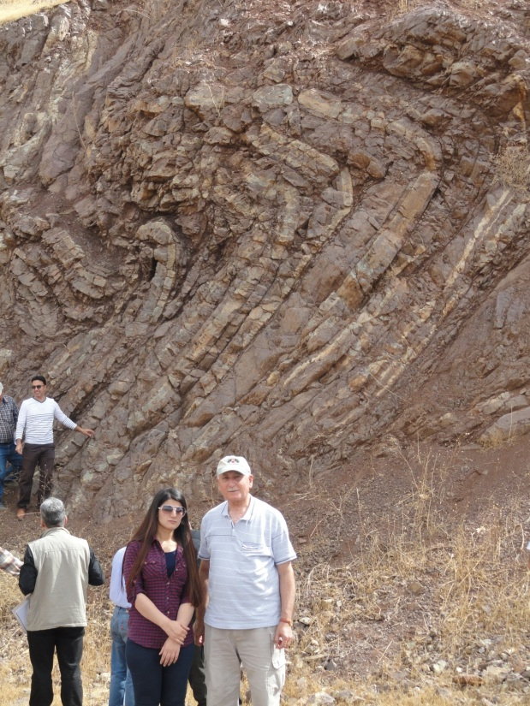
B
A
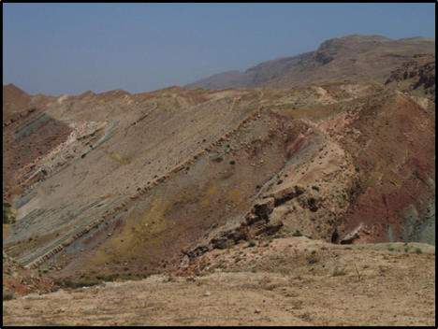
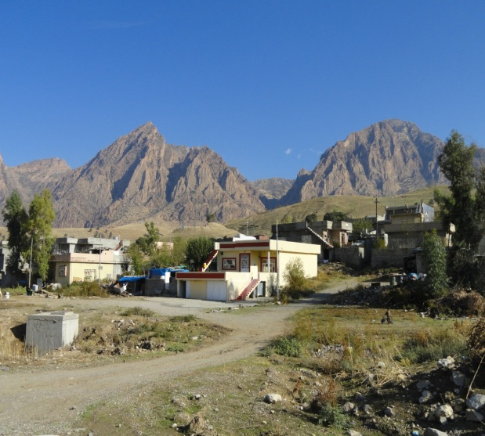
D

C

Fig.16: Suggested sites for tourism geology
A) Qulqula Radiolarian limestone (Cretaceous) well thinly bedded and highly deformed due to tectonic activities during Cretaceous, B) A tight syncline within the Pila Spi Formation (Eocene) with small water fall, C) High ridges and giant Iron Flats within the massive carbonates of the Qamchuqa Formation (Lower Cretaceous), and D) Varicolored clastics, carbonates, marl and claystone of the Fatha (ex-Lower Fars) (Middle Miocene) and Injana (ex-Upper Fars) (Upper Miocene) formations

Another unique and significant site is shown in Fig. (17). A single house is built within the massive carbonates of the Qamchuqa Formation utilizing the folding of the beds. The owner of the house uses it as a rest site during vacations.
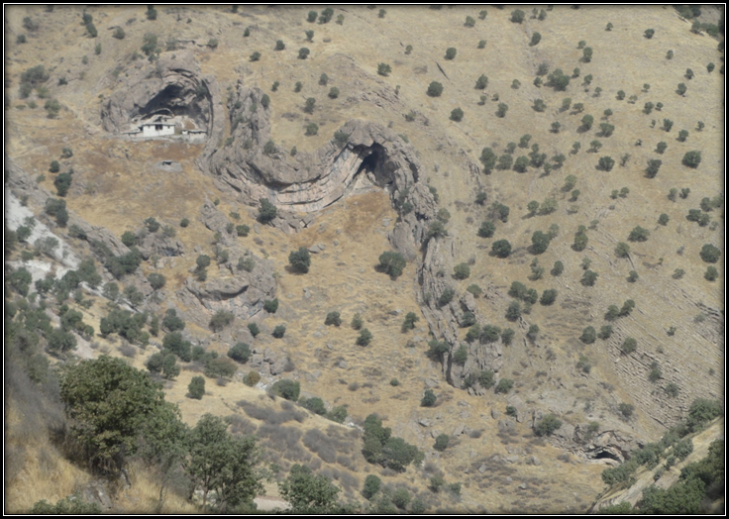

Fig.17: single house built under the folded massive carbonate beds of the
Qamchuqa Formation

Results and Discussions
Unfortunately, rocks, landforms and processes that has received the least attention in tourism, and consequently is the least known and understood [17]. This then is the real power of geotourism, in that it puts the tourist spotlight firmly on geology, and brings it to the forefront of understanding through tourism.

To increase and encourage tourism geology in Iraq, a lot of work should be carried on by defining the interesting touristic sites with geological interest, including tourism geology in some Iraqi universities that have Geology Departments in their structures, paying attention in Geological Survey offices in different parts of Iraq and through the media by different visual and readable sources. The last aspect can be done by means of printing broachers for the available sites to attract the tourists and give them preliminary knowledge about the geology of the site.

The mentioned 13 principles by National Geographic Society - Geotourism Charter [7] in the Geotourism Charter are briefly discussed; hereinafter.
- Integrity of place: All the mentioned touristic sites; in this article are well known not only for the people living nearby areas, but even to those living few hundred kilometres far from the sites. All are linked by paved road.
- International codes: Among all the mentioned sites, only one has UNESCO code number as a heritage for
- Market selectivity: Almost all the mentioned sites have excellent tourism market, usually arranged by tourism companies that transport the tourists from different parts of Iraq, especially from Baghdad.
- Market diversity: All the mentioned sites serve relevant food and accommodation for the tourists.
- Tourist satisfaction: This is clear from the continuous increase in the number of the tourists who had visited the site year after year
- Community involvement: In all the mentioned sites the services are run by the local people. Occasionally the whole family is involved in the provided services.
- Community benefit: Majority of the sites are visited by tourists transported by small tourism companies and/ or bureaus, which encourages people from far areas to pay visits to the sites.
- Protection and enhancement of destination appeal: Unfortunately, this principle almost does not exist due to non-existence of Geotourism principles and its culture among the majority of the visitors; therefore, locally some damages can be seen, which are intentionally executed.
- Land use: All the mentioned sites have developed relevant accommodation to the tourists, if not near the sites, then few kilometres far from the site. However, some are built in not relevant style that had caused distortion to the site.
- Conservation of resources: This principle is also not well followed by the tourists; unfortunately. Therefore, pollution of the running fresh water by littering the domestic garbage; haphazardly can be seen almost in all sites, although many attention signs can be seen in all the mentioned sites to keep the site clean.
- Planning: People working almost in all the mentioned sites have well planned their resources, workers are employed from other cities; even few hundred kilometres far from the sites. Locally, small shops, motels, bungalows are rented to people to run the commodity during tourism season.
- Interactive interpretation: Many attempts are performed to engage both visitors and hosts in learning about the site. Owners of commodities are encouraging residents to promote the natural and cultural heritage of their communities so tourists gain a richer experience and residents develop pride in their locales.
- Evaluation: Establish an evaluation process to be conducted on a regular basis by an independent panel representing all stakeholder interests, and publicize evaluation results.

Conclusions
The following can be concluded from this article.
- Tourism Geology in Iraq is not known and not established yet within the involved offices, universities and touristic companies and bureaus.
- Majority of the summer resorts include magnificent geological scenes that can be utilized as Tourism Geology.
- All the existing sites can be reached via paved roads, except Shanidar cave that can be reached via artificial ladder with many rest stations from which spectacular scene of the site and near surrounding can be seen.
- Almost all the existing sites include domestic necessities; however, some of them include relevant hotels and motels.
- Hundreds of interesting sites with magnificent geological interest occur in different parts of the involved area that can be utilized as sites of Tourism Geology.

References
[1] Sissakian, V.K. and Fouad, S.F., 2014a. Geological Map of Sulaimaniyah Quadrangle, sheet No. NI – 38 – 3, scale 1: 250000, 2nd edition. Iraq Geological Survey Publications, Baghdad, Iraq.
[2] Sissakian, V.K. and Fouad, S.F., 2014b. Geological Map of Erbil and Mahabad Quadrangles, sheets No. NJ – 38 – 14 and NJ – 38 – 15 , scale 1: 250000, 2nd edition. Iraq Geological Survey Publications, Baghdad, Iraq.
[3] Sissakian, V.K. and Fouad, S.F., 2012. Geological Map of Iraq, scale 1: 1000000, 4th edition. Iraq Geological Survey Publications, Baghdad, Iraq.
[4] Beth, L., 2004. "Around the Mall: From the Attic". Found and Lost. Smithsonian. Archived from the original on 2006-11-29. Retrieved 2008-03-07.
[5] Solecki, R.S., Solecki, R.L. and Agelarakis, A.P., 2004. The Proto-Neolithic Cemetery in Shanidar Cave. Texas A&M University Press. pp. 3–5. ISBN 9781585442720.
[6] Cowgill, L. W., Erik, T. and Melinda, A. Z., 2007. "Shanidar 10: A Middle Paleolithic immature distal lower limb from Shanidar Cave, Iraqi Kurdistan". Journal of Human Evolution 53: 213–223. doi:10.1016/j.jhevol.2007.04.003. Retrieved 17 October 2014.
[7] National Geographic Society, 2015. Geotourism Charter. Wikipedia, https://en.wikipedia.org/wiki/Geotourism
[8] Sissakian, V.K. and Saeed, Z.B., 2012. Lithological Map of Iraq, Compiled using GIS Techniques. Iraqi Bull. Geol. Min., Vol. 8, No.3, p. 1 – 13.
[9] Sissakian, V.K., Abdul Jab’bar, M.F., Al-Ansari, N. and Knutsson, S., 2015 Development of Gulley Ali Beg Gorge in Rawandouz Area, Northern Iraq. Engineering, 2015, 7, 16-30. Published Online January 2015 in SciRes. http://www.scirp.org/journal/eng http://dx.doi.org/10.4236/eng.2015.71002.
[10] Sissakian, V.K. and Abdul-Jabbar, M.F., 2010. Morphometry and genesis of the main Transversal Gorges in North and Northeast Iraq. Iraqi Bull. Geol. Min., Vol.6, No.1, p.95 – 120.
[11] Owen, E., 2010. The Skeletons of Shanidar Cave. Smithsonian Magazin, March 2010. Retrieved 17 October 2014.
[12] Solecki, R.S., 1975. Shanidar IV, a Neanderthal Flower Burial in Northern Iraq, Science, vol. 190, iss. 4217, pp. 880-881.
[13] Erik, T., 1983. The Shanidar Neanderthals. Academic Press. ISBN 0-12-7005501.
[14] Lietava, J., 1992. Medicinal plants in a middle paleolithic grave Shanidar IV?, Journal of Ethnopharmacology, vol. 35(2), pp. 263-266, 1992
[15] Stewart, T.D., 1963. Shanidar Skeletons IV and VI. Sumer, Vol. 19, pp. 8-26.
[16] Pettitt, P.B., 2002. The Neanderthal Dead, exploring mortuary variability in middle Paleolithic Eurasia.
[17] Newsome, D. and Dowling, R.K., 2010. Geotourism: The Tourism of Geology and Landscape. Oxford: Goodfellow Publishers.

