Title
Tobacco harm reduction: underpinning issues, challenges, and scope for innovation

Corressponding & Primary author
Primary author: Samir Vinchurkar*^{+Ψ} (corresponding author);
Email for correspondence: samirvinchurkar@hrric.com
Postal address: 17b Madhu Estate, Worli, Mumbai 400016

Co-authors:
1. Shilpa Gupta*: shilpa@hrric.com; HRRIC, Mumbai, India
3. Reena Jamthani*: reenajhamtani@hrric.com; HRRIC, Mumbai, India
4. Nilesh Jain*: nilesh@hrric.com; HRRIC, Mumbai, India

Affiliation:
*HRRIC – Harm Reduction Research and Innovation Center, Mumbai, India
+National University of Ireland at Galway, Ireland
Ψ Corresponding author

Word count: 3411

Abstract

Tobacco is one of the leading causes of mortality in India where it is significantly correlated with gender, occupation, education and age. With more than 100 million smokers and another 200 million users of smokeless tobacco products (SLTs), India ranks as one of the highest manufacturer and consumer of tobacco products worldwide. In India more than 50% oral cancers are attributed to use of smokeless tobacco with the highest mortality rates globally from oral cancers in women. The magnitude and pattern of tobacco consumption are likely to be influenced by the geographical setting, and with rapid urbanization in India, there is an urgent need to understand this differential pattern. This will further assist in planning tobacco cessation initiatives across rural and urban India. Tobacco harm reduction initiatives over the last decade have creatively employed innovative methods for harm reduction including philately to smartphone based apps for awareness, detection, treatment, diet and lifestyles. One of the major challenges for conducting such studies was the confluence of socio-economic factors, gender, age and education. The authors report a significant gap between the outreach of tobacco harm reduction (THR) programs and the efficient use of technology and innovation especially for underprivileged and vulnerable populations including women and children. The authors review existing strategies for THR and propose two existing technologies for early detection of cancers and encourage the use of additional technologies for THR initiatives.

Keywords: Tobacco use and associated factors; Innovation and strategy; smokeless tobacco products; Nicotine replacement therapy; tobacco cessation and safe alternatives; use of technology for tobacco cessation;

Introduction

Socio-economics of tobacco harm in India – Tobacco is one of the leading causes of mortality globally, and in India, where it is significantly correlated with gender, occupation, education and age [1]. With more than 100 million smokers and another 200 million users of smokeless tobacco (SLT) products, India ranks as one of the highest manufacturer and consumer of tobacco products worldwide [2]. Further alarming is that women constitute approximately 13% prevalence as consumers of SLT products including a significant population that is pregnant [3]. The economic burden of tobacco harm in India is an astounding US$ 22 billion with 91% males contributing as smokers. However, the economic burden accounted by women is much higher at 30% for consumption of SLTs [2]. The magnitude and pattern of tobacco consumption are likely to be influenced by the geographical setting, and with rapid urbanization in India, there is an urgent need to understand this differential pattern and acceptance of tobacco cessation initiatives across rural and urban India.

Problem with tobacco products in India – South-East Asia is unique in terms of tobacco consumption in that almost 80% of global users of smokeless tobacco products (SLTs) live in the region [4]. Whilst in many countries the prevalence of smoking is decreasing, in India, three quarters of tobacco users consume SLTs which is expected to increase further [5]. India especially represents a rare case where such disproportionate numbers of tobacco users consume SLTs. These SLTs comprise a broad variety of different products including Mishri, Khaini, Paan Masala procured as a part of the current study by the authors in October 2019 as illustrated in Figure 1. With a significant shift towards manufactured SLTs [6] leading to estimated 368,127 deaths (217,076 women and 151,051 men) were accounted to SLT use in the year 2010 (Gupta et al., 2010). However, the health crisis due to SLTs is largely unreported and unregulated with complex government policies and absence of data on SLT manufacturing, regulation, consumption and associated burden of diseases. There is an urgent need for a scientific approach to this problem supporting the infrastructure necessary to generate credible unbiased data by independent researchers with improved methodologies published as open access which will have a direct impact on tobacco harm reduction. The current study will focus on innovative methods which can be used for alleviating the harm caused due to tobacco in different forms.

Lack of credible data – India is the largest manufacturer of SLTs and yet there are no standards, regulations, or even the infrastructure to test these products in public or private labs. This has led to a lack of exposure of the problem and data on SLTs. A recent policy review by [4] published in The Lancet brings to our attention the disproportionate legislative and research focus that smokeless tobacco receives relative to cigarettes despite being a leading cause of head and neck cancers. Among 180 countries that have subscribed to the WHO Framework Convention on Tobacco Control (FCTC), only 3% perform chemical testing for smokeless tobacco products. Discussion about the lack of data and scientific evidence in even the most fundamental areas such as product characteristics is limited to reports such as those by [4].There are negligible policies and penalties associated with manufacturing unhealthy, addictive SLT products in India. Further, the most vulnerable populations bear most of the burden of mortality and morbidity resulting from SLTs. Additionally, SLTs comprise around 0.3% of GDP in India, and yet there is negligible information available on product characterization, constituents and micro as well as macro-economic impact. The impact on overall public health is largely unquantified, with limited attempts at consideration of reduced-risk products (RRPs) or alternatively less harmful products which are clinically validated before reaching the consumer. There is a dire need to conduct replication studies, set gold standards for regulation, and improve harm reduction efforts leading to alleviating the burden of head and neck cancer. A subsequent study by the authors will undertake chemical testing and validation of the constituents for products illustrated in Figure 1.

Other significant factors: Mass media messages have a significant influence on tobacco harm reduction through indirect interpersonal as well as other social pathways. Pictorial warnings capture attention, create awareness of health risk , and a motivation to quit. Increased Health warning label (HWLs) size significantly increases the level of effectiveness – from GATS 1 (Global Adult Tobacco Survey) to GATS 2, the size of HWLs has increased from 40% on single side to 85% on both sides of the packet. As the size of HWLs grew, this led to a significant impact on both intention and attempt to quit SLT[7], [8]. Increase in tobacco taxes is another important approach used to reduce the demand of tobacco and showed a 7% decrease in tobacco consumption in young people with 10% increase in tobacco taxes according to a World Bank report, especially true for LMIC (Lower and middle income countries) countries[9], [10]. However, an increase in price showed other limitations such as greater demand for smuggled products. These factors are beyond the scope of this paper and will be covered in detail in the following article on the review of current trends in SLT consumption across India.

Cessation strategies – There is clear evidence of cessation strategies initiated globally considering the extensive health burden of tobacco on society. These strategies can be broadly classified as smartphone based strategies and NRT (Nicotine replacement therapies) based strategies to achieve cessation or by all means alleviate the ill effects of smoking and SLT products. Further there are other technologies that can be leveraged in tobacco cessation and reduce mortality caused by tobacco consumption. This paper present a background of the available strategies used for tobacco cessation and some promising technologies[11] which can be leveraged to reduce tobacco harm and reduce mortality by early detection and better diagnosis of tobacco induced diseases such as COPD and oral cancer.

Methods

The use of mobile technology for healthcare is gaining popularity given the exponential increase in access to smartphones worldwide[12]. However, challenges still remained considering that smartphone apps are programmed using the English language. Most utilized and accepted app features were audiovisual features with quit plan facilitating tracking of the progress. Varied forms of interventions were applied in studies some of which included recruitment of a buddy[13] whereas most were provided as audiovisual features available through a smartphone app[14], [15]. The results and challenges are discussed in the next section.
Additionally, NRTs can deliver nicotine directly from body to brain and act as an efficacious harm-reduction alternative[16]–[18]. Nicotine gum can be used via chewing technique and provide as fast acting form of replacement that is designed for a constant, slow buccal absorption of nicotine from the gum[19], [20]. On the urge to smoke, smokers are encouraged to chew one piece of gum and recommended that the gum should be chewed very slowly until a slight tingling in the mouth is perceived continuing for about 30 minutes.
Another cessation strategy is the use of transdermal patches that contain nicotine. These patches are applied on the subject’s skin since nicotine is absorbed through skin. Because of the simplicity of this method, it is preferred by consumers, and these patches are designed in such a way that they can be changed regularly. Nicotine patches are available in different doses that provide between 5mg and 22mg of nicotine in 24 hours delivering a steady state nicotine concentration which can be maintained in the blood plasma[21], [22].
The primary objective of the authors’ research strategy is to perform product sampling and constituents characterization followed by innovative intervention studies in tobacco harm reduction. These studies will perform analysis of products such as Paan Masala, chewing tobacco, Mishri (commonly used as toothpaste), Khaini and Gutkha, which illustrate heterogeneity in terms of higher concentrations in particular geographical areas such as Uttar Pradesh in North India, resulting in extremely high rates of oral cancer[23]. SLTs including the aforementioned contain around 28 carcinogens prominently including nitrosamines [24].However, due to the diversity and geographical specificity of the use of these SLTs, there is negligible data on characterization of chemical constituents in different products or batches depending on the geographical locations and procurement sources. On the other hand, Smoking causes COPD – chronic obstructive pulmonary disease which is almost directly correlated to lung health and infamously known to affect quality of life[25], [26].

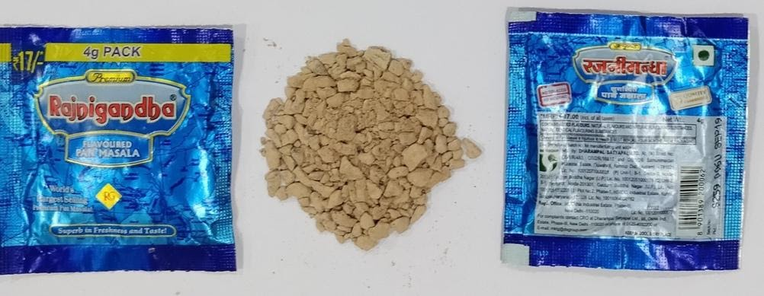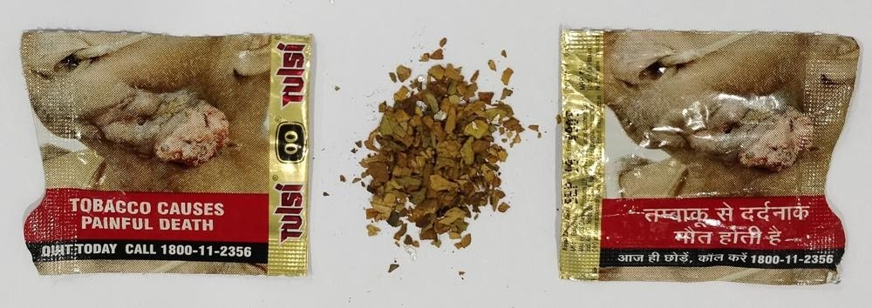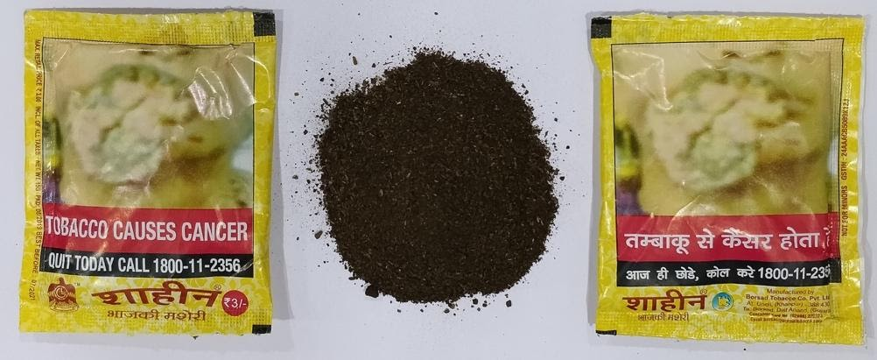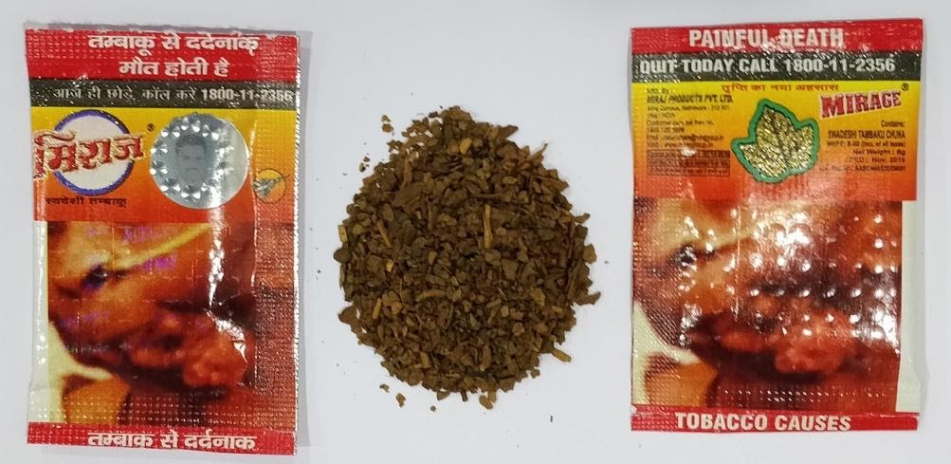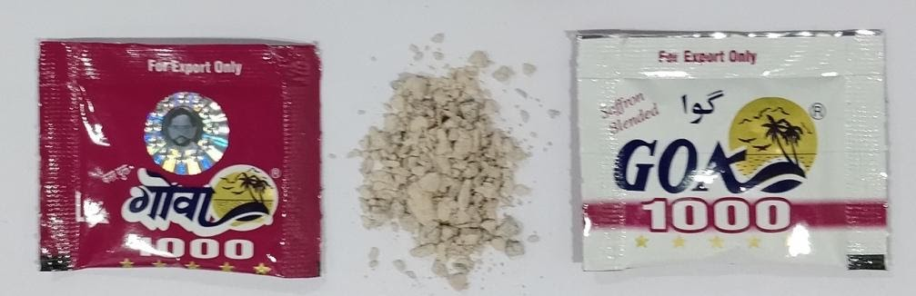
Figure 1. Smokeless tobacco samples collected from four different locations across India in November 2019

This paper will focus on the intricacy of SLT use in India and innovative strategies which can be employed to alleviate tobacco harm from smoking and smokeless products. Further, sample products procured across India are presented in Figure 1 followed by chemical testing for constituents and validation on the same to be discussed in subsequent studies. By initiating this flywheel effect, the authors propose to build long term research capability using innovations in the area of tobacco harm reduction and cessation. These are expected to lead to innovative and cost effective harm reduction and cessation products, and further initiate research to reduce some of the highest oral cancer death rates and tobacco related disability rates in India caused by tobacco consumption.

Results

NRTs for harm reduction – Nicotine gum is a chewing technique and fast acting form of replacement that is designed to provide constant, slow buccal absorption of nicotine from the gum[18]. Whenever they have the urge to smoke, subjects were encouraged to chew one piece of gum and recommended that the gum should be chewed very slowly. By using this technique nicotine level can be maintained at constant level in the blood stream by providing slow and constant absorption. The usage of nicotine gum is limited because of its bad taste and may lead to mouth ulcers and heartburn. Another disadvantage is that some people continue to use this nicotine product beyond the 3 months’ period specified by the FDA that causes prolonged nicotine addiction. Depending on excise taxes, nicotine gums are only available in large quantities, making the purchase price far more expensive for users[16], [17].
Nicotine lozenge is quick and discreet way to fight tobacco craving. However, long-term use of nicotine lozenges causes serious side effects and withdrawal symptoms such as anxiety and irritability [27].
Another NRT strategy is the use of transdermal patches that contain nicotine making it popular due to the simplicity of this method with the patches designed in such a way that they can be changed regularly. Nicotine patches are available in different doses that provide between 5mg and 22mg of nicotine in 24 hours and deliver nicotine in such a way that a steady state nicotine concentration can be maintained in the blood plasma [22], [28]. Transdermal patch is an emerging mode of drug delivery. This eliminates the fluctuations that can occur when using gum or tablets which must be taken regularly. In addition, these nicotine patches reduced withdrawal symptoms such as cravings to smoke, anger, impatience, anxiety, and difficulty concentrating with the most frequently reported side effects including skin rashes and improper use of these patches result resulting in nicotine overdose if consumed together with smoking[20], [22].
Use of Mobile technology for harm reduction – Use of mobile technology that has shown smoking cessation success in terms of promising quit rates using smartphone based apps include Smokefreebuddy (Janina Luscher, 2019), Smokefree28 (Harveen Kaur Ubhi, 2015) and Quit4Health (Katarzyna Czernaik, 2018). One such study increases the knowledge regarding effectiveness of smoking cessation through mobile intervention and concludes that recruitment of smokers remains a challenge for cessation trials using smartphone apps (Janina Luscher, 2019). However, the impact of innovative smartphone apps show significant gaps including access to consumers, scientific terminology and alignment of content with medically validated evidence. Further, SLT consumers in South Asia and other LMIC countries might not have access to a good internet connection restricting access to visual materials like videos or other content requiring a reliable internet connection with sufficient bandwidth. Additionally, these populations have the lower end of smartphones with limited graphic processing capabilities. Nonetheless, as one study shows promising results using text based cessation studies (Scott-Sheldon et al, 2016), a text based phone strategy seems appropriate to the average SLT consumer in Asia – the challenge with this would be the ownership of phones by vulnerable populations such as women and children.

Mass media and taxes – Mass media messages have a significant influence on tobacco reduction through indirect interpersonal as well as other social pathways. Pictorial warnings capture attention, create awareness of health risk , and a motivation to quit. Increased Health warning labels (HWLs) size significantly increases the level of effectiveness – from GATS 1 (Global Adult Tobacco Survey) to GATS 2, the size of HWLs has increased from 40% on single side to 85% on both sides of the packet. As the size of HWLs grew, this led to a significant impact on both intention and attempt to quit SLT[7], [8]. Increase in tobacco taxes is another important factor used to reduce the demand of tobacco and showed a 7% decrease in tobacco consumption in young people with 10% increase in tobacco taxes according to a World Bank report, especially true for LMIC countries. However, an increase in price showed other limitations such as greater demand for smuggled products [9], [10]. These factors though have a significant effect on tobacco consumption, are beyond the scope of this article and will be covered by the authors in detail in a forthcoming article on ‘current trends in SLT consumption’.

Global cues on innovation applied to reducing harm caused by tobacco –
India is one of the leading countries for nicotine dependence characterized by varied, predominantly socio-economic factors for prevalence of tobacco use. There were limited studies found on efficacy of reduced risk products (RRPs) or similar devices (e.g., ENDS – Electronic nicotine delivery systems) for harm reduction and tobacco cessation studied for the Indian population (Naskar et al., Harmeet Rehan et al.). One of the major challenges for conducting such a study was the confluence of socioeconomic factors, gender, age and education (Rani et al., Sorensen et al.). India together with other LMIC countries constitute 82% of the smoking population globally. Unclear directives on the use of RRPs for cessation was the lower sensitivity of the tools to assess efficacy of these devices and cessation success. Further, a continuous access to RRP devices and vaping liquids in rural areas, lack of gender parity and affordability add to the challenges of creating a pragmatic solution for cessation of smoking and smokeless use of tobacco products. This causes tobacco related cancers in India with esophagus and mouth cancer leading lung cancer at a significantly higher rate as compared with the developed world.
Tobacco harm reduction initiatives over the last decade have creatively employed innovative methods for harm reduction including philately to smartphone based apps for awareness, detection, treatment, diet and lifestyles. [14] have reviewed various strategies using smartphones for deploying tobacco cessation programs with limited success. The authors recommended using evidence-based approach in addition to record keeping or data collection for tobacco harm reduction initiatives. Using a different approach,[29] have used philately in the form of pictures, visuals and presentations in tobacco cessation programs. The authors found that their effort which was felicitated as the world’s largest stamp collection on cancer resulted in a significant quit rate. The authors recommended using this together with other cessation programs to increase success rates on tobacco harm reduction initiatives. Further Smartphone based app although hold promise, text based interventions in tobacco cessation have shown success in the feedback from users enrolled in a quit program[30].

Proposed state-of-the-art diagnostic and preventive techniques – Tobacco harm reduction is challenging and equally important given the burden of disease on the society and its multiplicative effect on the next generation family and friends of tobacco users. Innovative technologies and strategies have shown limited success rates for tobacco cessation and harm reduction programs. Although several innovations have been presented in the last decades to deal with this menace, there is a definite need for further technological innovations and research in this area.
The authors present two techniques for tobacco harm reduction based on innovative technology for smokers and smokeless tobacco users. The first technique is a novel method for emphysema quantification which was previously published by the authors[11] is based on CT lung imaging of smokers. This is illustrated in Figure 2 along with a comparative image showing absence of emphysema for non-smokers. This method has advantage in terms of actually diagnosing chronic obstructive pulmonary disease (COPD), and explaining it to the patient with comparison to a normal subject with similar demographics. Understanding the effect of smoking on their lungs gives a different perspective in choosing smoking for nicotine delivery. This can be followed by offering less harmful alternatives to smoking overseen by the physician in a clinic such that follow ups of the success can be quantified and abuse of these technologies can be minimized.
Lately, ENDS has been criticized and further banned in several countries including India. However, it is proven to be less harmful than cigarettes for nicotine delivery, and therefore can be used as prescription medicine with stringent regulations and tracking systems to avoid the spill off among teens in the society. In addition to ENDS, Snus can provide as a less harmful alternative to smoking. These alternative nicotine delivery systems can be targeted at COPD phase 3 and phase 4 patients initially on a trial basis since these patients have a lower life expectancy.
The second technique presented by the authors is based on real-time telecytology based oral cancer screening platform called ‘AMURA – advanced morphology unit for real-time analysis’. This platform includes slide acquisition, image preprocessing and machine learning detecting carcinogenic cells leading to early detection of throat cancer for SLT users. This technology is currently driven by a start-up and is currently in the process of applying for a patent. The technique could be used as an intervention technique for detecting symptoms of oral cancer followed by enrolment in a program for alternatives to nicotine delivery based on Snus or similar products which are clinically tested and validated. The representative Amura system is illustrated in Figure 3 and is currently under development.

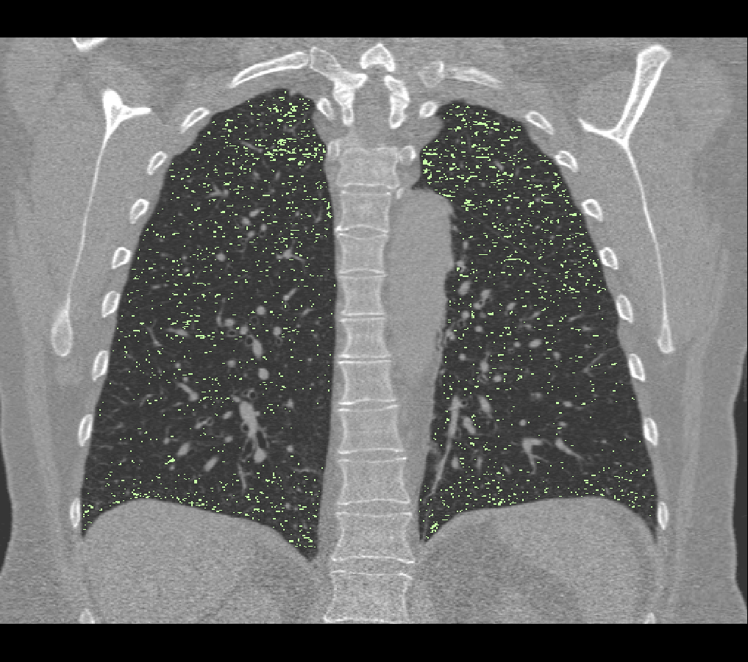
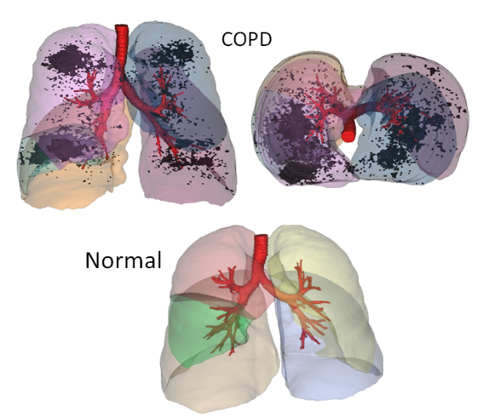
Figure 2. Quantitative analysis of emphysema in COPD patients shown in a CT shown on left and as 3D cloud compared with a normal subject on the right[11]

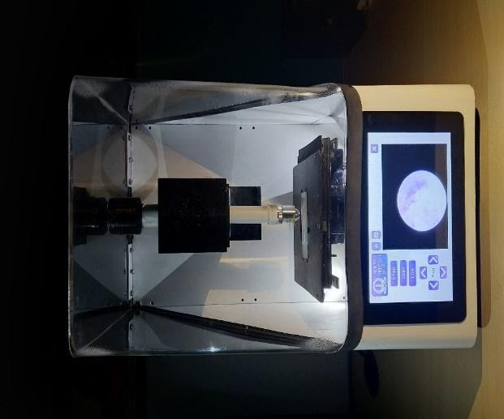

Figure 3. The Amura system for detecting atypical cells that could be sent to a remote pathologist for analysis

Discussion
The burden of tobacco use on health and wellbeing far exceeds the economic benefits in terms of exports and jobs. In Asian LMIC countries similar to India, smokeless tobacco users were reported as twice that of smokers. One of the popular forms of smokeless tobacco products sold in India was gutkha. Recently, several states in India had banned the sale of gutkha. The gutkha ban by several states [31] in India emphasizes its detrimental effect on health and wellbeing in the Indian society. However, there are several reports that the effect of this ban is and will continue to have limited benefits given the fact that gutkha is still widely consumed across India in a different form [32]. The authors found that there were complex hindrances to tobacco cessation in India including politico-bureaucratic nexus, conflicts of interest, socio-economic patterns, cultural and traditional bias, and most significantly absence of regulation and testing infrastructure for tobacco products. Further, the latest ban on gutkha by several state governments has led to an innovative ‘Jugaad’ by tobacco companies. In the wake of this ban, gutkha companies have started manufacturing tobacco and paan masala as two ingredients sold separately falling outside the ambit of the ban. These individual packets are mixed by the consumer or the vendor (paan shops) to yield different grades of gutkha depending on the strength of nicotine and the combination of the mixture. Additionally, the authors were surprised that majority of researchers were not aware of the aforementioned facts during a discussion at a National level tobacco conference in India in late 2019.

Conclusion

The problem of tobacco harm reduction can benefit immensely from latest innovations with the popularity of smartphone based apps reaching rural places with the advent of internet in developing countries. Developing countries account for majority of the harm caused by tobacco consumption where the recent extent of internet services can be leveraged to pursue innovative strategies in tobacco harm reduction. The authors have presented the problem of tobacco burden in India followed by the associated factors affecting sale and consumption. The authors have proposed two innovative methods for tobacco harm reduction and cessation solutions. Future work will include field based pilot studies for cessation by establishing SLT testing infrastructure and promoting clinically validated SLT products to replace unregulated and hazardous tobacco products widely sold across India for nicotine consumption. Further, innovation and entrepreneurship for alternate economic sustainability will be studied for mitigating risks and providing overall sustainability.

Acknowledgments
The authors are grateful to HRRIC for their continued support in Tobacco Harm Reduction initiatives in India. The authors would also like to thank Ms. Shweta Wani and Ms. Francie Patel for their continued support and encouragement in addition to assistance in reviewing this article.

Competing Interests
The authors would like to report no existing or potential conflicts of interest

Funding and all other required statements
This paper was funded by the Harm Reduction Research and Innovation Center (Mumbai, India)

References

[1] G. Sorensen, P. C. Gupta, and M. S. Pednekar, “Social disparities in Tobacco use in Mumbai, India: The roles of occupation, education, and gender,” American Journal of Public Health. 2005, doi: 10.2105/AJPH.2004.045039.
[2] G. of I. Ministry of Health and Family Welfare, “Executive summary,” ASHE-ERIC High. Educ. Rep., vol. 23, no. 7, pp. iii–vii, 1994, doi: 10.1002/aehe.3640230702.
[3] “Global Tobacco Surveillance System Data (GTSSData): Explore by Location | OSH | CDC,” pp. 1–2, 2019.
[4] R. Mehrotra et al., “Smokeless tobacco control in 180 countries across the globe: call to action for full implementation of WHO FCTC measures,” Lancet Oncol., vol. 20, no. 4, pp. e208–e217, 2019, doi: 10.1016/S1470-2045(19)30084-1.
[5] G. K. Mini and K. R. Thankappan, “Switching to smokeless tobacco, the most common smoking cessation method: results from the Global Adult Tobacco Survey, India,” Public Health, vol. 136, pp. 172–174, 2016, doi: 10.1016/j.puhe.2016.03.035.
[6] A. Singh and L. Ladusingh, “Prevalence and determinants of tobacco use in India: Evidence from recent global adult tobacco survey data,” PLoS One, vol. 9, no. 12, pp. 1–18, 2014, doi: 10.1371/journal.pone.0114073.
[7] H. Singhavi and P. Chaturvedi, “Do mass media in health awareness make a palpable impact on cessation of smokeless tobacco use?,” Indian Journal of Medical and Paediatric Oncology. 2019, doi: 10.4103/ijmpo.ijmpo_200_19.
[8] M. M. Bala, L. Strzeszynski, and R. Topor-Madry, “Mass media interventions for smoking cessation in adults ( Review ) SUMMARY OF FINDINGS FOR THE MAIN COMPARISON,” Cochrane Database Syst. Rev., no. 11, 2017, doi: 10.1002/14651858.CD004704.pub4.www.cochranelibrary.com.
[9] C. Marr and C.-C. Huang, “Higher Tobacco Taxes Can Improve Health And Raise Revenue Smoking Causes One in Five Deaths in the United States,” pp. 1–6, 2014.
[10] P. Bader, D. Boisclair, and R. Ferrence, “Effects of tobacco taxation and pricing on smoking behavior in high risk populations: A knowledge synthesis,” Int. J. Environ. Res. Public Health, vol. 8, no. 11, pp. 4118–4139, 2011, doi: 10.3390/ijerph8114118.
[11] S. Vinchurkar, C. Van Holsbeke, W. Vos, W. De Backer, and J. De Backer, “A Novel Method For Obtaining Local Quantitative Emphysema In COPD Patients: Correlation With Lung Function Tests And Standard Patient Reported Outcome Scores,” 2012, doi: 10.1164/ajrccm-conference.2012.185.1_meetingabstracts.a4332.
[12] A. L. Rathbone and J. Prescott, “The use of mobile apps and SMS messaging as physical and mental health interventions: Systematic review,” J. Med. Internet Res., vol. 19, no. 8, pp. 1–13, 2017, doi: 10.2196/jmir.7740.
[13] J. Lüscher, C. Berli, P. Schwaninger, and U. Scholz, “Smoking cessation with smartphone applications (SWAPP): Study protocol for a randomized controlled trial,” BMC Public Health, vol. 19, no. 1, pp. 1–10, 2019, doi: 10.1186/s12889-019-7723-z.
[14] P. Sharma, S. Dwivedi, and R. Dubey, “A review on innovations in Pharmacotherapy for tobacco addiction,” Int. J. Pharm. Life Sci., vol. 7, no. 10/11, pp. 5300–5310, 2016.
[15] B. L. Haskins, D. Lesperance, P. Gibbons, and E. D. Boudreaux, “A systematic review of smartphone applications for smoking cessation,” Transl. Behav. Med., vol. 7, no. 2, pp. 292–299, 2017, doi: 10.1007/s13142-017-0492-2.
[16] J. Le Houezec, A. Mcneill, and J. Britton, “Tobacco, nicotine and harm reduction,” Drug Alcohol Rev., vol. 30, no. 2, pp. 119–123, 2011, doi: 10.1111/j.1465-3362.2010.00264.x.
[17] E. Beard, A. McNeill, P. Aveyard, J. Fidler, S. Michie, and R. West, “Association between use of nicotine replacement therapy for harm reduction and smoking cessation: A prospective study of English smokers,” Tob. Control, vol. 22, no. 2, pp. 118–122, 2013, doi: 10.1136/tobaccocontrol-2011-050007.
[18] L. Shahab, L. S. Brose, and R. West, “Novel delivery systems for nicotine replacement therapy as an aid to smoking cessation and for harm reduction: Rationale, and evidence for advantages over existing systems,” CNS Drugs, vol. 27, no. 12, pp. 1007–1019, 2013, doi: 10.1007/s40263-013-0116-4.
[19] M. K. W. Leung et al., “Combined nicotine patch with gum versus nicotine patch alone in smoking cessation in Hong Kong primary care clinics: A randomised controlled trial,” BMC Public Health, vol. 19, no. 1, pp. 1–10, 2019, doi: 10.1186/s12889-019-7634-z.
[20] U. Wadgave and L. Nagesh, “Nicotine replacement therapy: An overview,” Int. J. Heal. Sci., vol. 10, no. 3, pp. 425–435, 2016, doi: 10.12816/0048737.
[21] P. CARE, “A clinical practice guideline for treating tobacco use and dependence,” Jama, 2000.
[22] S. Ravi, P. K. Sharma, and M. Bansal, “A review: Transdermal drug delivery of nicotine,” International Journal of Drug Development and Research. 2011.
[23] P. C. Gupta and C. S. Ray, “Smokeless tobacco and health in India and South Asia,” Respirology. 2003, doi: 10.1046/j.1440-1843.2003.00507.x.
[24] K. Niaz, F. Maqbool, F. Khan, H. Bahadar, F. Ismail Hassan, and M. Abdollahi, “Smokeless tobacco (paan and gutkha) consumption, prevalence, and contribution to oral cancer,” Epidemiol. Health, vol. 39, p. e2017009, 2017, doi: 10.4178/epih.e2017009.
[25] T. A. R. Seemungal, G. C. Donaldson, E. A. Paul, J. C. Bestall, D. J. Jeffries, and J. A. Wedzicha, “Effect of exacerbation on quality of life in patients with chronic obstructive pulmonary disease,” Am. J. Respir. Crit. Care Med., 1998, doi: 10.1164/ajrccm.157.5.9709032.
[26] E. Ståhl et al., “Health-related quality of life is related to COPD disease severity,” Health Qual. Life Outcomes, 2005, doi: 10.1186/1477-7525-3-56.
[27] M. Sukhija, R. Srivastava, and A. Kaushik, “Pharmacokinetic characterization of three novel 4-mg nicotine lozenges,” Int. J. Clin. Pharmacol. Ther., vol. 56, no. 3, pp. 1–4, 2018, doi: 10.5414/CP203097.
[28] S. The Tobacco Use and Dependence Clinical Practice Guideline Panel, Staff, and Consortium Representatives, Representatives, and Consortium, “Astrocytes_heatmap_PearsonClustering.pdf,” JAMA J. Am. Med. Assoc., vol. 283, no. 24, pp. 3244–3254, 2000, doi: 10.1001/jama.283.24.3244.
[29] U. Sanyal, “A Unique Approach Toward Cancer and Tobacco Control Using Philately As Innovative Tool,” Journal of Global Oncology, no. 4_suppl_2. pp. 131s-131s, 2018, doi: 10.1200/jgo.18.22600.
[30] P. Gopinathan et al., “Self-reported quit rates and quit attempts among subscribers of a mobile text messaging-based tobacco cessation programme in India,” BMJ Innov., 2018, doi: 10.1136/bmjinnov-2018-000285.
[31] L. Tv, “Assam bans gutka, pan masala containing tobacco-nicotine for one year,” pp. 1–7, 2020.
[32] T. F. Safety and F. Safety, “Arun Jithendra : Pan masala — a way for the tobacco industry to bypass the gutkha ban ? Comment and opinion from The BMJ ’ s international community of readers , authors , and,” pp. 1–5, 2020.

