**Creep stabilization of slopes in soft clay**

Pusch, R.[1], Yang, T[2] and Knutsson S.[3]

Abstract

The microstructural constitution of illitic and smectitic clays control the rheological behaviour. Organic residue in the form of microbes, microscopic plant debris and organic molecules, making up more than one or two weight percent, has a significant impact on it. In normally consolidated organic-poor clay slopes exposed to low and moderately high deviator stresses, a self-strengthening process function takes place by successive mobilization of higher energy barriers. This can explain why old slopes with very low safety factors have remained stable. The same effect may also play a role in secondary consolidation of clays under own weight.

**JEL classification numbers:** xxxxx

**Keywords:** activation energy, clay, creep, energy barrier, self-strengthening, shear failure, slope

1. Scope

1.1 Background

There are long natural clay slopes formed under marine conditions, dipping only by one or a few percent, that have remained stable since they appeared above sea level a few thousand years ago despite very low factors of slope stability (cf. Bernander, 2008). This is in contrast with certain similarly oriented and shaped slopes formed in the same or similar way and environment that have not remained stable as exemplified by the disastrous Surte and Tuve slope failures in Sweden. The reason for the survival of the firstmentioned has not been thoroughly investigated and discussed in the literature, a suggested explanation being that they have not been exposed to disturbances in the form of loading by fillings or by pile-driving. Since such impact would have only had localized effect on the stability of the large involved clay masses there may be other explanations of the actual stability. A possible reason for the survival of undisturbed as well as of disturbed clay slopes can be that strengthening by microstructural healing can have taken place. This matter, which is strongly related to strain rate, is considered in the paper, the basis of which is the longitudinal section of a clay slope in Figure 1.



Figure 1. Division of potentially unstable clay into lamellae for conventional calculation of turning moments (Janbu, 1977). For c´=10 kPa, φ=28o, and unit weight 1800 kg/m3, one gets F=1.3

The gravitational shear stresses in the potentially sliding clay mass in Figure 1 vary depending on the shape of the slipping mass and the effective normal pressure along the assumed slip plane, as well as on the effective normal pressure on the vertical boundaries of the lamellae. The shear strain is larger where the degree of strength mobilization is highest, i.e. at the toe and crown, and smaller where the available shear strength has been utilized to a lower degree, commonly in the central part of the slip plane. The shear stress along the slip plane may correspond to the residual strength at its lowermost and uppermost parts, while the shear stress may represent the peak strength in the central part of the slip plane. This assumption is reasonably correct for circular cylindrical slip surfaces while for the common, more or less ellipsoidal shape, the stress situation and thereby the strain pattern within the clay mass play a role also for the shear stress distribution along the slip plane.

Bernander (2011) showed that the kinetics of failing long slopes govern the movements of and within them, ultimately generating passive soil pressure at the toe and active soil pressure at the crown at progressive failure. The different parts of a clay mass about to slide have undergone successive stress transition from one of maximum mobilized shear resistance to one of somewhat reduced resistance and further to one representing the residual strength.

1.2 Hypothesis of self-strengthening of potentially unstable clay slope

Those parts of a clay slope where reduction of the shear resistance has taken place, generated by large strain, may undergo stiffening if the porewater pressure raised by the shearing can disseminate. The clay thereby becomes overconsolidated, using common terminology, with the higher shear resistance serving to anchor the potentially sliding mass. With time these strengthened parts undergo the same process over again, i.e. successive reduction of the shear strength due to overstressing and stress transfer to less strongly loaded parts etc, ultimately tending to give a uniform shear resistance. This process can also take place on the microstructural level if the shear stresses are not high enough to cause instant slope failure. Naturally, any external impact in the form of pile-driving, causing disturbance or pore water overpressure can trigger local failure that can spread and yield large-scale failure (Pusch et al. 2016). The theory behind such self-strengthening and application of it make up the scope of the paper.

1. Creep effects in clay
   1. General

Creep is long-term strain under defined stress conditions. For the present case we will consider a time interval long after a clay stratum emerged from the marine environment where it was formed, which allows us to assume that consolidation and salt dilution are over and no longer control the rheological performance. The role of water is simply to occupy and be retained in the clay voids.

We will consider a case of long-term creep strain under constant external stress conditions and use the Feltham/Pusch formulation of creep strain here assuming volume constancy. This conceptual microstructural creep model can be expressed in mathematical form by considering:

• The structural heterogeneity and bond strength variation expressed by a spectrum in bond strength or activation energy,

• That each clay element contains a certain number of slip units (patches of atoms) in a given interval of the activation energy spectrum at any particular time after the onset of creep,

• That, in the course of the creep, new slip units are created at the lower end of the energy spectrum while the high energy end is an “absorbing barrier”, representing a “blue-shift” of the spectrum,

• That jumps on the atomic or molecular scale bring a slip unit up or down against a barrier by a certain amount, higher or lower than the previous one. Applying thermodynamics the number of potential slip units per unit volume held up at barriers of a certain height can be defined by use of the Arrhenius rate equation v(u)=vD exp (-u/kT), introducing an averaged atomic vibrational frequency vD and using Boltzmann’s constant and the absolute temperature,

• Introduction of a relevant number of energy barriers of certain height and energy interval between successive jumps of a unit, making the entire process stochastic. The change in activation energy in the course of evolution of strain means that the number of slip units is determined by the outflux from any energy level into the adjacent, higher energy interval and by a simultaneous inflow into the interval from the lower part of the barrier spectrum,

• That when a slip has taken place, meaning that a barrier has been overcome, a contribution to the bulk shear strain has been made by the associated extension of the local slip-patch. The next barrier to be encountered by the same spreading slip unit will be either higher or lower by the same average amount of energy.

For low shear stresses, allowing for “uphill” rather than “downhill” jumps and assuming that each transition of a slip unit between consecutive barriers gives the same contribution to the bulk strain one gets the bulk shear strain rate as in Eq.(2) with t<to as boundary condition:

*d/dt*=B(1*-t/to*) (1)

The coefficient B and the value of *to* depend on the deviator stress, temperature and structural details of the slip process (Feltham, 1993). The creep can be expressed as in Eq.(2), meaning that the creep starts off linearly with time and then dies out, hence corresponding to “primary” creep.

**=*t* –*t*2, (*t*</2) (2)

where  and *b* are constants.

For higher bulk deviator stresses, the strain on the microstructural level yields some irreversible changes associated with local breakdown and reorganization of whole particles. Still, there is repair by inflow of new low-energy barriers parallel to the strain retardation caused by the successively increased number of slip units that meet higher energy barriers as illustrated by the “blue-shift” of the energy barrier spectrum exemplified in Fig.2. This type of creep can go on for ever without approaching failure. Feltham (1993) demonstrated that for thermodynamically appropriately defined limits of the u-spectrum the strain rate appertaining to logarithmic creep takes the form of Eq.(3):

*d/dt*=*BT/(t+to)* (3)

where *B*=is a function of the shear stress **. *to* is a constant of integration which leads to a creep relation closely representing the commonly observed logarithmic type implying that the creep strain is proportional to log(*t+to*).

The detailed microstructural process involves early triggering of low barriers associated with activation of new slip units at the lower end of the barrier spectrum, which represents the “generating barrier” end, while the upper is “absorbing”. The energy spectrum hence changes in the course of the creep as illustrated by Figure 2, which represents the case of initially uniform distribution of barriers in the assumed interval 0.1-0.9 eV. The graph shows the calculated successive change in the number of barriers of different activation energies as a function of time. At the end of the creep period (stage 5) the number of very low barriers has dropped from the initially assumed number 100 to 1, while those representing 0.5 eV have increased from 100 to about 400 [9]. If the shear stress is kept constant the energy spectrum moves from lower to higher levels in the course of the mobilization of stronger barriers and the system becomes dominated by strong interparticle bonds.

The practical meaning of all this is that the large majority of contacting clay aggregates are “hung up” in old natural clay slopes and that they do not exhibit significant creep. High stresses prevail at these contacts and rather small external impact, like pile-driving or road construction close to the crown of the slope can trigger failure.

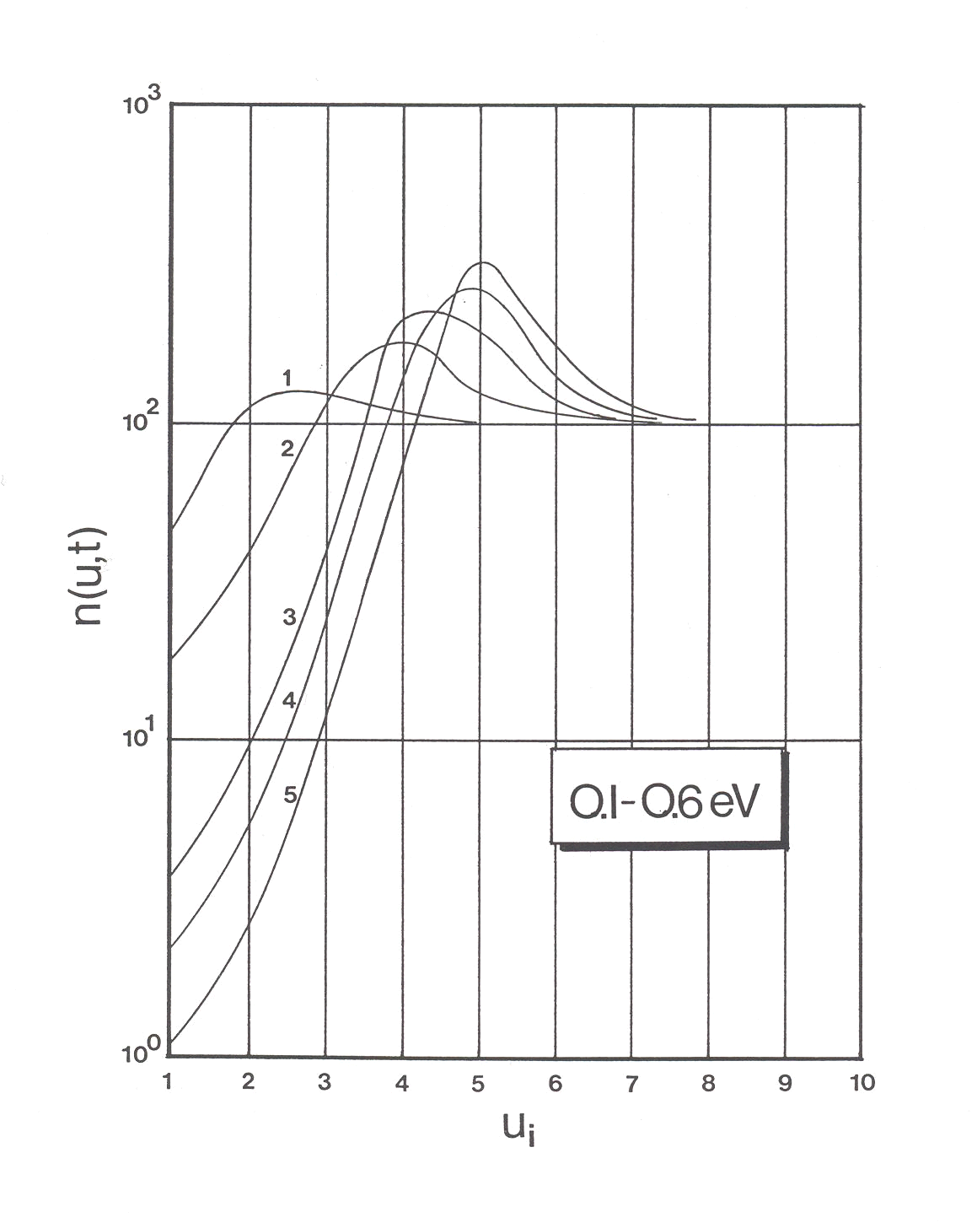

Figure 2. Successive change in distribution of energy barriers in the course of transient creep. 1, 2, 3 etc denote time stages and *n(u,t)* the fraction of barriers of energy level *ui*. The initial number of barriers is 1000 (Pusch, 2015).

The significance of *to* is understood by considering that in the course of applying a deviatoric stress, at the onset of of the creep test, the deviator rises from zero to its nominal, final value. A *u*-distribution exists at *t*=0, i.e, immediately after full load is reached, which may be regarded as equivalent to one which would have evolved in the material initially free from slip units, had creep taken place for a time to before loading. This behaviour was shown by the rather soft freshwater clay represented by Curve F in Fig.3. Negative *to* has been foundfor significantly cemented clay. High organic content (Curve E) represents large microstructural strain with poor strain-related microstructural recovery and self-strengthening.

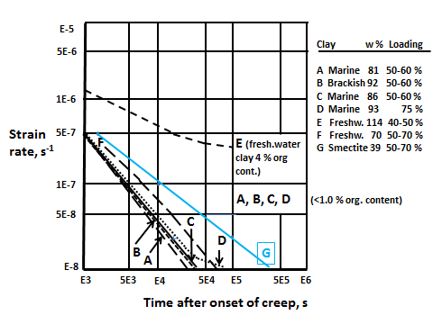

Figure 3. Creep curves of clays in unconfined compression tests. A-F Natural Quaternary, illite-dominated clays. The actual loading rates are in percent of the respective failure load. Smectite clay (G) prepared by expansion of bentonite granules in oedometer.

**2.2 Mechanisms in shear strain**

**2.2.1 How much of a clay mass is involved in a failure process and preceding creep?**

A microstructural study based on ultra-thin section technique and transmission electron microscopy of illitic clay samples that had been exposed to uniaxial compression were investigated with respect to microstructural response to shearing (Pusch, 1970). In the macroscopic shear zone the shear forces tended to orient and deform the particle aggregates (Fig. 2). The extent to which other parts were involved and underwent microstructural strain was investigated by focusing on the microstructure at different distances from the macroscopic failure plane giving the orientation “rosettes” in Figures 6-8, from which one concludes that the same degree of particle orientation prevailed from this plane to at least 15 mm from it. One can therefore assume that all microstructural elements in a clay body in critical state have undergone the same slip and rotational strain.

C:\Users\R. Pusch\Documents\Mina skanningar\skanna0116.tif

Figure 5 Location of specimens for microstructural analysis (Pusch, 1970).

C:\Users\R. Pusch\Documents\Mina skanningar\skanna0117.tif 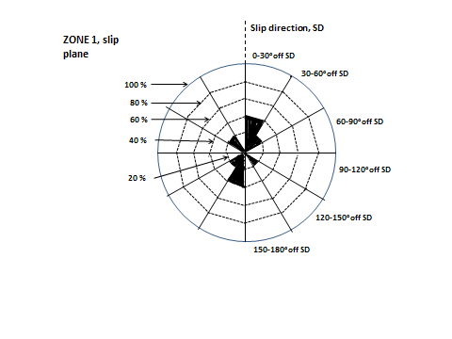

Figure 6. Microstructural constitution in the macroscopic failure zone (0-5 mm).

C:\Users\R. Pusch\Documents\Mina skanningar\skanna0118.tif 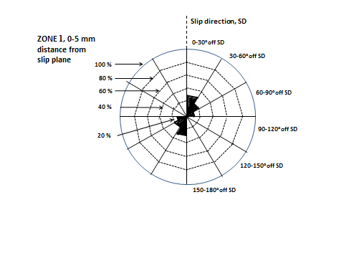

Figure 7. Microstructural constitution in Zone 1 (5-10 mm from macroscopic failure plane). Shear-induced “domains” encircled.

C:\Users\R. Pusch\Documents\Mina skanningar\skanna0119.tif 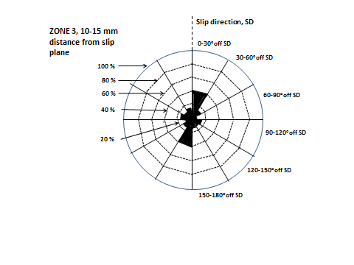

Figure 8. Microstructural constitution in Zone 2 (10-15 mm from macroscopic failure plane).

**Practical application of model**

**3.1 Definitions**

The starting point is the clay stratum in Fig.6, representing, in 2D, an element of a long slope in smectitic clay, and providing specific data for calculating the safety factor and shear strain and strain rate 10, 100 and 100 years after onset of creep strain under drained conditions. The slope is considered to behave as a large coherent body of initially normally consolidated clay sliding along a plane base (“firm bottom”). The considered element is assumed to be exposed to the same lateral earth pressure on the sides. Critical strength conditions and large longitudinal shear strain imply that there is no cohesion intercept of the Mohr/Coulomb stress relationship. The initial angle of internal friction □ is taken as 10o, increasing with time according to the relation **= □ log*t*), with *t* in years (10 and higher). This relationship relates to the general creep strain rate of soft illitic clay under moderate shear stress (cf. Figure 3). The initial safety factor is expressed as the ratio of tan□   and tan i.e.  his value is conventionally deemed to be too low according to regulations and experience.

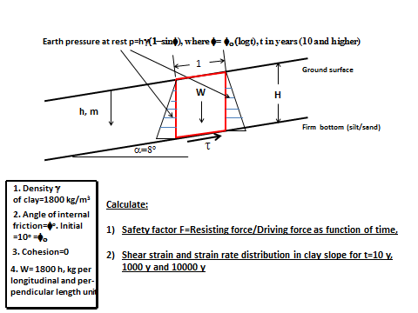

Figure 6. Example of element in a long clay slope for calculation of safety factor and shear strain and strain rate distribution as functions of time. The slope is assumed to be located above the groundwater surface.

**3.2 Calculations**

Using finite element technique the shear stress (Figure 7) and strain were calculated for an assumed length of the clay stratum of 100 m, locking the lower left node and allowing for vertical expansion/contraction of the clay body. The shear stress is shown as a function of the slope angle in Figure 7. Figure 8 gives the shear strain in the longitudinal XY plane for t=10 years. Figure 9 gives the safety factor expressed as  for different periods of time. For the assumed log-time controlled increase in energy barrier height one finds that the maximal shear strain for t=10 years is about 1.2 %, corresponding to a safety factor of around 1.2 for a 12o slope in smectite-dominated clay slope.



Figure 7. Shear stress in bottom layer as a function of the slope angle.

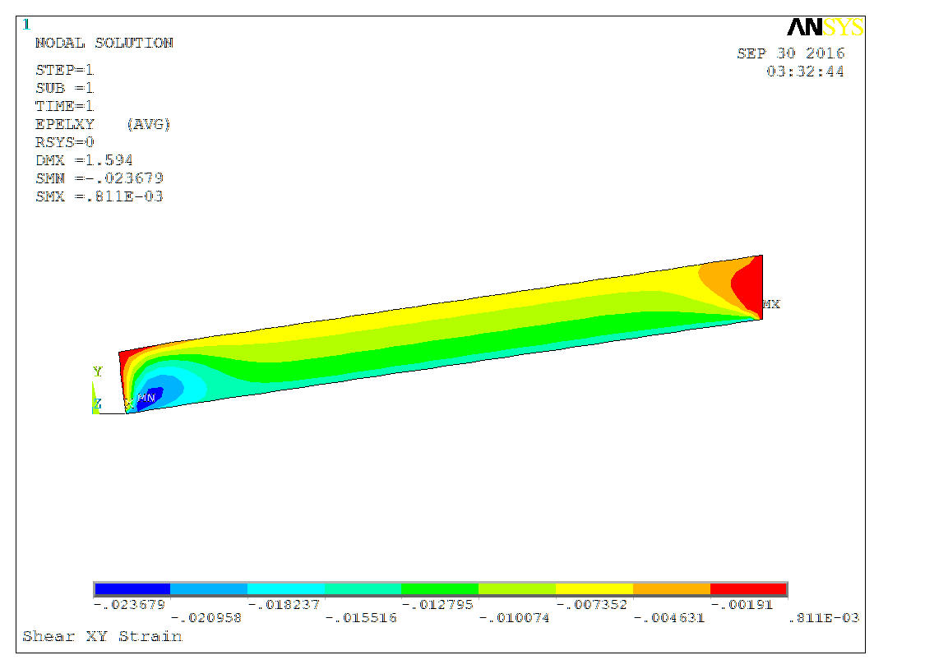

Figure 8. Shear strain in longitudinal XY plane of a slope with 12o inclination for t=10 years. The upper end of the slope is unloaded while the upper end is exposed to paassive earth pressure (cf. Bernander, 1994).



Figure 9. Factor of safety for differently inclined smectite-rich clay slopes after 10 years. Failure would take place for slope angles higher than about 12o, while about 8o inclination gives a safety factor of about 1.3 (After Nakano).

**4 Discussion and Conclusions**

The study concerns the evolution of creep strain in long slopes in clay with strain-related generation of the shear resistance. The nature of the strengthening mechanisms was outlined and application made of log-time functions for the strengthening and its contribution to improved slope stability. This illustrates the role of microstructural modelling and use of thermodynamics for scientific and practical purposes. The major points were:

* Stochastical mechanics applied to clay microstructure implies use of energy barrier spectra with weak links like hydrogen bonds at the lower ends and strong primary valence bonds at the upper ones. Under deviator stresses, shifts take place successively leading to dominance of high-energy barriers and higher bulk strength,
* Approaching a critical state condition causes shear-induced displacement of most clay particles, followed by particle rearrangement, repeated shear movements, and local breakdown. For sufficiently high stresses on the microstructural level, time will not suffice to allow for rearrangement, the strain rate will increase and give ultimate failure,
* The creep-induced strengthening reduces the strain rate if the bulk deviator stress is sufficiently low, i.e. below about 60% of the undrained shear strength according to empirical data for illitic clay. This means that under this condition slopes are expected to remain stable for any period of time if no disturbance takes place as in the case of loading of the ground surface, and piling causing porewater overpressure,
* Smectites have much more interwoven clay particle networks and much higher number of interparticle bonds per unit volume than equally dense illite. Since low-barriers (H-bonds) dominate, the strain rate is higher despite the higher density (lower water content) for the G-curve in Figure 3,
* Organic-rich clays (Curve E in Figure 3) undergo large microstructural strain with poor strain-related microstructural recovery and self-strengthening, like smectites. Their content of degrading substances can cause considerable change in rheological performance over time,
* Macroscopic failure of normally consolidated illitic clay takes place if the shear stress exceeds 50-60 % of the undrained strength determined by unconfined uniaxial compression, cone penetration or vane tests. This means that design of slopes for reaching long-term stability requires application of a safety factor of at least 1.3. For very old stable slopes the calculated safety factor may be found to be as low as unity.
* Macroscopic failure of normally consolidated smectite-rich clay is not a commonly observed phenomenon but creep testing in the laboratory indicate that it is preceded by or associated with very large strain, indicating that the same self-strengthening process is valid as for illites.

One concludes from all this that the self-strengthening function of illitic and smectitic clays, including also those with considerable organic content, i.e. by successive mobilization of higher energy barriers in the course of shear-induced strain, can explain why even very old slopes with low safety factors have remained stable. This effect may also play a role in secondary consolidation of clays under own weight.

**4 References**

Bernander, S., Progressive landslides in long natural slopes, 2011. Doct. Thesis, Luleå University of Technology (ISBN: 978-91-7439-283-8; ISSN: 1402-1544).

Janbu, N., 1977. State-of-the-Art Report: Slopes and excavations. Proc. 9th ICSMFE, Tokyo, 1977.

Pusch, R., 1970. Microstructural changes in soft quick clay at failure. Can. Geotechn. Journal, Vol.7, No. 1.

Pusch, R., 2015. Bentonite Clay, CRC Press, Taylor & Francis Group, (ISBN: 13:978-1-4822-4343-7).

Pusch, R., Knutsson, S., Xiaodong, L., Yang, Ting, 2016. Creep can strengthen Clay: A Matter of Long-term Slope Stability, Journal of Earth Sciences and Geotechnical Engineering, vol. 6, no.1, 2016, 1-18 ISSN: 1792-9040 (print), 1792-9660 (online) Scienpress Ltd.

**Creep stabilization of slopes in soft clay**

**Document 1**

Pusch, R.1, Yang, T1, Knutsson, S.1,

**Grouting of rock for Construction of deep railway tunnels**

**Document 3**

Pusch, R.1, Yang, T1, Knutsson, S.1,

**Cement-based grout for Sealing Fractured Rock**

**Document 2**

Pusch, R.1, Muhammed, X, Knutsson, S.1,

1. Affiliation of the first author. e-mail: 1) Luleå University of Technology, Luleå, Sweden Roland Pusch [drawrite.se@gmail.com](mailto:drawrite.se@gmail.com); Sven.Knutsson@ltu.se
2. Affiliation of the second author. e-mail: Lund Technical University, Lund, Sweden.
3. Article Info: *Received:* January 10, 2011*. Revised: June 23, 2019.*

   *Published online*: July 17, 2011.