Comparative Study of the Cement and Rock Flour Stabilization on the Engineering Properties of Lateritic Soil in Supare – Akoko, Southwestern Nigeria

*Ogunribido, T. H. T¹ and Abiola, O.¹
¹Department of Earth Sciences, Adekunle Ajasin University, PMB 01 Akungba–Akoko, Nigeria
*Correspondence Author E – Mail: ogunribido_henry@yahoo.com
Abstract
The comparative study of cement and rock flour stabilization on the engineering properties of lateritic soil in Supare-Akoko, Southwestern Nigeria was carried out in order to determine the effects of additives as stabilizer on lateritic soil in road construction.
The study area is underlain by the Precambrian Basement Complex rocks of Southwestern Nigeria. The major rock types are: granites, granite gnesis, charnokites and migmatite gnesis and granite occurring as the dominant rocks.
Three soil samples were collected at different locations at a depth of 1m within the study area. The soil samples were air dried at the Laboratory for two weeks before analyses. The tests carried out include specific gravity, grain size analysis, Atterberg limits, linear shrinkage, compaction, California Bearing Ratio and Unconfined Compressive Strength. The soils were stabilized with 2, 4, 6, 8 and 10% cement and rock flour respectively. The addition of 2, 4, 6, 8 and 10% by weight of cement and rock flour for soil samples 1, 2 and 3 shows continuous increase in the California Bearing Ratio. Cement additives shows higher percentage increase when compared with rock flour.
Unconfined Compressive Strength decreases for the three soil samples with increase in the percentage of rock flour and the reverse is the case when cement was added. Also, the addition of cement shows increase in the Shear Strength for all the soil samples and decreases with the addition of equal percentage of rock flour.
Keywords: Comparative Study, rock flour stabilization, Precambrian Basement Complex, cement additives

- Introduction
The major problem facing the geotechnical or highway engineer today is the soil instability when they are used as sub grade material. The problem of instability may result from large content of swelling or expansive clay material which makes the soil unsuitable as a construction material in foundation, road, reservoir or any other engineering constructions.
Lateritic soils are relatively abundant and have found wide application in engineering construction works particularly road building. Lateritic soil in Nigeria usually contain large content of clay, therefore there is need for stabilization before they are use as construction material. In the recent time, researchers has used various stabilization agents to assess the improvement in the engineering properties of lateritic soil, such workers includes Ogunribido, (2012), Oloruntola et al.,(2008), Okunade, (2012), Amu et al., (2011), Amadi, (2010), Joel and Agbede, (2008), and Oyediran and Kalejaiye,(2011).
The purpose of this research is to compare the influence of cement and rock flour as stabilization agents on lateritic soil in road construction.

2. Location and the Geology of the Study Area
The study area lies between latitude 7º 25.5¹and 7º28¹ North and longitude 5º 40¹and 5º42.5¹East (Figures 1 and 2).
The study area, Supare, forms part of the area underlain by the Pre-Cambrian Basement Complex rock of Southwestern Nigeria (Figure 1) (Rahaman, 1976, Rahaman, 1988). The major rock types are granites, granite gneiss, charnockites, and migmatite gneiss. Granites are the dominant rock in the study area.
3. Materials and Methods
Three soil samples were collected at three different locations at depth of 1m from the study area. The soil samples were air dried at the laboratory of Geology Department of the Federal University of Technology, Akure for two weeks before laboratory analysis.
Test carried out includes Specific Gravity, Atterberg Limits, Compaction, California Bearing Ratio and Unconfined Compressive Strength.
The soils samples were stabilized with 2,4,6,8 and 10% cement and rock flour respectively.

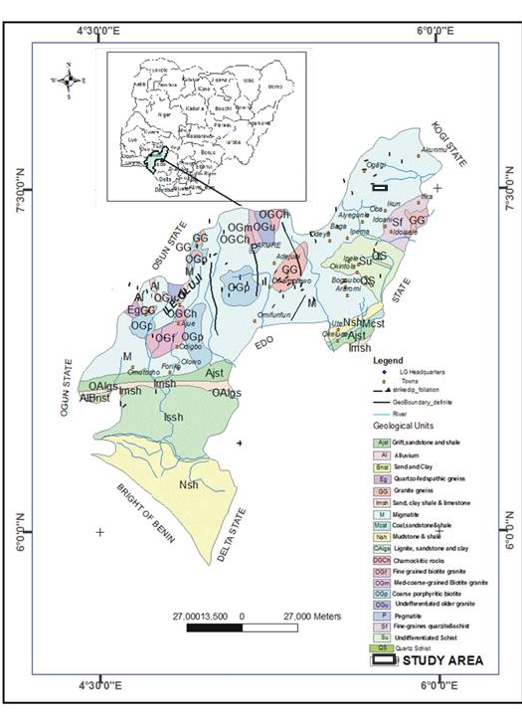

Figure 1. Geological Map of Ondo State showing Study Area (Modified after GSN)

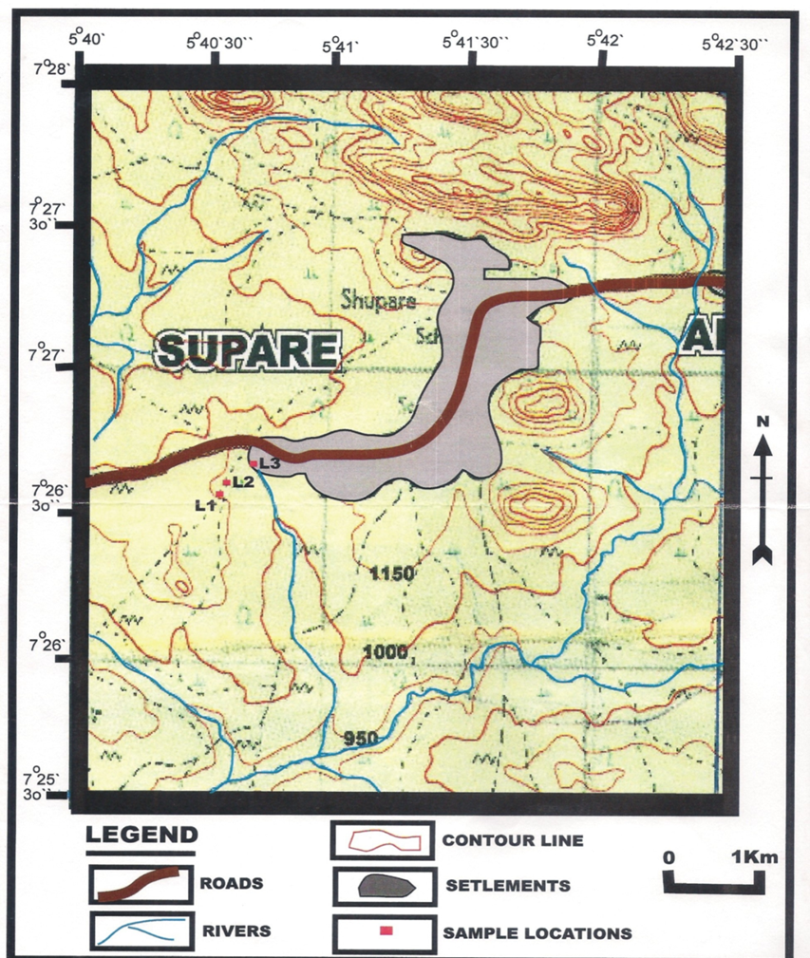

Figure 2: Topographical Map Showing the Study Area

4.0 Results and Discussion
The geotechnical properties of the soil with rock flour and cement stabilization for the soil samples are presented in Tables 1 and 2 as shown below.

Table 1: Geotechnical properties of the soil with rock flour stabilizer
Sample Number | Rock flour (%) | Liquid limit (%) | Plastic limit (%) | Plasticity Index | Specific gravity | CBR (%) | UCS | Shear strength
L1 | 0 | 28.2 | 18.2 | 10.0 | 2.68 | 53.0 | 107.88 | 53.94
 | 2 | 27.7 | 18.5 | 9.2 |  | 58.0 | 97.09 | 48.55
 | 4 | 26.6 | 18.9 | 7.7 |  | 62.0 | 87.17 | 43.58
 | 6 | 25.8 | 25.8 (NP) | 0.0 |  | 66.0 | 80.65 | 40.33
 | 8 | 25.2 | 25.2 (NP) | 0.0 |  | 68.0 | 75.27 | 37.63
 | 10 | 24.7 | 24.7 (NP) | 0.0 |  | 73.5 | 71.61 | 35.80
L2 | 0 | 33.7 | 19.6 | 14.1 | 2.69 | 38.5 | 189.63 | 94.82
 | 2 | 33.0 | 19.9 | 13.1 |  | 40.5 | 172.34 | 86.15
 | 4 | 32.4 | 20.3 | 12.1 |  | 43.5 | 156.37 | 78.15
 | 6 | 31.7 | 20.7 | 11.0 |  | 45.5 | 145.42 | 73.23
 | 8 | 31.1 | 21.2 | 9.9 |  | 49.0 | 138.3E | 69.19
 | 10 | 30.5 | 21.6 | 8.9 |  | 50.5 | 133.46 | 66.73
L3 | 0 | 30.3 | 19.5 | 10.8 | 2.67 | 41.5 | 107.18 | 53.94
 | 2 | 29.4 | 19.8 | 9.6 |  | 43.5 | 97.09 | 48.55
 | 4 | 28.8 | 20.4 | 8.4 |  | 47.0 | 87.17 | 43.58
 | 6 | 28.2 | 20.8 | 7.4 |  | 50.0 | 80.65 | 40.33
 | 8 | 27.1 | 21.3 | 5.8 |  | 53.0 | 75.27 | 37.63
 | 10 | 26.6 | 26.6 | 0.0 |  | 57.0 | 71.61 | 35.80
NP: Non-plastic

Table 2: Geotechnical properties of the soil samples with cement stabilizer
Sample Number | Cement (%) | Liquid limit (%) | Plastic limit (%) | Plasticity Index | Specific gravity | CBR (%) | UCS | Shear strength
L1 | 0 | 28.2 | 18.2 | 10.0 | 2.68 | 63.5 | 136.10 | 68.05
 | 2 | 27.7 | 18.5 | 9.2 |  | 67.0 | 142.91 | 71.45
 | 4 | 26.6 | 18.9 | 7.7 |  | 72.5 | 150.05 | 75.03
 | 6 | 25.8 | 25.8 (NP) | 0.0 |  | 75.0 | 161.22 | 80.61
 | 8 | 25.2 | 25.2 (NP) | 0.0 |  | 77.0 | 170.89 | 85.44
 | 10 | 24.7 | 24.7 (NP) | 0.0 |  | 82.5 | 184.56 | 92.28
L2 | 0 | 33.7 | 19.6 | 14.1 | 2.69 | 48.0 | 107.88 | 53.94
 | 2 | 33.0 | 19.9 | 13.1 |  | 52.0 | 114.36 | 57.18
 | 4 | 32.4 | 20.3 | 12.1 |  | 55.0 | 123.50 | 61.75
 | 6 | 31.7 | 20.7 | 11.0 |  | 57.0 | 132.15 | 66.07
 | 8 | 31.1 | 21.2 | 9.9 |  | 60.0 | 140.08 | 70.04
 | 10 | 30.5 | 21.6 | 8.9 |  | 62.5 | 151.28 | 75.64
L3 | 0 | 30.3 | 19.5 | 10.8 | 2.67 | 51.0 | 107.88 | 53.94
 | 2 | 29.4 | 19.8 | 9.6 |  | 53.0 | 114.36 | 57.18
 | 4 | 28.8 | 20.4 | 8.4 |  | 56.0 | 123.50 | 61.75
 | 6 | 28.2 | 20.8 | 7.4 |  | 60.0 | 132.15 | 66.07
 | 8 | 27.1 | 21.3 | 5.8 |  | 64.0 | 140.08 | 70.04
 | 10 | 26.6 | 26.6 | 0.0 |  | 68.0 | 151.28 | 75.64
NP: Non-plastic

4.1 Specific Gravity
The specific gravity of the three soil samples ranged between 2.67 and 2.69, this range indicates that the soil is good for engineering construction.

4.2 California Bearing Ratio (CBR)
The addition of 2,4,6,8 and 10% by weight of the soil of cement and rock flour for soil samples 1,2 and 3 shows continuous increase in the CBR. Cement additives shows higher percentage increase when compare with rock flour. This indicates cement improves the engineering properties of the soil samples than the rock flour at the same percentage.
4.3 Unconfined Compressive Strength
The unconfined compressive strength decreases for soil sample 1, 2 and 3 with increase in the percentage of rock flour added to the soils. The reverse was the case when cement was added, the unconfined compressive strength increases at addition of 2% all through to 10%. This indicates an improvement when cement was added over rock flour additive.
4.4 Plasticity Index
The influence of cement and rock flour on the consistency limits of the soil shows similar trend. The plasticity index for soil sample in location 2 for addition of 6% by weight of the soil for both the cement and rock flour is 11% each, where plasticity drops from 14.1% to 8.9% for 10% addition of cement or rock flour. The same is applicable for soil sample 3 at addition of 10% of cement or rock flour the plasticity index drops from 10.8% to 0%.
4.5 Shear strength
The addition of the cement at 2, 4, 6, 8 and 10% to the three soil samples shows increase in the shear strength of soil in location 1, 2 and 3. The reverse is the case for the addition of rock flour at 2, 4, 6, 8 and 10%. The decrease in the shear strength of the soil from location 1, 2 and 3 confirmed that cement increases unconfined compressive strength and rock flour do not improve unconfined compressive strength of the soil.
Cement here improve the shear strength of the soil while the rock flour reduces the shearing strength, the presence of calcium oxide in cement might have led to increase in the shear strength of the soil.

5. Conclusion
- Cement and rock flour are good stabilizers for lateritic soil.
- Cement increases the shear strength and unconfined compressive strength of the soil, while rock flour decreases both the shear strength and unconfined compressive strength of the soil.
- Cement has a greater influence on the CBR of the soil by increasing at 2, 4, 6, 8and 10% when compared with the rock flour at the above mentioned percentages.
- Rock flour though is a good stabilizer, but when compared with cement, cement is a better stabilizer.
References

AMADI, AGAPITUS (2010): Evaluation of Changes in Index Properties of latentic soil Stabilized with Fly Ash Leonardo Electronic Journal of Practices and Technologies, Issue 17. pp. 69-78.
OKUNADE, E.A. (2010): Geotechnical Properties of some coal Fly Ash Stabilized South Western Nigeria Latentic soil, Modern Applied Sciences. Vol. 4, No 12, pp. 66-73.
OLORUNTOLA, M.O., ADEYEMI, G.O AND ODUNEYE, O.C. (2008) :Comparative study of the Influence of Cement and lime Stabilization on Geotechnical Properties of Latentic soil Derived from Pegmatite in Ago- Iwoye, Southwestern Nigeria. Journal of Mining and Geology, Vol. 44(1), pp. 95-105.

RAHAMAN, M.A. (1976): Review of basement Geology of Southwestern Nigeria, In C.A. Kogbe, (ed) Geology Of Nigeria, Elizabethan publishing co. Lagos, pp. 41 – 58.

RAHAMAN, M.A. (1988): Benin – Nigeria Geo-traverse, International Meeting on Proterozoic Geology and Tectonic of High – Grade Nigeria terrains. Program Lecture Series Project 215, PP 1 -36.
AMU, O.O., ORIGBEMIDE, A.R. AND SASEUN, E.O. (2010): Effects of dissolved Alum on the Geotechnical Properties of Lateritic soil for Road Construction, Research Journal of Applied Sciences, Engineering and Technology. Vol. 2(6) pp 543-546
O.O. Amu, O.F. Bamisaye and I.A. Komolafe, The suitability and lime stabilization
Requirement of some lateritic soil samples as pavement, Int. J. Pure Appl. Sci. Technol., 2(1)
(2011a), 29 – 46.
JOEL, M and AGBEDE, I. O (2008): Effect of lime on some geotechnical properties of Igumale shale. EJGE, Vol. 13. Pp.1-12

Ogunribido , T. H.T (2012): Potentials of sugar cane straw ash for lateritic soil stabilization in road construction, International Journal of Science Emerging Tech., Vol.3, No.5, pp. 102 – 106

Oyediran I.A and Kalejaiye, M (2011) Effects of increasing cement content on strength and compaction parameters of some lateritic soils Southwestern Nigeria, EJGE, Vol. 16, pp.1501 – 1514

GSN

