Strangulation of giant rectal prolapse: A case report
Imad El Moussaoui, Manke Dika, Augustin Limbga,Abdelilah Mehdi.

Department of General Surgery, Free University of Brussels, Etterbeek-Ixelles Hospital,
Brussels, Belgium.

Correspondence to:
Imad EL Moussaoui
Department of surgery, Etterbeek-Ixelles Hospital
Rue Jean Paquot 63, 1050 Brussels, Belguim
E-mail : imadmed7@gmail.com
Tel : 0032483682428

Abstract

Introduction: Rectal prolapse is the complete protrusion of the rectum through the anal
canal.
Incarceration rarely complicates rectal prolapse. Even more rarely, it becomes strangled and
gangrenous, necessitating emergency surgery.

Case presentation: We report an extremely rare case of strangulated acute rectal prolapse
as the first manifestation of rectal prolapse. The patient was a 26-year-old man who
presented on admission a 20x6cm semi-spherical mass extra-anally. Rectosigmoidectomy
associated to sacral rectopexy was performed with resection of 20cm of the incarcerated
rectum and sigmoid colon.
The postoperative course was quite uneventful with an excellent final result after colostomy
closure and continuity restoration.

Conclusion: The successful treatment of this patient illustrates the value of surgery in the
difficult and unusual case scenario of rectal incarceration.

Key words: Anorectal disease; Incarceration; Rectosigmoidectomy; Rectopexy.

Introduction

Rectal prolapse is the complete protrusion of the rectum through the anal canal [1]. It is
most common in elderly people, but can rarely affect individuals at any age. It was described
in Ebers Papyrus as early as 1500 BC [2]. There are many contributing factors: constipation,
pregnancies, diastasis of the elevators, redundant sigmoid colon, deep cul-de-sac, abnormal
rectal angle, and lack of retroperitonealization of the rectum [3].

Incarceration rarely complicates rectal prolapse. Even more rarely, it becomes strangled and
gangrenous, requiring emergency surgery.

To the best of our knowledge, our case is the first to describe a strangulated acute rectal
prolapse as the first manifestations of this pathology on patient without a relevant previous
history or symptoms of rectal prolapse.

Case report

A 26- year-old man was admitted to the emergency department with painful extra-anally protruding mass evolving for 24 hours. He reported a sudden protrusion of a mass from the
anus during defecation, accompanied by excruciating anal pain. The patient has no medical
history, specially no previous history or symptoms of rectal prolapse or constipation.

Physical examinations showed an abdominal distention without signs of peritonitis.
At the anus, there was a prolapse strangled, edematous, dark red measuring 20 cm long by 6
cm wide (Fig. 1).

The laboratory data only showed a slightly elevated white blood cell count (11,800 /μl) and
C-reactive protein level (2.4mg/dl).

Given the failure of the external manual reduction and installation of necrosis, we decided to
perform an emergency laparotomy. The incarcerated sigmoid and rectal wall was reduced
back into the normal position by both transanal and intraabdominal maneuvering. Since the
anterior wall of the sigmoid, upper and medium rectum was necrotic (Fig. 2),
rectosigmoidectomy was done by resecting 20cm of the necrotic rectosigmoid colon with the creation of a colostomy (Hartmann’s procedure) and combined to a sacral rectopexy.
The postoperative recovery was uneventful with bowel function recovery on 2nd day
postoperative returning home on the 6th day of postoperative. Histopathological
examination revealed transmural necrosis in resected sigmoid and rectum.

Six months later, the patient was readmitted for colostomy closure. Anal manometry,
colonoscopy and barium enema were normal. The colostomy was closed without further
complications. Since, and for a two-year period, the patient has been well.

Discussion

Incarceration rarely complicates rectal prolapse. Even more rarely, it becomes strangled and
gangrenous [4], especially in patients with recurrent rectal prolapse.
This case is one of the rare cases of incarcerated acute rectal prolapse,
without a relevant previous history or symptoms of predisposing pathology.

The essential sign of strangulation is irreducibility painful of prolapsed rectum. It is
edematous, swollen mucosa is purplish red. When this initial stage is passes, the mucosa
becomes cyanotic and sweating is abundant and fetid [5].

The exact mechanism of incarceration of rectal prolapse in this case during the first episode
is unclear. No neoplastic mass can be identified as precipitating the cause. However, it is
possible to assume that the sphincter mechanism and pararectal tissues have not undergone
the chronic laxity and stretching that are seen with recurrent rectal prolapse. The relatively
tight sphincter mechanism and pararectal tissues probably prevent the acute incarcerated
rectal prolapse from spontaneous reduction.

There is yet no formal agreement on the technique to use and very few references were
found on the management of rectal strangled prolapse [6,7].

Several external maneuvers have been described for the reduction of strangled prolapse:
ordinary table sugar for its drying effect on tissue edema, the injection of hyaluronidase [8],
the wet bathing and elastic compression wrap [6-9]. These actions are effective if done
before the swelling becomes too large. They must be performed under general anesthesia,
gently to avoid the prolapse breaking, source of evisceration [9]. When the prolapse is not
reducible and signs of ischemia are present, surgery is needed. In this case, the technique of
choice remains the rectosigmoidectomy with rectopexy and the results are satisfactory [10].
Several others surgical techniques have been described with the goal of the anatomical
anomaly correction and to restore normal anorectal physiology. We distinguish techniques
of resection, fixation or a combination of both. The approach may be perineal or abdominal,
by laparotomy or laparoscopy [11,12]. Abdominal rectopexy techniques such as those
Ripstein (anterior rectal sling), Wells (posterior rectal) or Loygue Orr (latero-rectal) are most
used. Randriamananjara et al. call first for a colostomy to allow resorption of edema, before
proceeding to a rectopexy [6]. By perineal approach, the interventions of Delorme
(mucosectomy and rectal muscle plication) and that of Altemeier (rectosigmoidectomy with
or without colostomy) are most frequent.

The transabdominal procedures, posterior rectopexy and resection with posterior rectopexy,
offer better functional results, the recurrence rate associated with transabdominal
procedures is lower than those seen with transperineal procedures. Currently, the latter are
indicated for elderly patients with a considerable surgical risk. For younger patients and
older patients with less surgical risk factors, transabdominal procedures are prefered.
Therefore, resection with rectopexy is the most widely performed procedure.

Conclusion

A rare case of incarcerated acute rectal prolapse, without a relevant previous
history or symptoms of predisposing pathology is described in our case report. The exact
mechanism of incarceration is unclear, however the surgical treatment with resection and
rectopexy techniques remain the most appropriate.

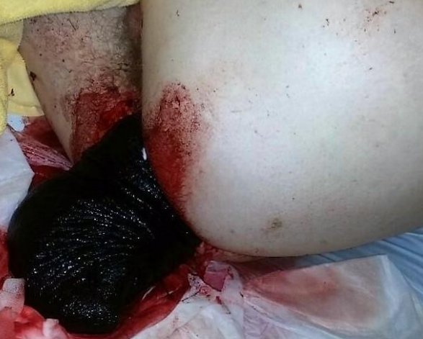

Figure 1. Rectal prolapse strangled at the admission to the emergency department.

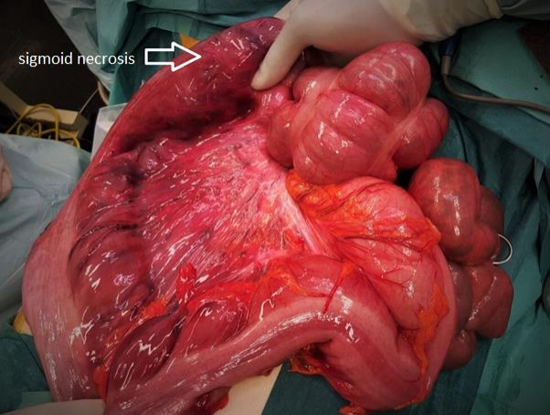

Figure 2. Intraoperative picture showing a necrotic area of the sigmoid colon.

References

1. Goldstein SD, Maxwell PJ. Rectal prolapse. Clinics in colon and rectal surgery. 2011;
24(01): 039-045.

2. O'Brien DP. Rectal prolapse. Clinics in colon and rectal surgery. 2007; 20(02): 125-132.

3. Gordon PH, Nivatvongs S. Principles and practice of surgery for the colon, rectum, and
anus. CRC Press. 2007: 415–443.

4. Hovey MA, Metcalf AM. Incarcerated rectal prolapse: Rupture and ileal evisceration after
failed reduction. Diseases of the colon & rectum. 1997; 40(10): 1254-1257.

5. Contou JF, Godeberge P. Prolapsus rectal. Traité de proctologie. 2007; 1 : 147-152.

6. Randriamananjara N,Rabarioelina L. Le prolapsus colo rectal aigu : A propos d’un cas
traité. Medecine Afrique Noire. 1997; 40(11): 610-611.

7. Sarpel U, Jacob BP, Steinhagen RM. Reduction of a large incarcerated rectal prolapse by
use of an elastic compression wrap. Diseases of the colon & rectum. 2005; 48(6): 1320-1322.

8. Chaudhuri A. Hyaluronidase in the reduction of incarcerated rectal prolapse: a novel
use. International journal of colorectal disease. 1999; 14(4): 264-264.

9. Coburn WM, Russell MA, Hofstetter WL. Sucrose as an aid to manual reduction of
incarcerated rectal prolapse. Annals of emergency medicine. 1997; 30(3): 347-349.

10. Azimuddin K, Khubchandani IT, Rosen L, Stasik JJ. Rectal prolapse: a search for the" best"
operation. The American surgeon. 2001; 67(7): 622-627.

11. Soravia C, Vollenweider E. Prolapsus rectal incarcéré après préparation colique au
polyethylene gly- col. Gastroentérologie Clinique et Biologique. 2004 ; 28 : 1177- 1178.

12. Madiba TE, Baig MK, Wexner SD. Surgical management of rectal prolapse. Archives of
Surgery. 2005; 140(1): 63-73.

