Stability of Earthfill Dams of Materials Containing Soluble Gypsum

Abbas Z. Ijam¹ and Esraa Saleh Altarawneh²
Civil and Environmental Engineering Department
Faculty of Engineering, Mutah University, Mutah, Jordan
1 Professor of Civil Engineering, 2 Water and Environmental Engineer
1 Corresponding author, Email: abbasa@mutah.edu.jo

Abstract
Gypsies soils are often found in arid and semiarid zones where leaching process of the gypsum from the soil cover is insufficient by the rainfall. The dissolution of gypsum salts causing caves, increasing the permeability of soil materials, increases of flow rate due to enlarging fissures and causing excessive settlements, all these causes reduce the efficiency of dams impounding water. The main aim of this work is to understand the behavior of earthfill dams and check stability if the gypsum materials are found in the construction materials of the body of the earthfill dam. Seven experimental models of earthfill dams are constructed in a laboratory drainage and seepage tank. The dimensions of models are same to fit the space of the tank but different in percentage of gypsum, 0%, 1%, 2%, 3%, 4%, 5%, and 10%. For each model, results are obtained for location of seepage line, the variation of seepage flow rate and gypsum dissolution rate with time, and slopes failure during operation and at sudden drawdown. Increasing gypsum content increases the seepage flow due to the enlargement of the voids caused by the disintegration of the soil by gypsum dissolution. Slopes failure occur at gypsum ≥ 4%, therefore one can say earth material with gypsum ≤ 3% are suitable for construction of earthfill dams.

Keywords: Stability, Earthfill, Dams, Dissolution, Gypsum

1 Introduction
Earthfill dams have been used since the early days of civilization to store water for irrigation. The simplest type is the homogeneous type which is composed of only one kind of material, except for slope protection, USBR [1]. For the homogeneous type, most soils are suitable for construction and the principal term to accept the soil is that it should not deteriorate during construction and operation. In other words, the suitable soil for the earthfill dams is the soil containing small quantities of soluble salts and organic matter , Gloze [2]. Gypsies soils are considered problematic when used as the foundation for civil engineering structures such as roads, buildings and dams due to their solubility action ,Aldaood et al. [3a, 3b]. These soils are resistant and have good engineering properties in their dry state. However, when saturated by rain water, a rising groundwater table or seepage water, the soluble minerals are washed out, resulting in subsidence or slopes failure of the structures built on them, Asghari et al. [4].
Numerous authors have conducted research to study failure mechanisms of embankment dams to improve their stability and avoid catastrophic damages and losses of life and property. Foster et al. [5a] presented the results of statistical analysis of failures and accidents of embankment dams, specifically focusing on those incidents involving piping and slope stability. The study concluded that the failure due to piping through the embankment is two times higher than that through the foundation and 20 times higher than that from the embankment into the foundation. Moreover, embankment slides account for only 4% of embankment failures. Foster et al. [5b] used the University of New South Wales, Australia method to analyze historic failures and accidents of embankment dams. The method was intended only for preliminary assessments, as a ranking method for risk assessments, and to identify dams to prioritize for more detailed studies. Coleman et al. [6] investigated experimentally the overtopping breach of homogeneous embankment. Models were made from a range of uniform non-cohesive materials. The findings enabled the prediction of the development with time of breach cross section, breach longitudinal profile, eroded volumes, and breach flows. Awal et al. [7] conducted experimental work to study the enlargement of piping and flow rate through embankment dams. It was found that the pipes are of non-uniform sections along seepage flow directions.
A number of studies have been conducted to investigate the effect of soluble minerals exist in the foundation and abutments of dams on their stability and efficiency. Drebrodt et al. [8] simulated the leakage flow below a dam with grouting curtain. The dam is located on a terrene of fractured rocks. Karstification process occurred in two states, in the first these fractures widen slowly and this lets leakage increases. In the second state of karstification, dissolution rates increases along these fractures which makes the leakage increasing in excessive rates. Turkmen, S. [9] investigated the efficiency of grouting curtain against leakage problems used for Kalecik dam in Turkey. It is found that seepage paths were extended after grouting and moved with time so that seepage problems were still continuing. Johnson, K. S. [10] examined dam projects suffered from gypsum karsts in the U.S.A. The Upper Mangum dam in southwest Oklahoma was abandoned before construction because of the gypsum karsts in the abutments and the impoundment area. The second project was the Quail Creek Dike in southwest Utah that collapsed in 1989 due to the flow of water through undetected karsified gypsum below the earthfill dam. The third project suffers from leakage and sink holes caused by gypsum dissolution was Horsetooth reservoir and Carter lake reservoir in Colorado. The fourth project was the Anchor dam in northwest Wyoming. It suffered from leakage through the foundation and abutments due to the combination of gypsum karsts limestone karsts and other geologic features, however only a small quantity of water has been held in the reservoir. Mancebo Piqueras, J. A. et al. [11] used a scaled model for Caspe dam in Spain to estimate how much material lost through dissolution of karstified foundation. Results showed that although the flow and porosity increase with time, the rate of dissolution decreases. Al-Ansari et al. [12] presented the results of models used to predict what would happen in the case of failure of Mosul dam in Iraq. The dam suffers from seepage problems due to gypsum and anhydrite beds dissolution under the dam foundation. To avoid the failure disaster, The researchers recommended the seepage problems should be controlled through grouting and completing the construction of Badush dam downstream of Mosul dam to hold the wave that could be created by the failure of Mosul dam. Adamo et al. [13] investigated the mystery of Mosul dam. Different mix design are evaluated to eliminate the seepage problems under the dam. Their work did not reach a specific mix design to be implemented.
Altarawneh, E. S. [14] conducted laboratory experimental work to investigate the change of soil properties after mixing with gypsum salts, mainly the soil permeability, it increases as the percentage of gypsum increases.
All previous studies have agreed that gypsum soils are critical and should be handled with caution if they exist either in the foundation or in the abutments of the dams. But the question what are the effects of gypsum dissolution on the earthfill dams if the embankment materials contain a percent of gypsum. The present work investigates experimentally the stability of earthfill dams containing gypsum.

2 Experimental Work Setup
Experimental earthfill dam models are constructed in a drainage and seepage tank containing different percentages of gypsum. Due to the restrictions of the available space of the laboratory apparatus shown in Figure (1), the model dimensions are chosen to fit the available space. The free space 110 cm long, 50 cm height and 10 cm width. The model is trapezoidal with base width 84 cm, height 25 cm, crest width 9 cm and 10 cm width. The upstream and downstream are fixed at 1.5H: 1V. Constant head of water 20.5 cm at upstream and 2.8 cm at downstream are kept throughout the experimental work. Dimensions of models are shown in Figure (2).
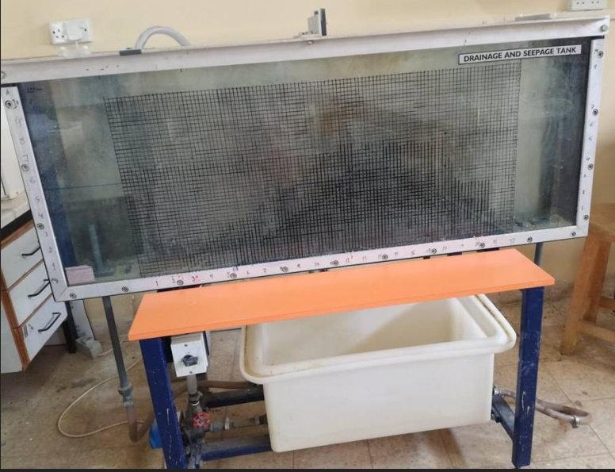
Figure (1) the Seepage and Drainage Apparatus

9 cm

1.5 H
1V
20.5 cm 25 cm
2.8 cm

84 cm

Figure (2) a Schematic Diagram of the Model Shape and Dimensions

Each model is done in subsequent layers each about 5 cm thickness while minimum compaction effort is applied. The experiment starts by storing water at upstream side until the model reaches saturated state and seepage is starting. Outflow water is collected using gradual cylinder every 10 minutes, with collection time 30 seconds for models with gypsum 0%, 1%, 2%, and 3 % and collection time 15 seconds for models with 4%, 5%, and 10% gypsum. Free surface seepage line is traced by injecting ink at the intersection point between the upstream slope of the model and the upstream water surface.
Sieve analysis is carried out for natural materials from different locations in AlKarak city in Jordan. From the results obtained, it is noticed that the Wadi deposit material collected from the Southern AlMazar in AlKarak city is accepted in the present work according to the graduation specifications applied for earthfill dams, Gloze (1977). Results for the selected soil are shown in table (1). The soil can be classified as well graded sand. Permeability test for the selected soil is conducted and it is found to be 4.5x10 ^{̶ 4} m/sec. Commercial gypsum material is used with purity as Calcium Sulfate Dehydrate Ca So₄ .2H₂o ≥ 85% by weight. Grain size sieve analysis results for the used gypsum are shown in table (2). The gypsum is mixed with the natural soil to obtain a homogeneous material for the dam model. Different models are tested each with a specified percentage of gypsum. More details on models preparation in the laboratory are given by Altarawneh, E. S. [14].

Table (1)
Grain size distribution of dam model soil
Sieve  (mm) | Sieve  No. | Weight retained(gm) | %Weight retained | % Weight cumulative | % pass
4.75 | 4 | 9.5 | 1.188 | 1.188 | 98.8
2.38 | 8 | 226.7 | 28.35 | 29.54 | 70.5
1.18 | 16 | 126.41 | 15.81 | 45.35 | 54.7
0.6 | 30 | 173.8 | 21.74 | 67.08 | 32.9
0.3 | 50 | 122.12 | 15.27 | 82.35 | 17.6
0.15 | 100 | 133.3 | 16.67 | 99.02 | 0.98
0.075 | 200 | 4.6 | 0.575 | 99.6 | 0.4
0 | pan | 3.2 | 0.4 | 100 | 0

Table (2)
Grain size distribution of gypsum material
Sieve (mm) | Sieve  No. | weight  retained  (gm) | % weight retained | %  weight cumulative | % pass
4.75 | 4 | 0 | 0 | 0 | 100
2 | 10 | 44.4 | 5.564 | 5.564 | 94.4
1.18 | 16 | 47.7 | 5.977 | 11.54 | 88.5
0.85 | 20 | 75.1 | 9.411 | 20.95 | 79.0
0.425 | 40 | 80.9 | 10.14 | 31.09 | 68.9
0.3 | 50 | 196 | 24.56 | 55.65 | 44.3
0.15 | 100 | 154 | 19.3 | 74.95 | 25.0
0.075 | 200 | 147 | 18.42 | 93.37 | 6.6
0 | Pan | 52.9 | 6.629 | 100 | 0

3 Results and Discussions
3.1 Free Water Surface position:
The seepage through the dam model is under the effect of constant head difference and by injecting the ink, the free water surface line is drawn on the grid of the glass side wall of the tank. The same procedure is applied for all models. Figure (3) show a typical schematic diagram for the position of the free water surface line for 0% and 5% gypsum.

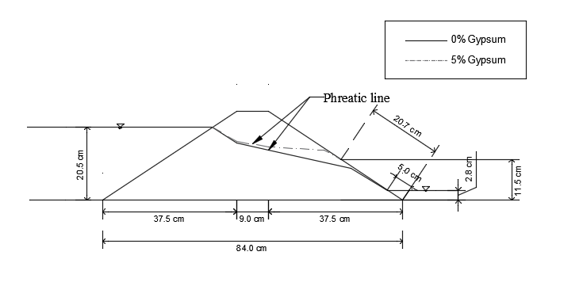
Figure (3) a Schematic Diagram for the Position of the Free Water Surface Line

The seepage line for 0% and 5% gypsum forming seepage face 5 cm and 20.7 cm respectively along the downstream slope of the dam model as shown in figure. The seepage line becomes higher for a model with gypsum, and seepage flow field covers more area and endanger the stability of downstream slope. The seepage face for 0%, 1%, 2%, 3%, 4%, 5%, and 10% are 5, 9, 10.8, 20.2, 16.2, and 20.7 cm respectively. The seepage face increases with increasing in gypsum percentage accept for 4% and 10%, this can be attributed to the failure mode at downstream slope which forced the seepage line to change its path.
3.2 Seepage Flow and Dissolution:
Seepage water flow rate and its total dissolved solids (TDS) are measured every 10 minutes for models with 0%, 1%, 2%, 3%, 4%, 5%, and 10% gypsum. Variation of flow rate with time is shown in Figure (4) and variation of TDS with time is shown in Figure (5). The flow rate increases with time due to increases in permeability, this as a result of washing out of fine particles and dissolution of gypsum. The increasing seepage velocity enlarges voids so the flow increases and may reach a steady condition. The decrease in TDS with time is due to the continuous process of gypsum dissolution. With increases in gypsum content, the outflow rate of seepage increases and the possibility of failure increases. From Figure (5) one can conclude more time is needed to guarantee the full dissolution of gypsum content of the dam materials.

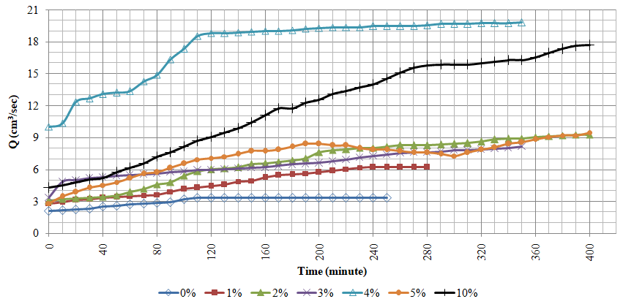
Figure (4) Variation of Seepage Flow Rate with Time for Different Gypsum Content

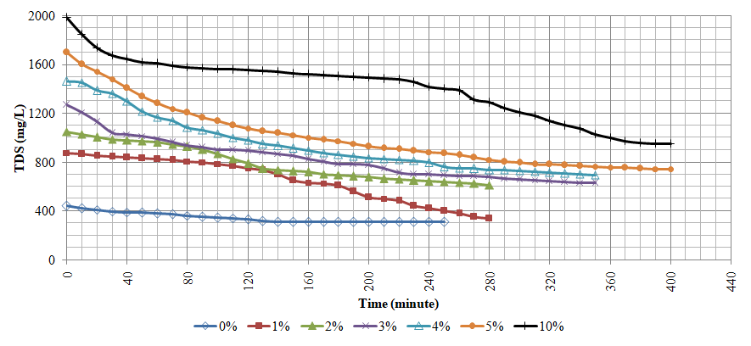
Figure (5) Variation of Seepage Water Total Dissolved Solids (TDS) with Time for Different Gypsum Content
3.3 Slope Failure Measurements:
One of the main objectives of the present work is to investigate experimentally the effect of occurrence of gypsum in the construction materials of the earthfill dam on the slopes stability. The failure of downstream slope is investigated during the experiment operation for constant heads at upstream and at downstream. The failure of upstream slope is investigated during sudden drawdown of upstream reservoir water. For models with 0%, 1%, 2%, and 3% gypsum no slope failure occurred. The slopes failure occurred for three models with 4%, 5%, and 10% gypsum. The failure for 4% gypsum was faster since the soil disintegrated and voids were sufficiently enlarged after the gypsum was dissolved. Figure (6) shows the slopes failure for 4% gypsum.
Figure (6) Slopes Failure for 4% Gypsum Content

The failure of models with 5%, and 10% gypsum is slower and less in dimensions as shown in Figure (7) and (8). It is thought that these models need more time to complete the gypsum dissolution and excessive total settlement occurred which lead to less soil volume slipped down. Figures (9), (10), and (11) show the distinct location of downstream and upstream slopes failure for 4%, 5%, and 10% gypsum respectively. The volume of slipped down material and its percent of total volume of the model (11625 cm³) is presented in table (3). For the downstream slope, the three models behaved differently. For the 4% gypsum sliding occurred, while for 5% and 10% gypsum sliding happened in addition to excessive settlement occurred. For the upstream slope, sliding down due to sudden drawdown of reservoir water occurred for the three models.

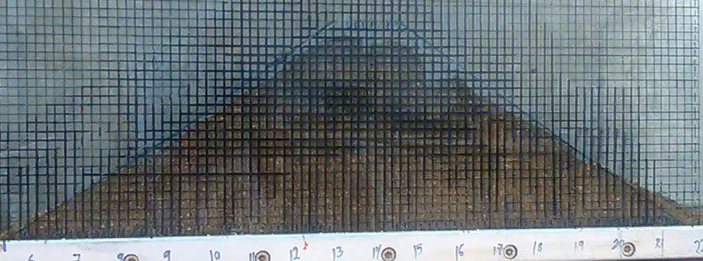
Figure (7) Slopes Failure for 5% Gypsum Content

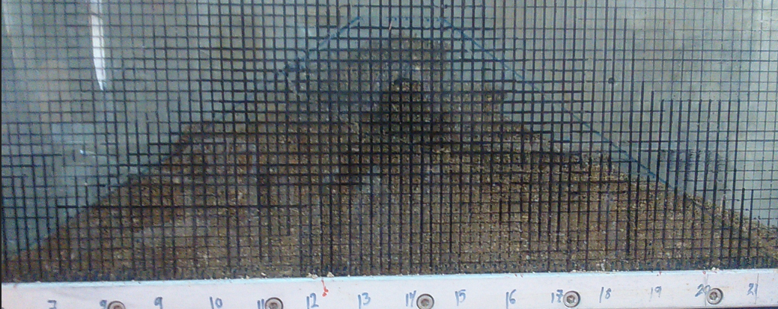
Figure (8) Slopes Failure for 10 % Gypsum Content

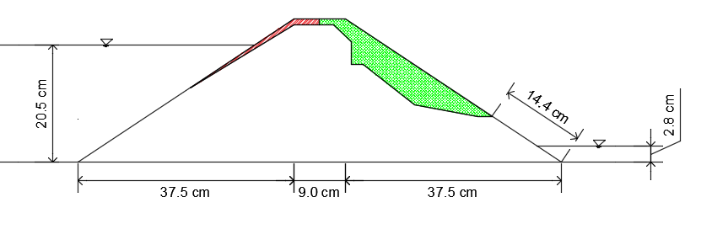
Figure (9) Schematic diagrams of 4% gypsum content failure

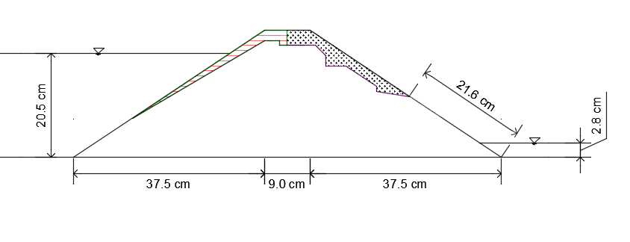

Figure (10) Schematic diagrams of 5% gypsum content failure

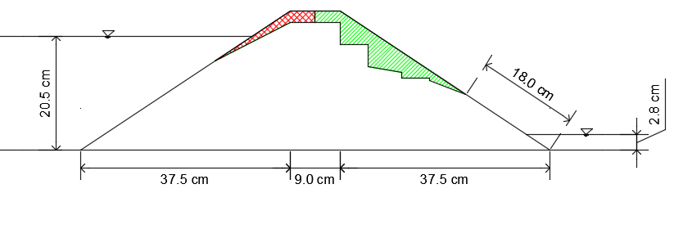
Figure (11) Schematic diagrams of 10% gypsum content failure

4 Conclusions
The main concern of this research work was the stability of earthfill dams were built with materials containing gypsum. In general the dissolution of gypsum due to seepage flow through the dam embankment shift the location of the free water surface upward and increase the seepage face along the downstream slope. The results confirm the continuous process of gypsum dissolution and with increasing gypsum content the seepage flow rate increases for enlargement of the voids due to disintegration of soil. The rate of dissolution decreases with time since the content of gypsum decreases with time. No sign of slope failure and settlement for dam models with gypsum ≤ 3%. Slopes failure exists for gypsum content ≥ 4%, and settlement failure exist for gypsum content ≥ 5%. Considering the restrictions imposed by type of soil and model dimensions, one can conclude that the soil to be used in construction of earthfill dams should not contain gypsum more than 3%.

References
[1] United States Bureau of Reclamation, USBR (1987) Design of Small Dam, Third edition, U.S.A Department of the Interior.
[2] Golze, A.R. (1977) Handbook of Dam Engineering, Van Nostrand Reinhold Company.
[3a] Aldaood, A., Bouasker, M., & Al-Mukhtar, M. (2014.a). Soil–water characteristic curve of lime treated gypseous soil. Applied Clay Science, 102, 128–138.
[3b] Aldaood, A., Bouasker, M., & Al-Mukhtar, M. (2014.b). Impact of freeze–thaw cycles on mechanical behaviour of lime stabilized gypseous soils. Cold Regions Science and Technology, 99, 38–45.
[4] Asghari, S., Ghafoori, M. and Tabatabai, S. S. (2017). Changes in chemical composition and engineering properties of gypseous soils through leaching: an example from Mashhad, Iran. Bulletin of Engineering Geology and the Environment, Vol. 77 ,No.1: 165–175.
[5a] Foster, M., Fell, R. and spannagle, M. 2000a. The statistics of embankment dam failures and accidents. Canadian Geotechnical Journal, Vol.37 :1000- 1024.
[5b] Foster, M., Fell, R. and spannagle, M. 2000b. A method for assessing the relative likelihood of failure of embankment dams by piping. Canadian Geotechnical Journal, Vol.37: 1025–1061.
[6] Coleman, S. E., Andrews, D. P., & Webby, M. G. (2002). Overtopping Breaching of Noncohesive Homogeneous Embankments. Journal of Hydraulic Engineering, Vol.128 No.(9): 829–838.
[7] Awal, R., Nakagawa, H., Kawaike, K., Baba, Y., & Zhang, h. (2011). Experimental study on piping failure of natural dam. Journal of Japan Society of Civil Engineers, Ser. B1 (Hydraulic Engineering) , Vol. 67,No.(4): I_157 - I_162.

[8] Dreybrodt, W., Romanov, D. and Gabrovsek, F. (2002). Karstification below dam sites: a model of increasing leakage from reservoirs. Environmental Geology, Vol.42:518–524.
[9] Turkmen, S. (2003). Treatment of the seepage problems at the Kalecik Dam (Turkey). Engineering Geology,Vol. 68(3-4):159–169.
[10] Johnson, K. S. (2007). Gypsum-karst problems in constructing dams in the USA. Environmental Geology, Vol.53, No.(5): 945–950.
[11] Mancebo Piqueras, J. A., Sanz Pérez, E., & Menéndez-Pidal, I. (2011). Water seepage beneath dams on soluble evaporite deposits: a laboratory and field study (Caspe Dam, Spain). Bulletin of Engineering Geology and the Environment, vol.71: 201–213.
[12] Al-Ansari1,N., Adamo,N., Issa, I.E., Sissakian, V. K. and Knutsson, S.(2015). “Mystery of Mosul Dam the Most Dangerous Dam in the World: Dam Failure and its Consequences”. Journal of Earth Sciences and Geotechnical Engineering, vol. 5, no.3: 95-111.
[13] Adamo, N., Al-Ansari, N., Issa,I.E., Sissakian, V.K.,and Knutsson,S . (2015). Mystery of Mosul Dam the Most Dangerous Dam in the World: Maintenance Grouting”. Journal of Earth Sciences and Geotechnical Engineering, vol. 5, no.3: 71-77.
[14] Altarawneh, E. S. (2018). Effect of Gypsum Dissolution on the Stability of Embankment Dams. M. Sc. Thesis, Mutah University, Jordan.

