A Probabilistic Framework for the Assessment of Environmental Effects in Groundwater Contaminant Hydrology
Theo S. Sarris^{1*}, Lee F. Burbery¹ and Murray E. Close¹
¹Institute of Environmental Science and Research (ESR), Christchurch, NZ
*Corresponding Author: Theo Sarris, email: theo.sarris@esr.cri.nz, Tel: +64 3 351 6019

Abstract
Professional scientists and engineers are often tasked to predict the environmental impact of human activities by combining the understanding of complex physical systems with advanced analytical and numerical tools. At the same time, uncertainty has always been a critical aspect of most engineering projects. In this paper, we present a simple probabilistic framework that incorporates model parameter uncertainty and translates the results to predictive uncertainty, as required for risk-based decision making. The framework is applied to three relatively simple, yet well understood groundwater contaminant transport problems adapted from real-world case examples. We use well-known analytical solutions documented in most contaminant hydrogeology textbooks, coded using freely available tools. The presented examples provide a useful illustration of the general methodology that should be applied, irrespective of problem type, when data uncertainty needs to be accounted for in design and decision-making. We have found the framework to be well understood by water resource managers and well received by decision-makers.
Keywords
Hydrogeology, Groundwater modelling, Contaminant transport, Environmental engineering, Model Uncertainty, Stochastic Modelling, Decision Support, Risk Based Modelling.

Introduction
Professional engineers are often tasked to predict the impact of human activities on the environment by combining the understanding of complex physical systems with advanced analytical and numerical tools. At the same time, uncertainty has always been a critical aspect of most engineering projects. As decision makers, professional engineers need to make the best technical decisions in the presence of scientific and economic uncertainties and addressing uncertainty is an indispensable part of modelling and prediction [1].
In the area of groundwater hydrology, issues of parameter heterogeneity, scaling and uncertainty have been a very active research area since the 1970’s [2] giving rise to the topic of Stochastic Subsurface Hydrology. In modelling applications, effective properties are often employed to address spatial heterogeneity, but their estimation is scale dependent, while the limited amount of field measurements result in significant uncertainties [3]. By incorporating a probabilistic (or stochastic) approach, the model parameters become random stochastic functions, and the governing flow and transport equations become stochastic partial differential equations. Consequently, the solution is no longer deterministic, and is characterized by the ensemble instead. The result can then be presented in the form of a cumulative distribution function, where the answer takes the form of probabilities that the assessed outcomes would fall within ranges, that have some significance for the considered problem [4].
There are several probabilistic approaches available, but Monte Carlo based methods are perhaps the most commonly used, for complex nonlinear problems. These involve generating multiple equally likely realizations of all parameters, with each deterministic realization used to solve the underlying problem. Multiple realizations are used to reconstruct the solution multivariate distribution, providing estimates of the solution lower order statistics (such as mean and variance), relating parameter uncertainty to predictive uncertainty [5].
Despite the recognition that deterministic solutions only provide a modeler’s best guess and do not represent reality at all [6], there has been limited adoption of stochastic methods by practitioners, for practical applications of groundwater flow and contaminant transport analysis and assessments of environmental effects [7]. Practitioners often rely on very basic sensitivity analysis that typically provides only crude estimations of possible solution ranges, with no probabilistic support or cross dependencies. These limitations often form crucial barriers for the decision maker, when risk-based decisions are being sought.
In this work we adopt a probabilistic framework, to quantify the risk to the groundwater resource used for drinking water supply, from a hypothetical contamination event in an unconfined alluvial gravel aquifer. Given the lack of site-specific information, we opted to estimate the probabilities of contamination reaching these supply wells under various scenarios, using a Monte Carlo approach. Two case studies are presented, based on real applications in which we examine three advective-dispersive subsurface contaminant transport modelling scenarios. Well-known analytical solutions documented in most contaminant hydrogeology textbooks are used in the problems and coded within a Microsoft Excel- spreadsheet. The stochastic analysis is undertaken using a publicly available Monte Carlo analysis add-in for Microsoft Excel, eliminating the need for specialized software.

Case studies
For this study we consider two resource consenting problems in New Zealand. Both are simplified so that the transport problem becomes tractable with analytical methods. This means that some physical and geochemical interactions and processes are ignored in favor of simplicity, but these simplifications have been deemed acceptable by the consenting authorities. The same approach can be easily extended to problems where analytical solutions may not be available, but specialty software or coding may be required.

Impact of a permeable reactive barrier on water chemistry
The first problem is a simplification of a case study that involves the installation and monitoring of an experimental denitrifying permeable reactive barrier (PRB) at the Silverstream Reserve near Christchurch, New Zealand [8]. This is part of an ESR research project to develop and demonstrate technologies to enhance the removal of nitrate from shallow groundwater systems before they impact receiving surface waters such as streams and lakes. The approach being trialed at the Silverstream Reserve uses a woodchip denitrifying PRB or ‘denitrification wall’ [9] to enhance natural attenuation of nitrate pollution in a shallow gravel aquifer. The denitrification wall comprises a binary mixture of coarse woodchip and gravel, entrenched below the water table, and aligned across the path of groundwater flow. The organic carbon in the woodchip provides a solid-phase food source for facultative heterotrophic bacteria that live in the aquifer and can reduce nitrate to benign gaseous nitrogen via the process of denitrification (e.g. [10]). The role of the coarse gravel component is to provide structural support to the PRB and maintain its high permeability. Denitrification is a microbial respiration process that proceeds in groundwater only when all available dissolved oxygen has been exhausted. Although the aim of a denitrifying PRB is to remove nitrate from groundwater filtering through it, to achieve this it must also strip dissolved oxygen from the water. The gravel aquifer at Silverstream Reserve is habitat to a complex groundwater ecology that includes stygofauna that live within the pores of the gravel sediments. Because stygofauna require oxic conditions [11], it is perceived that construction and operation of a denitrification wall will adversely impact on them, particularly in the initial stages of operation when the woodchip is fresh and at its most reactive with a high content of labile organic carbon (e.g. [12]). Lesser, but similar concerns were expressed pertaining to potential impacts on a freshwater stream 600 m down-gradient of the field site, known to be fed by groundwater discharge. Accordingly, the question of the likely extent of the impacts on the native aquifer ecology was asked. For this exercise we concentrate on the propagation of the oxygen and nitrate-depleted groundwater plume expected from the woodchip PRB.

Groundwater resource vulnerability assessment
The second problem pertains to a proposal to expand quarrying operations within the Christchurch Groundwater Protection Zone – a planning zone intended to limit the risk of contamination of the City’s drinking water resource from land-use activities. Existing regulations in Christchurch limit quarrying depths to within one meter above the highest recorded water table [13]. In a bid to secure more aggregate, quarry operators have sought to challenge this rule, proposing an alternative scenario whereby they will excavate to within one meter of the water table, but ‘chase the water-table’ and back-fill with ‘clean-fill’, which on occasion, will rest below the water table. Provided only clean virgin fill is used in back-fill operations, the only perceivable impact on the quality of the groundwater resource would be possible changes to aesthetic properties of the water (e.g. pH, hardness, iron and manganese). Such impacts, if realized, are considered to be of insignificant consequence. A more significant impact would be from the illicit act of burying hazardous materials in the quarry, which is considered here. We assess how vulnerable the groundwater resource that is exploited for drinking water supply is to such a hypothetical pollution incident. For the purpose of an initial assessment, the forced convection from the abstraction wells is ignored, which is a conservative assumption given concentrations at a pumped well are diluted by the effect of radial flow. Glyphosate [N-(Phosphonomethyl)glycine] and benzene are assumed as the hazardous contaminants of concern in the problem that we present as two individual scenarios. Glyphosate is the most widely used herbicide in the world, including New Zealand. Whilst there is no evidence glyphosate is hazardous to human health if consumed in drinking water, it is classified by the International Agency for Research on Cancer (a subdivision of the World Health Organization) as a probable human carcinogen [14]. There is growing interest from health and water quality advocates to properly assess its fate and transport in the environment, which is why it was included, as an extreme case, in the groundwater vulnerability assessment. Benzene is a volatile, yet soluble hydrocarbon solvent with carcinogenic properties. The Maximum Acceptable Value (MAV) for benzene in New Zealand drinking water is 0.01 mg/L [15].

Methods
For this study we assume steady state, one-dimensional uniform velocity, in a three-dimensional homogeneous aquifer, with longitudinal and transverse dispersion. Vertical dispersion is only assumed in one dimension, from the water table to the deeper parts of the aquifer.

Problem 1: Woodchip PRB plume mixing
For the predictive simulation of a plume of de-oxygenated and nitrate-free water originating from the PRB installation, a continuous source of finite dimensions is assumed. A closed form analytical solution to the advection-dispersion problem described above is given by Domenico and Robbins [16], where the relative concentration (C/C₀) of the contaminant of interest in 3-dimensional space and time is given by:
$$\begin{aligned}\frac{C\left(x,y,z,t\right)}{C_{0}}=\frac{1}{8} erfc\left[\frac{x-vt}{2\sqrt{\left(α_{x}vt\right)}}\right] erf\left[\frac{Y_{PRB}}{4\sqrt{\left(α_{y}x\right)}}\right] erf\left[\frac{Z_{PRB}}{2\sqrt{\left(α_{z}x\right)}}\right]\#\left( AUTONUMLGL \backslash e \right)\end{aligned}$$
In equation (1), x, y, z, and t are space and time coordinates. Y_{PRB} and Z_{PRB} are the known source dimensions (60 m and 4.5 m respectively), α_{w} is dispersivity in the w direction, v is the one-dimensional uniform contaminant velocity in the x-direction, and erf and erfc are the error, and complementary error, functions, respectively. Srinivasan et al. [17] have shown that for all nonzero longitudinal dispersivity values the above solution is prone to finite error that reduces for transport problems having low longitudinal dispersivity values, high advection velocities, and large simulation times. We overlook these limitations in our problems, which involve high velocities and long transit times. The conceptual source characteristics and the idealized contaminant migration geometry are shown in Figure 1a.
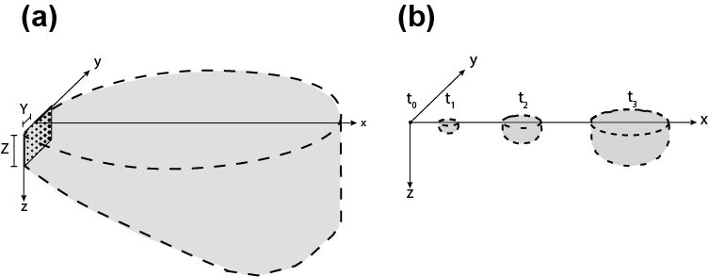
Figure 1: Idealization of plume development with a steady state planar source (a) and point instantaneous source (b).

Problem 2a: Glyphosate spill
Glyphosate strongly binds to soil particles, which limits its mobility in surface applications. However, in this problem, we assume a truckload of glyphosate is dumped into the quarry, as might be imaginable if its use as an herbicide is outlawed in the future and stockpiles of product are illegally disposed of. Being extremely soluble, glyphosate would be expected to instantaneously dissolve in groundwater and the whole spilled mass transport mechanism should commence relatively fast. For an instantaneous point source, Baetsle [18] derived an analytical solution of the plume propagation with biodegradation, according to:
$$\begin{aligned}C\left(x,y,z,t\right)=\frac{C_{0}V_{0}}{8{\left(πt\right)}^{3/2}\sqrt{α_{x}α_{y}α_{z}}} \exp\left[-\frac{{\left(x-vt\right)}^{2}}{4α_{x}t}-\frac{y^{2}}{4α_{y}t}-\frac{z^{2}}{4α_{z}t}-λt\right] \#\left(2\right)\end{aligned}$$
where the product $C_{0}V_{0}$ is the spilled mass, α_{w} is the coefficient of hydrodynamic dispersion in the w direction and λ is a first-order degradation rate. Equation (2) was used to simulate the reactive mass transport of glyphosate in the unconfined aquifer. Figure 1b shows the idealized plume development from the instantaneous point source.

Problem 2b: Benzene spill
Benzene is a volatile, light non-aqueous phase liquid that floats on water. A release from a source below the water table, such as leaking buried drums would form a pool of pure benzene of relatively low mobility that will steadily dissolve and generate a contaminant plume that would propagate down gradient whilst undergoing some degree of biodegradation. For this assessment, we make conservative assumptions that the source mass is infinite and ignore any effects of volatilization. Under these assumptions, the benzene source concentration in groundwater C₀ at the LNAPL-groundwater interface was calculated according to (e.g. [19]; [20]):
$$\begin{aligned}C_{0}=\frac{{k^{*} C}_{S} A}{v Y Z} \#\left(3\right)\end{aligned}$$
where k*is the time invariant benzene mass transfer coefficient, C_{s} is the benzene solubility in water and A is the random pool interface area, inferred from the random spill volume and random spill dimensions Y and Z. We treated the problem as a finite plane source (identical to the geometry of the PRB problem, Figure 1a) where we conceived the source concentration could spread over the depth the leaking drums are below the water table. Accordingly, the following solution provided by [21], which is the solution of Domenico and Robbins [16] modified to include decay/degradation, was used to model the reactive transport of the dissolved benzene:
$$\begin{aligned}\frac{C\left(x,y,z,t\right)}{C_{0}}=\frac{1}{8}\exp\left[\frac{x}{a_{x}}\left(1-\sqrt{1+\frac{4λa_{x}}{v}}\right)\right] erfc\left[\frac{x-vt\sqrt{\left(1+{4λa_{x}}/v\right)}}{2\sqrt{\left(a_{x}vt\right)}}\right] \\ \left\{erf\left[\frac{y+Y/2}{2\sqrt{\left(a_{y}x\right)}}\right]-erf\left[\frac{y-Y/2}{2\sqrt{\left(a_{y}x\right)}}\right]\right\}\left\{erf\left[\frac{z+Z}{2\sqrt{\left(a_{z}x\right)}}\right]-erf\left[\frac{z-Z}{2\sqrt{\left(a_{z}x\right)}}\right]\right\}\#\left(4\right)\end{aligned}$$
In equation (4), Y and Z are the random spill dimensions calculated from the random spilled benzene volume (as per equation (3)), and λ is the first-order decay rate constant. Retardation effects are ignored in the problem for the reason being the aquifer contains exceedingly low levels of organic matter to which benzene might otherwise absorb to. It is useful to note that if retardation were to be considered then v in equation (3) needs to be substituted with v_{R}=v/R_{f} , where R_{f} is the benzene retardation factor in the aquifer.

Model parameters and modelling
Subsurface transport model parameters are always uncertain to various degrees. Aside from knowledge that the two field sites considered in this exercise relate to a common, extensive unconfined gravel aquifer composed of alluvial outwash deposits of Holocene age, no site-specific investigations were undertaken to collect hard data. Consequently, in an effort to quantify our uncertainty regarding parameter values and the resulting uncertainty of the model predictions, we treat all parameters of the analytical models as random variables. This transforms the deterministic analytical expressions (1) through (4) to stochastic functions that can be characterized by their ensemble statistics. The question: “what is the concentration from a particular source at the location x₁, y₁, z₁ and t₁”? is therefore rephrased to: “recognizing our limited knowledge of the physical system, what are the potential concentration ranges from a particular source at the location x₁, y₁, z₁ and t₁”? To answer the latter question, the random model parameters are sampled from their assumed distributions, with the distribution shape, lower moments and ranges drawn from previous studies and relevant literature [22]. The relevant statistics used here are summarized in Table 1.
Table 1: Summary statistics of uncertain model parameters.
 | Variable | Min | Mean / most likely | Max | Standard deviation, σ | Distribution | Comment
All problems | Aquifer properties
 | Contaminant velocity, v  [m/day] | 10 | 100 | 350 | n/a | Triangular | [23], [24]
 | Longitudinal dispersivity α_{x} [m] | 1 | 10 | 30 | 3 | Log-normal | [24]
 | Lateral dispersivity anisotropy ratio, α_{y}/α_{x} | 0.05 | 0.1 | 0.2 | 0.02 | Truncated Normal | [24]
 | Vertical dispersivity anisotropy ratio, α_{z}/α_{y} | 0.1 | 0.5 | 1 | 0.1 | Truncated Normal | [24]
Problem 2a | Glyphosate physiochemical properties
 | Source concentration, C₀ [g/m³] | 7000 | 10500 | 157000 | n/a | beta-PERT | [25], [26]
 | First-order degradation rate, λ [1/day] | 0.007 | 0.01 | 0.045 | n/a | beta-PERT | [27]
Problem 2b | Benzene physiochemical properties
 | First-order degradation rate, λ [1/day] | 0 | 0.0002 | 0.002 | n/a | beta-PERT | [28], [29], [30]
 | Mass transfer coefficient, k* [m/day] | 0.0146 | 0.0166v_{x}+0.000384 | 0.0166v_{x}+0.000384 | n/a | beta-PERT | [20]
 | Solubility, C_{s} [g/m³] | 1735 | 1775 | 1815 | 10 | Truncated Normal | [31]
 | Spilled Volume, V [L] | 1000 | 1500 | 2000 | 150 | Truncated Normal | Subjective. Assumed 1,500 L mean (equivalent to 7¹/₂, 200 L drums)
 | Contamination source thickness, Z  [m] | 0.01 | 1.07 | 1.63 | n/a | beta-PERT | Subjective. Extracted from historic water table fluctuations
*n/a: not applicable

The stochastic results have been analytically calculated using expressions (1) through (4) using a Monte Carlo scheme. A flow diagram of the scheme is shown in Figure 2. The Monte Carlo approach starts by considering a deterministic set of appropriate model parameter values, sampled from their respective distributions as summarized in Table 1. This would form one random realization and the result of interest is calculated. In this example this involves the concentration calculation of the three contaminants, at predefined points in the aquifer. We obtained concentrations for all three plumes at distances 50, 100, 200 and 500 m from the source, along the plume center-line (x-direction) and at five depths, 8, 10, 20, 30 and 50 m from the water table (z-direction). This means that for each realization 20 concentrations were calculated for each of the three contaminants. The stochastic anoxic, nitrate-treated groundwater and benzene contaminant plumes were calculated for t=3650 days, ensuring that all plume realizations reached equilibrium and thus simulating steady state conditions from the constant source. The glyphosate concentrations were calculated for t_{i}=x_{i}/v, where x_{i} is the horizontal distance between the observation point and the source. Time t_{i} corresponds to the plume center of mass arrival time to the observation point, and therefore to the greatest concentration at this location. Since v is a random variable it follows from t_{i}’s definition that it is also a random variable. The calculated concentrations were recorded and the next realization was undertaken. For this example, a total of 50,000 realizations were generated. When all realizations were completed, the concentration moments at each monitored location were calculated.
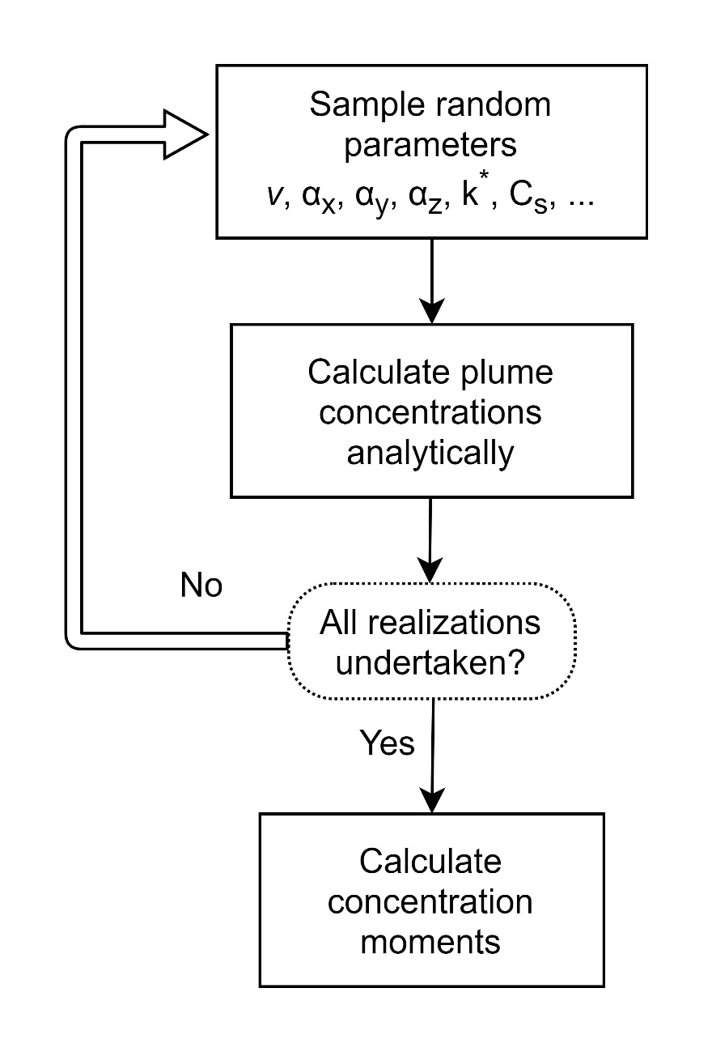
Figure 2: Flowchart of the Monte Carlo scheme.

The Monte Carlo simulation was undertaken using YASAIw 2.0w [32, 33], a freely available open-source Monte Carlo add-in for Microsoft Excel [4]. The model files are available from the corresponding author upon request.

Results
The first step, understanding the concept of incorporating uncertainty in the analysis is achieved by visualization of the parameter uncertainty. As summarized in Table 1, longitudinal dispersivity α_{x} and contaminant velocity v were sampled from a log-normal and a triangular distribution, respectively, while glyphosate biodegradation rate and benzene solubility were sampled from a truncated normal and a beta-PERT distribution (a smooth variant of the triangular distribution), respectively. Truncation has been implemented when a normal distribution was assumed, to ensure that all sampled parameter values were positive. The histograms of the 50,000 sampled values for the four aforementioned parameters are shown in Figure 3.
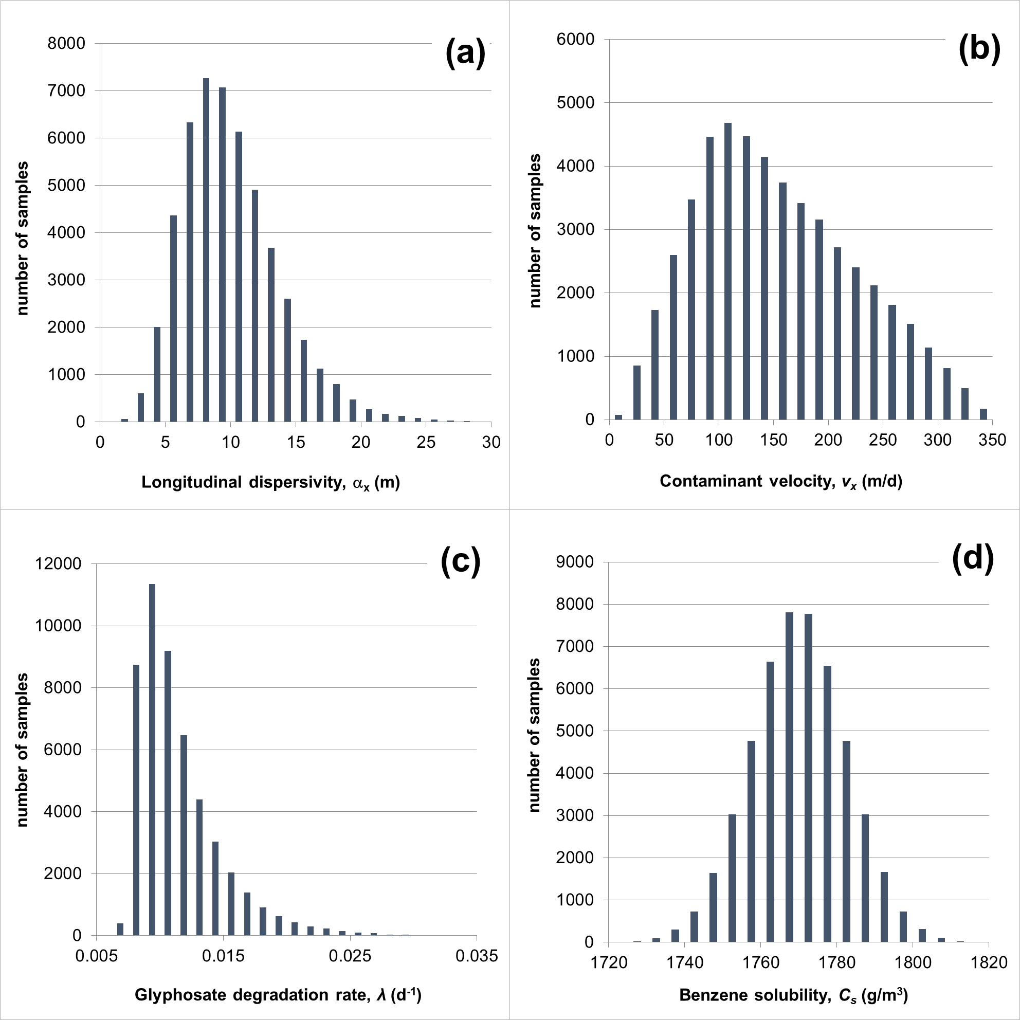

Figure 3: Parameter uncertainty. Histogram of the simulated longitudinal dispersivity (a) one dimensional contaminant velocity (b) glyphosate biodegradation rate (c) and benzene solubility (d). Longitudinal dispersivity was assumed to follow a log-normal distribution with mean value 10 m and standard deviation 3 m. Contaminant velocity was assumed to follow a triangular distribution, ranging between 10 and 350 m/d with a most likely value of 100 m/d. Glyphosate biodegradation rate was assumed to follow a beta-PERT distribution ranging from 0.007 to 0.045 d⁻¹ with a most likely value of 0.01 d⁻¹. Benzene solubility was sampled from a truncated normal distribution with mean 1775 g/m³, standard deviation 10 g/m³, truncated at less than 1735 g/m³ and greater than 1815 g/m³.

Results accounting for predictive uncertainty can be presented in a number of ways, including (a) table of summary statistics, (b) histogram of results and (c) cumulative distribution function (CDF). The simplest (and maybe the less informative) way to summarize results would be a summary table. Table 2 for example summarizes the average calculated benzene concentrations at distance x=100 m from the hypothetical source at 5 depths. If a concentration of 0.01 g/m³ is considered the upper safe limit, the conclusion from results in Table 2 is that, on average, the limit will be exceeded for depths up to 20 m, and that at 30 m depth there is a slightly greater than 50% chance that the limit will be exceeded. It can also be concluded with almost certainty that the limit will not be breached at depths greater than 50 m, as the prediction standard deviation is almost zero. Given the lack of knowledge regarding the prediction distribution, only limited conclusions can be drawn regarding the probability of exceeding the upper concentration limit for the summary statistics. The third column of Table 2 shows the estimated 95th percentile of the simulated concentration range in a particular location. This can be interpreted as an upper/high estimate of the possible concentrations, due to our limited knowledge of the parameter values. The deterministic estimates for the same problem are also presented in Table 2. These are derived by using the most likely values for all parameters in (3) and (4) and would likely be the outcome of a more “standardized” practical approach. Not surprisingly, discrepancies up to 20% with the ensemble average are observed, due to the lack of linearity and the skewed ranges of parameter values.
Table 2: Benzene concentration summary statistics evaluated at x=100 m.
Depth (m) | Benzene concentration (g/m³)
 | Average | Standard deviation | 95th percentile | Deterministic
8 | 0.632 | 0.232 | 1.058 | 0.682
10 | 0.505 | 0.169 | 0.814 | 0.570
20 | 0.101 | 0.056 | 0.200 | 0.128
30 | 0.012 | 0.014 | 0.042 | 0.011
50 | 10⁻⁴ | 4*10⁻⁴ | 4*10⁻⁴ | 3*10⁻⁶

Figure 4 shows the histogram of relative degree of mixing of the treated water from the woodchip PRB with ambient groundwater at x=100 m and z=20 m, and the spilled benzene concentrations, predicted at x=500 m and z=50 m. The dashed vertical lines correspond to the upper acceptable limit for the contaminant of interest. For benzene this is the drinking water MAV of 0.01 mg/L or g/m³ [15]. In the case of the PRB assessment, we adopted a threshold concentration value of 0.05 (dimensionless), suggesting that the de-oxygenated and nitrate-treated water leaving the PRB has mixed and been diluted at least by 95% with the (oxic) regional groundwater. For the glyphosate we adopted a threshold value of 0.7 g/m³, which is the Maximum Contaminant Level Goal set by the USEPA under the federal Safe Drinking Water Act [34]. Consequently, resulting concentrations plotting to the right of these limits suggest exceedances (unfavorable outcomes). The exceedance frequency can be evaluated from the relative proportion of the number of analytical solutions exceeding this limit to the total number of Monte Carlo simulations. From the benzene concentration histogram in Figure 4 for example, it can be inferred that approximately 20,000 out of the total 50,000 analytical solutions resulted in exceedance of the 0.01 g/m³ limit, suggesting that this should be expected with a frequency of about 40%. Similarly, the 5% limit for the PRB-treated groundwater plume is exceeded in about 25,000 instances, suggesting an exceedance frequency of 50%.

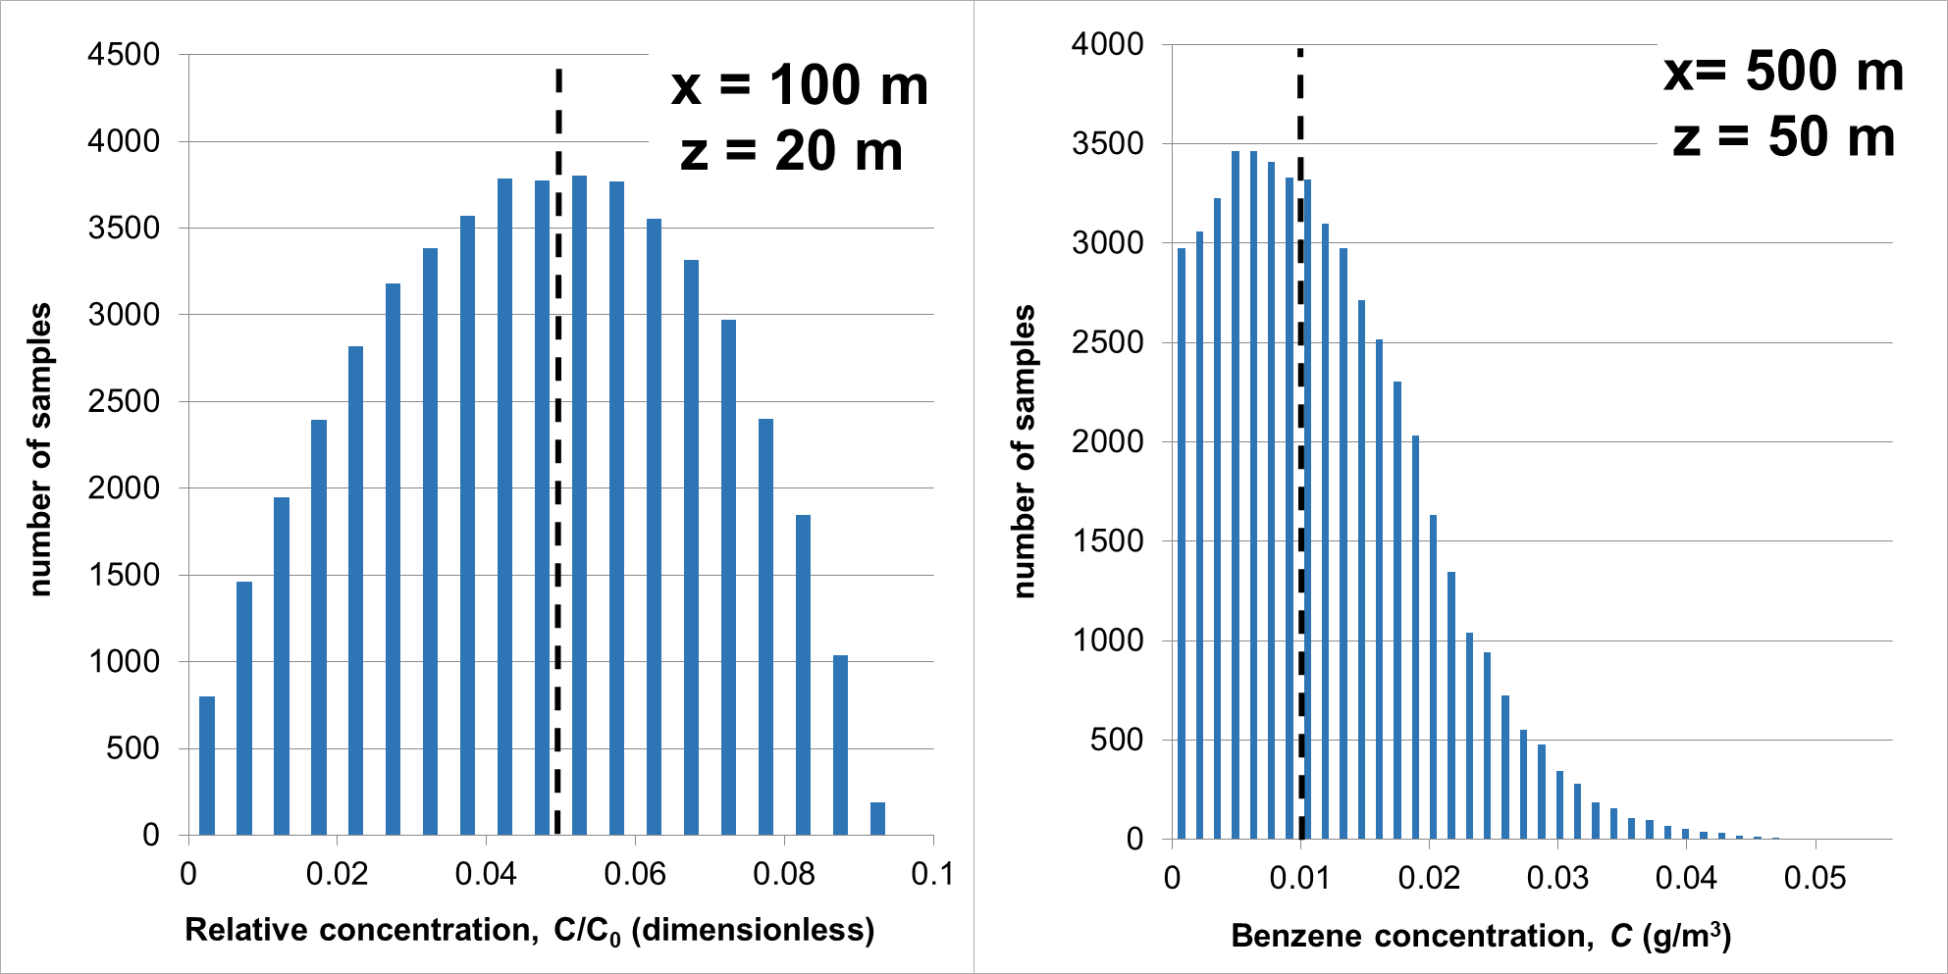
Figure 4: Predictive uncertainty. Histogram of simulated relative mixing of the treated water from the woodchip PRB and benzene concentrations at two locations. Dashed vertical line represents the upper acceptable limit of the pollutant.

Contrary to a histogram, a cumulative distribution function (CDF) plot is not biased by bin selection. It shows instead, in a continuous plot, the probability that a specific value would not be exceeded. This is demonstrated in Figure 5, which plots the CDFs for the modelled PRB plume, glyphosate and benzene concentrations, at distances 100 m and 500 m from the hypothetical sources, at all five depths considered in the study. Again, the vertical dashed lines demark the upper acceptable concentration limits, referred to above.
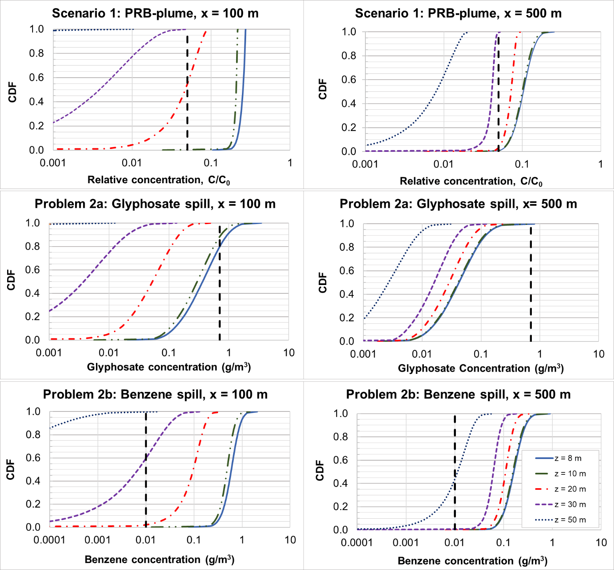
Figure 5: Predictive uncertainty. Cumulative distribution function (CDF) of the simulated relative mixing of the treated water from the woodchip PRB, glyphosate and benzene concentrations, calculated at 100 m and 500 m distances from the source and five depths. Dashed vertical line represents the upper acceptable limit of the pollutant.

From the intersection point of the limit line and the CDF for the PRB-plume at 20 m depth, it can be inferred that 100 m down-gradient of the PRB there is approximately 45% probability that effects of the PRB will be noticeable, or 55% chance the plume is sufficiently mixed/diluted with ambient groundwater. For the same depth at x = 500 m, the effects of the PRB are predicted to be more noticeable with just 5% chance of sufficient mixing of the treated plume water. The apparent positive increase in concentration with increasing travel distance in this case stems from the effects of vertical dispersion in creating a three-dimensional plume. Similar conclusions can be drawn from the glyphosate CDFs. At distance 100 m from the source, the exceedance probabilities are 12% and 20% at depths of 8 and 10 m respectively, while at 500 m distance it should be expected that groundwater quality would be unaffected by an illicit glyphosate release incident. Calculated exceedance probabilities can also form the basis for risk assessment analysis for exceeding concentration thresholds. This is achieved by calculating the product of the exceedance probability and the cost of the exceedance such as cleanup or lost productivity [35].

Summary and conclusions
Models of hydrological systems are tools often used by professional engineers to integrate our current knowledge about a system, in order to address a range of issues of concern to stakeholders. Uncertainty, due to our limited knowledge of natural processes, model structures or model parameters, means that there will always be alternative outcomes that a decision maker needs to be aware of. In this work we developed a relatively simple probabilistic framework that accounts for model parameter uncertainty. The framework was applied to three relatively simple, yet well understood groundwater contaminant transport problems adapted from real-world case examples. We have shown how practitioners can efficiently account for parameter uncertainty and translate results to predictive uncertainty for which a range of possible outcomes can be evaluated in a probabilistic manner and form the basis for a risk-based assessment. Also, we have demonstrated how the statistical moments of the outcomes can be visualized and interpreted to provide useful outcomes in terms of limit exceedances.
While the groundwater modelling examples used in this paper were simple in the sense that they did not address issues like heterogeneity, they provide a useful illustration of the general methodology that should be applied, irrespective of problem type, when data uncertainty needs to be accounted for in design and decision-making. The presented framework is not limited to simple problems with analytical solutions, but more advanced tools and coding may be required otherwise. The framework can be further expanded to account for model structure uncertainty or conceptualization uncertainty, by incorporating additional numerical implementations. We have found the framework to be well understood by water resource managers and well received by decision-makers.
Acknowledgments
The authors wish to acknowledge…[reviewers]. Preparation of this paper was supported by the Institute of Environmental Science and Research’s Strategic Science Investment Fund, under the Groundwater Mitigations research program.
References
- Guillaume, J. H. A., R. J. Hunt, A. Comunian, R. S. Blakers, and B. Fu, Methods for Exploring Uncertainty in Groundwater Management Predictions, in Integrated Groundwater Management: Concepts, Approaches and Challenges, A.J. Jakeman, et al., Editors. 2016, Springer International Publishing: Cham. p. 711-737.
- Freeze, R.A., A stochastic-conceptual analysis of one-dimensional groundwater flow in nonuniform homogeneous media. Water Resources Research, 1975. 11(5): p. 725-741.
- Sarris, T.S. and E.K. Paleologos, Numerical investigation of the anisotropic hydraulic conductivity behavior in heterogeneous porous media. Stochastic Environmental Research and Risk Assessment, 2004. 18(3): p. 188-197.
- Sarris, T.S. and L.F. Burbery, Stochastic multi-objective performance optimization of an in-stream woodchip denitrifying bioreactor. Ecological Engineering, 2018. 124: p. 38-50, doi:10.1016/j.ecoleng.2018.09.006.
- Paleologos, E.K. and T.S. Sarris, Stochastic analysis of flux and head moments in a heterogeneous aquifer system. Stochastic Environmental Research and Risk Assessment, 2011. 25(6): p. 747-759.
- Sanchez-Vila, X. and D. Fernàndez-Garcia, Debates—Stochastic subsurface hydrology from theory to practice: Why stochastic modeling has not yet permeated into practitioners? Water Resources Research, 2016. 52(12): p. 9246-9258.
- Rajaram, H., Debates—Stochastic subsurface hydrology from theory to practice: Introduction. Water Resources Research, 2016. 52(12): p. 9215-9217.
- Burbery, L.F., Mellis, R., Abraham, P., Finnemore, M., Weaver, L. Close, M.E. 2019. Denitrification Wall Trial in a Gravel Aquifer. Proceedings of the International Interdisciplinary Conference on Land Use and Water Quality Agriculture and the Environment. Aarhus, Denmark, 3-6 June 2019.
- Schipper, L.A.; Robertson, W.D.; Gold A.J.; Jaynes, D.B.; Cameron, S.G. (2010) Denitrifying bioreactors – an approach for reducing nitrate loads to receiving waters. Ecological Engineering. 36 (11): 1532-1543. doi:10.1016/j.ecoleng.2010.04.008.
- Burbery, L. F. 2018. "Nitrate reactivity in groundwater: a brief review of the science, practical methods of assessment, and collation of results from New Zealand field investigations." Journal of Hydrology New Zealand 57 (2):51-79.
- Fenwick, G. (2016). Groundwater Ecosystems. In: Jellyman, P.G., Davie, T.J.A., Pearson, C.P, Harding, J.S. (eds.), Advances in New Zealand Freshwater Sciences. pp. 345-356. New Zealand Hydrological Society and New Zealand Limnological Society.
- Schmidt, C.A. and Clark, M.W. (2012). Evaluation of a Denitrification Wall to Reduce Surface Water Nitrogen Loads. Journal of Environmental Quality 41:724–731. doi:10.2134/jeq2011.0331
- Environment Canterbury (2019) Canterbury Land and Water Regional Plan. https://eplan.ecan.govt.nz/eplan/#Rules/0/50/1/23844 (accessed 29 July 2019)
- International Agency for Research on Cancer (2015). IARC Monograph on Glyphosate. https://www.iarc.fr/featured-news/media-centre-iarc-news-glyphosate/
- Ministry of Health (2018). Drinking-water Standards for New Zealand 2005 (revised 2018). Wellington: Ministry of Health.
- Domenico, P.A. and G.A. Robbins, A New Method of Contaminant Plume Analysis. Groundwater, 1985. 23(4): p. 476-485.
- Srinivasan, V., Clement, T.P., Lee, K.K. 2007. Domenico Solution—Is It Valid? Ground Water 45 (2): 136-146. doi: 10.1111/j.1745-6584.2006.00281.x
- Baetsle, L.H. 1969. “Migration of Radionuclides in Porous Media.” In: A. M. F. Duhamel (Ed.), Progress in Nuclear Energy Series XII, Health Physics, pp. 707-730. Pergamon Press, Elmsford, NY.
- Sulaymon, A.H. and Gzar, H.A. 2011. Dissolution of Benzene In the Saturated Porous Media. Journal of Engineering 17 (4), 898-911
- Gzar, H.A. (2012) LNAPL Dissolution in Porous Media and Dissolution Rate Computations. Journal of University of Babylon 20 (4), 1122-1135
- Domenico, P.A., An analytical model for multidimensional transport of a decaying contaminant species. Journal of Hydrology, 1987. 91(1): p. 49-58.
- Avanidou, T., and E. K. Paleologos. 2002. "Infiltration in stratified, heterogeneous soils: Relative importance of parameters and model variations." Water Resources Research 38 (11):14-1-14-15. doi: 10.1029/2001wr000725.
- Close M.E., Matthews, M., Burbery L.F., Abraham P., Scott D. (2014) Use of radon to characterise surface water recharge to groundwater. Journal of Hydrology New Zealand 53 (2): 113-127.
- Sarris, T.S., Close, M. and P. Abraham. 2018. “Using solute and heat tracers for aquifer characterization in a strongly heterogeneous alluvial aquifer”, Journal of Hydrology, DOI 10.1016/j.jhydrol.2018.01.032, Vol.558, pp. 55-71, 2018.
- Fu, W., Guo, Q., and J. Wang (2010). Solubility of Glyphosate in Ethanol + Water, 1-Propanol + Water, and 2-Propanol + Water from (293 to 333) K. Journal of Chemical & Engineering, 55 (9), 3915-3917, DOI: 10.1021/je901006c
- NPIC, National Pesticide Information Center (2019). Glyphosate Technical Fact Sheet, http://npic.orst.edu/factsheets/archive/glyphotech.html, accessed July 2019.
- CCME (1989) Canadian water quality guidelines. Ottawa, Ontario, Environment Canada, Canadian Council of Ministers of the Environment.
- Aronson, D., Citra, M., Shuler, K., Printup, H., Howard, P.H. (1999). Aerobic biodegradation of organic chemicals in environmental media: A summary of field and laboratory studies. Technical Report SRC TR 99-002 prepared by the Syracuse Research Corporation for USEPA, Athens Georgia, January 1999.
- Suarez, M. P. and Rifai, H.S. (1999). Biodegradation Rates for Fuel Hydrocarbons and Chlorinated Solvents in Groundwater, Bioremediation Journal, 3(4): 337-362.
- Newell, C.J., Rifai, H.S., Wilson, J.T., Connor, J.A., Aziz, J.A., Suarez, M.P. (2002). Calculation and Use of First-Order Rate Constants for Monitored Natural Attenuation Studies. United States Environmental Protection Agency Ground Water Issue. EPA/540/S-02/500, November 2002.
- Weaver, J.W. 2004. On-line Tools for Assessing Petroleum Releases. USEPA Report: EPA 600/R-04/101 73p.
- Pelletier, G., A modified version of an opensource addin for Excel to provide additional functions for Monte Carlo simulation. 2009: Department of Ecology Olympia, WA.
- Eckstein, J. and S.T. Riedmueller, YASAI: Yet another addin for teaching elementary Monte Carlo simulation in Excel. 2001, Rutgers University, Piscataway, New Jersey.
- USEPA, United States Environmental Protection Agency (2018) “EPA's evaluation of the carcinogenic potential of glyphosate”. USEPA Assessment Document. https://cfpub.epa.gov/si/si_public_record_report.cfm?Lab=OPP&dirEntryID=337935
- Sarris, T. S., D. M. Scott, M. E. Close, B. Humphries, C. Moore, L. F. Burbery, C. Rajanayaka, G. Barkle, and J. Hadfield, The effects of denitrification parameterization and potential benefits of spatially targeted regulation for the reduction of N-discharges from agriculture. Journal of Environmental Management, 2019. 247: p. 299-312, doi: 10.1016/j.jenvman.2019.06.074..

