**Site Selection for Landfills in Babylon Governorate, Iraq**

Ali Chabuk1, Nadhir Al-Ansari1, Hussein Musa Hussein2, Sven Knutsson1, Roland Pusch1 and Jan Laue1

1Department of Civil Environmental and Natural Resources Engineering, Lulea University of Technology, Lulea, Sweden.

1[ali.chabuk@ltu.se;nadhir.alansari@ltu.se](mailto:ali.chabuk@ltu.se;nadhir.alansari@ltu.se); [Sven.Knutsson@ltu.se](mailto:%20Sven.Knutsson@ltu.se); [drawrite.se@gmail.com](mailto:drawrite.se@gmail.com); [jan.laue@ltu.se](mailto:jan.laue@ltu.se)

2Department of Geology, Faculty of Science, University of Kufa, Kufa, Iraq. 2humhudhy02@gmail.com

**Abstract**

Babylon Governorate is located in the middle of Iraq and includes five major districts called Qadhaa. It occupies an area of 5315 km2 with population of 2,092,998 in 2015. The process of selecting landfill site is considered complicated task related to many factors and regulations. Currently, there is no landfill site in Babylon Governorate that fulfils the scientific and environmental criteria. Therefore, in this study fifteen of suitable criteria were selected. These criteria are: groundwater depth, urban canters, rivers, villages, soil types, elevation, agriculture, roads lands use slope, land use, archaeological sites, power lines, gas pipelines, oil pipelines and railways. Then these criteria were used in the GIS (geographic information system), which has a high ability to manage and analyse various data. In addition, the AHP (analytical hierarchy process) method was used to derive the weightings of criteria through using a matrix of pair-wise comparison. After that the weighted linear combination (WLC) method was used to obtain the suitability index map for candidate landfill sites. Ten suitable candidate sites for landfill were selected (two for each District), where all these sites satisfied the scientific and environmental criteria which were adopted in this study. The areas of the selected sites were adequate to accommodate solid waste from 2020 until 2030.

**Keywords**

Landfill, GIS, AHP, Babylon, Iraq

**1. Introduction**

The solid waste is a wide term that includes the useless materials generated from various sources such as residential, industrial and commercial areas. Solid waste was classified based on its origin (domestic, industrial, commercial, construction and institutional) [1]. The main reasons for a significant increase in quantities of waste production in urban areas are: improving standards of living, increase of population growth rates, increasing affluence and increasing levels of commercial activities. The unsound management for solid waste in third-world countries which represent 80% of the world population causes danger for the population as well as pollution to air, soil and water [2].

It is very important to select or design a landfill site even in countries that recycle or combust most parts of their waste resulting from burning solid waste for the protection of the environment in those areas and their surrounding [3, 4, 5]. The process of a landfill siting is considered a complex task due to many factors such as public health, social and environmental factors, government regulation, government and municipal funding, economic factors, reduced availability land for landfills and increasing political and public opposition to the establishment of landfill sites [6, 7, 8].

The current study was used the geographical information systems (GIS), and spatial multi-criteria decision making analysis, which is used to solve the problem of landfill site selection. Decision-makers and planners often use multi criteria decision analysis to manage large complex data. AHP and GIS are powerful combined tools used to solve the problem of landfill siting. AHP is a multi-criteria decision making method that was developed by Thomas Saaty in 1980 to reduce the complex decision problem to a series of pair-wise comparisons within a matrix to support decision making. The GIS has an important role in the process of landfill site selection through managing the data efficiently from variety of sources. It reduces the cost and time in the landfill siting process [9, 10, 11].

The objective of this study is to select the most important criteria for landfill siting for Babylon Governorate that confirm to the scientific and environmental criteria. These criteria will be used as a reference to enable decision-makers to apply them in other similar areas when selecting a new landfill site. These criteria are to be used within GIS (geographic information system) through applying the AHP (analytical hierarchy process) method to locate the most suitable landfill site in Babylon Governorate.

**2**. **Methodology**

**2.1. Study area**

Babylon Governorate includes one of the famous cities of the ancient world; the ancient Babylon city was considered the power centre of an influential empire. Babylon Governorate is located in the middle part of Iraq about 100 km to the south of the Iraqi capital, Baghdad [12]. It is situated between latitude 32˚5'41''N and 33˚7'36''N, and longitude 44˚2'43''E and 45˚12'11''E (**Figure 1**). Babylon Governorate covers an area of 5315 km2 [13]. Babylon Governorate has a population of about 1,974,490 inhabitants distributed throughout its cities [14]. Babylon Governorate is divided administratively into five major cities, referred to as Qadhaa (district). These Qadhaa are Al-Hillah, Al-Hashimiyah, Al-Musayiab, Al-Mahawil and Al-Qasim). Sixteen smaller cities belong to these major cities are called Nahiah.

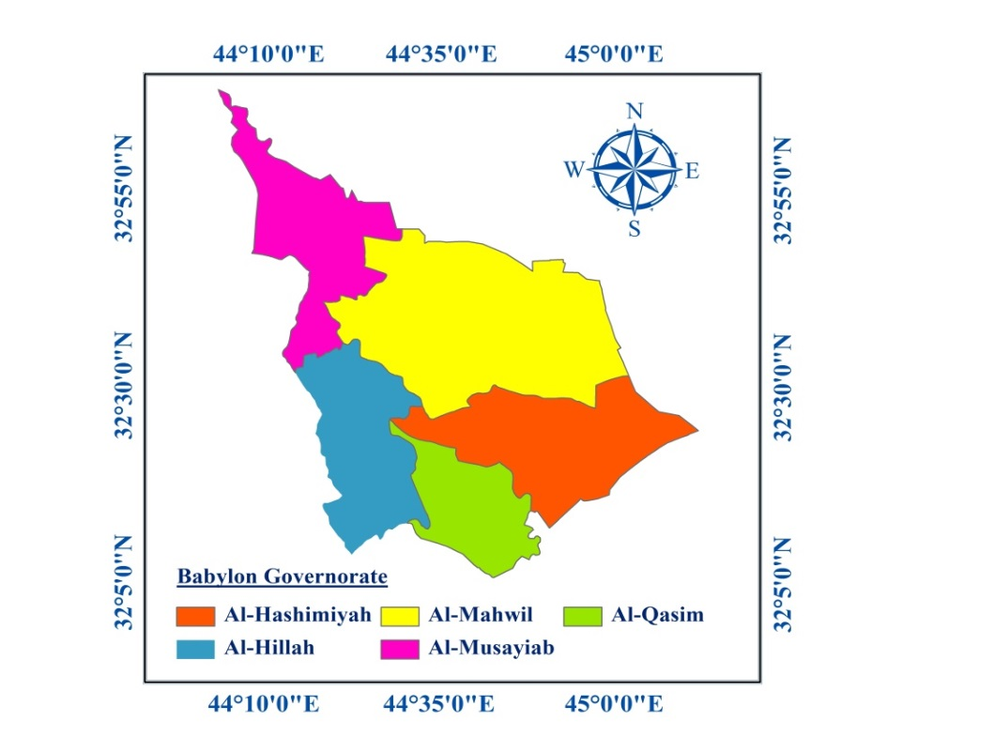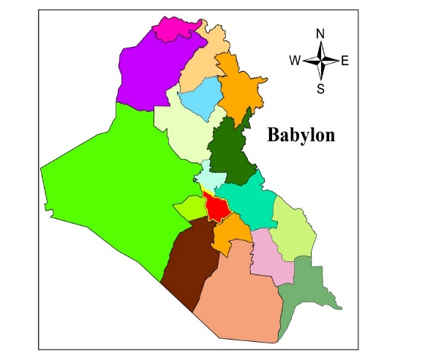

**Baghdad**

**Figure 1.** Map of Babylon Governorate

**2.2. The Required Maps**

The required maps for this study were prepared based on many sources. The first source was as digital maps (shape files). These maps are: urban centres, river, villages, roads, topography, slope, archaeological sites, power lines, gas pipelines, oil pipelines and railways. These maps were prepared according to the internal reports of the Iraqi Ministry of Education [15]. The other source was created based on the available data which was entered into GIS, where the readings of 170 wells for the groundwater depths were used to make an interpolation between these data using the spatial analysis tool “Kriging” to produce the map of groundwater depth in Babylon Governorate [16]. The published maps were used to produce the required maps in this study as a third source. These maps were drawn within GIS using spatial analysis tools as a separate shape file depending on the relevant information in the each map, and then each map was converted to the digital map. The map of industrial areas (scale 1:400,000) [13] locates the industrial sites within Babylon Governorate, whilst the map of archaeological sites of Iraq scale (1:1,500,000) [17] shows the important archaeological and religious sites in the governorate. The digital map of “agricultural land” was determined using the published map of land capability of Iraq (scale 1:1,000,000) [18], and each category (three categories) was checked by analysing satellite images of the Babylon Governorate from 2011 [19]. The digital map of “soil types” was prepared in GIS using the map of exploratory soil of Iraq (scale 1:1,000,000) [20].

**2.3. The rating Values of Sub-Criteria**

For the current study, the literature review, opinion of experts in this field, various requirements, regulations and available data about the study area were used to classify each criterion into categories (sub-criteria). After that each category was assigned a suitability score. For preparing each criterion and sub-criteria, many steps were performed in GIS environment using special analysis tools, as shown in (**Table 1**) and (**Figures 2, 3 and 4**).

**Table 1.** Summary of the input layers used in the analysis.

|  |  |  |  |  |  |  |  |  |
| --- | --- | --- | --- | --- | --- | --- | --- | --- |
| No. | Criterion | Buffer zone | Rating | No. | Criterion | Buffer zone | Rating | |
| 1 | Groundwater depth (m) | 0 - 2.5 | 1 | 7 | Agricultural land use | Agricultural lands | 0 | |
| 2.5 - 5 | 2 | Orchards | 5 | |
| 5 - 7.5 | 4 | Unused lands | 10 | |
| 7.5 - 10 | 6 | 8 | Roads (km) | 0 – 0.5 | 0 | |
| > 10 | 10 | 0.5 - 1 | 7 | |
| 2 | Rivers (km) | 0 - 1 | 0 | 1 - 2 | 10 | |
| > 1 | 10 | 2 - 3 | 5 | |
| 3 | Elevation (a.m.s.l.) | 11 - 28 | 3 | > 3 | 3 | |
| 28 - 34 | 7 | 9 | Railways (km) | 0 – 0.5 | 0 | |
| > 34 | 10 | > 0.5 | 10 | |
| 4 | Slope (degree) | 0 - 5° | 10 | 10 | Urban centers (km) | 0 - 5 | 0 | |
| > 5° | 5 | 5 - 10 | 10 | |
| 5 | Gas pipelines (m) | ≤ 250 | 0 | 10 - 15 | 7 | |
| ˃ 250 | 10 | > 15 | 4 | |
| 6 | Oil pipelines (m) | ≤ 75 | 0 | 11 | Villages (km) | 0 - 1 | 0 | |
| ˃ 75 | 10 | > 1 | 10 | |
| No. | Criterion | Buffer zone | Rating | No. | Criterion | Buffer zone | | Rating |
| 12 | Soils types | Soil (1K) | 1 | 14 | Land use | Industrial areas | | 0 |
| Soil (17J) | 2 | Urban Centers | | 0 |
| Soil (18I) | 3 | Villages | | 0 |
| Soil (11H) | 4 | Rivers | | 0 |
| Soil (4G) | 5 | Archaeological sites | | 0 |
| Soil (9F) | 6 | Agricultural lands | | 0 |
| Soil (5E) | 7 | University | | 0 |
| Soil (5'D) | 8 | Treatment plant | | 0 |
| Soil (6B), Soil (8C) | 9 | Agricultural airport | | 0 |
| Soil (7A) | 10 | Orchards | | 5 |
| 13 | Archaeological sites (km) | 0 - 1 | 0 | Unused lands | | 10 |
| 1 - 3 | 5 | 15 | Power lines (m) | ≤ 30 | | 0 |
| > 3 | 10 | ˃ 30 | | 10 |

**Note:** a.m.s.l.: above mean sea level; Soil (1K): Gypsiferous Gravel Soils, Soil (17J): Mixed gypsiferous desert land; Soil (18I): Sand Dune Land; Soil (11H): Active dune land; Soil (4G): River levee soils; Soil (9F): Silted haur and marsh soils; Soil (5E): River basin soils, poorly drained phase; Soil (5'D): River basin soils, poorly drained phase; Soil (6B): Basin depression soils; Soil (8C): Haur soils; Soil (7A): periodically flooded soils.

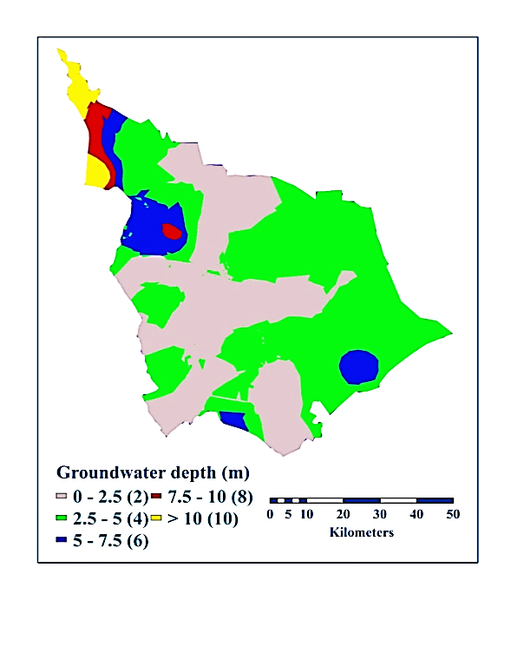

**(a)**

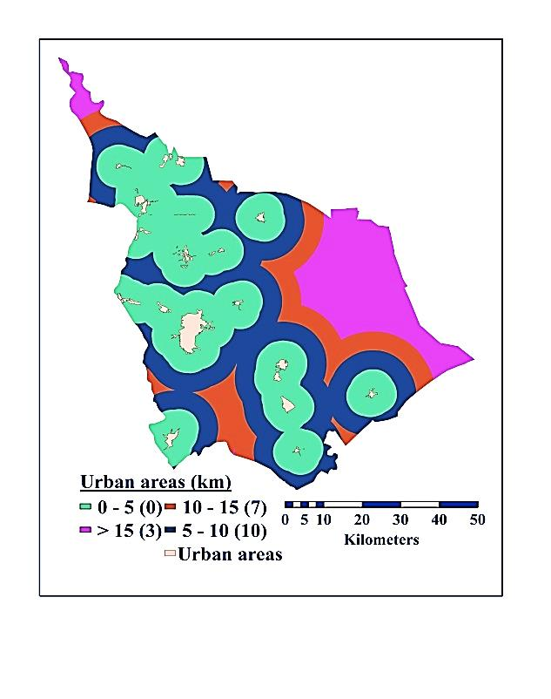

**(b)**

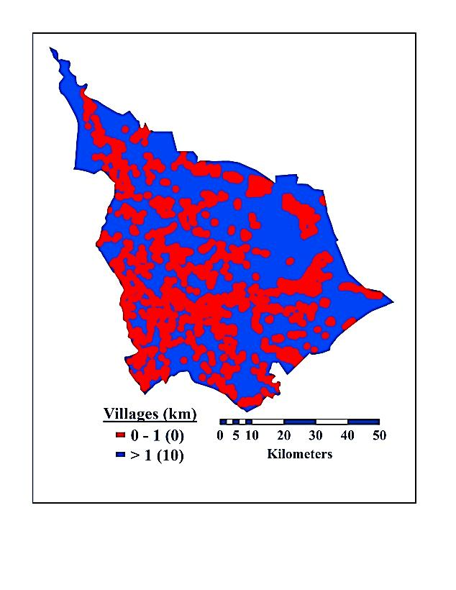

**(d)**

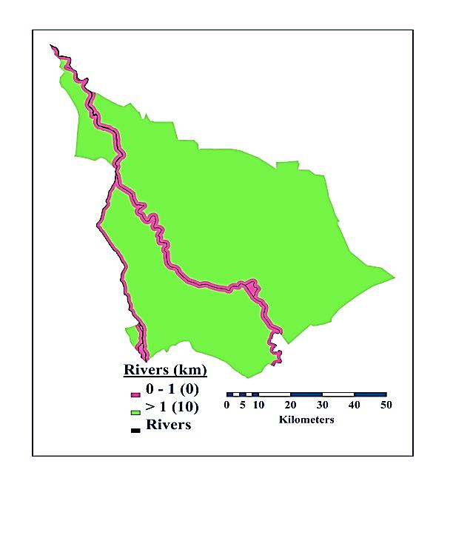

**(c)**

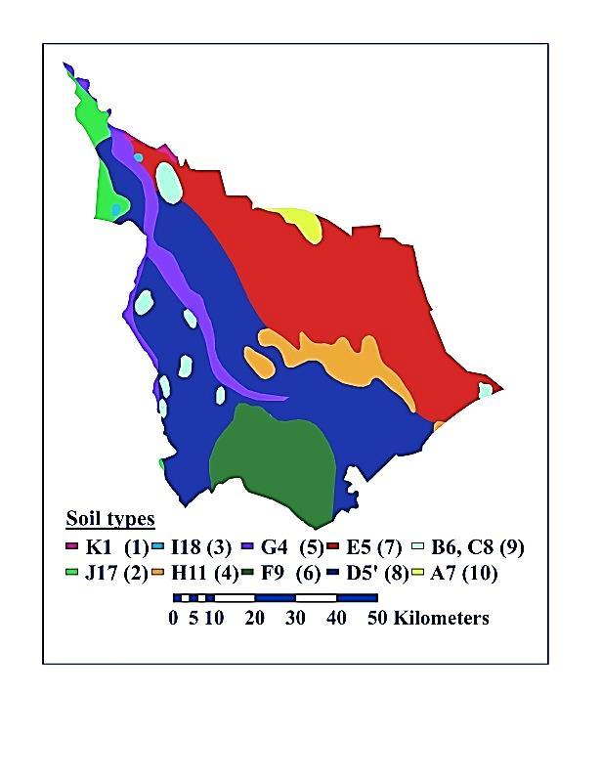

**(e)**

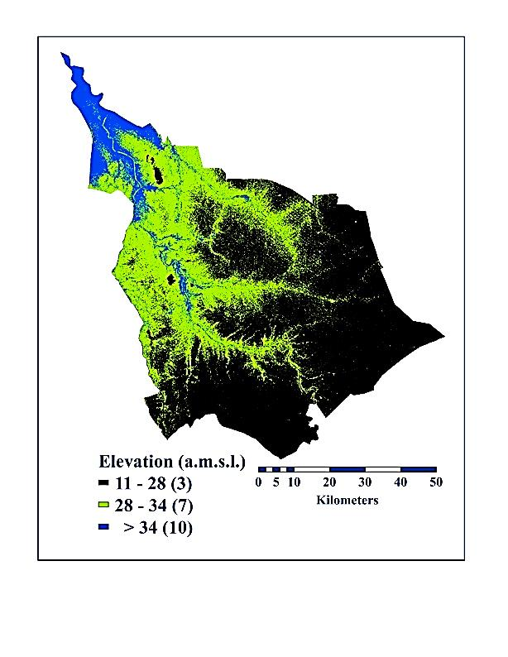

**(f)**

**Figure 2.** Maps of (a): Groundwater depth; (b): Urban centres; (c): Rivers; (d): Villages; (e): Soil types; (f): Elevation

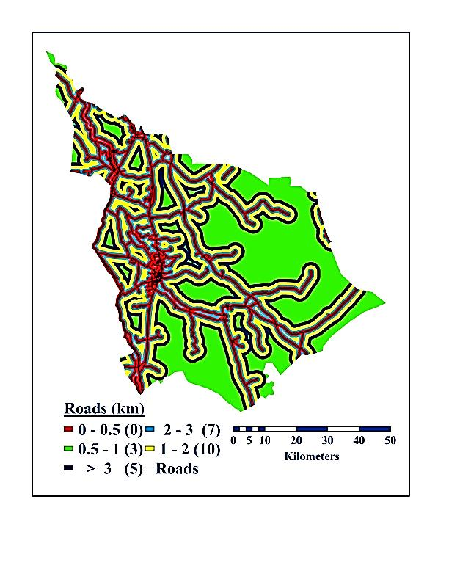

**(b)**

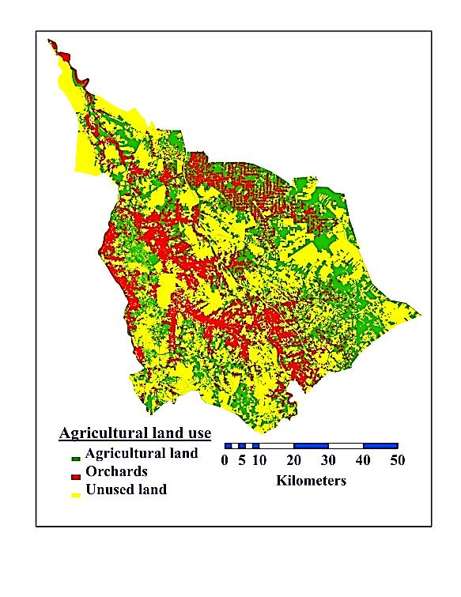

**(a)**

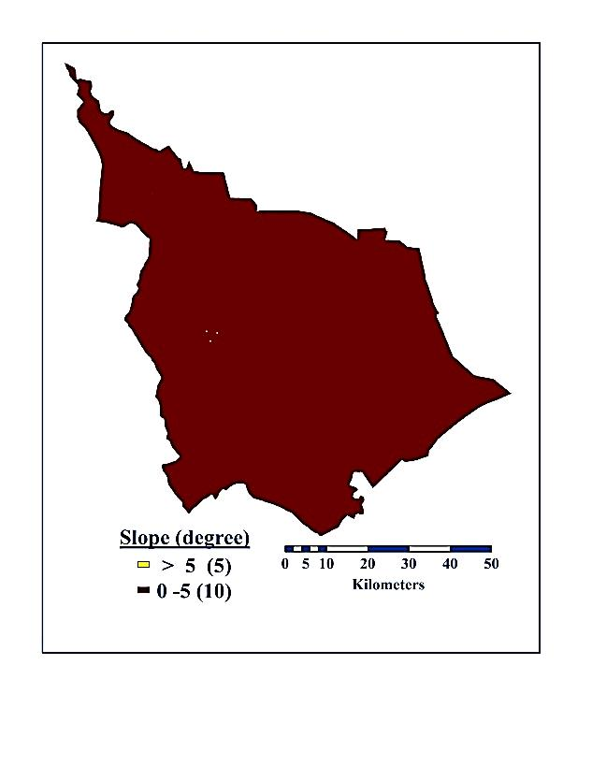

**(c)**

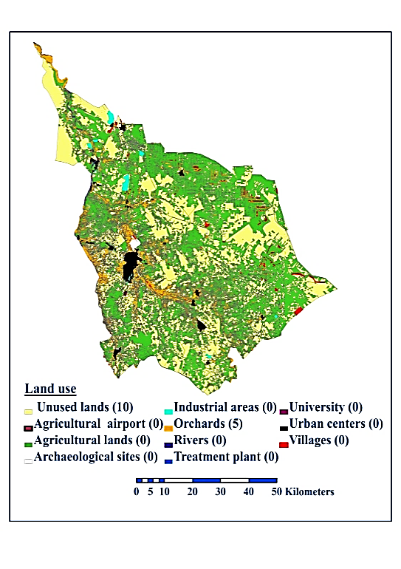

**(d)**

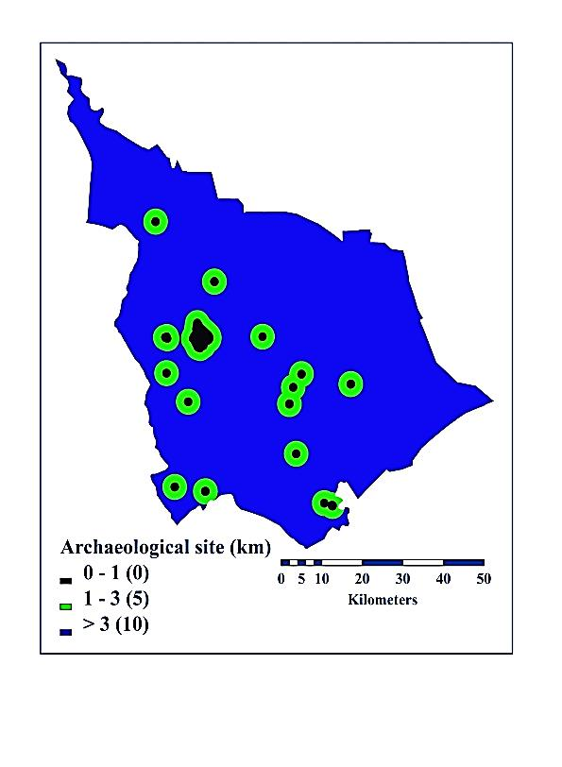

**(e)**

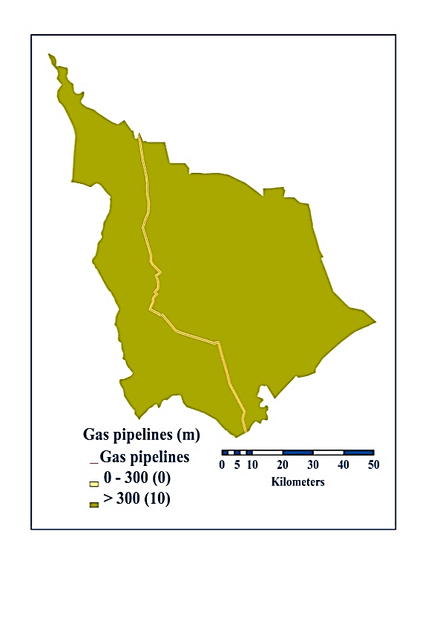

**(f)**

**Figure 3.** Maps of (a): Agricultural land use; (b): Roads; (c): slope; (d): Land use;

(e): Archaeological sites; (f): Gas pipelines

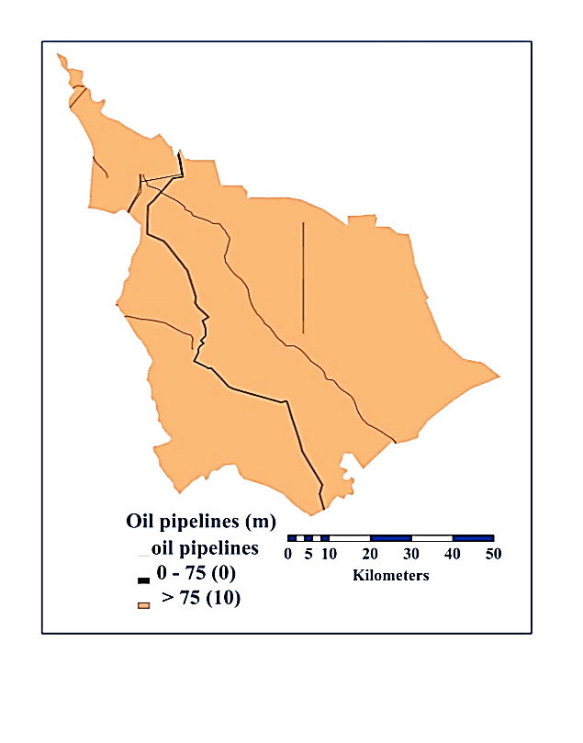

**(a)**

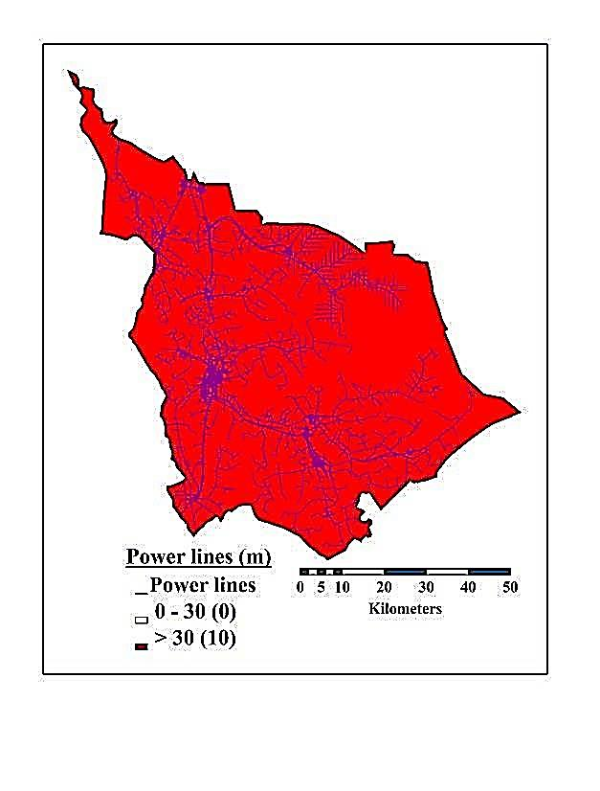

**(b)**

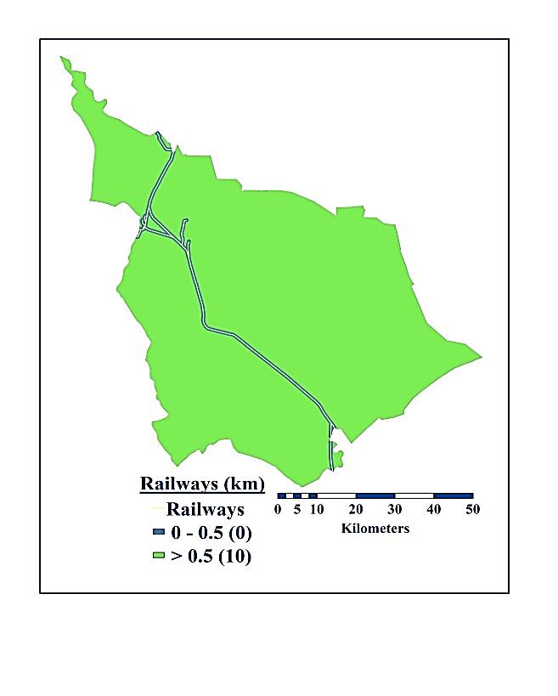

**(c)**

**Figure 4.** Maps of (a): Oil pipelines; (b): Power lines; (c): Railways

**2.6 Evaluation Criteria’s Weights Using AHP Method**

The AHP method was developed by Saaty in 1980 [21], where AHP is represented a comprehensive method and can be applied to multi-criteria in making decisions. This method enables decision-makers to determine the relative weighted importance between two criteria, and then check the consistency of judgments through using a series of pair-wise comparisons [22, 23]. In the AHP method, numerical scale of nine-point was presented by Saaty [12] in 1980 and further developed in 2008 [24]. It is used in a hierarchy of typical analytic to show which criterion is more important for another criterion with respect to the criteria [25]. After constructing the matrix of pair-wise comparisons, the weights of the criteria were calculated using series of formula. The eigenvectors (Egi) was calculated for each row depending on multiplying the value in each column for each criterion in the same row for the matrix of the pair wise comparison. After that the output value was putting under the root for numbers of criteria in this row, and then applying this to each row (**Figure 5**).

The priority vector (Pri) was determined by normalizing the eigenvalue to 1 by dividing each weight of criterion by their sum. For determining if the comparisons between criteria in a matrix of pair-wise comparisons are consistent, this is done through estimating the consistency ratio. This involves the following procedure: The lambda max (λmax) is obtained after computing the Eigenvalue and the priority vector. This is done from the summation of products of multiplying the sum of each column of the matrix by the corresponding value of the priority vector. Then the consistency index was estimated using the follows formula: (CI= (λmax - n/n - 1)) which represents the equivalent to the mean deviation of each comparison factor and the standard deviation of the evaluation error from the true ones [26]. Therefore, the value of (λmax) and (CI) in this study were 15.612 and 0.044 respectively. The most important step in consistency analysis in AHP was calculating the consistency ratio (CR=CI/RI) which is determined according to [21], through dividing the value of consistency index (CI) by the value (RI), where random index is the mean deviation of randomly for matrices with different size (RI15=15.9) [21]. If the value of CR is smaller than 0.1, the ratio shows a reasonable consistency level in the pair-wise comparison. So, in this study CR was equal to 0.027 lower than the critical limit of 0.1.



**Figure 5.** Pair-wise comparisons matrix for selecting a suitable landfill site and normalized weights

For obtaining the suitability index value of the potential areas, the method of WLC (Weighted Linear Combination) was used based on the following formula (Ai = $\sum_{j=1}^{n}{W_{j} × C_{ij}}$).

Where:

Ai: is the suitability index for area (i), Wj: is the relative importance weight of criterion, Cij: is the grading value of area (i) under criterion (j) and n: is the total number of criteria [27, 28].

The method of WLC was applied on all criteria using the special analysis tool “map algebra” in GIS to estimate the suitability index. This is done through summation of the products of multiplying the rating values of the sub-criteria for each criterion (based on the opinion of experts in this field) by the corresponding relative importance weight (which was calculated by using AHP method).

**3. Results and Discussion**

After determining the weights for all criterions using the AHP method as well as adequate weightings for the sub-criteria of each criterion based on the previous studies and opinion of experts in this field was assigned. Then, the WLC method was applied to determine the final output map of suitability index value for a landfill siting in Babylon Governorate, which was divided into four categories of suitability areas (**Figure 6**). These categories are: unsuitable areas, moderately suitable areas, suitable areas and most suitable areas.

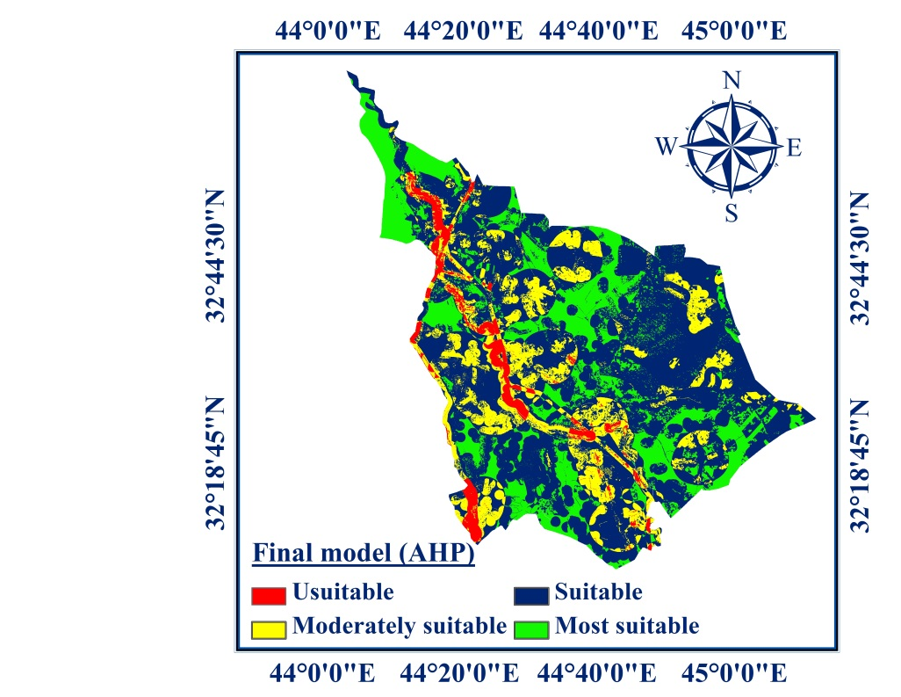

**Figure 6.** Map of suitability index for landfill sites in Babylon Governorate

The area for each category and its proportion of the total study area in Babylon Governorate which was resulted from the final map of suitability index for landfill sites can be seen in **Table 2**.

**Table 2.** The summary of areas and their proportion for categories of landfill maps.

|  |  |  |  |
| --- | --- | --- | --- |
| No. | Category | Area (km2) | Proportion% |
| 1 | Unsuitable areas | 230.51 | 4.34 |
| 2 | Moderately suitable areas | 873.51 | 16.42 |
| 3 | Suitable areas | 3022.67 | 56.82 |
| 4 | Most suitable areas | 1192.62 | 22.42 |

The expected solid waste quantity in 2030 in Babylon Governorate is 1,030,174 tonnes. The cumulative quantity of solid waste expected from 2020 to 2030 is 8,752,506 tonnes based on a predicted population in 2030 in the governorate is 3,556,966 inhabitants, according to the calculations made by Chabuk et al. [29]. The density of waste in waste disposal sites is 450 kg/m3 in the Babylon Governorate [30, 31]. By dividing the solid waste quantity over the density of waste, the expected volume of waste and the predictable volume of cumulative waste in 2030 are 2,289,275 m3 and 19,450,013 m3, respectively. In each Qadhaa in Babylon Governorate, the future population in 2030, the expected solid waste quantity in 2030, the cumulative quantity of solid waste expected from 2020 to 2030 and the expected volume of waste, the predictable volume of cumulative waste in 2030 and the generation rate of solid waste (GRW) kg/ (capita. day) in 2013, can be seen in **Table 3**.

**Table 3.** The summary of calculating the quantity and volume of solid waste in 2030 and the cumulative quantity and volume of solid waste in the year 2020-2030 in the Babylon Governorate’ Qadhaas

|  |  |  |  |  |  |  |
| --- | --- | --- | --- | --- | --- | --- |
| Qadhaa | Present population Po(2013) | Generation rate of solid waste (GRW) kg/ (capita. day)  in 2013. | Quantity of solid waste Qs (tonnes) in 2030 | Cumulative quantity of solid waste Qs(c) (tonnes)  for 2020-2030 | Volume of waste in 2030 (m3) | Cumulative waste volume 2020 - 2030 (m3) |
| Al-Hillah | 807,777 | 0.82 | 472,474 | 4,300,864 | 1,049,942 | 9,557,476 |
| Al-Qasim | 184,605 | 0.57 | 76,374 | 695,219 | 169,720 | 1,544,931 |
| Al-Mahawil | 336,148 | 0.4 | 96,389 | 877,419 | 214,198 | 1,544,931 |
| Al-Hashimiyah | 270,020 | 0.52 | 100,155 | 911,695 | 222,567 | 2,025,989 |
| Al-Musayiab | 374,684 | 0.77 | 205,792 | 1,873,295 | 457,315 | 4,162,878 |
| Babylon Governorate | 1,973,234 | 0.67 | 1,030,174 | 8,752,506 | 2,289,275 | 19,450,013 |

The groundwater depth from a ground surface in Babylon Governorate is shallow. Therefore, the average suggested height on the surface of the required solid waste in the landfill sites that resulted from this study was adopted as 2 m. **Table 4** shows the needed area for a candidate site in each Qadhaa in Babylon Governorate and its location to accommodate the cumulative quantity of solid waste generated from 2020 to 2030 according to this condition.

**Table 4.** The values of required area, available area of candidate sites

for landfill in Babylon Governorate and their locations.

|  |  |  |  |  |  |
| --- | --- | --- | --- | --- | --- |
| Qadhaa | Required area (km2) | Available area of candidate sites | | Latitude | Longitude |
| Site Symbol | Area (km2) |
| Al-Hillah | 4.778 | Hi-1 | 6.768 | 32° 18' 45" N | 44° 24' 40" E |
| Hi-2 | 8.204 | 32° 13' 43" N | 44° 29' 15" E |
| Al-Qasim | 0.772 | Q-1 | 2.766 | 32° 11' 43" N | 44° 32' 26" E |
| Q-2 | 2.055 | 32° 14' 38" N | 44° 37' 10" E |
| Al-Hashimiyah | 1.013 | Hs-1 | 1.288 | 32° 15' 54" N | 44° 53' 38" E |
| Hs-2 | 1.374 | 32° 24' 51" N | 44° 54' 41" E |
| Al-Mahawil | 0.975 | Ma-1 | 2.950 | 32° 29' 59" N | 44° 41' 2" E |
| Ma-2 | 2.218 | 32° 38' 12" N | 44° 34' 9" E |
| Al-Musayiab | 2.080 | Mu-1 | 7.965 | 32° 48' 39" N | 44° 8' 59" E |
| Mu-2 | 5.952 | 33° 0' 14" N | 44° 6' 46" E |

Two candidate sites were selected for landfill in each Qadhaa (district) in Babylon Governorate among the many sites located within the category of the “most suitable index” (**Figure 7a**).

These sites were checked on the satellite images (2011) of the Babylon Governorate to make sure that these sites were adequate for landfills in Babylon Governorate (**Figure 7b**).

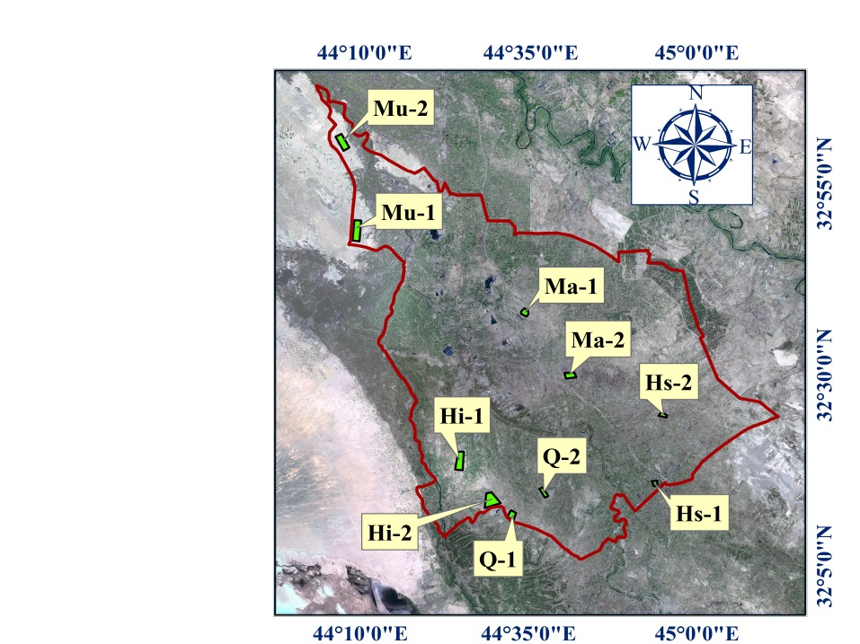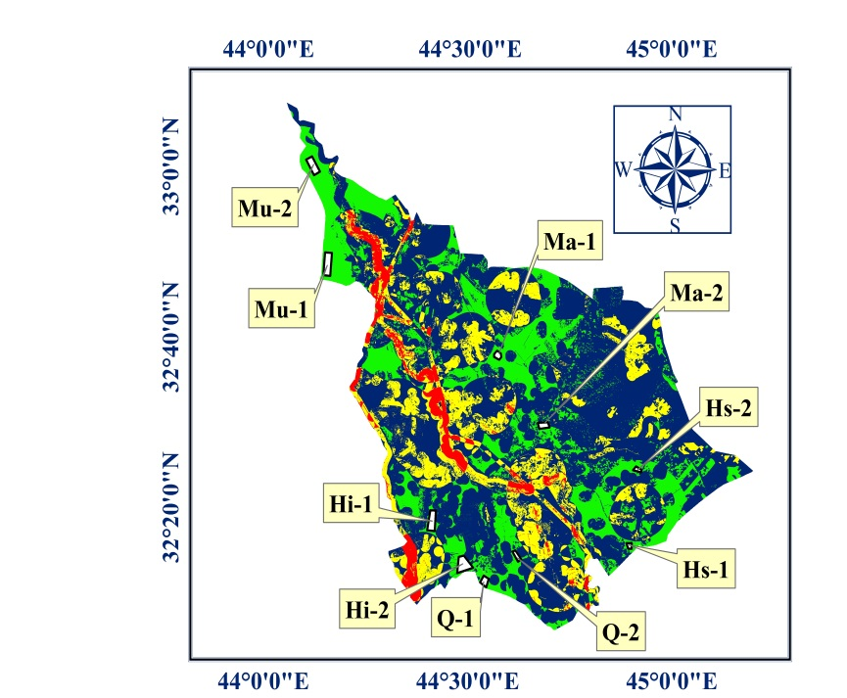

**(a)**

**(b)**

**Figure 7.** The candidate sites for landfill in Babylon Governorate on (a): The suitability final map for landfill. (b): The satellite images of Babylon Governorate.

**4. Conclusions**

Babylon Governorate is situated in the middle part of Iraq. The existing waste disposal sites do not conform to the scientific and environmental criteria. Therefore, this study aimed to select suitable sites for landfill in Babylon Governorate using GIS and Multi Criteria Decision Making method (AHP). For obtaining the most adequate sites for landfills in Babylon Governorate, fifteen layers of criteria were incorporated into GIS for the analysis process. These layers according to their importance were: groundwater depth, urban centers, rivers, villages, soil types, elevation, agriculture land use, roads, slope, land use, archaeological sites, gas pipelines, oil pipelines, power lines and railways.

The AHP method was used to derive the weightings of criteria using a pair-wise comparison through constructing a matrix of comparison. Then, the method of WLC was applied on all criteria to produce the final output map of suitability index for Babylon Governorate.

Finally, two candidate sites were identified on the final map for landfill siting among several locations in each Qadhaa in Babylon Governorate within the category of “most suitable”.

In this study, the available areas of candidate sites are appropriate to receive the cumulative waste produced in 2020-2030 based on the required area for candidate landfills in each Qadhaa in Babylon Governorate.

**References**

[1] Femi, F. & Oluwole, O. (2013) “Management of Municipal Solid Waste”, <http://www.acad-emia.edu/4254191/Management_of_Municipal_Solid_Waste>, last access: 6th- January- 2015.

[2] Al-Ansari, N.A. (2013) “Locating landfills in arid environment”, Journal of Earth Sciences & Geotechnical Engineering, Vol. 3, pp11-24.

[3] Brockerhoff, M.P. (2000) “An Urbanizing World”, Population Reference Bureau (PRB), Vol. 55, No. 3, pp1-48.

[4] Nas, B. Cay, T. Iscan, F. & Berktay, A. (2010) “Selection of MSW landfill site for Konya”, Turkey using GIS and multi-criteria evaluation, Environmental Monitoring & Assessment, Vol. 160, pp 491-500.

[5] Proske, H. Vlcko, J. Rosenbaum, M.S. Dorn, M. Culshaw, M. & Marker, B. (2005) “Special purpose mapping for waste disposal sites”, Bulletin of Engineering Geology and the Environment, Vol. 64, pp 1-54.

[6] Siddiqui, M.Z. Everett, J.W. & Vieux, B.E. (1996) “Landfill siting using geographic information systems: A demonstration”, Journal of Environmental Engineering, Vol. 122, pp515-523.

[7] Lin, H. & Kao, J. (1999) “Enhanced spatial model for landfill siting analysis”, Journal of Environmental Engineering, Vol. 125, pp 845-951.

[8] Wang, G. Qin, L. Li, G. & Chen, L. (2009) “Landfill site selection using spatial information technologies and AHP: A case study in Beijing, China”, Journal of Environmental Management, Vol. 90, pp 2414-2421.

[9] Delgado, O.B Mendoza, M. Granados, E.L. & Geneletti, D. (2008) “Analysis of land suitability for the siting of inter-municipal landfills in the Cuitzeo Lake Basin, Mexico”, Waste Management, Vol. 28, pp1137-1146.

[10] Kontos, T.D. Komilis, D.P. & Halvadakis, C.P. (2003) “Siting MSW Landfills on Lesvos Island with a GIS Based Methodology”, Waste Management & Research, Vol. 21, No. 3, PP 262-77.

[11] Moeinaddini, M. Khorasani, N. Danehkar, A. Darvishsefat, A.A. & Zienalyan, M. (2010) “Siting MSW landfill using weighted linear combination and analytical hierarchy process (AHP) methodology in GIS environment (case study: Karaj)”, Waste Management, Vol. 30: pp 912-920.

[12] Al Khalidy, K.S. Chabuk, A. & Kadhim, M.M. (2012) “Measurement of Lead Pollution in the Air of Babylon Governorate, Iraq during Year 2010”, World Academy of Science, Engineering and Technology, Vol. 6, pp 830-833.

[13] Iraqi Ministry of Municipalities and Public Works, (2009) “Structural Plan of Babylon Governorate”, The Directorate General of Urban Planning, Information Analysis Report (Revised), stage 2, pp 223.

[14] Iraqi Ministry of Planning, (2015) “Records of Directorate of Census Babylon”, internal reports, Baghdad: Iraqi Ministry of Planning.

[15] Iraqi Ministry of Education, (2015) “Data of the Directorate General”, internal reports, The department of scientific affairs, Baghdad.

[16] Iraqi Ministry of Water Resources, (2015) “General Commission for Groundwater”, internal reports, Baghdad: Iraqi Ministry of Water Resources.

[17] World Digital Library, (2013) “The Archaeological Map of Iraq”, http://www.wdl.org/en/-item/212/, last access: 24th – September- 2015.

[18] Iraqi Ministry of Water Resources, (1990) “State commission of survey”, internal reports, Baghdad: Iraqi Ministry of Water Resources.

[19] Iraqi Ministry of Municipalities and Public Works, (2011) “Directorate of Sewage Babylon”, internal reports. Baghdad: Iraqi Ministry of Municipalities and Public Works.

[20] Buringh, P. (1960) “Soils and Soil Conditions in Iraq”, Baghdad, Iraq: The Ministry of Agriculture, pp337.

[21] Saaty, T.L. (1980) “The Analytic Hierarchy Process: Planning, Priority Setting”, Resources Allocation. New York: McGraw.

[22] Ersoy, H. & Bulut, F. (2009) “Spatial and Multi-criteria Decision Analysis-Based Methodology for Landfill Site Selection in Growing Urban Regions”, Waste Management & Research Vol.27, No. 5, pp489-500.

[23] Rezaei-Moghaddam, K. & Karami, E. A. (2008) “A Multiple Criteria Evaluation of Sustainable Agricultural Development Models Using AHP.” Environment, Development and Sustainability, Vol.10, No. 4, pp 407-26.

[24] Saaty, T. L. (2008) “Decision Making with the Analytic Hierarchy Process.” International Journal of Services Sciences, Vol.1, No. 1, pp83-98.

[25] Chabuk, A. Al-Ansari, N. Hussain, H. M. Knutsson, S. & Pusch, R. (2016) “Landfill Siting Using GIS and AHP (Analytical Hierarchy Process): A Case Study Al-Qasim Qadhaa, Babylon, Iraq.” Journal of Civil Engineering and Architecture, Vol. 10, pp 530-543.

[26] Sólnes, J. (2003) “Environmental Quality Indexing of Large Industrial Development Alternatives Using AHP”, Environmental Impact Assessment Review, Vol. 23, pp 283-303.

[27] El Alfy, Z. Elhadary, R. & Ahmed, E. A. (2010) “Integrating GIS and MCDM to Deal with Landfill Site Selection”, International Journal of Engineering & Technology, Vol. 10, No. 6, pp 32-42.

[28] Eskandari, M. Homaee, M. & Mahmodi, S. (2012) ”An Integrated Multi Criteria Approach for Landfill Siting in a Conflicting Environmental, Economical and Socio-Cultural Area”, Waste Management, Vol. 32, No. 8, pp1528-38.

[29] Chabuk, A. Al-Ansari, N. Hussain, H. M. Knutsson, S. & Pusch, R. (2015) “Present Status of Solid Waste Management at Babylon Governorate, Iraq.” Engineering, Vol. 7, pp408-23.

[30] Iraqi Ministry of Municipalities and Public Works, (2015a) “Records of Directorate of Babylon Municipalities”, Babylon, internal reports, Baghdad: Iraqi Ministry of Municipalities and Public Works.

[31] Iraqi Ministry of Municipalities and Public Works, (2015b) “Records of Directorate of Al-Hillah Municipality”, Babylon, internal reports, Baghdad: Iraqi Ministry of Municipalities and Public works.