A retrospective study of survival and recurrence in patients undergoing resection for sigmoid and rectal cancer to compare local rates to published data.
Alkhusheh M, Pilarski A, Jones D
Digestive Diseases Department, Brighton and Sussex University Hospitals, UK

Abstract
Aim:
A retrospective study of survival and recurrence in patients undergoing sigmoid and rectal cancer (CRC) resections at a large UK South Coast colorectal unit to compare local rates to published data.
Methods:
Patients undergoing sigmoid and rectal cancer resections between Jan 2010 and Dec 2012 were eligible (n=263). Recurrence data was taken from local colorectal Multi-Disciplinary-Meeting (MDM) reports and mortality data from local MDM records and the hospital patient administration system. Mortality was recorded up to 15/01/2016, and recurrence up to last MDM discussion. Operative details were taken from procedure descriptions on theatre databases.
Results:
222 patients were eligible for analysis. 79 (35.59%) underwent sigmoid colectomy and 143 (64.41%) anterior resection of rectal cancer. 33 patients (14.93%) had recurrence of cancer. Total 30 day mortality for confirmed CRC patients was 1.80% (n=4), and total 3 year mortality was 13.96% (n=31). 5-year mortality data was available for 78 patients, with survival of 70.5%. Cox proportional hazards modelling revealed impaired survival with increasing age (HR 1.05, 95% CI 1.02-1.08, p=0.002), emergency admission (HR 9.31, 3.44-25.16, p<0.001), and recurrence of cancer (HR 9.16, 4.96-16.94, p<0.001).
Conclusion:
30-day mortality and recurrence at our centre is broadly in line with existing published data, with subgroup analysis of patients with 5-year data demonstrating improved survival.
Key words: Sigmoid cancer, rectal cancer, anterior resection, survival.

Introduction:
Colorectal cancer is the third most common malignant tumor throughout the Western world. Rectal cancer comprises approximately one third of the cases. During the last few decades, improvements in survival and reduced local recurrence rates have been observed, probably because of changes in treatment strategies [1-5] surgical technique, [6-10] and centralization to specialized units [11-12]
Beneficial effects in terms of reduced local recurrence rates and enhanced survival have been seen in several randomized trials and summarized in systematic overviews [3,13,14] Rectal cancer is uncommon in people under the age of 50 years, but later in life, it is one of the most significant diseases in terms of morbidity and mortality. As longevity continues to increase, an increasing proportion of elderly patients will live for a long time after a curative treatment of rectal cancer.
One of the major problems in the treatment of rectal cancer has been the inability to achieve local control. The conventional surgical procedure, which involves blunt digital dissection, is associated with a high incidence of local recurrence.
In an attempt to improve local control and survival, many adjuvant treatment modalities have been investigated

In recent decades, substantial progress has been made in the treatment of rectal cancer. New surgical techniques have played a major role in improving treatment outcome. Local control and survival have been improved by the TME technique. TME is accomplished by precise sharp dissection within the true pelvis around the integral mesentery under direct vision, enveloping the entire midrectum. Apart from the beneficial effect on local recurrence and survival, the TME dissection is also associated with a higher incidence of sphincter preservation and of pelvic and autonomic nerve preservation.

In this study, We report our local experience of mortality, survival and recurrence rates in patients undergoing sigmoid and rectal cancer resections in the context of sigmoid and rectal cancer at a large teaching hospital in the UK in order to compare local rates to existing published data.
Methods:
A retrospective analysis was carried out on a consecutive series of 263 patients, both emergency and elective cases, undergoing colorectal resections for colorectal cancer at one UK centre from Jan 2010 to December 2012.
Data on recurrence rates were taken from local colorectal cancer Multi-Disciplinary Meeting (MDM) outcomes. Mortality data was taken from both local MDM records, and the hospital patient administration system (PAS). Follow up data was obtained from the hospital electronic record of outpatient attendances. Demographic data was obtained from PAS. Mortality was recorded up to 15th January 2016, and recurrence up to last MDM discussion. Operative details were identified through recorded procedure codes description on theatre databases.
Results:
Of the 263 patients who underwent colorectal surgery, 41 (15.59%) of the patients had no cancer shown at post-operative histology and were excluded from further analysis. Survival data was calculated from date of initial surgery. In patients who had proven cancer (n=222), 79 (35.59%) underwent sigmoid colectomy and 143 (64.41%) underwent anterior resection.
133 patients were male (59.91%) and 89 female (40.09%). Age at operation ranged from 31-90 years (mean 69.42, median 70.5).
209 (94.14%) patients were elective admissions for surgery, compared to 13 (5.86%) admitted as an emergency.
Outpatient follow up was recorded post-procedure for 218 (98.2%) patients.
Analysing procedure codes, 113 patients (50.9%) underwent open surgery, 109 (49.09%) underwent laparoscopic surgery, and 11 (4.95%) were converted from laparoscopic to open. Rates were broadly similar throughout all three years.
Recurrence data from MDM discussions was available for all but one patient (mean follow up 303.79 days). 33 (14.93%) patients had recurrence of cancer within the follow up period. 10 (4.50%) had local recurrence only, 23 (10.36%) had distal or both local and distal recurrence. Recurrence data was unavailable for one patient.
Follow up data for mortality was available for all patients until either death, or to 15th January 2016 (mean follow up time 1455 days, median 1537, range 2-2192 days). Total 30 day mortality for confirmed cancer patients was 1.80% (n=4), and total 3 year mortality was 13.96% (n=31). 5 year data was available for 78 patients operated on in 2010 and early January 2011, with 23 patients having died within 5 years post-procedure (29.49%).
A Cox proportional hazards model was generated utilising sex, age at operation, admission type (emergency Vs elective), type of operation (sigmoid colectomy vs anterior resection) and recurrence, via manually implemented backwards elimination. The effect of sex and laparoscopic vs open surgery on survival were non significant (p>0.2) and they were eliminated from the model.
Increasing age carried impaired survival (HR 1.05, 95% CI 1.02-1.08, p=0.002). Emergency admissions were associated with a hazard ratio of over 9 compared to elective admissions (HR 9.31, 95% CI 3.44-25.16, p<0.001,). Sigmoid colectomy conveyed improved survival compared to anterior resection (HR 0.46, 95% CI 0.21- 0.98, p=0.045). Recurrence of cancer was associated with significantly reduced survival (HR 9.16, 95% CI 4.96-16.94, p<0.001).
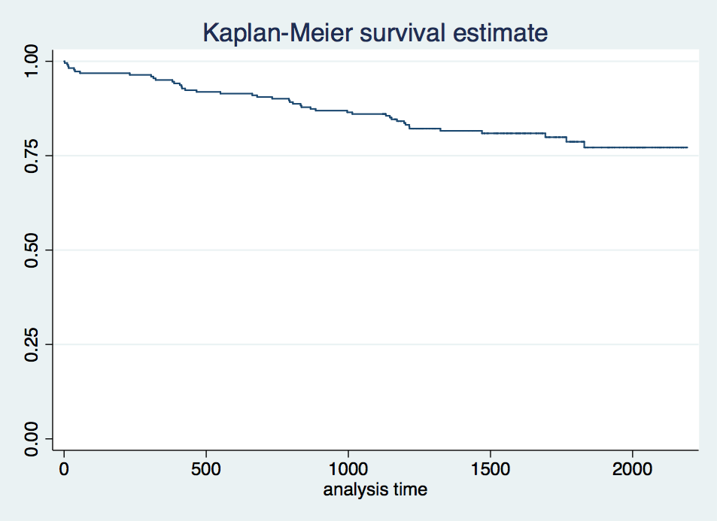
Emergency admissions were significantly more likely to undergo sigmoid colectomy compared to anterior resection than elective admissions (76.92% emergency admissions vs 23.08% elective, p=0.001). No emergency admissions underwent laparoscopic surgery.
Fig1: Kaplan-Meier Survival during the follow up
Discussion:
This study shows our experience and the outcome of sigmoid and rectal cancer resection.
The local and distal recurrence rates are 4.5% and 10.36% respectively. The 30 day mortality is 1.8%. 3 year and 5 year mortality are 13.9% and 29.4% respectively.
This study showed no significant effect of gender or type of surgery ( Laparoscopic Vs open) on the survival rate. However, increased age, emergency admission and recurrence of cancer carried and impaired survival.

Data | Our Study | Senapati et al (2012) | Leroy et al (2004) | Barlehner et al (2005)
Patients included | 222 | 1606 | 102 | 194
30 day mortality(%) | 1.8 | 4.6 | 2.0 | -
3 year survival (%) | 86.2 | - | - | 74.5
Total recurrence(%) | 14.9 | - | - | 18.4
Local recurrence(%) | 4.5 | 4.0 | 6.0 | 6.7
Distal recurrence(%) | 10.7 | - | - | 11.7
Follow up (%) | 98.2 | 97.0 | 100 | 100
Table 1: Comparison between our data and published data

A recent study (Senapai et al) showed that Among 940 patients undergoing a potentially curative major resection the operative mortality was 4.6%, and the crude 5-year survival 61%. The local recurrence rate after curative anterior resection was 2.9%. The overall local recurrence rate after a potentially curative major resection was 4.0%.[15]
Leroy et al showed that after laparoscopic TME, The overall mortality rate was 2%, The local recurrence rate was 6%, and the cancer-specific survival of all curatively resected patients was 75% at 5 years. The overall survival rate of all curatively resected patients was 65% at 5 years; mean survival time was 6.23 years (95% confidence interval [CI], 5.39-7.07). [16]
Another study by Barlehner et al on 194 patients underwent laparoscopic resection of rectal cancer showed tumor recurrence developed in 23 of the 145 curative resected patients (11.7% distant metastases and 4.1% local recurrence). Overall local recurrence rate was 6.7% (4.1% after curative resection and 14.3% after palliative resection). Overall survival rate was 90.6% at 1 year, 74.5% at 3 years, and 66.3% at 5 years. Overall 5-year survival rate was 76.9% after curative resection and 31.8% after palliative resection. [17]
A possible limitation of this is the retrospective nature which bears the risk of recall bias due to follow up drops. However, the Outpatient follow up was recorded post-procedure for 218 (98.2%) patients.

Conclusions:
The 30 day mortality, recurrence and follow up at our centre is broadly in line with existing published data. Due to the recent nature of our data it is only possible to calculate 3 year survival rates for all patients, however subgroup analysis of those patients with over 5 years since procedure revealed improved survival compared to published data. Cox proportional hazards modelling revealed significantly reduced survival with recurrence of cancer, and with emergency admission compared to elective. Increasing age carried a poorer prognosis with respect to survival.

References:
- The National Board of Health and Welfare: National Quality Register for Rectal Cancer Surgery. Stockholm, Sweden, The National Board of Health and Welfare, 2001
- ↵ Swedish Rectal Cancer Trial: Improved survival with preoperative radiotherapy in resectable rectal cancer. N Engl J Med 336:980-987, 1997
- ↵ Colorectal Cancer Collaborative Group: Adjuvant radiotherapy for rectal cancer: A systematic overview of 8,507 patients from 22 randomised trials. Lancet 358:1291-1304, 2001
- Mattsson S, Brahme A, Carlsson J, et al: Swedish Cancer Society radiation therapy research investigation. Acta Oncol 41:596-603, 2002
- ↵ Talbäck M, Stenbeck M, Rosén M, et al: Cancer survival in Sweden 1960-1998: Developments across four decades. Acta Oncol 42:637-659, 2003
- ↵ Heald RJ, Ryall RD: Recurrence and survival after total mesorectal excision for rectal cancer. Lancet 1:1479-1482, 1986
- Dahlberg M, Påhlman L, Bergström R, et al: Improved survival in patients with rectal cancer: A population-based register study. Br J Surg 85:515-520, 1998
- ↵ Kapiteijn E, Marijnen CA, Nagtegaal ID, et al: Preoperative radiotherapy combined with total mesorectal excision for resectable rectal cancer. N Engl J Med 345:638-646,2001
- Kapiteijn E, Putter H, van de Velde CJ: Impact of the introduction and training of total mesorectal excision on recurrence and survival in rectal cancer in the Netherlands. Br J Surg 89:1142-1149, 2002
- Martling AL, Holm T, Rutqvist LE, et al: Effect of a surgical training programme on outcome of rectal cancer in the County of Stockholm: Stockholm Colorectal Cancer Study Group, Basingstoke Bowel Cancer Research Project. Lancet 356:93-96, 2000
- ↵ Dahlberg M, Glimelius B, Pahlman L: Changing strategy for rectal cancer is associated with improved outcome. Br J Surg 86:379-384, 1999
- ↵ Smedh K, Olsson L, Johansson H, et al: Reduction of postoperative morbidity and mortality in patients with rectal cancer following the introduction of a colorectal unit. Br J Surg 88:273-277, 2001
- ↵ Cammà C, Giunta M, Fiorica F, et al: Preoperative radiotherapy for resectable rectal cancer: A meta-analysis. JAMA 284:1008-1015, 2000
14 Glimelius B, Grönberg H, Järhult J, et al: A systematic overview of radiation therapy effects in rectal cancer. Acta Oncol 42:476-492, 2003
15. Senapati A1, O'Leary DP, Flashman KG, Parvaiz A, Thompson MR
Low rates of local recurrence after surgical resection of rectal cancer suggest a selective policy for preoperative radiotherapy. Colorectal Dis. 2012 Jul;14(7):838-43. doi: 10.1111/j.1463-1318.2011.02827.x.
16. Leroy J1, Jamali F, Forbes L, Smith M, Rubino F, Mutter D, Marescaux J.
. Laparoscopic total mesorectal excision (TME) for rectal cancer surgery: long- term outcomes.
Surg Endosc. 2004 Feb;18(2):281-9. Epub 2003 Dec 29
17. E. Bärlehner, T. Benhidjeb , S. Anders, B. Schicke
Laparoscopic resection for rectal cancer: Outcomes in 194 patients and review of the literature
Surgical Endoscopy And Other Interventional Techniques
June 2005, Volume 19, Issue 6, pp 757-766

