Characterizing aggregate deposits using electrical resistivity method: case history of sand search in the Niger Delta, Nigeria
K.S. Okiongbo¹ and C. Soronnadi-Ononiwu²
¹Geophysics Unit, Department of Physics, Niger Delta University,
Wilberforce Island, Bayelsa State, Nigeria
²Department of Geology, Niger Delta University, Wilberforce Island,
Bayelsa State, Nigeria
Abstract

Natural aggregates (e.g sand and gravel) are indispensible natural resource for any society. This is because sand and gravel deposits are good groundwater and hydrocarbon reservoirs, sources of obtaining economic placer deposits such as gold, tin, diamond etc, and are useful construction aggregates for civil engineering projects. It will be difficult to maintain our current quality of life without sand and gravel. In order to obtain robust subsurface models to accurately delineate the geometry of sand and gravel deposit, we integrated geoelectric sounding and 2D resistivity imaging in an attempt to source for natural aggregates to reclaim swampy land in two oil bearing communities in the Niger Delta. The electrical resistivity investigations were carried out in seven locations. Due to the problem of equivalence associated with the interpretation of geoelectric sounding data, borehole data was used to constrain the interpretation. The total volume of dredgeable sand was calculated by using a simple volume arithmetic in which the length and width of the survey area was multiplied by the average sand thickness. The results show that four of the seven sites, whose bulk resistivity did not exceed 900 Ωm, were found to have no coarse material when drilled for verification. Significant accumulations of about 50,000 m³ of high resistivity deposits were found in each of the remaining three sites and were recommended for dredging. Application of geophysics to sand and gravel prospecting enhances considerable economic saving for the aggregate industry and also an environmental saving for society.
Keywords: Sand and gravel, 2D resistivity imaging, Geoelectric sounding, Swampy land, Dredge, Niger Delta
1 Introduction

Naturally occurring sand and gravel constitute aggregate resources. These resources have had such a great impact on our lives to an extent that it will be difficult or impossible to maintain our current quality of life without them. This is because sand and gravel deposits are often good groundwater and hydrocarbon reservoirs; are sources of obtaining economic placer deposits such as gold, tin, diamond etc; and (3) sources of construction aggregate i.e materials used for sand fill reclamation of swampy lands. Additionally, sand and gravel are used in the construction of major civil engineering works such as airports, bridges, roads, highways, residential and commercial buildings, power generating facilities, factories, water supply and waste treatment facilities. The drive towards rapid industrialization has placed an unrelenting demand for aggregates in most parts of the world including Nigeria.
In anticipation of population increase in the near future and the need to provide suitable land for infrastructural development in Amabolou and Norgbene in Bayelsa State, Shell Petroleum Development Company of Nigeria (SPDC) under the new community interface model, based on global memorandum of understanding (GMoU) accepted to fund the sand filling of these communities. Before now, natural aggregates had to be hauled more than 50 km to build and maintain roads in these communities. To source the sand for this project, a program of sand search was commissioned. In the Niger Delta, sand and gravel are usually explored along river channels using drilling methods carried out on floating barges. But in this instance, the riverbed of the creek passing through these communities (Fig. 1) is deeper than 12 m. It was considered that most dredgers in the area would find such water depth too deep because of their short dredging arms. Thus, the search was carried out on land. The search was to determine the availability of sand, estimate the strippable overburden and determine the volume of exploitable sand. This information could of course be obtained by drilling a network of test holes, an approach that was thought to be invasive, extremely time consuming and expensive. Besides, lateral facies changes and stratigraphy cannot be delineated without extensive drilling programme. It was considered that surface geophysical investigation using the electrical resistivity method would furnish the information with minimum test holes for control. The electrical resistivity technique is used to investigate a wide range of problems such as hydrogeological, geological, engineering and environmental problems [1]. The electrical resistivity method had been used for hydrogeological investigations in the Niger Delta [2,3]. In these studies, the electrical resistivity data displays good resistivity contrasts between the overburden, sand and gravel, and bedrock; a useful albeit qualitative indicator for the applicability of the electrical method. The electrical resistivity technique can delineate compositional variations in a rock layer in the subsurface, and can therefore be used to distinguish between different geological sequences e.g clean sand and gravel (high resistivity) and clay (low resistivity). If the fluid conductivity does not vary, the resistivity of unconsolidated sedimentary deposits generally increases with grain size [4]. Thus the electrical resistivity method has the capability of providing a qualitative estimate of the grain size of a sand and gravel deposit [5]. It was considered therefore that the electrical resistivity technique will be effective in mapping the lithology and areal extent of aggregate deposits.
Since the 1940s, electrical resistivity method is being used as a viable tool for locating and mapping sand and gravel deposits [6-8]. For instance, [5] used surface geophysical methods to characterise aquifers in the northeastern United States and reported that the bulk resistivity of an aquifer was generally representative of the aquifer’s grain size characteristics. [9] used contour maps of apparent and true resistivity values obtained from electrical resistivity measurements (sounding and profiling) to estimate the volume of aggregates. Generally, the applicability of the electrical method to sand and gravel prospecting is based on the high resistivity contrast between coarse grained materials and the surrounding soil, clay or silt. The study of [9] also corroborated the ability of the electrical method as a viable tool in determining the physical characteristics of natural aggregates important for evaluating the quality of the deposit. In this study, in order to reduce the uncertainty and thus have robust subsurface models, we have integrated geoelectrical sounding and 2D resistivity imaging to map sand and gravel deposits. In areas with promising potential for sand and gravel, the volume of exploitable sand and gravel was determined using the areal extent of the deposit determined from the 2D resistivity cross-sections.

2 Study Area and Geological Setting
The study area is between latitude N04º 59' 0'' and N04º 59' 30'' North and longitude E005º 47' 0'' and E005º 48' 30'' East of the prime meridian and is within the freshwater swamps, back-swamps, deltaic plain alluvium and meander belt of the recent Niger Delta (Fig. 1). The area is low lying with dense vegetation with an anastomosing network of rivers and creeks. Natural levees occur on both banks of the rivers and creeks, behind which occur vast areas of back-swamps. The banks of the creeks and rivers consist of firm sandy silty clay soil, and are generally less than 3 m in height [10, 11]. During the flood season, the swamps are often submerged by up to 0.5 m in places [11].
The present day Niger Delta is due to build-up of fined grained sediments eroded and transported by the River Niger and its tributaries, a process which started in the Eocene. The geologic sequence of the Niger Delta consists of three main Tertiary subsurface lithostratigraphic units [10] namely from top to bottom Benin, Agbada and Akata Formations. [11] reported that the Benin Formation consists of either a relatively uniform lithology or an alternating sequence of sand, silt, clay-peat or sand-silt-clay mixtures, with the clay and peat increasingly more prominent seaward.

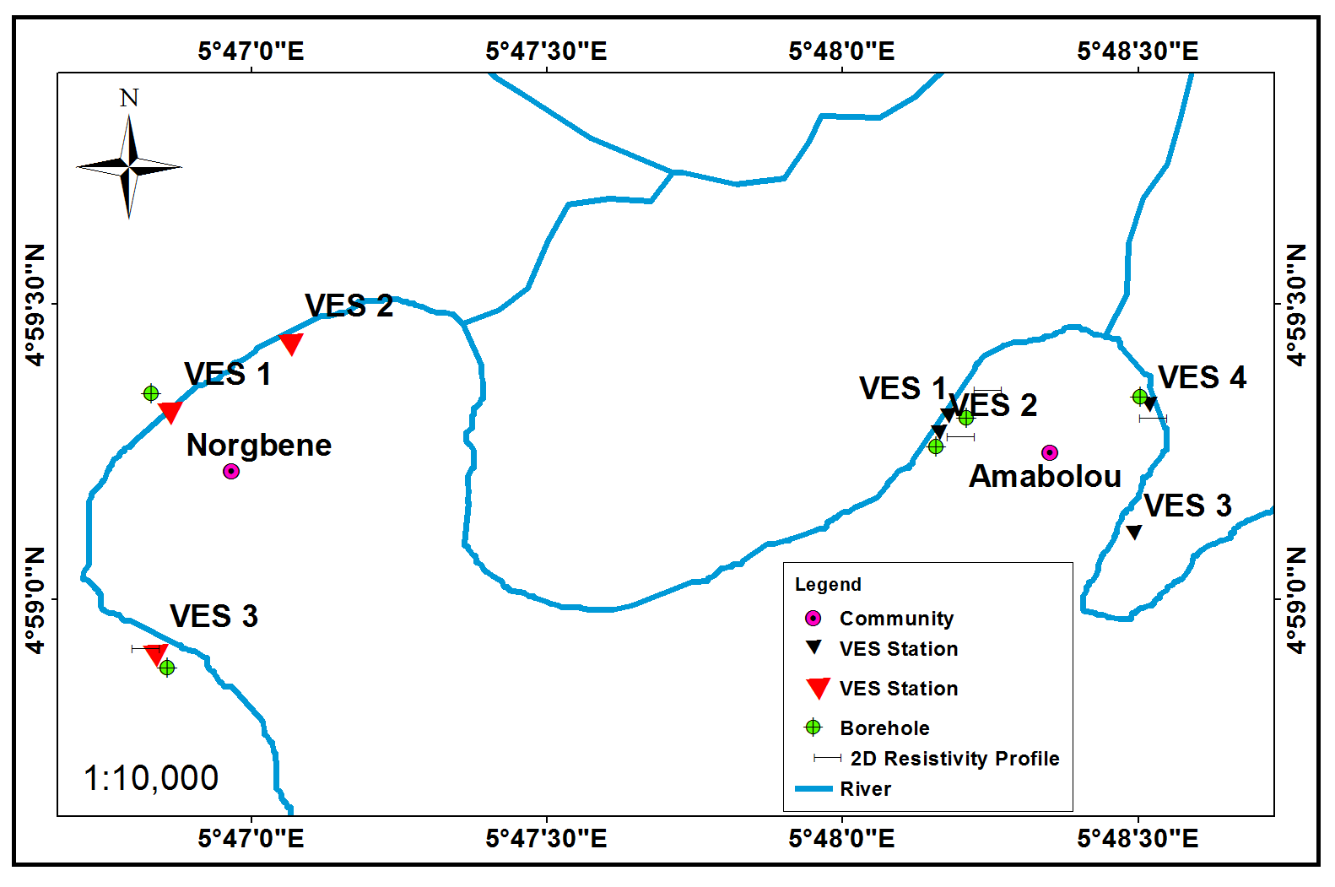
Fig.1. Map of the study area showing VES, 2D Resistivity profiles and borehole locations

Various types of Quaternary deposits overlie these lithostratigraphic units. Sand and gravel deposits occur within the Quaternary deposits of the Niger Delta [11]. Studies by [12,13] and [14] revealed that the sediments were deposited under the influence of fluctuating Pleistocene eustatic sea levels. Existing borehole records show a wide occurrence of sand in the Niger Delta [11]. The Sand deposits are usually overlain by clayey sand or peaty clay that vary from less than 1 to 10 m thick. [11] reported that the boundary is usually sharp but may be occasionally gradational.

3 Materials and Method
3.1 Vertical Electrical Sounding (VES)
In the electrical resistivity method of geophysical prospecting current is injected via two current-electrodes, AB, and the potential difference created due to the passage of the electric current through the earth materials is measured across a pair of potential-electrodes, MN. The electrical resistivity investigations were conducted using the Schlumberger configuration in seven (7) locations across the study area, four soundings were acquired in Amabolou while three were acquired in Norgbene community. The data was acquired with a DC resistivity meter (Abem Terrameter SAS 1000). The number and distribution of the soundings in the present study was based on both accessibility due to dense vegetation and also by our desire to obtain as uniform coverage of the study area as possible. Maximum current electrode half-spacing (AB) range between 80-100 m assuming that depth penetration varies between 0.25AB and 0.5AB [15,16]. Potential electrode separation (MN) varies between 0.3 at AB = 1.0 m to a maximum of 10 m at AB = 100 m. The positions and surface elevations of VES locations were also recorded during survey with a hand held GPS receiver.
The apparent resistivity values obtained from the VES were used to generate sounding curves which were subsequently interpreted both qualitatively and quantitatively. Computer assisted I-D forward modelling using a I-D inversion technique software (Interpex, USA) was used to obtain the one dimensional resistivity model for the area. This program uses the least-squares optimization technique in which a starting model is adjusted successively until the difference between the field data and the model output is reduced to a minimum. The program converts the apparent resistivities obtained as a function of spacing in the field to true resistivities as a function of depth. In constructing a model, the interpreter arbitrarily divides the subsurface into a number of horizontal layers of given thickness. The program iteratively changes the resistivities to obtain a best fit with the field data for the layer thicknesses chosen for the model. Due to the inherent problem of equivalence in geosounding data interpretation [17], lithological information from drilled boreholes were used to constrain all depth estimates in order to minimise the choice of equivalent models by fixing layer thicknesses and depths while allowing the resistivities to vary [18]. The resulting true resistivities represent the best average bulk resistivity for the given layer.

3.2 2D Resistivity Imaging
We also acquired two 2D profiles in Amabolou and one in Norgbene using the Wenner array. The resistivity imaging profile acquired was to supplement the I-D geoelectrical sounding data because it displays a clearer picture of the lateral and vertical variation of the subsurface lithology. We used a manual data collection technique in acquiring the 2D resistivity imaging data. Each of the 2D traverses was 100m in length. The electrode spacing ranged from 5 to 30m in an interval of 5m, with a total of 21 electrode positions for each traverse line. The 2D resistivity data were acquired by using the Wenner configuration. The field measurements was carried out with electrode spacing of 5.0 m at electrode positions 1, 2, 3 and 4 in each profile. Then, each electrode was moved a distance of 5.0 m (one unit electrode spacing), the active electrode positions being 2, 3, 4, and 5. This procedure was continued to the end of the profile with electrode positions for the last measurement being 18, 19, 20 and 21. The electrode spacing was then increased by 5.0 m, as mentioned above for measurements of next data level, such that the active positions were 1, 3, 5 and 7. The procedure was then repeated by moving each of the electrodes a distance 5.0 m (one unit electrode spacing) and maintaining the electrode spacing for the data level until the electrodes were at electrode positions 15, 17, 19 and 20. This procedure was continued until 6 data levels were observed, yielding a total of 63 data points in each of the profiles. RES2DINV computer code [19] was used in the inversion of the 2D data. The computer program takes advantage of the nonlinear optimization technique in which a 2D resistivity model of the subsurface is automatically determined for input apparent resistivity data [19,20]. In this program, the subsurface is subdivided into a number of rectangular blocks based on the spread of the observed data. In inverting the 2D data, the least-squares inversion with standard least-squares constraint which minimizes the square difference between the observed and the calculated apparent resistivity values was used.
3.3 Drilling of borehole
Three boreholes were drilled at different sites, using manual drilling technique in order to calibrate the resistivity results and also to observe the geological sequences. This is important because the calibration of the resistivity interpretation with known geological sequences or lithological information from borehole is vital for its meaningful interpretation. During the drilling, disturbed sediment samples were collected at 1 m intervals and when changes in sediment characteristics were observed. The depths of the boreholes vary from 20 – 22 m. We thoroughly examined and classified all samples recovered from the boring in the field to produce lithological logs. We retrieved samples with considerable sand content and carried out grain size analysis in view of the intended use of the sand. The grain size distribution is important as it is required for the determination of the grain size composition of sand. Also, to determine the frictional strength of sand and as well as its permeability [21], which is a measure of the ease with which fluid flows through a porous medium, particle size distribution is a key requirement. In each location, about 300g of the drill cuttings from the sandy layer was collected in marked polythene bags, tied, labelled and brought to the laboratory for analysis. About 100g of the drill cuttings were dried, and the mechanical sieving technique using Ro-tap shaker was used to determine the grain size distribution [22].

4. Results and Discussion
A summary of the VES model resistivity values and their corresponding thicknesses are presented in Tables 1 and 2, while Figs. 2, 4 and 6 show the VES curve types obtained in the area. Also shown in Figs 2, 4 and 6 are the lithological information obtained in the nearest test drill holes to the VES points. The VES model resistivity values complement the inversion results of the 2D resistivity images. Correlation of the VES interpretation results of VES 1 in Amabolou with the lithological information from the nearest drill test hole (Fig. 2) shows that the stratigraphic sequence consists of three layers (within the depth of investigation ~ 0-20 m) in which the model resistivity of the middle layer is much lower than those of the upper and lower layers. That is, in this curve type, the resistivity decreases at shallow depths (2-5 m) but shows an increase in resistivity as depth increases which is a possible indicator of the presence of aggregate materials such as sand and gravel in. Based on the fact that potential sand and gravel deposits are easily distinguished by their high resistivity values from their surrounding clay and silt [23-25], the basal unit which exhibits high resistivity is the supposed major unit for sand and gravel production. We observed that this stratigraphic sequence is prevalent in the study area as all the geoelectric sounding curves are three layer curves except VES 3 in Norgbene community (Fig. 6).
The three layer VES curves were classified into two groups. Group I consists of VES 1 and 3 (Amabolou) and VES 1 and 2 (Norgbene) whose bulk resistivity values in the basal unit range between 71 – 385 Ωm. Fig.2 is the geoelectric sounding curve at VES 1 (Amabolou) and the 2D resistivity cross section within the vicinity of VES 1 is shown in Fig.3. The 2D resistivity cross section (Fig. 3) also shows low resistivity deposits below the ground within the depth range of 0-20 m corroborating the results of the vertical electrical sounding (VES). Figure 3 shows a clay layer underlying the top soil. The clay layer is about 7 m thick and is characterised by low apparent resistivity values less than 50 Ωm. Underlying the clay layer, is a layer with slightly higher apparent resistivity values ranging between 60-120 Ωm. The test drill hole shows that this basal layer is composed of fine sand in a matrix of finer sediments (clay). This layer thickness cannot be ascertained because drilling was stopped at about 20 m.
Group II consists of VES 2 and 4 (Amabolou) and VES 3 Norgbene. The bulk resistivity of the basal unit in these VES locations ranges between 967 – 4241 Ωm (Tables 1 and 2). Fig. 4 shows the geoelectric sounding curve at VES 2 and the lithological information from the test drill hole near VES 2, while Fig.5 shows the 2D resistivity cross section in the vicinity of VES 2. The test drill hole confirmed the presence of significant accumulations of aggregate deposits with an average thickness of about 10 m within the depth range of 0-22 m indicating promising potential for sand and gravel and thus recommended for excavation. The 2D resistivity cross section correlated well with the borehole information (Fig. 4), and shows the detailed variation of the subsurface lithological sequence. The second layer underlying the top soil (Fig. 5) has an apparent resistivity range ~ 100-125 Ωm. Below the sandy clay layer is the basal sandy layer with apparent resistivity greater than 500 Ωm. The contact between the sandy clay layer and the sandy layer is very clear at a depth of about 10 m (Fig. 5). The thickness of the top soil and sandy clay (~10 m) constitute the strippable overburden.
VES 3 in Norgbene community (Fig. 7) shows a strippable overburden of about 6.5 -7.0 m thick. The 2D resistivity cross section in this location is shown in Fig. 8. The test drill hole in this location shows that the overburden consists of two thin sandy clay layers sandwiched by a thin layer of sand with bulk resistivity values ranging between 84 – 98 Ωm for the thin sandy clay and 432 Ωm for the thin sand strata. In all locations where 2D profiles were acquired, the lithology suggested by the 2D resistivity interpretation correlated well with the observed subsurface materials obtained from ground-truthing.
Table 1: Summary of VES model resistivity values and their corresponding thicknesses Amabolou

 | Layer 1 |  |  | Layer 2 |  |  | Layer 3 |  | RMS
 | Resistivity | Thickness |  | Resistivity | Thickness |  | Resistivity | Thickness | Error
 | (Ωm) | (m) |  | (Ωm) | (m) |  | (Ωm) | (m) | (%)
VES 1 | 137 | 2.1 |  | 7 | 11.8 |  | 71 | - | 3.7243
VES 2 | 160 | 1 |  | 81 | 9.5 |  | 4241 | - | 2.813
VES 3 | 195 | 2 |  | 38 | 21.8 |  | 207 | - | 4.2855
VES 4 | 183 | 0.8 |  | 53 | 4.4 |  | 967 | - | 2.9114

Table 2: : Summary of VES model resistivity values and their corresponding thicknesses Norgbene
 | Layer 1 |  |  | Layer 2 |  |  | Layer 3 |  |  | Layer 4 |  |  | Layer 5 |  | RMS
 | Resistivity | Thickness |  | Resistivity | Thickness |  | Resistivity | Thickness |  | Resistivity | Thickness |  | Resistivity | Thickness | Error
 | (Ωm) | (m) |  | (Ωm) | (m) |  | (Ωm) | (m) |  | (Ωm) | (m) |  | (Ωm) | (m) | (%)
VES 1 | 354 | 0.8 |  | 60 | 3.7 |  | 385 | - |  | - | - |  | - | - | 5.7525
VES 2 | 121 | 2.7 |  | 41 | 18 |  | 320 | - |  | - | - |  | - | - | 3.2685
VES 3 | 915 | 0.5 |  | 98 | 1.1 |  | 432 | 3.7 |  | 84 | 1.2 |  | 1489 | - | 4.2855

Fig. 2. (a) VES 1 Curve (b) Correlation of the VES 1 interpretation results with the lithology
of the nearest borehole

From the observations above, we conclude that bulk resistivity values ranging between~ 71 – 385 Ωm delineate a mix of sand and clay in the study area, while the bulk resistivity of economically viable coarse material was greater than 500 Ωm. We set 500 Ωm as the working limit of the prospect. We limit our search to the depth range of 0-20 m. This was because the dredging arm of the dredger for the project was about 20 m. The colour of the retrieved sand samples from the boreholes drilled in the group II VES locations was principally dark grey but might likely brighten during hydraulic transport through the dredger host. The sand thickness varies from around 10 – 12 m (Fig. 4 and 5).
Fig. 3. Resistivity cross section at VES 1 location at Amabolou
The grain – size analysis of the samples of the sandy layer show that they are fine textured and more than 70% of the grain size ranges from 0.1-0.3mm, which according to AASHTO soil classification, can be, categorized as fine sand [26]. The sand composition becomes coarser and richer in gravel content with depth. The lateral extent of the sand deposit from the 2D survey was used to estimate the volume of sand, and thus enables the assessment of the general economic value of the suspected sand accumulation especially at the promising sites.
We determined the volume of exploitable sand by multiplying the average sand thickness with the length and width of the survey area [27]. It is worthy to note that sand volume estimated using this method provides only a conservative approximation. We attribute this to the dilatant behaviour of sand [28], which enables it to expand upon dredging. In estimating the volume of the exploitable sand, the capability of the dredger was a key consideration. In this instance as earlier mentioned, the dredger arm was about 20 m.
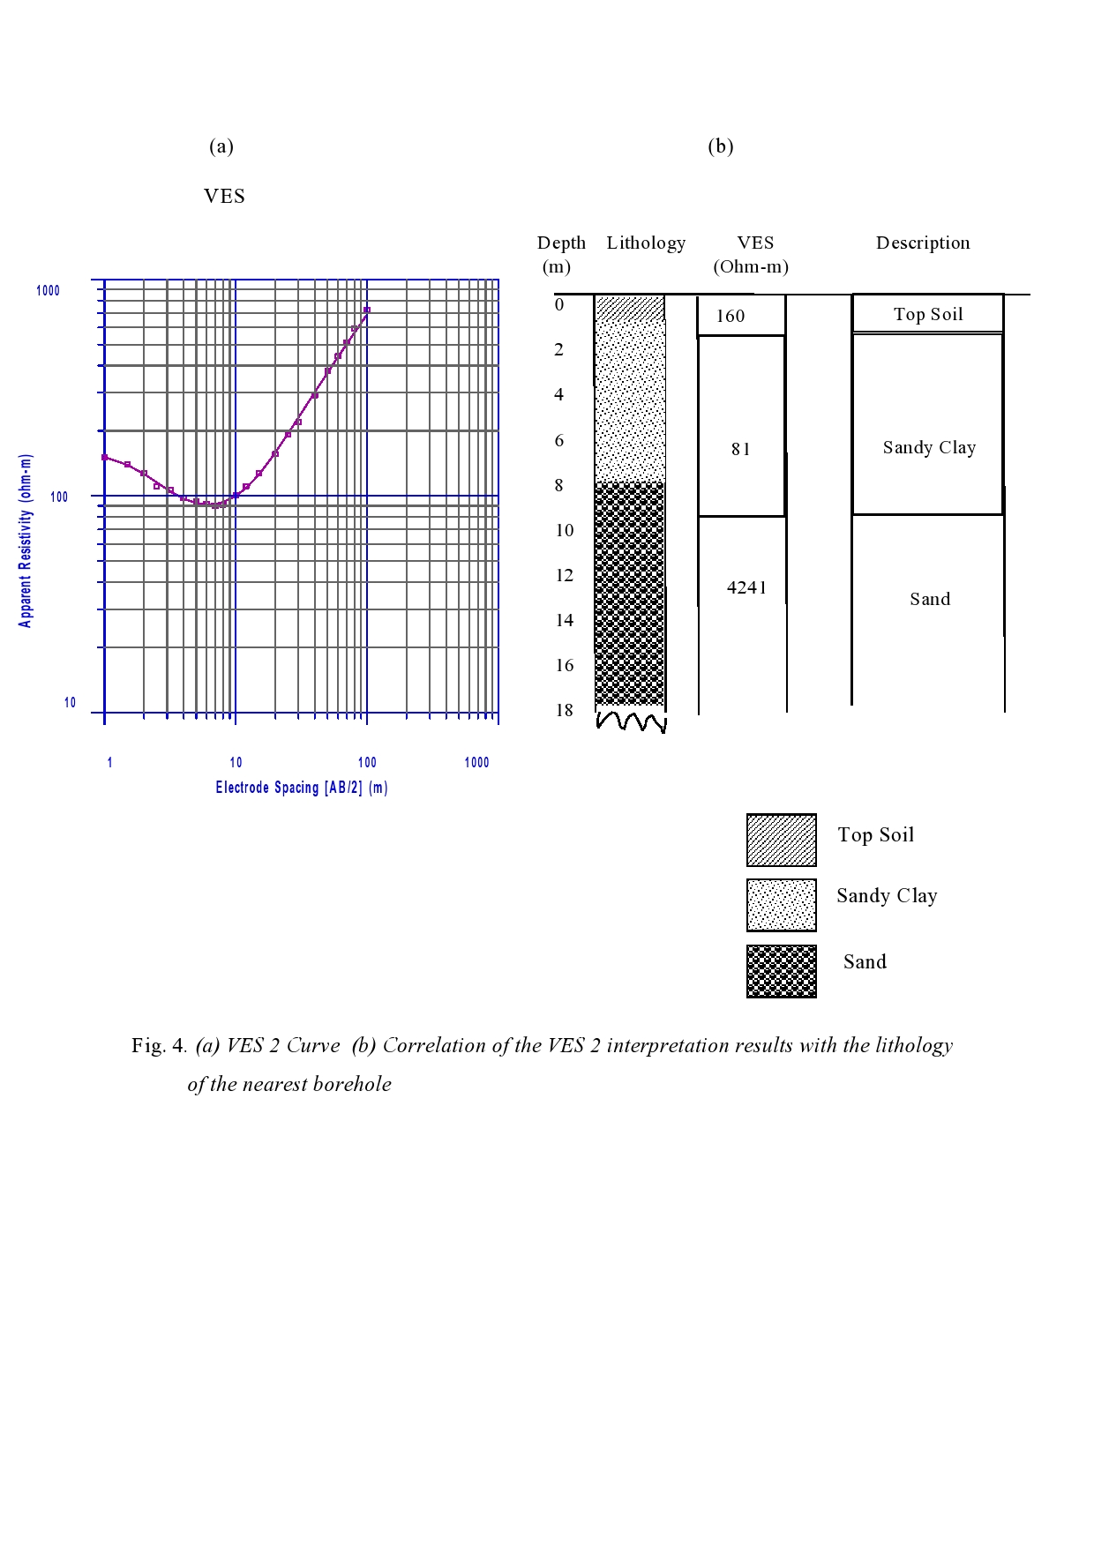
Fig. 4. (a) VES 2 Curve (b) Correlation of the VES 2 interpretation results with the lithology
of the nearest borehole
Fig. 5. 2D Resistivity cross section at VES 2 location at Amabolou
Sand
Sandy Clay
Although the borehole logs in the three locations recommended for excavation show sand column more than 12 m, the thickness of the sand column used in determining the volume of exploitable sand was 10 m. In each of the recommended sites, the 2D survey profile length was 100 m, and an average sand layer thickness of 10 m and a width of 50 m was used as the dredgeable sandbody dimensions. Thus volume of available and dredgeable sand is 100 m × 50 m × 10 m giving an estimated sand volume of about 50, 000 m³ in each location.
Sand
Sandy Clay

Fig. 6. 2D Resistivity cross section at VES 4 location at Amabolou

Because of the intended use, i.e reclamation of swampy land, we did not attach any importance to the colour of sand nor the grain size composition or texture. It is important to note that when this volume of sand is dredged, we presume that the flow dynamics of the area will be altered and thus will exact some adverse impact on the river, micro-ecology on sections of the river and community. Therefore in order to avoid erosion and subsequent bank instability, the flow must be directed away from sensitive and vulnerable banks.

Fig. 7. (a) VES 3 Curve (b) Correlation of the VES 3 Interpretation Results with the lithology
of the nearest borehole at Norgbene community
Sand
Sandy Clay

Fig. 8. 2D Resistivity cross section at VES 3 location at Norgbene
Conclusion
We carried out geoelectric sounding and 2D resistivity surveys to map potential aggregate sources in two oil producing communities in the Niger Delta. The investigations were conducted in seven locations across the study area consisting of seven VES points and three 2D profiles. Due to the inherent problem of equivalence in geoelectric sounding data, borehole data were used to constrain the interpretation. VES locations 1 and 3 (Amabolou community); and VES 1 and 2 (Norgbene community) exhibit bulk resistivity values less than 400 Ωm within the depth range of interest (0-20m). The results of the test drill holes show that these locations have no coarse material. The remaining three sites exhibited high resistivity which is a possible indicator of potential sand and gravel deposit. The test drill holes also confirmed the presence of aggregate materials. The areal extent based on the 2D profiles in these locations were used to estimate the volume of available sand and gravel using simple volume arithmetic in which the average sand thickness was multiplied by length and width of the survey area. In each of the three sites VES 2 and 4 (Amabolou community) and VES 3 (Norgbene community), estimated sand and gravel volume of about 50, 000 m³ was obtained. Dredging this volume of sand will have adverse environmental effects. Thus conscious steps must be taken to minimize ecological and environmental effects.

ACKNOWLEDGEMENTS
We are grateful to the numerous land owners in Amabolou and Norgbene communities who allowed us to conduct sand reconnaissance surveys on their lands. We are also thankful to the Community Development Committee (CDC) Chairman of Norgbene community for his hospitality and support.

References
[1] J.C. Bowling, A.L. Harry, A.B Rodrigued and C. Zheng, Integrated geophysical and
geological investigation of a heterogeneous fluvial aquifer in Columbus Mississippi,
Journal of Applied Geophysics, 62, (2007), 58-73.

[2] K.S.Okiongbo and P. Mebine, Estimation of aquifer hydraulic parameters from
geoelectric method – A case study of Yenagoa and environs, Southern Nigeria, Arabian
Journal of Geosciences, 8, (2015), 6085-6093.

[3] K.S.Okiongbo and E. Akpofure, Hydrogeophysical characterization of shallow
unconsolidated alluvial aquifer in Yenagoa and environs, Southern Nigeria, Arabian
Journal of Science & Engineering, 41, (2016), 2261-2270.

[4] D.W. Urish, Electrical resistivity –hydraulic conductivity relationships in glacial outwash
aquifers, Water Resources Research, 17, (1981), 1401-1408.

[5] F.P. Haeni, 1995. Application of surface-geophysical methods to investigations of sand
and gravel aquifers in the glaciated north eastern United States. Regional Aquifer-System
Analysis—Northeast Glacial Valleys, U.S. Geol. Surv. Prof. Pap., (1995) A1–A70.

[6] S.W. Wilcox, Sand and gravel prospecting by the earth resistivity method, Geophysics,
13, (1932), 36-46.

[7] J.J. Jakosky, Exploration Geophysics, 2nd edn. Trija Publishers, Los Angeles, 1950

[8] C. J. Welkie, and R.P. Meyer, Geophysical evidence that the Haeger Till member
underlies southern western Lake Michigan, Geoscience Wisconsin, 8, (1983), 45–48.

[9] A.A. Nowroozi, G.R. Whittecar, and J.C. Daniel, Estimating the yield of crushable
stone in an alluvial fan deposit by electrical resistivity methods near Stuart Draft,
Virginia, Journal of Applied Geophysics, 38, (1997) 25– 40.

[10] K.C.Short, and A.J. Stauble, Outline of the geology of the Niger Delta. Bull. AAPG. 51,
(1967), 761-779.

[11] E.U. Akpokodje, and J.O. Etu-Efeotor, The occurrence and Economic potential of clean
sand deposits of the Niger Delta, Journal of African Earth Science, 6, (1987), 61-65.

[12] R.L.Allen, The Nigerian Continental Margin: bottom sediments, submarine morphology
and geological evolution, Marine Geology, 1, (1964), 289-332.

[13] J.R.L. Allen, (1965) Late Quaternary Niger delta and adjacent sedimentary
environments and lithofacies, AAPG Bull., 49, (1965), 547–600.

[14] J.R. Allen, and J.W. Wells, Holocene coral banks and subsidence of the Niger Delta,
Journal of Geology, 70, (1962), 387-397.

[15] K.K.Roy, and H.M. Elliot, Some observations regarding depth of exploration in DC
electrical methods, Geoexploration, 19, (1981), 1-13.

[16] K.P. Singh, Nonlinear estimation of aquifer parameters from surficial resistivity
measurements, Journal of Hydrology Earth System Science, 2, (2005), 917-938.

[17] R.Van Overmeeren, Aquifer boundaries explored by geoelectrical measurements in the
coastal plain of Yemen, A case of equivalence, Geophysics, 54, (1989), 38–48.
doi:10.1190/1.1442575

[18] A. T. Batayneh, and A.A. Al-Diabat, Application of a two –dimensional electrical
tomography technique for investigating landslides along the Amman Dead sea highway,
Jordan, Environmental Geology, 42, (2002), 399-403.

[19] M.H. Loke, and R.D.Baker, Rapid leastsquare inversion of apparent resistivity
pseudosections by a quasi-Newton method, Geophysical Prospecting, 44, (1996a),
131-152.

[20] D. H. Griffiths, R.D. Barker, Two-dimensional resistivity imaging and modelling
in areas of complex geology, Journal of Applied Geophysics, 29, (1993), 211 –226.

[21] B.Vickers, Laboratory work in soil mechanics, 2nd edn., Granada, London, (1978).

[11] M.S. Alyamani, and Z. Sen, Determination of hydraulic conductivity from grain size
distribution curves, Groundwater, 31, (1993), 551-555.

[23] D. Baines, D. G. Smith, D.G. Frose, P. Bauman, and G. Nimack, Electrical resistivity
ground imaging [ERGI]: a new tool for mapping the lithology and geometry of channel-
belts and valley-fills, Sedimentology, 49, (2002), 441-449.

[24] I.A.Beresnev, C.E. Hruby, C.A. Davis, The use of multi-electrode resistivity imaging in
gravel prospecting, Journal of Applied Geophysics, 49, (2002), 245-254.

[25] M.K.Magnusson, J.M.R. Fernlund, and T. Dahlin, Geoelectrical imaging in the
interpretation of geological conditions affecting quarry operations, Bull. Eng. Geo.
Environ., 69, (2010), 465-486.

[26] C. Liu, and J.B. Evett, Soils and Foundations. 1st Edition, Prentice Hall,
Englewood Cliffs, New Jessey, 2005.

[27] A.C.Tse, and E.G. Akpokodje, Geotechnical evaluation of some sand deposits in
parts of the eastern Niger Delta, Nigeria Journal of Mining and Geology, 38, (2002),
135–141.

[28] W.Van Leussen, and J.D. Nieuwenhuis, (1984) Soil mechanics aspects of
dredging, Geotechnique, 34, (1984), 359–381.

