A Geospatial Intelligence System for Digital Allocation of Feed and Waste Zones in Iron Ore Mining
Sairam Korada¹ and Murali Krishna Gurram²

¹Geologist, BIOM, NMDC, Dantewada, India.
Mobile No. +91-9676381289
E-mail: sairam.drbrau@gmail.com

²Head, GIS Technology & Applications, Xinthe Technologies, Visakhapatnam- India.
Mobile No. +91-9666498379
E-mail: murali.krishna.gurram@gmail.com

ABSTRACT
This study demonstrates the utility of a geospatial intelligence system for efficiently tracking and managing different types of HEMM which are frequently movable in nature. The framework is capable of systematic identification, handling and scheduling of mine assets for transportation which is amenable to the development of a centrally operable mine management system. The geospatial system digitally maps the corresponding locations of each asset along with their properties and assigns a unique id for them which dynamically monitors and track these movable assets at any given point of time on screen even from a remote location. In addition to the asset management, mapping of the mining space also enables the administration to keep an account of the volume of the ore being mined and transported from time to time. The system uses the power of GIS to catalogue these assets by classifying them at micro level and replaces the existing manual methods of flagging the ore and Waste for identification, feeding and tracking. This also makes it possible to proper gradation of the ore being mined. The system initially may be implemented as a pilot in a iron ore mine area –Deposit-5 confined to an area of 540.05 sq.km located in the state of Chhattisgarh and upon showing promising results and can be extended for the integrated management of mining operations elsewhere.

Keywords: Geospatial intelligence system, GIS, digital maps, ore mining

1. INTRODUCTION
Mining assets which mainly include mineral/ore, equipment and other machinery are movable and frequently change their positions/locations. Proper identification and tracking is core to accounting and management of these assets. Manual identification processes which are in practice are subjectively erroneous and highly laborious especially while carrying out the mining activity at greater depths with large machinery. The present world/generation is going towards machine learning, artificial intelligence and robotics to make use and ease of the things. But mining industry is being operated in the way far behind, which may be due to the reasons like draining of the jobs of local folk… etc. However, it is the need of the hour for automation and to adopt new systems to become more efficient and profitable. Employing efficient operation and management systems and tools are crucial not only for optimal productivity but also for profitability of ore mining. Mining activity, whether it is on surface or underground is purely a spatial phenomenon. Various processes involved in mining such as drilling, blasting, gradation of the ore zones according to their quality, ore stockpiling by volume & grade and transport of ore/waste, are all location specific in nature. Therefore positional information is vital for both exploration as well as extraction of the ore. It is imperative to deploy tools which are capable of handling location specific information to identify, classify, track, monitor and manage these scenarios virtually in real-time. In this context, GIS technology is considered to have a wide range of spatial capabilities with increased productivity and reduced costs.
There are noted studies which attempted to use GIS technology in different ways in various stages of mining. Jim and Stephen (2016) in their study mention that the geospatial technology is indispensable in planning, managing and administrating the mine lease areas and mine assets.
This paper in detail discusses about the implementation of an integrated geospatial system framework in various stages of mining starting from mine head to loading plant with special emphasis on digital allocation of feed and waste zones.

2. MATERIALS AND METHODS
This paper introduces methods for incorporating geospatial techniques for managing the iron ore being mined and transported in a coordinated way. The following sections describe in detail about the various elements developed exclusively for the application.

Figure 1 represents the methodology flow applied for the study.
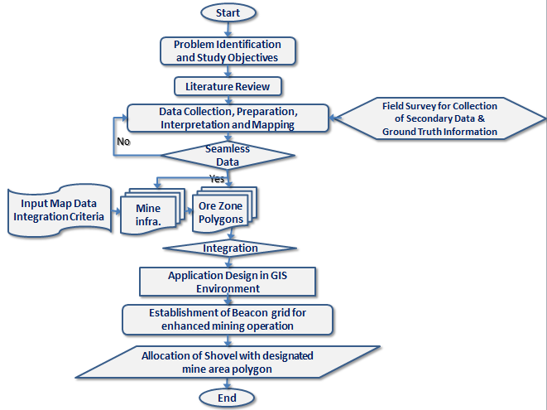
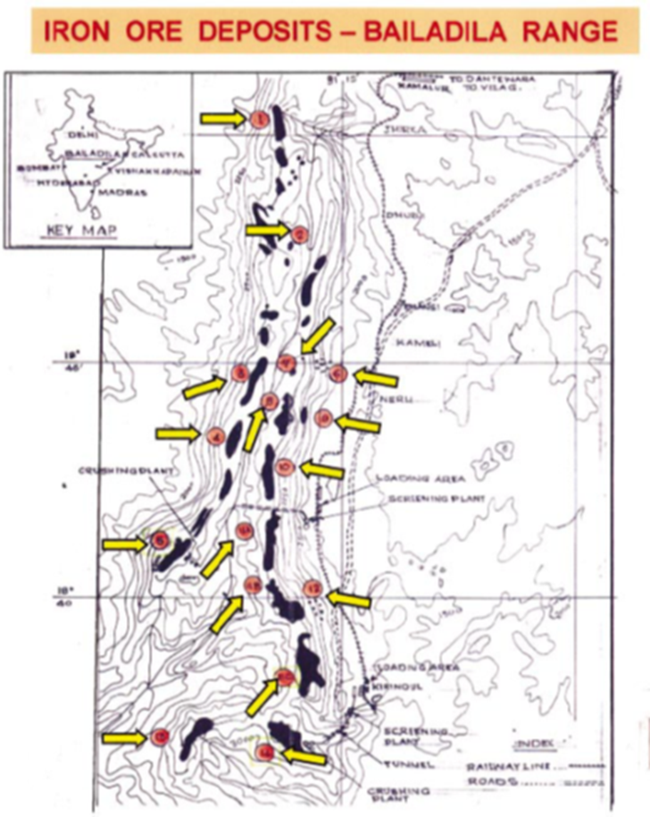
2.1 ABOUT THE STUDY AREA
Bailadila hill range in Bastar region of Chhattisgarh covers some of the important iron bearing belts of the country and is very important as far as iron mineral production is concerned. Bailadilla range of hills is 40 Km in length and 10 km in width. 14 deposits have been distinctly demarcated and designated from 1 to 14. Iron ore of this area is distributed in the form of lenticular deposits in the Eastern and Western ridges of the Bailadila Iron Ore Series.

Figure 2. Map showing the locations of all 14 deposits of Bailadila Range
The Present study area is Deposit No. 5 with Fe content of more than 68 % is located in the southernmost part of the western ridge and is operative since 1977. This deposit lies between the latitudes 18⁰ 41’ and 18⁰ 42’ and longitudes 81⁰11’ and 81⁰12’30”. Based on the topography and configuration of the ore bodies, the deposit is basically divided into four blocks viz., South Block, Central Block, North West Block and North Block. The regional strike of Deposit-5 is N37⁰E.
The study area is covered by the Survey of India 1:50,000 topographic sheet numbered 65 F/2. Opencast terrace is the mining approach which is being practiced over here. Bailadila mines are known for world’s best grade of hard lumpy iron ore containing +68% iron, which is free from sulphur and other deleterious material having best physical properties needed for steel making and are the main source for major iron and steel manufacturing units located in the country.
2.2. THE PROCESS OF IRON ORE GRADING/CATEGORIZATION
Iron ore categorization should be done ideally by taking into consideration of various quality or grade parameters based on the chemical analysis results obtained from the samples collected from the blast holes. But in real and practical scenarios, most of the times, we remain with no time to wait for chemical analysis, hence with the noted geological observations from field, with the study on adjacent work faces, top and bottom benches, the trend, behaviour of the ore body/formation …etc. and with assessment of various physical and chemical characteristics of the ore such as expected lump recovery, fine recovery, expected grade of Fe, Sio2, Al2o3 and Loss On Ignition the categorization/grading takes place. All the prior stated factors play a major role in identifying different zones as ‘Feed’ or ‘waste’ zones.
2.3. GIS APPLICATION FOR THE STUDY
Following are the various sections which elaborates the various essential components of the GIS applications specifically designed for the study.
2.3.1. Data and Model
A detailed map developed through ground survey methods was scanned and georeferenced for using it as a base map for further application use. The details and features in the map were extracted as vector feature objects to bring them into live spatially in the GIS environment.
The most important task in the suggested process is initial digitization of the Feed zones/Waste zones from the blast hole maps, which are generally furnished by the surveyor of the deposit, according to the factors mentioned earlier. These zones are delineated as vector polygons and assigned unique ids according to their category of identification and these polygons are considered as Phase 1 polygons. These polygons are very important as they indicate the actual positioning of the type of the material and their respective grades.
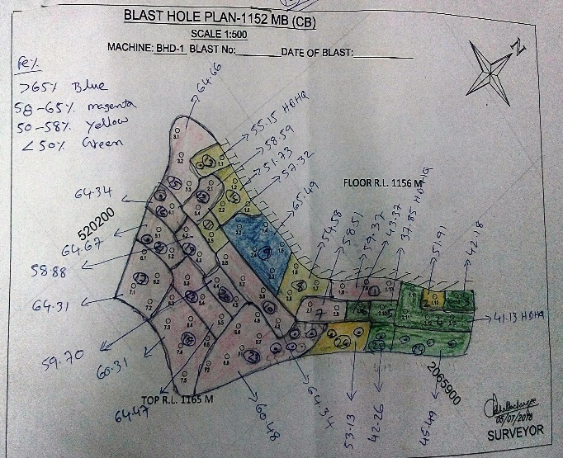  Plate A | 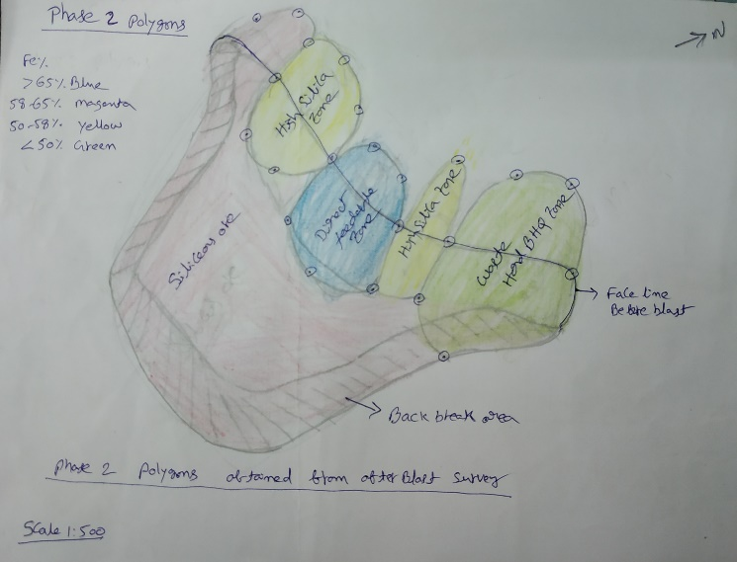  Plate B
Plate A showing Phase 1 Polygons, which are derived from Blast hole samples before Blast.
Plate B showing Phase 2 Polygons, which are obtained from the after blast survey/inspection.

As soon as the blasting is done, with the help of a handheld/rugged GPS the zones are again marked by using the collected coordinates after the blast. The vectors polygons are delineated again are the Phase 2 polygons. The reason for the second time delineating of the zones after the blast is because of the reason that the blasting results-in the spread of ore in different directions as it would be mixed and thrown/pushed in any direction. Delineation of the polygons in the Phase 2 is in fact is an alternative for the manual process of flagging ore and waste zones with the use of different colour coded flags.
The data model is designed to accommodate various spatial features to integrate in a spatially enabled environment. The data model supposed to integrate and overlap point, line and polygon vectors representing different types of spatial features pertaining to a mine.

2.4. SPATIALLY ENABLING THE LOCATION AND SHOVEL EQUIPMENT
Superimposing of two sets of polygon layers pertaining to the mine zones delineated in the Phase 1 and Phase 2 in the zoning process by means of digitisation helps in proper categorization of those ore zones finally. This in turn makes the features like Feed zones/Waste Zones attain geographical awareness in the GIS environment and facilitate analysing them spatially. These polygons are further used as data feed for GPS enabled shovels which carry the corresponding resource to work in the designated area and send the material to CP feed/ Stock/ waste dump.
On the other hand, the shovels being operated for mining operations have to be fitted with GPS devices which makes them spatially enabled recognizing and treading according to the geographical coordinates fed to it for a specific purpose.
Apart from that it is also essential to establish a network of beacons which in a way amplifies the satellite signals within the mine environment.
2.4.1. Devices Specifications
A device called ‘beacon’ which is capable of recognising and detecting GPS signal of very low strength especially in remote areas are to be installed in the study area for making it spatially enabled. Beacons are being used in many applications where it is difficult to get the satellite signals for positioning. Baek et al. (2017) in their study demonstrated the utility of using beacons for closed mining operations where signal strengths are very low and at times even not available for operation. In order to do this, a beacon grid was established with a grid resolution of 3x3 meter distance which enables the entire location into spatially integrated environment and facilitates an uninterrupted location positioning throughout the mine area. Beacons can be installed even on poles erected for lighting purposes in case of unavailability of any permanent structures within the mine area. Following are the specifications of the beacons used for the study. Following are the minimum Beacon specifications required for the proposed study:
MCU Bluetooth® SoC
ARM® Cortex®-M4 32-bit processor with FPU
64 MHz Core speed; 512 kB Flash memory; 64 kB RAM memory
Radio: 2.4 GHz transceiver Bluetooth® 4.2 LE standard
Range: up to 200 meters (650 feet)
Output Power: -20 to +4 dBm in 4 dB steps, “Whisper mode” -40 dBm, "Long range mode" +10 dBm
Sensitivity: -96 dBm
Frequency range: 2400 MHz to 2483.5 MHz
No. of channels: 40 ; Adjacent channel separation: 2 MHz
Sensors Motion sensor (3-axis); Temperature sensor; Ambient Light sensor
Magnetometer (3-axis); Pressure sensor
EEPROM Memory 1 Mb
RTC clock
Additional features GPIO
Power Supply 4 x CR2477 – 3.0V lithium primary cell battery (replaceable)
High efficient Step-Down DC-DC converter
Environmental Specification Operating Temperature: 0°C to 60°C (32°F to 140°F)
Length: 62.7 mm (2.47 inches) / Width: 41.2 mm (1.62 inches)
Height: 23.6 mm (0.93 inches) / Weight: 67g (2.36 ounces)

2.4.2. Custom Designed GPS Devices and Sensors:
Rugged GPS are the custom designed GPS devices extensively used in areas which are highly remote, harsh and rugged and can withstand rough weather and rough handling. These GPS devices or Sensors are fitted to the bucket of the shovel or in any area of hinge point where heavy weight turbulence is low, (May be a detailed evaluation study on the location where these sensors to be fitted on the shovel bucket should be taken up later ) so that this enables to monitor the location of the shovels virtually in the GIS environment at any given point of time.
2.5. SPATIAL MANAGEMENT OF ORE
Facilitation of smooth handling of ore within a mine area is vital as this enacts as a lifeline for mining activity and involves transporting the mined ore along with equipment and resource as per the schedules. This involves virtual monitoring of shovels through GIS systems and positioning using GPS based sensors which in a way contribute for the precision mining. Spatial management of ore is made possible through the mine areas and digitised as spatial layers which when integrated simultaneously used for tracking and also for other mining activities such as ore extraction, gradation, resource allocation, tracking and scheduling.
3. RESULTS AND DISCUSSION
3.1. Advantages
Apart from the many advantages outlined, the system is

- Capable of scheduling the number trips to be done to and from different Ore/Stock/Waste polygons.
- Completely replaces the process of manually flagging the ore stockpiles (An example of how the ore zones are identified and the grades are marked using flags are shown in Plates C to F mentioned below.
- In addition, it also makes it possible to assign shovel work area, devise the trips for every work shift. Even after completion of the shift, the system helps simply track how much time and volume of ore transported out from the respective zones of mine including the reasons.
- Most importantly the system even works perfectly in less visibility and in false visibility conditions especially in night time when it is highly difficult to differentiate between different flags under the light of halogen lamps. Flagging of ore stockpiles can be seen in Plate G and Plate H represents the mining operations being carried out under the halogen lights which normally makes the conditions difficult to operate.
- Similarly, the system is highly productive in monsoon season (in the months of June, July, August and September) during which the entire mine region is under the cloud cover making it difficult to operate and even to identify the flags.
- It is also helps in the appropriate assessment of the ROM grade of a zone where the shovel already worked in different shifts, so that it helps for better plan and improve the grade or fine tune the grade and ore recovery in the next/further shifts.

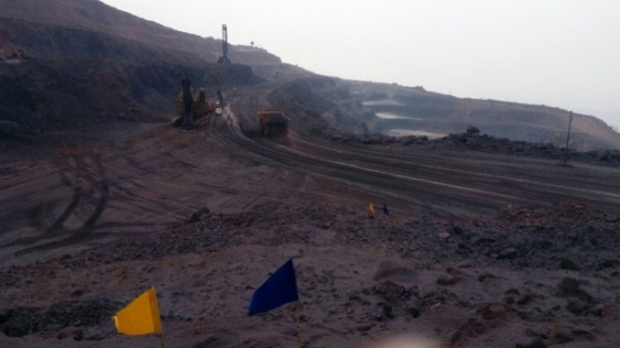  Plate C | 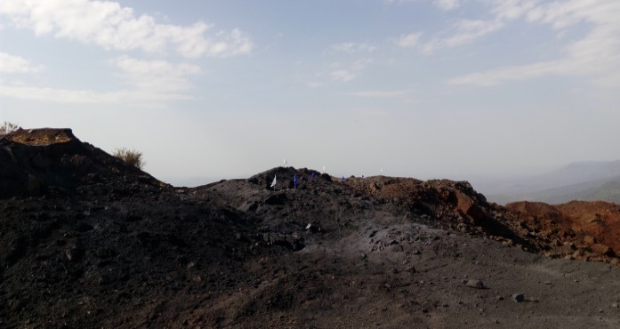  Plate D
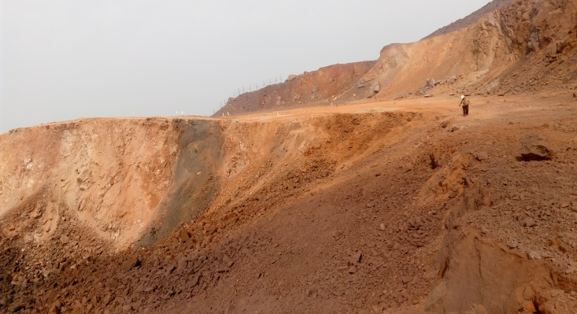  Plate E | 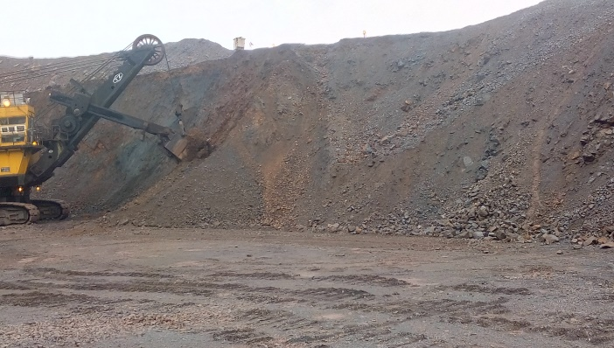  Plate F
An example of how the ore zones are identified and the grades are marked using flags are shown in Plates C to F mentioned
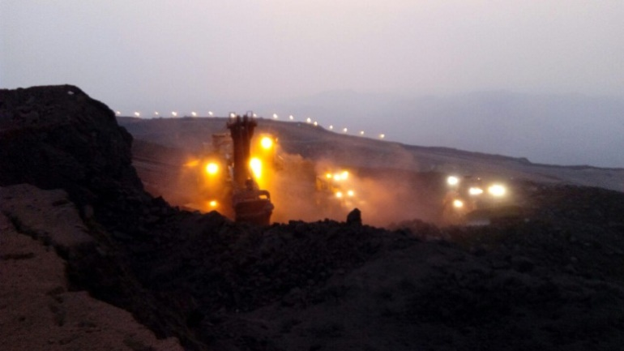  Plate G | 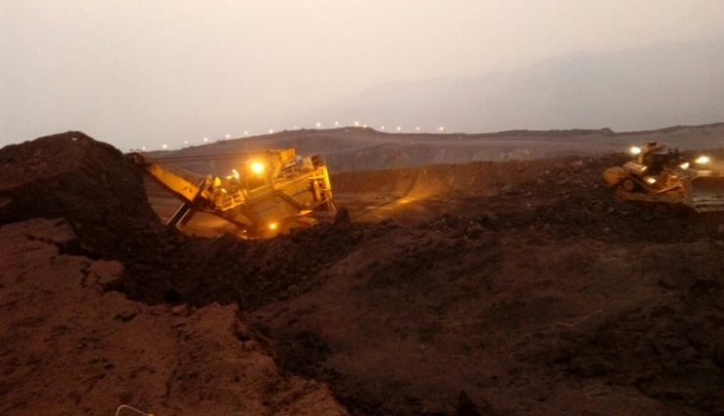  Plate H
Plate G and Plate H showing mining operations being carried out under the halogen lights.

4. CONCLUSION
This study successfully demonstrated the frame work of the efficient use of GIS based mine management for allocating the Feed Zones and Waste zones digitally. The various features and utility of the application is presented and discussed in this paper. The data model developed for the application has the capability to store different sets of information themes available in the form of spatial data layers generated for all categories of mine information. Establishment of Beacons across the mine with a closed grid distance of 3X3 meter would provide accurate and uninterrupted satellite signals throughout the mine. The GIS system is found highly effective for planning, administration and future expansion and to obtain relevant information to steer and control the daily mine operations. The system initially may be implemented as a pilot in iron ore mine area –Deposit-5 confined to an area of 540.05 sq.km located in the state of Chhattisgarh and upon showing promising results and can be extended for the integrated management of mining operations elsewhere.
The authors recommend implementation of the geospatial intelligence system discussed in this paper, so that it will adopt smart and new operational practise in the mining industry.
5. REFERENCES
[1] Jim, H., and Stephen, O. (2016): Precision surface mining, the next steps. “SYMPHOS 2015” 3rd International Symposium on Innovation and Technology in the Phosphate Industry, Procedia Engineering, ScienceDirect, Elsevier, Vol. 138, pp. 40-48.

[2] Beak, J., Choi, Y., Lee, C., Suh, J., and Lee, S. (2017): Minerals. DE Gruyter, Vol. 7, No. 228, pp. 1-16. doi:10.3390/min7110228.

[3] Murali Krishna, G., and Nooka Ratnam, K. (2016): Utility of Large Scale Photogrammetric Techniques for 3-D Mapping and Precision Iron Ore Mining in Open Pit Areas. Journal of Geology & Geophysics, Vol. 6, No. 1, pp. 270. doi: 10.4172/2381-8719.1000270.

[4] Laxmi, G., Prasad, P.R.C., and Firoz, A. (2017): Geospatial Technology Perspectives for
Mining vis-a-vis Sustainable Forest Ecosystems. DE Gruyter, Vol. 11, No. 1, pp. 219-238. DOI 10.1515/pesd-2017-0020.

ACKNOWLEDGEMENTS:
Authors express their sincere thanks to NMDC Management for providing permission to publish this paper and to Sri C.V.S Subrahmanyam (DGM) and to Sri K.C. Gupta (Jt.GM) of Deposit-5, Bacheli Complex for their constant support and encouragement.

