SMEs finance and bankruptcies:

**the role of credit guarantee schemes in the UK**

**Paolo Agnese[1], Manuel Rizzo[2] and Gianfranco A. Vento[3]**

**Abstract**

With reference to consideration on the future of credit guarantees in the world, it may be interesting to analyze the UK framework of guarantee schemes in favour of SMEs, where there are no private guarantee providers and where there is a substantial public monopoly. In particular, in this paper it emerges that among the countries examined by the OECD, the country where the credit guarantees are least widespread is the United Kingdom. However, the trend in bankruptcies recorded in recent years by British firms is better than the median of the other countries considered. Results from the regression analysis show that among years of operation where EFG has been introduced, possibly this kind of government loan guarantees scheme for SMEs played a minor role, compared to macroeconomic indicators as GDP, in dealing with SMEs bankruptcies.

**JEL classification numbers:** G21, G28, G29

**Keywords:** Guarantee schemes, Credit, Bankruptcies

**1 Introduction**

The recent financial crisis started in 2007 highlighted significant difficulties for Small and Medium Enterprises (SMEs) in accessing to credit from financial institutions. These difficulties have also been amplified the regulatory response to the crisis, known as ‘Basel III’, which is going to impose an increase in capital requirements for banks, a shift towards more expensive regulatory capital items as well as the requirement for banks to increase more liquid assets and longer-term sources of funding.

These difficulties have also affected British SMEs. In order to mitigate the credit crunch faced by British SMEs, public programs have been put in place either before or after the financial crisis. These programs are addressed mostly to facilitate the access to credit by the provision of public guarantees.

In the light of above, the paper aims at critically reviewing the functioning of the credit guarantee schemes used during the crisis in United Kingdom, in order to highlight possible strengths and weaknesses.

A regression analysis will also be performed on data related to British SMEs bankruptcies, in order to give insight on the role the present schemes play in favour of SMEs.

The paper is structured as follows. Section 2 presents some key figures about SMEs in UK. Section 3 points out the role of policy makers in SME finance, whereas section 4 highlights the functioning of the Enterprise Finance Guarantee (EFG) and how it has evolved over time. Section 5 deals with the impact of government loan guarantees for SMEs on bankruptcies in the UK. Last, section 6 offers some conclusions.

**2 Small and Medium Enterprises in the UK: Some Evidence**

In the United Kingdom the small and medium business sector represents a significant portion of private businesses. This is determined by the sheer number of SMEs, the level of employment they provide and their annual turnover with respect to the total private enterprises.

This is proven by the statistics elaborated by the Department for Business, Energy & Industrial Strategy (BEIS), which periodically publishes the “Business Population Estimates for the UK and Regions” regarding UK Business Population.

The above mentioned publication reports that at the beginning of 2017, there were an estimated 5.7 million UK private sector businesses, with an estimated annual turnover of over £3.7 trillion. It is not surprising that almost all of these businesses in the UK were small and medium-sized enterprises (SME)[4], accounting for 99.9% of all private sector businesses and had an estimated annual turnover of £1.9 trillion (51% of all private sector turnover in the UK). Almost all private businesses (99.3%) were small; about 0.6% were medium whereas only 0.1% were large (see table 1).

Table 1: Estimated number of businesses in the UK private sector and their associated employment and turnover by size of business start of 2017

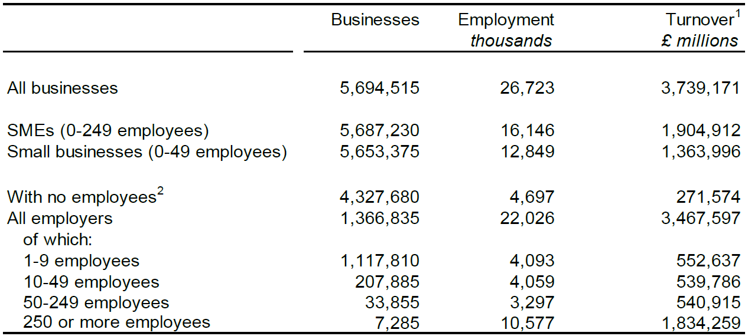

1. Total turnover figures exclude financial and insurance activities where turnover is not available on a comparable basis.

2: “With no employees” includes sole proprietorships and partnerships with only the self-employed owner-manager(s), and companies with a single employee, who are assumed to be directors.

Source: Department for Business, Energy & Industrial Strategy (2017).

Further interesting findings have emerged from the statistics published by the BEIS. We can see, for example, that of the above-mentioned 5.7 million businesses active in the UK at the beginning of 2017, about 5 million were in England. Most of these businesses were to be found in London and the South East of England and in both of these areas there were one third of all private businesses in the UK. London and the South East also had the highest business density rates in the UK, based on the size of the resident adult population (see figure 1).

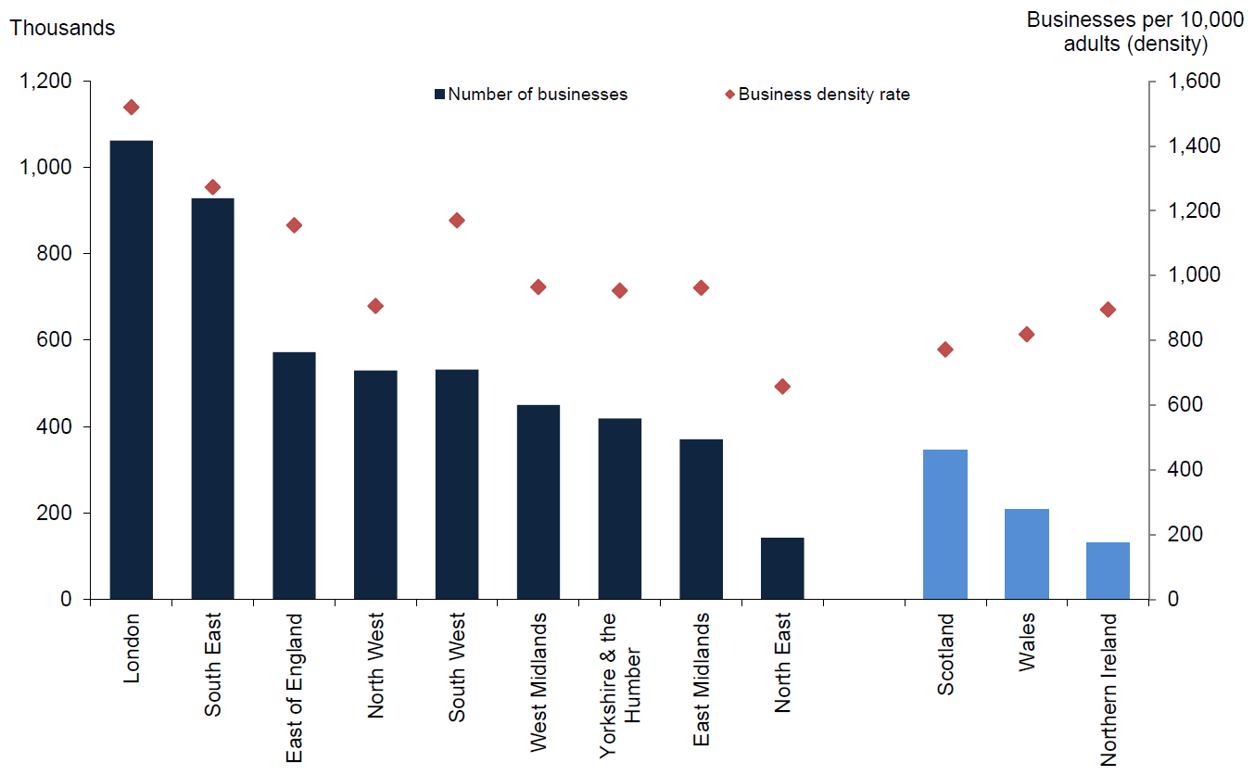

Figure 1: Number of businesses and business density rate in the private sector by English region and UK country, start of 2017

Source: Department for Business, Energy & Industrial Strategy (2017).

**3 The Policy Makers’ Role in SME Finance**

Several empirical studies confirmed that there is a structural failure problem for viable SMEs financing, particularly in recent years characterised by periods of economic downturn, when they have difficulties in accessing bank funds due to insufficient guarantees or track records (Department for Business, Innovation & Skills, 2010, 2009).

Although the recent financial crisis made the lack of funding for British SME more urgent, the problem is not new. An analysis of this issue was proposed decades ago by the *Wilson Committee* which in 1979 stated “competition between banks…was insufficiently effective to ensure that viable small businesses always had the necessary access to sufficient funds on reasonable terms”.

As a response to this, in 1981 the British government introduced a guarantee scheme named “Small Firms Loan Guarantee” (SFLG) in favour of profitable SMEs which would not have been otherwise able to obtain credit through conventional lending due to insufficient guarantees and/or track record.

However, this scheme, in use for three decades, in recent years has proven to be inadequate in supporting the growing demand for credit from viable SMEs. This is mainly due to the serious international economic and financial crisis as well as to the regulatory response to the financial crisis – known as “Basel III” – which requires banks to increase the amount of regulatory capital, to improve its quality and to increase the volume of liquid assets that banks have to hold.

Consequently, in order to avoid the credit crunch caused by the crisis and a more stringent regulatory framework, in January 2009 the British government introduced a further measure in favour of SMEs facing difficulties in credit access: the Enterprise Finance Guarantee (EFG) substituted the previous Small Firms Loan Guarantee.

It is worth stating that both schemes (SFLG and EFG) were created to give financial aid to viable SMEs that were not able to access bank credit due to their lack of adequate guarantees and/or track record, and not as a substitute to conventional bank loans. SFLG and EFG are thus an addition to the conventional bank loan and not a substitute.

Both schemes (SFLG and EFG) are very similar, but the EFG compared to the SFLG is open to a larger number of viable SMEs, as it can count on greater financial resources. This facilitates even further, compared to the past, the concession of bank loans to SMEs, and it is in response to the credit crunch triggered by the economic-financial crisis.

The sum of the loans backed by the SFLG and the EFG however, is relatively low compared to that of bank loans granted to SMEs. In fact, loans granted by these schemes account for no more than 1%-2% of the total number of loans to SMEs (Department for Business, Innovation & Skills (2009, 2008).

**4 The Enterprise Finance Guarantee (EFG)**

As mentioned previously, in January 2009 the Small Firms Loan Guarantee was substituted by another government scheme to guarantee and support viable SMEs in the UK, the Enterprise Finance Guarantee (EFG). The Scheme is managed by *British Business Financial Services*, a wholly-owned subsidiary of *British Business Bank plc*, but remains on the balance sheet of the government *Department for Business, Energy & Industrial Strategy* (BEIS)[5].

The EFG was created to assist viable SMEs operating within the UK in a particularly difficult economic-financial period. In fact, it’s aim was to facilitate the transfer of bank credit to those SMEs unable to access conventional loans – due to insufficient or no guarantees and/or track record – but that can prove to have the ability to repay the credit, in full, over time.

As before mentioned, all decisions regarding whether a business is eligible or not for the EFG loan scheme, are solely made by accredited *lenders*[6]*.* The *lender*, in determining whether or not the request to borrow from the Scheme is possible, must first evaluate a whole range of qualitative and quantitative information normally required by the borrower: details of the purpose of the loan and details of other borrowings of the business; historical and prospective business information (business plan).

After that, the lender has to evaluate if the borrower satisfies the following EFG eligibility criteria:

* The *borrower* must be an SME operating in the UK with an annual turnover of a maximum of £41 million (if the *borrower* is part of a group, the turnover must refer to that of the group);
* The loan must be for a minimum period of three months and a maximum of ten years (exceptions are made for *Invoice Finance Guarantee*, O*verdraft Guarantee* and other revolving facilities, which operate for a period no longer than three years);
* The borrowing proposal must be between a minimum of £1,000 and a maximum of £1.2 million (for terms beyond 5 years, the maximum loan amount is capped at £600,000);
* The borrower must have inadequate security to meet a lender’s normal requirements;
* The borrower must be in an eligible economic sector. The majority of economic sectors are eligible with principal exclusions relating to businesses in the coal industry, and certain aspects of agriculture and financial services;
* The borrower has to be able to confirm that they have not received other public support or state aid beyond euro 200,000 equivalent over the previous three years.

Having completed the assessment the *lender* should be able to confirm or not the application to the EFG. In fact, a viable SME which applies for an assisted loan from the scheme is not automatically accepted, nor is there a standardized procedure to obtain the loan. Therefore, the decisions concerning an application to the guarantee offered by the EFG – including the decision whether it is appropriate or not to use it for each loan application – are entirely made by the participating lenders. In fact, the *Department for Business, Energy & Industrial Strategy* (BEIS) does not intervene in the assessment process nor in the application process.

Through the EFG, the loan can be granted according to various processes, such as: new term loans; revolving facilities; invoice finance facilities; term loan for debt consolidation or refinancing; revolving facility refinance; invoice finance refinance.

The government guarantee offered by the scheme covers 75% of the loan. It is issued in favour of the *lender*, not in favour of the *borrower*. This means it is not an insurance for the *borrower* in the event of his inability to repay the loan. As with any other commercial transaction, the borrower is responsible for repayment of 100% of the EFG loan. In fact, the 75% guarantee in favour of the lender doesn’t mean that the borrower is only liable for 25% of the loan. In case of default, the lender has to follow the standard commercial recovery procedures, including the realization of any security held and calling upon any personal guarantees which may have been provided, before they make a claim against the government guarantee[7].

In exchange for government backing the *borrower* is required to pay other than the capital sum and interest (plus any commission that may come with the loan), a premium to cover the cost of the guarantee[8]. The premium equals 2% yearly of the loan’s outstanding balance. This premium is calculated and paid for every three months for the entire duration of the loan[9].

An evaluation of the EFG scheme was carried out in 2013[10]. Some of the key results were, in summary, the following: the vast majority (83%) of users indicated that they would not have been able to obtain a loan without EFG scheme (this compares to 70% and 76% found within the 1999 and 2006 evaluations of previous scheme, the SFLG scheme); businesses receiving finance generated employment and sales growth comparable to other borrowers, indicating that the EFG scheme is able to remove the barriers to growth presented by the borrowers that have inadequate security to meet a lender’s normal requirements (European Investment Bank, 2015).

Below we report some trends recorded by the EFG scheme since the year of its establishment.

Figure 2 illustrates the sum (in £m) of loans offered and of loans actually granted thanks to the EFG scheme. It shows that in the first months of the EFG’s activity, there was a huge demand, which decreased gradually over time. This is likely to be due to the bank credit’s tension on the market and the resulting credit crunch caused by the international crisis. These tensions were particularly felt during the years 2009-2010, while in the following years they slowly eased off as confirmed by the decreasing trend in the demand for the government scheme.



Figure 2: Value of Loans Offered (£m) & Value of Loans Drawn (£m), 2009-2016

Source: British Business Bank, “Enterprise Finance Guarantee Quarterly Statistics”, 2017.

Conversely, figure 3 shows the total sum (in £m) of loans offered and of loans actually granted through the EFG divided between all the various regions in the UK. The EFG, like that of the SFLG, covers all regions of the UK. Looking at the figure in question, it is possible to note how the geographical distribution of the value of loans offered and the value of loans drawn is roughly in line with the geographical distribution of the SMEs (see figure 1, already commented before).



Figure 3: Value of Loans Offered (£m) & Value of Loans Drawn (£m) 2009-2016, Regions

Source: British Business Bank, “Enterprise Finance Guarantee Quarterly Statistics”, 2017.

Finally, figure 4 shows the total sum (in £m) of loans offered and of the loans actually granted through the EFG subdivided by “Age of business”. The figure shows that both start-up SMEs (present on the market for no longer than three months) and mature SMEs (present on the market for at least five years) are most supported by the government scheme. This could be due to several reasons, among which, for example, lack of track record on behalf of the younger SMEs and insufficient guarantees available on behalf of the older SMEs.



Figure 4: Value of Loans Offered (£m) & Value of Loans Drawn (£m), 2009-2016, Age of Business

Source: British Business Bank, “Enterprise Finance Guarantee Quarterly Statistics”, 2017.

**5** **The impact of government loan guarantees for SMEs on bankruptcies in the UK**

A natural question related to EFG aims at evaluating the effectiveness of such scheme. Namely, as long as these kind of government loan guarantees schemes are introduced to support SMEs in critical periods, it is worth asking whether EFG effectively provides a valuable help in preventing SMEs bankruptcies. Such a question is common to many advanced countries which introduced government loan guarantees schemes for SMEs, in particular in a delicate period of time started with financial crisis.

Table 2: Trend of bankruptcies in the UK and in the rest of the world, 2009-2015 (Year-on-year growth rates, as a percentage)



Note: “Median” is calculated on the percentage of year-on-year growth rates of the following countries: Austria, Belgium, Canada, Czech Republic, Denmark, Estonia, Finland, France, Greece, Hungary, Israel, Italy, Japan, Korea, Netherlands, Russian Federation, Slovak Republic, Spain, Turkey, United Kingdom, United States. Data on Mexico are not available.

Source: OECD, “Financing SMEs and Entrepreneurs 2017: An OECD Scoreboard”, OECD Publishing, Paris, 2017.

Table 2, for example, shows the trend of year-on-year growth rate of SMEs bankruptcies (as a percentage) for the UK and for the median of a large selection of countries adopting government loan guarantees schemes, between 2009 and 2015. It shows that in this time period values for UK are generally lower than considered median, which may indicate a positive effect of EFG with respect to these countries, also because 2009 is the year in which this scheme was introduced.

However, characteristics and values of such schemes differ, sometimes considerably, from country to country, especially if we take into account the specific features of each nation, so comparison should be performed with caution.

With reference in particular to the value (measured as a percentage of GDP) of the schemes in question measured in year 2015, credit guarantees are more widely used in Greece (about 8%), followed by Japan (around 5%). In most other countries (for example, Spain, Italy and France), the value of credit guarantees represents considerably less than 1% of GDP. Among the countries observed, the nation for which these credit guarantees is least widespread (0.002%) is the United Kingdom (see Figure 5).

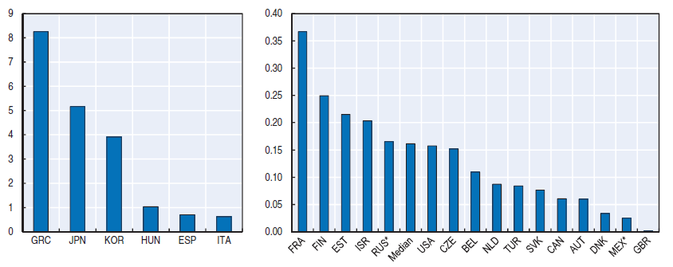

Figure 5: Share of government loan guarantees for SMEs, 2015

(as a percentage of GDP)

Note: Countries marked with an asterisk make use of 2014 data. The median value refers to all depicted countries in both graphs.

Source: OECD, “Financing SMEs and Entrepreneurs 2017: An OECD Scoreboard”, OECD Publishing, Paris, 2017, p. 55.

This could suggest that SMEs bankruptcies in UK may be influenced also by macroeconomic factors. This topic has been widely studied in literature, with reference to companies in general and not only SMEs. Many proposals have considered many macroeconomic indicators, most of which related to GDP and business cycle, as possible factors influencing probability of default of companies. For example, Koopman et al. (2009) concluded that defaults can be strongly affected by macroeconomic variables as GDP-growth and business cycle. Qu (2008) studied the relationship between default probability and macroeconomic indicators in many nations, arguing that behavior could be different from country to country. Jiménez and Mencía (2009) focused on economic situation in Spain, asserting that exposure at default is higher during recessions than during economic upturns.

In order to gain indications on possible implications of SMEs bankruptcies in the UK we shall conduct a linear regression analysis limited to available data, in which the response variable is the number of SMEs bankruptcies, and explanatory variables are GDP and government guaranteed loans for SMEs, in the period 2009-2015. Data employed in the analysis and results are summarized in Table 3.

Table 3: Regression analysis for SMEs bankruptcies in the UK



Sources:

* Data on SMEs bankruptcies: OECD, “Financing SMEs and Entrepreneurs 2017: An OECD Scoreboard”, OECD Publishing, Paris, 2017.
* Data on government guaranteed loans for SMEs: British Business Bank, “Enterprise Finance Guarantee Quarterly Statistics”, 2017.
* Data on GDP: World Bank, <https://data.worldbank.org>

Parameter estimates are substantially small in absolute value, because of very large values of explanatory variables. There is clear evidence on significance for parameter “GDP” (p-value=0.009), which does not hold true for “Government guaranteed loans”. In any case the whole set of parameters is highly significant (p-value of F statistics equal to 0.003) and adequacy of model is confirmed also by large value of R squared index.

As far as we have very few data, having EFG only recently been introduced, no strong statement basing on these results can be made. However a general suggestion, in perspective of future more in-depth analysis, is that SMEs bankruptcies could be due to several factors, and possibly government loans scheme as EFG could be play a minor role, compared to specific macroeconomic features of the UK.

**6 Conclusion**

In most advanced and developing countries there is some form of guarantee schemes in favour of SMEs, even though, obviously, each country has its own peculiarities in this regard.

In the United Kingdom, too, the SME segment is a very important part of all private businesses.

In this context there is no mention of “system” of guarantees in favour of SMEs, but there is essentially only the presence of government guarantee schemes (in the past the SFLG, currently the EFG) to guarantee loans in favour of British viable SMEs that are not able to access bank credit due to their lack of adequate guarantees and/or track record.

An analysis of the characteristics of the UK guarantee schemes has shown, moreover, that the loans guaranteed by these schemes typically account for no more than 1%-2% of the total value of the conventional bank loans granted to British SMEs. Furthermore, it has also emerged that, among the various countries observed, the country in which the share of government loan guarantee for SMEs as a percentage of GDP) is less widespread is the United Kingdom, with a percentage equal to 0.002%.

Results from the regression analysis showed that among years of operation where EFG has been introduced, possibly this kind of government loan guarantees scheme for SMEs played a minor role, compared to macroeconomic indicators as GDP, in dealing with SMEs bankruptcies. As far as we focused on few data, due to the fact that EFG has been introduced only recently, we can only gain suggestions on this topic, to be used as a basis for further studies. These latter could be also devoted to the analysis of government loan guarantee schemes in other countries, for which more information is available so more precise and possibly different conclusions could be reached.

**References**

1. Berger, A.N., Udell, G.F., “A more complete conceptual framework for SME finance”, *Journal of Banking & Finance*, Volume 30, Issue 11, pp. 2945-2966, 2006.
2. British Business Bank, “Enterprise Finance Guarantee Quarterly Statistics”, 2017.
3. British Business Bank, “Small Business Finance Markets 2016/17”, 2017.
4. British Business Bank, “Annual Report and Accounts 2017”, 2017.
5. British Business Bank, “Enterprise Finance Guarantee (EFG). Scheme Strategic And Operational Design Review 2015/16”, 2016.
6. British Business Bank, “Enterprise Finance Guarantee. Application Process and List of Lenders”, 2014.
7. British Business Bank, “Enterprise Finance Guarantee. Business Sectors and Purposes”, 2014.
8. Cowling M., Siepel J., “Public intervention in UK small firm credit markets: Value-for-money or waste of scarce resources?”, *Technovation*, Volume 33, Issues 8–9, pp. 265-275, 2013.
9. Cowling M., “The role of loan guarantee schemes in alleviating credit rationing in the UK”, *Journal of Financial Stability*, Volume 6, Issue 1, pp. 36-44, 2010.
10. Department for Business, Energy & Industrial Strategy, “Business Population Estimates for the UK and Regions 2017”, Statistical release, 30 November 2017.
11. Department for Business, Innovation & Skills, “BIS Performance Indicators. Value Enterprise Finance Guarantee funds used by businesses”, 2015.
12. Department for Business, Innovation & Skills, “Economic Evaluation of The Enterprise Finance Guarantee (EFG) Scheme”, Report by: Allinson G., Robson P. and Stone I., Policy Research Group Durham Business School/St Chad’s College, 2013.
13. Department for Business, Innovation & Skills, “SME Access to Finance Schemes. Measures to support SME growth”, 2013.
14. Department for Business, Innovation & Skills, “Economic Evaluation of the Small Firms Loan Guarantee (SFLG) Scheme”, by Cowling M., Institute for Employment Studies, 2010.
15. Department for Business, Innovation & Skills, “Early Stage Assessment of the Impact of the Enterprise Finance Guarantee (EFG) on Recipient Firms”, by Allinson G., Stone I., Braidford P., Houston M., Policy Research Group Durham Business School/St Chad’s College, 2009.
16. Department for Business, Innovation & Skills, “Small Firms Loan Guarantee: Annual Report for Financial Year 2007/08, 2008.
17. European Investment Bank, “Using Financial Instruments for SMEs in England in the 2014-2020 Programming Period. A study in support of the ex-ante assessment for the deployment of EU resources”, 2015.
18. Green A., “Credit Guarantee Schemes for Small Enterprises: An Effective instrument to Promote Private Sector-Led Growth?”, SME Technical Working Papers Series, Working Paper No. 10, UNIDO, 2003.
19. IFF Research, “Qualitative Research into the Delivery and Operation of EFG Loans”, Prepared for The British Business Bank by IFF Research, 2016.
20. Jiménez, G., Mencía, J., “Modelling the distribution of credit losses with observable and latent factors”, *Journal of Empirical Finance*, Volume 16, Issue 2, pp. 235-253, 2009.
21. Koopman, S. J., Kräussl, R., Lucas, A. and Monteiro, A. B., “Credit Cycles and Macro Fundamentals”, *Journal of Empirical Finance*, Volume 16, Issue 1, pp. 42-54, 2009.
22. Leone P., Vento G.A. (eds.), *Credit Guarantee Institutions and Sme Finance*, Palgrave Macmillan, 2012.
23. OECD, “Financing SMEs and Entrepreneurs 2017: An OECD Scoreboard”, OECD Publishing, Paris, 2017.
24. Page M., “Policy on small firms 1997-2015”, House of Commons Library, briefing paper no 7363, 2015.
25. Qu, Y., “Macroeconomic factors and probability of default”, *European Journal of Economics, Finance and Administrative Sciences*, 13, 192-215, 2008.
26. Vento G.A., Agnese P., “The guarantee system in Argentina”, in Leone P., Vento G.A. (eds.), *Credit Guarantee Institutions and Sme Finance*, Palgrave Macmillan, 2012.
27. Vento G.A., Agnese P., “Guarantee institutions and credit to Smes: mutual guarantee societies in Argentina”, in *Bancaria* n. 1/2011, Bancaria Editrice, Roma, 2011.

1. LUISS Guido Carli University Rome, Italy, e-mail: [pagnese@luiss.it](mailto:pagnese@luiss.it)
2. Sapienza University of Rome, Italy, e-mail: [manuel.rizzo@uniroma1.it](mailto:manuel.rizzo@uniroma1.it)

   Regent’s University London, UK, e-mail: [ventog@regents.ac.uk](mailto:ventog@regents.ac.uk)

   Article Info: *Received* :xxxxxxx xx, xxxx*. Published online* : xxxxxxx xx, xxxx
3.
4. A small business is defined as a business with 0-49 employees, a medium-sized business is one with 50-249 employees, and a large business is one with 250 or more employees. Small and medium-sized enterprises (SMEs) are defined as businesses with 0-249 employees. See Department for Business, Energy & Industrial Strategy (2017).
5. The British Business Bank is a development bank wholly owned by HM Government. It delivers most of the government’s programmes aimed at supporting SME access to finance through a range of financial facilities. For further clarifications regarding the EFG scheme, visit the website of the *British Business Bank*, <http://british-business-bank.co.uk>.
6. Currently, there are over 40 participating lenders ranging from the main high street banks to smaller specialist institutions, some of which have a specific geographic, sectoral or product focus. The list of lenders is available on *British Business Bank* website.
7. The only exception from normal commercial practice is that the lender is expressly prohibited from taking a charge over a principal private residence as security for an EFG loan.
8. The interest rates and any likely commissions to be added on to guaranteed EFG loans are set by the accredited *lenders*.
9. The premium, in effect, only partially covers the cost of the guarantee. The premium in question is not the same as an insurance premium.
10. In total, 1,399 SME were surveyed including 500 EFG supported businesses and 899 unassisted businesses. The survey tracked SME performance for the period 2009-2012 (Department for Business Innovation & Skills,2013).