SARIMA MODELLING OF NIGERIAN BANK PRIME LENDING RATES
Ette Harrison Etuk
Department of Mathematics/Computer Science
Rivers State University of Science and Technology
Port Harcourt
Nigeria

Uyodhu Amekauma Victor-Edema
Department of Mathematics/Statistics
Ignatius Ajuru University of Education
Port Harcourt
Nigeria

ABSTRACT
The monthly Prime Lending Rates of Nigerian Banks are modelled herein by SARIMA methods. The realization considered here spans from January 2006 to July 2014. The original series called herein PLR has a generally horizontal secular trend. Its correlogram reveals some seasonality of period 12 months. Moreover preliminary data analysis shows that yearly maximums are mostly between October and the next March, and the minimums mostly between April and September. That means that the maximums tend to lie in the first and the fourth quarters of the year and the minimums in the second and the third quarters of the year. That means that the series is seasonal of 12 monthly period. Twelve-monthly differencing of PLR yields the series called SDPLR which also has a generally horizontal trend. Augmented Dickey Fuller (ADF) Tests consider both PLR and SDPLR to be non-stationary. A non-seasonal differencing of SDPLR yields the series DSDPLR which is considered stationary by the ADF tests. Its correlogram attests to a 12-monthly seasonality as well as the presence of a seasonal moving average component of order one. The autocorrelation structure suggests the proposal of the following models: (1) a SARIMA(0, 1, 1)x(0, 1, 1)₁₂ (2) a SARIMA(0,1,1)x(1,1,1)₁₂ and (3) a SARIMA(0, 1, 1)x(2, 1, 1)₁₂ . The foregoing models follow a descending order of degree of adequacy on AIC grounds. However, from the SARIMA(0, 1, 1)x(2, 1, 1)₁₂ model, a SARIMA(0,1,0)x(2,1,1)₁₂ model becomes suggestive and it outdoes the rest on all counts. Its residuals are mostly uncorrelated and also follow a normal distribution with mean zero. Hence it is adequate and may be used to forecast the prime lending rates.

KEY WORDS: Prime Lending rates, Sarima Models, Seasonal Time Series, Nigeria

INTRODUCTION:
Prime lending rates are rates at which banks give loans to their best customers. These customers are called best in the sense of having a long term relationship and credit reputation with the bank and are often big-time and well-established clients. These rates are usually minimal and they fluctuate according to the economic realities of the nation. The aim of this work is to fit a seasonal autoregressive integrated moving average (SARIMA) model to the monthly prime lending rates of Nigerian banks.
The rates are herein observed to show some seasonality of period 12 months as many other economic and financial time series. Hence, the proposal of a SARIMA fit. In the literature time series that have been modelled by SARIMA techniques because of their intrinsically seasonal nature include temperature (Khajavi et al., 2012), tourism patronage (Padhan, 2011), airways patronage (Box and Jenkins, 1976), inflation (Fannoh et al., 2012), savings deposit rates (Etuk et al., 2014), rice prices (Hassan et al., 2013), tuberculosis incidence (Moosazadeh et al., 2014), stock prices (Etuk, 2012), cucumber prices (Luo et al., 2013), internally generated revenues (Etuk et al., 2014), dengue numbers (Martinez et al., 2011) and tomato prices (Adanacioglu and Yercan, 2012), to mention but a few.
MATERIALS AND METHODS
Data: The data analyzed in this work are 103 prime lending rates from January 2006 to July 2014 retrievable from the website of the Central Bank of Nigeria, www.cenbank.org. They are published under the Money Market Indicators subsection of the Data and Statistics section.
Sarima Models: A stationary time series {X_{t}} is said to follow an autoregressive model of order p and q denoted by ARMA(p, q) if it satisfies the following difference equation

X_{t} - α₁X_{t-1} - α₂X_{t-2} - ... - α_{p}X_{t-p} = ε_{t} + β₁ε_{t-1} + β₂ε_{t-2} + ... + β_{q}ε_{t-q} (1)

where the sequence of random variables {ε_{t}} is a white noise process. The α’s and β’s are constants such that the model is both stationary and invertible. Suppose that we write model (1) as

A(L)X_{t} = B(L)ε_{t} (2)

where A(L) and B(L) are the autoregressive (AR) and the moving average (MA) operators respectively defined by A(L) = 1 - α₁L - α₂L² - ... - α_{p}L^{p} and B(L) = 1 + β₁L + β₂L² + ... + β_{q}L^{q} and L is the backward shift operator defined by L^{k}X_{t} = X_{t-k}.

If a time series is non-stationary, Box and Jenkins (1976) proposed that differencing of the series a certain number of times may make it stationary. Let ∇ be the differencing operator. Then ∇ = 1 – L. If d is the minimum number of times for which the d^{th} difference {∇^{d}X_{t}} of {X_{t}} is stationary and {∇^{d}X_{t}} follows model (1) or (2) the original series {X_{t}} is said to follow an autoregressive integrated moving average model of order p, d and q, denoted by ARIMA(p,d,q).

If in addition the time series {X_{t}} is seasonal of period s, Box and Jenkins (1976) moreover proposed that it may be modelled by

A(L)Φ(L^{s})∇^{d}∇^{D}_{s}X_{t} = B(L)Θ(L^{s})ε_{t} (3)

where ∇_{s} is the seasonal differencing operator defined by ∇_{s} = 1 – L^{s} , D is the minimum number of times of seasonal differencing for stationarity and Φ(L) and Θ(L) are the seasonal AR and MA operators respectively. Suppose Φ(L) and Θ(L) are polynomials of orders P and Q respectively model (3) is called a multiplicative seasonal autoregressive integrated moving average model of order (p,d,q)x(P,D,Q)_{s} denoted by SARIMA(p,d,q)x(P,D,Q)_{s} model.

Sarima Model Fitting: The fitting of a SARIMA model of the form (3) starts invariably with the determination of the orders p, d, q, P, D, Q and s. The seasonal period might be directly suggestive by knowledge of the seasonal nature of the series as with monthly rainfall for which s = 12 or hourly atmospheric temperature for which s = 24. An inspection of the series could reveal an otherwise unclear seasonality. Moreover the correlogram could reveal seasonality if the autocorrelation function (ACF) has a sinusoidal pattern. In this case the period of seasonality is the same as that of the ACF. The differencing orders d and D are often chosen so that d + D < 3. This is usually enough to make the series stationary. Before and after differencing at each stage the series is tested for stationarity using the Augmented Dickey Fuller (ADF) Test. The AR orders p and P are estimated by the non-seasonal and the seasonal cut-off lags of the partial autocorrelation function (PACF) respectively and the MA orders q and Q are estimated by the non-seasonal and the seasonal cut-off lags of the ACF respectively.

The model parameters may be estimated by the use of a nonlinear optimization technique like the least squares procedure or the maximum likelihood technique. This is due to the presence of items of the white noise process in the model. The best of competing models shall be chosen on minimum Akaike’s Information Criterion (AIC) grounds. Any chosen model is tested for goodness-of-fit to the data by analysis of its residuals. An adequate model must have residuals that are uncorrelated and/or follow the Gaussian distribution.

Statistical Software: The software used here is Eviews 7. It employs the least error sum of squares criterion for model estimation.

RESULTS AND DISCUSSION:

The time plot of the realization of the prime lending rates called herein PLR in Figure 1 shows a generally horizontal trend with a big hunch between 2009 and 2010. It is observed that yearly minimums tend to lie in the second and third quarters of the year and the maximums in the first and fourth quarters of the year. It has a sinusoidally patterned ACF (see Figure 2) revealing a seasonal tendency of period 12 months. A 12-monthly differencing produces the series SDPLR which also has a fairly horizontal trend with a hunch between 2009 and 2010 (See Figure 3). A non-seasonal differencing of SDPLR yields the series DSDPLR which has a generally horizontal trend. The ADF test statistic for PLR, SDPLR and DSDPLR are respectively equal to -2.4, -2.4 and -5.8. With the 1%, 5% and 10% critical values of -3.5, -2.9 and -2.6 respectively the ADF test considers both PLR and SDPLR non-stationary and DSDPLR as stationary. The correlogram of DSDPLR shows an ACF of a series with a SARIMA(0,1,1)x(0,1,1)₁₂ component and a seasonal AR component of order 2. The models proposed are (1) a SARIMA(0,1,1)x(0,1,1)₁₂ model (2) a SARIMA(0,1,1)x(1,1,1)₁₂ model (3) a SARIMA(0,1,1)x(2,1,1) model and (4) a SARIMA(0,1,0)x(2,1,1)₁₂ model .

The SARIMA(0,1,1)x(0,1,1)₁₂ model as estimated in Table 1 is given by

X_{t} = 0.3046ε_{t-1} – 0.6386ε_{t-12} + 0.0563ε_{t-13} + ε_{t} (4)
(±0.1076) (±0.1007) (±0.1107)

The additive SARIMA model suggestive by model (4) is estimated in Table 2 by

X_{t} = 0.2486ε_{t-1} – 0.7512ε_{t-12} + ε_{t} (5)
(±0.0987) (±0.0893)

The SARIMA(0,1,1)x(1,1,1)₁₂ model as estimated in Table 3 is given by

X_{t} + 0.3085X_{t-12} = 0.2773ε_{t-1} – 0.6114ε_{t-12} – 0.5619ε_{t-12} + ε_{t} (6)
(±0.1021) (±0.0965) (±0.0731) (±0.0945)

The SARIMA(0,1,1)x(2,1,1)₁₂ model as estimated in Table 4 is given by

X_{t} + 0.9314X_{t-12} + 0.3833X_{t-24} = 0.1165ε_{t-1} + 0.9484ε_{t-12} + 0.0847ε_{t-13} + ε_{t} (7)
(±0.0805) (±0.0650) (±0.1246) (±0.0223) (±0.1215)

which suggests a SARIMA(0,1,0)x(2,1,1)₁₂ model. This is estimated in Table 5 as

X_{t} + 0.9329X_{t-12} + 0.3849X_{t-24} = 0.9330ε_{t-12} + ε_{t} (8)
(±0.0750) (±0.0612) (±0.0200)

In models (4) through (8), X represents DSDPLR. Model (8) is the most adequate on minimum AIC grounds.

The residuals of model (8) are mostly uncorrelated (See Figure 6) and normally distributed ( See the Jarque Bera test of Figure 7) implying that model (8) is adequate.

CONCLUSION

It may be concluded that the prime lending rates of Nigerian banks follow a SARIMA(0,1,0)x(2,1,1)₁₂ model. Forecasting of these rates may be done on the basis of the model.

REFERENCES

- Adanacioglu, H. and Yercan, M. (2012). An analysis of tomato prices at wholesale level in Turkey: an application of SARIMA model. Custos e @ gronegocio on line, Vol. 8, No. 4, 52 – 75.
- Box, G. E. P. and Jenkins, G. M. (1976). Time Series Analysis, Forecasting and Control. San Francisco: Holden-Day.
- Etuk, E. H. (2012). A multiplicative seasonal Box-Jenkins model to Nigerian Stock Prices. Interdisciplinary Journal of Research in Business, Vol. 2, No. 4, 1 – 7.
- Etuk, E. H., Aboko, I. S., Victor-Edema, U. A., and Dimkpa, M. Y. (2014). An additive seasonal Box-Jenkins model for Nigerian Monthly Savings Deposit Rates. Issues in Business Management and Economics. Vol. 2, No. 3, 54 – 59.
- Etuk, E. H., Agbam, A. S., Sibeate, P. U., and Etuk, F. E. (2014). Another Look at the Time Series Modelling of Monthly Internally generated Revenue of Mbaitoli LGA of Nigeria. International Journal of Management Sciences, Vol. 3, No. 10, 838 – 846.
- Fannoh, R., Orwa, G. O. and Mung’atu, J. K. (2012). Modeling the Inflation Rates in Liberia SARIMA Approach. International Journal of Science and Research. Vol. 3, Issue 6, 1360 – 1367.
- Hassan, M. F., Islam, M. A., Imam, M. F. and Sayem, S. M. (2013). Forecasting wholesale price of coarse rice in Bangladesh: A seasonal autoregressive integrated moving average approach. Journal of Bangladesh Agricultural University. Vol. 11, No. 2, 271 – 276.
- Khajavi, E., Behzadi, J., Nezami, M. T., Ghodrati, A. and Dadashi, M. A. (2012). Modeling ARIMA of air temperature of the southern Caspian Sea Coasts. International Research Journal of Applied and Basic Sciences. Vol. 3, No. 6, 1279 – 1287.
- Martinez, E. Z., Soares Da Silva, E. A. and Fabbro, A. L. D. (2011). A sarima forecasting model to predict the number of cases of dengue in Campinas, state of Sao Paulo, Brazil. Rev. Soc. Bras. Med. Trop., vol. 44, 436 – 440.
- Moosazadeh, M., Nasehi, M., Bahrampour, A. Khanjani, N., Sharafi, S. and Ahmadi, S. (2014). Forecasting Tuberculosis Incidence in Iran Using Box-Jenkins Models. Iranian red crescent Medical Journal. Vol. 16, No. 5. www.ircmj.com/?page=article&article_id=11779.
- Padhan, P. C. (2011). Forecasting international Tourists footfalls in India: An Assortment of Competing Models. International Journal of Business and Management. Vool. 6, No. 5, 190 – 202.

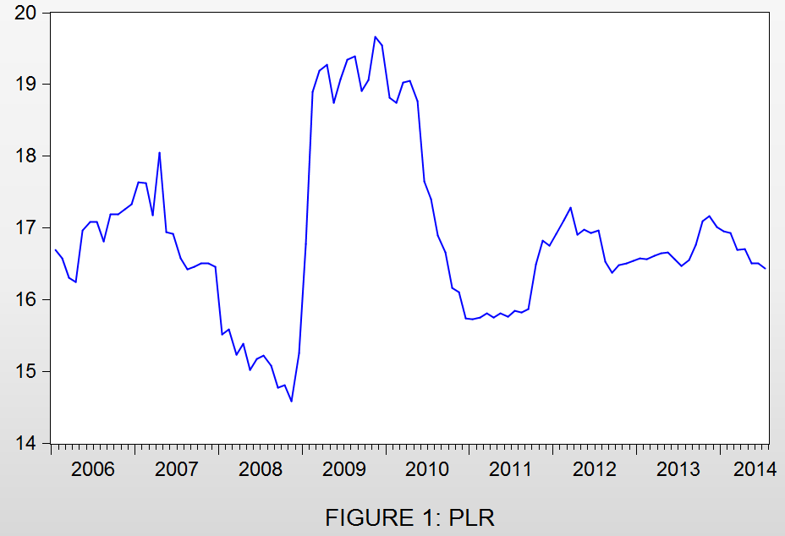

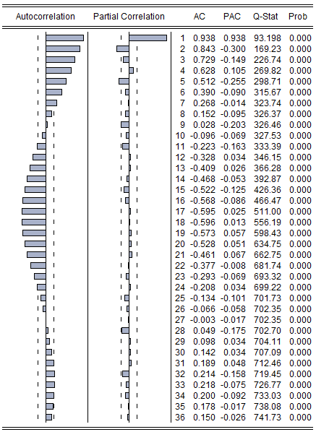
FIGURE 2: CORRELOGRAM OF PLR

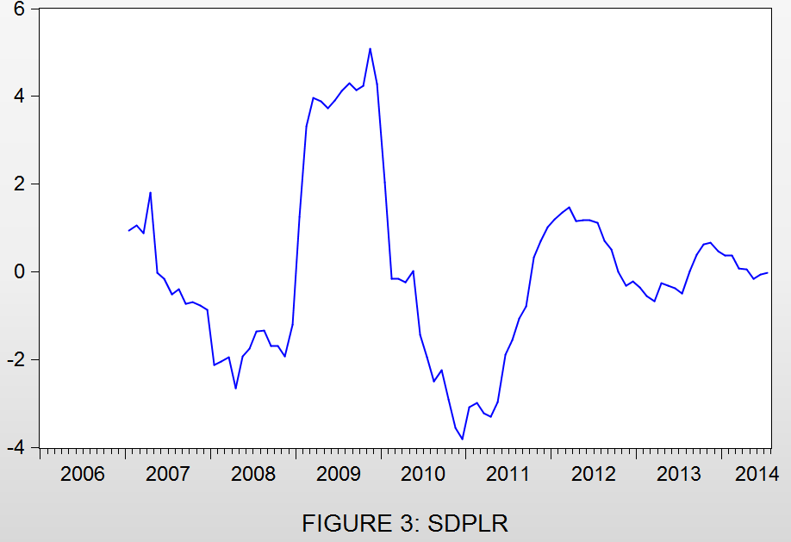

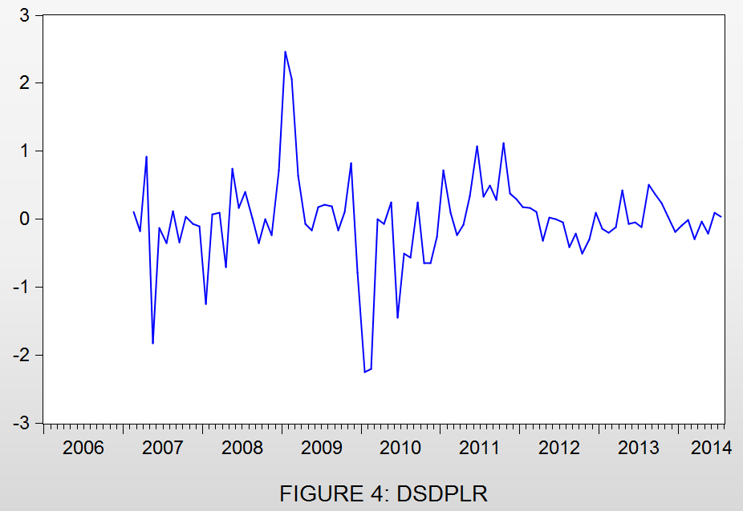
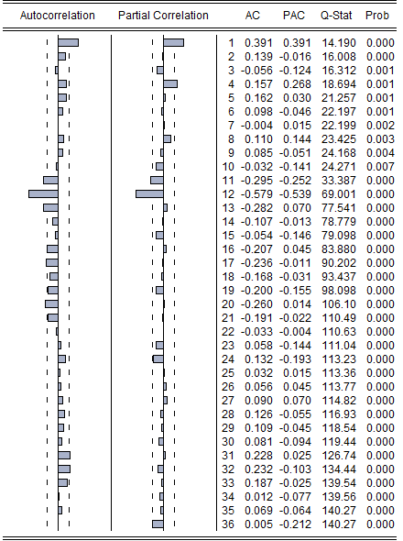
FIGURE 5: CORRELOGRAM OF DSDPLR

TABLE 1: ESTIMATION OF THE SARIMA(0,1,1)X(0,1,1)₁₂ MODEL
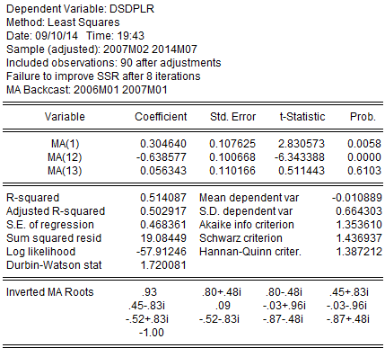
TABLE 2: ESTIMATION OF THE ADDITIVE SARIMA MODEL
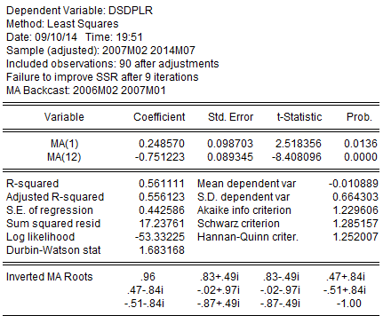

TABLE 3: ESTIMATION OF THE SARIMA(0,1,1)X(1,1,1)₁₂ MODEL
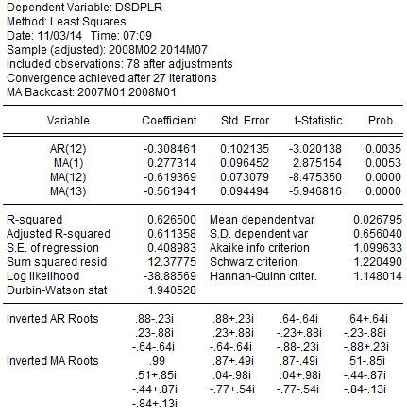

TABLE 4: ESTIMATION OF THE SARIMA(0,1,1)X(2,1,1)₁₂ MODEL
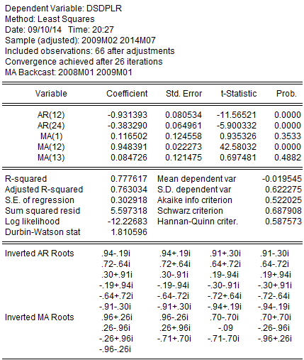

TABLE 5: ESTIMATION OF THE SARIMA(0,1,0)X(2,1,1)₁₂ MODEL
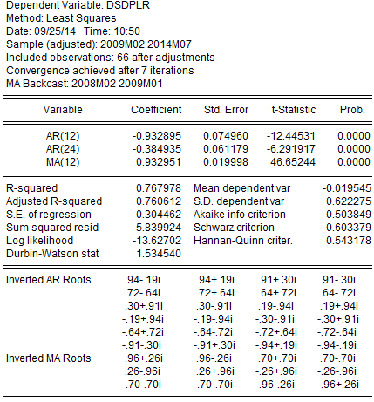

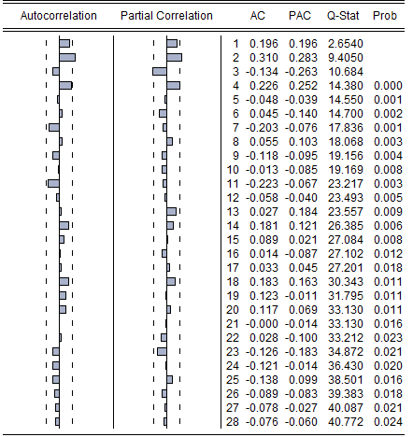
FIGURE 6: CORRELOGRAM OF THE SARIMA(0,1,0)X(2,1,1)₁₂ RESIDUALS
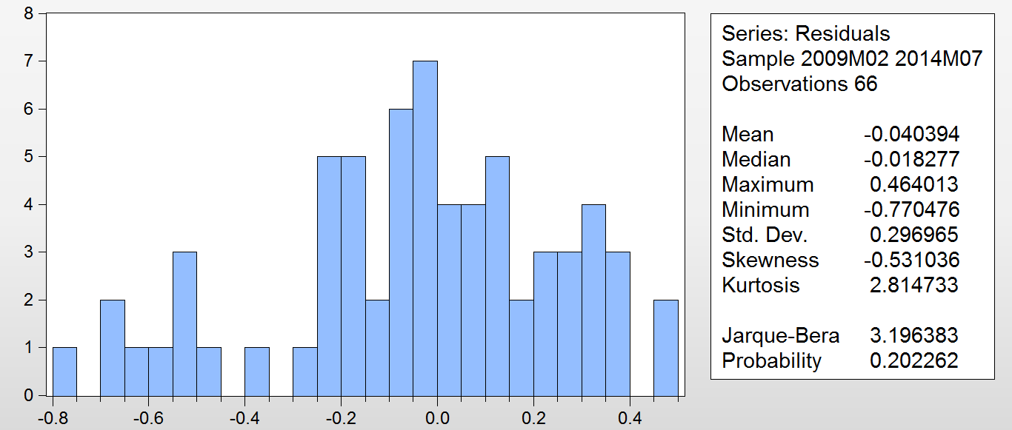
FIGURE 7: HISTOGRAM OF THE SARIMA(0,1,0)X(2,1,1)₁₂ RESIDUALS

