The Engineering Properties of Manufactured Sand with Rock Quarry Dust

and Muck Material District Jamshoro Sindh Province Pakistan.

1.MUSHTAQUE AHMED PATHAN, 2.MS.MARYAM MAIRA, 3.AGHA JAMSHED AHMED

1.CENTER FOR PURE & APPLIED GEOLOGY, UNIVERSITY OF SINDH, JAMSHORO SINDH PAKISTAN

2. INSTITUTE OF ENVIRONMENTAL ENGG. & MANAGEMENT MEHRAN UNIVERSITY JAMSHORO SINDH PAKISTAN

3. DEPARTMENT OF ARCHITECTURE, MEHRAN UNIVERSITY JAMSHORO SINDH PAKISTAN.

MUSHTAQUE AHMED PATHAN (Corresponding Author) E-mail:ma.pathan12@yahoo.com

ABSTRACT: Concrete material has widen its scope and usage from natural course and fine aggregates to the manufactured aggregates as the world of construction industry grown up worldwide from ground floor homes to multistory buildings. This was because of availability of good quality aggregates in limited quantity in such regions where the natural aggregate resources are not present in sufficient quantity.

The Jamshoro district of Sindh province Pakistan has huge quantity of exposed sedimentary rocks as limestone, sandstone, shale, and large area of sand deposits which has been used in construction industry throughout the province in very huge quantity for development projects like highways, motorways, bridges, buildings, dams etc. [Photograph A] Keeping view the huge demand the alternate resources like manufactured sand and sweet earth materials are also under observation to use in concrete.

In this research study the impact on the strength of the mixture of sweet earth or mud material concrete have been investigated.

Key words; Manufactured sand, V S I, Gradation or sieve analysis, Sweet earth mud material.

INTRODUCTION
Pakistan is a fastly growing developing country after the international cooperation of the different neighboring countries like China, and friendly countries like UAE, SAUDI ARABIA etc, also the world Bank, Asian Bank and IMF. The large portion of funding was done by China in the name of CPEC ( CHINA PAKISTAN ECONOMIC CORRIDOR). A number of projects started in all four provinces of Pakistan specially highways, motorways, buildings of educational institutions and railway tracks including small das in arid regions were top priority, all these projects needed large quantity of construction aggregates both course and fine aggregates.
More than 50% material demand is covered with natural aggregates while remaining 50% is covered with manufactured sand with mixing of allowable sweet earth or mud material in concrete and also in dam embankments, highway subgrade materials.[8]
Also the environmental requirements are considered for sand mining to an allowable limit and standards for local people and wildlife habitants.
The number of engineering properties like shape and characteristics of manufactured sand aggregates, allowable proportions for particle packing, shrinkage, raveling and creeping for insuring good quality material.

- MATERIALS AND METHODS
- Materials for Crushed Sand
The manufactures sand samples were taken from the crusher plants operating in the Jamshoro area around the suburb of the residential town near the large elevated limestone rocks. These rocks are the major source of getting crushed stone and crusher dust for use in concrete and the desirable sizes of coarse aggregates for macadam and asphalt mixes for highway construction etc.[3] [2].
There are number of engineering properties and testing methods for selection of suitable material starting from geological or petrographical , indicating their nature or origin like igneous, sedimentary, metamorphic, texture, surface structure, alteration regarding weathering and erosion hardness, specific gravity, strength, colour and porosity percentage.
Each and every property has its own importance and application.[6] [7].
The original source material having the basic properties can produce manufactured sand of such resembling nature. All that material must be treated with environmental contamination materials like fine clays, rains, weathering effects etc. The stock piles should not be kept in open ground for months or long, the ideal period is to use within 30 days according to local climate conditions.
- Manufacturing Processes of Crushed Sand
There are number of crushing equipments like rod mills, roll crushers, cone crushers, and impact crushers etc. Manufactured sand involves two main important operations to control the particle shape and gradation during the manufacturing process. A normal crusher plant has a jaw or gyratory crusher called primary crusher and other type of crushers are also used for the required production
Cone crusher is used in large scale quarries even a tertiary cone stage may be used for final (third or fourth) stage for making cubical fine grained particles, a Vertical Shaft Impactor (VSI) has often been the proper solution ^{[2]}. generally gyratory or cone crushers producing crushed sand of the flabby particle shapes. On the other hand, impact crushers such as hammer mills and rod mills yield excellent cubical shapes. VSI has proved itself to be an effective way of producing cubical (even rounded) particles in the small and medium size fractions (< approx 5 mm). It is a challenge to avoid generating of high percentage of fines. However, the advancement in this field with latest generation of dry screening equipment combined with the latest development of air classification have, enabled to govern the grading curve very precisely, including the finest part.[4]
TEST METHODS FOR MANUFACTURED SAND
- Grading and Passing 75-Micron

Particle size analysis (grading) conducted as per ASTM E2651 – 19 on manufactured sands (down to the 75-micron size fraction) is useful for determining the total combined particle distribution, which indicates particle packing or voids within a concrete mix. From this perspective, grading is considered a reportable test, and would be specified in a supply agreement for any particular source. For assessment manufactured sand, the grading is a necessary test for design and quality control of concrete ^{[5]}.
- Sand Equivalent TesT (ASTM D2419 - 14) is very important to measure the relative proportions of detrimental fine dust or clay-like material in soil or fine aggregates. This test is performed with measured volume of soil or fine aggregate and a small quantity of flocculating solution are poured into a graduated plastic cylinder and are agitated to loosen the clay-like coatings from the sand particles in the test substance. The substance is then processed using additional flocculating solution forcing the clay-like material into suspension above the sand. After a specified sedimentation period, the height of flocculated clay is read and the height of sand in the cylinder is determined. The sand equivalent is defined as the ratio of the height of sand to the height of clay times 100.This test is used to qualify aggregates for applications where sand is desired but fines and dust are not. A higher values of sand equivalent indicates the presence of less clay‐like material in a sample [12]

- Durability Tests

This test is to determine resistance to disintegration of fine aggregates by saturated sodium sulphate or magnesium sulphate solution can be done as per ASTM D3744 / D3744M - 18 . This test actually provides information which is helpful in assessing the soundness of aggregates subject to weathering action, specially when related information is not available from previous records of the material exposed to actual weathering conditions.

- Mortar Trials
In modern technology, curing process is not mostly done while constructing a building and use of cement mortar is very high in bonding the concrete. Curing process need more time, days, and weeks to set the cement mortar bonding between the blocks and to obtain its strength. There rises a need of alternative material in the cement mortar for its internal curing. Specifically selected size of manufactured sand is added and tested for its selfcuring process. Thereafter finding the self-curing of the manufactured sand it is added to the cement mortar. By addition of the manufactured sand, the strength of cement mortar increased and the curing process is lowered, which can be obtained through hydration process and by its self-curing process. More, adding of manufactured sand reduced the self-weight to 1.2 times the weight of ordinary cement mortar. ^{[11]}.

EXPEREMENTAL INVESTIGATION

In this study two separate types of manufactured sand has been selected to investigate the effect of effect of of compressive strength
i) crushed sand by crushing rock quarry material and ii) crushed sand by crushing quarry rock and muck material. [9]
A. Materials
The materials used for mix are OPC, manufactured sand blended with 50-50% crushed and VSI sand from rock quarry designated as SCR-1, SCR-2 and SCR-3 and hence forth read as Crushed Sand – I and in another set crushed sand taken from quarry rock and muck material designated as SCRM-1, SCRM-2 and SCRM-3 and hence forth read as Crushed Sand – II, 20 mm and 10 mm size coarse aggregate taken from rock quarry and water reducing admixture. Keeping the grading of crushed sand in Zone-II.
Petrographically rock quarry materials were hard, compact, massive, sedimentary consisting sub-rounded to sub-angular hard limestones with calcareous sandstones. It consists mainly fine grained quartz and feldspar with minor amount of sericite, biotite, chlorite and iron oxides. Quartz is anhedral to subhedral, fine to medium grained. Some of the quartz grains are recrystallised.[10]
The muck material (rock) is mucks tend to be fine-grained, more colloidal, and more decomposed and behave more like inorganic soils because of particle size and a higher percentage of mineral matter, particularly clays.
It consists of mainly fine to medium grained quartz and feldspar with some amount of biotite, and muscovite. Biotites occur in the form of fine flakes, along the boundary of quartzo-feldspathic grains.[1]

The properties of the materials are shown in the following tables:

Table -1 Showing Four Cement Samples of Different Weeks had been tested for their Physical Properties and Test Results.
Sl No | Type of Cement | Normal Consistency | Soundness (mm) | Setting Time (Min) |  | Fineness  (90µ retained) | Compressive Strength (MPa)
 |  |  |  | Initial | Final |  | 03 days | 07 days | 28 days
1 | PPC 18.16 | 29.5 | 1.2 | 124 | 176 | 1.58 | 26.10 | 34.80 | 44.20
2 | PPC 19.16 | 29.5 | 1.1 | 138 | 194 | 1.36 | 27.8 | 33.60 | 46.40
3 | PPC 20.16 | 29.0 | 1.3 | 136 | 179 | 1.25 | 24.60 | 30.30 | 43.60
4 | PPC 21.16 | 30.0 | 1.2 | 146 | 193 | 1.23 | 18.70 | 29.20 | 52.00

Table 2 showing Grading of Crushed Sand – I presented below.
Sample no →  Sieve ↓ | SCR-1 | SCR-2 | SCR-3 | Criteria  Limits for Zone-II
10 mm | 100 | 100 | 100 | 100
4.75 mm | 100 | 97.65 | 98.40 | 90-100
2.36 mm | 98.20 | 77.10 | 76.20 | 75-100
1.18 mm | 74.20 | 53.62 | 52.60 | 56-100
600 µm | 46.20 | 41.49 | 43.00 | 35-59
300 µm | 35.40 | 30.92 | 36.00 | 8-30
150 µm | 28.20 | 20.94 | 26.20 | 0-20
<75 µm | 12.40 | 13.11 | 13.56 | -
FM | 2.97 | 2.78 | 2.68 | -

From the above table it can be seen that the FM limit varies from 2.68 to 2.97. The corresponding graph for the gradation of SCR-1, SCR-2 and SCR-3 are presented in fig 1.0, fig 2.0 and fig 3.0. Upper and lower limits of the graph represents the boundary limits of Grading Zone-II as per ASTM E2651 – 19 .

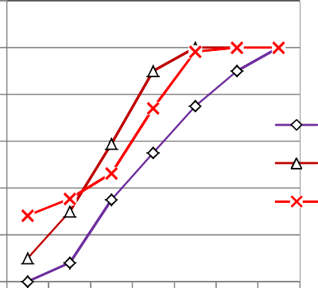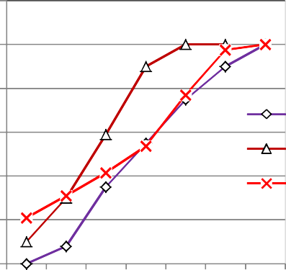Fig 1.0
120
100
80
60
40
20
0
Z2L Z2U
SCR-1
0.15 0.3 0.6 1.18 2.36 4.75 10
Sieve Size
120

100
80
60
40
Z2L Z2U
SCR-2
20
0
0.15 0.3 0.6 1.18 2.36 4.75 10
Sieve Size
% Passing
% Passing

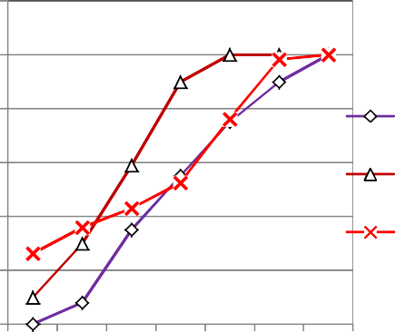
Fig 2.0
Sieve Size
Z2L Z2U
SCR-3
% Passing

120
100
80
60
40
20
0 | 0.15 0.3 0.6 1.18 2.36 4.75 | 10

Fig 3.0
From the above gradation curves it has been observed that in Crushed Sand-I finer fraction (< 150 µm) are more than the permissible limit.

Table 3 showing Grading of Crushed Sand -II presented below.
Sample no → Sieve ↓ | SCRM-1 | SCRM-2 | SCRM-3 | Criteria Limits for  Zone-II
10 mm | 100 | 100 | 100 | 100
4.75 mm | 98.20 | 98.61 | 97.70 | 90-100
2.36 mm | 77.73 | 79.48 | 80.30 | 75-100
1.18 mm | 50.97 | 53.22 | 62.20 | 56-100
600 µm | 39.38 | 41.83 | 42.90 | 35-59
300 µm | 29.99 | 28.17 | 25.2 | 8-30
150 µm | 20.72 | 18.96 | 10.70 | 0-20
<75 µm | 7.70 | 10.43 | 10.04 | -
FM | 2.83 | 2.80 | 2.81 | -

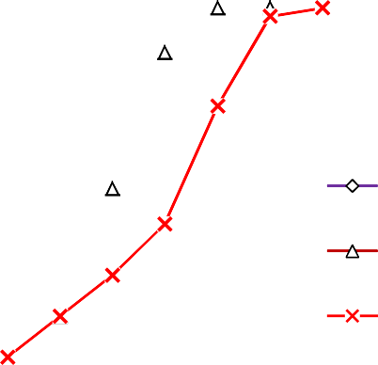

Fig 4.0
0.15 0.3 0.6 1.18 2.36 4.75 10
Sieve Size
0
20
Z2U

SCRM-1
40
Z2L
60
80
100
120
% Passing

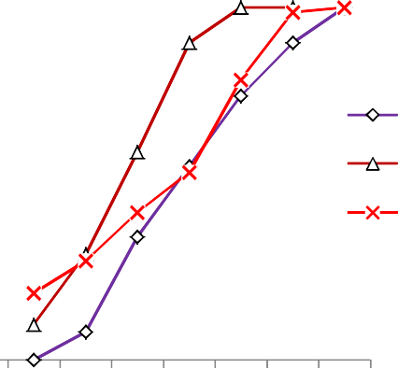Fig 5.0
120

100

80

60

40
Z2L
Z2U SCRM-2
20

0
0.15 0.3 0.6 1.18 2.36 4.75 10
Sieve Size

From the Table-3, it can be see that the FM limit varies from 2.80 to 2.83. The corresponding graph for the gradation of Crushed Sand
- II is presented in fig 4.0, fig 5.0 and fig 6.0. Upper and lower limits of the graph represents boundary limits of Grading Zone-II as per ASTM E2651 – 19.
% Passing
0.15 0.3 0.6 1.18 2.36 4.75 10
Sieve Size
0
20
Z2L Z2U
SCRM- 3
80

60

40
100
120

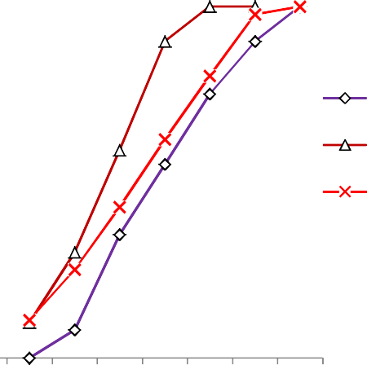

Fig 6.0

From the above gradation curves it has been observed that finer fraction (< 150 µm) much less then Crushed Sand - I However, finer fraction (< 150 µm) is more than the permissible limit as per ASTM E2651 – 19 .
Table 4 ShowsThe Physical Properties of the Rock Quarry Materials i.e. Specific Gravity, Water Absorption, Flakiness Index, Elongation Index, Soundness Loss, Impact Value, Abrasion Value and Crushing Value are shown below:
Sl No | Sample No | Sp Gr | Water Absorption | Flakiness Index | Elongation Index | Soundness Loss | Impact Value | Abrasion Value | Crushing Value
1 | C-1 | 2.68 | 0.76 | 12.68 | 13.17 | 1.20 | 22.19 | 27.20 | 18.96
2 | C-2 | 2.70 | 0.57 | 12.52 | 13.81 | 0.85 | 20.36 | 27.80 | 19.36
3 | C-3 | 2.72 | 0.39 | 12.11 | 13.14 | 1.90 | 21.84 | 32.68 | 20.05
4 | C-4 | 2.68 | 0.70 | 11.57 | 12.71 | 1.20 | 19.25 | 28.54 | 18.22
5 | C-5 | 2.71 | 0.52 | 11.14 | 13.16 | 1.00 | 14.72 | 20.78 | 19.65
6 | C-6 | 2.67 | 0.71 | 13.30 | 14.15 | 1.10 | 19.90 | 28.20 | 25.82
7 | C-7 | 2.70 | 0.52 | 11.26 | 13.14 | 0.70 | 14.29 | 23.36 | 19.65
8 | C-8 | 2.69 | 0.54 | 11.07 | 14.29 | 1.05 | 19.10 | 30.72 | 19.37
9 | C-9 | 2.71 | 0.57 | 12.12 | 13.02 | 1.45 | 17.10 | 29.14 | 18.65
10 | C-10 | 2.70 | 0.38 | 13.96 | 14.92 | 1.40 | 20.67 | 29.64 | 19.42
Table 5 Shows The Physical Properties of the Muck Materials i.e. Specific Gravity, Water Absorption, Flakiness Index, Elongation Index, Soundness Loss, Impact Value, Abrasion Value and Crushing Value are shown below:
Sl No | Sample No | Sp Gr | Water Absorption | Flakiness Index | Elongation Index | Soundness Loss | Impact Value | Abrasion Value | Crushing Value
1 | C-11 | 2.56 | 0.75 | 4.57 | 5.62 | 1.60 | 39.32 | 50.42 | 31.87
2 | C-12 | 2.59 | 1.08 | 3.32 | 4.51 | 1.15 | 39.12 | 51.00 | 32.87
3 | C-13 | 2.59 | 1.06 | 3.66 | 4.71 | 1.00 | 40.49 | 49.42 | 32.60
4 | C-14 | 2.60 | 1.10 | 3.10 | 4.39 | 1.15 | 40.15 | 51.55 | 35.22
5 | C-15 | 2.57 | 1.02 | 3.58 | 4.83 | 1.40 | 40.02 | 48.87 | 33.65
6 | C-16 | 2.61 | 0.85 | 4.10 | 4.96 | 1.00 | 38.86 | 48.61 | 31.82
7 | C-17 | 2.57 | 1.00 | 4.65 | 5.59 | 1.60 | 39.68 | 50.40 | 31.65
8 | C-18 | 2.59 | 1.14 | 3.84 | 4.75 | 1.75 | 39.16 | 49.04 | 31.37
9 | C-19 | 2.61 | 0.92 | 3.96 | 5.10 | 1.25 | 39.10 | 50.26 | 30.65
10 | C-20 | 2.60 | 1.08 | 4.12 | 5.36 | 1.25 | 40.45 | 51.12 | 31.42

Table 6: Compressive Strength of Concrete of Different Grades using Fine Aggregate as Crushed Sand-I and Quarry Stone as Coarse Aggregate in concrete as shown below:
Sl No | FM | % Finer than 75µm | Slump |  |  | 28 days comp strength
 |  |  | M15A20 | M25A20 | M30A20 | M15A20 | M25A20 | M30A20
1 | 2.97 | 12.40 | 155 | 150 | 145 | 22.13 | 31.21 | 36.67
2 | 2.97 | 12.40 | 150 | 160 | 140 | 22.34 | 30.40 | 36.58
3 | 2.97 | 12.40 | 160 | 150 | 160 | 22.55 | 29.88 | 36.90

4 | 2.78 | 13.11 | 150 | 155 | 145 | 22.37 | 30.03 | 36.87
5 | 2.78 | 13.11 | 155 | 160 | 160 | 22.07 | 30.34 | 36.72
6 | 2.78 | 13.11 | 150 | 160 | 160 | 22.86 | 30.33 | 36.84
7 | 2.68 | 13.56 | 150 | 150 | 150 | 22.59 | 30.47 | 36.95
8 | 2.68 | 13.56 | 155 | 160 | 160 | 22.73 | 30.41 | 36.13
9 | 2.68 | 13.56 | 155 | 150 | 160 | 22.74 | 30.47 | 36.21

Table 7 Shows Compressive Strength of Concrete of Different Grades using Fine Aggregate as Crushed Sand-II and Quarry Stone as Coarse Aggregate in concrete as shown below
Sl No | FM | % Finer than 75µm | Slump |  |  | 28 days comp strength
 |  |  | M15A20 | M25A20 | M30A20 | M15A20 | M25A20 | M30A20
1 | 2.81 | 7.70 | 135 | 140 | 145 | 22.68 | 31.24 | 36.84
2 | 2.81 | 7.70 | 140 | 140 | 140 | 22.58 | 31.42 | 36.87
3 | 2.81 | 7.70 | 140 | 150 | 150 | 22.76 | 31.0 | 36.74
4 | 2.80 | 10.43 | 140 | 150 | 150 | 22.50 | 36.76 | 36.90
5 | 2.80 | 10.43 | 140 | 155 | 140 | 22.69 | 30.95 | 37.04
6 | 2.80 | 10.43 | 145 | 145 | 150 | 22.80 | 31.32 | 37.23
7 | 2.83 | 10.04 | 140 | 140 | 145 | 22.93 | 31.29 | 37.11
8 | 2.83 | 10.04 | 140 | 155 | 145 | 22.73 | 31.56 | 37.32
9 | 2.83 | 10.04 | 140 | 140 | 150 | 22.68 | 31.17 | 36.58

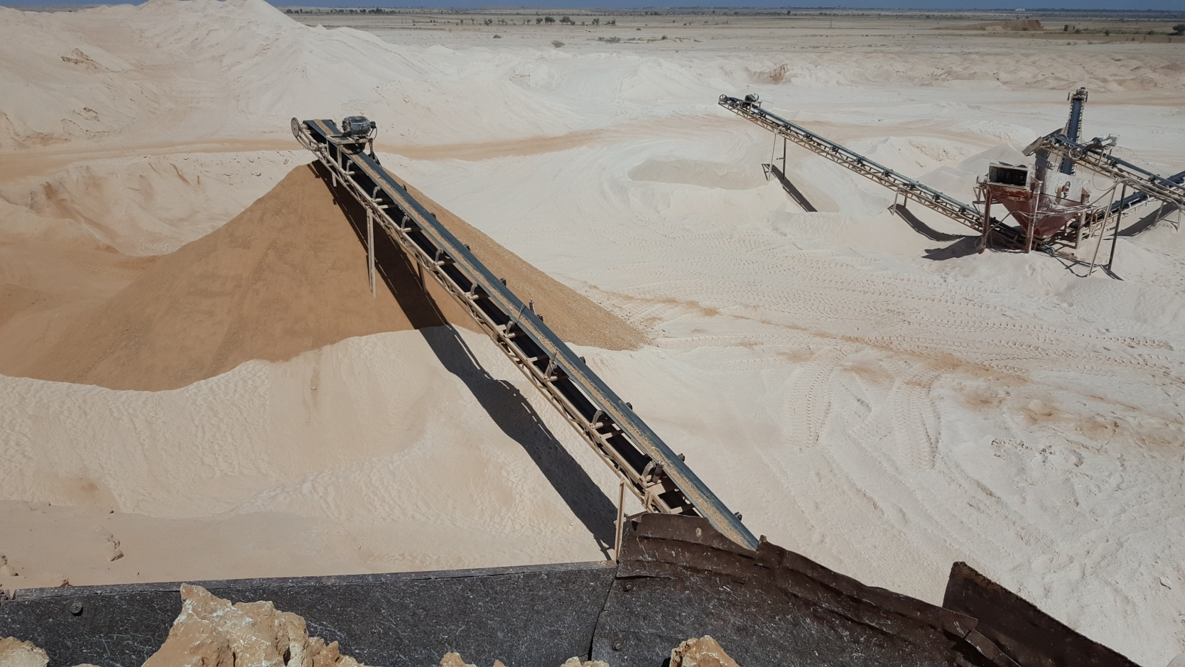

Photograph of crushing plant manufacturing sand in the Jamshoro district Sindhprovince Pakistan. [A]

DISCUSSION
In this research investigation, it has been observed that physical parameters of samples of rock quarry are confirming to wearing surfaces except C-3 and C-8 samples, whereas physical parameters of muck materials are confirming to non-wearing surfaces. Soundness loss of both the samples are comparable and well within the criteria limit as per ASTM E2651 – 19 . an excellent cohesive and consistent mix was obtained with Crushed Sand – II rather than Crushed Sand – I. This change has happend due to particle shape of the manufactured sand. . Shape of the particles of Crushed Sand-II was cube shape whereas Crushed Sand-I was having flaky in nature, cause of which to make consistent mix was difficult / not possible. remarkable slump loss has been observed while comparing two mixes of the same grade keeping all the variables same. It has also been observed from the sieve analysis that percentage finer than 75 µm fractions is more in the Crushed Sand-I in comparison to Crushed Sand-II. [3]
Durability of the concrete depends mostly on permeability, compactability, strength and material quality. In a unit composition of concrete 70-80 % volume occupied by aggregate and out of which 30 -35 % volume occupied by the fine aggregate ^{[4]}. As per the test results, it is evident that crushed sand manufactured with quarry and muck materials can be used to produce concrete provided the aggregates (both coarse and fine) from rock quarry, tunnel muck and blended sand meet the physical, chemical and durability criteria especially soundness losses as per ASTM E2651 – 19 .

CONCLUSION

It is concluded that though both the crushed sand used in the mixes are comparable in respect of compressive strength of concrete with same cement, aggregate, water cement ratio, admixture type and its doses. Durability study of concrete is required to be checked in longer run for re-use of tunnel muck having high abrasion loss but meeting the requirements for use in non-wearing surfaces as ASTM E2651 – 19 as a granular material in the form of crushed sand in concrete.
The manufactured sand produced with the help of proper machines can be a better substitute to river sand. The sand must be of suitable gradation (it should have particles from 150 microns to 4.75 mm in proper proportion).When fine particles are in proper proportion, the sand has fewer voids. The cement quantity required will be less. Such sand will be more economical. The construction industry seeks for manufactured fine aggregates for making concrete is increasing day by day as river sand cannot meet the rising demand of construction sector. The process of formation of natural river sand takes millions of years to form. Considering, the increasing demand and acute shortage of river sand, huge short coming on quality of river sand, high cost, greater impact on road damages and environmental effects, The Construction Industry should start using the manufactured sand to full extent as alternative, reduce the impacts on environment by not using the river sand. The Local Authorities/Public Works Department/ Government, should encourage the use of Manufactured sand in Public Construction Works, if possible, should make mandatory to use Manufactured sand wherever available with immediate effect. The Government. Should come out with, Policy on Sand – encourage the industry people to set up more number of Sand crushing Units across all Districts, States to meet the sand requirements of the Construction Industry.

References.
[1]CCAA, T., 60, Guide to the specification and use of manufactured sand in concrete. Cement concrete aggregate Australia, ISBN, pp.978-1.
[2] Elavenil, D.S. and Vijaya, B., 2013. Manufactured Sand, a Solution and an Alternative to River Sand in Concrete Manufacturing. International Journal of Civil Engineering Research and Development (IJCERD), 3(1).
[3]Ilangovana, R., Mahendrana, N. and Nagamanib, K., 2008. Strength and durability properties of concrete containing quarry rock dust as fine aggregate. ARPN Journal of Engineering and Applied Sciences, 3(5), pp.20-26.
[4]Jadhav, P.A. and Kulkarni, D.K., 2012. An experimental investigation on the properties of concrete containing manufactured sand. International Journal of Advanced Engineering Technology, 3(2), pp.101-104.
[5]Li, B., Wang, J. and Zhou, M., 2009. Effect of limestone fines content in manufactured sand on durability of low-and high-strength concretes. Construction and Building Materials, 23(8), pp.2846-2850.
[6]Mingwei, W., Zhaogang, F., Tiexiang, L. and Dehui, W., 2000. Experimental research on the effect of crusher dust content on concrete performance [J]. RAILNAY CORSTRUCTION TECHNOLOGY, 4.
[7]Nanthagopalan, P. and Santhanam, M., 2011. Fresh and hardened properties of self-compacting concrete produced with manufactured sand. Cement and concrete composites, 33(3), pp.353-358.
[8]Pathan, M.A., Lashae-Ri, R.A. and Maira, M., 2018. Geotech Properties of Petaro Crushing Plants Coarse & Fine Aggregates used in Concrete Asphalt in Road & Building Construction, District Jamshoro Sindh, Pakistan. International Journal of Engineering Science, 17863.
[9]Shen, W., Yang, Z., Cao, L., Cao, L., Liu, Y., Yang, H., Lu, Z. and Bai, J., 2016. Characterization of manufactured sand: Particle shape, surface texture and behavior in concrete. Construction and Building materials, 114, pp.595-601.

[10]Vijayaraghavan, N. and Wayal, A.S., 2013. Effects of manufactured sand on compressive strength and workability of concrete. International Journal of Structural and Civil Engineering Research, 2(4), pp.228-232.
[11] Yamei, H. and Lihua, W., 2017. Effect of particle shape of limestone manufactured sand and natural sand on concrete. Procedia engineering, 210, pp.87-92.
[12]Zhao, S., Ding, X., Zhao, M., Li, C. and Pei, S., 2017. Experimental study on tensile strength development of concrete with manufactured sand. Construction and Building Materials, 138, pp.247-253.

