East Iran – Lesser Caucasus, Middle East: geology and tectonics related to the African superPlume, melt and fluid inclusions; some data on metallogeny and hydrocarbons (OIL, HC)
A. Romanko¹, N.A. Imamverdiyev², V. Prokofiev³, I. Vikentiev³, A. Savichev¹, Sh.F. Abdullayeva², A. Poleshchuk¹, M. Heidari⁴, B. Rashidi⁵
¹ Geological Institute, Academy of Sciences (RAS), Moscow, Russian Federation
² Baku State University, Baku, Republic of Azerbaijan
³ Institute of geology of ore deposits, Academy of Sciences (RAS), Moscow, Russian Federation
⁴Parsi Kan Kav, Tehran, Iran
⁵Satrap Resources, Perth, Australia

*Corresponding Author: a-romanko@ya.ru, (a.romanko@yahoo.com), inazim17@yahoo.com

Abstract. Cenozoic tectonic-magmatic-metallogenic events in Lesser Caucasus and East Iran, Middle East have some common similarities. Important geological – metallogenic +- OIL / HC correlation for the Alpine time exists (metallogeny of East Iran led by outstanding regional trio: E. Romanko, A. Houshmandzadeh, and M.A.A. Nogole-Sadat). Geological northeastern (NE) zoning and “hot” tectonics due to the African superplume activity including, probably, known delamination of lithospheric mantle during collision of mantle lithosphere ca. 13 Ma is principal here. Intraplate alkaline-subalkaline rocks of the region studied including Quaternary real carbonatites of Hanneshin, Afghanistan were derived from enriched African superplume-related mantle sources being enriched in HFSE - Nb, Ta, Zr, Y, P, Ti etc. Late Cenozoic High-K calc-alkaline rocks in the Lesser Caucasus could be deal with African superplume activity too despite their subduction-related rock geochemistry. Important data exist about a general meridianal-close (ca. N-S) zoning of oil / hydrocarbons (HC), muds, salts etc. here. This is one of arguments in favor of deep HC input alongside to traditional HC interpretation too. Large regional economic Cu-Au porphyry etc. metallogeny deals mainly with Eocene (Pg2) shoshonite – latite series rocks formed during known subduction of Arabian plate beneath the Central Iran.

Keywords: Central part of the Alpine-Himalayan mobile belt, Lesser Caucasus – East Iran, Middle East, geology, geochemistry, tectonics, magmatism, metallogeny, African superPlume, delamination, mineralogy, melt and fluid inclusions, northeastern (NE) tectonic-magmatic-metallogenic +- oil / hydrocarbons (HC) zoning.

Introduction

Central part of the famous and fantastically interesting Alpine – Himalayan mobile belt is geologically, economically… extremely important, however, very irregular investigated region. Great importance of its regional study is obvious, surely. Lesser Caucasus (materials by N.A. Imamverdiyev) is geologically better known versus East Iran. Poorly studied East Iran close to the very Alpine – Himalayan tectonic junction (Khain, Leonov, 1988; also in many other works as follows: Stocklin et al., 1965; Nogole-Sadat, 1985; Houshmandzadeh et al., 1986; Imamverdiyev, 2000; E. Romanko et al, 1984; Milanovsky, Koronovsky, 1973 etc. and etc.) studied under the leadership of outstanding geo-trio – known regional specialists Dr. E. Romanko, Dr. A. Houshmandzadeh, and Dr. M.A.A. Nogole-Sadat. We present some new data on this intriguing region.

Review of Geology and Results

General geology and tectonics of this economically and geologically interesting region were described in such works as follows: (Khain, 2001; Imamverdiyev, 2000; Milanovsky, Koronovsky, 1973; Leonov et al, 2010; Trifonov, Ruzhentsev, 1984, etc., fig. 1-2).
Two groups of magmatic rocks were revealed here as: mainly Eocene shoshonitic-latitic etc. rocks of the first group and principally other rocks - Neogene – Quaternary intraplate subalkaline and alkaline ones, second group.
Rocks of the first group (subduction-related differentiated rocks) are the products of a large subduction of the Arabian plate beneath the Central Iran block (Fig. 1). This subduction is confirmed by the regional tectonic analysis (Khain 2001; Leonov et al., 2010), High-resolution tomography by known J. Ritsema’s team (Bull et al., 2009 etc.), geochemistry (Imamverdiyev, 2000; Romanko et al., 2013; etc., fig. 1) etc. Catastrophic earthquakes as 8 M and more by the Richter scale, unfortunately, are not rare here. A recent catastrophic example is 2003 Bam earthquake in East Iran with a lot of casualties.
Antipodes of the second group related to African superplume activity are: intraplate K-Na subalkaline and alkaline rocks – High-Ti trachybasalts, trachyandesites, real Quaternary carbonatites of Hanneshin, Afghanistan, Late Cenozoic carbonatites of Arabia, also Neogene lamproites of Algeria etc. by E. Romanko et al., 1988 and Romanko et al., 2013 (tables 1-11, fig. 1-2, 9-11; Bogatikov et al., 1987; Luchitsky, 1985, Yarmolyuk et al., 2001, Knipper et al., 1992 etc.).

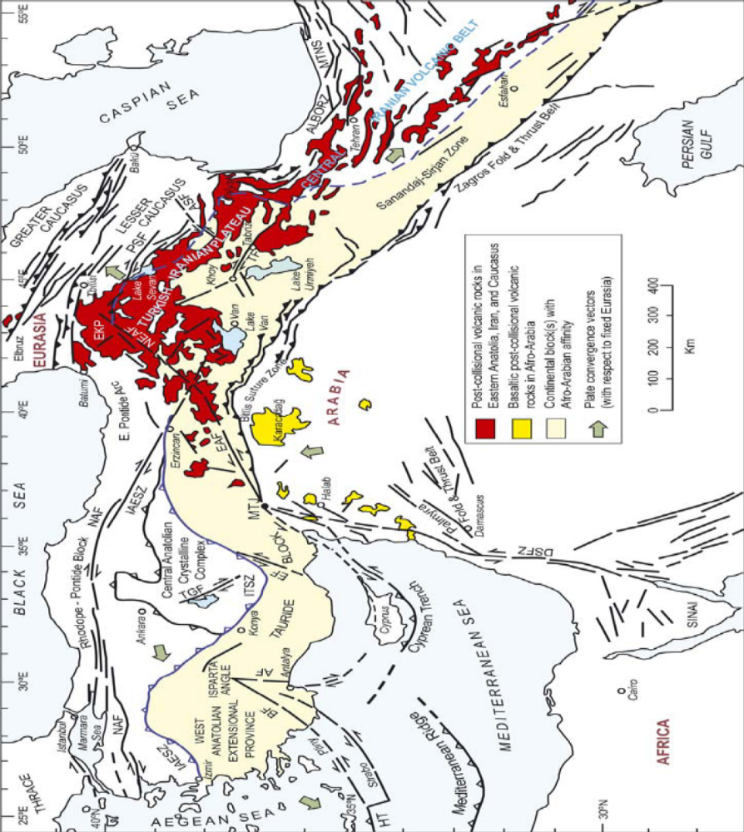

Fig.1. Magmatic complexes in Lesser Caucasus using (Dilek, Imamverdiyev, Altunkaynak, 2010)

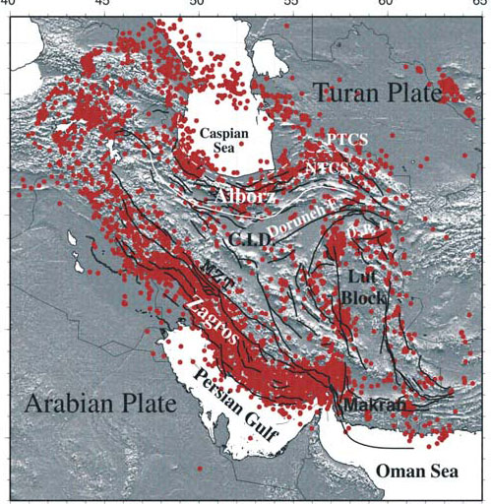

Fig. 1-2. Distribution of earthquake epicenters – red circles - in the Middle East due to (Alinaghi et al., 2007). We can see known Lut Block and immediately next to the east - studied East Iran mobile zone area (Hushmandzadeh et al., 1987, E. Romanko et al., 1984, etc.).

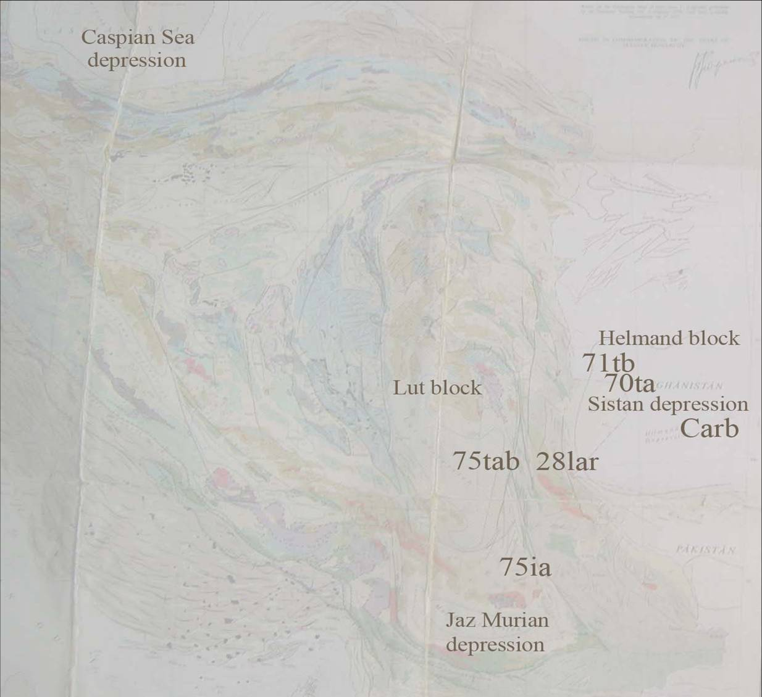
Abbas Abad

Fig.1-3. Magmatic rocks sample position in East Iran using Geological map scale 5: 000 000. R-70, R-71 – intraplate rocks in Sistan, R-75ia - High K-dacite with a high crystallization temperature as shown in text, Carb = carbonatites of Hanneshin, Afghanistan, R-28 – Lar alkaline intrusion with Cu-Au porphyry mineralization, Abbas Abad – important area with Cu deposits, tab = basic trachyandesite, tb = trachybasalt.

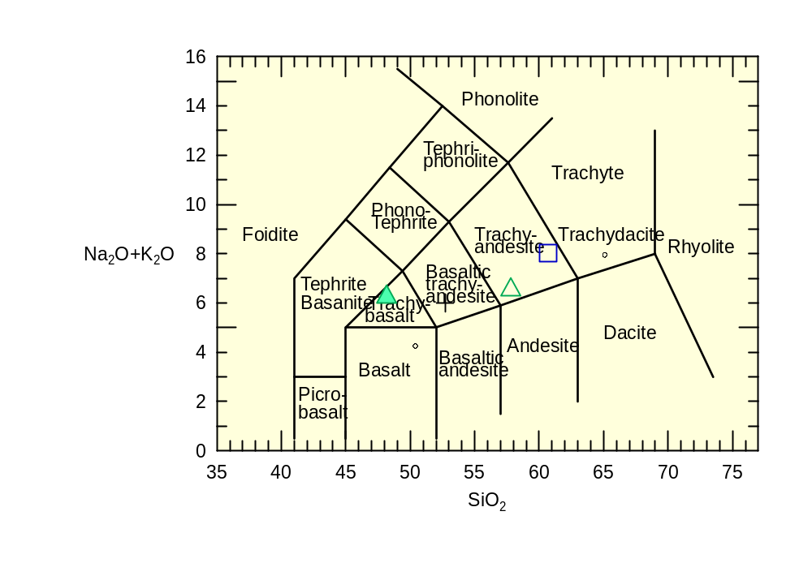

Fig.2-1. Na₂O+K₂O (wt %) versus SiO₂ (wt %) or TAS diagram. Triangles - intraplate rocks of East Iran, N? age, quadrangle – Lar alkaline intrusive massif with Cu-Au mineralization, Pg3? age, E. Iran/ W. Afghanistan border. Dot – trachydacite of shoshonite – latite series, Kurama zone, Tien-Shan, C3-P1, analogue of Pg2 shoshonite – latite series (Lesser Caucasus - Central Iran - East Iran).

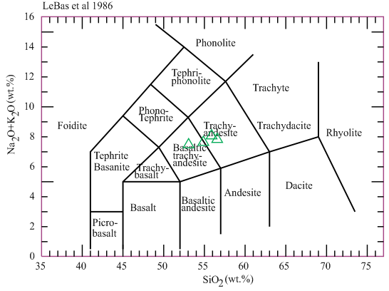

Fig.2-2. Na₂O+K₂O (wt %) versus SiO₂ (wt %) or TAS diagram for the Abbas Abad Cu-mining area, Central Iran (NE Iran by a formal geography), Pg2? age. Samples of M. Heidari et al.

These intraplate rocks, in contrast to subduction-related calc-alkaline and other rocks, are characterized by an enrichment in both LILE - K, Rb, Ba, Cs and HFSE - Nb, Y, Ta, Zr, Ti, P, etc. (Tables or tab. 1, 5-11, fig. 3) with a characteristical positive Eu/Eu* - more than 1.0-1.1. Also, increased content of P₂O₅ - sometimes more than 1.0% (very high) - is a characteristic feature of intraplate rocks.
We have received fair low isotopic data ⁸⁷Sr/⁸⁶Sr (ISr) in two samples of intraplate rocks of the second type - trachyandesites R70-2 – 0.7039 ÷ 0,2 (high K/Rb=393) and trachybasalt R71-4 – 0.70489 ÷ 0,18 (K/Rb=375, fig. 4). For subduction-related calc-alkaline andesite of stratovolcano Bazman, sample R-25 was determined a rather low value ISr = 0.70456 ÷ 0.05, K/Rb=250 (tab. 1). Isotopic data of these our intraplate rocks differ from collisional and subduction-related rocks from Anatolia, Turkey (Khain, 2001; Imamverdiyev, 2008 etc.). Igneous rocks of the volcanic rocks are fully differentiated series of the regional known Sahand – Bazman belt. Known mainly andesite stratovolcanoes in this belt are: Bazman with a height 3490m and Taftan - 3940m (old mark was 4042m). Old 0.7049 isotopic date for a ‘volcanite’ of an unnamed volcano in a desert was reported by Canadian team (Camp, Griffis, 1982).

Table 1. Major- and trace-element composition in the rocks studied

Sample | 1 | 2 | 3 | 4 | 5 | 6 | 7 | 8 | 9
SiO₂  TiO₂  Al₂O₃  Fe₂O₃  FeO  MnO  MgO  CaO  Na₂O  K₂O  P₂O₅  Rb  Ba  Sr  Ni  Co  Cr  V  Cu  Zn  Pb  Zr  Y  Nb  Sc  Th  U  La  Ce  Nd  Sm  Eu  Gd  Tb  Er  Yb  K/Rb | 48.17  2.20  3.80  9.32  2.56  0.14  5.75  8.98  4.93  1.31  0.23  30  375  1185  86  33  64  220  63  113  5  283  25  23  19  3  1.2  44  101  -  -  -  -  -  -  -  560 | 57.80  1.31  17.48  4.37  1.07  0.09  2.27  7.10  5.11  1.42  0.61  19  293  912  53  14  60  95  65  88  20  232  19.5  17  10.7  3.65  0.99  32.4  68.3  31.4  6.00  2.11  5.08  0.78  1.64  1.26  620 | 54.50  1.87  15.94  6.39  0.40  0.09  3.37  7.58  5.81  1.73  1.05  20  -  4470  58  -  38  -  64  113  51  339  25  19  -  -  -  -  -  -  -  -  -  -  -  -  586 | 54.00  1.52  -  6.25  -  0.08  -  7.40  -  1.09  -  15  292  950  59  -  <64  -  77  98  5  217  15  -  26.2  4.84  1.31  30  63  -  -  -  -  -  -  -  581 | 60.69  0.36  15.32  2.70  2.07  0.09  3.65  3.90  3.64  4.38  0.31  145  1230  870  50  12  50  81  69  32  20  96  15  5.8  10  12  1  18  32  -  -  -  -  -  -  -  245 | 65.39  0.42  13.71  3.25  -  0.057  1.39  2.08  2.87  4.51  0.11  117  577  232  7  5  16  63  15  40  27  158  11  8  -  -  -  -  -  -  -  -  -  -  -  -  307 | 65.10  0.51  15.54  2.42  2.32  0.13  1.72  2.80  3.36  4.59  0.20  109  1597  359  13  6  18  54  11  57  22  246  29  12  -  16.7  4.62  34.0  64.5  27  5.6  1.3  4.1  -  1.9  1.7  350 | 85.00  0.60  4.00  3.21  1.10  0.02  0.52  0.29  0.28  0.21  0.09  7  390  440  10  4  11  55  17  8  20  136  13  6  6.5  1  3  15  28  -  -  -  -  -  -  -  230 | 58.67  1.70  15.13  6.69  2.19  0.09  2.28  1.77  5.06  2.05  0.30  47  557  263  44  21  72  107  33  82  10  219  23  30  10  12  3  35.2  64.2  25.0  5.1  1.9  4.8  0.9  1.6  1.6  350

1 and 2 - trachybasalt (sample R71-4) and trachyandesite (sample R70-2) correspondently, Haji lake, Neogene (?), Afghan block, 3 - trachyandesite, Baluchestan, Iran (Camp, Griffis, 1982), 4 - trachyandesite, R75wp, Lut block, 5 - syenite, Lar intrusiion with Cu-Au mineralization, Miocene(?) 6 – K-dacite, R75, Lut block, and 7 - trahydacite, standard, Kurama Ridge Middle Tien Shan, Karamazar, Tajikistan, Late Carboniferous - Early Permian, using data and extrapolation from (Rusinov, Kovalenker, 1991; Razdolina, Moralev et al., 1993; Mamajanov, 2005; Romanko et al., 1989) 8 - leucorhyolite, R-82, East Bazman volcano, Quarternary(?), 9 - trachyandesite, continental rift, standard, Proterozoic, Pechenga area, Fennoscandian or Baltic shield, by Romanko et al., 1989.
Table 2. Chemistry of melt inclusions glass (wt %) in plagioclase (1, 3), host mineral (2, 4), host acid K-volcanite (5), rhyolite from Bazman stratovolcano, and plagioclase standards (7-9) due to A. Betekhtin, 1953.

Sample | SiO₂ | TiO₂ | Al₂O₃ | FeO | MnO | MgO | CaO | Na₂O | K₂O | P₂O₅ | Cl | S | Sum
1 | 74.77 | 0.19 | 12.94 | 0.58 | 0.08 | 0.12 | 1.52 | 3.88 | 3.93 | 0.26 | 0.00 | 0.01 | 98.28
2 | 58.69 | 0.01 | 24.77 | 0.23 | 0.00 | 0.01 | 6.68 | 7.22 | 0.49 | 0.00 | 0.00 | 0.01 | 98.11
3 | 74.48 | 0.15 | 14.53 | 0.53 | 0.04 | 0.10 | 1.69 | 3.02 | 4.10 | 0.00 | 0.01 | 0.01 | 98.66
4 | 58.36 | 0.00 | 24.71 | 0.28 | 0.02 | 0.05 | 7.15 | 6.90 | 0.46 | 0.04 | 0.00 | 0.01 | 97.98
5  6  7  8 | 65.39  85.00  58.16  56.05 | 0.42  0.60  -  - | 13.71  4.50  26.57  28.01 | 2.93  3.98  -  - | 0.06  0.02  -  - | 1.39  0.52  -  - | 2.08  0.29  8.35  10.1 | 2.87  0.28  6.92  5.89 | 4.51  0.21  -  - | 0.11  0.09  -  - | -  -  -  - | - | -  -  -
9 | 62.43 | - | 23.70 | - | - | - | 5.03 | 8.84 | - | - | -

1, 3 - melt inclusions glasses in plagioclase, 2, 4 - host minerals, 5 – hosted Hi-K-volcanite, sample R-75, 6 – leucorhyolite from stratovolcano Bazman, Quaternary(?), 7-9 plagioclase standards: 7 - andesite, SiO₂ = 58.16, empirical formula - Na_{0.6}Ca_{0.4}Al_{1.4}Si_{2.6}O₈, chemical formula andesite - (Na, Ca) (Si, Al)₄O₈, Webmineral.com, 8 - 9 - plagioclase theoretical composition: An₅₀ (8) and An₂₅ (9), by A. Betekhtin, Moscow, 1953.

Table 3. Sum of gases by thermobarogeochemistry (cub. cm / kg)
Sample | Sum of gase (Cubic cm/kg) | Rock, age, notes
1. R26 | 0.933 | subvolcanites and shallow intrusions, West Taftan volcano, diorites, probably Miocene
2. R38 | 1.022 | Lar intrusion, Oligocene-Miocene
3. R61 | 0.401 | ophiolites, Cretaceous
4. R85 | 0.655 | ophiolites, Cretaceous
5. R35 | 12.942 | Subvolcanites intruding CARBONATIC rocks, West Taftan stratovolcano,  maximal contain, probably Oligocene-Miocene. Highest content.
6. R66 | 1.262 | Young Cu-Zn-Pb mineralization with Au and Ag, Taftan stratovolcano, probably Quaternary
Sum of gases includes H2, O2, N2, CO2, CH4, C2H6, C3H8, C4H10, C5H12, and C6H14. Temperature of Au mineralization is 220 – 278oC, Oligocene-Quaternary, important Lar intrusive massif with Au up to 25.4 ppm, T = 220–226oC by analyst R. Mudrogova, VNIIYG GB or Nuclear geophysics Institute, Moscow region (E. Romanko et al., 2000). Maximum of gases are in subvolcanites intruding CARBONATIC rocks. Minimum of gases are in ophiolite mélange rocks.

Table 4. ⁸⁷Sr/⁸⁶Sr (ISr) isotopic data from the rocks
Sample | ⁸⁷Sr/⁸⁶Sr | Rock, mineral, age, notes
1. | 0,7039+-0,0002 | Trachyandesite, sample R-70-2, Hilmand (Afghan) block, maybe Neogene
2. | 0,70489+-0,00018 | trachybasalt, R71-4, lake Haji area, Hilmand (Afghan) block, maybe Neogene
3. | 0,70456+-0,00005 | calk-alkaline basic andesite, R-25-1, East Bazman volcano, Neogene-Quaternary

4. | 0,7049 | ‘volcanite’ by Camp and Griffis, 1982, No data about age
5. | 0,7047+-0,0003 | biotite from trachybasalt, sample 64, Shurab - Galecha, Eocene
6. | 0,7048+-0,0003 | dacite, sample 166, Eocene
7. | 0,7051 | andesite, sample 206, Eocene
8. | 0,7055 | biotite from andesite, sample 203, Cheh-meh-Huri, Eocene
9. | 0,7059 | andesite, sample 193-A, no age data
10. | 0,7051 | biotite from dacite, sample 143, Gazu area, no age
11. | 0,7043 | granodiorite, sample 146, no age data
12. | 0,7045 | granodiorite, sample 151, no age data
13. | 0,7051+-0.0003 | biotite from granodiorite, Gazu area, Campanian
14. | 0,7048+-0,0003 | biotite from dacite, Shurab-Galecha, Eocene
15. | 0,7056+-0.0002 | plagioclase from dacite, Eocene
16. | 0,7065+-0.0003 | biotite from dacite, Kuh-Berg, Eocene
17. | 0,7070+-0.0003 | granodiorite, Sor-Kuh, Middle Jurassic
18. | 0,7041+-0.0001 | Late Cenozoic magma, ENd= +4.1 +- 0.2, Great Caucasus
19. | 0,7040 | Late Cenozoic magma, ENd= +3, Great Caucasus

1-3 - author’s data, 4 - after (Camp, Griffis, 1982), 5-9 – Lut block, immediately west from
East Iranian zone, after Sandwall E., Turkell N. Zor E. et al., 2003;
18-19 – Geat Caucasus, courtesy of I. Chernyshev, S. Bubnov, A. Lebedev et al., IGEM, RAS, Moscow.

Table 5. Composition of rock-forming and accessory minerals

Sample | 1 | 2 | 3 | 4 | 5 | 6 | 7 | 8 | 9 | 10 | 11 | 12 | 13
SiO₂  TiO₂  Al₂O₃  Fe₂O₃  FeO  MnO  MgO  CaO  Na₂O  K₂O  P₂O₅ | 55.45  0.26  1.51  -  11.66  0.24  28.21  1.89  0.32  -  0.18 | 54.11  0.19  1.52  -  15.73  0.34  27.01  1.16  -  -  - | 55.20  0.22  1.50  -  12.7  0.28  28.14  1.93  -  -  - | 43.79  1.88  11.37  -  13.68  0.28  15.16  10.55  2.08  0.49  - | 44.65  1.71  7.88  -  13.05  0.27  14.23  10.48  1.31  0.38  - | 46.25  1.84  7.69  - 13.39  0.24  15.32  10.42  1.48  0.44  - | 46.87  1.36  6.40  -  15.00  0.03  13.68  11.51  1.40  0.75  - | 53.86  -  29.51  -  -  -  -  8.97  5.55  0.28  - | 54.54  -  28.22  -  -  -  -  9.99  5.59  0.34  - | 64.49  0.26  17.82  -  2.79  0.16  0.85  1.87  9.90  1.78  - | 68.94  -  17.20  -  1.12  -  0.15  0.47  7.09  4.96  0.22 | 68.61  0.13  17.85  -  0.96  -  0.15  0.70  7.55  3.71  0.22 | 0.018  29.79  0.02  -  62.11  0.17  1.60  0.08  -  -  -

1-3 – Orthopyroxenes, 2-3 – standard bronzites, orthopyroxenes, 2 – from andesite and 3 – from Hb-norite, by H. Kuno,1964; 4-7 – amphiboles; 8-9 – plagioclases; 10-12 – alkali feldspars; 13 – magnetite.

Table 6. Major elements composition in the rocks

Sample | 1 | 2 | 3 | 4 | 5 | 6 | 7 | 8 | 9 | 10 | 11 | 12 | 13
SiO₂  TiO₂  Al₂O₃  Fe₂O₃  FeO  MnO  MgO  CaO  Na₂O  K₂O  P₂O₅ | 48.17  2.20  13.80  9.32  2.56  0.14  5.73  8.98  4.93  1.31  1.11 | 49.0  1.69  14.1  9.10  - 0.11 9.23 7.72 3.06 1.84 0.40 | 52.76  1.11  17.44  3.14  5.40  0.13  5.55  8.62  3.46  1.31  0.40 | 54.50  1.87  15.94  6.39  0.40  0.09  3.37  7.58  5.81  1.73  0.51 | 56.95  1.27  16.40  5.28  0.46  0.08  3.35  6.80  5.33  1.50  0.59 | 57.80  1.31  17.48  4.37  1.07  0.09  2.27  7.10  5.11  1.42  1.05 | 35.10  0.74  13.48  7.53  0.73  0.16  5.46  26.66  0.80  0.10  0.16 | 44.26  0.81  12.70  4.81  0.87  0.12  6.60  17.10  2.96  0.42  0.38 | 46.10  0.49  10.30  5.10  -  0.08  9.00  15.86  0.86  2.36  0.12 | 56.7 0.60  11.1 4.90  - 0.10 4.85  12.0 1.84 1.95 0.12 | 60.69  0.36  15.32  2.70  2.07  0.09  3.65  3.90  3.64  4.38  0.31 | 61.79  0.52  17.10  1.16  3.53  0.10  3.04  5.25  4.11  1.58  0.19 | 85.00  0.60  4.05  2.51  1.21  0.02  0.37  1.55  0.28  0.21  0.03

1-10 – Hilmand (Afghan) block: 1-3 – trachybasalts, 11 – syenite, Lar massif, 12 – 13 – Bazman volcano, Neogene – Quaternary, author’s data; 2, 7,10 – data by А. Houshmandzadeh and M.A.A. Nogol Sadat et al., 3 and 4 – (Camp, Griffis, 1982), ‘–‘ not determined.

Table 7. Rare Earth Elements (REE) in the rocks studied and standards
Sample | 1 | 2 | 3 | 4 | 5 | 6 | 7 | 8 | 9 | 10
La | 32.4 | 32.1 | 44.8 | 18.6 | 35.2 | 34 | 63 | 78 | 31.3 | 23
Ce | 68.3 | 69.3 | 91.9 | 37.7 | 64.2 | 71 | 115 | 50 | 50.8 | 43
Pr | 8.23 | 8.05 | 9.80 | 4.32 | - | - | - | - | - | -
Nd | 31.4 | 32.9 | 37.8 | 17.7 | 25.0 | 43 | 70 | 63 | 21.3
Sm | 6.00 | 5.98 | 7.24 | 3.92 | 5.1 | 10 | 17 | 12 | 4.09 | 4.72
Eu | 2.11 | 1.83 | 1.31 | 1.23 | 1.9 | 3.0 | 4.5 | 4.0 | 1.26 | 1.56
Gd | 5.08 | 5.55 | 6.19 | 4.20 | 4.8 | 7.5 | 11 | 10 | 3.42
Tb | 0.78 | 0.71 | 0.70 | 0.54 | - | - | - | - | 0.55 | 1.93
Dy | 3.20 | 3.13 | 3.76 | 3.50 | - | - | - | - | -
Ho | 0.68 | 0.57 | 0.64 | 0.69 | - | - | - | - | -
Er | 1.26 | 1.40 | 1.93 | 2.21 | 1.6 | 2.8 | 3.7 | 2.9 | 1.79
Tm | 0.31 | 0.26 | 0.26 | 0.32 | - | - | - | - | -
Yb | 1.26 | 1.10 | 1.74 | 2.23 | 1.6 | 1.8 | 2.4 | 2.8 | 1.94 | 1.97
Lu | 0.34 | 0.23 | 0.25 | 0.34 | - | - | - | - | -
1-4 - intraplate rocks in West Baluchestan: 1-2 – trachyandesites, Neogene (r70-2 and r70-23 samples, analytics by A. Housmandzadeh and M.A.A. Nogol Sadat support); Helmand basin, 3-4 – subalkaline rocks, Lut block (r75-1 and r75-2); 1-4 - analytics by A. Housmandzadeh and M.A.A. Nogol Sadat support; 5-trachyandesite, standard, continental rift, Paleoproterozoic, Kuetsjarvi unit, Pechenga zone, Fennoscandian Shield by A. Romanko et al.; 6-8 – basalt and dolerite (intraplate standard rocks), continental rift, Jurassic, Karoo formation, Save-Limpopo rift, Zimbabwe, E. and A. Romanko; 9 – trachyandesite, Eocene, subduction-related setting, sample BH-13 from a well, Talmessi deposit, Central Iran, courtesy of H. Bagheri, 10- trachybasalt, sill, sample Ta-39, Eocene, Lesser Caucasus, Imamverdiyev, 2010.

Table 8. Composition of glass in acid volcanite R-82, East Bazman stratovolcano, T crystallization = 690oC, content of H2O = 6 wt%.

Sample | SiO₂ | TiO₂ | Al₂O₃ | FeO | MnO | MgO | CaO | Na₂O | K₂O | P₂O₅ | Cl | S | Sum | Rastr
1 | 72.70 | 0.10 | 10.88 | 0.68 | 0.05 | 0.08 | 0.68 | 2.49 | 3.69 | 0,04 | 0.11 | 0.02 | 91.52 | 12 x 12
2 | 72.78 | 0.14 | 11.39 | 0.75 | 0.07 | 0.12 | 0.74 | 2.63 | 3.69 | 0,02 | 0.13 | 0.04 | 92.50 | 12 x 12
3 | 72.59 | 0.14 | 11.40 | 0.71 | 0.05 | 0.12 | 0.72 | 2.22 | 3.74 | 0.03 | 0.12 | 0.03 | 91.87 | 20 x 20
5 | 71.44 | 0.07 | 11.10 | 0.71 | 0.06 | 0.13 | 0.77 | 2.64 | 3.57 | 0.04 | 0.16 | 0.01 | 90.70 | 12 x 12
6 | 71.96 | 0.09 | 11.17 | 0.62 | 0.00 | 0.16 | 0.74 | 2.78 | 3.70 | 0.14 | 0.13 | 0.03 | 91.52 | 12 x 12
7 | 72.03 | 0.13 | 11.12 | 0.72 | 0.07 | 0.13 | 0.79 | 2.88 | 3.71 | 0.15 | 0.15 | 0.01 | 91.89 | 12 x 12
8 | 72.61 | 0.06 | 11.31 | 0.72 | 0.00 | 0.13 | 0.71 | 2.83 | 3.75 | 0.12 | 0.16 | 0.02 | 92.42 | 12x 12
1-8 – composition of glass inclusion in Quartz of acid volcanite, rhyolite R-82, East Bazman stratovolcano, T of crystallization = 690oC, High content of H2O = 6 wt%. There are many sulfides in a sample correlated with higher content of Cu, Zn etc. in a sample R-82. Analyses led by V. Prokofiev.

Table 9. Rare, trace (ppm) and major (%) elements composition
sample | Ni Cu Zn | Ga Pb Rb Sr Y | Zr | Fe₂0₃t | K₂0 | CaO | Ti0₂ | Cr₂0₃ | MnO | Ba | La | Ce
1. 75-WP  2. 71-4  3. 71-42  4. 71-43  5. 70-32  6. 70-4  7. 70-5  8. 70-6  9. 70-7  10. 70-8  11. 70-9  12. 70-10  13. 70-11  14. 70-12  15. 70-13  16. 70-14  17. 70-15  18. 82-5 | 59 77 98 14 5 15 950 15  77 75 113 13 6 18 1138 24  87 63 197 14 5 14 1097 22  82 68 110 14 6 16 1115 23  40 131 71 9 26 5 181 18  43 166 164 6 20 5 505 17  162 86 89 10 13 20 751 13  136 65 79 11 10 22 782 18  49 77 86 14 13 16 992 15  42 77 87 13 5 13 1106 16  38 60 83 14 6 14 875 14  67 80 93 16 12 16 683 9  52 62 92 17 8 16 943 15  50 85 89 15 9 17 900 15  57 57 79 12 14 20 917 17  51 60 83 19 8 15 863 18  67 80 93 16 12 16 683 9  20 70 170 18 - 93 52 36 |  | 217  245  223  234  91  146  186  180  208  205  183  100  215  205  201  203  199  516 | 6.25 1.09 7.40 1.52 <64  9.96 1.10 9.73 2.49 64  9.56 1.23 10.19 2.02 <64  9.8 1.16 9.73 2.49 64  7.39 0.02 34.89 0.48 <64  4.72 0.32 21.32 0.63 <64  5.91 1.31 10.88 1.12 0.04  5.86 130 10.47 1.14 0.03  6.01 1.09 7.90 1.50 64  6.24 1.11 8.04 1.52 <64  5.11 1.55 6.54 1.27 <64  5.62 1.46 7.87 1.53 <64  6.21 1.30 7.04 1.64 <64  6.10 1.47 7.63 1.38 <64  5.96 1.37 8.19 1.36 <64  5.06 1.47 6.93 1.31 <64  5.62 1.46 7.87 1.53 <64  7.81 4.35 0.99 1.12 <64 |  |  |  |  | 0.08  0.13  0.12  0.13  0.12  0.09  0.08  0.07  0.07  0.07  0.07  0.08  0.08  0.08  0.08  0.06  0.08  0.12 | 292 30 63  376 40 111  375 44 101  376 40 106  40 13 14  155 20 37  310 28 57  304 23 55  319 21 69  334 35 64  270 30 69  318 31 68  273 30 58  324 32 68  379 35 67  292 28 64  318 31 68  781 56 104
1- 17 – intraplate rocks, Baluchestan and Sistan Province: 1- Lut block (R-75wp, sample of E. Romanko), 2-4 temporary Haji lake, north from Zabol, 5-17 – unnamed volcano in desert, 18 – important calc-alkaline rhyolite R-82, T crystallization = 690oC, H2O = 6 wt.%, east Bazman stratovolcano, Quaternary ?. “-“means below resolution concentration. XRF is by TEFA–3 techniques.

Table10. ICP-MS data (ppm) on volcanites and ore sample
 | 1 | 2 | 3 | 4 | 5
Sample | 5s12 | 1s59 | 9s66 | 3as1 | 9s15
Li | 42 | 50 | 40 | 45 | 43
Be | 1,9 | 2,3 | 2,1 | 1,6 | 2,8
Sc | 10,3 | 11,3 | 9,7 | 12,1 | 9,7
Ti | 3787 | 4097 | 3786 | 4060 | 3769
V | 142 | 137 | 138 | 165 | 138
Cr | 19 | 12 | 6,9 | 17 | 11
Mn | 670 | 731 | 1025 | 786 | 671
Co | 12 | 14 | 13 | 18 | 12
Ni | 4,5 | 3,6 | 1,8 | 6,5 | 2,4
Cu | 853 | 38 | 284 | 13 709 | 62
Zn | 91 | 95 | 125 | 91 | 44
Ga | 28 | 28 | 27 | 27 | 26
Rb | 115 | 101 | 69 | 104 | 78
Sr | 886 | 915 | 1309 | 814 | 938
Y | 17 | 18 | 18 | 17 | 17
Zr | 130 | 144 | 134 | 130 | 132
Nb | 7,0 | 7,5 | 6,9 | 7,5 | 6,9
Mo | 0,94 | 1,1 | 0,74 | 3,1 | 1,0
Cs | 8,4 | 2,4 | 10 | 4,1 | 36
Ba | 512 | 639 | 517 | 534 | 512
La | 28 | 29 | 29 | 26 | 30
Ce | 54 | 59 | 58 | 54 | 57
Pr | 6,8 | 7,3 | 7,2 | 6,7 | 7,0
Nd | 26 | 29 | 28 | 27 | 27
Sm | 5,0 | 5,4 | 5,3 | 5,1 | 5,2
Eu | 1,5 | 1,6 | 1,6 | 1,6 | 1,6
Gd | 4,7 | 5,3 | 5,0 | 5,0 | 5,0
Tb | 0,64 | 0,71 | 0,67 | 0,67 | 0,67
Dy | 3,4 | 3,9 | 3,7 | 3,6 | 3,6
Ho | 0,70 | 0,75 | 0,74 | 0,72 | 0,71
Er | 2,0 | 2,2 | 2,2 | 2,1 | 2,1
Tm | 0,28 | 0,32 | 0,31 | 0,30 | 0,31
Yb | 2,0 | 2,2 | 2,2 | 2,0 | 2,1
Lu | 0,29 | 0,33 | 0,32 | 0,30 | 0,30
Hf | 3,2 | 3,6 | 3,4 | 3,2 | 3,3
Ta | 0,44 | 0,47 | 0,42 | 0,45 | 0,43
W | 0,71 | 1,8 | 0,49 | 0,82 | 0,73
Pb | 14 | 16 | 14 | 14 | 15
Bi | 0,03 | 0,003 | 0,022 | 0,091 | 0,085
Th | 6,8 | 7,6 | 7,3 | 6,9 | 7,2
U | 2,1 | 2,4 | 2,6 | 2,4 | 2,0
1-5 – volcanites including Cu-rich ones, Eocene (Pg2)?, Abbas Abad
Cu mining area, samples of M. Heidari.

Table 11. Trace elements in rocks (ppm)
Sample | Rb | Sr | Y Zr Nb Ba | V Ni Co Cr | Sc | As U Th
1.R71-4  2.R70-8  3.R70-28  4.R70-27  5.70.272  6.R28-59  7.34-24 | 16  16  17  3.8  4.1  145  6.7 | 1290  970  970  510  170  1230  170 | 25 270 38 380  14 220 15 380  16 220 16 340  12 130 11 140  16 75 5.5 120  13 110 5.8 870  23 85 8.4 76 | 240 72 35 100  95 32 14 53  100 36 13 54  89 26 12 72  130 20 2.8 21  81 50 12 55  34 7 5.3 39 | 25  14  13  16  27  15  5 | 13 <1 <1  8.9 <1 1.8  10 <1 2.9  19 <1 3.3  17 4.2 3.6  7.9 6.3 12  4.8 1 14
R-71-4 - trachybasalt, samples R-70 – trachyandesites and associated intraplate rocks, 28-59- syenite,
Lar, intrusive massif, N1?, 34-24 – acid subduction-related dacite, N. Pamirs, Late Permian (P2), V. Novikov,
A. Romanko et al, 1992, for comparing. XRF, ppm, Geological Institute, RAS.

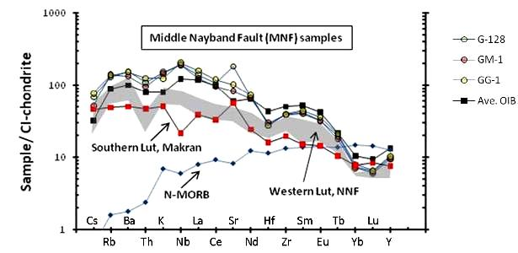
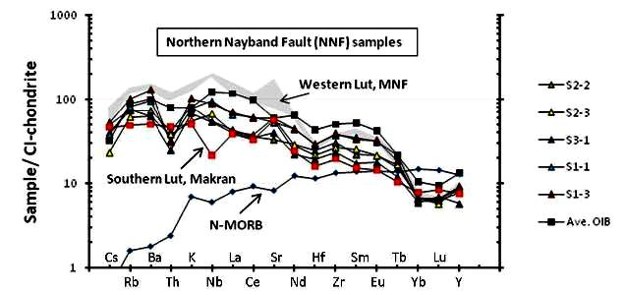

Fig.3. The distribution of the contents of rare and trace elements normalized to chondrite composition (Sun, McDonaugh, 1989), using (Saadat S, Stern C.R., 2011).

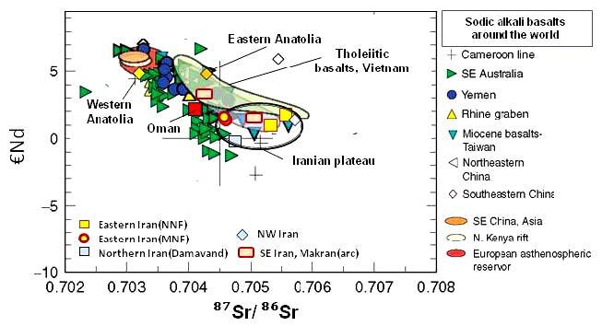

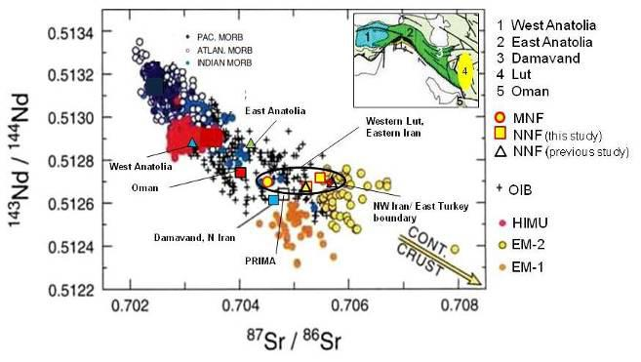

Fig. 4. Isotope systematics of igneous rocks in the region and standards using (Saadat S, Stern C.R., 2011).

Inclusions

Melt inclusions in this region were firstly investigated under the leadership of Prof. Prokofiev, IGEM RAS as well as fluid inclusions by E. Romanko et al. in 2000. Some notes and conclusions here are as folllows:
- Melt inclusions are not typical for the African super-plume-related intraplate igneous rocks. Intraplate rocks are confirmed by a tomography of known Ritsema’s team (Bull et al., 2009 etc). Also, melt inclusions are not typical or rare for shoshonite series rocks of Abbas Abad area. T crystallization of melt inclusions in similar Eocene shoshonite series rocks with Fe-skarn mineralization, West Iran is fairly high - ca 300oC by V. Prokofiev et al.
- unusual fairly high temperature, 1150-1180º C - up to 1220º C melt inclusions were revealed in plagioclase of subduction-related K-dacite, sample 75-l by V. Prokofiev et al, 2011 (Prokofiev, 2000; Romanko et al., 2012, Fig. 5 and 6, Tables 2, 8.). This fairly deep, non-calc-alkaline rock was also affected by indirect (?) influence of a huge African super-plume, as proposed. Homogenization occurs under High T = 1150-1220º C (for comparing, for example, T much lower for acid volcanite of Quaternary Pektusan volcano, Korea, paper of O. Andreeva et al., IGEM RAS, Moscow, 2013). A higher viscosity of a glass provides more inclusions coexistence in a sample.
Maximal concentration on fluid CH₄ and other CH-based fluid inclusions were revealed in shallow intrusions on the contact with carbonate-rich host rocks in west Taftan zone; also in important Lar syenite massif with Cu-Au mineralization (Table 3, E. Romanko et al., 2000). Opposite, minimal data are in Cretaceous ophiolitic mainly melange rocks.

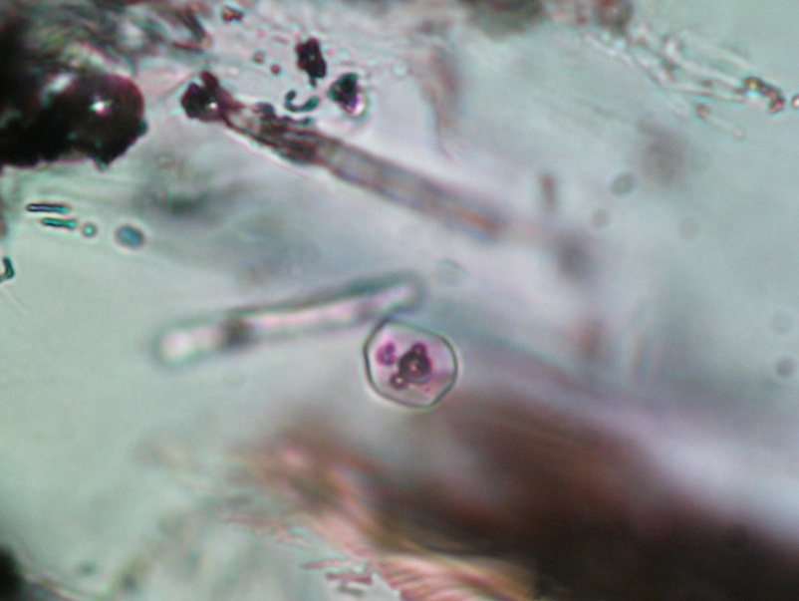

Fig 5. Sample R-75ia. East Iran. T=1150ºC. View of melt inclusions in acid glass from Plagioclase

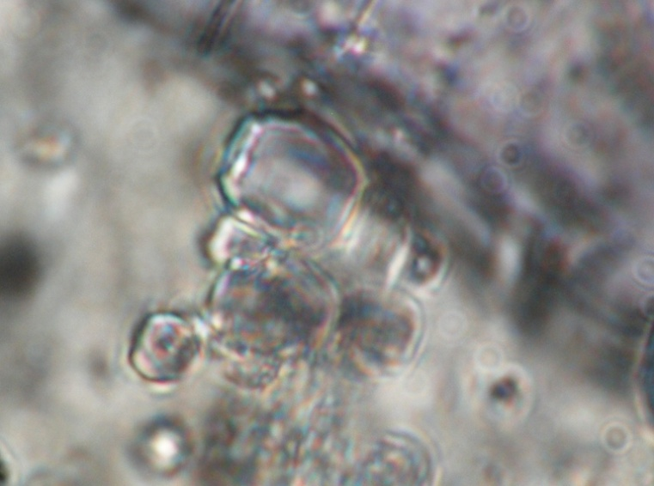

Fig 6. Sample R-75ia. Broad T interval in general is 1150-1220oC. Homogenization of melt inclusions.

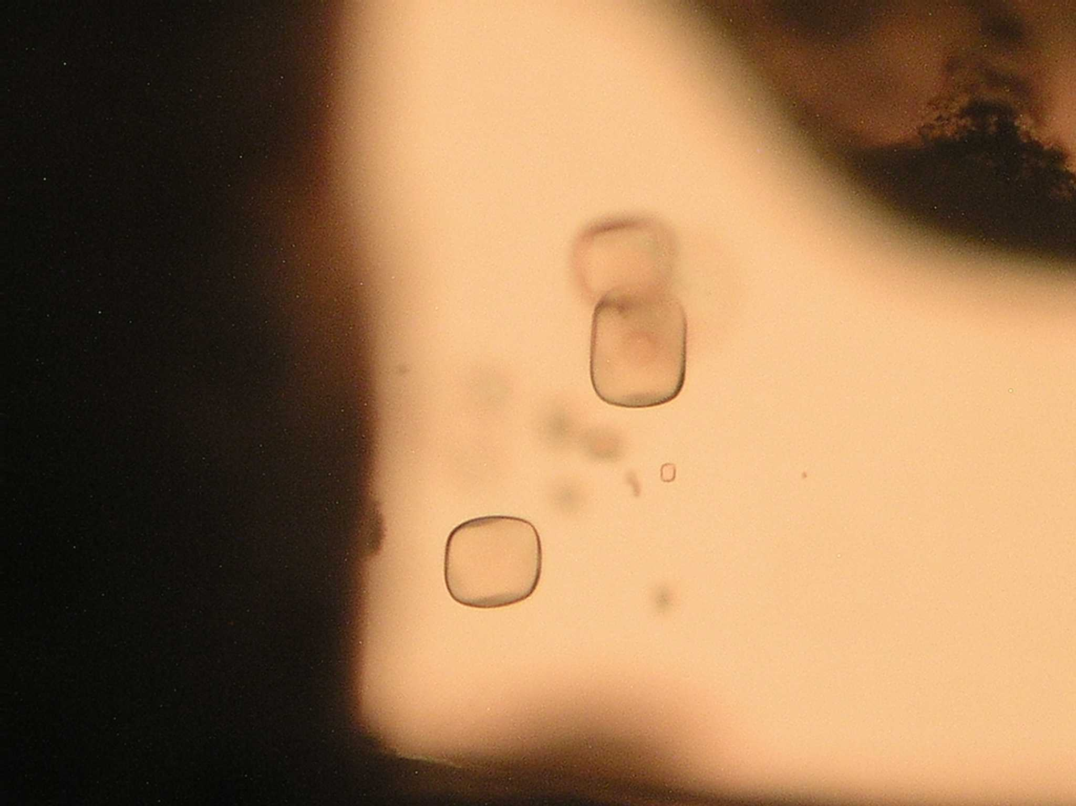

Fig7. Sample R-82. Melt inclusions in Quartz, rhyolite, East Bazman volcano, T = 690oC. H2O content = 6 wt%. Naturally chilled melt inclusion. Maximal size of inclusion is ca 60 µm or microns.

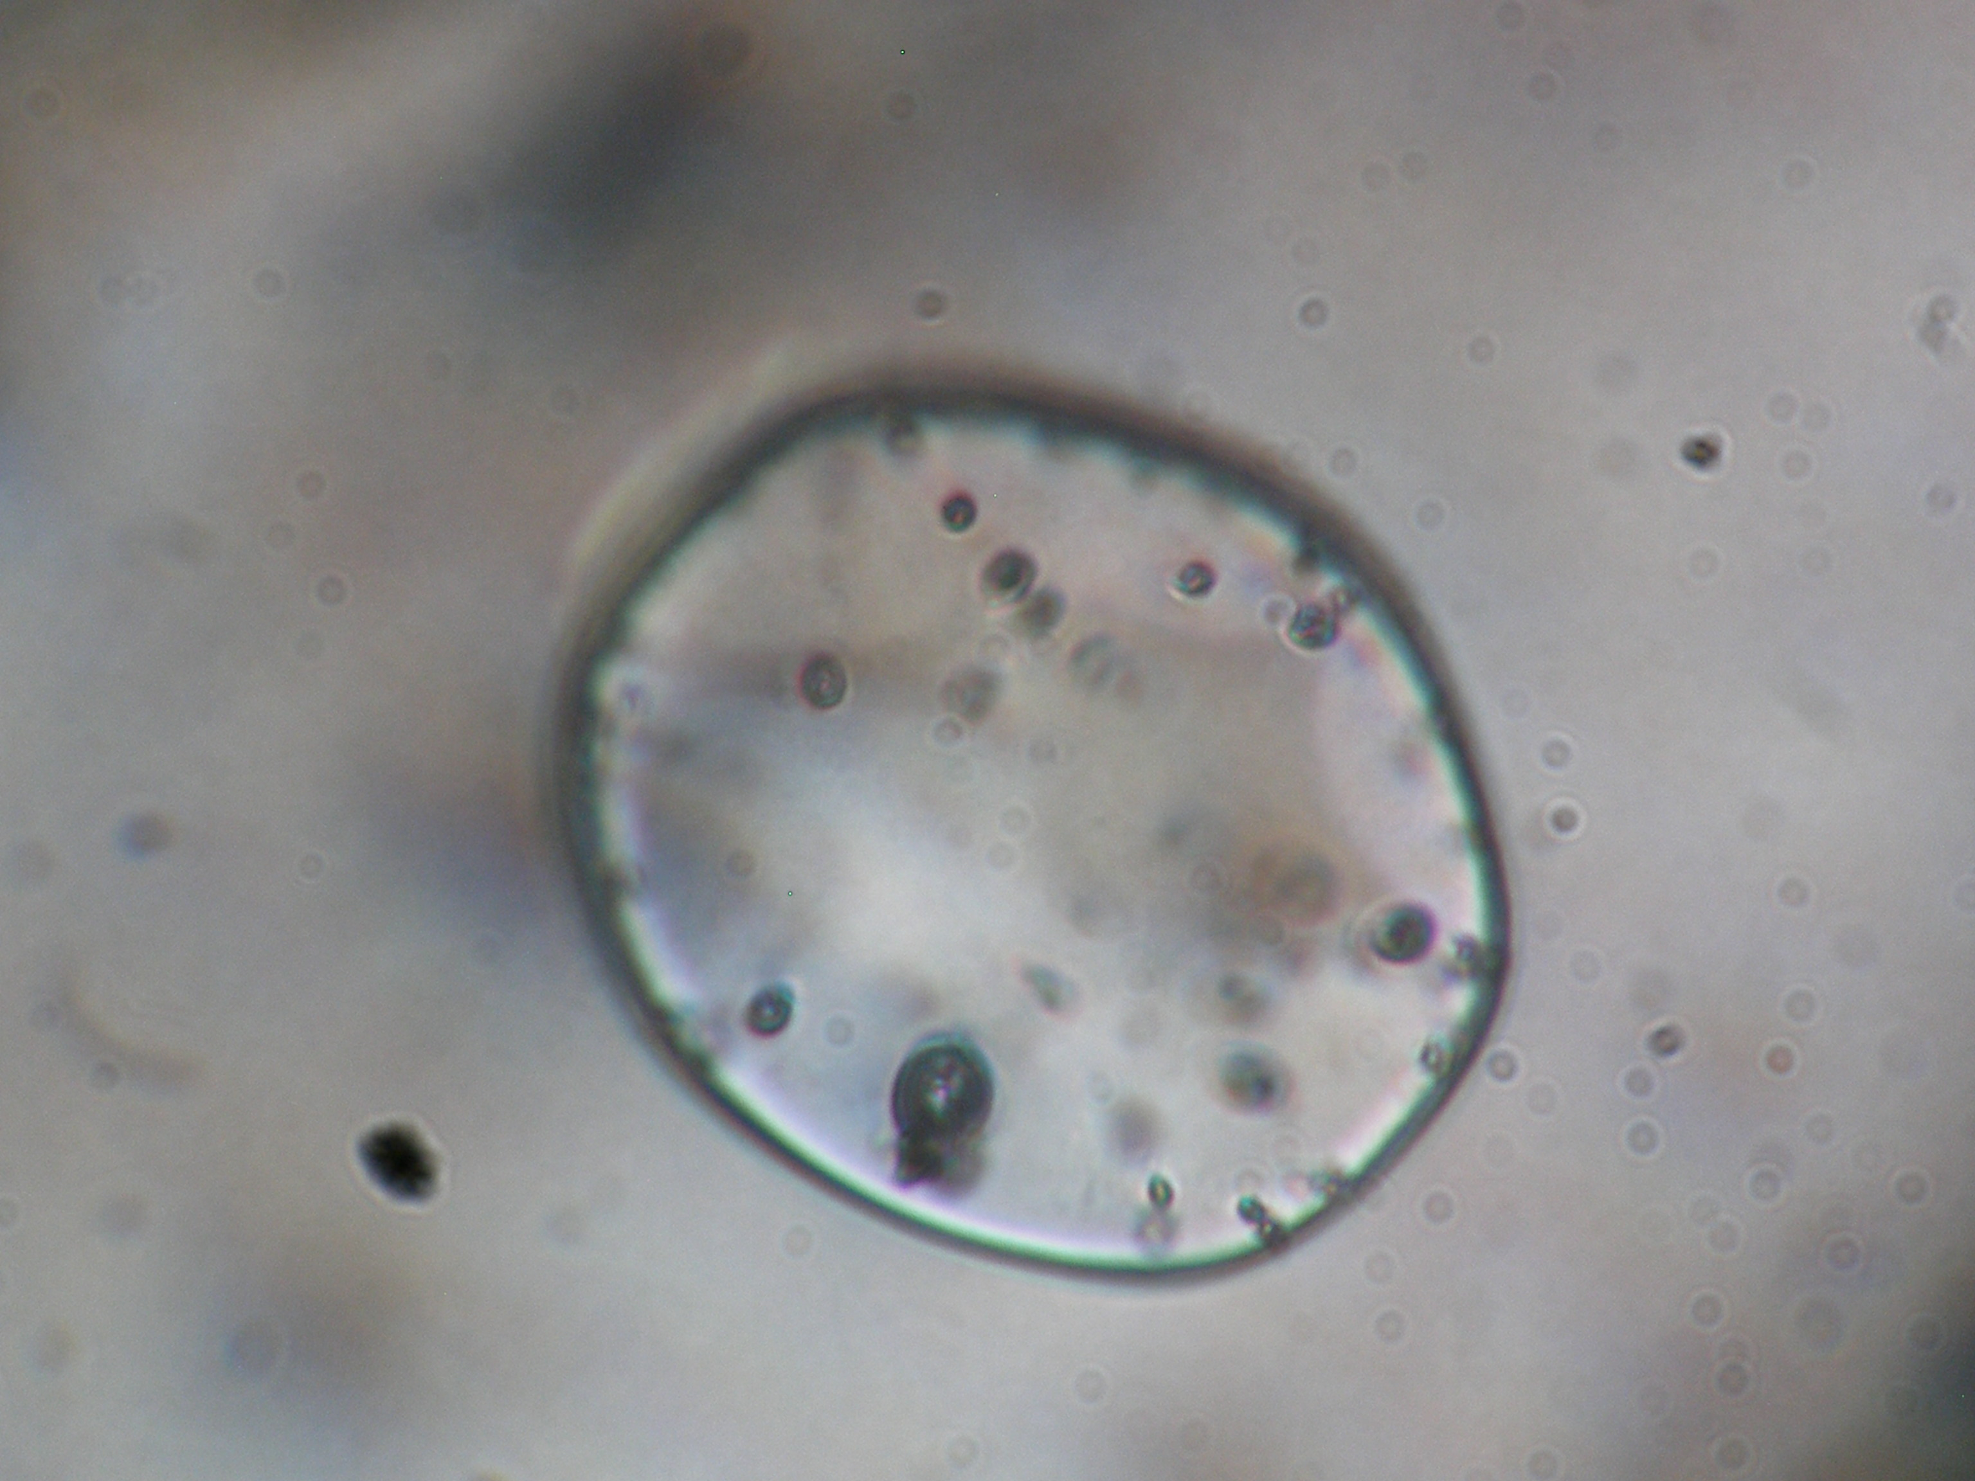

Fig 8. Sample R-82. Similar melt inclusion with gas bubbles in Quartz, rhyolite, East Bazman volcano, T = 630oC. After next T = 690oC gas bubbles will disappear. H2O content is up to 6 wt%.

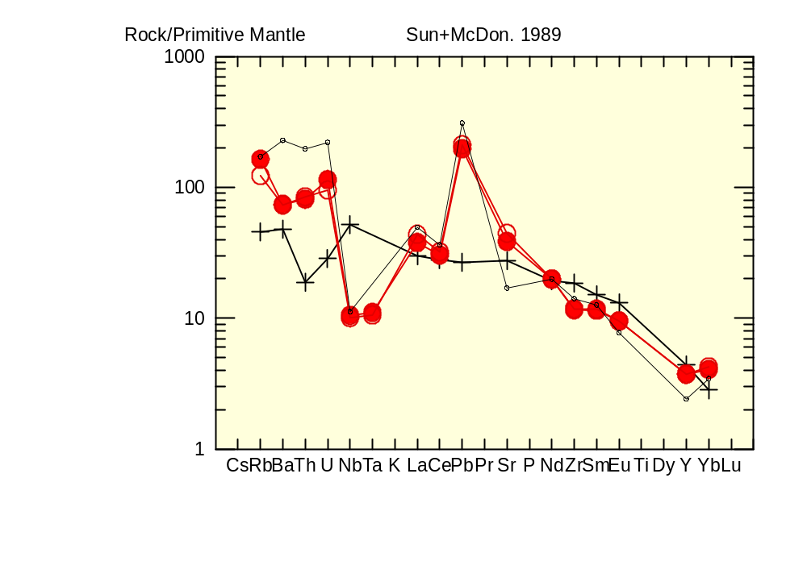

Fig 9. Spider-diagram for non-intraplate rocks, principally other, probably - subduction-related rocks. Circles – shoshonite series rocks, Abbas Abad copper deposit, Central Iran, M. Heidari’s samples, cross – intraplate rocks pf Lut block by Saadat et al, 2002, dots – Kurama Mt, Tien Shan, C3-P1 age, analogues of studied shoshonitic – latitic rocks. Usual positive anomaly by Pb. Ta – Nb deficit here is in subduction-related? rocks. For a comparison, example: Cross – principally OTHER intraplate rocks of Lut block by Saadat et al, 2002.

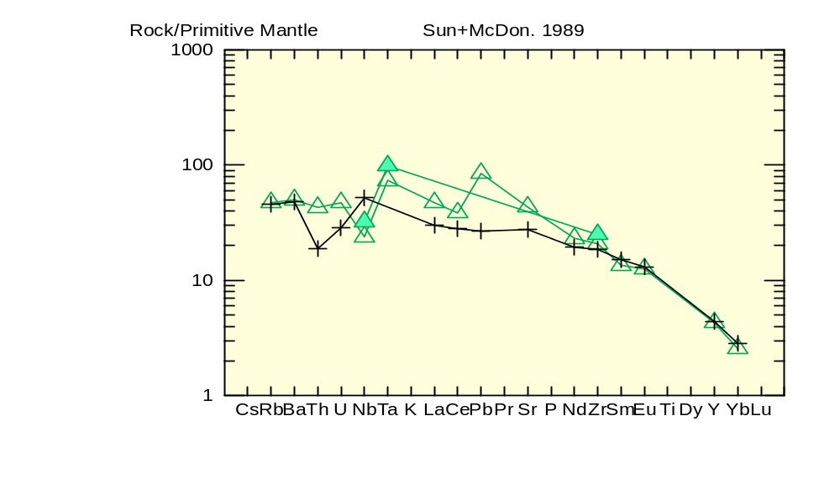
Fig 10. Spider-diagram for intraplate rocks of East Iran, typical flat profiles. Sometimes -usual Pb positive anomaly. Triangiulars - R-70 – unnamed volcano (full plot with usual Pb – positive anomaly), R-71 – Haji temporary lake in a desert, not-full profile, no Middle - HREE data here, cross – intraplate rocks of Lut block by Saadat et al, 2002.

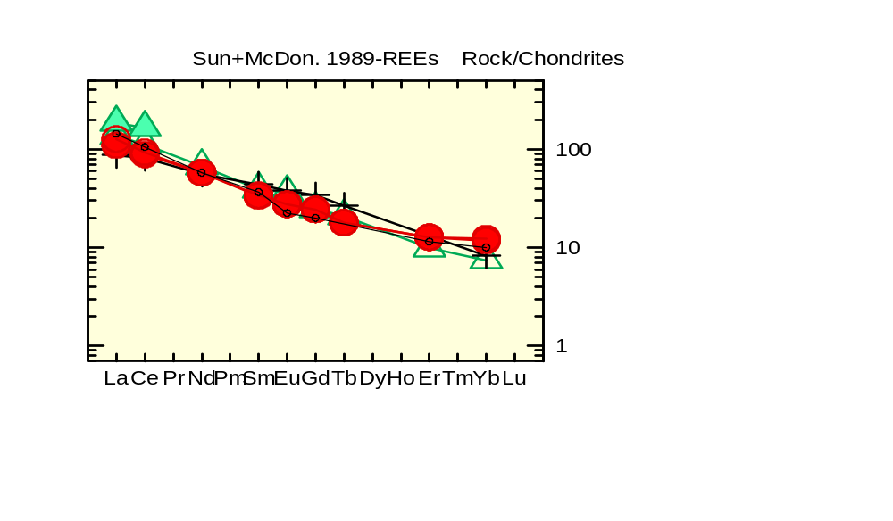

Fig 11. REE chondrite-normalized diagrams for Cenozoic intraplate rocks and Eocene subduction-related ones of Iran, N=6. Intraplate rocks are: R-70 (triangulars), R-71 (filled green triangulars), and crosses - sample from Lut block (Saadat et al., 2002). Circles – shoshonite – latite series rocks, Eocene (Pg2), Abbas Abad Cu mining area, N=2, samples of M. Heidari. Dots – rock of shoshonite- latite series, analogue, Kurama Mts, Middle Tien Shan, Late Carboniferous – Early Permian (C3-P1). Absent of Eu-deficit is typical for both intraplate and subduction-related rocks.

Intraplate rocks were derived from deeper mantle source versus subduction-related Eocene and Late Cenozoic rocks. This is supported by the following:
- Geological and petrographic and mineralogical data
- The general style of petrology and geochemistry of these rocks, we can the same on other regions
- Obvious geochemical materials, for example, the stable high K/Rb = 560-586-620 etc.
The region is expected to at least partial compensation of Pg2-Q aged compression and subduction-related Magmatism by intraplate magmatism. The latter, according to the imaging may be associated with the tail of the most powerful African superplume (Bull et al., 2009). There is also discussion in modeling - the partial screening of the plume push up plate, which is not an obstacle - it is known that plate moves may not stop movement of the tail superplume in lateral direction.

Metallogenic notes

Neogene rocks of the Lesser Caucasus is interesting for economic and non-economic metallogeny as:
- New Low-temperature Au-Ag, Hg, As, Sb, Cu-Mo with Au, Cu-Pb-Zn and Pb-Zn deposits and occurrences is proposed here,
- Non-ore raw – tuffs, slags, pumice etc. are of interest too.

Metallogeny of Cenozoic rock of East Iran was studied under the leadership of outstanding regional trio – Dr. Eugene Romanko, Dr. A. Houshmandzadeh, and Dr. M.A.A. Nogole-Sadat.
Calc-alkaline intrusive, extrusive, pyroclastic and volcanogenic-sedimentary rocks here are characterized by a common copper-gold (Cu-Au) metallogenic profile for Baluchestan and Sistan Province in East Iran, as in the whole Sahand – Bazman volcanic-plutonic belt of Iran. The overwhelming majority of occurrences the study area is associated with magmatic complexes. Such metallogenic types were revealed here as:
- Multi-sulfide (Au-Mo-Cu-Pb-Zn) subvolcanic porphyry type;
- Au-As-Hg-W-Mo-volcanic exhalation one;
-Low-sulfide gold-silver plutonic one;
-Gold-copper (Au-Cu) skarn and plutonic-hydrothermal one (E. Romanko et al., 2000; data by Pars Kani Co, 2003 by Daliran et al., 2005) using also known data on mineralization of different region including former USSR / CIS (Prokofiev et al., 2000; Vikentiev et al., 2004 etc.);
-Sulfide, sulfur, alunite exhalation, surface one;
-Native-copper-sulphide volcanogenic one with zeolites;
-Silver volcanogenic sulphide (+ gold?) one.
Thus, intraplate rocks are strongly specialized in REE, P (usual process), then in Sr, Ba, U, Th due to nowdays materilas. So, tectonic-magmatic, and as revealed E.Romanko – metallogenic zonation in the region was revealed in the region studied (at least in the Central – East Iran). Younger magmatic products are in the northeast of region due to lithosphere subduction and decreasing of Afrocan superplume activity in the same direction. Subduction-related (1 group of rocks) dominated calc-alkaline rocks and shoshonites-latites. , and, intraplate African superplume-related (Laverov et al., 2004; Yarmolyuk, personal communication, 2013, etc.) midalkaline – alkaline rocks including known Pleistocene carbonatites of Hanneshin, Afghanistan and, also, of one of Arabia are subordinated (2 group of rocks). Rocks of 1 and 2 groups are interpreted by us as a tectonic-magmatic couple due to one from physics etc. In this case, at least, partial compensation of subduction compression by the intraplate extension is possible. Cenozoic intraplate rocks intraplate carbonatite-derived depth of the melt - an argument in favor of the African superplume influence on the magma plume of a large region, which is in agreement with effective tomography of the well-known J. Ritsema’s team (Bull et al., 2009).

Oil and gas, hydrocarbons (HC), some notes

There are known materials about of Caspian Sea OIL / HC resources or productivity decreasing in north – northeast (N - NE) tectonic direction or lineament as stressed by known Prof. V. Khain with co-authors in the Explanatory map of Caspian Sea region scale 1:2 500 000 etc. (Khain, 2001; Leonov et al., 2010). This decreasing is as follows: from extremely rich Persian Gulf to South – Middle – North Caspian Sea. It is in agreement with the increasing distance from the African superplume by effective tomography (Bull et al., 2010), tectonics etc.
More specifically, this HC super belt is as Persian Gulf – Russian Arctic coast, due to old Russian HC maps, ex., USSR oil structures map scale 1:2 500 000 etc. Also, important as HC traps salt domes in the east Persian Gulf are oriented due to this tectonic direction. Relation of HC field with faults is obvious. Other possibility for HC fields is combining of well-known H2 fluxes from the depth on faults with organic C in sediments.
Some experienced HC specialists believe now that there are no strong contradictions in combined biogenic and abiogenic data. HC fields are only of Cenozoic age, 0.8 Ma for oil and 0.1 Ma for gas (not Riphean - Paleozoic – Mesozoic etc.) due to high mobility of HC, ex. ca 1 m/year by known HC specialists including R. Seyful-Mulyukov, A. Timurziev etc. So we see obvious deep, fault-related HC fluid input here, but biogenic factor including favorable climate is very important too. More data on HC peculiarities in the region studied needed, surely.

Conclusions

1. Some common geo-similarities on Cenozoic events in the region studied were revealed. At least, in East Iran important north-east tectonic-magmatic zoning and partly, metallogenic one (metallogeny under the leadership of known regional trio as E. Romanko, A. Houshmandzadeh, and M.A.A. Nogole-Sadat) due to African superplume activity exists here. It caused directly by known subduction of the Arabian plate under the Central Iran. African superplume activity strongly controls magmatism, “hot” regional tectonic regime, and, at least, partly - metallogeny in the region studied. Also, African superplume closely deals with known Jurassic Karoo flood basalts event in Africa, Paleogene magmatism in East Africa, since mainly Eocene (Pg2) subduction in Iran – Turkey etc., Neogene 11-9 Ma opening of Red Sea etc., and probably, delamination of a mantle lithosphere in East Mediterranean in Miocene and as a result – lack of regional Cu-porphyry mineralization versus economic one in Eocene before important delamination.
2. Two different types of Cenozoic magmatic rocks exist in the region studied: 1 – intraplate alkaline and subalkaline rocks and 2 – shoshonite - latite series rocks and calc-alkaline ones mainly dealing with subduction – collision events. Low crystallization temperature – 690oC and High H2O content up to 6 wt. %, and natural melt chilling were revealed for a probably Quaternary subduction-related rhyolite of the Bazman volcano (all data on melt inclusions led by V. Prokofiev) Sudden high/very high crystallization temperature, up to 1220oC on melt inclusions in High-K probably subduction-related dacite of remnant subduction were received too. Otherwise, for intraplate rocks as well for shoshonite – latite subduction related ones melt inclusions are not typical due to proposed warm conditions.
3. Eocene (Pg2) subduction-related shoshonite – latite series rocks almost in the whole region are characterized by an economic Cu-Au mineralization with a subordinate different mineralization (Cu-Pb-Zn-Au-Ag, Hg-As, Au-Ag low-sulphide, Ag-sulfide with Au (?) etc.). Cu mineralization deals with deep basic enriched water-containing source. Cu mineralization disappears with time and higher in general magmatic section after disappears of relation with deep enriched source using (Haschke et al., 2010). Intraplate rocks bear, at least, REE, P, also Sr, Ba, Th, and U mineralization.

Acknowledgments

We are extremely grateful to outstanding regional trio - E. Romanko†, A. Houshmandzadeh, and M.A.A. Nogole-Sadat for their leadership in the field works and comprehensive care, also – to famous V.E. Khain†, M. Goncharov, and N. Bozhko, all from Lomonosov Moscow State University, MSU (long discussions and advises), V. Trifonov, V. Burtman, I. Pospelov, M. Kopp, Yu. and M. Leonov, M. Fedonkin, M. Khutorskoy, B. Polyak, V. Yarmolyuk, A. Geptner, D. Alexeev, M. Luchitskaya, M. Pevzner, G. Karpova, M. Buyakayte, D. Astafiev, M. Rodkin, I. Gablina, Yu. Malinovsky, S. Palandzhyan and G. Nekrasov, A. Knipper†, S, Ruzhentsev†, V. Kovalenker, V. Rusinov†, A. Girnis, A. Babansky, A. Mokhov, V. Volkov, N. Tarasov, S. Bubnov, A. Gurbanov, and A. Dockuchaev, G. Moralev, G. Gogonenkov et al., A. Timurziev, also to A. Meskhi from Kazan, Russia; S.M. Tabatabaeimanesh, M. Hosseini, M. Ziaii, and more other geo-specialists for discussion, analytical help etc.

This work was made on “Dynamics of lithogenetic processes on formation and evolution of intra-continental and post-rift structures in Phanerozoic of Eurasia” theme and on the RF Basic Research, project 03-05-64805.

REFERENCES

      - Abdullah S., Chmyrev V., Dronov V., Ed., 1980. Geology and Mineral Resources of Afghanistan. Moscow: Nedra. Book 1, p. 535, Book 2, 336 p. (in Russian).
      - Alinaghi A., Koulakov I., Thybo H., 2007. Seismic tomographic imaging of P- and S-waves velocity perturbations in the upper mantle beneath Iran. Geophysical J. International, 169, pp. 1089-1102.
      - Artemiev M., 1971. Some features of the deep structure of the Mediterranean type basins according to isostatic gravity anomalies. Bull. Moscow Society of Naturalists, Dept. Geol., no 4, pp. 30-41 (in Russian).
      - Bogatikov O.A, Kovalenko V.I., Yarmolyuk V.V., Bubnov S.N., 1987. Series of igneous rocks: problems and solutions. Reports of the Academy of Sciences of the USSR, Series Geol, no 3, pp. 3-12 (in Russian).
      - Bortnikov N.S., Prokofyev V.Yu., 2007. Major mesothermal gold ore deposit of Russia: composition and origin of ore-forming fluids. Digging Deeper. Proceedings of the Ninth Biennial meeting of the society for geology applied to mineral deposits. Dublin, Ireland. 2007. Dublin Published Irish Association for Economic Geology, pp. 793-796.
      - Bortnikov N.S., Vikentiev I.V., 2004. Modern ore minerals formation in the oceans. Ore deposits and ore-forming processes. M. IGEM, pp. 325-356. In Russian.
      - Bull A.L., McNamara A.K., Ritsema J., 2009. Plume clusters and thermochemical piles. Earth Planet. Sci. Lett. Vol. 278, pp. 152–162.
      - Burtman V.S., 2012. Tien-Shan and High Asia. Geological Institute RAS Transactions. M: GEOS, 188 p. In Russian.
      - Dilek Y., Imamverdiyev N.A., Altunkaynak S., 2010. Geochemistry and tectonics of Cenozoic volcanism in the Lesser Caucasus (Azerbaijan) and the Peri-Arabian region: Collision-induced mantle dynamics and its magmatic fingerprint. International Geology Review, vol. 52, issue 4-6, pp. 536-578.
      - Haschke M., Ahmadian J., Murata M., McDonald I., 2010. Copper mineralization prevented by arc-root delamination during Alpine-Himalayan collision in Central Iran. Economic Geologists, v. 104, pp. 885-895.
      - Hushmand-Zadeh A., Nabavi M.H., 1986. Metamorphic Map of Iran Scale 1: 2,500,000. Tehran: Geol. Survey. Iran.
      - Imamverdiyev N.A. 2000. Geochemistry of Late Cenozoic volcanic complexes Lesser Caucasus Baku. Nafta-Press. 2000. 192 p.
      - Imamverdiyev N.A. 2008. Delamination of subducted lithospheric slab as the cause of Late Cenozoic volcanism in the Lesser Caucasus. News of State Baku University. Natural sciences Series. no 3, pp.536-578.
      - Khain V., 2001. Tectonics of Continents and Oceans (year 2000). Moscow: Scientific World, 2001. 606 p. (in Russian).
      - Khain V., Goncharov. M., 2006. Endogenic processes of different tectonic settings. Herald of MSU. Vol. 5. pp. 15-23.
      - Knipper A., Dobretsov N., Bogdanov N., 1992. Ophiolites and “orogenic lherzolites” of Bet Cordillera, Spain. Reports of the Academy of Sciences. Geological Series. N 12, pp. 8-24. In Russian.
      - Koronovsky N.V., Demina L.I., 1999. Collisional stage of the Caucasian sector Alpine fold belt: geodynamics and Magmatism. Geotektonika, no 2, pp. 17-35. In Russian.
      - Koronovsky N.V, Lomize M.G., 2006. Tectonic accretion and collision as the steps of forming intra-continental fold belts. Areas of active tectonics in modern and ancient history of the Earth. Materials of 39 Tectonic meeting, vol. 1, Moscow: GEOS. pp. 353-357. In Russian.
      - Laverov N., Kovalenko V., Yarmolyuk V. et al., 2006. The latest volcanic activity in Northern Eurasia: Zoning and environment of formation. Russian Academy of Sciences Reports. vol. 410. no 4, pp. 498-502. In Russian.
      - Leonov Yu. G., Edit., 2007. Great Caucasus in the Alpine Epoch. Moscow: GEOS. 368p. In Russian
      - Leonov Yu., Volozh Yu., Antipov M. et al., 2010. Consolidated crust of Caspian region. M. GEOS. 64 p. In Russian.
      - Luchitsky I.V., 1985. Palaeovolcanology. Moscow: Science (Nauka), 235 p. In Russian.
      - Marakushev A.A., 1988. Petrology. Moscow. MSU publishing, 206 p. In Russian.
      - Milanovsky E.E., Koronovsky N.V., 1973. Orogenic volcanism and tectonics of the Alpine belt of Eurasia. Moscow: Nedra, 280 p. In Russian.
      - Nogole-Sadat, M.A., 1985. Les Zones de Decrochement et les Virgation Structurales en Iran: Geol. Survey of Iran, Report, 55, 259 p.
      - Pars Kani Co, 2003. Preliminary report on the prospection of epithermal gold mineralization in Chahnali north of Bazman, Sistan-va-Baluchestan province, Southeast Iran. International Report. 136 (in Farsi language with English abstract).
      - Pospelov I., 2009. Tectonics of Pamir. Tectonics and geology. V. 5, pp. 15-25.
      - Prokofiev V.Yu., 2000. Geochemistry of ore-forming fluids of hydrothermal gold deposits of different genetic types according to the study of fluid inclusions. Moscow. Science (Nauka), Novosibirsk, 192 p. In Russian.
      - Prokofiev V.Yu., Bortnikov N.S., Zorina L.D. et al., 2000. The Darasun intrusive-related gold-base metal deposit, Eastern Transbaikalia, Russia: Petrochemical, melt and fluid inclusion, REE and stable isotope (O, C, and S) studies. Applied Mineralogy. Rammlmair et al., Eds. Balkema, Rottertdam, Brookfield, 399-402 pp.
      - Romanko E., Kokorin Y.., Krivyakin B. et al., 1984. Outline of metallogeny of Anarak Area (Central Iran). Ministry of mines and metals. Geological Survey of Iran. Rep. 21, Tehran. Technoexport, 136 p.
      - Romanko E., Voinkov D., Houshmandzadeh A. et al., 2000. Characteristic features of ore mineralization in the Sistan-Baluchestan Province, SE Iran: evidence from fluid inclusions data. International conference on geology of Mediterranean belt. Absracts. Beograd.
      - Romanko E., Houshmandzadeh A., Nogol-Sadat M.A.A. et al., 2000. Metallogenic zonation in Seistan and Baluchestan Province, East Iran. Reports of Russian Academy of Sciences. V. 370, N 1, pp. 76-79, in Russian.
      - Romanko E., Romanko A., Meskhi A., 1998. On a Geology and Geochemistry of Mesozoic-Cenozoic igneous rocks in NE Algeria. Reports of Russian Academy of Sciences, vol. 362, no 2, pp. 236-238, in Russian.
      - Romanko A., 2005. New data on Cenozoic subalkaline intraplate rocks the East Iran. Reports of the Russian Academy of Sciences, v. 404, no 4, pp. 510-513.
      - Romanko A., Imamverdiyev N.A., Prokofiev V., Vikentiev I., Savichev A., Stepanov S., 2013. Alpine tectonic-magmatic-metallogenic peculiarities in West Baluchestan, Middle East: new data, “hot” tectonics, inclusions, discussion, hydrocarbons (HC), and constraints. Universal Journal of Geoscience, vol. 1, pp. 130-138.
      - Romanko A., Imamverdiyev N. A., Prokofiev V., Heidari M. et al. 2012. On Cretaceous – Quaternary tectonic-magmatic-metallogenic peculiarities in east Iran and South Tajikistan: new data melt inclusions, constraints, and some problems. European Seismological Commission Assembly. ESC. Book of abstracts. M. Polygraph, pp. 154-155.
      - Rusinov V.L., 1985. Propilites and propilitization. M.: Nauka. 185 p. In Russian
      - Sandwall E., Turkell N., Zor E. et al., 2003. Shear wave splitting a young continent collision. Geophys. Res. Lett., 30. no 24 b, pp.185.-194.
      - Trifonov V., Ruzhentsev S., 1984. Tectonic napes in East Pamir, Tajikistan and tectonic layering. Episodes. 32 IGC. Special Issue. pp. 15-20.
      - Vikentiev I.V., Yudovskaya M.A., Mokhov A.V. et al. 2004. Gold and PGE in massive sulphide ores of the Uzelginsk deposit, Southern Urals, Russia. Canadian Mineralogist. v. 42, no 5, pp. 651-665.
      - Yarmolyuk V.V., Kovalenko V.I., 2003. Deep geodynamics, mantle plumes and their role in Central-Asian mobile belt formation. Petrology. Vol. 11. No 6. pp. 556-586. In Russian.
      - Yarmolyuk V.V., Kovalenko V.I., Bogatikov O.A., 1990. South Baikal "hot spot" mantle and its role in the formation of the Baikal Rift region. Reports of Russian Academy of Sciences. Vol. 312. No 1. pp. 187-191. In Russian.

\\\\\\\\ \\\\
= = = \\\ END \\\ \\\\

